Information Statement
  - 2023-2024

Contents
1 Introduction 5
1.1 Background 6
2 Legislation Administered 7
2.1 Local Laws of the City of Nedlands 9
2.2 Standards & Codes of Practice Affecting the City of Nedlands 9
3 Structure and Functions 11
3.1 Council 11
1.1.1 Role of Council 11
3.1.2 Role of Mayor 11
3.1.3 Role of Deputy Mayor 11
3.1.4 Role of Councillors 11
3.2 City of Nedlands Administration 13
3.2.1 Office of the CEO 13
3.2.2 Corporate Services Directorate 14
3.2.2 Planning and Development Directorate 14
3.2.3 Technical Services Directorate 14
3.2.4 Customer and Community Services Directorate (Proposed) 15
3.3 Delegated Authority 15
4 Decision Making Functions 16
4.1 Council 16
4.2 Council Committees and Delegations 16
4.3 Chief Executive Officer (CEO) 16
5 Public Participation 17
5.1 Written Requests 17
5.2 Public Address at Council/Committee Meetings 17
5.3 Petitions 17
5.4 Electors’ Meetings 18
5.5 Annual Meeting of Electors 18
5.6 Special Meeting of Electors 18
5.7 Elected Members 18
5.8 Community Engagement 18
5.9 Council Committees 18
6 Documents held by the City 20
6.1 Council and Committee Agendas and Minutes 20
6.2 Public Registers 20
6.3 Local Laws 20
6.4 Policies Manual and Register of Delegated Authority 20
6.5 Strategic Community Plan 21
6.6 Community Directory 21
6.7 Disability Access and Inclusion Plan 21
6.8 Electoral Rolls and Street Directories 21
6.9 Schedule of Fees and Charges 21
6.10 Annual Budget 21
6.11 Annual Report 21
6.12 Tender Register 21
6.13 Contracts Register 22
6.14 Freedom of Information (FOI) Statement (This document) 22
6.15 Local Government Retention and Disposal Schedule 22
6.16 Records Management Manual 22
6.17 Record Keeping Plan 22
6.18 Building/Development Applications 22
6.19 Municipal Heritage Inventory 23
6.20 Local Studies Collection (Nedlands Library) 23
6.21 Correspondence files 24
6.22 Current files 24
6.23 Archived files 24
7 Access to Documents - Outside of FOI 25
7.1 Documents Published (some available for inspection) 25
7.2 Paid Services 26
7.3 CCTV Footage 26
8 Freedom of Information 27
8.1 Lodging a Freedom of Information Application 27
8.2 Freedom of Information Charges 27
8.3 Deposit 28
8.4 Access Arrangements 28
8.5 Notice of Decision 28
8.6 Refusal of Access 29
8.7 Amendment of Personal Information 29
8.8 Privacy Rights and Legislation 30
8.9 Freedom of Information Legislation 30

Disclaimer

The information contained within this publication is considered correct at the time of publication. The information has been compiled with care, but no warranty, expressed or implied, is given to the accuracy, correctness, or completeness of the information, or for any advice given, or omissions.

Introduction
The most important feature of local government is that it is ‘local’. Established under the Local Government Act of Western Australia its primary concern is providing services in the local area for its local people.

The Freedom of Information Act 1992 (the Act) creates a general right of access to State and local government documents. The objects and intent of the Act are to:
- Enable the public to participate more effectively in governing the State; and
- Make the persons and bodies that are responsible for State and local government more accountable to the public.

Part 5 (Division 94) of The Act also requires that government agencies (State and local) prepare and publish an Information Statement annually. This Information Statement must:
- State the structure and functions of the City;
- Describe the ways in which the functions of the City affect members of the public;
- Describe any arrangements that exist to enable members of the public to participate in the formulation of the City’s policy and performance of the City’s functions;
- Describe the types of documents that are usually held by the City which may be viewed, purchased, or obtained free of charge;
- Describe the City’s procedures for giving members of the public access to documents; and
- Describe the City’s procedures for amending personal information in the documents held by the City.

This Information Statement is published by the City of Nedlands in accordance with the requirements of the Act as outlined above. Copies of this document can be obtained by accessing the City’s website ( www.nedlands.wa.gov.au ) or by visiting the City’s Administration Building (71 Stirling Hwy, Nedlands, 6009).

Enquiries about this document can be made by submitting an enquiry online via:
- Create Customer Request; or
- www.nedlands.wa.gov.au
Alternatively, by contacting the City’s Information Management Team on (08) 9273 3500 Monday to Friday 8.30am – 5.00pm.

1.1 Background
The City of Nedlands had its’ origins in the Claremont Road Board. This was due primarily to the fact that the Nedlands’ district fell within the former Claremont jurisdiction. The Claremont Road Board came about because of the population growth in Claremont prior to the turn of the 20th Century.
This allowed the residents in the area to petition the government and they received their own Road Board by 1893. Seven men were nominated to the new Board, which became the first local government authority for the Nedlands area.
In 1932, the Nedlands Road Board was formed. On 1 July 1959, the City of Nedlands became a City. The City was made up of four wards – Melvista, Hollywood, Dalkeith and Coastal. These wards continue to the present day.
In all, the City encompasses some 20.6km². Within this area, the Council is responsible for the maintenance of 155.16km of sealed roads and more than 316ha of parks and gardens. 22,132 residents live in the City of Nedlands (2021 census).

Legislation Administered
The City of Nedlands was established under, and operates in accordance with, the Local Government Act 1995. Section 3.1 (2) of the Local Government Act (1995) requires that the scope of the general function of local government is to be constructed in the context of other functions and constraints imposed by it and any other Act.
General – section 3.1
The general function of a local government under s. 3.1 of the Act is to provide for the good government of persons in its districts. The general function of a local government under the Act includes legislative and executive responsibilities.

Legislative – section 3.5
Using its legislative powers under s. 3.5 of the Act, a local government may make local laws prescribing all matters that are required or permitted to be prescribed by a local law or are necessary or convenient to be so prescribed for it to perform any of its functions under the Local Government Act 1995.

Executive – section 3.18
The local government's executive powers under s. 3.18 of the Act, involves administering its local laws and doing other things that are necessary or convenient to be done for, or in connection with, performing its functions under the Local Government Act 1995 including the provision of services and facilities.

There are over 300 statutes that local governments are wholly and partially responsible for administering in Western Australia. Some of the main ones that the City of Nedlands administers include:
- Local Government Act 1995
  - Local Government (Administration) Regulations 1996
  - Local Government (Audit) Regulations 1996
  - Local Government (Constitution) Regulations 1998
  - Local Government (Elections) Regulations 1997
  - Local Government (Employee Superannuation) Regulations 2016
  - Local Government (Financial Management) Regulations 1996
  - Local Government (Functions and General) Regulations 1996
  - Local Government (Long Service Leave) Regulations
  - Local Government (Parking for People with Disabilities) Regulations 2014
  - Local Government (Regional Subsidiaries) Regulations 2017
  - Local Government (Rules of Conduct) Regulations 2007
  - Local Government (Uniform Local Provisions) Regulations 1996
- Local Government (Miscellaneous Provisions) Act 1960
- Public Health Act
- Health (Miscellaneous Provisions) Act 2005
- Bush Fires Act 1954
  - Bush Fire Regulations 2012
- Town Planning and Development Act 2005
- Dog Act 1976
  - Dog Regulations 2013
- Food Act 1976
- Disability Services Act 1993
  - Disability Services Regulations 2004
- Animal Welfare Act 2002
- Building Act 2011
  - Building Regulations 2012
- Cat Act 2011
  - Cat Regulations 2012
- Dividing Fences Act 1961
  - Dividing Fences Regulations 1971
- Emergency Management Act 2005
  - Emergency Management Regulations 2006
- Environmental Protection Act 1986
  - Environmental Protection Regulations 1987
  - Environmental Protection (Noise) Regulations 1997
- Equal Opportunity Act 1984
  - Equal Opportunity Regulations 1986
- Fire and Emergency Services Act 1998
  - Fire and Emergency Services Regulations 1998
- Freedom of Information Act 1992
  - Freedom of Information Regulations 1993
- Health Act 1911
- Local Government Grants Act 1978
- Occupational Health and Safety Act 1984
  - Occupational Health and Safety Regulations 1986
- Planning and Development Act 2005
  - Planning and Development Regulations 2009
  - Planning and Development (Local Planning Schemes) Regulations 2015
  - Planning and Development (Development Assessment Panels) Regulations 2011
- Public Interest Disclosure Act 2003
  - Public Interest Disclosure Regulations 2003
- Public Works Act 1902
- Rates and Charges (Rebates and Deferments) Act 1992
  - Rates and Charges (Rebates and Deferments) Regulations 1992
- Salaries and Allowances Act 1975
  - Salaries and Allowances Regulations 1975
- State Records Act 2000
  - State Records Principles and Standards 2016
- Workers Compensation and Injury Management Act 1981
  - Workers Compensation and Injury Management Regulations 1982
- City of Nedlands Local Planning Scheme No. 3
- City of Nedlands Local Planning Strategy 2017

Copies of Acts and Regulations are available from: -
State Law Publisher - 10 William Street, PERTH 6000
Ph. 6552 6000 - Fax 9321 7536 - www.slp.wa.gov.au
Or, electronically at the Australasian Legal Information Institute – www.austlii.edu.au/

2.1 Local Laws of the City of Nedlands
Local Laws are enforceable rules made by local governments to apply within their district. They help to establish and maintain the quality of life in line with the expectations of the local community and provide a standard under which businesses, residents and ratepayers must conduct their activities.
Local Laws support higher legislation (Acts of Parliament) to control and manage the more basic matters that affect the community. They can be helpful in the resolution of disputes, as well as achieving effective government.
- Local Laws – Standing Orders
- Local Laws – Health
- Local Laws – Dogs
- Local Laws – Council Halls
- Local Laws – Reserves, Foreshores and Beaches
- Local Laws – Thoroughfares
- Local Laws – Parking and Parking Facilities
- Local Laws – Site Erosion and Sand Drift
- Local Laws – Trading in Public Places
- City of Nedlands Repeals Local Law 2016
- The City of Nedlands Waste Local Laws 2016

All of the above Local Laws are available to view on the City’s website (Local Laws) and are currently under review.

2.2 Standards & Codes of Practice Affecting the City of Nedlands
The following government and industry standards and codes of practice have been imposed upon or adopted by the City of Nedlands:
- Australian Accounting Standards
- Australian Records Management Standard AS/ISO 15489-2002 Parts 1 & 2
- General Disposal Authority for Local Government Records DA2015-001/1
- Quality Management ISO 9000/2000
- National Competition Policy
- Risk Management AS/NZS ISO 31000:2009
- Environmental Management ISO14001-2004

Structure and Functions

3.1 Council
The City of Nedlands is represented by eight (8) councillors, two (2) in each ward, and an independently elected Mayor. The Deputy Mayor is elected by the Councillors. The Mayor and Councillors act in a voluntary capacity, receiving an allowance only. Each Councillor serves for a term of four (4) years. Elections for half the council are held every two (2) years. Council has adopted a Code of Conduct to enable efficient decision-making.

Link to Current Mayor & Councillors

Role of Council
The Council -
- Governs the local government’s affairs;
- Is responsible for the performance of the local government’s functions;
- Oversee the allocation of the local government’s finances and resources; and
- Determine the local government’s policies.

Role of Mayor
The role of the Mayor is to:
- Preside at meetings in accordance with the Local Government Act 1995;
- Provide leadership and guidance to the community in the district;
- Carry out civic and ceremonial duties on behalf of the local government;
- Speaks on behalf of the local government;
- Performs such other functions as are given to the Mayor by the Local Government Act 1995 or any other written law; and
- Liaises with the CEO on the local government’s affairs and the performance of its functions.

Role of Deputy Mayor
The Deputy Mayor performs the functions of the Mayor when the Mayor is unavailable or unwilling to perform the functions of the Mayor.

Role of Councillors
A Councillor –
- Represents the interest of electors, ratepayers and residents of the district;
- Provides leadership and guidance to the community in the district;
- Facilitates communications between the community and the council;
- Participates in the local government’s decision-making processes at council and committee meetings; and
- Performs such other functions as are given to a councillor by the Local Government Act 1995 or any other written law.

Decisions of Council are made at Council Meetings. Ordinary Meetings are held on the fourth Tuesday of each month excluding December when a meeting is held on the third Tuesday of the month and January when no meetings are scheduled.

These meetings are held in the Council Chamber at 71 Stirling Highway, Nedlands and are also livestreamed. Council Agendas and Minutes are published and are available on the City’s website for public viewing at www.nedlands.wa.gov.au.

A review of the ward system is required by law every eight years with the City’s last ward review done in 2021.

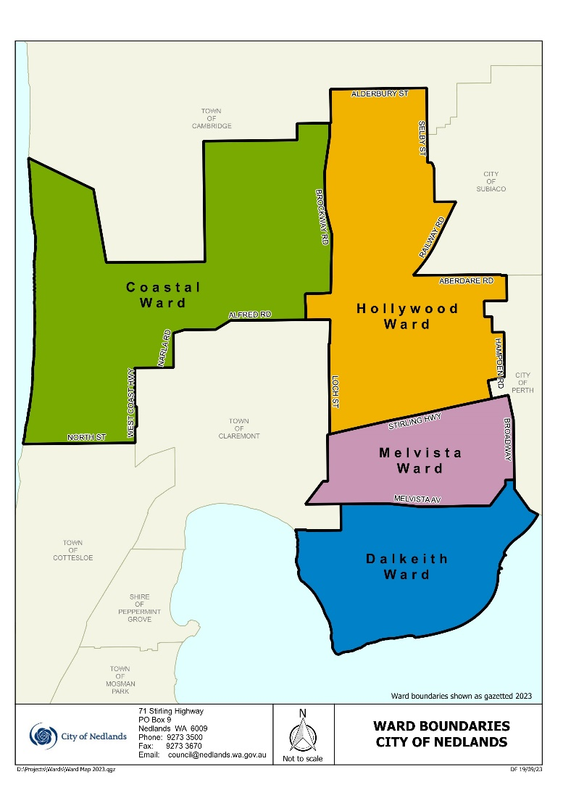

3.2 City of Nedlands Administration
Each local government employs a Chief Executive Officer (CEO) to employ and manage staff, to provide advice to the Council and administer the day-to-day operations of the local government. The CEO is appointed by Council and is the conduit between the elected members of Council and the local government staff. All staff receive their direction from and are responsible to the CEO.
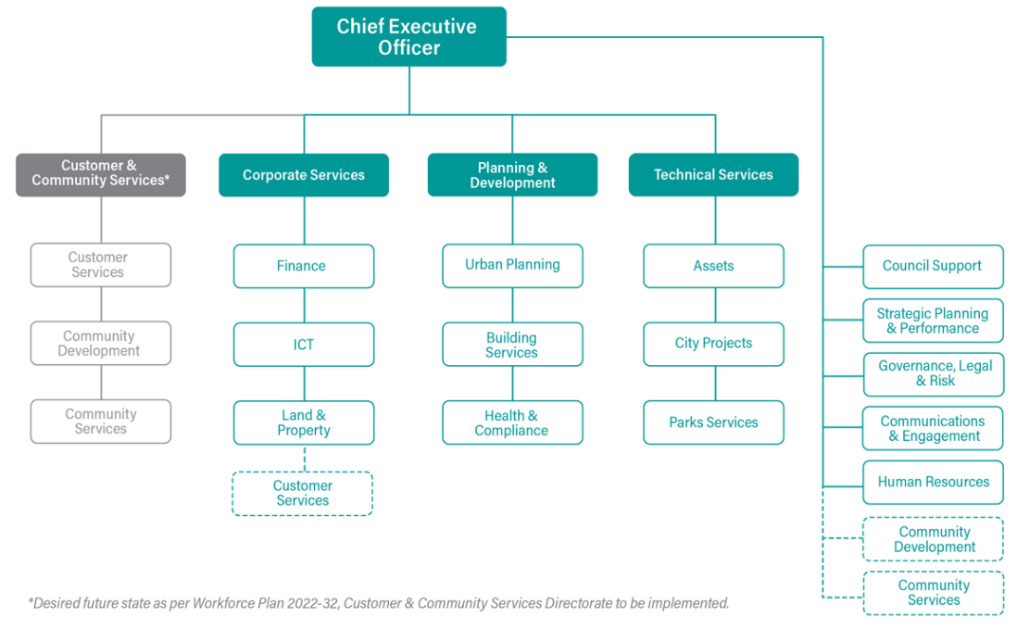

The City of Nedlands Administration consist of the following Directorates by Business Units and Services Areas as per Workforce Plan 2022-23:

Office of the CEO
The Office of the Chief Executive Officer develops and implements strategic plans that enable the organisation to deliver the community’s vision and aspirations. It is responsible for Council and Executive Support, Strategic Planning and Performance, Governance, Legal and Risk Management, Communications and Engagement and Human Resources. It is also responsible for Community Development and Community Services whilst the Customer and Community Services whilst the Directorate position is vacant.
Business Units | Service Areas
CEO Office | CEO Office
Council Support | Members of Council
Strategic Planning & Performance | Strategic Planning & Projects
Governance, Legal & Risk | Governance & Legal
Communications & Engagement | Corporate Communications
Human Resources | Human Resources
Customer & Community Services Directorate | Customer & Community Services Administration
Community Services | Library Services  Childcare Services  Positive Ageing  Nedlands Community Care (NCC)
Community Development | Community Development  Community Programs & Events  Sport and Recreation  Volunteer Services  Youth Development  Tresillian

3.2.2 Corporate Services Directorate
The Corporate Services Directorate is responsible for all corporate matters and provides services to internal teams. This includes Finance and Information and Communication Technology (ICT) Services. It is also responsible for Customer Services, whilst the Customer and Community Services whilst the Directorate position is vacant, which facilitates both internal and external community interactions.
Business Units | Service Areas
Corporate Services Director | Corporate Services Administration  Land & Property
Finance | General Financial Services
Information and Communication Technology (ICT) | Information Technology  Information and Records Managements  OneCouncil Project  Customer Services

Planning and Development Directorate
The Planning and Development Directorate performs research and creates the plans required to deliver a liveable, prosperous, sustainable city. It is responsible for Urban Planning – Strategic and Statutory Planning, Building Services and Health and Compliance.
Business Units | Service Areas
Planning & Development Director | Planning & Development Services Administration
Urban Planning | Urban Planning – Strategic  Urban Planning – Statutory
Building Services | Building Services
Health & Compliance | Environmental Health  Environmental Conservation  Rangers Services

Technical Services Directorate
The Technical Services Directorate designs, constructs, manages and maintains infrastructure, buildings, fleet assets and the City of Nedlands’s public spaces. It is responsible for City Projects, Assets and Parks Services.
Business Units | Service Areas
Technical Services Director | Technical Services Administration
City Projects | City Projects & Programs  Civil Maintenance  Building Maintenance
Assets | Asset Management  Fleet Management  Waste Management  Transport & Development
Parks Services | Parks Maintenance
 | Arboriculture

Customer and Community Services Directorate (Proposed)
The Customer and Community Services Directorate provides an internal and external focus on providing excellent customer service and community services and development to the community. It is responsible for Customer Services, Community Development and Customer Services. Business Units fall under to the Office of the CEO and Corporate Services Directorate whilst Director position is vacant.

Delegated Authority
In addition to the legislated functions of the CEO and to ensure the efficient management of Council activities, authority has been delegated to the CEO and other officers to make decisions of an operational nature according to Council policies and specific matters by resolution of Council.
Delegated Authorities are listed in the Delegated Authority Manual and are reviewed at least annually by Council.

Decision Making Functions

Council
Meetings of Council are held to make all decisions concerning the municipal district, other than those delegated, as authorised by the Local Government Act 1995 and other legislation as appropriate. Decisions are generally made after considering recommendations from committees unless a Special Meeting of Council has been called to consider a specific issue.

Council Committees and Delegations
Committees meet to consider issues which are under their area of control as identified in their Terms of Reference. These committees may comprise elected members, and community representatives. Committees are constituted by council and have special responsibilities depending on their function. Council Administration provides reports and advice to the various Council committees in the agenda for each meeting and recommends an appropriate course of action. The committee may then either endorse the administration recommendation or recommend an alternative course of action. The committee is responsible for the recommendations to Council as recorded in the minutes of the committee meeting.
Council also meets as a committee of the whole to consider the reports to council prior to their consideration by council.

Chief Executive Officer (CEO)
The CEO’s functions are to advise council in relation to the functions of City of Nedlands under the Local Government Act 1995 and other written laws and to ensure information is available so that informed decisions are made. The CEO is also responsible for all staff matters. The CEO is to liaise with the Mayor on local government affairs and the performance of the City of Nedlands as well as ensure records and documents are properly kept.

Public Participation
Members of the public have various methods to participate in the formulation of the City’s Strategies, Policies, and Plans. The public can also have their say on the performance of the City’s Services and Functions.

Written Requests
The public can write to the Council on any policy, activity, function, service of the Council via:
- Make an Enquiry » City of Nedlands; or
- Written correspondence addressed to:
Chief Executive Officer
City of Nedlands
PO Box 9
Nedlands WA 6909

Public Address at Council/Committee Meetings
The public have the opportunity to ask Council and staff questions about City matters in general in Council meeting.
- Committee Meeting members of the public are permitted to only address topics listed on the agenda for that meeting.
- In order to make an address, a person is required to give written notice of their intention to do so to the CEO or immediately and in writing prior to the meeting.
- The rules governing the Public Address Session are outlined in Clause 3.4 of the City of Nedlands Local Law Relating to Standing Orders available on the City’s website or on request.
- Two forms incorporating an Application and these Rules have been developed:
1. Addresses by members of the public, and
2. Public question time submission.
- These forms are available from the Council Meetings and the Council Agendas/Minutes section of the City’s website www.nedlands.wa.gov.au or on request from the City.
- The public address is restricted to electors of the City unless the Council, by resolution, decides otherwise.
- Council meetings are held on the 4th Tuesday of each month, except December and January.
- Committee meetings are held on the 2nd Tuesday of each month, except December and January.

Petitions
Written petitions can be presented to the Council on any issue within the Council's jurisdiction.

Electors’ Meetings
Electors have an opportunity to give their opinions on any issue at either the Annual Meeting of Electors or Special Meetings of Electors.

Annual Meeting of Electors
An Annual Meeting (AGM) of Electors is held at least once in each financial year, at a time appointed by Council for the following purposes:
- Receiving the Annual Report,
- Special Business of which notice has been given, and
- General Business.

Special Meeting of Electors
Electors may initiate a Special Meeting of Electors under procedures prescribed in the Local Government Act 1995.
Special meetings are called to consider special business which is notified when calling the meeting.
No business shall be transacted at a special meeting other than that for which the special meeting was called.

Elected Members
Members of the public can contact the City’s Elected Members to discuss any issue relevant to the Council.
Electors can vote every second year for Councillors in their Ward to represent them in the decision-making functions of Council.

Community Engagement
Council may consult residents on any issue that is currently under consideration.
Other than direct consultation, or via its website, Council may notify residents of issues by advertising in local papers, calling public meetings, or surveys.
Under each of these methods electors, ratepayers and residents can provide input and lodge objections and are provided with guidelines for doing so.

Council Committees
The following council committees have been established pursuant to the Local Government Act 1995 to provide assistance to the Council on specific matters of interest affecting the local government. Some, but not all of the committees, have community representatives sitting as members, and those that have a delegated authority are open to members of the public for example.

- Audit and Risk Committee
- Chief Executive Officer’s Performance Review Committee
- Chief Executive Officer's Recruitment & Selection Committee
- Foreshore Management Steering Committee
- Integrated Transport Strategy Committee
- Public Art Committee

Council also has Councillor delegates on the following external committees:
- Western Suburbs Regional Organisation of Councils (WESROC)
- WALGA Central Metropolitan Zone
- Development Assessment Panel
- Lake Claremont Advisory Committee
- Metropolitan Regional Road Group – Western Suburbs Group

Delegates to these committees represent the City of Nedlands. Minutes of these meetings are presented to Council, as are specific matters that require Council consideration.

Documents held by the City
Council maintains records regarding its operational activities according to legislative requirements. Many of these documents are available for public inspection free of charge.
Public inspection may take place at:
- City of Nedlands Administration Building - 71 Stirling Highway, Nedlands, 6909;
- Nedlands Library - 60 Stirling Highway, Nedlands, 6909;
- Mt. Claremont Branch Library – 19 Haldane Street, Mt Claremont, 6010; or
- City website (www.nedlands.wa.gov.au).

The types of documents available are explained below.

Council and Committee Agendas and Minutes
Reports listed for discussion at Council and Committee Meetings and the resultant minutes of those meetings are available for viewing as soon as they are produced, no later than 10 working days after Council Meetings or 5 working days after Committee Meetings.

Public Registers
In accordance with the Local Government Act 1995, the following registers are available for inspection at Council:
- Delegations of Authority,
- Gift Register,
- Electoral Gift Register,
- Annual and Primary Financial Returns of Elected Members and staff granted delegated authority,
- Disclosure of Financial Interests Register,
- Register of Owners and Occupiers,
- Rates Record,
- Tenders Register,
- Complaints Register (Rules of Conduct Regulations), and Code of Conduct.

Local Laws
The laws that Council makes to enable it to fulfil its functions. Copies of the City’s local laws are available electronically from the City’s website, or in hard copy from the City’s administration centre.

Policies Manual and Register of Delegated Authority

All current Council Policies are available on the City website and may be accessed using the link.
The City has adopted a Register of Delegated Authority, which is reviewed annually. A copy of the Register is available on the City’s website.

Strategic Community Plan
A community-based document which outlines the City's vision, mission, beliefs, and key focus areas over ten years. The City’s Corporate Business Plan is drawn from the City’s Strategic Community Plan and is updated every year, planning for a four-year period.

Community Directory
A Western Suburbs Regional Organisation of Councils (WESROC) initiative, providing a combined database of organizations, sporting bodies and activities within the City of Nedlands and wider Western Suburbs area. Only available electronically through the City’s website, www.nedlands.wa.gov.au.

Disability Access and Inclusion Plan
A plan developed by the City as required by the Disability Services Act 1993 to ensure that people with disabilities have access to the City’s functions, facilities, and services.

Electoral Rolls and Street Directories
The Council is required to keep a continuing electoral roll of the municipality, consisting of a Residents roll and an Owners and Occupiers roll (Sections 4(40) and 4(41) of the Local Government Act 1995). The Electoral roll is available for viewing at the City’s Administration Centre.

Schedule of Fees and Charges
A schedule of fees and charges for services and facilities provided by the City and approved by Council annually.

Annual Budget
Gives details of the budget approved by Council within a financial year. Available from the City’s website, www.nedlands.wa.gov.au.

Annual Report
Produced by the City of Nedlands, detailing the Council activities for the year. Available from the City’s website, www.nedlands.wa.gov.au.

Tender Register
Gives details and results of tenders called for works and services.

Contracts Register
Gives details of contracts awarded for all non-tender items (consultancies etc). Access is available provided it is demonstrated to be in the public interest and there is no conflict with commercial confidentiality.

Freedom of Information (FOI) Statement (This document)
A document required under the Freedom of Information Act 1992 which provides detailed information on the City of Nedlands. The Statement is designed as a guide for the community on the structure and nature of the Council.

Local Government Retention and Disposal Schedule
A manual released by the State Records Office to ensure conformity and safekeeping of records within Local Government.

Records Management Manual
A manual written to enable staff within the Council to abide by the procedures and policies decided by Council to ensure the safekeeping of records within its care. The Manual incorporates the FOI Procedure to ensure the correct application of the Freedom of Information Act 1992.

Record Keeping Plan
The State Records Act 2000 governs the creation and management of Government and State records, including Local Government records. This Act requires the development and implementation of a Record Keeping Plan based on the management of records addressing six fundamental Principles:
- Proper and Adequate Records,
- Policies and Procedures,
- Language Control,
- Preservation,
- Retention and Disposal, and
- Compliance
The Plan provides an accurate reflection of the record keeping program within the organization.
The current Record Keeping Plan was approved by the State Records Commission on 07 September 2023. The plan will be reviewed within 5 years of the approval date.

Building/Development Applications
As the authority responsible for granting planning approval for development and issuing building licences for land zoned under the City Planning Scheme, the City of Nedlands has a vast record of drawings and plans of buildings within the City area. The drawings and plans can include site plans, floor plans, elevations and in some cases perspective drawings.
Access to this information is available subject to the consent of the current owner of the property. Information about the year of construction, builder details and cost of construction can also be obtained. Charges apply for obtaining this information and the availability of plans in all instances cannot be assured. Contact Planning and Development Services for more information.

Municipal Heritage Inventory
Under the Heritage of Western Australia Act 1990 the City of Nedlands is required to prepare a Municipal Heritage Inventory. This is an inventory of all buildings within the boundary of the City of Nedlands that are or may become of cultural heritage significance to the community. Details in the inventory include, property address, ownership, description, historical information, architectural information, bibliography, listing status, and an electronic image of each building.
Contact Planning and Development Services for more information.

Local Studies Collection (Nedlands Library)
The Local Studies Collection is in the Nedlands Library at 60 Stirling Highway, Nedlands. Access to the Local Studies Collection is free of charge.
The Local Studies Collection contains materials which relate to the history and development of the Nedlands area (including Claremont) and the City of Nedlands. It consists of:
  - Books,
  - Reports,
  - Pamphlets,
  - maps & posters,
  - local newspapers – copies are held in the Local Studies Collection, with complete sets of back copies located at the J.S. Battye Library of Western Australia (Alexander Library Building),
  - videos,
  - minute books,
  - subject files of articles from newspapers & periodicals,
  - photographs,
  - genealogy tools including CD-ROMS and online databases,
  - Oral History interviews,
  - Microfiche, and
  - CD-ROMs.
Some materials may be restricted for conservation/preservation or privacy reasons. For further information, the library can be reached via:
- Online: Make a Library enquiry;
- Phone: (08) 9273 3644; or
- Written Correspondence addressed to:
The Local Studies Librarian
Nedlands Library Services
60 Stirling Highway
NEDLANDS WA 6009

Correspondence files
The City of Nedlands manages several files relating to various functions of the City. All files are subject to disposal in accordance with the current General Disposal Authority for Local Government Records (GDA2015-001/1)

Current files
These files are located at the council’s administration centre and at the city’s offsite facility, with an electronic file and correspondence register available. Majority of the files relate to specific property/street addresses, roads, and reserves/parks, with several subject files relating to organisations, events, services provided, special projects and general administrative issues also forming part of the current filing system.

Archived files
These files are located at the City’s offsite facility.
Please note considerable research maybe required to locate some information and the search may result in a considerable number of files being retrieved.
FOI Applications to view these files will be considered on a case-by-case basis and information may be released in an edited form. Charges may apply to accessing these records as specified in the Freedom of Information Act (Regulations) 1993 and listed in Section 9.6 of this document.

Access to Documents - Outside of FOI
Members of the public have access to various forms of council information (hardcopy or digital) outside of the FOI process. This information is made available through a range of mediums including:
- Public Statements
- News Releases
- The City’s Internet Website
- Advertisements placed in local and state-wide newspapers
- Public Notice Boards
- Library Services
- Information Sheets and other publications
- Individual Correspondence
- Public and Statutory Documents
- Reports

Documents Published (some available for inspection)
The City’s website (www.nedlands.wa.gov.au) is updated on a regular basis and may contain information not listed at time of preparation of this document.
- Agendas, Minutes, Reports (Council / Committee) (2011 to current)
- Annual Budget
- Annual Report
- City Planning Schemes
- Code of Conduct – Council Members, Committee Members & Candidates
- Asset Management Strategy
- Community Directory
- Corporate Business Plan
- Council Policies
- Customer Service Charter
- Delegations
- Electoral Roll/s
- Electors Meeting Minutes/Agenda
- Employee Code of Conduct
- Governance Manual
- Disability Access & Inclusion Plan
- District Map with ward boundaries
- Financial Interest Register
- Freedom of Information
- Gifts Register
- Information Statement (this document)
- Local Government Act 1995
- Local Government Directory
- Local Government Retention and Disposal Schedule
- Local Laws
- Local Planning Strategy
- Long Term Financial Plan
- Public Interest Disclosure Information
- Minor Breaches Register
- Minutes AGM
- Minutes of annual Electors’ meetings
- Professional Development Register
- Public Notices
- Public Interest Disclosure Information
- Planning
- Rates, Fees and Charges
- Register of Gifts and Contributions to Travel
- Strategic Community Plan
- Strategic Recreational Plan
- Tender Register
- Urban Forest Strategy

Paid Services
- Retrieval of House Plans/Property Files

CCTV Footage
City utilises CCTV surveillance system to keep City buildings and assets safe and minimise crime and damage. The City’s CCTV practice allows for footage to be released to:
- Only to WA Police (for investigation and/or prosecution);

Freedom of Information
It is the aim of the City to make information available promptly and at the lowest reasonable cost. Whenever possible, documents will be provided outside of the FOI process.
The Freedom of Information Act 1992 (the Act) provides a general right of access to documents held by the City, subject to limitations. It also enables the public to ensure that personal information help by the City is accurate, complete, and up to date.
The documents accessible under the FOI Act include paper records, plans and drawings, photographs, tape recordings, films, videotapes, or information stored in a computerised form.

Lodging a Freedom of Information Application
A valid Freedom of Information application must:
- Be in writing;
- Give enough information so that the documents requested can be identified;
- Give an Australian address to which notices can be sent; and
- Be lodged at the City with the application fee payable.
Applications and enquiries can be made via:
- Freedom of Information Request; or
- Written correspondence addressed to:
Information Management Officer
City of Nedlands
PO BOX 9
NEDLANDS WA 6909

The FOI application form is available here.
Applications will be acknowledged in writing, and you will be notified of the decision within 45 calendar days.

Freedom of Information Charges
A scale of fees and charges are set out in the FOI Regulations 1993. Apart from the application fee for non-personal information (information that is not personal information about the applicant), all charges are discretionary. The fees and charges are as follows:
Type of FOI request | Chare Applicable
Personal Information about the Applicant | No Fee
Amending personal information | No Fee
Application fee (non-personal information) | $30
Access time supervised by staff (per hour or pro rata) | $30
Dealing with applications (per hour or pro rata) | $30
Photocopying (per copy) | 20c
Transcribing from tape, film, or computer (per hour or pro rata) | $30
Duplicating a tape, film, or computer information | Actual Cost
Delivery, packaging, and postage | Actual Cost

An estimate of charges will be provided if the cost is expected to exceed $25.00. For impecunious applicants or those issued with prescribed pensioner concession cards, any charges payable are reduced by 25%.

If an estimate of charges in submitted to the applicant, processing of the FOI application will not proceed until written consent of the estimate has been received and the required deposit is paid. If the applicant is not satisfied with the estimate, the applicant can work with the City to discuss how the scope can be revised to reduce the estimate.

Deposit
A deposit of 25% of the estimated charge may be requested. A further advance deposit of up to 75% of the fee may be required should it be considered necessary to meet the charges for dealing with the application. The imposition of this charge is entirely at the discretion of the City of Nedlands.

Access Arrangements
Access to documents can be granted by way of inspection; a copy of a document; a copy of an audio or video tape; a computer disk; or a transcript of a recorded, shorthand or encoded document from which words can be reproduced.

Notice of Decision
As soon as possible but in any case, within 45 days, applicants are provided with a Notice of Decision which will include the following details:
- the date the decision was made;
- the name and the designation of the officer who made the decision;
- If access is refused, the reason for claiming the document is exempt; and
- Information on the right to review and the procedures to be followed to exercise those rights.

Refusal of Access
Applicants who are dissatisfied with a decision of the City are entitled to ask for an internal review by the City. The internal review application should be made in writing within 30 days of receiving the notice of decision.
Applicants will be notified of the outcome of the review within 15 days.
If applicants disagree with the result of the internal review, they can then apply to the Information Commissioner (details are located below) for an external review. The external review application should be made within 60 calendar days after being given the City’s written notice of the internal review decision. (Note: if you are requesting external review as a third party or following an application for amendment of personal information, you must lodge your external review application within 30 calendar days after being given written notice of the internal review decision.
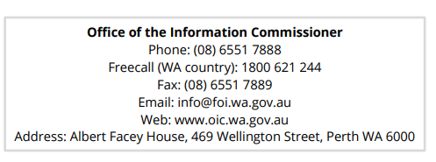

Amendment of Personal Information

The Act gives a person the right to apply for amendment of personal information, which is inaccurate, incomplete, and out of date or misleading. The agency may make the amendment by altering, striking out, inserting information or inserting a note in relation to the information.

Applications to amend personal information must be in writing to:
- Freedom of Information Request; or
- Written correspondence addressed to:
Information Management Officer
City of Nedlands
PO BOX 9
NEDLANDS WA 6909
There are no fees or charges associated with an application for the amendment of personal information under the FOI Act.
Note: The FOI Act does not allow the City to obliterate or remove information or destroy a document without written certification from the Information Commissioner.

Privacy Rights and Legislation

The City of Nedlands views privacy compliance as an integral part of its commitment to accountability and integrity in all its activities and programs. The City is committed to compliance with the laws that deal with personal and health information about individuals that is stored or received by it. Consequently, we will:
- Only use personal information provided by an individual for the purposes for which it was collected and for any other authorised use;
- Only disclose personal information to any third party (including other authorities) where authorised or as required/allowed under the Australian Privacy Principals and Privacy Act 1988; and
- Take all necessary measures to prevent unauthorised access or disclosure. ensure personal information is collected, accessed, used, stored and disposed of in accordance with the Privacy Act 1988 and Privacy Amendment Act 2004 and to provide guidelines for the City when dealing with information.

Freedom of Information Legislation
Should you wish to obtain a copy of the Freedom of Information Act 1992 or associated regulations, please visit the State Law Publisher Website at www.slp.wa.gov.au where a full copy of all State Legislation is available.

Further information about Freedom of Information (FOI) can also be found on the Office of the Information Commissioner (Freedom of Information for Western Australia) website at www.oic.wa.gov.au.

Bill Parker
CHIEF EXECUTIVE OFFICER

