Minutes

Audit & Risk Committee Meeting
20 February 2023

ATTENTION

This is a Committee which has only made recommendations to Council. No action should be taken on any recommendation contained in these Minutes. The Council resolution pertaining to an item will be made at the next Ordinary Meeting of Council following this meeting.

Information

Audit & Risk Committee Meetings are run in accordance with the City of Nedlands Standing Orders Local Law. If you have any questions in relation to items on the agenda, procedural matters, public question time, addressing the Committee or attending meetings please contact the Executive Officer on 9273 3500 or council@nedlands.wa.gov.au

Public Question Time

Public question time at an Audit & Risk Committee Meeting is available for members of the public to ask a question about items on the agenda. Questions asked by members of the public are not to be accompanied by any statement reflecting adversely upon any Council Member, Committee Member or Employee.

Questions should be submitted as early as possible via the online form available on the City’s website: Public question time | City of Nedlands

Questions may be taken on notice to allow adequate time to prepare a response and all answers will be published in the minutes of the meeting.

Addresses by Members of the Public

Members of the public wishing to address the Audit & Risk Committee in relation to an item on the agenda must complete the online registration form available on the City’s website: Public Address Registration Form | City of Nedlands

The Presiding Member will determine the order of speakers to address the Council and the number of speakers is to be limited to 2 in support and 2 against any particular item on a Special Council Meeting Agenda. The Public address session will be restricted to 15 minutes unless the Council, by resolution decides otherwise.

Disclaimer

Members of the public who attend Committee meetings should not act immediately on anything they hear at the meetings, without first seeking clarification of Council’s position. For example, by reference to the confirmed Minutes of Council meeting. Members of the public are also advised to wait for written advice from the Council prior to taking action on any matter that they may have before Council.

Any plans or documents in agendas and minutes may be subject to copyright. The express permission of the copyright owner must be obtained before copying any copyright material.

Table of Contents

1. Declaration of Opening 4
2. Present and Apologies and Leave of Absence (Previously Approved) 4
3. Public Question Time 4
4. Addresses by Members of the Public 4
5. Disclosures of Financial Interest 5
6. Disclosures of Interests Affecting Impartiality 5
7. Declarations by Members That They Have Not Given Due Consideration to Papers 5
8. Confirmation of Minutes 5
9. Items for Discussion 6
9.1 ARC01.02.23 Update from Moore Australia 6
9.2 ARC02.02.23 Internal Audit - Financial Management Review 8
9.3 ARC03.02.23 Internal Audit - Regulation 17 Review 11
9.4 ARC04.02.23 Internal Audit - Asset Management Review 14
9.5 ARC05.02.23 OneCouncil Project Status Report 17
10. In Camera 24
11. Date of Next Meeting 24
12. Declaration of Closure 24

Declaration of Opening

The Presiding Member declared the meeting open at 5:30pm and drew attention to the disclaimer below and advised the meeting was being livestreamed.

Present and Apologies and Leave of Absence (Previously Approved)

Councillors Councillor L J McManus (Presiding Member) Coastal Districts Ward
Councillor R Senathirajah Melvista Ward
Councillor A W Mangano Dalkeith Ward
Councillor O Combes Hollywood Ward

Staff Mr W R Parker Chief Executive Officer
Mr M R Cole Director Corporate Services
Mr M K MacPherson Director Technical Services
Mrs N M Ceric Executive Officer
Ms L J Kania Coordinator Governance & Risk
Mr S Billingham Manager Financial Services

Invited Ms M Shafizadeh Director Governance & Risk Moore Australia
Guests Mr N Goosen Associate Director Moore Australia

Public There were no members of the public present and two online.

Press Nil.

Leave of Absence Nil.
(Previously Approved)

Apologies Mayor F E M Argyle

Public Question Time

Public questions submitted were read at this point.

Nil.

Addresses by Members of the Public

Addresses by members of the public who had completed Public Address Registration Forms were made at this point.

Nil.

Disclosures of Financial Interest

The Presiding Member reminded Council Members and Staff of the requirements of Section 5.65 of the Local Government Act to disclose any interest during the meeting when the matter is discussed.

There were no disclosures of financial interest.

Disclosures of Interests Affecting Impartiality

The Presiding Member reminded Council Members and Staff of the requirements of Council’s Code of Conduct in accordance with Section 5.103 of the Local Government Act.

There were no disclosures affecting impartiality.

Declarations by Members That They Have Not Given Due Consideration to Papers

Nil.

Confirmation of Minutes

  - Audit & Risk Committee Meeting Minutes – 21 November 2022

Moved – Councillor Senathirajah
Seconded – Councillor Combes

The Minutes of the Audit & Risk Committee Meeting 21 November 2022 be accepted as a true and correct record of that meeting.
CARRIED UNANIMOUSLY 4/-

Items for Discussion

9.1 ARC01.02.23 Update from Moore Australia

Meeting & Date | Audit & Risk Committee – 20 February 2023
Applicant | City of Nedlands
Employee Disclosure under section 5.70 Local Government Act 1995 | Nil.
Report Author | Moore Australia
Director | Michael Cole – Director Corporate Services
Attachments | 1. Moore Australia – Agenda Paper – 20 February 2023

Moved – Councillor Senathirajah
Seconded – Councillor Combes

That the Recommendation be adopted.
(Printed below for ease of reference)
CARRIED UNANIMOUSLY 4/-

Committee Recommendation / Recommendation

That the Audit and Risk Committee received the agenda paper from Moore Australia.

Purpose

This report is for Moore Australia to present its agenda paper to the Audit and Risk Committee.

Voting Requirement

Simple Majority

Background

Moore Australia has submitted an agenda paper for the discussion at the Committee meeting.

Consultation

Nil.

Strategic Implications

This item relates to the following elements from the City’s Strategic Community Plan.

Vision Our city will be an environmentally sensitive, beautiful and inclusive place.

Values High standard of services
We have local services delivered to a high standard that take the needs of our diverse community into account.

Great Governance and Civic Leadership
We value our Council’s quality decision-making, effective and innovative leadership, transparency, accountability, equity, integrity and wise stewardship of the community’s assets and resources. We have an involved community and collaborate with others, valuing respectful debate and deliberation.

Budget/Financial Implications

There are no financial implications to this report.

There may be budget implications when the report’s recommendations are addressed in detail, where operational impacts are estimated and considered by the Administration, and then by Council at the appropriate time. There is no immediate budgetary implication to receiving this report.

Decision Implications

Should the recommendations be endorsed, administration will implement actions as outlined in report.

Conclusion

That Audit and Risk Committee receives the agenda paper from Moore Australia.

Further Information

Nil.

9.2 ARC02.02.23 Internal Audit - Financial Management Review

Meeting & Date | Audit & Risk Committee – 20 February 2023
Applicant | City of Nedlands
Employee Disclosure under section 5.70 Local Government Act 1995 | Nil.
Report Author | Stuart Billingham – Manager Financial Services
Director | Michael Cole Director Corporate Services
Attachments | - Financial Management Review 2023 - See appendix 2 of Item ARC01.02.23 Moore Aust Report

Moved – Councillor Senathirajah
Seconded – Councillor Combes

That the Recommendation be adopted.
(Printed below for ease of reference)
CARRIED 3/1
(Against: Cr. Mangano)

Committee Recommendation / Recommendation

That the Audit & Risk Committee recommends that Council:

- notes the auditors report on the review of the City’s financial management and procedures; and

- notes the management responses to those comments and recommendations.

Purpose

To present to the Audit & Risk Committee the Auditor’s report on the appropriateness and effectiveness of the financial management systems and procedures at the City of Nedlands.

Voting Requirement

Simple Majority.

Background

- The Local Government (Financial Management) Regulations 1996 regulation 5(2)(c), requires the Chief Executive Officer to undertake Financial Management Reviews regularly (and not less than once in every three years). The main purpose of a Financial Management Review (FMR) is to examine the appropriateness and effectiveness of the financial management systems and procedures of the City.

- Through a formal request for quote process, Moore Australia (WA) Pty Ltd was appointed to undertake the financial management audit. The audit covered the period ending December 2022.

- The Auditors report did not find any major issues with processes however matters for improvement were identified as shown in the table below:

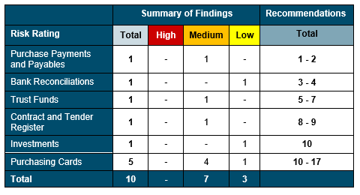

Consultation

Moore Australia (WA) Pty Ltd, Director Corporate Services, Manager Financial Services, Senior Project Accountant, Coordinator Revenue, Finance Officer Revenue, Finance Officer Accounts Payable and Coordinator Procurement and Contracts.

Strategic Implications

This item relates to the following elements from the City’s Strategic Community Plan.

Vision Our city will be an environmentally sensitive, beautiful and inclusive place.

Values High standard of services
We have local services delivered to a high standard that take the needs of our diverse community into account.

Great Governance and Civic Leadership
We value our Council’s quality decision-making, effective and innovative leadership, transparency, accountability, equity, integrity and wise stewardship of the community’s assets and resources. We have an involved community and collaborate with others, valuing respectful debate and deliberation.

Budget/Financial Implications

There are no budget or financial implications to this report.

Legislative and Policy Implications
The following legislation is adhered to:
Regulation 5(2)(c) of the Local Government (Financial Management) Regulations 1996

Decision Implications

Nil.

Conclusion

That the Audit & Risk Committee recommends that Council:

- notes the auditors report on the review of the City’s financial management and procedures.

- notes the management responses to those comments and recommendations.

Further Information

Nil.

9.3 ARC03.02.23 Internal Audit - Regulation 17 Review

Meeting & Date | Audit & Risk Committee – 20 February 2023
Applicant | City of Nedlands
Employee Disclosure under section 5.70 Local Government Act 1995 | Nil.
Report Author | Stuart Billingham – Manager Financial Services
Director | Michael Cole Director Corporate Services
Attachments | 1. Regulation 17 Report 2022 - See appendix 3 of Item ARC01.02.23 Moore Aust Report

Moved – Councillor Senathirajah
Seconded – Councillor Combes

That the Recommendation be adopted.
(Printed below for ease of reference)
CARRIED 3/1
(Against: Cr. Mangano)

Committee Recommendation / Recommendation

That the Audit & Risk Committee recommends that Council:

1. notes the auditors report on the review of the City’s systems and procedures in relation to risk management, internal controls and legislative compliance; and

2. notes the management responses to those comments and recommendations.

Purpose

To present to the Audit & Risk Committee the Auditor’s report on the appropriateness and effectiveness of the City’s systems and procedures in relation risk management, internal controls and legislative compliance.

Voting Requirement

Simple Majority.

Background

The Local Government (Audit) Regulations 1996 regulation 17, requires the Chief Executive Officer is to review the appropriateness and effectiveness of a local government’s systems and procedures in relation to:

  - Risk management; and
  - Internal control; and
  - Legislative compliance

not less than once every 3 financial years and report any findings to the audit committee.

Through a formal request for quote process, Moore Australia (WA) Pty Ltd was appointed to undertake the Regulation 17 review report. The audit covered the period ending December 2022.

The auditors Regulation 17 report made 12 recommendations as summarised in the table below:

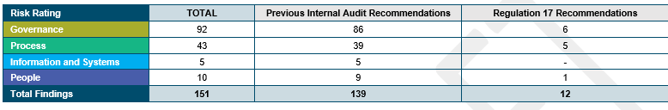

Consultation

Moore Australia (WA) Pty Ltd, Director Corporate Services, Manager Financial Services, Manager ICT, Executive Officer and Senior Project Accountant.

Strategic Implications

This item relates to the following elements from the City’s Strategic Community Plan.

Vision Our city will be an environmentally sensitive, beautiful and inclusive place.

Values High standard of services
We have local services delivered to a high standard that take the needs of our diverse community into account.

Great Governance and Civic Leadership
We value our Council’s quality decision-making, effective and innovative leadership, transparency, accountability, equity, integrity and wise stewardship of the community’s assets and resources. We have an involved community and collaborate with others, valuing respectful debate and deliberation.
Budget/Financial Implications

There are no budget or financial implications to this report.

Legislative and Policy Implications
The following legislation is adhered to:
Regulation 17 of the Local Government (Audit) Regulations 1996

Decision Implications

Nil.

Conclusion

That the Audit & Risk Committee recommends that Council:

- notes the auditors report on the review of the City’s systems and procedures in relation to risk management, internal controls and legislative compliance; and

- notes the Management responses to those comments and recommendations.

Further Information

Nil.

9.4 ARC04.02.23 Internal Audit - Asset Management Review

Meeting & Date | Audit & Risk Committee – 20 February 2023
Applicant | City of Nedlands
Employee Disclosure under section 5.70 Local Government Act 1995 | Nil.
Report Author | Stuart Billingham – Manager Financial Services
Director | Michael Cole – Director Corporate Services
Attachments | - Internal Audit Asset Management - See appendix 4 of Item ARC01.02.23 Moore Australia Report

Moved – Councillor Senathirajah
Seconded – Councillor Combes

That the Recommendation be adopted.
(Printed below for ease of reference)
CARRIED 3/1
(Against: Cr. Mangano)

Committee Recommendation / Recommendation

That the Audit & Risk Committee recommends that Council:

1. notes the internal auditors report on the review of the City’s Asset Management; and

2. notes the management responses to those comments and recommendations.

Purpose

To present to the Audit & Risk Committee the Internal Auditor’s report on City of Nedlands Asset Management.

Voting Requirement

Simple Majority.

Background

In November 2022 Moore Australia (WA) Pty Ltd were engaged to undertake the internal audit of Asset Management at the City of Nedlands with nine matters raised as shown in the table following:

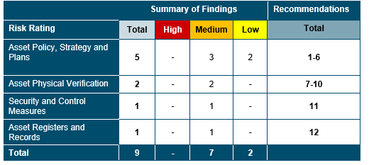

Consultation

Moore Australia (WA) Pty Ltd, Director Corporate Services, Manager Financial Services, Finance Officer (AR, Assets & Insurance), Manager ICT, Information Technology (IT) Governance Officer, Manager City Projects and Programs, Manager Assets, Coordinator Land and Property, Coordinator Fleet, Building Maintenance Officer, Coordinator Civil Maintenance.

Strategic Implications

This item relates to the following elements from the City’s Strategic Community Plan.

Vision Our city will be an environmentally sensitive, beautiful and inclusive place.

Values High standard of services
We have local services delivered to a high standard that take the needs of our diverse community into account.

Great Governance and Civic Leadership
We value our Council’s quality decision-making, effective and innovative leadership, transparency, accountability, equity, integrity and wise stewardship of the community’s assets and resources. We have an involved community and collaborate with others, valuing respectful debate and deliberation.

Budget/Financial Implications

There are no budget or financial implications to this report.

Legislative and Policy Implications

Nil.

Decision Implications

Nil.

Conclusion

That the Audit & Risk Committee recommends that Council:

- notes the internal auditors report on the review of the City’s Asset Management and;

- notes the management responses to those comments and recommendations.

Further Information

Nil.

9.5 ARC05.02.23 OneCouncil Project Status Report

Meeting & Date | Audit & Risk Committee – 20 February 2023
Applicant | City of Nedlands
Employee Disclosure under section 5.70 Local Government Act 1995 | Nil.
Report Author | Emma Van der Weile – Project Manager (ERP)
Director | Michael Cole – Director Corporate Services
Attachments | Nil.

Moved – Councillor Combes
Seconded – Councillor Senathirajah

That the Recommendation be adopted.
(Printed below for ease of reference)
CARRIED 3/1
(Against: Cr. Mangano)

Committee Recommendation / Recommendation

Audit & Risk Committee receives the OneCouncil Project Status Report.

Purpose

The purpose of this report is to clearly demonstrate the Project status and current health of the OneCouncil Enterprise Resource Planning system implementation.

Voting Requirement

Simple Majority.

Background

At the Ordinary Council Meeting held on the 22^{nd of} June 2021 Council resolved the following:

- approves the supplier, TechnologyOne, to be awarded the contract for RFT 2020-21.03 – Provision City Finance System (Enterprise Resource Planning System) for the initial term of 5 years, comprising the initial 3 years with two one-year extensions, to be awarded under Local Government (Functions & General) Regulations 1996 11(2).

- agrees to enter a contract with TechnologyOne to purchase their Enterprise Resource Planning System, called OneCouncil, with final contract subject to independent review to the satisfaction of the Chief Executive Officer; and notes:

- The adoption of the Integrated Enterprise Resource Planning approach for implementing Information Systems; and

b. The implementation of the TechnologyOne One Council solution using the Cloud model called “Software as a Service”.

The OneCouncil implementation project has been managed as an internal project, resourced to accommodate a staged roll out of fundamental modules across the organisation. The project has been divided into three key phases which align evenly to a three-year commitment of delivery.

The City successfully implemented the modules forecast in the first phase, on time and with organisational wide support and engagement.

Discussion

The City are currently engaged in phase two of the project implementation, scheduled for completion by July 2023. The current phase is on track and continues to meet each milestone within the recently revised project plan.

Recent developments in the approach to manage the macro project with each module adopted as a micro project has proven beneficial in ensuring transparency in the granularity of deliverable tasks whilst also elevating overall maturity with internal and external stakeholder collaboration and productivity. For a comprehensive overview of the phase 2 tracking, refer to figure 1. Phase 2 - Project progress tracker for the January 2023 reporting period.
Area | Previous Status | Current Status | Comments
Scope |  |  | Scope is being effectively managed through a rigour process of expectation and agreement.
Budget |  |  | The budget forecast for the year remains within the allocated budget
Schedule |  |  | The schedule has been adjusted to accommodate the project resources limitations with minimal impact on the overall phase 2 trajectory

Green |  | Project is on track to deliver the expected outcomes at the budgeted cost in the currently agreed timeframe
Amber |  | Currently agreed outcomes, time, cost and/or quality requirements are at risk of being exceeded if specific action is not taken
Red |  | Currently agreed outcomes, time, cost and/or quality requirements have been or will be exceeded and specific action is required to address
Activities recently completed (January 2023 reporting period):

- Onboarding of new Project Manager and Change Manager.
- New project schedule created: Differing approach; defining each module as a mini project within a broader project with the same methodology.
- Engaging in an agreement/internal acceptance with the internal stakeholders.
- Introducing OneCouncil system champions and communicating what that translates to for the City of Nedlands.
- Introducing a continuous improvement register and associated procedure to manage ongoing initiatives, incorporating governance to support the procedure effectively.
- Establishing a communicative visual for the broader organisation to understand the macro lens, including what it looks and feels like.
- Focus on an engaged project team and empowering them with skills to negotiate and communicate with clarity to their impacted business areas.
- Establishing robust governance of the project with focus on transparency and clarity.
- Revisiting internal relationships and negotiating clarity on expectations and deliverables of modules.
- Communicating our approach to share the same outcome with the business area impacted by the module implementation.
- Configuring assets and works module development.
- Configuring e-Recruitment with a focus on refining process and translating policy into system automation.
- Establishing new internal relationships and setting expectations and commitments.
- Gathering information for DXP Meetings and PPLGS modules – Forecast for pending implementation.
- Commencement of modules – briefing portfolio.
- Establishing a communication and change plan informed by the organisational survey responses and Managers meetings.

Upcoming period’s activities:
- Phase 3 – Draft schedule development.
- Project team strategy days - program preparation for Phase 3.
- External stakeholder engagement/planning with other Local Governments.
- Champion engagement workshop and program of works.
- Internal communications program on project status and system uses best practice/instructions.
- Assets configuration completion.
- Performance Planning Local Government (PPLGS) development and configuration.
- DXP meetings module development and configuration.
- Information gathering – Process improvement review, analysis, and workshops.

Issues:
Open
- Infrastructure Department – Migration of Data

Complexities:
- Existing asset data is stored in an end-of-life system.
- Data is required to be aligned with a regulated standard prior to migration.
- External organization is completing body of work to form a gap analysis of current data.
- Dates of external work do not lend to the scheduled go live which may be an empty system until complete and transferred.

Proposed Solution
Communicate with clarity, the impact of the external works on the project and agree on the revised deliverables and expectations detailing, who, what and when.

Closed
- Payroll – Project resources (Business Systems Analyst) allocated as 100% FTE to payroll for extended period.
- Solution: Payroll officer has returned from leave and Manager Finance and Director Corporate services actively recruiting an additional resource to manage leave balances.
- Human Resources – Lack of clarity in understanding the deliverables.
- Solution: Establish trust in stakeholder meeting, seeking to understand and translate that to transactional context.
- Human Resources – Outstanding commitments not tracked or communicated.
- Solution: Establish trust, seeking to understand. Develop a tracker of items to be discussed and document progress and clarity on what can be achieved and within clear timeframes.
- Human Resources – Process waste and communicating change in process for Managers to recruit.
- Solution: Conduct a workshop on current process with the intent to refine and eliminate waste. Assist in the development of a managers recruitment change and coaching workshop.
- Infrastructure department – Lack of engagement due to understanding in translating value and benefit at an operational level.
- Solution: Discussed with Director Infrastructure strategy to take action in relaying benefits. Project and Change Manager to present a benefits demonstration with input from external Local Governments Assets department.
- Infrastructure department – Information gathering timeliness and completeness, causing delays in technical configuration.
- Solution: Discussed with Director Infrastructure to understand the competing priorities of both teams and encourage information gathering.
- Infrastructure department – Commitment to the module deliverables.
- Solution: Discussed with Director Infrastructure to offer a share in a forward approach to work collaboratively and achieve the shared outcome.

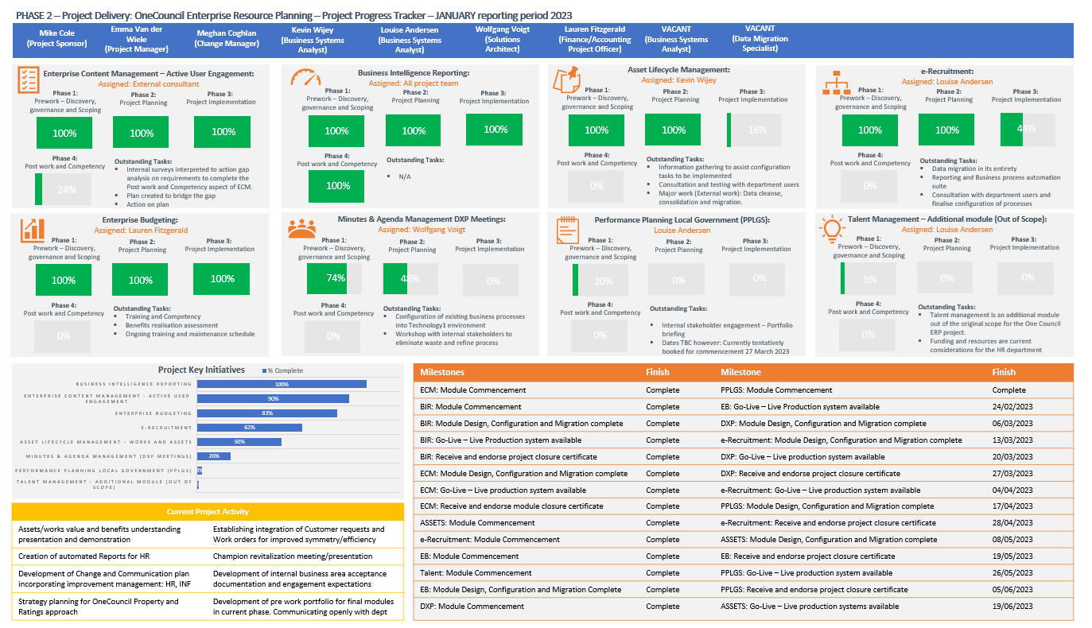
Consultation

This report summarises detailed consultative information which observes the accuracy of the project status and health. Consultative efforts are managed in accordance with the below Stakeholder Consultation Plans.

Stakeholder Consultation Plans | Purpose
Change Management Plan | To outline the strategy and approach to managing the organisational change associated with implementing the OneCouncil project for employees, customers, and stakeholders.
Communication Plan | To provide an overall framework for the ongoing management, coordination, and delivery of communications to all staff across the City of Nedlands impacted by the OneCouncil project activities.
Stakeholder Engagement Plan | To outline the City’s approach to managing stakeholder engagement throughout the implementation of the OneCouncil solution to ensure clear direction for the delivery of stakeholder engagement actions.

Strategic Implications

This item relates to the following elements from the City’s Strategic Community Plan.

Vision Our city will be an environmentally sensitive, beautiful, and inclusive place.

Values High standard of services
We have local services delivered to a high standard that take the needs of our diverse community into account.

Great Governance and Civic Leadership
We value our Council’s quality decision-making, effective and innovative leadership, transparency, accountability, equity, integrity and wise stewardship of the community’s assets and resources. We have an involved community and collaborate with others, valuing respectful debate and deliberation.

Priority Area

- The implementation of OneCouncil is a key result area for the Chief Executive Officer.

Budget/Financial Implications

A provision for the continuing implementation of OneCouncil is included in the approved City of Nedlands 2022/23 Annual Budget.

Legislative and Policy Implications

Nil.

Decision Implications

The City has sufficient information to present the OneCouncil Project status report.

Conclusion

The implementation of the OneCouncil project underpins the strategic and operational requirements for the City of Nedlands through a single, integrated solution. The change benefits of the software allow the City to embrace technological strategies to deliver smart community goals.

Recent changes to the project plan and approach to manage the modules and deliverables has been pivotal in shaping the transparency, engagement, and productivity of the entire perspective for both the project team and broader organisation.

Project milestones for phase 2 are consistently being met and are on track for the scheduled July 2023 completion. Efforts to ensure the project continues to mature in line with the milestone dates include operating with a collaborative lens, addressing issues raised for escalation and continuous improvement initiatives are managed efficiently and effectively in partnership.

The project team are currently working in synergy to prepare for phase 3 of the broader project and have committed to an internal strategy engagement to aid in exploring the projects forecasted modules to build a comprehensive plan. The engagement will produce a detailed review for each module including stakeholder analysis, deliverables and timeframes, complexities, demonstrations, change impact to the organisation, dependencies review, associated risks and benefits realisation.

Further Information

Nil.

In Camera

Allocated time for Committee to discuss items with Auditors without Administration or Public present.

The meeting closed to members of the public and administration at 7.05pm with the following in attendance:

Councillors Councillor L J McManus (Presiding Member) Coastal Districts Ward
Councillor R Senathirajah Melvista Ward
Councillor A W Mangano Dalkeith Ward
Councillor O Combes Hollywood Ward

Invited Ms M Shafizadeh Director Governance & Risk Moore Australia
Guests Mr N Goosen Associate Director Moore Australia

The meeting opened to members of the public and administration at 7.16pm with the following in attendance:

Councillors Councillor L J McManus (Presiding Member) Coastal Districts Ward
Councillor R Senathirajah Melvista Ward
Councillor A W Mangano Dalkeith Ward
Councillor O Combes Hollywood Ward

Staff Mr W R Parker Chief Executive Officer
Mr M R Cole Director Corporate Services
Mrs N M Ceric Executive Officer
Ms L J Kania Coordinator Governance & Risk

Invited Ms M Shafizadeh Director Governance & Risk Moore Australia
Guests Mr N Goosen Associate Director Moore Australia

Date of Next Meeting

The date of the next meeting of the Audit & Risk Committee Meeting will be on Monday 22 May at 5.30pm and a special Audit & Risk Meeting before the March OCM to be advised.

Declaration of Closure

There being no further business, the Presiding Member declared the meeting closed at 7.16pm.

