Minutes

Audit & Risk Committee Meeting

14 March 2022

ATTENTION

This is a Committee which has only made recommendations to Council. No action should be taken on any recommendation contained in these Minutes. The Council resolution pertaining to an item will be made at the next Ordinary Meeting of Council following this meeting.

Information

Audit & Risk Committee Meetings are run in accordance with the City of Nedlands Standing Orders Local Law. If you have any questions in relation to items on the agenda, procedural matters, public question time, addressing the Committee or attending meetings please contact the Executive Officer on 9273 3500 or council@nedlands.wa.gov.au

Public Question Time

Public question time at an Audit & Risk Committee Meeting is available for members of the public to ask a question about items on the agenda. Questions asked by members of the public are not to be accompanied by any statement reflecting adversely upon any Council Member, Committee Member or Employee.

Questions should be submitted as early as possible via the online form available on the City’s website: Public question time | City of Nedlands

Questions may be taken on notice to allow adequate time to prepare a response and all answers will be published in the minutes of the meeting.

Addresses by Members of the Public

Members of the public wishing to address the Audit & Risk Committee in relation to an item on the agenda must complete the online registration form available on the City’s website: Public Address Registration Form | City of Nedlands

The Presiding Member will determine the order of speakers to address the Council and the number of speakers is to be limited to 2 in support and 2 against any particular item on a Special Council Meeting Agenda. The Public address session will be restricted to 15 minutes unless the Council, by resolution decides otherwise.

Disclaimer

Members of the public who attend Committee meetings should not act immediately on anything they hear at the meetings, without first seeking clarification of Council’s position. For example, by reference to the confirmed Minutes of Council meeting. Members of the public are also advised to wait for written advice from the Council prior to taking action on any matter that they may have before Council.

Any plans or documents in agendas and minutes may be subject to copyright. The express permission of the copyright owner must be obtained before copying any copyright material.

Table of Contents

1. Declaration of Opening 4
2. Present and Apologies and Leave of Absence (Previously Approved) 4
3. Public Question Time 4
4. Addresses by Members of the Public 4
5. Disclosures of Financial Interest 5
6. Disclosures of Interests Affecting Impartiality 5
7. Declarations by Members That They Have Not Given Due Consideration to Papers 5
8. Confirmation of Minutes 5
9.1 Audit & Risk Committee Meeting Minutes – 23 November 2021 5
10 Items for Discussion 6
10.1 ARC01.03.22 Annual Compliance Return 2021 6
10.2 ARC02.03.22 Update on Audit Recommendation of Contract Management 9
10.3 ARC03.03.22 Procurement and Planning for the ERP Implementation 15
10.4 ARC04.03.22 Update from Moore Australia 18
10.5 ARC05.03.22 Status of the City of Nedlands Internal Audit Log 20
10.6 ARC06.03.22 Update on Records Management 23
10.7 ARC07.03.22 OneCouncil Project Status Report #3 28
11 Date of Next Meeting 37
12 Declaration of Closure 37

Declaration of Opening

The Presiding Member declare the meeting open at 5.30pm and drew attention to the disclaimer below.

Present and Apologies and Leave of Absence (Previously Approved)

Councillors Councillor L J McManus (Presiding Member) Coastal Districts Ward
Mayor F E M Argyle Councillor O Combes Hollywood Ward
Councillor A W Mangano Dalkeith Ward
Councillor R Senathirajah Melvista Ward

Observers Councillor F Bennett

Staff Mr W R Parker Chief Executive Officer
Mr M R Cole Director Corporate Services
Mrs N M Ceric Executive Officer
Ms R Jahmeerbacus Manager Financial Services
Mr T Benson Manager ICT

Invited Guests Ms M Shafizadeh (online) Director Governance & Risk Advisory
Moore Australia
Mr I Toure Manager Government & Risk Advisory
Moore Australia

Public There were 0 members of the public present and 0 online.

Leave of Absence Nil.
(Previously Approved)

Apologies Nil.

Public Question Time

Public questions submitted to be read at this point.

Nil.

Addresses by Members of the Public

Addresses by members of the public who have completed Public Address Registration Forms to be made at this point.

Nil.

Disclosures of Financial / Proximity Interest

The Presiding Member reminded Council Members and Staff of the requirements of Section 5.65 of the Local Government Act to disclose any interest during the meeting when the matter is discussed.

                - There were no disclosures of financial interest.

Disclosures of Interests Affecting Impartiality

The Presiding Member reminded Council Members and Staff of the requirements of Council’s Code of Conduct in accordance with Section 5.103 of the Local Government Act.

                - There were no disclosures affecting impartiality.

Declarations by Members That They Have Not Given Due Consideration to Papers

Members who have not read the business papers to make declarations at this point.

Councillor McManus advised he did not read the papers in depth but has a good understanding of the papers.

Confirmation of Minutes

Audit & Risk Committee Meeting Minutes – 23 November 2021

Moved – Mayor Argyle
Seconded – Councillor Senathirajah

The Minutes of the Audit & Risk Committee Meeting 23 November 2021 be accepted as a true and correct record of that meeting.
CARRIED UNANIMOUSLY 5/-

Items for Discussion

ARC01.03.22 Annual Compliance Return 2021

Meeting & Date | Audit & Risk Committee Meeting – 14 March 2022  Council Meeting – 22 March 2022
Applicant | City of Nedlands
Employee Disclosure under section 5.70 Local Government Act 1995 | Nil.
Report Author | Nicole Ceric - Executive Officer
Director/CEO | Bill Parker - Chief Executive Officer
Attachments | - Compliance Audit Return 2021

Moved – Mayor Argyle
Seconded – Councillor Senathirajah

That the Recommendation be adopted.
(Printed below for ease of reference)
CARRIED 4/1
(Against: Cr. Mangano)

Committee Recommendation / Recommendation

That Council adopts the 2021 Compliance Audit Return as per recommendation by the Audit & Risk Committee.

Purpose

The purpose of this report is for Council to review and adopt the City of Nedlands 2021 Annual Compliance Return required for submission to the to the Department of Local Government, Sport and Cultural Industries by 31 March 2022. The Audit & Risk Committee has reviewed the Audit Return and submits it for Council adoption.

Voting Requirement

Simple / Absolute Majority

Background

Local governments are required to complete an annual Compliance Audit Return each year. It is required to be review by the Audit and Risk Committee and then considered and adopted by Council, and submitted to the Department of Local Government, Sports and Cultural Industries by 31 March 2022.

Discussion

The attached return for the City of Nedlands is for the period 1 January 2021 to 31 December 2021. The City’s 2021 Compliance Audit Return was completed in February by Management following a review and assessment of:

- Council meeting agendas and minutes;
- Performance plans, media advertisements, procedures and policies, registers, delegation records, local laws; and
- Interviews with responsible officers.

Consultation

The Audit and Risk Committee has reviewed the return at its meeting on Monday 14 March 2022 and is now submitting the results of that review to Council.

Strategic Implications

This item relates to the following elements from the City’s Strategic Community Plan.

Vision Our city will be an environmentally-sensitive, beautiful and inclusive place.

Values Great Governance and Civic Leadership
We value our Council’s quality decision-making, effective and innovative leadership, transparency, accountability, equity, integrity and wise stewardship of the community’s assets and resources. We have an involved community and collaborate with others, valuing respectful debate and deliberation.

Budget/Financial Implications

The 2021 Compliance Audit Return has been conducted using internal resources and there are no other financial impacts.

Legislative and Policy Implications

In accordance with Regulation 14 and 15 of the Local Government (Audit) Regulations 1996 the 2021 Annual Compliance Audit Return must be:

- Presented to the Audit and Risk Committee for review and then presented to Council;
- Adopted by Council;
- Recorded in the minutes of the meeting at which it was adopted; and
- A certified copy of the return, along with a copy of the minutes recording its adoption, to be submitted to the Department by 31 March 2022.

Decision Implications

Should Council choose to adopt the 2021 Compliance Audit Return for submission to the Department of Local Government Sport and Cultural Industries the City would fulfil its prescribed statutory requirements in regulation 13 of the Local Government (Audit) Regulations 1996.

Should Council choose not to adopt the 2021 Compliance Audit Return for submission to the Department of Local Government Sport and Cultural Industries Council would be in breach the prescribed statutory requirements in regulation 13 of the Local Government (Audit) Regulations 1996.

Conclusion

Therefore, it is recommended by the Audit & Risk Committee that the 2021 Annual Compliance Return be adopted and submitted to the Department of Local Government as required by the 31 March 2022.

Further Information

Nil.

ARC02.03.22 Update on Audit Recommendation of Contract Management

Meeting & Date | Audit & Risk Committee – 14 March 2022
Applicant | City of Nedlands
Employee Disclosure under section 5.70 Local Government Act 1995 | Nil.
Report Author | Nathaly Alvarez - Coordinator Procurement and Contracts
Director/CEO | Reshma Jahmeerbacus – Acting Director Corporate & Strategy
Attachments | Nil.

Moved – Councillor Combes
Seconded – Councillor Senathirajah

That the Recommendation be adopted.
(Printed below for ease of reference)
CARRIED UNANIMOUSLY 5/-

Committee Recommendation / Recommendation

That Council notes the progress made to date to address the findings from the Moore Australia Contract Management Audit Report.

Purpose

This report provides an update on the recommendations from the audit of the City’s Contract Management processes conducted by Moore Australia.

Voting Requirement

Simple majority

Background

Moore Australia are the City’s appointed Internal Auditors and in accordance with the internal audit plan have facilitated a review of the City’s contract management processes.

The attached report which contained details of the issues raised and management’s comments were presented to the Audit and Risk Committee on 31 May 2021.

A proposed action list to address the issues raised was presented to Council on 22 June 2021.
Discussion

Since the last Audit and Risk Committee in October 2021, the City has continued to progress the implementation of the recommendations from the Internal Audit Report. Extensive consultation has continued with internal stakeholders, WALGA and Moore Australia.

The implementation of the City’s Enterprise Resource Planning system, OneCouncil, has presented an opportunity for the recommendations to be reviewed and integrated within the OneCouncil’s contract management capabilities. The Procurement Coordinator and Manager Financial Services are working closely with the OneCouncil project team to review the draft contract management policy and procedures and align them with OneCouncil capabilities. The process documentation will also occur as part of this implementation work.

The target dates have been revised accordingly to account for the work that will be undertaken to align contract management practices with OneCouncil.

In summary, findings 1,3, 4 and 6(a) have been completed and addressed. Findings 5, 6(b) and 7 will be addressed as part of the OneCouncil implementation. Finding 2 is being addressed as part of the Organisational Review. Finding 8 will be addressed through the City’s Risk Management framework yet to be undertaken.

A detailed update on the status and progress of each finding is provided below:

Finding | Description | Status | % Complete | Target Date identified in Audit report | New Target Date | Issues | Activity
1 | Contract Management Training |  | 100% | 01 September 2021 | - | Nil. | - Officers attended various training sessions held by WALGA  - Training needs are being identified by supervisors as part of Performance Reviews
2 | Review of Resourcing |  | 0% | 30 June 2021 | 30 June 2022 | Nil. | - This is being addressed as part of the Organisational Review currently underway
3 | Contracts Management Framework |  | 100% | 30 June 2021 | 30 Nov 2021 | Nil. | - EMT endorsed the new Contracts Management Framework on 04 Nov 2021
4 | Contracts Register |  | 100% | 01 July 2021 | 30 Nov 2021 | Nil | - Comprehensive Contracts Register developed and completed incorporating the City’s current contracts
5 | Delegation Matrix |  | 80% | 31 December 2021 | 30 June 2022 | Nil | - The draft Delegation Matrix will also be reviewed as part of the implementation of OneCouncil and incorporated in the process documentation.
6 | Policies and Procedures |  | 100%  70% | 27 July 2021 | 30 June 2022 | Nil. | - Procurement Policy approved by Council on 27 July 2021  - Draft Contract Management Policy and procedures will be reviewed as part of the process mapping for the implementation of OneCouncil
7 | Executive Reporting |  | 0% | 30 June 2022 | 31 July 2022 | Nil | - Reporting on contract management performance, issues and opportunities will be implemented once OneCouncil is live and reporting capabilities exist.
8 | Risk Assessment |  | 0% | 31 October 2021 | 30 June 2022 | Nil | - Draft Risk Register to be developed as part of City’s wider Risk Management Framework

Legend | Description
 | Milestone delayed > 10%.
 | Potential for milestone delay.
 | Milestone on target.

Consultation

Over the period of the audit several staff members across the city were interviewed and consulted by the Moore Australia audit team regarding their involvement with contract management, and the processes structures guiding around them.

Strategic Implications

This item relates to the following elements from the City’s Strategic Community Plan.

Vision Our city will be an environmentally-sensitive, beautiful and inclusive place.

Values
High standard of services
We have local services delivered to a high standard that take the needs of our diverse community into account.

Great Governance and Civic Leadership
We value our Council’s quality decision-making, effective and innovative leadership, transparency, accountability, equity, integrity and wise stewardship of the community’s assets and resources. We have an involved community and collaborate with others, valuing respectful debate and deliberation.

Priority Area

Nil.

Budget/Financial Implications

There are no financial implications to this report.

There may be budget implications when the report’s recommendations are addressed in detail, where operational impacts are estimated and considered by the Administration, and then by Council at the appropriate time.

There is no immediate budgetary implication to receiving this report. Due to the current status, as identified by the Audit Report, the City is exposed to risk with a continuation of a business as usual operation within this function. This will need to be considered by the Administration and Council at a later date

Decision Implications

Not required.
Conclusion

The findings reported by Moore Australia are progressively being addressed as a matter of priority.

Addressing all the findings will occur throughout the 2021/2022 financial year.

Further Information

N/A

ARC03.03.22 Procurement and Planning for the ERP Implementation

Meeting & Date | Audit & Risk Committee – 14 March 2022
Applicant | City of Nedlands
Employee Disclosure under section 5.70 Local Government Act 1995 | Nil.
Report Author | Reshma Jahmeerbacus – Acting Director Corporate & Strategy
Director/CEO | Reshma Jahmeerbacus – Acting Director Corporate & Strategy
Attachments | - Moore Australia Contracts Management Internal Audit Report

Moved – Councillor Mangano
Seconded – Mayor Argyle

That the Recommendation be adopted.
(Printed below for ease of reference)
CARRIED UNANIMOUSLY 5-

Committee Recommendation / Recommendation

The Audit and Risk Committee receives the Procurement and Planning for the ERP implementation Report and notes the findings, recommendations of the Audit and the and management comments provided.

Purpose

This report provides the findings and recommendations from the audit of the City’s Procurement and Planning for the ERP implementation conducted by Moore Australia.

Voting Requirement

Simple majority

Background

Moore Australia are the City’s appointed Internal Auditors and in accordance with the internal audit plan have facilitated a review of the City’s Procurement and Planning for the ERP Implementation.

An Audit is a process through which internal control effectiveness is examined and assessed. The objective is to provide an Audit for compliance with relevant legislation, management policies and procedures. The assessment is conducted with input from city personnel and is facilitated by the Moore Australia audit team.

The attached report contains details of the issues raised and management comments.

Discussion

Council approved the purchase of a new ERP system on 22 June 2021. This system will replace the City’s ageing corporate systems with a single integrated one, with implementation scheduled over 3 phases.

The audit consisted of an entrance meeting on 8 October 2021 for the audit engagement planning, numerous site visits from Moore Australia for evidence sourcing, and exit/feedback meetings for the finalisation of the report. Moore Australia provided a first draft report on 10 November 2021 following which management provided further comments and evidence, which resulted in a number of findings being removed and amended.

The final report attached contains the findings from Moore Australia together with management comments for each finding. Management has endeavored to provide as much background information in the “Management Comment” section to provide context as to some of the responses to the findings and recommendations. The findings and management comments are thus presented to the Committee.

Consultation

Over the period of the audit several staff members across the city were interviewed and consulted by the Moore Australia audit team regarding their involvement with procurement, planning and implementation of the ERP.

Strategic Implications

This item relates to the following elements from the City’s Strategic Community Plan.

Vision Our city will be an environmentally sensitive, beautiful and inclusive place.

Values
High standard of services
We have local services delivered to a high standard that take the needs of our diverse community into account.

Great Governance and Civic Leadership
We value our Council’s quality decision-making, effective and innovative leadership, transparency, accountability, equity, integrity and wise stewardship of the community’s assets and resources. We have an involved community and collaborate with others, valuing respectful debate and deliberation.

Priority Area

Nil.

Budget/Financial Implications

There are no financial implications to this report.

There may be budget implications when the report’s recommendations are addressed in detail, where operational impacts are estimated and considered by the Administration, and then by Council at the appropriate time. There is no immediate budgetary implication to receiving this report.

Decision Implications

Not required.

Conclusion

The findings and management comments of the Procurement and Planning of the implementation of the ERP audit is presented to the Audit and Risk Committee for their information.

ARC04.03.22 Update from Moore Australia

Meeting & Date | Audit & Risk Committee – 14 March 2022
Applicant | City of Nedlands
Employee Disclosure under section 5.70 Local Government Act 1995 | Nil.
Report Author | Moore Australia
Director/CEO | Reshma Jahmeerbacus – Acting Director Corporate & Strategy
Attachments | - Moore Australia Agenda Paper Audit and Risk Committee March 2022

Moved – Councillor Senathirajah
Seconded – Councillor Combes

That the Recommendation be adopted.
(Printed below for ease of reference)
CARRIED UNANIMOUSLY 5/-

Committee Recommendation / Recommendation

That the Audit and Risk Committee received the agenda paper from Moore Australia.

Purpose

This report is for Moore Australia to present its agenda paper to the Audit and Risk Committee.

Voting Requirement

Simple Majority

Background

Moore Australia has submitted an agenda paper for the discussion at the Committee meeting.

Consultation

Nil.

Strategic Implications

This item relates to the following elements from the City’s Strategic Community Plan.

Vision Our city will be an environmentally sensitive, beautiful and inclusive place.

Values
High standard of services
We have local services delivered to a high standard that take the needs of our diverse community into account.

Great Governance and Civic Leadership
We value our Council’s quality decision-making, effective and innovative leadership, transparency, accountability, equity, integrity and wise stewardship of the community’s assets and resources. We have an involved community and collaborate with others, valuing respectful debate and deliberation.

Priority Area

Nil.

Budget/Financial Implications

There are no financial implications to this report.

There may be budget implications when the report’s recommendations are addressed in detail, where operational impacts are estimated and considered by the Administration, and then by Council at the appropriate time. There is no immediate budgetary implication to receiving this report.

Decision Implications

Not required.

Conclusion

That Audit and Risk Committee receives the agenda paper from Moore Australia.

ARC05.03.22 Status of the City of Nedlands Internal Audit Log

Meeting & Date | Audit & Risk Committee – 14 March 2022
Applicant | City of Nedlands
Employee Disclosure under section 5.70 Local Government Act 1995 | Nil.
Report Author | Reshma Jahmeerbacus – Acting Director Corporate & Strategy
Director/CEO | Reshma Jahmeerbacus – Acting Director Corporate & Strategy
Attachments | - Internal Audit Log – Feb 2022

Moved – Councillor Combes
Seconded – Mayor Argyle

That the Recommendation be adopted.
(Printed below for ease of reference)
CARRIED UNANIMOUSLY 5/-

Committee Recommendation / Recommendation

The Audit and Risk Committee notes the status of the City’s Audit Log as per Attachment 1.

Purpose

This report is to provide an update on all the recommended actions from previous audit reports.

Voting Requirement

Simple Majority

Background

The Audit Log captures and reports on the progress of all recommended actions from previous audit reports.

Item 15 relating to the access to position management in the Payroll function has been completed and verified by Moore Australia. This item is now closed.

Consultation

Nil.

Strategic Implications

This item relates to the following elements from the City’s Strategic Community Plan.

Vision Our city will be an environmentally sensitive, beautiful and inclusive place.

Values
High standard of services
We have local services delivered to a high standard that take the needs of our diverse community into account.

Great Governance and Civic Leadership
We value our Council’s quality decision-making, effective and innovative leadership, transparency, accountability, equity, integrity and wise stewardship of the community’s assets and resources. We have an involved community and collaborate with others, valuing respectful debate and deliberation.

Priority Area

Nil.

Budget/Financial Implications

There are no financial implications to this report.

There may be budget implications when the report’s recommendations are addressed in detail, where operational impacts are estimated and considered by the Administration, and then by Council at the appropriate time. There is no immediate budgetary implication to receiving this report.

Decision Implications

Not required.

Conclusion

That Audit and Risk Committee notes the progress of all recommended actions from previous audit reports.

ARC06.03.22 Update on Records Management

Meeting & Date | Audit & Risk Committee – 14 March 2022
Applicant | City of Nedlands
Employee Disclosure under section 5.70 Local Government Act 1995 | Nil
Report Author | Tony Benson - Manager ICT
Director/CEO | Reshma Jahmeerbacus - Acting Director Corporate and Strategy
Attachments | - Sample Reports

Moved – Councillor Senathirajah
Seconded – Councillor Combes

That the Recommendation be adopted.
(Printed below for ease of reference)
CARRIED UNANIMOUSLY 5/-

Committee Recommendation / Recommendation

That the Audit & Risk Committee receives the update on the Records Management Audit progress.

Purpose

This report is to present an update of the key records management initiatives being undertaken, along with their progress, to address the findings from Moore Australia (Internal Auditor’s) Records Management Audit and the Dialog IT SharePoint and Recordkeeping Audit Report.

Voting Requirement

Simple Majority.

Discussion

The Moore Australia (WA) Pty Ltd (“Moore Australia”) audit into Records management identified a total of 9 key findings. The Dialog IT report identified eight recommendations. All recommendations are subsumed into the overarching audit report completed by Moore Australia.
Overall, the findings reported by Moore Australia and Dialog IT are considered very serious. The City has been reviewing the audit findings and has been working on addressing these as a matter of urgency to achieve increased compliance with the State Records Act.

Consultation

The Information Management team have a regular dialog with the State Records Office of Western Australia.

Updates

Previously reported changes in staffing levels have been resolved and training and up skilling of those staff has been delivered with more training scheduled.

New Procedures for the accessing and retrieval of physical records have been enacted with monitoring of these procedures by the Information Management team.

The Information Management Team are working with the Office of Information Commissioner to deliver onsite update training to general staff. This will be become twice a year process.

The RecordPoint solution is live and providing key insights (see attached) to the Information Management team. These insights are highlighting the true size of the challenge facing the team. That is, the city currently has around 1.6 million documents that require retrospective classification.

Those files have been created in SharePoint over the last ten years with little or no reference to the need to eventually dispose. Whilst a more tightly controlled naming convention may have alleviated some of the current shortcomings, those benefits would need to be off-set by the operational impact of being obliged to name files in accordance with a disposal process rather than adopting naming conventions that are appropriate to the everyday operations of staff. The reclassification of records is required so that records can be retained or disposed in compliance with the State Records Office guidelines codified in “General Disposal Authority for Local Government Records (GDA)”. The application of an appropriate GDA classification must be done at the individual records level which is a time-consuming process.

The Information Management team is working hard, along with our RecordPoint partners to complete that retrospective records classification, but the process will not be quick one. It is envisaged that the ongoing monitoring of this classification would be reported as part of standard operational reporting from the Information Management team to the Executive Management Team. A key benefit of the classification process from RecordPoint is that it is transparent to end users meaning staff operational workload and behaviours do not inherently have to change to support better records management practices.

Additional monitoring procedures and processes to highlight potential unauthorised removal of digital records, within the SharePoint environment, have been implemented to help mitigate any risk of potential inappropriate record loss.

Whilst the Moore’s Audit cites the inadequate management of retention and disposal of records as one of its’ findings, the advent of global cloud computing and storage means that the ongoing retention of digital content is less challenging than the obligation to dispose or transfer.

It should also be noted that the implementation of the OneCouncil ERP solution for the City has significant components for records management contained within it.

The configuration and management of the Records Management components are being closely managed by the Information Management team to ensure that the appropriate classification of records happens automatically in the OneCouncil system from inception. This process is also transparent to Staff.

The combination of transition to OneCouncil for many of the City’s processes and the use of RecordPoint for classification of the existing quantum of records will over time allow the City to close the gap on its Record Management compliance with the State Records Act (2000).

The below table references each of the specific findings from the report. The target dates have been removed due to the nature on the ongoing work that is required to address most issues. The team is working hard and the final delivery of compliance with the State Record Act is a long-term and ongoing process. However, the team will have made noticeable progress against all the findings by the end of the current financial year, with the intention to allow final resolution on the audit findings in Q1 of FY2223.

Finding | Description | Status | % Complete | Activity/Comments
1 | Lack of Records Management Policy & Procedures |  | 80% | Information Management Policy and Procedures drafted. Policy and Procedures undergoing appropriate review and approval processes.
2 | Inadequate Record Keeping Plan |  | 50% | Recordkeeping Plans are significant documents with many integrated subcomponents. The update of the plan will not be completed until the configurations of OneCouncil ECM and Records365 systems are finalised.
3 | Lack of Qualified & Experienced Staff |  | 90% | Incumbent staff are actively upskilling and training on an on-going basis
4 | Inadequate Records Management Training |  | 0% | All hands training to commence on completion of finding #9 and as part of the OneCouncil processes.
5 | Lack of Monitoring |  | 60% | Additional monitoring and reporting created. Regular reporting via operational management hierarchy to be created.
6 | Physical & Digital Security of Documents |  | 90% | Item will only 100% once all records are classified. However, additional reporting and procedures that records cannot be removed without the Information Management Team’s knowledge have been implemented.
7 | Inadequate management of retention & disposal of records |  | 10% | Interim processes in place to identify and resolve potential incorrect disposal of records but the retrospective classification of records will take some time. In the interim the disposal of records will be set to permanent.
8 | Inconsistent naming of documents |  | 10% | Will be resolved by the updated Record Keeping Plan, the full operational use of OneCouncil and consultation with operational areas. The application of metadata to documents is automatic when using OneCouncil and will require some adjustments for files not covered by OneCouncil.
9 | Non-compliance with State Records Act - SharePoint |  | 60% | Specialist software, RecordPoint365, is now implemented and its operations will continue to be refined over the Financial Year.
Legend | Description
 | Target date will be delayed.
 | Potential for target date delay.
 | On target

Strategic Implications

This item relates to the following elements from the City’s Strategic Community Plan.

Values Great Governance and Civic Leadership
We value our Council’s quality decision-making, effective and innovative leadership, transparency, accountability, equity, integrity and wise stewardship of the community’s assets and resources. We have an involved community and collaborate with others, valuing respectful debate and deliberation.
Priority Area

- Records Management does not currently represent a top-level priority.

Budget/Financial Implications

Nil.

Legislative and Policy Implications

State Records Act of Western Australia (2000).

Decision Implications

Nil.

Conclusion

The Information Management team is working hard to address the audit issues raised by Moore’s in its audit into Records Management. Progress is being made at the same time as the City drives the implementation and adoption of the OneCouncil solution.

Further Information

N/A.

ARC07.03.22 OneCouncil Project Status Report #3

Meeting & Date | Audit & Risk Committee – 14 March 2022
Applicant | City of Nedlands
Employee Disclosure under section 5.70 Local Government Act 1995 | Nil.
Report Author | Ed Herne – Director Corporate & Strategy
Director/CEO | Bill Parker – Chief Executive Officer
Attachments | Nil.

Moved – Councillor Senathirajah
Seconded – Councillor Combes

That the Recommendation be adopted.
(Printed below for ease of reference)
CARRIED UNANIMOUSLY 5/-

Committee Recommendation / Recommendation

That the Audit & Risk Committee receives the OneCouncil Project Status Report.

Purpose

The purpose of this report is to present the Project Status Report for the implementation of the City’s Enterprise Resource Planning System - OneCouncil.

Voting Requirement

Simple Majority.

Background

At the Ordinary Council Meeting held on the 22 June 2021 Council Resolved the following:

- approves the supplier, TechnologyOne, to be awarded the contract for RFT 2020-21.03 – Provision City Finance System (Enterprise Resource Planning System) for the initial term of 5 years, comprising the initial 3 years with two one-year extensions, to be awarded under Local Government (Functions & General) Regulations 1996 11(2);

- agrees to enter a contract with TechnologyOne to purchase their Enterprise Resource Planning System, called OneCouncil, with final contract subject to independent review to the satisfaction of the Chief Executive Officer; and

- notes;

a. the adoption of the Integrated Enterprise Resource Planning approach for implementing Information Systems; and
b. the implementation of the TechnologyOne OneCouncil solution using the Cloud model called “Software as a Service”.

Following the Council resolutions made at the Ordinary Council Meeting dated 22nd June 2021, the Acting Chief Executive Officer entered into a contract with TechnologyOne to purchase their Enterprise Resource Planning System, called OneCouncil.

Discussion

This is the third report prepared to provide the Audit and Risk Committee with a project status update of the implementation of the Enterprise Resource Planning System, called OneCouncil.

To date, detailed project management plans, change management plans and the scheduling of the OneCouncil Project has been finalised. These plans will form the baseline for reporting, tracking and controlling the project implementation. The Project Planning, Project Team Recruitment and the Project Team Training milestones have been completed on time.

The City has been facing challenges in retaining experienced and skilled staff for the OneCouncil Project because Western Australia has the strongest performing jobs market of all states and very low unemployment levels.

The City has now completed the formal training program for the OneCouncil project team and key staff which is key to ensuring knowledge transfer from TechnologyOne to the City’s staff. In addition, system configuration design workshops with staff have been completed to determine and incorporate the City of Nedlands specific requirements into the OneCouncil solution.

Change management activities are ongoing and various communications channels have been established. These communication channels include a OneCouncil section on the City’s Intranet, a OneCouncil email address for staff to ask questions and regular updates at the CEO’s monthly staff meetings.

In summary, the implementation of OneCouncil will be via three (3) phases over three (3) years using a standard project management methodology as per the following.
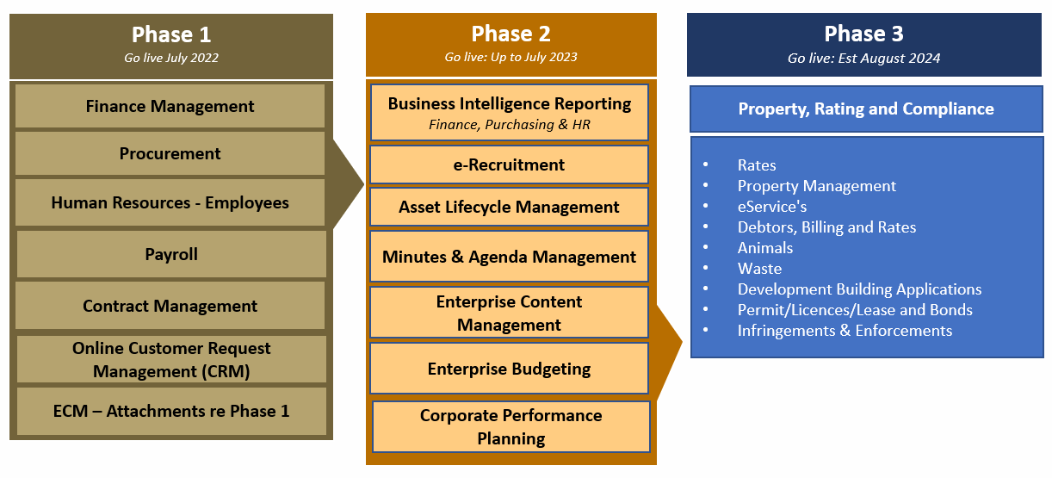
Figure 1 -OneCouncil : Overview of Phases

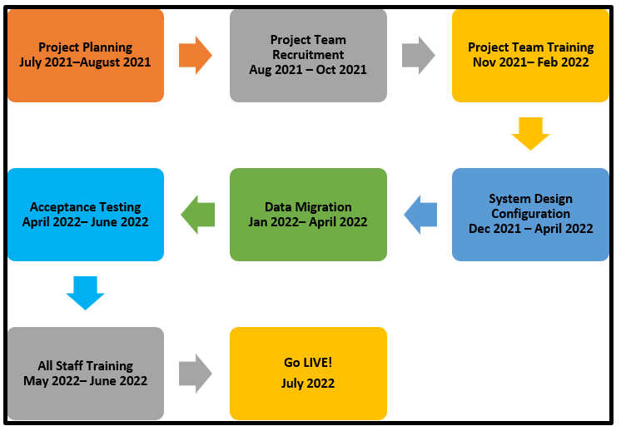
In terms of implementing Phase 1 of OneCouncil, the graphical representation below outlines the key project milestones:
Figure 2 -OneCouncil Phase 1 Milestones

Update on Progress
The OneCouncil project is 55% complete as per the Project Schedule below.
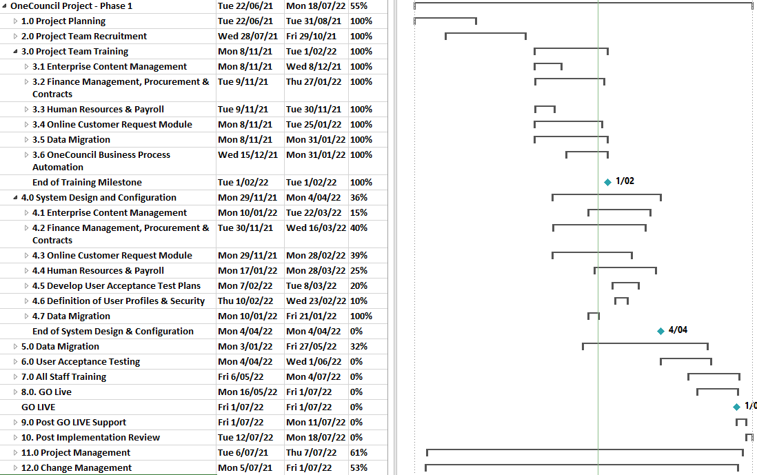

Milestone Status
The status of the key milestones outlined in the project schedule for the implementation of OneCouncil Phase 1 are:
# | Milestone | Status | %  Complete | Target Date
1 | Project Planning |  | 100% | 31 August 2021
2 | Project Team Recruitment |  | 100% | 29 October 2021
3 | Project Team Training |  | 100% | 11 February 2022
4 | System Design & Configuration |  | 36% | 30 April 2022
5 | Data Migration |  | 32% | 30 May 2022
6 | Acceptance Testing |  | 0% | 30 May 2022
7 | All Staff Training |  | 0% | 30 June 2022
8 | Go LIVE |  | 0% | July 2022

Legend | Description
 | Milestone delayed > 10%.
 | Potential for milestone delay.
 | Milestone on target.

Key Activities Completed: 1st November 2021 to 30th January 2022

The key activities completed are:

- Milestone #3 – Project Team Training : 100% Complete

  - Completed project team training for Finance, Payroll, Purchasing, Customer Request Management, Contracts and Human Resources. These training sessions included subject matter experts from relevant business units.

- Milestone #4 System Design & Configuration : 36% Complete

  - Finalise Finance Chart of Accounts;
  - Completed OneCouncil System Configuration Design Workshops for the following OneCouncil Modules:

    - Finance;
    - Procurement;
    - Customer Request Management;
    - Enterprise Content Management for Connected Content;
    - Contracts Management;
    - Human Resources; and
    - Payroll.

Key Activities Planned for next period – February 2022 to May 2022

The key activities planned for the next period are:

- Milestone #4 System Design & Configuration

  - Finalise the OneCouncil system design configuration for the following:

    - Finance;
    - Procurement;
    - Customer Request Management;
    - Enterprise Content Management for Connected Content;
    - Contracts Management;
    - Human Resources; and
    - Payroll.
    - Finalise the OneCouncil system security model.

- Milestone #5 Data Migration

  - Finalise the migration of data from the Authority System for the following:

    - Finance;
    - Procurement;
    - Contracts Management;
    - Human Resources; and
    - Payroll.

- Milestone #6 User Acceptance Testing

  - Develop the OneCouncil User Acceptance Test Strategy;
  - Develop Test Plans for the following Modules the migration of data from the Authority System for the following:

    - Finance;
    - Procurement;
    - Customer Request Management;
    - Enterprise Content Management for Connected Content;
    - Contracts Management;
    - Human Resources; and
    - Payroll.
    - OneCouncil system security model.

  - Commence Testing the OneCouncil System.

Project Governance

The OneCouncil Steering Committee is the City’s Executive Management Team. OneCouncil Steering Committee Meetings are scheduled monthly with the City’s project manager tabling a formal report on the overall status of the OneCouncil project.

The City’s CEO also provides monthly updates to staff in the Monthly Staff Newsletter and provides regular updates to Council.

Regular OneCouncil project team meetings are also held to monitor and control the OneCouncil project progress.

Consultation

The OneCouncil Project team has developed the following stakeholder consultation plans:

Stakeholder Consultation Plans | Purpose
Change Management Plan | To outline the strategy and approach to managing the organisational change associated with implementing the OneCouncil project for employees, customers and stakeholders.
Communication Plan | To provide an overall framework for the ongoing management, coordination and delivery of communications to all staff across the City of Nedlands impacted by the OneCouncil project activities.
Stakeholder Engagement Plan | To outline the City’s approach to managing stakeholder engagement throughout the implementation of the OneCouncil solution to ensure clear direction for the delivery of stakeholder engagement actions.

The City has also been consulting with the City of South Perth and the Shire of Serpentine Jarrahdale who are also implementing the same TechnologyOne OneCouncil system. The City has signed a Memorandum of Understanding (MoU) with the City of South Perth and the Shire of Serpentine Jarrahdale for the purpose of sharing information, system configuration/setup and lessons learnt.

Strategic Implications

This item relates to the following elements from the City’s Strategic Community Plan.

Vision Our city will be an environmentally sensitive, beautiful and inclusive place.

Values High standard of services
We have local services delivered to a high standard that take the needs of our diverse community into account.

Great Governance and Civic Leadership
We value our Council’s quality decision-making, effective and innovative leadership, transparency, accountability, equity, integrity and wise stewardship of the community’s assets and resources. We have an involved community and collaborate with others, valuing respectful debate and deliberation.

The City has adopted an Enterprise Resource Planning approach that sets the foundation for all organisational information technology systems and other supporting technologies. Investing in information systems and technology will provide the City of Nedlands with the requisite tools to plan, execute, evaluate all existing and future operations.

The overarching benefits of implementing OneCouncil were reported to the Audit and Risk Committee meetings held in August 2021 and November 2021.

Priority Area

The implementation of OneCouncil is a key result area for the Chief Executive Officer.

Budget/Financial Implications

The provision of the implementation of OneCouncil is included in the City of Nedlands 2021/22 Annual Budget.

Legislative and Policy Implications

This section should identify the legislative and policy implications that apply to the item being considered. Include name of legislation or policy which applies and the section/s.
Decision Implications

The City has sufficient information to present the OneCouncil project status report.

Conclusion

The implementation of OneCouncil Project is a significant investment that enables a whole new way of doing business more effectively. It is more than just new software as the City is implementing transformational change that impacts every aspect of how we do our business.

To date, the OneCouncil Project has achieved all milestones as scheduled for Project Planning, Project Team Recruitment and Project Team Training. In addition, the Project Team has implemented strategies to minimise the impact that resource challenges have presented.

The Project Team are now commencing the system design configuration and progressing the migration of data from the City’s legacy system, Authority, to OneCouncil.

Further Information

Not Applicable.

Date of Next Meeting

The date of the next meeting of the Audit & Risk Committee Meeting will be on Monday 30 May 2022 at 5.30pm.

Declaration of Closure

There being no further business, the Presiding Member declared the meeting closed at 6.45pm.

