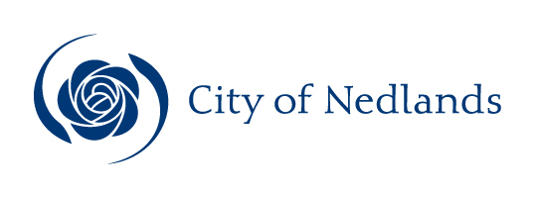
Agenda

Audit & Risk Committee Meeting
23 November 2021

ATTENTION

This Agenda has yet to be dealt with by the Committee.

The Administration Recommendations, shown at the beginning of each item, have yet to be considered by the Committee and are not to be interpreted as being the position of either the Committee or Council.

The Minutes of the meeting held to discuss this Agenda should be read to ascertain the decision of the Committee.Before acting on any recommendation of the Committee a check must also be made in the Ordinary Council Minutes following the Committee Meeting to ensure that Council did not make a decision at variance to the Committee Recommendation.

The public can continue to participate by submitting questions and addresses via the required online submission forms at:

http://www.nedlands.wa.gov.au/intention-address-council-or-council-committee-form

http://www.nedlands.wa.gov.au/public-question-time

Once the venue is at capacity no further admission into the room will be permitted. Prior to entry, attendees will be required to register using the SafeWA App or by completing the manual contact register prior to entry - as stipulated by Department of Health mandatory requirements.
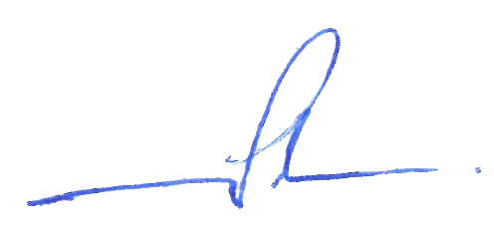
Chief Executive Officer
19 November 2021
Table of Contents

Declaration of Opening 3
Present and Apologies and Leave of Absence (Previously Approved) 3
1. Public Question Time 3
2. Addresses By Members of the Public (only for items listed on the agenda) 4
3. Disclosures of Financial and/or Proximity Interest 4
4. Disclosures of Interests Affecting Impartiality 4
5. Declarations by Council & Committee Members That They Have Not Given Due Consideration to Papers 5
6. Confirmation of Minutes 5
7. Matters for Which the Meeting May Be Closed 5
8. Items for Discussion 5
8.1 Annual Financial Statement for Year Ended 30 June 2021 6
8.2 Update on Audit Recommendation of Contract Management 9
8.3 Update on Audit of Records Management 15
8.4 Status of City’s Internal Audit Log 22
8.5 Update from Moore Australia 24
8.6 Enterprise Resource Planning System – OneCouncil: Project Status Report #2 26
9. Urgent Business Approved By the Presiding Member or By Decision 37
10. Confidential Items 37
11. Date of next meeting 37
Declaration of Closure 37

City of Nedlands

Notice of a meeting of the Audit & Risk Committee to be held in the Council Chamber, 71 Stirling Highway, Nedlands on Tuesday 23 November 2021 at 5pm.

Audit & Risk Committee Agenda

Declaration of Opening

The Presiding Member will declare the meeting open at 5pm and will draw attention to the disclaimer below.

Present and Apologies and Leave of Absence (Previously Approved)

Leave of Absence None at distribution of agenda.
(Previously Approved)

Apologies None at distribution of agenda.

Disclaimer

Members of the public who attend Council meetings should not act immediately on anything they hear at the meetings, without first seeking clarification of Council’s position, for example, by reference to the confirmed Minutes of the Council meeting. Members of the public are also advised to wait for written advice from the CEO, on behalf of Council prior to taking action on any matter that they may have before Council.

Any plans or documents in agendas and minutes may be subject to copyright. The express permission of the copyright owner must be obtained before copying any copyright material.

Public Question Time

A member of the public wishing to ask a question should register that interest by notification in writing to the CEO in advance, setting out the text or substance of the question. Questions tabled at the meeting may be unable to be answered due to the requirement for technical research and will therefore be answered directly afterwards.

Questions must relate to a matter contained within the agenda of this meeting.

Addresses By Members of the Public (only for items listed on the agenda)

Addresses by members of the public who have completed Public Address Session Forms will be invited to be made at this point.

Disclosures of Financial and/or Proximity Interest

The Presiding Member to remind Council Members, Committee Members and Employees of the requirements of Section 5.65 of the Local Government Act to disclose any interest during the meeting when the matter is discussed.

A declaration under this section requires that the nature of the interest must be disclosed. Consequently a Council or Committee Member who has made a declaration must not preside, participate in, or be present during any discussion or decision making procedure relating to the matter the subject of the declaration.

However, other Council & Committee Members may allow participation of the declarant if the Council Member further discloses the extent of the interest. Any such declarant who wishes to participate in the meeting on the matter, shall leave the meeting, after making their declaration and request to participate, while other Council & Committee Members consider and decide upon whether the interest is trivial or insignificant or is common to a significant number of electors or ratepayers.

Disclosures of Interests Affecting Impartiality

                - The Presiding Member to remind Council Members, Committee Members and Employees of the requirements of Council’s Code of Conduct in accordance with Section 5.103 of the Local Government Act.

                - Council Members, Committee Memebrs and employees are required, in addition to declaring any financial interests to declare any interest that may affect their impartiality in considering a matter. This declaration does not restrict any right to participate in or be present during the decision-making procedure.

                - The following pro forma declaration is provided to assist in making the disclosure.

"With regard to the matter in item x ….. I disclose that I have an association with the applicant (or person seeking a decision). This association is ….. (nature of the interest).

                - As a consequence, there may be a perception that my impartiality on the matter may be affected. I declare that I will consider this matter on its merits and vote accordingly."

                - The Council Member, Committee Members or employee is encouraged to disclose the nature of the association.

Declarations by Council & Committee Members That They Have Not Given Due Consideration to Papers

Council & Committee Members who have not read the business papers to make declarations at this point.

Confirmation of Minutes

Audit & Risk Committee Meeting 21 September 2021

The minutes of the Audit & Risk Committee held 21 September 2021 are to be confirmed.

Matters for Which the Meeting May Be Closed

Council, in accordance with Standing Orders and for the convenience of the public, is to identify any matter which is to be discussed behind closed doors at this meeting, and that matter is to be deferred for consideration as the last item of this meeting.

Nil.

Items for Discussion

Note: Regulation 11(da) of the Local Government (Administration) Regulations 1996 requires written reasons for each decision made at the meeting that is significantly different from the relevant written recommendation of a committee or an employee as defined in section 5.70, but not a decision to only note the matter or to return the recommendation for further consideration.

8.1 Annual Financial Statement for Year Ended 30 June 2021

Committee | 23 November 2021
Applicant | City of Nedlands
Employee Disclosure under section 5.70 Local Government Act 1995 | Nil.
Director | Ed Herne - Director Corporate & Strategy
Attachments | - 2020-21 Annual Financial Report;  - 2020-21 Management Letter  - 2020-21 Draft Audit Opinion;  - 2020-21 Audit Completion Report from KPMG; and  - 2020-21 Audit Representation Letter.
Confidential Attachments | Nil.

Executive Summary

The Annual Financial Report for the year ended 30 June 2021, including the Auditor’s Report and the Audit Completion Report by The Auditor General, is presented to the Audit & Risk Committee. The Committee is requested to recommend to Council that it be received and be included as part of the City’s Annual Report for discussion at the Annual Electors’ Meeting.

The Audit Representation Letter is also presented.

Recommendation to Committee

That Council:

1. accepts the Financial Report for the City of Nedlands for the year ended 30 June 2021 comprising the Financial Report and the Auditor’s Report; and

2. accepts the 2021 Audit Completion Report as presented.

Voting Requirement

Absolute Majority.

Discussion/Overview

Background

Financial Performance

A brief overview of the City’s financial performance for the 2020/21 financial year is provided below.

The City completed the 2020/21 year with a surplus net result of $5.8m compared to the adopted budget surplus of $0.9m. The overall favourable variance was mostly due to an underspend in Capital projects and higher revenue for the year.

Operating Revenue for the year totalled $34.9m, which is higher than the budget target of $33.6m for the year. This is mostly due to higher rates revenue, together with higher operating grants and general fees and charges.

Operating Expenditure marginally increased to $31.9m compared to a budget of $31.6m. This was mostly due to an overspend in Employee costs and Materials and Contracts offset by an underspend in utilities, depreciation and other expenditure.

Capital Works of $5.9m were completed in 2020/21 compared to a budget of $8.1m. This was mostly due to delays in projects.

The City’s key financial ratios in Note 36 provide an overview of the financial performance of the City in 2020/21 compared with the previous two years. All the ratios are within recommended standard benchmarks set by the Department of Local Government, indicating sound financial health for the City.

 |  |  | 2021 | 2020 | 2019
 |  | Target | Actual | Actual | Actual
Current ratio |  | >1.10 | 1.50 | 1.18 | 0.98
Asset consumption ratio |  | >0.50 | 0.72 | 0.59 | 0.58
Asset renewal funding ratio |  | 0.75 - 0.95 | 1.02 | 0.95 | 0.92
Asset sustainability ratio |  | 0.9 - 1.10 | 1.36 | 1.61 | 2.33
Debt service cover ratio |  | >2.0 | 3.79 | 4.34 | 5.61
Operating surplus ratio |  | 0.01 - 0.15 | 0.09 | 0.12 | 0.18
Own source revenue coverage ratio |  | >0.4 | 1.03 | 1.06 | 1.14

Key Relevant Previous Council Decisions: Nil

Consultation

Nil.

Strategic Implications

How well does it fit with our strategic direction?
The Financial Report is required to comply with Local Government Act and regulations and supports the City in sound strategy and governance around its financial health.

The following legislation is adhered to:

Section 6.4 of the Local Government Act 1995
Regulation 36 of the Local Government (Financial Management)
Regulations 1996
Regulations 9 and 10 of the Local Government (Audit)
Regulations 1996

Who benefits?
The City and the Community.

Does it involve a tolerable risk?
There is no risk involved.

Do we have the information we need?
Not applicable.

Budget/Financial Implications

There are no financial implications to this report.

Conclusion

The financial report showing the financial performance of the City for 2020/21 is recommended for approval.

8.2 Update on Audit Recommendation of Contract Management

Committee | 23 November 2021
Applicant | City of Nedlands
Employee Disclosure under section 5.70 Local Government Act 1995 | Nil.
Director | Ed Herne
Attachments | Nil.
Confidential Attachments | - Moore Australia Contracts Management Internal Audit Report

Executive Summary

This report provides an update on the recommendations from the audit of the City’s Contract Management processes conducted by Moore Australia.

Recommendation to Committee

That the Audit and Risk Committee notes the progress made to date to address the findings from the Moore Australia Contract Management Audit Report.

Discussion/Overview

Moore Australia are the City’s appointed Internal Auditors and in accordance with the internal audit plan have facilitated a review of the City’s contract management processes.

The attached report which contained details of the issues raised and management’s comments were presented to the Audit and Risk Committee on 31 May 2021.

A proposed action list to address the issues raised was presented to Council on 22 June 2021.

Update on Progress

Following the appointment of the Procurement Coordinator in August 2021, the focus has been primarily to address the findings and implement the recommendations from the Moore Australia audit.

Since then, substantial work has been done in the Contracts Management space between mid-August and the end of October, involving extensive consultation with internal stakeholders, training and working closely with WALGA and Moore Australia.
As a result, several recommendations have been successfully addressed and implemented.
The target dates for implementation of the findings, as shown below and presented at the last Audit and Risk Committee meeting in August 2021, were based on the Procurement Coordinator position being vacant for about two half months. Considering the role has now been filled, the target dates have been revised accordingly.

An update on status and progress of each finding is provided below:

Finding | Description | Status | % Complete | Target Date identified in Audit report | New Target Date | Issues | Activity
1 | Contract Management Training | ` | 100% | 01 Sep 2021 | - | Nil. | - Officers attended various training sessions held by WALGA  - Training needs are being identified by supervisors as part of Performance Reviews
2 | Review of Resourcing |  | 0% | 30 June 2021 | 30 June 2022 | Nil. | - Will be addressed as part of the Organisational Review
3 | Contracts Management Framework |  | 100% | 30 June 2021 | 30 Nov 2021 | Nil. | - EMT endorsed the new Contracts Management Framework on 04 Nov 2021
4 | Contracts Register |  | 100% | 01 July 2021 | 30 Nov 2021 | Nil | - Comprehensive Contracts Register developed and completed with the City’s current contracts
5 | Delegation Matrix |  | 80% | 31 Dec 2021 | - | Nil | - Manager City Projects will be working together with Executive Officer to update the Delegation Matrix
6 | Policies and Procedures |  | 100%  70% | 27 July 2021 | 31 March 2022 | Nil. | - Procurement Policy approved by Council on 27 July 2021  - Contract Management Policy and procedures in draft to be verified for currency and approved by EMT
7 | Executive Reporting |  | 0% | 30 June 2022 | - | Nil | - Reporting on contract management performance, issues and opportunities will be implemented once the policies and procedures in place.
8 | Risk Assessment |  | 0% | 31 Oct 2021 | 30 June 2022 | Nil | - Draft Risk Register to be developed as part of City’s wider Risk Management Framework
Legend | Description
 | Target date will be delayed.
 | Potential for target date delay.
 | On target.

Key Relevant Previous Council Decisions:

The audit findings were reported to the Audit and Risk Committee at the meeting held on the 31st May 2021. The Audit and Risk Committee recommended the following:

- notes with concern the Moore Australia Audit into Contracts Management;
- notes the actions recommended by the City’s Officers; and
- refers the report to the next Ordinary Council Meetings, where the Chief Executive Officer is requested to advise Council what resources are required to address this matter on an urgent basis.

At the Ordinary Council meeting dated 22nd June 2021, Council resolved the following:

- notes with concern the Moore Australia Audit into Contracts Management;
- notes the actions recommended by the City’s officers.

Consultation

Over the period of the audit several staff members across the city were interviewed and consulted by the Moore Australia audit team regarding their involvement with contract management, and the processes structures guiding around them.

Strategic Implications

How well does it fit with our strategic direction?
Strategically, the City is committed to reducing operational risk and continual improvement of administrative processes to deliver more efficient services.

Who benefits?
The City benefits from the effective management of its contracts. This ensures regulatory compliance, transparency, reduced risk, process efficacy, and improved controls on contract expenditure, especially that related to contract variance and executive reporting.

Does it involve a tolerable risk?
The greatest risk is that we do nothing. This will expose the City to multiple risks operationally, reputationally and financially. The availability of an effective Procurement and Contracts function with sufficiently resourced and qualified staff will ensure the City can address those risks identified.

What level of risk is associated with the option? How can it be managed?
The audit report demonstrates that the City is performing poorly in all areas of its contract management activities and this represents a high risk to the City, financially, reputationally and operationally.

Do we have the information we need?
The Moore Australia Audit into the City’s contract management function provides all the information required to improve our contract management processes.

Budget/Financial Implications

There are no financial implications to this report.

There may be budget implications when the report’s recommendations are addressed in detail, where operational impacts are estimated and considered by the Administration, and then by Council at the appropriate time.

Can we afford it?
There is no immediate budgetary implication to receiving this report. Due to the current status, as identified by the Audit Report, the City is exposed to risk with a continuation of a business as usual operation within this function. This will need to be considered by the Administration and Council at a later date.

How does the option impact upon rates?
There will be no impact on rates in the receipt of this report. Future costs will need to be considered by the Administration and Council at a later date following a detailed review of the report’s implications to the City’s operations.

Conclusion

The findings reported by Moore Australia are progressively being addressed as a matter of priority.

Addressing all the findings will occur throughout the 2021/2022 financial year.

8.3 Update on Audit of Records Management

Committee | 23 November 2021
Applicant | City of Nedlands
Employee Disclosure under section 5.70 Local Government Act 1995 | Nil.
Director | Ed Herne – Director Corporate & Strategy
Attachments | Nil.
Confidential Attachments | - Moore Australia Records Management Internal Audit Report

Executive Summary

The objective of this report is to present an update of the key records management initiatives being undertaken, along with their progress, to address the findings from Moore Australia (Internal Auditor’s) Records Management Audit and the Dialog IT SharePoint and Recordkeeping Audit Report for endorsement.

Recommendation to Committee

That the Audit & Risk Committee notes the progress made to address the findings from Moore Australia (Internal Auditor’s) Records Management Audit and the Dialog IT SharePoint and Recordkeeping Audit Report.

Voting Requirement

Simple Majority.

Discussion/Overview

The Moore Australia (WA) Pty Ltd (“Moore Australia”) audit into Records management identified a total of 9 key findings. The Dialog IT report identified eight recommendations. All recommendations are subsumed into the overarching audit report completed by Moore Australia.

Overall, the findings reported by Moore Australia and Dialog IT are considered very serious as the City’s records are largely unmanaged and lack compliance with the relevant principles and standards under the State Records Act 2000.

The City has been reviewing the findings and has been working on addressing these as a matter of urgency to achieve increased compliance.

Update on Progress

Circumstances have resulted in the Senior Information Management Officer position being vacated. This is having an impact on the Information Management team however this position will be filled as soon as possible. The recent appointment of a full time Manager ICT will mitigate the shortfall in capacity as an interim solution.

Additionally, the Manager ICT appointment has led to some delays in work completion as objectives are handed over to this position whilst completing the City’s onboarding processes.

The above changes notwithstanding, the focus of activity since the previous Audit and Risk Committee Report has been the engagement of RecordPoint, and the enablement and configuration of its’ Records365 solution. This solution overlays the standard Microsoft SharePoint functionality, using a rules-based approach to classify documents and records against the appropriate General Disposal Authority criteria. RecordPoint have been extremely patient, and flexible, in bringing clarity and foresight to the City’s’ incumbent Records Management processes. This patience and flexibility have allowed the City to understand more completely the difference between its current practices and best practice Records Management processes. It has also made clear to the City that previous thought processes were causing confusion and preventing the City from making sensible, pragmatic decisions which would support the City’s in satisfying its’ Record Management obligations

The Information Management team is working diligently to make these pragmatic choices active and available to all staff in the shortest time possible.

The secondary area of the team’s focus has been against the digitalization of physical records. The team has completed site visits to potential external Solution Providers who have both been very candid in their engagement with the City. In conjunction with this candor, the team has been reaching out to fellow Councils to understand how they have been approaching the basic challenge of digitization; digitize and then classify or classify and then digitize. Unsurprisingly, many of the councils spoken with have not given the topic much detailed thought and it should be noted that some Councils are no better placed than Nedlands in this regard.

The team will be working to finalize a specialist partner for the digitization of Physical Records, working with the nominated partner to formalize a program of activities to give the City clarity on milestones and timeframes. This program is likely to run over several phrases.

The provision of a robust, compliant, and useable Records Management solution for the City will take some time to deliver, especially with regard to digitization of physical records which have proven challenging for many Councils for several years. The costs and expenses, of which, will be managed through existing budgetary processes.

The following table is an update on the status and progress of each finding:

Finding | Description | Status | % Complete | Previous Target Date | New Target Date | Issues | Activity/Comments
1 | Lack of Records Management Policy & Procedures |  | 40% | 30-Oct-21 | 31-Dec-21 | Staff turnover. | - Records Management Policy and Procedures drafted  - Policy and Procedures undergoing internal review before sending for adoption
2 | Inadequate Record Keeping Plan |  | 20% | 31-Dec-21 |  | Nil. | - Existing Records Keeping plan to be re-written  - State Records Office in public consultation over new RKP standard. New draft standard available but not officially released  - IM Team to assess differences between existing and new templates, then make recommendation as to which version, existing or draft updated, to refresh the existing RKP against.
3 | Lack of Qualified & Experienced Staff |  | 50% | 31 Dec 2021 | 31-Mar-21 | Additional capacity to address this finding. | - Temporary Resource extended until end of Financial Year.  - Senior Information Officer departed City, with associated resource implications. Replacement recruitment underway. Not expected to be filled until new calendar year.
4 | Inadequate Records Management Training |  | 0% | 30-Jun-22 |  | Capacity to train all City staff. | - No change from last report  - External training for existing staff by end of November  - All hands training (160+ staff) to commence on completion of finding #9
5 | Lack of Monitoring |  | 10% | 30-Jun-22 |  | Capacity to address this finding. | - Minimal Change from last report  - To be addressed on completion of finding #9
6 | Physical & Digital Security of Documents |  | 80% | 30-Sep-21 | 24-Dec-21 | Staff turnover. | - Physical Records Room procedure updated  - Undergoing internal consultation before final implementation  - Digital Document Security will be addressed as part of finding #9
7 | Inadequate management of retention & disposal of records |  | 10% | 30-Jun-22 |  | Additional capacity to address the ongoing management of this finding. | - Minimal change from last report  - The City adopt the State Records Office Guideline for Records Retention and Disposal  - For Digital Documents, the implementation (ongoing) of Specialist Software will support closing this finding  - For Physical Documents, there is an ongoing market assessment to able the selection of specialist partner to support closing this finding
8 | Inconsistent naming of documents |  | 10% | 30-Jun-22 |  |  | - Minimal change from last report; the naming standard will be based on the Keywords for Council standard with this standard incorporated into staff training
9 | Non-compliance with State Records Act - SharePoint |  | 40% | 31-Jan-22 |  | Nil. | - Procurement of specialist software, RecordPoint365, completed with implementation underway

Legend | Description
 | Target date will be delayed.
 | Potential for target date delay.
 | On target.

Key Relevant Previous Council Decisions:

The audit findings were reported to the Audit and Risk Committee at the meeting held on the 31st May 2021. The Audit and Risk Committee recommended the following:

- notes with concern the Moore Australia Audit into Records Management and Dialog I.T.;
- notes the actions recommended by the City’s Officers; and
- refers the report to the next Ordinary Council Meetings, where the Chief Executive Officer is requested to advise Council what resources are required to address this matter on an urgent basis.

At the Ordinary Council meeting dated 22nd June 2021, Council resolved the following:

- notes with concern the Moore Australia Audit into Records Management and Dialog I.T;
- notes the actions recommended by the Administration; and
- ensures the CEO notes the Council’s concerns of what the Audit Report – Records Management revealed and requests the CEO address the remedial action as an urgent matter and report back to Council as soon as possible.

Consultation

The City’s officers have consulted with the Director of State Records Office of Western Australia.

Strategic Implications

How well does it fit with our strategic direction?
Addressing the findings reported by Moore Australia and Dialog IT audit reports will ensure that the City can achieve increased compliance with the State Records Act 2000 and reduce operational and strategic risk.

Who benefits?
The City will benefit by complying with the State Records Act 2000.

Does it involve a tolerable risk?
The Moore Australia and Dialog IT audit reports have identified a significant number of business risks that can only be mitigated to a manageable level if their recommendations are addressed by the City.

What level of risk is associated with the option and how can it be managed?
Addressing the Moore Australia and Dialog IT audit reports recommendations will reduce the risks that the City is currently exposed to in Records Management.

Do we have the information we need?
Yes, the Moore Australia and Dialog IT audit reports has fully informed the City on what actions are required to mitigate the identified records management risks.

Budget/Financial Implications

Can we afford it?
Addressing the Moore Australia and Dialog IT audit report recommendations will initially be addressed with existing resources. Future requirements for increasing capacity in the Records Management area will be subject to the City’s budgetary processes.

How does the option impact upon rates?
Accepting the Officers recommendations in this report will not impact rates.

Conclusion

The findings reported by Moore Australia and Dialog IT are progressively being addressed within the capacity of existing records management resources.

Fully addressing all the findings will occur throughout the 2021/2022 financial year as the administration will have a significant amount of work to do after 5 years of no attention to the records management function.

8.4 Status of City’s Internal Audit Log

Committee | 23 November 2021
Applicant | City of Nedlands
Employee Disclosure under section 5.70 Local Government Act 1995 | Nil.
Director | Ed Herne
Attachments | - Internal Audit Log
Confidential Attachments | Nil.

Executive Summary

This report is to provide an update on all the recommended actions from previous audit reports.

Recommendation to Committee

The Audit and Risk Committee:

- notes the status of the City’s Audit Log as per Attachment 1; and

- notes that items 19, 23, 25 and 26 of the Audit Log as being addressed and closed as per Attachment 1.

Discussion/Overview

The Audit Log captures and reports on the progress of all recommended actions from previous audit reports. The following items have been addressed and implemented by the City and verified by Moore Australia. They are now marked as closed and can be subsequently removed from the Audit Log.

Item 19 – Payroll Review – payroll change reporting
Item 23 – Contracts Management Review – training program
Item 25 – Contracts Management Review – Contract Management Framework
Item 26 – Contract Management Review – Contracts register

Key Relevant Previous Council Decisions:
Nil.

Consultation

Nil.

Strategic Implications

How well does it fit with our strategic direction?
The City of Nedlands relies on internal audit as the third line of defense to provide insight and improvement opportunities to the system of internal control.

Who benefits?
The City will benefit from having a Strategic Internal Audit Plan. This provides a strategic view of the internal audit topics planned for the next year to demonstrate the risks being mitigated by the work performed by the internal audit function, Office of the Auditor General via their financial and performance audit function and what work needs to be performed by the City of Nedlands.

Does it involve a tolerable risk?
The work included within the Strategic Internal Plan aims to reduce the residual risk identified by the City of Nedlands by identifying controls and improvement opportunities.

What level of risk is associated with the option? How can it be managed?

Nil.

Do we have the information we need?

Yes. The Strategic Internal Audit Plan identified the internal audit topics for the years ending 30 June 2022 to 30 June 2024.

Budget/Financial Implications

Can we afford it?
Recommendations from the audit reports have been included in the 2021-22 budget..

How does the option impact upon rates?
The impact of this option has already been included in the 2021-22 budget.

Conclusion

That Audit and Risk Committee notes the progress of all recommended actions from previous audit reports.

8.5 Update from Moore Australia

Committee | 23 November 2021
Applicant | City of Nedlands
Employee Disclosure under section 5.70 Local Government Act 1995 | Nil.
Director | Ed Herne
Attachments | - Moore Australia Agenda Paper Audit and Risk Committee
Confidential Attachments | Nil.

Executive Summary

This report is for Moore Australia to present its agenda paper to the Audit and Risk Committee.

Recommendation to Committee

That the Audit and Risk Committee receives the agenda paper from Moore Australia.

Voting Requirement

Simple Majority.

Discussion/Overview

Moore Australia has submitted an agenda paper for the discussion at the Committee meeting.
Key Relevant Previous Council Decisions:
Nil.

Consultation

Nil.

Strategic Implications

How well does it fit with our strategic direction?
The City of Nedlands relies on internal audit as the third line of defense to provide insight and improvement opportunities to the system of internal control.

Who benefits?
The City will benefit from having a Strategic Internal Audit Plan. This provides a strategic view of the internal audit topics planned for the next year to demonstrate the risks being mitigated by the work performed by the internal audit function, Office of the Auditor General via their financial and performance audit function and what work needs to be performed by the City of Nedlands.

Does it involve a tolerable risk?
The work included within the Strategic Internal Plan aims to reduce the residual risk identified by the City of Nedlands by identifying controls and improvement opportunities.

What level of risk is associated with the option? How can it be managed?
Nil.

Do we have the information we need?
Yes. The agenda paper contains updates relevat to the City’s internal audit plan.

Budget/Financial Implications

Can we afford it?
Recommendations from the audit reports have been included in the 2021-22 budget..

How does the option impact upon rates?
The impact of this option has already been included in the 2021-22 budget.

Conclusion

That Audit and Risk Committee receives the agenda paper from Moore Australia.

8.6 Enterprise Resource Planning System – OneCouncil: Project Status Report #2

Committee | 23 November 2021
Applicant | City of Nedlands
Employee Disclosure under section 5.70 Local Government Act 1995 | Nil.
Director | Ed Herne – Director Corporate & Strategy
Attachments | Nil.
Confidential Attachments | - OneCouncil Project Management Plan.

Executive Summary

The objective of this report is to present the Project Status Report for the implementation of the City’s Enterprise Resource Planning System - OneCouncil.

Recommendation to Committee

That the Audit & Risk Committee receive the OneCouncil Project Status Report #2.

Voting Requirement

Simple Majority.

Discussion/Overview

This is the second report prepared to provide the Audit and Risk Committee with a project status update of the implementation of the Enterprise Resource Planning System, called OneCouncil.

Following the Council resolutions made at the Ordinary Council Meeting dated 22nd June 2021, the Acting Chief Executive Officer entered into a contract with TechnologyOne to purchase their Enterprise Resource Planning System, called OneCouncil.

To date, detailed project management plans, change management plans and the scheduling of the OneCouncil Project has been finalised. These plans will form the baseline for reporting, tracking and controlling the project implementation. The planning milestone was completed on time.

The City has been very successful in recruiting experienced and skilled staff for the OneCouncil Project given that:

- Western Australia has the strongest performing jobs market of all states and very low unemployment levels; and
- The City is competing with other Councils who are recruiting the same roles for their respective implementation of OneCouncil.

The recruitment milestone was completed on time.

The City has now commenced the formal training program for the OneCouncil project team which is key to ensuring knowledge transfer from TechnologyOne to the City’s staff. The training sessions will run from November 2021 through to the end of January 2022 and cover all of the Phase 1 modules (Finance, Payroll, Procurement, Human Resources, Customer Request Management, Enterprise Content Management and Contract Management). As the training programs for each OneCouncil module finish, workshops will commence to determine and incorporate the City of Nedlands specific requirements into the OneCouncil solution.

Change management activities have formally started with the OneCouncil Change Manager starting on the 25th October 2021. Staff briefing sessions are well advanced and various communications channels have been established. These communication channels include a OneCouncil section on the City’s Intranet, a OneCouncil email address for staff to ask questions and regular updates at the CEO’s monthly staff meetings. Future communication plans include developing screen savers, monthly posters to inform at staff of progress and surveys of staff to assess the effectiveness of the change management program.

In summary, the implementation of OneCouncil will be via three (3) phases over three (3) years using a standard project management methodology as per the following.

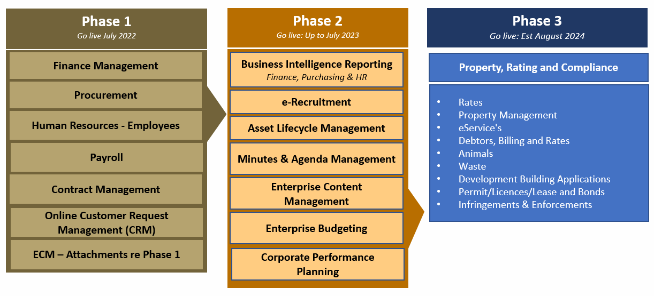
Figure 1 -OneCouncil : Overview of Phases

The scope of the abovementioned phases is largely driven by the fact that we are leveraging the implementation work undertaken at other Western Australian Local Governments. This approach reduces the implementation cost and overall risk to the City. Furthermore, the scope of Phase 1 is designed to lay the foundation systems ready for future phases of OneCouncil to build upon.
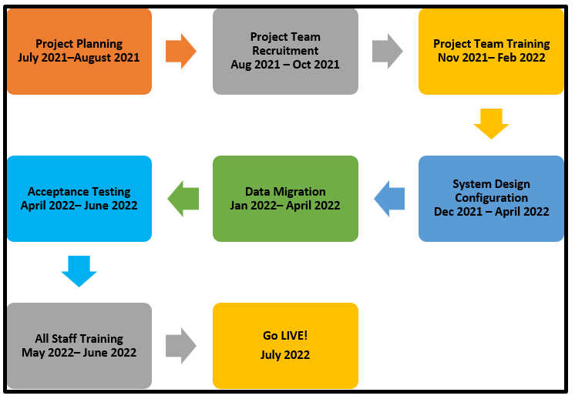
In terms of implementing Phase 1 of OneCouncil, the graphical representation below outlines the key project milestones:

Figure 2 -OneCouncil Phase 1 Milestones

Update on Progress
The OneCouncil project is 29% complete as per the Project Schedule below.
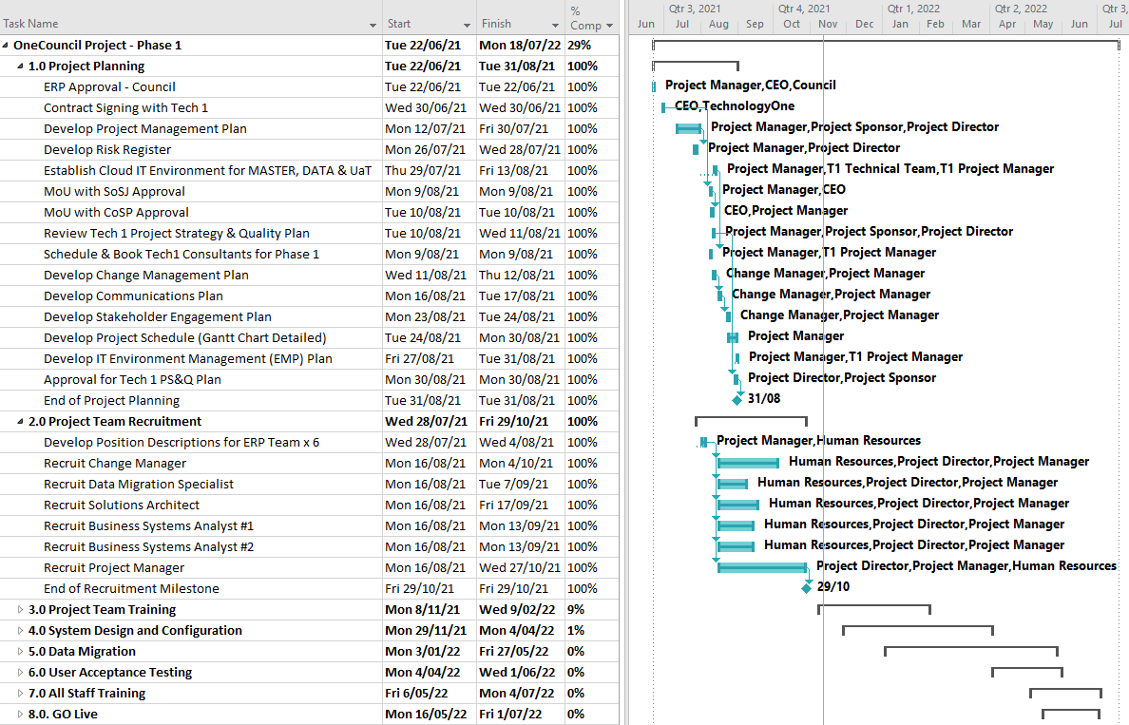
Figure 3 -OneCouncil Phase 1 Project Schedule

Milestone Status

The status of the key milestones outlined in the project schedule for the implementation of OneCouncil Phase 1 are:

# | Milestone | Status | %  Complete | Target Date
1 | Project Planning |  | 100% | 31 August 2021
2 | Project Team Recruitment |  | 100% | 29 October 2021
3 | Project Team Training |  | 9% | 11 February 2022
4 | System Design & Configuration |  | 1% | 30 April 2022
5 | Data Migration |  | 0% | 30 May 2022
6 | Acceptance Testing |  | 0% | 30 May 2022
7 | All Staff Training |  | 0% | 30 June 2022
8 | Go LIVE |  | 0% | July 2022
Legend | Description
 | Milestone delayed > 10%.
 | Potential for milestone delay.
 | Milestone on target.

Key Activities Completed: 23 August 2021 to 31 October 2021

- Milestone #1 – Project Planning : 100% Complete

- Project Management Plan approved (refer to confidential attachment #1);
- Project Risk Register developed;
- Project Change Management Plan developed;
- Project Stakeholder Engagement Plan developed;
- Project Communication Plan developed;
- Cloud based OneCouncil IT Environments established;
- Development of a detailed Project Schedule (Gantt Chart);
- Booking of TechnologyOne Consultants for Phase 1 through to end of June 2022;
- Development of an IT Environment Management (EMP) Plan; and
- Development of the TechnologyOne Project Strategy & Quality Plan.

- Milestone #2 – Project Team Recruitment : 100% Complete

- Recruited Project Manager;
- Recruited Change Manager;
- Recruited Data Migration Specialist (since resigned on 5th November 2021 and a replacement has been recruited);
- Recruited Solutions Architect; and
- Recruited Business Systems Analysts x 2.

Key Activities Planned for next period – November 2021 to February 2022

The key deliverables planned for the next period are:

- Milestone #3 – Project Team Training

- Communication with all staff on the ‘what, why, when and how’ of the OneCouncil project; and
- Completion of project team training for Finance, Payroll, Purchasing, Customer Request Management, Contracts and Human Resources. These training sessions will include subject matter experts from relevant business units.

- Milestone #4 System Design & Configuration

- Finalise Finance Chart of Accounts;
- Commence OneCouncil System Design Workshops; and
- Commence Configuration of the OneCouncil system.

Project Governance

The OneCouncil Steering Committee is the City’s Executive Management Team. The inaugural OneCouncil Steering Committee meeting was held on the 7th October 2021 and a subsequent Steering Committee meeting was held on the 11th November 2021. Included on the agenda for the inaugural OneCouncil Steering Committee meeting was a presentation by TechnologyOne’s State Consulting Manager and TechnologyOne’s Project Manager.

OneCouncil Steering Committee Meetings are scheduled monthly with the City’s project manager tabling a formal report on the overall status of the OneCouncil project.
The City’s CEO also provides monthly updates to staff in the Monthly Staff Newsletter and provides regular updates to Council.

Fortnightly OneCouncil project team meetings have also commenced to monitor and control the OneCouncil project progress.

Key Relevant Previous Council Decisions:

At the Ordinary Council Meeting held on the 22nd June 2021 Council Resolved the following:

1. approves the supplier, TechnologyOne, to be awarded the contract for RFT 2020-21.03 – Provision City Finance System (Enterprise Resource Planning System) for the initial term of 5 years, comprising the initial 3 years with two one-year extensions, to be awarded under Local Government (Functions & General) Regulations 1996 11(2);

2. agrees to enter a contract with TechnologyOne to purchase their Enterprise Resource Planning System, called OneCouncil, with final contract subject to independent review to the satisfaction of the Chief Executive Officer; and

- notes;

a. the adoption of the Integrated Enterprise Resource Planning approach for implementing Information Systems; and
b. the implementation of the TechnologyOne OneCouncil solution using the Cloud model called “Software as a Service”.

Consultation

The OneCouncil Project team has developed the following stakeholder consultation plans:

Stakeholder Consultation Plans | Purpose
Change Management Plan | To outline the strategy and approach to managing the organisational change associated with implementing the OneCouncil project for employees, customers and stakeholders.
Communication Plan | To provide an overall framework for the ongoing management, coordination and delivery of communications to all staff across the City of Nedlands impacted by the OneCouncil project activities.
Stakeholder Engagement Plan | To outline the City’s approach to managing stakeholder engagement throughout the implementation of the OneCouncil solution to ensure clear direction for the delivery of stakeholder engagement actions.

The City has also been consulting with the City of South Perth and the Shire of Serpentine Jarrahdale who are also implementing the same TechnologyOne OneCouncil system. The City has signed a Memorandum of Understanding (MoU) with the City of South Perth and the Shire of Serpentine Jarrahdale for the purpose of sharing information, system configuration/setup and lessons learnt.

Strategic Implications

How well does it fit with our strategic direction?
The City has adopted an Enterprise Resource Planning approach that sets the foundation for all organisational information technology systems and other supporting technologies. Investing in information systems and technology will provide the City of Nedlands with the requisite tools to plan, execute, evaluate all existing and future operations.

Who benefits?
The benefits were reported to the Audit and Risk Committee in August 2021 and are re-iterated in this report for completeness.

Council will benefit from the implementation of OneCouncil by:

- Improved online services for ratepayers and residents;
- Implementing the ability for customers/residents to engage the City online from any device and anytime;
- More efficient tools for reporting budget and statutory reporting obligations;
- Improved staff morale by reducing pressure/stress on staff - this will reduce the need to increase FTE in the future - as staff will have the right tools to do their job;
- The ability to attract talent from other Councils that use TechnologyOne;
- Improved planned and scheduled maintenance of our Assets;
- Reduced strategic and operational risk by replacing the City’s obsolete IT systems;
- Improved granularity of financial reporting with a revised Financial Chart of Accounts; and
- Increased financial system controls with full audit capability to reduce the risk of fraud / corruption.

The City’s administrative staff will benefit from the implementation of OneCouncil by:

- Optimization of business processes - Being more effective & efficient;
- Improved information accuracy and decision-making capability - A more strategic City;
- Improved and efficient business processes and tools for:

  - Business Intelligence & Reporting;
  - Financial management, budgeting, governance and transparency;
  - Employee performance management, learning, training and development;
  - Corporate strategic planning and reporting;
  - Sharing information between all areas of the City;
  - Comprehensive Asset management; and
  - Workforce mobility.

- Elimination of unnecessary manual and paper-based business processes;
- Delivers contemporary ICT systems with the capability to scale as the City grows; and
- Increased capacity for staff to work on business improvement activities rather than manual data entry/extraction Improved capacity for staff to work ‘on the business’ rather than ‘in the business’

The Customer, community and other stakeholders will benefit from this initiative by:

- Customers will have access to on-line services 24x7 – this is an expectation;
- Ability for customers to report issues and/or request information online;
- Automated communication to customers - Request lodgement, progress and completion outcomes;
- Ability to track requests for information or service online – rather than calling the City;
- Online ability to lodge, track and pay for :

  - Building Applications and Development applications;
  - Dog/Cat renewals/licences;
  - Requests for new services (i.e. Bins, Verge collections);
  - Copies of plans; and
  - Infringements / Fines.

- Having an improved customer and interface experience with the availability of online processes that can be completed at their convenience, not only during the City’s operating hours as is the current situation; and
- Simplification of the customer’s communication and engagement with the City of Nedlands.

Does it involve a tolerable risk?
The implementation of transformational change has inherent risks. These risks have been formally identified, and risk mitigation strategies will be identified and implemented. A project risk register has been developed as part of the implementation of the Enterprise Resource Planning System. This will be supported by implementing robust project governance and project management to ensure visibility and accountability over the progress of the project.

A key risk mitigation strategy includes the establishment of a Memorandum of Understanding (MoU) with the City of South Perth and the Shire of Serpentine Jarrahdale as these local governments currently use the OneCouncil solution. This will enable the City to minimise resource effort and risk in the City’s overall implementation. Importantly, adopting a pre-configured business process that another local government has already implemented will give the City a solid foundation on which to accelerate the implementation.

What level of risk is associated with the option and how can it be managed?
There is no risk associated with receiving this report.

Do we have the information we need?
The City has sufficient information to present the OneCouncil project status report.

Budget/Financial Implications

Can we afford it?
The provision of the implementation of OneCouncil is included in the City of Nedlands 2021/22 Annual Budget.

How does the option impact upon rates?
Receiving this report will not impact rates.

Conclusion

The implementation of OneCouncil Project is a significant investment that enables a whole new way of doing business more effectively.

A critical component of the implementation is effectively managing the transformational change that will occur right across the City. To this end, OneCouncil briefing sessions have been delivered to the CEO, Directors, Managers and Coordinators. All staff will be briefed at the CEO’s monthly staff meeting scheduled for the 25th November 2021.

The following key messages being consistently communicated across the City:

- We need to evolve our organisation to ensure that we meet the expectations of the community we serve both now and in the future;
- The goal is to deliver a best-practice system that improves our processes, strengthens the capacity of our people and facilitates the delivery of excellent service to our customers;
- OneCouncil is a 3-year project managed in three (3) Phases and is an organisation-wide project that will touch most facets of the City;
- It is more than just new software. We are transforming the way we do things by simplifying our work processes and adopting best practice;
- You will be able to work ‘on’ the business rather than ‘in’ the business; and
- Active involvement by all staff in this change is vital to success.

Urgent Business Approved By the Presiding Member or By Decision

Any urgent business to be considered at this point.

Confidential Items

Any confidential items to be considered at this point.

Date of next meeting

The next meeting of the Audit & Committee is to be advised.

Declaration of Closure

There being no further business, the Presiding Member will declare the meeting closed.

