Agenda

Audit & Risk Committee Meeting

30 May 2022

Notice of Meeting

To Mayor & Councillors

A Meeting of the Public Art Committee of the City of Nedlands is to be held on Monday, 30 May 2022 in the Council chambers at 71 Stirling Highway Nedlands commencing at 5.30pm.

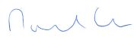

Michael Cole
Acting Chief Executive Officer
27 May 2022
Information

Audit & Risk Committee Meetings are run in accordance with the City of Nedlands Standing Orders Local Law. If you have any questions in relation to items on the agenda, procedural matters, public question time, addressing the Committee or attending meetings please contact the Executive Officer on 9273 3500 or council@nedlands.wa.gov.au

Public Question Time

Public question time at an Audit & Risk Committee Meeting is available for members of the public to ask a question about items on the agenda. Questions asked by members of the public are not to be accompanied by any statement reflecting adversely upon any Council Member, Committee Member or Employee.

Questions should be submitted as early as possible via the online form available on the City’s website: Public question time | City of Nedlands

Questions may be taken on notice to allow adequate time to prepare a response and all answers will be published in the minutes of the meeting.

Addresses by Members of the Public

Members of the public wishing to address the Audit & Risk Committee in relation to an item on the agenda must complete the online registration form available on the City’s website: Public Address Registration Form | City of Nedlands

The Presiding Member will determine the order of speakers to address the Council and the number of speakers is to be limited to 2 in support and 2 against any particular item on the Agenda. The Public address session will be restricted to 15 minutes unless the Committee, by resolution decides otherwise.

Disclaimer

Members of the public who attend Committee meetings should not act immediately on anything they hear at the meetings, without first seeking clarification of Council’s position. For example, by reference to the confirmed Minutes of Council meeting. Members of the public are also advised to wait for written advice from the Council prior to taking action on any matter that they may have before Council.

Any plans or documents in agendas and minutes may be subject to copyright. The express permission of the copyright owner must be obtained before copying any copyright material.

Table of Contents

1. Declaration of Opening 4
2. Present and Apologies and Leave of Absence (Previously Approved) 4
3. Public Question Time 4
4. Addresses by Members of the Public 4
5. Disclosures of Financial / Proximity Interest 4
6. Disclosures of Interests Affecting Impartiality 5
7. Declarations by Members That They Have Not Given Due Consideration to Papers 5
8. Confirmation of Minutes 5
8.1 Audit & Risk Committee Meeting Minutes – 14 March 2022 5
9. Items for Discussion 6
9.1 ARC08.05.22 City of Nedlands Audit Plan for year ending 30 June 2022 6
9.2 ARC09.05.22 Internal Audit – Occupational Health and Safety Report 8
9.3 ARC10.05.22 Audit Log Report 11
9.4 ARC11.05.22 Update from Moore Australia 14
9.5 ARC12.05.22 OneCouncil Project Status Report #4 16
10. Date of Next Meeting 26
11. Declaration of Closure 26

Declaration of Opening

The Presiding Member will declare the meeting open at 5.30pm and will draw attention to the disclaimer below.

Present and Apologies and Leave of Absence (Previously Approved)

Leave of Absence None.
(Previously Approved)

Apologies None as at distribution of this agenda.

Public Question Time

Public questions submitted to be read at this point.

Addresses by Members of the Public

Addresses by members of the public who have completed Public Address Registration Forms to be made at this point.

Disclosures of Financial / Proximity Interest

The Presiding Member to remind Council Members and Staff of the requirements of Section 5.65 of the Local Government Act to disclose any interest during the meeting when the matter is discussed.

A declaration under this section requires that the nature of the interest must be disclosed. Consequently, a member who has made a declaration must not preside, participate in, or be present during any discussion or decision-making procedure relating to the matter the subject of the declaration.

However, other members may allow participation of the declarant if the member further discloses the extent of the interest. Any such declarant who wishes to participate in the meeting on the matter, shall leave the meeting, after making their declaration and request to participate, while other members consider and decide upon whether the interest is trivial or insignificant or is common to a significant number of electors or ratepayers.

Disclosures of Interests Affecting Impartiality

The Presiding Member to remind Council Members and Staff of the requirements of Council’s Code of Conduct in accordance with Section 5.103 of the Local Government Act.

Council Members and staff are required, in addition to declaring any financial interests to declare any interest that may affect their impartiality in considering a matter. This declaration does not restrict any right to participate in or be present during the decision-making procedure.

The following pro forma declaration is provided to assist in making the disclosure.

"With regard to the matter in item x ….. I disclose that I have an association with the applicant (or person seeking a decision). This association is ….. (nature of the interest).

As a consequence, there may be a perception that my impartiality on the matter may be affected. I declare that I will consider this matter on its merits and vote accordingly."

The member or employee is encouraged to disclose the nature of the association.

Declarations by Members That They Have Not Given Due Consideration to Papers

Members who have not read the business papers to make declarations at this point.

Confirmation of Minutes

Audit & Risk Committee Meeting Minutes – 14 March 2022

The Minutes of the Audit & Risk Committee Meeting 14 March 2022 are to be accepted as a true and correct record of that meeting.

Items for Discussion

ARC08.05.22 City of Nedlands Audit Plan for year ending 30 June 2022

Meeting & Date | Audit & Risk Committee – 30 May 2022
Applicant | City of Nedlands
Employee Disclosure under section 5.70 Local Government Act 1995 | Nil.
Report Author | Stuart Billingham – Acting Manager Financial Services
Director/CEO | Michael Cole – Director Corporate & Strategy
Attachments | - City of Nedlands Audit Plan for the year ending 30 June 2022

Purpose

This report is for the Office of the Auditor General and KPMG staff to present the City of Nedlands Audit Plan for the year ending 30 June 2022 to the Audit & Risk Committee.

Recommendation

That the Audit & Risk Committee receive the report on the City of Nedlands Audit Plan for the year ending 30 June 2022.

Voting Requirement

Simple Majority

Background

The Office of the Auditor General and KPMG has submitted an Audit Plan paper for discussion at the Committee meeting.

Consultation

Office of the Auditor General, KPMG, Director Corporate & Strategy, Finance Coordinator.

Strategic Implications

This item relates to the following elements from the City’s Strategic Community Plan.

Vision Our city will be an environmentally sensitive, beautiful and inclusive place.

Values High standard of services
We have local services delivered to a high standard that take the needs of our diverse community into account.

Great Governance and Civic Leadership
We value our Council’s quality decision-making, effective and innovative leadership, transparency, accountability, equity, integrity and wise stewardship of the community’s assets and resources. We have an involved community and collaborate with others, valuing respectful debate and deliberation.

Priority Area

Nil.

Budget/Financial Implications

There are no financial implications to this report.

Legislative and Policy Implications

Nil.

Decision Implications

Nil.

Conclusion

That the Audit & Risk Committee receives the City of Nedlands Audit Plan for the year ending 30 June 2022.

Further Information

N/A

ARC09.05.22 Internal Audit – Occupational Health and Safety Report

Meeting & Date | Audit & Risk Committee – 30 May 2022
Applicant | City of Nedlands
Employee Disclosure under section 5.70 Local Government Act 1995 | Nil.
Report Author | Shelley Mettam – Manager Human Resources
Director/CEO | Michael Cole
Attachments | - Internal Audit – Occupational Health and Safety

Purpose

This report provides the findings and recommendations from the audit of the City’s Occupational Health and Safety management conducted by Moore Australia.

Recommendation

The Audit and Risk Committee receives the Occupational Health and Safety Report and notes the findings, recommendations of the Audit and the management comments.

Voting Requirement

Not required.

Background

Moore Australia as the City’s appointed Internal Auditors conducted a review of the City’s compliance with the Occupational Safety and Health Act 1984 (the Act) in its provision of a safe working environment for all employees.

Moore’s audit of the effectiveness of the safety and health systems was conducted with input from City personnel.

The attached report contains details of the findings, issues raised and management comments.

Discussion

The City has a statutory responsibility to provide and maintain, as far as practicable, a safe working environment for all its employees.

Moore Australia was engaged to conduct an audit of the City’s provision of a safe working environment. The audit consisted of an entrance meeting on 19 January 2022, and subsequent requests for information and follow up meetings, culminating in a preliminary report on 3 March 2022 and a final report on 24 March 2022.

The final report contains the findings from Moore Australia together with management comments for each finding.

The audit findings are noted and accepted with agreed actions. The identified actions are aimed at continuous improvement in safety and health management by: meeting legislative requirements; applying better practice principles; ensuring a sound OS&H management system.

The report and its findings are presented to the Committee.

Consultation

Over the period of the audit, City staff members were interviewed and consulted with by the Moore Australia audit team.

Strategic Implications

The provision of a safe working environment is both a legislative requirement and good business practice due to the significant implications, including cost implications, should an unsafe environment exist.

Good governance of the City requires provision of appropriate safety and health measures.

Values Healthy and Safe
Our City has clean, safe neighbourhoods where public health is protected and promoted.

Budget/Financial Implications

Contemporary legislative requirements are that employers are to maintain a safe working environment. This requires ongoing safety leadership, management and provision of appropriate safety and health resources and systems. The annual budget includes health and safety resourcing – this will be ongoing.

Legislative and Policy Implications

The Occupational Safety and Health Act 1984 required the provision and maintenance of a safe working environment for all employees.

Since the finalisation of the audit, the Work Health & Safety Act 2020 superseded the OSH Act 1984, coming into effect as of 31 March 2022.

The Work Health and Safety Act 2020 provides an increased onus on employers to provide safe systems of work. The audit findings provide a baseline on which to further build safety and health management at the City.

Decision Implications

Nil.

Conclusion

The Occupational Health and Safety Audit Report findings, with management comments, is presented to the Audit and Risk Committee for their information.

ARC10.05.22 Audit Log Report

Meeting & Date | Audit & Risk Committee – 30 May 2022
Applicant | City of Nedlands
Employee Disclosure under section 5.70 Local Government Act 1995 | Nil.
Report Author | Stuart Billingham – Acting Manager Financial Services
Director/CEO | Michael Cole – Director Corporate & Strategy
Attachments | - Internal Audit Log – May 2022.

Purpose

This report is to provide an update on all the recommended actions from previous audit reports.

Recommendation

The Audit and Risk Committee notes the status of the City’s Audit Log as per Attachment 1.

Voting Requirement

Simple Majority.

Background

The Audit Log captures and reports on the progress of all recommended actions from previous audit reports.

Items 40 - 42 added from recent Procurement and Planning for implementation of ERP system Audit in Feb 2022.

Discussion

Nil.

Consultation

Nil.

Strategic Implications

This item relates to the following elements from the City’s Strategic Community Plan.

Vision Our city will be an environmentally sensitive, beautiful and inclusive place.

Values High standard of services
We have local services delivered to a high standard that take the needs of our diverse community into account.

Great Governance and Civic Leadership
We value our Council’s quality decision-making, effective and innovative leadership, transparency, accountability, equity, integrity and wise stewardship of the community’s assets and resources. We have an involved community and collaborate with others, valuing respectful debate and deliberation.

Priority Area

Nil

Budget/Financial Implications

There are no financial implications to this report.

There may be budget implications when the report’s recommendations are addressed in detail, where operational impacts are estimated and considered by the Administration, and then by Council at the appropriate time. There is no immediate budgetary implication to receiving this report

Legislative and Policy Implications

Nil.

Decision Implications

Nil.

Conclusion

That Audit and Risk Committee notes the progress of all recommended actions from previous audit reports.

Further Information

N/A.

ARC11.05.22 Update from Moore Australia

Meeting & Date | Audit & Risk Committee – 14 March 2022
Applicant | City of Nedlands
Employee Disclosure under section 5.70 Local Government Act 1995 | Nil.
Report Author | Moore Australia
Director/CEO | Michael Cole - Director Corporate & Strategy
Attachments | 1. Moore Australia Agenda Paper Audit and Risk Committee May 2022

Purpose

This report is for Moore Australia to present its agenda paper to the Audit and Risk Committee.

Recommendation

That the Audit and Risk Committee received the agenda paper from Moore Australia.

Voting Requirement

Simple Majority.

Background

Moore Australia has submitted an agenda paper for the discussion at the Committee meeting.

Consultation

Nil.

Strategic Implications

This item relates to the following elements from the City’s Strategic Community Plan.

Vision Our city will be an environmentally sensitive, beautiful and inclusive place.
Values
High standard of services
We have local services delivered to a high standard that take the needs of our diverse community into account.

Great Governance and Civic Leadership
We value our Council’s quality decision-making, effective and innovative leadership, transparency, accountability, equity, integrity and wise stewardship of the community’s assets and resources. We have an involved community and collaborate with others, valuing respectful debate and deliberation.

Priority Area

Nil.

Budget/Financial Implications

There are no financial implications to this report.

There may be budget implications when the report’s recommendations are addressed in detail, where operational impacts are estimated and considered by the Administration, and then by Council at the appropriate time. There is no immediate budgetary implication to receiving this report.

Decision Implications

Nil.

Conclusion

That Audit and Risk Committee receives the agenda paper from Moore Australia.

Further Information

N/A

ARC12.05.22 OneCouncil Project Status Report #4

Meeting & Date | Audit & Risk Committee – 30 May 2022
Applicant | City of Nedlands
Employee Disclosure under section 5.70 Local Government Act 1995 | Nil.
Report Author | Tony Benson – Manager ICT
Director/CEO | Michael Cole – Director Corporate Services
Attachments | Nil.

Purpose

The purpose of this report is to present the Project Status Report for the implementation of the City’s Enterprise Resource Planning System - OneCouncil.

Recommendation

That the Audit & Risk Committee receives the OneCouncil Project Status Report.

Voting Requirement

Simple Majority.

Background

At the Ordinary Council Meeting held on the 22nd June 2021 Council Resolved the following:

- approves the supplier, TechnologyOne, to be awarded the contract for RFT 2020-21.03 – Provision City Finance System (Enterprise Resource Planning System) for the initial term of 5 years, comprising the initial 3 years with two one-year extensions, to be awarded under Local Government (Functions & General) Regulations 1996 11(2);

- agrees to enter a contract with TechnologyOne to purchase their Enterprise Resource Planning System, called OneCouncil, with final contract subject to independent review to the satisfaction of the Chief Executive Officer; and

- notes;

a. the adoption of the Integrated Enterprise Resource Planning approach for implementing Information Systems; and
b. the implementation of the TechnologyOne OneCouncil solution using the Cloud model called “Software as a Service”.

Following the Council resolutions made at the Ordinary Council Meeting dated 22nd June 2021, the Acting Chief Executive Officer entered into a contract with TechnologyOne to purchase their Enterprise Resource Planning System, called OneCouncil.

Discussion

This is the fourth report prepared to provide the Audit and Risk Committee with a project status update of the implementation of the Enterprise Resource Planning System, called OneCouncil.

To date, detailed project management plans, change management plans and the scheduling of the OneCouncil Project has been finalised. These plans will form the baseline for reporting, tracking and controlling the project implementation. The Project Planning, Project Team Recruitment and the Project Team Training milestones have been completed on time.

The City has been facing challenges in retaining experienced and skilled staff for the OneCouncil Project because Western Australia has the strongest performing jobs market of all states and very low unemployment levels.

The City has now completed the formal training program for the OneCouncil project team and key staff which is key to ensuring knowledge transfer from TechnologyOne to the City’s staff. In addition, system configuration design workshops with staff have been completed to determine and incorporate the City of Nedlands specific requirements into the OneCouncil solution.

Change management activities are ongoing and various communications channels have been established. These communication channels include a OneCouncil section on the City’s Intranet, a OneCouncil email address for staff to ask questions and regular updates at the CEO’s monthly staff meetings.

In summary, the implementation of OneCouncil will be via three (3) phases over three (3) years using a standard project management methodology as per the following.

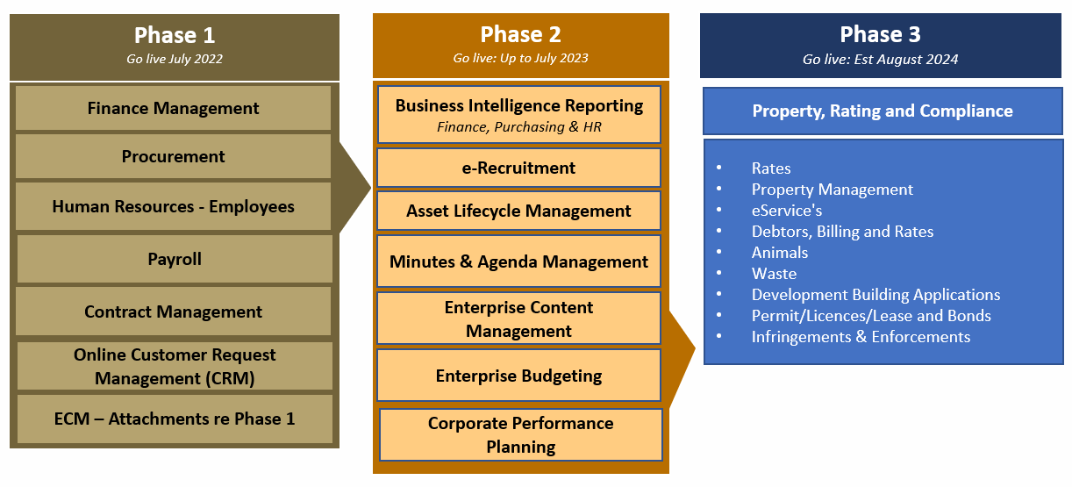
Figure 1 -OneCouncil: Overview of Phases

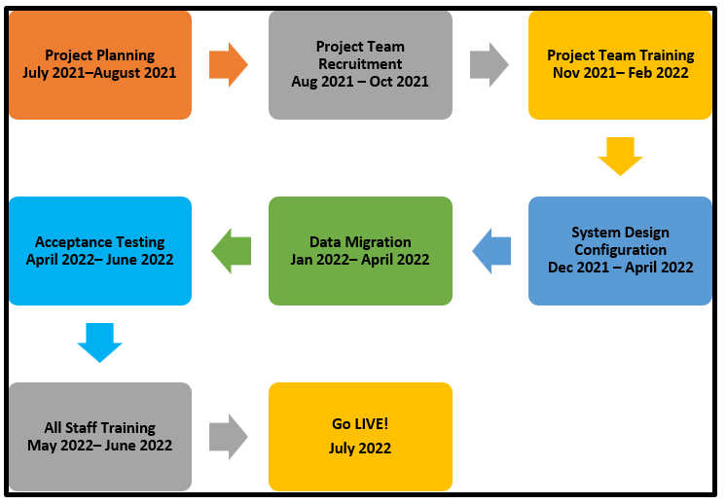
In terms of implementing Phase 1 of OneCouncil, the graphical representation below outlines the key project milestones:
Figure 2 -OneCouncil Phase 1 Milestones

Update on Progress
                - The OneCouncil project is 77% complete. The OneCouncil Phase 1 project dashboard follows:

KPI | Status | Notes
Budget |  | Tracking under for 2021/2022.
Schedule |  | Go Live, Phase 1 is scheduled for 1st July 2022.  Scheduled Go Live is not movable. However, changes in Project Team, and inability to maintain 100% headcount means that certain aspects of Go-Live will be less fully featured.
Resources |  | - Previously reporting positions remain unfilled  - They will now not be filled this FY  - The status remains red due to availability of payroll resources and the challenges with that space
Risks |  | - Staff turnover within the Team has settled. The incumbent team are all committed to the project
Scope |  | - The delivery of more nuanced features within the Procurement and Contract Management modules has been impacted both by Project Team changes but also of the City’s own ability to support these process

Legend | Description
 | Attention required.
 | Potential impact on project.
 | No issues.

Milestone Status
The status of the key milestones outlined in the project schedule for the implementation of OneCouncil Phase 1 are:

# | Milestone | Status | %  Complete | Target Date
1 | Project Planning |  | 100% | 31 September 2021
2 | Project Team Recruitment |  | 100% | 29 October 2021
3 | Project Team Training |  | 100% | 11 February 2022
4 | System Design & Configuration |  | 98% | 30 April 2022
5 | Data Migration |  | 85% | 30 May 2022
6 | Acceptance Testing |  | 61% | 30 May 2022
7 | All Staff Training |  | 39% | 30 June 2022
8 | Go LIVE |  | 0% | 4 July 2022

Legend | Description
 | Milestone delayed > 10%.
 | Potential for milestone delay.
 | Milestone on target.

The overall project schedule is below:

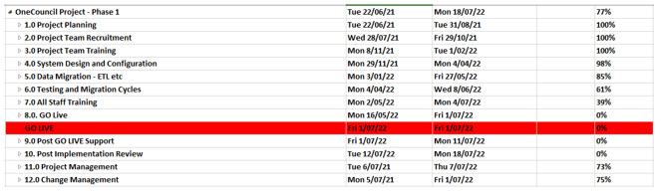

Key Activities Completed: April 2022

The key activities completed by the OneCouncil Project in March 2022 were:

- Milestone #4 - System Design & Configuration – 98% Complete

- Completed : Configurations appropriate to Finance, HR and Payroll, Request Management are completed
- Outstanding : Final ‘Tweaks’ subject to training session feedback

- Milestone #5 – Data Migration – 85% Complete

- Continue: Develop the data extraction and identification of data quality issues from the Authority System.
- Particular note: Leave balances are proving a challenge. A significant portion of those balances are, apparently, untrustworthy.
- The first resolution session is scheduled for 11/05/2022. This, and associated sessions, will result in a proposal for resolution that may require executive sign off.

- Project Management

- Ongoing : Team management, meetings and knowledge transfer.
- Ongoing : refinement of Go-Live checklist for period 20/06/2022 to 03/07/2022

- Change Management

- Ongoing communications.
- Training Period kicked off with Morning Tea and demo session

Key Activities Planned for next period - May 2022

The key activities planned for the next period are:

a. Milestone #7 – System Testing and Migration Cycles
i. Complete 2nd AND 3rd Cycle of Testing

b. Milestone #8 – completion and publication of the Go-Live strategy for the business to understand what is required of it over that period

c. Change Management

i. Delivery of training to staff.
ii. Booking mechanisms already available

Project Governance

The OneCouncil Steering Committee is the City’s Executive Management Team. OneCouncil Steering Committee Meetings are scheduled monthly with the City’s project manager tabling a formal report on the overall status of the OneCouncil project.

The City’s CEO also provides monthly updates to staff in the Monthly Staff Newsletter and provides regular updates to Council.

Regular OneCouncil project team meetings are also held to monitor and control the OneCouncil project progress.

Consultation

The OneCouncil Project team has developed the following stakeholder consultation plans:

Stakeholder Consultation Plans | Purpose
Change Management Plan | To outline the strategy and approach to managing the organisational change associated with implementing the OneCouncil project for employees, customers and stakeholders.
Communication Plan | To provide an overall framework for the ongoing management, coordination and delivery of communications to all staff across the City of Nedlands impacted by the OneCouncil project activities.
Stakeholder Engagement Plan | To outline the City’s approach to managing stakeholder engagement throughout the implementation of the OneCouncil solution to ensure clear direction for the delivery of stakeholder engagement actions.

The City has also been consulting with the City of South Perth and the Shire of Serpentine Jarrahdale who are also implementing the same TechnologyOne OneCouncil system. The City has signed a Memorandum of Understanding (MoU) with the City of South Perth and the Shire of Serpentine Jarrahdale for the purpose of sharing information, system configuration/setup and lessons learnt.

Strategic Implications

This item relates to the following elements from the City’s Strategic Community Plan.

Vision Our city will be an environmentally sensitive, beautiful and inclusive place.

Values High standard of services
We have local services delivered to a high standard that take the needs of our diverse community into account.

Great Governance and Civic Leadership
We value our Council’s quality decision-making, effective and innovative leadership, transparency, accountability, equity, integrity and wise stewardship of the community’s assets and resources. We have an involved community and collaborate with others, valuing respectful debate and deliberation.

The City has adopted an Enterprise Resource Planning approach that sets the foundation for all organisational information technology systems and other supporting technologies. Investing in information systems and technology will provide the City of Nedlands with the requisite tools to plan, execute, evaluate all existing and future operations.

The overarching benefits of implementing OneCouncil were reported to the Audit and Risk Committee meetings held in August 2021 and November 2021.

Priority Area

The implementation of OneCouncil is a key result area for the Chief Executive Officer.

Budget/Financial Implications

The provision of the implementation of OneCouncil is included in the City of Nedlands 2021/22 Annual Budget.

Legislative and Policy Implications

This section should identify the legislative and policy implications that apply to the item being considered. Include name of legislation or policy which applies and the section/s.

Decision Implications

Nil.

Conclusion

The implementation of OneCouncil Project is a significant investment that enables a whole new way of doing business more effectively. It is more than just new software as the City is implementing transformational change that impacts every aspect of how we do our business.

To date, the OneCouncil Project has achieved all milestones as scheduled for Project Planning, Project Team Recruitment and Project Team Training. In addition, the Project Team has implemented strategies to minimise the impact that resource challenges have presented.

The Project Team are now commencing the system design configuration and progressing the migration of data from the City’s legacy system, Authority, to OneCouncil.

Further Information

N/A.

Date of Next Meeting

The date of the next meeting of the Audit & Risk Committee Meeting will be on Monday 29 August 2022 at 5.30pm.

Declaration of Closure

There being no further business, the Presiding Member will declare the meeting closed.

