
AGENDA

Council Meeting Agenda Forum
Tuesday, 14 May 2024

Notice of Meeting

Mayor & Councillors

A Council Meeting Agenda Forum of the City of Nedlands is to be held on Tuesday, 14 May 2024 in the Council chambers at 71 Stirling Highway Nedlands commencing at 7pm.
This meeting will be livestreamed Livestreaming Council & Committee Meetings » City of Nedlands



Matthew MacPherson | Acting Chief Executive Officer
9 May 2024
Information
Council Meeting Agenda Forum are run in accordance with the City of Nedlands Governance Framework Policy. If you have any questions in relation to the agenda, procedural matters, addressing the Council or attending these meetings please contact the Executive Officer on 9273 3500 or council@nedlands.wa.gov.au
Public Question Time
Public Questions are dealt with at the Ordinary Council Meeting.
Deputations
Members of the public may make presentations or ask questions on items contained within the agenda. Presentations are limited to 5 minutes. Members of the public must complete the online registration form available on the City’s website: Public Address Registration Form | City of Nedlands
Disclaimer
Members of the public who attend Council Meetings Agenda Forum should not act immediately on anything they hear at the meetings, without first seeking clarification of Council’s position. For example, by reference to the confirmed Minutes of Council meeting. Members of the public are also advised to wait for written advice from the Council prior to taking action on any matter that they may have before Council.
Any plans or documents in agendas and minutes may be subject to copyright. The express permission of the copyright owner must be obtained before copying any copyright material.

Table of Contents

1. Declaration of Opening 5
2. Present and Apologies and Leave of Absence (Previously Approved) 5
3. Public Question Time 5
4. Deputations 5
5. Requests for Leave of Absence 5
6. Petitions 5
7. Disclosures of Financial Interest 6
8. Disclosures of Interests Affecting Impartiality 6
9. Declarations by Members That They Have Not Given Due Consideration to Papers 6
10. Confirmation of Minutes 6
11. Announcements of the Presiding Member without discussion 7
12. Members Announcements without discussion 7
13. Matters for Which the Meeting May Be Closed 7
14. En Bloc Items 7
15. Minutes of Council Committees and Administrative Liaison Working Groups 7
15.1 Minutes of the following Committee Meetings (in date order) are to be received: 7
16. Divisional Reports - Planning & Development 8
16.1 PD31.05.24 Nedlands Village Precinct Structure Plan – Recommendation to the Western Australian Planning Commission 8
16.2 PD32.05.24 Consideration of Change of Use from ‘Single House’ to ‘Display Home’ and associated Signage at 53 Stanley Street, Nedlands 27
16.3 PD33.05.24 Section 31 Reconsideration of Development Application – Additions and Alterations to Single House at 89 Watkins Road, Dalkeith 35
16.4 PD34.05.24 Proposed naming of unnamed laneway north of Haldane Street, Mt Claremont 46
16.5 PD35.05.24 Consent to Advertise Local Planning Policy 1.1 -Residential Development 50
16.6 PD36.05.24 Consent to Advertise draft Local Planning Policy – Precincts 58
16.7 PD37.05.24 Invitation for Involvement in the Design Process of the Proposed Greenspace Adjacent to WA Bridge Club, Allen Park, Swanbourne 63
16.8 PD38.05.24 West Waratah Precinct Parking Restrictions Consultation 67
17. Divisional Reports - Technical Services 77
17.1 TS17.05.24 Brockway Roadside Safety Inspection 77
17.2 TS18.05.24 Tree Removal to Facilitate a City Project – WA Bridge Club Car Park 85
18. Divisional Reports – Community Services & Development 90
18.1 CDS02.05.24 Reclassification of Point Resolution Child Care Centre license 90
19. Divisional Reports - Corporate Services 105
19.1 CPS23.05.24 Monthly Financial Report – April 2024 105
19.2 CPS24.05.24 - Monthly Investment Report - April 2024 105
19.3 CPS25.05.24 - List of Accounts Paid - April 2024 105
19.4 CPS26.05.24 – Powerlyt Solar Recommendations 106
19.5 CPS27.05.24 Underground Power – Consideration of Results from Consultation and Next Steps 110
20. Reports by the Chief Executive Officer 119
20.1 CEO13.05.24 Outstanding Council Resolutions 119
20.2 CEO15.05.24 City of Nedlands Dogs Local Law 2023 – Undertaking to Joint Standing Committee on Delegated Legislation 121
21. Council Members Notice of Motions of Which Previous Notice Has Been Given 124
22. Urgent Business Approved By the Presiding Member or By Decision 124
23. Confidential Items 125
24. Declaration of Closure 126

Declaration of Opening

The Presiding Member will declare the meeting open at 7.00 pm and acknowledge the Whadjuk Nyoongar people, Traditional Custodians of the land on which we meet, and pay respect to Elders past, present and emerging. The Presiding Member will draw attention to the disclaimer on page 2 and advise the meeting is being livestreamed.

Present and Apologies and Leave of Absence (Previously Approved)

Leave of Absence Nil.
(Previously Approved)

Apologies None as at distribution of this agenda.

Public Question Time

Public questions will be dealt with at the Ordinary Council Meeting.

Deputations

Deputations by members of the public who have completed Public Address Registration Forms.

Requests for Leave of Absence

Any requests from Council Members for leave of absence will be dealt with at the Ordinary Council Meeting.

Petitions

Petitions will be dealt with at the Ordinary Council Meeting.

Disclosures of Financial Interest

The Presiding Member to remind Council Members and Staff of the requirements of Section 5.65 of the Local Government Act to disclose any interest during the meeting when the matter is discussed.

A declaration under this section requires that the nature of the interest must be disclosed. Consequently, a member who has made a declaration must not preside, participate in, or be present during any discussion or decision-making procedure relating to the matter the subject of the declaration.

However, other members may allow participation of the declarant if the member further discloses the extent of the interest. Any such declarant who wishes to participate in the meeting on the matter, shall leave the meeting, after making their declaration and request to participate, while other members consider and decide upon whether the interest is trivial or insignificant or is common to a significant number of electors or ratepayers.

Disclosures of Interests Affecting Impartiality

The Presiding Member to remind Council Members and Staff of the requirements of Council’s Code of Conduct in accordance with Section 5.103 of the Local Government Act.
Council Members and staff are required, in addition to declaring any financial interests to declare any interest that may affect their impartiality in considering a matter. This declaration does not restrict any right to participate in or be present during the decision-making procedure.

The following pro forma declaration is provided to assist in making the disclosure.

"With regard to the matter in item x ….. I disclose that I have an association with the applicant (or person seeking a decision). This association is ….. (nature of the interest).

As a consequence, there may be a perception that my impartiality on the matter may be affected. I declare that I will consider this matter on its merits and vote accordingly."

The member or employee is encouraged to disclose the nature of the association.

Declarations by Members That They Have Not Given Due Consideration to Papers

This item will be dealt with at the Ordinary Council Meeting.

Confirmation of Minutes

This item will be dealt with at the Ordinary Council Meeting.

Announcements of the Presiding Member without discussion

This item will be dealt with at the Ordinary Council Meeting.

Members Announcements without discussion

This item will be dealt with at the Ordinary Council Meeting.

Matters for Which the Meeting May Be Closed

For the convenience of the public, the following Confidential items are identified to be discussed behind closed doors, as the last items of business at this meeting.

En Bloc Items

This item will be dealt with at the Ordinary Council Meeting.

Minutes of Council Committees and Administrative Liaison Working Groups

Minutes of the following Committee Meetings (in date order) are to be received:

This is an information item only to receive the minutes of the various meetings held by the Council appointed Committees (N.B. This should not be confused with Council resolving to accept the recommendations of a particular Committee. Committee recommendations that require Council’s approval should be presented to Council for resolution via the relevant departmental reports).

This item will be dealt with at the Ordinary Council Meeting.

Divisional Reports - Planning & Development

PD31.05.24 Nedlands Village Precinct Structure Plan – Recommendation to the Western Australian Planning Commission

Meeting & Date | Council Meeting 28 May 2024
Applicant | CLE Town Planning and Design
Information Provided | All relevant information required has been provided.
Employee Disclosure under section 5.70 Local Government Act 1995 | Nil.
Report Author | Nathan Blumenthal – A/Manager Urban Planning
Director/CEO | Roy Winslow – A/Director Planning and Development
Attachments | - Zoning Map  - Nedlands Village Precinct Structure Plan dated received 10 January 2024  - Design Review Panel Minutes  - Schedule of Submissions  - External Agency Submissions  - Revised Transport Impact Assessment dated received 4 April 2024  - Schedule of Modifications  - Modified Zoning and Height Map

Purpose

The purpose of this report is for Council to make a recommendation to the Western Australian Planning Commission (WAPC) on the proposed Nedlands Village Precinct Structure Plan. The Precinct Structure Plan has been prepared and submitted by CLE Town Planning and Design on behalf of the landowner, Hesperia.

It is recommended that the Council recommend to the WAPC that the proposed Structure Plan be approved, subject to modifications and provided proposed Amendment No.15 to the City of Nedlands Local Planning Scheme No.3 is approved.

Recommendation

That Council:

In accordance with Clause 20 of the Deemed Provisions of the Planning and Development (Local Planning Schemes) Regulations 2015:

- Note that the land subject of the proposed Nedlands Village Precinct Structure Plan is subject of Amendment No.15 to the City of Nedlands Local Planning Scheme No.3 to rezone the land from “Residential” to “Mixed Use” and approval of this Structure Plan by the Western Australian Planning Commission should not occur unless and until the Hon. Minister for Planning approves Amendment No.15 to the City of Nedlands Local Planning Scheme No.3 and the land is rezoned.

- Recommend to the Western Australian Planning Commission that the proposed Nedlands Village Precinct Structure Plan be approved in the instance where:

- The Hon. Minister has approved Amendment No.15 to the City of Nedlands Local Planning Scheme No.15 and the land has been rezoned;

- The modifications, as set out in Attachment 7, are made to the Nedlands Village Precinct Structure Plan;

- The Western Australian Planning Commission, on the advice of Main Roads WA, is satisfied that the Structure Plan area will not be subject to any adverse impact on the road network; and

- The Western Australian Planning Commission, on the advice of Department of Fire Emergency Services is satisfied that the Structure Plan area will not be subject to any adverse impact from Bushfire risk.

- Forward the full Structure Plan proposal, Schedule of Submissions and the recommended modifications to the Western Australian Planning Commission for its determination.

- Notify the Applicant, affected landowners and submitters of Council’s recommendation.

Voting Requirement

Simple Majority.

Background

Land Details

Metropolitan Region Scheme Zone | Urban
Existing Local Planning Scheme Zone | Residential
R-Code | N/A
Land area | Total: 7.41ha  Lot 101: 1.73ha  Lot 102: 1.86ha  Lot 103: 3.82ha

On 10 January 2024 the City received an application for a Precinct Structure Plan pertaining to Lots 101 and Lot 102 Monash Avenue and Lot 103 Karella Street, Nedlands (Figure 1) and known as the Nedlands Village Precinct Structure Plan (PSP). The three lots have a combined area of 7.41ha. The lots are currently zoned ‘Residential’ with additional use rights in accordance with Local Planning Scheme No.3 (LPS 3) Clause Table 4 ‘A3’. The A3 provisions include Car park, Office, Medical Centre, Place of worship, Residential aged care facility and Shop. In addition, the existing A3 includes built form provisions (maximum 6 storeys or 3 storeys for interface with residential uses) where no structure plan is in place.

There is currently no density code applicable as the area has long been used for the purposes of residential aged care and retirement care, which is subject to separate controls under planning and other legislation. Lot 103 Karella Street is presently vacant. Lots 101 and 102 Monash Avenue are occupied by two residential aged care facilities (Regis Weston and Regis Nedlands) and one retirement village (Centennial Close). The Regis Nedlands building (built in 2018) is proposed to be retained.
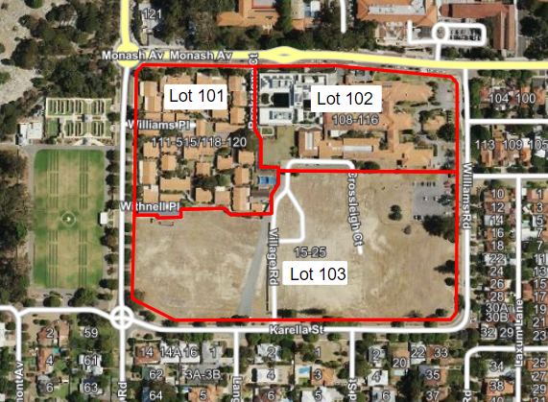
Figure 1: Aerial image of Nedlands Village PSP area.

Site Context

Towards the south and south-west of the PSP area, the existing development is predominantly low scale single houses zoned between R10 and R20 which are not expected to significantly change in terms of density or height in the immediate future. The residential lots to the east are zoned R40 and R60, and the lots to the north-east along Monash Avenue are zoned Mixed Use R-AC3. These lots are expected to undergo a gradual transition to a higher density and scale of development.
To the north of the site is Hollywood Primary School, Hollywood Private Hospital and the QEII Medical Centre.

Application Details

The Nedlands Village PSP has been prepared by CLE on behalf of Hesperia. Precinct Structure Plans are guiding documents on how an area could be developed in the future. It outlines land use, density, and development (including built form), access arrangements, infrastructure, environmental assets and community facilities at a precinct scale to facilitate future subdivision and development.
A separate Scheme Amendment (Scheme Amendment 15) has been lodged to align the LPS 3 zoning and land uses with the PSP. This was presented to Council for initiation at its meeting on 27 February 2024. It is noted that the Scheme Amendment will need to be approved by the Minister to enable the change in zoning and new additional use provisions before the PSP can be finalised.

Discussion

Planning and Development (Local Planning Schemes) Regulations 2015

The Schedule 2 Part 4 Deemed Provisions of the Planning and Development (Local Planning Schemes) Regulations 2015 outlines the process for preparing and amending structure plans. It specifies that they are to be subject to the approval of the WAPC and are to operate as documents of ‘due regard’ (i.e. without the statutory weight of the scheme and consequently capable of flexibility in application). The City has followed the relevant processes outlined within the Regulations in the processing of the structure plan.

State Planning Policy 7.2 Precinct Design Guidelines (SPP 7.2)

SPP 7.2 builds upon the ‘10 Design Principles’ in SPP 7.0, by introducing the concept of design review into the precinct planning through six performance-based design elements. Assessment of the PSP against the intent, objectives, consideration, and guidance of the SPP 7.2 Design Elements is provided below.

Design Element 1: Urban Ecology

Bushfire

The north-west portion of the subject site is within a Bushfire prone area (Figure 2). As such, SPP 3.7: Planning in Bushfire-Prone Areas is applicable (SPP 3.7). The applicant has prepared a Bushfire Management Plan (BMP) in accordance with SPP 3.7 (Refer to Appendix 2 of Attachment 2). The Nedlands Village PSP was referred to the Department of Fire and Emergency Services (DFES) which has noted that the BMP in its current form does not adequately address the SPP 3.7 policy measures. Modifications to the BMP are required as per DFES advice prior to the endorsement of the PSP (Attachment 5).

The BMP assigns responsibility to the City for monitoring of vegetation fuel loads in private landholdings and liaising with relevant stakeholders to maintain fuel loads at minimal/appropriate fuel levels. This is a standard responsibility of the City in accordance with the Bush Fires Act 1954.
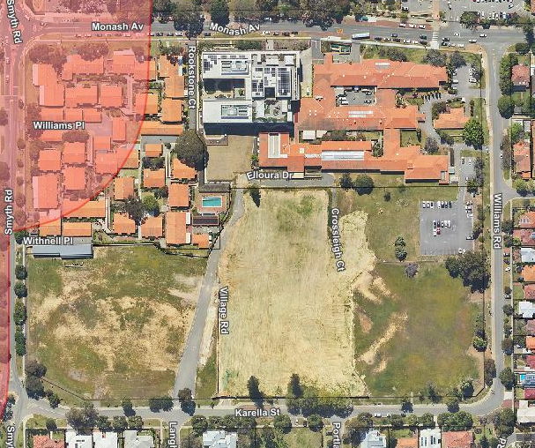
Figure 2: Bushfire prone area highlighted in red.
Carnaby’s Black Cockatoo

Several Carnaby’s black cockatoo roosting sites are known within the greater local area. However, no roosting sites have been identified within the site boundaries. The applicant has provided an Environmental Assessment and Management Strategy (refer to Appendix 4 of Attachment 2) which confirms that no cockatoo species or any other threatened ecological communities or flora species are present on the site. Further, the likelihood that the site can provide important habitat for any fauna species of conservation significance is low, given the site primarily comprises cleared areas and non-native vegetation. The PSP was also referred to the Department of Biodiversity Conservation and Attractions which has not raised any concerns with the proposal.
Notwithstanding, the landscape concept design prepared includes appropriate species selection to help to support the functionality of the identified ecological linkage and provide a secondary foraging habitat for Black Cockatoos and other fauna.

Design Element 2: Urban Structure

Pedestrian Access Ways

The Nedlands Village PSP as lodged proposes one pedestrian access way (PAW) which connects the Hardy Road extension through to Monash Avenue, to the west of the Regis Nedlands building. Following the Design Review Panel (DRP) meetings and public consultation, the applicant has committed to providing two further PAWs, one connecting the Hardy Road extension through to Monash Avenue, to the east of the Regis Nedlands building, and one connecting Karella Street through to the proposed POS (Figure 3). It is recommended that the PSP be modified prior to approval to include the additional two PAWs. The proposed street alignment and inclusion of multiple PAWs is considered to appropriately promote an urban structure which supports accessibility and connectivity within and outside of the PSP area (SPP 7.2 Objective O2.2). Particularly, the new PAW through to the POS from Karella Street highlights a key destination and focal point within the urban structure and creates an opportunity to draw existing Nedlands residents into the site.

This additional PAW connectivity proposed has been supported by the DRP which commented “The site permeability and connectivity within the surrounding precinct has been improved by the inclusion of the new north south pedestrian right of way. The three vehicle access points are supported and provide an adequate level of access to the site”.
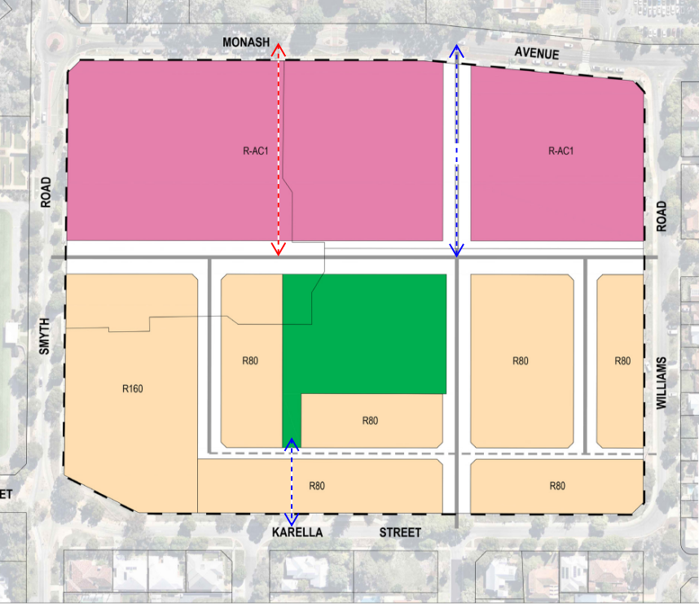
Figure 3: Recommended PAW network. Red PAW is currently proposed. Blue PAW’s are recommended.
Streetscape Activation

The City’s DRP have highlighted the importance of streetscape activation being locked in via the PSP stage. As per advice from the City’s Design Review Panel (DRP) it is recommended that the wording of section 4.2.4 (b) of the PSP be amended to ensure that all at-grade parking within the PSP area is sleeved. This is to ensure high quality streetscape activation whilst minimising dead spaces and streetscapes dominated by parking.

Design Element 3: Public Realm

Public Open Space

Development Control Policy 2.3 Public Open Space in Residential Areas (DCP 2.3) sets out the requirements for the provision of public open space contributions within residential areas. In accordance with DCP 2.3 the typical requirement is for 10% of the gross subdivisible area of the lot be given up free of cost and vested to the Crown as a reserve for Recreation. Any land which is allocated for schools, major regional roads, public utility sites, municipal use sites or other non-residential use is deducted from the gross subdivisible area.

The PSP has excluded the existing Nedlands Regis aged care facility and the future Commercial/Medical Centre site on the corner of Williams Road and Monash Avenue from the gross subdivisible area. After these exclusions, the PSP proposes 9.6% (0.59 ha) public open space. The applicant has committed to the provision of cash in lieu of open space for the remaining 0.4%. In this regard it is recommended that prior to approval, the PSP be modified to include the following wording:

“As a condition of subdivision, the applicant will be required to provide a cash-in-lieu payment for the provision of public open space, to the extent of any shortfall in the ceding of gross subdivisible area.”

Both the Nedlands Regis aged care facility and the future Commercial/Medical Centre site are proposed to be zoned ‘Mixed Use’ via Scheme Amendment 15, and thereby will have the ability to be developed as residential land uses in the future. If this were to occur, the provision of residential public open space would be 7.9%, which is considered insufficient for the needs of the community. To ensure that adequate open space will be provided should these lots be redeveloped as residential, it is recommended that prior to approval the PSP be modified to include the following wording:

“The Nedlands Regis site and the Commercial/Medical Centre site have not made a public open space contribution. Should these sites be developed with a residential component in the future they are subject to a public open space contribution in accordance with Development Control Policy 2.3.”

Landscape Design

The applicant has provided a landscape concept design prepared by Plan E Landscape Architects for the public realm as part of the PSP package which is to be implemented as part of the subdivision process (refer to Appendix 5 of Attachment 2). Landscaping of individual development sites will be assessed as part of the development application processes.

Design Element 4: Movement

Traffic Management

The applicant has prepared a Transport Impact Assessment (TIA) in accordance with WAPC Transport Impact Assessment Guidelines (refer to Appendix 7 of Attachment 2). Given a majority of the existing site is vacant, it is acknowledged that any form of development would result in the generation of additional traffic within the area. The TIA as originally lodged has since been updated to address concerns raised by the City. It is recommended that the revised TIA (Attachment 6) be included as part of any final PSP approval. The revised TIA appropriately demonstrates that the forecast traffic generation from the proposal is capable of being catered for within the existing road network, subject to a left in, left out configuration at the Smyth Road / Hardy Road extension intersection. This has been recommended as a modification to the PSP. It is further recommended that the Hardy Road road reserve be increased from 18m to 20m in width to provide sufficient space for future service alignments. Additionally, a crossover strategy is requested to demonstrate access to the R-AC1 and R160 sites.

The Nedlands Village PSP was referred to Main Roads WA (MRWA) given the site’s proximity to Stirling Highway, which is a Primary Regional Road Reserve. MRWA has requested further information to be included within the TIA (Attachment 5). It is understood that the revised TIA has addressed the matters raised by MRWA. However, it is recommended that the WAPC refer the revised TIA to MRWA for comment prior to approval of the PSP.

Parking

The proposed street reserve design has been configured to allow for on-street parking to be provided within specific street reserves as highlighted in Figure 4 below. Final design configurations will be confirmed via the subdivision and detailed stages of the development in collaboration with the City. It is estimated that approximately 40 on-street parking bays will be provided.

Parking requirements for individual developments will be assessed at development application stage in accordance with the City of Nedlands Local Planning Policy 4.1 Parking and the Residential Design Codes.
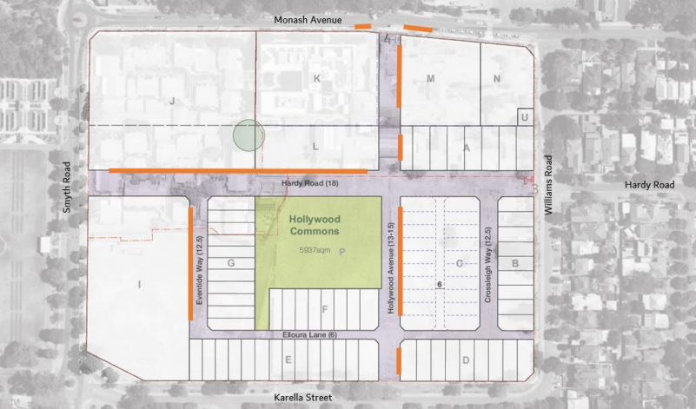
Figure 4: Proposed location of on-street parking
Design Element 5: Land Use

R-Code Density

The proposed Structure Plan is intended for ‘Residential’ and ‘Mixed Use’ land uses. The PSP proposes R-code densities of R160 to lots abutting Smyth Road, R80 to the lots abutting Karella Street and R-AC1 to the lots abutting Monash Avenue. The PSP as proposed has an estimated dwelling yield of 500 dwellings, inclusive of 80 townhouses and 420 apartments.
The City of Nedlands is set a target of 4,320 additional dwellings by 2050 in accordance with Perth and Peel @3.5 Million (2018), which will increase the total number of dwellings in the City to 12,390. The City’s adopted Local Planning Strategy identifies the subject site as available for development/redevelopment for the purposes of increasing dwelling numbers. This is one of four targeted infill sites identified within the Strategy. In this regard the Residential land use is supported.

The draft Liveable Neighbourhoods 2015 provides guidance on the determination of density codes surrounding activity centres and high-frequency public transport routes. The site is in proximity to a high frequency public transport route the UWA/QE2 Specialised Activity Centre. This location does not neatly fit into any of the categories identified in draft Liveable Neighbourhoods but would most closely correlate to a density code of R30 to R50.

Given the more recent infill targets set by Perth and Peel @3.5 Million and the City’s Strategy, the density guidance outlined in draft Liveable Neighbourhoods may no longer be adequate to achieve infill targets. The City’s Strategy preferences targeted density over ad-hoc subdivisions, and thereby the site is an appropriate location to accommodate increased density. The Strategy does not set a prescriptive dwelling target for specific lots; therefore, consideration of density is primarily guided by the recently released State Planning Policy 7.2: Precinct Design.

Land Use

The land uses proposed are largely imposed via the proposed Scheme Amendment 15 (Figure 5). The land uses proposed are not a significant change from the existing additional land uses accessible to the site. Existing Lots 101 and 102 are already afforded a range of additional non-residential use rights, therefore the proposed zoning change from ‘Residential’ to ‘Mixed Use’ is broadly consistent with the existing LPS3. The applicant has indicated that the intended land uses for the mixed use sites are for Medical Centre, Consulting Rooms, Offices and residential. These are all uses which can be considered within the mixed use zone in accordance with LPS3.

Scheme Amendment 15 proposes a new ‘A10’ additional use right to the residential zones which allows for discretionary consideration of ‘Office’, ‘Recreation-private’, ‘Restaurant/café’ and ‘Shop’ The additional use rights proposed via ‘A10’, are consistent with the existing additional use rights afforded to the site, with the addition of ‘Recreation – private’. It is acknowledged that some ‘Recreation – private’ land uses may be appropriate and provide a greater level of amenity within this locality. All proposed non-residential uses are discretionary and therefore will require development approval to be obtained from the City prior to commencement. This allows for detailed assessment of the specific land uses and operations to occur via the development application pathway.
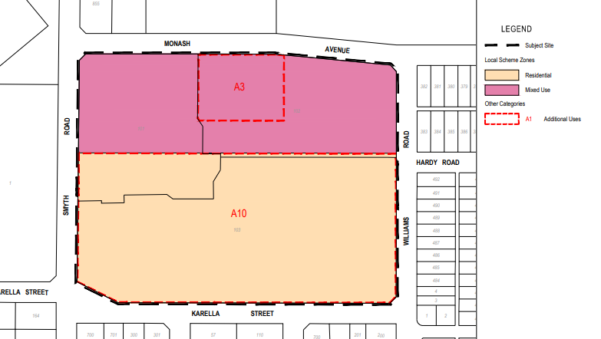
Figure 5: Proposed zoning and Additional Use rights map.
Design Element 6: Built Form

Height & Plot Ratio

The Nedlands Village PSP is intended to be read in conjunction with State Planning Policy 7.3 – Residential Design Codes Volume 1 (R-Codes Volume 1) and State Planning Policy 7.3 – Residential Design Codes – Apartments (R-Codes Volume 2). Section 4.2 of the PSP provides additional development provisions which vary from or are in addition to the R-Codes. In relation to allowable building height this references Plan B: Built Form Controls (Figure 6).
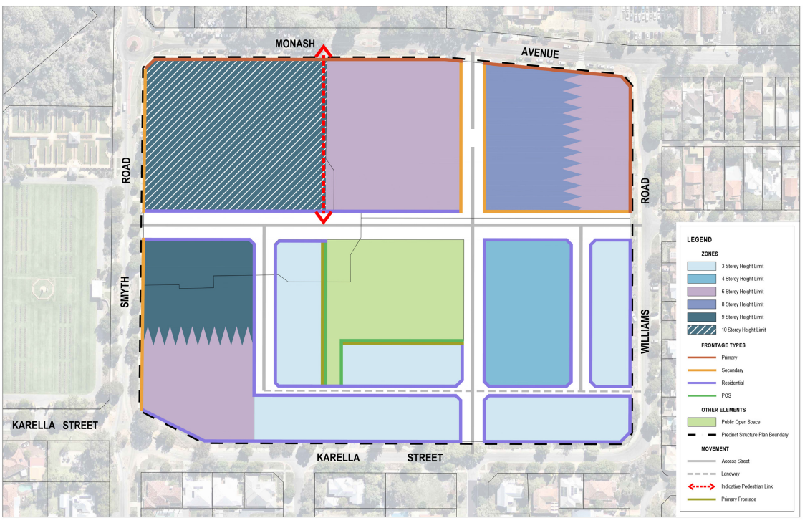
Figure 6: Plan B: Built Form Controls
The current overall height limit for the site in LPS 3 is 6 storeys, or 3 storeys where the development has a residential interface. The PSP generally maintains the 3 storey height limit where the development has a residential interface, except for the lot on the south-west corner of the site, identified in the PSP as Lot I. This lot is proposed to have a height of 6-9 storeys. Officers are not supportive of the height proposed to this lot as it is not responsive to the purpose, context and intended character of the precinct (SPP 7.2 Objective O6.1) nor does it provide for a sensitive transition between lots of differing densities, particularly the existing low-coded lots directly across Karella Street. Further, the height proposed is inconsistent with the R-Codes Volume 2, which sets an Acceptable Outcome of 5 storeys for the R160 coding. Little justification has been provided in the PSP to justify why this height limit and/or density code is proposed.

It is recommended that the existing height limit of 3 storeys is imposed where the development has a residential interface. The remainder of the block is to be as per the R-Codes Volume 2 acceptable outcome (5 storeys). A mark-up of the recommended height controls for the Residential zoned lots is provided at Figure 7 below. This proposed built form has been supported by the DRP which commented

“The south-west lot is not acceptable in its current form. The built form should be 3 storeys to Karella Street with further height being positioned towards Hardy Road”.
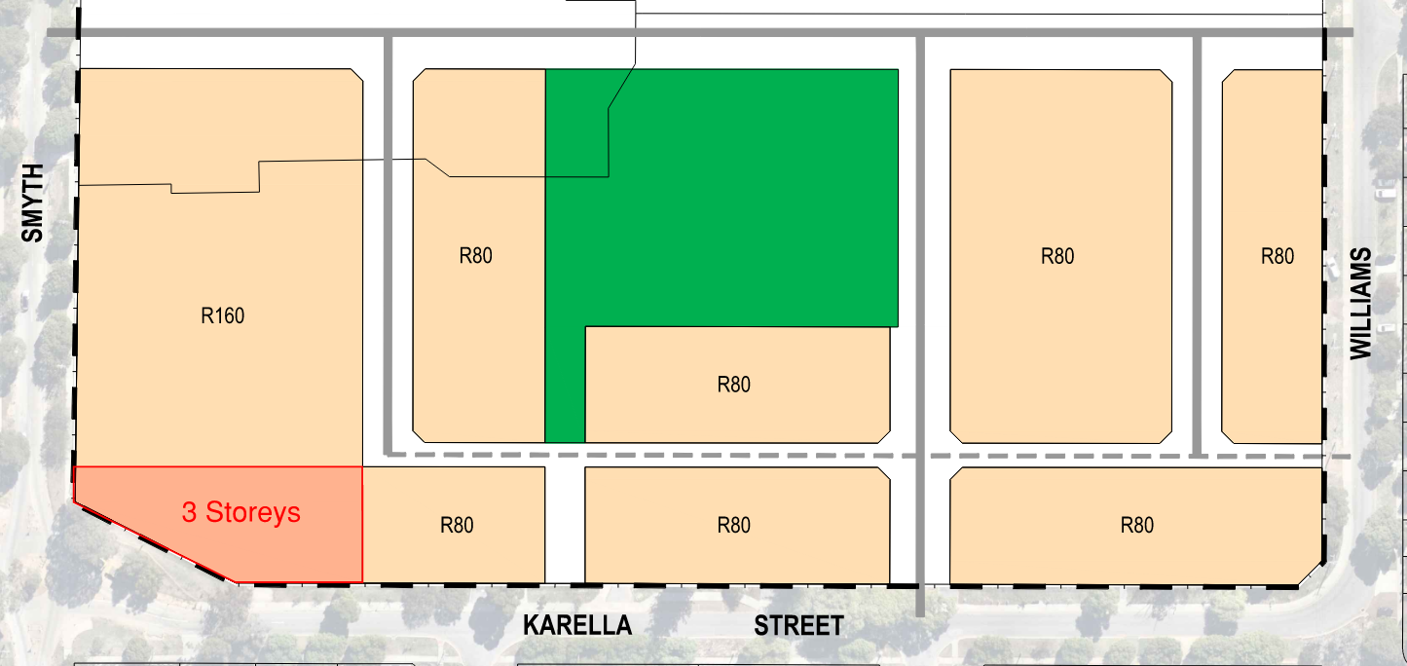
Figure 7: Recommended Height provisions for Lot I
In relation to the Mixed Use zones to the north of the PSP area, the Plan B: Built Form Controls proposes a range of transitional heights ranging from 6 storeys to 10 storeys. The R-Codes Volume 2 sets an Acceptable Outcome of 9 storeys for the R-AC1 coding. Whilst is acknowledged that a transition of heights is likely appropriate to respond to the existing surrounding context, this consideration is already included as part of the R-Codes Volume 2 (Element Objective O2.2.1: the height of development responds to the desired future scale and character of the street and local area, including existing buildings which are unlikely to change). In this regard, the prescriptive heights set in Plan B, especially those which exceed the acceptable outcome, are not necessary to facilitate development which will appropriately respond the context. It is recommended that the height controls pertaining to the Mixed Use zones are reverted back to the R-Codes acceptable outcomes.

In addition to height, the PSP Table 3: Built Form Controls proposes to remove plot ratio outcomes for all lots. The only justification provided for the removal of plot ratio is that

“Building envelopes are to be delivered in accordance with ‘frontage type’ development provisions, as opposed to applying a generic plot ratio. The intent here is to ensure that all buildings are responsive to the existing surrounds and future context” (PSP Page 76).

This consideration is already included as part of the R-Codes Volume 2 (Element Objective O2.5.1: the overall bulk and scale of development is appropriate for the existing or planned character of the area). In this regard, the removal of plot ratio controls via the PSP is not supported and it is recommended that the plot ratio provisions are reverted to the R-Codes acceptable outcomes. This approach has been supported by the DRP which commented

“The PSP should not include additional height or plot ratios beyond the specified R-Code. Any height variations should be addressed as part of the development application process”.
Design Guidelines

The applicant has proposed that the townhouse component of the Nedlands Village PSP area will be subject to a set of site-specific Design Guidelines. These are being developed by the applicant to complement the existing planning framework and facilitate a cohesive architectural response. This is anticipated to be lodged in conjunction with the future subdivision application and is subject to separate approval from the WAPC. Minimal details of the proposed Design Guidelines have been provided as part of the PSP lodgement.

Key objectives of Design Element 6 are to ensure that built form design reduces energy demand by facilitating climate responsive design and to ensure designs are responsive to the streetscape and create a safe and comfortable public realm. This should consider the layout of building to optimise natural ventilation and the design of setbacks and building envelopes to define the streetscape character. Without the provision of Design Guidelines at the PSP stage, these elements of SPP 7.2 are unable to be adequately assessed. In principle, officers are supportive of the preparation of Design Guidelines. However, this should be provided, at minimum, in draft form at the PSP stage. This approach has been supported by the DRP which commented

“Design guidelines, including indicative architectural solutions to the more constrained single residential lots, should be prepared as soon as possible and included within the PSP”.

Minor Modifications

In addition to the modifications discussed above, a number of minor modifications to the PSP as lodged are recommended as followed:

- Modify Plan A to show Hollywood Street north of Hardy Road being zoned ‘Mixed Use – R-AC1’ – The public road as shown on the lodged PSP is to be replaced with a PAW.
- Rename all references to ‘Nedlands Village’ to ‘Nedlands Reserve’ – This name change is at the request of the applicant. This has no planning implications and is supported.
- Update all figures to reflect updated Structure Plan Map Part A and B – For consistency and clarity.

Consultation

Public Consultation (Community)

In accordance with the Regulations the Structure Plan was advertised as follows for 42 days, from 15 January 2024 to 26 February 2024, in the following manner:

- Written notification to owners and occupiers within a 200m radius.
- Four signs placed on site at each street for the duration of the advertising period.
- Two community information sessions held on Wednesday 7 February 5pm – 7pm and Saturday 17 February 9am – 11am.
- Social media post on the City’s Facebook on the 6 February 2024.
- Notice and publication on the City’s website.
- Notice on the information board at the City’s Administration Building.
- Notice in the Post Newspaper.

At the close of the advertising period, the City received 102 submissions. A full schedule of submissions and applicant responses are provided at Attachment 3. A summary of the key themes from submissions is provided in Table 1.

Table 1: Public Consultation
Issue Raised | No. of Submissions | Officer Comment
Concerns with increase in traffic – inability for existing road network to accommodate more traffic. | 22 | It has been adequately demonstrated that the projected traffic generation can be accommodated within the existing and proposed road network subject to a left in, left out configuration at the Smyth Road / Hardy Road extension intersection.
Concerns with proposed new road network and rat run traffic | 18 | The proposed road design is intended to integrate into the existing grid road network rather than create an enclave. The design aims to eliminate any long, open view lines for motorists that might encourage rat running.
Loss of Character / Nedlands leafy green feel | 8 | The Nedlands Village PSP proposes over 200 new trees which is a significant improvement on tree canopy in comparison to the pre-development condition. Trees are generally located along pedestrian access linkages to facilitate pedestrian movements and deliver amenity and canopy to the local area. Further, the proposal has generally been supported by the City’s DRP in relation to its response to local context.
Inadequate provision of Open Space. | 8 | Refer to discussion of Public Open Space within this report.
Concerns with location of Open Space – should be more accessible to the public. | 4 | The central location of the public open space is generally supported, subject to additional PAW links to create for a more effective visual connection and accessibility to the greater public.
Support for proposed Open Space. | 13 | Noted.
Proposed building heights / densities are too high. | 18 | Refer to discussion on Land Use and Built Form within this report.
Concerns with lack of on-site and street parking. | 10 | Refer to discussion on Parking within this report.
Support for redevelopment of an underutilised site. | 30 | Noted.
Concerns with construction management. | 3 | The City requires a Construction Management Plan to be submitted to, approved by and monitored by the City of Nedlands for all stages of development. This will require the applicant to adhere to appropriate noise, dust, vibration and tree protection measures.

Public Agencies/Departments

The application was referred to the following Departments and Agencies for comment.

- ATCO
- City of Perth
- City of Subiaco
- Department of Biodiversity Conservation and Attractions
- Department of Education
- Department of Fire and Emergency Services
- Department of Health
- Department of Planning Lands and Heritage
- Department of Water and Environmental Regulation
- Main Roads WA
- Metropolitan Cemeteries Board
- Public Transport Authority
- Water Corporation
- Western Power

Attachment 4 provides comments from those agencies that made submissions during the consultation period, along with a City Officer response.

Design Review Panel

The PSP was presented to the City’s Design Review Panel (DRP) on two occasions on 5 February and 18 March 2024 Full DRP Minutes are provided at Attachment 3 along with responses from the applicant. A summary of the DRP advice is provided in Table 2 below.

Table 2: Design Review Evaluation
 | Supported
 | Further information required
 | Not yet supported
 | Yet to be addressed
 |  | DRP1 – 5 February | DRP2 – 18 March
Element 1 – Urban Ecology
Element 2 – Urban Structure
Element 3 – Public Realm
Element 4 – Movement
Element 5 – Land Use
Element 6 – Built Form

Broadly, the DRP comments provided support for the re-development and renewal of the site, the proposed permeability and connectivity within the surrounding precinct, commitment to sustainability, the provision of new housing and commercial offerings to the community, and response to local context and Nedlands ‘sense of place’. Scoring of the Built Form principle remained as ‘not yet supported’ on the basis of height, plot ratio and lack of Design Guidelines as discussed above. These matters have been requested to be modified prior to the approval of the PSP.

It is noted that the City is obligated to process the PSP within a prescribed period of time. This has required the PSP to be presented to Council with DRP support not yet forthcoming.

Strategic Implications

This item relates to the following elements from the City’s Strategic Community Plan.

Vision Sustainable and responsible for a bright future

Pillar Place
Outcome 6. Sustainable population growth with responsible urban planning.

Budget/Financial Implications

Nil

Legislative and Policy Implications

The Precinct Structure Plan is to be processed in line with the requirements of the Planning and Development (Local Planning Scheme) Regulations 2015.

Decision Implications

The processes and determination powers with respect to Structure Plans are governed by the Deemed Provisions of Schedule No.2 of the Planning and Development (Local Planning Schemes) Regulations 2015. Under these regulations, the Western Australian Planning Commission is the sole authority responsible for making determinations on Structure Plans.

Pursuant to Regulation 20 (1), Part 4, Schedule 2 of the Planning and Development (Local Planning Schemes) Regulations 2015, the responsible authority must prepare a report to the Western Australian Planning Commission on that Structure Plan, inclusive of a recommendation as to whether or not it should be approved, within 60 days of the date of closure of the public advertising period, or alternatively by a date agreed to by the Western Australian Planning Commission.

The reason why this Structure Plan proposal is advancing now ahead of the Scheme Amendment is because the Applicant obtained the necessary consent from the Western Australian Planning Commission for this to be lodged, advertised and assessed before the land is rezoned via Scheme Amendment No.15, on the proviso that the Structure Plan is not finalised by the Western Australian Planning Commission (not Council) until the rezoning is in-place.

Conclusion

The proposed Nedlands Village PSP is broadly consistent with the six-design elements of SPP 7.2 subject to modifications. The City’s adopted Local Planning Strategy identifies the subject site as available for development/redevelopment for the purposes of increasing dwelling numbers and the PSP includes appropriates provisions for both residential and non-residential land uses. The proposed public open space is well designed and of a suitable size to enhance residential amenity for both new residents and existing residents within the greater Nedlands locality. The proposed road network provides suitable connectivity to the existing road network and is capable of accommodating the increased traffic generation.

It is recommended that Council adopts the officer recommendation to WAPC, to approve the PSP subject to modifications and the endorsement of Scheme Amendment 15.

Further Information

Nil

PD32.05.24 Consideration of Change of Use from ‘Single House’ to ‘Display Home’ and associated Signage at 53 Stanley Street, Nedlands

Meeting & Date | Council Meeting – 28 May 2024
Applicant | CF Town Planning and Development
Employee Disclosure under section 5.70 Local Government Act 1995 | Nil.
Report Author | Nathan Blumenthal – A/Manager Urban Planning
Director | Roy Winslow – A/Director Planning and Development
Attachments | - Zoning Map  - Development Plans  - Cover Letter  - CONFIDENTIAL ATTACHMENT – Schedule of Submissions and Applicants Response

Purpose

The purpose of this report is for Council to consider a development application for a temporary change of use from a ‘Residential - Single House’ to ‘Display Home’ and an associated sign at 53 Stanley Street, Nedlands. The application is presented to Council as objections have been received during the advertising period.

Recommendation

That Council:

In accordance with Clause 68(2)(b) of the Deemed Provisions of the Planning and Development (Local Planning Schemes) Regulations 2015, approves the development application in accordance with the plans date stamped 17 November 2023 for a change of use from ‘Residential – Single House’ to ‘Display Home’ and associated signage at 53 Stanley Street, Nedlands (DA23-90352) subject to the following conditions:

- This approval is valid for 18 months commencing from the soonest of:

  - The date of the completion of the construction works at 53 Stanley Street, Nedlands; or
  - 12 months of the date of this decision notice.

After such time the signs are to be removed and the use will revert to a residential single house.

- This approval relates only to a temporary change of use from Residential – Single House’ to ‘Display Home’ and one sign. It does not relate to any other development on this lot.

- The operation of the Display Home is limited to the following:

- Monday to Friday – appointments only.
- Saturday and Sunday – 2:00pm to 4:00pm.

- Signage associated with the land use shall be limited to the following:

a. One (1) fixed sign with a maximum width of 0.72 metres by a maximum height of 0.7 metres and a maximum overall height of 2.04 metres with posts, to be displayed only for the life of this approval.

All signage is to be located wholly inside the property boundaries.

- A maximum of 6 visitors and 1 employee are permitted on site at any one time.

- All staff shall park within the garage and visitors instructed to park on the property where available by the staff of the display home during opening hours.

Voting Requirement

Simple Majority.

This report is of a quasi judicial nature as it is a matter that directly affects a person’s rights and interests. The judicial character arises from the obligation to abide by the principles of natural justice. Examples of Quasi-Judicial authority include town planning applications and other decisions that may be appealable to the State Administrative Tribunal.

The decision must be made in a manner that is impartial, free from bias, and in accordance with the principles of natural justice. The decision must be made in having regard to the facts of the matter under consideration, and in accordance with the relevant laws and policies as they apply to that matter.
Discretionary considerations and judgments in the decision must be confined to those permitted to be considered under the laws and polices applicable to the matter and given such weight in making the decision as the relevant laws and polices permit them to be given.

Background

Land Details

Metropolitan Region Scheme Zone | Urban
Local Planning Scheme Zone | Residential
R-Code | R10
Land area | 1,011m²
Land Use | Existing – Single House  Proposed – Display Home
Use Class | Use not Listed – ‘A’ use

The subject site is located at 53 Stanley Street, Nedlands, directly opposite the former Loreto Primary School (Figure 1). The site is located on the western side of Stanley Street, Nedlands. On 18 January 2023, the City granted development approval for a two-storey, single house on the site. The house is currently under construction. The lot is regular in shape, with a 20m frontage and a total area of 1,011m².
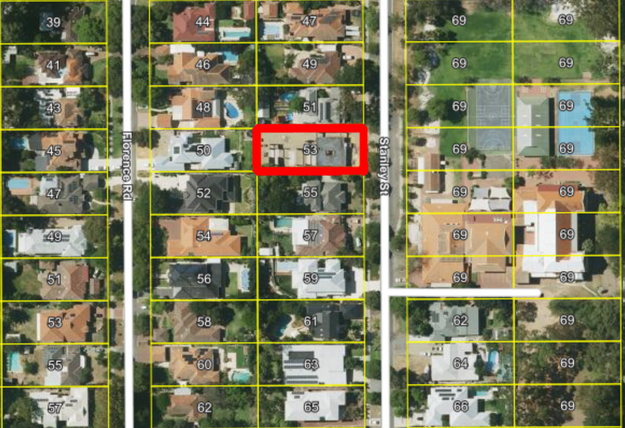Figure 1: Aerial image of 53 Stanley Street, Nedlands
Application Details

The application seeks development approval for a temporary change of use from ‘Single House’ to ‘Display Home’ for a minimum period of three years, after which the site will revert back to a single house.

Details of the proposed Display Home have been outlined in the attached cover letter. These are as follows:

- Hours of operation:
Monday to Friday – Appointments only.
Saturday and Sunday – 2pm to 4pm.

- Employees on site
One staff member at any given time and a second may attend on occasions.

- Visitors
The estimated patronage is between two and six persons at any one time.

- Signage
A ‘monolith’ type sign with a height of 3m and a width of 1.4m is proposed. The proposed sign is further discussed below.

Discussion

Local Planning Scheme No. 3

Schedule 2, Clause 67(2) (Consideration of application by Local Government) – identifies those matters that are required to be given due regard to the extent relevant to the application. Where relevant, these matters are discussed in the following sections. Overall, the development is considered to meet these objectives, and the impact on the local amenity will be minimal for the reasons discussed in the below section.

A Display Home is considered a ‘use not listed’ by the City of Nedlands Local Planning Scheme No.3 (the Scheme). As per clause 18 (4)(b), uses that are not specifically listed may be considered for approval having regard to the objectives of the zone. The proposal has been assessed against, and is considered consistent with, the below relevant objectives of the ‘Residential’ zone.

To provide for a range of non-residential uses, which are comparable with and complimentary to residential development.

- Display homes are complimentary to the Residential zone as they can typically be found in suburban areas and are used by real estate agencies and building companies to facilitate the sale or design of houses.

- The proposed display home will be temporary in nature. Although three years has been applied, City Officers recommend that an initial 18-month approval period be conditioned. This is in line with other Display Homes previously considered by Council. After the Display Home use lapses, the land use will default back to a single house. The proponent also has the ability to apply for an extension in the future.

To ensure development maintains compatibility with the desired streetscape in terms of bulk, scale, height, street alignment and setbacks.
- The proposed development is compatible with the character of the area as it pertains to a two-storey single house that will not physically alter the low-density residential streetscape appearance of the locality.

- The use will be limited in operational hours and number of visitors to eliminate any potential detrimental impact to neighbourhood amenity.

- Six parking bays are provided on site to accommodate visitors and staff.

Local Planning Policy – Parking

A Display Home use is a ‘use not listed’ within the Scheme. In accordance with Clause 4.2.1 of the Local Planning Policy-Parking, where a land use is not listed, the parking ratio will be determined having regard to similar and surrounding uses. The Display Home use can be considered similar to a home business use as staff and customers will be arriving and leaving the property during operational hours. Therefore, the parking requirements (as per Table 1 of LPP 4. 1) are informed by the number of staff and customers expected to visit the property at any given time.
The proposal identifies that the Display Home will comprise of one staff member and up to six visitors at any given time which requires a total of seven bays. This is a ‘worst case’ scenario that assumes that all visitors will come in separate vehicles. The site will be serviced by three bays in the garage and three bays in the property’s driveway which will provide a total of six car parking bays on site. This indicates that there will be a one car parking bay policy shortfall.

Parking arrangements are considered acceptable for this site due to the following reasons.

- The site is serviced by a crossover from the site to Stanley Street which will be able to facilitate one extra parking bay.

- Visitation during the week will be by appointment only, which limits the number of people arriving and leaving throughout the opening hours.

- Most visitors are likely to be in groups arriving together in a single vehicle reducing the need for multiple parking bays.

- The use will mostly operate outside of peak hours and when on-street parking availability is at its highest. This includes seven bays directly opposite the site, in front of the former Loreto Primary School.

Local Planning Policy – Signage and Advertisements

The proposal includes the erection of a ‘monolith’ advertising sign within the front setback of the site for the purpose of advertising the display home. The sign is proposed to have a height of 3m and a maximum width of 1.4m, with the sign to be displayed for the entirety of the duration of the Display Home use. In accordance with Local Planning Policy – Signage and Advertisements, the sign is determined as a ‘monolith’ sign, which is not permitted within a ‘Residential’ zoned area. Therefore, the sign is required to be assessed against the objectives of the policy identified in section 3.0.

The sign does not contain any flashing details which would adversely impact the amenity of the surrounding area and the display details are consistent with the temporary use for the site. The location is sited to not impact sight lines.

City Officers do however recommend that the sign should be reduced in size to a maximum height of 2.04m and width of 0.72m – this is reflected in a recommended condition and is commensurate to a standard door size. This size is slightly larger than other approved Display Home signage, however, the difference relates to the construction of the front fence.

Applying a smaller sign of the standard 1m would not be visible to visitors. This site is appropriate for a fixed sign given the proposed location of the sign is positioned behind the front fence and will be relatively small in comparison to the originally proposed ‘monolith’ sign.

Consultation

The development application was advertised in accordance with the Planning and Development (Local Planning Schemes) Regulations 2015 and the City’s Local Planning Policy - Consultation of Planning Proposals. The application was advertised for a period of 28 days from 9 February 2024 to 8 March 2024. A sign was placed on site and letters inviting comment were sent to a total of 157 owners and occupiers within a 200m radius of the site. At the close of the advertising period, two objections were received.

The following is a summary of the concerns/comments raised and City Officers’ response and action taken in relation to each issue. Comments relating to the housing crisis, compensation and tax dispensations cannot be considered by the planning framework.

- Use of the land for Display Home is not in accordance with the City of Nedlands By-Laws and Local Planning Scheme No.3 with a density coding of R10.

As per clause 18(4)(b) of LPS 3, a ‘Use not listed’ can be considered for approval through a development application. The development application will be determined having regard to the objectives of the Scheme, the objectives of any relevant local planning policy and the submissions received during advertising. In this case, the proposal satisfies all relevant local planning frameworks.

- The period requested for a Display Home is not clear and should not be longer than 1 year.

As per condition 1, the approval period shall be no longer than 18 months. This timeframe is aligned with previous Council and SAT decisions for other display homes.

- A commercial operation is not permitted within the ‘Residential’ zone.

LPS 3 allows for some non-residential uses within the ‘Residential’ zone provided the proposal is complimentary to the area and does not have a detrimental impact on amenity. The determination of all applications is assessed on individual merit. The nature of the operation is considered to meet the planning framework.

Strategic Implications

This item is strategically aligned to the City of Nedlands Council Plan 2023-33 vision and desired outcomes as follows:

Vision Sustainable and responsible for a bright future

Pillar Place
Outcome 6. Sustainable population growth with responsible urban planning.

Budget/Financial Implications

Nil

Legislative and Policy Implications

Council is requested to make a decision in accordance with clause 68(2) of the Deemed Provisions. Council may determine to approve the development without conditions (cl.68(2)(a)), approve with development with conditions (cl.68(2)(b)), or refuse the development (cl.68(2)(c)).

Decision Implications

If Council resolves to approve the proposal, the ‘Display Home’ use can proceed.

In the event of a refusal, the applicant will have a right of review to the State Administrative Tribunal. The Tribunal will have regard to the R-Codes as a State Planning Policy. Similarly, should an applicant be aggrieved by one or more conditions of approval, this can be reviewed by the Tribunal.

Conclusion

The application for a change of use from a ‘Residential – Single House’ to ‘Display Home’ has been presented for Council consideration due to objections being received. The proposal is considered to meet the objectives of the ‘Residential’ zone within the Local Planning Scheme No. 3 and the relevant local planning policies. The development is unlikely to have significant adverse impact on the locality’s amenity. The proposal is recommended for a temporary approval of 18 months and to reduce the size of the display signage.

Accordingly, it is recommended that the application be conditionally approved by Council.

Further Information

Nil

PD33.05.24 Section 31 Reconsideration of Development Application – Additions and Alterations to Single House at 89 Watkins Road, Dalkeith

Meeting & Date | Council Meeting – 28 May 2024
Applicant | Design Management Group
Information Provided | All relevant information required has been provided.
Employee Disclosure under section 5.70 Local Government Act 1995 | Nil.
Report Author | Nathan Blumenthal – A/Manager Urban Planning
Director/CEO | Roy Winslow – A/Director Planning and Development
Attachments | - Zoning Map  - Development Plans  - CONFIDENTIAL ATTACHMENT - Submissions

Purpose

The purpose of this report is for Council to reconsider a development application for additions and alterations to a single house at 89 Watkins Road, Dalkeith.

At the 30 January 2024 Special Council Meeting (Refer item PD01.01.24), the application was refused by Council. The proponent appealed to the State Administrative Tribunal (SAT) and there followed a series of discussions with the neighbours and a formal mediation with the City around amended plans. Subsequent to Orders made by SAT and amended development plans submitted to the City, this application is presented to Council to reconsider the proposal under section 31 of the SAT Act 2004 and make a determination.

Recommendation

That Council, in accordance with Section 31(2)(c) of the State Administrative Tribunal Act 2004, set aside its refusal to grant development approval for additions and alterations to a single house at 89 Watkins Road, Dalkeith dated 30 January 2024 and substitutes the new decision as follows:

In accordance with Clause 68(2)(b) of the Deemed Provisions of the Planning and Development (Local Planning Schemes) Regulations 2015, approves the development application in accordance with the plans date stamped 24 April 2024 for additions and alterations to a single house at 89 Watkins Road, Dalkeith (DA22-81970), subject to the following conditions:

- This approval relates only to the development as indicated on the approved plans dated 24 April 2024. It does not relate to any other development on this lot and must substantially commence within 2 years from the date of the decision letter.

- All works indicated on the approved plans shall be wholly located within the lot boundaries of the subject site.

- Prior to the issue of a demolition permit and a building permit, a Demolition or Construction Management Plan (as appropriate) shall be submitted and approved to the satisfaction of the City. The approved Demolition and Construction Management Plans shall be observed at all times throughout the construction and demolition processes to the satisfaction of the City.

- Prior to occupation, walls on or adjacent to lot boundaries are to be finished externally to the same standard as the rest of the development in:

- Face brick;
- Painted render;
- Painted brickwork; or
- Other clean finish as specified on the approved plans.

And are to be thereafter maintained to the satisfaction of the City of Nedlands

- The street tree(s) within the verge in front of the lot are to be protected and maintained through the duration of the demolition and construction processes to the satisfaction of the City of Nedlands. Should the tree(s) die or be damaged, they are to be replaced with a specified species at the owner’s expense and to the satisfaction of the City of Nedlands.

- Prior to occupation, a deed of agreement or other suitable arrangements, are to be made for the payment of funds to the City of Nedlands for the implementation and maintenance of the landscaping within the Parks and Recreation reserve for a period of ten (10) years as shown on the approved landscape plans. The agreement shall be prepared by the City’s solicitors, to the satisfaction of the City, and at the landowner/applicants cost.

- All stormwater discharge from the development shall be contained and disposed of on-site unless otherwise approved by the City of Nedlands. Prior to the issue of a building permit the applicant is to submit stormwater drawings to demonstrate that stormwater infrastructure is be designed to accommodate the 1%AEP rainfall event fully on site without any overflow into the road reserve or adjacent properties.

- All vegetated landscaping planted as screening of the neighbouring property to the north is to be planted prior to occupation and maintained at all times to the satisfaction of the City of Nedlands.

DBCA Conditions

- Within twelve (12) months of the completion of the approved works, an amended landscape plan is to be implemented to the satisfaction of the City of Nedlands on the advice of the Department of Biodiversity, Conservation and Attractions.

- The applicant shall take appropriate preventative measures to ensure that no construction material, sediment (including as a result of stormwater run-off), or rubbish enters the Parks and Recreation reserve or river as a result of the works.

- Stormwater run-off from constructed impervious surfaces generated by small rainfall events (that is, the first 15 mm of rainfall) must be retained and/or detained and treated (if required) at-source as much as practical and will not be permitted to enter the river untreated.

- No wastewater/backwash from the swimming pool is to be discharged onto the land, into the river or the local government drainage system.

Voting Requirement

Simple Majority.

This report is of a quasi judicial nature as it is a matter that directly affects a person’s rights and interests. The judicial character arises from the obligation to abide by the principles of natural justice. Examples of Quasi-Judicial authority include town planning applications and other decisions that may be appealable to the State Administrative Tribunal.

The decision must be made in a manner that is impartial, free from bias, and in accordance with the principles of natural justice. The decision must be made in having regard to the facts of the matter under consideration, and in accordance with the relevant laws and policies as they apply to that matter.

Discretionary considerations and judgments in the decision must be confined to those permitted to be considered under the laws and polices applicable to the matter and given such weight in making the decision as the relevant laws and polices permit them to be given.

Background

Land Details

Metropolitan Region Scheme Zone | Urban
Local Planning Scheme Zone | Residential
R-Code | R12.5
Land area | 6409m²
Land Use | Residential – Single House
Use Class | ‘P’ – Permitted Use

The site is located at 89 Watkins Road, Dalkeith, on the corner of Victoria Avenue. The site is made up of six green title lots with a total area of 6,409m². This development application occurs over three of the lots closest to the river, lots 274 – 276. For the purposes of assessment, these three lots are considered the subject site.

The subject site is 3,397m² in area, with a frontage of 74m. The site abuts the Swan Canning Development Control Area and a Metropolitan Region Scheme (MRS) “Parks and Recreation” reserve on its western boundary. To the north, the site abuts the Local Government boundary with the Town of Claremont.
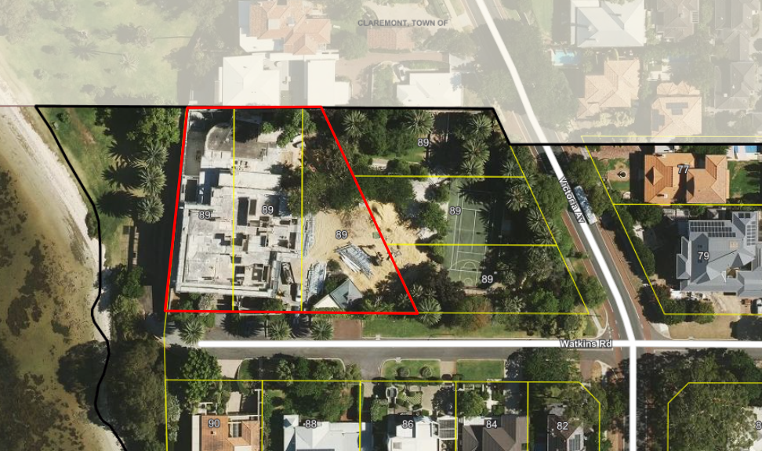
Figure 1: Aerial image of 89 Watkins Road, Dalkeith

Previous Decision
At the Ordinary Council Meeting on 30 January 2024, Council considered a proposal for additions and alterations to a single house at 89 Watkins Road, Dalkeith. Council resolved to refuse the application for the following reason:

- The development is inconsistent with the design principles of clause 5.1.3 Lot boundary setback of the R-Codes as the rear lot boundary setbacks are insufficient to reduce impacts of building bulk on adjoining properties.
SAT Application

In February 2024, the applicant lodged an application with the SAT to review the decision. The proponents, the affected neighbours and City Officers all met and discussed the issues through SAT mediation. Subsequent to orders being set out by SAT and amended development plans being received by the City in April 2024, the application is presented to Council to reconsider the proposal and make a determination. Reconsideration is enabled by section 31 of the SAT Act (see legislative and policy implications section of this report).

Amended Plans

The application seeks development approval for additions and alterations to a single house at 89 Watkins Road, Dalkeith. The works include a new garage, porte cochere and parcel drop off building in the front setback area, and a new pavilion, pool, pool store and landscaping to the north-west of the site. The contested items of development were only those relating to the north-west of the site.

Pursuant to the order made by the SAT, amended plans were prepared which make the following changes from the plans that were considered by Council on 30 January 2024:

- Increased setback of the pool from the northern boundary from 3.2m to 4.3m.
- Increased setback of the pool deck from the northern boundary from 2.2m to 3.5m.
- Conversion of the non-trafficable planter adjacent to the northern boundary to a pebble garden.
- A reduction in the height of the pebble garden of 0.44m (6.88 AHD – 6.44 AHD).
- An alteration in the height of the northern boundary wall. The eastern portion of the wall is increasing in height by 0.3m and the western portion of the wall is decreasing in height by 0.4m.

Discussion

Assessment of Statutory Provisions

If a proposal does not satisfy the deemed to-comply provisions of the State Planning Code Residential Design Codes (R-Codes), Council is required to exercise a judgement of merit to determine the proposal against the design principles of the R-Codes. The R-Codes require the assessment to consider the relevant design principle only and to not apply the corresponding deemed-to-comply provisions. It is recommended that the application be approved by Council as it is considered to satisfy the design principles of the R-Codes. Further, it is considered unlikely that the development will have a significant adverse impact on the local amenity and character of the locality.

Local Planning Scheme No. 3

Schedule 2, Clause 67(2) (Consideration of application by Local Government) – identifies those matters that are required to be given due regard to the extent relevant to the application. Where relevant, these matters are discussed in the following sections. Overall, the development is considered to meet these objectives, particularly in regard to height, scale, bulk and appearance, and the potential impact it will have on the amenity of the adjoining landowner and public open space.

State Planning Policy 7.3 - Residential Design Codes – Volume 1

The R-Codes apply to all single and grouped dwelling developments. An approval under the R-Codes can be obtained in one of two ways. This is by either meeting the deemed-to-comply provisions or via a design principle assessment pathway.

The proposed development is seeking a design principle assessment pathway for parts of this proposal relating to street setback, lot boundary setback and visual privacy. As required by the R-Codes, Council, in assessing the proposal against the design principles, should not apply the corresponding deemed-to-comply provisions.

Street Setback (Clause 5.1.2)

The development proposes a garage, carport (porte cochere) and outbuilding (parcel drop off) within the 9m street setback area. The design principles for lot boundary setbacks consider the impact of building bulk on adjoining properties and streetscape, providing adequate open space for dwellings and site planning features. The proposed street setback is considered to meet the design principles for the following reasons:

- The Watkins Road frontage contains an existing solid street fence along the entire length, which varies in height between 1.0m and 4.8m given the slope of the land. Where the garage is to be located with nil setback, this has been designed to match the height of the existing fence and thereby will not be visible from the street.
- The six lots of 89 Watkins Road occupy the entire street block between the foreshore reserve and Victoria Avenue. In this regard the proposed street setback will not impact on any directly adjoining properties.
- In relation to the carport, this is setback a minimum of 3.9m from Watkins Road which lessens the impact to the street. Whilst the carport is larger in size than a typical carport, it is considered appropriate in the context of the large landholding.
- In relation to open space, the proposal meets the deemed-to-comply open space provisions thereby maintaining adequate open space for residents, parking, landscaping, and utilities.

Eastern Lot Boundary Setback (Clause 5.1.3 and DBCA).

The development proposes to alter the existing limestone boundary wall on the western (riverfront) lot boundary. The existing wall is approximately 6.8m in height for a majority of its length, and 5.2m in height to the northern portion. This is proposed to be increased in height to 8.2m around the pool lounge area and to 5.7m to the pool planter area. A portion of the wall is also proposed to be decreased in height from 6.6m to 5.7m (see Figure 2). There are no provisions for deemed-to-comply boundary walls in the R12.5 code. This boundary wall is abutting the Swan Canning Development Control Area, and assessment of this wall is against State Planning Policy 2.10: Swan-Canning River System and Swan Canning Development Control Area policies. Officers from the DBCA have assessed the application against relevant policies and have advised that they have no objections to the proposal, subject to conditions being applied by the City in the event of approval.

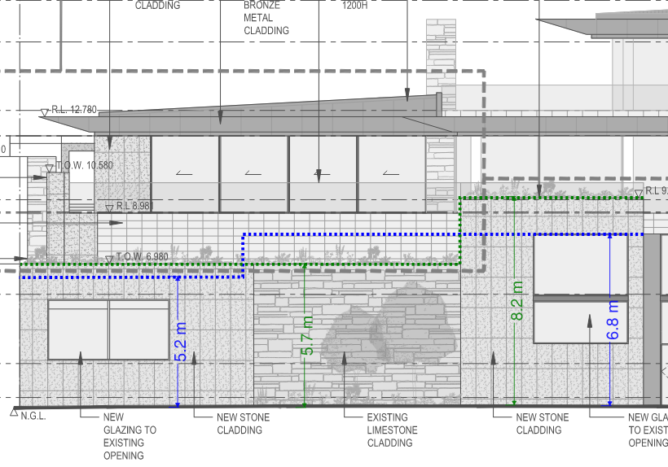
Figure 2: Diagram of existing western boundary wall height (blue) and proposed boundary wall height (green).
In addition to standard conditions, DBCA Officers have requested that the applicant implement landscaping within the adjoining ‘Parks and Recreation’ reserve to improve and soften the appearance of the development when viewed from the foreshore and the Swan River. It is acknowledged that the existing wall has a harsh interface with the reserve, and that this may be exacerbated by the proposed development. It is recommended that a condition be placed on any approval granted by Council for the applicant to provide funding for the planting of landscaping and its ongoing maintenance for a period of 10 years. Condition 7 has been recommended to this effect. In addition to the landscaping, the existing wall is proposed to be altered to introduce a variety of materials and additional glazing to aid in breaking up the visual bulk of the wall as viewed from the river and foreshore reserve.

Rear Lot Boundary Setback (Clause 5.1.3)
The development proposes a pavilion and screen wall within the 6m rear setback area to the northern lot boundary. The northern boundary wall is proposed to be increased in height by 0.6m. The existing boundary wall on the eastern boundary is proposed to be increased in height by 0.4m. The design principles for lot boundary setbacks consider the impact of building bulk on adjoining properties, providing adequate sun and ventilation and minimising overlooking. The proposed northern lot boundary setback is considered to meet the design principles for the following reasons:

- In relation to the pavilion, the 2.4m setback measurement has been taken to the overhanging eaves. The solid portion of wall is set back a minimum of 4.9m from the lot boundary. The large eaves proposed are open beneath, thereby limiting the extent of building bulk imposed to the northern adjoining property and ensuring adequate natural ventilation is maintained. The pavilion addition meets the deemed-to-comply visual privacy setbacks and does not result in overlooking of the adjoining property.
- The setbacks of the pavilion and screen wall are commensurate with the side setbacks of the adjoining property, which is set back from the boundary between 1.5m to 2.4m. In this regard the proposed setbacks are consistent with the existing pattern of development and allow a substantial view of the river from the back deck.
- The increase in height to the existing boundary wall is to match the planter height on the eastern elevation. A portion of the wall is also proposed to be decreased in height by 0.3m. On balance the proposed alteration to the wall has minimal building bulk impact on the adjoining property. This portion of wall relates to a pebble garden ‘planter’ thereby not resulting in any visual privacy concerns.
- All overshadowing from the proposed additions will fall within the subject site at midday 21 June, thereby there is no loss of natural sun to the adjoining property.

Visual Privacy (Clause 5.4.1)

The development proposes a raised pool deck with a 5.1m visual privacy setback from the northern adjoining property. The design principles for visual privacy consider the impact of any direct overlooking into active habitable spaces and outdoor living area. The proposed pool deck is considered to meet the design principles for the following reasons:

- The area of overlooking falls upon a non-active undercroft area. It does not impact any major openings or active habitable spaces. The pool terrace has included a screen wall to minimise direct overlooking, and the remaining area of overlooking is oblique.
- The pool is a non-habitable area, so is not subject to the visual privacy provisions of the R-Codes. Notwithstanding this, overlooking from the pool is minimised as the depth of the pool towards northern lot boundary is approximately 1.8m. Resultingly, a view of the northern lot from the pool could only be facilitated by a person pulling themselves up on the pool ledge.

Minor Variations

The key elements of the development proposal which require Council consideration have been outlined in this report. The application also involves technical variations to street walls and fences (Clause 5.2.4), sightlines (Clause 5.2.5), site works (Clause 5.3.7) and outbuildings (Clause 5.4.3). These are all technical variations with no adverse impact on the amenity of adjoining properties or surrounding area.

Consultation

No additional formal consultation has occurred since the Council decision on 30 January 2024. The City engaged directly with the adjoining northern landowner to seek comment on the amended development proposal.

The objection from the northern landowner was updated and maintained (confidential attachment). The following is a summary of the concerns/comments raised and the Administration’s response and action taken in relation to each issue:

- Objection to rear (north) setback in relation to bulk and scale, access to natural ventilation and impact to views.

The northern setback has been increased by 1.1m since the plans that were considered on 30 January 2024 to mitigate the impact of building bulk to the adjoining property. Consideration of the rear setback is outlined above.

In relation to the neighbour’s request that the pool be shifted further back and away from the north and east boundaries, the proponent has provided an engineer’s assessment that, due to the construction of the existing house, it is not possible to relocate the pool any further north or east. Doing so would require cutting into the structural supports, which would catastrophically undermine the existing house.

- Objection to northern boundary wall and concerns with boundary alignment.

A condition of approval is recommended to ensure all works are wholly located within the lot boundaries of the subject site.

- Objection to western setback in relation to bulk and scale and dominance over public realm.

The visual impact of the western elevation of the property has been the focus of assessment by the DBCA and has led to a series of plan changes over the life of the application. The current plans subject to Council consideration are the culmination of this liaison with the DBCA and have been supported by the Department, subject to conditions.

- Visual privacy concerns from the pool

The R-Codes specifically exclude unenclosed swimming pools from the definition of ‘habitable room/space’, and therefore they are not subject to visual privacy controls. As outlined in the report above, the proposal does seek exercise of discretion in relation to visual privacy from the pool terrace. The pool terrace includes a visual privacy screen and restricts overlooking to a small portion of the adjoining lot that is not frequently occupied as it is an outdoor staircase.

Strategic Implications

This item is strategically aligned to the City of Nedlands Council Plan 2022-23 vision and desired outcomes as follows:

Vision Sustainable and responsible for a bright future

Pillar Place
Outcome 6. Sustainable population growth with responsible urban planning.

Budget/Financial Implications

Given that Council’s previous decision was contrary to the Officer’s recommendation, the City employed the services of an independent party, McLeods Barristers, to run the SAT mediation process. Costs incurred to date are estimated to be $7,000. In the event that this matter is considered at a formal hearing of the SAT, the City will require McLeods representation to continue, as well as requiring the services of a planning consultant experienced in SAT representation. Costs associated with a full hearing are anticipated at between $40,000-$60,000, depending on the complexity.

Should Council resolve to grant development approval, no further costs are anticipated.

Legislative and Policy Implications

The reconsideration is being conducted in accordance with section 31 of the SAT Act. This section allows for the SAT to invite a decision-maker to reconsider the initial decision. Upon being invited to reconsider the decision the decision-maker may:

- Affirm the decision
- Vary the decision or
- Set aside the decision and substitute a new decision.

Decision Implications

Council is acting as the decision-maker for the purposes of section 31 of the SAT Act. Should Council affirm the original decision, the matter will be subject to further directions. The applicant will then have the ability to request the SAT conduct a formal hearing and make a decision to either dismiss or uphold the application for review. In this event, the SAT will become the decision-maker and effectively either approve or refuse the development.

In the event Council resolves to grant development approval, the SAT matter will only continue in the event the applicant is aggrieved by the decision. Resolving to grant development approval will likely result in the withdrawal of the SAT review and the development can proceed after a building permit is granted.

Conclusion

The application for additions and alterations to a single house at 89 Watkins Road, Dalkeith has been presented to Council for reconsideration by section 31 of the State Administrative Tribunal Act 2004 (WA). With the updated development plans the proposal is considered to meet the key amenity related elements of R-Codes Volume 1 and as such is unlikely to have a significant adverse impact on the local amenity of the area. The proposal has been assessed and satisfies the design principles of the R-Codes and is consistent with the immediate locality and streetscape character.
Accordingly, it is recommended that the application be conditionally approved by Council.

Further Information

Nil.

PD34.05.24 Proposed naming of unnamed laneway north of Haldane Street, Mt Claremont

Meeting & Date | 28 May 2024
Applicant | City of Nedlands
Employee Disclosure under section 5.70 Local Government Act 1995 | The author, reviewers and authoriser of this report declare they have no financial or impartiality interest in this matter.
Report Author | Nathan Blumenthal – Acting Manager Urban Planning
Director | Roy Winslow – Acting Director Planning & Development

Purpose

The purpose of this report is for Council to consider endorsement of possible names for an unnamed laneway in Mt Claremont prior to community consultation.

Recommendation

That Council:

- Endorses the following names for the purpose of advertising for community input the naming the unnamed laneway north of Haldane Road and west of Rochdale Road, Mt Claremont:

- Boundary Lane
- Grevillia Lane
- Maleluca Lane
- Jacksonia Lane;

- Refers the names to the adjoining landowners and wider community for a period of 30 days; and

- Upon conclusion of the consultation period refers the two preferred names to the Geographical Names Committee for registration.

Voting Requirement

Simple Majority.

Background

There is an unsealed laneway on the City’s northern boundary with the Town of Cambridge in Mt Claremont which has remained unnamed. The lane is currently referred to as Nameless Lane. The laneway should be named to enable ease of locating it.

Discussion

The location of the laneway is illustrated in pink in Figure 1 below.

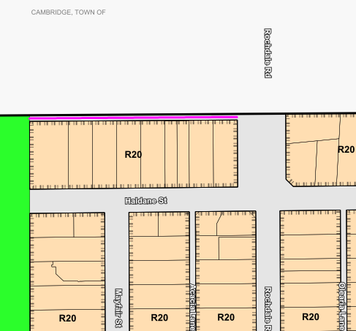
Figure 1: Location of the laneway

The Geographical Names Committee has confirmed the laneway remains unnamed and outlined the process which needs to be undertaken to have the laneway named.

As Council does not have a list of endorsed street names with which to select a name from, this report provides a number of possible names for Council to consider. Landgate suggests putting forward a preferred name, as well as a second option. It is recommended that Council endorse the name options below to present to adjoining landowners.

Consistent with Landgate policy, the names have been selected to avoid duplication of street names within the City or within 10km. The Naming Reserves, Parks, Roads, Public Facilities and Buildings Council Policy states that the naming of roads is guided by the Landgate publication ‘Policies and Standards for Geographical Naming in Western Australia’ (Policies and Standards). The following names have been assessed against the criteria for naming roads in this document and Officers believe they are suitable for submission to Landgate. The Policies and Standards support the naming of laneways with the road type ‘Lane’.

Boundary Lane

Through correspondence the City has received relating to this laneway, it has come to light that the laneway has been referred to as ‘Boundary Lane’ by residents in the vicinity.

Plant species

Laneways in Mt Claremont have been named after native plant species. For example, Acacia Lane, Olearia Lane and Clematis Lane. Officers have reviewed the Native Plant Inventory for the Mt Claremont Reserve and complied a list of three possible names.

- Grevillia Lane
- Jacksonia Lane
- Melaleuca Lane

Consultation

The Policies and Standards provide a framework for consultation with the community when proposing a road name. It is recommended the City consult with the immediate landowners and extended community. The following methods of consultation are recommended:

- A minimum 30-day consultation period
- Letters to notify owners and occupiers immediately adjacent to the laneway of proposed names and how to make a submission
- Notice in the local newspaper
- A notice on the City’s Notice Board
- A notice on the City’s Your Voice engagement portal
- Post on social media channels

The recommendation is for Council to endorse the four names and present to affected residents both within the City and those directly affected in the Town of Cambridge. Upon conclusion of the advertising period, the two preferred names will be referred to the Geographical Names Committee through a formal submission.

Strategic Implications

This item is strategically aligned to the City of Nedlands Council Plan 2023-33 vision and desired outcomes as follows:

Vision Sustainable and responsible for a bright future

Pillar Place
Outcome 8. A city that is easy to get around safely and sustainably.

Budget/Financial Implications

Expenses for this work relate to public advertising. No additional budget is required to complete this work.

Legislative and Policy Implications

The Geographic Names Committee is responsible for approving and registering place names in Western Australia. In selecting a name for the laneway, the City is guided by the Policies and Standards for Geographical Naming in Western Australia.

Decision Implications

If Council resolves to progress with the naming of the laneway, the endorsed names will be advertised in accordance with the process above. Upon conclusion of advertising the preferred names resulting from the consultation will be presented in the submission to Landgate.

If Council reserves not to progress with the recommendation the laneway will remain unnamed.

Conclusion

It is recommended that Council endorse naming of the laneway north of Haldane Street, Mt Claremont, including advertising to the community and referral to the Geographic Names Committee in accordance with City and Landgate policy.

Further Information

Nil.

PD35.05.24 Consent to Advertise Local Planning Policy 1.1 -Residential Development

Meeting & Date | Ordinary Council Meeting – 28 May 2024
Applicant | City of Nedlands
Employee Disclosure under section 5.70 Local Government Act 1995 | Nil.
Report Author | Nathan Blumenthal – Acting Manager Urban Planning
Director | Roy Winslow – Acting Director Planning & Development
Attachments | - Draft Local Planning Policy 1.1 – Residential Development  - Change Notes  - Current Adopted Local Planning Policy 1.1 – Residential Development

Purpose

The purpose of this report is for Council to consider adoption of the draft Local Planning Policy 1.1 Residential Development (the Policy), found at Attachment 1, for the purpose of advertising.

Recommendation

That Council adopts the draft Local Planning Policy 1.1: Residential Development (Attachment 1) for the purpose of advertising in accordance with Clause 4 of the Deemed Provisions of Schedule 2 of the Planning and Development (Local Planning Schemes) Regulations 2015.

Voting Requirement

Simple Majority.

Background

Local Planning Policy 1.1: Residential Development (the Policy) was reviewed and advertised in December 2022. However, various changes to the state planning framework over the course of 2023 and early 2024 have delayed the policy being presented back to Council and given Officers the opportunity to further enhance the Policy.

The gazettal of the Residential Design Codes Volume 1 on 10 April 2024 introduced a new set of provisions (Part C) to be used in the assessment of Single Houses R50 and above, Grouped Dwellings R30 and above and Multiple Dwellings R30 to R60.

The policy has been drafted to be compatible with Part C. In addition, a number of the provisions included in Part C have been viewed as innovative and an improvement on the previous Residential Design Codes Volume 1.

In Officers’ experience, some medium density development in the City tends to be constructed with poor thermal performance and amenity, limited vegetation and excessive hardstand and roof cover.

The Policy seeks to implement some of the improvements in Part C to single dwellings coded R30 to R40 including private open space, size and layout of dwellings, solar access, ventilation, waste management and siteworks and retaining walls.

The policy review has resulted in amendments to a number of existing policy provisions as well as introducing new measures.

A summary of the amendments are as follows:

- Formatting and division of the policy into three major sections to make clear the application of each policy measure and to be consistent with the R-Codes Volume 1 and draft Local Planning Policy: Precincts;
- The addition of clause 6.2 with Deemed-to-Comply criteria and Design Principles for R30 to R40 Single Dwellings adopted from Part C;
- Additional Local Housing Objectives to ensure consistency in officer interpretation;
- Clarification regarding impervious surfaces, soft landscape and deep soil area;
- Removed definitions that are unused or covered by the R-Codes Volume 1 and included additional definitions;
- Additional figures relating to Clause 6.2 and policy measures not applicable in the St John’s Wood Estate;

The amended Policy will apply to all development to which the R-Codes Volume 1 applies. Where there is any inconsistency with a Local Development Plan, Structure Plan, Precinct Plan or Local Planning Policy that applies to a specific site, precinct, area or density code, the provisions of that specific instrument shall prevail for the extent of the inconsistency. This ensures that the Residential Development Policy does not inhibit the planning of specialised areas such as infill areas, precinct areas, master planned estates or character areas.

In reviewing the Local Planning Policy, two resolutions from Council relating to the policy have been addressed in the review. The resolutions are as follows:

- On 23 November 2021, - “protection from overshadowing, of solar panels, windows to main living areas of adjoining dwellings and potential future solar panels.”

- On 22 February 2022, - “Deemed-To-Comply Height Requirements as written in Table 3, Category B of Volume 1 of the R-Codes 2021, for Single and Grouped Dwellings.”

The above resolutions have been considered and new Local Housing Objectives for the protection of outdoor living areas and solar collectors from overshadowing are proposed. However, adding or altering the Deemed-to-Comply criteria for this element would trigger the requirement for Western Australian Planning Commission (WAPC) approval. The City considers that it is unlikely that WAPC approval would be granted. Verbal communications with WAPC have indicated that support for these elements is unlikely.

Local Housing Objectives for the assessment of building heights are proposed to accompany the building height criteria of the existing policy. The existing building heights in the current policy are well established in the low-density suburbs of Swanbourne and Dalkeith. They are tailored to the Nedlands context with the heights allowing for dwellings to be built easier on land that slopes down to the river or the ocean. Reducing building heights would lead to inconsistent streetscapes.

Discussion

The draft Policy differs from the current adopted version (Attachment 3). The proposed changes are discussed in detail below.

Layout and Formatting of Policy

The revised Policy has been drafted to distinguish how each policy measure applies and make navigation easier. This has been done with the use of colour coding, a table format and inclusion of a schedule of amendments.

Building Height

A comparison between the existing building height criteria of the Policy and the R-Codes Volume 1 are shown in the below table:

Table 1: Policy versus R-Codes Vol 1 heights
Element | R-Codes Volume 1 Height | Existing Policy Height
Wall height (roof above) | 7m | 8.5m
Wall height (gable, skillion and concealed roof) | 8m | 8.5m
Roof height | 10m | 10m

Should Council adopt the height settings of the R-Codes Volume 1, it would reduce the Deemed-to-Comply wall heights across the City. It is recommended that the height settings of the existing policy remain. Further to this:

- The City of Nedlands height controls were originally enshrined in Council’s former Town Planning Scheme No. 2. Dwellings have been developed to this greater Deemed-to-Comply allowance for several decades, with the design response well enshrined throughout the City.

- The areas of Swanbourne and Dalkeith tend to have larger houses, owing to the steep slope of the natural ground level of the sites (particularly near the river and the ocean) and the general expectations of residents. Reducing the current Deemed-to-Comply heights to meet the R-Codes would disadvantage newer houses and additions to existing houses compared to any immediate neighbours. The Deemed-to-Comply height reduction would also impact any house on a lot with steeply sloping ground level, particularly those near the Swan River and the ocean. Any reduction in the current height criteria is likely to result in more houses seeking a Design Principles assessment.

- The City of Nedlands traditionally has higher quality development with better amenity than the R-Codes allows. A key measure of indoor liveability is floor to ceiling heights. Larger floor to ceiling heights make house interiors seem more spacious, and allow for better sunlight access and ventilation through the use of larger windows. Retaining the increased building heights will continue to encourage high quality housing.

- The Policy seeks to introduce a Local Housing Objective for solar access on adjoining sites. This will reduce the effect that building height has on existing solar collectors and outdoor living areas on neighbouring properties.

Given the longstanding nature of the height controls in place in Nedlands, their general acceptance by the community, and the improved internal amenity outcomes, removal of the local planning policy height provisions is not recommended.

Solar Access for Adjoining Sites

A new Local Housing Objective is proposed to encourage protection of existing solar collectors and outdoor living area on adjoining lots.

Guidance has been adopted from the State of Victoria Planning Practice Note 88 to assist in the assessment of whether the location of solar panels is reasonable and appropriate for purposes of a Design Principles assessment. For instance, consideration can be given to whether the panels are located high on the roof, whether the adjoining building is set back appropriately, etc. During drafting of the policy, it was found that some of the considerations given can be applied to protecting existing outdoor living areas too. The Local Housing Objectives have been adapted to include these protections. Importantly, these considerations can only be used where a house does not meet the Deemed-to-Comply criteria for overshadowing. Attempting to make this mandatory would require WAPC approval, which is unlikely to be forthcoming.

Interpretation of R-Codes Definitions

The R-Codes Volume 1 contains a definition for ‘soft landscape’. There are related terms such as ‘deep soil area’, and ‘impervious surfaces’ which rely on the definition of ‘soft landscape’. The ‘soft landscape’ definition states that turf is included in the definition, however this can create confusion as turf is a broad term and can include traditional lawns but also artificial turf and turf cell which can occasionally be impermeable and strays from the purpose of soft landscaping and deep soil area which is for vegetation and natural areas.

Officers have drafted Clause 8.1 to provide clarification by stating that artificial turf and turf-cell are considered to be included in impervious areas/surface and materials so therefore do not contribute to soft landscape.

Additional Deemed-to-Comply Criteria and Design Principles for Single Houses on Land Coded R30-R40
The release of the Medium Density Code in early 2023 proposed to radically change the assessment of medium density dwellings. The considerations of the Medium Density Code required that development be more site responsive, include better open space and tree coverage and improve the sustainability and internal amenity of dwellings.

The deferral of the Medium Density Code in August 2023 to review elements of the policy and remove applicability of the policy from single houses below R50 meant that the benefits of the code were unlikely to be as far reaching within the City of Nedlands. The criteria were considered to increase the cost of delivering housing and would have been a burden towards development in WA’s low- and medium-income areas. Officers considered that the proposed policy did offer many benefits to medium density housing development.

It is proposed that elements of the Medium Density Code should be introduced into the draft Policy for single houses R30 to R40 where the City can adopt them free of WAPC approval.

The following elements have been added to the draft Policy:

- Private Open Space
  - Although the R-Codes Volume1 requires open space in any residential development, there is a lack of criteria about how that space is laid out. The private open space element includes requirements such as minimum dimensions, maximum permanent cover, and tree planting requirements which ensure open space is usable and that there is a balance of shade, solar access and provision of tree canopy.

- Size and Layout of Dwellings (excluding storage)
  - The element specifies ceiling heights, maximum depth of primary living space vs ceiling height, minimum internal floor area, a mix of dwelling sizes in large developments and protection of internal amenity.

- Solar Access and Natural Ventilation
  - This element ensures that each habitable room in a dwelling has sufficient daylight and natural ventilation, and the dwellings are responsive to the warm temperate climate.

- Waste Management
  - This element requires provision of waste facilities, screening of bins and protection of the streetscape, major openings and primary garden areas from the amenity impacts of waste storage.
- Site Works and Retaining Walls
  - This element requires that any excavation, fill and retaining is done with respect to the site’s natural ground level, the amenity of adjoining properties and can respond to the drainage requirements of the land and need for natural light.

Deleted or Modified Clauses

The review of the policy has not only included new requirements that improve the quality of development in the City but has also sought to remove clauses that are not necessary and add complexity. The policy also modifies some existing clauses. Attachment 2 provides detailed notes on how policy measures in the current adopted policy have been changed. The following policy measures have been deleted or modified:

- Lot boundary setback
  - Clause 4.4.1 C3.1vii of the existing policy regarding the assessment of swimming pool fences and pool pump screens behind the street setback line has been deleted. The treatment of this scenario will be included in an internal Statutory Planning Practice document to ensure consistent assessment and thus is no longer required in policy.
- Street Setback
  - The draft Policy proposes to modify the provisions relating to street setback of minor incursions to allow for flexibility of building positioning without impacting on soft landscaping.
- Dividing Fences
  - The dividing fences section of the policy and definitions relating to dividing fences have been removed from the policy as they were advice only and held no statutory weight.
- Building Heights
  - Two footnotes regarding the measurement of external walls for gable walls, and roof ridges, have been removed to maintain consistency with the current R-Codes Volume 1.
- Street Walls and Fences
  - Clause 4.6.1 C4.1ii has been removed as passive surveillance to the street is already maintained under clause 5.2.3 C3.1 of the R-Codes.
- Laneway Widening Provision
  - The provision in the current Policy to increase lot boundary setbacks to accommodate future laneway widening has been found to be unenforceable without WAPC approval as it varies Clause 5.1.3 Lot Boundary Setbacks in the R-Codes. It is recommended that consideration of future laneway widening should form part of the assessment of any varied lot boundary setbacks. The consideration of laneway widening has been moved to Clause 7 and is to be used as a Local Housing Objective rather than Deemed-to-Comply criteria.

Revocation of Existing Policy at Adoption

Officers are of the opinion that the draft Policy is different enough from the current adopted Policy to warrant treatment as a new policy. Amending policies should generally result in few changes and where such changes exist, they should apply to existing clauses or include small additions and deletions.
As the draft Policy proposes multiple additions, deletions and reorders the policy provisions, it warrants treatment as a new Policy. Officers have proposed that upon conclusion of advertising, the existing adopted Policy be revoked, and the draft Policy be adopted in its place.

Officers recommend the draft Policy retains the name of the existing adopted Policy as this accurately describes the Policy’s application.

Consultation

Although advertising of an amended policy took place in December 2022, the Policy has changed significantly with some proposed clauses being removed, others added and various changes in the state and local planning framework over the course of 2023. No advertising has taken place for the current version of the draft Policy.

It is recommended that Council adopt the policy for the purpose of advertising.

If Council adopts the Policy for the purpose of advertising, it will be advertised in accordance with the City’s Consultation of Planning Proposals Local Planning Policy.

Strategic Implications

This item is strategically aligned to the City of Nedlands Council Plan 2023-33 vision and desired outcomes as follows:

Vision Sustainable and responsible for a bright future

Pillar Planet
Outcome 5. Climate resilience.

Pillar Place
Outcome 6. Sustainable population growth with responsible urban planning.

Budget/Financial Implications

Nil

Legislative and Policy Implications

Clause 4 of the Deemed Provisions of the Planning and Development (Local Planning Schemes) Regulations 2015 provides the procedure for preparation of a Local Planning Policy. Where a Local Planning Policy is advertised, the City must publish a notice of the proposed policy for a period of not less than 21 days and seek submissions.

Following the advertising period, the Policy will be presented back to Council to consider any submissions received to:

- Proceed with the Policy without modification;
- Proceed with the Policy with modification; or
- Not proceed with the Policy.

Decision Implications

If Council resolves to adopt the Policy for advertising, it will be advertised in accordance with the process outlined above.

If Council resolves to adopt the Policy for advertising with modifications, the policy will be amended to include the modifications and will be advertised to the public. If any modifications require approval of the Commission, they will be referred to the Commission for approval.

If Council resolves not to endorse the recommendation, the existing Policy will remain in use by the City.

Conclusion

The draft Local Planning Policy 1.1: Residential Development has been prepared to enhance and protect the existing Nedlands streetscape, improve the quality of dwellings and increase the quantity of vegetation on residential land. It is recommended that Council adopt the draft Local Planning Policy 1.1 – Residential Development for the purpose of advertising.

Further Information

Nil.

PD36.05.24 Consent to Advertise draft Local Planning Policy – Precincts

Meeting & Date | Council Meeting - 28 May 2024
Applicant | City of Nedlands
Employee Disclosure under section 5.70 Local Government Act 1995 | The author, reviewers and authoriser of this report declare they have no financial or impartiality interest in this matter.
Report Author | Nathan Blumenthal – Acting Manager Urban Planning
Director | Roy Winslow – Acting Director Planning & Development
Attachments | - Draft Local Planning Policy - Precincts

Purpose

The purpose of this report is for Council consider adoption of the draft Local Planning Policy – Precincts (the Policy), found at Attachment 1, for the purpose of advertising.

Recommendation

That Council adopts the draft Local Planning Policy – Precincts (Attachment 1) for the purpose of advertising in accordance with Clause 4 of the Deemed Provisions of Schedule 2 of the Planning and Development (Local Planning Schemes) Regulations 2015.

Voting Requirement

Simple Majority.

Background

This Policy seeks to consolidate the previously adopted Broadway, Hampden-Hollywood and Nedlands Stirling Highway Activity Corridor – Residential (NSHAC-R) Precinct Local Planning Policies (LPP) in to one Policy, with the addition of the draft Waratah Precinct LPP. The Policy also includes new criteria what were not previously adopted.

The adopted LPPs and the advertised Waratah Precinct LPP have been reviewed in light of the gazettal of the new Residential Design Codes Volume 1 (R-Codes Volume 1) on 10 April 2024. As a result of the review process, this Policy has been developed to include only provisions which do not require approval from the Western Australian Planning Commission (WAPC). It is proposed that once this Policy is adopted that the Broadway, Hampden-Hollywood and NSHAC-R LPPs be revoked.
Discussion

Early last year the City resolved to adopt three Precinct LPPs:

- 5.10 Broadway Precinct
- 5.11 Hampden-Hollywood
- 5.12 Nedlands Striling Highway Activity Corridor – Residential (NSHAC-R)

A fourth precinct LPP for Waratah was also scheduled to be adopted prior to the Minister for Planning announcing deferral of the introduction of the Medium Density R-Codes Volume 1. Uncertainty around timeframes and a lack of clear direction surrounding the introduction of the Medium Density R-Codes led to a delay in the Waratah Policy being presented back to Council post advertising. In addition, all four of the precinct LPPs contained provisions which triggered the need for WAPC approval.

The individual precinct policies sought to amend several provisions of the R-Codes Volume 1 and 2 which required WAPC approval. Initial verbal advice from the WAPC was that the policies could be adopted in their entirety, but those elements requiring WAPC approval could not be enforced until such approval was granted. At a later meeting with the WAPC, City Officers were verbally advised that the strict reading of the Planning and Development (Local Planning Schemes) Regulations 2015 (the Regulations) meant that any policies amending criteria that required WAPC approval could not be lawfully adopted until after the WAPC had granted approval. This puts the adopted precinct policies into a grey area and open to challenge. City Officers have not been provided a timeframe of when the approvals requested would likely to be granted or if they will be supported by the WAPC. However, public statements by the Minister for Planning lead City Officers to believe that any variations to the recently gazetted R-Codes which require WAPC approval will not be supported.

The new R-Codes Volume 1 was gazetted on 10 April 2024. The R-Codes Volume 1 set out improved criteria for single houses and grouped dwellings, as well as multiple dwellings on lots coded up to R60. The criteria include new considerations for internal amenity, such as ventilation and sunlight to habitable rooms, as well as a primary garden area. Overall, City Officers considered that the proposed changes were an improvement on the previous R-Codes, and so similar in many ways to the City’s recently adopted precinct policies as to make some of the criteria unnecessary. In that respect, City Officers began simplifying and combining the individual precinct policies into a single Policy.

Precincts LPP

The draft Policy simplifies the existing policies both in format and complexity, taking into account the recent legislative changes discussed above. The draft Precincts LPP proposes to combine elements of the Broadway, Hampden-Hollywood, NSHAC-R and Waratah Policies so that each precinct is discussed in a separate section. The Policy includes only those items that can be adopted without WAPC approval.

Each precinct of the draft Policy includes a Desired Future Character Statement which carries the intent of the provisions provided within the Policy. The following provisions were in the precinct policies but have been removed from the draft Policy:

- Landscaping
- Sustainability
- Mixed Use
- Side and rear setbacks for single and grouped dwellings
- Building Height for R80 and R160 lots (single and grouped dwellings only)

The general provisions for landscaping and sustainability have been removed from the Policy as these items require WAPC approval to have effect. Modified sustainability provisions have been absorbed LPP3.3 Sustainable Design – Residential. LPP1.1 incorporates elements proposed for the Medium Density Codes that improve internal amenity and garden space. The Precincts Policy refers to those elements in LPP1.1 and 3.3 so that outcomes are consistent across the City.

The current versions of the Hampden-Hollywood, NSHAC-R and draft Waratah Precinct Policies contained building heights for R80 and R160 lots which vary provisions of the R-Codes Volume 1. As with the above landscaping and sustainability provisions, WAPC approval is required for these variations. The draft Policy reverts to the R-Codes Volume 1 deemed to comply provision of 4 storeys for single and grouped dwellings on R80 and R160 lots.

The Desired Future Character Statements have been carried over from the four individual Policies. These statements have been formulated based on the key priorities and values highlighted by the community during the engagement process and provide a basis for the provisions contained within the draft Policy.

It is proposed that should Council resolve to proceed with the draft Precincts LPP, upon final adoption, the Broadway, Hampden-Hollywood and NSHAC-R Precinct Policies be revoked.

Consultation

Each of the four precincts have been subject to comprehensive community consultation. This included stakeholder and community reference groups, open house community information sessions, engagement via the City’s Your Voice portal and formal advertising of the draft Policies.

Due to the extent of the changes proposed and Officers presenting this as a new Policy, the Policy is required to be advertised to the community prior to final adoption.

Should Council resolve to advertise the Policy, it will be advertised in accordance with the City’s Constitution of Planning Proposals Local Planning Policy.

Strategic Implications

This item is strategically aligned to the City of Nedlands Council Plan 2023-33 vision and desired outcomes as follows:

Vision Sustainable and responsible for a bright future

Pillar Place
Outcome 6. Sustainable population growth with responsible urban planning.

Budget/Financial Implications

The remaining expenses for the Precinct Policy work relate to public advertising. No additional budget is required to complete the work for the Policy.

Legislative and Policy Implications

Clause 3(1) of the Deemed Provisions of Schedule 2 of the Planning and Development (Local Planning Schemes) Regulations 2015 allows the City to prepare a local planning policy in respect to any matter related to the planning and development of the Scheme area. Once Council resolves to prepare an LPP, in accordance with Clause 4 of the Deemed Provisions it must publish a notice of the proposed Policy for a period of not less than 21 days and seek submissions. Advertising will also include details being posted on the City’s website and Your Voice engagement portal. Following the advertising period, the policy will be presented back to Council to consider any submissions received and resolve to:

- Proceed with the Policy without modification; or
- Proceed with the Policy with modification; or
- Not proceed with the Policy.

Decision Implications

If Council resolves to prepare the Policy, it will be advertised in accordance with the process above.

If Council resolves not to endorse the recommendation, the Policy will not be advertised, or progressed. This will result in there being no Policy in place with specific built form controls for the Waratah Precinct. This would also mean the three adopted Policies would remain unchanged with elements which are not approved by the WAPC.

Conclusion

As a result of extensive research and consultation, the Local Planning Policy – Precincts, provides contextually appropriate built form outcomes for the Broadway, Hampden-Hollywood, Nedlands Stirling Highway Activity Corridor – Residential and Waratah Precincts. It incorporates elements of the newly gazetted Residential Design Codes wherever possible and improves landscaping and sustainability outcomes. It is recommended that Council adopt the draft Policy for formal advertising.

Further Information

Nil.

PD37.05.24 Invitation for Involvement in the Design Process of the Proposed Greenspace Adjacent to WA Bridge Club, Allen Park, Swanbourne

Meeting & Date | Council Meeting - 28 May 2024
Applicant | City of Nedlands
Employee Disclosure under section 5.70 Local Government Act 1995 | Nil.
Report Author | Nathan Blumenthal – Acting Manager Urban Planning
Director | Roy Winslow – Acting Director Planning & Development
Attachments | - Perth Children’s Hospital Foundation Presentation – Proposed Rehabilitation of Vacant Land adjacent to WA Bridge Club, Allen Park, Swanbourne

Purpose

The purpose of this report is to allow Council to consider participating in the design process for the proposed greenspace adjacent to the WA Bridge Club located at Allen Park, Swanbourne.

Recommendation

That Council accepts the invitation from the Perth Children’s Hospital Foundation for elected members and senior City officers to participate in the design process of the proposed greenspace adjacent to the WA Bridge Club located at Allen Park, Swanbourne.

Voting Requirement

Simple Majority.

Background

The Perth Children’s Hospital Foundation (PCHF) has extended an invitation to the City to be involved in the design process of a proposed greenspace located between the WA Bridge Club and future WA Children’s Hospice (WACH) located at Allen Park, Swanbourne (Figure 1).

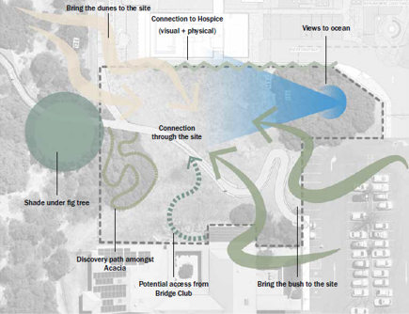
Figure 1: Location of greenspace

Discussion

The PCHF is proposing to rehabilitate the cleared land between the WA Bowls Club and WACH and are inviting the City to be involved in the design process. The area surrounds the Norn Bidi trail pathway, which the City has committed to constructing. Rehabilitating and rejuvenating the cleared land is an opportunity to provide additional greenspace for the community to enjoy.

The site for the greenspace is 3000m² and predominately cleared of vegetation. Participation in the greenspace design process would assist in making a space which complements the design of the Norn Bidi trail pathway.

The PCHF is committing $4 million to the consultation, design, construction and maintenance of the greenspace, subject to securing a funding sponsor. The PCHF are also committed to appointing and funding community engagement professionals to lead the Council, community and stakeholder engagement for the design process. The final design is intended to be referred to Council for approval.

A licence agreement between the City and PCHF for the construction of the greenspace is proposed by PCHF. The agreement would cover site access and conditions. Post construction, PCHF are proposing an additional licence agreement for a period of 10 years, with three 10 year options to extend. PCHF are prepared to pay an annual licence fee agreed to by the City and PCHF. Maintenace costs for the greenspace would be covered by PCHF at an agreed rate for the period of the licence agreement. Details of all agreements would be negotiated between the City and PCHF.

The Proposed Rehabilitation of Vacant Land Adjacent to WA Bridge Club, Allen Park, Swanbourne (Attachment 1) outlines the PCHF vision and design concept for the greenspace.
Consultation

Should Council decide to be involved in the design process for the greenspace the PCHF has committed to appointing and funding community engagement professionals to conduct consultation with the community and stakeholders.

Strategic Implications

This item is strategically aligned to the City of Nedlands Council Plan 2023-33 vision and desired outcomes as follows:

Vision Sustainable and responsible for a bright future

Pillar People
Outcome 1. Art, culture and heritage are valued and celebrated.

Pillar Planet
Outcome 4. Healthy and sustainable ecosystems.

Pillar Place
Outcome 6. Sustainable population growth with responsible urban planning.
7. Attractive and welcoming places.

Budget/Financial Implications

There is no cost to the City proposed for this project. The project and improvement of the vacant land will be a positive addition to the Allen Park location that the community will benefit from.

Legislative and Policy Implications

Nil.

Decision Implications

Should Council decide to accept the invitation to be involved in the design process elected members and senior City officers would contribute their input throughout the design process, including progress reports back to Council.

Should Council decide not to accept the invitation, the design will likely proceed with support from the State, and the City will have limited input into the design of the greenspace.

Conclusion

It is recommended that Council accept the invitation from the Perth Childrens Hospital Foundation to be involved in the design process for the rehabilitation and rejuvenation of the greenspace adjacent to the WA Bowls Club at Allen Park, Swanbourne.

Further Information

Nil.

PD38.05.24 West Waratah Precinct Parking Restrictions Consultation

Meeting & Date | Council Meeting – 28 May 2024
Applicant | City of Nedlands
Employee Disclosure under section 5.70 Local Government Act 1995 | Nil.
Report Author | Andrew Melville (Manager Health and Compliance)
Director/CEO | Roy Winslow (Acting Director Planning and Development)
Attachments | - Current West Waratah Precinct Parking Restrictions  - Option 1 – Proposed Limited Parking Restrictions around Waratah Avenue  - Option 2 – Proposed Timed Parking Restrictions Waratah Precinct  - Option 3 – Proposed No Parking Restrictions Waratah Precinct

Purpose

To undertake community consultation within the West Waratah Precinct on the proposal to introduce timed parking restrictions. The aim of this is to alleviate parking impacts on residents and business, in response to increased construction activities particularly around the development at 129-133 Waratah Avenue, Dalkeith.

Recommendation

That Council:

- Notes the proposed consultation with residents, businesses, and community/sporting organisations to introduce temporary parking restrictions for the streets surrounding the development as per attachments 2,3 and 4; and

- Notes the consultation period for the introduction of temporary parking restrictions be for a minimum of 28 days.

Voting Requirement

Simple Majority.

Background

A Development Application has been approved by the Joint Development Assessment Panel for the development of a three-story health and wellness centre at 129-133 Waratah Avenue, Dalkeith.

The majority of on-street parking surrounding the development is currently unrestricted and primarily used for residential purposes, with very few commercial entities operating within the vicinity. It is anticipated that the demand for on street parking will increase markedly when the development begins its construction phase.

Discussion

The Administration will continue to require builders to address parking as part of their construction management plans. However, the City is limited in its ability to encourage and enforce builders to manage the parking associated with their development without changes to the existing parking restrictions. It is expected that vehicles associated with the construction will predominately park close to the building sites. Officers are seeking to consult with the local community on parking restriction for the duration of the build.

Officers are proposing the three options which include a variety of temporary parking restrictions. A section of verge adjacent Dalkeith Tennis and Dalkeith Nedlands Bowling Victoria on Avenue has been proposed in options 2 and 3 which allocates parking to the construction company at a cost and designated as ‘Authorised Vehicles Only.’

It is anticipated that this will ensure equitable use of the on street parking surrounding the development. This reflects similar arrangements adopted by Council in:

- February 2022 for the Broadway Precinct Parking Restrictions and the allocation of land on Bruce Street, and
- September 2023 for the West Melvista Parking Restrictions and the allocation of land adjacent College Park.

This area will be allocated for vehicles only, with storage of materials not being permitted. Payment to reserve a parking area for trades vehicles associated with the construction site will be in accordance with the City’s Fees and Charges Schedule 2023/24 which will be approximately $1,200 each month the space is occupied.

Option 1 proposes limited temporary parking restrictions surrounding the construction site permitting vehicles to park unrestricted. Restrictions will include ‘No Parking 7am – 5pm Monday to Saturday’ on both sides on Waratah Avenue from Alexander Road to Victoria Avenue.

This will encourage traffic flow along a busy Local Distributor road. This option will also propose ‘No Parking’ on one side of the road on Roberts Street from Watkins Road to Neville Road, ‘No Parking’ on one side on Leon Road from Alexander Road to Victoria Avenue, and ‘No Parking’ on one side on Philip Road from Alexander Road to Victoria Avenue.

Certain sections of streets not covered by 'No Parking' signs would still allow trades vehicles to park near the construction site as parking availability is high in these residential streets.

This Option aims to minimise inconvenience for residents outside the designated area by avoiding the need for parking restrictions and parking permit applications.

Option 2 proposes temporary implementation of two-hour time restricted parking 7am – 5pm Monday to Saturday’ on one side of all streets within the precinct, with ‘No Parking 7am – 5pm Monday to Saturday’ applying to the other side surrounding this development.

A section of verge on the eastern side of Victoria Avenue adjacent Dakeith Tennis and Dalkeith Nedlands Bowling Club will be allocated to the construction company at a cost and designated as ‘Authorised Vehicles Only’. The use of the verge allocated as ‘Authorised Vehicles Only’ will be invoiced in accordance with the City’s Fees and Charges 2023/24 at $2.50 per square metre. This would equal to $1,200 per month.

Option 3 proposes the temporary implementation of ‘No Parking – City of Nedlands Permit Holders Exempt’ applying to both sides of the streets surrounding the development. The section of verge on the eastern side of Victoria Avenue adjacent Dakeith Tennis and Dalkeith Nedlands Bowling Club will also be allocated to the construction company at a cost and designated as ‘Authorised Vehicles Only’ which will be invoiced in accordance with the City’s Fees and Charges 2023/24 at $2.50 per square metre, totalling $1,200 per month. This option reflects the Council Resolution made at the Ordinary Council Meeting held 26 September 2023 item 16.3 West Melvista Parking Restrictions whereby Attachment 3 was adopted. Attachment 3 included a precinct wide ‘No Parking’, with the exemption for parking permits.

In support of Option 2 and 3, the City currently offers parking permits to residents in accordance with the City of Nedlands Parking and Parking Facilities Local Law 2013. This allows residents and their visitors to park over the time limitation on streets near their property when displaying a valid permit.

The number of permits an eligible person may receive is dependent on how many on-site parking bays at the property. For example: if a property has no on-site parking bays, an eligible person can receive four permits. Most properties will have a double garage which will entitle a person to have two parking permits. Notwithstanding, the City acknowledges the impact of the construction in this residential area and may under unusual circumstances, be prepared to accommodate temporary additional parking permits under the discretionary authority provision. Residents will be advised through this consultation process of this option and how they can apply.

The current parking restrictions for the West Waratha Precinct are illustrated in the attachments 2, 3, and 4. The proposed parking restriction options is listed in the table below.

Street | Section | Current Restriction | Option 1 | Option 2 | Option 3
Watkins Road | Adelma Road – Victoria Avenue | No restrictions | No restrictions | No Parking 7am-5pm Mon-Sat (one side)  2P 7am-5pm Mon-Sat (other side) | No Parking City of Nedlands Permit Holders Exempt (both sides)
Philip Road | Alexander Road – Victoria Avenue | No restrictions | No Parking 7am-5pm Mon-Sat (one side) | No Parking 7am-5pm Mon-Sat (one side)  2P 7am-5pm Mon-Sat (other side) | No Parking City of Nedlands Permit Holders Exempt (both sides)
Waratah Avenue | Alexander Road – Robert Street | 30mins Mon – Fri ‘No Parking’, and Bus Zone | No Parking (both sides), 30mins Mon – Fri, Bus Zones | No Parking 7am-5pm Mon-Sat (both sides), Bus Zones | No Parking 7am-5pm Mon-Sat (both sides)
Waratah Avenue | Robert Street – Victoria Avenue | No restrictions | No Parking | No Parking 7am-5pm Mon-Sat (both sides), Bus Zones | No Parking 7am-5pm Mon-Sat (both sides)
Leon Road | Alexander Road – Victoria Avenue | No restrictions | No Parking 7am-5pm Mon-Sat (one side) | No Parking 7am-5pm Mon-Sat (one side)  2P 7am-5pm Mon-Sat (other side) | No Parking City of Nedlands Permit Holders Exempt (both sides)
Neville Road | Alexander Road – Victoria Avenue | No restrictions | No restrictions | No Parking 7am-5pm Mon-Sat (one side)  2P 7am-5pm Mon-Sat (other side) | No Parking City of Nedlands Permit Holders Exempt (both sides)
Viking Road | Alexander Road – Victoria Avenue | No restrictions | No restrictions | No Parking 7am-5pm Mon-Sat (one side)  2P 7am-5pm Mon-Sat (other side) | No Parking City of Nedlands Permit Holders Exempt (both sides)
Minora Road | Alexander Road – Victoria Avenue | No restrictions | No restrictions | No Parking 7am-5pm Mon-Sat (one side)  2P 7am-5pm Mon-Sat (other side) | No Parking City of Nedlands Permit Holders Exempt (both sides)
Beatrice Avenue | Alexander Road – Victoria Avenue | No restrictions | No restrictions | No Parking 7am-5pm Mon-Sat (one side)  2P 7am-5pm Mon-Sat (other side) | No Parking City of Nedlands Permit Holders Exempt (both sides)
Victoria Avenue | Jutland Road – Beatrice Road | No Parking at entry to Pt Resolution | No Parking at entry to Pt Resolution | No Parking 7am-5pm Mon-Sat (both sides)  ‘Authorised Vehicle Only’ (verge) | No Parking City of Nedlands Permit Holders Exempt (both sides)
Victoria Avenue | Beatrice Road – Watkins Avenue | Solid white road line and sections of No Parking | Solid white road line and sections of No Parking | No Parking 7am-5pm Mon-Sat (one side)  2P 7am-5pm Mon-Sat (other side) | No Parking City of Nedlands Permit Holders Exempt (both sides)
Bishop Road | Victoria Avenue | No restrictions | No restrictions | No Parking 7am-5pm Mon-Sat (one side)  2P 7am-5pm Mon-Sat (other side) | No Parking City of Nedlands Permit Holders Exempt (both sides)
Hynes Road | Beatrice Road – Leon Road | No restrictions | No restrictions | No Parking 7am-5pm Mon-Sat (one side)  2P 7am-5pm Mon-Sat (other side) | No Parking City of Nedlands Permit Holders Exempt (both sides)
Robert Street | Neville Road – Waratah Avenue | No restrictions | No Parking 7am-5pm Mon-Sat (one side) | No Parking 7am-5pm Mon-Sat (one side)  2P 7am-5pm Mon-Sat (other side) | No Parking City of Nedlands Permit Holders Exempt (both sides)
Robert Street | Waratah Avenue – Watkins Road | No restrictions | No Parking 7am-5pm Mon-Sat (one side) | No Parking 7am-5pm Mon-Sat (one side)  2P 7am-5pm Mon-Sat (other side) | No Parking City of Nedlands Permit Holders Exempt (both sides)

With regard to other signage within this precinct, the installation of ‘No Stopping’ signs at each intersection will align with the proposed in the parking maps and in accordance with Australian Standards and the Road Traffic Code.

Officers are recommending not to mark additional yellow lines within this precinct. Yellow line marking is a more permanent method of controlling parking that can last more than five years. As the City is implementing temporary parking restrictions for the construction phase, it is more cost effective to install signs only. When the construction phase is complete and the health centre transitions into being operational, it would then be appropriate for the City to consult with the community about the long-term and permanent parking restrictions, which may then include a combination of parking signs and yellow line marking.

With regard to the enforcement by the City’s Ranger Service, additional resources will be required for both Options 2 and 3 to maintain current service levels. The Ranger Service will respond to complaints in accordance with its priority but will be limited proactive monitoring. This is in response to the increasing number of complaints regarding non-compliant parking at construction sites.

With the same resources and FTE allocation, Officers are suggesting there will be an overall decrease in the service level to all areas of the City resulting in longer response times and less enforcement activity. The Ranger Service will be able to maintain current service levels if Option 1 was to be implemented.

Out of business hours complaints will be directed to the City’s afterhours service. Currently all calls outside ordinary administration office hours (8:30am – 5pm Monday to Friday) are directed to the out of hours’ service provider. This provider escalates the call to the appropriate ‘on-call’ officer based on the scenario and risk of the call. The Ranger Service is able respond effectively to a variety of calls, including calls regarding serious thoroughfare obstructions, damages to Council infrastructure etc. as to not expose the organisation to unnecessary risk. Complaints regarding obstruction of driveways, major activity on the road, or damages to infrastructure will be escalated to the on-call Ranger for a response.

Consultation

Officers will consult with residents, businesses and sporting/community groups in the areas affected by letter to explain proposed parking restrictions along with the impacts if these parking measures are not in place. As part of the consultation, residents would be advised of the opportunity to apply for parking permits if Option 2 or 3 was adopted, in line with the current scheme to allow them or their visitors on street parking where posted restrictions are proposed to be implemented.

Further information regarding the changes to the parking restrictions will be communicated to Dalkeith Pre Primary & Kindergarten, Dalkeith Primary School, PRCC, Dalkeith Nedlands Junior Football Club, Collegians Football Club, Dakeith Nedlands Bowling Club, Dalkeith Tennis Club, and the Western Suburbs Cricket Club.

The community consultation for these proposals will include a targeted letter campaign to the residents of the precinct likely to be affected by the changes, along with an online community engagement through Your Voice on the City’s website.

This will be advertised for a minimum of 28 days following a resolution of Council. This will be undertaken in accordance with the Community Engagement Council Policy as it relates to engagement processes with respect to consultation. This feedback obtained through the consultation period will be then collated and the information presented to Council for consideration with names and contact details having been redacted.

Strategic Implications

This item is strategically aligned to the City of Nedlands Council Plan 2023-33 vision and desired outcomes as follows:

Vision Sustainable and responsible for a bright future

Pillar People
Outcome 2. A healthy, active and safe community.

Pillar Place
Outcome 8. A city that is easy to get around safely and sustainably.

Pillar Performance
Outcome 12. A happy, well-informed and engaged community.

Budget/Financial Implications

The consultation expenditure will be accounted for within the existing operational accounts.

With regard to the implementation of any parking restrictions, there is no budget allocation for 2023/24 Financial Year.

The City has been quoted the following:

- Option 1 – Proposed Limited Parking Restrictions around Waratah Avenue - $20k.
- Option 2 – Proposed Timed Parking Restrictions Waratah Precinct - $62k.
- Option 3 – Proposed No Parking Restrictions Waratah Precinct - $63k.

Legislative and Policy Implications

City of Nedlands Parking and Parking Facilities Local Law 2013 Section 1.8 and 2.1.
Community Engagement Council Policy

Decision Implications

Should Council not support the recommendation to consult with the community regarding these temporary parking restrictions, it would be contrary to the Community Engagement Council Policy. This Policy outlines the Council’s commitment to community and stakeholder engagement to support the City’s vision and internationally accepted core engagement values.

Without the implementation of temporary parking restrictions, the control, management and enforcement of vehicles will be problematic. Parking access to residents situated around the construction area will likely be impacted by increases to parking demand within their vicinity.

Conclusion

Increased demand for parking is anticipated in the West Waratah Precinct due to the construction activity at 129-133 Waratah Avenue, Dalkeith.

Officers recommend that Council approve a consultation period to obtain feedback on the three options to introduce temporary parking restrictions in the surrounding streets and progress parking arrangements with builders for the exclusive use of a section of verge on Victoria Avenue.

Further Information

Nil.

Divisional Reports - Technical Services

TS17.05.24 Brockway Roadside Safety Inspection

Meeting & Date | Council Meeting – 28th May 2024
Applicant | City of Nedlands
Employee Disclosure under section 5.70 Local Government Act 1995 | Nil.
Report Author | Aaron MacNish – Coordinator Transport and Development
Director | Matthew MacPherson – Director Technical Services
Attachments | - Attachment 1 – Brockway Road Road Safety Inspection  - Attachment 2 – Brockway Road Corrective Action Report

Purpose

At the Council meeting on the 1st of December 2023, the Council resolved to request the Chief Executive Officer to:

- Commission an independent Road Safety Audit by a suitable practitioner to audit Brockway Road between Alfred Road and Camelia Avenue with additional consideration given to Camelia Avenue on the approach to Brockway Road; and
- Present the findings and recommendations from the Road Safety Audit to the Council for further consideration.

This report fulfils action two of the above Council resolution following the completion of the Road Safety Inspection in March 2024.

Recommendation

That Council

- receives the Road Safety Inspection and corresponding Corrective Action Report for Brockway Road / Camelia Avenue / Quintilian Road, and

- lists for considerations an allocation of $30,000 for the detailed design and construction of Local Area Traffic Management devices on Camelia Avenue for consideration in the 2024/25 budget.

Voting Requirement

Simple Majority

Background

The City of Nedlands has a Traffic Warrant Guideline which ranks potential safety improvement locations on a risk-based assessment. This guideline defines the investigation process and considers data collection and crash history.

A complaint was received from a member of the public in 2023. The complaint focused on the speed of vehicles travelling along Camelia Avenue and Brockway Road and requested the following actions to occur:

- install a ‘speed hump’ on Camelia Avenue to slow vehicle speeds,
- replace the intersection control at Camelia Avenue / Brockway Road from give-way sign control to stop sign control.
- a pedestrian crossing to allow children and parents safe access to the other side of Brockway Road, and
- reduce the speed limit along Brockway Road between Alfred Road and Camelia Avenue to 50 km/h.

City officers investigated the complaint and collected data including traffic volumes, vehicle speeds and the 5-year crash history. A summary of the data collected is presented below:

- Traffic Volume – 1,348 Vehicles Per Day
- Speed – Posted speed limit 50km/h, 85% speed 54km/h.
- Crash history – no crashes along Camelia Avenue, 3 crashes at the intersection of Brockway Road and Camelia Avenue.

Based on the above information, the section of Camelia Avenue between Mooro Drive and Brockway Road did not meet the Warrant Criteria to consider physical Local Area Traffic Management devices.

The resident was informed of the outcome of the City’s investigation and disagreed with the findings. The investigation process adopted by the administration allows complainants who are not satisfied with the warrant criteria determination to seek input from City of Nedlands Council who can raise a Notice of Motion requesting a Road Safety Audit (RSA).

A Notice of Motion was put to the Council at the December 2023 OCM, and the Council resolved to commission an independent Road Safety Audit. That Road Safety Audit was completed in March 2024.

Discussion

A Road Safety Inspection (RSI) is a formal examination of an existing road in which an independent, qualified team reports on the crash potential and likely safety performance of the location.

A Road Safety Audit is a formal, systematic assessment of the potential safety risks associated with a new road project or road improvements project. The assessment considers all road users and suggests measures to eliminate or mitigate those risks. Audits of existing road environments are known as Road Safety Inspections and are recognised as an important process towards ensuring the ongoing safety of the foreseeable road user groups travelling on an established road. As this intersection is an existing road, an RSI is the correct naming convention and was undertaken as opposed to an RSA.

While items with a high-risk rating(s) should be viewed with due importance by the City, it is important to remember that it is not mandatory for the City to accept any findings or recommendations within a Road Safety Inspection report.

Four findings and recommendations were made, City officers have considered the findings and the recommendations and agree with all four. City officers are seeking the Councils input on the proposed actions moving forward. For simplicity, each recommendation will be discussed individually below.

Finding 2.1 High number of conflicting movements

The first and most critical finding of the Road Safety Inspection is that a four-way intersection with sign-controlled (give-way signs) conflicting movements may result in a number of different crash types, with a likelihood of right-angle crashes as a result of through and turning movements and potential rear-end crashes as a result of overshoot or restart crashes. The recommendation states:

“With 85th percentile speeds above 50km/h and with a crash resulting in someone requiring hospital treatment, implement a higher form of control at the intersection such as controlling the conflicting movements formally through a roundabout or traffic signals, or remove the right turn movements through the implementation of left in/left out only arrangements or closure of side road access assessing the impact of this on rerouting of traffic.”
Austroads Guide to Road Safety Part 2: Safe Roads provides a safe system assessment framework hierarchy of intersection treatments as follows:

Considering the above table from Austroads City officers propose to investigate the following treatments for the intersection of Brockway Road / Camelia Road / Quintilian Road:

- Closing Camelia Avenue to vehicle traffic.
- Closing Quintilian Road to vehicle traffic.
- Extending the median island along Brockway Road to make both side streets left-in/left-out.
- Reconstruct the intersection as a signalised intersection.
- Reconstruct the intersection as a roundabout.

City officers proposed to run the five options through a Multi-Criteria Analysis to determine a preferred treatment. The results of the Multi-Criteria Analysis and the preferred treatment could then be used to shortlist the most beneficial treatments for community consultation. Given the location of the intersection, community engagement and consultation are going to be critical, particularly with the following stakeholders:

- Quintilian School
- Moerlina School
- Department of Health
- Department of Defense
- Public Transport Authority
- Main Roads WA

Constraints at the intersections include the high voltage transmission line on the southwest corner of the intersection, current bus routes that utilise Camelia Avenue, and the limited land availability for any additional intersection footprint.

Finding 2.2 – Safe Intersection Sight Distance at Camelia Avenue and Brockway Road

The verge planting along Brockway Road immediately to the south of Camelia Avenue is partially obscuring sight lines for vehicles existing on Camelia Avenue.

The recommendation is:

“Adequate Safe Intersection Sight Distance should be provided in accordance with Austroads guidelines.”

A works request has been raised with the Park Service’s team to prune the hedge in the Brockway Road reserve adjacent to 2 Camelia Avenue and relocate the young tree that has been recently planted on this verge.

No further action is considered necessary to complete the recommendation attached to this finding.

Finding 2.3 – Speed on Camelia Avenue on approach to Brockway Road

The default speed limit in built-up areas is 50 km/h. The City will often receive requests from residents complaining that the speed on their street is too high and that the City should do something to lower the vehicle speeds.

It would be an expensive and impractical exercise for the City to commit to providing traffic calming measures on every street where vehicle speeds exceed 50 km/h. A general rule of thumb, the City considers the 85% speed of vehicles travelling on the street when making a decision about needing any speed reduction measures. The 85% speed refers to the speed at which 85% of vehicles along a section of road are travelling at or below.

In the case of Camelia Avenue, the 85% speed was 54 km/h. This means that 85% of users on Camelia Avenue were travelling at or below 54km/h. The low volume of traffic on Camelia Avenue (1,348 vehicles per day) coupled with the relatively minor increase in 85% speed above 50km/h means that on speed and traffic data alone Camelia Avenue does not meet the City’s threshold intervention levels to warrant capital expenditure.

As discussed earlier, the Road Safety Inspection process does not consider things like available resources or the condition and safety of other assets across the City when making their findings. Considering recent feedback from the Council and the wider community regarding various Local Area Traffic Management treatments it would be irresponsible for City officers to recommend the installation of “speed humps” along Camelia Avenue without following due process.

City officers propose to prepare several viable options for traffic calming devices along Camelia Avenue that will be effective in reducing the 85% speed to below 50km/h. These options will then be presented to the community for consultation.

It is proposed to include the $30,000 for detailed design and construction of LATM devices in the upcoming 2024/25 budget.

Finding 2.4 – Unprotected Bike Lanes

The Road Safety Inspection identified that the on-street cycle lanes along Brockway Road do not have any physical protection between vehicles and the users of the bike lane.

It is well-established that the human body can only withstand certain forces when subject to a crash. The limit that the human body can withstand depends largely on the speed at which the crash occurs and the nature of the crash.
The acceptable limit for crashes involving vulnerable road users like cyclists and pedestrians is 30km/h.

The City of Nedlands is yet to adopt a Long-Term Cycling Network and as such has made little progress by way of planning for active transport corridors. The recommendation from the Road Safety Inspection states:

“Provide physical protection along the on-street bike lane.”

The immediate action of the City officers will be to prepare options for the on-street cycle lanes along Brockway Road between Lemnos Street and Alfred Road these options will include an option to construct a protected on-street cycling lane that physically separates riders from vehicle traffic.

Alternative options for consideration are the removal of the on-street lanes, widening the verges and providing a comparable off-street cycling facility or consider downgrading the role Brockway Road plays in the City’s cycling network and removing the cycling infrastructure altogether.

The investigation of various options is proposed to be undertaken in the 2024 / 25 financial year with any capital works that may be required as a result being prepared for consideration in the 25/26 capital budget.

Consultation

No consultation has occurred regarding the results of the Road Safety Inspection nor the proposed recommendations.

Strategic Implications

This item is strategically aligned to the City of Nedlands Council Plan 2022-23 vision and desired outcomes as follows:

Vision Sustainable and responsible for a bright future

Pillar People
Outcome 2. A healthy, active and safe community.

Pillar Place
Outcome 8. A city that is easy to get around safely and sustainably.

Pillar Performance
Outcome 11. Effective leadership and governance.
12. A happy, well-informed and engaged community.

Budget/Financial Implications

Recommendation 2.2 has been resolved as part of the City’s usual operational maintenance. Items 2.1, 2.3 and 2.4 are currently unfunded projects.

If the recommendation is adopted, $30,000 for investigation, design and delivery of the treatment options for Camelia Avenue will be listed for consideration on the draft Capital Budget for 2024/25.

It is worth noting that while the City would likely be required to meet the cost of funding the design component, undertaking an RSI permits submission to the blackspot program may attract either full or two-third / one-third funding for the construction component.

Legislative and Policy Implications

Nil.

Decision Implications

Should the Council endorse the recommendation City officers will focus on the planning, design, and consultation of Local Area Traffic Management devices for installation on Camelia Avenue in the 2024/25 financial year with the investigation and planning for upgrades at the Camelia Avenue / Brockway Road / Quintilian Road intersection to follow.

Conclusion

The Road Safety Inspection recommended several improvements to the intersection of Camelia Avenue / Brockway Road / Quintilian Road. The nature of these improvements means that investigation and community engagement are required before any decisions should be made on the preferred outcome. Proper planning and investigation of these options will ensure that any project is considered in the context of the City’s overall capital works program, taking the needs of the wider community and stakeholders into account.

Further Information

Nil.

TS18.05.24 Tree Removal to Facilitate a City Project – WA Bridge Club Car Park
Meeting & Date | Council Meeting – 28th May 2024
Applicant | City of Nedlands
Employee Disclosure under section 5.70 Local Government Act 1995 | Nil
Report Author | Jac Scott, Manager Urban Landscape and Conservation
Director/CEO | Matthew MacPherson, Director Technical Services
Attachments | nil

Purpose

The City is undertaking a project to realign and refurbish the car-park at the WA Bridge Club in Swanbourne. In order to facilitate the works it is proposed to remove six Araucaria heterophylla (Norfolk Island Pine) that are in poor condition and not performing well. They would be replaced with suitable alternative species that will provide shade and canopy cover and that will perform well in the car-park environment.

Approval of a tree of this size for removal is no longer an administrative decision following a Notice of Motion passed at the Ordinary Council Meeting held on 28th November 2023.

Recommendation

That Council approves the removal and subsequent stump grinding of six Araucaria heterophylla (Norfolk Island Pine) from the car park at the WA Bridge Club, Swanbourne to facilitate a City Project.

Voting Requirement

Simple Majority.

Background

At the Ordinary Council Meeting of 28th November 2023, the following Notice of Motion was passed.

That Council requests that the Chief Executive Officer present

- Any verge tree above 5 metres in height which is not dead, diseased, or dying come before Council for approval to remove.

There are three trees in the main car park and three to the south where the new Whadjuk Trail (norm bidi) connection is proposed, completing the bush to beach pathway.

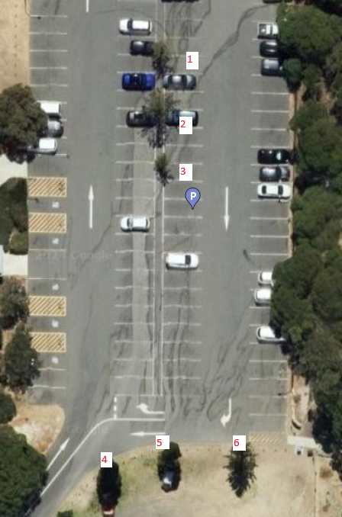
Figure 1: Location of Tree proposed for removal
The trees proposed for removal within the current car-park (Trees 1-3) are performing poorly, and are not expected to achieve their full potential. The location of the trees limits the ability to reconfigure the car park, as required by the project scope. Poor performance includes poor form, stunted growth, irregular and stunted branch development. The existing trees are estimated to be 6-10m height. There is evidence of trunk damage to the trees located within the current car park, likely due to impact from cars.
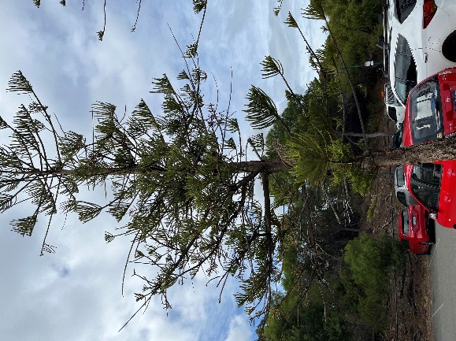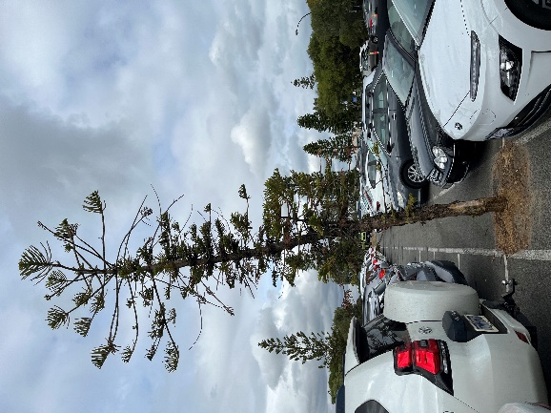
Tree 3
Tree 2
Tree 1
The trees proposed for removal for the southern pathway are in better condition, but also of small size, with average performance. Tree 6 exhibits evidence of trunk damage, however this appears to be healing.
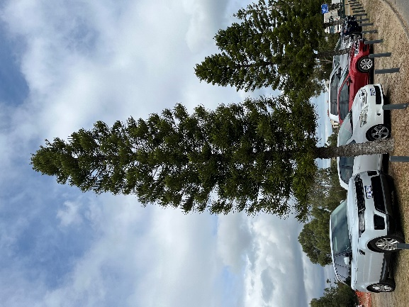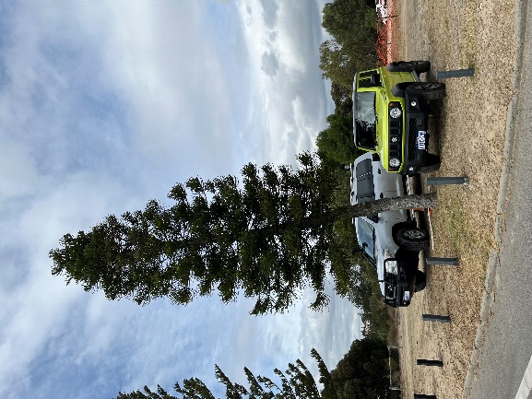
Tree 6
Tree 5
Tree 4
Discussion

Replacement with suitable species, planted in dedicated tree wells, would both facilitate the works and also allow for more appropriate tree species to be planted that are expected to have better performance and provide improved future canopy.

The three trees proposed for removal within the car-park would be replaced with 8 trees in the car-park, with 4 trees to be replaced on the southern path. Twelve replacement trees aligns to the 2 for 1 replacement ratio required for private development under policy, and is considered good practice for City projects also where possible.

Species currently proposed for replacement are Corymbia ficifolia (Red Flowering Gum) or Corymbia maculata (Spotted Gum). Both species would perform well in this location, have suitable upright form, and broad canopies. The species finally selected will depend on stock availability, should alternative species be required it will be ensured that the species selected is suitable to the environment with similar characteristics. It is proposed to plant 150 litre tree stock, subject to availability and budget capacity.

Corymbia ficifolia will grow approximately 60cm annually. Corymbia maculata grow slightly slower at 50cm per annum, however will achieve greater height and spread at maturity. The existing species, Aracauria heterophylla, is slow growing at 7-15cm per annum. Accordingly, the replacement trees would be expected to exceed the canopy of the existing trees within 5 years.

Consultation

The WA Bridge Club and Melon Hill Bush Group have been consulted about the removal of the car park trees.

Strategic Implications

This item is strategically aligned to the City of Nedlands Council Plan 2022-23 vision and desired outcomes as follows:

Vision Sustainable and responsible for a bright future

Pillar Planet
Outcome 4. Healthy and sustainable ecosystems.

Pillar Place
Outcome 7. Attractive and welcoming places.

Pillar Performance
Outcome 11. Effective leadership and governance.

Budget/Financial Implications

The removal and subsequent replacement costs were not included within the original estimate for the project. The removal and replacement costs are still being assessed in detail and the project is still forecast to be completed within 5% of budget.

Internal staff labour was spent in the formalisation of this report.

Legislative and Policy Implications

The removal aligns with the Street Tree Policy given no suitable design alternative exists.

Decision Implications

Should Council not endorse the removal, the City will be required to redesign the works to retain the existing trees in their current location, this would not meet the scope of the current project and would significantly reduce parking bay numbers.

Conclusion

The removal of the trees will ensure an improved design outcome. The replacement trees are expected to exceed the canopy coverage that would be provided by the current trees within 5 years.

Removal should be approved.

Further Information

Nil.

Divisional Reports – Community Services & Development

CDS02.05.24 Reclassification of Point Resolution Child Care Centre license

Meeting & Date | Council Meeting - 28 May 2024
Applicant | City of Nedlands
Employee Disclosure under section 5.70 Local Government Act 1995 | Nil.
Report Author | Sally De Freitas - Acting Manager Community Development
Director | Matthew MacPherson – Acting Chief Executive Officer
Attachments | - CONFIDENTIAL – Attachment 1 – Point Resolution Compliance issues and penalties

Purpose

This report aims to address compliance issues identified during the investigation of the Point Resolution Childcare Centre (PRCC) from January to April 2024, particularly regarding Workplace Health and Safety Management, Childcare Safety, Record Management, National Quality Standards, and First Aid requirements.

The report presents potential solutions to rectify these concerns, emphasising the necessity of maintaining compliance across all areas and adjusting staffing and educator ratios, given that the current model of accommodating 26 children has contributed to the shortfall in meeting educator requirements.

Recommendation

That Council, pending the outcome of recommended outcome 2 approves the reclassification of Point Resolution Childcare Centre’s license to enrol up to 24 children per day from the ages of 8 months to 6 years of age.

Voting Requirement

Simple Majority.

Background

Enrolment and Attendance

54 Children are enrolled to attend sessions across 5 days and fill up to 26 approved places in an open room setting. The City is approved by Education Care Regulatory Unit (ECRU) for up to 26 spaces which is decided based on maximum available floor space. As is, there is no option to increase enrolment numbers without increasing available floor space.

60% of current enrolled children are from within the City of Nedlands Boundaries.
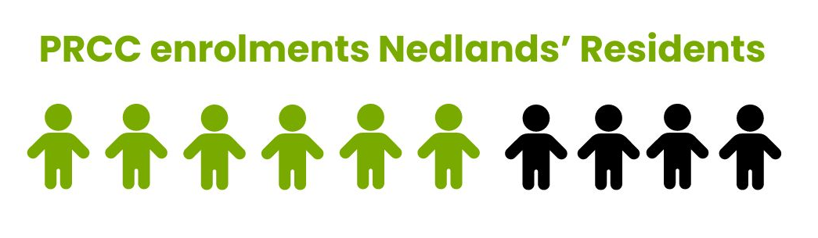
Only 1 child is enrolled fulltime for 5 days with most children enrolled for 2 days a week and several attending on an ad hoc casual basis when space is available due to planned absence.

Although the City’s enrolment policy states that priority will be City of Nedlands Residents, priority appears to be given to siblings of attending and past children, and any enrolment requests for days where there are spaces available at the time.

The enrolment and attendance records show that spaces are filled as they are offered, and full-time daycare does not appear to be an urgent priority. Typically, 3-5y enrolments would reflect a kindy attendance (families requiring care on the days the child is not at school), however this is not reflective of PRCC. Staff have also commented that most of the children have other forms of care, including grandparents and nannies and use the centre as a form of socialisation.

The structure of enrolments is noticeably shaped by the staff to children’s ratios. For example, children under the age of 2 require a lower ratio 1:4, 2-3 years is 1:5 whereas over 3 is 1:11. This means that enrolments and places are largely prioritised to certain age groups to meet ratios and ensure a full roster.

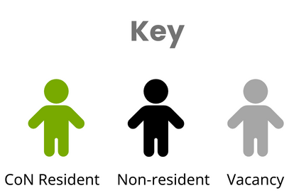

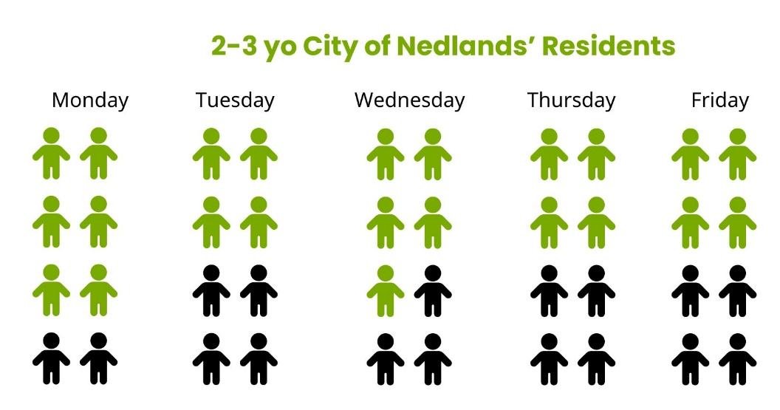
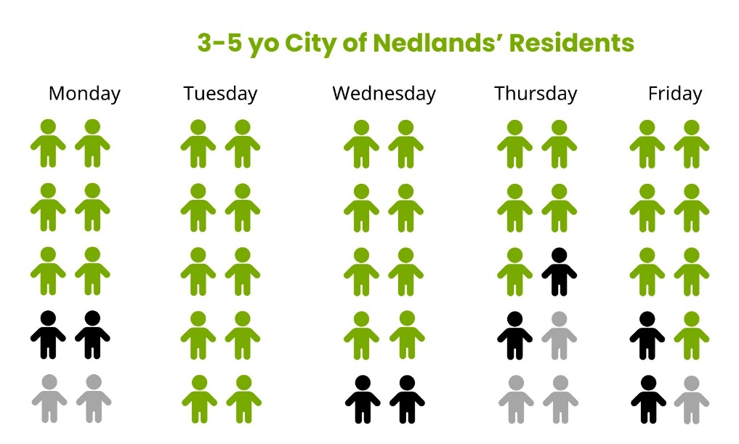
As of April, just over 25% of enrolled children are under two, and there are only 2 children under 12 months on any day.

This is a strong indication that there isn’t a significant demand from ratepaying families for care for under 2s, in particular, for under 12 months. Of the under 2s, one third are younger siblings of other children currently attending or were attending at the time of enrolment.

The staffing ratios and tendency to ‘fill spaces’ restricts the ability to offer consistent and regular care required by families looking for full time care.

The need to fill the requirements of long daycare is also reflected in the operating hours. Typically, long day care opening hours start from 6.30/7 and finish at 6. PRCC reduced hours mean that it excludes a significant client base that require a longer day (12 hours) or flexibility on hours available.

For Q1 of 2024, there were only 2 days where the number of children enrolled to attend exceeded 24.

Fees

The current fees are a flat rate of $160 per day regardless of hours attended, with a childcare subsidy available to those eligible. There is an expected increase of $5 per day each financial year.

The centre does not offer a discount for planned absences (holidays etc) and families are charged the full rate for public holidays. The Child Care Subsidy still subsidise for up to 42 absence days per child, per financial year. The fees and enrolments are charged at the beginning of the calendar year when the child returns, this means that typically the centre operates at a lower capacity for attendance, resuming to usual capacity of an average of 24 children per day, this is despite 26 approved spaces.
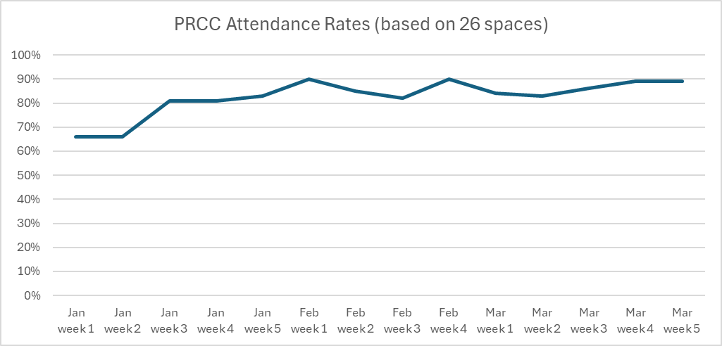
Frequently, when families are on a planned absence, ‘spaces’ are offered to other families to meet the full enrolment. This means that there is often extra income as ‘spaces’ are resold. This financial year an additional 312 spaces, or 1.7 per day have been ‘resold’ so far adding an additional $49,920.

The fee includes food (morning tea, lunch, afternoon tea).
Nappies and formula are not included in this fee, however with most of the enrolled children at or near toilet training age, this would not be significant cost to the centre.

There is also an annual fee of $150 per year per family which generates an added approximate $8,000 per year. It is not yet apparent what this fee goes to, or the service provided to families for this charge, and this is still being investigated.

Despite the location, the staffing levels mean that excursions are not possible, except for ‘kindy’ visits to Dalkeith Kindy for older children that are enrolled.

There are also no regular incursions, however irregular sessions with associates or family members are planned throughout the year, as are functions and events with families.

Compliance Issues

Refer to confidential attachment - PRCC Compliance and Issues

Other Care in Nedlands

There are 11 centres offering care in the Nedlands Dalkeith area. 10 of these have vacancies. The average cost for childcare around Nedlands is $150.25/day. The next sized similar style of service is Kidz Galore Nedlands franchise with 40 approved places charges $145 per day. At the higher end of the cost range Sparrow Early Learning Nedlands charges $171 per day however is a new modern facility with separate rooms for ages groups.

Financials

FY | 17/18 | 18/19 | 19/20 | 20/21* | 21/22 | 22/23
(surplus)\deficit | 120,906 | 57,958 | 85,455 | (95,201) | (125,255) | (49,153)
Registered children | 24 | 24 | 24 | 26 | 26 | 26
Budgeted children | 24 | 24 | 24 | 24 | 24 | 24
*From 2020 when licensing was increased to 26 per day the budget was not amended to reflect the increase in potential revenue; which in part has resulted in a false surplus.

For 5 years up to the FY 20/21 Point Resolution Daycare ran at a significant loss. A decision was made in November 2020 to increase the number of enrolled spaces to 26 children from Jan 2021, and increase the fees $15 per day per child. This would increase the expected revenue from $135 per day @ 24 spaces = $826,200 (expected annual income based on 51 weeks of operation) to $150 per day @ 26 spaces = $994,500 (expected annual income based on 51 weeks of operation), adding an additional $ 84,150 for the period Jan 2021-June 2021.

Inconsistencies
Budget & Estimating
The additional 2 spaces that have been allocated and have service approval have not been included or reflected in the previous 3 budgets that were adopted. The annual administrative fee was not included until this most recent budget (23/24), and an estimate on income generated by casual spaces or late fees is not included for the previous 3 budgets.

This has meant that additional income from the 2 spaces, and other forms of income depicted in the Fees and Charges has not been accounted for and appears as a surplus since FY20/21.

Expenditure, Compliance and Spending

Staffing and ratios
Over the past 3 years there has been significant turn over resulting in a lower than planned spend on salary and wages. This has been reflected in an increase in spend in agency staff and casuals with $20,237 or 129% of the budget. While childcare industry experiences shortages, there has been a higher-than-expected turnover for the Early Childhood Teacher (ECT) role, with the last employee resigning after 3 months (this included a month in November when the centre was not operational). There was also a significant underspend in staff training and professional development where only 20% and 28% of the 22/23 budget was spent respectively, and only 18% for this financial year so far.

While most childcare providers struggle to operate at full capacity, the implications of increasing the enrolled spaces to 26 spaces can be seen through an inaccurate budget, and inability to maintain more consistent staffing ratios and positions. For example, an enrolment number of 24 only requires a part time ECT for 10 hours a week, whereas 26 children require an ECT onsite for at least 6 hours a day. As an ECT is a degree qualified educator, and local government rates are not competitive with award rates, PRCC has struggled to attract and retain this role. This means that agency staff will be required to infill, at a significant cost.

Food

The budget for food for has been well below the advised $3.50 per child per day for long daycare and is only budgeted for 24 children. This also presents a problem when casual spaces are allocated to children in the 3-5 year categories who require a higher quantity of food, and different nutritional requirements due to their developmental phase.
This underspend has a direct correlation with the inadequate nutritional content of the food being served. An analysis of the shopping lists shows lower quality cuts of meat as substitutes for healthier offering. For example, minced meat is used in meals, where the menu insinuates something that uses a higher quality cut of meat i.e. Beef stir fry. Food that is high in refined carbohydrates, fat and salt are also purchased in favour of wholegrains and nutritionally dense food; instant noodles, macaroni, and white rice featured heavily throughout the week. A report provided by a nutritionist to PRCC in 2022 identified a several of these concerns as priorities to address.

Resources and equipment

The resources and equipment at PRCC are old, dated, and inadequate to support the development of the different ages of children attending. While the budget suggests that some effort has been made recently to purchase resources, many of the toys are second hand donations. Inside, the furniture and coverings are dated with some damaged exposing children to a health and safety risk. Because of the open plan room, and the accessibility to toys by younger children, it is critical that resources are in optimal condition to reduce the risk of injury. The outdoor area contains no fixed equipment to help develop gross motor skills, or engage in calculated and supervised risky play, and largely made up of plastic toys. Most of the outdoor equipment were sun damaged, and showed signs of disrepair, and in a few instances, there was equipment with visible exposed rust. The condition of resources and equipment has been identified several times by ECRU as being an issue with compliance notices issued as recent as 2023, and a breach being registered against PRCC in 2022 for this.

Resources should be purchased brand new from a reputable education supplier with an ongoing budget of around $5000 annually for a childcare of this size, this current financial year only $2500 has been budgeted, an increase from $2000 for the last financial year. An overview of the purchasing shows that resources were mostly purchased from Kmart, and a majority of the allocated budget was spent on decorations and theming items for events that parents attended.

Financial sustainability and compliance are vital considerations. Reserves will need to be used if the centre is to remain operational to purchase necessary equipment and resources aligned with children's developmental needs and educational requirements specified by the National Quality Framework (NQF), which are currently lacking at the centre.

This proactive investment not only ensures compliance but also enhances the educational environment, supporting holistic child development.

Discussion

PRCC currently has 54 children enrolled at the centre, 60% of which reside in the City of Nedlands. The centre operates as cost-neutral with reserves used for upkeep and replacement of equipment and maintenance requirements.

Four possible options for the future of PRCC have been outlined below for Council’s consideration:

Option 1 (Not recommended)

Maintain current state of service (26 children ages 0-6)

To maintain the current enrolments at the Point Resolution Childcare Centre (PRCC), there's a need to increase the Full-Time Equivalent (FTE). According to the National Quality Framework (NQF), a centre with 26 children requires a full-time Early Childhood Teacher (ECT).

Ensuring the right number of caregivers for each child is crucial. The current model has challenges with the baby-to-staff ratio in the 0-2 age bracket, requiring 5 staff on the floor. This has been challenging to manage, relying mainly on casual workers or agency staff. This isn't ideal for the children who form bonds with their caregivers, and the turnover of casual workers is also costly.

Historically, PRCC has struggled to meet nutrition standards outlined by the NQF. PRCC will need to hire a dedicated cook for half of a full-time position (FTE 0.5). This is a requirement set by the Childcare Services Regulations 2006.

Maintaining compliance requires continuation of full-time equivalents (FTEs) for both the ECT and Coordinator, plus the additional 0.5 FTE for a dedicated cook which adds financial strain to a small centre; increasing to 7.0 from 6.5.

Option 2 (Recommended)

Reclassify Point Resolution Childcare Centre’s license to enrol up to 24 children per day from the ages of 8 months to 6 years of age.

The Point Resolution Childcare Centre (PRCC) is facing persistent challenges in finding and keeping a full-time Early Childhood Teacher (ECT), as required by the National Quality Framework (NQF) for centres accommodating up to 26 children. Given the small size of the centre, one option may be to streamline the Coordinator’s role to integrate the ECT responsibilities into the Coordinator position, which now requires tertiary qualifications. At 24 children or under an ECT is only required for 20% of the centres operating hours (10 hours per week).

This option meets regulatory standards and maximises the utilisation of existing staff structures. This consolidation enables the centre to focus more on meeting the needs of the children, aligning with its commitment to providing high-quality childcare services and age-appropriate programs and activities.

Despite these changes, maintaining optimal caregiver-to-child ratios remains a priority. The proposed reclassification ensures compliance with standards, with each caregiver responsible for four infants aged 0-2 years. Any decrease in enrolled children will occur naturally over time, preserving the centre’s community involvement and continuity.

The centre has historically been unable to meet nutrition standards set by the NQF. In the proposed plan, PRCC will hire a dedicated cook for half of a full-time position (FTE 0.5). This is also a requirement under the Childcare Services Regulations 2006.

This option makes it easier for the centre to reach compliance to maintain an ECT; and reduces the total FTE at the centre to 6.0 from 6.5.

Option 3 (Not recommended)

Seek Expressions of Interest for outside childcare providers to take over the running of the centre.

Given the significant risks and expenses associated with operating a childcare centre, the Council may consider the possibility of opening up PRCC to Expressions of Interest from external providers (EOI).

Larger childcare providers often benefit from economies of scale, enabling them to manage staffing more efficiently across multiple locations. Considering that childcare is not a primary focus of local government community services, the Council must evaluate whether its involvement in this sector is still warranted. Specialised childcare providers are better equipped to handle the regulatory and quality standards, as well as marketing efforts to attract enrolments, areas where PRCC has faced challenges. It's important to note that while the centre operates on a cost-neutral basis, it's the community that ultimately subsidises family’s attendance at the centre which is currently operating at 60% City of Nedlands residents.

This option also presents an opportunity for current staff to continue their employment under the new provider, ensuring continuity of care for the children currently enrolled at the centre.

The facility can become part of the City's portfolio of leasable or hireable facilities, considering its location on crown land and its current use as a childcare centre. Under a commercial arrangement like other leasehold facilities, the lessee would be responsible for the annual maintenance costs and would pay an agreed-upon rental rate, with no cost to the ratepayer. The City would continue to be responsible for maintaining and insuring the site, and a usage fee would be applied, estimated to be $65,000 per annum based on a valuation March 2024.

Outsourcing the service to an external provider will result in a reduction of 6.5 Full Time Equivalent (FTE) positions.

Option 4 (Not recommended)

Close Point Resolution Child Care Centre

The building, situated on Crown land and presently designated for childcare purposes, could be added to the list of City facilities available for hire, license, or lease. The building, situated on Crown land and presently designated for childcare purposes, could be added to the list of City facilities available for lease, licence, exclusive licence or hire arrangement.

Under this arrangement the City would make its community facilities available to eligible users based on the arrangement, subject to evaluation and approval process. The conditions of tenure will consider matters relating to obligations, costs, and compliance.

This proposal was presented to Council in September 2020 but was not supported.

Given the current challenges the centre faces with bringing it to compliance, and in line with best practice benchmarking against other like providers, the City is lacking sufficient information to justify a decision as significant as closing a service that is actively used by families and has ongoing enrolments.

Closing the service to an external provider will result in a reduction of 6.5 Full Time Equivalent (FTE) positions.

Consultation

For confidentiality reasons there has been no external consultation.

Should a change to the service or use of facility consultation will be required under Section 3.58 of the Local Government Act.

Strategic Implications

This item is strategically aligned to the City of Nedlands Council Plan 2023-33 vision and desired outcomes as follows:

Vision Sustainable and responsible for a bright future

Pillar People
Outcome 3. A caring and supportive community for all ages and abilities.

Pillar Prosperity
Outcome 10. Active participation in education and lifelong learning.

Pillar Performance
Outcome 11. Effective leadership and governance.

Budget/Financial Implications

Options 1 & 2 both require budget to ensure the centre meets compliance as outlined in attachment # It is recommended the centre makes allowances in the future budgets to reach best practice or exceed compliance to remain competitive in the market.

Option 3 the centre will need to meet compliance and address major structural needs to go to market for EOI.

Option 4 will still require budget to get the centre to meet compliance until such time it determined the centre will cease operations.

There is currently $140,000 in reserves which can be accessed immediately to meet compliance requirements as identified in Options 1 & 2

2024/25 | Meet Compliance | Details
Electrical | $1601.00 | Reduce hazards to current electrical
Playground Equipment & Maintenance | $40,000.00 | There is no fixed outdoor play equipment in the centre that provides for children’s development of gross motor skills. Bike track needs to be repaired or replaced.
Educational Resources | $10,000.00 | Replacement of books, toys and other equipment not currently meeting standards.
Miscellaneous repairs | $17,102.00 | Including maintenance for doors, shelving and render which are posing safety hazards to children and staff.
Staff offices and break areas | $5,000.00 | Re-fit of space to meet WHS requirements
Total | $73,703.00

Staffing implications

Options | FTE | Comment | Redundancy
1 | 7.0 (+0.5) | Increase FTE to allow for 1 FTE ETC and Cook | N/A
2 | 6.0 (-0.5) | Reduction in FTE by combining Coordinator/ECT role while still employing a cook | N/A
3 | 0 |  | $96,278.00 (est.)
4 | 0 |  | $96,278.00 (est.)

Legislative and Policy Implications

Childcare Services Regulations 2006
Department of Communities - Education Quality Care Unit (ECRU)

The City currently has two staff nominated as Persons with Management Control of the centre:

- Tony Free (Acting CEO) - application has been completed

- Sally De Freitas – application pending

The process to be approved as Persons with Management Control can take up to four months and a rigorous process that involves a Police Check, Working with Children’s Check and the completion of an extensive online course.

Persons with management or control of the provider (PMC) have certain obligations and tasks they must perform.

A person responsible at the service has similar obligations to a PMC, but at the service level.

If these tasks aren’t competed within certain timeframes, the provider risks:

- not being approved to run a childcare service
- losing approval to run a childcare service
- receiving an infringement.

The City is currently at risk of being non-compliant with current staffing changes.

The City is currently compliant with respect to a nominated supervisor who is responsible for the day-to-day operation of the centre. In the case of the City this staff member is Acting Coordinator Emma Bassett.
The Coordinator of PRCC does not currently satisfy the requirements of the Department to be the PMC.

Decision Implications

If the Council endorses the officer recommendation there will be favourable results for the City both financially and in terms of compliance. Integrating Early Childhood Teacher (ECT) responsibilities into the Coordinator role at the Point Resolution Childcare Centre (PRCC) aligns with the National Quality Framework (NQF) standards, optimising staff structure utilisation. This consolidation not only ensures regulatory compliance but also allows the centre to focus on providing high-quality childcare services.

Additionally, the proposed reclassification guarantees optimal caregiver-to-child ratios, maintaining compliance with standards and enhancing childcare quality. Natural attrition in enrolment preserves community involvement and operational continuity. Hiring a dedicated cook to meet nutrition standards further strengthens compliance efforts, aligning with Childcare Services Regulations 2006 requirements.

Overall, the endorsement of this recommendation promotes financial efficiency by maximising existing resources and mitigating potential compliance-related costs. It also demonstrates the City's commitment to providing quality childcare services while adhering to regulatory standards, fostering positive outcomes for both the community and the City's budget.

If Council does not endorse the officer recommendation and maintains the current status of PRCC an increase in Full-Time Equivalent (FTE) staff to meet regulations for the current enrolment of 26 children is required. This lack of investment in staffing and infrastructure not only compromises compliance but also reduces the quality of care and education provided.

The centre’s struggle to retain qualified staff, particularly Early Childhood Teachers (ECTs), due to uncompetitive salaries may necessitate reclassification and budgetary expansions. In its current state, PRCC faces ongoing challenges in fulfilling its obligations, endangering the well-being and developmental outcomes of the children.

The discrepancy between the current budget and the actual enrolments indicates an inaccurate surplus, likely leading to a return to a cost-neutral or deficit position if the status quo persists. Addressing these deficiencies is imperative to ensure PRCC's financial stability and ability to provide high-quality services.

Should Council wish to pursue an alternative option, potential alternative recommendations may be suitable as follows:

Option 1

That Council approves the increase of FTE at Point Resolution Childcare Centre to 7.0 from 6.5; to meet compliance requirements for the number of 26 children per day from the ages of 8 months to 6 years of age.

Option 3

That Council requests the CEO to:
- call for Expressions of Interest (EOI) for an external childcare provider to undertake childcare services at 53 Jutland Parade, Dalkeith for a term of up to 21 years in accordance with the Management Order, with proviso that current staff and currently registered children are included in the transition of the service; and
- report back to Council the outcome of the Expression of interest for further consideration.

Option 4

- Approves the CEO to cease operations of the Point Resolution Childcare Centre (PRCC) at 53 Jutland Parade, Dalkeith at the earliest opportunity within the 2024/25 financial year;
- Approves an increase to the budget for the Point Resolution Childcare Centre Employment costs by $90,000 of Municiple funds. The funds will be required to enable to payment of the due transitional costs (redundancies).

Conclusion

The report thoroughly addresses compliance issues identified at the Point Resolution Child Care Centre from January to April 2024, focusing on Workplace Health and Safety Management, Childcare Safety, Record Management, National Quality Standards, and First Aid requirements. Potential solutions are presented to rectify these concerns, highlighting the importance of maintaining compliance across all areas and adjusting staffing and educator ratios.

Given that the current capacity of accommodating 26 children has led to challenges in meeting educator requirements, the recommendation is for Council approval to reclassify the childcare centre's license to enrol up to 24 children per day, aged 8 months to 6 years.

Further Information

Nil.

Divisional Reports - Corporate Services

CPS23.05.24 Monthly Financial Report – April 2024

This item will be dealt with at the Council Meeting.

CPS24.05.24 - Monthly Investment Report - April 2024

This item will be dealt with at the Council Meeting.

CPS25.05.24 - List of Accounts Paid - April 2024

This item will be dealt with at the Council Meeting.

CPS26.05.24 – Powerlyt Solar Recommendations

Meeting & Date | Council Meeting – 28 May 2024
Applicant | City of Nedlands
Employee Disclosure under section 5.70 Local Government Act 1995 | Nil.
Report Author | Aleisha Smit Land and Property Officer
Director | Michael Cole Director Corporate Services
Attachments | - Powerlyt report – Nedlands Solar Recommendations V2

Purpose

This report is in response to a Council resolution to conduct an audit and report on utility costs. The City engaged electrical engineer Powerlyt to prepare a report with recommendations on how to decrease the City’s top contributors of power usage by way of solar PV.

Recommendation

That Council:

- Receives the report from Powerlyt with recommended Solutions for the Provision or Augmentation of Solar PV Systems at 8 locations

- Lists the recommendations for consideration in the forward capital works program

Voting Requirement

Simple Majority.

Background

Following Council resolution from August 2022, due to extremely high utility costs in the budget, the CEO was directed to conduct an audit and report on utility costs on several items, one of which was to provide at least 80% of daytime electricity from solar PV at the City’s staff occupied buildings.
The City of Nedlands awarded a contract to electrical engineers, Powerlyt. Powerlyt conducted inspections and research to prepare a report with recommendations on how to decrease the City’s top contributors of power usage. 8 facilities were identified to be equipped with Solar PV Systems. The nominated sites are as follows:
- Administration Building – 71 Stirling Highway, Nedlands
- Nedlands Cottage – 110 Smyth Road, Nedlands
- Carrington Street Depot – 1 Broome Street, Nedlands
- Nedlands Library – 60 Stirling Highway, Nedlands
- Mt Claremont Library – 105 Montgomery Avenue, Mt Claremont
- Tresillian Art Centre – 21 Tyrell Street, Nedlands
- Nedlands Positive Ageing – 97 Waratah Avenue, Dalkeith
- Point Resolution Child Care – 53 Jutland Parade, Dalkeith
An audit was carried out on the relevant facilities electricity cost and consumption history, with information provided to Powerlyt.
Inspections at the facilities commenced in February 2024, and were completed over a two-day period. The purpose was to identify which roof or parts of roof of the following buildings would be available for installing solar panels.
Following the audit on historic data in conjunction with the inspection, Powerlyt provided the City with a report modelling their recommendations of the appropriate size Solar PV Systems for each of the 8 sites.

Discussion

The option to have battery storage for the Solar systems has been considered, as it is thought that some of the power beyond a certain generation is perishable, as only a certain amount can be returned to the grid. This is a critical factor with the City’s vehicle fleet being converted to electric in the future, with charging stations to be utilised at the City’s Administration and Depot locations, both of which are a part of the 8 nominated facilities for solar PV installations.

Based on the preliminary assessment, Powerlyt advised that there are limited resources in the way of space available across the 8 facilities, preventing the correct size of solar panel to be installed for the load profile required to achieve a justifiable payback period. It was confirmed that the City would likely achieve a payback period of around 7 to 8 years with battery storage. As the typical lifecycle for the batteries is around 10 years, batteries were therefore decided against being included within the recommendation.

Other issues considered in shaping this recommendation were the financial outlay to the City. As required, numerous quotes for the works were obtained and evaluated. Powerlyt was chosen as the preferred contractor to the City as they successfully demonstrated the ability to satisfy the requirements for the project brief whilst providing the City with value for money within the market coming in at $15,480 plus Ancillary costs where required. It is therefore advantageous for the City to continue working with Powerlyt on this project.

Consultation

The Land and Property Officer coordinated a suitable inspection time and date for Powerlyt to inspect as required.

The City provided a consent form addressed to Western Power permitting Powerlyt access to the City's energy meter consumption data. In addition, data on both electricity consumption and cost for each of the nominated sites was extracted from Azility and provided to aid Powerlyt’s calculations for recommendations of Solar PV to the City’s top contributors of power usage.

Strategic Implications

This item is strategically aligned to the City of Nedlands Council Plan 2023-33 vision and desired outcomes as follows:

Vision Sustainable and responsible for a bright future

Pillar Planet
Outcome 4. Healthy and sustainable ecosystems.

Budget/Financial Implications

The recommendation can be included in the forward capital works program. While the City will incur additional expenditure for maintenance and renewal, the saving overall in expenditure on electricity consumption and carbon emissions will be fruitful.

Total cost of the project is $129,180 for all 7 buildings with a payback period ranging between 2 years and 8 months and 4 years and 7 months.

Administration have checked the condition of the roof structure of the nominated buildings against a recent condition survey. This condition survey indicates there is no requirement for major works (that would require the removal of any solar system) on the roofs of the buildings listed in this report in the short to medium term. There may be a requirement for minor repairs, but this is not expected to be impacted by the installation of any solar system.

Finally, a consideration is whether the reduced energy costs impact the contestability of these sites is yet to be determined. Provided consumption is more than 50,000 kWh of electricity per year or a spend more than $15,000 per annum this should remain contestable.

Legislative and Policy Implications

Referring to the Local Government Act 1995, Section 3.1 of the Local Government Act 1995, the Community Plan and any sustainability policy that was adopted. By proceeding with Powerlyt’s recommendations to install the solar PV systems at the nominated facilities, the City would be forward planning to ensure reduction in both electricity consumption expenditure and carbon emissions.

Local Government Act 1995 - [07-aj0-01].pdf (legislation.wa.gov.au)

Decision Implications

Should Council endorse this report, the recommendations will be listed for consideration in the forward capital works budget for consideration during budget discussions.
Alternatively, should Council decide not to proceed with Powertly’s recommendations to install solar PV systems, alternate planning, prospecting, research, time and money will be required to resolve the significantly high utility costs within the budget.

Conclusion

The City has engaged electrical engineer Powerlyt to provide recommendations on how we can reduce the high utility costs within the budget from an electricity consumption perspective, with reduction of carbon emissions in mind. This aligns with the City’s Council Plan on climate resilience, Outcome 5, 5.1, encouraging the adoption of sustainable practices to work towards being carbon neutral. The City recommends that the Council adopt this proposal so that we can work towards a more sustainable future for the City of Nedlands whilst reducing unnecessary expenditure.

Further Information

Nil.

CPS27.05.24 Underground Power – Consideration of Results from Consultation and Next Steps

Meeting & Date | Council Meeting – 28 May 2024
Applicant | City of Nedlands
Employee Disclosure under section 5.70 Local Government Act 1995 | Nil.
Report Author | Michael Cole
Acting CEO | Matthew Macpherson
Attachments | - Nedlands Underground Power Survey – April 2024

Purpose

To present to Council the results obtained from the landowner’s survey regarding the costs related to the installation of Underground Power in the Nedlands North and Nedlands West areas. This report provides an overview and analysis of the feedback received from landowners during the consultation process and outlines next steps should Council agree to proceed.

Recommendation

Council:

- Receives the results of the survey of landowners in Nedlands North (Floreat) and Nedlands West (Mt Claremont).

- Agrees to proceed with underground power in the Nedlands North (Floreat) and Nedlands West (Mt Claremont) project areas and:

  - Authorises the Chief Executive Officer and Mayor to sign the co funding agreements with Western Power on completion of negotiations.

  - Notes service charges for Nedlands North (Floreat) will be included in the 2025/2026 Draft Annual Budget, after the estimated completion of the project in that area with Nedlands West (Mt Claremont) in subsequent years after the completion of the project in that area.

  - Notes proposed borrowings will be listed for consideration in the 2024/2025 Draft Annual Budget.

  - Notes additional Project Management resources will be listed for consideration in the 2024/2025 Draft Annual Budget.

Voting Requirement

Simple Majority.

Background

The City of Nedlands commenced the installation of underground power in its local government area in 1997 and since then, 78% of the City’s residences have been converted to underground power through the delivery of five staged projects. However, the City still has 1,701 residences in Nedlands North (Floreat), Nedlands West (Mt Claremont) and Hollywood East that are connected to overhead power.

Underground power is specified in the City of Nedlands Council Plan 2023-33 with Council having passed a resolution for all Underground Power to be completed by June 2026.

The City engaged the services of Whitney Consulting to prepare the business case and ACIL ALLEN Consulting to prepare the Cost Benefit Analysis. The business case identified the numerous benefits underground power brings to a range of stakeholder groups.

Benefits to Property Owners (ratepayers)

- Increased property valuations (research reflects that higher value properties benefit more than properties with lower starting values), as an outcome of
- Improved visual amenity values
- Safer local communities due to the installation of new, more energy efficient street lighting
- Improved reliability of the electricity network
- Improved quality of the electricity supply
- Other benefits, such as reduced short term vegetation management costs

Benefits to Western Power

- Avoiding costly and complex pole replacement
- Reduced operating and maintenance costs
- Reduced costs associated with power interruptions

Benefits to Local Governments

- Reduced short term maintenance of streetscapes and verges (tree lopping costs for trees under overhead power lines)

Benefits to the Wider Community

- Improved reliability of electricity supply during severe weather events
- Improved amenity to non-residents
- Health and safety benefits – reduced electrical contact injuries, reduced motor vehicle and power pole collisions
- Reduced environmental impact – reduction in use of herbicides (weed control) and pesticides (termite control) around wooden power poles
- Improved street lighting – when an area is converted to underground power, new streetlights are designed and installed to meet Australian Standards. These new streetlights have more efficient fixtures and optimized spacing, which delivers brighter and more evenly lit streets, providing up to 15% more efficient street lighting. This may also enhance the local security of an area

In March 2023 Council considered the business case and agreed to consult with the wider community. In July 2023, Council considered a report on the results of community engagement on underground power and resolved as follows:

“That Council:

- receives the results of the community engagement for underground power for the remaining 1,701 properties in Nedlands North, Nedlands West and Hollywood East that are connected to overhead power;
- authorises the CEO to enter into an agreement with Western Power to progress the City of Nedlands underground power project to procurement stage for all three projects;
- notes the CEO will present a further report to Council once Western Power has provided the cost estimates within 10% accuracy; and
- requests the Mayor and CEO to actively explore additional sources of funding for the project to reduce the financial burden on the City and the residents.”

Western Power completed their procurement process and provided updated costings for Nedlands North and Nedlands West. Hollywood East is yet to be provided as the final design may need to be changed once the impacts on the design of new Hesperia Development are concluded.

In previous discussions with Western Power, it was envisaged that Hollywood East would commence construction once Nedlands North and Nedlands West were completed. Accordingly, Western Power have indicated a preference to call for tenders in late 2026 when the Hollywood East project is closer to commencement ensuring costings are reflective of market conditions at that time.

Given the increase in costs, Council resolved in February 2024 to:

- consult with affected property owners in Nedlands North (Floreat) and Nedlands West (Mt Claremont) on the increased costs of undergrounding power to their properties; and
- requests to Acting Chief Executive Officer report back to Council with the outcomes of the consultation.

In addition to the above, the Mayor and A/Chief Executive Officer met with senior Western Power representatives to discuss options and costings of the projects.

Discussion

The City engaged Data Analysis Australia Pty Ltd to engage with the affected landowners and the results of the survey are included in Attachment 1.

In summary:

- 52.7 % of affected landowners responded
- 65.6% in support of the projects,
- 58.4% willing to pay
- 42% are willing to pay upfront.

The response rate was higher for these two project areas than the previous survey in 2023 when only 35% responded.

Table 2 from the report provides a breakdown of the source of responses with highe4st responses coming from email invitations.

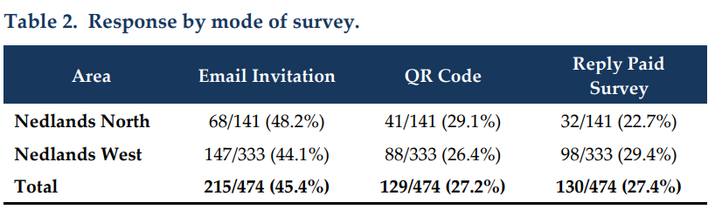
Table 3 from the report is the general response statistics.

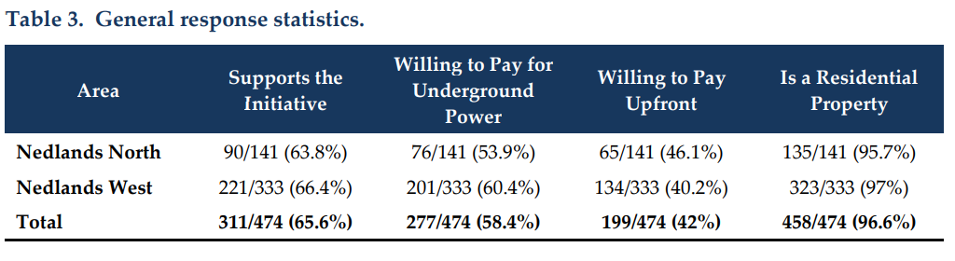
Tables 4, 5, 6 and 7 from the report are the responses to the survey questions.

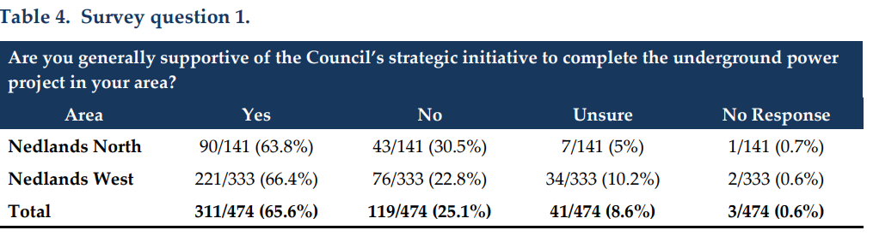

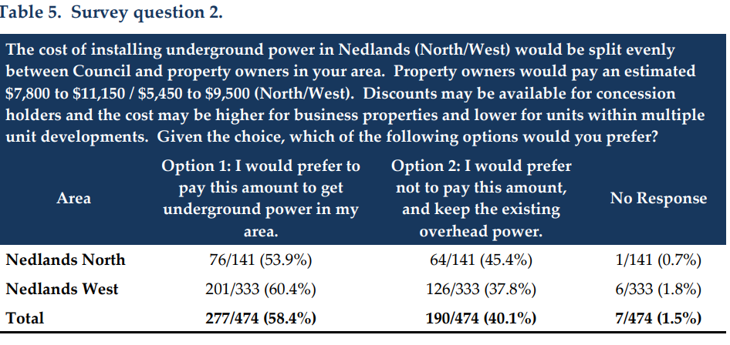

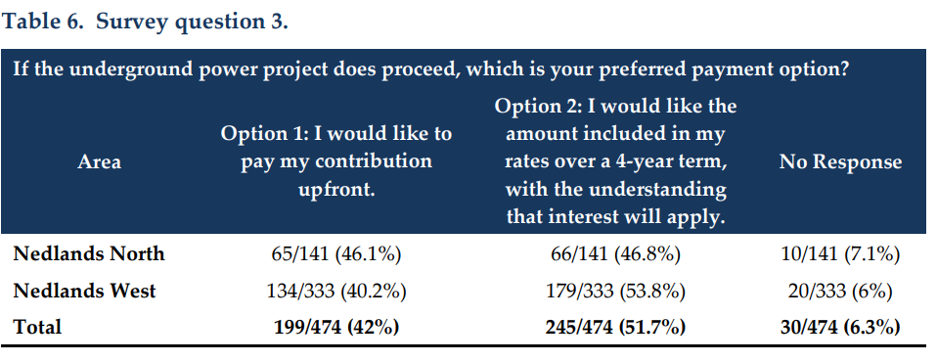

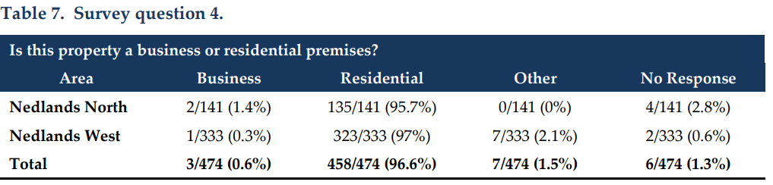

Written feedback was broken into three categories:

- those opposing the initiative,
- those conditionally supporting but preferring not to proceed financially, and
- those in support and willing to proceed with financial contributions.

A common thread across all three categories was the concern about the high cost of the project and the inequality in cost distribution.

Not in support – 25.1%

Among those not in support, the significant cost and cost-of-living crisis with many preferring the City focus on other initiatives such as parks, playgrounds, footpaths, and maintenance of trees.

Some residents suggested that underground power be put on hold for a “couple of years” until the cost-of-living crisis has improved. Others suggested a longer payment period (ie 6 to 8 years) or capping the total cost to landowners.

In support but preferring not to proceed or pay 8.65%
This group were concerned about the significant expense and stating with very few tangible benefits. Several requested all residents be treated equally and for those with high transmission lines remaining after the project is completed to pay significantly less than what is proposed. Many suggested that if the project were to proceed, payment should be made after project completion.

In support of the initiative and willing to proceed with a financial contribution 56.5%
More than half of residents are in support of the initiative and would prefer to proceed. The general sentiment is that they have waited far too long for underground power to be completed in their area, leading to significantly increased burden of costs to residents, with neighbouring areas paying far less for underground power.

Many also cited the cost-of-living crisis and the poor timing of the projects. Some believed the Council should lobby the State Government or Western Power to subsidise the cost to landowners. Many referred to residents of Nedlands being treated equally as previous areas had paid far less. Another suggestion was aligning the cost to property values.

Consultation

In addition, the survey of affected landowners, the Mayor and A/Chief Executive Officer met with senior officials from Western Power.

The City was advised that Nedlands North and Nedlands West are listed at the back end of their 10-year plan for replacement of the existing overhead network, ie 2034. Hollywood East is ranked lower and not in their 10-year plan.

Western Power’s contribution to the current projects is based on the remaining useful life of the network. When the network is due for replacement, local governments for that area are approached to determine whether the overhead network is to be replaced with an overhead network or if the local government will contribute to undergrounding the network.

While it is difficult to provide a solid estimate 10 years out, on current costings, replacing an overhead network with an overhead network is 60% to 70% cheaper than replacing with an underground network. Western Power’s contribution to the capital cost of undergrounding would be capped at the equivalent overhead replacement cost.

Based on the remaining useful life of the overhead network in Nedlands North and Nedlands West, Western Power are proposing to contribute only 45% of the capital cost. Based on the above information, in approx 10 years Western Power would more than likely contribute between 60% and 70% of this cost.

The capital cost, being the replacement of the overhead wires, is $22.5m for the two project areas. Western Power’s contribution is $9.8m. Assuming a 60% to 70% contribution if these projects were at the end of their useful lives, Western Power’s contribution would be $13.5m to $15.8m, resulting in a significant reduction in City and landowner contributions.

For Nedlands North (Floreat), the standard cost for landowners would be reduced by between $2,000 and $3,300 per property.

For Nedlands West (Mt Claremont), the standard cost for landowners would be reduced by between $1,500 and $2,500 per property.

Strategic Implications

This item is strategically aligned to the City of Nedlands Council Plan 2022-33 vision and desired outcomes as follows:

Vision Sustainable and responsible for a bright future

Pillar Place
Outcome 7. Attractive and welcoming places.

Pillar Performance
Outcome 11. Effective leadership and governance.
Budget/Financial Implications

The revised estimates from Western Power for Nedlands North (Floreat) and Nedlands West (Mt Claremont) will require the City to contribute $7.0m, which is an additional $1.8m over the amount indicated in the business case.

With approx. $3.0m in the Underground power reserve, the Council would be required to contribute an additional $4.0m to the project. Such a contribution could not be achieved without a significant allocation from rates each year.

The business case identified the significant impact the three underground power projects will have on the Draft Long-Term Financial Plan 2023-2038. The Long-term Financial Plan will need to be updated depending on the final decision by Council on whether to proceed with Underground Power at this time.

At present, the net cashflow impact on the City is a reduction of available funding of approximately $4 million for Road Infrastructure Renewals in the first 4 years of the Plan. It is worth noting here that the City currently has an estimated infrastructure backlog of $43 million.

Legislative and Policy Implications

Local Government Act 1995 Section 6.38 (1)

Local Government (Financial Management Regulations 1996 Reg 54(c)

Underground Power Policy

Decision Implications

Should Council agree to proceed, the Chief Executive Officer and Mayor with be authorised to sign the final co-funding agreements with Western power once negotiations are completed.

A communications plan to inform landowners and the wider community is being developed to deliver key messages and project updates.

However, given current financial constraints on the City, the Council may wish to defer commencement of projects until sufficient funds are accumulated in the Underground Power Reserve to fund the City’s portion of these projects.

Council may also consider deferring further consideration of underground power until the network reaches the end of its useful life in which case a great contribution from Western Power is expected. This may be not less than 10 years away.

Conclusion

Summarise the report and what you are recommending.

Further Information

Nil.

Reports by the Chief Executive Officer

CEO13.05.24 Outstanding Council Resolutions

Meeting & Date | Council Meeting – 28 May 2024
Applicant | City of Nedlands
Employee Disclosure under section 5.70 Local Government Act 1995 | No officer involved in the preparation of this report has a declarable interest.
Report Author | Libby Kania – Coordinator Governance and Risk
Director/CEO | Tony Free – Acting CEO
Attachments | - Register of Outstanding Council Resolutions

Purpose

For Council to consider the Register of Outstanding Council Resolutions (OCR) and the actions taken by Administration in progressing these items.

Recommendation

That Council receives the Register of Outstanding Council Resolutions dated May 2024.

Voting Requirement

Simple Majority.

Background

Council has requested that all Outstanding Council Resolutions be tabled on a monthly basis at the OCM.

Discussion

Attached to the Council report is the register of OCRs for Council’s noting and consideration.

The report has been updated by officers when required.

Information will be periodically provided to Councillors on previous resolutions of Council that:

- have been completed since the last update and
- have not yet been fully implemented. Reasons for any delays or unforeseen challenges are included.
Councillors are able to seek an update on any particular project or resolution outside of the reporting period, by contacting the CEO directly for information or by referring to the information on the Councillor portal.

Consultation

Nil.

Strategic Implications

This item is strategically aligned to the City of Nedlands Council Plan 2022-23 vision and desired outcomes as follows:

Vision Sustainable and responsible for a bright future

Pillar Performance
Outcome 11. Effective leadership and governance.

Budget/Financial Implications

Nil.

Legislative and Policy Implications

Local Government Act 1995.

Decision Implications

Councillors have oversight of the implementation of previous Council decisions, through access to the Register and the Councillor portal. Information on decisions may be provided through the CEO Weekly update, and direct request to the CEO. The City may include the register on the website to provide transparency to the community, although the community is able to access the document through the Council agenda.

Conclusion

That the Council receives the Register of Outstanding Council Resolutions for noting.

Further Information

Nil.

CEO15.05.24 City of Nedlands Dogs Local Law 2023 – Undertaking to Joint Standing Committee on Delegated Legislation

Meeting & Date | Council Meeting – 28 May 2024
Applicant | City of Nedlands
Employee Disclosure under section 5.70 Local Government Act 1995 | Nil.
Report Author | Libby Kania – Coordinator Governance and Risk
Director | Tony Free – Acting Chief Executive Officer
Attachments | - City of Nedlands Dogs Local Law 2023.

Purpose

The purpose of this report is for Council to consider the undertaking required to be made to the Joint Standing Committee on Delegated Legislation (the Committee) in regards to the City of Nedlands Dogs Local Law 2023 (the Local Law).

Recommendation

That Council resolves to undertake to the Joint Standing Committee on Delegated Legislation that –

- When the local law is next reviewed –
  - Insert a full stop at the end of clause 2.2(1)(c).
  - In clause 5.1 delete the reference to clause 5.3 and replace it with clause 5.4.
- Not enforce the local law to the contrary before it is amended in accordance with undertaking 1.
- Ensure all consequential amendments arising from the undertakings will be made.
- Where the local law is made publicly available by the City, whether in hard copy or electronic form, ensure that it is accompanied by a copy of the undertaking.

Voting Requirement

Simple Majority.

Background

The City of Nedlands resolved to make the Local Law on 12 December 2023. The Local Law was gazetted on 20 February 2024. In accordance with s. 3.12(7) of the Local Government Act 1995, a copy of the Local Law was sent for scrutiny to the Joint Standing Committee on Delegated Legislation. The Committee has considered the Local Law and determined that minor amendments are required. The Committee has requested that the Council provide an undertaking that these amendments will be made when the local law is next amended or reviewed.

Discussion

The Joint Standing Committee on Delegated Legislation is the body responsible for the scrutiny of all delegated legislation made by local government. It is able to disallow a local law and require amendment be made to a local law where it is deemed appropriate. Should a local government fail to make an undertaking in accordance with the recommendation made by the Joint Standing Committee on Delegated Legislation, the local law may be disallowed.

The amendments required to be made to the local law are minor and deal with correcting any ambiguity within the local law.

Amendment 1 deals with the insertion of a full stop at the end of clause 2.2(1)(c).

Amendment 2 clause 5.1 in the definition of infringement notice delete the reference to clause 5.3 and replace it with a reference to clause 5.4. Clause 5.3 deals with modified penalties and clause 5.4 deals with the issue of infringement notices.

Consultation

Nil.

Strategic Implications

This item is strategically aligned to the City of Nedlands Council Plan 2023-33 vision and desired outcomes as follows:

Vision Sustainable and responsible for a bright future

Pillar Performance
Outcome 11. Effective leadership and governance.

Budget/Financial Implications

There are no budget implications to make the undertaking should Council wait until the next local law review.

Legislative and Policy Implications

Section 3.12(7) of the Local Government Act 1995.

Decision Implications

The Council is required to make the undertaking to ensure that the Local Law is compliant.

Conclusion

Council is required to adopt the undertaking requested by the Joint Standing Committee on Delegated Legislation and the Mayor is required to advise the Committee of the Council’s decision.

Further Information

Nil.

Council Members Notice of Motions of Which Previous Notice Has Been Given

These items will be dealt with at the Ordinary Council Meeting.

Urgent Business Approved By the Presiding Member or By Decision

These items will be dealt with at the Ordinary Council Meeting.

Confidential Items

There were no confidential items at distribution of this agenda.

Declaration of Closure

There being no further business, the Presiding Member will declare the meeting closed.

