
AGENDA

Council Meeting Agenda Forum
Tuesday, 14 November 2023

Notice of Meeting
Mayor & Councillors
A Council Meeting Agenda Forum of the City of Nedlands is to be held on Tuesday, 14 November 2023 in the Council chambers at 71 Stirling Highway Nedlands commencing at 6pm.
This meeting will be livestreamed Livestreaming Council & Committee Meetings » City of Nedlands
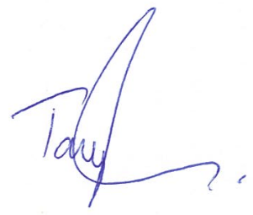
Tony Free | Acting Chief Executive Officer
9 November 2023
Information
Council Meeting Agenda Forum are run in accordance with the City of Nedlands Governance Framework Policy. If you have any questions in relation to the agenda, procedural matters, addressing the Council or attending these meetings please contact the Executive Officer on 9273 3500 or council@nedlands.wa.gov.au
Public Question Time
Public Questions are dealt with at the Ordinary Council Meeting.
Deputations
Members of the public may make presentations or ask questions on items contained within the agenda. Presentations are limited to 5 minutes. Members of the public must complete the online registration form available on the City’s website: Public Address Registration Form | City of Nedlands
Disclaimer
Members of the public who attend Council Meetings Agenda Forum should not act immediately on anything they hear at the meetings, without first seeking clarification of Council’s position. For example, by reference to the confirmed Minutes of Council meeting. Members of the public are also advised to wait for written advice from the Council prior to taking action on any matter that they may have before Council.
Any plans or documents in agendas and minutes may be subject to copyright. The express permission of the copyright owner must be obtained before copying any copyright material.

Table of Contents

1. Declaration of Opening 4
2. Present and Apologies and Leave of Absence (Previously Approved) 4
3. Public Question Time 4
4. Deputations 4
5. Requests for Leave of Absence 4
6. Petitions 4
7. Disclosures of Financial Interest 5
8. Disclosures of Interests Affecting Impartiality 5
9. Declarations by Members That They Have Not Given Due Consideration to Papers 5
10. Confirmation of Minutes 6
11. Announcements of the Presiding Member without discussion 6
12. Members Announcements without discussion 6
13. Matters for Which the Meeting May Be Closed 6
14. En Bloc Items 6
15. Minutes of Council Committees and Administrative Liaison Working Groups 6
15.1. Minutes of the following Committee Meetings (in date order) are to be received: 6
16. Divisional Reports - Planning & Development 7
16.1. PD47.11.23 - Consideration of Development Application – Additional use of ‘Holiday House’ to ‘Single House’ at 56 Williams Road, Nedlands 7
16.2. PD48.11.23 - Consideration of Development Application – Addition to Single House at 15 Watt Street, Swanbourne 14
16.3. PD49.11.23 - Consideration of Development Application - Residential - Single House at 24A Lisle Street, Mt Claremont 20
16.4. PD50.11.23 - Consideration of Development Application – Residential – Additions and Alterations to a Single House at 22 Wattle Avenue, Dalkeith 29
17. Divisional Reports - Technical Services 39
17.1. TS17.11.23 – Shirley Fyfe Park Gazebo – Waratah Avenue, Dalkeith 39
17.2. TS18.11.23 – Interstate Travel – Waste Expo Australian 2023 Participation 54
17.3. TS19.11.23 - Establishment and Appointment of Members – Integrated Transport Steering Committee 58
17.4. TS20.11.23 – Stanley Street & Florence Road Cul-de-sacs 65
18. Divisional Reports – Community Services & Development 77
18.1. CSD07.11.23 - Disability Access and Inclusion Plan 2023 - 2028 77
19. Divisional Reports - Corporate Services 81
21.1. CPS42.11.23 – Superannuation for Council Members 81
21.2. CPS43.11.23 - Monthly Financial Report - September 2023 85
21.3. CPS44.11.23 - Monthly Investment Report - September 2023 85
21.4. CPS45.11.23 - List of Accounts Paid - September 2023 85
21.5. CPS46.11.23 - Monthly Financial Report – October 2023 85
21.6. CPS47.11.23 - Monthly Investment Report - October 2023 85
21.7. CPS48.11.23 - List of Accounts Paid - October 2023 85
20. Reports by the Chief Executive Officer 86
25.1. CEO31.11.23 - Review of Register of Delegated Authority 86
25.2. CEO32.11.23 – Proposed Parking Amendment Local Law 91
25.3. CEO33.11.23 – Application for Payment of Training Costs – Councillor Coghlan 95
25.4. CEO34.11.23 – Register of Outstanding Council Resolutions 98
25.5. CEO35.11.23 – City of Nedlands Council Plan 2023-33 for Adoption 101
21. Council Members Notice of Motions of Which Previous Notice Has Been Given 111
22. Urgent Business Approved By the Presiding Member or By Decision 111
23. Confidential Items 111
24. Declaration of Closure 111

Declaration of Opening
The Presiding Member will declare the meeting open at 6.00 pm and will draw attention to the disclaimer on page 2 and advise the meeting is being livestreamed.

Present and Apologies and Leave of Absence (Previously Approved)
Leave of Absence Nil.
(Previously Approved)
Apologies None as at distribution of this agenda.

Public Question Time
Public questions will be dealt with at the Ordinary Council Meeting.

Deputations
Deputations by members of the public who have completed Public Address Registration Forms.

Requests for Leave of Absence
Any requests from Council Members for leave of absence will be dealt with at the Ordinary Council Meeting.

Petitions
Petitions will be dealt with at the Ordinary Council Meeting.

Disclosures of Financial Interest
The Presiding Member to remind Council Members and Staff of the requirements of Section 5.65 of the Local Government Act to disclose any interest during the meeting when the matter is discussed.
A declaration under this section requires that the nature of the interest must be disclosed. Consequently, a member who has made a declaration must not preside, participate in, or be present during any discussion or decision-making procedure relating to the matter the subject of the declaration.
However, other members may allow participation of the declarant if the member further discloses the extent of the interest. Any such declarant who wishes to participate in the meeting on the matter, shall leave the meeting, after making their declaration and request to participate, while other members consider and decide upon whether the interest is trivial or insignificant or is common to a significant number of electors or ratepayers.

Disclosures of Interests Affecting Impartiality
The Presiding Member to remind Council Members and Staff of the requirements of Council’s Code of Conduct in accordance with Section 5.103 of the Local Government Act.
Council Members and staff are required, in addition to declaring any financial interests to declare any interest that may affect their impartiality in considering a matter. This declaration does not restrict any right to participate in or be present during the decision-making procedure.
The following pro forma declaration is provided to assist in making the disclosure.
"With regard to the matter in item x ….. I disclose that I have an association with the applicant (or person seeking a decision). This association is ….. (nature of the interest).
As a consequence, there may be a perception that my impartiality on the matter may be affected. I declare that I will consider this matter on its merits and vote accordingly."
The member or employee is encouraged to disclose the nature of the association.

Declarations by Members That They Have Not Given Due Consideration to Papers
This item will be dealt with at the Ordinary Council Meeting.

Confirmation of Minutes
This item will be dealt with at the Ordinary Council Meeting.

Announcements of the Presiding Member without discussion
This item will be dealt with at the Ordinary Council Meeting.

Members Announcements without discussion
This item will be dealt with at the Ordinary Council Meeting.

Matters for Which the Meeting May Be Closed
For the convenience of the public, the following Confidential items are identified to be discussed behind closed doors, as the last items of business at this meeting.
Nil.

En Bloc Items
This item will be dealt with at the Ordinary Council Meeting.

Minutes of Council Committees and Administrative Liaison Working Groups

Minutes of the following Committee Meetings (in date order) are to be received:
This is an information item only to receive the minutes of the various meetings held by the Council appointed Committees (N.B. This should not be confused with Council resolving to accept the recommendations of a particular Committee. Committee recommendations that require Council’s approval should be presented to Council for resolution via the relevant departmental reports).
This item will be dealt with at the Ordinary Council Meeting.

Divisional Reports - Planning & Development

PD47.11.23 - Consideration of Development Application – Additional use of ‘Holiday House’ to ‘Single House’ at 56 Williams Road, Nedlands
Meeting & Date | Council Meeting – 28 November 2023
Applicant | W & G McGowan
Information Provided | All relevant information required for this assessment has been provided by the applicant.
Employee Disclosure under section 5.70 Local Government Act 1995 | The author, reviewers and authoriser of this report declare they have no financial or impartiality interest with this matter.  There is no financial or personal relationship between City staff involved in the preparation of this report and the proponents or their consultants.
Report Author | Roy Winslow – Acting Director Planning & Development
CEO | Tony Free – Acting Chief Executive Officer
Attachments | - Zoning Map  - Management Plan dated 3 October 2023  - Development Plan  - CONFIDENTIAL ATTACHMENT – Submissions and Applicants Response.  - CONFIDENTIAL ATTACHMENT – Map of Submissions

Purpose

The purpose of this report is for Council to consider a development application for the addition of a Short-Term Accommodation land use (‘Holiday House’) to the existing Residential (‘Single House’) development at 56 (Lot 469) Williams Road, Nedlands.

Recommendation

That Council:

In accordance with Clause 68(2)(b) of the Deemed Provisions of the Planning and Development (Local Planning Schemes) Regulations 2015, approves the development application in accordance with the plans date stamped 14 July 2023 for addition of a Short-Term Accommodation land use (‘Holiday House’) to existing Residential (‘Single House’) development at 56 Williams Road, Nedlands (DA23-87884), subject to the following conditions:

- The approval period for the Holiday House is limited to 12 months (1 year) from the date of this decision letter.

- The Management Plan date stamped 3 October 2023 forms part of this development approval and shall be complied with at all times, to the satisfaction of the City of Nedlands.

- A copy of the approved management plan for the Holiday House shall be provided to residents of adjoining and abutting properties prior to the commencement of operations.

- A maximum of two (2) guests are permitted to reside at the Holiday House at any one time.

- All vehicles of the guests of the Holiday House shall be parked within the property boundaries of the subject site. No guest parking is permitted on the verge or street.

Voting Requirement

Simple Majority.

This report is of a quasi judicial nature as it is a matter that directly affects a person’s rights and interests. The judicial character arises from the obligation to abide by the principles of natural justice. Examples of Quasi-Judicial authority include town planning applications and other decisions that may be appealable to the State Administrative Tribunal.

The decision must be made in a manner that is impartial, free from bias, and in accordance with the principles of natural justice. The decision must be made in having regard to the facts of the matter under consideration, and in accordance with the relevant laws and policies as they apply to that matter.
Discretionary considerations and judgments in the decision must be confined to those permitted to be considered under the laws and polices applicable to the matter and given such weight in making the decision as the relevant laws and polices permit them to be given.

Background

Land Details
Metropolitan Region Scheme Zone | Urban
Local Planning Scheme Zone | Residential
R-Code | R40
Land area | 508m²
Land Use | Existing – Residential  Proposed – Residential and Holiday House
Use Class | Proposed – ‘A’ use class for Holiday House in the Residential zone

The subject site is 56 Williams Road, Nedlands, located on the corner of Willams Road to the east and Park Road to the south, with Laxum Lane to the rear of the site (Figure 1). The lot is regular in shape, zoned Residential R40 and has an area of 508m². The site contains an existing one storey single house and a recent approved addition including a two-bay garage at ground level with an ancillary dwelling directly above, located towards the rear of the lot.
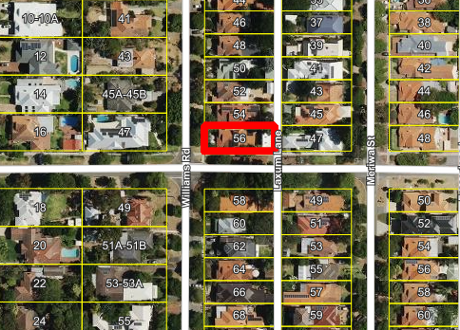
Figure 1: Aerial image of 56 Williams Road, Nedlands
Application Details
The application seeks development approval for the addition of a Short-Term Accommodation land use (‘Holiday House’) to the existing Residential (‘Ancillary Dwelling’) development. No works is proposed as part of this application. The City of Nedlands Local Planning Scheme No. 3, a ‘Holiday House’ is defined as:

“a single dwelling on one lot used to provide short-term accommodation but does not include a bed and breakfast.”

The applicant, who is the owner of the property, is seeking to operate the ‘Holiday House’ at the subject property within the Ancillary Dwelling while the owners of the property will continue to reside at the existing single house. The Holiday House will be managed by a property manager with all urgent requests dealt with on-site by the property owners.

Discussion
Local Planning Scheme No. 3
Schedule 2, Clause 67(2) (Consideration of application by Local Government) – identifies those matters that are required to be given due regard to the extent relevant to the application. The zone objectives of the Local Planning Scheme No. 3 is considered relevant to the proposal. The proposal has been assessed against, and is considered consistent with, the below objective of the ‘Residential’ zone with the City’s Local Planning Scheme No. 3.

Objective: To provide for a range of non-residential uses, which are compatible with and complementary to residential development.

The holiday house is complementary to existing residential development as it provides short term stay for residents who require to be within close proximity to Hospitals and UWA. Providing short stay in this locality would complement the existing high level of activity and vehicle/pedestrian movement.

Local Planning Policy 2.2 – Short Term Accommodation
The Local Planning Policy 2.2 – Short Term Accommodation provides guidance and development provisions for operators seeking to establish short-term accommodation within the City. In accordance with Part 4.1 of the Policy, development applications for the ‘Holiday House’ land use where the owner resides on-site are generally supported in all zones where allowed by the Scheme.
A Management Plan has been provided and assessed. In the Management Plan, all points identified in Part 7.1 of the Policy have been addressed and has been deemed acceptable. The Management Plan will form part of the approval and is to be complied with at all times to the City’s satisfaction as per recommended Condition 2.
As per the Short-Term Accommodation LPP, the City may grant temporary development approval for short-term accommodation uses for an initial 12-month period. A subsequent development approval will be required to be submitted for the renewal of the approval for the short-term accommodation which may then be on a permanent basis. Condition 1 is recommended to this effect.
For a renewal to be considered, the City will give regard to any substantiated complaints against the operation of the short-term accommodation in accordance with the conditions of its development approval.
It should be noted that in the matter of Joseph and City of Nedlands [2022] WASAT 13, the State Administrative Tribunal (SAT) determined that due to the existence of the City’s Short Term Accommodation Policy and the guidance it provides, that the Policy ought to be afforded the most weight in determining the proposal. The subject application is wholly consistent with the objectives of the City’s Local Planning Policy – Short Term Accommodation.

Local Planning Policy – Parking

As per the City’s Local Planning Policy – Parking, the parking requirements under Table 1 (LPP 4.1) for a Holiday House land use is one per guest bedroom, in addition to any bays required under the R-Codes for the dwelling (if applicable). The application proposes one guest bedroom and as per the requirements of the R-Codes, two car parking bays are required for the single dwelling. Therefore the Policy requires a total of three car parking bays for this proposal.
The site is serviced by two existing crossovers from Williams Road and one off Park Road leading into Laxum Lane. All parking within the site is accessed from Laxum Lane, a double garage underneath the ancillary dwelling and a paved area to the north of the ancillary dwelling which can be accessed via an electric gate. Therefore the site can accommodate three car bays and satisfies the requirements of the City’s Local Planning Policy – Parking.

Consultation
A Holiday House is an ‘A’ Use in a Residential Zone, meaning that the use is not permitted unless the local government has exercised its discretion by granting development approval after giving notice in accordance with clause 64 of the deemed provisions.
The application was advertised for a period of 14 days from 8 August 2023 to 22 August 2023. At the close of the advertising period, two objections and three statements of support were received.
The applicant consulted with the surrounding neighbours prior to the formal advertising period. Four surrounding neighbours were consulted and all have provided statements of support.
The following is a summary of the concerns/comments raised and the Officer response in relation to each issue:

- Concerns with the number of short term accommodations at the site.

The concern is based on the applicant referencing the holiday house as 56a Williams Road. The application is for a short term accommodation at the existing freehold site of 56 Williams Road. The applicant makes reference to the address of the ancillary dwelling as 56a Williams Road for ease of reference for guests, this is not the legal address of the property.

- Concerns of no annual fees given to the City for holiday house short-stay.

There is an annual City fee of $243, this only applies if the premise accommodates more than six people. The annual fee does not apply with this application as it is noted that the holiday house can only accommodate a maximum of two adults and 1 infant. The applicant has paid the required development application fee of $295 and advertising fee of $220.

- Concern of having no register for short-stay accommodations.

A registration scheme is currently under consideration by the State Government for all short-term accommodation in response to the 2019 Parliamentary enquiry. This is currently not adopted and as such there is no legislative requirement within the current planning framework.

- Concerns with parking.

The proposal complies with the parking requirements of the City’s Local Planning Policy – Parking. Further, a condition of approval has been recommended to ensure that all vehicles for the guests of the Holiday House, are parked on site.

- Concern that the short-stay is not abiding by Environmental Health requirements.

This proposal is meeting all relevant local government requirements. This includes Environmental Health requirements, abiding by the relevant food and noise regulations.
- Short-term accommodation does not alleviate Australia’s limited housing supply.

This concern is outside of the scope of the City’s planning framework.

Strategic Implications

This item relates to the following elements from the City’s Strategic Community Plan.

Vision Our city will be an environmentally-sensitive, beautiful and inclusive place.

Values Great Natural and Built Environment
We protect our enhanced, engaging community spaces, heritage, the natural environment and our biodiversity through well-planned and managed development.

Priority Area Urban form - protecting our quality living environment

Budget/Financial Implications

Nil.

Legislative and Policy Implications

Council is requested to make a decision in accordance with clause 68(2) of the Deemed Provisions. Council may determine to approve the development without conditions (cl.68(2)(a)), approve with development with conditions (cl.68(2)(b)), or refuse the development (cl.68(2)(c)).

Decision Implications

If Council resolves to approve the proposal, the holiday house can commence operation, subject to addressing all relevant conditions of approval.

In the event of a refusal, the applicant will have a right of review to the State Administrative Tribunal. The Tribunal will have regard to the R-Codes as a State Planning Policy. Similarly, should an applicant be aggrieved by one or more conditions of approval, this can be reviewed by the Tribunal.

Conclusion

The application for the addition of a Short-Term Accommodation (‘Holiday House’) to existing Residential (‘Single House’) development at 56 Williams Road, Nedlands has been presented for Council consideration due to objections being received. The proposal is considered to meet the development provisions of the City’s local planning framework and, as such, is unlikely to have significant adverse impact on the local amenity of the area.

Accordingly, it is recommended that the application be approved by Council, subject to conditions of Administration’s recommendation.

Further Information

Nil.

PD48.11.23 - Consideration of Development Application – Addition to Single House at 15 Watt Street, Swanbourne
Meeting & Date | Council Meeting – 28 November 2023
Applicant | J Edwards
Information Provided | All relevant information required has been provided.
Employee Disclosure under section 5.70 Local Government Act 1995 | The author, reviewers and authoriser of this report declare they have no financial or impartiality interest with this matter.  There is no financial or personal relationship between City staff involved in the preparation of this report and the proponents or their consultants.
Report Author | Roy Winslow – Acting Director Planning & Development
CEO | Tony Free – Acting Chief Executive Officer
Attachments | - Zoning Map  - Development Plans  - CONFIDENTIAL ATTACHMENT - Submissions

Purpose

The purpose of this report is for Council to consider a development application for additions to a single house at 15 Watt Street, Swanbourne. The proposal is being presented to Council for consideration due to the proposal receiving objections within the consultation period. Council is specifically requested to exercise its judgement in considering the merits of the application against the design principles for the following aspects of the proposal:

- Rear lot boundary setback (see report section Lot Boundary Setback)

Recommendation

That Council:

In accordance with Clause 68(2)(b) of the Deemed Provisions of the Planning and Development (Local Planning Schemes) Regulations 2015, approves the development application in accordance with the plans date stamped 30 August 2023 for a Residential – Additions to a Single House at 15 Watt Street, Swanbourne (DA23-89130), subject to the following conditions:

- This approval relates only to the development as indicated on the approved plans dated 30 August 2023. It does not relate to any other development on this lot and must substantially commence within 2 years from the date of the decision letter.

- The street tree(s) within the verge in front of the lot are to be protected and maintained through the duration of the demolition and construction processes to the satisfaction of the City of Nedlands. Should the tree(s) die or be damaged, they are to be replaced with a specified species at the owner’s expense and to the satisfaction of the City of Nedlands.

- All stormwater discharge from the development shall be contained and disposed of on-site unless otherwise approved by the City of Nedlands.

Voting Requirement

Simple Majority.

This report is of a quasi judicial nature as it is a matter that directly affects a person’s rights and interests. The judicial character arises from the obligation to abide by the principles of natural justice. Examples of Quasi-Judicial authority include town planning applications and other decisions that may be appealable to the State Administrative Tribunal.
The decision must be made in a manner that is impartial, free from bias, and in accordance with the principles of natural justice. The decision must be made in having regard to the facts of the matter under consideration, and in accordance with the relevant laws and policies as they apply to that matter.
Discretionary considerations and judgments in the decision must be confined to those permitted to be considered under the laws and polices applicable to the matter and given such weight in making the decision as the relevant laws and polices permit them to be given.

Background

Land Details
Metropolitan Region Scheme Zone | Urban
Local Planning Scheme Zone | Residential
R-Code | R15
Land area | 744m2
Land Use | Residential – Single House
Use Class | ‘P’ – Permitted Use

The site is located at 15 Watt Street, Swanbourne. The site is oriented north south and is bound by Kirkwood Road to the west and Walpole Street to the east. The lot is rectangular in shape, with a 20m frontage and an area of 744m². The site features an existing two storey single house. The site is located on the north side of Watt Street. The properties to the south side of Watt Street are zoned Residential R35.
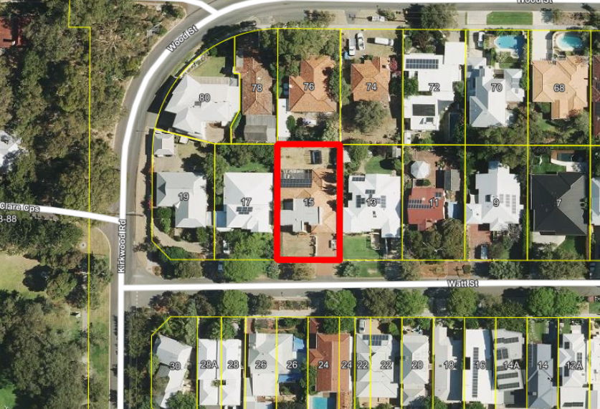
Figure 1: Aerial image of 15 Watt Street, Swanbourne
Application Details
The application seeks development approval for single storey rear additions and alterations to an existing single house at 15 Watt Street, Nedlands. The works include internal alterations, a new pergola and an enclosed rear alfresco. The internal works and pergola are exempt from requiring planning approval. The rear alfresco addition meets all R-Code deemed-to-comply provisions except for rear setback.

Discussion
Local Planning Scheme No. 3
Schedule 2, Clause 67(2) (Consideration of application by Local Government) – identifies those matters that are required to be given due regard to the extent relevant to the application. Where relevant, these matters are discussed in the following sections. Overall, the development is considered to meet these objectives, particularly in regard to height, scale, bulk and appearance, and the potential impact it will have on the local amenity.

State Planning Policy 7.3 - Residential Design Codes – Volume 1
The R-Codes apply to all single and grouped dwelling developments. An approval under the R-Codes can be obtained in one of two ways. This is by either meeting the deemed-to-comply provisions or via a design principle assessment pathway.
The proposed development is seeking a design principle assessment pathway for parts of this proposal relating to lot boundary setback.
If a proposal does not satisfy the deemed to-comply provisions of the State Planning Policy 7.3: Residential Design Codes (R-Codes), Council is required to exercise a judgement of merit to determine the proposal against the design principles of the R-Codes. The R-Codes require the assessment to consider the relevant design principle only and to not apply the corresponding deemed-to-comply provisions. It is recommended that the application be approved by Council as it is considered to satisfy the design principles of the R-Codes. Further, it is considered unlikely that the development will have a significant adverse impact on the local amenity and character of the locality.

Lot Boundary Setback (Clause 5.1.3)
The development proposes a 1.9m rear setback from the northern lot boundary. The design principles for lot boundary setbacks consider the impact of building bulk on adjoining properties, providing adequate sun and ventilation and minimising overlooking. The proposed northern lot boundary setback is considered to meet the design principles for the following reasons:
- The impact of building bulk is minimised as the proposal is limited to single storey. The R-Codes Vol. 1 explanatory guidelines speaks to the minimal impact that single storey walls generally have on adjacent lots: “single storey walls are not usually problematic in terms of impact on adjoining properties”.
- The intrusion within the rear setback area occupies 15m2 or 12% of the total rear setback area. Were an averaging of setback applied, the encroachment is offset by 63m2 of compensating area in the open space provided behind the 6m rear setback line. The compensating area of open space will reduce the appearance of building bulk to surrounding properties.
- Ventilation is ensured with the minimum setback of 5.5m to the east and 11.1m to the west. Solar access is ensured as overshadowing from the extension falls wholly within the subject lot. There is no additional overshadowing on adjoining properties from this proposal.
- The proposal is not raised more than 0.5m above natural ground level, therefore there is no visual privacy impacts to adjoining landowners.
- In considering the immediate locality, there is an existing pattern of development within the rear setback area to varying extents, including at 9, 13 and 11 Watt Street, and 60, 66, 72, 76 and 78 Wood Street. The proposal is consistent with this existing character.

Consultation
The application is seeking assessment under the design principles of the R-Codes for lot boundary setback.
The development application was advertised in accordance with the City’s Local Planning Policy - Consultation of Planning Proposals to five adjoining properties. The application was advertised for a period of 14 days from 6 September 2023 to 20 September 2023. At the close of the advertising period, two objections were received.
The following is a summary of the concerns/comments raised and the Administration’s response and action taken in relation to each issue:
- Opposed to rear setback.
As outlined in this report, Administration supports the proposed setback as the development proposal is consistent with the surrounding development context and is will not negatively impact the amenity of adjoining landowners or the streetscape.

- Concerns with overlooking.
The addition is not raised more than 0.5m above the natural ground level and is not subject to the visual privacy provisions of the R-Codes.

- Concerns with height and visual impact.
The addition is single storey with a maximum height of 3.5m to the top of the pitched roof. This meets the deemed-to-comply height provisions and is a typical height for a single storey development.

- Concerns with increased noise from aluminium shutters.
Aluminium shutters are a typical fixture for residential properties. Notwithstanding, occupiers of the site are required to comply with the Environmental Protection (Noise) Regulations 1997.

- Concerns with impact to local wildlife and biodiversity.
There is no direct impact to local biodiversity as a result of this application. The application does not impact any street trees or trees on adjoining properties. Adequate open space remains on site for landscaping and green space.

Strategic Implications

This item relates to the following elements from the City’s Strategic Community Plan.

Vision Our city will be an environmentally-sensitive, beautiful and inclusive place.

Values Great Natural and Built Environment
We protect our enhanced, engaging community spaces, heritage, the natural environment and our biodiversity through well-planned and managed development.

Priority Area Urban form - protecting our quality living environment

Budget/Financial Implications

Nil.

Legislative and Policy Implications

Council is requested to make a decision in accordance with clause 68(2) of the Deemed Provisions. Council may determine to approve the development without conditions (cl.68(2)(a)), approve with development with conditions (cl.68(2)(b)), or refuse the development (cl.68(2)(c)).

Decision Implications

If Council resolves to approve the proposal, development can proceed after receiving a Building Permit and necessary clearances.

In the event of a refusal, the applicant will have a right of review to the State Administrative Tribunal. The Tribunal will have regard to the R-Codes as a State Planning Policy. Similarly, should an applicant be aggrieved by one or more conditions of approval, this can be reviewed by the Tribunal.

Conclusion

The application for additions to a single house at 15 Watt Street, Swanbourne has been presented for Council consideration due to objections being received. The proposal is considered to meet the key amenity related elements of R-Codes Volume 1 and, as such, is unlikely to have a significant adverse impact on the local amenity of the area. The proposal has been assessed and satisfies the design principles of the R-Codes in relation to being consistent with the immediate locality and streetscape character.

Accordingly, it is recommended that the application be approved by Council, subject to conditions.

Further Information

Nil.

PD49.11.23 - Consideration of Development Application - Residential - Single House at 24A Lisle Street, Mt Claremont
Meeting & Date | Council Meeting – 28 November 2023
Applicant | Webb & Brown-Neaves
Information Provided | All relevant information required has been provided.
Employee Disclosure under section 5.70 Local Government Act 1995 | The author, reviewers and authoriser of this report declare they have no financial or impartiality interest with this matter.  There is no financial or personal relationship between City staff involved in the preparation of this report and the proponents or their consultants.
Report Author | Roy Winslow – Acting Director Planning & Development
CEO | Tony Free – Acting Chief Executive Officer
Attachments | - Zoning Map  - Development Plans  - CONFIDENTIAL ATTACHMENT - Submission

Purpose

The purpose of this report is for Council to consider a development application for a two-storey single house at 24A Lisle Street, Mt Claremont. The proposal is being presented to Council for consideration due to the proposal receiving an objection within the consultation period. Council is specifically requested to exercise its judgement in considering the merits of the application against the design principles for:

- Northern lot boundary setback (see section of report – Lot Boundary Setbacks)
- Vehicle access (see section of report – Vehicular Access)
- Site works (see section of report – Site Works)
- Overshadowing (see section of report – Solar Access for Adjoining Sites)

Recommendation

That Council:

In accordance with Clause 68(2)(b) of the Deemed Provisions of the Planning and Development (Local Planning Schemes) Regulations 2015, approves the development application in accordance with the plans date stamped 10 October 2023 for a single house at 24A Lisle Street, Mt Claremont (DA23-87397), subject to the following conditions:

- This approval relates only to the development as indicated on the approved plans dated 10 October 2023. It does not relate to any other development on this lot and must substantially commence within 2 years from the date of the decision letter.

- All works indicated on the approved plans shall be wholly located within the lot boundaries of the subject site.

- Prior to the issue of a building permit, a Construction Management Plan shall be submitted and approved to the satisfaction of the City. The approved Construction Management Plan shall be observed at all times throughout the construction process to the satisfaction of the City.

- Prior to occupation, walls on or adjacent to lot boundaries are to be finished externally to the same standard as the rest of the development in:

- Face brick;
- Painted render;
- Painted brickwork; or
- Other clean finish as specified on the approved plans.

And are to be thereafter maintained to the satisfaction of the City of Nedlands.

- Prior to occupation, the guest bedroom located on the southern elevation as annotated in red on the approved plans, shall be screened in accordance with the Residential Design Codes by either;

- fixed and obscured glass to a height of 1.6 metres above finished floor level; or
- fixed screening devices to a height of 1.6 meters above finished floor level that are at least 75% obscure and made of a durable material; or
- a minimum sill height of 1.6 metres above the finished floor level; or
- an alternative method of screening approved by the City of Nedlands.

The required screening shall be thereafter maintained to the satisfaction of the City of Nedlands.

- All stormwater discharge from the development shall be contained and disposed of on-site unless otherwise approved by the City of Nedlands.

- Prior to a building permit being issued, stormwater disposal plans, details and calculations must be submitted for approval by the City of Nedlands and thereafter implemented, constructed and maintained to the satisfaction of the City of Nedlands.

Voting Requirement

Simple Majority.

This report is of a quasi judicial nature as it is a matter that directly affects a person’s rights and interests. The judicial character arises from the obligation to abide by the principles of natural justice. Examples of Quasi-Judicial authority include town planning applications and other decisions that may be appealable to the State Administrative Tribunal.

The decision must be made in a manner that is impartial, free from bias, and in accordance with the principles of natural justice. The decision must be made in having regard to the facts of the matter under consideration, and in accordance with the relevant laws and policies as they apply to that matter.
Discretionary considerations and judgments in the decision must be confined to those permitted to be considered under the laws and polices applicable to the matter and given such weight in making the decision as the relevant laws and polices permit them to be given.

Background

Land Details
Metropolitan Region Scheme Zone | Urban
Local Planning Scheme Zone | Residential
R-Code | R20
Land area | 506m²
Land Use | Residential – Single House
Use Class | ‘P’ – Permitted Use

The site is located at 24A Lisle Street, Mt Claremont. The site is currently vacant. The site is orientated east west and is bound by Lisle Street to the west and Agonis Lane to the east. The lot is rectangular in shape with a 10.1m frontage and an area of 506m². The site features a natural slope, with a 3.5m fall from east to west.
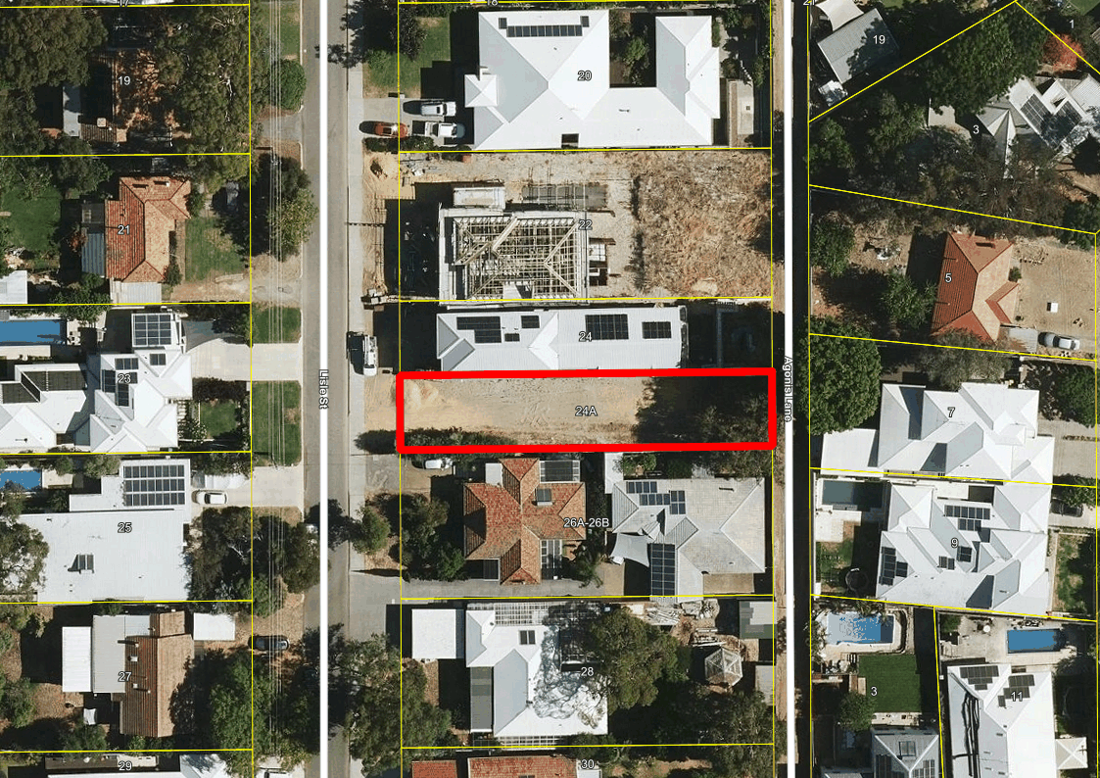
Figure 1: Aerial image of 24A Lisle Street, Mt Claremont.
Application Details
The application seeks development approval for the construction of a two-storey single house at 24A Lisle Street, Mt Claremont. The southern adjoining property is a strata development, being 26A (front lot) and 26B (rear lot) on Lisle Street.

Following the initial consultation period, the applicant provided amended plans on 10 October 2023 (Attachment 2) to address concerns raised by the City and the public submissions.

The changes proposed by the amended plans are summarised as follows:

- Reduction in boundary wall length to the southern boundary to achieve the deemed-to-comply provisions.
- Reduction in finished floor levels of the ground floor by 250mm.
- Reduction in ground levels and the extent of fill and retaining required.
- Reduction in overall building height. Reduced ground floor wall heights resulted in achieving the deemed-to-comply provisions for lot boundary setbacks to the northern study wall and the southern WIP to store wall.

Discussion

Local Planning Scheme No. 3

Schedule 2, Clause 67(2) (Consideration of application by Local Government) identifies those matters that are required to be given due regard to the extent relevant to the application. Where relevant, these matters are discussed in the following sections. Overall, the development is considered to meet these objectives, particularly in regard to height, scale, bulk and appearance, and the potential impact it will have on the local amenity.

State Planning Policy 7.3 - Residential Design Codes – Volume 1
The R-Codes apply to all single and grouped dwelling developments. An approval under the R-Codes can be obtained in one of two ways. This is by either meeting the deemed-to-comply provisions or via a design principle assessment pathway.
The proposed development is seeking a design principle assessment pathway for parts of this proposal relating to lot boundary setbacks, vehicle access, site works and solar access to adjoining sites.
If a proposal does not satisfy the deemed to-comply provisions of the State Planning Policy 7.3: Residential Design Codes (R-Codes), Council is required to exercise a judgement of merit to determine the proposal against the design principles of the R-Codes. The R-Codes require the assessment to consider the relevant design principle only and to not apply the corresponding deemed-to-comply provisions. It is recommended that the application be approved by Council as it is considered to satisfy the design principles of the R-Codes. Further, it is considered unlikely that the development will have a significant adverse impact on the local amenity and character of the locality.

Lot Boundary Setbacks – Northern (Clause 5.1.3)

The entire northern wall proposes a minimum setback of 1.5m to the ground floor. The design principles for lot boundary setbacks consider the impact of building bulk on adjoining properties, providing adequate sun and ventilation and minimising overlooking. The proposed northern setback is considered to achieve the design principles as:
- The ground floor incorporates multiple wall articulations along the length. The provided setbacks, varying from 1.5m to 3.5m will allow the perception of building bulk to be broken up.
- Ventilation is maintained by the minimum 1.5m setback.
- Solar access is ensured as the wall is located to the north of the subject site. Overshadowing is considered to achieve the design principles in relation to solar access. Refer to overshadowing section below.
- The openings to habitable rooms are not raised more than 0.5m above natural ground level thereby visual privacy is maintained.

Vehicular Access (Clause 5.3.5)

The development proposes vehicular access off the primary street. The design principles for vehicular access consider vehicle and pedestrian safety, legible access and impacts on the streetscape. The proposed vehicular access is considered to achieve the design principles as:

- The proposal maintains vehicle safety as it provides 6.7m of manoeuvring area between the road and car parking bays on site.
- The development proposes one 4.7m wide crossover from the street. This is an established vehicle access pattern for lots along Lisle Street in lieu of, or in addition to the laneway.
- The crossover, driveway, garage and pedestrian entrance are visible and clearly defined from the street to indicated points of entrance.
- Pedestrian safety is ensured as adequate clearance is provided from the garage to the footpath and no solid structures within sight lines.
- Sufficient soft landscaping is provided to the front setback area to provide visual streetscape interest.

Site Works (Clause 5.3.7)

The development proposes retaining walls and fill to a maximum height of 0.7m located on the northern and southern lot boundaries. The design principles for site works consider the proposal’s response to the natural features of the site and ensuring that the site can be used effectively without detrimentally impacting adjoining properties. The proposal meets the design principles for the following reasons:

- The site features a natural slope of approximately 3.5m from the east to west. Due to the slope, the development seeks to use a combination of cut and fill. The dwelling features three finished floor levels throughout the ground floor to respond to the natural topography. This demonstrates that the site works proposed have been designed in response to the natural site levels and have balanced the amount of cut and fill required throughout the site, whilst ensuring useability.
- The site works respect the natural ground level at the street boundary through the stepping of finished floor levels and site works to align with the natural contours of the site. The dwelling and site levels, as viewed from the street presents as a two-storey dwelling and will ensure a consistent streetscape elevation with adjoining properties.
- The proposed site works do not create undue building bulk or over-height walls, with building height achieving the deemed-to-comply provisions and lot boundary setbacks considered to achieve the design principles as noted above.

Solar Access for Adjoining Sites (Clause 5.4.2)

The development proposes 32% overshadowing to 26A Lisle Street, Mt Claremont at the winter solstice. It is noted that the southern adjoining property is a strata lot with two lots, being 26A (front lot) and 26B (rear lot) on Lisle Street. Due to the subdivision form of the adjoining southern lot, overshadowing is calculated on the individual exclusive use strata area, not the overall parent lot.

Given the site’s narrow lot width, east-west orientation and 3.5m slope, it is acknowledged that achieving deemed-to-comply overshadowing is unlikely to occur.

The design principles consider effective solar access for the subject development, and the protection of solar access for neighbouring properties. The application meets the design principles as:

- Given the battle-axe lot configuration to the south, it is difficult to design a dwelling that disperses overshadowing evenly across the two lots and avoids overshadowing to the front lot entirely. The proposed development has positioned the upper floor to the front of the site to avoid impacting outdoor living areas to both lots as much as possible.
- The southern property at 26A Lisle Street has two outdoor living areas, one to the north and one to the south. The R-Codes recommend a 30m2 outdoor living area provision for lots coded R20. The southern outdoor living area which is 30m2 in size, is not impacted by the shadow of the proposed dwelling. Therefore, a sufficiently sized outdoor living area is protected from overshadowing.
- Further, the R-Codes considers overshadowing at mid-winter when the outdoor living area is least likely to be utilised by residents. At other times of the year the north-facing outdoor living area will have adequate access to natural sunlight.
- North facing major openings at 26A may be impacted by the proposed development. However, given the dwellings existing northern setback, an otherwise deemed-to-comply boundary wall would impact these openings.
- In relation to solar collectors, the southern site has one hot water solar system. Based on a sectional overshadowing assessment, the solar panel will not be impacted by the shadow cast from the proposed development.

Consultation
The application is seeking assessment under the design principles of the R-Codes for lot boundary setbacks, vehicle access, site works and solar access.
The development application was advertised in accordance with the City’s Local Planning Policy - Consultation of Planning Proposals to four adjoining properties. The application was advertised for a period of 14 days from 23 August 2023 to 6 September 2023. At the close of the advertising period, one objection was received.
The following is a summary of the concerns/comments raised and the Administration’s response and action taken in relation to each issue:

- The overshadowing proposed will obstruct the solar panels and adversely impact the amenity.

Given the lot constraints this site faces, including the narrow width, orientation and natural slope, administration supports the proposed overshadowing, and the solar access is considered to achieve the design principles. See overshadowing discussion above.

- Concerns with the southern boundary wall length and height.

The proposed southern boundary wall satisfies the deemed-to-comply provision in relation to lot boundary setbacks. The amended plans received 10 October 2023 (Attachment 2) reduced the southern boundary wall length to a combined length of 14.7m and maximum height to 3.2m.

- Concerns with the southern lot boundary setbacks.

The proposed southern lot boundary setbacks on the ground and upper floor satisfy the deemed-to-comply provisions in relation to lot boundary setbacks. The amended plans received 10 October 2023 (Attachment 2) reduced the ground floor southern wall height to a maximum of 3.5m, which resulted in the setback satisfying the deemed-to-comply provision. The solar access is considered to achieve the design principles.

- Concerns with visual privacy from bathroom and water closet along southern elevation.

Bathrooms and water closet windows are classified as minor openings as they are defined by the R-Codes as non-habitable rooms. Minor openings are not required to be screened with obscure glass or highlight windows. All openings contained in the development achieve the deemed-to-comply provisions for visual privacy by using screening, obscure glazing or highlight windows.

Strategic Implications

This item relates to the following elements from the City’s Strategic Community Plan.

Vision Our city will be an environmentally-sensitive, beautiful and inclusive place.

Values Great Natural and Built Environment
We protect our enhanced, engaging community spaces, heritage, the natural environment and our biodiversity through well-planned and managed development.

Priority Area Urban form - protecting our quality living environment.

Budget/Financial Implications

Nil.

Legislative and Policy Implications

Council is requested to make a decision in accordance with clause 68(2) of the Deemed Provisions. Council may determine to approve the development without conditions (cl.68(2)(a)), approve with development with conditions (cl.68(2)(b)), or refuse the development (cl.68(2)(c)).

Decision Implications

If Council resolves to approve the proposal, development can proceed after receiving a Building Permit and necessary clearances.

In the event of a refusal, the applicant will have a right of review to the State Administrative Tribunal. The Tribunal will have regard to the R-Codes as a State Planning Policy. Similarly, should an applicant be aggrieved by one or more conditions of approval, this can be reviewed by the Tribunal.

Conclusion

The application for a single house at 24 A Lisle Street, Mt Claremont has been presented for Council consideration due to an objection being received. The proposal is considered to meet the key amenity related elements of R-Codes Volume 1 and, as such, is unlikely to have a significant adverse impact on the local amenity of the area. The proposal has been assessed and satisfies the design principles of the R-Codes in relation to being consistent with the immediate locality and streetscape character.

Accordingly, it is recommended that the application be approved by Council, subject to conditions.

Further Information

Nil.

PD50.11.23 - Consideration of Development Application – Residential – Additions and Alterations to a Single House at 22 Wattle Avenue, Dalkeith
Meeting & Date | Council Meeting – 28 November 2023
Applicant | ROW Architects
Information Provided | All relevant information required has been provided.
Employee Disclosure under section 5.70 Local Government Act 1995 | The author, reviewers and authoriser of this report declare they have no financial or impartiality interest with this matter.  There is no financial or personal relationship between City staff involved in the preparation of this report and the proponents or their consultants.
Report Author | Roy Winslow – Acting Director Planning & Development
CEO | Tony Free – Acting Chief Executive Officer
Attachments | - Zoning Map  - Development Plans  - CONFIDENTIAL ATTACHMENT - Submission

Purpose

The purpose of this report is for Council to consider a development application for additions to a single house at 22 Wattle Avenue, Dalkeith. This proposal is being presented to Council for consideration due to the proposal receiving an objection during the consultation period. The proposed development is seeking a design principle assessment pathway for:

- Street setback (see section of report – Street Setback)
- Lot boundary setback (see section of report – Lot Boundary Setback)
- Open space (see section of report – Open Space)
- Landscaping (see section of report – Landscaping)
- Visual privacy (see section of report – Visual Privacy)

As the property abuts the Swan River foreshore, the Department of Biodiversity, Conservation and Attractions (DBCA) has provided its conditions in the event Council grants approval.

Recommendation

That Council:

In accordance with Clause 68(2)(b) of the Deemed Provisions of the Planning and Development (Local Planning Schemes) Regulations 2015, approves the development application in accordance with the plans date stamped 11 October 2023 for additions to the single house at 22 Wattle Avenue, Dalkeith (DA23-87752), subject to the following conditions:

- This approval relates only to the development as indicated on the approved plans dated 11 October 2023. It does not relate to any other development on this lot and must substantially commence within 2 years from the date of the decision letter.

- All works indicated on the approved plans shall be wholly located within the lot boundaries of the subject site.

- Prior to the issue of a Building Permit, a Demolition and Construction Management Plan shall be submitted and approved to the satisfaction of the City. The approved Construction Management Plan shall be observed at all times throughout the construction process to the satisfaction of the City of Nedlands.

- Prior to occupation, the redundant crossovers on Wattle Avenue shall be removed and the verge and kerbing reinstated to the City’s specifications, at the expense of the applicant and to the satisfaction of the City of Nedlands.
- Prior to occupation, the privacy screens to the Kitchen, Master Bedroom, Bed 2 and Bed 3, as annotated in red on the approved plans, shall be screened in accordance with the Residential Design Codes by either;

- fixed and obscured glass to a height of 1.6 metres above finished floor level; or
- fixed screening devices to a height of 1.6 meters above finished floor level that are at least 75% obscure and made of a durable material; or
- a minimum sill height of 1.6 metres above the finished floor level; or
- an alternative method of screening approved by the City of Nedlands.

The required screening shall be thereafter maintained to the satisfaction of the City of Nedlands.

- The street tree(s) within the verge in front of the lot are to be protected and maintained through the duration of the demolition and construction processes to the satisfaction of the City of Nedlands. Should the tree(s) die or be damaged, they are to be replaced with a specified species at the owner’s expense and to the satisfaction of the City of Nedlands

- All stormwater discharge from the development shall be contained and disposed of on-site unless otherwise approved by the City of Nedlands.

- Prior to occupation, the verge shall be landscaped to the satisfaction of the City Nedlands.

Department of Biodiversity, Conservation & Attractions Conditions

- The applicant shall take appropriate preventative measures to ensure that no construction material, sediment (including as a result of stormwater run-off), or rubbish enters the Parks and Recreation reserve or river as a result of the works.

- Stormwater run-off from constructed impervious surfaces generated by small rainfall events (i.e. the first 15 mm of rainfall) shall be retained and/or detained and treated (if required) at-source as much as practical and will not be permitted to enter the river untreated.

- No poolwater/ backwash from the swimming pool is to be discharged onto the land, into the river or the local government drainage system.

- Fencing and any balustrading are to be: a. ‘open-view’ style above one metre in height; b. no more than 1.8 metres in height; c. constructed so that gates open inwards to the lot, and not outwards into the parks and recreation reserve.

- Development and works are to be undertaken in accordance with an approved Landscaping Management Plan to the satisfaction of the Department of Biodiversity, Conservation and Attractions.

Voting Requirement

Simple Majority.

This report is of a quasi judicial nature as it is a matter that directly affects a person’s rights and interests. The judicial character arises from the obligation to abide by the principles of natural justice. Examples of Quasi-Judicial authority include town planning applications and other decisions that may be appealable to the State Administrative Tribunal.

The decision must be made in a manner that is impartial, free from bias, and in accordance with the principles of natural justice. The decision must be made in having regard to the facts of the matter under consideration, and in accordance with the relevant laws and policies as they apply to that matter.
Discretionary considerations and judgments in the decision must be confined to those permitted to be considered under the laws and polices applicable to the matter and given such weight in making the decision as the relevant laws and polices permit them to be given.

Background

Land Details
Metropolitan Region Scheme Zone | Urban
Local Planning Scheme Zone | Residential
R-Code | R12.5
Land area | 927m²
Land Use | Single House
Use Class | ‘P’ – Permitted Use

The site is located at 22 Wattle Avenue, Dalkeith, within the street block bounded by Wattle Avenue and Adelma Place. The lot is rectangular in shape with a total area of 927m² and a 46.1m frontage to Wattle Avenue. The southern portion of the site abuts the Swan River foreshore (see aerial below). The land comprising the foreshore is reserved ‘Parks and Recreation’ by the Metropolitan Region Scheme. The site features a natural slope of approximately 18m from northern lot boundary down to the Swan River foreshore.
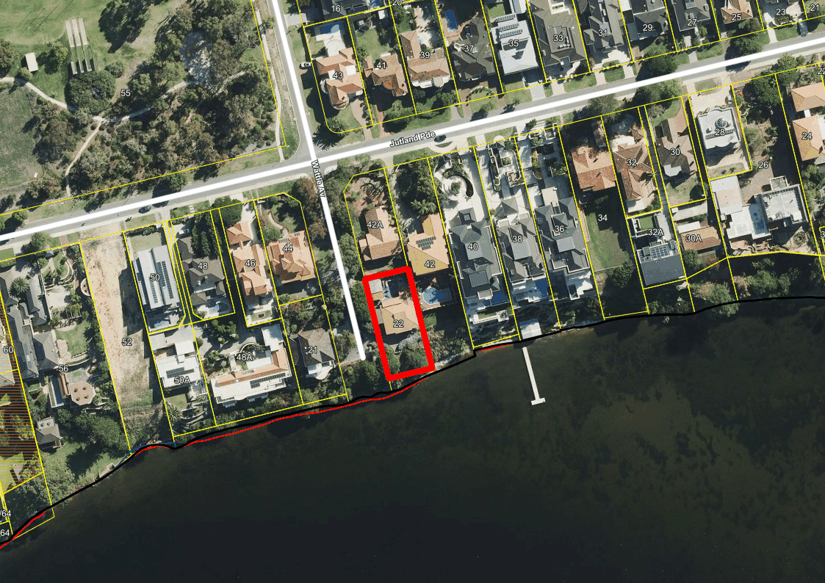
Application Details
This application seeks development approval for additions to a single house. The additions comprise:

- An additional terrace and pool service room on the ‘undercroft’ level;
- a new master bedroom, lounge, staircase and garage on the ‘lower ground’ level;
- a new terrace, pool, entrance, theatre room, gym, kitchen and extension to the dining and living room on the ‘ground floor’; and
- A new ‘upper level’ containing two bedrooms and two bathrooms.

On 2 October 2023, amended plans were submitted. The amended plans added visual privacy screening to the main terrace and pool deck area.
Discussion

Local Planning Scheme No. 3

Schedule 2, Clause 67(2) (Consideration of application by Local Government) – identifies those matters that are required to be given due regard to the extent relevant to the application. Where relevant, these matters are discussed in the following sections. Overall, the development is considered to meet these objectives, particularly in regard to height, scale, bulk and appearance, and the potential impact it will have on the local amenity.

State Planning Policy 7.3 - Residential Design Codes – Volume 1

The R-Codes Volume 1 apply to all single and grouped dwelling developments. An approval under the R-Codes can be obtained in one of two ways. This is by either meeting the deemed-to-comply provisions or via a design principle assessment pathway.

The proposed development is seeking a design principle assessment pathway for parts of this proposal relating to street setback, lot boundary setback, open space, landscaping and visual privacy.
If a proposal does not satisfy the deemed to-comply provisions of the State Planning Policy 7.3: Residential Design Codes (R-Codes), Council is required to exercise a judgement of merit to determine the proposal against the design principles of the R-Codes. The R-Codes require the assessment to consider the relevant design principle only and to not apply the corresponding deemed-to-comply provisions. It is recommended that the application be approved by Council as it is considered to satisfy the design principles of the R-Codes. Further, it is considered unlikely that the development will have a significant adverse impact on the local amenity and character of the locality.

Street Setback (Clause 5.1.2)

The design principles for street setback consider the development’s compatibility with the immediate streetscape, privacy, site planning requirements and building mass. The development meets the design principles as:

- The established streetscape along Wattle Avenue is characterised by houses setback 2m from the street. The two existing single houses on the western side of the road are setback 2m from Wattle Avenue. The recently approved single house at 42A Jutland Parade has a varied street setback but also maintains a minimum of 2m from Wattle Avenue. The development proposes a minimum setback of 1.8m from the primary street which is largely consistent with this setback pattern along Wattle Avenue.
- The existing house on the site currently features two garages with a nil setback to the street boundary. These structures are proposed to be removed as the vehicle access point is relocated further south. The new garage will be setback 4.5m from the street. The increased setback of the new garage will reduce the visual prominence of garage doors and have a positive impact on the streetscape.
- The impact of bulk is ameliorated by articulation and design features. The front façade provides a varied setback to Wattle Avenue ranging from 1.8m to 4.5m and incorporates a diversity of materials such as bronze batten screening and light coloured, textured render finish. The impact of building bulk is also mitigated by the building height. As viewed from the street, the house does not exceed two storeys in height and ‘steps down’ with the natural topography of the land.
- Bulk is further mitigated by greenery in front the lot. The dwelling is screened by extensive, existing landscaping on the majority of the verge, including four verge trees.
- The proposal adequately responds to site planning requirements, including vehicle access, parking, and utility services. These site planning requirements are appropriately screened from the street interface.

Lot Boundary Setback (eastern boundary – Clause 5.1.3)

The design principles for lot boundary setbacks consider the impact of building bulk on adjoining properties, providing adequate sun and ventilation and minimising overlooking. The proposal is seeking discretion be exercised for the wall adjacent to the eastern lot boundary. The proposed lot boundary setbacks are considered to meet the design principles for the following reasons:

- The wall is adjacent to the vegetated slope leading to the river on the adjoining lot. This area is separated from the neighbouring outdoor living area by a fence and is not considered to be habitable or usable as an outdoor living space. Accordingly, the wall’s bulk will have no adverse impact on the amenity of the adjoining occupiers.
- The proposed lot boundary setbacks do not impede on the eastern adjoining lot’s solar access or ventilation. Overshadowing achieves the deemed-to-comply provisions of the R-Codes.
- The Pool Deck and Main Terrace are screened, and the Master Bedroom wall does not contain any major openings. As such, the proposed setback does not impact adjoining properties in terms of overlooking.

Open Space (Clause 5.1.4)

The design principles for open space consider the development’s compatibility with its setting, impact of building bulk, provision of adequate sun and ventilation and ability to use external spaces for outdoor pursuits and recreation. The proposed open space meets the design principles for the following reasons:

- Site coverage is consistent with that seen on other properties in the vicinity and consistent with the bulk and scale of housing that abuts the river. The application results in a high quality, architecturally designed house that is contemporary in nature, featuring a variety of materials and colours that will contribute to the existing streetscape.
- The proposal is a single house with an ‘elongated’ shape and lower height rather than a taller building with a smaller footprint. This design choice has been made to ensure the dwelling does not obscure views of the river for the northern adjoining lot and complies with the restrictive covenant which limits the height of structures.
- Sufficient external space is provided for residents for outdoor pursuits. 150m² of open space is provided adjacent to the river reserve, a basketball court 40m² in size is provided towards the north of the site and a terrace and pool with a combined area of 90m² is provided on the upper floor. This equates to a total of 280m² of outdoor area for the use of occupants.
- All habitable rooms within the dwelling are provided with operable major openings across all floors. This ensures appropriate access to natural light and ventilation for inhabitants.
- Adequate space is provided on site for external fixtures and essential facilities.

Street Fencing (Clause 5.2.4)

The design principles for street fencing consider how the structure enhances the streetscape and permits passive surveillance to the street. The proposed fence meets the design principles as:

- The site currently features solid fencing along the entirety of the frontage with the exception of the vehicle access point and the pedestrian entry. The proposal involves partial replacement of the existing walls and the installation of new solid fencing in place of the current garage doors. The fence as proposed is consistent with the immediate streetscape as Wattle Avenue and Jutland Parade are characterised by full height, solid fences.
- The development sufficiently interacts with the street as the fence follows the topography of the land and steps down towards the river. As such, major openings on the ground floor and upper floor are viewable from the street and provide passive surveillance.

Landscaping (Clause 5.3.2)

The design principles for landscaping provide for retention or planting of vegetation and a positive contribution to the streetscape. The proposed landscaping meets the design principles as:

- Any hardscaping within the front setback area of the site will be obscured by the solid fencing and offset by the extensive existing landscaping on the verge, including four verge trees.
- The ‘leafy green’ nature of the Wattle Avenue streetscape will be maintained and improved by the proposal, which results in increased verge landscaping through the removal of two existing crossovers.
- The site includes approximately 90m² of landscaped or vegetated area behind the street setback area in the southern portion of the site, adjacent to the river reserve. This greenery is partially visible from the street and provides residents with landscape features that offset the hardscaped surface within the front setback area.

Visual Privacy (Clause 5.4.1)

Bedroom 2 on the upper floor overlooks the adjoining eastern lot at 42 Jutland Parade. The design principles for visual privacy consider the minimal overlooking of active habitable spaces and outdoor living areas of adjacent dwellings and maximum visual privacy to side and rear boundaries. The proposed overlooking is considered to meet the design principles for the following reasons:
- Overlooking is minimised as the southern Bedroom 2 window faces south and is intended to provide an outlook over the river. As a result, overlooking of the adjoining property is oblique rather than direct.
- The eastern Bedroom 2 window is fixed with privacy fins which alter the cone of vision. The view from the eastern window falls over the adjoining blank façade wall and avoids all adjoining outdoor living areas.

Department of Biodiversity Conservation and Attractions

The application was referred to the DBCA pursuant to Clause 30A(2)a(i) of the MRS, as the proposed development is on land that is partially within the Swan Canning Development Control Area (DCA). The DBCA advised that it had no objections to the proposal, subject to relevant conditions and advice notes.

Consultation
The application is seeking assessment under the design principles of the R-Codes for lot boundary setbacks, site works and visual privacy.
The development application was advertised in accordance with the City’s Local Planning Policy - Consultation of Planning Proposals to two adjoining properties. The application was advertised for a period of 14 days from 23 August 2023 to 6 September 2023. At the close of the advertising period, one objection was received.
The following is a summary of the concerns/comments raised and the Administration’s response and action taken in relation to each issue:

- The proposed street setback will result in undesirable bulk and scale and will have an adverse impact on the river views for the northern adjoining lot.

The street setback satisfies the design principles and objectives of the R-Codes Volume 1 and the objectives as it responds to the immediate context of Wattle Avenue. The height of the building does not exceed 6.5m. See Street Setback above for further discussion.

- The setback of the northern wall will reduce ventilation and increase building bulk, negatively impacting the amenity of the northern lot.

The setback of the northern wall is deemed-to-comply. The wall ensures ventilation as it is articulated with a setback ranging from 1.1m to 1.7m. Bulk is mitigated as the majority of the wall will be perceived by the northern lot as 2m in height due to the topography of the land.

- Open space is insufficient and incompatible with the surrounding low-density development. The lack of open space will result in increased building bulk and reduced ventilation and will have a direct adverse impact on the northern adjoining lot.
The built form is consistent with other properties in the locality. Building bulk is mitigated for adjoining lots through adequate setbacks of walls, limited maximum height and a dwelling design that follows the natural topography of the land to ensure views are maintained.

Strategic Implications

This item relates to the following elements from the City’s Strategic Community Plan.

Vision Our city will be an environmentally-sensitive, beautiful and inclusive place.

Values Great Natural and Built Environment
We protect our enhanced, engaging community spaces, heritage, the natural environment and our biodiversity through well-planned and managed development.

Priority Area Urban form - protecting our quality living environment

Budget/Financial Implications

Nil.

Legislative and Policy Implications

Council is requested to make a decision in accordance with clause 68(2) of the Deemed Provisions. Council may determine to approve the development without conditions (cl.68(2)(a)), approve with development with conditions (cl.68(2)(b)), or refuse the development (cl.68(2)(c)).

Decision Implications

If Council resolves to approve the proposal, development can proceed after receiving a Building Permit and necessary clearances.

In the event of a refusal, the applicant will have a right of review to the State Administrative Tribunal. The Tribunal will have regard to the R-Codes as a State Planning Policy. Similarly, should an applicant be aggrieved by one or more conditions of approval, this can be reviewed by the Tribunal.

Conclusion

The application for additions to a single house at 22 Wattle Avenue, Dalkeith has been presented for Council consideration due to an objection being received. The proposal is considered to meet the key amenity related elements of R-Codes Volume 1 and, as such, is unlikely to have a significant adverse impact on the adjoining lots or local amenity of the area. The proposal has been assessed and satisfies the design principles of the R-Codes in relation to being consistent with the immediate locality and streetscape character.

Accordingly, it is recommended that the application be approved by Council, subject to conditions of Administration’s recommendation.

Further Information

Nil.

Divisional Reports - Technical Services

TS17.11.23 – Shirley Fyfe Park Gazebo – Waratah Avenue, Dalkeith
Meeting & Date | Council Meeting – 28 November 2023
Applicant | City of Nedlands
Employee Disclosure under section 5.70 Local Government Act 1995 | Employee disclosure required where there is an interest in any matter of which the employee is providing advice or a report.
Report Author | Daniel Kennedy-Stiff - Manager City Projects and Programs
Director | Matthew MacPherson - Director Technical Services
Attachments | - Shirley Fyfe Park Gazebo Structural report  - Contractor Pricing Proposal (CONFIDENTIAL)  - Men’s Shed Proposal (CONFIDENTIAL)

Purpose

To address a Council Resolution arising from the ordinary council meeting held May 2023 – Report and Protection of Tram Stop Rotunda, this report seeks to inform Council of potential options for the long-term future of the Tram stop / Gazebo (the Gazebo) at Shirley Fyfe Park, Waratah Avenue, Dalkeith.

Recommendation

The Council request the CEO to:

- capture heritage information regarding the dilapidated gazebo for future record; and
- remove the gazebo at Shirley Fyfe Park and reinstate the turf area.

Voting Requirement

Simple Majority.

Background

History of the Site:

The Gazebo is a historic bus stop, shaped as an octagonal timber framed shelter, on the corner of Waratah Avenue and Wavell Road.

It has aesthetic, historic, social and cultural heritage value which is mentioned in the City of Nedlands Municipal Inventory 2013 which indicated that:

- The construction of the gazebo was between World War I and World War II.
- The gazebo has also been utilised as a polling booth during past elections, with this it has aesthetic, historic, social, and cultural heritage values.
- There is a bus stop nearby and it is possible this structure is used for shelter by patrons on occasion.

Maintenance History
In February/ March 2018, The City of Nedlands was scheduled to refurbish the historic bus stop at Shirley Fyfe Reserve, Waratah Avenue, Dalkeith.

The works were undertaken by a contractor and included the below listed scope items Works were completed in mid-April 2018.

- Roof Works – Pressure clean of the roof, replacing of eight roof tiles with similar design and sealing of the roof.
- Seating – Removed timber slats, prepared seat brackets, refix slats with new bolts and add 12 new slats.
- Cladding and framework – Expose timber for inspections and paint, replace 30m2 of cladding and associated members.
- Painting – Paint all exposed timberwork internally and externally, paint timber slats and paint rafter ends.
- Total cost of refurbishment $12,214.12.

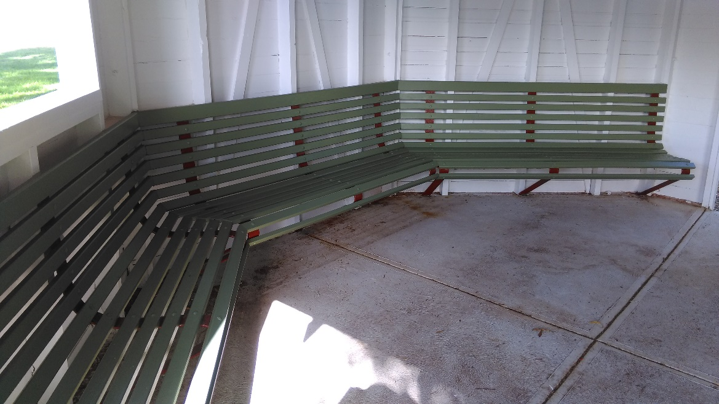
Figure 1: Internal refurbishment - April 2018

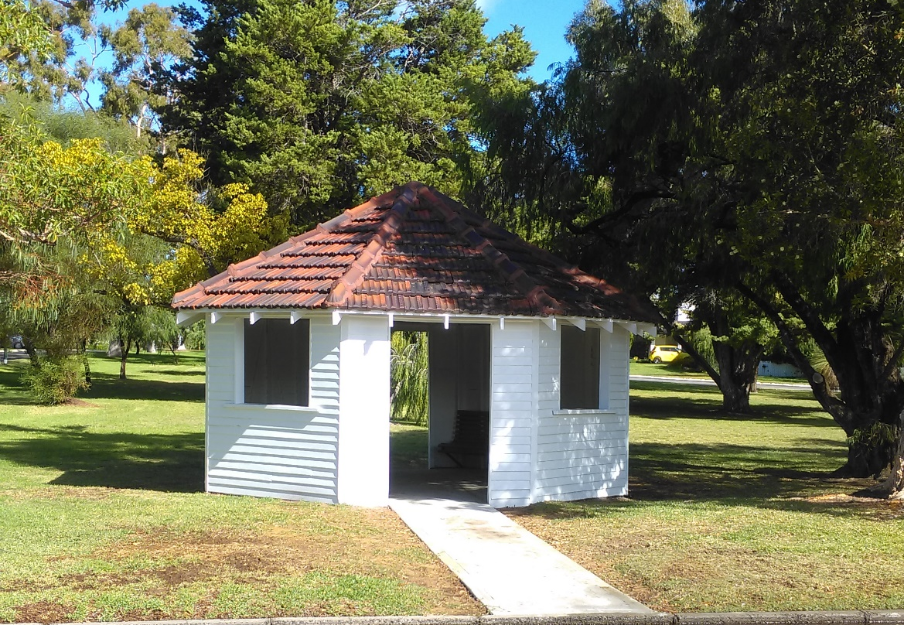
Figure 2: External refurbishment - April 2018
It should be noted that the majority of the scope of work is for cosmetic enhancements and there is little attention given to structural changes to increase its useful longevity.

Current Condition

In early 2023, the City of Nedlands commissioned a structural engineering firm to review and report on the current condition of the Gazebo (Attachment 1 refers). The overall condition of the Gazebo was rated as very poor. Major damage has been caused to structural wall elements by moisture and termites. There is significant, visible damage to a number of lower structural members, and the cladding of the Gazebo and termite damage has weakened the structure causing the frame to shift out of alignment.
The roof structure is in good condition relative to the lower structure elements. Some rafters are splitting and cracking, and the battens generally are in poor condition. The tiles are in reasonable condition and are likely to be the only truly salvageable element – however matching tiles into the future are likely be increasingly hard to source.
The vertical members, including door and window framing elements, as well as corner posts and cover panels appear to be the main vertical members damaged by termites. The wall cladding has also been damaged by termites, with further damage accelerated by moisture from irrigation and rain.
The Concrete slab/ foundation of the structure appears in good condition, although soil and grass on the North side of the structure has built up above the slab level and around the direct buried members. This prevents the weather step from achieving its purpose of keeping the timber structure out of the ground and water. This has led the structure to become more damaged.
Findings from this report are as follows:

The City engaged the services of a structural engineering firm, Atelier JV (AJV), to undertake a structural assessment of the Gazebo. This assessment (attachment 1 refers) found that the structural damage present is too extensive for retention, as well as highlighting the likelihood of further damage present in the wall panel corner cavities. AJV recommend that the Gazebo requires deconstruction and rebuilding on the existing slab structure.

The Structural assessment makes the following recommendations:

- Roof tiles and rafters can be kept and re-used for reconstruction where possible (roof timbers are to be inspected by a qualified professional for presence of pests).
- Roof fixings are significantly corroded and require replacement.
- Roof battens appear significantly weathered and therefore require replacement.
- Wall cladding is very damaged by water and pests and will require replacement.
- Timber stud and wall elements are to be fully replaced to prevent the possible retention of pest-ridden timbers being re-introduced to the new structure.
- The surrounding park area and trees to be inspected for timber attacking pests.
- The park irrigation system be reviewed to minimise spray onto the structure.
- the soil and grass level adjacent the shelter be brought down to below the slab level to allow a sufficient weather step to protect the future structure.
- A certified pest barrier or protection method shall be installed to suit the new structure and deter future pest damage.

Given the current poor condition of the structure the City of Nedlands must decide regarding its long-term future.

At the Ordinary Council Meeting of May 2023, a notice of motion was put which resolved the following:
“That the CEO is directed to provide a report with 3 quotes to Council by June OCM to repair the rotunda in Shirley Fyfe Park, and to protect it from further damage immediately, and to consider it for listing on the City of Nedlands Heritage inventory.”
Discussion

The following has been undertaken in an effort to address the Council Resolution:

Obtaining Quotations:

On the assumption that the aim of the project is to retain as much of the heritage value as possible, the City initially approached the following:

- 6 local contractors that advertise in the local community newspaper.
- 2 previous City contractors.

With the intent to obtain a priced proposal to return the structure toward its original condition. Feedback from approached businesses is as follows:
- Contractor I: Not involved in restorations; open to designing and building a new gazebo in the future.
- Contractor II: Semi-retired and not taking on new projects; will be fully retired in the next two months.
- Contractor III: Provided condition report upon request. Follow-up for a meeting and quote; no response received.
- Contractor IV: Sent condition report but temporarily halted work due to having COVID. Will resume when available; no further response received.
- Contractor V: Initial email sent with no response. Follow-up email send 12 June 2023; no response received.
- Contractor VI: Enquiry made online; no response received.
- Contractor VII: Contractor will do the work but are not a licensed builder. Estimated cost above $20k; proposed starting February 2024.
- Contractor VIII: Inspected the site and found the gazebo structurally damaged beyond repair. Advised against personnel entering the area.
In discussion with an Elected Member, an additional contractor’s details were provided to the City, who works locally and was familiar with the structure that may be able to accommodate the required works.

A later site meeting occurred with the City and the contractor on Monday 19th June 2023 at 1:30pm. The Contractor (Contractor IX) was provided with a copy of the structural report and later provided a price proposal on Sunday 25th June 2023 (Attachment 2 refers - Confidential).

The Contractor showed in their correspondence:

- Concern over the lean of the structure and recommended that the City engage a structural engineer to review and design future bracing to prevent leaning later.
- Install a temporary prop under the apex of the gazebo until works can begin.
- Work can begin on the Gazebo in seven weeks with the direct costs being approximately $60,000 inc. GST.

As such, despite efforts to obtain three quotations from nearly ten potential providers, the City was unable to source three within a reasonable time.

Men’s Shed Proposal

On 22 August 2023, in response to an article in the Post, the Claremont Men’s Shed approached the CEO with a proposal to undertake the repairs to the gazebo. This proposal was presented to the OCM on 22 August 23, where the following resolution was made:

“That Council requests the CEO:
- to enter into negotiations with the Claremont Men’s Shed to undertake the restoration of the Shirley Fife Gazebo; and

- If negotiations are successful, enter into an agreement for the Claremont Men’s Shed to restore the Gazebo, with the City funding:
  - The cost of the materials; and
  - A donation to the Claremont Men’s Shed.”

City Officers have undertaken negotiations with the Claremont Men’s Shed, with a proposal being formally submitted to the City on 08 September 2023. The Men’s Shed proposal is based on their charge out rates when Men’s Shed Members undertake outside projects. The Men’s Shed proposal indicates the labour costs (i.e., the donation the City would make to the Shed) are approx. $35,000 - $40,000. This figure excludes materials and sundries. The Men’s Shed proposal can be found in attachment 3.

Officers estimate materials for the restoration would cost approx. $15,000-$20,000. Moreover, the Men’s Shed proposal excludes any work on the tiled roof and roof structure, which require a different set of skills, equipment, and safety considerations. Should this proposal be supported, the City would have to arrange for the tiles to be removed and reinstated and any batten repairs undertaken. It is estimated that this will cost approx. $10,000 in direct costs.

It is expected that if this option is selected, a larger proportion of staff time would be required to assist in the planning and management of the work – more so than any other option. This is assumed due to the nature of this engagement and methodology differing from that of a provider which specialises in this type of work as their core business. This is not a reflection on the Men’s Shed association, but a consideration which should be given to any alternative form of project delivery. If this option is selection it is recommended to increase the standard overheads on this project to 30%.

Although the Men’s Shed proposal offers an opportunity to partner with a Community organisation to undertake the restoration works the total costs of this option is significant and will yield the same end result as a commercial builder undertaking the project.

Protection of the Structure:

Since late 2022 the City has undertaken the following to protect the structure whilst a long-term decision is made:

- Termite Treatment completed 5 January 2023.
- Fencing and Hoarding has been installed to prevent access.

Based on recent discussions with contractors, it was proposed to prop the roof structure to ease the burden on the walls. Whilst arranging this, however, the City’s electrician has declined to remove a light in the apex of the roof due to the current compromised condition being a potential work health and safety risk.

Similar concerns are likely to be raised by any company undertaking propping and thus engaging a suitable provider may prove difficult. Further, this highlights a risk to the City and any engagement with a contractor to undertake repairs must also demonstrate effective measures are in place to the safety of their employees and community.

Potential long-term options:

Originally put to Council were four options for consideration. The additional proposal from the Men’s Shed has added a fifth option for consideration:

- Replacement / repair like for like (by a commercial builder / trades person)
- Remove and not replace.
- Remove and replace with fit-for purpose, ‘off the shelf’ structure, including heritage aspects.
- Design of a new structure improving on material durability and including heritage aspects.
- Replacement / repair like for like (by a suitable community group).

Summary of these are provided below, with all costs outlined in the Financial Implications section of this report:

OPTION 1: Replacement / repair like for like (commercial builder)
Summary | The Gazebo would be surveyed and re-designed/drawn to a more modern standard where required but re-built as a heritage style structure in all other regards. This would return the structure to an all, but ‘as-new’ state and the look would be similar to the 2018 re-furbished outcome as seen in Figure 2 herein. Works would be undertaken by a Commercial Builder.  Fifteen year costs = $190,950
Positives |  | Negatives
- Retains all heritage aspects save for modern enhancements for longevity.  - Is familiar and likely to be generally well received by the community.  - Can provide incidental benefit of shelter to nearby park and bus users. |  | - Relatively costly compared to off the shelf products.  - Initial flaws of passive surveillance and enclosed nature will be retained.  - Materials, namely tiles, will become increasingly hard to source.  - Materials used will have the same weaknesses of the initial structure.  - No guarantee of the funding and long-term management to avoid history repeating.
Comments | A re-built structure is an attractive addition to the local area, but there is little support to justify significant spend on an asset for which the use and benefit beyond the heritage values can be warranted over and above other assets which are reaching the end of their useful life and are more in demand by the community for regular usage. As such this is not the recommended option.
OPTION 2: Remove and not replace
Summary | The Gazebo would be decommissioned and de-constructed with certain elements / materials and photographs retained to be included into a historic record for potential future presentation. Fifteen year costs = $9,600
Positives |  | Negatives
- Decreases the cost of the asset to zero.  - Allows funding to be directed to other assets for the community. |  | - Retains only fragments of historic record.  - Does not provide incidental shelter use in the same location.  - Community generally do not favour reduction in assets / services.
Comments | Since the fencing of the location in February 2023, there has been little demand for its use or concern at its current state until it was highlighted from a heritage perspective. Therefore, there is little evidence for the need of a structure of any type in the nearby area, and any retention would be for heritage only – something the City has received limited feedback in regard to the gazebo being closed. In an effort to balance limited funds to where it best services the community, Council may wish to consider this as a regrettable loss in favour of higher quality retention elsewhere. This is not the recommended option.

OPTION 3: Remove and replace with an ‘off the shelf’ gazebo with additional heritage elements
Summary | The Gazebo would be decommissioned and de-constructed. Certain elements which can be retained. A new ‘off the shelf’ Gazebo can be installed providing the bones of a re-built gazebo to which heritage elements could be added to, to give acknowledgement to the previous form. This could be by potentially using salvaged cladding, which was replaced in 2018, introducing new cladding and copying the historic colour palette of white and orange. Interpretive history signage with past photos and presenting previous materials can be installed alongside the new structure – which is not uncommon with older buildings that fall beyond repair or not fit for purpose and need of significant renovation. Fifteen year costs = $88,800
Positives |  | Negatives
- Easy to source and install quickly.  - Scale-able to budget in terms of element inclusions.  - Still retains heritage elements.  - Increased longevity of modern materials and replacement parts.  - Least whole of life cost for any replacement option.  - Structure / incidental usage still available to the community.  - Can be relocated nearby and re-oriented for better passive surveillance and community use. |  | - Retains fragments of historic record and overall aesthetic but not the structure itself  - Cost still would be at the expense of other assets which are subject to greater demand and use.
Comments | With such a significant asset backlog, the City should treat every full replacement in a similar manner to a new asset. This includes ensuring the asset meets demand but is provided in a way that is sustainable long term. By their bespoke nature and age, heritage structures and buildings, are more difficult and costly to maintain. Council would be best served in ensuring assets provide the services for which they are intended for the best value possible. That said, history is important to the City and the community and this option goes some way to acknowledge history in a modern way. On the balance of these considerations, this option is the recommended option.

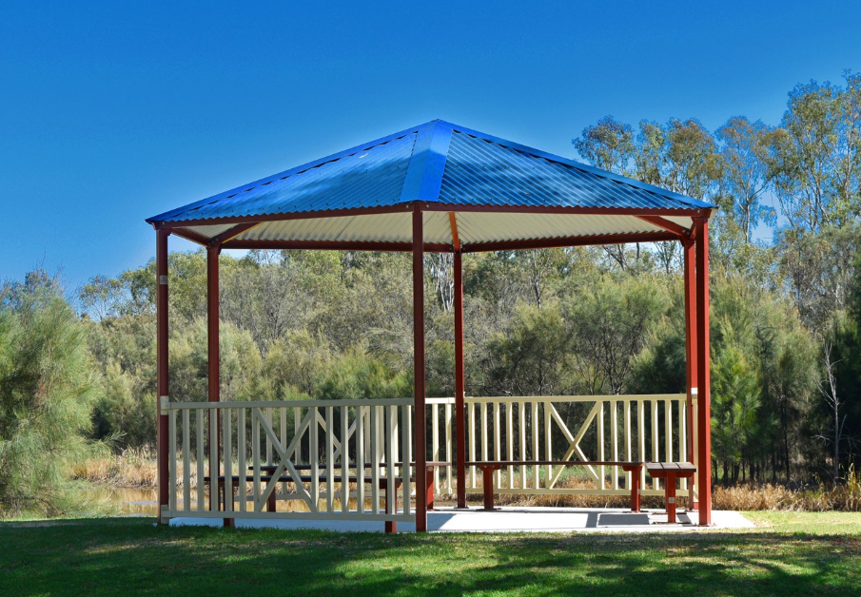
Figure 3: 'Brookdale' prefabricated shelter from Exteria – potential base structure for Option 3
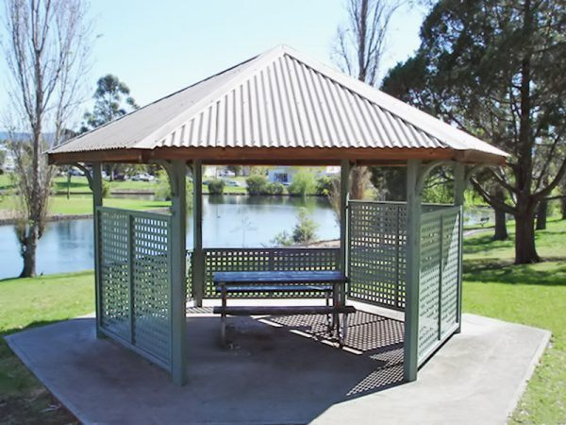
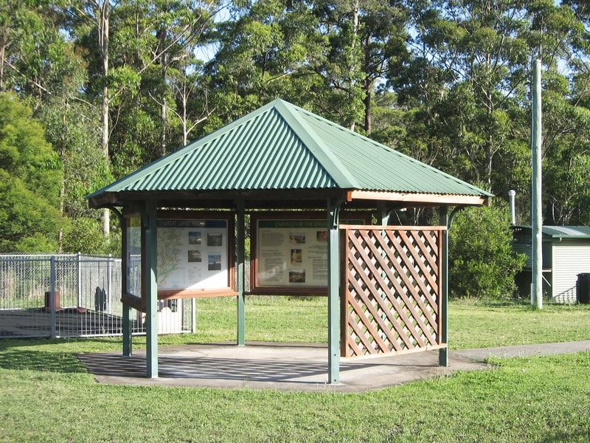
Figure 4 & 5: 'Goulburn’ prefabricated shelter from Landmark – potential base structure for Option 3 showing custom cladding arrangements

OPTION 4: Remove and completely re-design a new structure with all modern materials
Summary | The Gazebo would be decommissioned and de-constructed. A new custom gazebo would be designed and built to 2023 standards and materials. It would be painted in a similar colour scheme to the 2018 refurbishment. Fifteen year costs = $154,800
Positives |  | Negatives
- Still retains heritage elements.  - Increased longevity of modern materials and replacement parts.  - Structure / incidental usage still available to the community.  - Can be relocated nearby and re-oriented for better passive surveillance and community use. |  | - Retains fragments of historic record and overall aesthetic but not the structure itself.  - Cost still would be at the expense of other assets which are subject to greater demand and use.  - Will take time to design and certify, tender and build from custom parts.  - Likely significant capital costs relative to other options.
Comments | This option creates a number of benefits from other options, at a slightly greater cost. It is the officer’s opinion however that such an option does not go significantly beyond the benefit provided in Option 3. As the Gazebo is a traditional, octagonal shape, readymade alternatives which can be added to would be better value than a modernization which may have been favored if the original structure was of an architectural design. This is not the recommended option.

OPTION 5: Replacement / repair like for like (Claremont Men’s Shed)
Summary | The Gazebo would be surveyed and re-designed/drawn to a more modern standard where required but re-built as a heritage style structure in all other regards. This would return the structure to an all, but ‘as-new’ state and the look would be similar to the 2018 re-furbished outcome as seen in Figure 2 herein. Works would be undertaken by the Claremont Men’s Shed, with the City purchasing materials, and providing support and assistance.  Fifteen year costs = $231,364
Positives |  | Negatives
- Retains all heritage aspects save for modern enhancements for longevity.  - Is familiar and likely to be generally well received by the community.  - Can provide incidental benefit of shelter to nearby park and bus users.  - Provide’s for a good community engagement activity with a prominent local group. |  | - Relatively costly compared to off the shelf products.  - Initial flaws of passive surveillance and enclosed nature will be retained.  - Materials, namely tiles, will become increasingly hard to source.  - Materials used will have the same weaknesses of the initial structure.  - No guarantee of the funding and long-term management to avoid history repeating.  - Higher City Officer involvement will require resourcing.
Comments | A re-built structure is an attractive addition to the local area, but there is little support to justify significant spend on an asset for which the use and benefit beyond the heritage values can be warranted over and above other assets which are reaching the end of their useful life and are more in demand by the community for regular usage. As such this is not the recommended option.

Consultation

No consultation has occurred with regard to this report and decision.

It is worth noting an interested resident has contacted City of Nedlands as she had read in the local newspaper that the City of Nedlands were demolishing the heritage structure. The resident offered to restore the Gazebo and relocate it to their property in the southwest at no cost to the City.

Strategic Implications

Vision Our city will be an environmentally sensitive, beautiful and inclusive place.

Values Healthy and Safe
Our City has clean, safe neighborhoods where public health is protected and promoted.

Great Natural and Built Environment
We protect our enhanced, engaging community spaces, heritage, the natural environment and our biodiversity through well-planned and managed development.

High standard of services
We have local services delivered to a high standard that take the needs of our diverse community into account.

Reflects Identities
We value our precinct character and charm. Our neighborhoods are family-friendly with a strong sense of place.

Easy to Get Around
We strive for our City to be easy to get around by preferred mode of travel, whether by car, public transport, cycle or foot.

Priority Area

- Renewal of community infrastructure such as roads, footpaths, community and sports facilities
- Retaining remnant bushland and cultural heritage

Budget/Financial Implications

The long-term financial implications for the options presented are tabled below:

Legislative and Policy Implications

Depending on the decision of Council, the City officers may be required to undertake a procurement process in line with the Council’s Procurement Policy. This will add delay to undertaking any works whilst this occurs, unless Council determine that these works can occur outside the policy and process. As the works are unlikely to go beyond the tender requirements, the Council’s policy is the determining document.

Decision Implications

The decision of Council in respect to the structure will have implications on either financial requirements or local heritage, which will be determined based on the preferred option.
Conclusion

Five options provided regarding the repair/ restructure/ new design to be built of the Shirley Fyfe Tram Stop Rotunda/ Gazebo due to the poor condition and state of the structure, Administration has attempted to source contractors to refurbish the structure. Due to limited interest, and concern over the current state, this has proven difficult.

As such, Administration is requesting that Council consider the options presented herein, with the recommendation for Option 2. This recommendation was considered alongside the City’s current infrastructure asset backlog. The reality of the current situation with dilapidated assets, relative use of the asset, difficulty in arranging works for a competitive price and the City’s limited financial resources in general prevent the officers from recommending action above a number of other community assets in need of attention.

Alternatively, Council may wish to retain a structure in this location, should this be the case, Option 3 seeks to strikes a balance between the asset being provided, linking to the past, modern materials and is financially prudent;

Council may propose an alternative resolution being:

That Council:

- include in the 2023-24 financial year budget an allocation of $45,000 to remove and replace the gazebo at Shirley Fyfe Park with prefabricated structure and additional heritage elements; and

- capture heritage information regarding the dilapidated gazebo for future record.

Council also may wish to attempt to negotiate a more financially affordable price with the Men’s Shed in line with their expectations. If this is the case option 5 could be adopted per the following alternative resolution, with Council nominating the contribution:
That Council:

- authorises the CEO to propose entering into an agreement with the Men’s Shed for a donation of $_________;

- approves inclusion during the mid-year budget review of an additional $_______ plus materials and on-costs to fund the works;

- approves for consideration during the development of the 2024-25 financial year budget, a suitable allocation to fund the ongoing maintenance of the structure into the future.

Further Information

Nil.

TS18.11.23 – Interstate Travel – Waste Expo Australian 2023 Participation
Meeting & Date | Council Meeting – 28 November 2023
Applicant | City of Nedlands
Employee Disclosure under section 5.70 Local Government Act 1995 | Employee disclosure required where there is an interest in any matter of which the employee is providing advice or a report.
Report Author | Chaminda Mendis - Waste Minimisation Coordinator
Director | Mathew MacPherson - Director Technical Services
Attachments | - 2023 Waste Summit Conference Agenda

Purpose

This report informs the Council that there was a City officer representative that participated in the ‘Waste Expo Australia’, held at Melbourne Convention and Exhibition Centre, Melbourne on Wednesday 25th October 2023 till Thursday 26th October 2023, 9am – 5pm.

Recommendation

That Council:

- note the Administration’s participation at the Melbourne Waste Expo 2023; and,
- request the CEO provide a report to Council in accordance with the “Interstate and International Travel” Policy at the appropriate Ordinary Council Meeting.

Voting Requirement

Simple Majority.

Background

The Waste Expo Australia 2023 is a free event, which presents a valuable opportunity to learn about the latest advancements, and strategies in waste management, including:

- industry best practices,
- cost-effective solutions, and
- environmentally sustainable performance strategies to further enhance the City's diversion targets.

Discussion

The conference's key focus areas, align closely with the City's interests, and offer the potential for significant benefits. Specifically, the administration will explore the future of waste-to-energy, and the associated challenges in this sector. This is particularly important to the City as we consider the opportunity of recovering the non-recyclable waste through waste to energy technology. The insights shared by industry experts are crucial in guiding our decision-making process.

The conference agenda included:

- comprehensive discussions on the circular economy,
- focusing on its practical application to our waste management practices,
- government policies, and
- regulations.

These discussions will help us understand how important it is to manage waste sustainably using circular economy principles. For instance, the conference will explore opportunities for the City to pioneer new recycling technologies. As demonstrated, by our previous successful adoption of compacted verge hard-waste recycling, making us the first metropolitan LGA in Western Australia to implement this innovative program.

The City has a ‘Interstate and International Travel Policy’. The application has been made in writing and approved by the CEO.

As per this Interstate and International Travel Policy clauses, point 4 and 5 are pertinent to this report:

4. A written report on the travel and event/s attended should be presented to Council by the person who travelled no later than the second meeting after return from the travel.

5. Interstate travel for staff for work related purposes is subject to approval by the CEO and report of the approval and reason for it to the Council at the meeting following that approval.

Consultation

Not required.

Strategic Implications

This item relates to the following elements from the City’s Strategic Community Plan.

Vision Our city will be an environmentally-sensitive, beautiful and inclusive place.

Values Healthy and Safe
Our City has clean, safe neighbourhoods where public health is protected and promoted.

High standard of services
We have local services delivered to a high standard that take the needs of our diverse community into account.

Great Governance and Civic Leadership
We value our Council’s quality decision-making, effective and innovative leadership, transparency, accountability, equity, integrity and wise stewardship of the community’s assets and resources. We have an involved community and collaborate with others, valuing respectful debate and deliberation.

Priority Area

- Urban form - protecting our quality living environment.

Budget/Financial Implications

The expense for this conference is in line with the approved 23/24 waste budget – Professional Development for the financial year. The allocated budget for this event is capped at around $2,000 which would approximately cover for:
- Airfares $ 768
- Accommodation $ 740
- Meals $ 221
- Transport (Taxi’s) $ 200
- Total Costing: $1,929

Legislative and Policy Implications

Interstate and International Travel Council Policy

Decision Implications

The expenditure for this conference falls within the approved 2023/24 waste budget under Professional Development.

Conclusion

This event stands as one of Australia's premier gatherings for waste management and resource recovery professionals. It offers a valuable platform for staying well-informed of the latest technologies and industry best practices. The discussion topics are closely aligned with our City's objectives and will provide greater understanding and assistance in increasing our landfill diversion targets.

Further Information

Nil.

TS19.11.23 - Establishment and Appointment of Members – Integrated Transport Steering Committee
Meeting & Date | Ordinary Council Meeting – 28 November 2023
Applicant | City of Nedlands
Employee Disclosure under section 5.70 Local Government Act 1995 | Nil.
Report Author | Aaron MacNish – Coordinator Transport and Development
Director | Matthew MacPherson – Director Technical Services
Attachments | Nil.

Purpose

The purpose of this report is for Council to consider for the re-establishment and re-adoption the Terms of Reference for the Integrated Transport Strategy (ITS) Steering Committee and confirm the appointment of its members.

Recommendation

Council:
- re-establishes the Integrated Transport Strategy Steering Committee and Re-adopts the Terms of Reference as per below;
- appoints the Mayor and four Councillors (one Councillor from each ward) as Committee Members:
    - Councillor (insert name) - Coastal Ward
    - Councillor (insert name) - Hollywood Ward
    - Councillor (insert name) - Dalkeith Ward
    - Councillor (insert name) - Mevista Ward; and
- appoints the Deputy Mayor and four Councillors (one Councillor from each ward) as Deputy Members of the Committee:
    - Councillor (insert name) - Coastal Ward
    - Councillor (insert name) - Hollywood Ward
    - Councillor (insert name) - Dalkeith Ward
    - Councillor (insert name) - Mevista Ward

Terms of Reference

Purpose

This Committee is established by Council in accordance with section 5.8 of the Local Government Act 1995, to oversee and provide guidance to the Administration on the City of Nedlands Integrated Transport Strategy Project.

Scope

- Provide guidance to the Consultant on the Community Consultation Plan and process;

- Approve the Community Consultation Plan;

- Provide guidance to the Consultant on the Community Consultation results.

- Provide guidance and input to each iteration of the draft Integrated Transport Strategy; and

- Consider the draft Integrated Transport Strategy and make a recommendation to Council on the adoption of the Integrated Transport Strategy.

Membership

- The membership of the Committee shall comprise the Mayor and one Councillor from each ward with the Councillors being determined by nomination and if necessary, a ballot conducted at a Council Meeting.

- Council will appoint one Councillor from each ward as deputy members of the Committee.

- If a vacancy on the Committee occurs for whatever reason, then Council shall appoint a replacement in accordance with the same arrangements as for the original appointment.

- Deputy members are only required to attend and vote if the primary member is absent, an apology or on leave or has resigned.

- The term of the Presiding Member and Committee Members will expire immediately prior to the next ordinary Council election.

- The Presiding Member shall be determined by election amongst the Members of the Committee at the first meeting of the Committee.

- The election of the Presiding Member will take place at the first meeting following the reconstitution of the Committee after each Ordinary Council election.
- Should the elected Presiding Member not be present during a meeting of the Committee then a temporary Presiding Member shall be elected in accordance with 7 above.

Staff

The Project Management Team, including the City’s Project Managers and the appointed Consultant team will work closely with the Committee throughout the Project.

Meetings

- This Committee operates under the Council’s Standing Orders Local Law.

- The committee shall have flexibility in relation to when it needs to meet, but as a minimum shall meet monthly. It is the responsibility of the Presiding Member to call the meetings of the Committee.

Reporting

The Committee shall report quarterly to the Council summarising its activities during the previous financial year.

Voting Requirement

Absolute Majority.

Background

The City of Nedlands 2018-2028 Strategic Community Plan (SCP) clearly articulates the community's vision and aspirations for the future of the City. It demonstrates the City's bold vision to perform a critical economic, social and cultural role within Perth Metropolitan Area. To support the future growth, the City intends to develop an Integrated Transport Strategy (ITS) to address the transport challenges by developing a clear framework for the future planning and upgrade of the City’s transport system. The ITS will guide future works as the City seeks to make it safe, easy, environmentally friendly and enjoyable to get around Nedlands.

In addition to the SCP, the City's Local Planning Scheme No. 3 (LPS3) was approved in 2019 and provides the basis for a significant increase to the City's population through changes to the zoning, land use permissions, density codes and development standards.

It is essential that the City's transport network effectively accommodate the transport needs of this increase in population. This planned growth will generate significant travel demand, placing greater stress on transport infrastructure and services. The City is seeking to have an integrated and holistic approach to transport initiatives and advocacy, by developing a transport strategy to manage the community's existing and future sustainable transportation needs.

Further to this, the State Government is responsible for planning and delivering public transport and major road infrastructure. The City needs to have a comprehensive understanding of various transport modes requirements to inform advocacy and collaboration with relevant State Government agencies on these matters.

At the Ordinary Council Meeting held on 23 February 2021, Council resolved to:

- Commence the development of the Integrated Transport Strategy and Transport Impact Assessments for the Broadway, Waratah Avenue and Town Centre Precinct Plans; and

- Approve a budget allocation of $145,000 in the 2020/21 and $50,000 in the 2021/22 financial years to engage a consultant to deliver the Integrated Transport Strategy and the Transport Impact Assessments for the Broadway, Waratah Avenue and Town Centre Precinct Plans.

In response to these matters and the Council Resolution, the City has sought quotes from experienced engineering consultants to prepare an Integrated Transport Strategy. Arup were selected as the preferred consultant, have been awarded this package of works, and have commenced the data gathering phase of the project.

Due to delays in the procurement process and contract negotiations, a contract for this project was not signed until April 2022. As such a budget allocation was be made as part of the 2022/23 Annual Budget process to complete this project.

The ITS will consider relevant stakeholders’ transport strategies/initiatives/plans. Those stakeholders will include neighbouring Local Governments, Department of Transport, Main Roads WA, those undertaking large infrastructure projects, and other stakeholders that will impact on the City of Nedlands’ transport network. The final report will be submitted to the City of Nedlands and will be sole property of the City with full rights on its subsequent use.

Discussion

Due to the strategic importance of the ITS, the Administration is seeking to establish a Steering Committee, to provide guidance, and input into the process of developing a comprehensive ITS.

The proposed project timeline is shown below:

ACTIVITY | INDICATIVE TIMELINE
Appoint ITS Steering Committee. | 26 July 2022
Community Consultation Plan approved by Steering Committee. | 04 August 2022
Key stakeholder and Community Consultation commences. | August 2022
Draft ITS presented to Council* | February 2024
ITS approved by Council* | March 2024

* Note: original dates were delayed by approximately one month (one OCM) to allow for additional engagement following limited participation in previous stages.

Consultation

A Stakeholder Engagement Plan will be developed as part of this project, and consultation with the Community, the Steering Committee and key stakeholders will be undertaken throughout the project.

Strategic Implications

This item relates to the following elements from the City’s Strategic Community Plan.

Vision Our city will be an environmentally-sensitive, beautiful and inclusive place.

Values Healthy and Safe
Our City has clean, safe neighborhoods where public health is protected and promoted.

Great Natural and Built Environment
We protect our enhanced, engaging community spaces, heritage, the natural environment and our biodiversity through well-planned and managed development.

Great Governance and Civic Leadership
We value our Council’s quality decision-making, effective and innovative leadership, transparency, accountability, equity, integrity and wise stewardship of the community’s assets and resources. We have an involved community and collaborate with others, valuing respectful debate and deliberation.
Great Communities
We enjoy places, events and facilities that bring people together. We are inclusive and connected, caring and support volunteers. We are strong for culture, arts, sport and recreation. We have protected amenity, respect our history and have strong community leadership.

Reflects Identities
We value our precinct character and charm. Our neighborhoods are family-friendly with a strong sense of place.

Easy to Get Around
We strive for our City to be easy to get around by preferred mode of travel, whether by car, public transport, cycle or foot.

Priority Area

- Urban form - protecting our quality living environment
- Renewal of community infrastructure such as roads, footpaths, community and sports facilities
- Managing parking
- Working with neighboring Councils to achieve the best outcomes for the western suburbs as a whole.

Budget/Financial Implications

A budget allocation of $30,065 has been proposed as part of the 2023/24 Annual Budget Process to complete this project.

Legislative and Policy Implications

Section 5.8 of the Local Government Act 1995 allows Council to establish Committees to assist the Council to exercise the power and discharge the duties of the Local Government.

Decision Implications

If Council endorse the recommended Terms of Reference for the establishment of this Committee, the Project will be able to proceed with Councillor input and guidance throughout the project.

If Council does not endorse recommended Terms of Reference for the establishment of this Committee, the Project will have limited Councillor involvement. This will significantly increase the risk of changes to the Plan, or the Plan not being endorse when presented to Council.

Without an endorsed ITS, the Administration will not have Strategic guidance on how to effectively plan and manage the transport issues the City will facing in the coming years, which will result in a poor outcome for this key area of the City.

An ITS that has been endorsed by Council will enable the City to apply for state and federal grant funding opportunities that will assist to deliver future capital works.

Conclusion

The City of Nedlands Integrated Transport Strategy Project presents a unique opportunity for the City of Nedlands to undertake community consultation that will inform the City as to how its residents will move about the City over the coming decades, and then to develop a long-term strategic plan to manage and improve transport modes throughout the City.

The establishment of the ITS Steering Committee will ensure Council has the opportunity to provide strategic guidance to the project and is involved in the development process.

Further Information

Nil.

TS20.11.23 – Stanley Street & Florence Road Cul-de-sacs
Meeting & Date | Council Meeting – 28 November 2023
Applicant | City of Nedlands
Employee Disclosure under section 5.70 Local Government Act 1995 | Nil.
Report Author | Aaron MacNish – Coordinator Transport and Development
Director | Matthew MacPherson – Director Technical Services
Attachments | Nil.

Purpose

This report is in response to a notice of motion of the Ordinary Council Meeting held 28th March 2023 requesting the CEO to present a report to Council regarding traffic modelling of partial closures on Stanley Street and Florence Road; the potential road layout arrangements considered, the impacts of any proposed treatments and a preferred treatment of closure.

Recommendation

That Council:
- adopt Scenario 4, being Florence Road northbound only, and Stanley Street southbound only as the preferred treatment of closure for further development;
- authorise the CEO to commence liaison with relevant applicants to include with their Local Area Traffic Treatment plans the proposed conversion of Stanley Street and Florence Road to one-way movements in line with the preferred treatment in the vicinity of the southern boundary of the “Woolworths” development; and
- request the CEO to report back to Council the outcomes of the Local Traffic Treatment Plan for further consideration.

Voting Requirement

Simple Majority.

Background

The Woolworths development site compromises of six individually owned properties and is occupied by:

- the Captain Stirling Hotel,
- a drive-through liquor store with associated car parking,
- a vacant lot at No.5 Stanley Street
- single houses on the remaining properties.
- the two-storey hotel built in 1935 is a State registered heritage place and is considered a landmark building on Stirling Highway.

The Woolworths proposal requires:
- demolition of the existing drive-through liquor store,
- minor additions to the hotel and landscape elements
- the demolition of four single houses. - The subject site has three road frontages, the primary frontage at Stirling Highway and secondary frontages at both Florence Road and Stanley Street.

The development application was lodged in 2019 and reviewed by City of Nedlands (CoN), Main Roads and the State Heritage Office with concerns raised regarding:

- traffic,
- transport and access issues,
- the requirement for further information regarding heritage issues and the integration of the project in the Nedlands Town Centre.

Following SAT mediation, the development was approved on 10 February 2023 by the Metro Inner-North Joint Development Assessment Panel, with the following condition relating to traffic and transport:

- “Condition 25: Prior to issue of a Building Permit the applicant is to develop in consultation with the City of Nedlands, a Local Area Traffic Treatment Plan that will minimise the adverse impact of the additional traffic generated by the development on the residents of neighbouring streets, namely Stanley Street, Florence Road and Edward Street.”

Following the development approval, at the Ordinary Council Meeting held 28 of March 2023, Council resolved that:

  - By absolute majority, allocate $5,000 in the 2022-23 financial year budget for traffic modelling to determine the impacts of cul-de-sacs and one-way arrangements on:

    - Florence Road, between Stirling Highway and Edward Street, Nedlands; and
    - Stanley Street, between Stirling Highway and Edward Street, Nedlands; and in the vicinity of the southern boundary of the development at 71 Stirling Highway, Nedlands.

  - Request the CEO present a report to Council in June 2023 following the completion and assessment of the modelling regarding:

    - Potential road layout arrangements considered,
    - The impacts of any proposed treatment and,
    - A preferred treatment of closure.

Due to staffing turn over and a significant number of competing time critical undertakings occurring during the busy end of financial year period, the original slated June OCM was unable to be met.

Discussion

The City of Nedlands collaborated with ARUP to conduct traffic modelling and sensitivity testing, aiming to assess the potential impacts on the surrounding road network in the year 2025. This evaluation focused on four different configurations of Stanley Street and Florence Street cul-de-sacs. The traffic modelling was completed within the “Nedlands Traffic Model” which was completed and endorsed by Main Roads WA on 7 July 2021.

Over the past two years, it’s reasonable to anticipate changes in the City’s current traffic volumes compared to those in 2021. To account for these changes, the 2021 model was updated by incorporating traffic data collected at the end of 2022. This updated data was then used to determine the current traffic distribution.

The City of Nedlands Traffic Model also made sure to consider the impact of future lot developments in the study area (Chellingworth and ALDI) which are indicated in Figure 1.
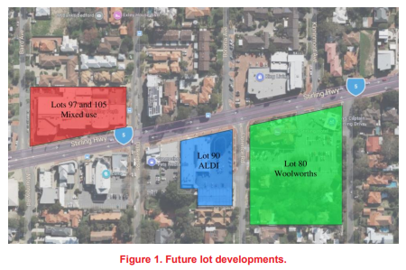
Figure 1 - Additional "scenario D" Land Uses

Four cul-de-sac scenarios were tested using the 2025 model. The results plotted, summaries of link volume, difference in volume, maximum approach delay, delay difference, and volume/capacity ratio.

Scenario 0 was developed as a starting point, showing the current road network layout without cul-de-sacs. The difference plots for each other of the four cul-de-sac scenarios compare each of them to this no-cul-de-sac scenario. In other words, Scenario 0 is the or future baseline model as if the developments occurred as currently planned and NO traffic treatments were introduced.

The four scenarios tested are summarised in Table 1, and Figure 2 through to Figure 5 below:

Scenario | Florence Rd Treatment | Stanley St Treatment
0 (Base) | No Change | No Change
1 (North bound only) | North bound full access, south bound blocked at boundary of development | North bound full access, south bound blocked at boundary of development
2 (South bound only) | North bound blocked at boundary of development, South bound full access | North bound blocked at boundary of development, South bound full access
3 (Florence South, Stanley North) | North bound blocked at boundary of development, South bound full access | North bound full access, south bound blocked at boundary of development
4 (Florence North, Stanley South) | North bound full access, south bound blocked at boundary of development | North bound blocked at boundary of development, South bound full access
Table 1 - Scenario Configurations

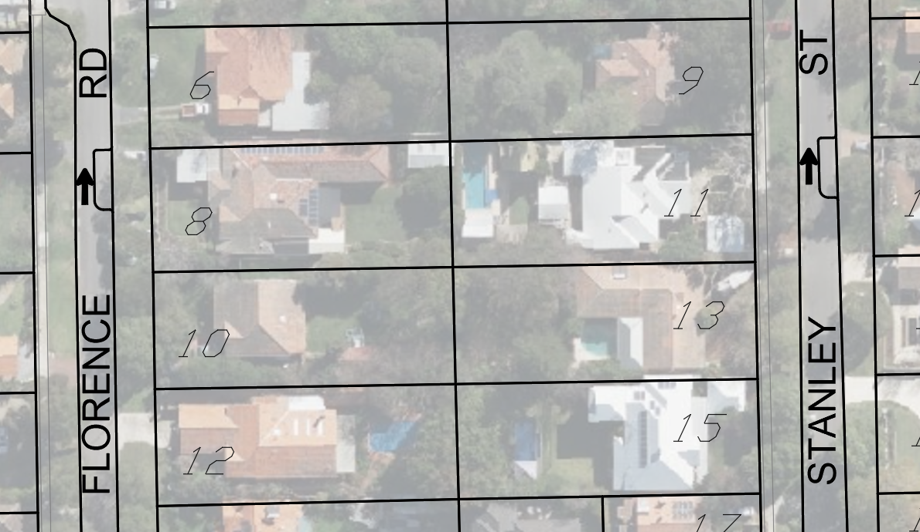
Figure 2 - Scenario 1 Configuration

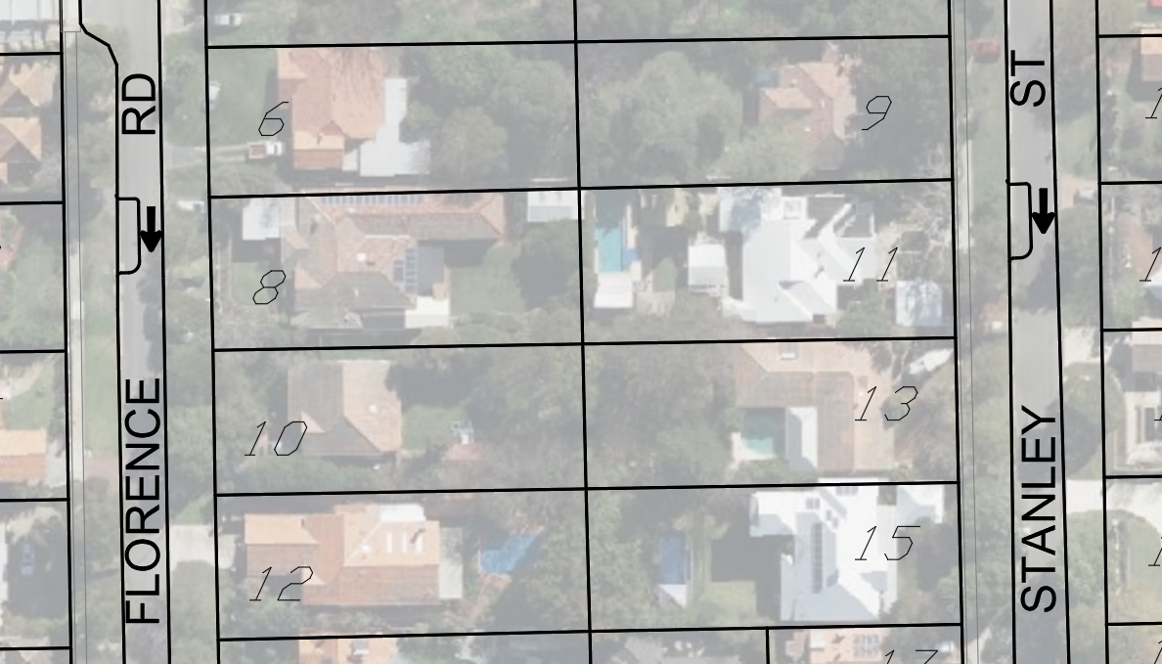
Figure 3 - Scenario 2 Configuration

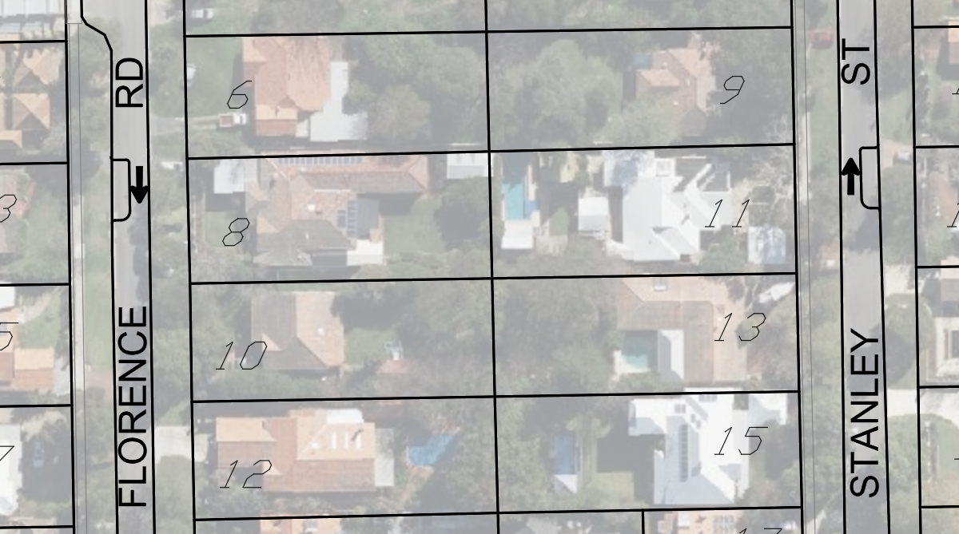
Figure 4- Scenario 3 Configuration
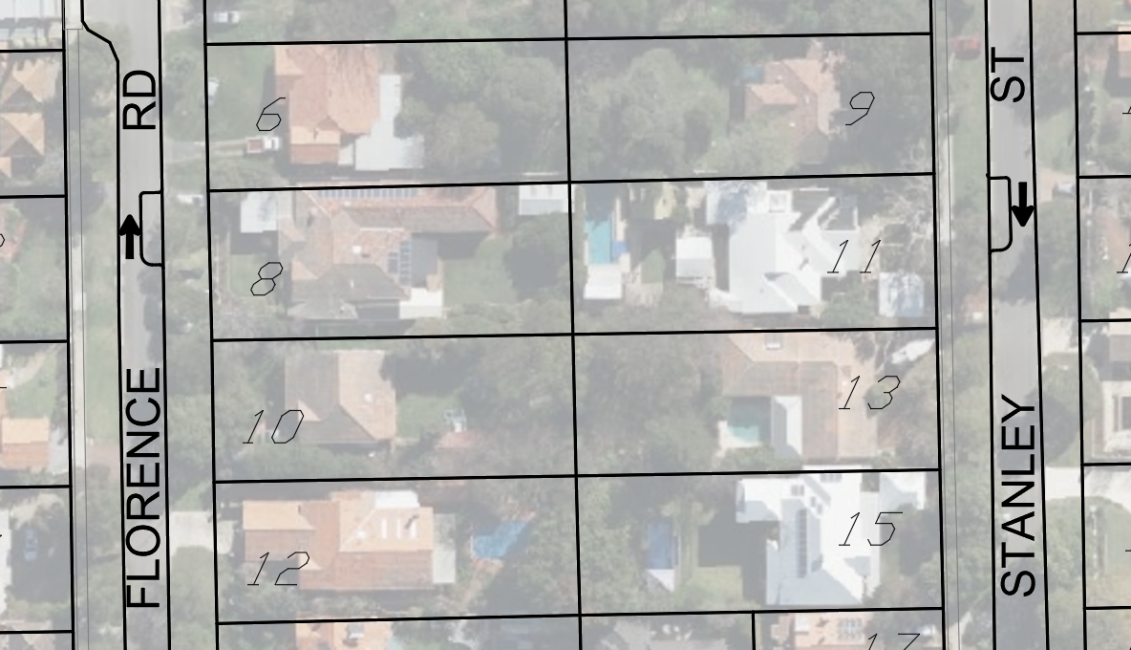
Figure 5 - Scenario 4 Configuration
- An animated simulation was conducted for one of the seeded microscopic runs for each scenario (including Scenario 0) and peak. The following observations have been noted for the morning (AM) peak:

- Congestion issues are centred around the following corridors in all scenarios:
  - Stirling Highway,
  - Dalkeith Road,
  - Bruce Street,
  - Boronia Avenue,
  - Kinninmont Avenue and
  - Carrington Street.
- The signals at Stirling Highway/ Broadway creates large eastbound rolling queues. This affects the right turn onto Stirling Highway from the Bruce Street south approach. This extends into the preceding intersection with Edward Street. Scenarios 1, 2 and 3 see this queue disperse by the final 5 minutes of the model run.
- Some westbound rolling queues were observed on Stirling Highway. Due to the signalling at the Dalkeith Road intersection, this had consequential effects on other intersections along Stirling Highway. Particularly on Baird Avenue, Mountjoy Road, and Louise Street. This was noted to be the worst in Scenario 2.
- The Carrington Street/ Kinninmont Avenue intersection saw congestion issues in Scenario 1, where vehicles on the south approach did not find sufficient gap time for the right turn. This issue stems from the intersection with Smyth Road, where there is insufficient capacity for the left turn from the west approach.

- The following observations were noted for the afternoon (PM) peak:

- Stirling Highway appeared to perform adequately with little to no queuing observed in all scenarios.
- Congestion was present in all scenarios, on:
  - Carrington Street,
  - Boronia Avenue, and
  - Kinninmont Avenue

- The traffic volumes appear to originate from local zones, and the queues, which could be attributed to poor dynamic route choice. As with the AM Peak, this issue also stems from the intersection with Smyth Road, where there is insufficient capacity for the left turn from the west approach.

The modelling results demonstrated mixed impacts on the local network. The scoring table (Table 2) was developed by ARUP to quantify the net impact that the cul-de-sac configurations have on key corridors in the network.

The net impact analysis looks at the volume and delay differences of the sensitivity scenarios with Scenario 0:
- Positive scores are allocated to corridors which show a decreased delay, with +1 (√) or +2(√√) given if it accompanies a respective increase or decrease in traffic volume.
- Negative scores are allocated to corridors which show increased delay with -1(X) or -2(XX) if it accompanies a respective decrease or increase in traffic volume.
Table 2 - Net Scenario Scores
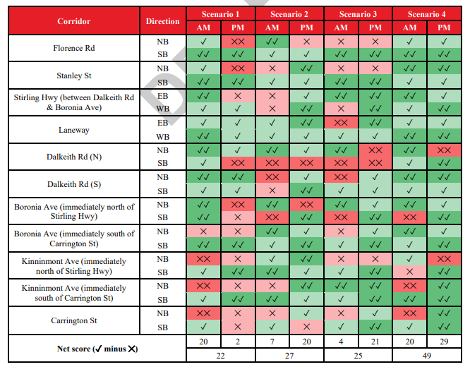
In all sensitivity scenarios, there is a positive impact on key corridors. Scenario 4, with a total of +49, is the best option and the preferred treatment of closure treatment; this is Florence North bound only and Stanley South Bound only.

Although, scenario 4 performs the best. It is noted that all assessments are weighted equally, with some roads having one or two sections each. Scenarios 1 through 3 are all within single digits of one another. In the absence of Scenario 4, providing more favourable outcomes by far on key PM routes, such as, Dalkeith Road and Carrington Street in addition to the adjacent Florence Road and Stanley Street, officers would recommend a further and finer grain assessment.

Nevertheless, some issues remain from Scenario 0. One problem being, is the high volume/capacity ratio seen on the west approach of the Carrington Street/Smyth Road intersection, reaching almost practical capacity at 0.83 during the PM peak. This persists because it's a priority intersection causing some problems, as seen on the west approach of the Carrington Street/Smyth Road.

Should Council decide that action is required in the form of a cul-de-sac / one way configuration, according to the traffic modelling, scenario 4 would be preferrable. This enables only northbound movement on Florence Road and only southbound movements on Stanley Street from the laneway. This is primarily due to it showing the best delay benefits across both the AM and PM peak along key corridors in the local network.

However, problems in the wider network still exists in all the cul-de-sac scenarios. Tests which includes, high delays, and long queues experienced on Bruce Street in the AM Peak, and Carrington Street in the PM Peak. These issues may be partially attributed to the poor route choice, due to dynamic traffic assignment performed in the mesoscopic model runs. They are also attributed to the priority intersection at these locations at peak volume, which was observed in the animated microscopic simulations where vehicles (especially right turning) could not find adequate gap time to perform their movements across the intersection.

Furthermore, apart from cul-de-sacs Scenario 4, additional research/ investigation may be required to address congestion at key Carrington Street intersections like Boronia Avenue, Kinninmont Avenue, and Smyth Road, especially in the PM Peak. This could include further traffic studies at the intersection of Stirling Highway at Dalkeith Road and Broadway which could alleviate the queuing at other priority intersections along Stirling Highway, at an appropriate time. It would be recommended that this be investigated once traffic patterns stabilise outside of the construction and ‘honeymoon’ periods of the new developments pass and routine patronage is established – in effect creating a new baseline.

Laneway Impact:

Historically, the concept of a connecting laneway between Dalkeith Road and Florence Road has been recommended as a possible option for traffic connectivity in the area. However, Council and the developer could not come to an agreement about the final alignment of the laneway, as such officers did not pursue the implications of a laneway connection in the current modelling.

Should Council reconsider its position in this regard, the scenarios could be re-modelled each with, and without, a laneway connection.

Consultation

Consultation has occurred with Council through a Concept Forum on the 19th of September 2023.

Strategic Implications

This item relates to the following elements from the City’s Strategic Community Plan.

Vision Our city will be an environmentally sensitive, beautiful and inclusive place.

We will have easy access to community ‘hubs’ where a mix of parks, shops, community and sporting facilities will bring people together, strengthening local relationships.”

We will enjoy great transport systems and people will have access to local facilities through efficient cycling and walking facilities.”

Values Healthy and Safe
Our City has clean, safe neighbourhoods where public health is protected and promoted.

Great Natural and Built Environment
We protect our enhanced, engaging community spaces, heritage, the natural environment and our biodiversity through well-planned and managed development.

Great Governance and Civic Leadership
We value our Council’s quality decision-making, effective and innovative leadership, transparency, accountability, equity, integrity and wise stewardship of the community’s assets and resources. We have an involved community and collaborate with others, valuing respectful debate and deliberation.

Great for Business
Our City has a strong economic base with renowned Centres of Excellence and is attractive to entrepreneurs and start-ups.

Easy to Get Around
We strive for our City to be easy to get around by preferred mode of travel, whether by car, public transport, cycle or foot.
Priority Area

- Urban form - protecting our quality living environment.
- Renewal of community infrastructure such as roads, footpaths, community and sports facilities

Budget/Financial Implications

$5,000 was allocated for traffic modelling to determine the impacts of the development. It estimated at the time of the Notice of Motion, on an assumption of data on hand. However, the final cost of modelling was $10,800 due to the final level of modelling and updating required.
No dedicated allowance has been made for the detailed design, consultation or construction of any cul-de-sacs or local traffic treatments on Stanley Street or Florence Road in the current 2023-24 budget or long-term financial plan. The City does provision allocation for investigation works City wide, typically to gather information for future funding applications. This budget could be supplemented and utilised for further investigation and conceptualisation.
As previously advised anticipated time frames for the road closure process and the cul-de-sac design and construction were provided, however these were based on experience of a much higher resourced Band 1 Local Government with a dedicated transport team of approximately 30% more FTE. Adjusting this timeline accordingly an optimistic timeframe would be:
- 197 working days for the Road Closure process; and,
- 261 working days for the cul-de-sac design and construction estimate.

A portion of the cul-de-sac design could occur concurrently with the closure process. Previous estimates concluded the design and consultation process, would likely cost between $20,000 - $40,000 which is currently unbudgeted.
Condition 25 of the DA approval requires the applicant (Woolworths) to develop a Local Traffic Treatment Plan in consultation with the City prior to the City granting a Building Permit for the development meaning the Developer could reasonably be expected to wear the cost of the design of the cul-de-sac treatments as part of fulling their DA condition.

Legislative and Policy Implications

Local Government Act 1995, Division 2, Subdivision 5 – Certain Provisions about thoroughfares - Local Government Act 1995.

Decision Implications

Should Council endorse the recommendation, it is likely the installation of one-way thresholds on Stanley Street and Florence Road will be applied in the Local Traffic Treatment Plan required to be produced by Woolworths prior to issuing of a Building Permit by the City.

This will allow development of the concepts for the street treatments to be undertaken wholistically for the site, while still incorporating the City’s vision of minimising the adverse impact of the additional traffic generated by the development. It also allows for considerable engagement with the developer, so that when the formal local public notice ordering the partial closure of Stanley Street and Florence Road there is less likelihood that this is challenged.

Should Council choose not to endorse the recommendation and instead pursue cul-de-sacs in isolation of the traffic treatment plan from the developer, Council would need to find budget for City officers to prepare concept designs of the street modifications for advertising to the local community during the c. Adjacent landowners would still have the opportunity to make comments and submissions on the treatments.

Conclusion

Condition 25 of the Woolworths DA states, Prior to issue of a Building Permit the applicant is to develop in consultation with the City of Nedlands, a Local Area Traffic Treatment Plan that will minimise the adverse impact of the additional traffic generated by the development on the residents of neighbouring streets, namely Stanley Street, Florence Road, and Edward Street.

Based on the above condition, it is recommended that Council request the CEO to commence liaison with the applicant with the view of developing a Local Area Traffic Treatment plan that includes the proposed conversion of Stanley Street and Florence Road to one-way movements in the vicinity of the southern boundary of the Woolworths development, with Scenario 4, being the preferred recommended treatment.

Further, modelling is based on a few assumptions, which due to a variety of factors will change over time to become certain.

An alternative approach when it comes to road closures is to implement a trial arrangement to allow long term monitoring of implications. Thereafter, if the council is satisfied by the benefits and impacts, a permanent and properly designed infrastructure solution complementary to the area can be delivered. A long-term trial would be recommended before a dedicated capital work project is undertaken. At present, nothing in effect precludes this from occurring during the construction period, however, to do so would force heavy vehicles down residential streets with

Finally, Council may reconsider its previous position, in regards, to a connection through to Dalkeith Road and Florence Road, and formally request that attempts be made to re-start negotiations on that prospect. Should this be the Council’s sentiment, an alternative resolution may be developed to re-engage with the applicants to undertake further modelling with a laneway connection, which in doing so may alter traffic patterns and therefore the preferred roadway treatment recommended.

Further Information

Nil.

Divisional Reports – Community Services & Development

CSD07.11.23 - Disability Access and Inclusion Plan 2023 - 2028
Meeting & Date | Council Meeting – 28 November 2023
Applicant | City of Nedlands
Employee Disclosure under section 5.70 Local Government Act 1995 | Nil.
Report Author | Samantha Edwards, Community Development Officer (Events and Access)
CEO | Tony Free - Acting Chief Executive Officer
Attachments | - Draft Disability Access and Inclusion Plan Actions 2023 - 2028

Purpose

The City of Nedlands Disability Access and Inclusion Plan 2023 – 2028 (DAIP) is a key strategic document outlining the City’s approach to working towards a more accessible and inclusive community.

Recommendation

That Council approve the Disability Access and Inclusion Plan 2023 – 2028 as per Attachment 1.

Voting Requirement

Simple Majority.

Background

The Disability Services Act 1993 (WA) requires public authorities to develop a DAIP, implement it and report annually against the plan to the Department of Communities (previously Disability Services Commission). The DAIP aims to improve access for:

- People with permanent disability;
- Parents with young children and prams;
- Elderly
- People from cultural and linguistically diverse backgrounds; and
- people with a temporary impairment

As required by legislation, this DAIP is structured to address the following seven specified outcome areas:

Outcome 1: People with disabilities have the same opportunities as other people to access the services of, and any events organised by the City of Nedlands.

Outcome 2: People with disabilities have the same opportunities as other people to access the buildings and other facilities of the City of Nedlands.

Outcome 3: People with disabilities receive information from the City of Nedlands in a format that will enable them to access the information as readily as other people are able to access it.

Outcome 4: People with disabilities receive the same level and quality of service from the employees of the City of Nedlands as other people receive.

Outcome 5: People with disabilities have the same opportunities as other people to provide feedback to the City of Nedlands.

Outcome 6: People with disabilities have the same opportunities as other people to participate in any public consultation conducted by the City of Nedlands.

Outcome 7: people with disabilities have the same opportunities as other people to access employment with the City of Nedlands.

The draft actions for 2023 – 2028 were presented to Councillors at a Concept Forum on 10 August 2023.

Discussion

The City of Nedlands Disability Access and Inclusion Plan 2018 – 2023 was developed with input from the community and was lodged with the relevant government department at the time. This DAIP has since expired and the City is now required to adopt a new DAIP to provide strategic direction and actions on how the City will manage access and inclusion for the next five years.

The primary focus of the proposed DAIP is to provide equitable access and opportunity for people with disabilities, but the plan also benefits other groups of people within our community such as seniors, youth, and people from minority groups who may face language or cultural barriers.

The DAIP recognises that all residents contribute to the vibrant social, economic and cultural life of our local community and it provides guidance to the City through the actions contained within it to ensure equitable access to services, events, facilities and information provision that are within the City’s control.

Access is about ensuring all people are able to access information, services and facilities.
Inclusion is about ensuring that all people can fully participate in activities and services provided by the City. The goal is to create a place where people of all ages, abilities, and nationalities feel welcome and supported. This DAIP is a further step in this journey.

If Council adopts the proposed DAIP, the City will be required to report on an annual basis to the Department of Communities the measures that it has implemented to ensure access and inclusion within the district, and any further measures that it may have undertaken in that reporting year.

Council is now required to consider the proposed DAIP, and if satisfied, to adopt it.

Consultation

Concept forum date:

The consultation period was open for three weeks. During this time, community members had the opportunity to complete an online survey through the City’s digital engagement platform ‘YourVoice’ or attend one of the two drop-in sessions which were held at Nedlands and Mount Claremont libraries.

Sixteen community members completed the survey online through YourVoice. Twenty-one community members completed the survey manually and seven community members attended the drop-in sessions at the libraries.

The draft actions were then presented at a Concept Forum to Councillors on 10 August, 2023.

Strategic Implications

This item relates to the following elements from the City’s Strategic Community Plan.

Vision Our city will be an environmentally-sensitive, beautiful and inclusive place.

Values Healthy and Safe
Our City has clean, safe neighbourhoods where public health is protected and promoted.

Great Communities
We enjoy places, events and facilities that bring people together. We are inclusive and connected, caring and support volunteers. We are strong for culture, arts, sport and recreation. We have protected amenity, respect our history and have strong community leadership.

Easy to Get Around
We strive for our City to be easy to get around by preferred mode of travel, whether by car, public transport, cycle or foot.

Priority Area

- Renewal of community infrastructure such as roads, footpaths, community and sports facilities.

Budget/Financial Implications

None of the actions in Attachment 1 require additional budget beyond the current budget allocation for the DAIP.

Legislative and Policy Implications

Western Australian Disability Services Act (1993) –
Disability Services Act 1993 - [04-g0-00].pdf (legislation.wa.gov.au)

Local Government Act (1995) –
Local Government Act 1995 - [07-v0-01].pdf (legislation.wa.gov.au)

Commonwealth Disability Discrimination Act (1992) –
Disability Discrimination Act 1992 (legislation.gov.au)

Western Australian Equal Opportunities Act (1984) –
Microsoft Word - EqualOpportunityAct1984_07-f0-02.docx (legislation.wa.gov.au)

Decision Implications

If the new DAIP is not approved by Council, the City will be non-compliant with the requirements of the Disability Services Act 1993 which requires all local governments to develop and implement a DAIP. The City’s current DAIP has expired.

Conclusion

It is recommended that Council approves the draft Disability Access and Inclusion Plan 2023 – 2028, as contained in Attachment 1.

Further Information

Nil.

Divisional Reports - Corporate Services

CPS42.11.23 – Superannuation for Council Members
Meeting & Date | Council Meeting – 28 November 2023
Applicant | City of Nedlands
Employee Disclosure under section 5.70 Local Government Act 1995 | Nil.
Report Author | Stuart Billingham - Manager Financial Services
Director | Michael Cole - Director Corporate Services
Attachments | Nil

Purpose

For Council to consider becoming an Eligible Governing Body for the purposes of Commonwealth taxation and superannuation legislation.

Recommendation

That Council approve/refuse

OR

Council RESOLVES UNANIMOUSLY to become an eligible governing body under Division 446 of the Taxation Administration Act 1953 (Cth) effective 1 December 2024.

Voting Requirement

Unanimous decision required under Division 446 of the Taxation Administration Act 1953 (Cth).

Background

At its meeting of 26 September 2023, in response to a Notice of Motion, Council resolved as follows:

With respect to recent moves taken by City of Stirling to enable Elected Members to receive superannuation entitlements; and in line with the proposed Local Government reform measures; Council instructs the CEO to:

- present a report to the 28 November 2023 Council meeting for Council to consider resolving to become an eligible governing body allowing the City to make compulsory superannuation contributions to Elected Members; and

- provides details of the overall budget implications of this measure.

Discussion

As outlined in response to the Notice of Motion from 26 September 2023 on this matter, under current arrangements, Elected Members can voluntarily decide to have all or a portion of their allowances paid into a superannuation fund.

In addition, under the Superannuation Guarantee (Administration) Act 1992 (Cth), Local Governments can unanimously resolve to be considered an ‘eligible local governing body’ through the Taxation Administration Act 1953 (Cth). As a consequence of such a resolution, Elected Members would then be treated similarly to employees and the Local Government would be required to make superannuation contributions in addition to payment of allowances.

However, a resolution of this nature also has significant implications:

- Pay as you go (PAYG) tax would be required to be withheld from Council member allowances for remission to the Australian Taxation Office (ATO)

- Fringe Benefit Tax (FBT) would be applicable to all other benefits provided to Elected Members, ie ICT Allowance and Travel. For these reasons, Local Governments in Australia typically do not pursue this course of action.

In a full year with employer superannuation contributions of 11%, the cost to the City would total $33,898. This will increase to $35,439 in 2024/25 when superannuation is 11.5% and $36,980 in 2025/26 when superannuation is 12%. The estimated FBT liabilty is $28,732 per annum. For 2023/24 this could apply from December 2023.

It is understood the State Government is considering amendments to the Local Government Act 1995 to address superannuation for Elected Members and is proposed to be introduced in the next tranche of local government reforms.

Consultation

Nil.

Strategic Implications

This item relates to the following elements from the City’s Strategic Community Plan.

Vision Our city will be an environmentally-sensitive, beautiful and inclusive place.
Values Great Governance and Civic Leadership
We value our Council’s quality decision-making, effective and innovative leadership, transparency, accountability, equity, integrity and wise stewardship of the community’s assets and resources. We have an involved community and collaborate with others, valuing respectful debate and deliberation.

Budget/Financial Implications

Should Council unanimously endorse this report, the financial impact on the existing operational budget for Council Members is as follows. These changes will be included in the updated version of the Long Term Financial Plan.

2023/24 – Additional Operating Expenditure $31,515 (part year)
2024/25 – Additional Operating Expenditure $64,170 (full year part year)
Subsequent years dependent on Salaries and Allowances Tribunal determinations

Legislative and Policy Implications

In accordance with the requirements of the Taxation Administration Act 1953 (Cth). a unanimous resolution to become an eligible governing body must specify the day on which the resolution takes effect. Such date should be no more than 28 days from the day after the resolution was made.

The City must give written notice of the resolution to the Commissioner within seven days of the resolution being made.

Once the Commissioner is notified of the resolution, the Commissioner must publish notice of the making of the resolution by way of a notifiable instrument and will include the City’s name and the date on which such resolution takes effect.
﻿

Decision Implications

If the recommendation fails to be resolved unanimously, payments to Elected Members will remain as-is. There is no other option for the City to pay superannuation to Elected Members.

Conclusion

For Council to consider becoming an Eligible Governing Body for the purposes of Commonwealth taxation and superannuation legislation, a unanimous decision is required.

Further Information

Nil.

CPS43.11.23 - Monthly Financial Report - September 2023
This item will be dealt with at the Council Meeting.

CPS44.11.23 - Monthly Investment Report - September 2023
This item will be dealt with at the Council Meeting.

CPS45.11.23 - List of Accounts Paid - September 2023
This item will be dealt with at the Council Meeting.

CPS46.11.23 - Monthly Financial Report – October 2023
This item will be dealt with at the Council Meeting.

CPS47.11.23 - Monthly Investment Report - October 2023
This item will be dealt with at the Council Meeting.

CPS48.11.23 - List of Accounts Paid - October 2023
This item will be dealt with at the Council Meeting.

Reports by the Chief Executive Officer

CEO31.11.23 - Review of Register of Delegated Authority
Meeting & Date | Council Meeting – 28 November 2023
Applicant | City of Nedlands
Employee Disclosure under section 5.70 Local Government Act 1995 | Nil.
Report Author | Libby Kania - Coordinator Governance and Risk
CEO | Tony Free - Acting Chief Executive Officer
Attachments | - Register of Delegated Authority dated 22 September 2022  - Register of Delegations (dated 22 June 2021) to be repealed

Purpose

The purpose of this report is for Council to review the Register of Delegations to the CEO, to consider the proposed amendments to these delegations, and to formally repeal the previous register of delegations dated 22 June 2021.

Recommendation

That Council:

- in accordance with Section 5.46(2) of the Local Government Act 1995, reviews its delegations to the Audit and Governance Committee, Public Arts Committee, and to the Chief Executive Officer as contained in Attachment 1 to this report;

- in accordance with Section 5.42(1) of the Local Government Act 1995, adopts the amended delegations of authority to the Chief Executive Officer as provided in Attachment 1 to this report; and

- resolves to repeal the Register of Delegations dated 22 June 2021 as contained in Attachment 2.

Voting Requirement

Absolute Majority.

Background

The Local Government Act 1995 requires that all delegations be reviewed by the delegator at least once every financial year. The Delegations Register was adopted by Council in September 2022. The register was based on the WALGA template and was a significant amendment from the previous register that was adopted by Council. The Delegations Register is required to be reviewed in the 2023/2024 financial year. It is considered appropriate to review the Delegations Register at a similar time each year.

Any review does not preclude Council from further reviewing the Delegations Register in the same financial year if required.

Discussion

The review of the duties to be performed, conditions and legislation of the current delegations has been undertaken in accordance with section 5.46(2) of the Local Government Act 1995. The review was undertaken to determine the appropriateness of the delegations and whether any further delegations were necessary to the Chief Executive Officer to ensure the efficiency of decision-making.

The proposed amendments are as follows. A copy of the draft amended Delegations Register has been attached to this report (Attachment 1), with proposed amendments highlighted in red.

Amendment | Justification
Delegation 1.1.17 - Tenders for Goods and  Services – Accepting and Rejecting Tenders  Include - The CEO in consultation with the Mayor  accept a tender to a maximum value of $500,000 and  may decline to accept any tender, from the 27th  December to 31 January during the yearly Council  recess period. | This delegation was in the previous Register of Delegations  and is considered appropriate to include in the current  register to ensure that any tenders that may be accepted during  the holiday period may be dealt with expeditiously.
Delegation 10.2.2 - Development Control  Powers – Powers of Local Governments and  DOT - Metropolitan Region Scheme (DEL.2017/02) | Delegation to the Director Planning and Development,  Manager Urban Planning, Coordinator Statutory Planning  and Senior Planning Officer to align this with 9.2.1 (LPS 3).
Delegation 10.2.3 - WA Planning  Commission – Powers of Local Governments - s.15 of  the Strata Titles Act 1985 (DEL.2020/01) | In regard to the built strata delegation, a delegation to the  Director Planning and Development, Manager Urban  Planning, Coordinator Statutory Planning, and Manager  Building Services. This will ensure certainty of officers who  have delegated authority.
Arts Committee Terms of Reference | This delegation was contained in the previous Register  of Delegations dated 22 June 2021. This allows for the  Committee to implement public artworks of not more than  $10,000 where there is a budget allocation approved by  Council in the current financial year's budget.
Audit and Risk Committee | This delegation was contained in the previous Register  of Delegations dated 22 June 2021. This allows for the Audit  and Risk Committee to meet with the auditor in accordance  with Section 7.12A(2) of the Local Government Act 1995.
Leases at the Tresillian Arts Centre | This has been included in the current register in accordance  with Council Resolution CPS19.05.23 dated 23 May 2023.

(a) Register of Delegations dated 22 June 2021

The Register of Delegations dated 22 June 2021 (Attachment 2) should have been repealed when Council adopted the new Delegations Register in September 2022. The old Register continues to have some application where delegations exist that are not in the new register. As a consequence, an audit of the old register and the current register was undertaken. Those delegations that are required have been included in the new register (Attachment 1) and marked in red.
These delegations are as follows:

- Arts Committee subject to the Terms of Reference & Council’s Resolution of 23 April 2019

The Committee has delegated authority to implement public artworks of not more than $10,000 each to the value of up to, in all, the budget allocation approved by Council within the current financial year’s budget. Artworks over $10,000 shall be recommended to Council for approval.

2. Audit and Risk Committee

At the Special Council meeting dated 31 October 2023, Council adopted the Terms of Reference of the Audit and Risk Committee that delegated to the Audit Committee the authority to meet with the auditor at least once a year.

Delegated Authority - The Audit and Risk Committee will have delegated authority to meet with the auditor in accordance with Section 7.12A(2) of the Local Government Act 1995.

All other delegations in the old Register of Delegations were either in the current register or were deemed no longer applicable due to amendments to the legislation or inclusion under a separate policy. For example, the appointment of authorised persons by the local government is now the role of the CEO under s. 9.10 of the Local Government Act 1995.

Consultation

On 8 August 2023, EMT were requested to provide feedback on the effectiveness of the current delegations of authority as contained in the register. Feedback was received from each directorate and forms the basis of the amendments that have been requested to the register.

Strategic Implications

Vision Our city will be an environmentally-sensitive, beautiful and inclusive place.

Values Great Governance and Civic Leadership
We value our Council’s quality decision-making, effective and innovative leadership, transparency, accountability, equity, integrity and wise stewardship of the community’s assets and resources. We have an involved community and collaborate with others, valuing respectful debate and deliberation.

Budget/Financial Implications

No direct financial implications.

Legislative and Policy Implications

Local Government Act 1995 – s. 5.42 – s. 5.46 Local Government (Administration) Regulations 1996 – reg. 19

Decision Implications

Where there is ineffective use of delegation powers this may result in additional financial cost to the City, through additional administrative resources required to refer minor decisions to Council, and potential financial cost to Customers from slower decision-making.

Conclusion

Council is required to review the Register of Delegations to the CEO at least once each financial year. A number of amendments to the register have been requested by the CEO to increase efficiency of decision-making. It is for Council to determine whether or not to adopt these amendments or to make other amendments to the register as it sees fit.

Further Information

Nil.

CEO32.11.23 – Proposed Parking Amendment Local Law
Meeting & Date | Council Meeting – 28 November 2023
Applicant | City of Nedlands
Employee Disclosure under section 5.70 Local Government Act 1995 | Nil.
Report Author | Libby Kania - Coordinator Governance and Risk
CEO | Tony Free - Acting Chief Executive Officer
Attachments | - Draft City of Nedlands Parking Amendment Local Law 2023  - Consolidated City of Nedlands Parking and Parking Facilities Local Law with Amendment  - CONFIDENTAL - List of Submissions

Purpose

For Council to consider the submissions received from members of the public on the proposed City of Nedlands Parking Amendment Local Law 2023, and for Council, if satisfied, to resolve to make the local law.

Recommendation

That Council:

- notes the submissions received at the close of the public submission period for the proposed City of Nedlands Parking Amendment Local Law 2023 and as outlined in Attachment 1 to this report;

- by an absolute majority makes the City of Nedlands Parking Amendment Local Law 2023 as contained in Attachment 2 to this report and authorises the common seal to be affixed;

- requests the CEO to progress the remaining actions to finalise the local law adoption process as detailed in section 3.12 and section 3.15 of the Local Government Act 1995; and

- advises all submitters of Council's decision.

Voting Requirement

Absolute Majority.

Background

At its meeting held on 28 March 2023, Council resolved to advertise the proposed City of Nedlands Parking Amendment Local Law for public submissions.

In accordance with section 3.12(3) of the Local Government Act 1995 (the Act) the City publicly advertised the proposed local law for a period of six weeks and forwarded a copy to the Minister for Local Government.

During the public submission period, the Department of Local Government, Sporting and Cultural Industries (DLGSC) provided feedback to the City under cover of a letter dated 18 July 2023, suggesting a minor amendment to the local law. A member of the public also provided feedback on the format of the proposed local law.

Discussion

The City of Nedlands Parking Amendment Local Law 2023 has been progressed to specifically amend certain provisions within the Parking and Parking Facilities Local Law.

In summary, the proposed amendments are:

- Amendments to existing definitions to accurately reflect those in the Road Traffic Code 2000.
- Added provisions preventing parking in cul de sac heads.
- Added provisions pertaining to parking on or near painted traffic islands.
- Clarification of provisions related to the parking of vehicles that may be abandoned, unregistered or disused.
- Provisions clarifying parking or stopping in clearways when in operation, and:
- Increased penalties reflecting the passage of time since the original local law was endorsed in 2013, including:
  - The minimum penalty that may be imposed by a Court has been increased from $250 to $500 to better provide the City to recover expenses when undertaking a prosecution under the Local Law.
  - Increased modified penalties have been increased from $60-$80 to $100-120 for offences considered minor, and $90-$150 for higher risk offences.
  - The abovementioned increased amounts align to neighboring local governments including the Town of Claremont, City of Vincent and City of Perth.

Public Submissions

The public submission period closed on 30 June 2023. Two submissions were received. One member of the public provided a submission on the local law, that was in relation to formatting and appearance of the draft local law. These amendments were administrative in nature and have been incorporated into the local law. A copy of these comments is included in Attachment 1.

On behalf of the Minister, the Department of Local Government, Sporting and Cultural Industries (DLGSC) recommended that ‘Sub Clause’ as it appeared in the local law be replaced to ‘Clause’ in the proposed local law.
The suggested amendments are shown ‘marked’ on the attached final draft of the local law and are considered minor. None of these amendments constitutes a significant change from the local law that was originally proposed and advertised for comment.

Council is now required to either:

- Adopt the local law as advertised
- Adopt the local law with modifications following the public submission period, subject to the modifications not being significantly different to what was advertised; or
- not adopt the proposed local law.

The recommended option is for Council to adopt the proposed local law with the minor amendment requested by the DLGSC.

Consultation

In accordance with s. 3.12 of the Local Government Act 1995 and as resolved by council, local public notice was given that the City proposes to make the amendment local law, its purpose and effect, and a copy sent to the Minister for Local Government. Pertinent to s. 3.12 of the Act, a period of at least six weeks was provided.

One member of the public provided a submission on the local law, that was in relation to formatting and appearance of the draft local law. The DLGSC, on behalf of the Minister, provided feedback to the City for a minor amendment to be made to the local law.

Strategic Implications

Vision Our city will be an environmentally-sensitive, beautiful and inclusive place.

Values Great Governance and Civic Leadership
We value our Council’s quality decision-making, effective and innovative leadership, transparency, accountability, equity, integrity and wise stewardship of the community’s assets and resources. We have an involved community and collaborate with others, valuing respectful debate and deliberation.

Budget/Financial Implications

There are financial and resource implications associated with the advertisement, processing and eventual adoption of the proposed Local Laws. These include publication in the Government Gazette and local public notice.

Legislative and Policy Implications

The process to make and review local laws is set out in section 3.12 of the Local Government Act 1995.

Decision Implications

If adopted, the proposed City of Nedlands Parking Amendment Local Law will amend the 2013 Parking and Parking Facilities Local Law.

Conclusion

The proposed Parking Amendment Local Law reflects the passage of time since the original Local Law was endorsed in 2013, as such the suggested changes are proposed to ensure that the local law remains valid and consistent with legislation.

Further Information

Nil.

CEO33.11.23 – Application for Payment of Training Costs – Councillor Coghlan
Meeting & Date | Council Meeting – 28 November 2023
Applicant | City of Nedlands
Employee Disclosure under section 5.70 Local Government Act 1995 | Nil.
Report Author | Libby Kania - Coordinator Governance and Risk
CEO | Tony Free - Acting Chief Executive Officer
Attachments | - Letter of Offer WALGA  - City of Nedlands Council Member and Employee Training and Conference Attendance

Purpose

For Council to consider an application for payment of training costs pursuant to the Council Policy, Council Member and Employee Training and Conference Attendance.

Recommendation

That Council, in accordance with the Council Member and Employee Training and Conference Attendance Policy, approves the payment of $5,085 to WALGA for Cr Coghlan to complete the Diploma of Local Government Elected Member Course.

Voting Requirement

Simple Majority.

Background

On 5 October, Cr Coghlan was notified of her offer of a place in the WALGA Diploma of Local Government Elected Member Course to commence on 20 November 2023. Cr Coghlan has been provided with a WALGA scholarship that covers part of the course fees. The Diploma costs $10,170 with 50% of the fees in a scholarship grant and the remainder to be provided by the student.

On 26 October, Cr Coghlan accepted the offer. In accordance with Council Policy Council Member and Employee Training and Conference Expenses, Cr Coghlan has applied to the City to consider payment of the remaining training fees.

Discussion

Under Council’s policy where an elected member requests approval to attend a training course and no specific budget allocation has been made, but sufficient funds are available within the budget, and the cost of the training is over $2,000, the application must be referred to Council for approval.

The application before Council is for payment of the outstanding course fees. This being $5,085. The City has unallocated funds within the Councillor training budget that would be able to accommodate the fees. The training directly relates to the Councillor’s role on Council. Participation in the course by the Councillor will ultimately benefit the City in providing a deeper knowledge and understanding of the local government sector, that goes beyond the basic mandatory training required under the Act.

The course consists of the following units:

- Mandatory Training (Completed)
- Effective Community Leadership
- Strategic Policy and Development
- Dealing with Conflict
- Strategic Decision Making
- Planning Practices

These units provide a well rounded understanding of local government and the requirements of elected members as strategic leaders.

Consultation

Nil.

Strategic Implications

Vision Our city will be an environmentally-sensitive, beautiful and inclusive place.

Values Great Governance and Civic Leadership
We value our Council’s quality decision-making, effective and innovative leadership, transparency, accountability, equity, integrity and wise stewardship of the community’s assets and resources. We have an involved community and collaborate with others, valuing respectful debate and deliberation.

Budget/Financial Implications

There are financial implications associated with the approval. Council has allocated monies in the 2023/24 Annual Budget to provide for elected member training expenses.
Legislative and Policy Implications

Council Policy – Council Member and Employee Training and Conference Attendance.

Decision Implications

The provision of training is integral to the professional development of elected members to facilitate their role and discharge their functions on Council. Additional training for elected members outside of the mandatory training should be encouraged where the training directly relates to their function on Council and where allocation has been provided in the Annual budget.

Conclusion

Professional development is significant to ensure that Councillors understand their role under the Local Government Act 1995 and feel confident in performing their function.

Further Information

Nil.

CEO34.11.23 – Register of Outstanding Council Resolutions
Meeting & Date | Council Meeting – 28 November 2023
Applicant | City of Nedlands
Employee Disclosure under section 5.70 Local Government Act 1995 | Nil.
Report Author | Libby Kania - Coordinator Governance and Risk
CEO | Tony Free - Acting Chief Executive Officer
Attachments | - Register of Outstanding Council Resolutions (This will be provided to Councillors with the Council agenda).

Purpose

For Council to consider the Register of Outstanding Council Resolutions (OCR) and the actions taken by Administration in progressing these items.

Recommendation

That Council receives the Register of Outstanding Council Resolutions dated November 2023.

Voting Requirement

Simple Majority.

Background

Council has requested that all Outstanding Council Resolutions be tabled on a monthly basis at the Ordinary Council Meeting. The first Outstanding Council Resolutions report was tabled at the March Ordinary Council Meeting.

Discussion

Attached to the Council report is the register of Outstanding Council Resolutions for Council’s noting and consideration. The report has been updated by officers when required. Information will be periodically provided to Councillors on previous resolutions of Council that:

(i) have been completed since the last update and
(ii) have not yet been fully implemented.
Reasons for any delays or unforeseen challenges are included. Councillors are able to seek an update on any particular project or resolution outside of the reporting period, by contacting the CEO directly for information.

Consultation

Nil.

Strategic Implications

Vision Our city will be an environmentally-sensitive, beautiful and inclusive place.

Values Great Governance and Civic Leadership
We value our Council’s quality decision-making, effective and innovative leadership, transparency, accountability, equity, integrity and wise stewardship of the community’s assets and resources. We have an involved community and collaborate with others, valuing respectful debate and deliberation.

Budget/Financial Implications

Nil.

Legislative and Policy Implications

Local Government Act 1995.

Decision Implications

Councillors have oversight of the implementation of previous Council decisions, through access to the Register and the Councillor portal. Information on decisions may be provided through the CEO Weekly update, and direct request to the CEO. The City may include the register on the website to provide transparency to the community, although the community is able to access the document through the Council agenda.

Conclusion

That the Council receives the Register of Outstanding Council Resolutions for noting.

Further Information

Nil.

CEO35.11.23 – City of Nedlands Council Plan 2023-33 for Adoption
Meeting & Date | 28 November 2023
Applicant | City of Nedlands
Employee Disclosure under section 5.70 Local Government Act 1995 | Nil.
Report Author | Gemma Johnstone – Corporate Planning & Performance Coordinator
CEO | Tony Free – Acting Chief Executive Officer
Attachments | - Feedback Received during Public Comment Period & City of Nedlands Response  - City of Nedlands Council Plan 2023-33

Purpose

The purpose of this report is for Council to adopt the City of Nedlands Council Plan 2023-33 (Strategic Community Plan and Corporate Business Plan) (Attachment 2), to achieve statutory compliance in accordance with Section 5.56 of the Local Government Act 1995 and Regulation 19C and 19DA of the Local Government (Administration) Regulations 1996, and provide strategic direction to City of Nedlands’ service and project delivery to the community.

Recommendation

That Council:

- notes the feedback received on the draft Council Plan 2023-33 (Strategic Community Plan and Corporate Business Plan) during public notice period between 27 September and 1 November 2023 (Attachment 1) and its consideration in the Council Plan 2023-33 (Attachment 2); and

- adopts the City of Nedlands Council Plan 2023-33 (Attachment 2), to achieve statutory compliance in accordance with Section 5.56 of the Local Government Act 1995 and Regulation 19C and 19DA of the Local Government (Administration) Regulations 1996 and provide strategic direction to City of Nedlands’ service and project delivery to the community.

Voting Requirement

Absolute Majority.

Background

Integrated Planning and Reporting Framework

In accordance with Section 5.56 of the Local Government Act 1995 (the Act), all local governments are required to plan for the future of their local government area. Regulation 19C and 19DA of the Local Government (Administration) Regulations 1996 (the Administration Regulations) prescribe how this is achieved, through adoption of a Strategic Community Plan and Corporate Business Plan.

The Integrated Planning and Reporting Framework (IPRF, see infographic below) provides the mechanism for local governments to comply with the statutory requirements detailed above.

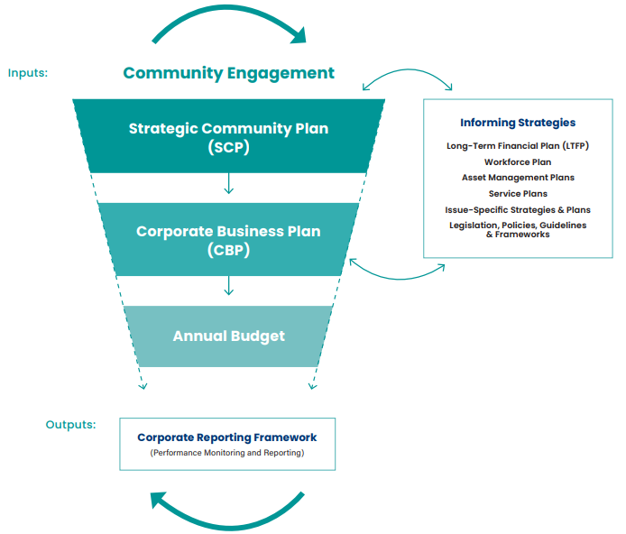
Figure 1: DLGSC IPRF Framework & Guidelines Infographic, adapted version 1

Current Status

The City is currently non-compliant with Section 5.56 of the Act and Regulations 19C and 19DA of the Administration Regulations.

The City’s Strategic Community Plan (Nedlands 2018-2028) was adopted by Council at its meeting held on 22 May 2018 and was due for major review in 2022-23.

The City does not currently have a valid Corporate Business Plan, as the previous Corporate Business Plan (2013-2017/18) was never updated in accordance with statutory review requirements.

Review of both plans and conducting a community scorecard also form part of CEO’s 2022/23 Key Result Areas and Indicators (KRAs/KPIs).

Major Review

Given the non-compliant status of the City’s Strategic Community Plan and Corporate Business Plan, CATALYSE® was appointed in December 2022 to facilitate major review of both plans. This process included facilitating extensive community consultation to identify and test contemporary community priorities to facilitate the development of a Council Plan.

The Council Plan approach aligns with local government reform recommendations and the subsequent Local Government Amendment Act 2023 (Assent Date 18 May 2023) which prescribes deletion of the Section ‘5.56 – Planning for the future’ and replacement with ‘5.56 – Council Plan’. The Council Plan approach simplifies the IPRF by combining Strategic Community Plan and Corporate Business Plan into one document (see infographic below), thus addressing the inherit overlap and duplication that often occurs between the two plans.

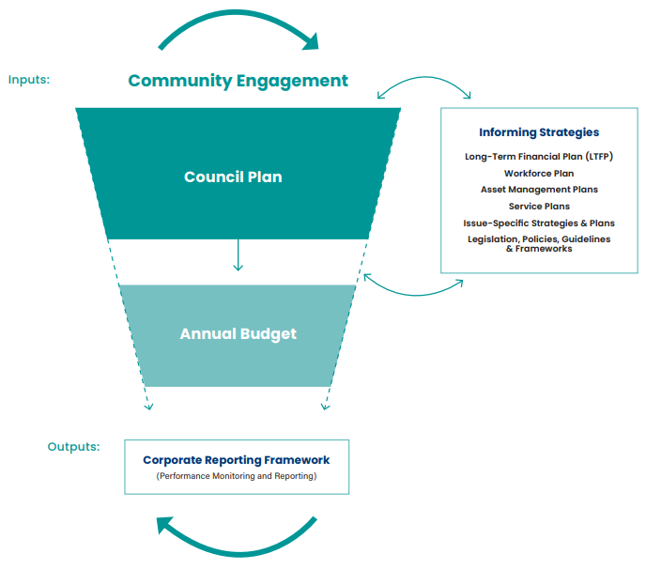
Figure 2: IPRF With Council Plan Infographic, adapted version 2
Whist the local government sector is awaiting the Assent of amended subsidiary legislation, the Department of Local Government, Sport and Cultural Industries (DLGSC) has provided support for the City to proceed with the Council Plan approach as part of the major review, provided it meets all requirements prescribed in 19C and 19DA of the Administration Regulations.

Timeline

Desktop Review

Between December 2022 and February 2023, a desktop review of the City’s IPRF and other key documents and studies was conducted. This included, but not limited to, the:

- current Strategic Community Plan
- previous Corporate Business Plan
- Long Term Financial Plan
- Asset Management Plans
- Workforce Plan
- Service Plans
- Local Planning Framework (Strategy & Scheme)
- Urban Forest Strategy
- Disability, Access and Inclusion Plan
- Strategic-Recreation-Plan-2010-2015 (draft version)
- Engagement Studies (Broadway Precinct, Waratah Village Precinct, Hampden/ Hollywood Precinct, Nedlands Foreshore, Integrated Transport etc.), and
- CEO KRAs/KPIs.

Actions from these existing plans and strategies were extracted and consolidated to form the basis of the draft Council Plan (draft outcomes, objectives and actions), as well as providing alignment and correlation with the existing strategic direction.

Community Consultation

At its meeting held on 28 February 2023, Council approved the Community Engagement Plan for the major review, including community engagement activities:

- MARKYT® Community Scorecard
- FUYTR® Planning Workshops with Council & Executive Management Team (EMT)/Managers, and
- FUYTR® Community Workshops.

The Community Engagement Plan was specifically designed to meet DLGSC IPRF Guideline – ‘Advanced Standard’ requirements to involve at least two (2) community engagement activities, to attract least 500 or 10% (whichever was fewer) of community members. It also was designed to ensure multiple ‘touch points’ with Council for its oversight as the major review and the Council Plan process is progressed.

Between 27 March and 14 April 2023, the MARKYT® Community Scorecard was sent to all residents as unaddressed mail and electronically to the City of Nedlands database customer contacts. Participation was also promoted through the City’s website and social media channels.

At close, the MARKYT® Community Scorecard attracted 1,686 community member responses and 91,364 words where the community qualitatively described their priorities and aspirations. This response exceeded the IPRF Guideline – ‘Advanced Standard’ requirement of 500 community responses and was a significant improvement in community participation from the 2016 MARKYT® Community Scorecard, which attracted 435 community responses.

At its meeting held on 27 June 2023, Council received the MARKYT® Community Scorecard Report which detailed the summary of results from the 1,686 community member responses and 91,364 words describing contemporary community priorities and aspirations. Top priority areas were:

- responsible growth and development
- planning and building approvals
- streetscapes, trees and verges
- activation of town centres/local shopping areas, and
- sustainable practices/climate change.

All results from the MARKYT® Community Scorecard were integrated and aligned to the draft Council Plan that emerged from the Desktop Review process.

Draft Council Plan outcomes, objectives and actions were presented to the Council and the EMT for consideration in FUYTR® Planning Workshops held on 9 June and 10 June 2023.

Draft Council Plan outcomes, objectives and actions were then tested with community members in four (4) FUYTR® Community Workshops held on 14 June and 22 June 2023. Community members also worked on their visions for the City of Nedlands in these workshops.

Following completion of the FUYTR® Community Workshops, the EMT aligned the draft Council Plan outcomes, objectives and actions with resourcing requirements (financials and workforce), drawing on Informing Strategies and Plans adopted by Council including the Long-Term Financial Plan, Workforce Plan, Asset Management Plans, the Annual Budget and Capital Works Program.

During this time, Service Area responsibility, timing and funding were also added to the draft Council Plan outcomes, objectives and actions, as well as all other remaining sections comprising the draft including additional operating expenditure, the capital program, service planning, and narrative and statistics.

Further Consultation with Council

Following the above processes, the draft Council Plan (for public comment) was circulated to Council on 22 August 2023, and a reminder sent on 30 August 2023, to review and provide feedback prior to its presentation at the Concept Forum held on 5 September 2023.

One submission was received during this time and was considered in the revised draft Council Plan presented at the Concept Forum.

Following the Concept Forum, Council was provided with an additional week to review and provide feedback.

Two submissions were received during this time and considered in the revised draft Council Plan.

Draft Council Plan for Public Comment

At its meeting held on 26 September 2023, Council approved a five (5) week Public Comment Period for the draft Council Plan 2023-33, to provide the community with the opportunity to comment and validate if it appropriately captures and addresses contemporary community priorities identified in the community engagement activities.

In accordance with Section 1.7 of the Act and 3A of the Administration Regulations, public notice provided as follows:

- City of Nedlands Website
- Local Newspaper – The Post
- E-newsletter – Nedlands News
- Social media – Facebook
- Direct email to Community Workshop participants, and
- City of Nedlands Intranet.

Discussion

Summary of Public Comment Period Engagement

Medium | Activity
City of Nedlands Website | - Published on 27 September 2023 on the City of Nedlands consultation webpage yourvoice.nedlands.wa.gov.au.  - Draft Council Plan downloaded 144 times.  - Page visits 244 – informed visitors 120, aware visitors 162 and engaged visitors 12.  - Published on the City website available under Corporate Documents.
Local Newspaper | - Public Notice published in The Post Newspaper on 6 October 2023.  - Section within Nedlands News published in The Post Newspaper 6 October 2023.
E-newsletter | - Nedlands News E-newsletter emailed on 6 October 2023 to 1,711 subscribers, open rate of 53.5%, 6.8% click through rate on Council Plan article.
Social Media | - Facebook post on 28 September 2023 with a reach of 254 and an engagement of 12.  - Facebook post on 13 October 2023 with a reach of 180 and an engagement of 2.
Email | - Email sent to participants of the Community Workshops on 17 October 2023. 98 subscribers, open rate 79.2% and an email click through rate of 37.5%
Intranet | - Council Plan placed on the City of Nedlands intranet site on 28 September 2023 with 63 views.

Direct Feedback Received during the Public Comment Period

At close of the Public Comment Period on 1 November 2023, 244 community members visited the Nedlands Consultation webpage – yourvoice.nedlands.wa.gov.au.

12 engaged visitor submissions were received and the City of Nedlands responses to these are provided in Attachment 1.

Final Council Plan 2023-33

In summary, the commentary was generally positive in response to the question - What did you like most the Draft Council Plan? See Attachment 1.

Furthermore, all commentary received in response to the question – Did we miss anything? Are there other things you think should be in the Council Plan? – was considered accounted for and/or acknowledged within the Draft Council Plan or existing Service Planning processes. See Attachment 1.

Therefore, the final Council Plan 2023-33 for Council adoption is provided Attachment 2.

Annual Reviews

Once endorsed by Council, the Council Plan 2023-33 will be reviewed annually and in accordance with any amended subsidiary legislation provision (upon Assent).

The annual review process will provide the Council and community the opportunity to regularly consider prioritisation, timing and funding of the Council Plan outcomes, objectives and actions so that they remain contemporary to the needs of the City of Nedlands community.

Consultation

Consultation Timeline

- Desktop Review of City of Nedlands IPRF and key documents and studies in December 2022-February 2023.
- The community via the MARKT® Community Scorecard 2023 Summary Report held in March-April 2023, the FUYTR® Community Workshops held in June 2023.
- The EMT and managers via FUYTR® Planning Workshops Workshops in June 2023 and final refining of the draft Council Plan in July and August 2023.
- The Council via FUYTR® Planning Workshop held in June 2023.
- The Council via presentation of the draft Council Plan at the Concept Forum September 2023.
- The Council via the additional feedback opportunity provided following the Concept Forum on the draft Council Plan in September 2023.
- The community via the five (5) week Public Comment Period held in September 2023-November 2023.
- The Council via presentation of the final Council Plan at the Concept Forum November 2023.

Strategic Implications

This item relates to the following elements from the City’s Strategic Community Plan.

Vision Our city will be an environmentally-sensitive, beautiful and inclusive place.

Values Healthy and Safe
Our City has clean, safe neighbourhoods where public health is protected and promoted.

Great Natural and Built Environment
We protect our enhanced, engaging community spaces, heritage, the natural environment and our biodiversity through well-planned and managed development.

High Standard of services
We have local services delivered to a high standard that take the needs of our diverse community into account.

Great Governance and Civic Leadership
We value our Council’s quality decision-making, effective and innovative leadership, transparency, accountability, equity, integrity and wise stewardship of the community’s assets and resources. We have an involved community and collaborate with others, valuing respectful debate and deliberation.

Great Communities
We enjoy places, events and facilities that bring people together. We are inclusive and connected, caring and support volunteers. We are strong for culture, arts, sport and recreation. We have protected amenity, respect our history and have strong community leadership.

Reflects Identities
We value our precinct character and charm. Our neighbourhoods are family-friendly with a strong sense of place.

Great for Business
Our City has a strong economic base with renowned Centres of Excellence and is attractive to entrepreneurs and start-ups.

Easy to Get Around
We strive for our City to be easy to get around by preferred mode of travel, whether by car, public transport, cycle or foot.

Budget/Financial Implications

In accordance with Regulations 19C and 19DA of the Administration Regulations, the Strategic Community Plan and Corporate Business Plan have a ten (10) and four (4) year planning and funding horizon, respectively.

The Council Plan 2023-33 (Strategic Community Plan and Corporate Business Plan), therefore, has 10-year and rolling planning and funding horizon. Each year the first four (4) years will be funded by the Long-Term Financial Plan, year 1 funding being the Annual Budget.

It is to be noted that some actions proposed within the Council Plan 2023-33 are subject to internal and external funding. Delivery of these actions is therefore subject to acquiring funding.

Legislative and Policy Implications

- Section 5.56 of the Local Government Act 1995 – All local governments are required to plan for the future of their local government area.
- Regulation 19C and 19DA of the Local Government (Administration) Regulations 1996 – Prescribes how Section 5.56, through adoption of a Strategic Community Plan and Corporate Business Plan, is achieved.
- Section 68 of the Local Government Amendment Act 2023 – Prescribes amendment of the Local Government Act 1995 by deleting Section ‘5.56 – Planning for the future’ and replacement with ‘5.56 – Council Plan’.
- Council Policy Community Engagement – All community engagement and consultation will be carried out in accordance this policy.
- Section 1.7 of the Local Government Act 1995 – Requirements for providing local public notice.
- Regulation 3A of the Local Government (Administration) Regulations 1996 – Prescribes how Section 1.7 local public notice must be provided.

Decision Implications

If Council approves the Officer’s Recommendation, the Council Plan 2023-33 will become active. This will finalise the major review process and achieve statutory compliance in accordance with Section 5.56 of the Local Government Act 1995 and Regulation 19C and 19DA of the Local Government (Administration) Regulations 1996.

If Council does not approve the Officer’s Recommendation, major review of the Strategic Community Plan and Corporate Business Plan and further development of the Council Plan 2023-33 will be further delayed, and the City of Nedlands will remain non-compliant with statutory obligations until such time the major review process is finalised.

Conclusion

It is proposed that Council approve the City of Nedlands Council Plan 2023-33 (Strategic Community Plan and Corporate Business Plan) (Attachment 2), to achieve statutory compliance and provide the strategic direction to the City of Nedlands’ service and project delivery to the community.

Further Information
Nil.

Council Members Notice of Motions of Which Previous Notice Has Been Given
This item will be dealt with at the Ordinary Council Meeting.

Urgent Business Approved By the Presiding Member or By Decision
This item will be dealt with at the Ordinary Council Meeting.

Confidential Items
Confidential items to be discussed at this point.
Nil.

Declaration of Closure
There being no further business, the Presiding Member will declare the meeting closed.

