AGENDA

Council Meeting Agenda Forum

8 August 2023

Notice of Meeting

To Mayor & Councillors

A Council Meeting Agenda Forum of the City of Nedlands is to be held on Tuesday 8 August 2023 in the Council chambers at 71 Stirling Highway Nedlands commencing at 6pm.

This meeting will be livestreamed Livestreaming Council & Committee Meetings » City of Nedlands


Bill Parker
Chief Executive Officer
3 August 2023
Information

Council Meeting Agenda Forum are run in accordance with the City of Nedlands Governance Framework Policy. If you have any questions in relation to the agenda, procedural matters, addressing the Council or attending these meetings please contact the Executive Officer on 9273 3500 or council@nedlands.wa.gov.au

Public Question Time

Public Questions are dealt with at the Ordinary Council Meeting.

Deputations

Members of the public may make presentations or ask questions on items contained within the agenda. Presentations are limited to 5 minutes. Members of the public must complete the online registration form available on the City’s website: Public Address Registration Form | City of Nedlands

Disclaimer

Members of the public who attend Council Meetings Agenda Forum should not act immediately on anything they hear at the meetings, without first seeking clarification of Council’s position. For example, by reference to the confirmed Minutes of Council meeting. Members of the public are also advised to wait for written advice from the Council prior to taking action on any matter that they may have before Council.

Any plans or documents in agendas and minutes may be subject to copyright. The express permission of the copyright owner must be obtained before copying any copyright material.

Table of Contents

1. Declaration of Opening 4
2. Present and Apologies and Leave of Absence (Previously Approved) 4
3. Public Question Time 4
4. Deputations 4
5. Requests for Leave of Absence 4
6. Petitions 4
7. Disclosures of Financial Interest 4
8. Disclosures of Interests Affecting Impartiality 5
9. Declarations by Members That They Have Not Given Due Consideration to Papers 5
10. Confirmation of Minutes 5
11. Announcements of the Presiding Member without discussion 5
12. Members Announcements without discussion 5
13. Matters for Which the Meeting May Be Closed 6
14. En Bloc Items 6
15. Minutes of Council Committees and Administrative Liaison Working Groups 6
15.1 Minutes of the following Committee Meetings (in date order) are to be received: 6
16. Divisional Reports - Planning & Development Report No’s PD37.08.23 to PD40.08.23 7
16.1 PD37.08.23 – Adoption for advertising – Local Planning Policy 7.1 - Public Open Space Contributions and Local Planning Strategy Amendments 7
16.2 PD38.08.23 – Adoption for Advertising of Draft Local Planning Policy 3.3 – Sustainable Design - Residential 16
16.3 PD39.08.23 – Adoption of Amendments to Local Planning Policy 7.1 – Exempt Development 22
16.4 PD40.08.23 – Amendments to Local Planning Policy 1.2 – Removal of Occupancy Restrictions 27
17. Divisional Reports - Technical Services Report No’s TS09.08.23 to TS10.08.23 32
17.1 TS09.08.23 – Shirley Fyfe Gazebo – Waratah Avenue, Dalkeith 32
17.2 TS10.08.23 – Tawarri Car Park Drainage Improvement 44
18. Divisional Reports - Community Services & Development Report No’s CSD05.08.23 to CSD06.08.23 50
18.1 CSD05.08.23 – Club Night Light Application – College Park Lower Oval Sports Floodlighting 50
18.2 CSD06.08.23 – Age-Friendly Nedlands Working Group Terms of Reference 56
19. Divisional Reports - Corporate Services Report No’s CPS34.08.23 to CPS37.08.23 60
19.1 CPS34.08.23 – Monthly Financial Report – June 2023 60
19.2 CPS35.08.23 – Monthly Financial Report – July 2023 60
19.3 CPS36.08.23 – Monthly Investment Report – July 2023 60
19.4 CPS37.08.23 – List of Accounts Paid – July 2023 60
20. Reports by the Chief Executive Officer CEO20.08.23 61
20.1 CEO20.08.23 - Register of Outstanding Resolutions 61
21. Council Members Notice of Motions of Which Previous Notice Has Been Given 64
22. Urgent Business Approved By the Presiding Member or By Decision 64
23. Confidential Items 64
24. Declaration of Closure 64

Declaration of Opening

The Presiding Member will declare the meeting open at 6.00 pm and will draw attention to the disclaimer on page 2 and advised the meeting is being livestreamed.

Present and Apologies and Leave of Absence (Previously Approved)

Leave of Absence Councillor B G Hodsdon Hollywood Ward
(Previously Approved)

Apologies None as at distribution of this agenda.

Public Question Time

Public questions will be dealt with at the Ordinary Council Meeting.

Deputations

Deputations by members of the public who have completed Public Address Registration Forms.

Requests for Leave of Absence

Any requests from Council Members for leave of absence will be dealt with at the Ordinary Council Meeting.

Petitions

Petitions will be dealt with at the Ordinary Council Meeting.

Disclosures of Financial Interest

The Presiding Member to remind Council Members and Staff of the requirements of Section 5.65 of the Local Government Act to disclose any interest during the meeting when the matter is discussed.

A declaration under this section requires that the nature of the interest must be disclosed. Consequently, a member who has made a declaration must not preside, participate in, or be present during any discussion or decision-making procedure relating to the matter the subject of the declaration.

However, other members may allow participation of the declarant if the member further discloses the extent of the interest. Any such declarant who wishes to participate in the meeting on the matter, shall leave the meeting, after making their declaration and request to participate, while other members consider and decide upon whether the interest is trivial or insignificant or is common to a significant number of electors or ratepayers.

Disclosures of Interests Affecting Impartiality

The Presiding Member to remind Council Members and Staff of the requirements of Council’s Code of Conduct in accordance with Section 5.103 of the Local Government Act.

Council Members and staff are required, in addition to declaring any financial interests to declare any interest that may affect their impartiality in considering a matter. This declaration does not restrict any right to participate in or be present during the decision-making procedure.

The following pro forma declaration is provided to assist in making the disclosure.

"With regard to the matter in item x ….. I disclose that I have an association with the applicant (or person seeking a decision). This association is ….. (nature of the interest).

As a consequence, there may be a perception that my impartiality on the matter may be affected. I declare that I will consider this matter on its merits and vote accordingly."

The member or employee is encouraged to disclose the nature of the association.

Declarations by Members That They Have Not Given Due Consideration to Papers

This item will be dealt with at the Ordinary Council Meeting.

Confirmation of Minutes

This item will be dealt with at the Ordinary Council Meeting.

Announcements of the Presiding Member without discussion

This item will be dealt with at the Ordinary Council Meeting.

Members Announcements without discussion

This item will be dealt with at the Ordinary Council Meeting.

Matters for Which the Meeting May Be Closed

For the convenience of the public, the following Confidential items are identified to be discussed behind closed doors, as the last items of business at this meeting.

Nil.

En Bloc Items

This item will be dealt with at the Ordinary Council Meeting.

Minutes of Council Committees and Administrative Liaison Working Groups

Minutes of the following Committee Meetings (in date order) are to be received:

This is an information item only to receive the minutes of the various meetings held by the Council appointed Committees (N.B. This should not be confused with Council resolving to accept the recommendations of a particular Committee. Committee recommendations that require Council’s approval should be presented to Council for resolution via the relevant departmental reports).

This item will be dealt with at the Ordinary Council Meeting.

Divisional Reports - Planning & Development Report No’s PD37.08.23 to PD40.08.23

PD37.08.23 – Adoption for advertising – Local Planning Policy 7.1 - Public Open Space Contributions and Local Planning Strategy Amendments

Meeting & Date | Council – 22 August 2023
Applicant | City of Nedlands
Employee Disclosure under section 5.70 Local Government Act 1995 | The author, reviewers and authoriser of this report declare they have no financial or impartiality interest in this matter.  There is no financial or personal relationship between City staff involved in the preparation of this report and the proponents or their consultants.
Report Author | Roy Winslow – Manager Urban Planning
Director | Tony Free – Director Planning and Development
Attachments | - Draft Local Planning Policy 7.7: Public Open Space Contributions  - Draft Amendments to the Local Planning Strategy (Excerpts)

Purpose

This report is being presented to Council for adoption to commence advertising the draft Local Planning Policy 7.7: Public Open Space Contributions (the Policy) and amendments to the City of Nedlands Local Planning Strategy (LPS). The Western Australian Planning Commission (WAPC) has advised that for the public open space contributions to be approved the relevant information is to be incorporated into the LPS, which what is reflected in this report. The proposal is not nor is it recommended that the LPS in its entirety be updated.

Recommendation

That Council:

- amends the City of Nedlands Local Planning Strategy as shown in Attachment 2;

- refers the Local Planning Strategy amendments to the Western Australian Planning Commission in accordance with regulation 12 of the Planning and Development (Local Planning Schemes) Regulations 2015;

- upon receipt of the Commission’s confirmation to advertise, advertises the amendments to the Local Planning Strategy in accordance with regulation 13 of the Planning and Development (Local Planning Schemes) Regulations 2015 for a period of not less than 21 days;

- adopts the draft Local Planning Policy 7.7: Public Open Space Contributions (Attachment 2) for the purposes of advertising in accordance with Clause 4 of the Deemed Provisions of Schedule 2 of the Planning and Development (Local Planning Schemes) Regulations 2015; and

- advertises the Local Planning Policy 7.7: Public Open Space Contributions concurrently with the Local Planning Strategy amendments for 21 days in accordance with the City of Nedlands Local Planning Policy – Consultation of Planning Proposals.

Voting Requirement

Simple Majority.

Background

At the 27 October 2020 Ordinary Council Meeting, Council resolved to commence the preparation of an Infrastructure Contributions Framework, and allocated funds to allow for this work.

At the 22 March 2022 OCM, Council considered a Community Benefits and Infrastructure Contributions research project (Item 16.5). It was resolved in part that Council:

- selects the Cash-in-lieu of land for Public Open Space developer contribution model, with effect as follows:

- For all affected developments (i.e. 6 lots/units or more) with a building permit issued on or before 30 June 2022, no contribution for public open space will be requested at the time of subdivision;

- For all affected developments (i.e. 6 lots/units or more) that have a building permit issued between 1 July 2022 and 30 September 2022, 50% of the normal public open space contribution, as calculated in accordance with the Planning and Development Act 2005 will be requested at the time of subdivision; and

- For all affected developments (i.e. 6 lots/units or more) that have a building permit issued on or after 1 October 2022, 100% of the normal public open space contribution, as calculated in accordance with the Planning and Development Act 2005 will be required at the time of subdivision; and

- supports the development of a Public Open Space Strategy and associated Local Planning Policy.

The public open space (POS) strategy work has been carried out and is discussed below.

The Western Australian Planning Commission’s (WAPC) Development Control Policy 2.3 – Public Open Space in Residential Areas (DC2.3) sets out the following contribution criteria:

- 10% of the gross subdivisible value for creation of 6 lots or more is to be ceded to the local government for public open space.
- Where the land is too small to be practical for use as POS, or not in a suitable location for the local government, a cash-in-lieu contribution of 10% may be accepted.

On 9 June 2023, the WAPC released a draft revision of DC2.3 that proposed the following changes:

- For infill areas, a maximum 5% cash-in-lieu contribution may be collected.
- The draft DC2.3 implies, but does not specifically state, that contributions may be collected on creation of 3 lots or more.

The 5% contribution maximum may be increased, and extended to development creating 3 lots or more, with the approval of the WAPC through the amendment of the LPS.

Discussion

Any expenditure of POS cash-in-lieu funds must be directly related to the use or development of land for POS purposes.

Research on the amount, type and distribution of existing POS and its capacity to accommodate envisaged population growth has been carried out. This background research includes information on any POS shortfalls and the amount attributable to dwelling and population growth. The work has been compiled into a draft Policy (Attachment 1) and amendments to the LPS (Attachment 2).

The LPS amendment provides the rationale for the POS contribution criteria and broadly sets out where and on what the contributions are proposed to be spent. Importantly, any attempts to spend the contributions must be approved by the Minister for Planning beforehand as part of a separate process and must be consistent with the LPS. Creating LPS amendments that have a strong foundation in evidence-based reasoning will strengthen the City’s position relating to future investment in POS.

The Policy provides a statutory basis for collection of funds and sets out criteria that the City uses to determine whether a land contribution or cash-in-lieu contribution is preferable.

As per the draft DC2.3, in order to request a contribution exceeding 5%, the Local Planning Strategy must be amended to include the specified percentage of POS that the local government intends to collect from each subdivision as well as the number of lots to which the contribution will apply. These amendments then must be endorsed by the WAPC before they can take effect.

Amendment to the LPS

The amendment:

- includes a review of the City’s expected future population growth and how it correlates with the existing public open space provision;
- maps out existing public open space assets and audits them based on their level of amenity;
- identifies general locations where future public open space will be required based on anticipated population density;
- estimates the cost of such upgrades and land acquisitions against the expected population growth to arrive at an amount of funds needed in the long-term; and
- uses the cost estimate along with the population estimate to come to a cash-in-lieu figure of 7% of the open space for new developments that create three or more lots. The cash will be used to purchase land for public open space and upgrade/develop public open space.

The monetary contributions are the direct result of the population increase due to densification and will be used to improve POS in the locality.

The LPS amendment broadly describes that a number of local, neighbourhood and district parks will need to be upgraded to accommodate the future population. It also identifies that a high percentage of residential lots are not within the recommended 400m catchment area of a local park, and many are not in the 400m catchment area of any park (see Figure 1 below). To that end, a key recommendation is that 11 new parks be created to alleviate this shortfall and fill identified gaps.

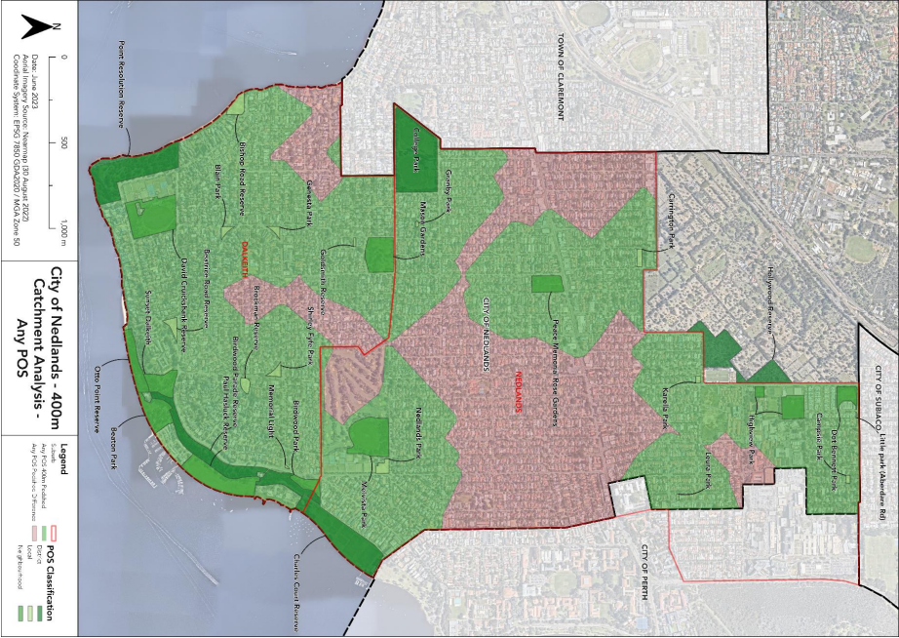
Figure 1: Areas in red are not within a walkable catchment of 400m of any public open space.

The Policy

The Policy encodes the contribution structure into a formal framework and is based on the LPS amendments. The draft Policy proposes that a POS contribution of land equal to 10% of the lot value be provided for each development proposing the creation of 3 dwellings or more. This contribution is reduced to 7% where cash-in-lieu of POS is provided. The reduction provides an incentive to developers to provide cash in lieu rather than land, as land contributions may result in a number of small pocket parks within each developer’s lot that have little utility to the wider community.

The Policy also reflects the City’s above resolution on a reduction in the amount of contribution required based on issue date of a building permit for creation of 6 lots or more. It is reasonable to carry this expectation forward to demonstrate that the City is consistent in decision-making. It is also a fair approach to developers that are already a long way into the building process and have costed their development based on past City resolutions and existing legislation.

For similar reasons, the Policy exempts or reduces development contributions for creation of 3 to 5 lots as follows:

- where a building permit has been issued or a subdivision application received from the WAPC by 31 March 2024, no POS contribution is requested;
- where a building permit has been issued or a subdivision application received from the WAPC between 1 April 2024 and 31 July 2024, a 50% reduction in the POS contribution (ie: 3.5%) is requested; and
- where a building permit has been issued or a subdivision application received from the WAPC on or after 1 August 2024, 100% of the POS contribution (ie: 7%) is requested.

It is noted that WAPC approval is required to implement POS contributions on 3 to 5 lots, so the above dates in the Policy may need to be amended depending on when or if WAPC approval is received.

Contribution criteria

Given the public attention around this issue, some version of the draft DC2.3 that reduces the 10% cash-in-lieu contribution in infill areas such as Nedlands is likely to be approved by the Department of Planning, Lands and Heritage in the near to midterm. The LPS amendment includes a strong argument for why cash-in-lieu contributions should be 7% in the City of Nedlands. Should the WAPC approve the proposed amendments, the City would be able to require a cash-in-lieu contribution of 7% on creation of 3 lots or more rather than 5% on creation of 6 lots or more.

The City will retain the option to require a 10% public open space land contribution in locations where a public open space shortfall has been identified. Reducing the cash-in-lieu levy will incentivise development to provide cash for upgrading and procurement of new public open space rather than ceding land. Ceding of land has the potential to create small pocket parks that do not serve community needs and are not located in areas with an identified public open space shortfall.

The LPS amendment has been researched in-depth to provide a strong basis for the 7% rate and a reduction in the lot creation threshold to 3 lots or more. The expected contributions will allow the City to procure and upgrade open space commensurate with the increased density. Because the ability to spend funds is limited to only those upgrades that can be linked to the increase in population (ie: it excludes standard maintenance and general replacement of assets), accruing substantial additional funds will be of little benefit to the City. Setting a cash-in-lieu threshold beyond this amount will have limited rationale should a decision be appealed.

Consultation

Should Council adopt the Policy and LPS amendments for advertising, they will be advertised for not less than 21 days.

Following the Concept Forum of 18 July reference has been incorporated into the LPS to foreshore areas the need to ensure that these areas remain useable and accessible to the community, notwithstanding the threat of sea level rise. The LPS also acknowledges that regional parks serve a large catchment area and contain sporting, recreational and environmental opportunities beyond that of local parks, and thus it is reasonable to factor identified costs with such parks notwithstanding them being located in other suburbs within the City of Nedlands.

Strategic Implications

This item relates to the following elements from the City’s Strategic Community Plan.

Vision Our city will be an environmentally-sensitive, beautiful and inclusive place.

Values Great Natural and Built Environment
We protect our enhanced, engaging community spaces, heritage, the natural environment and our biodiversity through well-planned and managed development.

High standard of services
We have local services delivered to a high standard that take the needs of our diverse community into account.

Great Communities
We enjoy places, events and facilities that bring people together. We are inclusive and connected, caring and support volunteers. We are strong for culture, arts, sport and recreation. We have protected amenity, respect our history and have strong community leadership.

Priority Area

- Urban form - protecting our quality living environment
- Renewal of community infrastructure such as roads, footpaths, community and sports facilities

Budget/Financial Implications

The LPS amendment includes some assumptions on development takeup, density and land values to arrive at a figure of almost $64 million in developer contributions to the City by the year 2050. This figure can be broken down as follows:

$42.48 million Purchase of 11 new parks (averaging 1,816 sqm per park)
$4 million Upgrading of new parks after purchase
$9.7 million Sports and Recreation Facilities on existing public open space
$6.2 million Upgrades to 31 existing parks
$1.5 million Converting drainage sumps to parks

As per the Planning and Development Act 2005 and DC2.3, such money can only be spent on certain items related to public open space and only with approval of the Minister for Planning. The figures above are based on what City Officers believe can reasonably be paid for with cash-in-lieu funds.

Legislative and Policy Implications

The Planning and Development Act 2005 provides the head of power for local governments to require a public open space or cash in lieu contribution for new development of not less than 3 lots. The Western Australian Planning Commission’s Development Control Policy 2.3: Public Open Space in Residential Areas and the draft DC2.3 allows the Commission to impose a public open space contribution on 3 lots or more where the local government has identified an existing or potential deficiency of public open space and has an adopted strategy to improve or provide open space by land acquisition in the locality of the subdivision.

Clause 3(1) of the Deemed Provisions of Schedule 2 of the Planning and Development (Local Planning Schemes) Regulations 2015 allows the City to prepare a local planning policy in respect to any matter related to the planning and development of the Scheme area.

Decision Implications

Council may resolve to:

- Proceed with the Policy and amendments to the Local Planning Strategy without modification; or
- Proceed with the Policy and amendments to the Local Planning Strategy with modification; or
- Not to proceed with the Policy and amendments to the Local Planning Strategy.

If Council resolves to proceed with or without modification, the amendments to the Local Planning Strategy will be referred to the Commission for review. Following that, the Policy and amendments to the Local Planning Strategy will be advertised for 21 days before being referred back to Council for a final recommendation.

If Council resolves not to proceed, the Policy and amendments to the Local Planning Strategy will not be adopted and the City will have a legislative deficiency for enforcement of public open space contributions. The contribution rates and lot creation thresholds will default to those in DC 2.3. Without the necessary legislative framework such contributions will be more difficult to require and spend, as well as more open to appeal.

Conclusion

The draft DC2.3 sets out a 5% cash-in-lieu public open space contribution for subdivisions creating 6 lots or more. The City’s proposal seeks to amend this to be a 7% contribution for subdivisions creating 3 lots or more. Before the City can enforce this proposal, the WAPC will need to endorse the proposal through approval of the proposed amendments to the Local Planning Strategy.

It is recommended that Council adopt for advertising the Draft Local Planning Policy 7.7: Public Open Space Contributions and the amendments to the Local Planning Strategy.

Further Information

Nil.

PD38.08.23 – Adoption for Advertising of Draft Local Planning Policy 3.3 – Sustainable Design - Residential

Meeting & Date | Council Meeting – 22 August 2023
Applicant | City of Nedlands
Employee Disclosure under section 5.70 Local Government Act 1995 | The author, reviewers and authoriser of this report declare they have no financial or impartiality interest with this matter.
Report Author | Roy Winslow – Manager Urban Planning
Director | Tony Free – Director Planning & Development
Attachments | - Draft Local Planning Policy – Sustainable Design - Residential

Purpose

The purpose of this report is for Council to adopt for advertising the draft Local Planning Policy 3.3: Sustainable Design - Residential (the Policy).

Recommendation

That Council:

- adopts the draft Local Planning Policy 3.3: Sustainable Design - Residential (Attachment 1) for the purpose of advertising in accordance with Clause 4 of the Deemed Provisions of Schedule 2 of the Planning and Development (Local Planning Schemes) Regulations 2015; and

- notes that the advertising period will be for a minimum of 21 days.

Voting Requirement

Simple Majority.

Background

At its meeting on 23 November 2021 Council resolved:

That the Chief Executive Officer:

- prepares a report for Council’s consideration that details:

  - The existing and proposed energy efficiency provisions for residential and mixed-use development under the Residential Design Codes Volume 1 and 2.
  - The various planning instruments that are available to Council to reduce non-renewable energy use via development approvals.

The recently adopted precinct policies contain some sustainability criteria. However, the criteria only affected certain types of development and targeted the specific precincts. The draft Policy aims to address energy efficiency across the City. It is intended that the sustainability criteria within the existing precinct policies will be relocated to this draft Policy.

Discussion

Existing energy efficiency provisions

The current planning framework at the City as it relates to residential development is split into three documents:

- The Residential Design Codes (R-Codes) Volume 1 (Parts B and C);
- The R-Codes Volume 2; and
- Local Planning Policies (LPPs).

Volume 1 of the R-Codes is the assessment tool for all single houses and grouped dwellings, and (as of 1 September 2023) all development on land zoned less than R60. The R-Codes coming into effect in September 2023 further splits Volume 1 into Parts B and C. Part B contains the current version of the R-Codes, but modified such that they only apply to development on land coded R25 and below. Part C introduces new criteria for medium density development on land coded R30 to R60 (for multiple dwellings) and land coded R30 and above (for single houses and grouped dwellings).

Volume 1 has no existing or proposed criteria that directly addresses energy efficiency. Indirectly, Volume 1 does address concepts of energy efficient design such as identifying the importance of north facing living areas, and (in Part C) sufficient openings to allow for sunlight and ventilation, but these are not directly linked to specific deemed-to-comply sustainability criteria.

Volume 2 of the R-Codes is the assessment tool for development of apartments (multiple dwellings) on land zoned greater than R60. This volume of the R-Codes has significant assessment criteria for energy efficiency, adaptive reuse, water management, waste management and focuses more on the siting and location of apartment dwellings for energy efficiency and cross ventilation. Volume 2 provides a pathway for apartments to exceed the minimum Nationwide Housing Energy Rating Scheme (NatHERS) requirements for all dwellings by 0.5 of a star or provide energy efficient initiatives such as PV systems for communal services and solar powered lighting to external spaces. However, the other energy efficiency initiatives set out in the Design Guidance of Volume 2 as options for achieving the Objectives are relatively minor.

Some of the City’s existing planning policies address energy efficiency by way of requiring additional insulation and providing for siting and layout of development. However, these criteria are outdated and only apply to select neighbourhoods within the City. It is proposed that the draft Policy collect the best practice of energy efficiency and locate it in one policy that applies for the whole of the City.

Draft Policy

A copy of the Policy is attached (Attachment 1). WAPC approval for a policy is only required if a policy alters the R-Codes. Advice from the Western Australian Planning Commission (WAPC) is that they will not support energy efficiency criteria that goes beyond the R-Codes or the National Construction Codes. The Policy has therefore been crafted in a manner that will not require WAPC approval, as it does not alter any existing R-Codes criteria.

A summary of the requirements is provided below and applies to new development only, not additions to existing development.

Single houses

Single houses are to have a minimum 3kw solar panel system and water fixtures within 1 star of the WELS maximum. These requirements increase energy and water efficiency with minimal cost to a build. Additionally, over the life of the development, the criteria will result in savings that far outweigh the initial expenditure. The initial expenditure for 3kw solar panels is between $2900 - $5600.

It is noted that advice from the WAPC is that a local planning policy that adds criteria not currently covered by the R-Codes cannot be used on a development that is deemed-to-comply. In other words, if a house meets all the deemed-to-comply criteria of the R-Codes, this Policy cannot be used as a reason to deny planning approval. However, where a design principle assessment is sought, this Policy can be applied.

Grouped dwellings

Grouped dwellings are to achieve the same criteria as single houses, along with additional criteria that the landscaping plan demonstrate waterwise principles and heat-tolerant plants, and that the development be fitted to allow provision of vehicle charging. Any additional cost implications on developments of these requirements are considered to be minor.

Multiple dwellings (Volume 1)

Volume 1 of the R-Code covers lots with densities of R60 and below and any multiple dwelling developments within these lots tend to consist of few units. The Policy sets out a list of specific and reasonable criteria that are to be adhered to. These criteria improve the development without imposing an undue burden.

For small multiple dwelling developments (less than ten), proponents will be required to demonstrate that their development reduces the heat island effect through colour and landscaping choices, includes the use of low flow taps, waterwise landscaping, and provision to allow electric vehicle charging in the parking bays. They are also to select any two additional measures from within the Table in the Policy. Costing for these mandatory criteria is expected to be minimal.
Larger developments of 10 units or more will be required to select an additional measure from the Table. The cost implications will vary depending on which measure is proposed.

Multiple dwellings (Volume 2)

The criteria for larger developments are based on the criteria within the Green Star Building Code. Green Star is an internationally recognized sustainability rating system for the built environment. It is a national, voluntary rating system that covers many aspects of sustainable design and has become a best practice benchmark. Green Star provides a list of criteria that may apply and it operates on a points-based system. Only buildings that achieve 4 stars and above through the official certification process can claim they are Green Star buildings.

Green Star is the accepted industry standard. The consensus in the design community is that an uncertified Green Star design is unreliable and insufficient to ensure that the design actually meets the star rating that the proponent has selected. Designs must be certified through the Green Star building process to ensure that they achieve their designated rating. However, the certification process is expensive and is not financially viable for projects under $15 million.

For that reason, a Table within the Policy is provided that includes selected aspects of the Green Star Building Code. The City will rely on this Table to set out criteria for smaller developments. These criteria can be verified in-house by City Officers as part of the Planning and Building processes without requiring these smaller developments to go through the expensive formal certification process.

The sustainability guidance within the Policy includes the criterion that developments above $15 million are to go through the formal certification process for a minimum 5-star Green Star.

Of note for development in relation to Volume 2 of the R-Codes. The Policy does not change the Element Objectives of the R-Codes. Ultimately, a proponent may opt to achieve the Element Objectives in a different manner than meeting the Green Star criteria or the suggested design guidance within the Table of the Policy. All proposals will be assessed by City Officers against the Acceptable Outcomes of the R-Codes.

Further, Volume 2 of the R-Codes includes provision for Energy Efficiency. As noted above, in order to avoid having to seek WAPC approval, the proposed Volume 2 criteria has been worded to state that these criteria are the City’s preferred outcome, without attempting to make them required.

Consultation

Consultation on the Policy will take place should Council adopt it for advertising.

Following the Concept Forum of 20 July, officers have sought where possible provide an indication of the cost implications of the Policy within this report. The Policy has also been modified to ensure that roofs also act as solar collectors are not penalised.
Strategic Implications

This item relates to the following elements from the City’s Strategic Community Plan.

Vision Our city will be an environmentally-sensitive, beautiful and inclusive place.

Values Healthy and Safe
Our City has clean, safe neighbourhoods where public health is protected and promoted.

Great Natural and Built Environment
We protect our enhanced, engaging community spaces, heritage, the natural environment and our biodiversity through well-planned and managed development.

Priority Area Encouraging sustainable building

Budget/Financial Implications

Nil.

Legislative and Policy Implications

Clause 3(1) of the Deemed Provisions of Schedule 2 of the Planning and Development (Local Planning Schemes) Regulations 2015 allows the City to prepare a Local Planning Policy in respect to any matter related to the planning and development of the Scheme area. Once Council resolves to prepare a Local Planning Policy, in accordance with Clause 4 of the Deemed Provisions it must publish a notice of the proposed policy for a period of not less than 21 days and seek submissions.

Following the advertising period, the Policy will be presented back to Council to consider any submissions received and to:

- Proceed with the Policy without modification;
- Proceed with the policy with modification; or
- No proceed with the policy.

Decision Implications

If Council resolves to adopt the Policy for advertising, it will be advertised in accordance with the process outlined above.

If Council resolves not to endorse the recommendation, the Policy will not be advertised or progressed.
Conclusion

It is recommended that Council adopt the draft Local Planning Policy 3.3: Sustainable Design - Residential for advertising.

Further Information

Nil.

PD39.08.23 – Adoption of Amendments to Local Planning Policy 7.1 – Exempt Development

Meeting & Date | Council Meeting – 22 August 2023
Applicant | City of Nedlands
Employee Disclosure under section 5.70 Local Government Act 1995 | The author, reviewers and authoriser of this report declare they have no financial or impartiality interest with this matter.
Report Author | Roy Winslow – Manager Urban Planning
Director | Tony Free – Director Planning & Development
Attachments | - Draft amended Local Planning Policy – Exempt Development  - Part 7 of the Deemed Provisions for Local Planning Schemes

Purpose

Council’s consideration is requested in regard to draft amendments to Local Planning Policy 7.1: Exempt Development (LPP 7.1). The review is being conducted as part of the City’s periodical review of Local Planning Policies. The changes proposed to LPP 7.1 are being made to bring the policy into consistency with current legislation, consistency with other local planning policies, and in response to a resolution by Council to explore additional exemptions.

Recommendation

That Council:

- determines that the draft amended Local Planning Policy – Exempt Development, as set out in attachment 1 is a minor amendment and does not require consultation in accordance with the Planning and Development (Local Planning Schemes) Regulations 2015 Schedule 2 Part 2 Clause 5(2); and

- proceeds to adopt the draft amended Local Planning Policy – Exempt Development, as set out in attachment 1, in accordance with the Planning and Development (Local Planning Schemes) Regulations 2015 Schedule 2, Part 2, Clause 5.

Voting Requirement

Simple Majority.

Background

The Local Planning Policy 7.1: Exempt Development (LPP 7.1) was adopted by Council on 2 May 2019 and, as a result of the 2020 amendments to the Planning and Development (Local Planning Schemes) Regulations 2015 (the Regulations), the policy was reviewed on 27 April 2021.

The policy was originally designed to provide exemptions for a range of small residential projects. This continued in the 2021 review which only removed uses from the policy as they were covered by the 2021 amendments to the Regulations. On 27 April 2021 Council carried the following motion to:

“request the CEO to undertake a further review of the Exempt Development Policy injunction with the Planning Regulations and Local Planning Scheme No 3, in order to identify other opportunities to exempt further uses or development from the need to obtain planning approval, with the outcomes reported to Council.”

The review of LPP 7.1 has taken place with the above resolution in mind, as well as the introduction of the new R-Codes in September 2023.

The policy has provided benefit to the City’s landowners, occupiers and staff by reducing red tape around minor development. The policy identifies development beyond that exempted by the Regulations and specifies the criteria to be met for a development to not require a development application.

This review of the policy actions Council’s resolution by proposing an increased list of exempt uses.

Discussion

LPP 7.1 has provided benefits to landowners, developers and to the City by reducing red-tape and the need to unnecessarily assess minor development that has no negative impact on surrounds. The layout has also been revised to mirror that within the Regulations for consistency.

Importantly, LPP7.2 does not exempt works that are contrary to State Planning Policies, the Local Planning Scheme, Local Planning Policies, Local Development Plans, Structure Plans, heritage protection criteria, or any planning conditions imposed on a development. A list of the new exemptions and explanation for each is as follows:

- Minor development
- The Minor development exemption assists officers to provide an exemption to landowners where a proposal may not fit any other exemption category, but the development is of such a low impact to a site and the surrounding area that any development approval for such a proposal would be a minor matter. An example of developments assessed by the City that could have been exempted by such an exemption is:

- A proposal for the widening of a door and addition of a non street-facing window on a commercial building. There were no impacts to any adjoining properties.

- Mural
  - The addition of Mural to the exemption list further removes barriers to public art. Mural is to be exempt in all zones with conditions to ensure Murals are not exempt where located in a heritage-protected place, where they feature profanities, offensive content or depictions of illegal material or acts, or where they contain advertising material.

- Outdoor Hard Surface
  - The proposed exemption for outdoor hard surface allows for the construction of pathways and paved surfaces in all zones without development approval. The exemption does not allow for unrestricted paving in all locations on a lot. The conditions of the exemption make this explicit by protecting soft landscaping and deep soil areas. The exemption must also comply with conditions to be located behind the primary street setback area.

- Painting
  - The exemption allows for painting of buildings in all zones.

- Roof replacement
  - Roof replacement is exempt subject to there being no change to roof form or pitch. This exemption allows for a replacement of roof sheets, tiles or other material provided they are consistent with any criteria in any other legislative framework. The exemption applies to heritage-protected places only where the replacement is like-for-like.

- Temporary works
  - The exemption for temporary works allows works to be in place for up to fourteen days in any twelve-month period.

- Wall cladding replacement
  - The exemption allows for changes to be made to the cladding of walls where the works do not involve structural changes and the materials and colours are as specified in any relevant local planning policy.

- Works to heritage-protected places
  - The landowners of heritage-protected places do not benefit from some of the other exemptions given the potential to detrimentally affect heritage places without a proper assessment of the impacts. However, a number of common, internal works are allowed that will not detrimentally impact the heritage significance of the place. It is expected that this exemption will assist landowners in preventing their heritage-protected places from falling into disrepair and disuse.

The review has also resulted in the removal of satellite dishes from the list of exemptions. The City has not received enquiries in recent years relating to the exemption for ground mounted and non-ground mounted satellites on non-residential properties. There is little evidence to suggest that this exemption has provided a benefit to landowners and the City’s planning staff. It is also suggested that the role of satellites are reduced somewhat due to the rise of streaming services and greater internet use for communications.

Maintenance has been removed from the exemption policy as this is already an exempt use under Clause 61 of the Deemed Provisions of the Planning and Development (Local Planning Schemes) Regulations 2015. Painting has been separated from maintenance and is included in the exemption table.

Consultation

The Planning and Development (Local Planning Schemes) regulations 2015 Schedule 2 Part 2 Clause 5(2) states “Despite subclause (1), the local government may make an amendment to a local planning policy without advertising the amendment if, in the opinion of the local government, the amendment is a minor amendment.”

Given there are only minor changes to how the policy operates, the increased exemptions are less restrictive on landowners and the policy does not seek to modify state planning policies, it is recommended that Council resolve that the proposed amended policy is a minor amendment, and that consultation is not necessary.

From the Concept Forum of 18 July, modifications have been made to the conditions which allow for hard paving to be exempt from needing approval. The policy now states that hard paving is not exempt if the requirements of soft landscaping and deep soil provision are not going to be satisfied as a result. It is acknowledged that 10 square metre garden sheds are exempt from both planning and building approval.

Strategic Implications

This item relates to the following elements from the City’s Strategic Community Plan.

Vision Our city will be an environmentally-sensitive, beautiful and inclusive place.

Values Great Natural and Built Environment
We protect our enhanced, engaging community spaces, heritage, the natural environment and our biodiversity through well-planned and managed development.

Great Governance and Civic Leadership
We value our Council’s quality decision-making, effective and innovative leadership, transparency, equity, integrity and wise stewardship of the community’s assets and resources. We have an involved community and collaborate with others, valuing respectful debate and deliberation.

Priority Area Urban form - protecting our quality living environment

Budget/Financial Implications

Nil.

Legislative and Policy Implications

Clause 5(2) of the Deemed Provisions of Schedule 2 of the Planning and Development (Local Planning Schemes) Regulations 2015 allows the City to amend a Local Planning Policy in respect to any matter related to the planning and development of the Scheme area without advertising if the local government is of the opinion that the amendment is minor.

Decision Implications

If Council resolves to endorse the recommendation without modifications, the policy will come into effect.

If Council resolves to endorse the recommendation with modifications, the policy will be amended to include the modifications and may or may not need to be advertised depending on whether the changes greatly modify the policy.

If Council resolves not to support the recommendation, the existing Policy will remain in use by the City.

Conclusion

The amendments to LPP 7.1 address Council’s resolution to explore further exemptions and makes the policy easier to read and use while reducing red-tape.

It is recommended that Council determine that the amended Local Planning Policy 7.1: Exempt Development is a minor amendment not requiring consultation and adopt the policy in accordance with the Planning and Development (Local Planning Schemes) Regulations 2015 Schedule 2 Part 2 Clause 5.

Further Information

Nil.

PD40.08.23 – Amendments to Local Planning Policy 1.2 – Removal of Occupancy Restrictions

Meeting & Date | Council Meeting – 22 August 2023
Applicant | City of Nedlands
Employee Disclosure under section 5.70 Local Government Act 1995 | The author, reviewers and authoriser of this report declare they have no financial or impartiality interest with this matter.
Report Author | Roy Winslow – Manager Urban Planning
Director | Tony Free – Director Planning & Development
Attachments | - Draft amended Local Planning Policy – Removal of Occupancy Restrictions

Purpose

Council’s consideration is requested in regard to draft amendments to Local Planning Policy: Removal of Occupancy Restrictions (LPP 1.2). The review is being conducted as part of the City’s periodical review of Local Planning Policies. The changes proposed to LPP 1.2 include removing the occupancy restrictions and specifying that removal of the Over 55’s caveat will only be supported where the lot meets the minimum and average site area within the Residential Design Codes (R-Codes).

Recommendation

That Council:

- adopts the draft amendments to Local Planning Policy 1.2: Removal of Occupancy Restrictions (Attachment 1) for the purpose of advertising in accordance with Clause 5 of the Deemed Provisions of Schedule 2 of the Planning and Development (Local Planning Schemes) Regulations 2015; and

- notes that the advertising period will be for a minimum of 21 days.

Voting Requirement

Simple Majority

Background

LPP1.2 was presented to Council on 24 March 2020 where the policy was adopted for advertising. At the close of advertising, no comments had been received. LPP1.2 was adopted by Council on 28 July 2020.
The policy was prepared after LPS3 had come into effect and responded to various requests from landowners received in the 2000s and 2010s for removal of occupancy restrictions on their properties.

The policy states that “all properties restricted to Aged and Dependent Persons (over 55’s) Dwellings through the provision of an Additional Use and associated Development Approval issued under Town Planning Scheme 2 (TPS2) shall no longer be required to maintain this occupancy restriction under Local Planning Scheme 3 (LPS3).”

It is estimated that there are at least 29 lots (each lot includes two or more dwellings) in the City that had an additional use granted under TPS 2 for aged and dependent dwellings. Some properties may have a restriction without being recorded as having an additional use under TPS 2. Of the 29 known properties that have had restrictions, it is estimated from the City’s records that seven (7) of these lots have received approval for their occupancy restrictions to be removed.

Discussion

New Layout and Formatting

The revised policy has been rearranged into a table format like other newly adopted Local Planning Policies for consistency and clarity.

Requirement for Dwellings to be Consistent with Site Area Per Dwelling and Parking Requirements.

Adoption of the policy has resulted in some properties being able to subdivide without restrictions into new lots that do not meet the minimum or average site area requirements of the R-Codes.

The reviewed policy includes a new requirement for dwellings to meet the site area per dwelling and car parking criteria of the R-Codes before removal of the occupancy restriction can be considered. Both requirements apply to Aged and Dependent Dwellings but only the parking requirement applies to Ancillary Dwellings.

The Aged and Dependent Dwellings affected by the policy were developed as a result of development bonuses provided to landowners who restricted the properties to occupancy by aged and dependent persons. The development bonus was a site area per dwelling requirement which required less site area per dwelling than the density code of the site at the time. In other words, it allowed a landowner to build a second house on a lot where they would not ordinarily be allowed to build one on the proviso that it be for the use of an aged or dependent person. This promoted ageing in place and dwelling size diversity within the City.

Removing the occupancy restrictions on properties that do not meet the site area per dwelling requirements results in unrestricted dwellings on land that are undersized for their density code. The current LPP in force does not contain protection against this outcome and currently allows landowners to effectively increase the density of the area.
In addition, Local Government does not have the discretion to vary the site area per dwelling requirements as the density codes for lots are determined by the scheme and require WAPC approval to change. The current LPP is contrary to the R-Codes and therefore of questionable enforcement. The proposed amended LPP seeks to rectify these issues by only allowing the removal of occupancy restrictions where a lot size would be consistent with the current density code of a subject lot.

Ancillary dwellings, on the other hand, have already been considered as smaller houses subservient to the main house. Removal of the occupancy restrictions on ancillary dwellings is more a technical matter because those restrictions were removed from the R-Codes some time ago. This change aligns with the current R-Codes.

Consultation

The Planning and Development (Local Planning Schemes) Regulations 2015 Schedule 2 Part 2 Clause 5(2) state “Despite subclause (1), the local government may make an amendment to a local planning policy without advertising the amendment if, in the opinion of the local government, the amendment is a minor amendment.”

The City is of the opinion that there is sufficient change in the draft LPP1.2 that the amendment should not be considered minor. Consultation on the Policy will take place should Council adopt it for advertising.

At the Concept Forum of 18 July, the question of previous consultation and community feedback was raised. As outlined in the Background section of this report, no comments were received during the consultation process of 2020, however the City had received requests to allow the removal of the caveats in the years prior to the introduction of LPS3.

Strategic Implications

This item relates to the following elements from the City’s Strategic Community Plan.

Vision Our city will be an environmentally-sensitive, beautiful and inclusive place.

Values Great Natural and Built Environment
We protect our enhanced, engaging community spaces, heritage, the natural environment and our biodiversity through well-planned and managed development.

Great Governance and Civic Leadership
We value our Council’s quality decision-making, effective and innovative leadership, transparency, equity, integrity and wise stewardship of the community’s assets and resources. We have an involved community and collaborate with others, valuing respectful debate and deliberation.

Priority Area Urban form - protecting our quality living environment

Budget/Financial Implications

Nil.

Legislative and Policy Implications

Clause 3(1) of the Deemed Provisions of Schedule 2 of the Planning and Development (Local Planning Schemes) Regulations 2015 allows the City to prepare a Local Planning Policy in respect to any matter related to the planning and development of the Scheme area. Adopted Local Planning Policies can be amended in accordance with Clause 5 of the Deemed Provisions. Where the amendment is not a minor amendment, the Local Government must publish a notice of the proposed policy for a period of not less than 21 days and seek submissions.

Following the advertising period, the Policy will be presented back to Council to consider any submissions received and to:

- Proceed with the Policy without modification;
- Proceed with the policy with modification; or
- Not proceed with the policy.

Decision Implications

If Council resolves to endorse the recommendation without modifications, the policy will come into effect.

If Council resolves to endorse the recommendation with modifications, the policy will be amended to include the modifications and may or may not need to be advertised depending on whether the changes greatly modify the policy. If Council seeks to make modification to the R-Codes or another State Planning Policy through this policy, the policy may need to be referred to the Western Australian Planning Commission for a decision.

If Council resolves not to support the recommendation, the existing Policy will remain in use by the City.

Conclusion

The proposed amended policy is an improvement which ensures consistency with the R-Codes and improves formatting.

It is recommended that Council adopt the draft amended Local Planning Policy 1.2: Removal of Occupancy Restrictions for the purpose of advertising.

Further Information

Nil.

Divisional Reports - Technical Services Report No’s TS09.08.23 to TS10.08.23

TS09.08.23 – Shirley Fyfe Gazebo – Waratah Avenue, Dalkeith

Meeting & Date | Council Meeting – 25 July 2023
Applicant | City of Nedlands
Employee Disclosure under section 5.70 Local Government Act 1995 | Employee disclosure required where there is an interest in any matter of which the employee is providing advice or a report.
Report Author | Daniel Kennedy-Stiff - Manager City Projects & Programs
CEO | Matthew MacPherson – Director Technical Services
Attachments | - Shirley Fyfe Park Gazebo Structural report  - CONFIDENTIAL - Contractor Pricing Proposal

Purpose

To address a Council Resolution arising from the ordinary council meeting held May 2023 – Report and Protection of Tram Stop Rotunda, this report seeks to inform Council of potential options for the long-term future of the Tram stop / Gazebo (the Gazebo) at Shirley Fyfe Park, Waratah Avenue, Dalkeith WA 6009.

Recommendation

The Council request the CEO to:

- capture heritage information regarding the dilapidated gazebo for future record; and

- remove the gazebo at Shirley Fyfe Park and reinstate the turf area.

Voting Requirement

Simple Majority.

Background

History of the Site:

The Gazebo is a historic bus stop, shaped as an octagonal timber framed shelter, on the corner of Waratah Avenue and Wavell Road.

It has aesthetic, historic, social and cultural heritage value which is mentioned in the City of Nedlands Municipal Inventory 2013 which indicated that:

- The construction of the gazebo was between World War I and World War II.
- The gazebo has also been utilised as a polling booth during past elections, with this it has aesthetic, historic, social, and cultural heritage values.
- There is a bus stop nearby and it is possible this structure is used for shelter by patrons on occasion.

Maintenance History
In February/ March 2018, The City of Nedlands was scheduled to refurbish the historic bus stop at Shirley Fyfe Reserve, Waratah Avenue, Dalkeith.

The works were undertaken by a contractor and included the below listed scope items Works were completed in mid-April 2018.

- Roof Works – Pressure clean of the roof, replacing of eight roof tiles with similar design and sealing of the roof.
- Seating – Removed timber slats, prepared seat brackets, refix slats with new bolts and add 12 new slats.
- Cladding and framework – Expose timber for inspections and paint, replace 30m2 of cladding and associated members.
- Painting – Paint all exposed timberwork internally and externally, paint timber slats and paint rafter ends.
- Total cost of refurbishment $12,214.12

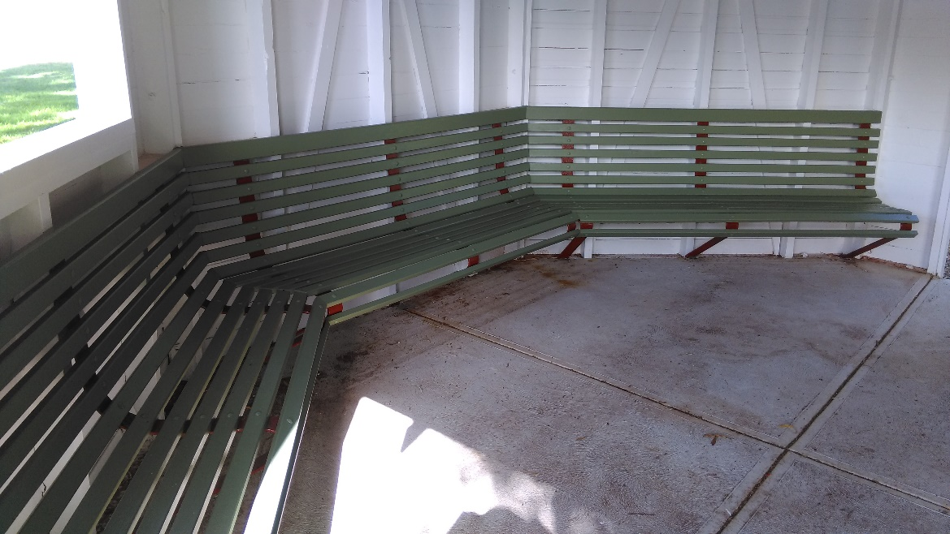
Figure 1: Internal refurbishment - April 2018

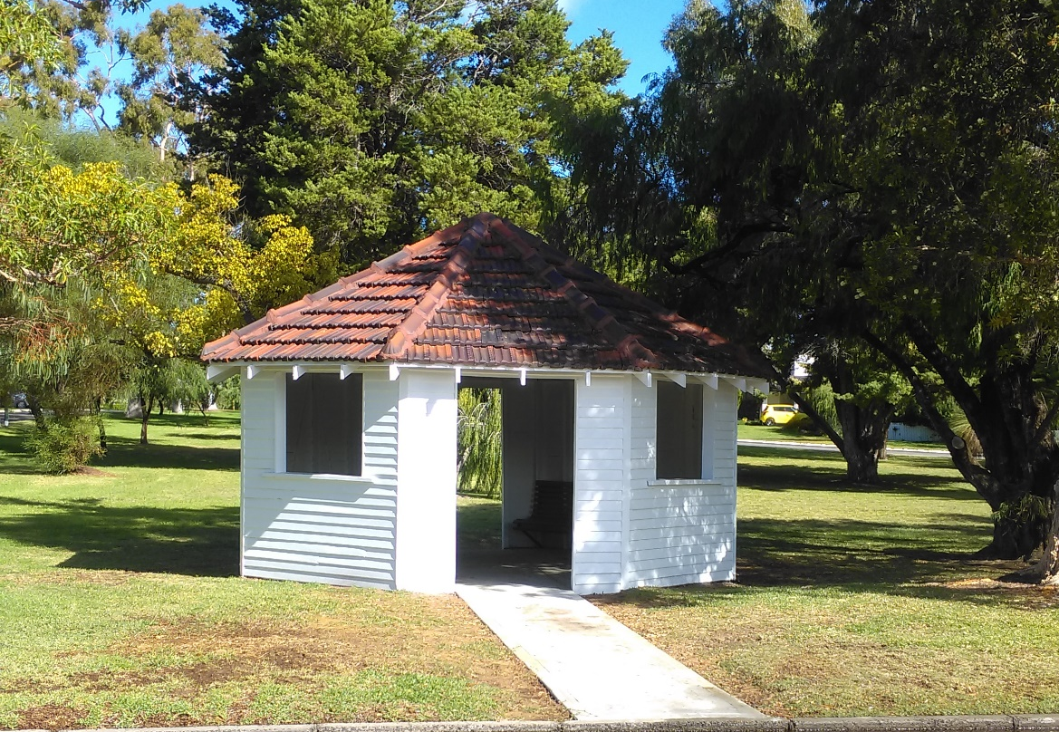
Figure 2: External refurbishment - April 2018

It should be noted that the majority of the scope of work is for cosmetic enhancements and there is little attention given to structural changes to increase its useful longevity.

Current Condition

In early 2023, the City of Nedlands commissioned a structural engineering firm to review and report on the current condition of the Gazebo (Attachment 1 refers). The overall condition of the Gazebo was rated as very poor. Major damage has been caused to structural wall elements by moisture and termites. There is significant, visible damage to a number of lower structural members and the cladding of the Gazebo and termite damage has weakened the structure causing the frame to shift out of alignment.

The roof structure is in good condition relative to the lower structure elements. Some rafters are splitting and cracking, and the battens generally are in poor condition. The tiles are in reasonable condition and are likely to be the only truly salvageable element – however matching tiles into the future are likely be increasingly hard to source.

The vertical members, including door and window framing elements, as well as corner posts and cover panels appear to be the main vertical members damaged by termites. The wall cladding has also been damaged by termites, with further damage accelerated by moisture from irrigation and rain.

The Concrete slab/ foundation of the structure appears in good condition, although soil and grass on the North side of the structure has built up above the slab level and around the direct buried members. This prevents the weather step from achieving its purpose of keeping the timber structure out of the ground and water. This has led the structure to become more damaged.

Findings from this report are as follows:

The City engaged the services of a structural engineering firm, Atelier JV (AJV), to undertake a structural assessment of the Gazebo. This assessment (attachment 1 refers) found that the structural damage present is too extensive for retention, as well as highlighting the likelihood of further damage present in the wall panel corner cavities. AJV recommend that the Gazebo requires deconstruction and rebuilding on the existing slab structure.

The Structural assessment makes the following recommendations:

- Roof tiles and rafters can be retained and re-used for reconstruction where possible (roof timbers are to be inspected by a qualified professional for presence of pests).
- Roof fixings are significantly corroded and require replacement.
- Roof battens appear significantly weathered and therefore require replacement.
- Wall cladding is very damaged by water and pests and will require replacement.
- Timber stud and wall elements are to be fully replaced to prevent the possible retention of pest-ridden timbers being re-introduced to the new structure.
- The surrounding park area and trees to be inspected for timber attacking pests.
- The park irrigation system be reviewed to minimise spray onto the structure.
- the soil and grass level adjacent the shelter be brought down to below the slab level to allow a sufficient weather step to protect the future structure.
- A certified pest barrier or protection method shall be installed to suit the new structure and deter future pest damage.

Given the current poor condition of the structure the City of Nedlands is required to make a decision regarding its long-term future.

At the Ordinary Council Meeting of May 2023, a notice of motion was put which resolved the following:

“That the CEO is directed to provide a report with 3 quotes to Council by June OCM to repair the rotunda in Shirley Fyfe Park, and to protect it from further damage immediately, and to consider it for listing on the City of Nedlands Heritage inventory.”

CARRIED 6/5

Discussion

The following has been undertaken in an effort to address the Council Resolution:

Obtaining Quotations:

On the assumption that the aim of the project is to retain as much of the heritage value as possible, the City initially approached the following:

- 6 local contractors that advertise in the local community newspaper.
- 2 previous City contractors.

With the intent to obtain a priced proposal to return the structure toward its original condition. Feedback from approached businesses is as follows:

Contractor I
Response by advising they do not do restorations, but happy to design and build a new gazebo if required in future.

Contractor II
Spoke to owner who advised that he is currently semi-retired and will be fully retired in the next two months and will not be taking on new projects.

Contractor III
Communication received and condition report emailed through as requested from contractor. Follow up email sent Friday 2 June 2023 to organise a meet and greet to go through a quote, no response received.

Contractor IV
Communication received and condition report emailed through as requested from contractor. Follow up email sent Friday 2 June 2023 to organise a meet and greet to go through a quote. Contractor responded they currently have COVID and has put all work on hold until he receives a negative result. Will contact when available. No response to date.

Contractor V
Email sent through, no response back from Contractor. Follow up email sent through Monday 12 June 2023. No response to date.

Contractor VI
Could only enquire through their website enquiry from online. Enquired on Wednesday, 7 June 2023, no response received.

Contractor VII
Response received as they are well placed to carry out the works, they are not a licensed builder. Provided a rough estimate quote based on the scope of the work will be come in over $20k. Also gave timeline to commence works would be after February 2024.

Contractor VIII
Contractor contacted and their response: after inspecting the site, advised the Gazebo is structurally damaged beyond repair, it’s visually clear all structural components on this Gazebo are damaged beyond repair. We advise no personnel is to enter this area.

In discussion with an Elected Member, an additional contractor’s details were provided to the City, who works locally and was familiar with the structure that may be able to accommodate the required works.

A subsequent site meeting occurred with the City and the contractor on Monday 19th June 2023 at 1:30pm. The Contractor (Contractor IX) was provided with a copy of the structural report and subsequently provided a price proposal on Sunday 25th June 2023 (Attachment 2 refers - Confidential).

The Contractor indicated in their correspondence:

- Concern over the lean of the structure and recommended that the City engage a structural engineer to review and design future bracing to prevent leaning at a later date.
- Install a temporary prop under the apex of the gazebo until works can begin.
- Work can begin on the Gazebo in seven weeks with the direct costs being approximately $60,000 inc. GST.

As such, despite efforts to obtain three quotations from nearly ten potential providers, the City was unable to source three within a reasonable time frame.

Protection of the Structure:

Since late 2022 the City has undertaken the following to protect the structure whilst a long-term decision is made:

- Termite Treatment completed 5 January 2023.
- Fencing and Hoarding has been installed to prevent access.

Based on recent discussions with contractors, it was proposed to prop the roof structure to ease the burden on the walls. Whilst arranging this, however, the City’s electrician has declined to remove a light in the apex of the roof due to the current compromised condition being a potential work health and safety risk.

Similar concerns are likely to be raised by any company undertaking propping and thus engaging a suitable provider may prove difficult. Further, this highlights a risk to the City and any engagement with a contractor to undertake repairs must also demonstrate effective measures are in place to the safety of their employees and community.

Potential long-term options:

At present there are four options for Council to consider pursuing:
- Replacement / repair like for like.
- Remove and not replace.
- Remove and replace with fit-for purpose, ‘off the shelf’ structure, including heritage aspects.
- Design of a new structure improving on material durability and including heritage aspects.

Summary of these are provided below, with all costs outlined in the Financial Implications section of this report:

OPTION 1: Replacement / repair like for like.
Summary | The Gazebo would be surveyed and re-designed/drawn to a more modern standard where required but re-built as a heritage style structure in all other regards. This would return the structure to an all, but ‘as-new’ state and the look would be similar to the 2018 re-furbished outcome as seen in Figure 2 herein. Fifteen year costs = $190,950
Positives |  | Negatives
- Retains all heritage aspects save for modern enhancements for longevity.  - Is familiar and likely to be generally well received by the community.  - Can provide incidental benefit of shelter to nearby park and bus users. |  | - Relatively costly compared to off the shelf products.  - Initial flaws of passive surveillance and enclosed nature will be retained.  - Materials, namely tiles, will become increasingly hard to source.  - Materials used will have the same weaknesses of the initial structure.  - No guarantee of the funding and long-term management to avoid history repeating.
Comments | A re-built structure is an attractive addition to the local area, but there is little support to justify significant spend on an asset for which the use and benefit beyond the heritage values can be warranted over and above other assets which are reaching the end of their useful life and are more in demand by the community for regular usage. As such this is not the recommended option.

OPTION 2: Remove and not replace
Summary | The Gazebo would be decommissioned and de-constructed with certain elements / materials and photographs retained to be included into a historic record for potential future presentation. Fifteen year costs = $9,600
Positives |  | Negatives
- Decreases the cost of the asset to zero.  - Allows funding to be directed to other assets for the community. |  | - Retains only fragments of historic record.  - Does not provide incidental shelter use in the same location.  - Community generally do not favour reduction in assets / services.
Comments | Since the fencing of the location in February 2023, there has been little demand for its use or concern at its current state until it was highlighted from a heritage perspective. Therefore, there is little evidence for the need of a structure of any type in the nearby area, and any retention would be for heritage only – something the City has received limited feedback in regard to the gazebo being closed. In an effort to balance limited funds to where it best services the community, Council may wish to consider this as a regrettable loss in favour of higher quality retention elsewhere. This is not the recommended option.

OPTION 3: Remove and replace with an ‘off the shelf’ gazebo with additional heritage elements
Summary | The Gazebo would be decommissioned and de-constructed. Certain elements which can be retained. A new ‘off the shelf’ Gazebo can be installed providing the bones of a re-built gazebo to which heritage elements could be added to, to give acknowledgement to the previous form. This could be by potentially using salvaged cladding, which was replaced in 2018, introducing new cladding and copying the historic colour palette of white and orange. Interpretive history signage with past photos and presenting previous materials can be installed alongside the new structure – which is not uncommon with older buildings that fall beyond repair or not fit for purpose and need of significant renovation. Fifteen year costs = $88,800
Positives |  | Negatives
- Easy to source and install quickly.  - Scale-able to budget in terms of element inclusions.  - Still retains heritage elements.  - Increased longevity of modern materials and replacement parts.  - Least whole of life cost for any replacement option.  - Structure / incidental usage still available to the community.  - Can be relocated nearby and re-oriented for better passive surveillance and community use. |  | - Retains fragments of historic record and overall aesthetic but not the structure itself  - Cost still would be at the expense of other assets which are subject to greater demand and use.
Comments | With such a significant asset backlog, the City should treat every full replacement in a similar manner to a new asset. This includes ensuring the asset meets demand but is provided in a way that is sustainable long term. By their bespoke nature and age, heritage structures and buildings, are more difficult and costly to maintain. Council would be best served in ensuring assets provide the services for which they are intended for the best value possible. That said, history is important to the City and the community and this option goes some way to acknowledge history in a modern way. On the balance of these considerations, this option is the recommended option.

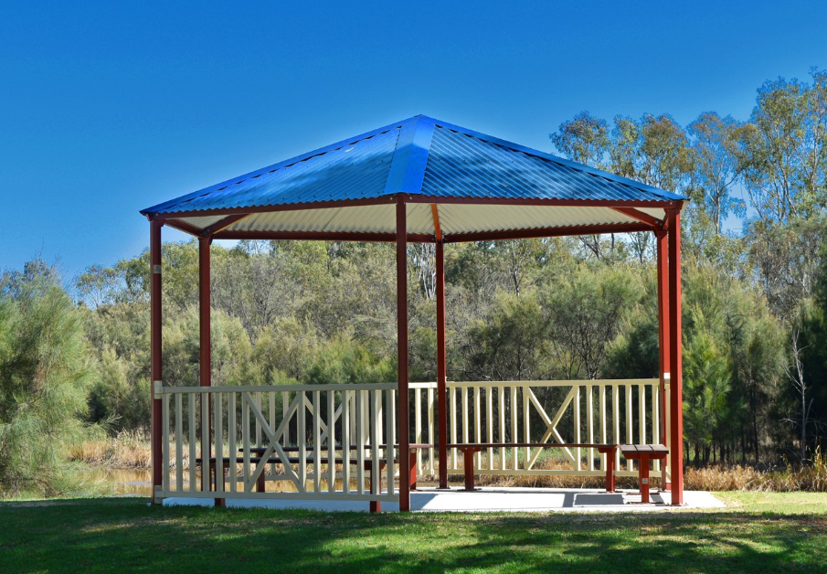
Figure 3: 'Brookdale' prefabricated shelter from Exteria – potential base structure for Option 3
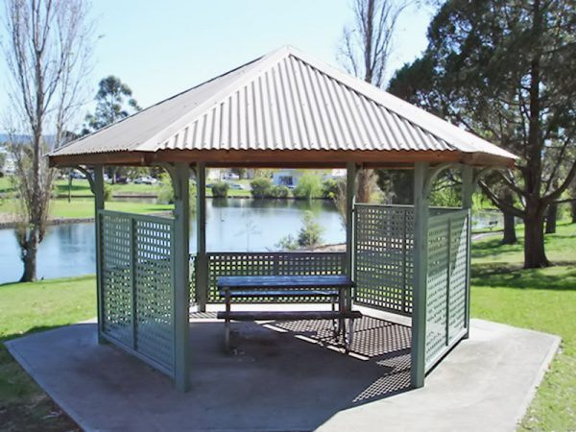 | 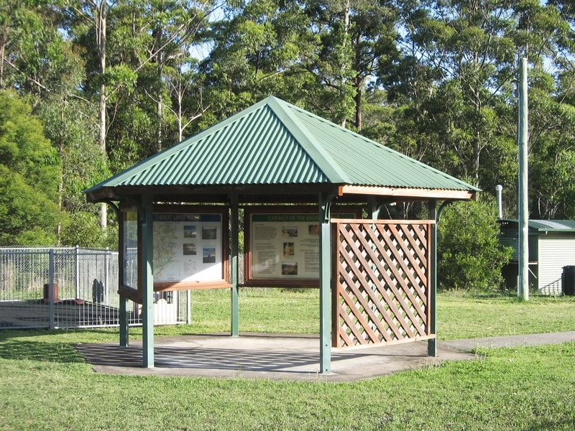
Figure 4 & 5: 'Goulburn’ prefabricated shelter from Landmark – potential base structure for Option 3 demonstrating custom cladding arrangements

OPTION 4: Remove and completely re-design a new structure with all modern materials
Summary | The Gazebo would be decommissioned and de-constructed. A new custom gazebo would be designed and built to 2023 standards and materials. It would be painted in a similar colour scheme to the 2018 refurbishment. Fifteen year costs = $154,800
Positives |  | Negatives
- Still retains heritage elements.  - Increased longevity of modern materials and replacement parts.  - Structure / incidental usage still available to the community.  - Can be relocated nearby and re-oriented for better passive surveillance and community use. |  | - Retains fragments of historic record and overall aesthetic but not the structure itself.  - Cost still would be at the expense of other assets which are subject to greater demand and use.  - Will take time to design and certify, tender and build from custom parts.  - Likely significant capital costs relative to other options.
Comments | This option creates a number of benefits from other options, at a slightly greater cost. It is the officer’s opinion however that such an option does not go significantly beyond the benefit provided in Option 3. As the Gazebo is a traditional, octagonal shape, readymade alternatives which can be added to would be better value than a modernization which may have been favoured if the original structure was of an architectural design. This is not the recommended option.

Consultation

No consultation has occurred with regard to this report and decision.

It is worth noting an interested resident has contacted City of Nedlands as she had read in the local newspaper that the City of Nedlands were demolishing the heritage structure. The resident offered to restore the Gazebo and relocate it to their property down south at no cost to the City.

Strategic Implications

Vision Our city will be an environmentally sensitive, beautiful and inclusive place.

Values Healthy and Safe
Our City has clean, safe neighborhoods where public health is protected and promoted.

Great Natural and Built Environment
We protect our enhanced, engaging community spaces, heritage, the natural environment and our biodiversity through well-planned and managed development.

High standard of services
We have local services delivered to a high standard that take the needs of our diverse community into account.

Reflects Identities
We value our precinct character and charm. Our neighborhoods are family-friendly with a strong sense of place.

Easy to Get Around
We strive for our City to be easy to get around by preferred mode of travel, whether by car, public transport, cycle or foot.

Priority Area

- Renewal of community infrastructure such as roads, footpaths, community and sports facilities
- Retaining remnant bushland and cultural heritage

Budget/Financial Implications

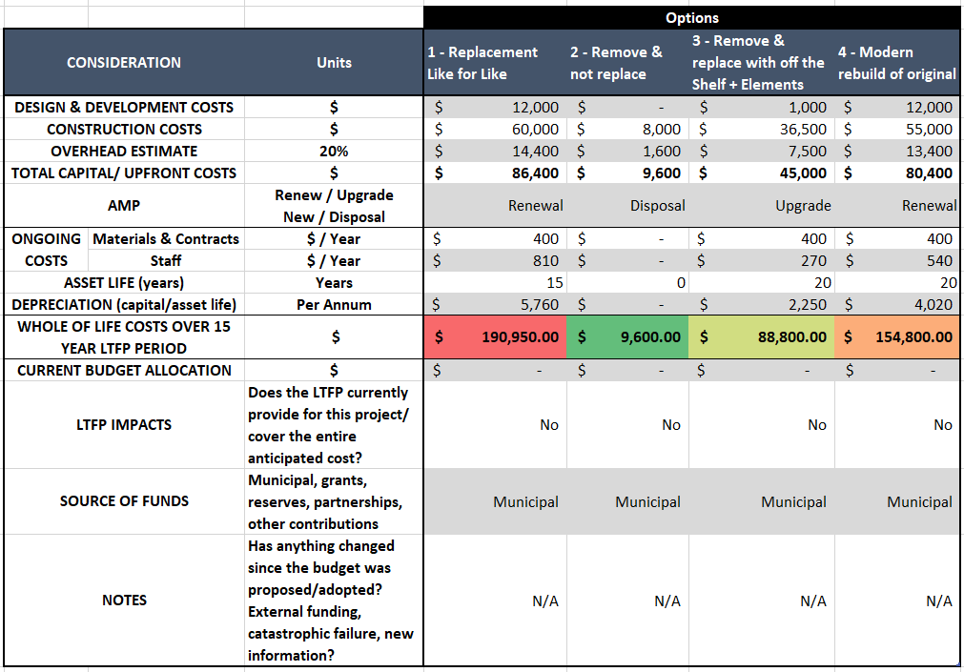
The long-term financial implications for the options presented are tabled below:
Legislative and Policy Implications

Depending on the decision of Council, the City officers may be required to undertake a procurement process in line with the Council’s Procurement Policy. This will add delay to undertaking any works whilst this occurs, unless Council determine that these works can occur outside the policy and process. As the works are unlikely to go beyond the tender requirements, the Council’s policy is the determining document.

Decision Implications

The decision of Council in respect to the structure will have implications on either financial requirements or local heritage, which will be determined based on the preferred option.

Conclusion

Four options provided regarding the repair/ restructure/ new design to be built of the Shirley Fyfe Tram Stop Rotunda/ Gazebo due to the poor condition and state of the structure, Administration has attempted to source contractors to refurbish the structure. Due to limited interest, and concern over the current state, this has proven difficult.

As such, Administration is requesting that Council consider the options presented herein, with the recommendation for Option 2.

Alternatively, Council may wish to retain a structure in this location, should this be the case, option 3 seeks to strikes a balance between the asset being provided, linking to the past, modern materials and is financially prudent;

Council may propose an alternative resolution being:

- Include in the 2023-24 financial year budget an allocation of $45,000 to remove and replace the gazebo at Shirley Fyfe Park with prefabricated structure and additional heritage elements; and

- Capture heritage information regarding the dilapidated gazebo for future record.

Further Information

Nil.

TS10.08.23 – Tawarri Car Park Drainage Improvement

Meeting & Date | Council - 22 August 2023
Applicant | City of Nedlands
Employee Disclosure under section 5.70 Local Government Act 1995 | Nil.
Report Author | Bhavesh Bhavsar – Assets Engineer
Director | Matthew MacPherson – Director Technical Services
Attachments | - Option 1 - Wetland Bio-Retention Basin  - Option 2 - Stream Bio-Swale  - Option 3 - Central Wetland Bio-Retention Basin  - Option 4 - Repurpose Parking to Landscape Area  - Option 5 – Raising Carpark & Roadway

Purpose

The purpose of this report is to provide a response to the September 27, 2022, Council Resolution (22.3) on presenting probable solutions to resolve flooding at the Tawarri car park. This report has several options for Council to consider including concept drawings, design specifications, cost estimates, and information on the benefits and drawbacks.

Recommendation

That Council:

- adopt Option 5 as the preferred long-term treatment for stormwater at the Tawarri Carpark; and

- request the CEO to work toward this treatment option in conjunction with the development works associated with the Tawarri Hot Springs development.

Voting Requirement

Simple Majority.

Background

At the 27 September 2022 Ordinary Council Meeting, Council resolved to “Request the CEO to present a report to Council at the December Ordinary Council Meeting detailing solutions to the flooding in the Tawarri car park including increased soakwell capacity at the current location, additional soakwells, raising the roadway, or any other solutions.”
The Administration presented a report to Council at the 13 December 2022 Ordinary Council Meeting detailing the probable cause(s) and contributing factors to the drainage issues at the Tawarri car park and provided probable solutions to resolve this flooding. A comparison between the proposed solutions were presented taking into consideration the complexity of work, magnitude of cost, the benefits and drawbacks for Council consideration.

The Administration proposed three options considering interim to long-term implications and requested further investigation be conducted to determine the most effective solution. The proposed options by the Administration were:

Option 1: Raising of roadway from the Tawarri Car Park to the Perth Flying Squadron Yacht Club entry.

Option 2: Provision of stormwater collection, treatment, and disposal to the Swan River.

Option 3: Do nothing and maintain the current status quo.

At the 13 December 2022 Ordinary Council Meeting, Council resolved to:

“That Council request the CEO to further investigate the suitability of the proposed options and present a report to Council at the April 2023 Ordinary Council Meeting detailing preferred options, concept designs, and estimated costs. Options are to include consideration of a reed bed, living stream and other solutions to filter the runoff and that only in extreme events the stormwater is discharged into the Swan River.”

The Administration engaged a hydrology consultant and presented two feasible concept solutions with high-level cost estimates, benefits and drawbacks at the May 30, 2023. Council Briefing session. The presented options were as follows:

Option 1: Wetland/Bio-Retention Basin to lawned area southeast of car park (see attachment 1).

Option 2 - Stream/Bio-Swale with water treatment and river discharge (see attachment 2).

At this briefing, Council requested the Administration to investigate the feasibility of two additional options:

Option 3: Wetland/bio-retention basin to the central parking area.

Option 4: Converting a southeast portion of the existing parking area to wetland area and allow overland flow for natural infiltration.

Discussion

The Tawarri car park provides additional access to the Beaton Park for community recreational activity including Jo Wheatley All Abilities Play Space. It provides a dedicated bus parking bay and 26 car parking bays. This car parking space is suitable considering the traffic and parking requirements, however, improvement in the design and provision of drainage infrastructure is required, with due consideration to the proximity to the Swan River and high-water table throughout the year.

The Administration with the hydrologic consultant has prepared four proposed solution options, including concept sketches, design requirements, specifications, indicative magnitude of cost, and anticipated advantages and disadvantages. Given that all proposed solutions are within the river protection zone, formalised designs and submission for approval to the Department of Biodiversity, Conservation, and Attractions (DBCA) will be required.

The options for Council consideration are as follows:

Option 1 – Wetland / Bio-Retention Basin (refer to Attachment 1)

Regrading a portion of the car parking to enable overland flow to additional drainage infrastructure and a newly created wetland area for natural infiltration of stormwater. The intended wetland area proposes retention of the current natural vegetation with additional planting of further vegetation to provide shade, maintain low water temperatures, and support mosquito predator species (frogs, bats, and dragonflies).

Option 2 – Stream / Bio-Swale (refer to Attachment 2)

Regrading a portion of the car parking to allow overland flow to additional drainage infrastructure and a proposed living stream facilitating treatment of stormwater prior to discharge to the Swan River. Similar to Option 1, preservation of the existing and additional vegetation is proposed with the living stream vegetation aiding in the appropriate treatment of stormwater prior to discharge to the Swan River. It is anticipated that significantly more design, investigation, and liaison with DBCA will be required for approval given the conditions for discharge of stormwater into the Swan River.

Option 3 – Central Wetland / Bio-Retention Basin (refer to Attachment 3)

Regrading a larger portion of the car parking to enable overland flow to the proposed central wetland for natural infiltration without the need for additional drainage infrastructure. This concept also suggests planting new trees and plants in the proposed wetland to offer shade, maintain lower water temperatures, and sustain mosquito predator species.

Option 4 – Repurpose Parking to Landscape Area (refer to Attachment 4)

Conversion of a considerable portion of car parking to a newly created wetland area, allowing natural infiltration of stormwater to a larger footprint. This option drastically limits available parking spaces which would not meet community needs and would require the relocation of the of bays utilised for bus parking and park waste collection.

Approval from the Department of Planning, Lands and Heritage (DPLH) will be required in order to amend the use of this land parcel from road purpose to natural area. The Administration anticipates that the Department would not be supportive of this proposal.

Option 5 – Raising Carpark & Roadway (refer to Attachment 5)

Raising of roadway from the Tawarri Car Park to the Perth Flying Squadron Yacht Club entry. A concept sketch for this option was prepared by the Administration to allow for additional formal parking along the Esplanade and ties in with the works that were proposed by the Tawarri Hot Springs development.

This concept also targets existing drainage issues at parking spaces along the Esplanade, drainage issues at the south-east corner of the carpark and improves drainage capacity by grading the carpark away from the current trapped low point along with additional drainage infrastructure along the proposed road section. Further, raising of the land level along the foreshore is currently under consideration as a potential treatment for future foreshore management in the long term, and this approach would lend itself to matching increased ground level along the entire Esplanade.

It is anticipated that this option would be significantly higher capital cost compared to other proposed solutions, however, would allow a more wholistic approach to the renewal of the infrastructure and mitigating the drainage issues. There may also be opportunities for this to be staged.

If this option becomes the preferred solution, then detailed investigation and designs will need to be completed to ensure the works will remediate the drainage issues currently experienced on the site.

Option 6 – Do Nothing and maintain status quo.

The status quo would be maintained with no modification or additional drainage infrastructure being added and equating in no capital cost being incurred to the City. Given the condition and remaining useful life of the current infrastructure assets it is not recommended to have disposal / renewal activities completed prematurely.

The Administration would collaborate with the Tawarri Hot Springs developer during development to mitigate the current flooding issues and propose a holistic solution that would be mutually beneficial to all parties.

Consultation

Consultation with internal stakeholders was conducted, and feedback was sought to ensure a holistic approach to the proposed solutions. Further engagement with both internal and external stakeholders (DBCA and DPLH) will be required, depending on the preferred proposed solution.

Strategic Implications

This item relates to the following elements from the City’s Strategic Community Plan.

Vision Our city will be an environmentally-sensitive, beautiful and inclusive place.

Values Healthy and Safe
Our City has clean, safe neighbourhoods where public health is protected and promoted.

Great Natural and Built Environment
We protect our enhanced, engaging community spaces, heritage, the natural environment and our biodiversity through well-planned and managed development.

High standard of services
We have local services delivered to a high standard that take the needs of our diverse community into account.

Great Governance and Civic Leadership
We value our Council’s quality decision-making, effective and innovative leadership, transparency, accountability, equity, integrity and wise stewardship of the community’s assets and resources. We have an involved community and collaborate with others, valuing respectful debate and deliberation.

Great Communities
We enjoy places, events and facilities that bring people together. We are inclusive and connected, caring and support volunteers. We are strong for culture, arts, sport and recreation. We have protected amenity, respected our history and have strong community leadership.

Priority Area

- Urban form - protecting our quality living environment.
- Renewal of community infrastructure such as roads, footpaths, community and sports facilities.
- Providing for sport and recreation
- Managing parking

Budget/Financial Implications

Dependent on the option that Council endorses, detailed design work will be required to progress towards implementable solution. The Administration would fund the detailed design development from the current year’s operational budget, however, an adjustment at Mid-Year review would be require funding the implementation of the proposed solution. The indicative magnitude of cost for implementation of each solution is as follows:

Option | Description | Magnitude of Cost
One | Wetland / Bio-Retention Basin (Attachment 1) | $75,000
Two | Stream / Bio-Swale (Attachment 2) | $100,000
Three | Central Wetland / Bio-Retention Basin (Attachment 3) | $70,000
Four | Repurpose Parking to Landscape Area (Attachment 4) | $85,000
Five | Raising Carpark & Roadway | $1,500,000
Six | Do Nothing and maintain status quo. | $0

Legislative and Policy Implications

- Community Engagement Council Policy – the City is required to consult with stakeholders on all proposals and new initiatives in accordance with Council’s policy.
- Planning for Stormwater Management Affecting the Swan Canning Development Control Area – Corporate policy statement no. 49 – The City is obligated to:

- Not result in further water quality degradation of the Swan Canning river system, and where possible, improve the situation; and
- Protect and enhance the ecological health, community benefits and amenity of the river system.

Decision Implications

Based on the preferred solution, further investigation, detailed design, and external stakeholder approval will be required as detailed in the option descriptions above. The implementation of any of these proposed solutions will result in the removal of funding from other capital work projects.

Conclusion

The Administration presented six potential solutions for improving the drainage at the Tawarri Carpark, considering design requirements, specifications, indicative magnitude of cost, and anticipated advantages and disadvantages. Further detailed design work and investigation will be required to progress towards implementable solution.

The Administration recommends that Council instruct the CEO to proceed with Option 5 – long term level height increases, allowing the Administration to investigate and resolve this issue in collaboration with developer during the Tawarri Hot Springs development.

Further Information

Nil.

Divisional Reports - Community Services & Development Report No’s CSD05.08.23 to CSD06.08.23

CSD05.08.23 – Club Night Light Application – College Park Lower Oval Sports Floodlighting

Meeting & Date | Council Meeting – 22 August 2023
Applicant | City of Nedlands
Employee Disclosure under section 5.70 Local Government Act 1995 | Nil.
Report Author | Rose Stewart - A/Coordinator Community Development
CEO | Bill Parker
Attachments | - Preliminary Lighting Design  - Application (to be circulated with Council Agenda)

Purpose

This item seeks Council’s endorsement of a grant application to the Department of Local Government, Sport and Cultural Industries (DLGSCI) to the Club Night Lights Program (CNLP) Small Grants Round for an upgrade to the sports floodlighting at College Park Lower Oval.

Submissions to DLGSCI’s CNLP Small Grants Round close on 31 August 2023. Submissions must be accompanied by a formal Council resolution. Therefore, it is important that Council make a decision at the Council meeting on 22 August 2023.

Recommendation

That Council:

- advises Department of Local Government, Sport and Cultural Industries (DLGSCI) that it has ranked and rated the application to the Club Night Lights Program Small Grants Round as follows:

- City of Nedlands – Sports Floodlight Upgrade, College Park Lower Oval: Well planned and needed by the municipality (A Rating); and

- endorses the application to DLGSCI on the condition that all necessary statutory approvals are obtained by the applicant.

Voting Requirement

Simple Majority.

Background

Club Night Lights Grant Program

DLGSCI administers the CNLP. The purpose of the program is to provide financial assistance to community groups and local governments to develop sports floodlighting infrastructure. The program aims to maintain or increase participation in sport and recreation with an emphasis on physical activity, through rational development of good quality, well-designed and well-utilised facilities. Applications to the CNLP Small Grant Round are eligible to receive funding to cover up to half the project, up to a limit of $200,000 in total funding.

For applications to be supported by DLGSCI, they must first be supported by the relevant local government.

College Park

College Park is a well-used community reserve managed by the City. The main users of the reserve are Claremont Nedlands Junior Football Club, UWA Nedlands Football Club, Westside Wolves Hockey Club, Claremont Nedlands Junior Cricket Club, Western Suburbs Cricket Club and Kaos Ultimate Frisbee Club. The reserve is used by other ad hoc hirers on a casual basis including various schools, personal trainers and recreation groups. It is also a popular passive recreation space for dog walkers and general community members.
Claremont Nedlands Junior Football Club
Claremont Nedlands Junior Football Club (CJFC) is a longstanding club within the City. It is based at College Park. The Club have a management license of the John Leckie Clubrooms and hire the space for 6 months of the year. The Club hire the grounds on a seasonal basis.

CJFC would like to upgrade the sports lighting at College Park, which is its home ground.

Sports Lighting in General

There are ten sporting ovals located within the City. These are located at Allen Park, Swanbourne, College Park, David Cruickshank Reserve, Melvista Oval, Mt Claremont Oval, Charles Court Reserve, and Highview Park. Of these, only Allen Park Lower Oval has sports lighting that meets the Australian Standards for matches (100 Lux). The lights at Allen Park Lower Oval were upgraded through the Club Night Lights Program in 2018.
There is a high demand for sport lighting as it illuminates the field of play, is safer and facilitates night matches.

Existing sports lighting at College Park Lower

The existing sports lighting at College Park was installed in 2008 and consists of four light poles, which are approx. 25m tall. The Claremont Junior Football Club commissioned a lighting report in 2021 which identified that the current lighting at College Park is no longer fit for purpose under the Australian Standards. The average lux level of the existing lights is 9.68 lux which was is below the recommended Lux levels for both training (50 lux) and matches (100 lux).

The existing sports lighting is no longer fit for purpose. This has the following impact:

- Community Safety: The current levels of illumination pose a safety risk.
- Limits on use: The limited lighting restricts training to mainly daylight hours. This is particularly limiting for winter sports, such as football, as there are less daylight hours.
- No capacity for Women’s AFL matches: The WA football commission fixtures women’s matches on Friday evenings. CJFC has 113 female participants. The female teams are not able to play these games at the club’s home ground as the lighting is not sufficient. This is a barrier for CJFC as it makes it difficult to create an inclusive club culture.
- Impact on sporting club: CJFC has expressed that there is a perception that other clubs have better facilities and the club have lost players to neighbouring clubs as a result. The club has received negative feedback from parents who are concerned about the low light levels during training and the consequential safety issues that this presents.

Discussion

Proposed Project

The City is seeking a Club Night Lights Program Grant to assist in an upgrade to the sports lighting at College Park Lower Oval. The proposed works would involve removing the four existing sports lighting poles at College Park Lower Oval and installing four new poles, up to 34 meters tall, with LED light fittings. The floodlighting would be designed to meet the Australian Standard (AS2560.2.2021) Lighting for Football (All Codes), Club competition and match practice (100 lux) and the Australian Standard for Control of Obtrusive Effects of Outdoor Lighting (AS/NZS 4282.2019). A preliminary concept plan has been attached at Attachment 1.

Project Cost

The City has received a range of indicative quotes for the project based on initial design.
These quotes range from $199,944 to $384,477.10 for the project exclusive of the required power upgrade. A quote of $435,318.25 was received including a power upgrade.

A full RFQ Process in line with LG Regulations will be required to finalise project costs.

The typical model for grants funded through the DLGSCI grant program is that DLGSCI will fund up to 1/3 of the total cost of an approved project, the local government will fund 1/3 and the applicant sporting club will pay the remaining 1/3. Administration has identified through its Asset Management Planning process that it is not in a position to contribute financially to the proposed project. CJFC are willing to increase its contribution to the project in order to proceed without financial support from Council.

DLGSCI has increased its funding for applications within the Club Night Lights Small Grant Round and may now cover up to half the project, up to a limit of $200,000 in total funding.
Therefore, the intention is for ½ of the project cost to be funded by the CJFC and ½ to be funded by the DLGSCI. Administration proposes to support CJFC by undertaking the work involved in managing the grant application and managing the project which will include the design and construction phases of the project. Therefore, the only cost to the City will be staff time.

A memorandum of understanding detailing the financial commitments and project governance framework will be drafted and agreed upon prior to the City commencing works on this project.

Consultation

Community consultation method

Community consultation was undertaken from the 7 July – 28 July.

Administration engaged with the community in the following way:

Direct engagement via letter or email with:

- Residents and ratepayers within a 200 m radius of College Park Lower and Upper Ovals (letter),
- Claremont residents as identified by the Town of Claremont,
- representatives from the University of WA,
- representatives from College Park user groups,
- representatives from regular users of John Leckie Pavilion, which is located next to the reserve.

Online engagement through:

- Your Voice project page,
- online community survey,
- social media (Instagram and Facebook),

Community consultation outcome

There were 93 survey submissions of which 80 strongly supported the proposed lighting project. Of the total respondents, 57 were City of Nedlands residents. 79 of the respondents utilise the College Park Lower Oval, while 67 also used for informal recreation such as dog walking.

Feedback from the community included comments regarding increased safety for those playing sport, especially in the winter months when lighting is poor in the early evening. There was a strong sentiment that increased lighting would provide better utilisation of the grounds by multiple clubs.

There were a handful of community members who expressed concern about the effect of lighting on the surrounding residential area, however these were in the minority of those surveyed.

Strategic Implications

This item relates to the following elements from the City’s Strategic Community Plan.

Vision Our city will be an environmentally-sensitive, beautiful and inclusive place.

Values Healthy and Safe
Our City has clean, safe neighborhoods where public health is protected and promoted.

Great Natural and Built Environment
We protect our enhanced, engaging community spaces, heritage, the natural environment and our biodiversity through well-planned and managed development.

High standard of services
We have local services delivered to a high standard that take the needs of our diverse community into account.

Great Communities
We enjoy places, events and facilities that bring people together. We are inclusive and connected, caring and support volunteers. We are strong for culture, arts, sport and recreation. We have protected amenity, respect our history and have strong community leadership.

Priority Area

- Renewal of community infrastructure such as roads, footpaths, community and sports facilities
- Providing for sport and recreation

Budget/Financial Implications

The City will not be providing financial support to this project. The only cost to the City will be staff time for managing the grant application and project delivery. This is estimated to be approximately $100,000 of overhead cost.

The City will be responsible for the ongoing maintenance of the asset. Maintenance of the current system is about $5,000 per annum. This is not expected to increase if new lighting is installed. The expected life of a sports lighting pole is 40 years, leading to an annualised lifecycle cost of $15,000 per annum.

It is usual for increased turf maintenance costs to be required to manage additional usage of sports fields out of hours. In this instance however, the turf on the lower oval is performing well under the current usage. It is not expected that the addition of 1-2 matches weekly would require additional turf maintenance activities.

Legislative and Policy Implications

Capital Grants to Sporting Clubs Council Policy

Decision Implications

If Council do support the recommendation, the City will submit the application for grant funding to DLGSCI. If the application is successful and receives funding, the project will proceed to construction.

If Council does not support the recommendation, the City will not be able to submit the grant application and the project will not proceed.

Conclusion

It is recommended that Council endorses the application for funding to DLGSCI. The upgrade will have a high level of community benefit not only to CJFC but the wider community. It will also have a high level of benefit for women’s’ AFL teams and foster an inclusive sporting community in the City of Nedlands. Council’s support for the application will reinforce Council’s position that supporting and developing sport and recreation infrastructure is essential for creating healthy communities.

Further Information

Nil.

CSD06.08.23 – Age-Friendly Nedlands Working Group Terms of Reference

Meeting & Date | Council Meeting – 8 August 2023
Applicant | City of Nedlands
Employee Disclosure under section 5.70 Local Government Act 1995 | Nil.
Report Author | Patricia Panayotou, Manager Community Service Centres
CEO | Bill Parker
Attachments | - Draft Terms of Reference – Age-Friendly Nedlands Working Group.

Purpose

This report provides proposed Terms of Reference for an Age-Friendly Nedlands Working Group (AFNWG) as required by Council Resolution of 27 June 2023, item 17.2 CSD03.06.23 Developing an Age-Friendly Strategy.

Recommendation

That Council approves the proposed Terms of Reference to support an Age Friendly Nedlands Working Group (AFNWG) as per Attachment 1.

Voting Requirement

Simple Majority.

Background

Council resolved at its Ordinary Meeting on 27 June 2023 as follows:

That Council:

- supports the development of an Age-Friendly Nedlands Strategy.

- requests the CEO to submit to the August Council meeting the Terms of Reference for an Age-Friendly Nedlands Working Group (AFNWG), consisting of Councillors, Staff and Community members. The role of the AFNWG is to assist with the development of the Strategy, and its implementation following adoption by Council; and

- requests the CEO, as part of the Workforce Implementation process, to assign the required resource to coordinate the Strategy development process and to provide administrative support to the Working Group (AFNWG).

This report addresses the second requirement in the Council Recommendation, which is to submit the Terms of Reference for an AFNWG to the August 2023 Council meeting.

Discussion

Council resolved to support the development of an Age-Friendly Nedlands Strategy and further resolved for the CEO to submit Terms of Reference for an Age-Friendly Nedlands Working Group (AFNWG), consisting of Councillors, Staff and Community members. The role of the AFNWG is to assist with the development of the Strategy, and its implementation following adoption by Council.

In-line with the City’s Advisory & Working Groups Policy, Administration staff have developed a draft Terms of Reference (Attachment 1) for a future AFNWG.

The Terms of Reference can be provided at this time as the City’s Advisory & Working Groups Policy allows for Terms of Reference to be determined before a Working Group is established.

Terms of Reference

The following items are in the draft Terms of Reference and are in-line with the Advisory & Working Groups Policy - Policy Principles - 1.2 Operations, which required determination by Administration as part of the document development:

- Purpose

The Age-Friendly Nedlands Working Group (AFNWG) is responsible for the development of the Age-Friendly Strategy and its subsequent implementation.

The role of the AFNWG is to act in an advisory and consultative capacity, providing the Council and Administration with its views and proposals on age friendly issues.
The AFNWG will provide strategic direction and leadership to ensure:

- A link between Council, the Administration and the Nedlands community; and
- Provide community members with the opportunity to assist in the development and implementation of the City’s Age Friendly strategy.

- Objective

The AFNWG will:

- Provide recommendations, feedback and monitor the progress of the Age Friendly Strategy.
- Provide forums to identify and articulate relevant information on developments, services and activities of interest in the City of Nedlands.
- Raise issues and opportunities that impact Age Friendly initiatives.
- Represent community views on matters brought before the Working Group.

- Membership and Chair

The AFNWG will comprise 14 members. The members shall include:

- Two (2) Council members
- Three (3) City of Nedlands officers:
  - Manager Community Service Centres
  - Coordinator Community Development
  - Positive Ageing Supervisor
- Seven (7) Community members
- Two (2) Service providers and relevant stakeholders

The inclusion of three City of Nedlands officers is proposed as it reflects the diversity of current support to aged community members across two Administration business units – Positive Ageing and Community Development.

The AFNWG can seek information from other business units in Administration when required, as part of the Terms of Reference.

Consultation

N/A

Strategic Implications

This item relates to the following elements from the City’s Strategic Community Plan.

Vision Our city will be an environmentally-sensitive, beautiful and inclusive place.

Values Great Communities
We enjoy places, events and facilities that bring people together. We are inclusive and connected, caring and support volunteers. We are strong for culture, arts, sport and recreation. We have protected amenity, respect our history and have strong community leadership.

Budget/Financial Implications

There is no budget implication for the submission of the draft Terms of Reference.
Any future financial implications may occur based on the outcomes of the AFNWG once it is operational.

Legislative and Policy Implications

The proposed Terms of Reference for the AFNWG is compliant with the City’s Advisory & Working Groups Policy.

Decision Implications

If Council endorses the recommendation, the Terms of Reference will be available for when an AFNWG is formed.

If Council does not support the recommendation, the Terms of Reference may not be available when an AFNWG is formed.

Conclusion

Council supports the development of an Age Friendly Nedlands Strategy and has requested Terms of Reference for an Age-Friendly Nedlands Working Group (AFNWG), consisting of Councillors, Staff and Community members be submitted to the August Council meeting.

Administration has created Terms of Reference for an AFNWG in-line with the City’s Advisory & Working Groups Policy. If Council endorses the draft Terms of Reference, it will remove the need to develop Terms of Reference when an AFNWG is established.

It is recommended that Council endorses the Terms of Reference presented in this report.

Further Information

Nil.

Divisional Reports - Corporate Services Report No’s CPS34.08.23 to CPS37.08.23

CPS34.08.23 – Monthly Financial Report – June 2023

This item will be dealt with at the Ordinary Council Meeting.

CPS35.08.23 – Monthly Financial Report – July 2023

This item will be dealt with at the Ordinary Council Meeting.

CPS36.08.23 – Monthly Investment Report – July 2023

This item will be dealt with at the Ordinary Council Meeting.

CPS37.08.23 – List of Accounts Paid – July 2023

This item will be dealt with at the Ordinary Council Meeting.

Reports by the Chief Executive Officer CEO20.08.23

CEO20.08.23 - Register of Outstanding Resolutions

Meeting & Date | Council Meeting – 22 August 2023
Applicant | City of Nedlands
Employee Disclosure under section 5.70 Local Government Act 1995 | No officer involved in the preparation of this report has a declarable interest.
Report Author | Libby Kania – Coordinator Governance and Risk
CEO | Bill Parker - CEO
Attachments | - Register of Outstanding Council Resolutions (to be provided with the Council Meeting Agenda)

Purpose

For Council to consider the Register of Outstanding Council Resolutions (OCR) and the actions taken by Administration in progressing these items.

Recommendation

That Council receives the Register of Outstanding Council Resolutions dated August 2023.

Voting Requirement

Simple Majority.

Background

Council has requested that all Outstanding Council Resolutions be tabled on a monthly basis at the OCM. The first OCR report was tabled at the March OCM.

Discussion

Attached to the Council report is the register of OCRs for Council’s noting and consideration.

The report has been updated by officers when required.

Information will be periodically provided to Councillors on previous resolutions of Council that:

(i) have been completed since the last update and
(ii) have not yet been fully implemented. Reasons for any delays or unforeseen challenges are included.

Councillors are able to seek an update on any particular project or resolution outside of the reporting period, by contacting the CEO directly for information.

Consultation

Nil.

Strategic Implications

This item relates to the following elements from the City’s Strategic Community Plan.

Vision Our city will be an environmentally-sensitive, beautiful and inclusive place.

Values Great Governance and Civic Leadership
We value our Council’s quality decision-making, effective and innovative leadership, transparency, accountability, equity, integrity and wise stewardship of the community’s assets and resources. We have an involved community and collaborate with others, valuing respectful debate and deliberation.

Budget/Financial Implications

Nil.

Legislative and Policy Implications

Local Government Act 1995.

Decision Implications

Councillors have oversight of the implementation of previous Council decisions, through access to the Register and the Councillor portal. Information on decisions may be provided through the CEO Weekly update, and direct request to the CEO. The City may include the register on the website to provide transparency to the community, although the community is able to access the document through the Council agenda.

Conclusion

That the Council receives the Register of Outstanding Council Resolutions for noting.

Further Information

Nil.

Council Members Notice of Motions of Which Previous Notice Has Been Given

This item will be dealt with at the Ordinary Council Meeting.

Urgent Business Approved By the Presiding Member or By Decision

This item will be dealt with at the Ordinary Council Meeting.

Confidential Items

Confidential items to be discussed at this point.

Declaration of Closure

There being no further business, the Presiding Member will declare the meeting closed.

