
NOTES

Council Meeting Agenda Forum
Tuesday, 9 April 2024

Information
Council Meeting Agenda Forum are run in accordance with the City of Nedlands Governance Framework Policy. If you have any questions in relation to the agenda, procedural matters, addressing the Council or attending these meetings please contact the Executive Officer on 9273 3500 or council@nedlands.wa.gov.au
Public Question Time
Public Questions are dealt with at the Ordinary Council Meeting.
Deputations
Members of the public may make presentations or ask questions on items contained within the agenda. Presentations are limited to 5 minutes. Members of the public must complete the online registration form available on the City’s website: Public Address Registration Form | City of Nedlands
Disclaimer
Members of the public who attend Council Meetings Agenda Forum should not act immediately on anything they hear at the meetings, without first seeking clarification of Council’s position. For example, by reference to the confirmed Minutes of Council meeting. Members of the public are also advised to wait for written advice from the Council prior to taking action on any matter that they may have before Council.
Any plans or documents in agendas and minutes may be subject to copyright. The express permission of the copyright owner must be obtained before copying any copyright material.

Table of Contents

1. Declaration of Opening 5
2. Present and Apologies and Leave of Absence (Previously Approved) 5
3. Public Question Time 6
4. Deputations 6
5. Requests for Leave of Absence 6
6. Petitions 6
7. Disclosures of Financial Interest 6
8. Disclosures of Interests Affecting Impartiality 7
9. Declarations by Members That They Have Not Given Due Consideration to Papers 7
10. Confirmation of Minutes 7
11. Announcements of the Presiding Member without discussion 7
12. Members Announcements without discussion 7
13. Matters for Which the Meeting May Be Closed 7
14. En Bloc Items 8
15. Minutes of Council Committees and Administrative Liaison Working Groups 8
15.1 Minutes of the following Committee Meetings (in date order) are to be received: 8
16. Divisional Reports - Planning & Development 8
16.1 PD26.04.24 Consent to Advertise draft Local Planning Policy 3.3 – Tree Retention 8
16.2 PD27.04.24 - Endorsement of Public Open Space Strategy, Adoption of Local Planning Policy 7.7 – Public Open Space Contributions, and Progression of Amendments to the Local Planning Strategy 9
16.3 PD28.04.24 - Consent to Advertise Heritage Areas and Local Planning Policy 6.2: Heritage Protected Places 11
16.4 PD29.04.24 - Reconsideration of Car Parking Contribution for Hot Springs Development at 120 Esplanade, Dalkeith 12
17. Divisional Reports - Technical Services 13
17.1 TS11.04.24 Foreshore Master Plan Update 13
17.2 TS12.04.24 Adoption of the Integrated Transport Strategy 2024 13
17.3 TS13.04.24 RFQ 2023-24.10 Electric Vehicle Charges 13
17.4 TS14.04.24 Street Tree Policy 2024 Minor Amendments 14
17.5 TS15.04.24 Tree Removal for Development – 18 Betty Street Nedlands 14
17.6 TS16.04.24 Western Metropolitan Regional Council (WMRC) – Agreement Extension 15
18. Divisional Reports - Corporate Services 15
18.1 CPS18.04.24 - Monthly Financial Report - March 2024 15
18.2 CPS19.04.24 - Monthly Investment Report - March 2024 15
18.3 CPS20.04.24 - List of Accounts Paid - March 2024 15
18.4 CPS21.04.24 - Appointment of Member to the Audit & Risk Committee 15
18.5 CPS22.04.24 – Town of Claremont Lease 15
19. Reports by the Chief Executive Officer 17
19.1 CEO09.04.24 - Council Plan 2023-33 Report to March 17
19.2 CEO10.04.24 - Register of Outstanding Council Resolutions 17
20. Council Members Notice of Motions of Which Previous Notice Has Been Given 19
21. Urgent Business Approved By the Presiding Member or By Decision 19
22. Confidential Items 19
22.1 CEO11.04.24 - Confidential Final Determination Report (7344/23) 19
22.2 CEO12.04.24 - Confidential Request for Legal Representation 19
23. Declaration of Closure 20

11. Declaration of Opening

The Presiding Member declared the meeting open at 7.00 pm and acknowledged the Whadjuk Nyoongar people, Traditional Custodians of the land on which we meet, and paid respect to Elders past, present and emerging. The Presiding Member will drew attention to the disclaimer on page 2 and advised the meeting was being livestreamed and recorded.

2. Present and Apologies and Leave of Absence (Previously Approved)

Councillors Councillor K A Smyth (Presiding Member) Coastal Ward
Councillor B G Hodsdon Hollywood Ward
Councillor B Brackenridge Melvista Ward
Councillor R A Coghlan Melvista Ward
Councillor H Amiry (until 8.07pm) Coastal Ward
Councillor F J O Bennett Dalkeith Ward
Councillor N R Youngman Dalkeith Ward

Staff Mr T G Free Acting Chief Executive Officer
Mr M R Cole Director Corporate Services
Mr F Macleod Acting Director Technical Services
Mr R A Winslow Acting Director Planning & Development
Mrs N M Ceric Executive Officer
Ms L J Kania Coordinator Governance & Risk
Ms E Bock PA to Director Corporate Services

Public There were 1 members of the public present and 3 online.

Press Post Newspaper Representative

Leave of Absence Councillor L J McManus Hollywood Ward
(Previously Approved)

Apologies Mayor F E M Argyle

3. Public Question Time

Public questions will be dealt with at the Ordinary Council Meeting.

4. Deputations

Deputations by members of the public who had completed Public Address Registration Forms.

Nil.

5. Requests for Leave of Absence

Any requests from Council Members for leave of absence will be dealt with at the Ordinary Council Meeting.

6. Petitions

Petitions will be dealt with at the Ordinary Council Meeting.

7. Disclosures of Financial Interest

The Presiding Member reminded Council Members and Staff of the requirements of Section 5.65 of the Local Government Act to disclose any interest during the meeting when the matter is discussed.

  - Councillor Hodsdon – 16.3 - PD28.04.24 - Consent to Advertise Heritage Areas and Local Planning Policy 6.2: Heritage Protected Places

Councillor Hodsdon disclosed a financial interest in Item 16.3 – PD28.04.24 - Consent to Advertise Heritage Areas and Local Planning Policy 6.2: Heritage Protected Places, his interest being that you own a property in one of the impacted streets. Councillor Hodsdon declared that he would leave the room during discussion on this item.

8. Disclosures of Interests Affecting Impartiality

The Presiding Member reminded Council Members and Staff of the requirements of Council’s Code of Conduct in accordance with Section 5.103 of the Local Government Act.
Council Members and staff are required, in addition to declaring any financial interests to declare any interest that may affect their impartiality in considering a matter. This declaration does not restrict any right to participate in or be present during the decision-making procedure.

There were no disclosures affecting impartiality.

9. Declarations by Members That They Have Not Given Due Consideration to Papers

This item will be dealt with at the Ordinary Council Meeting.

10. Confirmation of Minutes

This item will be dealt with at the Ordinary Council Meeting.

11. Announcements of the Presiding Member without discussion

This item will be dealt with at the Ordinary Council Meeting.

12. Members Announcements without discussion

This item will be dealt with at the Ordinary Council Meeting.

13. Matters for Which the Meeting May Be Closed

For the convenience of the public, the following Confidential items were identified to be discussed behind closed doors, as the last items of business at this meeting.

Item 22.1 CEO11.04.24 - Confidential Final Determination Report (7344/23)
Item 22.2 CEO12.04.24 - Confidential Request for Legal Representation

14. En Bloc Items

This item will be dealt with at the Ordinary Council Meeting.

15. Minutes of Council Committees and Administrative Liaison Working Groups

15.1 Minutes of the following Committee Meetings (in date order) are to be received:

This is an information item only to receive the minutes of the various meetings held by the Council appointed Committees (N.B. This should not be confused with Council resolving to accept the recommendations of a particular Committee. Committee recommendations that require Council’s approval should be presented to Council for resolution via the relevant departmental reports).

This item will be dealt with at the Ordinary Council Meeting.

16. Divisional Reports - Planning & Development

PD26.04.24 Consent to Advertise draft Local Planning Policy 3.3 – Tree Retention

Requests for Further Information

Councillor Youngman – Why is a site survey required? 1 If the City of Nedlands is going to assign the Regulated Trees, meaning the position in space must be known, why is there a need for a Site Survey which will cost at least $2,000?

Councillor Youngman – 7.1.1 Is perpetuity the correct wording in the document? The use of the word “Perpetuity” seems to be out of context for a tree which has a finite life. Should more suitable wording be used?

Councillor Youngman – 7.1.4 Solar installations. Solar panels do not work in the shade. If the State or Federal Government were to mandate renewables will that override this policy?

Councillor Youngman - Definitions “general appearance”. Pruning isn’t about appearance; it is about keeping the tree healthy and importantly balanced. Could better wording be used?

Councillor Youngman - Penalties What penalties would apply if the policy were not adhered to?

Councillor Hodsdon - Will the local policy be as robust as the previously proposed amendment 12 in the town planning scheme?
Council Hodsdon - Will there be any rights of appeal against decisions made based on a policy and will those appeals be handled any differently to how appeals are treated against the town planning scheme?

Councillor Hodsdon - Will there be a need to have extra staff for the management of this local policy change and has this been budgeted.

PD27.04.24 - Endorsement of Public Open Space Strategy, Adoption of Local Planning Policy 7.7 – Public Open Space Contributions, and Progression of Amendments to the Local Planning Strategy

Requests for Further Information

Councillor Youngman – Allen Park page 38 and 109 in other location. Shouldn’t the POS funds be spent on those areas referenced in the report bottom of page 38. On page 38 there is mentioned “Allen Park” and on page 109 “other locations” when discussing where the funds raised by this policy might be allocated. Is there some form of proximity allocated to these funds relative to where the development is being proposed? Noting that the Hollywood area has the most desperate need for more park land, does the policy allow the funds to be directed to this area?

Councillor Youngman - On page 39 (Amenity scores) How did Paul Hasluck Reserve receive a score of 39? Provide additional information. Paul Hasluck Reserve scored an Amenity Score of 39 (see page 39). Given there is no playground equipment, tables and chairs or barbecue facilities, plus there is contaminated ground there, why does it score so highly compared to other parks?

Councillor Youngman - What happens when the developer gives up the land instead of paying the contribution? On pages 110 & 111 the discussion is about forfeiting 10% of the land or paying 5% or 7% of the land value. What if the proponent chooses to give up the land what contingency is in place to deal with this? On a 1000 square metre block the City of Nedlands could end up with a 100 square metre section of land that nothing can be done with.

Councillor Hodsdon - Will the local policy be as robust as the previously proposed amendment 12 in the town planning scheme?

Council Hodsdon - Will there be any rights of appeal against decisions made based on a policy and will those appeals be handled any differently to how appeals are treated against the town planning scheme?

Councillor Hodsdon - Will there be a need to have extra staff for the management of this local policy change and has this been budgeted?

Deputy Mayor Smyth – The LK Advisory report represents the study area only for the development of the Strategy, however the Strategy is used to inform the Policy which covers the whole City. Hence, the Strategy (study area) is silent on the remainder of the City. This raises the question how well informed is the Policy applicable to the whole City?

Deputy Mayor Smyth – Siting Admin Report - Legislative and Policy Implications
States that the “Clause 3(1) of the Deemed Provisions of Schedule 2 of the Planning and Development (Local Planning Schemes) Regulations 2015 allows the City to prepare a local planning policy in respect to any matter related to the planning and development of the Scheme area. “Will the WAPC be made aware that the LK Advisory Strategy that informs the Policy only applies to a study area that is not inclusive of the whole City.?
Will the WAPC expect the Policy to apply to the whole City?

Deputy Mayor Smyth – Siting LK Advisory Attachment 1
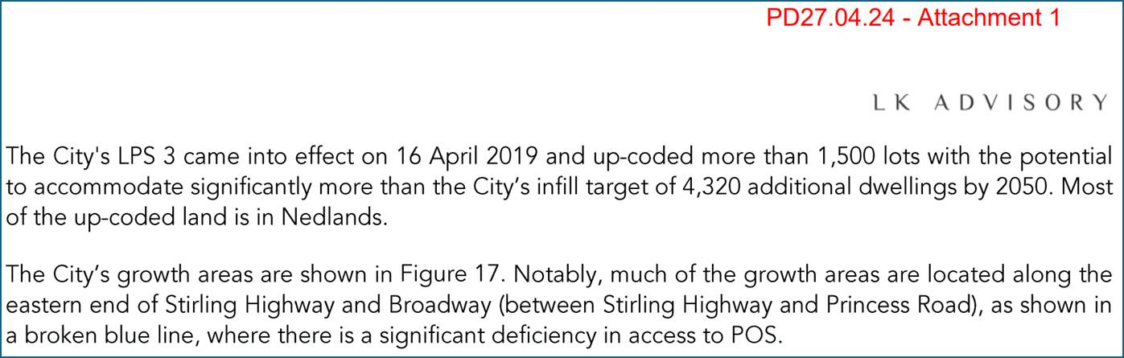
How many lots were up coded in the remainder of the City, and what is the potential contribution to the infill targets?
This question is referring to the Floreat and Mt Claremont up zoning and also the likely increases due to Montario Quarter and Graylands subdivisions.

Deputy Mayor Smyth – Siting LK Advisory Attachment 1 Part 1 – Section 6. Summary of POS in Nedlands and Dalkeith
Referencing Tables 1, 2, & 3
Could figures for the whole City of Nedlands be included for comparison?

Deputy Mayor Smyth – Siting LK Advisory Attachment 1 Part 1 – Section 8. Conclusion
States that the “there is a need to establish a road map to resolve the existing and growing gap in POS accessibility within the study area.”
Will this Strategy be applied across the whole City?
Will the 5% contributions apply to subdivisions not in the study area?
What research has been undertaken to establish POS needs in remaining area of City outside the study area?

Deputy Mayor Smyth – Siting LK Advisory Attachment 1 Part 2 – City of Nedlands Study Area Maps
Referencing Figires 2, 6, 7, 8, 9, 11, 14, 15, 16, 17,18
All these Maps carry the title City of Nedlands – plus subject line, this is misleading and incomplete information.
The title is more accurately: City of Nedlands (south) or (study area only)
Could the Map titles be changed to avoid misunderstanding that the whole City of Nedlands is being depicted in the maps?

Deputy Mayor Smyth – Siting Policy Attachment 3 Table 19 Local Park
Can Anne Dorrington Park be added to the list of Local Parks?
Noting this omission was identified prior to advertising; has a valuable Public Art installation; and accounts for the POS allocation associated with the Old Swanbourne Hospital LPP.
Of concern - Officer response to Further Information for Item 16.10 PD18.03.24 Adopt Amended Local Planning Policy 5.2 – Old Swanbourne Hospital Precinct (OCM March 2024)
States “The ongoing management of the POS, natural bush and greenways within the Old Swanbourne Hospital Precinct area it is not a matter for the LPP to address.” This is of concern because although the Annie Dorrington Park was part of a developer contribution it does not have access to Policy or LPP.

Councillor Amiry retired from the meeting at 8.07pm.

PD28.04.24 - Consent to Advertise Heritage Areas and Local Planning Policy 6.2: Heritage Protected Places

Councillor Hodsdon left the room at 9.19pm.

Requests for Further Information

Councillor Bennett - Why are Allen Park and the foreshore Heritage areas treated separately?

Deputy Mayor Smyth - Can an amendment be prepared for the council meeting to include Allen Park and the foreshore as Heritage areas?

Deputy Mayor Smyth - As this is a Pilot of only four streets how will other areas be added? For example: Local Planning Policy 6.2 Heritage-Protected Places as shown in Attachment 1, will there need to be other Heritage LLP for other areas of the City.

Deputy Mayor Smyth - Can we have a guarantee that assessment of heritage streetscapes is applied equitably across the City?

Councillor Coghlan – Can an amendment be prepared and considered to include Tyrell Street South to Stirling Highway.

Councillor Hodsdon returned to the room at 9.35pm.

PD29.04.24 - Reconsideration of Car Parking Contribution for Hot Springs Development at 120 Esplanade, Dalkeith

Requests for Further Information

Councillor Bennett – Where will the City be left financially when addressing the drainage within the area, in the event that the proposed condition is accepted, and a $200,000 contribution is provided towards drainage rather than $268,000 towards car parking improvements?

17. Divisional Reports - Technical Services

TS11.04.24 Foreshore Master Plan Update

Requests for Further Information

Councillor Bennett – Can we organise a meeting where all councillors are invited to discuss this prior to the council meeting?

Councillor Bennett - Can the Foreshore Management Plan go to a separate session for discussion?

TS12.04.24 Adoption of the Integrated Transport Strategy 2024

Requests for Further Information

Councillor Bennett – Aberdare Rd and Railway Parade - What has been proposed for the retention of these mature trees?

TS13.04.24 RFQ 2023-24.10 Electric Vehicle Charges

Requests for Further Information

Councillor Youngman – Will this mean there are two less carparks at each of the four sites?

Deputy Mayor Smyth – Will the energy be renewable energy? Clause to be added to instruct the CEO to develop options for a second lot of chargers to be used more broadly by the public.

Deputy Mayor Smyth – Are all 4 EV Charging locations open to use by public?
Will there be charges and limits to the period of parking at the station?
Will there be limits associated with staff charging private vehicles alongside charging City fleet vehicles?
Will there be FBT implications?
Can Councillors use the corporate facility?

Deputy Mayor Smyth – Will the power use for the Electric Vehicle Charging be totally renewable energy sourced?

Deputy Mayor Smyth - What City buildings could be used to harness solar energy for additional EVC?

TS14.04.24 Street Tree Policy 2024 Minor Amendments

Requests for Further Information

Deputy Mayor Smyth - Could a Glossary of Terms be added to the Policy please?

This Policy should be able to stand alone without the reader requiring “insider knowledge” of the terms and other documents not referenced.

For example:
- schedule of tree species considered unsuitable for nature strips
- register of individual street trees considered to pose a height problem
- an Aggregate Tree Canopy Area of at least one and half times the Nature Strip Area and preferably two times,
  - what does this mean, is there a diagram, are footpaths and driveways included in the total verge calculation, where is the 150% canopy overhang?
- Native species.

Deputy Mayor Smyth - Can this default statement be reviewed please, with the addition of other options? Planting para 4 “ Where the available nature strip area makes planting of the above species impracticable, the default street species are Modong (Melaleuca preissiana) or WA Willow Peppermint (Agonis flexuosa).”

Councillor Youngman – page 604 reference to significant street tree register. Do we have one? Can an amendment be provided to have consideration be given to these to be existing street scapes preserved?

Councillor Bennett – Provide copy of the street tree list the city is working on. Can the ranges of the width of the verges throughout the City to be provided? Can the document include categories of small, medium and large trees and the selection of tree that fit into the verge according to size.

Councillor Coghlan – Can a session with Elected Member be organised before the Council meeting to ensure that the Council fully understands the Policy?

TS15.04.24 Tree Removal for Development – 18 Betty Street Nedlands

Requests for Further Information

Nil.

TS16.04.24 Western Metropolitan Regional Council (WMRC) – Agreement Extension

Requests for Further Information

Nil.

18. Divisional Reports - Corporate Services

CPS18.04.24 - Monthly Financial Report - March 2024

This item will be dealt with at the Council Meeting.

CPS19.04.24 - Monthly Investment Report - March 2024

This item will be dealt with at the Council Meeting.

CPS20.04.24 - List of Accounts Paid - March 2024

This item will be dealt with at the Council Meeting.

CPS21.04.24 - Appointment of Member to the Audit & Risk Committee

Requests for Further Information

Nil.

CPS22.04.24 – Town of Claremont Lease

Requests for Further Information

Deputy Mayor Smyth - Could you please provide a summary of all the current and proposed depot lease arrangements in tabulated format? (Have Cities of Perth, Subiaco or Vincent expressed interest?) For example: Lease Holder, Location, Area, Use, Income, Costs, Period, Termination Date.

Deputy Mayor Smyth - Is there a business opportunity for a “Super Depot” in WESROC zone and where would this best be located? Could an alternative motion be advised to explore this option? I am trying to understand the context and broader picture of other Municipalities disposing of their depots at a lucrative gain, only to impose on City of Nedlands amenity.
Deputy Mayor Smyth – Has consideration been given to amalgamation of Cambridge Depot with Claremont at 21 Lemnos Street? Image below.
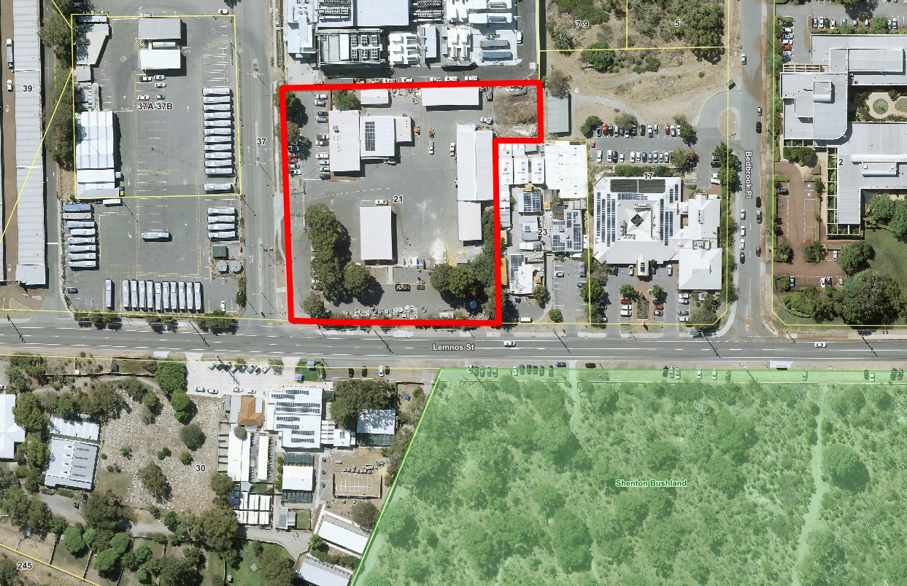
Deputy Mayor Smyth – Proposed Alternate – Council Meeting 23 April 2024

That Council:

- Does not provide in Principle support to a lease of a portion of the John XXIII Depot to the Town of Claremont;
- Does not endorse proposed key terms; and
- Instructs the CEO to investigate options for the consolidation of municipal depot sites giving due regard to Local Planning Strategy 5.9.3

Reasons

The Lease of 10 plus 5 plus 5, is a 20-year commitment to have Town of Claremont depot traffic in the heart of a City of Nedlands Education and recreation precinct.

The Officers further information provides numerous statements that bear consideration, for example the bitumen entry road being defer until 2027/28.

The Mt Claremont Master Plan Concept Forum draw considerable discussion causing a re-think.

Due regard should be given to Local Planning Strategy 5.9.3

Deputy Mayor Smyth - Update on other municipalities interest.

19. Reports by the Chief Executive Officer

CEO09.04.24 - Council Plan 2023-33 Report to March

Requests for Further Information

Deputy Mayor Smyth - Actions Red Projects Not Started

1.3.4 What is timeline for action to commence?

2.2.6 What leverage can be applied to commence this action?

7.1.2 What allocations in the upcoming budget will be required to activate this action?

7.2.5 Is there a timeline or Budget for this action?

8.2.1 What potential actions are forthcoming from the ITS and what budget allocations are required?

11.1.2 Not awaiting, as currently have been asked to provide feedback, please clarify?

12.1.2 What action is being taken with EPS to deliver better access for Council, for example “Cr Dashboard”?

Can the March report be modified if responses to my questions are substantial?

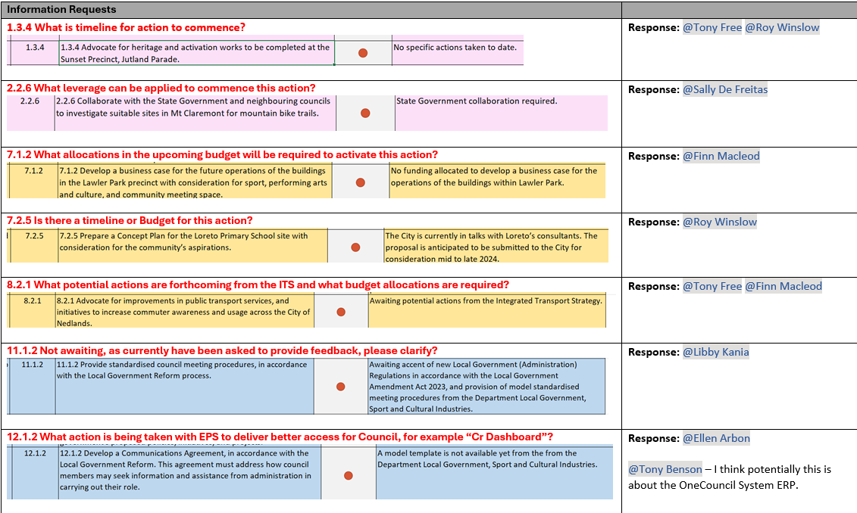

CEO10.04.24 - Register of Outstanding Council Resolutions

Request for Further Information

Nil.

Council Members Notice of Motions of Which Previous Notice Has Been Given
This item will be dealt with at the Ordinary Council Meeting.

Urgent Business Approved By the Presiding Member or By Decision

This item will be dealt with at the Ordinary Council Meeting.

Confidential Items

Confidential items to be discussed at this point.

Councillor Bennett left the room at 9.13pm.

CEO11.04.24 - Confidential Final Determination Report (7344/23)

A confidential report has been circulated to Council Members separately.

CEO12.04.24 - Confidential Request for Legal Representation

A confidential report has been circulated to Council Members separately.

Declaration of Closure
There being no further business, the Presiding Member declared the meeting closed at 9.26 pm.

