

Agenda

Council Committee Meeting

4 December 2018

Dear Council Member

The next meeting of the Council Committee will be held on Tuesday 4 December 2018 in the Council Chambers at the City of Nedlands located at 71 Stirling Highway, Nedlands commencing at 7.00pm.

Greg Trevaskis
Chief Executive Officer
29 November 2018
Table of Contents

Declaration of Opening 3
Present and Apologies and Leave Of Absence (Previously Approved) 3
1. Public Question Time 4
2. Addresses By Members of the Public (only for items listed on the agenda) 4
3. Disclosures of Financial Interest 4
4. Disclosures of Interests Affecting Impartiality 5
5. Declarations by Members That They Have Not Given Due Consideration to Papers 5
6. Confirmation of Minutes 5
6.1 Committee Meeting 13 November 2018 5
7. Matters for Which the Meeting May Be Closed 5
8. Divisional Reports 5
8.1 Planning & Development Report No’s PD66.18 to PD75.18 6
8.2 Technical Services Report No’s TS27.18 to TS29.18 7
8.3 Community Development No’s CM05.18 8
8.4 Corporate & Strategy Report No’s CPS22.18 to CPS24.18 9
9. Reports by the Chief Executive Officer 10
9.1 Lisle Villages Inc - Draft New Rules of Association 10
9.2 Hockey Proposal at Mt Claremont Reserve – Community Engagement Results 12
10. Urgent Business Approved By the Presiding Member or By Decision 19
11. Confidential Items 19
Declaration of Closure 19

City of Nedlands

Notice of a meeting of the Council Committee to be held in the Council Chambers, Nedlands on Tuesday 4 December 2018 at 7 pm.

Council Committee Agenda

Declaration of Opening

The Presiding Member will declare the meeting open at 7 pm and will draw attention to the disclaimer below.

(NOTE: Council at its meeting on 24 August 2004 resolved that should the meeting time reach 11.00 p.m. the meeting is to consider an adjournment motion to reconvene the next day).

Present and Apologies and Leave Of Absence (Previously Approved)

Leave of Absence None.
(Previously Approved)

Apologies None as at distribution of this agenda.

Disclaimer

Members of the public who attend Council meetings should not act immediately on anything they hear at the meetings, without first seeking clarification of Council’s position. For example by reference to the confirmed Minutes of Council meeting. Members of the public are also advised to wait for written advice from the Council prior to taking action on any matter that they may have before Council.

Any plans or documents in agendas and minutes may be subject to copyright. The express permission of the copyright owner must be obtained before copying any copyright material.

Public Question Time

A member of the public wishing to ask a question should register that interest by notification in writing to the CEO in advance, setting out the text or substance of the question.

The order in which the CEO receives registrations of interest shall determine the order of questions unless the Mayor determines otherwise. Questions must relate to a matter affecting the City of Nedlands.

Addresses By Members of the Public (only for items listed on the agenda)

Addresses by members of the public who have completed Public Address Session Forms will be invited to be made as each item relating to their address is discussed by the Committee.

Disclosures of Financial Interest

The Presiding Member to remind Councillors and Staff of the requirements of Section 5.65 of the Local Government Act to disclose any interest during the meeting when the matter is discussed.

A declaration under this section requires that the nature of the interest must be disclosed. Consequently a member who has made a declaration must not preside, participate in, or be present during any discussion or decision making procedure relating to the matter the subject of the declaration.

However, other members may allow participation of the declarant if the member further discloses the extent of the interest. Any such declarant who wishes to participate in the meeting on the matter, shall leave the meeting, after making their declaration and request to participate, while other members consider and decide upon whether the interest is trivial or insignificant or is common to a significant number of electors or ratepayers.

Disclosures of Interests Affecting Impartiality

The Presiding Member to remind Councillors and Staff of the requirements of Council’s Code of Conduct in accordance with Section 5.103 of the Local Government Act.

Councillors and staff are required, in addition to declaring any financial interests to declare any interest that may affect their impartiality in considering a matter. This declaration does not restrict any right to participate in or be present during the decision-making procedure.

The following pro forma declaration is provided to assist in making the disclosure.

“With regard to …… the matter in item x….. I disclose that I have an association with the applicant (or person seeking a decision). As a consequence, there may be a perception that my impartiality on the matter may be affected. I declare that I will consider this matter on its merits and vote accordingly.”

The member or employee is encouraged to disclose the nature of the association.

Declarations by Members That They Have Not Given Due Consideration to Papers

Members who have not read the business papers to make declarations at this point.

Confirmation of Minutes

Committee Meeting 13 November 2018

The Minutes of the Council Committee held 13 November 2018 are to be confirmed.

Matters for Which the Meeting May Be Closed

In accordance with Standing Orders and for the convenience of the public, the Committee is to identify any matter which is to be discussed behind closed doors at this meeting and that matter is to be deferred for consideration as the last item of this meeting.

Divisional Reports

Note: Regulation 11(da) of the Local Government (Administration) Regulations 1996 requires written reasons for each decision made at the meeting that is significantly different from the relevant written recommendation of a committee or an employee as defined in section 5.70, but not a decision to only note the matter or to return the recommendation for further consideration.

Planning & Development Report No’s PD66.18 to PD75.18

Planning & Development Report No’s PD66.18 to PD75.18 to be dealt with at this point (copy attached yellow cover sheet).

PD66.18 No. 29A Carrington Street, Nedlands – Proposed Animal Establishment (Dog Day Care) (Use Not Listed)

PD67.18 No. 2/23 Carrington Street, Nedlands – Proposed Additional Customer Seating (Retrospective) for Brick Alley Café – Change of Use Restaurant

PD68.18 No. 42 Kirwan Street, Floreat – Additions (Two Carports) to Existing Single Dwelling

PD69.18 No. 50 Florence Road, Nedlands – Amendment to Existing Approval (DA17/306)

PD70.18 No. 7 Nardina Crescent, Dalkeith – Proposed Street Boundary Fencing (Retrospective)

PD71.18 No. 82 Kingsway, Nedlands – Front Fencing addition to Single House

PD72.18 No. 11B Brockway Road, Mount Claremont – Two Storey Single House

PD73.18 Scheme Amendment No. 214 – Lot 381 (No.45) Carrington Street, Nedlands

PD74.18 Christ Church Grammar School - Possible Acquisition of Landfill Site

PD75.18 West Australian Bridge Club Inc. at Reserve 7804, Swanbourne – Extension to Lease Term

Technical Services Report No’s TS27.18 to TS29.18

Technical Services Report No’s TS27.18 to TS29.18 to be dealt with at this point (copy attached blue cover sheet).

TS27.18 Leon Road Footpath between Robert Street and Alexander Road

TS28.18 Quintilian Road Traffic Management

TS29.18 Western Metropolitan Regional Council (WMRC) Funding Request

Community Development No’s CM05.18

Report No’s CM05.18 to be dealt with at this point (copy attached orange cover sheet).

CM05.18 Purchase of Artwork from Sculptures by the Sea

Corporate & Strategy Report No’s CPS22.18 to CPS24.18

Report No’s CPS22.18 to CPS24.18 to be dealt with at this point (copy attached green cover sheet).

CPS22.18 List of Accounts Paid – October 2018

CPS23.18 Policy Review

CPS24.18 Post Audit Changes to 2018/19 Budget

Reports by the Chief Executive Officer

Lisle Villages Inc - Draft New Rules of Association

Committee | 4 December 2018
Council | 18 December 2018
Applicant | Lisle Villages Inc
CEO | Greg Trevaskis
Attachments | - Extract Council Minutes 26 September 2017  - Lisle Villages Inc Letter – 20 July 2018  - Response letter to Lisle Villages re Draft New Rules of the Association - 24 July 2018  - Lisle Villages Inc Letter – 26 November 2018  - Lisle Villages Inc Final Draft New Rules of Association

Executive Summary

Lisle Villages Inc has requested the City to expeditiously approve the Final Draft of the latest version of the proposed new Rules of Association. There is a deadline for the latest version of the constitution to be submitted to the Commissioner for Consumer Protection within 1 month of passing the special resolution at the Association’s Extraordinary General Meeting held on 21 November 2018 (i.e. by 20 December 2018).

“We believe that the amendments that were made to the Final Draft do not prejudice or materially affect the City, given the City’s previous correspondence with Lisle and its request to remove any reference to the involvement of the City in the affairs of Lisle. Further, the Final Draft has received overwhelming support from Members, and is supported by the Commissioner for Consumer Protection.”

Recommendation to Committee

Council approves the Final Draft New Rules of Association received from Lisle Villages (Inc) on the 26 November 2018 as per attachment 5.

Key Relevant Previous Council Decisions:

Ordinary Council Meeting of 26 September 2018

Council Resolution

Council formally advises Lisle Villages Board of Management that it no longer intends to nominate a Councillor to be a Board Member and suggest that the Constitutions should be amended to remove this requirement.

Consultation

Not required.

Budget/Financial Implications

There are no financial implications for the City of Nedlands if this report is approved or not.

Conclusion

The new Rules of the Association are for the Board and membership of Lisle Villages (Inc) have been endorsed by the Association’s membership. The Constitution is a matter for Lisle Villages (Inc) and not the City. The requirement for a councillor to be on the Board was a past anomaly and this requirement has now been sensibly removed. Council is asked to finally approve this final draft to ensure the current rules are adhered to avoid potential complications for Lisle Villages (Inc).

Hockey Proposal at Mt Claremont Reserve – Community Engagement Results

Committee | 4 December 2018
Council | 18 December 2018
Applicant | Westside Wolves Hockey Club
Officer | Caroline Walker, Community Engagement Coordinator
CEO | Greg Trevaskis
Attachments | - Community Engagement Report

Executive Summary

Council at its meeting on 23 October 2018 resolved:

“That Council endorses the proposed community engagement plan for Mt Claremont Oval and seeks a report to be prepared on the results of the consultation for consideration in December 2018.”

This report presents the findings form the community engagement activities undertaken as contained in Attachment 1 of this report. Submissions and surveys have been summarised along with the identification of the key themes resulting from the feedback received.

Access to all documents have been provided to Councillors (via Council portal) to maintain confidentiality for respondents. An overview of the results from the community engagement activities follow.

Recommendation to Committee

Council:

- Receives the Community Engagement Report (Attachment A) in relation to the proposal by Westside Wolves Hockey Club to establish a synthetic hockey pitch and club facilities at the Mt Claremont Reserve.

- Requests the Chief Executive Officer to prepare a report to the March 2019 Council round of meetings on the key options for future use at Mt Claremont Reserve as suggested by the community.

- Receives the petitions submitted in opposition to the Westside Wolves Hockey Club proposal:

- Petition 1: Save Mt Claremont Oval – Ditch the Pitch
- Petition 2: Save Mt Claremont Oval – Ditch the Pitch, change.org
- Petition 3: Leaweena and Lisle Villages – Rejection of Westside Wolves Proposal

Discussion/Overview

Community engagement has been undertaken with residents, property owners, user groups, sporting clubs, associations and stakeholders, along with the broader community, on a proposal for the Westside Wolves to develop permanent hockey facilities (club rooms, artificial turf and car park) on a section of green space at Mt Claremont Reserve.
The aim of the engagement project was to understand the level of community support and their views on the proposal, to assist with the Council’s decision-making on whether to approve a period for the club to further investigate and develop a detailed proposal and business plan (including designs, costings and sources of funding).

The community was invited to complete an online survey to enable the City to gauge the level of community support for this proposal. Opportunities were also provided for submissions via email, post or delivery to the Administration Centre. Hardcopy surveys were produced and submissions by telephone were provided for people who did not have access or did not use computers.

- Communications and participation

1,410 property owners and residents were directly contacted within the area bounded by Lantana Avenue, Moora Drive, Heritage Lane, St Johns Wood Boulevard, Haldene Street and Rochdale Road as they would be impacted or potentially impacted by this proposal (1,424 including stakeholders).

A media release was issued and advertising was published in the POST and Western Suburbs Weekly newspapers along with notices and large banners displayed in various locations in key traffic areas around the reserve.

Posts were placed on the City’s Facebook and Twitter accounts which reached 3,099 people and included 334 reactions, comments and shares.

During the engagement period, the City became aware of the unsolicited promotion and awareness of the project by local community and activist groups:

  - Westside Wolves Hockey Club – full-page advertising in the POST newspaper and a brochure insert along with information on their website promoting “the Wolves need a Den”.
  - A group called “Friends of the Mt Claremont Oval” produced a Facebook page, website and a flyer “Save Mt Claremont Park/oval from the Westside Wolves”. This flyer was distributed within the community, placed on the Mt Claremont Community Centre noticeboard and attached to the City of Nedlands hardcopy survey.
  - Two petitions were attached to the Friends of the Mt Claremont Oval submission: Ditch the Pitch petition (paper) and electronic (change.org) (see Section below)
  - One petition from the Leaweena and Lisle Villages rejecting the proposal (see Section below)
  - Numerous Facebook posts from the Friends of the Mt Claremont Oval, the Westside Wolves Hockey Club and their supporters.
  - Notices and statements from users of the oval were attached to the cricket practice nets at the reserve.
  - There were also numerous complaints to the City regarding the behaviour of people within the community protesting the proposal and those supporting the proposal.
  - Facebook posts were also placed by the POST newspaper, Western Suburbs Weekly, Sunday Times and the online publication, Perth Now.
  - Approximately 30 letters to the editor in the POST newspaper and the Western Suburbs Weekly.

The communication activities resulted in 6,920 visits, mostly using the methods of: typing Your Voice Nedlands into the address bar after receiving the letter (3,781 people, 55 per cent). 2,330 people (34 per cent) accessed the site via social media with another 483 people (7 per cent) using a search engine. 200 people were referred from other websites (3 per cent) and 81 (1 per cent) used a .gov site (City of Nedlands) to access the site.

Of the 6,920 visits to the engagement page, 5,427 people viewed at least one page with 3,291 people progressing further to look at the images, download the concept plans (549) and read the key dates (42) and FAQs (510). 1,613 of these people progressed to becoming engaged with the project by completing the online survey (1,582) and/or asking questions (31) of the City. Submissions were also received from community groups both in support and opposing the hockey facility.

- Petitions received

Three petitions were received opposing the proposal from the Westside Wolves Hockey Club, as follows:

Petition 1: Save Mt Claremont Oval – Ditch the Pitch (paper petition)

This petition stated “The Westside Wolves propose to take approximately 40% of the oval for fenced Astro Turf Hockey Pitch, new Club House and a 60 space carpark. The remaining 60% grassed area will not be large enough to facilitate the needs of the Mt Claremont Primary Schools sporting activities, not the current 4 sporting clubs that use it. We fear this is privatising public space. Westside Wolves will become the exclusive lessee for one code, one club and one single use.

There will be an impact on the local residents and school children crossing the road due to the increased generation of traffic for the facility. Not to mention the environmental impact on the surrounding bushland.

To see more reasons as why we need to save Mt Claremont oval as open green space, go to “Friends of Mount Claremont Oval” Facebook Page www.saveoouroval.com

We, the undersigned oppose the Mt Claremont Oval – Proposal from Westside Wolves Hockey Club.”

Petition 2: Save Mt Claremont Oval – Ditch the Pitch (change.org)

This petition was an electronic survey through the website www.change.org and stated, “Save Mt Claremont Oval – Ditch the Pitch.” No other commentary was provided.

Petition 3: Leaweena and Lisle Villages

This petition was presented from the Residents’ Committee, titled “Mount Claremont Oval Westside Wolves Hockey Club Proposal”. This petition stated “We the undersigned residents of Lisle & Leaweena Villages reject unequivocally the above proposal.”

- Overall results

Due to the nature of responses to the engagement activities, particularly the completeness of the hardcopy surveys, the receipt of informal petitions, emails, letters and the complexity in tracking duplications has resulted in difficulties with determining the number of multiple responses by the same people.

In addition, the City received three informal petitions, two were attached to the Friends of Mt Claremont Oval (781 signatures) submission and one (41 signatures) came from the Leaweena and Lisle Villages opposing the project. The signatures from these petitions have not been recorded in the table below, however appear to represent 45 per cent per cent of the Mt Claremont area. Signatures may be duplicated in other forms of feedback on this subject and therefore cannot be validated.

Of the surveys received, 675 (43 per cent) surveys were received from residents who indicated they lived in Mt Claremont and 195 (12 per cent) were residents who indicated they lived in Claremont. The remaining 715 (45 per cent) relate to the remainder of the western suburbs, metropolitan Perth and country Western Australia. The table below provides the level of support for the proposal from all feedback mechanisms used for this project.

Support for the Proposal

Support | Online Survey | Hardcopy Surveys | Stakeholder Submissions | Emails | Phone Calls | Total
Yes, I support the proposal | 846 | 274 | 0 | 7 | 7 | 1134
No, I do not support the proposal | 725 | 150 | 6 | 43 | 6 | 930
I am unsure | 11 | 2 | 0 | 2 | 0 | 15
Total Received | 1582 | 426 | 6 | 52 | 13 | 2,078
Regarding the survey responses, people indicated their interest in the reserve and the age range as follows:
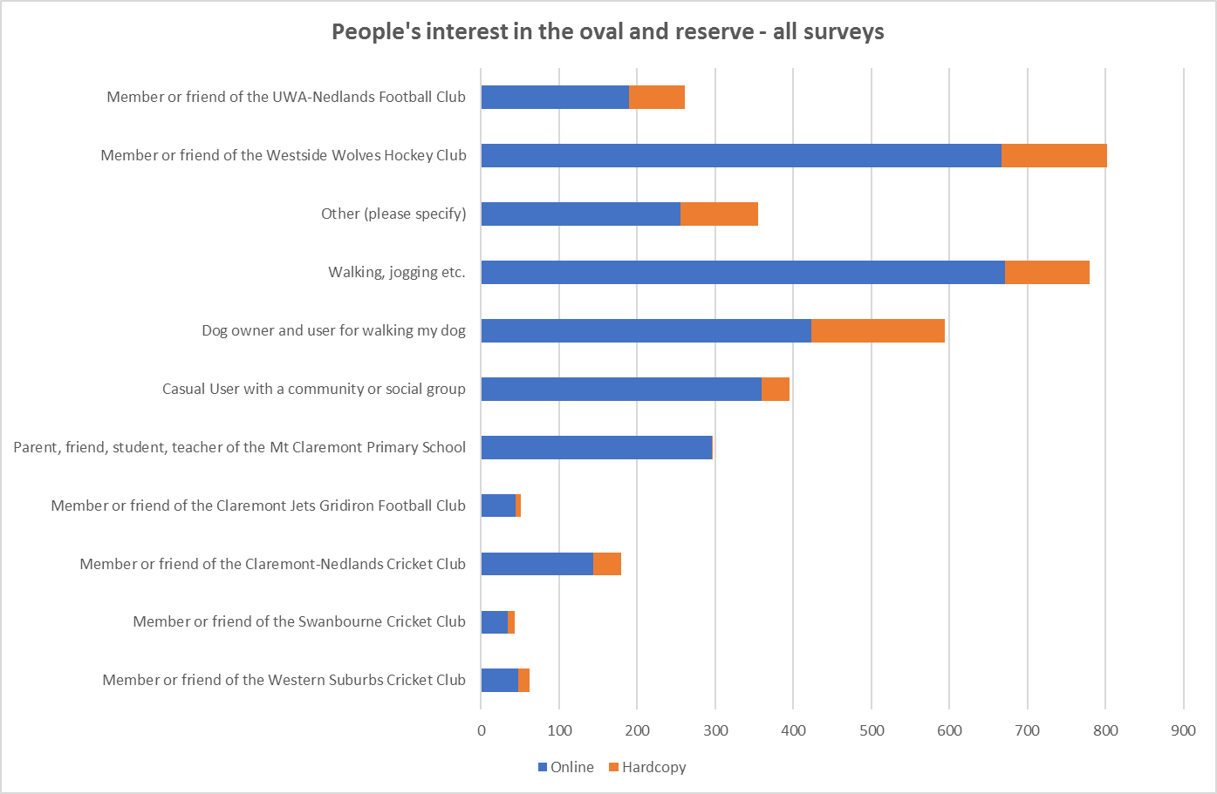
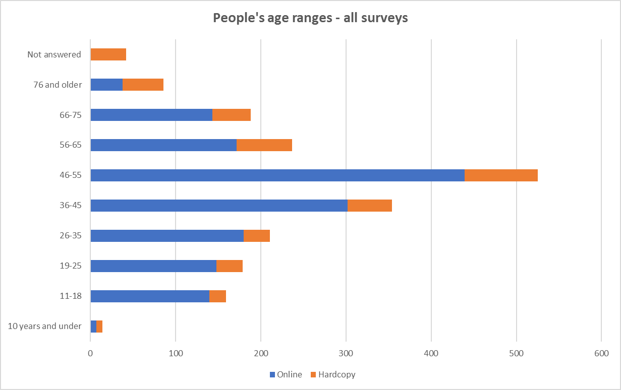
The results of the community engagement feedback: comments recorded (online survey, hardcopy surveys, telephone conversations, emails, letters, face-to-face) during the period have been analysed and developed into key themes which emerged from the review.
Several detailed submissions were received.
All feedback received was grouped and summarised into key themes (refer to Section 8 of the Community Engagement Report).
Key Relevant Previous Council Decisions

Ordinary Council meeting – 23 October 2018 (to adopt a community engagement plan and provide for a report on the outcomes of the engagement for the December 2018 Ordinary Council meeting).

Ordinary Council Meeting – 22 May 2018 (to convene a workshop and explore possible alternative sites).

Councillor Briefing – 4th September 2018 (review Workshop Minutes 9 August 2018).

Budget/Financial Implications

Should the Mt Claremont Reserve be selected as a potential site for a new hockey pitch, the Westside Wolves Hockey Club will be required to prepare a detailed business plan on funding for capital works, sources of funding, independent environmental study, quantity surveyors report, detailed working drawings, project lifecycle/maintenance costs and a traffic management study.

Any decision by Council to progress to the next stage does not pre-commit Council to future funding obligations for this project. The decision to assist with funding is a separate decision and will be considered on its merits, Council’s financial capacity and any other relevant considerations.

Conclusion

Community engagement to understand the level of support for the Westside Wolves proposal to construct an artificial turf, car parking and clubrooms on a portion of green space at the Mt Claremont Oval Reserve has been completed.

The aim of the engagement was to receive community opinion on the proposal to assist with Council’s decision-making to approve/not approve a period of time for the club to further investigate and develop a detailed proposal and business plan (including designs, costings and sources of funding).

There has been significant community interest in this proposal resulting in a high level of engagement and one of the most successful engagement projects the City has undertaken in terms of participation. The significant input has been provided resulting in there being an equal view on the proposal, to support or not support the proposal. The feedback has also identified a variety of benefits and challenges.

Based on the feedback received, it is proposed that the City’s administration will now prepare a report to the March 2019 Council round of meetings on the key options for future use at Mt Claremont Reserve as suggested by the community.

Urgent Business Approved By the Presiding Member or By Decision

Any urgent business to be considered at this point.

Confidential Items

Any confidential items to be considered at this point.

Declaration of Closure

There being no further business, the Presiding Member will declare the meeting closed.

