

Agenda

Council Committee Meeting

10 September 2019

Dear Council Member

The next meeting of the Council Committee will be held on Tuesday 10 September 2019 in the Council Chambers at the City of Nedlands located at 71 Stirling Highway, Nedlands commencing at 7.00pm.
INCLUDEPICTURE "cid:image001.png@01D4D35A.38AFF500" \* MERGEFORMATINET 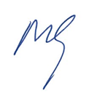
Mark Goodlet
Chief Executive Officer
5 September 2019
Table of Contents

Declaration of Opening 3
Present and Apologies and Leave Of Absence (Previously Approved) 3
1. Public Question Time 4
2. Addresses By Members of the Public (only for items listed on the agenda) 4
3. Disclosures of Financial Interest 4
4. Disclosures of Interests Affecting Impartiality 5
5. Declarations by Members That They Have Not Given Due Consideration to Papers 5
6. Confirmation of Minutes 5
6.1 Committee Meeting 13 August 2019 5
7. Matters for Which the Meeting May Be Closed 5
8. Divisional Reports 5
8.1 Planning & Development Report No’s PD34.19 to PD40.19 6
8.2 Community Development No’s CM03.19 to CM05.19 7
8.3 Corporate & Strategy Report No’s CPS14.19 8
9. Reports by the Chief Executive Officer 9
9.1 Bruce Trust and Esplanade 9
9.2 Policy Reviews 16
10. Urgent Business Approved By the Presiding Member or By Decision 21
11. Confidential Items 21
11.1 TS19.19 – Government Road and Loch Street Sumps 21
Declaration of Closure 21

City of Nedlands

Notice of a meeting of the Council Committee to be held in the Council Chambers, Nedlands on Tuesday 10 September 2019 at 7 pm.

Council Committee Agenda

Declaration of Opening

The Presiding Member will declare the meeting open at 7 pm and will draw attention to the disclaimer below.

(NOTE: Council at its meeting on 24 August 2004 resolved that should the meeting time reach 11.00 p.m. the meeting is to consider an adjournment motion to reconvene the next day).

Present and Apologies and Leave Of Absence (Previously Approved)

Leave of Absence None.
(Previously Approved)

Apologies None as at distribution of this agenda.

Disclaimer

Members of the public who attend Council meetings should not act immediately on anything they hear at the meetings, without first seeking clarification of Council’s position. For example by reference to the confirmed Minutes of Council meeting. Members of the public are also advised to wait for written advice from the Council prior to taking action on any matter that they may have before Council.

Any plans or documents in agendas and minutes may be subject to copyright. The express permission of the copyright owner must be obtained before copying any copyright material.

Public Question Time

A member of the public wishing to ask a question should register that interest by notification in writing to the CEO in advance, setting out the text or substance of the question.

The order in which the CEO receives registrations of interest shall determine the order of questions unless the Mayor determines otherwise. Questions must relate to a matter affecting the City of Nedlands.

Addresses By Members of the Public (only for items listed on the agenda)

Addresses by members of the public who have completed Public Address Session Forms will be invited to be made as each item relating to their address is discussed by the Committee.

Disclosures of Financial Interest

The Presiding Member to remind Councillors and Staff of the requirements of Section 5.65 of the Local Government Act to disclose any interest during the meeting when the matter is discussed.

A declaration under this section requires that the nature of the interest must be disclosed. Consequently, a member who has made a declaration must not preside, participate in, or be present during any discussion or decision-making procedure relating to the matter the subject of the declaration.

However, other members may allow participation of the declarant if the member further discloses the extent of the interest. Any such declarant who wishes to participate in the meeting on the matter, shall leave the meeting, after making their declaration and request to participate, while other members consider and decide upon whether the interest is trivial or insignificant or is common to a significant number of electors or ratepayers.

Disclosures of Interests Affecting Impartiality

The Presiding Member to remind Councillors and Staff of the requirements of Council’s Code of Conduct in accordance with Section 5.103 of the Local Government Act.

Councillors and staff are required, in addition to declaring any financial interests to declare any interest that may affect their impartiality in considering a matter. This declaration does not restrict any right to participate in or be present during the decision-making procedure.

The following pro forma declaration is provided to assist in making the disclosure.

“With regard to …… the matter in item x….. I disclose that I have an association with the applicant (or person seeking a decision). As a consequence, there may be a perception that my impartiality on the matter may be affected. I declare that I will consider this matter on its merits and vote accordingly.”

The member or employee is encouraged to disclose the nature of the association.

Declarations by Members That They Have Not Given Due Consideration to Papers

Members who have not read the business papers to make declarations at this point.

Confirmation of Minutes

Committee Meeting 13 August 2019

The Minutes of the Council Committee held 13 August 2019 are to be confirmed.

Matters for Which the Meeting May Be Closed

In accordance with Standing Orders and for the convenience of the public, the Committee is to identify any matter which is to be discussed behind closed doors at this meeting and that matter is to be deferred for consideration as the last item of this meeting.

Divisional Reports

Note: Regulation 11(da) of the Local Government (Administration) Regulations 1996 requires written reasons for each decision made at the meeting that is significantly different from the relevant written recommendation of a committee or an employee as defined in section 5.70, but not a decision to only note the matter or to return the recommendation for further consideration.

Planning & Development Report No’s PD34.19 to PD40.19

Planning & Development Report No’s PD34.19 to PD40.19 to be dealt with at this point (copy attached yellow cover sheet).

PD34.19 No. 20 Nardina Crescent, Dalkeith – Additions to Single House

PD35.19 No. 52 Stirling Highway, Nedlands – Single Dwelling

PD36.19 No. 100 Stirling Highway, Nedlands – Roof Sign (Retrospective)

PD37.19 Scheme Amendment No. 2 – Lot 325-329 Bedford Street, Nedlands

PD38.19 Local Planning Scheme 3 – Local Planning Policy Waste Management and Guidelines

PD39.19 Local Planning Scheme 3 – Local Planning Policy Parking

PD40.19 Local Planning Scheme 3 – Local Planning Policy - Residential Development: Single and Grouped Dwellings

Community Development No’s CM03.19 to CM05.19

Report No’s CM03.19 to CM05.19 to be dealt with at this point (copy attached orange cover sheet).

CM03.19 Community Sport and Recreation Facilities Fund Applications- Swanbourne Nedlands Surf Life Saving Club and Nedlands Golf Club

CM04.19 Approval of Expenditure on Artwork Installation Annie Dorrington Park

CM05.19 Arts Committee Recommendation Co-ordinator Annie Dorrington Park

Corporate & Strategy Report No’s CPS14.19

Report No’s CPS14.19 to be dealt with at this point (copy attached green cover sheet).

CPS14.19 List of Accounts Paid – July 2019

Reports by the Chief Executive Officer

Bruce Trust and Esplanade

Committee | 13 September 2019
Council | 24 September 2019
Applicant | City of Nedlands
Employee Disclosure under section 5.70 Local Government Act 1995 | Nil.
CEO | Mark Goodlet
Attachments | - Bruce Trust Deed  - Attorney General Advice Dated 1 May 2019

Executive Summary

This report seeks formal Council approval to seek the Attorney Generals consent to amend the indenture of the Bruce Trust Deed to allow part of the Bruce Trust Land to be used as road reserve.

Recommendation to Committee

Council instructs the CEO to put forward a Scheme Proposal to the Office of the Attorney General to vary the Bruce Trust Indenture as follows, by the insertion of a new clause numbered ‘9’:

The Indenture, dated 4 June 1909, in respect of the Bruce Trust Land, is varied by adding, immediately after clause 8, a new clause 9 as follows:

‘9. Notwithstanding anything in this Indenture, the Road Board may do whatever is necessary or appropriate to:

- enable part of the said Lot 792 (but not exceeding twenty feet in width) to be used as a road, aligned as nearly as practicable to the existing road known as The Esplanade;

- enable the application of the City of Nedlands Parking and Parking Facilities Local Law 2013 (as amended or replaced from time to time) to the road known as The Esplanade, including any part of the road that is on the said Lot 792; and

- prohibit the charging of fees that allow for parking on any part of the road that is on the said Lot 792; and

- maintain, but not increase, the bituminised surface and associated road infrastructure constructed on the said Lot 792, as existing at 31st May 2019.
Discussion/Overview

The Bruce Trust Land

The far east section of Swan River foreshore that lies within the City’s boundaries is known as the Charles Court Reserve an area made up of several separate land parcels. One of these land parcels was vested in the City’s predecessor, the Claremont Road Board, in June 1909, with the legal responsibility now remaining with the City. This land was vested subject to a number of conditions expressed in a document known as the Bruce Trust Deed (Attachment 1), and the land parcel is hereunto referred to as the ‘Bruce Trust Land’. As Trustees of the Deed the City of Nedlands is required to apply the conditions within it to any activity affecting the land.

The ‘Bruce Trust Land’, labelled 3 in the diagram below with the area represented in blue, is identified as Lot 792 on deposited plan 2948 with an area of 19,482.6 m². It sits adjacent to a strip of Crown land, Class A reserve labelled 2 below, which has a management order to the City of Nedlands from the Department for Planning and Infrastructure. In practise, the two parcels of land are utilised as a combined area exclusively used for sports and recreation as playing fields and as a public recreational area. Playing fields are marked out across the two and games are frequently held on the land by the Nedlands Rugby club, who lease a club house from the City labelled 1 below, and informal games are played upon it by various visiting members of the community and recreational user groups.
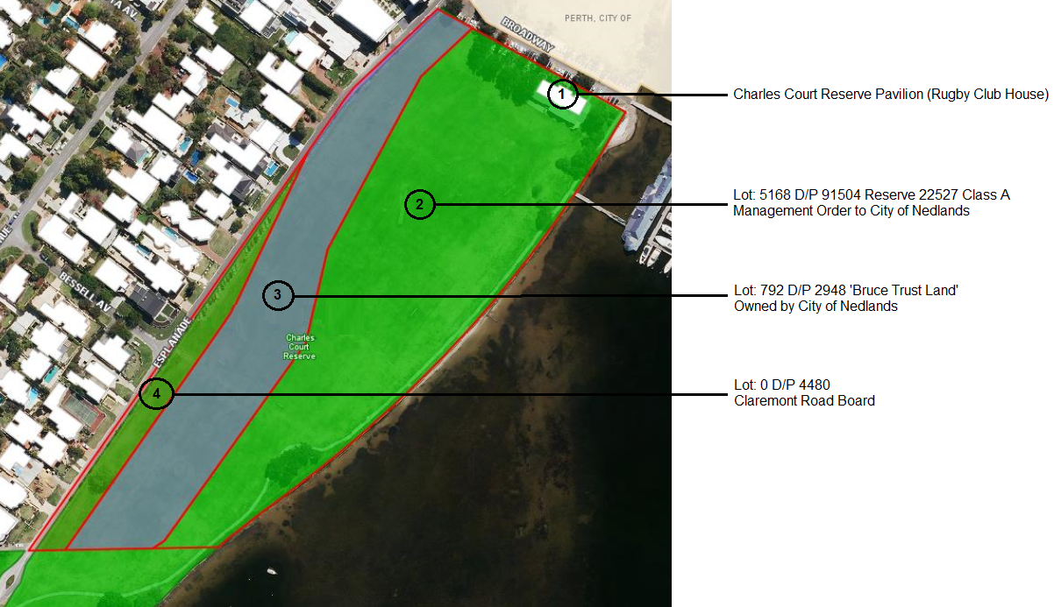

The Esplanade

The Esplanade provides access to the Charles Court Reserve that is inclusive of the Bruce Trust Land. With the exception of a small number of residential properties that front the road, some parking facilities, and a small function centre at the far end, this road leads to recreational facilities and a large area of public reserve. As such, this road may be considered to primarily service recreation and reserve.

In summer months, based on the City’s current data, approximately 1,070 vehicles travel along the Esplanade on average each day past the Bruce Trust Land. The City has issues with the Esplanade currently that it wishes to resolve, so that the road can effectively facilitate safe and compliant access for these road users to access the recreational reserves and facilities in alignment with the Australian standards for road design and construction.

One issue is that the section of Esplanade road reserve, at its northern end, adjacent to the Bruce Trust is only 10m wide, being half the standard width. The Esplanade carriageway itself is constructed to inconsistent widths and currently overlaps onto the Bruce Trust Land by differing amounts along a length of approximately 140m. A total approximate stretch of 190m of the Esplanade lies in such close proximity to the boundary of the Bruce Trust Land that the road reserve could not be extended to the full width of 20m without encroaching further onto the Bruce Trust Land.

A current issue is that cars regularly park along this section of the Esplanade, often half on the road and half on the grass, being wholly parked on the Bruce Trust Land or parked half on the Esplanade and half on the Bruce Trust. While the City’s Parking and Parking Facilities Local Law applies to roads and reserves throughout the City. The City is unable to apply the full Parking and Parking Facilities Local Law to properly manage and enforce this parking, as not all parts of this Local Law can be applied to land that is not road reserve, and as such cannot be applied to vehicles that are parked on the Bruce Trust land. Cars parked in this narrow section of the Esplanade create sight line hazards and congestion along the Esplanade, particularly at weekends during rugby games.

Previous Scheme Proposal

In September 2016, Council approved for a submission to be put forward to the Attorney General’s Office under section 7B of the Charitable Trusts Act 1962 proposing that the Bruce Trust Land be combined with adjacent Crown land. This would in effect transfer the land in ownership from the City to the Crown and for it to be subjected to a management order vested to the City of Nedlands, combining the two parcels of land into one to be jointly administered as a managed public resource for recreation. It was proposed that such a scheme would enable the City to more effectively manage and provide for the charitable purpose of the land, being as a reserve and recreational grounds. This would allow for more effective and consistent management of the Reserve as a single entity and would be the first step towards amending the boundary of the Reserve to resolve the narrowness of the Esplanade and resolving the associated parking issues. Part of this proposal was also to allow for the upgrading of existing sports lighting which is reaching its end of life and not compliant with current Australian Standards.

A submission was put forward to the Attorney General who referred the matter to the State Solicitors Office (SSO). The City worked through various options with the SSO and it became apparent that changing the terms of the Trust, instead of merging the Trust land with the surrounding Class A Reserve, could be a solution to resolve parking and lighting issues more quickly. The City then put forward a proposal to the Attorney General seeking a change to the Trust conditions, effectively to:

- allow part of the Trust to be used ‘as if’ it were road reserve, enable the application of the City’s Parking and Parking Facilities Local Law on the abovementioned section of land; and
- to increase the allowed building heights to allow for higher lighting.
The Attorney General instructed the City to give notice inviting public submissions in opposition to the City’s Proposal and instructed this be sent to all key stakeholders including the ‘Nedlands Park Estate’, this being a designated area comprising properties owned by over 800 people. The SSO collated the responses and provided a summary to the City, giving the City the opportunity to respond to the submissions made. Following this the Attorney General provided the City advice in respect to what he would and would not approve, see Attachment 2. In short, he will support the effective use as a road and parking, but not the increased height of the floodlighting.

New Scheme Proposal

Taking the Attorney General’s advice into consideration, the City has drafted a new Scheme Proposal, as put forward in the recommendation of this report.

The Attorney General advised that he will not, support a submission in respect to increasing the allowing building heights of infrastructure which would enable the construction of higher sports lighting. As a result, the City has not included this in the draft Scheme Proposal recommended for Council approval.

The Attorney General expressed concerns over the charging of parking on the land and increasing the physical bituminised surface of the road. As a result, the City has included new clauses that prohibit these. In addition, the Attorney General specified how much land he would approve to be used as road reserve, being no more than 20 foot in width (approximately 6 metres). This is also reflected in the new Scheme Proposal.

The new Scheme Proposal that has been drafted for Council consideration is as follows:

The Scheme Proposal being put forward is to vary the Bruce Trust Indenture as follows by the insertion of a new clause numbered ‘9’:

The Indenture, dated 4 June 1909, in respect of the Bruce Trust Land, is varied by adding, immediately after clause 8, a new clause 9 as follows:

‘9. Notwithstanding anything in this Indenture, the Road Board may do whatever is necessary or appropriate to:

- enable part of the said Lot 792 (but not exceeding twenty feet in width) to be used as a road, aligned as nearly as practicable to the existing road known as The Esplanade;

- enable the application of the City of Nedlands Parking and Parking Facilities Local Law 2013 (as amended or replaced from time to time) to the road known as The Esplanade, including any part of the road that is on the said Lot 792; and

(c) prohibit the charging of fees that allow for parking on any part of the road that is on the said Lot 792; and

(d) maintain, but not increase, the bitumanised surface and associated road infrastructure constructed on the said Lot 792, as existing at 31st May 2019.

Conclusion

Council’s approval of this Scheme Proposal, and the subsequent Attorney General’s approval, will enable the City to utilise a 20ft strip (approximately 6m) of the Bruce Trust land along its adjacent length to the Esplanade, as road reserve. This would increase the width of the road reserve to approximately 16m inclusive of a nature strip on both sides. The yellow lines in the concept below shows the new area that would be treated as a road reserve including the existing Esplanade and a 6m wide strip of the Bruce Trust Land.

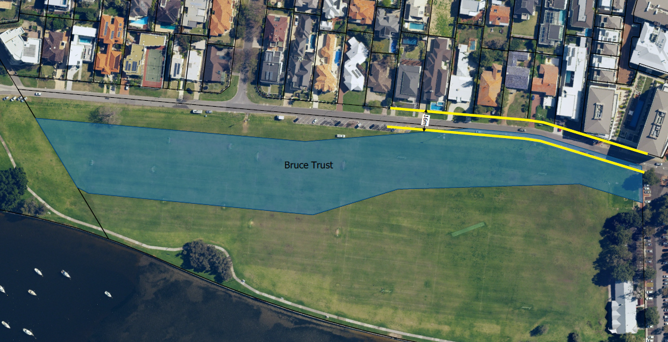

The City may not increase the bitumen surface of the carriageway or charge for parking but will be able to effectively enforce parking compliance including for the existing ‘no standing’ and ‘3-hour limit’ parking restrictions in place. The only physical change would be to move the existing bollards further into the Bruce Trust area to create a length of grassed nature strip wide enough for vehicles to wholly park on, eliminating the ‘half on the road’ parking situation and resolving congestion and sight line issues on the Esplanade.

Key Relevant Previous Council Decisions:

Council resolved at the Ordinary Meeting of Council 27 September 2016, item 13.6:

‘Council instruct the CEO to prepare and submit a scheme to the Attorney General, seeking approval to combine the ‘Bruce Trust Land’ (Lot 792 on deposited plan 2948) with adjacent Class A Reserve (Lot 5168 on deposited plan 91504), under section 7B of the Charitable Trusts Act 1962.’

Consultation

The City has undertaken public statutory consultation in respect to this matter at the instruction of the Attorney General in April 2018. This included information being released above and beyond the Attorney General’s statutory notice, and a public workshop being held. The City has also met with all residents who have requested meetings to discuss the matter, in some cases on several occasions.

In relation to using part of the Bruce Trust as if it were road reserve, there was some concern expressed during consultation that the City was seeking the change in order to create a car park and charge payment for parking. The proposed Scheme Amendment creates restrictions regarding the charging of parking and the extension of any bituminised areas in order to address these concerns. Additionally, during meetings with some local residents, there was concern about changes to where vehicles would be allowed to park opposite residences. The City maintains this Scheme Proposal proposes no changes to any existing parking road marking and signage, the existing ‘no standing’ areas and ‘3-hour limit’ areas intend to be retained. If at any stage in the future the City reviews the parking arrangements in this area, this would be subject to the standard community engagement and Council approval processes applied to parking reviews throughout the City.

Budget/Financial Implications

The City has sufficient operating budget allocated to ‘Governance’, and sufficient Parks Operating Budgets for the moving of the bollards adjacent to the Esplanade, to adequately cover the costs of implementing this amendment should it be approved.

Policy Reviews

Committee | 13 September 2019
Council | 24 September 2019
Applicant | City of Nedlands
Employee Disclosure under section 5.70 Local Government Act 1995 | Nil.
CEO | Mark Goodlet
Attachments | - Staff Superannuation Contributions Policy - Existing  - Superannuation Contributions Policy - New  - Footpaths – Construction and Maintenance Policy  - Naming of Parks, Streets, Public Facilities and Buildings Policy  - Shading of Streetlights Policy  - Dinghy Storage on River Foreshore Reserves Policy  - Crossover Construction and Maintenance Policy  - Superannuation Contributions Procedure  - Footpaths – Construction and Maintenance Procedure  - Naming of Parks, Streets, Public Facilities and Buildings Procedure

Executive Summary

All Council policies are required to be reviewed regularly and approved by Council. This report contains policies that have been reviewed and require formal Council adoption.

Recommendation to Committee

Council:

- revokes the Staff Superannuation Contributions Policy;

- adopts the new Superannuation Contributions Policy;

- adopts the following updated policies;

  - Footpaths – Construction and Maintenance Policy;
  - Naming of Parks, Streets, Public Facilities and Buildings Policy;
  - Shading of Streetlights Policy;
  - Dinghy Storage on River Foreshore Reserves Policy;
  - Crossover Construction and Maintenance Policy; and

- notes the following procedures:

  - Superannuation Contributions Procedure;
  - Footpaths – Construction and Maintenance Procedure;
  - Naming of Parks, Streets, Public Facilities and Buildings Procedure; and

Discussion/Overview

Council policies are reviewed periodically to ensure they reflect the strategic direction and responsibilities of Council and are kept up to date.

The procedure for policy reviews is as follows:

- Policies will be reviewed and updated by staff with any amendments due to changes in any Legislation, Local Laws, Regulations etc. and recommendations made to the Executive Management Team;

- Staff recommendations are reviewed by the Executive Management Team and amended as required and recommendations made to Council;

- Where there are major amendments to existing policies these policies are then presented at a Councillor Briefing for discussion prior to presentation to Council;

- Where a number of policies have common themes, these policies may be combined to establish a new policy. Redundant and old policies will be revoked where they are substantially changed, and a new replacement policy will be presented at a Councillor Briefing for discussion prior to presentation to Council; and

- Administration may at times recommend a policy be revoked with no Council Policy to replace it. This may occur when it has been identified that the policy is operational or covered under legislation and/or the responsibility of the Chief Executive Officer.

Policy statements should provide guidance for decision-making by Council and demonstrate the transparency of the decision-making process.

Superannuation Contributions Policy

This policy was reviewed as required and it is recommended that the Staff Superannuation Contributions Policy (attachment 1) be revoked and replaced with the Superannuation Contributions Policy (attachment 2), due to the extent of rewording. This policy sets out the criteria for the payment of government guaranteed superannuation to employees as well as additional superannuation contributions to employees where employees elect to make a voluntary contribution.
The fundamental contribution percentage remains unchanged.

Footpaths – Construction and Maintenance Policy

This policy was reviewed as required and it is recommended that the Footpaths – Construction and Maintenance Policy (attachment 3) be adopted with one minor change (as tracked in attachment 3) being the removal of KFA (Key Focus Area) – Natural and Environment which was referenced in our previous Strategic Community Plan but is no longer referenced in our current Strategic Community Plan.

Naming of Parks, Streets, Public Facilities and Buildings Policy

This policy was reviewed as required and it is recommended that the revised Naming of Parks, Streets, Public Facilities and Buildings Policy (attachment 4) (previously Naming of Parks, Streets, Public Facilities, Buildings and Signs on Reserves Policy) be adopted with the recommended changes (as tracked in attachment 4) for the following reasons:

- Removal of KFA (Key Focus Area) – Community Wellbeing Governance and Civic Leadership which was referenced in our previous Strategic Community Plan but is no longer referenced in our current Strategic Community Plan.

- Updating the titles of relevant documents i.e. changing ‘Guidelines’ to ‘Policies and Standards’ for Geographical Naming in Western Australia.

- Policies & standards do not allow the use of names associated with ‘past’ or ‘ongoing public service within all levels of government.

- Policies & standards prescribe ‘Requests to approve names that commemorate or that may be construed to commemorate, a living person will also not be accepted.

- Signs on reserves has been removed from this policy for the following reasons:

- statutory approval requirements are dealt with under Local Planning Scheme 3 and the Local Planning Policy – Signs;
- the provisions within the policy are better aligned for inclusion in the ‘Community Signage’ Policy.

Shading of Streetlights Policy

This policy was reviewed as required and it is recommended that the Shading of Streetlights Policy (attachment 5) be adopted with one minor change (as tracked in attachment 5) being the removal of KFA (Key Focus Area) – Natural and Environment which was referenced in our previous Strategic Community Plan but is no longer referenced in our current Strategic Community Plan.

Dinghy Storage on River Foreshore Reserves Policy

This policy was reviewed as required and it is recommended that the Dinghy Storage on River Foreshore Reserves Policy (attachment 6) be adopted with two minor changes (as tracked in attachment 6) for the following reasons:

- removal of KFA (Key Focus Area) – Governance and Civic Leadership which was referenced in our previous Strategic Community Plan but is no longer referenced in our current Strategic Community Plan.

- Updating jurisdictional powers from ‘Swan River Trust’ to ‘Parks and Wildlife Service’.

Crossover Construction and Maintenance Policy

This policy was reviewed as required and it is recommended that the Crossover Construction and Maintenance Policy (attachment 7) be adopted with two minor changes (as tracked in attachment 7) for the following reasons:

- removal of KFA (Key Focus Area) – Natural and Environment which was referenced in our previous Strategic Community Plan but is no longer referenced in our current Strategic Community Plan.

- adding additional clause 7 to support single crossovers to double garage to allow owners the option of having more garden / lawn area rather than paving/cement on their verge where safe to do so.

Internal Procedures

The following procedures are provided to Council for noting as internal procedures used by administration staff to ensure policy alignment with day to day operations.

- Superannuation Contributions Procedure (attachment 8);
- Footpaths – Construction and Maintenance Procedure (attachment 9); and
- Naming of Parks, Streets, Public Facilities and Buildings Procedure (attachment 10).

Key Relevant Previous Council Decisions

Nil.

Consultation

Policies were discussed at Councillor Briefings as per the list below prior to presentation to Council.

18 June 2019

- Superannuation Contributions Policy
- Footpaths – Construction and Maintenance Policy

2 July 2019

- Naming of Parks. Streets, Public Facilities, Building and Signs on Reserves Policy
- Shading of Streetlights Policy
- Dinghy Storage on River Foreshore Reserve Policy

6 August 2019

- Crossover Construction and Maintenance Policy

Budget/Financial Implications

Nil.

Urgent Business Approved By the Presiding Member or By Decision

Any urgent business to be considered at this point.

Confidential Items

TS19.19 – Government Road and Loch Street Sumps

Confidential Report circulated separately to Councillors.

Declaration of Closure

There being no further business, the Presiding Member will declare the meeting closed.

