NOTES

Council Meeting Agenda Forum

11 October 2022

Bill Parker
Chief Executive Officer
14 October 2022
Information

Council Meeting Agenda Forum are run in accordance with the City of Nedlands Governance Framework Policy. If you have any questions in relation to the agenda, procedural matters, addressing the Council or attending these meetings please contact the Executive Officer on 9273 3500 or council@nedlands.wa.gov.au

Public Question Time

Public Questions are dealt with at the Ordinary Council Meeting.

Deputations

Members of the public may make presentations or ask questions on items contained within the agenda. Presentations are limited to 5 minutes. Members of the public must complete the online registration form available on the City’s website: Public Address Registration Form | City of Nedlands

Disclaimer

Members of the public who attend Council Meetings Agenda Forum should not act immediately on anything they hear at the meetings, without first seeking clarification of Council’s position. For example, by reference to the confirmed Minutes of Council meeting. Members of the public are also advised to wait for written advice from the Council prior to taking action on any matter that they may have before Council.

Any plans or documents in agendas and minutes may be subject to copyright. The express permission of the copyright owner must be obtained before copying any copyright material.

Table of Contents

1. Declaration of Opening 4
2. Present and Apologies and Leave of Absence (Previously Approved) 4
3. Public Question Time 4
4. Deputations 4
5. Requests for Leave of Absence 5
6. Petitions 5
7. Disclosures of Financial Interest 5
8. Disclosures of Interests Affecting Impartiality 5
9. Declarations by Members That They Have Not Given Due Consideration to Papers 5
10. Confirmation of Minutes 5
11. Announcements of the Presiding Member without discussion. 6
12. Members Announcements without discussion. 6
13. Matters for Which the Meeting May Be Closed 6
14. En Bloc Items 6
15. Minutes of Council Committees and Administrative Liaison Working Groups 6
15.1 Minutes of the following Committee Meetings (in date order) are to be received: 6
16. Divisional Reports - Planning & Development Report No’s PD66.10.22 to PD71.10.22 7
16.1 PD66.10.22 Consideration of Development Application – Signage at 47 Aberdare Road, Nedlands 7
16.2 PD67.10.22 Consideration of Development Application –Single House at 24 Rockton Road, Nedlands 7
16.3 PD68.10.22 Amendments to Local Planning Policy – Residential Development 7
16.4 PD69.10.22 Statutory Planning Controls for the Conservation of Heritage and Character 7
16.5 PD70.10.22 Adoption for Advertising of Local Planning Policy – Signage and Advertisements 7
16.6 PD71.10.22 Adoption of the Election Signs Council Policy 8
17. Divisional Reports - Technical Services Report No’s TS21.10.22 8
17.1 TS21.10.22 Repurposing of Former Tennis Courts at David Cruickshank Reserve, Dalkeith 8
18. Divisional Reports - Corporate & Strategy Report No’s CPS46.10.22 to CPS49.10.22 9
18.1 CPS46.10.22 New Lease to Dalkeith Nedlands Bowling Club 9
18.2 CPS47.10.22 Monthly Financial Report – September 2022 16
18.3 CPS48.10.22 Monthly Investment Report – September 2022 16
18.4 CPS49.10.22 List of Accounts Paid – September 2022 16
19. Council Members Notice of Motions of Which Previous Notice Has Been Given 17
20. Urgent Business Approved By the Presiding Member or By Decision 17
21. Confidential Items 17
22. Declaration of Closure 17

Declaration of Opening

The Presiding Member declared the meeting open at 6.00 pm and drew attention to the disclaimer on page 2.

Present and Apologies and Leave of Absence (Previously Approved)

Councillors Mayor F E M Argyle (Presiding Member)
Councillor R A Coghlan Melvista Ward
Councillor R Senathirajah Melvista Ward
Councillor H Amiry Coastal Districts Ward
Councillor L J McManus Coastal Districts Ward
Councillor K A Smyth Coastal Districts Ward
Councillor F J O Bennett Dalkeith Ward
Councillor A W Mangano Dalkeith Ward
Councillor N R Youngman Dalkeith Ward
Councillor O J Basson Hollywood Ward
Councillor O Combes Hollywood Ward
Councillor B G Hodsdon (from 6.03pm) Hollywood Ward

Staff Mr W R Parker Chief Executive Officer
Mr M R Cole Director Corporate Services
Mr T G Free Director Planning & Development
Mr D Kennedy-Stiff Acting Director Technical Services
Mrs N M Ceric Executive Officer

Public There were 6 members of the public present and 1 online.

Leave of Absence Nil.
(Previously Approved)

Apologies Councillor B Brackenridge Melvista Ward

Public Question Time

Public questions will be dealt with at the Ordinary Council Meeting.

Deputations

Deputations by members of the public who had completed Public Address Registration Forms.

Miss Sascha Crawford, spoke in opposition to the recommendation for item 16.2 – PD67.10.22 Consideration of Development Application –Single House at 24 Rockton Road, Nedlands.

Councillor Hodsdon joined to the meeting at 6.03 pm.

Mr Nathan Fuller, spoke in support of the recommendation for item 16.2 – PD67.10.22 Consideration of Development Application –Single House at 24 Rockton Road, Nedlands.

Requests for Leave of Absence

Any requests from Council Members for leave of absence will be dealt with at the Ordinary Council Meeting.

Petitions

Petitions will be dealt with at the Ordinary Council Meeting.

Disclosures of Financial Interest

The Presiding Member reminded Council Members and Staff of the requirements of Section 5.65 of the Local Government Act to disclose any interest during the meeting when the matter is discussed.

There were no disclosures of financial interest.

Disclosures of Interests Affecting Impartiality

The Presiding Member reminded Council Members and Staff of the requirements of Council’s Code of Conduct in accordance with Section 5.103 of the Local Government Act.

Council Members and staff are required, in addition to declaring any financial interests to declare any interest that may affect their impartiality in considering a matter. This declaration does not restrict any right to participate in or be present during the decision-making procedure.

There were no disclosures affecting impartiality.

Declarations by Members That They Have Not Given Due Consideration to Papers

This item will be dealt with at the Ordinary Council Meeting.

Confirmation of Minutes

This item will be dealt with at the Ordinary Council Meeting.

Announcements of the Presiding Member without discussion.

This item will be dealt with at the Ordinary Council Meeting.

Members Announcements without discussion.

This item will be dealt with at the Ordinary Council Meeting.

Matters for Which the Meeting May Be Closed

For the convenience of the public, the following Confidential items are identified to be discussed behind closed doors, as the last items of business at this meeting.

Nil.

En Bloc Items

This item will be dealt with at the Ordinary Council Meeting.

Minutes of Council Committees and Administrative Liaison Working Groups

Minutes of the following Committee Meetings (in date order) are to be received:

This is an information item only to receive the minutes of the various meetings held by the Council appointed Committees (N.B. This should not be confused with Council resolving to accept the recommendations of a particular Committee. Committee recommendations that require Council’s approval should be presented to Council for resolution via the relevant departmental reports).

This item will be dealt with at the Ordinary Council Meeting.

Divisional Reports - Planning & Development Report No’s PD66.10.22 to PD71.10.22

PD66.10.22 Consideration of Development Application – Signage at 47 Aberdare Road, Nedlands

Questions or Requests for Further Information

Nil.

PD67.10.22 Consideration of Development Application –Single House at 24 Rockton Road, Nedlands

Questions or Requests for Further Information

Councillor Youngman – are the plans viewed by Miss Crawford different from the submitted plans for the Development Application? Can the updated plans be provided to Miss Crawford?

Councillor Mangano – what is the maximum wall height on this application?

PD68.10.22 Amendments to Local Planning Policy – Residential Development

Questions or Requests for Further Information

Nil.

PD69.10.22 Statutory Planning Controls for the Conservation of Heritage and Character

Questions or Requests for Further Information

Nil.

PD70.10.22 Adoption for Advertising of Local Planning Policy – Signage and Advertisements

Questions or Requests for Further Information

Nil.

PD71.10.22 Adoption of the Election Signs Council Policy

Questions or Requests for Further Information

Councillor Mangano – has the City obtained legal advice?

Councillor Smyth – if someone removes a sign from their verge can they be fined?

Councillor Hodsdon – can we include in the policy a provision for the property owner to be able to provide consent for signs on their verge?

Divisional Reports - Technical Services Report No’s TS21.10.22

TS21.10.22 Repurposing of Former Tennis Courts at David Cruickshank Reserve, Dalkeith

Questions or Requests for Further Information

Councillor Bennett – Can trees be planted instead of bollards and would this be most cost effective?

Councillor Mangano – how much cut and fill is being done?

Councillor Bennett – Can the City work with local friends’ groups and school for weed management instead of spraying constantly?

Divisional Reports - Corporate & Strategy Report No’s CPS46.10.22 to CPS49.10.22

CPS46.10.22 New Lease to Dalkeith Nedlands Bowling Club

Meeting & Date | Council Meeting – 25 October 2022
Applicant | Dalkeith Nedlands Bowling Club (inc)
Employee Disclosure under section 5.70 Local Government Act 1995 | Nil.
Report Author | Peter Scasserra – Coordinator Land and Property
Director/CEO | Michael Cole – Director Corporate Services
Attachments | Nil

Purpose

The purpose of this report is for Council to consider a new lease for the Dalkeith Nedlands Bowling Club Inc. for portion of Reserve 1668, 55 Jutland Parade Dalkeith.

Recommendation

That Council:

- approves the disposal of a 13,860 m² (approx.) portion of Reserve 1668 (Part Lot 14867 on Deposited Plan 35721) by way of lease to the Dalkeith Nedlands Bowling Club Inc. consistent with the key terms noted within this report;

- approves an exemption to section 3.58 of the Local Government Act 1995 pursuant to Regulation 30 of the Local Government (Functions and General) Regulations 1996 for the disposal of a 13,860 m² (approx.) portion of Reserve 1668 (Part Lot 14867 on Deposited Plan 35721) by way of lease; and

- subject to the Minister for Lands’ Consent, authorises the Chief Executive Officer and Mayor to execute all documents necessary to give effect to a lease and apply the City’s Common Seal.

Voting Requirement

Simple Majority

Background

Reserve 1668 (Reserve) comprises Lot 14867 on Deposited Plan 35721 and is land owned by the State of Western Australia that has been vested to the City of Nedlands (City) by way of a Management Order.

The Management Order for the Reserve provides the City with a statutory right to manage and control the Crown land for the purpose of Recreation with power to lease for any term not exceeding 21 years, subject to consent of the Minister for Lands.

Reserve 1668 currently consists of land utilised by several Sporting Clubs a Day Care Centre and Pre-School. The Sporting Clubs and Pre-School occupy their respective facilities pursuant to either a lease or management licence whilst the Day Care Centre is operated by the City of Nedlands. The management licence agreements provide a source of revenue for the City.

The proposal seeks approval from the City to lease a 13,860 m² (approx.) portion of Reserve 1668 for the purpose of lawn bowls and clubrooms to the existing Dalkeith Nedlands Bowling Club.

Considering Reserve 1668 is land classified within the Metropolitan Region Scheme (MRS) area for parks and recreation purposes, a use that is within the definition of “parks and recreation” can be considered.

The Dalkeith Nedlands Bowling Club (Club) was established in 1948, with planting of the first two greens on the then Point Resolution Reserve in September that year. Following the establishment of the adjacent Tennis Club in 1938, the subject land began to establish itself as a Community Recreation Reserve.

The Club’s official opening occurred in November 1950. By the end of the year the Club had affiliated with the Western Australian Bowling Association and was entering teams regularly in pennant competition. A third green with electric lighting was eventually added to the facility to allow for night games.

The clubhouse building was officially opened in 1955 and remained unchanged until 1958 when the architects W.G. Bennet and Associates designed changes to facilitate required upgrades and extensions.

Presently, the facility has five greens in regular use as well as the existing clubhouse that is being occupied by the Club pursuant to a lease with the City. Considering the lease expires on 24 September 2022 with no option for a further term, the Club is seeking Council approval for a new lease to secure tenure and ensure their current operations can continue for a term of 10 years with a further term of 5 years.

Discussion

Reserve 1668 is located within the locality of Dalkeith and is situated on the corner of Jutland Parade and Victoria Avenue, opposite Point Resolution Reserve. Development within and surrounding the Reserve comprises Adam Armstrong Pavilion, Point Resolution Child Care Centre, Dalkeith Tennis Club, Dalkeith Pre-School and established single residential dwellings.

The Reserve is Crown land vested to the City by way of a Management Order. A Management Order provides a nominated management body with a statutory right to care, control and manage Crown land in accordance with any conditions on the use and development of the reserve and may grant the management body certain powers to deal with the land, such as power to lease.

The Management Order for Reserve 1668 permits the land to be used for the purpose of ‘Recreation’ and requires the City to seek the consent of the Minister for Lands prior to formalising any agreement for lease over the Reserve. The Club’s proposal does not change the existing land use which is consistent with the MRS reservation and with the Management Order.

Reserve 1668 is also an MRS Reserve classified for parks and recreation purposes. Noting the current use of the site by other recreational and sporting bodies that provide services of benefit to the community, it is considered that a use that is within the definition of “parks and recreation” can continue to operate on the site. The MRS defines “parks and recreation” as “Land of regional significance for ecological, recreation or landscape purposes”.

The Dalkeith Nedlands Bowling Club currently has 241 active members (excluding casual bowlers at functions), of which approximately one third are City of Nedlands residents. In addition to delivering sport and recreation for a wide range of community uses, their operations also provide various social and community benefits, particularly for seniors.

The recommendation proposes Council consider approving a lease for the Dalkeith Nedlands Bowling Club for a 13,860 (approx.) portion of Reserve 1668 for the purpose of lawn bowls and clubrooms and uses reasonably ancillary thereto subject to reviewing and being satisfied with the key terms and the inclusion of a redevelopment clause.

Key Terms and Special Conditions

The Key Terms have been negotiated in accordance with the City’s ‘Use of Council Facilities for Community Purposes Policy’.

On 18 August 2022, the Dalkeith Nedlands Bowling Club’s agreed to all the key terms noted within the report below to facilitate a lease.

Proposed Lease – Dalkeith Nedlands Bowling Club (Inc)
Key Terms
Lease Term | Details
Land | Part of Reserve 1668
Lease Area | As per Sketch (TBC)
Landlord | City of Nedlands
Tenant | Dalkeith-Nedlands Bowling Club (Inc)
Commencement Date | Upon execution by both parties
Term of Lease | 10 years with an additional 5 year option
Permitted Purpose | Lawn Bowls and Clubrooms and uses reasonably ancillary thereto.
Lease Fee | Peppercorn
Rent Reviews | N/A
Outgoings | All outgoings payable by Lessee
Insurance | Building Insurance - The City will insure its interest in the building and will on-charge a pro-rata premium to the Lessee.  Public Liability - The Lessee is responsible for Public Liability, however, the City will continue to hold its policy.
Maintenance | All maintenance obligations to be undertaken by the Lessee, including structural maintenance.
Works and Fit Out | N/A
Signage | With prior written consent from the Lessor and subject to the Lessors conditions.
Special Conditions | 1. Subject to City of Nedlands Council approval. 2. Subject to Minister for Lands consent.

Lease Area Sketch
The current lease area sketch is displayed below.

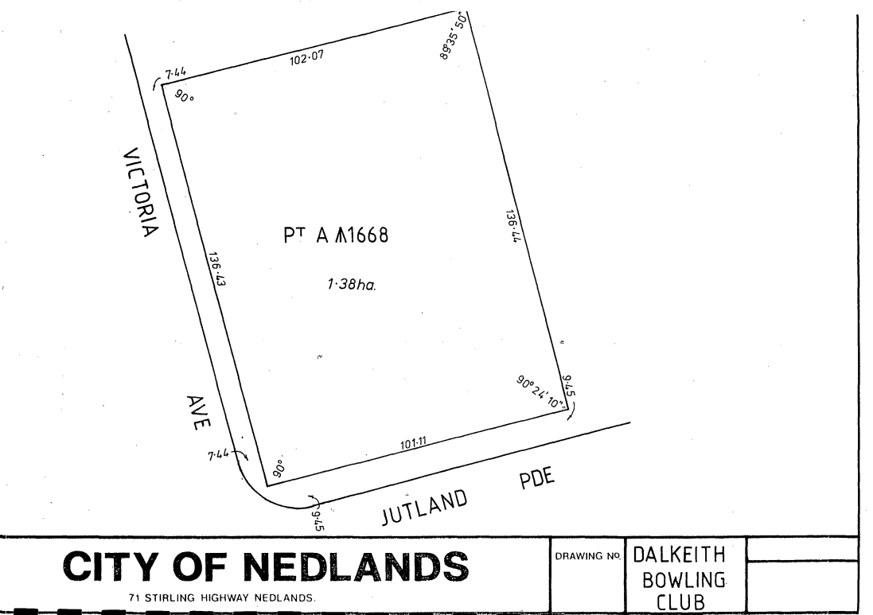

To identify the lease area more clearly, the following lease area sketch is proposed as an annexure to the lease should Council resolve to approve a new agreement.

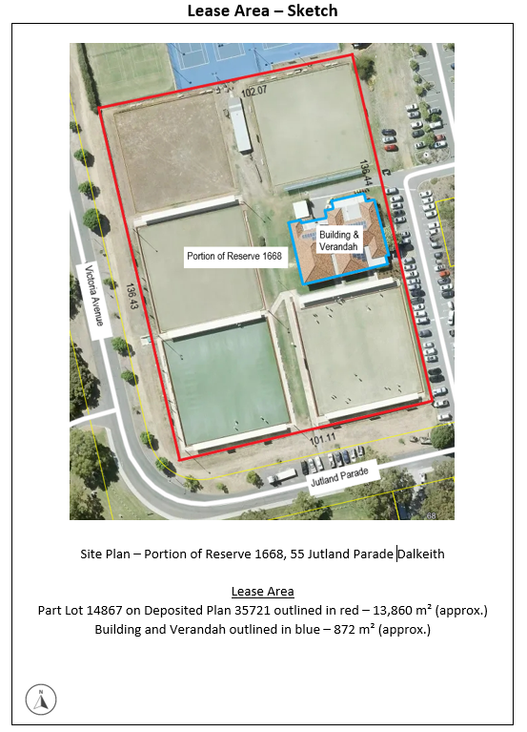

Consultation

Upon receiving the request from the Dalkeith Nedlands Bowling Club for a new lease for portion of Reserve 1668, 55 Jutland Parade Dalkeith, the City carried out the following internal engagement.

Planning Services
The City’s Planning Services Team advised they have no objections to land tenure arrangement, but suggested clauses be included within the agreement to ensure the Applicant understands no alterations or additions are to made without statutory approvals being obtained.

Community Development
The City’s Community Development Team advised they support Dalkeith Nedlands Bowling Club’s request for a new lease. The request is consistent with Council’s strategic priority of providing for sport and recreation.

Land & Property
The City’s Land & Property Team advised they have no objections to the land tenure arrangement. The proposed lease is consistent with the terms of the current arrangement and the inclusion of the updated survey sketch is of benefit to the City. The Key Terms as proposed within this report mitigate all risk to Council and do not have any cost implications either.

Strategic Implications

This item relates to the following elements from the City’s Strategic Community Plan.

Values Great Governance and Civic Leadership
We value our Council’s quality decision-making, effective and innovative leadership, transparency, accountability, equity, integrity and wise stewardship of the community’s assets and resources. We have an involved community and collaborate with others, valuing respectful debate and deliberation.

Budget/Financial Implications

The lease as proposed would be at no cost to Council.

Should elected members agree to the recommendation as proposed, the new lease would be prepared by a solicitor and full costs would be on-charged to the proponent.

Legislative and Policy Implications

The City is bound by specific conditions under the Local Government Act 1995 with regard to the disposal of property. Section 3.58 of the Act enables a local government to dispose of a property to the highest bidder at a public auction, by way of a public tender process or by giving local public notice of the proposed disposition and following the public consultation process as prescribed by sub-section section 3.58 (3) of the Act. In this context, disposing of a property means to ‘sell, lease or otherwise dispose of, whether absolutely or not’.

Considering the Dalkeith Nedlands Bowling Club are an incorporated recreational sporting body, they are eligible for an exemption to section 3.58 of the Local Government Act 1995 pursuant to Regulation 30 of the Local Government (Functions and General) Regulations 1996, therefore the proposed disposal of land is not required to be advertised.

Proposals to lease or licence land for a community/recreational purpose will be subject to the terms of the City’s ‘Use of Council Facilities for Community Purposes Policy’.

Crown land reserves vested to the City by way of a Management Order are generally subject to conditions. Consent is required from the Minister for Lands prior to formalising any lease agreement for Reserve 1668.

Decision Implications

Should Council resolve to approve the disposal of a 13,860 m² (approx.) portion of Reserve 1668 to the Dalkeith Nedlands Bowling Club by way of lease, Officers will instruct the City’s solicitor to prepare a lease in accordance with the key terms contained within this report at the full cost of the Lessee.

If Council do not resolve to approve the disposal of a 13,860 m² (approx.) portion of Reserve 1668 to the Dalkeith Nedlands Bowling Club by way of a lease, the proponent will not be able to secure tenure and will have to consider their future within the City. The lease expiry date is 27 September 2022.

Conclusion

The Dalkeith Nedlands Bowling Club have occupied the facility on portion of Reserve 1668 from circa 1950. Their lease will expire on 27 September 2022 and does not provide an option for a further term. To allow their operations to continue, the Dalkeith Nedlands Bowling Club are seeking Council approval to continue using a 13,860 m² (approx.) portion of Reserve 1668, 55 Jutland Parade Dalkeith in accordance with a lease for the purpose of lawn bowls and clubrooms and uses reasonably ancillary thereto.

Officers believe this request can be accommodated without significant changes to the current arrangement. Additionally, the proposal presents an opportunity for social engagement contributing to the health and well-being of the community.

Further Information

Questions or Requests for Further Information

Councillor Youngman – Can the bowling club be asked to monitor their water usage as part of the lease agreement?

Councillor Mangano – Can signs be included in lease which firmly identifies how many signs and what types of signs can be displayed?

CPS47.10.22 Monthly Financial Report – September 2022

This item will be dealt with at the Ordinary Council Meeting.

CPS48.10.22 Monthly Investment Report – September 2022

This item will be dealt with at the Ordinary Council Meeting.

CPS49.10.22 List of Accounts Paid – September 2022

This item will be dealt with at the Ordinary Council Meeting.

Council Members Notice of Motions of Which Previous Notice Has Been Given

This item will be dealt with at the Ordinary Council Meeting.

Urgent Business Approved By the Presiding Member or By Decision

This item will be dealt with at the Ordinary Council Meeting.

Confidential Items

Confidential items to be discussed at this point.

Declaration of Closure

There being no further business, the Presiding Member declared the meeting closed at 7.09pm.

