

**NOTES**

**Council Meeting Agenda Forum**

**Tuesday, 14 November 2023**

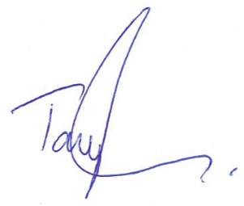

**Tony Free | Acting Chief Executive Officer**

17 November 2023

**Information**

Council Meeting Agenda Forum are run in accordance with the City of Nedlands Governance Framework Policy. If you have any questions in relation to the agenda, procedural matters, addressing the Council or attending these meetings please contact the Executive Officer on 9273 3500 or [council@nedlands.wa.gov.au](mailto:council@nedlands.wa.gov.au)

**Public Question Time**

Public Questions are dealt with at the Ordinary Council Meeting.

**Deputations**

Members of the public may make presentations or ask questions on items contained within the agenda. Presentations are limited to 5 minutes. Members of the public must complete the online registration form available on the City’s website: [Public Address Registration Form | City of Nedlands](https://www.nedlands.wa.gov.au/public-address-registration-form)

**Disclaimer**

Members of the public who attend Council Meetings Agenda Forum should not act immediately on anything they hear at the meetings, without first seeking clarification of Council’s position. For example, by reference to the confirmed Minutes of Council meeting. Members of the public are also advised to wait for written advice from the Council prior to taking action on any matter that they may have before Council.

Any plans or documents in agendas and minutes may be subject to copyright. The express permission of the copyright owner must be obtained before copying any copyright material.

**Table of Contents**

1. Declaration of Opening 4

2. Present and Apologies and Leave of Absence (Previously Approved) 4

3. Public Question Time 4

4. Deputations 4

5. Requests for Leave of Absence 5

6. Petitions 5

7. Disclosures of Financial / Proximity Interest 5

7.1 Councillor Coghlan– Item 20.3 – CEO33.11.23 - Application for Payment of Training Costs – Councillor Coghlan 5

7.2 Councillor Hodsdon – Item 16.1 – PD47.11.23 - Consideration of Development Application – Additional use of ‘Holiday House’ to ‘Single House’ at 56 Williams Road, Nedlands 5

8. Disclosures of Interests Affecting Impartiality 6

9. Declarations by Members That They Have Not Given Due Consideration to Papers 6

10. Confirmation of Minutes 6

11. Announcements of the Presiding Member without discussion 6

12. Members Announcements without discussion 6

13. Matters for Which the Meeting May Be Closed 6

14. En Bloc Items 6

15. Minutes of Council Committees and Administrative Liaison Working Groups 7

15.1. Minutes of the following Committee Meetings (in date order) are to be received: 7

16. Divisional Reports - Planning & Development 7

16.1. PD47.11.23 - Consideration of Development Application – Additional use of ‘Holiday House’ to ‘Single House’ at 56 Williams Road, Nedlands 7

16.2. PD48.11.23 - Consideration of Development Application – Addition to Single House at 15 Watt Street, Swanbourne 7

16.3. PD49.11.23 - Consideration of Development Application - Residential - Single House at 24A Lisle Street, Mt Claremont 7

16.4. PD50.11.23 - Consideration of Development Application – Residential – Additions and Alterations to a Single House at 22 Wattle Avenue, Dalkeith 8

17. Divisional Reports - Technical Services 8

17.1. TS17.11.23 – Shirley Fyfe Park Gazebo – Waratah Avenue, Dalkeith 8

17.2. TS18.11.23 – Interstate Travel – Waste Expo Australian 2023 Participation 8

17.3. TS19.11.23 - Establishment and Appointment of Members – Integrated Transport Steering Committee 8

17.4. TS20.11.23 – Stanley Street & Florence Road Cul-de-sacs 8

18. Divisional Reports – Community Services & Development 9

18.1. CSD07.11.23 - Disability Access and Inclusion Plan 2023 - 2028 9

19. Divisional Reports - Corporate Services 9

19.1 CPS42.11.23 – Superannuation for Council Members 9

19.2 CPS43.11.23 - Monthly Financial Report - September 2023 10

19.3 CPS44.11.23 - Monthly Investment Report - September 2023 10

19.4 CPS45.11.23 - List of Accounts Paid - September 2023 10

19.5 CPS46.11.23 - Monthly Financial Report – October 2023 11

19.6 CPS47.11.23 - Monthly Investment Report - October 2023 11

19.7 CPS48.11.23 - List of Accounts Paid - October 2023 11

20. Reports by the Chief Executive Officer 11

20.1 CEO31.11.23 - Review of Register of Delegated Authority 11

20.2 CEO32.11.23 – Proposed Parking Amendment Local Law 11

20.3 CEO33.11.23 – Application for Payment of Training Costs – Councillor Coghlan 11

20.4 CEO34.11.23 – Register of Outstanding Council Resolutions 12

20.5 CEO35.11.23 – City of Nedlands Council Plan 2023-33 for Adoption 12

21. Council Members Notice of Motions of Which Previous Notice Has Been Given 12

22. Urgent Business Approved By the Presiding Member or By Decision 12

23. Confidential Items 12

24. Declaration of Closure 12

# Declaration of Opening

The Presiding Member declared the meeting open at 6.01pm and drew attention to the disclaimer on page 2 and advised the meeting is being livestreamed.

# Present and Apologies and Leave of Absence (Previously Approved)

**Councillors** Mayor F E M Argyle (Presiding Member)

Councillor B G Hodsdon Hollywood Ward

Councillor L J McManus Hollywood Ward

Councillor F J O Bennett Dalkeith Ward

Councillor H Amiry Coastal Ward

Councillor K A Smyth Coastal Ward

Councillor R A Coghlan Melvista Ward

Councillor B Brackenridge (online) Melvista Ward

**Staff** Mr T G Free Acting Chief Executive Officer

Mr M R Cole Director Corporate Services

Mr M K MacPherson Director Technical Services

Mr R A Winslow Acting Director Planning & Development

Mrs N M Ceric Executive Officer

Ms L J Kania Coordinator Governance & Risk

**Public** There were 13 members of the public present and 5 online.

**Press** Nil.

**Leave of Absence** None.

**(Previously Approved)**

**Apologies** Councillor N R Youngman Dalkeith Ward

# Public Question Time

Public questions will be dealt with at the Ordinary Council Meeting.

# Deputations

Deputations by members of the public who had completed Public Address Registration Forms.

Mr Craig Sanderson, spoke in support of item 16.2 - PD48.11.23 - Consideration of Development Application – Addition to Single House at 15 Watt Street, Swanbourne.

Mr Thomas Jaeger, spoke in opposition to item 16.3 - PD49.11.23 - Consideration of Development Application - Residential - Single House at 24A Lisle Street, Mt Claremont.

Dr Sophie Kittson, spoke in support of item 16.3 - PD49.11.23 - Consideration of Development Application - Residential - Single House at 24A Lisle Street, Mt Claremont.

Mr Ben Carter, spoke in opposition to the recommendation for item 16.4 - PD50.11.23 - Consideration of Development Application – Residential – Additions and Alterations to a Single House at 22 Wattle Avenue, Dalkeith.

Mr Mark Scarfone, spoke in support of item 16.4 - PD50.11.23 - Consideration of Development Application – Residential – Additions and Alterations to a Single House at 22 Wattle Avenue, Dalkeith.

# Requests for Leave of Absence

Any requests from Council Members for leave of absence will be dealt with at the Ordinary Council Meeting.

# Petitions

Petitions will be dealt with at the Ordinary Council Meeting.

# Disclosures of Financial / Proximity Interest

The Presiding Member reminded Council Members and Staff of the requirements of Section 5.65 of the Local Government Act to disclose any interest during the meeting when the matter is discussed.

* 1. Councillor Coghlan– Item 20.3 – CEO33.11.23 - Application for Payment of Training Costs – Councillor Coghlan

Councillor Coghlan disclosed a financial interest in item 20.3 – Application for Payment of Training Costs – Councillor Coghlan her interest being that she is the applicant. Councillor Coghlan declared that she would leave the room during discussion on this item.

* 1. Councillor Hodsdon – Item 16.1 – PD47.11.23 - Consideration of Development Application – Additional use of ‘Holiday House’ to ‘Single House’ at 56 Williams Road, Nedlands

Councillor Hodsdon disclosed a proximity interest in Item 16.1 – Consideration of Development Application – Additional use of ‘Holiday House’ to ‘Single House’ at 56 Williams Road, Nedlands, his interest being that he owns a property at 45 Meriwa Street, Nedlands. Councillor Hodsdon declared that he would leave the room during discussion on this item.

# Disclosures of Interests Affecting Impartiality

The Presiding Member reminded Council Members and Staff of the requirements of Council’s Code of Conduct in accordance with Section 5.103 of the Local Government Act.



There were no disclosures affecting impartiality.

# Declarations by Members That They Have Not Given Due Consideration to Papers

Nil.

# Confirmation of Minutes

This item will be dealt with at the Ordinary Council Meeting.

# Announcements of the Presiding Member without discussion

This item will be dealt with at the Ordinary Council Meeting.

# Members Announcements without discussion

This item will be dealt with at the Ordinary Council Meeting.

# Matters for Which the Meeting May Be Closed

For the convenience of the public, the following Confidential items are identified to be discussed behind closed doors, as the last items of business at this meeting.

Nil.

# En Bloc Items

This item will be dealt with at the Ordinary Council Meeting.

# Minutes of Council Committees and Administrative Liaison Working Groups



## Minutes of the following Committee Meetings (in date order) are to be received:

This is an information item only to receive the minutes of the various meetings held by the Council appointed Committees (N.B. This should not be confused with Council resolving to accept the recommendations of a particular Committee. Committee recommendations that require Council’s approval should be presented to Council for resolution via the relevant departmental reports).

This item will be dealt with at the Ordinary Council Meeting.

# Divisional Reports - Planning & Development



## PD47.11.23 - Consideration of Development Application – Additional use of ‘Holiday House’ to ‘Single House’ at 56 Williams Road, Nedlands

Councillor Hodsdon left the room at 6.26 pm.

**Requests for Further Information**

Nil.

Councillor Hodsdon returned to the room at 6.29 pm.

## PD48.11.23 - Consideration of Development Application – Addition to Single House at 15 Watt Street, Swanbourne

**Requests for Further Information**

Nil.

## PD49.11.23 - Consideration of Development Application - Residential - Single House at 24A Lisle Street, Mt Claremont

**Requests for Further Information**

Nil.

## PD50.11.23 - Consideration of Development Application – Residential – Additions and Alterations to a Single House at 22 Wattle Avenue, Dalkeith

**Requests for Further Information**

Nil.

# Divisional Reports - Technical Services



## TS17.11.23 – Shirley Fyfe Park Gazebo – Waratah Avenue, Dalkeith

**Requests for Further Information**

Councillor Bennett – could something similar to our park bench policy be implemented for this project?

## TS18.11.23 – Interstate Travel – Waste Expo Australian 2023 Participation

**Requests for Further Information**

Nil.

## TS19.11.23 - Establishment and Appointment of Members – Integrated Transport Steering Committee

**Requests for Further Information**

Nil.

## TS20.11.23 – Stanley Street & Florence Road Cul-de-sacs

**Requests for Further Information**

Councillor Hodsdon – is the laneway option no longer an option – could we approach Woolworths?

Councillor Smyth - Regarding all Scenarios: other than at the one-way constrictions, is the traffic flow in Florence and Stanley intended to be two-way or one-way?

Councillor Smyth - Regarding Scenario 4: how can the one-way constriction be configured to allow for the new the driveway of the recent 3 lot subdivision at 8 Florence Road? Noting that the driveway for all 3 lots is on the northern boundary abutting the Woolworths development.

# Divisional Reports – Community Services & Development



## CSD07.11.23 - Disability Access and Inclusion Plan 2023 - 2028

**Requests for Further Information**

Nil.

# Divisional Reports - Corporate Services



## CPS42.11.23 – Superannuation for Council Members

**Requests for Further Information**

Councillor Smyth

1. Comparison of Superannuation

What are the projections for staff (KMP) superannuation as incrementally increase to 12% ($266,460 plus)?

What proportion of this is for payments above the threshold?

|  |  |  |
| --- | --- | --- |
| Fin Year Super Contributions | Council Members | City Staff |
| 2021.22 | $0 | $266,460 |
| 2022-23 | $0 | ? |
| 2023-24 (Super 11%) | $33,898 | ? |
| 2024-25 (Super 11.5%) | $35,439 | ? |
| 2025-26 (Super 12%) | $36,980 | ? |

**2. Comparison of Fringe Benefit Tax**

What are the projections for staff (KMP) fringe benefits within the salaries ($2,464,635 plus)?

What is the FBT liability for all staff compared to the estimated $28,732 for Council? How is Councillor ICT allowance currently taxed?

What is the projected change to FBT liability with the roll-out of Laptop (portable workstations) to all staff?

1. Savings from Council Reduction

Regarding Special Council Meeting Agenda 13 February 2023 - Item 8. CEO01.02.23 Review of Wards and Representation - Special Council Meeting Agenda 13 February 2023

“Budget/Financial Implications The proposed reforms may result in a reduction in costs. Based on the 2022/23 Councillor fees and allowances, a reduction in Councillor numbers from 12 to 8 would save the City of Nedlands approximately $110,000 per annum.”

Has this estimated savings been realised bringing the overall cost of Mayor and 8 Councillors to approximately $320K the equivalent of our CEO package?

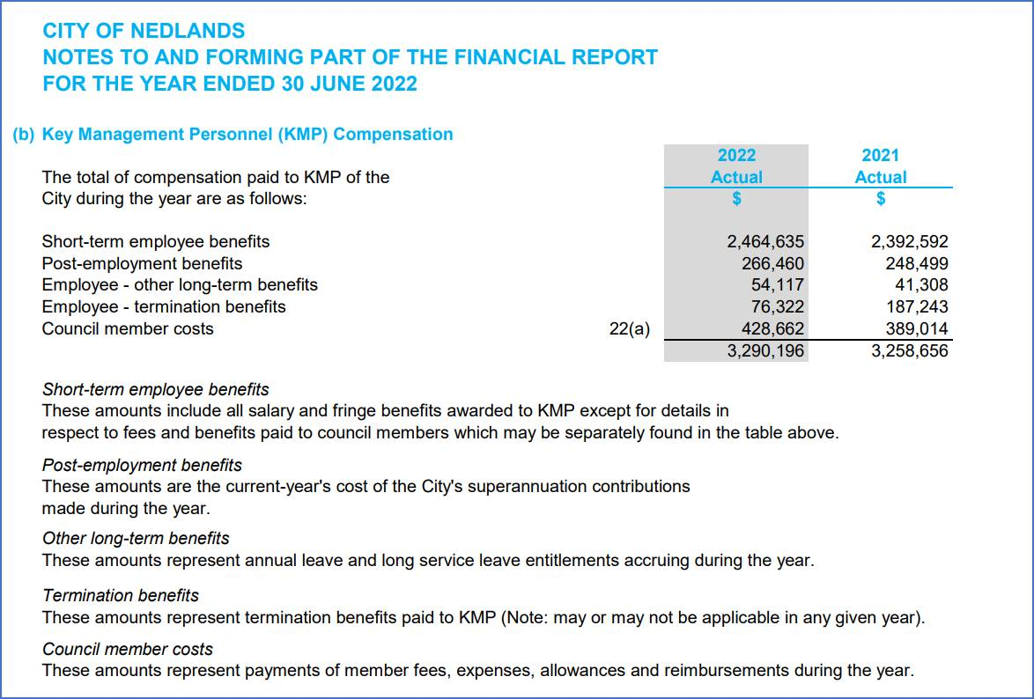

## CPS43.11.23 - Monthly Financial Report - September 2023

This item will be dealt with at the Council Meeting.

## CPS44.11.23 - Monthly Investment Report - September 2023

This item will be dealt with at the Council Meeting.

## CPS45.11.23 - List of Accounts Paid - September 2023

This item will be dealt with at the Council Meeting.

## CPS46.11.23 - Monthly Financial Report – October 2023

This item will be dealt with at the Council Meeting.

## CPS47.11.23 - Monthly Investment Report - October 2023

This item will be dealt with at the Council Meeting.

## CPS48.11.23 - List of Accounts Paid - October 2023

This item will be dealt with at the Council Meeting.

# Reports by the Chief Executive Officer



## CEO31.11.23 - Review of Register of Delegated Authority

**Requests for Further Information**

Nil.

## CEO32.11.23 – Proposed Parking Amendment Local Law

**Requests for Further Information**

Nil.

## CEO33.11.23 – Application for Payment of Training Costs – Councillor Coghlan

Councillor Coghlan left the room at 7.15pm.

**Requests for Further Information**

Mayor Argyle – What is the current budget allocation for Elected Member training? Is this budget allocated per Council Member?

## CEO34.11.23 – Register of Outstanding Council Resolutions

**Requests for Further Information**

Nil.

## CEO35.11.23 – City of Nedlands Council Plan 2023-33 for Adoption

**Requests for Further Information**

Nil.

# Council Members Notice of Motions of Which Previous Notice Has Been Given

This item will be dealt with at the Ordinary Council Meeting.

# Urgent Business Approved By the Presiding Member or By Decision

This item will be dealt with at the Ordinary Council Meeting.

# Confidential Items

Confidential items to be discussed at this point.

Nil.

# Declaration of Closure

There being no further business, the Presiding Member declared the meeting closed at 7.17 pm.