Planning and Development Reports

Committee Consideration – 4 December 2018

Council Resolution – 18 December 2018

Table of Contents

Item No. Page No.

PD66.18 No. 29A Carrington Street, Nedlands – Proposed Animal Establishment (Dog Day Care) (Use Not Listed) 2
PD67.18 No. 2/23 Carrington Street, Nedlands – Proposed Additional Customer Seating (Retrospective) for Brick Alley Café – Change of Use Restaurant 10
PD68.18 No. 42 Kirwan Street, Floreat – Additions (Two Carports) to Existing Single Dwelling 17
PD69.18 No. 50 Florence Road, Nedlands – Amendment to Existing Approval (DA17/306) 23
PD70.18 No. 7 Nardina Crescent, Dalkeith – Proposed Street Boundary Fencing (Retrospective) 29
PD71.18 No. 82 Kingsway, Nedlands – Front Fencing addition to Single House 35
PD72.18 No. 11B Brockway Road, Mount Claremont – Two Storey Single House 40
PD73.18 Scheme Amendment No. 214 – Lot 381 (No.45) Carrington Street, Nedlands 47
PD74.18 Christ Church Grammar School - Possible Acquisition of Landfill Site 52
PD75.18 West Australian Bridge Club Inc. at Reserve 7804, Swanbourne – Extension to Lease Term 58

PD66.18 | No. 29A Carrington Street, Nedlands – Proposed Animal Establishment (Dog Day Care) (Use Not Listed)
Committee | 4 December 2018
Council | 18 December 2018
Applicant | Canine Lounge
Landowner | A and D Ognenis
Director | Peter Mickleson – Director Planning & Development
Reference | DA18/31110
Previous Item | Nil.
Delegation | In accordance with Clause 6.7.1a) of the City’s Instrument of Delegation, Council is required to determine the application due to objections being received.
Attachments | 1. Photograph of the subject property

- Executive Summary

The purpose of this report is for Council to consider a development application received on 6 September 2018 for a dog day care to operate at 29A Carrington Street, Nedlands.

Plans received for the application were advertised to adjoining neighbours in accordance with clause 2.1 of Council’s Neighbour Consultation Policy due to the proposal being classified as a use not listed under Town Planning Scheme No. 2 (TPS 2).

Twelve (12) objections and 1 non-objection were received during the advertising period.

Considering the scale and nature of the proposal it is assessed that the proposal is unlikely to have a significant adverse impact on the local amenity. Accordingly, it is recommended that Council approves the application.

- Recommendation to Committee

Council approves the development application dated 6 September 2018 to operate a dog day care business at Lot 387 (29A) Carrington Street, Nedlands, subject to the following conditions and advice:

- The development shall at all times comply with the application and the approved plans, subject to any modifications required as a consequence of any condition(s) of this approval.

- All stormwater from the development, which includes permeable and non-permeable areas, shall be contained onsite

- No animals shall be kept on the premises overnight.

- No more than two staff members being on site at any given time.

- A maximum of 30 dogs are permitted on site at any one time.

- The recommendations in the environment noise assessment prepared by EcoAcoustics dated 23 August 2018 being implemented prior to the business commencing, and be complied with thereafter by the applicant, to the City’s satisfaction.

- The recommendations under sections 3 to 6 of the waste management plan prepared by Move Consultants dated August 2018 being implemented prior to the business commencing, and be complied with thereafter by the applicant, to the City’s satisfaction.

- An amended site plan being provided as part of the building permit application which shows at least 1 acrod (disabled) car parking bay being provided on site in accordance with AS 2890.6 2009 and AS 1428.1 2009.

- The acrod bay is to be provided on site prior to the use commencing.

- Prior to the use commencing 2 of the onsite car parking bays being marked by the applicant as being for staff only, to the City’s satisfaction.

- The onsite car parking bays for the unit being continually maintained by the applicant to the City’s satisfaction.

- The use only being permitted to operate between Monday and Friday 7:30am and 6:00pm (excluding public holidays).

- No dogs being kept on the premises outside of the permitted operating hours.

- Dog care spaces are to be booked in advance with no ‘same day’ ‘drop-ins’ permitted.

- Service and/or delivery vehicles shall not to service the premises before 7:00am or after 7:00pm Monday to Saturday or before 9:00am or after 7:00pm on any Sunday or public holiday, unless otherwise approved by the City.

- The signage being maintained by the applicant to the City’s satisfaction.

Advice Notes specific to this proposal:

- This decision constitutes planning approval only and is valid for a period of two years from the date of approval. If the subject development is not substantially commenced within the two-year period, the approval shall lapse and be of no further effect.

- A separate development applicant is required to be lodged with and approved by the City prior to installing any further signage not part of this approval, and if the number of dogs and/or staff stipulated in this approval is proposed to be increased.

- Noise levels are to comply with the Environmental Protection (Noise) Regulations 1997.

- The business shall not commence operating unless a Trade Waste Permit has been issued by the Water Corporation and/or the Water Corporation is satisfied with the premises’ drainage to sewer;

- No washing or cleaning activity or disposing of liquid wastes is to occur outside the building, or anywhere except as permitted by the Water Corporation;

- Arthropod pests and rodents shall be controlled such they are not harboured or allowed to breed at the premises;

- The premises shall be kept clean and sanitary and waste shall be kept frozen and contained in bags in dedicated freezers inside the premises building. Frozen bagged waste shall only be placed in rubbish bins on collection day;

- The applicant should ensure that they comply with the Pet Industry Association’s Standards and Guidelines for Best Practice - Boarding Facilities/Establishments and Doggy Day Care Centres.

- Background

3.1 Land Details

Land area | 696m²
Local Planning Scheme Zone | Light Industry
Metropolitan Region Scheme Zone | Urban

3.2 Previous Application

In February 2004, approval was granted for a hire service business at the premises with a shortfall of 4 car bays on site. The approved plans show 3 car bays adjacent to the Carrington Street side of the property, with a loading area/bay immediately adjacent to the property shown. This use has since ceased to operate.

3.3 Locality Plan

- Application Details

The applicant seeks approval for a dog day care to operate from the premises, details of which are as follows:

- Up to 30 dogs per day are proposed at the premises;
- A maximum of 2 staff are proposed to be on site at any one time;
- The proposed hours of operation are between Monday and Friday 7.30am to 6.00pm (excluding public holidays);
- Drop-off and pick-up times are proposed to be between 7.30am and 8.30am, and 4.30pm and 6.00pm. Half day care is also proposed to be available, with drop-off and pick-up times between 12.00pm and 1.00pm;
- Dog care spaces are proposed to be booked in advance with no ‘same day’ ‘drop-ins’ permitted;
- A Waste Management Plan and an Environmental Noise Assessment were commissioned by the applicant which show that the use would comply with the requirements;
- A traffic Engineering Review commissioned by the applicant concludes that the use is unlikely to create traffic and/or parking issues; and
- Three on site car parking bays are proposed to be available on the Carrington Street side of the property. Four street car parking bays are proposed to immediately adjoin the building where previously a loading bay/area was approved to be located.

- Consultation

The application was advertised in accordance with clause 2.1 of Council’s Neighbour Consultation Policy. Twelve (12) objections and 1 non-objection were received during the advertising period. The following is a summary of the concerns raised:

- Potential car parking issues if the application is approved;
- Vehicles reversing onto Carrington Street potentially creating safety issues;
- Potential noise impacts on nearby properties;
- Dogs potentially remaining on the premises overnight if not collected by their owners;
- Potential impact on property prices;
- Dogs being escorted to and from the building potentially being a risk to passers-by.
- There already being similar uses nearby already; and
- Use of Carrington Street dog park by the dog day care.

Note: A full copy of all relevant consultation feedback received by the City has been given to the Councillors prior to the Council meeting.

- Assessment of Statutory Provisions

6.1 Planning and Development (Local Planning Schemes) Regulations 2015

Schedule 2, Part 9, clause 67 (Matters to be considered by local government) stipulates those matters that are required to be given due regard to the extent relevant to the application. Where relevant, these matters are discussed in the following sections.

Under the Regulations a dog day care is deemed to be an animal establishment which under the Regulations is defined as being the following:

“animal establishment means premises used for the breeding, boarding, training or caring of animals for commercial purposes but does not include animal husbandry — intensive or veterinary centre.”

6.2 Metropolitan Region Scheme

The subject site is zoned ‘Urban’ under the Metropolitan Region Scheme (MRS). The proposal is an urban use and is therefore consistent with the zoning classification under the MRS.

6.3 City of Nedlands Town Planning Scheme No. 2

Under the provisions of the Scheme the subject site is zoned Light Industry.

A ‘Dog Day Care’ (Animal Establishment) is a use not listed under TPS 2.

6.3.1 Amenity

Under clause 5.5.1 Council may refuse to approve any development if:

“in its opinion the development would adversely affect the amenity of the surrounding area having regard to the likely effect on the locality in terms of the external appearance of the development, traffic congestion and hazard, noise or any other factor inconsistent with the use for which the lot is zoned.”

In accordance with provisions (m), (n) and (s) of the Regulations clause 67, due regard is to be given to the potential impact the proposal will have on the local amenity, and the availability of car parking bays.

6.3.2 Car Parking

Under Schedule III (Carparking Requirement by Use Class) of TPS 2 no requirements are stipulated for such a use therefore the required number of bays is at Council’s discretion.

- Budget / Financial Implications

N/A

- Risk management

N/A

- Administration Comment

Having had regard to the matters stipulated under the Regulations and the submissions received, the following is advised:

9.1 Car Parking

The proposed car parking supply for the site is 3 on-site bays for staff, located at the front of the premises.

Four (4) street car parking bays are adjacent to the premises.

A 4-car bay shortfall currently exists for the entire property.

Parking on Carrington Street limited to 30 minutes between 8am and 6pm Monday to Friday and 8am to 1pm on Saturday.

It is anticipated that clients will spend a maximum of 5 minutes during drop off and collection times. Dog care spaces are booked in advance with no same day ‘drop-ins’ permitted.

Service and delivery vehicles are proposed to undertake activities outside of peak periods.

A traffic engineering review (TER) was provided by the applicant to demonstrate how vehicle movements and parking can be accommodated for the business. The review concludes that peak hour traffic and parking for morning and afternoon drop-off and collection can be accommodated based on available parking on Carrington Street.

The City engaged a Traffic Consultant to review the TER received and they advised the following:

“We agree that the total trips would remain well below the WAPC assessment threshold of 100 trips per day.”

“This is a change of use. It does not appear that the TER has deducted the previous use from the existing background traffic. This reinforces the view that the traffic impact would be minimal.”

“We concur that sight distance is adequate at this location.”

“We agree that the parking supply proposed is sufficient for normal use. The random nature of customer arrival times means that there is a probability of the parking demand exceeding supply for short periods of time. This is unlikely to have a significant impact due to the availability of nearby street parking and the short-term nature of customer parking.”

“The TER asserts that short term parking by business clients is a reasonable use of the public street. We concur because:

- In a commercial area, with street frontage, it is normal for business customers to use street parking; and
- The forward bays of the tandem arrangement would be used by staff and the rear tandem bays would generally be used by customers who stay for a very short time. Blocking in is unlikely.”

Considering the above, the proposal is unlikely to have a significant impact on the availability of car parking within the local area and/or on traffic safety.

9.2 Noise

The applicant has submitted an Environmental Noise Assessment which was reviewed and is considered to sufficiently address the noise related concerns.

If the application is approved a condition of approval is recommended requiring that the business (applicant) comply with the management recommendations included in the Environmental Noise Assessment at all times which include the following:

- Internal pens are to have soft fall floors, such as rubber matting or the like;
- Investigations to be made into the installation of an acoustically absorptive panelling on either the ceiling or walls. Such products could include:
- perforated timber panelling internally lined with insulation;
- Basotect (or similar) panels cut into shapes and direct fixed to the walls;
- Autex ABC absorptive panels directly fixed to the walls/ceiling; or
- Rigid wall insulation panels (black faced) cut into shapes and directly fixed to the walls.

Any noise from barking dogs will be managed in terms of the recommendations contained in the Noise assessment.

The Noise Assessment also advises that the dog day care centre proposed will not allow for the overnight boarding of dogs within the premises.

Considering the above, the proposal will comply with the Environmental Protection (Noise) Regulations 1997 if the recommendations contained within the Noise Assessment are implemented.

Concerns were raised during the advertising period regarding dogs potentially remaining on the premises overnight if not collected by their owners and the noise issues this may create. The applicant has advised the following in response:

“Under no circumstances will dogs stay overnight at the premises. This would be ignoring my duty of care to them. Each owner will have to provide contact details of two additional people who will be allowed to pick up the dog and will be contacted if the primary carer has not picked up the dog. There will be a late pickup fee payable as well as the risk of being banned from using the facility. If, despite these precautions, the dog is still not collected, I will take it home with me overnight.”

If the application is approved by Council, it is recommended that a condition be included stating that no dogs are to remain on the premises outside of operating hours.

9.3 Waste Management

The applicant has submitted a waste management plan which was reviewed, and this is considered to be acceptable to the City.

If the application is approved by Council, it is recommended that a condition be included which requires the landowner to implement the management recommendations included under sections 3 to 6 of the waste management plan.

9.4 Other Matters

During the advertising period concerns were received in relation to:

- the potential impact on property prices;
- there already being similar uses nearby already; and
- use of the nearby dog park by the business.

Council is not required to have regard to matters relating to potential impacts on property prices and/or similar uses already existing when determining the application, in accordance with the Planning and Development (Local Planning Schemes) Regulations 2015.

Regarding those associated with the proposed business using the Carrington Street dog park, there is no restriction prohibiting the applicant from using the park to exercise dogs as long as it is in accordance with the City’s Dogs Local Law.

Considering the scale and nature of the proposal it is unlikely to have a significant adverse impact on the local amenity. Accordingly, it is recommended that Council approves the application.

PD67.18 | No. 2/23 Carrington Street, Nedlands – Proposed Additional Customer Seating (Retrospective) for Brick Alley Café – Change of Use Restaurant
Committee | 4 December 2018
Council | 18 December 2018
Applicant | L and F Martin
Landowner | L and F Martin
Director | Peter Mickleson – Director Planning & Development
Reference | DA18/29389
Previous Item | Item PD06.18 – February 2018
Delegation | In accordance with Clause 6.7.1a) of the City’s Instrument of Delegation, Council is required to determine the application due to an objection being received.
Attachments | - Photographs of the subject property

- Executive Summary

The purpose of this report is for Council to consider a retrospective development application received from the applicant on 7 June 2018 for 13 additional customer seats to remain at 2/23 Carrington Street, Nedlands. The land use approved for the site is “Lunch Bar” however the site is currently operating as a café (restaurant) within the Light Industrial area which is a prohibited land use and therefore cannot be approved.

Plans received for the application were advertised to adjoining neighbours in accordance with clause 2.1 of Council’s Neighbour Consultation Policy. One (1) objection was received during the advertising period which raised concerns regarding:

- Potential car parking issues if the application is approved.
- Potential noise impacts on nearby properties.

Given that the scale of the land use has exceeded its current approval by which reclassifies the land use from “lunch bar’ to ‘restaurant’ the City is concerned about potential land use conflicts within this light industry zoned site and does not believe that a restaurant café is an appropriate land use for this zone. Accordingly, it is recommended that the Council refuse the application for retrospective additional seating which reclassifies the land use to restaurant (including café) which is a prohibited land use in the Light Industry zone.

Under draft Local Planning Scheme No. 3, the property is proposed to be zoned Service Commercial. Within this zoning, a restaurant/café would not be permitted.

- Recommendation to Committee

Council refuses the retrospective development application dated 7 June 2018 to increase the number of customer seats from 6 to 19 resulting in a Change of Use from Lunch Bar to Restaurant at Lot 102 (2/23) Carrington Street, Nedlands, for the following reasons:

- The current retrospective operating land use being deemed to be a restaurant which is a use not permitted within the Light Industry zone under Table 1 (Use Class Table) of Town Planning Scheme No. 2.

- The development and use are contrary to the terms of an approved development application for a lunch bar and contrary to conditions attached to that approval in accordance with Clause 6.6b of Town Planning Scheme No. 2.

- A restaurant (café) land use located in a light industrial zone contravenes orderly and proper planning and gives rise to potential future and current land use conflict in the light industrial zone.

- As a restaurant the proposal land use does not comply with Schedule III – Car Parking Requirement by Use Class of Town Planning Scheme No.2 representing a 17-car parking bay shortfall.

- The proposal does not satisfy provisions (m), (n) and (s) of Clause 67 within the Planning and Development (Local Planning Schemes) Regulations 2015, as the proposal will likely create car parking issues within the locality considering its nature and scale.

Advice to Applicant

- The current approval for lunch bar dated February 2018 remains valid and the conditions associated with land use and numbers of customer seating forms part of that approval and shall be complied with. The applicant is required to remove the additional unauthorised seating including outdoor tables and chairs within 14 days of receipt of Council’s decision in order to avoid compliance action in accordance with the Planning and Development Act 2005.

- The applicant is advised that if it wishes to operate a Café “Restaurant” on this site in this light industrial zone that they may apply for an application to amend the Town Planning Scheme for an Additional Use “Restaurant” and provide all relevant information to the City in accordance with the Planning and Development Local Planning Scheme Regulations (2015) Through that statutory process the City will consider whether or not in this particular instance, a Café “Restaurant” land use should be permitted as an exception to the Scheme, Table 1 Use Class Table and determine whether or not it is appropriate within the light industry zone.

- The applicant is advised that the existing wall signage on the external façade of the building is to be removed within 14 days from the date of this decision to the City’s satisfaction. Alternatively, a separate (retrospective) development application is required to be submitted within 14 days from the date of this decision for it to possibly remain.

- Background

3.1 Land Details

Land area | 1,392m²
Local Planning Scheme Zone | Light Industry
Metropolitan Region Scheme Zone | Urban

3.2 Previous Application

In February 2018, Council resolved to approve an application for a lunch bar to operate at the subject property. This was subject to the following conditions, amongst others:

“1. The development shall at all times comply with the approved plans;

2. The proposed use complying with the lunch bar definition stipulated under the City's Town Planning Scheme No. 2 (refer to advice note 1).”

“5. A maximum of 6 seats being available for customers.”

“8. The lunch bar only being permitted to operate between Monday and Friday 6.00am to 5.00pm, and Saturdays 7.00am to 4.00pm.”

Subsequently the City became aware during an inspection of the premises that 19 customer seats were available.

3.3 Locality Plan

City’s depot

- Application Details

The applicant currently seeks retrospective development approval for additional customer seating but has not indicated that this will result in a land use re-classification to “restaurant”. The details of which are as follows:

- The applicant has stated that the premises are proposed to continue to be used as a lunch bar and be operated by 3 staff, 2 of whom are also employed to work in a commercial kitchen at Unit 1;
- Pre-packaged food such as toasties and sandwiches, cooked breakfasts, coffee and soft drinks are proposed to be available for customers;
- A maximum of 19 seats are proposed to be available for customers; and
- The use is proposed to operate between Monday and Friday 6.30am to 2.00pm, and Saturdays 7.30am to 1.00pm.

With the exception of the hours of operation and the proposed number of customer seats the way the business operates is to remain unchanged compared to when it was approved by Council previously as a lunch bar.

- Consultation

The application was advertised in accordance with clause 2.1 of Council’s Neighbour Consultation Policy. One (1) objection was received. The following is a summary of the concerns raised:

- Potential car parking issues if the application is approved.
- Potential noise impacts on nearby properties.

In addition to the submission a petition was received from the applicant which contains 103 signatures in support of the proposal.

Note: A full copy of all relevant consultation feedback and the petition received by the City has been given to the Councillors prior to the Council meeting.

- Assessment of Statutory Provisions

6.1 Planning and Development (Local Planning Schemes) Regulations 2015

Schedule 2, Part 9, clause 67 (Matters to be considered by local government) stipulates those matters that are required to be given due regard to the extent relevant to the application. Where relevant, these matters are discussed in the following sections.

6.2 Metropolitan Region Scheme

The subject site is zoned ‘Urban’ under the Metropolitan Region Scheme (MRS). The proposal is an urban use and is therefore consistent with the zoning classification under the MRS.

6.3 City of Nedlands Town Planning Scheme No. 2

Under the provisions of the Scheme the subject site is zoned Light Industry.

The uses Lunch Bar and Restaurant are defined as being the following under clause 1.8 (Interpretations) of TPS 2:

“Lunch Bar - means premises used for the preparation and/or sale of take-away sandwiches and similar foodstuffs within industrial and commercial areas in a form ready to be consumed without further preparation off the premises.”

“Restaurant - means a building wherein food is prepared solely for sale and consumption within the building or portion thereof and (without limiting the generality of the foregoing) the expression includes a licensed restaurant, or cafe. The expression also includes a restaurant at which food for consumption outside the building, or portion thereof, is sold where the Council is of the opinion that the sale of food for consumption outside the building is not the principal part of the business. The expression shall also include an outdoor establishment and in that case for the purpose of this definition, the outdoor eating area shall be treated as being within the building of the restaurant;”

6.3.1 Amenity

Under clause 5.5.1 Council may refuse to approve any development if:

“in its opinion the development would adversely affect the amenity of the surrounding area having regard to the likely effect on the locality in terms of the external appearance of the development, traffic congestion and hazard, noise or any other factor inconsistent with the use for which the lot is zoned.”

In accordance with provisions (m), (n) and (s) of the Regulations clause 67, due regard is to be given to the potential impact the proposal will have on the local amenity, and the availability of car parking bays.

6.3.2 Car Parking

Under Schedule III (Carparking Requirement by Use Class) of TPS 2 no requirements are stipulated for a lunch bar therefore the required number of bays is at Council’s discretion.

As a restaurant land use the requirement for car parking is 1 bay per 2.6m2 of restaurant seating area, or 1 per 2 persons, whichever is greater. Persons means the number of persons for which a building has been designed or for whom seating is provided. Employee means any person employed in the building.

The seating area is approximately 32m² and 19 customer seats are proposed, therefore requires 19 car parking bays to be provided and contained on site.

The applicant has provided 2 on site car bays and therefore does not comply with the requirements of TPS 2.

6.3.3 Contravention and Non-Compliance

Clause 6.6 of the Scheme states that:

Subject to the Act a person shall not:

b) erect, alter or add to any building or carry out any other development or use contrary to the provisions of the Scheme or contrary to the terms of any approval by Council or the approved plans, or contrary to any condition attached to such approval.

- Budget / Financial Implications

N/A

- Risk management

N/A

- Administration Comment

The retrospective approval sought does not comply with Clause 6.6b of the Scheme whereby the application is contrary to the provisions regarding land use and Table 1 and is operating contrary to conditions imposed relating to land use type and numbers of seating. It is a condition of Council’s previous approval that the use complies with the lunch bar definition under TPS 2. The definition specifically refers to the preparation and/or sale of take away sandwiches and similar foodstuffs. The applicant has submitted that Cooked breakfasts are available for customers. These are not deemed to be “similar foodstuffs” under the lunch bar definition. There is no reference in Council’s previous decision to cooked breakfasts being able to be served nor does it accord with a lunch bar “take away” focussed land use.

Upon inspection and review of the menu available online, the operating business “Brick Alley Café’ is serving a wider range of food beyond that would be expected from a lunch bar and more aligned with what you would find from a café restaurant as alluded to in the name of the business.

From the inspection the cafe is operating as a sit down, eat and drink experience with the option of taking food and drink away, including tables and chairs set up in the private lane way. The operation is not designed as a “lunch bar” for convenient packaged food and is clearly named as a café.

Operating as a restaurant means that potentially customers are likely to remain on the premises for longer compared with a lunch bar which is primarily take away food, and therefore nearby car parking bays are likely to become less frequently available for this and other nearby businesses. It is however noted that the business services local employees in surrounding businesses who may already be parking in the local area on another site or on the street. This, however, does not negate the non-compliance with car parking requirements for the restaurant (café) land use as required by the Scheme.

The tables and chairs present in the common driveway are not permitted. This is not the intention of the common driveway as it is to provide for vehicular and pedestrian access to all light industrial tenancies. This gives the City cause for concern in terms of potential land use conflict situations with current and potential future light industrial land uses. In effect a café restaurant is operating in a light industrial factory unit and permitted uses such as mechanical repair or panel beating could in the future potentially co-locate within the subject site and this is not deemed to be orderly and proper planning.

In addition to the above, signage exists at the premises stating ‘’Brick Alley Café’. The TPS 2 definition for the restaurant land use includes a café.

The number of customer seats is proposed to be increased from 6 to 19 which aligns with to what can be expected for a cafe ‘restaurant’ land use.

The City has no discretion in the Scheme to approve a prohibited land use. The alternative pathway for the applicant is to apply to the City for an “Additional Use” by way of amending the Scheme. The City would then need to determine whether the land use is appropriate given the context of light industry and potential land use conflicts that may exist or be approvable in the future in a nearby proximity.

As the City has approved a lunch bar, which is deemed to be approvable and suitable in the Light Industry zone it is recommended by the City to the Applicant to comply with their original approval of February 2018 and revert their operations to a true “lunch bar” which is focussed on take away food sales rather than café / restaurant “sit down” meals.

Considering the above, the use is now deemed to be defined a restaurant which is not permitted within the Light Industry zone under TPS 2. According it is recommended that the retrospective application be refused.

PD68.18 | No. 42 Kirwan Street, Floreat – Additions (Two Carports) to Existing Single Dwelling
Committee | 4 December 2018
Council | 18 December 2018
Applicant | Classic Home & Garage Innovations Pty Ltd
Landowner | G Van Ierland and S Griffiths
Director | Peter Mickleson – Director Planning & Development
Reference | DA18-31588
Previous Item | Nil
Delegation | In accordance with Clause 6.7.1a) of the City’s Instrument of Delegation, Council is required to determine the application due to an objection being received.
Attachments | - Photographs of the carports’ proposed locations

- Executive Summary

The purpose of this report is for Council to consider a development application received from the applicant on 27 of September 2018, for two proposed carports at 42 Kirwan Street, Floreat.

The development proposes variations to the deemed-to-comply provisions of the Residential Design Codes (R-Codes) for lot boundary setbacks.

As part of the application one objection and one non-objection regarding the setback variations were received.

It is recommended that the application be approved by Council as it is considered to satisfy the design principles of the R-Codes and is unlikely to have a significant adverse impact on the local amenity as considered under the City of Nedlands Town Planning Scheme No.2 (the Scheme).

- Recommendation to Committee

Council approves the development application dated 27 September 2018 for additions (two carports) to the existing single dwelling at Lot 179 (42) Kirwan Street, Floreat, subject to the following conditions and advice:

- The development shall at all times comply with the application and the approved plans, subject to any modifications required as a consequence of any condition(s) of this approval.

- This development approval only pertains to the carports behind the street setback area, one being adjacent to the property’s eastern lot boundary and the other being adjacent to the western lot boundary.

- All footings and structures to the Carports, shall be constructed wholly inside the site boundaries of the property’s Certificate of Title.

- All stormwater from the development, which includes permeable and non-permeable areas shall be contained onsite.

Advice Notes specific to this proposal:

- Any development in the nature-strip (verge), including footpaths, will require a Nature-Strip Development Application (NSDA) to be lodged with, and approved by, the City’s Technical Services department, prior to construction commencing.

- All street tree assets in the nature-strip (verge) shall not be removed. Any approved street tree removals shall be undertaken by the City of Nedlands and paid for by the owner of the property where the development is proposed, unless otherwise approved under the Nature Strip Development approval.

- All downpipes from guttering shall be connected so as to discharge into drains, which shall empty into a soak-well; and each soak-well shall be located at least 1.8m from any building, and at least 1.8m from the boundary of the block. Soak-wells of adequate capacity to contain runoff from a 20-year recurrent storm event. Soak-wells shall be a minimum capacity of 1.0m³ for every 80m² of calculated surface area of the development.

- This decision constitutes planning approval only and is valid for a period of two years from the date of approval. If the subject development is not substantially commenced within the two-year period, the approval shall lapse and be of no further effect.

- Background

3.1 Land Details

Land area | 875m²
Local Planning Scheme Zone | Residential R12.5
Metropolitan Region Scheme Zone | Urban

3.2 Locality Plan

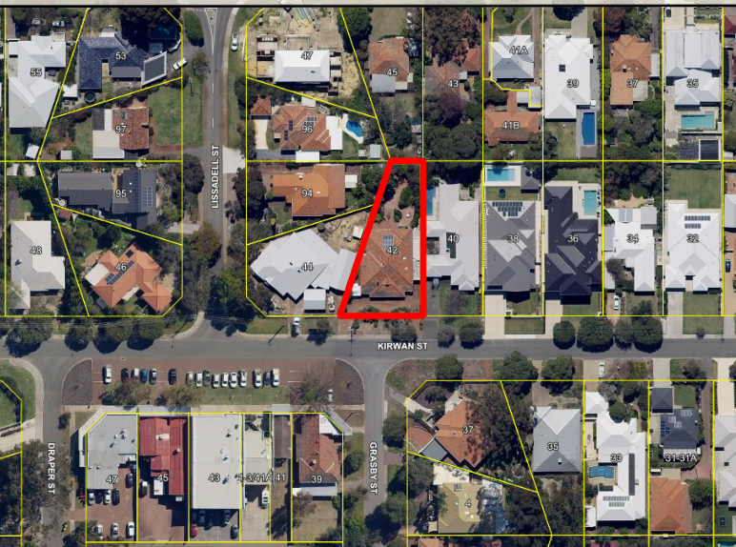

- Application Details

The applicant seeks approval to construct two carports, details of which are as follows:

- The proposed carports are to be flat roofed and located behind the property’s street setback area.
- A carport is proposed to be setback 0.5m in lieu of 1m from the eastern (side) lot boundary.
- Another carport is proposed to be setback between 0.7m and 1m in lieu of 1m from the western (side) lot boundary.
- No alterations are proposed to be made to the existing driveways and/or crossovers.

- Consultation

As part of the application one objection and one non-objection regarding the setback variations were received. The only concern raised was that the carport proposed adjacent to the western lot boundary was not setback in accordance with the requirements.

Note: A full copy of all relevant submissions received by the City has been given to the Councillors prior to the Council meeting.

- Assessment of Statutory Provisions

6.1 Planning and Development (Local Planning Schemes) Regulations 2015

Schedule 2, Part 9, clause 67 (Matters to be considered by local government) stipulates those matters that are required to be given due regard to the extent relevant to the application. Where relevant, these matters are discussed in the following sections.

In accordance with provisions (m) and (n) of the Regulations clause 67, due regard is to be given to the likely effect of the proposed development’s height, scale, bulk and appearance, and the potential impact it will have on the local amenity.

If Council does not support the proposed development, there is a right of review (appeal) to the State Administrative Tribunal (SAT) under Part 14 of the Planning and Development Act (2005)

6.2 Metropolitan Region Scheme

The subject site is zoned ‘Urban’ under the Metropolitan Region Scheme (MRS). The proposal is an urban use and is therefore consistent with the zoning classification under the MRS.

6.3 City of Nedlands Town Planning Scheme No. 2

6.3.1 Amenity

Under clause 5.5.1 Council may refuse to approve any development if:

“in its opinion the development would adversely affect the amenity of the surrounding area having regard to the likely effect on the locality in terms of the external appearance of the development, traffic congestion and hazard, noise or any other factor inconsistent with the use for which the lot is zoned.”

6.4 Policy Consideration

6.4.1 Residential Design Codes (State Planning Policy 3.1) - Lot Boundary Setbacks

Deemed-to-Comply  Requirement | Proposed | Complies?
C3.1 Buildings which are setback in accordance with the following provisions, subject to any additional measures or elements in the R-Codes:  - Buildings setback from lot boundaries in accordance with Table 1, Tables 2a and 2b (refer to Figure Series 3 and 4). | A carport is proposed to be setback 0.5m in lieu of 1m from the eastern (side) lot boundary.  Another carport is proposed to be setback between 0.7m and 1m in lieu of 1m from the western (side) lot boundary. | No

Design Principles

Variations to the deemed-to-comply requirements can be considered subject to satisfying the following Design Principle provisions:

“P3.1 Buildings set back from lot boundaries or adjacent buildings on the same
lot so as to:
- reduce impacts of building bulk on adjoining properties;
- provide adequate direct sun and ventilation to the building and open spaces on the site and adjoining properties; and
- minimise the extent of overlooking and resultant loss of privacy on adjoining properties.”

- Budget / Financial Implications

N/A

- Risk management

N/A

- Administration Comment

Having had regard to the matters stipulated under the Regulations and the submissions received, the following is advised:

9.1 Building Bulk

The proposed carports minimise the impact of building bulk on the adjoining properties in the following ways:

- Do not comprise large expanses of unarticulated blank wall surface;
- Are open ‘lightweight’ within height requirement; and
- Do not abut or adjoin any habitable rooms with major openings or any outdoor living areas.

9.2 Access to Direct Sunlight and Ventilation

The proposed carports maintain access to direct sunlight and ventilation to the adjoining properties in the following ways:

- The orientation of the property is north-south;
- The carports are located on the eastern and western lot boundaries and therefore do not restrict access to direct northern sunlight; and
- The open nature of the structures does not restrict ventilation or access to prevailing winds.

9.3 Minimising Loss of Privacy

The proposed carports minimise the extent of overlooking and loss of privacy to the adjoining dwellings in the following ways:

- Are non-habitable structures for the purpose of housing vehicles;
- Do not abut or adjoining any habitable rooms or outdoor living areas;
- Are situated adjacent to vehicle entry points and garages on both lot boundaries; and
- Existing dividing fencing along the western boundary provides effective screening.

9.4 Amenity

The proposed carports do not have an adverse impact on the amenity of adjoining properties or the locality as:

- They satisfy the relevant design principles of the R-Codes (as above);
- It is a form of development consistent with residential built form and consistent with the locality;
- They have minimal impact as viewed from the streetscape due to extensive screening vegetation along Kirwan Street; and
- They do not interfere with the residential use an occupation of outdoor living areas on adjoining properties.

9.5 Other Considerations

The following factors are taken into account in deeming the acceptability of the proposed carports:

- 42 Kirwan Street is situated immediately opposite a ‘T’ junction and as such vehicle access is limited to the periphery of the lot;
- A letter of non-objection was provided with the application for the eastern carport;
- The lot is irregular in shape, with an angled western lot boundary;
- Aligning buildings and structures to an oblique lot boundary while maintaining perpendicular development to the street frontage minimises development options; and
- The extent of the setback intrusion for the western lot boundary amounts to the north-western corner of the proposed carport.

In addition to satisfying the design principles of the R-Codes, the proposed carports are deemed to satisfy the amenity considerations provided in the Scheme. Accordingly, it is recommended that the Council approved the proposed development.

PD69.18 | No. 50 Florence Road, Nedlands – Amendment to Existing Approval (DA17/306)
Committee | 4 December 2018
Council | 18 December 2018
Applicant | Kensington Design Australia
Landowner | D Ganley and R Ganley
Director | Peter Mickleson – Director Planning & Development
Reference | DA18-30985
Previous Item | Item PD02.18 - 27 February 2018
Delegation | In accordance with Clause 6.7.1a) of the City’s Instrument of Delegation, Council is required to determine the application due to objections being received.
Attachments | - Site photographs

- Executive Summary

The purpose of this report is for Council to consider a development application received on 3 September 2018. The application proposes amendments to an approval for additions to the existing dwelling at 50 Florence Road, Dalkeith, which were previously approved by Council in February 2018. The components of the previous approval include a carport within the front setback area, a shed and patio at the rear of the property and additions to the rear of the existing dwelling.

The amendment seeks approval to remove the outbuilding and patio from the existing approval as well as minor alterations to setbacks. The setback alterations propose a variation to the deemed-to-comply provisions of the Residential Design Codes (R-Codes) for lot boundary setbacks.

The application was advertised to adjoining neighbours in accordance with clause 2.1 of Council’s Neighbour Consultation Policy. One objection was received during the advertising period.

It is recommended that the application be approved by Council as it is considered to satisfy the design principles of the R-Codes and is unlikely to have a significant adverse impact on the local amenity.

- Recommendation to Committee

Council approves the development application dated 3 September 2018 for Amendments to DA17/306 (additions to the existing dwelling) at Lot 389 (50) Florence Road, Dalkeith, subject to the following conditions and advice:

- The previous development approval (DA17/306, dated 7 March 2018) and conditions there-in, remain in effect. This application excludes the plans approved as part of the previous development application.

Advice Notes specific to this proposal:

- This decision constitutes planning approval only and is valid for a period of two years from the date of approval. If the subject development is not substantially commenced within the two-year period, the approval shall lapse and be of no further effect.
- Background

3.1 Land Details

Land area | 1,011.7m²
Local Planning Scheme Zone | Residential R10
Metropolitan Region Scheme Zone | Urban

3.2 Previous Application

A previous development application proposed to construct a single storey addition to the rear of the dwelling, a carport within the street setback area, an outbuilding 33m² in size up to the lot boundary and a patio at the rear of the property. On 27 February 2018 Council approved the development application subject to conditions. All but one variation was approved. Council conditioned the outbuilding proposed up to the lot boundary to be setback 1m from the lot boundary.

3.3 Locality Plan

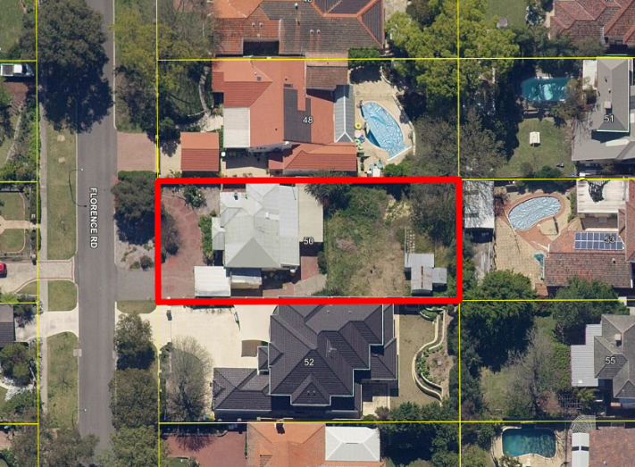

- Application Details

The applicant seeks approval for amendments to an existing development approval, details of which are as follows:

- Removal of a proposed shed (outbuilding) and pavilion from the plans;
- Minor internal alterations of bed 3 changing locations with the bathroom so as to be located further west;
- Reduced setback of bedrooms 2, 3 and bathroom from 3.2m to 2.77m to the southern lot boundary; and
- Alterations to the existing garage is currently setback 2m to a setback distance of 0.644m to the southern lot boundary.

- Consultation

The development application was advertised in accordance with clause 2.1 of Council’s Neighbour Consultation Policy. One objection was received. The following is a summary of the concerns raised relevant to the proposal:

- Concerns over glare from Colorbond roof from the carport and house;
- Request to relocate carport to northern boundary on the grounds of comprising building bulk and inconsistency with streetscape; and
- Request for garage to be setback in accordance with the Residential Design Codes (R-Codes).

Note: A full copy of all relevant consultation feedback received by the City has been given to the Councillors prior to the Council meeting.

- Assessment of Statutory Provisions

6.1 Planning and Development (Local Planning Schemes) Regulations 2015

Schedule 2, Part 9, clause 67 (Matters to be considered by local government) stipulates those matters that are required to be given due regard to the extent relevant to the application. Where relevant, these matters are discussed in the following sections.

In accordance with provisions (m) and (n) of the Regulations clause 67, due regard is to be given to the likely effect of the proposed development’s height, scale, bulk and appearance, and the potential impact it will have on the local amenity.

If Council does not support the proposed development, there is a right of review (appeal) to the State Administrative Tribunal (SAT) under Part 14 of the Planning and Development Act (2005)

6.2 Metropolitan Region Scheme

The subject site is zoned ‘Urban’ under the Metropolitan Region Scheme (MRS). The proposal is an urban use and is therefore consistent with the zoning classification under the MRS.

6.3 City of Nedlands Town Planning Scheme No. 2

6.3.1 Amenity

Under clause 5.5.1 Council may refuse to approve any development if:

“in its opinion the development would adversely affect the amenity of the surrounding area having regard to the likely effect on the locality in terms of the external appearance of the development, traffic congestion and hazard, noise or any other factor inconsistent with the use for which the lot is zoned.”
6.4 Policy Consideration

6.4.1 Residential Design Codes (State Planning Policy 3.1)

Lot Boundary Setback (5.1.3)

Deemed-to-Comply  Requirement | Proposed | Complies?
C3.1, i  Buildings setback from lot boundaries in accordance with Table 1, Tables 2a and 2b (refer to Figure Series 3 and 4)  Wall height(m) 3.5 or less by 13m length = 1.5m | Garage setback 0.644m to the southern lot boundary | No
Design Principles

Variations to the deemed-to-comply requirements can be considered subject to satisfying the following Design Principle provisions:

Buildings set back from lot boundaries or adjacent buildings on the same lot so as to:
- reduce impacts of building bulk on adjoining properties;
- provide adequate direct sun and ventilation to the building and open spaces on the site and adjoining properties; and
- minimise the extent of overlooking and resultant loss of privacy on adjoining properties.

- Other Issues Raised

N/A

- Budget / Financial Implications

N/A

- Risk management

N/A

- Administration Comment

Having had regard to the matters stipulated under the Regulations and the submissions received, the following is advised:

The submissions received during the advertising period refers to the location of the carport on the submitted plans. The proposed carport was approved by Council on 27 February 2018 in the indicated location. The carport does not comprise a part of this proposal.

10.1 Building Bulk

The proposed garage does not contribute unduly to building bulk on the adjoining property for the following reasons:

- Proportional to the length of the lot boundary the garage does not comprise large expanses of blank unarticulated wall surface;
- It is single storey in height;
- It is situated behind an existing 1.8m high brick wall along the shared lot boundary;
- The topography of 50 and 52 Florence Road slopes upward in an easterly direction, which results in the garage being between 0.5m and 1m below that of the main portion of the adjoining two storey dwelling;
- It does not abut any habitable rooms with major openings or outdoor living areas; and
- It is located behind the street setback and to be screened by the approved carport, mitigating its appearance as viewed from the street.

10.2 Access to Direct Sunlight and Ventilation

The proposed garage does not restrict access to direct sunlight and ventilation to the adjoining property as:

- It does not directly adjoin a habitable room with major openings or outdoor living areas and therefore does not affect any habitable living spaces;
- It is within the overshadowing requirements of the R-codes; and
- It is situated on a portion of the lot which does not restrict the adjoining property’s access to prevailing winds.

10.3 Minimising Loss of Privacy

The proposed garage minimises the extent of overlooking and loss of privacy of the adjoining dwelling as:

- It does not include any windows facing the adjoining property;
- It is not a habitable room and therefore not subject to the visual privacy requirements of the R-Codes;
- The existing brick wall (dividing fence) provides satisfactory screening to mitigate the impact of the garage; and
- The garage is positioned in a location which is 0.5m – 1m below that of the main portion of the adjoining dwelling due to the sloping topography of the lots.

10.4 Amenity

The proposed garage does not detrimentally impact on the amenity of the adjoining property of the locality as:

- It satisfies the design principles of the R-Codes; and
- It is located behind the street setback and an approved carport; thus, it’s built form is mitigated as viewed from the street.

10.5 Other Considerations

The proposed alterations to Bedrooms 2, 3 and the bathroom previously approved by Council on 27 February 2018 do not vary the requirements of the R-Codes. Accordingly, it is recommended that the proposed amended development application be approved.

PD70.18 | No. 7 Nardina Crescent, Dalkeith – Proposed Street Boundary Fencing (Retrospective)
Committee | 4 December 2018
Council | 18 December 2018
Applicant | C Wang
Landowner | C Wang
Director | Peter Mickleson – Director Planning & Development
Reference | DA2017/334
Previous Item | Item PD34.18 – July 2018
Delegation | Council has been requested by the SAT to reconsider its decision pursuant to Section 31(1) of the SAT Act 2004.
Attachments | - Photographs of the subject property

- Executive Summary

The purpose of this report is for Council to reconsider a retrospective development application for street boundary fencing which exists at 7 Nardina Crescent, Dalkeith, which Council resolved to approve at its July 2018 meeting subject to the following condition and advice, amongst others:

Condition:

“3. Amended plans being provided as part of the Building Certificate Application which shows the following alterations:

- The pillar for the letterbox on the northern side of the drive way being 0.5m in width; and
- The fencing on the southern side of the driveway consisting of one brick pier 1.9m in height and 0.5m in width, solid infill of 0.75m in height, and visually permeable infill up to 1.8m in height above natural ground level (refer to advice note 1).”

Advice Notes specific to this approval:

“1. The applicant is advised that a wall for the gas and electric meter is able to be located within the street setback area subject to being solid up to 1.8m in height, 1m in width, right aligned to the street, and not being closer than 1.5m from where a driveway meets the crossover on the subject property and/or an adjoining property.”

An appeal was lodged with the State Administrative Tribunal (the SAT) regarding Condition 3 and the proposal was discussed at a Mediation Hearing.

Amended plans have been received which show:

- The pillar for the letterbox on the northern side of the drive way being 0.5m in width;
- The fencing on the southern side of the driveway consisting of one brick pier 1.9m in height and 0.75m wide; and
- Visually permeable fencing of 1.8m in height within 1.5m of where the driveway meets the crossover.

After being reconsidered the matter is likely to go back to a Directions Hearing and/or a Full Hearing at the SAT, or the appeal maybe withdrawn by the applicant, depending on Council’s decision.

There is no statutory requirement for the amended plans to be advertised in accordance with Council’s Neighbour Consultation Policy.

It is recommended that the amended plans be approved by Council as they are considered to comply with Council’s Fill and Fencing Local Planning Policy (Fencing LPP) and satisfy the design principles of the Residential Design Codes (R-Codes).

- Recommendation to Committee

Pursuant to Section 31(1) of the State Administrative Tribunal Act 2004 (WA),
Council approves the development application with amended plans received on 2 November 2018 for proposed street boundary fencing at (Lot 3) No. 7 Nardina Crescent, Dalkeith, subject to the following conditions and advice notes:

- The development shall at all times comply with the application and the approved plans, subject to any modifications required as a consequence of any condition(s) of this approval.

- This development approval only pertains to the fencing which exists along the Nardina Crescent and Minora Road boundaries of the property.

- The alterations to the letterbox pillar and to the fencing on the southern side of the driveway, as shown on the approved plans, being undertaken by the landowner within 28 days of this decision, to the City’s satisfaction.

- The unauthorised step which encroaches into the Nardina Crescent road reserve being removed by the landowner of 7 Nardina Crescent, Dalkeith, within 28 days of this decision, to the City’s satisfaction.

- The alterations required to be made to the fencing specified under Condition 3 of this approval decision being made within 28 days of the Building Certificate being issued by the landowner to the City’s satisfaction, or by an alternative date agreed to in writing by the City.

- All footings and structures to the fencing shall be constructed wholly inside the site boundaries of the property’s Certificate of Title.

Advice Notes specific to this approval:

      - A separate development application is required to be submitted to and approved by the City prior to erecting any further fencing within the street setback area(s) which does not form part of this approval, is not compliant with the deemed-to-comply provisions of the Residential Design Codes, and/or erecting any fencing behind the primary street setback area which is more than 1.8m in height above natural ground level.

      - The applicant shall make application to the City’s Building Services for a Building Permit, to acknowledge any unauthorised works.

- Background

3.1 Land Details

Land area | 850m²
Local Planning Scheme Zone | Residential R10
Metropolitan Region Scheme Zone | Urban

3.2 Previous Decision by Council

In July 2018, Council resolved to approve solid sections of fencing up to 1.9m in height above natural ground level in lieu of 1.8m along both street boundaries of the subject property.

It is a condition of this decision that a 0.7m wide brick pier on the northern side of the driveway be reduced to 0.5m in width. It is required that a 2.29m high, 1.4m wide brick wall within the 1.5m truncation area on the southern side of the driveway be reduced to 1.9m in height and 0.5m in width and consist of solid infill up to 0.75m in height and visually permeable infill up to 1.8m in height above natural ground level.

3.3 Locality Plan

- Application Details

Amended plans have been received from the applicant which show the following:

- The pillar for a letterbox on the northern side of the drive way being 0.5m in width;
- The fencing on the southern side of the driveway consisting of one brick pier 1.9m in height and 0.75m wide; and
- Visually permeable fencing of 1.8m in height within 1.5m of where the driveway meets the crossover.

During a SAT Mediation hearing held at the property it was noted that steps leading to the main entrance of the dwelling encroach within the Nardina Crescent road reserve. Despite being asked to be, these have not been shown on the site plan provided.

- Consultation

There is no statutory requirement for the amended plans to be advertised.

When the original plans considered by Council previously were advertised one non-objection was received during the advertising period.

- Assessment of Statutory Requirements

6.1 Planning and Development (Local Planning Schemes) Regulations 2015

Schedule 2, Part 9, clause 67 (Matters to be considered by local government) of the Regulations stipulates those matters that are required to be given due regard to the extent relevant to the application.

In accordance with provisions (m) and (n) of the Regulations clause 67, due regard is to be given to the likely effect of the proposed development’s height, scale, bulk and appearance, and the potential impact it will have on the local amenity.

If Council does not support the proposed amended plans the matter will likely be determined by the SAT at a Final Hearing.

6.2 Metropolitan Region Scheme

The subject site is zoned ‘Urban’ under the Metropolitan Region Scheme (MRS). The proposal is an urban use and is therefore consistent with the zoning classification under the MRS.

6.3 City of Nedlands Town Planning Scheme No. 2

Under the provisions of the Scheme the subject site is zoned Residential R10.

6.3.1 Amenity

Under clause 5.5.1 of Town Planning Scheme No. 2 (TPS 2) Council may refuse to approve any development if:

“in its opinion the development would adversely affect the amenity of the surrounding area having regard to the likely effect on the locality in terms of the external appearance of the development, traffic congestion and hazard, noise or any other factor inconsistent with the use for which the lot is zoned.”

6.4 Residential Design Codes - Sight Lines

In accordance with clause 5.2.5 C5 of the R-Codes walls, fences and other structures are to be truncated or reduced to no higher than 0.75m within 1.5m of where walls, fences or other structures adjoin vehicle access points where a driveway meets a public street.

Variations to the deemed-to-comply requirements can be considered subject to satisfying the following Design Principle provisions:

“P5 Unobstructed sight lines provided at vehicle access points to ensure safety and visibility along vehicle access ways, streets, rights-of-way, communal streets, crossovers, and footpaths.”

6.5 Fill and Fencing Local Planning Policy

An objective of the Fencing LPP is to ensure that the amenity of neighbouring properties and the streetscape is maintained.

The Fencing LPP stipulates that within 1.5m of where the fencing adjoins a vehicle access point the following obstructions are deemed acceptable:

“4.5 Within the 1.5m area stipulated under clause 4.4 of this policy, the following obstructions are deemed acceptable by the City:

a) One pier with a maximum height of 2.1 metres above natural ground level with a length and width of no greater than 0.5m; and
b) All other solid structures to be reduced to a height of no greater than 0.75 metres above natural ground level; and
c) All visually permeable structures to a maximum height of 1.8 metres above natural ground level.”

Any fencing and/or fill which does not meet these requirements shall:

- Meet the design principles of the R-Codes;
- Be assessed in terms of the developments impact upon the streetscape; and;
- Be advertised in accordance with Council’s Neighbour Consultation Policy.

- Budget / Financial Implications

N/A

- Risk Management

N/A

- Administration Comment

Having had regard to the matters stipulated under sections 6.1 to 6.4 of this report the following is advised:

- Reducing the width of the existing letterbox pillar on the northern side of the driveway means that it will comply with the Fencing LPP;
- The visually permeable fencing which is proposed to encroach within 1.5m of where the driveway meets the crossover complies with the Fencing LPP;
- It is proposed to reduce the width of the wall on the southern side of the driveway by almost half which would improve sight lines for drivers leaving the property;
- No footpath exists along the verge adjoining the property therefore pedestrian movements and volumes are likely to be relatively low through this section of Nardina Crescent;
- There is a distance of approximately 20m between the subject property’s crossover and the nearest crossover on an adjoining property (being at 5 Nardina Crescent to the south) therefore the proposal is unlikely to create safety issues for vehicles leaving nearby properties; and
- The portion of verge where the crossover for 7 Nardina Crescent is located is approximately 7.5m wide meaning that drivers leaving the property will have unobstructed views in both directions of the street being entering onto the road.

Considering the above, the amended plans are deemed to satisfy the provisions of the Fencing LPP and the R-Codes. Accordingly, it is recommended that the amended plans be approved by Council.

If Council approves the application, it is recommended that a condition be included requiring the existing steps which encroach into the Nardina Crescent road reserve be removed.

PD71.18 | No. 82 Kingsway, Nedlands – Front Fencing Addition to Single House
Committee | 4 December 2018
Council | 18 December 2018
Applicant | Walter Hunter and Penny Watson Architects
Landowner | Mr J M & Mrs J O'Dea
Director | Peter Mickleson – Director Planning & Development
Reference | DA18/31279
Previous Item | Nil
Delegation | In accordance with Clause 6.7.1a) of the City’s Instrument of Delegation, Council is required to determine the application due to objections being received.
Attachments | - Site and Streetscape Photographs

- Executive Summary

The purpose of this report is for Council to consider a Development Application received on the 13th of September 2018, for a proposed Front Fence to a residential property at No. 82 Kingsway, Nedlands.

The front fence is permeable along the front boundary above a low solid wall 0.6m in height and existing solid side fencing which is currently at 1.5m in height is proposed to be increased in height to 1.8m.

- The subject site is within the Controlled Development Area (CDA)
- The application was advertised to adjoining neighbours due to the solid side fencing exceeding 1.2m in height as measured above natural ground level.
- One objection was received during the advertising period.

It is recommended that the application be approved by Council as it is considered to satisfy the design principles of the Residential Design Codes (R-Codes) and the objectives of the City’s Local Planning Policy for Fill and Fencing.

- Recommendation to Committee

Council approves the development application dated 13 September 2018 for a Front Fence addition to an existing Single House at Lot 673 (No. 82) Kingsway, Nedlands, subject to the following conditions and advice:

- The development shall at all times comply with the application and the approved plans, subject to any modifications required as a consequence of any condition(s) of this approval.

- This development approval only pertains to the proposed front fencing as shown on the approved plans.

- All footings and structures to the fencing shall be constructed wholly inside the site boundaries of the property’s Certificate of Title.

Advice Notes specific to this proposal:

- All street tree assets in the nature-strip (verge) shall not be removed. Any approved street tree removals shall be undertaken by the City of Nedlands and paid for by the owner of the property where the development is proposed, unless otherwise approved under the Nature Strip Development approval.

- This decision constitutes planning approval only and is valid for a period of two years from the date of approval. If the subject development is not substantially commenced within the two-year period, the approval shall lapse and be of no further effect.

- Background

3.1 Land Details

Land area | 910.5m²
Local Planning Scheme Zone | Residential – R12.5
Metropolitan Region Scheme Zone | Urban

The subject property is relatively flat within the front setback area.

3.2 Locality Plan

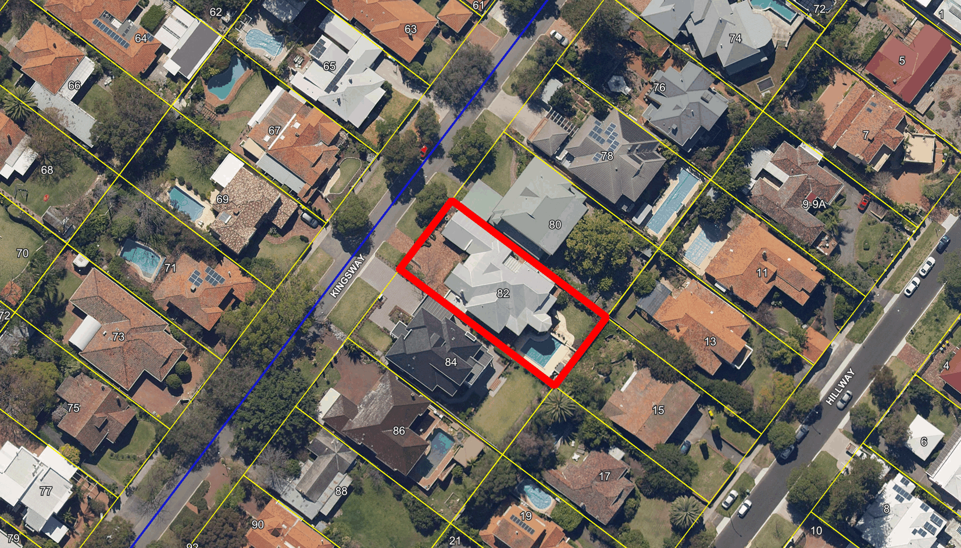

- Application Details

The applicant seeks approval to replace the existing timber front fence with a new masonry front fence with permeable in-fill and increase the existing solid fencing along the side lot boundaries to 1.8m within the front setback area. The existing solid fencing along the side lot boundaries is 1.5m in height.

- Consultation

The development application was advertised in accordance with Council’s Neighbour Consultation Policy and clause 6.3.1 of the Scheme. One submission of objection was received during the consultation period. The following is a summary of the concerns raised:

- “I believe that the relevant guidelines are reasonable and soundly based on a number of factors including safety when reversing vehicles from driveways, security in terms of eyes on the street and providing a pleasant streetscape without high visual barriers.
- The existing side fences are significantly higher than the policy permits.
- The City should enforce these policy guidelines equally for all residents as they are quite reasonable requirements.
- I don’t see how the proposed higher fences provide any practical benefit to the applicants and I strongly object to the proposal.”

Note: A full copy of all relevant consultation feedback received by the City has been given to the Councillors prior to the Council meeting.

- Assessment of Statutory Provisions

6.1 Planning and Development (Local Planning Schemes) Regulations 2015

Schedule 2, Part 9, clause 67 (Matters to be considered by local government) stipulates those matters that are required to be given due regard to the extent relevant to the application. Where relevant, these matters are discussed in the following sections.

In accordance with provisions (m) and (n) of the Regulations clause 67, due regard is to be given to the likely effect of the proposed development’s height, scale, bulk and appearance, and the potential impact it will have on the local amenity.

If Council does not support the proposed development, there is a right of review (appeal) to the State Administrative Tribunal (SAT) under Part 14 of the Planning and Development Act (2005)

6.2 Metropolitan Region Scheme

The subject site is zoned ‘Urban’ under the Metropolitan Region Scheme (MRS). The proposal is an urban use and is therefore consistent with the zoning classification under the MRS.

6.3 City of Nedlands Town Planning Scheme No. 2 - Amenity

Under clause 5.5.1 Council may refuse to approve any development if:

“in its opinion the development would adversely affect the amenity of the surrounding area having regard to the likely effect on the locality in terms of the external appearance of the development, traffic congestion and hazard, noise or any other factor inconsistent with the use for which the lot is zoned.”

6.4 Policy Consideration

6.4.1 Residential Design Codes (State Planning Policy 3.1) - Street walls and Fences

Deemed-to-Comply  Requirement | Proposed | Complies?
Solid fencing permitted to be 1.2m in height above natural ground level. | Existing solid fencing along the side lot boundaries are proposed to be increased to be 1.8m in height above natural ground level. | No
Design Principles

Variations to the deemed-to-comply requirements can be considered subject to satisfying the following Design Principle provisions:

“Front fences are low or restricted in height to permit surveillance (as per Clause 5.2.3) and enhance streetscape (as per clause 5.1.2), with appropriate consideration to the need:
  - for attenuation of traffic impacts where the street is designated as a primary or district distributor or integrator arterial; and
  - for necessary privacy or noise screening for outdoor living areas where the street is designated as a primary or district distributor or integrator arterial.”

6.4.2 Local Planning Policy – Fill and Fencing

Policy Requirement | Proposed | Complies?
In primary street setback areas, solid fencing to a maximum height of 1.2 metres above natural ground level, and visually permeable fencing to a maximum height of 1.8m above natural ground level. | Fencing to a maximum height of 1.8m is proposed to the side lot boundaries. | No
Policy Objectives

The following objectives are stipulated under the Policy:

“To outline the City’s requirements with regard to fill and the minimum standard of fencing to ensure that the amenity of neighbouring properties and the streetscape is maintained.”

- Budget / Financial Implications

N/A

- Risk management

N/A
- Administration Comment

Having had regard to the matters stipulated under the Regulations and the submissions received, the following is advised:

The provision of solid fencing within the streetscape is not uncommon with numerous examples of solid fencing along the side and front lot boundaries (see Attachment 1). The solid front fencing is setback over 1m from vehicle access points to ensure compliant sightlines at these vehicle access points and passive surveillance is not compromised with permeable fencing proposed to the front boundary to allow clear line of sight from the dwelling to the street. The north-eastern side lot boundary has both the subject property and neighbouring property’s carports adjacent and hence is not an open area of the streetscape with the fencing providing additional privacy for the residents.

The perpendicular nature of the solid fencing along the side lot boundaries to the street ensures that the open nature of the streetscape is maintained while providing additional privacy to the residents from neighbouring properties. Based on the above findings, it is considered that the additional solid fencing height will not compromise the amenity of the streetscape nor the passive surveillance and vehicle sightlines of both the subject property and neighbouring properties. Therefore, the development application is recommended for approval subject to conditions.

9.1 Recommended Conditions if Application is Refused

If Council resolves to refuse the over-height solid fencing along the side lot boundaries, the following additional condition is recommended as the rest of the front fencing is fully compliant with all relevant standards and should be able to proceed without requiring further development approval.

- Revised drawings shall be submitted with the Building Permit application, to the satisfaction of the City, removing the fencing modifications along the side lot boundaries within the front setback area or showing the fencing as being compliant with the City’s Fill and Fencing Local Planning Policy.

PD72.18 | No. 11B Brockway Road, Mount Claremont – Two Storey Single House
Committee | 4 December 2018
Council | 18 December 2018
Applicant | Webb and Brown-Neaves Pty Ltd
Landowner | S Poliwka
Director | Peter Mickleson – Director Planning & Development
Reference | DA18/29985
Previous Item | Nil.
Delegation | In accordance with Clause 6.7.1a) of the City’s Instrument of Delegation, Council is required to determine the application due to an objection being received.
Attachments | - Site Photograph

- Executive Summary

The purpose of this report is for Council to consider a development application received on 17 July 2018 for a proposed two-storey single house at 11B Brockway Road, Mount Claremont.

The development proposes variations to Council’s Local Planning Policy 6.18 – Reduction of Front Setbacks (LPP 6.18) and the deemed-to-comply provisions of the Residential Design Codes (R-Codes) for:

- Boundary setbacks (ground floor)
- Overshadowing
- Porch finished floor levels
- Average front setback.

The application was advertised to adjoining neighbours in accordance with clause 2.1 of Council’s Neighbour Consultation Policy. One objection and one non-objection were received during the advertising period.

It is recommended that the application be approved by Council as it is considered to satisfy the design principles of the Residential Design Codes (R-Codes) and is unlikely to have a significant adverse impact on the local amenity.

- Recommendation to Committee

Council approves the development application dated 17 July 2018 with amended plans received on 18 September 2018 to construct a Two Storey Single House at (Lot 700) No. 11B Brockway Road, Mount Claremont subject to the following conditions and advice:

- The development shall always comply with the application and the approved plans, subject to any modifications required as a consequence of any condition(s) of this approval.

- This development approval only pertains to the proposed single dwelling.

- All footings and structures to retaining walls and fences shall be constructed wholly inside the site boundaries of the property’s Certificate of Title.

- All stormwater from the development, which includes permeable and non-permeable areas shall be contained onsite.

- The parapet walls being finished to a professional standard within 14 days of the proposed development’s practicable completion and be maintained thereafter by the landowner to the City’s satisfaction.

Advice Notes specific to this proposal:

- A separate development application is required to be submitted to and approved by the City prior to erecting any fencing within the street setback area(s) which is not compliant with the deemed-to-comply provisions of the Residential Design Codes, and/or erecting any fencing behind the primary street setback area which is more than 1.8m in height above natural ground level.

- All crossovers to the street(s) shall be constructed to the Council’s Crossover Specifications and the applicant / landowner to obtain levels for crossovers from the Council’s Infrastructure Services under supervision onsite, prior to commencement of works.

- Any development in the nature-strip (verge), including footpaths, will require a Nature-Strip Development Application (NSDA) to be lodged with, and approved by, the City’s Technical Services department, prior to construction commencing.

- All downpipes from guttering shall be connected so as to discharge into drains, which shall empty into a soak-well; and each soak-well shall be located at least 1.8m from any building, and at least 1.8m from the boundary of the block. Soak-wells of adequate capacity to contain runoff from a 20-year recurrent storm event. Soak-wells shall be a minimum capacity of 1.0m³ for every 80m² of calculated surface area of the development.

- All internal water closets and ensuites without fixed or permanent window access to outside air or which open onto a hall, passage, hobby or staircase, shall be serviced by a mechanical ventilation exhaust system which is ducted to outside air, with a minimum rate of air change equal to or greater than 25 litres / second.

- The applicant is advised to consult the City’s Visual and Acoustic Privacy Advisory Information in relation to locating any mechanical equipment (e.g. air-conditioner, swimming pool or spa) such that noise, vibration and visual impacts on neighbours are mitigated. The City does not recommend installing any equipment near a property boundary where it is likely that noise will intrude upon neighbours.

Prior to selecting a location for an air-conditioner, the applicant is advised to consult the online fairair noise calculator at www.fairair.com.au and use this as a guide to prevent noise affecting neighbouring properties.

Prior to installing mechanical equipment, the applicant is advised to consult neighbours, and if necessary, take measures to suppress noise.

- This decision constitutes planning approval only and is valid for a period of two years from the date of approval. If the subject development is not substantially commenced within the two-year period, the approval shall lapse and be of no further effect.

- Background

3.1 Land Details

Lot area | 452m²
Local Planning Scheme Zone | Residential R25
Metropolitan Region Scheme Zone | Urban

3.2 Locality Plan

Moerlina School
Quintilian School

- Application Details

The applicant seeks approval to construct a two-storey single house. Details of which are as follows:

- A ground floor theatre room is proposed to have a nil setback in lieu of 1m from the northern (side) lot boundary.
- A garage having a parapet wall on the southern (side) lot boundary adjacent to a parapet wall for an existing garage on the adjoining lot.
- The development resulting in up to 34.8% of the adjoining lot being overshadowed in lieu of 25%.
- The development having an average front setback of 5.9m in lieu of 6m.

- Consultation

The development application was advertised in accordance with clause 2.1 of Council’s Neighbour Consultation Policy. One objection and one non-objection were received, and the following is a summary of the concerns raised:

- The development overshadowing and affecting natural ventilation to living areas on an adjoining lot.
- Overlooking onto an adjoining lot.

Note: A full copy of all relevant consultation feedback received by the City has been given to the Councillors prior to the Council meeting.

- Assessment of Statutory Provisions

6.1 Planning and Development (Local Planning Schemes) Regulations 2015

Schedule 2, Part 9, clause 67 (Matters to be considered by local government) stipulates those matters that are required to be given due regard to the extent relevant to the application. Where relevant, these matters are discussed in the following sections.

In accordance with provisions (m) and (n) of the Regulations clause 67, due regard is to be given to the likely effect of the proposed development’s height, scale, bulk and appearance, and the potential impact it will have on the local amenity.

6.2 Metropolitan Region Scheme

The subject site is zoned ‘Urban’ under the Metropolitan Region Scheme (MRS). The proposal is an urban use and is therefore consistent with the zoning classification under the MRS.

6.3 City of Nedlands Town Planning Scheme No. 2

6.3.1 Amenity

Under clause 5.5.1 Council may refuse to approve any development if:

“in its opinion the development would adversely affect the amenity of the surrounding area having regard to the likely effect on the locality in terms of the external appearance of the development, traffic congestion and hazard, noise or any other factor inconsistent with the use for which the lot is zoned.”

6.4 Policy Considerations

6.4.1 Residential Design Codes (State Planning Policy 3.1) - Lot boundary setbacks

Deemed-to-Comply  Requirement | Proposed | Complies?
Walls may be built up to a lot boundary behind the street setback:  Where the wall abuts an existing or simultaneously constructed wall of similar or greater dimension.  In areas coded R20 and R25, walls not higher than 3.5m with an average of 3m or less, up to a maximum length of the greater of 9m or one-third the length of the balance of the lot boundary behind the front setback, to one side boundary only.  Where point a) does not apply the wall is to be setback in accordance with Table 2A or 2B of the R-Codes. | A ground floor theatre room is proposed to have a nil setback in lieu of 1m from the northern lot boundary.  A garage is proposed to have a parapet wall on the southern (side) lot boundary adjacent to a parapet wall for an existing garage on the adjoining lot. | No  Yes
Design Principles

Variations to the deemed-to-comply requirements can be considered subject to satisfying the following Design Principle provisions:

“P3.1 Buildings set back from lot boundaries or adjacent buildings on the same lot so as to:
- reduce impacts of building bulk on adjoining properties;
- provide adequate direct sun and ventilation to the building and open spaces on the site and adjoining properties; and
- minimise the extent of overlooking and resultant loss of privacy on adjoining properties.

P3.2 Buildings built up to boundaries (other than the street boundary) where this:
- makes more effective use of space for enhanced privacy for the occupant/s or outdoor living areas;
- does not compromise the design principle contained in clause 5.1.3 P3.1;
- does not have any adverse impact on the amenity of the adjoining property;
- ensures direct sun to major openings to habitable rooms and outdoor living areas for adjoining properties is not restricted; and
- positively contributes to the prevailing or future development context and streetscape as outlined in the local planning framework.”

6.4.2 Visual privacy

Deemed-to-Comply  Requirement | Proposed | Complies?
Raised habitable spaces with major openings are to be setback from the portion of a lot boundary behind the front setback area in accordance with the following: | An upper storey sitting room is proposed to have a window with a sill 1.6m above the finished floor level, which is therefore not deemed to be a major opening under the R-Codes. | Yes
Bedrooms – 4.5m setback  Siting rooms – 6m setback | Upper storey bedrooms at the rear of the dwelling are proposed to have cones of vision of 4.6m and 4.9m from the nearest lot boundaries. | Yes

6.4.3 Overshadowing

Deemed-to-Comply  Requirement | Proposed | Complies?
Development can overshadow up to 25% of an adjoining property which is coded R25. | The development resulting in up to 34.8% of the adjoining lot being overshadowed in lieu of 25%. | No
Design Principles

Variations to the deemed-to-comply requirements can be considered subject to satisfying the following Design Principle provisions:

“P2.1 Effective solar access for the proposed development and protection of the solar access.

P2.2 Development designed to protect solar access for neighbouring properties taking account the potential to overshadow existing:
      - outdoor living areas;
      - north facing major openings to habitable rooms, within 15 degrees of north in each direction; or
- roof mounted solar collectors.”

6.5 Local Planning Policy 6.18 – Reduction of Front Setbacks

Policy Requirement | Proposed | Complies?
Mount Claremont – 6m average front setback as per the R-Codes | An average front setback of 5.9m is proposed therefore Council is to have regard to the design principles under the R-Codes. | No
Design Principles of the R-Codes

Variations to the deemed-to-comply requirements can be considered subject to satisfying the following Design Principle provisions:

“P2.1 Buildings set back from street boundaries an appropriate distance to ensure they:
- contribute to, and are consistent with, an established streetscape;
- provide adequate privacy and open space for dwellings;
- accommodate site planning requirements such as parking, landscape and utilities; and
- allow safety clearances for easements for essential service corridors.”

- Budget / Financial Implications

N/A

- Risk management

N/A

- Administration Comment

9.1 Lot Boundary Setback of Theatre Room

The ground floor theatre room is proposed to be setback approximately 15.5m from the street boundary, therefore it is unlikely to have a significant impact on the streetscape.

The reduced setback will not result in any non-compliant amount of overshadowing onto the adjoining lot.

The wall will occupy approximately 12% of the total lot boundary’s length, and the adjoining lot impacted is currently vacant.

A boundary wall agreement for the theatre room was received during the advertising period.

9.2 Overshadowing

The overshadowing variation is largely because of the lots concerned being relatively narrow (approximately 11m in width).

The amount of overshadowing proposed which is in excess of what the R-Codes permit equates to approximately 40sqm.

Based on the information provided and having referred to the City’s records for the adjoining lot, approximately 49sqm of the dwelling’s roof on the adjoining lot is likely to be overshadowed, and no outdoor living areas and/or solar collectors will be overshadowed.

Even if the development was designed to be compliant with the overshadowing requirements it is likely that the same rooms concerned on the adjoining lot would be overshadowed due to their close proximity to the lot boundary and the narrow width of the subject lot and the neighbouring lot. Considering this, the amount of overshadowing proposed is unlikely to have a detrimental impact on the neighbours.

9.3 Average Front Setback

Considering the scale of the development and the variation it is unlikely to have a detrimental impact on the streetscape.

The development is deemed to satisfy LPP 6.18 and the relevant design principles of the R-Codes therefore it is recommended that Council approves the application.

PD73.18 | Scheme Amendment No. 214 – Lot 381 (No.45) Carrington Street, Nedlands
Committee | 4 December 2018
Council | 18 December 2018
Applicant | CF Town Planning and Development
Landowner | Mr B Gray – Pine Ridge Holdings Pty Ltd
Director | Peter Mickleson – Director Planning & Development
Previous Item | Nil.
Attachments | - Scheme Amendment No. 214 Report  - Applicants Further Information

- Executive Summary

The purpose of this report is for Council to provide consent to advertise (initiate) proposed Scheme Amendment No. 214 to Town Planning Scheme No.2 (TPS2).

The proposed amendment is seeking to add an Additional Use to Lot 381 (No. 45) Carrington Street, Nedlands, to allow a Child Day Care Centre land use to be approved in order to facilitate a re-development of the site in the future. This addition use will be added to Schedule I (Additional Uses) in TPS2. Under TPS2, within the 'Light Industrial' zone, a 'Child Day Care Centre' is not permitted ("X").

It is recommended that Council provide consent to advertise for the purposes of initiating the scheme amendment.

- Recommendation to Committee

Council:

- Pursuant to Section 75 of the Planning and Development Act 2005, initiate an Amendment to Town Planning Scheme No. 2 by:

  - Amending the Scheme Text by inserting into Schedule I - Additional Uses entry ‘A 115’ over Lot 381 (45) Carrington Street, Nedlands for ‘Child Day Care Centre’; and
  - Amend the Scheme Map accordingly.

- In accordance with Planning and Development (Local Planning Schemes) Regulations 2015 section 35(2), the City believes that the amendment is a Standard Amendment for the following reasons:

  - the proposed amendment is consistent with a local planning strategy which has been endorsed by the Commission;
  - the proposed amendment will have minimal impact on land in the scheme area that is not the subject of the amendment; and
  - the proposed amendment does not result in any significant environmental, social, economic or governance impacts on land in the scheme area.

- Pursuant to Section 81 of the Planning and Development Act 2005, refers Scheme Amendment 214 – Carrington Street to the Environmental Protection Authority.

- Subject to Section 84 of the Planning and Development Act 2005 advertises Scheme Amendment 214 – Carrington Street in accordance with Regulation 47 of the Planning and Development (Local Planning Schemes) Regulations 2015 and Council Policy – Community Engagement.

- Background

3.1 Land Details

Land Area | 696m²
Town Planning Scheme No. 2 Zone | Light Industrial
Metropolitan Region Scheme Zone | Urban

3.2 Previous Resolution

At the Council Meeting on the 26 May 2015 Council resolved to not initiate any further amendments to TPS2. Due to Councils decision on the 31 July 2018 to not support LPS3 and the uncertainty surrounding LPS3, Administration recommends that the City does adopt for advertising (initiate) this amendment irrespective of the resolution made on the 26 May 2015.

3.3 Locality Plan

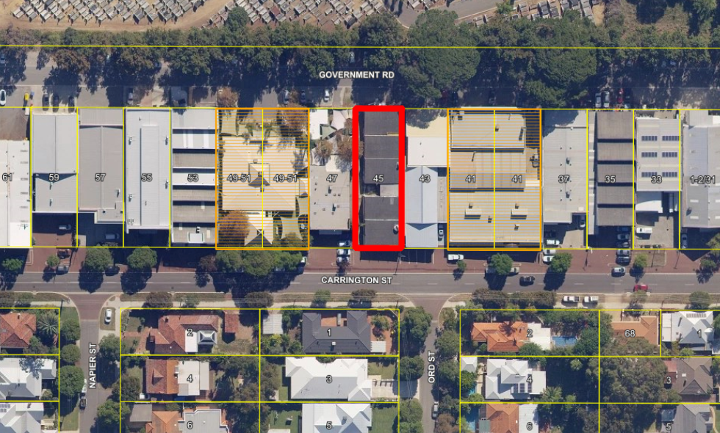

The subject site is located within an existing light industrial/commercial development located on Carrington Street in the suburb of Nedlands, immediately south of the Karrakatta Cemetery and adjacent to existing low-density residential development. It is important to note that adjoining lots numbered 49-51 and 47 are currently zoned Light Industry with the Additional Use of 'child day care centre' existing. These sites are also currently operating as one child care centre across the three lots.

- Amendment Details

The applicant is requesting a scheme amendment for the purposes of adding an Additional Use over Lot 381 (No. 45) Carrington Street (adjoining the existing Additional Use of child care centre) to allow for the consideration of use of a Child Day Care Centre on the site. The subject site is zoned 'Light Industrial' under the City's current TPS2.

The applicant has discussed with the City their future redevelopment intention which is to amalgamate the site with Lot 380 (No. 47) Carrington St, adjacent and demolish the current buildings to redevelop one child care centre over the two sites. As this is a Scheme Amendment request the development component does not form part of this current proposal. Further detailed plans for any future redevelopment will be shown through the development application process at a later stage.

Preliminary internal consultation with the City has been undertaken and no issues have been raised at this stage. It has been acknowledged by the applicant that further in-depth technical reports in relation to noise, traffic and any other health related studies relating to the previous industrial use on the site will need to be undertaken at the development application stage, see Attachment 2 for more information.

- Consultation

If the Scheme Amendment is granted consent to advertise the City will refer the application to the Environmental Protection Authority (EPA) who can advise of any land use conflicts given the location is in an existing industrial zone.

The application is required to be advertised in accordance with the Planning and Development (Local Planning Schemes) Regulations 2015 (the Regulations). The consultation of this Scheme Amendment is in line with the ‘consult’ engagement process under the City’s Community Engagement Council Policy. Advertisement of a standard amendment is as follows:

- The City must prepare a notice in a form approved by the West Australian Planning Commission (WAPC) giving details of; the purpose, where the amendment may be inspected and to whom and during what period submissions can be made.
- The City must then advertise the amendment by publishing the notice in the newspaper, display the notice in the Administration building, provide a copy to all public authorities which are likely to be affected and publish a copy on the City’s website.
- The advertising period can be no less than 42 days commencing on the day that the notice is published in a newspaper circulating in the scheme area.

Once submissions are received the City must acknowledge in writing the receipt of each submission.

The consideration period for a standard scheme amendment is 60 days after the end of the submission period, in which the City must consider all submissions and Council must pass a resolution to support, support with modifications or not support the proposed amendment.

Once Council has decided on the scheme amendment, all documents will be referred to the WAPC and they will deliver a recommendation to the Minister for Planning. The Minister will then make the final decision on the proposed scheme amendment.

- Assessment against Planning Framework

6.1 Metropolitan Region Scheme

The subject site is zoned ‘Urban’ under the Metropolitan Region Scheme (MRS). The proposal is an urban use and is therefore consistent with the zoning classification under the MRS.

6.2 Planning Bulletin 72/2009 Child Care Centres

This planning bulletin outlines the revised child care centre guidelines and aims to:

- differentiate between child care related activities operating in existing residential area, such as family day care that takes place in dwellings, and non-residential child care activities;
- outline a consistent policy approach to planning for child care centres; and
- advise of planning considerations in relation to the location and development of child care centres.

6.3 City of Nedlands Local Planning Strategy

The City’s Local Planning Strategy discusses the need to facilitate the natural evolution of the Carrington Street commercial strip as a mixed business area and encourage a reasonably high standard of redevelopment.

The Local Planning Strategy discusses how the biggest increase in floorspace in Carrington Street was in the Office/Business category, indicating a transition occurring in this area from an industrial/service industrial precinct to a more commercially‐oriented mixed business precinct. This transition is appropriate given the location and context of the complex and the City should further facilitate this transition.

6.4 City of Nedlands draft Local Planning Scheme No. 3

The advertised draft Local Planning Scheme No.3 (LPS3) proposed to rezone the subject site from Light Industrial to Service Commercial. Child Care Premises was listed as an “X” use within the Service Commercial zone meaning that new Child Care Premises would not be permitted.

However, the existing Child Care Premises at Lots 378, 379 and 380 were included as Additional Uses and therefore permitted on those specific sites.

The modified draft Local Planning Scheme No.3 (LPS3), presented to Council at the Council Meeting on the 31 July 2018, proposed to change the permissibility of Child Care Premises to an “A” use in the Service Commercial zone, meaning that it would be permitted where the local government granted development approval after advertising.

6.5 City of Nedlands Town Planning Scheme No. 2

Under the provisions of TPS2 the subject site is zoned Light Industrial, Child Day Care Centre is an ‘X’ use and therefore is not currently permitted in this zone.

- Budget / Financial Implications

Nil.

- Risk Management

Nil.

- Administration Comment

Administration is recommending support of the Scheme Amendment proposal for Lot 381 (No.45) Carrington Street, Nedlands as:

- The Amendment is in line with the City’s Local Planning Strategy.
- The Amendment would be permissible, with Council discretion and advertising, under the modified draft LPS3 with this area identified as a Service Commercial zone, moving away from the existing Light Industrial zone of the current Scheme.
- The proposal is in line with the Planning Bulletin 72/2009 Child Care Centres.

Once the Scheme Amendment is granted consent to advertise the City will refer the application to the Environmental Protection Authority who can advise of any land use conflicts given the proposals location in an industrial zone.

Once the City has received approval from the EPA, the City will then undertake advertising, subject to WAPC consent, and will report all submissions and any issues raised to Council for a final recommendation.

Considering the above, it is recommended that the Council grant consent for this scheme amendment to be advertised.

PD74.18 | Christ Church Grammar School - Possible Acquisition of Landfill Site
Committee | 4 December 2018
Council | 18 December 2018
Applicant | Taylor Burrell Barnett
Landowner | State of WA
Director | Peter Mickleson – Director Planning & Development
Previous Item | Nil.
Attachments | - Applicants formal request for endorsement

- Executive Summary

The purpose of this report is for Council to consider a request for endorsement for Christ Church Grammar School (CCGS) to acquire the former landfill site in North East Mt Claremont. The parcels of land are currently owned by the State Government and the school is seeking a letter of support for acquisition from the City. The exact land holdings are listed in Table 1 below.

It is recommended that endorsement be given by the Council for the school to purchase the land to be used for recreational purposes.

- Recommendation to Committee

Council instructs Administration to write a letter of endorsement from the City to support Christ Church Grammar Schools endeavours to acquire the former landfill site, lots shown in Table 1.

- Background

3.1 Land Details

Land Area | 16.3ha in total
Local Planning Scheme Zone | No Zone with a small parcel of Recreation
Metropolitan Region Scheme Zone | Urban with a small section of Public Purpose - Hospital

3.2 Locality Plan

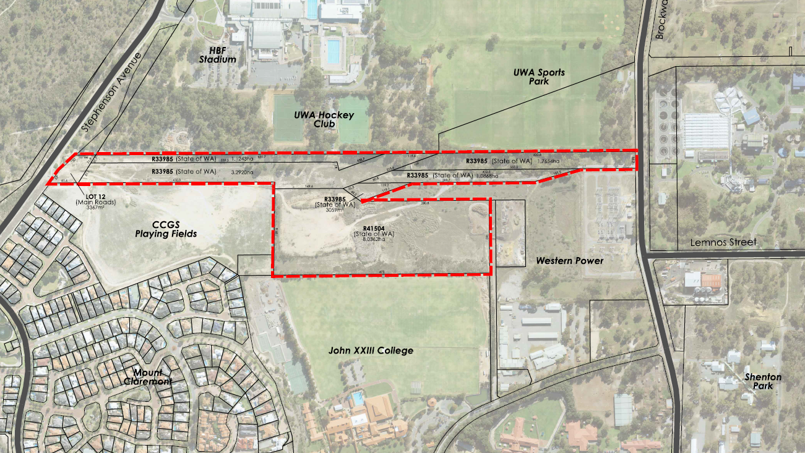

The subject sites are located within the North Eastern area of Mt Claremont. The parcels ownership and vesting arrangements are shown below in Table1. The sites are currently unused due to site contamination from the former landfill site.

Reserve No./Lot No./ Plan No. | Volume | Folio | Area | Registered Proprietor(s)
R33985 Lot  10949 on Plan  216951 | LR3141 | 650 | 1.1243ha | STATE OF WA (Minister for Sport and Recreation)
R33985 Lot 10781 on Plan 216951 | LR3141 | 649 | 3.2920ha | STATE OF WA (Minister for Sport and Recreation)
R33985 Lot 9206 on Plan 213700 | LR3141 | 646 | 3059m² | STATE OF WA (Minister for Sport and Recreation)
R33985 Lot 9208 on Plan 213700 | LR3141 | 647 | 1.0868ha | STATE OF WA (Minister for Sport and Recreation)
R33985 Lot 9209 on Plan 213700 | LR3141 | 648 | 1.7654ha | STATE OF WA (Minister for Sport and Recreation)
R41504 Lot 12970 on Plan 219939 | LR3111 | 283 | 8.0362ha | STATE OF WA (Minister for Sport and Recreation)
Lot 12 on Plan 024305 | 2205 | 636 | 3367m² | COMMISSIONER OF MAIN ROADS

- Application Details

CCGS is seeking endorsement from the City for their potential acquisition of the former landfill site. The school is wanting to use these parcels of land for extension of their current playing fields adjacent to the site.

The school is aware of the site contamination and are willing to undertake works to solve this issue on these sites.

The access and management arrangements are detailed in Attachment 1. CCGS has expressed that their intention is that access to the playing fields and associated facilities would be made available to the general public and community sports clubs for training and competition outside of the times the school is required to use the facilities. The school would require exclusive use of the oval and facilities at the following times, almost exclusively during the school term (38 weeks per annum):

- Monday to Thursday afternoons (3:30 – 5:00pm), for sports training;
- Friday afternoons (1:30 – 5:00pm) – for organised fixtures; and
- Saturday mornings (8am – 12:00pm) – for organised fixtures.

Outside of these times, community groups would have the ability to book the playing fields and facilities including change rooms and toilets, consistent with the arrangements at the existing CCGS playing fields.

Bookings would be advertised and scheduled online with a link placed on the City of Nedlands website. The bookings would be coordinated via an in-house resource, which would be utilised exclusively to book facilities to the general public and community groups. This resource is currently used by CCGS and regularly approached by community groups for access to playing fields, the school pool, gymnasium and boarding facility.

The general public would also have access to use the playing fields for recreation and non-organised sport and passive recreation, such as dog exercising, walking and general kick-to-kick, as is the case at the existing CCGS St John’s Wood playing fields.

- Consultation

The applicant has indicated that CCGS has discussed the proposal to acquire this land with the University of WA (UWA) and John XXIII College whereby they may wish to share the acquisition for similar purposes however this has not yet been confirmed or finalised.

CCGS has also approached the DLGSC for a letter of endorsement similar to that requested from the City. The applicant has informed that the DLGSC has verbally confirmed their support of the proposal.

- Assessment of Statutory Provisions

6.1 Metropolitan Region Scheme

Majority of the subject site is zoned ‘Urban’ under the Metropolitan Region Scheme (MRS), with a small portion to the east being zoned Public Purpose – Hospital. It is likely that the applicant will have to undergo an MRS amendment to remove the no longer relevant Public Purpose – Hospital zoning over the eastern positions of the site.

6.2 City of Nedlands Town Planning Scheme No. 2

Under the provisions of the Scheme the subject site is largely unzoned with a small area in the centre, adjacent to the City’s depot have a recreation zoning. It is acknowledged by the applicant that a Scheme Amendment will be required to zone the lots so that they are suitably identified in Town Planning Scheme No.2 for the intended development.

6.3 Local Planning Strategy

The City’s endorsed Local Planning Strategy sets out the following aims for the Mt Claremont East Precinct:

- Retain and enhance the character and streetscape of the existing residential areas
- Comprehensively plan for the remaining non-residential areas.
- Land uses and development within this area shall not conflict with the urban character being predominantly of sporting, research and educational facilities.
- Prevent the encroachment of sensitive land uses and residential development within the Subiaco WWTP odour buffer area.
- Consider opportunities to consolidate and improve access throughout the precinct.

The proposal to use these sites for recreation purposes is in line with the City’s Local Planning Strategy for the area.

6.4 AK Reserve / UWA Sports Park Master Plan

The AK Reserve / UWA Sports Park Master Plan was adopted by the WAPC in 2006 as a requirement of the PLRA. The Master Plan identifies sporting ovals on the subject land, including a cricket oval and rugby oval. This is shown in Figure 2 of Attachment 1.

6.5 Environmental Considerations

The subject land is located over the former Brockway Landfill site. Initial environmental investigations have been undertaken which indicate that landfill material remains buried across the subject land and asbestos-containing materials are located in some of the surface soils.

The applicant acknowledges that the subject land would be required to be remediated prior to development of playing fields, which may comprise capping with clean fill along with some degree of water and land fill gas management. CCGS are willing to undertake all required remediation works, understanding remediation works may be similar to those required on the adjacent CCGS St John’s Wood ovals which were recently developed.

6.6 Perry Lakes Redevelopment Act 2005

The parcels of land were formerly located within the Perry Lakes Redevelopment Act 2005 (PLRA) Area. The Governor proclaimed completion of the PLRA on the 25 November 2016, meaning that any applications over this area now received by the City will be assessed under the City’s Town Planning Scheme.

6.7 Mount Claremont Sports Precinct structure plan Draft Development Concept (2004)

A study was commissioned by the Department of Sport and Recreation and the Department of Planning and Infrastructure in 2005 to provide a detailed planning framework for a regional sports complex at Mt Claremont. The study provided two possible options for development of the site as a sports precinct. Figure 1 shown in Attachment 1 of this report shows the possible outcome of the structure plan. This study’s main emphasis was to allow for future expansion and development of sports facilities, associated infrastructure and other land uses within the study area.

6.8 Mt Claremont North-East Structure Plan Investigation

At the Council Meeting on the 23 October 2018 Council resolved to direct administration to prepare a Project Plan and Community Engagement Strategy for the Mt Claremont North-East area which includes the sites discussed by CCGS. This is required for the City to explore options for future development and planning for the Mt Claremont North-East area. The proposal by CCGS is aligned with this decision by Council as they will be using the central sites which are currently underused and poorly configurated. The applicant has also expressed interest to be included in any future planning undertaken by the City for this area.

- Budget / Financial Implications

N/A

- Risk Management

N/A

- Administration Comment

Upon consideration of the abovementioned factors the City supports the endeavours of CCGS seeking to acquire the former landfill site consisting of the lots listed in Table 1 above, for playing fields. The proposal is in line with the City’s overall vision for the area as stipulated in the Local Planning Strategy.

The potential amalgamation and decontamination of these sites proposed by the school would allow for these sites to no longer be left unused and would be asset to both the school and the community. The City recommends that Council endorse CCGS’s bid to acquire these lands for the purposes of extending their playing fields.

Assuming that the City provides in-principle support for the proposal, CCGS will engage with the Department of Planning, Lands and Heritage (Lands Division) to seek its agreement to remove the vesting of the subject land and sell the land to CCGS. If CCGS proceeds to purchase the land, consultation will be undertaken with the City of Nedlands to progress the necessary planning to facilitate development of the subject land.

PD75.18 | West Australian Bridge Club Inc. at Reserve 7804, Swanbourne – Extension to Lease Term
Committee | 4 December 2018
Council | 18 December 2018
Applicant | Western Australia Bridge Club Inc.
Landowner | City of Nedlands
Director | Peter Mickleson – Director Planning & Development
Previous Item | C27.05 on 26 April 2005
Attachments | - Nil

- Executive Summary

The purpose of this report is to consider a request by the West Australian Bridge Club Inc. (the Club) to extend their lease term for premises located at Allen Park.

The Club have requested a 20-year extension for the purpose of security of tenure and to reduce their annual expenses recorded in their financial statements. An increased term will enable the amortisation of their leasehold improvements to be spread over a longer period of lease, thereby reducing the cost annually.

The Club have a healthy financial position with increasing membership numbers, presenting a sound long term tenancy arrangement.

- Recommendation to Committee

- Council agrees to extend the term of lease by the West Australian Bridge Club Inc. for premises located at Reserve 7804, Allen Park Swanbourne subject to the following:

- The extended term will be for a further 20 years, from the expiration of the current term of lease, being 30 June 2026;

- The extension to the term of lease will be recorded in a Deed of Variation of Lease prepared by the City’s solicitors;

- The Club will pay for all costs associated with the preparation, execution and stamping of documentation to record the variation of the Lease and associated registration fees; and

- The Minister for Lands approval is obtained.

- Council delegates authority to the Chief Executive Officer and Mayor to sign the Deed of Variation of Lease and apply the City’s common seal.

- Background

3.2 Locality Plan

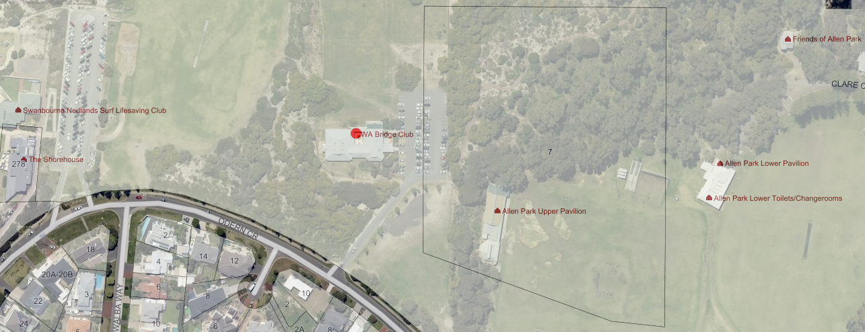
The WA Bridge Club is located on a portion of Reserve 7804 - Allen Park.

Discussion/Overview

The City of Nedlands is vested with a management order (the Order) for Reserve 7804, being Allen Park (the Reserve). The Reserve is a class “A” Crown reserve with the purpose “Park and Recreation”. The Order contains a power to lease for any term subject to the Minister for Lands approval.

The Club lease a portion of the Reserve for a term of 15 years and a further term of 5 years (the Lease). The Lease commenced on 1 July 2006. Shortly after the Lease commenced the Club commenced development to build its premises onsite. The value of construction was just over $1.5 million.

The Club have submitted a request to the City for an extension to their term of Lease. In the Club’s letter of request, they note the basis for this request is:

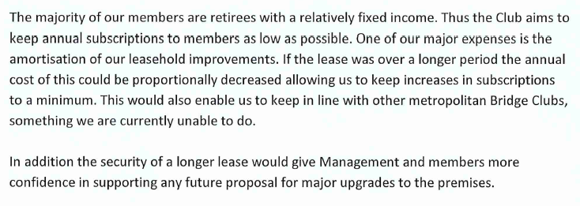

In their letter the Club further notes the following:

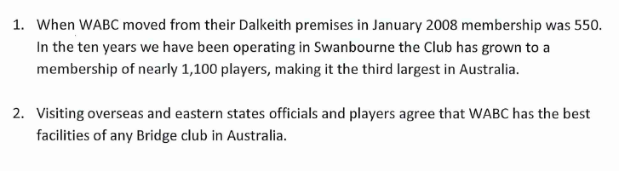
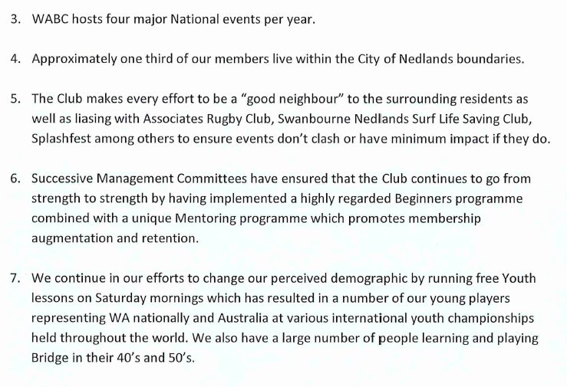
The Club’s financial statements show a healthy position and indicate an ability to sustain a longer-term tenancy as they now request.

The Club’s request would mean that the term of the Lease would become 15 years with a further term of 5 years and an additional term of 20 years.

Although it has been previously endorsed by Council that the City’s standard term of lease is 10 years with a further term of 5 years, there have been exceptions to this, particularly where significant investment by the lessee Club has occurred. One such example is the Cottesloe Golf Club which has a lease for a term of 21 years with a further term of 21 years. That lease agreement commenced on 1 May 2012.

- Key Relevant Previous Council Decisions:

On 26 April 2005 Council considered item C27.05 and resolved to approve the Club leasing the area that was the former Swanbourne Bowling Club’s lease area. Council agreed to a lease by the Club for 15 years with a five-year option and required the Club to develop a new building onsite; connect the necessary services at no cost to Council; the Club contribute to the costs of developing further carparking facilities onsite. In the same item Council resolved to approve the Associates Rugby Club’s use and Lease of the former Swanbourne Bowling Club’s premises.

- Consultation

The City’s Administration have liaised with the Club to understand their requirements.
If Council resolve to approve the Club’s request to extend the Lease, the City will seek the Minister for Lands consent to the Variation of Lease before executing the documentation.

- Budget/Financial Implications

There are no budget implications for the City relating to this proposal, as the Club will bear the costs of preparing, stamping, executing and registering the documentation to record the variation of the Lease.

