Planning and Development Reports

Committee Consideration – 8 October 2019

Council Resolution – 22 October 2019

Table of Contents

Item No. Page No.

PD41.19 No. 37 Philip Rd, Dalkeith - Covered Structure for Boat / Trailer Storage to Single House 2

Council: 22 October 2019

PD41.19 | No. 37 Philip Rd, Dalkeith - Covered Structure for Boat / Trailer Storage to Single House
Committee | 8 October 2019
Council | 22 October 2019
Applicant | Complete Approvals
Landowner | Toby and Kathleen Leys
Director | Peter Mickleson – Director Planning & Development
Employee Disclosure under section 5.70 Local Government Act 1995 | Nil.
Report Type  Quasi-Judicial | When Council determines an application/matter that directly affects a person’s right and interests. The judicial character arises from the obligation to abide by the principles of natural justice. Examples of Quasi-Judicial authority include town planning applications and other decisions that may be appealable to the State Administrative Tribunal.
Reference | DA19/36345
Previous Item | Nil
Delegation | In accordance with the City’s Instrument of Delegation, Council is requested to determine the application due to the development proposal being contrary with the City’s working practice.
Attachments | - Plans (Confidential)  - Assessment (Confidential).

- Executive Summary

The purpose of this report is for Council to determine a proposed development application for covered parking structure for a boat/trailer on a residential property at 37 Philip Rd, Dalkeith. This application was received by the City on the 5 May 2019.

The application is seeking discretion to be exercised relating to an open space and lot boundary setback.

The proposed additions represent an overdevelopment of the site and would result in a net 4.07% open space shortfall across the lot. The deemed to comply open space required for a R10 zoned property is 60%. The development proposal would result in 55.93% open space being provided across the lot.

The covered boat/trailer parking structure is proposed to be constructed with a nil lot boundary setback to the northern and eastern lot boundaries.

The application was advertised to adjoining neighbours in accordance with the City’s Local Planning Policy - Consultation of Planning Proposals. No submissions were received during the consultation period.

It is recommended that the application be approved by Council as it is considered to satisfy the design principles of the Residential Design Codes (R-Codes) and is unlikely to have a significant adverse impact on the local amenity, being consistent with the established character of the locality.
- Recommendation to Committee

Council approves the development application dated 5 May 2019 to install a covered boat/trailer parking structure at (Lot 291) 37 Philip Rd, Dalkeith, with the following conditions and advice notes.

Conditions:

- The development shall at all times comply with the application and the approved plans, subject to any modifications required as a consequence of any condition(s) of this approval.

- This development approval only pertains to the addition of a covered boat/trailer parking structure, as indicated on the plans attached to this approval.

- All sides of the boat/trailer covered parking structure shall remain open and shall not accommodate a door.

- All footings and structures shall be constructed wholly inside the site boundaries of the property’s Certificate of Title.

- All stormwater from the development, which includes permeable and non-permeable areas shall be contained onsite.

- The boat/trailer covered parking structure shall be used for the storage of a boat and/or trailer only. No motor vehicles are to be parked within the boat/trailer covered parking structure area.

Advice Notes specific to this proposal:

- Any boats and/or trailers proposed to be stored within the boat/trailer covered parking structure area are to be manually manoeuvred (by hand) into the storage area and not by motor vehicle.

- A separate development application is required to be submitted to and approved by the City prior to erecting any fencing within the street setback area(s) which is not compliant with the deemed-to-comply provisions of the Residential Design Codes, and/or erecting any fencing behind the primary street setback area which is more than 1.8m in height above natural ground level.

- Any development in the nature-strip (verge), including footpaths, will require a Nature-Strip Improvement Application and/or a Crossover Permit to be lodged with, and approved by, the City’s Technical Services department, prior to construction commencing.

- All street tree assets in the nature-strip (verge) shall not be removed. Any approved street tree removals shall be undertaken by the City of Nedlands and paid for by the owner of the property where the development is proposed, unless otherwise approved under the Nature Strip Improvement approval.

- All downpipes from guttering shall be connected so as to discharge into drains, which shall empty into a soak-well; and each soak-well shall be located at least 1.8m from any building, and at least 1.8m from the boundary of the block. Soak-wells of adequate capacity to contain runoff from a 20-year recurrent storm event. Soak-wells shall be a minimum capacity of 1.0m³ for every 80m² of calculated surface area of the development.

- This decision constitutes planning approval only and is valid for a period of two years from the date of approval. If the subject development is not substantially commenced within the two-year period, the approval shall lapse and be of no further effect.

- Background

3.1 Land Details

Metropolitan Region Scheme Zone | Urban
Local Planning Scheme Zone | Residential
R-Code | R10
Land area | 1062.3m²
Additional Use | No
Special Use | No
Local Development Plan | No
Structure Plan | No
Land Use | Single Residential House

3.2 Locality Plan

The subject property is located within the suburb of Dalkeith. Philip Road is the primary street frontage and Tree Martin Lane is the secondary street. The lot to the immediate east (35 Philip Road) is zoned Residential R60. The lot to the west of the subject site (39 Philip Road) is zoned Residential R10. The lot currently accommodates a single storey residential house. The subject property is surrounded by residential dwellings and a locality that displays typical low-density residential characteristics.

The Waratah Ave local centre is located to the south-east of the subject site.

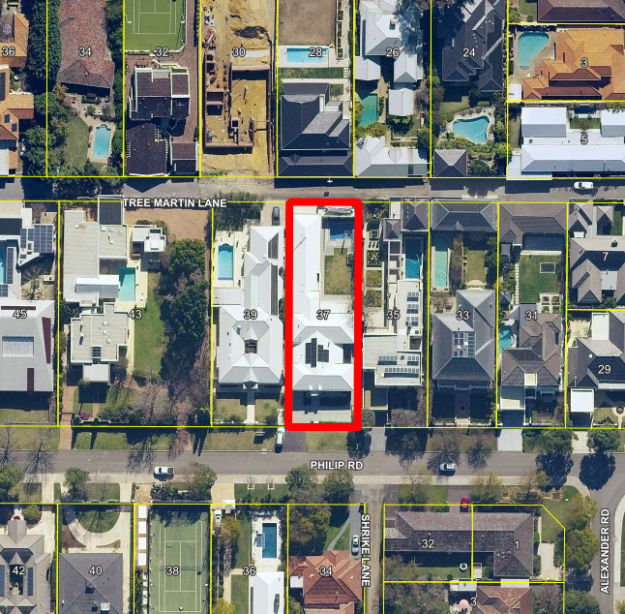

- Application Details

The applicant seeks development approval to install permanent roof cover to the existing boat/trailer storage area, located in the north-eastern corner of the lot. Details of this application are as follows:

- The property is zoned R10 under the City of Nedlands Local Planning Scheme No.3 (LPS3). The average lot area required for a R10 lot is 1000m². The residential lot exceeds this requirement by 62.3m² having a total lot area of 1063.3m². A residential density code of R10, requires a minimum 60% of the lot to be provided as ‘open space’, this permits a maximum site cover of 40%. Development on the site currently contributes to a total of 40.37% site cover. The proposed boat/trailer covered parking area contributes an addition 39.31m² (3.7%) of site cover to the lot. The resulting net covered site area for the lot would be 44.07%, an open space shortfall of 4.07%.

- The proposed boat/trailer covered parking area is to be constructed on the northern and eastern lot boundaries (2 boundaries). A R10 density code does not permit building on boundary as a right. The northern lot boundary abuts the secondary street, Tree Martin Lane.

By way of justification in support of the development application the applicant has provided a design principles assessment provided as an attachment to this report/ addressed the submissions received provided as an attachment to this report/ advised the following:

- The use of land/space was previously approved by council for boat storage. This is how the space has always been used.
- The proposed structure is intended to protect a valuable asset (boat) from the elements.
- The structure is deliberately a flat structure with no building bulk which does not exceed existing building heights.
- The structure is open on all sides.
- The development application has been advertised and there were zero submissions/objections to the development.
- There is already precedence for nil lot setback to the rear lane.
- The neighbouring property immediately to the east has recently been up coded to an R60 block, which means that block now only requires 40% open space.

- Consultation

The applicant is seeking assessment under the Design Principles of the R-Codes for the following:

- Building on Boundary
- Open Space Shortfall

The development application was therefore advertised in accordance with the City’s Local Planning Policy - Consultation of Planning Proposals to 7 neighbouring properties. No submissions or comments were received during the advertising period.

- Assessment of Statutory Provisions

6.1 Residential Design Codes – Volume 1 (State Planning Policy 7.3)

The applicant is seeking assessment under the Design Principles of the R-Codes for building on boundary and an open space shortfall as addressed in the below tables:

Building on Boundary

Design Principles
P3.2 Buildings built up to boundaries (other than the street boundary) where this:
- makes more effective use of space for enhanced privacy for the occupant/s or outdoor living areas;
- does not compromise the design principle contained in clause 5.1.3 P3.1;
- does not have any adverse impact on the amenity of the adjoining property;
- ensures direct sun to major openings to habitable rooms and outdoor living areas for adjoining properties is not restricted; and
- positively contributes to the prevailing or future development context and streetscape as outlined in the local planning framework.”

Deemed-to-Comply Requirement
An R10 density code requires the following:
- A minimum 1.0m setback to all lot boundaries abutting adjoining properties; and
- A minimum 3.0m setback to a secondary street.
Proposed
The applicant proposes a nil lot boundary setback to the northern lot boundary (secondary street) and eastern lot boundary.
Administration Assessment
The setback shortfall is present due to the proposed boat/trailer covered parking and storage being constructed on the northern and eastern lot boundaries. Due to the open nature of the proposed additions, a high dividing fence and the setback addressing the eastern lot boundary, it is unlikely to negatively impact ventilation and access to sunlight for the adjoining lot.

Building on boundary addressing the laneway, tree Martin Lane, is not unprecedented, with over 15 properties developing to (or on) the laneway boundary.

The eastern lot affected by the nil lot boundary setback (35 Philip Rd) has also been up coded to R60. Building on boundary is permitted under an R60 density code, possibly reducing the impacts of the proposed development.
The eastern neighbouring property has partially screened the proposed development site with trees and vegetation, possibly reducing any negative amenity impacts of the building on boundary.

Additionally, the laneway is over 6m in width and building to the boundary would not compromise the future use and function of the laneway

Open Space

Design Principles
The application seeks assessment under the design principles which are as follows:

“P4 Development incorporates suitable open space for its context to:
- reflect the existing and/or desired streetscape character or as outlined under the local planning framework;
- provide access to natural sunlight for the dwelling;
- reduce building bulk on the site, consistent with the expectations of the applicable density code and/or as outlined in the local planning framework;
- provide an attractive setting for the buildings, landscape, vegetation and streetscape;
- provide opportunities for residents to use space external to the dwelling for outdoor pursuits and access within/around the site; and
provide space for external fixtures and essential facilities.”
Deemed-to-Comply Requirement
The deemed to comply open space requirement is a minimum 60% open space, with a maximum of 40% site cover.

Proposed
The proposed additions would result 55.93% open space being provided across the lot. The deemed to comply minimum open space requirement for a R10 lot is 60%. The additional site cover represents an overdevelopment of the lot by 4.07%.
Administration Assessment
The existing dwelling currently occupies 40.37% of the site area. The existing building design maximises the permissible site cover permitted under a R10 density code. As a result, any additional development contributing to site cover would result in an open space shortfall for the lot.

The proposed structure contributes an additional 3.7% site cover. The additions would result in a net 4.07% open space shortfall. This shortfall would likely have a negligible impact on the adjoining property’s access to light and ventilation, due to the lot’s North/South orientation. In addition, the proposed additions are to be open from all sides, reducing the implied building bulk of the proposed development to adjoining properties and the existing laneway.

The eastern neighbouring property has been up coded to R60, permitting a site coverage of 60%, 20% higher than that permitted at the subject site. An R60 density code requires 40% of the site to be provided as open space in contract to the 60% open space required for a R10 zoned property. The higher density coding and future development potential of the neighbouring property further reduces the possible negative character and/or amenity outcomes for the neighbouring property.

- Conclusion

Although the proposed development represents an overdevelopment of the site, the open nature of the proposed structure, interface with the existing laneway, the north-south orientation of the lot, neighbour non-objection and a precedent of building on boundary within the immediate streetscape, this cumulatively results in the proposed development having a negligible impact on the amenity and character of the immediate area.

Considering the above, it is recommended that Council approves the application subject to the conditions identified above.

