Technical Services Reports

Committee Consideration – 8 September 2020

Council Resolution – 22 September 2020

Table of Contents

Item No. Page No.

TS15.20 Allen Park Cottage 2

TS15.20 Allen Park Cottage

Committee | 8 September 2020
Council | 22 September 2020
Applicant | City of Nedlands
Employee Disclosure under section 5.70 Local Government Act 1995 | Nil.
Director | Jim Duff – Director Technical Services
Attachments | - Hodge Collard Preston Architectural Report dated 30 June 2019  - Bushfire Management Report dated 24 January 2020

Executive Summary

The purpose of this report is for Council to consider the future options for Allen Park Cottage.

The Allen Park Cottage is a 100-year-old cottage located in the “Heritage Precinct” of Allen Park, Swanbourne. The cottage is a 1a residential dwelling and has been utilised by the “Friends of Allen Park Bushcare Group” (FOAPBG) who provide volunteer services to the City by means of bush care activities, clean up days and group meetings.

Recommendation to Committee

That Council:

- approve the use of the $150,000 budget to construct a custom-built extension to the rear of the Allen Park Pavilion Building that incorporates a meeting room, small kitchen and storage for equipment. An extension to the Pavilion Building also provides for the (FOAPBG) to have access to shower, changeroom and toilet facilities.
- allow the (FOAPBG) to continue to use the Allan Park Cottage as a meeting venue during the construction of the extension to the building.
- direct the CEO to repurpose or demolish the building and restore the area through a revegetation program

Discussion/Overview

Discussion

At the Special Council Meeting of 30 June 2020, Council resolved to adopt the City of Nedlands Statutory 2020/21 Annual Budget with a 0.0% increase in rates income when compared to 2019/20. In addition, the Chief Executive Officer was assigned specific (KRA’s) that includes the requirement to 5.3.2 (Review the City’s tangible assets with the intention of enhancing services, reducing costs and debt, and where possible increasing rate of return generated by assets).

In response to Council’s resolution and the budgetary considerations noted in the CEO’s key results area, Administration recommends that Council approve the use of $150,000 budget to construct a custom-built meeting facility to the rear of the Allen Park Pavilion, to support the ongoing work of the FOAPBG, with any surplus funds being allocated for repurposing or demolition of the Allen Park Cottage.

Currently, the FOAPBG do not have a formal Lease or Management Licence arrangement in place to use the Allen Park Cottage as a meeting venue. Council received a briefing in late 2018 regarding the benefits of formalising its Management Licence Framework. Under a standard management licence, the FOAPBG would be required to pay an annual fee of $10,000 for exclusive use of the facility. However, given the potential value of the Bushcare Volunteerism contributed by the FOAPBG, perhaps this could be approved through Council as a future cost neutral Management Licence.

Background

The existing cottage at 108 Wood Street, Swanbourne is said to be approximately 100 years old and is located within the Heritage Precinct of Allen Park. The site is currently zoned under Parks and Recreation. The building has a southern front elevation facing Clare Copse with no formal vehicle or pedestrian access. The building is classified as Class 1a residential and has been utilized as a meeting place by the “Friends of Allen Park Bushcare Group” (FOAPBG,) who undertake voluntary activities in the surrounding bushland as well as conduct meetings and general gatherings of the group.

Administration commissioned Hodge Collard Preston Architects to undertake a full structural assessment and development of detailed specifications for the building to be upgraded, to achieve the compliance certification as a (Class 9b) community building (refer to Attachment 1).

Construction costs are projected to be $250,000 exclusive of GST and on-costs. Due to the condition and age of the building, there is a significant risk that unforeseen items may arise during the works which has the potential to exceed the available budget.

Allen Park Cottage is located within a Class A forest. Administration engaged Stratagen JBS&G to undertake a Bushfire Attack Level Assessment (BAL) and Bushfire Management Plan, to better understand the risks associated with a building in this location. The report identified the Cottage as being within the highest BAL-FZ level and would be subject to significant ember attack in the event of a bush fire in the surrounding area (refer to Attachment 2).

Process

During the 2016/17 financial year, the City commissioned the development of a Master Plan for the Allen Park Precinct. This was formally endorsed by Council in December 2017. During the consultation process, the FOAPBG provided feedback for the retention and upgrading of the Cottage.

The adopted Allen Park Master Plan incorporated recommendations as below:

Heritage Precinct

“That the City continue to support the precinct and preserve the area to demonstrate commitment to the heritage value of the occupants.”

“That the City develop criteria and policy to assist in determining any future additions/inclusions to the heritage precinct.”

“That the City support the existing users to upkeep the infrastructure through project planning and advice, supporting grant and funding applications and provision of lease arrangements to operate from the upgraded facilities.”

“It is recommended that additional signage be introduced to the heritage precinct to highlight the historical value, including entrance signage and interpretive trails around the buildings and locations.”

The Master Plan identified the following capital items which have been incorporated into the LTFP.

- Allowance for support bushland revegetation $50,000
- Allowance for additional seating $7,500
- Allowance for trails improvement $100,000
- Allowance for upgrade to playground (nature play) $102,000
- Allowance for additional precinct signage $30,000

As a result, Council listed $50,000 in the 2017/18 budget for renovation of the Cottage, along with $100,000 listed under ‘Grants’.

The FOAPBG approached Lotterywest seeking $100,000 funding assistance and was subsequently advised they were unsuccessful as they did not meet the necessary funding criteria. The Cottage was then listed again in the 2018/19 budget under the same cost share arrangement. During the City’s mid-year budget review process in March 2019, Administration submitted a budget amendment request to increase the overall budget to $397,600 exclusive of on costs, which comprised of $257,600 municipal funding and $140,000 of potential grant funds for the Allen Park Cottage.

Administration briefed Council on 6 February 2020 and were requested to investigate potential sources of alternative funding through Lotterywest and the Heritage Council.
Lotterywest responded to the City advising they would not consider a grant application on the following basis:

- If the grant was for conservation or restoration for heritage purposes; and
- If the grant was for maintenance works.

Heritage Council grants through the Department of Planning, Lands and Heritage (DPLH) are unlikely to be supported on the following basis:

- The cottage and the precinct are not registered as State Heritage places and therefore do not have statutory protection.

- Funding for 2019/20 has been fully committed, and in previous years was not made available to local governments.

- In order for the FOAPBG to be eligible to apply for a heritage grant, they would need to be able to demonstrate they are responsible for the maintenance of the building as part of a lease agreement, which requires all parties to agree and the lease to be endorsed by Council.

The DPLH mentioned that as the Allen Park Heritage Precinct is a classified place by the National Trust, it may be eligible for their heritage appeals service, however this would require the appeal organisers to have stewardship of the cottage. Currently the FOAPBG do not have a lease, nor stewardship of the cottage.

Building Condition

The FOAPBG Cottage presents in a very poor condition. The entire structure is supported by stumps that have decayed causing sections of the building to subside, consequently effecting the buildings structural integrity. In turn, large cracks are clearly evident where the brick courses have pulled away and the bond between connecting walls is failing. The cladding and other external finishes predominantly Asbestos containing material.

Around the time that the mid-year budget was being approved in March 2019, the City became aware of termites having accessed the roof space during a routine annual termite check. As this could significantly impact the scope of works proposed, the commencement of works was put on hold temporarily and a building inspection was organised to check the extent of the damage. This has now been completed and a building inspector has confirmed the roof structure to be in sound condition, but with some minor termite damage to the pine battens that form part of the ceiling structure. Termite treatment has been implemented and is being regularly monitored.

Compliance

In advance of undertaking any works, the City’s Building Department confirmed that for the scope of works, a building permit would be required and, considering the building’s current use as a community facility and not a general residence, the building would need to be re-classified as a 9b assembly building suitable for general public/community use.

As a change of classification from 1a to 9b, this means the new building permit application would need to be assessed against all provisions of the National Construction Code BCA 2019, including structural, fire safety and services and energy efficiency. In addition, the building would need to comply with the required accessibility provisions including disability access to and within the building, a parking bay with fully accessible path of travel to the building and the provision of an accessible toilet.

The combination of new building requirements as a result of the building use re-classification and the need to comply with DDA have significant implications on the budget for the project. The existing scope upon which costings and budget are based, does not take the additional requirements of a 9b assembly building into consideration. It is anticipated the costs of renovation would be greater than previously anticipated and previously budgeted.

Risk

The City engaged Stratagen JBS&G to undertake a Bushfire Management Plan for the Heritage Precinct. It was highlighted in the plan the location of the Cottage was in a “High Risk” area surrounded by Class A forest which places it in the highest (Bushfire Attack Level – Fire Zone) BAL – FZ.

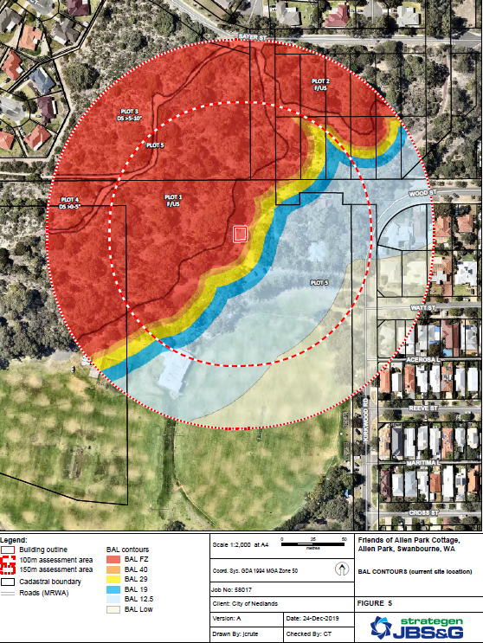

Figure 1: Showing cottage location inside BAL-FZ

The BAL contour map above indicates that the current site is situated within BAL-FZ and is likely subject to significant radiant heat and ember attack. For compliance to be achieved there is potential to reduce the radiant heat impacts on the subject site in its current location.

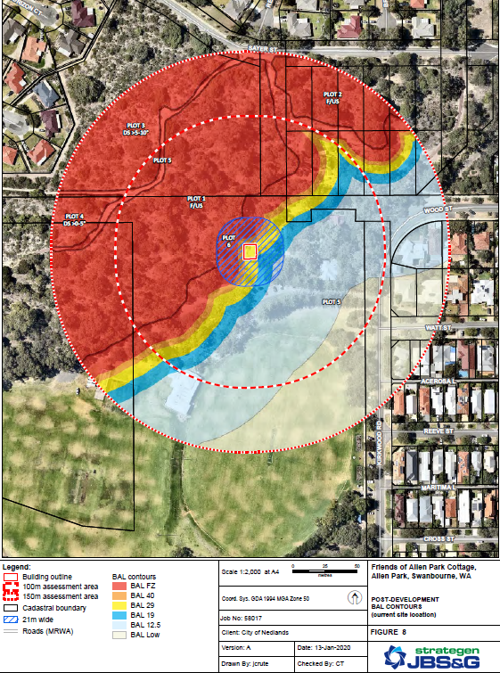

Figure 2: Showing 21 metre Asset protection Zone

Reduced risk through the implementation of a 21-metre-wide Asset Protection Zone (APZ) as depicted in the image above.

In order to renovate the building in its existing location, the City requires approval of a clearing permit from the Department of Water, Environment and Recreation to comply with the 21 metre buffer zone recommended through the bushfire management plan.

Due to the change in building classification from 1a to 9b, the City will be required to comply with the Disability Discrimination Act 1992.

Should the City call for Tenders (RFT) as required by the Regulations, the City may not have sufficient budget in the 2019/20 financial year to award the tender.

Legislation

The Local Government Act 1995

Planning and Development Act 2005

Planning and Development Regulations 2009

State Planning Policy 3.7 Planning in bushfire prone areas

Building Act 2011

Disability Discrimination Act 1992

Key Relevant Previous Council Decisions:

At the Ordinary Council meeting of 19 December 2017, Council resolved:

Item 13.5 – Allen Park Master Plan

“Council endorses the Allen Park Master Plan, as provided in Attachment 1, as a guiding document for future uses, activities, preservation, capital budgets and grant.”

At the Ordinary Council meeting of 26 March 2019, Council resolved:

Item CPS06.19 Mid-Year Budget Review – 2018-19

“receives and adopts, in accordance with Regulation 33A of the Local Government (Financial Management) Regulations 1996, the mid-year budget review and the revised Rate Setting Statement for the year ending 30 June 2019.”

Consultation

As part of the Allen Park Master Plan process the City undertook an extensive public consultation which culminated in the adoption of the Allen Park Master Plan in December 2017. Administration has been involved in ongoing dialogue with the FOAPBG regarding progression of identified elements of the Allen Park Master Plan. Administration met with the FOAPBG on Wednesday 11 December 2019 to discuss their concerns regarding the current condition of the cottage, and to gather a better understanding of the work they undertake in the bushland, as well as their current use of the cottage. Also discussed was what the group require in order to be able to undertake their activities, with the main requirements being:

- A place to hold and conduct meetings of the group;
- Kitchen facilities;
- WC facilities; and
- Storage facilities.

Petition

Council was presented with a petition at its Ordinary Meeting held on the 23 June 2020. Its signatories are requesting the City to restore the cottage for use by the Friends group. This Petition was received by Council, with no further action.

Strategic Implications

How well does it fit with our strategic direction?

Section 05 of the Strategic Community Plan “Our Priorities” states that we will ensure our buildings meet City and State Government Standards, particularly public safety and accessibility.

Who benefits?

At present providing an upgrade to the Allen Park Cottage will be only benefit the current user group “Friends of Allen park Bushland Group”. It is envisaged that by building a multi-use facility in proximity it will ensure equitable distribution of benefits to the community.

Does it involve a tolerable risk?

Renovating the cottage in its current location is a “High Risk” due to the impacts of surrounding bushland and its proximity inside the current bushfire attack zone. This means the building itself is at a high risk of ember attack should the surrounding bushland experience a fire. The risk can be managed by relocating demolishing the existing cottage and building a more robust multi use facility and locating it outside of the BAL zone.

Do we have the information we need?

Based on the age and condition of the current asset and the information provided by Stratagen, we now have robust evidence / data and analysis of options in order for a decision to be made on the future of this facility.

Budget/Financial Implications

Proposal 1

Renovate the Allen Park Cottage in its current location incorporating all necessary bush fire protection measures / modifications and retain the Allen Park Cottage as a Heritage Building. Noting there is a requirement to implement significant bushfire protection modifications to the exterior of the Cottage that could potentially compromise the aesthetic and heritage values of the building. Alternatively, there will be a requirement to reduce the potential fuel loading surrounding the building through clearing of vegetation for a distance of 21m surrounding the building.

Hodge Collard Preston Architects have undertaken a full assessment of the cottage and provided a conceptual design and cost estimate for the proposed alterations to enable the building to achieve compliance as a community building (Class 9b).

Construction costs are projected to be $250,000 exclusive of GST and projected on- costs. Due to the condition and age of the building, there is a substantial risk that unforeseen items may arise if a renovation is undertaken which could impact the construction budget (refer Table 1 below).

Construction Cost (Exc GST) | $215,000
Design + Contingency | $35,000
Construction Cost + Contingency (Exc GST) | $250,000
Bush Fire Protection Measures/ Modifications | TBC = $60,000 -$70,000
Temporary accommodation works | Excluded
Consultant fees + Disbursements | Excluded
Cost escalation to RFT | Excluded
Paving upgrade around building | Excluded
Air Conditioning | Excluded
External sewer and water service upgrade works | Excluded
External electrical infrastructure upgrade works | Excluded
Table 1. Concept Design and Cost Estimate

Should Council wish to renovate the Allen Park Cottage and achieve the (9b Assembly Building) classification, the following alternate recommendation applies:

Implement the works as contained in the Hodge Collard Preston Architects Report.

  - Secure approval from DWER for a clearing permit to clear a 21m buffer around the existing building as recommended within the Bush Fire Attach and Bush Management Report.
  - Implement the clearing permit requirements arising from any clearing permit approval as may be issued by DERW.
  - Arrange a change to the Cottage land-use classification to allow the building to be occupied as a public meeting pace.
  - Negotiate with the FOAPBG to enter into a formal lease arrangement that would enable the group to attract future grant funding.
  - Liaise with the Friends of Allen Park Group to identify an alternative meeting venue and storage facility close by for the duration of the proposed renovation works.

Proposal 2

Renovate the Allen Park Cottage in its current location incorporating all necessary bush fire protection modifications at an estimated cost of $300,000-$350,000 exclusive of GST and on-costs.

- Amend the current land vesting to allow the Cottage to be used as a public meeting place for the FOAPBG.
- Prepare a Lease or Management Licence to arrangement in conjunction with the FOAPBG to allow Allen Park Cottage as a meeting venue.

Proposal 3

Based on the information outlined in this report, Administration recommends that Council approve the use of the $150,000 budget to construct of a custom-built extension to the rear of the Allen Park Pavilion Building that incorporates a meeting room, small kitchen and storage for equipment. An extension to the Pavilion Building also provides for the FOAPBG to have access to shower, changeroom and toilet facilities.

Allow the FOAPBG to continue to use the Allan Park Cottage as a meeting venue during the construction of the extension to the building and repurpose or demolish the Allen Park Cottage.

Direct the direct the CEO to repurpose or demolish the building and restore the area through a revegetation program

Can we afford it?

The long-term financial plan allows for renewal of assets with a focus on upgrading the condition of all City buildings to a required modern standard. Consideration must be given to the current age and condition of the asset to ensure that any capital outlay prolongs the life of the asset and does not over capitalise.

How does the option impact upon rates?

The cost of the upgrade to this facility is equivalent to 1.5% of rates income based on 2020/2021 financial report.

