Technical Services Reports

Committee Consideration – 9 April 2019

Council Resolution – 23 April 2019

Table of Contents

Item No. Page No.

TS05.19 Execution of Grant of Easement 2
TS06.19 Peace Memorial Rose Gardens Restoration 5
TS07.19 Quintilian Road Partial Road Closure Community Engagement Results 9
TS08.19 Naming of Reserve 51183 – 30 (Lot 415) St Johns Wood Boulevard, Mt Claremont 18
TS09.19 Verdun Street Parking Station – Amendments to Parking Prohibitions 22
TS10.19 RFP 2018-19.01 - Design, Supply and Installation of Playground Equipment Panel 24

TS05.19 Execution of Grant of Easement

Committee | 9 April 2019
Council | 23 April 2019
Applicant | City of Nedlands
Employee Disclosure under section 5.70 Local Government Act 1995 | Nil.
Director | Martyn Glover – Director Technical Services
Attachments | - Copy of Easement in Gross documents

Executive Summary

The purpose of this report is to approve the application of the Common Seal on a grant of easement for the Aegis site, Mt Claremont.

The City has negotiated the creation of a Grant of Easement with Aegis Aged Care Group Pty Ltd, ACN 009 048 784 (Aegis) for the protection of the pipeline. For the City to finalise the easement creation, the Grant of Easement documentation (easement documents) in triplicate must be executed by way of signing by the Mayor and Chief Executive Officer plus the application of the Council Common Seal.

The City has an irrigation pipeline that carries water to Hamilton Gardens from Darren Park. This water is used for irrigating Hamilton Gardens, Pine Tree Park, Mooro Park, Grainger Reserve, Palm Island Reserve and Directors Gardens in Mt Claremont. This pipeline runs through Lot 416 (No. 1) Heritage Lane Mt Claremont which is owned by Aegis.

Recommendation to Committee

Council

- Approves the application of the Council Common Seal (seal) by the CEO on the Grant of Easement documentation in triplicate; and

- Directs the Mayor and Chief Executive Officer (CEO) to execute the Grant of Easement documentation in triplicate by way of signing.

Discussion/Overview

Background

During the process of the subdivision of the old Swanbourne Hospital site in 2012, a portion of the land was ceded to the Crown as a reserve for the purposes of Public Recreation and Right of Way. Reserve 51183 was created as part of this process.

During the City’s preliminary investigation in relation to the development of Reserve 51183, it was found that the City has irrigation infrastructure (pipeline) within the reserve that extended through Lot 416 (No1) Heritage Lane. This pipeline is critical infrastructure as it carries water to Hamilton Gardens from Darren Park. This water is used for irrigating Hamilton Gardens, Pine Tree Park, Mooro Park, Grainger Reserve, Palm Island Reserve and Directors Gardens in Mt Claremont.

On further investigation; it was found that the City has no easement rights over the location of the pipeline, and this presented a risk to the City. Without the easement rights the City would not have right to access the pipeline for future asset management.

Action

McLeods Solicitors and Barristers (McLeods) hand delivered the easement documents to the City on the 12 March 2019. Aegis has executed their portion of the easement documents.

Once approved by Council, the seal will be applied to the easement documents in triplicate in presence of the Mayor and CEO, who are then required to sign the easement documents in triplicate. At this point the documentation is said to be executed.

Once executed, the easement documents will be then be collected by McLeods. On receipt, Mcleods will arrange for the stamping and lodging of the easement documents at Landgate.

Legislation

The Local Government Act 1995 states:

9.49A. Execution of documents

(1) A document is duly executed by a local government if —

(a) the common seal of the local government is affixed to it in accordance with subsections (2) and (3); or
(b) it is signed on behalf of the local government by a person or persons authorised under subsection (4) to do so.

(2) The common seal of a local government is not to be affixed to any document except as authorised by the local government.

(3) The common seal of the local government is to be affixed to a document in the presence of —

(a) the mayor or president; and
(b) the chief executive officer or a senior employee authorised by the chief executive officer, each of whom is to sign the document to attest that the common seal was so affixed.

(4) A local government may, by resolution, authorise the chief executive officer, another employee or an agent of the local government to sign documents on behalf of the local government, either generally or subject to conditions or restrictions specified in the authorisation.

Key Relevant Previous Council Decisions:

Nil

Consultation

Negotiations were undertaken between Administration and Mr. Michael Cross, Chief Executive Officer of Aegis Aged Care Pty Ltd.

Budget/Financial Implications

Legal and lodgment fees for the execution are budgeted in the Technical Services 2018/19 operational budget.

TS06.19 Peace Memorial Rose Gardens Restoration

Committee | 9 April 2019
Council | 23 April 2019
Applicant | City of Nedlands
Employee Disclosure under section 5.70 Local Government Act 1995 | Nil.
Director | Martyn Glover – Director Technical Services
Attachments | - Digitisation of Bennett’s Original Plan 1948  - Amended Plan to fit existing Infrastructure

Executive Summary

The purpose of this report is to seek Council’s support for a staged renovation of the Peace Memorial Rose Gardens in consideration of the original design.

The Peace Memorial Rose Garden (the Garden) was originally constructed between 1948 and 1950, however the Garden as we know it now does not fully reflect the design by Architect WG (Bill) Bennett. The City now proposes to complete the original vision as designed by Bill Bennett in stages and subject to support by the Heritage Council and the community.

Recommendation to Committee

Council:

- Supports the development of the Peace Memorial Rose Garden to reflect the original design by WG (Bill) Bennett subject to the favourable outcome of the following:

  - The Heritage Council supports the project; and
  - A community engagement supports the project.

- Requests the Administration complete the detail design, costing and anticipated program of works for the project including an application for a Department of Veterans Affairs Grant.

Discussion/Overview

Background

The Peace Memorial Rose Garden (the Garden) is listed on both the State Heritage Register (PN 13688) and the Municipal Heritage Inventory (LGA PN N27). The Garden consists of 19 freehold lots (total area 1.7Ha) fronting Stirling Highway, Louise Street and Vincent Street and was originally purchased from the Salvation Army on 21 January 1948 by the Nedlands Roads Board.

A joint venture between the Roads Board and the National Rose Society WA, the Garden was proposed by Charles Frost, then President of the National Rose Society in 1945 and designed by the Board’s Architect, WG (Bill) Bennett in 1948. Former Mayor JC Smith also played an important part as he persuaded the Board to purchase the lots which made up the Garden as well as convincing them that it should be a memorial to fallen service men and women. Mayor Smith also personally acquired the 13” Jarrah posts for the arbour from Witchcliffe in the State’s south-west.

The Garden was originally constructed between 1948 and 1950 and was dedicated as a memorial on 22 October 1950. The Garden is ranked as the largest rose Garden in Western Australia but does not have the most roses. The Garden has been renovated several times and has been both reduced and expanded over time but the design by WG Bennett has never been completed.

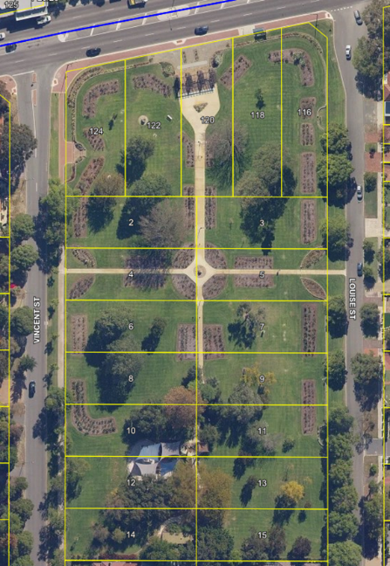
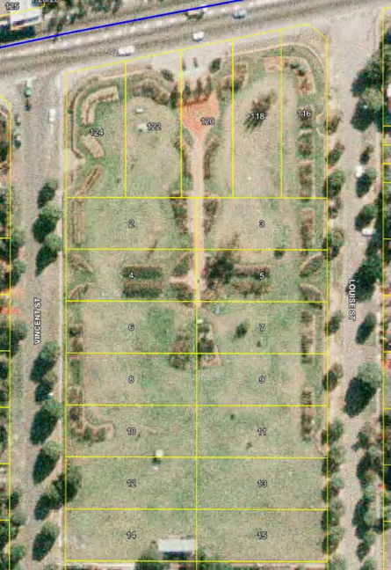
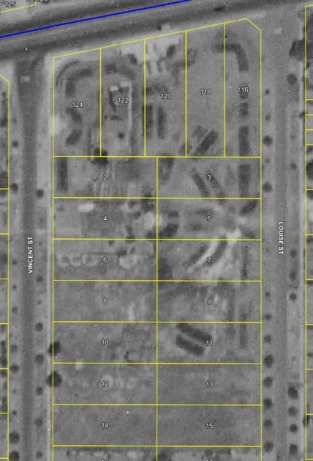
1953 1983 2018

Rose Garden Design

The Garden design included many geometrically designed paths and only the central spines were ever built. There were five substantial arbours but only one of these was built. There was a fountain proposed for the forecourt (see below) and this was never built. It has been suggested that this could be a community funded project by an organisation such as Lions.

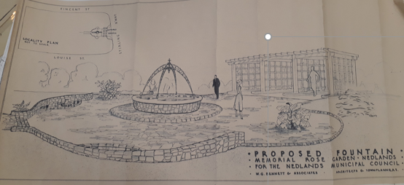
There should have been many more roses than the approximately 2,000 plants that exist and the arbours would have been covered with climbing roses. The original arbour did have climbing rose bushes, but these were never replaced when parts of the structural timber were removed and replaced during its renovation in April 2016. The original toilet was designed as Art Deco (see below) but the existing toilet is a more basic design.
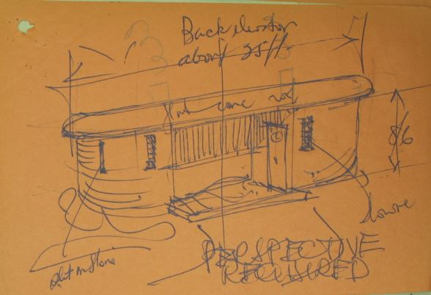
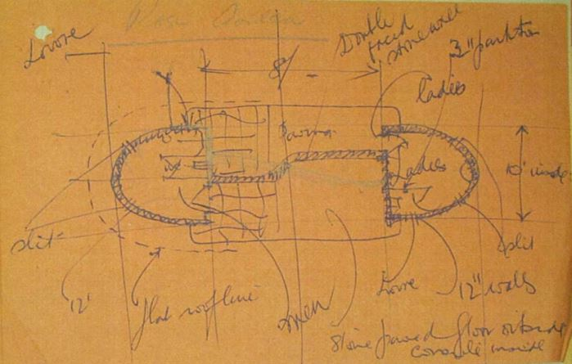
WG (Bill) Bennett’s original sketches (Battye Library)

The original design by Bennett has now been digitised by City staff and provides a predominantly symmetrical Garden (see attachment 1).

Although the park consisted of 19 lots, the design and the subsequent memorial only covers the northern 15 lots. The original toilet site was consequently moved south when it was eventually built in 1967. It is due for replacement in 2020/2021.

The overlay of the design over the existing aerial photograph confirms that the design was never completed and there is also infrastructure to the south of the park that would prevent the design being completed exactly as originally intended.

However, the City’s staff have manipulated the southern elements of the design so that it honours the original but also fits in between the existing vegetation and infrastructure (see attachment 2). It is anticipated that if Council were to support completing the Garden in accordance with the design, the Heritage Council would also support the development because it closely reflects the original.

Proposal

The proposal is to complete what was originally intended. Projects would include:

- Completing the path network including universal access.
- Install the four additional arbours including climbing roses.
- Relocate the bore to the south.
- Replace the toilet block with a modern disability access structure that has an Art Deco façade.
- Adjust the rose beds to their original shapes and mass plant them.
- Provide interpretive signage for the roses and trees.
- Construct the fountain.

To achieve this, the City would seek approval from both Council and the Heritage Council.

Key Relevant Previous Council Decisions

Nil.

Consultation

The City would need to consult with the Heritage Council and the community prior to commencing any development works on the site.

Budget/Financial Implications

The Five-Year Capital Works Program currently includes provision for a number of the projects already as follows:

- 2019/20 - $49,980 for the replacement of the bore and continued upgrade of the garden beds.

- 2020/21 - $411,880 for the replacement of the existing toilet block with a modern disability access facility, new access gates and continued upgrade of the garden beds.

- 2021/22 - $19,460 for replacement signage and continued upgrade of garden beds.

- 2022/23 - $63,700 for replacement of existing lighting and continued upgrade of garden beds.

- Total of $545,020 including 40 percent on-cost ($155,720).

It is noted that the five-year capital works program is an informing document aligned with the ten-year financial plan which is updated each year. However, only the first year is approved by Council as part of the budget.

TS07.19 Quintilian Road Partial Road Closure Community Engagement Results

Committee | 9 April 2019
Council | 23 April 2019
Applicant | City of Nedlands
Employee Disclosure under section 5.70 Local Government Act 1995 | Nil.
Director | Martyn Glover – Director Technical Services
Attachments | - Community Engagement Responses by Street  - Engagement Report  - Quintilian School Submission

Executive Summary

The purpose of this report is to review the outcomes of the recent community engagement and seek Council’s support for a minor change to the traffic management devices.

In December 2018, Council approved a proposed left-out only partial closure of Quintilian Road for the purposes of consultation with the affected residents and landowners. This was in response to the higher than normal volume of commercial traffic using Quintilian Road.

Consultation of the proposed partial closure was undertaken between 12 February 2019 and 4 March 2019. Late submissions were accepted until 5 March 2019. The City received 217 items of feedback via Your Voice Nedlands (feedback, survey), emails and submissions of which there is overwhelming opposition (82%) to the proposal.

Recommendation to Committee

Council:

- does not support the proposed left-out only partial road closure of Quintilian Road at Brockway Road;

- supports the installation of the speed pillows included in the original report of October 2017;

- supports the provision of flashing 40km/h speed zone signs in Quintilian Road; and

- commits to continue to review the traffic management in Quintilian Road.

Discussion/Overview

Quintilian Road is a local access road, 490m in length and is one of four roads within the City of Nedlands that connects Brockway Road to Stubbs Terrace in Mt Claremont.

In early 2018, speed reduction plateaus were installed on Quintilian Road to address complaints in relation to speed, volume and proportion of commercial vehicles. The results of this treatment are summarised below:

Table 1. Quintilian Road Traffic Count History

Traffic Measure | March 2017 | March 2018 | October 2018 | March 2019 | Change from March 2017
Average Daily Volume (5 Day) | 1993 | 2300 | 1970 | 1749 | Decreased by 12.2%
85th Percentile Speed (km/h) | 55.8 | 51.5 | 51.5 | 51.0 | Decreased by 8.6%
Proportion Commercial Vehicles | 4.3% | 5.2% | 5.0% | 4.8% | Increased by 0.5%

It is noted that the March 2018 traffic counts saw an increase in traffic which can be attributed to the temporary closure of the Ashton Avenue Bridge. A second traffic count taken in October 2018, approximately one month after the Ashton Avenue Bridge was re-opened, supports this. The most recent report in March 2019 has demonstrated a continued gradual reduction since March 2018. However, it is noted that while there was improvement in the 85th percentile speed and traffic volume, the proportion of commercial traffic has increased marginally.

In December 2018, Council approved a proposed left-out only partial closure of Quintilian Road at Brockway Road for the purposes of consultation to address the proportion of commercial vehicles. The partial closure was chosen because it would have the greatest impact on commercial vehicles while still promoting the anti-clockwise (safest) rotation around the school. The commercial vehicle traffic increase from 4.3% in March 2017 to 4.8% in March 2019 actually represents a decrease from 86 vehicles to 84 vehicles in reality. However, it is still greater than an anticipated 3.0% (less than 60 vehicles average for Local Access Road with this traffic volume).

Finally, it is noted that there have been eight crashes recorded on Quintilian Road (not including the intersections) in the past five years however there have been none since the installation of the plateaus.

Key Relevant Previous Council Decisions:

Ordinary Meeting of Council 18 December 2018, Item TS28.18

“That Council:

1. Supports the proposed left-out only partial road closure of Quintilian Road at Brockway Road for the purposes of a consultation process with the affected residents and landowners; and

2. Includes writing to all residents and landowners within the area bound by Mimosa Avenue, Alfred Road, Stubbs Terrace, Quintilian Road, Camelia Avenue and those living in Jubaea Gardens seeking their comments on the proposed partial closure.”

Ordinary Meeting of Council 24 October 2017, Item 13.5

“Council approves the traffic management design for Quintilian Road with the deferral of the installation of the traffic pillows until further assessment after first stage of work.”

Consultation

The proposed left-out only partial closure was presented to the residents bounded by the area shown in Figure 1 as per direction received from Council in the December 2018 Ordinary Meeting of Council.

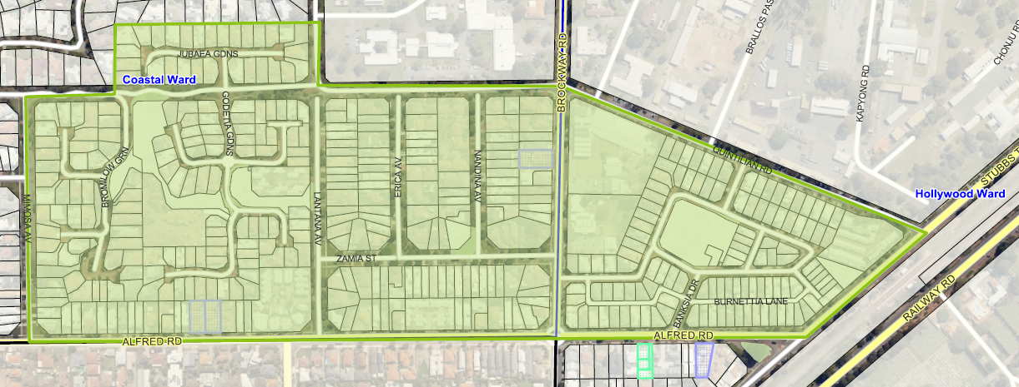
Figure 1. Consultation area

Road users outside of the project area were also encouraged to provide feedback through a variable message board (VMB). This VMB was positioned facing the southbound traffic along Brockway Road between 15 February 2019 and 5 March 2019. Engagement was undertaken between 12 February 2019 and 4 March 2019. Late submissions were accepted until 5 March 2019.

Opportunities for residents and the wider community to engage with the City and to seek information were provided as follows:

- A letter to the residents/property owners within the project area to provide information on and seek their thoughts on the proposal.
- Your Voice Nedlands: Online survey, plan of the proposed partial closure, FAQs, key dates and project team contact details.
- Contacting the City by email or telephone to discuss the proposal further

During the engagement period, the engagement page received 482 visitors who collectively made 556 site visits and viewed 2267 pages. 403 of these visits viewed at least one page. There were 84 document downloads (Council report and proposal) and 75 visits to the FAQ page.

The online survey sought to identify the level of support for the proposed partial closure and obtain feedback. 165 online surveys were completed and 19 items of feedback. The City also received 34 written submissions as well as 23 phone calls. All written feedback and phone call responses have been assessed together with the online survey submissions. Multiple submissions by an individual were assessed as one submission.

Figure 2 summarises the engagement responses received by the City. Most respondents were from the project area (see Attachment 1).

Figure 2. Engagement results
Issues raised by respondents centered around four main issues which are summarised in Table 2. More detailed information on the engagement and responses can be found in the Engagement Report (Attachment 2).

Table 2. Issues identified from community engagement.

Issue | Administration comment
Increased traffic through St Peter’s Square which is considered not only unsuitable for the area but a hazard for children and pedestrians. | This has been noted as one of the potential impacts of the proposed partial closure.
Increased congestion and journey times | The proposed partial closure is expected to result in an increase in traffic and journey times due to the need for vehicles to find alternative routes.
 | The increased traffic is expected to primarily affect the Brockway Road/Alfred Road intersection as well as Stubbs Terrace. While it is not unacceptable to divert traffic onto distributor roads such as Brockway Road, Alfred Road and Stubbs Terrace, given the existing high volumes of traffic on these roads, there is potential additional traffic to create congestion and delays.
Loss of an important link to Subiaco, the City and the railway station | The proposed partial closure will limit access directly to the railway station and to areas such as Subiaco and the City. While there are alternative routes around the proposed partial closure, the proposal will affect a large portion of residents residing to the west of Brockway Road. This is due to the large number of cul-de-sacs on the west side of Brockway Road which limits the number of entry/exit routes for residents.
Inability of on road cyclists to cycle on road heading east along Quintilian Road. | The proposed partial closure will deny on road cyclists from cycling on road heading east along Quintilian Road. There are currently plans for a future shared path along Quintilian Road to improve cyclist and pedestrian access to the railway station. Should the proposed partial closure go ahead there is a footpath available on the south side of Quintilian which can be used in the interim while plans for the shared path are being finalized.  Respondents did suggest the inclusion of a cyclist slipway in the partial closure. The Administration’s preference would be to include the suggestion for consideration as part of plans for a future shared path along Quintilian Road.
Some suggestions were also made by respondents. These suggestions are summarised in Table 3.

Table 3. Suggestions identified from community engagement

Suggestion | Administration comment
Roundabout at the intersection of Brockway Road/Quintilian Road/Camelia Avenue intersection | The objective of the proposal is to address the volume of commercial vehicles using Quintilian Road. While roundabouts can assist in reducing traffic speeds and potentially discouraging commercial traffic, the Administration does not believe a roundabout is a cost-effective solution to address commercial traffic volumes.  The Administration also does not consider a roundabout at the Brockway Road/Quintilian Road/Camelia Avenue intersection appropriate to due to the significantly different functions of the intersecting roads. In addition, there are no warrants for a roundabout at this intersection due to the low number of crashes (two) and their low severity.
Installation of chicanes on Quintilian Road | The objective of the proposal is to address the volume of commercial vehicles using Quintilian Road. In a similar manner to the installed speed plateaus, chicanes can help treat speeding issues and discourage commercial vehicles usage. However, given that the speed plateau treatment has seen an increase in commercial vehicle volumes, the Administration does not believe chicanes will adequately address the commercial traffic issue.
Signage banning/discouraging commercial vehicles from using Quintilian Road | The Administration does not support the use of any further signage. The over proliferation of signs creates not only visual pollution but can lead to general ambivalence to road signage, which reduces the efficacy of more important signs such as regulatory signs that are essential for maintaining road safety.
Closing of Tuart Entrance | This would limit the accessibility for the residents in St Peter’s Square and would require a separate consultation with residents.
Children’s Crossing/Traffic Warden | Safety around schools is the responsibility of the school. The Administration can assist with applications for traffic wardens and children’s crossing however this process needs to be instigated by schools.

The City also received a submission from the Quintilian School representing the school community (see Attachment 3) which did not support the closure and provided a series of suggestions for the traffic management summarized in Table 4.

Table 4. Suggestions raised by Quintilian School

Suggestion | Administration comment
Provision of cul-de-sac at eastern end of existing 40km/h zone. | The Administration does not support the cul-de-sac proposal because it would constitute closure of Quintilian Road mid-block which would not be supported by the community and would increase congestion at the Brockway Road intersection.
Three sets of speed pillows on Quintilian Road fronting the school. | The Administration originally proposed to install a set of speed pillows to the eastern end of the school to provide confirmation of the speed zone at 40km/h and provide a management device at a regular interval, thereby maintaining the low speed environment. The Administration does not support these devices opposite pedestrian crossing points as it confuses road users and is not the purpose of the device.
Installation of two LED flashing 40km/h zone signs to replace the static signs. | The Administration supports this proposal however it would also require approval by Main Roads WA.
Line marked and hatched pedestrian area behind parked cars on north side of Quintilian Road. | The Administration does not support this proposal as it establishes an increased risk of vehicles reversing into pedestrians and the hatching would have no legal standing.
Roundabout at the intersection of Brockway Road/Quintilian Road/Camelia Avenue intersection | The Administration does not consider a roundabout at the Brockway Road/Quintilian Road/Camelia Avenue intersection appropriate to due to the significantly different functions of the intersecting roads. In addition, there are no warrants for a roundabout at this intersection due to the low number of crashes (two) and their low severity.

Budget/Financial Implications

As there is no current provision for the project in the 2018-19 Capital Work Program, there is no anticipated financial impact should the project not proceed. The recommended speed pillows can be funded from the road maintenance budget.

Conclusion

From a technical perspective, the traffic volumes and speed along Quintilian Road are acceptable for a local access road:

- Volume at 1749vpd is less than warrant of 3,000vpd for a Local Access Road.
- 85th percentile speed at 51.0 km/h is only 1km/h above the posted speed zone of 50km/h. Note that the 40km/h school zone only applies during school days at pick-up and drop-off periods.

Some residents may consider 4.8% commercial vehicles volume to be higher than desirable however although the preference is for less than 3.0%, this higher proportion of commercial vehicle volume is not unusual for a Local Access Road especially when linking Distributor Roads as is the case in this instance.

Overall, the undesirable flow-on effects from the proposal outweigh the benefits. In addition, there is little community support for the proposed left-out only closure. It is noted that only five of the 19 respondents from Quintilian Road supported the partial closure. Furthermore, because this partial closure had the lowest impact of all the potential closure options for the road, the Administration recommends that no closures including the proposed left-out only partial closure be progressed as it is considered none of these would receive community support.

The Administration does however support the re-inclusion of the speed pillows at the eastern end of Quintilian School because this would provide improved spacing between the traffic management treatments and further emphasize the slow speed environment fronting the school. It is believed that this would further decrease the 85th percentile speed and further discourage commercial through traffic.

TS08.19 Naming of Reserve 51183 – 30 (Lot 415) St Johns Wood Boulevard, Mt Claremont

Committee | 9 April 2019
Council | 23 April 2019
Applicant | City of Nedlands
Employee Disclosure under section 5.70 Local Government Act 1995 | Nil.
Director | Martyn Glover – Director Technical Services
Attachments | - Policies and Standards for Geographical Naming in Western Australia (excerpt)

Executive Summary

The purpose of this report is to seek Council endorsement for the naming of Reserve 51183, street address 30 (Lot 415) St Johns Wood Boulevard, Mt Claremont.

Recommendation to Committee

Council instructs Administration to apply to the Geographic Names Committee to have reserve Reserve 51183, street address 30 (Lot 415) St Johns Wood Boulevard, Mt Claremont named ‘Abbey Park'.

Discussion/Overview

Background

Reserve 51183 was created in 2012 following the ceding of 2,482 m² of private land to the Crown as part of developing the Old Swanbourne Hospital site. At its meeting on 26 February 2019 Council agreed to award a contract to develop the reserve. Development of the park has commenced with completion scheduled during May 2019.

The City is currently seeking a management order for the reserve from the Department of Lands. The reserve has previously been referred to informally as St Johns Wood Public Open Space but has not officially been given a name. The City is seeking Council’s endorsement to apply to the Geographic Names Committee (GNC) to officially name the reserve.

Legislation

As per the provisions in the Land Administration Act 1997, the Minister for Lands (the
Minister) has the authority for officially naming all local parks and recreational reserves in Western Australia. The GNC acts on the Minister’s behalf to undertake the administrative responsibilities, including the development of policies and procedures, required for the formal approval of local parks and recreational reserve names.

GNC policy prescribes that Local governments and other authorities are to ensure that all naming submissions conform to the provisions in the publication ‘Policies and Standards for Geographical Naming in Western Australia’ (the Policies). An extract of relevant sections of the Policies can be viewed in Attachment 1.

Council Policy

Council’s Naming of Parks, Streets, Public Facilities, Buildings and Signs on Reserves prescribes that the naming of reserves must align with GNC Policy.

Analysis of Naming Options

In accordance with the Policies the proposed name is required to contain a name element (specific) followed by a feature class (generic). Several contextual options were considered for selecting a name that would conform with the Policies. The two most applicable approaches for the name element (specific) that would conform with the Policies would be to name the reserve after an adjoining road or to commemorate a person who has a significant historical connection to the site.

Options considered for the name element (specific) of the reserve being connected to an adjoining road include:

- Abbey; and
- St Johns Wood.

The two roads adjoining the reserve are St Johns Wood Boulevard and Abbey Gardens. The name St Johns Wood Estate was used by the developer of the subdivision for commercial purposes, with St Johns Wood Boulevard being derived from the estate name. St Johns Wood is a suburb of London and the name Abbey Gardens was derived from the suburb. The secretariat to the GNC has advised both these names conform with the Polices and are suitable to be adopted.

Options considered for the name element (specific) of the reserve associated with a significant historical connection to the area and that commemorates a person include:

- Sydney Montgomery;
- James Bentley;
- Ernest Thompson;
- John Grainger; and
- Hillson Beasley.

Sydney Montgomery, James Bentley and Ernest Thompson were all Inspectors General of the Insane and Medical Superintendents at the Claremont Hospital for the Insane. John Grainger and Hillson Beasley were both Principal Architects of the Public Works Department and were involved in designing the hospital campus and buildings to some degree. The remaining buildings comprising the Aegis Aged Care facility are listed on the State Heritage Register. The Heritage Council of WA describes the Claremont Hospital for the Insane buildings as ‘essential history of mental health buildings in the State’. The State Heritage Register lists three sites of significance that remain being the Hospital Director’s Residence, Garage and Surrounds; the Administration Building Swanbourne Hospital; and Montgomery Hall.

The names Grainger, Bentley and Montgomery do not conform with the Policies as there is either a reserve or a road close by using these names. They do not conform as they duplicate a named feature nearby which has the potential for confusion if an emergency situation was to arise. Of the two remaining names, neither are prominently established in the local area. Thompson was the Medical Superintendent of the hospital serving in this capacity from 1939 to 1941. Beasley has an indirect association with the site having designed the buildings for another project which the buildings at the Claremont Hospital for the Insane were an almost exact copy.

The GNC secretariat has advised that as all the above persons were paid public servants their use would not conform with the Policies and subsequently would not be supported.

Options for the feature class (generic) of the reserve are:

- Park;
- Reserve; and
- Gardens.

Any one of these feature class portion names is suitable and could be used. There is already a strong connection within the local area of name theming that associates with the suburb of St Johns Wood e.g. New Court Gardens, Cavendish Gardens and Hamilton Park. It is thought appropriate to continue with this theme to reflect the intrinsic fabric of names used throughout the local area. Gardens is unable to be used as the adjoining road is Abbey Gardens and the use of reserve is less reflective of the locality.

Key Relevant Previous Council Decisions

- Council Minutes 28 May 2013 – Item 12.3 – Report TS07.13, Proposed New Reserve for Purposes of “Public Recreation” and “Rights of Way” – Lot 415 on Deposited Plan 71165, Mt Claremont.

- Council Minutes 24 July 2018 – Item 12.3 – Report TS15.18, St Johns Wood Boulevard POS Community Consultation.

- Council Minutes 26 February 2019 – Item 13.2 – RFT 2018-19.04 - 30 (lot 415) St Johns Wood Boulevard, Mt Claremont - Public Open Space Development.

Consultation

GNC policy requires that where a name is proposed for a reserve, there needs to be demonstrated community support for the name. At its meeting of 24 July 2018, Council considered a report on the results of community consultation associated with the reserve. As part of the consultation, the community was asked to provide ideas for naming the park. The two most popular names put forward by the community were Abbey Park and Montgomery Park. The results of community consultation indicated there is broad community support to use either of these options for naming the park.

The City has sought advice from the secretariat of the GNC on the suitability of using either Abbey or Montgomery in the naming of the park. As indicated previously, the use of Montgomery does not conform with the Policies and the GNC secretariat have confirmed its use would not be supported.

Budget/Financial Implications

Nil.

Conclusion

Based on the requirements of the GNC Policies for geographic naming, it is recommended that the public open space in St Johns Wood Boulevard, Reserve 51183 be named Abbey Park, as this is the most likely name to be supported by the GNC.

TS09.19 Verdun Street Parking Station – Amendments to Parking Prohibitions

Committee | 9 April 2019
Council | 23 April 2019
Applicant | City of Nedlands
Employee Disclosure under section 5.70 Local Government Act 1995 | Nil.
Director | Martyn Glover – Director Technical Services
Attachments | - Proposed Parking Prohibitions Plan

Executive Summary

The purpose of this report is to seek Council’s approval for a change to the parking prohibitions at the Verdun Street Parking Station at Highview Park. The City proposes changes to the existing parking prohibitions at the Verdun Street Parking Station to improve public amenity. The change is required as a result of Ramsay Health Care terminating their parking lease on 30 November 2018.

Recommendation to Committee

Council approve changing the existing parking prohibition at the Verdun Street parking station from 2P to 4P.

Discussion/Overview

The Administration has observed that the City of Nedlands parking station at the corner of Smyth Road and Verdun Street has very low occupancy levels since Ramsay Health Care terminated their parking lease on 30 November 2018.

To improve public amenity for visitors to the hospital and other user groups during business hours it is proposed to change the existing parking prohibition from 2P to 4P (refer Attachment 1). The prohibition coverage will remain at 24 hours a day, 7 days a week to prevent the bays being filled up by hospital workers on night shift and weekends.

It has been observed that some Hollywood Primary School parents use the parking station at school drop off and pickup times. This use should continue as it reduces traffic congestion on Monash Avenue at peak times.

The construction of a temporary crossover has been approved by the City on Verdun Street, opposite Croydon Street, to facilitate access to construction works within Hollywood Private Hospital. The temporary crossover location is where the Health Services Family Association Outside School Hours Care (HSFAOSHC) Centre currently park their buses. The temporary crossover will be in place for at least two years. The HSFAOSHC Centre has requested six dedicated bays be provided within the parking station for their buses. Rangers are currently negotiating a lease agreement with the HSFAOSHC Centre for the exclusive use of these bays.

The Administration will continue to monitor the parking occupancy levels after the change to ensure there is available parking for all user groups including Hollywood Primary School, Hollywood Subiaco Bowling Club, Sand Sports Australia and Suburban Lions Hockey Club.

Consultation

Information of the parking prohibition change will be posted on the City’s “Your Voice” website and the following groups will be notified by letter:

- Hollywood Private Hospital (Ramsay Health Care)
- Hollywood Primary School
- Hollywood Subiaco Bowling Club
- Sand Sports Australia
- Suburban Lions Hockey Club

Budget/Financial Implications

Sign replacement cost is estimated at under $500.

Conclusion

The area of East Hollywood regularly saturates with street parking. Since the City has ceased the parking arrangement at the Verdun Street Parking Station with Hollywood Private Hospital, it has been noted by staff that the large carpark regularly has low occupancy. The adjustment of the current 2P prohibition to 4P is anticipated to assist with the current parking issues in this part of the City, especially visitors.

TS10.19 RFP 2018-19.01 - Design, Supply and Installation of Playground Equipment Panel

Committee | 9 April 2019
Council | 23 April 2019
Applicant | City of Nedlands
Employee Disclosure under section 5.70 Local Government Act 1995 | Nil.
Director | Martyn Glover – Director Technical Services
Attachments | - Brockman Reserve Playground Redevelopment – Community Engagement Results

Executive Summary

The purpose of this report is to seek finalisation of the appointment of suppliers to a panel for the Design, Supply and installation of Playground Equipment as well as agreeing to award the playground replacement in Brockman Reserve, Dalkeith.

Recommendation to Committee

Council

- agrees to appoint the following contractors to the RFP 2018-19.01 - Design, Supply and Installation of Playground Equipment Panel:
- Adventure Playgrounds Pty Ltd atf R & G Kelsey Business Trust t/as Adventure +
- Erutan Pty Ltd ta Nature Playgrounds
- MAS (WA) Pty Ltd as Trustee for the Simpson Family Trust T/As Miracle Recreation Equipment;
- Nature Play Solutions Pty Ltd;
- Playmaster Pty Ltd.
2. agrees to award the construction of the Brockman Reserve Playground to Erutan Pty Ltd ta Nature Playgrounds; and
3. authorises the Chief Executive Officer to Sign the acceptance of offers.

Discussion/Overview

Background

The City includes budget provisions for the supply and installation of playground equipment as part of the Parks Services capital works program. A program of capital works is scheduled annually to maintain and improve the City’s playground infrastructure. It is likely expenditure on this capital renewal program will exceed $150,000 annually. In order to comply with legislative requirements outlined in the Local Government Act 1995 and ensure the best value for money for the City, the supply of these services must be tendered.

Panel information

The Local Government (Functions and General) Regulations 1996 allows for local governments to establish panels of pre-qualified suppliers.

Request for Panel 2018-19.01 was advertised on 15 August 2018 in the West Australian Newspaper and at www.tenderlink.com/nedlands. The Panel invitation ended on 4 September 2018 and submitted responses were opened by officers of the City at 10.30am on 4 September 2018.

Five (5) compliant submissions were received by the City by the following companies;

- Adventure Playgrounds Pty Ltd atf R & G Kelsey Business Trust t/as Adventure +
- Erutan Pty Ltd ta Nature Playgrounds
- MAS (WA) Pty Ltd as Trustee for the Simpson Family Trust T/As Miracle Recreation Equipment
- Nature Play Solutions Pty Ltd
- Playmaster Pty Ltd

Evaluation

The tender was independently evaluated by three (3) City officers in accordance with the qualitative criteria specified in the Panel documentation. As the budget was provided to respondents, no price consideration was given, however, value for money considerations were evaluated under the qualitative criteria ‘proposal suitability’. The five (5) compliant submissions were all evaluated as being suitable as pre-qualified suppliers of playground equipment design, supply and installation services to the City.

In accordance with adopted community engagement practice, the two preferred playground design options for Brockman Reserve out to community consultation. The two designs chosen were assessed by the Administration as providing the best value for money and most suitable proposals for this specific project.

Conclusion

Following the assessment of the contractor submissions, it is proposed that Adventure Playgrounds Pty Ltd atf R & G Kelsey Business Trust t/as Adventure +, Erutan Pty Ltd ta Nature Playgrounds, MAS (WA) Pty Ltd as Trustee for the Simpson Family Trust T/As Miracle Recreation Equipment, Nature Play Solutions Pty Ltd and Playmaster Pty Ltd are all recommended for the design, supply and installation of playground equipment panel.

All respondents demonstrated their ability to provide the services required, demonstrating adequate experience and qualifications, along with evidence of producing quality outcomes. In accordance with RFP 2018-19.01 section 2.2 Panel Information, up to five Contractors may be appointed to the panel. For the City to have the widest range of options available for quotation, it is proposed all five contractors are appointed to the panel.

The final scores can be found in Attachment 1.

Key Relevant Previous Council Decisions:

- Council Minutes 26 June 2018 – Item 13.9 – Adoption of the Annual Budget 2018/19

Consultation

Community consultation on the two preferred Brockman Reserve playground submissions was undertaken as part of the tender assessment. Please refer to Attachment 2 Brockman Reserve Playground Redevelopment – Community Engagement Results.

The nature play style playground proposed by Erutan Pty Ltd ta Nature Playgrounds received the greatest level of support from the immediate community and is also recommended by the Administration.

In accordance with the adopted community engagement practice, it is proposed to undertake community consultation for each individual playground upgrade commenced throughout the term of the contract.

Budget/Financial Implications

Playground designs presented to the community from contractors on the panel will be established on the approved allocated budget in the relevant financial year.

The submission for the contractor recommended to Council for the supply and installation of playground equipment at Brockman Reserve is within the budget allocated to this project in the 2018/19 financial year.

