

Corporate & Strategy Reports

Committee Consideration – 9 February 2021
Council Resolution – 23 February 2021

Table of Contents

Item No. Page No.

CPS01.21 List of Accounts Paid – November and December 2020 2
CPS02.21 Alteration of Permitted Use – Sublease to Sand Volley Australia Pty Ltd 4
CPS03.21 New Lease to Allen Park Tennis Club 11
CPS04.21 Review of Point Resolution Child Care Centre Update 16

CPS01.21 List of Accounts Paid – November and December 2020

Committee | 9 February 2021
Council | 23 February 2021
Applicant | City of Nedlands
Employee Disclosure under section 5.70 Local Government Act 1995 | Nil.
Director | Ed Herne – Director Corporate & Strategy
Attachments | - Creditor Payment Listing – November 2020;  - Credit Card and Purchasing Card Payments – November 2020 (28 October – 29 November 2020);  - Creditor Payment Listing – December 2020; and  - Credit Card and Purchasing Card Payments – December 2020 (30 November - 28 December 2020)
Confidential Attachments | Nil.

Executive Summary

In accordance with Regulation 13 of the Local Government (Financial Management) Regulations 1996 Administration is required to present the List of Accounts Paid for the month to Council.

Recommendation to Committee

Council receives the List of Accounts Paid for the months of November and December 2020 as per attachments.

Discussion/Overview

Background

Regulation 13 of the Local Government (Financial Management) Regulations 1996 requires a list of accounts paid to be prepared each month, showing each account paid since the last list was prepared. This list is to include the following information:

- the payee’s name;
- the amount of the payment;
- the date of the payment; and
- sufficient information to identify the transaction.

It is normal practice for the monthly payment list to be a month in arrears to allow for the production of Council reports, the timetable is such that Council reports are being finalised for the following months’ round of meetings before the completion of the current month.

Risk Management

The accounts payable procedures ensure that no fraudulent payments are made by the City, and these procedures are strictly adhered to by the officers. These include the final vetting of approved invoices by the Manager Finance and the Director Corporate and Strategy (or designated alternative officers).

Conclusion

The List of Accounts Paid for the months of November and December 2020 complies with the relevant legislation and can be received by Council (see attachments).

Consultation

Required by legislation: Yes No
Required by City of Nedlands policy: Yes No

Strategic Implications

The 2020/21 approved budget is in line with the City’s strategic direction. Payments are made to meet the City’s spend on operations and capital expenses undertaken in accordance with the approved budget.

The 2020/21 approved budget ensured that there is an equitable distribution of benefits in the community

The 2020/21 budget was prepared in line with the City’s level of tolerance of risk and it is managed through budgetary review and control.

Budget/Financial Implications

The payments are made in accordance with the approved budget and achieves a surplus cashflow balance.

CPS02.21 Alteration of Permitted Use – Sublease to Sand Volley Australia Pty Ltd

Committee | 9 February 2021
Council | 23 February 2021
Applicant | City of Nedlands
Employee Disclosure under section 5.70 Local Government Act 1995 | Nil.
Director | Ed Herne – Director Corporate & Strategy
Attachments | - Letter of Request – Sand Volley Australia Pty Ltd
Confidential Attachments | Nil.

Executive Summary

Hollywood-Subiaco Bowling Club Inc (‘HSBC’) lease a portion of Crown Reserve 22384 which is vested to the City for care, control, and management. The lease premises are better known as portion of ‘Highview Park’, located on Smyth Road and Verdun Street, Nedlands. Sand Volley Australia Pty Ltd (‘Sand Volley’) sublease a smaller portion of that lease area from HSBC.

The current lease was varied on 25 November 2013 in line with the commencement of the sublease and both the lease and sublease agreements expired on 30 May 2018. The lease and sublease have been in ‘Holding Over’ since the expiry date, pending the endorsement of the Strategic Recreation Plan and subsequent Highview Master Plan. The completion of these documents enable Council to make an informed decision about the long-term future of the site.

In a letter dated 21 August 2020, Sand Volley (informally known as ‘Sandsports Australia’) proposed an alteration to the current ‘permitted purpose’ within the sublease arrangement. This letter is shown in Attachment 1.

The City’s Executive have examined this request and this item is now presented to Council for further consideration.

Recommendation to Committee

Council:

- requests the CEO to arrange preparation of new 2-year Deed of Lease and Sublease agreements based on the same terms and conditions as the current agreements, with the exception being the change of ‘permitted use’ within the sublease as defined within this report;

- notes that all costs related to the preparation of the new lease and sublease agreements will be borne by Sand Volley Australia Pty Ltd;
- subject to the Minister for Lands consent, authorises the CEO and Mayor to execute the new 2-year lease agreement with Hollywood-Subiaco Bowling Club Inc and apply the City’s Common Seal and;

- subject to the Minister for Lands consent, authorises the CEO and Mayor to execute the new 2-year sublease agreement with Hollywood-Subiaco Bowling Club Inc and Sand Volley Australia Pty Ltd and apply the City’s Common Seal.

Discussion/Overview

Background

The Proposal

On 21 August 2020, the City’s Sub-Lessee, Sand Volley Australia Pty Ltd submitted a proposal to slightly alter the current ‘permitted purpose’ within the sublease arrangement.

The current permitted purpose is defined as:
‘Purposes associated with or incidental to the sport of volleyball or netball’

The proposed amendment to the permitted purpose is defined as:
‘Purposes associated with or incidental to sand-based sports’

The proposal (as shown in Attachment 1) notes the request comes not only on the basis of diversifying income to ensure the long-term viability for the tenant, but to also increase the recreation options for the local community which will in-turn have a positive effect on the community’s mental health.

When discussing the proposal with Administration, Sand Volley were advised that HSBC, as party to the lease and sublease agreements, would need to be consulted and would need to be in support of the project. Sand Volley were also advised that due to the Holding Over status, any change to the sublease agreement would need to be reflected in the head lease agreement as well.

A depiction of the Sublease area is shown below;

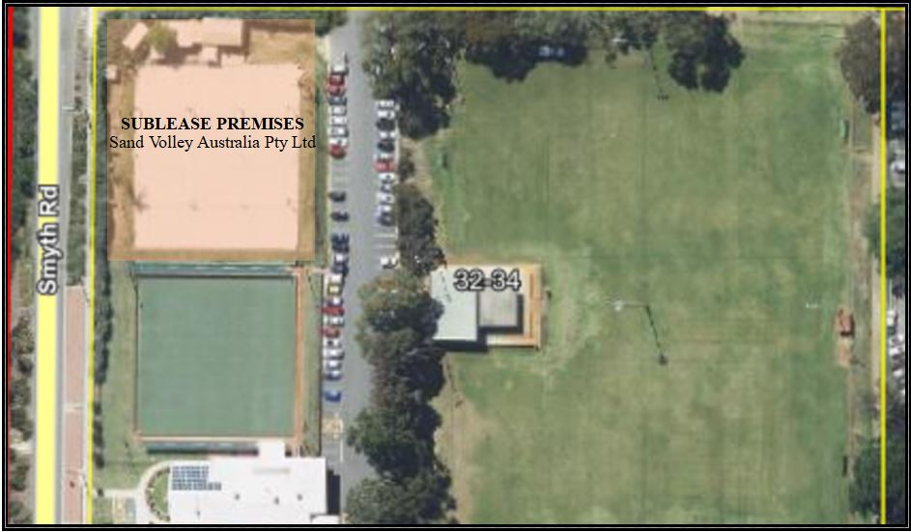

Lease and Sublease

HSBC lease a portion of Crown Reserve 22384 which is vested to the City for care, control, and management. The lease premises are better known as portion of ‘Highview Park’, located on Smyth Road and Verdun Street, Nedlands. The lease agreement was executed on 1 June 2003, but in order to formalise the sublease arrangement with Sand Volley, a Variation of Lease was also executed between the parties on 25 November 2013 - this is the most current version of the lease agreement. According to the terms and conditions of that agreement, the lease expired on 30 May 2018, at which time the City invoked the standard ‘Holding Over’ Clause. This means this tenancy is essentially operating on a month-by-month basis.

The current sublease agreement notes three parties, the City (Lessor), Hollywood-Subiaco Bowling Club Inc (Lessee) and Sand Volley Australia Pty Ltd (Sub-Lessee). Although the agreement commenced 25 November 2013, it is acknowledged that the tenant has been in possession of the sublease premises since 11 August 2004. The sublease expired on 30 May 2018, at which time the City invoked the ‘Holding Over’ Clause. This means this tenancy is essentially operating on a month-by-month basis.

The reason for the City invoking this clause on both agreements (and all other lease agreements at the Highview Park site) was to provide flexibility and align all agreements on the site should any major changes be approved following an endorsement of the Strategic Recreation Plan (‘SRP’) and subsequent Highview Master Plan. As Council are aware, the recent deferral of any decision on the next stage of the SRP (CM08.20) shows the City is still quite some time away from making any formal decisions about the future use of Highview Park.

Discussion

Following receipt of the proposal, on 16 November 2020, City staff met with representatives from both HSBC and Sand Volley to discuss the requirements involved and the options available to all parties to accommodate the request. The City’s Executive were then presented the options, which has led to this Council report.

Option 1 – Support for the change in permitted use, via new Deeds of Lease and Sublease

This option was presented to all parties with the following comments received.

- Sand Volley advised this option would be agreeable to them and they would be happy to bear all legal costs associated with agreement preparation.
- HSBC advised they did not want to stand in the way of the sublessee providing additional recreation services to City residents and advised they would prefer to see some sort of agreement be reached.
- The City’s Executive advised support of the change in permitted use, pending both compliance with the Local Government Act 1995 and an endorsement of Council. To maintain future flexibility at the Highview Site, the City’s Executive suggested a lease and sublease term for no longer than 2-years be recommended. This option would allow for the change in permitted use but would also ensure that after 2-years both agreements would again fall into a ‘Holding Over’ phase which would again ensure future flexibility with any long-term decision making.

Option 2 – Support for the change in permitted use, via exchange of letter.

This option was presented to all parties with the following comments received.

- Sand Volley advised this option would be agreeable to them.
- HSBC advised they did not want to stand in the way of the sublessee providing additional recreation services to City residents and advised they would prefer to see some sort of agreement be reached.
- The City’s Executive advised support of the change in permitted use, pending both compliance with the Local Government Act 1995 and an endorsement of Council. As this option would not be complaint with the Local Government Act 1995, there is no support for this option.

Option 3 - Do not support the change of permitted use.

This option was presented to all parties with the following comments received.

- As expected, Sand Volley did not support this option.
- HSBC did not support this option.
- The City’s Executive did not support this option.

When considering the comments of each party for each option, it is clear Option 1 is the best option for consideration by Council.

Sand Volley Additional Comments

The change would allow the opportunity to diversify the tenant’s income stream whilst also providing another recreational service to the community. Sand Volley would purchase mobile play equipment that can be set up on the sand for children. The intention is for this equipment to be used exclusively during weekends and on school holidays whilst in compliance with the Operating Hours as approved on the 2013 Development Application (see details below). The tenant has also noted that although they have dedicated ‘Operating Hours’, the children’s activities will generally only take place within daytime hours.

Sand Volley also appreciated there may be some concerns from neighbours about the potential change. Sand Volley advised they would continue to work in compliance with the sublease agreement which has clear clauses surrounding noise minimisation. Since the Development Application was approved in 2013, the City’s Health Services Team have confirmed there have been no complaints about excessive noise at the site.

As noted within the recommendation, Sand Volley are also aware that there is a cost associated with having the lease agreements formally changed to reflect the requested permitted purpose of use. McLeods have provided a quote for the agreement preparation – Sand Volley have advised they would proceed on the quoted figures.

HSBC Additional Comments

HSBC are in support of the change in permitted use. HSBC have advised they support the proposed change. HSBC have however, advised that they are concerned with the condition of the facility in which they lease. HSBC have advised they support the proposal on the basis of a 2-year agreement only as they do not want to legally be tied to their facility for an extended period of time. HSBC have advised they hope Council will consider the condition of their facility when the SRP and Highview Master Plan are progressed.

Limitations and Effects

At the time of writing this report, Sand Volley Australia Pty Ltd have a $0 balance on their debtor account and further to a recent Audit Inspection Report, the maintenance requirements for 2020/21 were considered minor. They are considered a strong and reliable tenant.

If the recommendation is accepted by Council, the Operating Hours would not be altered – as there is no intensification of site usage, there is no requirement for a Development Application to be submitted at this stage.

According to Planning Approval granted at OCM 25 June 2013, the Operating Hours are limited to:
Sunday-Thursday 10am – 10.30pm
Friday & Saturday 10am – 11.00pm

If the recommendation is accepted by Council, the ‘Minimise Nuisance to Neighbours’ clause within the sublease would not be altered. When considering there is no intensification of the site usage and that the sublease agreement has clear clauses surrounding compliance with all reasonable conditions the City imposes in relation to noise minimisation, it is expected there will be no change in effect on neighbours.

Conclusion

According to the current agreement, for any variation (including to the permitted purpose), a new Deed is required.

Option 1 allows for the City’s sub-lessee to achieve the objective they are striving for. Option 1 does not have any adverse effects on wither the City, it’s residents or HSBC.

Key Relevant Previous Council Decisions:

PD31.13 – On 23 July 2013, Council approved a Sublease to Sand Volley Australia Pty Ltd of “old bowling green” from Hollywood Subiaco Bowling Club and a Variation of Lease with Hollywood Subiaco Bowling Club Inc

PD26.13 – On 25 June 2013, Council approved Sand Volley Australia Pty Ltd Development Application for ‘Refurbishment of Existing and Construction of New Club Facilities’

Consultation

Extensive consultation has been undertaken between the three parties, being the City (Lessor), Hollywood-Subiaco Bowling Club Inc (Lessee) and Sand Volley Australia Pty Ltd (Sub-Lessee). The City’s Executive have also considered the proposal and the recommendation within this report reflects the best option available for consideration by Council.

Internally, the City’s Health Services Team, Planning Team, Building Maintenance Team, Finance Team and Community Development Team have contributed to this report and support its recommendation.

Strategic Implications

How well does it fit with our strategic direction?

Support of this request contributes towards the ‘Community Development’ key focus area of the City’s Strategic Community Plan by building community partnerships and strengthening the community’s capacity to meet its own needs.

Who benefits?

Sand Volley, its local members, and the local community benefit from the support of this request. The support will help enable a long term, and secure financial future for the tenant.

Does it involve a tolerable risk?

There is minimal risk associated with support of this request. All other terms of the Lease and Sublease agreements would remain the same. A new 2-year lease to both tenants would also be consistent with the ongoing development of the Sport and Recreation Plan by allowing the City to remain flexible for future decision making within the Highview Site.

Do we have the information we need?

All required information has been provided to Council.

Budget/Financial Implications

Can we afford it?

Support of a new lease and sublease agreements has no financial implications on the City as any legal costs associated with the arrangement of the new lease agreements will be borne by Sand Volley.

How does the option impact upon rates?

Approval of the recommendation would have no impact on rates.

CPS03.21 New Lease to Allen Park Tennis Club

Committee | 9 February 2021
Council | 23 February 2021
Applicant | City of Nedlands
Employee Disclosure under section 5.70 Local Government Act 1995 | Nil.
Director | Ed Herne – Director Corporate & Strategy
Attachments | - Letter of Request – Allen Park Tennis Club; and  - Draft Lease Agreement
Confidential Attachments | Nil.

Executive Summary

Allen Park Tennis Club (APTC) lease a portion of Crown Reserve 19349 which is vested to the City for care, control, and management. The premises are better known as ‘Allen Park Tennis Club’, Clement Street, Swanbourne.

The current lease commenced on 29 March 2006 for an initial term of 10 years and an additional Further Term of 5 years. The Further Term is due to expire on 8 March 2021.

In a letter dated 15 October 2020, APTC wrote to the City expressing upon the expiration of the current agreement, their intent to seek a new 10-year Lease agreement, with an additional 5-year option, on the same terms and conditions as the current agreement.

This item is presented to Council to consider that request.

Recommendation to Committee

Council:

- approves the draft lease agreement as noted in attachment 2 between the City of Nedlands and Allen Park Tennis Club;

- subject to the Minister for Lands Consent, authorises the CEO and Mayor to execute the agreement and apply the City’s Common Seal and;

- does not approve the request from Allen Park Tennis Club for the City to absorb the agreement preparation costs. This decision is consistent with the ‘Use of Council Facilities for Community Purposes Policy’ which states that peppercorn lease agreements are to be delivered at no cost to Council.

Discussion/Overview

Background

Allen Park Tennis Club (APTC) lease a portion of Crown Reserve 19349 which is vested to the City for care, control, and management. The premises are better known as ‘Allen Park Tennis Club’, Clement Street, Swanbourne.

The current lease commenced on 29 March 2006 for an initial term of 10 years and an additional Further Term of 5 years. The Further Term is due to expire on 8 March 2021 which marks the end of the agreement.

In a letter dated 15 October 2020, APTC wrote to the City expressing upon the expiration of the current agreement, their intent to seek a new lease agreement on the same terms and conditions as the current agreement (see attachment 1).

In the correspondence, APTC detailed their successful maintenance of the facility throughout the current agreement, and their extensive financial contributions towards various upgrades. In particular, the APTC are very proud of their ‘Book a Court’ system which makes courts available to the community for use and of their continuous community engagement events such as the ‘Swanbourne Carols by Candlelight’, an event which has nothing to do with tennis, but attracts 100s of community members each year.

Reflecting a positive relationship with the City, APTC have not requested any changes to the current lease provisions in the new agreement.

Current Lease & New Lease

Consistent with the City’s ‘Use of Council Facilities for Community Purposes’ Policy, the current lease is based on the standard terms of a peppercorn lease agreement with sporting clubs and community groups whereby the ‘tenant’ undertakes all maintenance of the facility in exchange for exclusive use and a peppercorn rental. The tenant is also responsible for all utility costs and any other costs related to the operations of the lease premises.

The current lease premises as shown below comprise of a clubroom, 6x grass courts and 4x hard courts with lighting infrastructure.

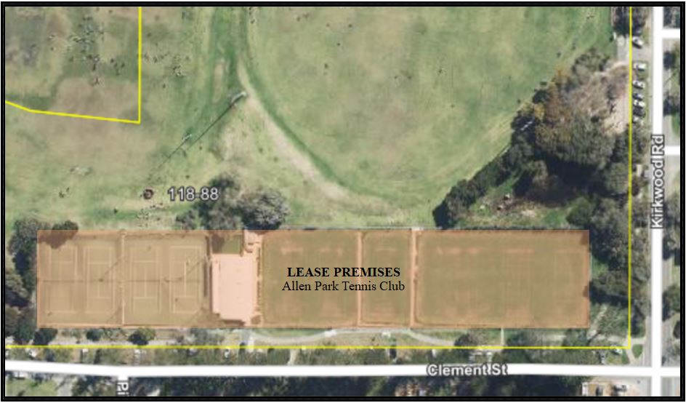

Following the receipt of the correspondence from APTC as noted above, negotiations with Officers commenced in the days following. As APTC have not requested any changes to the lease provisions, the proposed new lease agreement is consistent with the City’s ‘Use of Council Facilities for Community Purposes’ Policy and is still based on the standard terms of a peppercorn lease agreement.

It is noted the City’s Solicitor has made some minor updates to some clauses to ensure consistency with current practices (particularly with regard to insurances). The City’s Solicitors have also advised the changes are not controversial as they do not impose any unreasonable burden on APTC. Attachment 2 shows the draft (new) lease agreement which APTC have agreed to the terms of.

If endorsed by Council, the lease premises will not change and will continue to comprise of the clubroom, 6x grass courts and the 4x hard courts with lighting infrastructure.

Lease Performance

Throughout the term of any lease agreement, the City’s Administration manage the terms of the agreement which include regular inspections for maintenance identification, compliance with statutory requirements and payment of monies owed.

At the time of writing this report:

- The City’s Finance Team have advised APTC has a zero balance on their debtor account.
- The City’s Building Maintenance Team have advised APTC is not in default of any lease facility maintenance obligations.
- The City’s Health Services Team have advised APTC has no outstanding health-related statutory requirements to undertake.

Request from Allen Park Tennis Club

During the negotiation phase, Allen Park Tennis Club were advised that the cost for the preparation of the new agreement was to be borne by the Club.

Officers advised this position on the basis that the City is bound by the ‘Use of Council Facilities for Community Purposes’ Policy which states peppercorn lease arrangements should be at no cost to Council. In addition, there is also an unacceptable risk with the City not having a new agreement prepared by the City’s Solicitors where possible as the City must ensure each agreement when executed is consistent with current practices (i.e., legislation changes).

Councillors are advised that Allen Park Tennis Club have formally requested for the agreement preparation fees be absorbed by the City on the basis that it is a significant expense for a small tennis club.

The cost for the agreement preparation has been quoted at $1,080 - $1,350 + GST

Conclusion

As per s3.58 of the Local Government Act 1995, Council approval is required to enter into any Lease Agreement and when considering the above information, it is recommended that a new lease be approved by Council.

It is also recommended that Council do not approve the APTC request for the City to absorb the agreement preparation fees This recommendation is consistent with the ‘Use of Council Facilities for Community Purposes’ Policy which states that peppercorn lease agreements are to be delivered at no cost to Council.

Key Relevant Previous Council Decisions:

CM13.06 - On 28 March 2006, Council approved the lease between the City of Nedlands and Allen Park Tennis Club. This lease commenced 29 March 2006 and will expire on 28 March 2021.

Consultation

Aside from the technical advice provided above by various internal teams in the lease performance section, the City’s Community Development Team have provided the following comments.

The Community Development Team, who are responsible for the development of positive relationships and ongoing sustainability of the City’s sporting clubs provide support for a new lease to APTC. The Club provide a valuable and commendable service to the community. A new lease would be consistent with Council’s strategic priorities as per the Strategic Community Plan which prioritises providing for sport and recreation. It is also consistent with the Allen Park Master Plan which supports the development of tennis at Allen Park.

Strategic Implications

How well does it fit with our strategic direction?

Support of this request contributes towards the ‘Community Development’ key focus area of the City’s Strategic Community Plan by building community partnerships and strengthening the community’s capacity to meet its own needs.

Who benefits?

APTC, its local members and the local community benefit from the support of this request. The support will help enable a long term, and secure financial future for the Club.

Does it involve a tolerable risk?

There is minimal risk associated with support of this request. APTC are in a strong position and a new lease would be consistent with the Allen Park Master Plan which supports the development of tennis at Allen Park.

Do we have the information we need?

All required information has been provided to Council.

Budget/Financial Implications

Can we afford it?

Support of the recommendation and a new lease agreement would have no financial implications on the City as any legal costs associated with the arrangement of agreement would be borne by APTC, consistent with the City’s ‘Use of Council Facilities for Community Purposes’ Policy.

How does the option impact upon rates?

Approval of the recommendation would have no impact on rates.

CPS04.21 Review of Point Resolution Child Care Centre Update

Committee | 9 February 2021
Council | 23 February 2021
Applicant | City of Nedlands
Employee Disclosure under section 5.70 Local Government Act 1995 | Nil.
Director | Patricia Panayotou – Executive Manager Community Development
Attachments | Nil.
Confidential Attachments | Nil.

Executive Summary

This report is being presented to Council to provide an update on the Point Resolution Child Care Review. A report containing a review will not be available for Council in the March 2021 round of meetings, as Administration has been unsuccessful in meeting the required outcomes within the timeframes set by Council in the following reports.

In the Council report CPS20.20 ‘Review of Point Resolution Child Care Centre’ on 22 September 2020, the Council Resolution/Committee Recommendation was:

That this item be deferred to the March 2021 round of meetings in order to review the long-term needs for Child Care south of Stirling Highway in reference to the City’s land assets and undertake full community consultation with all stakeholders.

At that same meeting, Council made the same resolution on report CPS21.20 ‘Sale of 64-66 Melvista Avenue, Dalkeith’.

In the Council report CPS27.20 ‘Request for Funding to Engage a Consultant to Assess the need for Childcare Services’ on 27 October 2020, the Council Resolution/Committee Recommendation was:

Council:

- approves funding of up to $40,000 for the engagement of a consultant to undertake the necessary research and stakeholders consultations, and provide to Council a report on:

  - the future demand and suitable sites foe Childcare Services in the City of Nedlands south of Stirling Highway; and

  - the desirability and financial sustainability of the City continuing to manage the provision of Childcare Services at Point Resolution Childcare Centre compared to the privatisation of the provision of services at that site; and
- Instructs the CEO to arrange for quotations for the provision of these services and to appoint a consultant who demonstrates best value for money and the ability to deliver the requirements.

Every reasonable effort was made by Administration to engage a consultant to provide the requested review of Point Resolution Child Care Centre services, which would incorporate the extended research data and outcomes, including the options for the 64-66 Melvista Avenue, Dalkeith site.

The Administration recommendation to Committee seeks to fulfil the Council requirements in a strategic and timely manner, allowing every opportunity to engage a consultant that can deliver on the requirements of the PRCC review.

If Council accepts the Administration recommendation, services to PRCC families will still continue up to at least the end of December 2021, as required by Council.
The increased number of children (from 24 to 26) attending and the increased fees of $15.00 per day, per child will also have an impact on centre operations and potentially achieving a cost-neutral service.

A briefing session on this update will be conducted on 16 February 2021.

Recommendation to Committee

Council:

- with respect to the current requirement to review the long-term needs for Child Care south of Stirling Highway in reference to the City’s land assets and undertake full community consultation with all stakeholders;

  - notes that the Administration has been unsuccessful in appointing a consultant with the high level of direct experience and knowledge, deemed necessary to conduct the required review;

  - instructs the CEO to provide this report to Council by 30 June 2022.

- with respect to the continued operation of Point Resolution Child Care until the review is conducted
  - notes that from 4 January 2021, the number of children that can be enrolled at PRCC has increased from 24 to 26, as per Council resolution on 24 November 2020.

  - notes that fees for attendance at PRCC increased by $15.00 per day, per child from 4 January 2021, as per Council resolution on 27 October 2020.

  - instructs the CEO to oversee the continued operation of Point Resolution Child Care with annual fee increases commensurate with local childcare centres until the review is conducted;

- with respect to the Sale of 64-66 Melvista Avenue, Dalkeith;

  - agrees that the Committee/Council recommendation for report CPS21.20 to be ‘deferred to the March 2021 round of meetings in order to review the long-term needs for Child Care South of Stirling Highway in reference to the City’s land assets and undertake full community consultation with all stakeholders’ be revoked;
  - instructs the CEO to provide a separate report on the future of the City’s property at 64-66 Melvista Avenue, Dalkeith at a date to be determined after the report on the review of ‘the long-term needs for Child Care South of Stirling Highway’ has been provided to Council, in line with the prioritisation of the potential ‘Land Investment Strategy’ Projects.

Discussion/Overview

At the Normal Council Meeting on 22 September 2020, Administration presented a report to Council to initiate a review of Point Resolution Child Care.

The Council Resolution/Committee Recommendation was:

That this item be deferred to the March 2021 round of meetings in order to review the long-term needs for Child Care South of Stirling Highway in reference to the City’s land assets and undertake full community Consultation with all stakeholders.

Administration staff identified a lack of required skills and resources to conduct the review internally and in October 2020, funding to engage a consultant to conduct the review was requested in Council report CPS27.20.

The subsequent Council Resolution/Committee Recommendation was –

Council:

- approves funding of up to $40,000 for the engagement of a consultant to undertake the necessary research and stakeholders’ consultations, and provide to Council a report on:

  - the future demand and suitable sites for Childcare Services in the City of Nedlands south of Stirling Highway; and

  - the desirability and financial sustainability of the City continuing to manage the provision of Childcare Services at Point Resolution Childcare Centre compared to the privatisation of the provision of services at that site; and

- instructs the CEO to arrange for quotations for the provision of these services and to appoint a consultant who demonstrates best value for money and the ability to deliver the requirements.

With funding approved, Administration began the task of identifying consultants appropriately experienced and knowledgeable in childcare provision and requirements, to undertake the extensive review.

Market research was conducted to identify potential consultants as follows:

- Google Searching was undertaken
- Contact was made with WALGA
- Contact was made with WA Department of Communities/Education and Care
- Contact was made with WA Department of Education
- Contact was made with Child Australia

The above research provided the City with two potential consultants, Dave Lanfear Consulting (via Google) and Hans Boehm (Child Australia). Both these consultants were contacted and expressed an interest in the project.

Subsequently the City was contacted by Robert Yammouni who also declared an interest.

A request for quotation was sent to each consultant and a telephone briefing session was held with each to further expand and explain the City’s requirements.

Only one submission was received with no further response from the other two invitees.

This review was considered a significant project not only for the future of PRCC, but also understanding the childcare needs of the community south of Stirling Highway.
To that end, Administration staff deemed a single, albeit compliant, submission was an inadequate outcome and concluded that this had come about due to the strict timeframes for delivery.

It was further concluded that, in order to provide Council with a more comprehensive outcome, a longer project timeframe was necessary and that, pending Council approval for that timeframe, and a continuation of the services provide by PRCC in the interim, the initial request for quotation was terminated without any recommendation for award.

In September 2020, Administration presented Council with report CPS21.20 - Sale of 64-66 Melvista Avenue, Dalkeith.

The Council Resolution/Committee Recommendation was:

That this item be deferred to the March 2021 round of meetings in order to review the long-term needs for Child Care South of Stirling Highway in reference to the City’s land assets and undertake full community consultation with all stakeholders.

As this report was connected to the review of Point Resolution Child Care, the recommended option is:

The future of 64-66 Melvista Avenue, Dalkeith is also put-on hold and is reviewed at a date to be determined after the report on the review of ‘the long-term needs for Child Care south of Stirling Highway in reference to the City’s land assets and undertake full community consultation with all stakeholders’, has been provided to Council, in line with the prioritisation of the potential ‘Land Investment Strategy’ Projects.
The other factor influencing the request to suspend the review at this time, is the changes to the Executive management team, with two Directors and the CEO resigning. It is felt that this very community-based service review will benefit from the input and support from the Executive team and most importantly, the new CEO once they have settled into their roles.

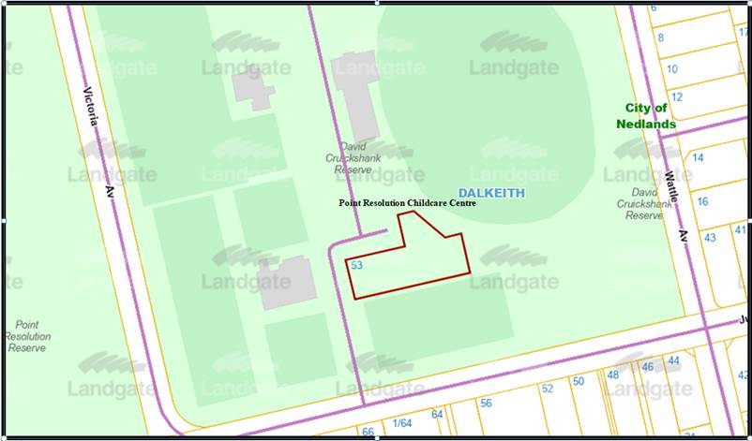
Point Resolution Child Care Centre at 53 Jutland Parade Dalkeith.

Consultation

No consultation has been undertaken at this time for either the PRCC review, or the 64-66 Melvista Avenue, Dalkeith report.

Strategic Implications

Suspending the review at this time would allow Administration the time to investigate how best to identify and approach potential consultants, who have the required experience and knowledge in childcare requirements.

This would meet the Strategic Community Plans Key Focus Area of ‘Governance and Civic Leadership’ through high-quality decision making whilst maintaining a sound and sustainable financial position.

Who benefits?

The continuation of the service, pending an outcome to this project will benefit the parents and children who are current users of PRCC services.

At a minimum, the delayed review will provide a guaranteed service to PRCC families until the end of December 2021, as per Council decision at the Council Meeting on 27 October 2020.

A considered decision by Council on whether to progress with selling 64-66 Melvista Avenue, Dalkeith, or delaying the decision as part of suspending the PRCC review, may benefit the community either way.

Does it involve a tolerable risk?

Not progressing with the review at this time and operating PRCC as normal until the review is done at a later date, is considered to be a tolerable risk.

Do we have the information we need?

At this time, we do not have the information we need to provide a review of Point Resolution Child Care services.

Budget/Financial Implications

The continuation of the provision of PRCC services may impact on the budget.
In order to minimise impact, fees will be increased accordingly, while the centre aims for full registration to increase revenue.

Can we afford it?

Delaying the review of PRCC services will still allow for revenue from families attending the centre.

Centre staff will be required to manage the allocated operational budget, with a target to keep the centre cost-neutral, or as close as possible to.

How does the option impact upon rates?

There is no expected impact on rates by not going ahead with the review.

Conclusion

City staff conclude that a new approach to the market with a longer period of time to deliver the required outcomes would be more likely to provide a greater market interest and give Council a greater assurance that all opportunities are taken to provide a considered outcome.

Services at Point Resolution Child Care will continue as normal with appropriate fee increases and operating processes applied, to continue to provide high quality of care for families attending the centre, while aiming for a cost-neutral service.

