Planning and Development Reports

Committee Consideration – 9 July 2019

Council Resolution – 23 July 2019

Table of Contents

Item No. Page No.

PD23.19 120 Montgomery Avenue Mt Claremont – Proposed Land Exchange for Crown Reserve Land at Reserve 43799 2
PD24.19 City of Nedlands Design Excellence Awards – Judging Criteria and Rebranding 8
PD25.19 Local Planning Scheme 3 – Local Planning Policy Child Care Premises 11
PD26.19 Local Planning Scheme 3 – Local Planning Policy Parking 13
PD27.19 Local Planning Scheme 3 – Local Planning Policy Residential Development 18
PD28.19 Local Planning Scheme 3 – Local Planning Policies for Heritage, SAT process and procedures, Refunding and Waiving fees, Planning Compliance and Signs. 24

Council: 23 July 2019

PD23.19 | 120 Montgomery Avenue Mt Claremont – Proposed Land Exchange for Crown Reserve Land at Reserve 43799
Committee | 9 July 2019
Council | 23 July 2019
Applicant | Western Power Corporation
Landowner | Western Power Corporation
Director | Peter Mickleson – Director Planning & Development
Reference | Nil.
Previous Item | 13 December 2016 (Special Council Meeting)
Delegation | Council is required to consider this land holding matter as Management Body of Crown Reserve Land.
Attachments | - Letter dated 24 May 2018 from Western Power proposing land boundary rationalisation

- Executive Summary

Western Power own (Lot 2000) 120 Montgomery Avenue in Mt Claremont. The land is vacant and located adjacent to the Mt Claremont Community Centre precinct and Crown Reserve Land which the City manages and controls. The lot boundaries for these parcels of land are irregularly shaped and held by the City and Western Power in this location. Western Power have proposed an exchange of land to rationalise the boundaries of these lots. The lots are zoned Residential with a density code of R30. This report discusses the proposal and seeks to provide a response to the Department of Planning, Lands & Heritage (DPLH) regarding the proposal with a recommendation of endorsement subject to condition.

- Recommendation to Committee

Council endorses the proposed land exchange at Montgomery Avenue, Mt Claremont, subject to the following condition:

- That all costs associated with this transaction be borne solely by the applicant being Western Power.

- Site Details

Area of Lot 2000 on Plan 17425 | 3,304m²
Proprietor | Western Power Corporation
Zoning under the Local Planning Scheme No. 3 | Residential R30
Area of Lot 12035 on Plan 19408 | Lot 12035 is comprised of 2 parts with the northern side being 801.8m² and the southern section being 4,822.6m²
Crown Reserve Land | Class C reserve with purpose Public Recreation (Reserve 43379)
Proprietor | Department of Planning & Infrastructure / City of Nedlands as Management Body

An aerial image showing the location of the property follows.

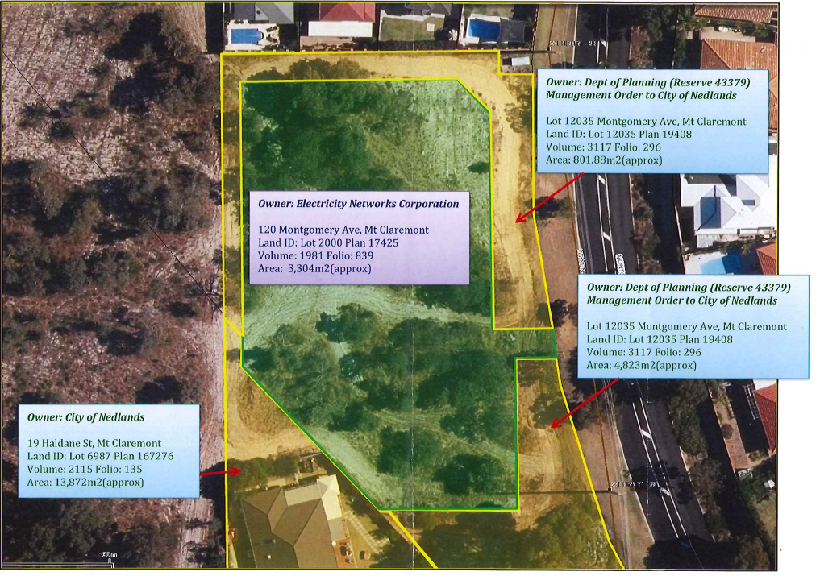

Figure 1 shows the current lot boundaries. Lot 2000 being Western Power’s lot is shaded in green. City of Nedlands managed reserve land is outlined and highlighted in yellow.

- Previous Council Items

On 13 December 2016 at a Special Council meeting, Council considered draft Local Planning Scheme No. 3 (LPS 3) and resolved to proceed to advertise the draft scheme with several specific modifications. One such modification relevant to the current item was “That 120 Montgomery Avenue, Mt Claremont maintain current zoning at that time of: Public Purposes”.

- Background

The current configuration of land as noted in Figure 1 is believed to have been designed to facilitate the construction and operation of an electrical substation that was previously planned for the site. Western Power advise that the site was “set aside for the standard design of a substation whilst Crown land was set aside as a buffer for it to surrounding land uses, ranging in distance between 3 -10m.” Western Power advises that the substation is no longer part of future plans and the land is surplus to their requirements.

In 2015 Western Power approached the City with a proposal for a land exchange, noting that the lots held by the City and Western Power are shaped irregularly, with the City being the management body of Crown Reserve land in a formation that essentially framed Western Power’s lot. In the current state the “frame” appears to provide the firebreak between bushland and residential setting. Western Power noted efficiencies that could be derived by a different lot configuration.
The City advised Western Power that as the proponent they would need to investigate the process required and revert to the City for its consideration.

Western Power liaised with the Department of Lands – the regulatory body at the time (since renamed the Department of Planning Lands & Heritage) and the City was advised the process to complete such a transfer would involve tabling the arrangement in Parliament.

Western Power also made a submission on LPS 3 and requested zoning of the lot be amended to “Residential” noting that the intention was to sell the surplus land. This request was considered by Council at a Special Council Meeting on 13 December 2016. The item related to the draft LPS 3 and Council resolved that the zoning for 120 Montgomery Avenue Mt Claremont remain as Public Purposes.

Western Power revised their approach and requested simply a land exchange in the format shown in yellow highlight and numbered “101” in the diagram on the right-hand side below.

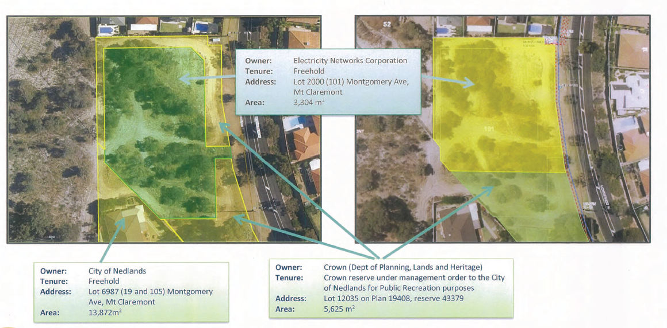

Figure 2. Left hand side shows the current land holding and to the right is the proposed land boundaries through the land exchange.

It is noted that the proposal by Western Power involves both parties retaining the same area of land as currently held just in a reconfigured format with approximately 831m² of land swapped between Lot 2000 and Reserve 43379.

In late 2018 Western Power made a request to DPLH to agree a land exchange pursuant to section 11 of the Land Administration Act 1997. In evaluating the request, the DPLH requested comment from the City as management body on the proposal. In November 2018, Administration advised the DPLH of Council’s resolution on 13 December 2016 noting that the City had rejected an application for the rezoning of Lot 2000 on the basis of Council’s understanding of the original subdivision, that the land was to be public open space and should the state not require it for the purpose of an electrical substation then the land was to revert to public open space. The Department was advised that the City did not support the proposed land exchange advising the land in Reserve 43379 and Lot 200 (in Figure 1) should remain as public open space for the wider community’s benefit.

Since the Department received the initial request by Western Power, the City’s LPS 3 has been gazetted and now in effect. The new LPS 3 has rezoned the land subject of the proposal to Residential R30. A snapshot from IntraMaps GIS Planning module for LPS 3 map is included below.

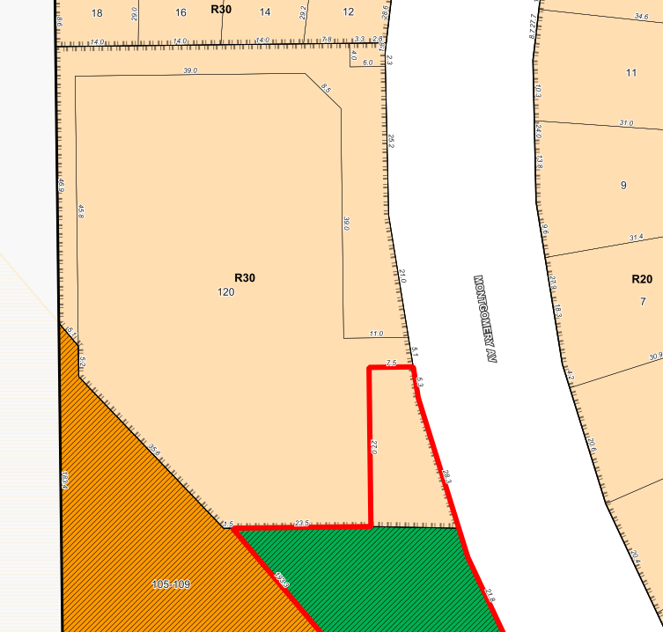

- Discussion

This proposal presents the City with an opportunity to arrange its landholding in a more manageable format which would increase efficiencies and control. By endorsing the land exchange, the City would achieve a consolidated parcel of land. This would ensure the City could control the preservation of bushland onsite and amenity of public open space. Land that is owned by a third party is beyond the control of the City except by regulation through its Local Planning Scheme. This ability to regulate remains the same no matter the configuration of the land holding. And since the commencement of LPS 3 this appears more relevant as the land becomes zoned as Residential R30.

The best control an entity can have over land is through proprietorship or in this case as the recognised Management Body of land and this proposal presents an opportunity for Council to secure a better configuration for land management. Western Power as landowner is open to use its land in a manner consistent with the Local Planning Scheme and with a zoning of “Residential R30” presumably they could develop the lot in its current format for that purpose subject to compliance with the Scheme and any associated State Planning Policies. It is proposed however that by rearranging the lot boundaries to become a consolidated area as in Figure 2 provides greater control and ability to manage the land.

While Council may view Western Power’s intention to sell the surplus land as a loss of public open space, it must be realised that this land is owned by Western Power whose mandate differs from that of Council. The fact this land has remained vacant and open to public entry and enjoyment has been fortuitous to some degree, but this land is now being reviewed by its owner for future use and the City has an opportunity to also benefit.

It is arguable that in future these lots of land will at some point be rationalised due to the irregular shape. Unless the City is prepared to purchase the land from Western Power, it is recommended that the alternative to ensure long term environmental optimisation is to exchange land with Western Power. Council may look to further investigate the opportunity to improve environmental outcomes through increased land received by the City through the exchange.

- Assessment of Statutory Provisions and Policy

7.1 Land Administration Act 1997 (the Act)

Section 11 Minister may acquire land in the public interest

Section 11 empowers the Minister to acquire land for the State in the public interest, through specific means including an exchange. The provision specifies process to value such land.

Section 46. Care, control and management of reserves

Section 46 outlines the care control and management of Crown land reserved under Section 41 (Reserve). Section 46 (1) notes that the Minister may by order appoint a person or persons (the Management Body) to manage and control a Reserve subject to conditions specified by the Minister.

Section 46(2) notes that the Minister may, with the consent of the Management Body of a Reserve, by order vary any condition to which the care, control and management of the Reserve is subject.

The City of Nedlands is the Management Body for Class C Reserve 43379 being the land at Montgomery Avenue subject of the proposed land exchange with Western Power. The Minister via the Department of Planning Lands & Heritage are liaising with the City regarding any proposal by Western Power to reconfigure the Reserve boundaries.

7.2 Council Policy – Asset Management

Council’s policy for Asset Management records an objective in setting a broad framework for decision making by Council in a “structured, coordinated and organised approach.”

This policy includes within the Statement that the primary goal of asset management is to provide the required level of service in the most cost-effective way through the creation, acquisition, maintenance, operation, rehabilitation and disposal of assets to provide for present and future generations.

Reconfiguring the City’s reserve land holding at Montgomery Avenue, as proposed will lead to improved efficiencies, in terms of both land management and financial cost of such.

- Budget / Financial Implications

There are no budget or financial implications to consider as it is proposed that any transaction that may result will be at the cost of the applicant, Western Power.

- Risk management

There is a risk that should Council decide not to agree with the proposal then Western Power may sell the lot as is. That is, in its current configuration and size which would allow for approximately 11 Grouped dwellings. The perimeter of Lot 2000 which is vested in the City of Nedlands would remain, with its new zoning and density code of R30 but in effect would be unusable for residential purposes due to its shape. In reality it could only practicably be used for open space, walkways, landscaping and the like.

Council may consider that this outcome is not the best use of land under its control whereas agreeing to the proposal may allow for the better use of the approximately 800m2 of land which would be added to and be contiguous with the land associated with the Mt Claremont Community Centre.

Council’s Bushcare Officer has noted that the Council controlled portion of this land is highly degraded with low biodiversity values. Consolidation of the land, as proposed, would enable better management for biodiversity if this was considered important to Council. It also allows for the possibility of a more viable linkage or “Greenway” between Montgomery Avenue and the bushland to the west within the Town of Cambridge.

- Conclusion

The proposal by Western Power presents an opportunity for Council to improve its land holding through a reconfigured parcel of land that is Crown Reserve land, albeit zoned R30. The reconfiguration will enable the City to more efficiently manage its land at Montgomery Avenue, potentially providing the public with improved amenity.

PD24.19 | City of Nedlands Design Excellence Awards – Judging Criteria and Rebranding
Committee | 9 July 2019
Council | 23 July 2019
Director | Peter Mickleson – Director Planning & Development Services
Reference | Nil.
Previous Item | PD45.17 – October 2017  PD64.18 – November 2018
Attachments | - City of Nedlands Design Excellence Awards - Judging Criteria and Conditions of Entry  - Former Civic Design Awards – Judging Criteria and Conditions of Entry

- Executive Summary

The purpose of this report is for Council to approve the judging criteria, rebranding and renaming from the Civic Design Awards to be the City of Nedlands Design Excellence Awards and to endorse the conditions of entry and judging criteria.

Administration is seeking to rebrand and rename the awards due to the confusion from the public as to whether the awards are only for City owned buildings or buildings which have a civic purpose.

Council is also being asked to endorse the conditions of candidate entry and associated judging criteria, following which Administration will put a call out for nominations from August 2019 until September 2019. Once nominations are closed, the judging panel which was nominated at the November 2018 Council Meeting will choose the winners for each category. The winners will then be presented with their awards by the panel at the City’s Business Sundowner on the 20 November 2019.

- Recommendation to Committee

Council endorses:

- the rebranding and renaming of the City of Nedlands Civic Design Awards to be the City of Nedlands Design Excellence Awards; and

- the revised judging criteria and conditions of entry as shown in Attachment 1.

- Background

In May 2016 Council resolved that the City investigate the introduction of a system of Design Awards, with certificates presented for outstanding examples of heritage restoration, contemporary design, art installations or projects otherwise contributing to the quality of the built environment within the City.

In accordance with the May 2016 Council resolution, Administration investigated and then provided Councillors with various award scheme options for consideration at a Councillor briefing. No decisions were made at this briefing, but comments were considered, and a draft system was developed for final consideration. This was presented to Council at their meeting in October 2017, where Council resolved to progress the implementation of the Design Awards beginning in 2018.

In November 2018 Council approved two Councillors and two community members to sit on the judging panel for the 2019 round of Design Awards.

- Details

The Civic Design Awards is proposed to be rebranded and renamed to the City of Nedlands Design Excellence Awards due to the confusion arising from the use of the word ‘civic’ and its connotations of being an award for civic buildings and not private buildings.

Administration have refined the judging criteria to include five categories. The categories are:

- Residential – For newly constructed single residential homes or renovation’s to single residential homes.
- Multi-residential Project – Includes townhouses, units and apartments.
- Commercial, Retail or Mixed Use – Includes both new and renovated spaces.
- Landscape Design and Public Art – Which provide a benefit to the general public.
- Heritage Project – Can be full renovations or additions which compliment and integrate with the aesthetic value of the heritage building. Properties do not have to be on the Municipal Inventory or Heritage List to nominate in this category.

The categories which have been chosen reflect judging criteria from other local governments across Australia who have their own Design Awards. The new criteria for each category can be found in Attachment 1, along with the conditions of entry.

The former judging criteria and conditions of entry are shown in Attachment 2. Applicants may apply for more than one category. People may nominate someone else’s property for an award so long as their entry form has been signed by the owner of the property which has been nominated.

Once nominations have closed, the judging panel elected at the Council Meeting in November 2018 will assess the applications and determine who, if any, are the winners for each category. Once the judges have reached a decision, the category winners will be presented with a plaque to place on their building stating that they are a winner of the City of Nedlands Design Excellence Awards and the year in which they won and the category in which they won. The plaques will be presented at the City’s Business Sundowner on the 20 November 2019 by the judging panel.

- Consultation

Once Council endorsement has been received in relation to the selection criteria Administration will advertise for nominations within the five specified categories. The City of Nedlands Design Excellence Awards are open to all City of Nedlands property owners and residents, as well as architects, designers, builders and government agencies that have undertaken projects within the City of Nedlands.
A person or company can nominate their own project or gain owner consent to nominate someone else’s property. Projects that are the subject of an entry must be completed or substantially completed to warrant consideration.

Conditions of entry and selection criteria are described in detail in Attachment 1.

- Budget / Financial Implications

The plaques which will be awarded will cost approximately $150 to $190 each with a maximum of 5 awards granted per year. Council will need to assign this expense to a relevant budget category.

Due to the ceremony being held on the night of the Business Sundowner no extra cost will be incurred to run this event.

- Risk Management

N/A

- Administration Comment

In order to progress the Design Excellence Awards as endorsed by Council on the 24 October 2017 Administration recommend that Council endorse the new awards name, revised conditions of entry, judging criteria and rebranding. This will allow for Administration to advertise for nominations for the awards.

PD25.19 | Local Planning Scheme 3 – Local Planning Policy Child Care Premises
Committee | 9 July 2019
Council | 23 July 2019
Director | Peter Mickleson – Director Planning & Development
Reference | Nil.
Previous Item | Item 6 – 2 May 2019 - Special Council Meeting
Attachments | - Draft Child Care Premises LPP  - Draft Child Care Premises LPP – tracked changes

- Executive Summary

The purpose of this report is for Council to adopt the Child Care Premises Local Planning Policy (LPP).

It is proposed that the policy be adopted with three modifications. These modifications can be viewed in Attachment 2.

The policy provides development standards relating to the location, design, size and operational matters (hours of operation, noise, parking & traffic) that the City will have regard to when considering an application for development approval.

The provisions of the policy must be taken into consideration by the decision maker in determining a Development Application including the JDAP or SAT.

The Child Care Premises Policy adopted as part of this report, will have effect once the notification of adoption is published in a local newspaper.

- Recommendation to Committee

Council resolves to proceed to adopt the Child Care Premises Local Planning Policy, with modifications as set out in Attachment 1, in accordance with the Planning and Development (Local Planning Schemes) Regulations 2015 Schedule 2, Part 2, Clause 4.

- Background

At the Special Council Meeting held on 2 May 2019, Council resolved to prepare and advertise a series of local planning policies for a period of 21 days, in accordance with the Planning and Development (Local Planning Schemes) Regulations 2015 Schedule 2, Part 2, Clause 4.

The Child Care Premises LPP was amended through Councils resolution at the Special Council Meeting, prior to being advertised, to:

- adding “particularly residential areas” to the end of clause 3.2;
- replacing 3.3 with ‘To ensure the siting of Child Care Premises do not incur significant risks from environmental health and safety hazards;
- in clause 4.1.2, deleting the words ‘are encouraged to’ and inserting the word ‘shall’; and
- in clause 4.1.1, deleting the words ‘or Local Centre.
- Consultation

This policy was advertised from the 18 May 2019 until the 8 June 2019. No submissions were received in relation to this policy during the advertising period.

- Proposed modifications to policy

Administration propose to add, objective 3.4 to the objectives section of the policy. This objective discusses the amenity impacts that a child care premises could have on a surrounding area and seeks to ensure that child care centres do not have adverse impact on the rest of the community in relation to elements such as noise and traffic. The other objectives of the policy currently do not cover this aspect.

It is proposed that clause 4.1.1, which relates to which zones child care premises are encouraged to locate, be removed from the policy due to the clause being vague. It is considered that objective 3.1, and clause 4.1.2, guides the desired location of these premises more clearly. The permissibility table in LPS 3 also allows for child care premises to be considered in all zones which would override this clause.

The final modification to the policy proposed by administration is to modify the draft clause 4.1.2 to ‘Residential zoned lot’ rather than ‘Residential lot’. This is so that lots which are not zoned Residential (e.g. Mixed Use) but contain a residential property are not captured by this clause. This word was added to clarify the intent of the clause.

Note: with the removal of clause 4.1.1, previous clause 4.1.2 is renumbered to 4.1.1.

- Statutory Provisions

Planning and Development (Local Planning Schemes) Regulations 2015

Schedule 2, Part 2, Clause 4(3) of the Regulations, sets out that after the expiry of the 21-day advertising period, the local government must review the proposed policy in light of any submissions made and resolve to:

- Proceed with the policy without modification;
- Proceed with the policy with modification; or
- Not to proceed with the policy.

Administration recommends that Council resolves to proceed with the adoption of the Child Care Premises policy with modifications, having been advertised in from the 18 May 2019 until the 8 June 2019.

- Conclusion

The Child Care Premises Policy provides the City with an operative local planning framework in place under LPS 3 to adequately address the built form and land use requirements associated with Child Care Premises. The modifications proposed to the draft policy provide clarity to both Administration and Council when assessing planning applications for Child Care Premises within the City on zoned land.

It is recommended that Council endorses the administration recommendation as set out in the resolution.
PD26.19 | Local Planning Scheme 3 – Local Planning Policy Parking
Committee | 9 July 2019
Council | 23 July 2019
Director | Peter Mickleson – Director Planning & Development
Reference | Nil.
Previous Item | Item 6 – 2 May 2019 - Special Council Meeting
Attachments | - Draft Parking LPP  - Draft Parking LPP – tracked changes

- Executive Summary

The purpose of this report is for Council to adopt the Parking Local Planning Policy (LPP). The draft policy has three modifications proposed post advertising. These modifications can be viewed in Attachment 2.

The purpose of this policy is to define the standards for parking areas and appropriate number of car parking bays and associated facilities for each applicable land use. It also includes provisions for vehicle access and ancillary facilities. The policy seeks to encourage the provision of amenities that enable and promote alternative modes of transport (including cycling, walking, public transport and motorcycles) and adaptability to changes in technology.

This policy seeks to ensure that developments are constructed to a high standard, reducing potential detrimental impacts to the surrounding area and assist in managing future traffic and parking issues.

Further to this, the provisions of the LPP must be taken into consideration by the decision maker including the JDAP or SAT. The risk is that in the absence of an LPP, relating to a matter that is of concern to Council, the decision maker will have no guidance as to the Council’s views and will come to its own conclusion and decision.

Once adopted the policy will have to be referred to the West Australian Planning Commission (WAPC) for approval, this is because the policy seeks to amend Part 3.9 of State Planning Policy 7.3 Residential Design Codes Volume 2 – Apartments (R-Codes Vol.2) with non-residential parking ratios and other parking related standards, which, under part 1.2.3 of the R-Codes Vol.2 require WAPC approval.

- Recommendation to Committee

Council proceeds to adopt the Parking Local Planning Policy, with modifications set out in Attachment 1, in accordance with the Planning and Development (Local Planning Schemes) Regulations 2015 Schedule 2, Part 2, Clause 4.; and refers the Parking Local Planning Policy to the Western Australian Planning Commission for final approval in line with State Planning Policy SPP7.3, Residential Design Codes Volume 2 – Apartments 2019 clause 1.2.3 and the City’s Local Planning Scheme No 3 clause 32.4(5).

- Background

At the Special Council Meeting 2 May 2019 Council resolved to prepare and advertise a series of policies for a period of 21 days, in accordance with the Planning and Development (Local Planning Schemes) Regulations 2015 Schedule 2, Part 2, Clause 4.

The LPP was modified via Councils Resolution and specifically altered the parking ratios for the following:

- Office car parking bay requirements revert to TPS 2 being 4.75 bays per 100m² of Net Lettable Area (NLA); and
- Shop car parking bay requirements revert to TPS 2 being 8.3 bays per 100m² of NLA.

- Detail

The draft LPP is proposed to be modified post advertising with three changes being made. The modifications are proposed as a result of further research being undertaken, analysing other Local Governments, guidelines, local context and the one submission which was provided during advertising.

Proposed modification 1 - Office

The parking ratios set out in Table 1 for the land use ‘Office’ which is defined as a premises used for administration, clerical, technical, professional or similar business activities, have been modified to a standard of 1 car parking bay per 40m² of NLA. This new proposed ratio is in line with the Road and Traffic Authority New South Wales Guide to Traffic Generating Developments (RTA Guide) which suggests that the ratio be 1 bay per 40m² of NLA. There is no such guide in Western Australia. Along with the guidelines this ratio is in line with many other Local Governments as shown below in Table 1.

This research along with the City of Nedlands context have shaped the suggested parking ratio of 1 bay per 40m² of NLA for the land use of ‘Office’. The former Town Planning Scheme 2 (TPS 2) parking ratio of 4.75 bays per 100m² of NLA are no longer in line with current best practice standards due to the age of the Scheme and parking ratios. The ratios applied under TPS 2 were heavily onerous in comparison to the RTA Guide and other comparable Local Governments.

Table 1:

Local Government | Office Parking Ratio
City of Vincent | 1 bay per 50m² of NLA
City of Subiaco | 1 bay per 40m² of NLA
City of Melville | 1 bay per 50m² of NLA
Town of Victoria Park | 1 bay per 40m² of NLA

Proposed modification 2 - Shop

A ‘Shop’ is defined under LPS 3 as a premises other than a bulky goods showroom, a liquor store – small used to sell goods by retail, to hire goods, or to provide services of a personal nature, including hairdressing or beauty therapy services. The land use parking ratio provision for the land use category of ‘Shop’ was modified by Council at the Special Council Meeting of 2 May 2019 with a ratio of 8.3 car bays per 100m² of NLA being applied and advertised. This ratio results in approximately 1 car bay per 12m² of NLA. This ratio was suggested by Council as it is in line with the previous TPS 2. The ratios suggested under TPS 2 are no longer in line with current best practice as they were created with a 1985 context. Technology, car dependency and the way businesses have operated have changed significantly since the parking ratios were developed.

The administration proposed parking ratio for the use of ‘Shop’ is 1 bay per 20m² of NLA. This ratio has been suggested as this is in line with the NSW guidelines which suggests a ratio of anywhere between 1 bay per 16m² to 24m² NLA depending on the scale and operation of the shop. Further, a 1 bay per 20m² ratio is in line with similar Local Governments in Western Australia as shown in Table 2. As well as being in line with other Local Governments, the former Dalkeith Special Control Area which was approved by Council in 2012 as an amendment to TPS 2, provided a parking ratio of 1 bay per 25m² of NLA for the use of Shop.

This research has led Administration to recommend a parking ratio of 1 bay per 20m² of NLA for the use of Shop as being best practice in 2019

Table 2:

Local Government | Shop Parking Ratio
City of Vincent | 1 bay per 20m² of NLA
City of Subiaco | 1 bay per 20m² of NLA
City of Melville | 1 bay per 20m² of NLA
City of South Perth | 1 bay per 25m² of NLA

Proposed modification 3 - Rounding

The third proposed modification is in relation to the rounding of parking bays to the nearest whole number. Table 1, note 1 of the draft policy has also been modified to remove the word ‘up’ which was an administrative error. This word has been removed so that applications who need 4.1 bays as per their calculated NLA and ratio will need 4 bays rather than requiring 5 bays. Rounding to the nearest whole number is current best practice.

- WAPC Approval

When Council adopts this policy, all provisions can be applied immediately to land zoned Private Community Purposes and Service Commercial.

However, the parking ratios and parking design elements will not be enforceable within the Neighbourhood Centre, Local Centre and Mixed Use zones until such time as the WAPC provides approval of the policy.

The reason for this, is due to clause 32.4(5) of LPS 3 which states that where standards are not contained within a Structure Plan, Activity Centre Plan or Local Development Plan, all non-residential developments within Mixed Use, Neighbourhood Centre and Local Centre zones are subject to the standards of the R-Codes.

The draft policy seeks to amend Part 3.9 – Car and bicycle parking of the R-Codes Vol.2 with non-residential parking ratios and other parking related standards, which, under part 1.2.3 of the R-Codes Vol.2 require WAPC approval.

Part 3.8 - Vehicle Access of the R-Codes Vol.2 is able to be modified by the Local Government without WAPC approval if it is in line with the element objectives. Therefore, the Vehicle Access section of the policy, once adopted by Council, is applicable to all zones without any further approval required from the WAPC.

Accordingly, once adopted by Council, the policy will be referred to the WAPC in order to seek their approval for provisions related to parking ratios and parking design within the Mixed Use Local Centre and Neighbourhood centre zones.

- Consultation

This policy was advertised in accordance with the Planning and Development (Local Planning Schemes) Regulations 2015 Schedule 2, Part 2, Clause 4 from the 18 May 2019 until the 8 June 2019. One submission was received in relation to this policy during advertising.

The main concerns raised through submissions were in relation to the parking ratios being quite high and onerous on developers specifically in relation to non-residential land uses on Stirling Highway. The submitter specifically objects to the parking ratios of the following uses;

- Convenience Store, Lunch Bar, Liquor Store-small, restaurant/café at 1 car bay per 30m² of NLA;
- Office at 4.75 car bays per 100m² of NLA;
- Small Bar / Tavern at 1 car bay per 20m² of NLA; and
- Shop at 8.3 car bays per 100m² NLA.

The submitter believes that the amount of parking required to create a well-balanced and vibrant mix of land uses on a site will result in poor urban design outcomes such as placing carparking at grade or reducing the mix of tenancies due to the cost of providing the large amount of parking required. The submitter believes that the high level of public transport offered along Stirling Highway should be greater taken into account along with full consideration of each individual site context.

This submission has been taken into account and their concerns noted. Two of the four ratios which have been stated are overly onerous have been suggested to be lowered. In relation to the other elements raised in this submission the policy allows for reductions to be applied for in relation to car parking if particular criteria are met and showcased through a Traffic Impact Assessment (TIA). Administration believe that the parking ratios proposed are in line with State wide best practice taking local context into account.

- Statutory Provisions

Planning and Development (Local Planning Schemes) Regulations 2015

Schedule 2, Part 2, Clause 4(3) of the Regulations, sets out that after the expiry of the 21-day advertising period, the local government must review the proposed policy in light of any submissions made and resolve to:

- Proceed with the policy without modification;
- Proceed with the policy with modification; or
- Not to proceed with the policy.

Administration recommends that Council resolves to proceed with the Parking policy to final adoption with modifications, having been advertised from the 18 May 2019 until the 8 June 2019.

Once adopted the policy will have to be referred to the WAPC for approval under part 1.2.3 of the R Codes Volume 2. The policy seeks to amend Part 3.9 of the Residential Design Codes Volume 2 (R-codes Vol.2) with non-residential parking ratios and other parking related standards.

- Conclusion

The Parking LPP is an integral policy under LPS 3 as to provide provisions and guidance for car parking and associated amenities within the City of Nedlands. In all zones with the absence of a parking table and guidelines within the Scheme itself this policy is a priority. The changes made to the draft policy are believed to reflect best practice and widely used guidelines and ratios.

As such, it is recommended that Council endorses administration’s recommendation and provides final adoption the policy with modifications to be sent to the WAPC for final approval.

PD27.19 | Local Planning Scheme 3 – Local Planning Policy Residential Development
Committee | 9 July 2019
Council | 23 July 2019
Director | Peter Mickleson – Director Planning & Development
Reference | Nil.
Previous Item | Item 6 – 2 May 2019 - Special Council Meeting
Attachments | - Draft Residential Development LPP  - Draft Residential Development LPP – tracked changes

- Executive Summary

The purpose of this report is for Council to consider modifications to the Residential Development Local Planning Policy (LPP) following consultation with the community.

The policy was adopted for consent to advertise with the community at the Special Council Meeting held on 2 May 2019. The policy was advertised for a period of three weeks with 14 submissions being received.

Following review of the submissions and further investigation of the policy provisions, it is recommended the LPP be modified to incorporate some changes. The proposed modifications include guidance for assessing applications which seek a reduction to the 9m front setback requirement, assessment of buildings within the 6m rear setback area for low density areas and inserting building heights to reflect those previously applied under Town Planning Scheme No. 2 alongside other modifications.

The proposed modifications seek to introduce a number of new provisions to the LPP and modify explanatory figures which officers believe are significant enough to warrant further consultation with the community.

Accordingly, it is recommended that Council modifies the draft Residential Development Policy and readvertises the LPP.

- Recommendation to Committee

Council proceeds with the draft Residential Development Local Planning Policy, with modifications as set out in Attachment 1, and re-advertise for a period of 21 days.

2.1 Alternative Recommendation

Council resolves to adopt the Residential Development Local Planning Policy, with modifications as set out in Attachment 1, in accordance with the Planning and Development (Local Planning Schemes) Regulations 2015 Schedule 2, Part 2, Clause 4.

- Background

Draft policy adopted by Council with amendments

The Residential Development LPP provides guidance and supplementary requirements to LPS 3 and State Planning Policy 7.3 Residential Design Codes Volume 1 (R-Codes Vol.1) in relation to single and grouped dwelling developments in all densities. The policy does not apply to multiple dwellings or mixed use developments which are captured by Volume 2 of the Residential Design Codes.

Council, at its Special Council Meeting held 2 May 2019, was presented with a range of draft policies to adopt for advertising as well as a list of redundant policies to revoke as they no longer had relevance with LPS3 being gazetted. In relation to the Residential Development LPP, Council resolved to adopt the draft with amendments.

Issue | As presented to Council | Amendment by Council
Carport setback from primary street | 2.5m | 3.5m
Building Height | 8.5m wall height & 10m to roof pitch (deemed to comply heights as were applicable in TPS 2) | 6m wall height & 9m to roof pitch (as per R-codes Vol. 1)
Further guidance required for variations to 9m front setback clauses in LPS3. | Local Housing Objectives included as cl. 4.1.1 of the policy to provide further guidance for the assessment of development applications proposing less than 9m front setback. | cl. 4.1.1 deleted  Proposed reductions to 9m assessed against Design Principles of R-Codes
St. Johns Wood & Hollywood | Location specific clauses have precedent | None, as this clause was already provided in the Policy.
Landscaping | No provisions proposed.  Officers did not consider landscaping requirements were required for single dwellings. Existing landscaping provisions for grouped dwellings are contained in the R-codes. | Provision inserted to require 20% minimum for all single house and grouped dwelling proposals.

- Consultation

The amendments resolved by Council on the 2 May 2019 were made to the LPP and the LPP was then advertised for 21 days, in which fourteen (14) submissions were received.

All 14 submissions requested that Council reinstate the administration proposed policy building heights for single and grouped dwellings being 8.5m to wall height & 10m to roof pitch. One submission raised two additional points which were in relation to landscaping and sight line requirements.

A copy of all submissions in full has been provided to Councillors as a confidential attachment.
The following is a summary of the issues raised:

- Strongly object to the R-Codes building heights being applied to the City of Nedlands. Previous TPS 2 heights of 8.5m for walls and 10m for buildings should be maintained.
- Strongly support the proposed vehicle sightlines changes.
- Strongly support the proposed landscaping provisions.

Proposed modifications to policy

- Remove duplication of scheme clause references and introductory statements within the policy

There was confusion caused by the replication of scheme clauses and introductory statements within the LPP, so a number of these have been removed for clarity. The policy will need to be read in conjunction with LPS 3 and the R-Codes and this is explained through the Application of Policy section of the LPP. Accordingly, the introductory statements within clause 4.1, 4.2 and 4.3 are proposed to be removed.

- Introduce Local Housing Objectives to guide how proposed reductions to the 9m setback will be assessed

Under Clause 26 of LPS 3 the front setback requirement under the R-Codes for R10, R12.5 and R15 densities has been modified (from an average 7.5m setback) to be a minimum of 9m.

As the 9m front setback is a discretionary requirement (rather than a non-discretionary requirement as previously under TPS 2), there is the ability for landowners to seek approval for a reduced setback through an assessment under the ‘Design Principles’ of the R-Codes.

Under the Design Principles, there are considerations for when a reduced front setback is acceptable, however, administration recommends further guidance is provided in the Policy to qualify how a ‘prevailing development context and streetscape’ is interpreted for the purpose of this assessment. This will ensure that the assessment of an established streetscape is consistent.

An established streetscape of less than 9m is described as occurring when more than 50% of the dwellings in the street are forward of the 9m setback. When this occurs, the setback of the dwelling is considered to be appropriate if it accords with the average setback distance of the dwellings on that side of the street. It is noted that without this provision, the assessment of a reduced setback is dependent on the design principles of the R-Codes which does not define what constitutes a prevailing streetscape.

In addition, a local housing objective has been included to account for where undersized or irregular shaped lots may not be able to meet the setbacks of the established streetscape. In this instance it is considered that ‘a reduced setback may be considered appropriate where the mass and form of the building is designed with an appropriate bulk and scale which minimises impact to the streetscape’.

The draft policy presented to Council in May included supplementary local housing objectives for front setback assessment. As this was removed by Council at the meeting of 2 May 2019, administration requests that Local Housing Objective provisions be reinstated to ensure that streetscape setback provisions are assessed appropriately and do not rely solely on the R-Codes design principles, which may result in degradation of the 9m setback, where Council deems this to be inappropriate.

- Introduce side setbacks for carports

This element was missing from the original draft and is now being included to ensure carports are setback from side boundaries in accordance with the R-Codes Vol. 1.

This has been introduced in clause 4.2.1 sub-clause C1.6 iv.

- Introduce pool fence exemption

Currently pool fences are captured by the R-Codes definition of a wall and are therefore subject to setbacks. Pool fences are a statutory requirement governed by separate legislation and it is not considered necessary to apply planning controls to these structures. As such, a provision has been inserted under Clause 4.4.1 to clarify that pool fences behind the street setback line are not subject to the standard setbacks of the R-Codes.

- Introduce Local Housing Objectives to guide how reductions to the 6m rear setback will be assessed for lots with a density of R15 or less.

As the 6m rear setback is a discretionary requirement under the R-Codes there is the ability for landowners to seek approval to reduce this setback.

Council has recently received a number of applications for buildings within the rear 6m setback area on low density lots and has been to the State Administrative Tribunal (SAT) over these matters.

The R-Codes provides some guidance to consider a reduction, however, specific guidance would assist staff and Council in making consistent decisions in the future.

There are no automatic allowances being introduced through the policy. Any application for a building/structure within the rear 6m setback area will still require a development application (except outbuildings which have their own separate requirements). The R-Codes Vol. 1 Design Principles will still apply to provide guidance for assessment and the same advertising procedures will apply.

In considering an application for a building in the rear 6m setback area, some structures may be appropriate and could be approved whilst others are not and should be refused.

The types of structures which may be considered appropriate are patios, ‘pool houses’, ancillary accommodation (granny flats) and the like, as these are common within the City of Nedlands context and many approvals have been granted for such applications. However, these are not proposed to be permitted as of right, and an application still needs to demonstrate the proposal meets the objectives of the Policy, which includes the presence of buildings on adjacent neighbouring properties, that the building contributes to a more effective use of space on the lot and the cumulative bulk and distribution of all buildings on site warrant consideration of a reduction to the setback.

It is in those circumstances an approval could be granted. The converse is also true, in that, should an application fail to demonstrate the above, it could be refused. Administration is of the opinion that the local housing objectives will assist staff and Council in determining what can and cannot be approved in the rear 6m setback areas.

These circumstances are expressed through the insertion of a Local Housing Objectives in the policy. Accordingly, clause 4.4.2 (a) & (b) are proposed to be inserted into the policy.

- Reinsert previous building heights

The advertised policy requires R-Code Vol. 1 wall and building heights of:
- 6m to top of walls; and
- 9m to the top of the roof.

Following advertising Fourteen (14) submissions were received seeking the wall and building height measurements applicable under TPS 2, to be reinstated under LPS 3.

Since 1985, Town Planning Scheme No. 2 permitted an 8.5m wall and 10m building height for all buildings within the City. These TPS 2 heights were established prior to the R-Codes and were non-discretionary.

Under the new LPS 3, there are no residential heights specified in the scheme and as a result, wall and building heights for residential development default to those specified in the R-Codes, resulting in lower deemed-to-comply heights of 6m and 9m respectively.

It is considered appropriate, given the Nedlands context of large, architecturally designed homes, for it to be permitted to build to a greater building height than that specified by the R-Codes.

The application of building heights as per the R-Codes (i.e. 6m and 9m) would result in advertising of applications that would previously have been deemed-to-comply and may result in an increase the number of referrals of development applications to Council for determination.

In order to allow the 8.5m and 10m wall and building height provisions to have effect these height limits need to be specified in the policy. Accordingly, the policy is recommended to be modified to permit 8.5m wall heights and 10m top of roof heights.

Statutory Provisions

Planning and Development (Local Planning Schemes) Regulations 2015 (the Regulations) Schedule 2, Part 2, Clause 4(3), sets out that after the expiry of the 21-day advertising period, the local government must review the proposed policy in light of any submissions made and resolve to:

a) Proceed with the policy without modification;
b) Proceed with the policy with modification; or
c) Not to proceed with the policy.

Administration recommends that Council resolves to proceed with the Residential Development policy with modifications.

There are modifications being proposed to the policy that respond to submissions, but there is also new content being introduced which the public have not had the opportunity to comment on and is not considered minor.

Despite it not being set out in the Regulations, due to the number and extent of the changes being recommended to the policy, particularly the insertion of new content and provisions, it is recommended that the policy be readvertised for a period of 21 days, in the same format as previously advertised.

Elements requiring WAPC approval

The draft policy contains provisions that are not provisions that a local government can introduce without the approval of the WAPC.

As per R-Codes part 7.3.1 (a), provisions relating to Landscaping are not listed as an element that a Local Government can amend.

Accordingly, WAPC approval is required prior to these provisions taking effect. Once the policy is adopted by Council, it will be forwarded to the WAPC for approval of those provisions. All other parts of the policy will be able to operate as intended upon Council adoption.

- Conclusion

The Residential Development policy provides guidance and supplementary requirements to LPS 3 and R-Codes Vol.1 in relation to single and grouped dwelling development.

The proposed modifications include guidance for assessing applications which seek a reduction to the 9m front setback requirement, assessment of buildings within the 6m rear setback area for low density areas and inserting building heights to reflect those previously applied under Town Planning Scheme No. 2 alongside other modifications.

Following advertising Fourteen (14) submissions have been received all seeking the 8.5m and 10m wall and building heights be reinstated.

As such, it is recommended that Council follows the administration recommendation, as set out in the resolution, and that the policy be readvertised, with modifications, for a further 21 days.
PD28.19 | Local Planning Scheme 3 – Local Planning Policies for Heritage, SAT process and procedures, Refunding and Waiving fees, Planning Compliance and Signs.
Committee | 9 July 2019
Council | 23 July 2019
Director | Peter Mickleson – Director Planning & Development
Reference | Nil.
Previous Item | Item 6 – 2 May 2019 - Special Council Meeting
Attachments | - Draft Heritage LPP  - Draft State Administrative Tribunal – Process and Procedures LPP  - Draft Refunding / Waiving Fees LPP  - Draft Planning Compliance LPP  - Draft Signs LPP

- Executive Summary

The purpose of this report is for Council to adopt, following advertising, a series of Local Planning Policies which are required under Local Planning Scheme 3 (LPS 3). All of the policies proposed to be adopted as part of this report remain unchanged since Council adopted them for advertising on the 2 May 2019.

The policies provide for the continuation of many of the City’s previous practices and application of development standards from Town Planning Scheme 2 (TPS 2), to apply in a similar fashion under LPS 3.

Once Council adopts these Local Planning Policies, they must be taken into account by the decision maker in determining a Development Application. This is particularly important when the decision maker is not the Council, that is, the JDAP or SAT. LPP’s allow Council’s views on a particular issue to have influence on the decision maker and thus be considered in any decision.

All policies adopted as part of this report, will have effect once notification of their adoption is published in a local newspaper.

- Recommendation to Committee

Council adopts the policies listed below, without modification, in accordance with the Planning and Development (Local Planning Schemes) Regulations 2015 Schedule 2, Part 2, Clause 4:

  - Heritage
  - State Administrative Tribunal – Process and Procedures
  - Refunding/ Waiving Fees
  - Planning Compliance
  - Signs

- Background

At the Special Council Meeting 2 May 2019 Council resolved to prepare and advertise a series of policies for a period of 21 days, in accordance with the Planning and Development (Local Planning Schemes) Regulations 2015 Schedule 2, Part 2, Clause 4.

These policies were advertised from the 18 May 2019 until the 8 June 2019. No submissions were received on any of these policies whilst they were advertised.

- Local Planning Policies for Adoption

There are 5 policies proposed for Council to adopt which have remained unchanged to what was ‘adopted to advertise’ at the Council Meeting 2 May 2019.

- Heritage

The existing Council Policies for Heritage Advice for Owners of Places of Significance and Refund of Planning Fees for Places of Heritage Significance were combined into one Local Planning Policy.

- State Administrative Tribunal – Process and Procedures

This policy prescribes the process to be followed when an appeal is lodged with the SAT regarding a development application, depending on whether it was made under delegation, the application was ‘deemed refused’ by the applicant, or the decision was made by Council.

- Refunding / Waving Fees

This policy outlines the circumstances where the City of Nedlands (the City), may refund or waive development application fees.

It gives a not-for-profit organisation a 50% reduction to a planning fee.

It sets out that the City may refund a development application fee, the refund amount varying, depending on how much officer time has been spent on the application.

- Planning Compliance

This policy is to provide guidance for the planning compliance process to be undertaken including:
- establishing a consistent and transparent approach;
- process for complaint handling and how to determine when further action is required;
- outlining options for dealing with unlawful activity; and
- establishing where further enforcement action is warranted.

- Signs

This policy amends the current Advertisement Signs on Zoned and Reserved Land (Except Road Reserves) Policy adopted under TPS 2. It largely retains the existing provisions, but is updated with the inclusion of:
- Photos rather than drawings for illustration
- Sponsorship signage requirements
- Variable (electronic) messaging boards
- Portable (A-frame sandwich board) signs

- Consultation

These policies were advertised from the 18 May 2018 until the 8 June 2019. No submissions were received on any of these policies.

- Statutory Provisions

Planning and Development (Local Planning Schemes) Regulations 2015 Schedule 2, Part 2, Clause 4(3) of the Regulations, sets out that after the expiry of the 21-day advertising period, the local government must review the proposed policy in light of any submissions made and resolve to:

- Proceed with the policy without modification;
- Proceed with the policy with modification; or
- Not to proceed with the policy.

Policies listed under the resolution are proposed to proceed to be adopted without modification, having been advertised from 18 May 2019 until 8 June 2019 with no submissions received.

- Conclusion

The draft LPP’s work towards the City having an operative local planning framework in place under LPS 3. All of the policies proposed to be adopted as part of this report remain unchanged since Council adopted them for advertising on the 2 May 2019.

As such, it is recommended that Council follows the administration recommendation as set out in the resolution.

