

AGENDA

Council Meeting Agenda
Tuesday, 23 July 2024

Notice of Meeting

Mayor & Councillors

A Council Meeting of the City of Nedlands is to be held on Tuesday, 23 July 2024 in the Council chambers at 71 Stirling Highway Nedlands commencing at 7pm.
This meeting will be livestreamed Livestreaming Council & Committee Meetings » City of Nedlands

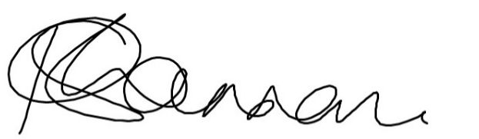
Keri Shannon | Chief Executive Officer
19 July 2024

Information

Council Meeting Agenda are run in accordance with the City of Nedlands Standing Orders 2016. If you have any questions in relation to the agenda, procedural matters, addressing the Council or attending these meetings please contact the Governance Officer on 9273 3500 or council@nedlands.wa.gov.au
Public Question Time
Public Questions are dealt with at the Ordinary Council Meeting.
Deputations
Members of the public may make presentations or ask questions on items contained within the agenda. Presentations are limited to 5 minutes. Members of the public must complete the online registration form available on the City’s website: Public Address Registration Form | City of Nedlands
Disclaimer
Members of the public who attend Council Meetings should not act immediately on anything they hear at the meetings, without first seeking clarification of Council’s position. For example, by reference to the confirmed Minutes of Council meeting. Members of the public are also advised to wait for written advice from the Council prior to taking action on any matter that they may have before Council.

Any plans or documents in agendas and minutes may be subject to copyright. The express permission of the copyright owner must be obtained before copying any copyright material.

Table of Contents

1. Declaration of Opening 5
2. Present and Apologies and Leave of Absence (Previously Approved) 5
3. Public Question Time 5
4. Deputations 5
5. Requests for Leave of Absence 5
6. Petitions 5
7. Disclosures of Financial Interest 5
8. Disclosures of Interests Affecting Impartiality 6
9. Declarations by Members That They Have Not Given Due Consideration to Papers 6
10. Confirmation of Minutes 6
10.1 Ordinary Council Meeting 25 June 2024 6
11. Announcements of the Presiding Member without discussion 6
12. Members Announcements without discussion 7
13. Matters for Which the Meeting May Be Closed 7
14. Minutes of Council Committees and Administrative Liaison Working Groups 7
14.1 Minutes of the following Committee Meetings (in date order) are to be received: 7
15. Audit Committee Reports 8
15.1 ARC19.07.24 Update from Independent Consultant Report 7 8
15.2 ARC21.07.24 Update from Independent Consultant – Root Cause Report 10
16. Divisional Reports - Planning & Development 13
16.1 PD48.07.24 Adoption of draft Local Planning Policy 5.13 – St Johns Wood Estate Fencing 13
16.2 PD49.07.24 Adoption of draft Local Planning Policy 3.3 - Tree Retention 17
16.3 PD50.07.24 Dog Exercise Area – Montario Quarter 23
16.4 PD51.07.24 Public Health Plan 29
17 Divisional Reports - Technical Services 48
17.1 TS22.07.24 Removal of Hazardous Tree – 88 Victoria Avenue, Dalkeith 48
17.2 TS23.06.2024 Removal of Hazardous Tree – 2A Tyrell Street, Nedlands 51
18 Divisional Reports – Community Services & Development 56
18.1 CSD04.07.24 Acquisition of Tim Macfarlane Reid Sculpture 56
19 Divisional Reports - Corporate Services 60
19.1 CPS32.07.24 LGIS Annual Insurance Renewal 2024-25 60
19.2 CPS33.07.24 Monthly Financial Report – June 2024 63
19.3 CPS34.07.24 - Monthly Investment Report - June 2024 69
19.4 CPS35.07.24 - List of Accounts Paid - June 2024 72
20 Reports by the Chief Executive Officer 74
20.1 CEO22.07.24 Proposed Establishment of Policy and Legislation Committee 74
20.2 CEO23.07.24 Workforce Agreements 78
20.3 CEO24.07.24 Elected Members Information Bulletin 86
20.4 CEO25.07.24 Outstanding Council Resolutions 88
20.5 CEO 26.07.24 Integrated Transport Strategy Committee Membership 91
20.6 CEO27.07.24 Foreshore Management Steering Committee Membership - Hollywood Ward 94
20.7 CEO 28.07.24 Public Art Committee Membership - Hollywood Ward 97
20.8 CEO 29.07.24 Adoption of Council Member Request and Provision of Information Policy 100
20.9 CEO30.07.24 Audit Committee Membership 103
20.10 CEO20.06.24 Establishment & Appointment of Members – CEO Performance Review Committee 105
20.11 CEO31.07.24 Exercise of Delegation 109
21 Council Members Notice of Motions of Which Previous Notice Has Been Given 111
21.1 NOM32.07.24 – Councillor Hodsdon - Council Meetings to Adjourn at 11.00pm 111
21.2 NOM33.07.24 – Councillor Youngman - Positive Aging & Affinity Club 112
22 Urgent Business Approved By the Presiding Member or By Decision 116
22.1PD52.07.24 Consideration of Responsible Authority Report for 27 Multiple Dwellings at 1A (Lot 2) Thomas Street, Nedlands 116
23 Confidential Items 127
23.1 CONFIDENTIAL CSD05.07.24 Point Resolution Childcare Centre (PRCC) 127
24 Declaration of Closure 127

Declaration of Opening

The Presiding Member will declare the meeting open at 7.00 pm and acknowledge the Whadjuk Nyoongar people, Traditional Custodians of the land on which we meet, and pay respect to Elders past, present and emerging. The Presiding Member will draw attention to the disclaimer on page 2 and advise the meeting is being livestreamed.

Present and Apologies and Leave of Absence (Previously Approved)

Leave of Absence Nil.
(Previously Approved)

Apologies None as at distribution of this agenda.

Public Question Time

Public Questions are to be addressed here

Deputations

Deputations by members of the public who have completed Public Address Registration Forms.

Requests for Leave of Absence

Any requests from Council Members for leave of absence.

Petitions

Petitions will be tabled

Disclosures of Financial Interest

The Presiding Member to remind Council Members and Staff of the requirements of Section 5.65 of the Local Government Act to disclose any interest during the meeting when the matter is discussed.

A declaration under this section requires that the nature of the interest must be disclosed. Consequently, a member who has made a declaration must not preside, participate in, or be present during any discussion or decision-making procedure relating to the matter the subject of the declaration.

However, other members may allow participation of the declarant if the member further discloses the extent of the interest. Any such declarant who wishes to participate in the meeting on the matter, shall leave the meeting, after making their declaration and request to participate, while other members consider and decide upon whether the interest is trivial or insignificant or is common to a significant number of electors or ratepayers.

Disclosures of Interests Affecting Impartiality

The Presiding Member to remind Council Members and Staff of the requirements of Council’s Code of Conduct in accordance with Section 5.103 of the Local Government Act.
Council Members and staff are required, in addition to declaring any financial interests to declare any interest that may affect their impartiality in considering a matter. This declaration does not restrict any right to participate in or be present during the decision-making procedure.

The following pro forma declaration is provided to assist in making the disclosure.

"With regard to the matter in item x ….. I disclose that I have an association with the applicant (or person seeking a decision). This association is ….. (nature of the interest).

As a consequence, there may be a perception that my impartiality on the matter may be affected. I declare that I will consider this matter on its merits and vote accordingly."

The member or employee is encouraged to disclose the nature of the association.

Declarations by Members That They Have Not Given Due Consideration to Papers

Nil

Confirmation of Minutes

Ordinary Council Meeting 25 June 2024

The Minutes of the Ordinary Council Meeting held 25 June 2024 are to be confirmed

Announcements of the Presiding Member without discussion

Written announcements by Council Members to be tabled at this point. Council
Members may wish to make verbal announcements at their discretion.

Members Announcements without discussion

Written announcements by Council Members to be tabled at this point. Council
Members may wish to make verbal announcements at their discretion.

Matters for Which the Meeting May Be Closed

For the convenience of the public, the following Confidential items are identified to be discussed behind closed doors, as the last items of business at this meeting.

Minutes of Council Committees and Administrative Liaison Working Groups

Minutes of the following Committee Meetings (in date order) are to be received:

This is an information item only to receive the minutes of the various meetings held by the Council appointed Committees (N.B. This should not be confused with Council resolving to accept the recommendations of a particular Committee. Committee recommendations that require Council’s approval should be presented to Council for resolution via the relevant departmental reports).

The Minutes of the following Committee Meetings (in date order) be received:

Audit Committee Meeting 17 June 2024
Confirmed at Audit Meeting 1 July 2024

Audit Committee Reports

ARC19.07.24 Update from Independent Consultant Report 7

Meeting & Date | Council Meeting – 23 July 2024
Applicant | City of Nedlands
Employee Disclosure under section 5.70 Local Government Act 1995 | Nil.
Report Author | Craig Ross – Independent Consultant
CEO | Keri Shannon
Attachments | - Progress Report - 7  - Report 7 Appendix  - Confidential attachment (available for viewing) Discussed at 9.2

Purpose
The Independent Consultant will verbally present a report to the Audit Committee.

Recommendation

That the Audit Committee receives the report from the Independent Consultant.

Voting Requirement

Simple Majority.

Background

N/A

Discussion

N/A

Consultation

Not applicable.

Strategic Implications

This item is strategically aligned to the City of Nedlands Council Plan 2023-33 vision and desired outcomes as follows:

Vision Sustainable and responsible for a bright future

Pillar Performance
Outcome 11. Effective leadership and governance

Budget/Financial Implications

There are no budget or financial implications in this report.

Legislative and Policy Implications

Not applicable.

Decision Implications

The Committee will be presented with a report from Mr. Ross.

Conclusion

Mr Ross will present his report to the Committee.

Further Information

Nil.

ARC21.07.24 Update from Independent Consultant – Root Cause Report

Meeting & Date | Council Meeting – 23 July 2024
Applicant | City of Nedlands
Employee Disclosure under section 5.70 Local Government Act 1995 | Nil.
Report Author | Craig Ross – Independent Consultant
CEO | Keri Shannon
Attachments | Confidential Attachment - Analysis of factors leading to the disclaimer of opinion on the financial report for the year ended 30 June 2023 (Root Cause Report) – Independent Consultant

Purpose
The Independent Consultant will verbally present an Analysis of factors leading to the disclaimer of opinion on the financial report for the year ended 30 June 2023 (Root Cause Report) to the Audit Committee.

Recommendation
That the Council
- receives the Report from the Independent Consultant; and
- considers the implications of the report for ongoing operations.

Voting Requirement

Simple Majority.

Background
N/A

Discussion
The separate report identifies a number of contributing factors which led to the submission of a financial report to the Auditor without complete and accurate underlying records .
A timeline was compiled by the independent consultant which showed that the City’s executive management did not advise the Mayor or the Council of the decision by the Office of the Auditor General to provide a modified opinion, which was known to them on or about 16 November 2023.
The independent consultant has found given the significance of the decision of the Office of the Auditor General it should have been reported to the Mayor and Council immediately with a full explanation of the implications of a modified opinion. The decision by the Office of the Auditor General to provide a modified opinion, in particular a disclaimer of opinion, was not reported to the Council until late February 2024.
The independent consultant found many of the contributing factors are process and technical in nature, however they are rooted in the following key failings within the financial management processes.

The Audit Committee of the Council failed to:
- Recognise the poor quality of the financial report submitted to the auditor
- Review the financial report prior to auditor submission
- Track execution of the audit fieldwork phases and completion timelines
- Ensure key internal audit findings impacting financial reporting were addressed
- Communicate emerging audit issues to the Council in a timely manner
- Challenge executive management on finance staff turnover reasons and capacity limitations

The City’s executive management failed to:
- Keep proper accounts and records
- Manage internal control to ensure the financial report was free from material misstatement
- Report emerging audit issues in an open and timely manner to Council
- Follow better practice financial reporting and audit readiness guides
- Provide external audit progress reports to the Audit Committee
- Address appropriately the high finance staff turnover and report implications to the Audit Committee
- Monitor directly finance staff performance
- Remediate key internal audit findings impacting the financial reporting process
- Respond accordingly to the change in audit approach when information was not reasonably available

The organisational culture:
- Prevented open communication of unfavourable information
- Allowed mistrust within the hierarchical structure of the Council and the executive management team
- Did not encourage better practice financial reporting processes
- Did not address timely management of inadequate finance staff performance
The report proposes a number of financial reporting specific recommendations for immediate consideration by the Council and the Chief Executive Officer. It is probable a number of the root causes leading to the disclaimer of opinion would have evolved over a number of years. Whilst the scope of this report is limited to the financial reporting and the external audit impact, it is recommended that Council and executive management review the factors contributing to the disclaimer of opinion through an integrated approach across the organisation.

Consultation

Not applicable.

Strategic Implications

This item is strategically aligned to the City of Nedlands Council Plan 2023-33 vision and desired outcomes as follows:

Vision Sustainable and responsible for a bright future

Pillar Performance
Outcome 11. Effective leadership and governance

Budget/Financial Implications

There are no budget or financial implications in this report.

Legislative and Policy Implications

Not applicable.

Decision Implications

The Committee will be presented with Analysis of factors leading to the disclaimer of opinion on the financial report for the year ended 30 June 2023 (Root Cause Report) from Mr. Ross.

Conclusion

Mr Ross will present his report to the Committee.

Further Information

Nil.

Divisional Reports - Planning & Development

PD48.07.24 Adoption of draft Local Planning Policy 5.13 – St Johns Wood Estate Fencing

Meeting & Date | Council Meeting – 23 July 2024
Applicant | City of Nedlands
Employee Disclosure under section 5.70 Local Government Act 1995 | The author, reviewers and authoriser of this report declare they have no financial or impartiality interest in this matter.
Report Author | Nathan Blumenthal – Acting Manager Urban Planning
Director | Tony Free – Director Planning and Development
Attachments | - Draft Local Planning Policy 5.13: St Johns Wood Estate Fencing  - Summary of Submissions

Purpose

The purpose of this report is for Council to consider modifications to the draft Local Planning Policy 5.13: St Johns Wood Estate Fencing (the Policy) post advertising and proceed to adoption.

Recommendation

That Council Proceeds with modifications to the Local Planning Policy 5.13: St Johns Wood Estate Fencing (Attachment 1) in accordance with Clause 4 of the Deemed Provisions of Schedule 2 of the Planning and Development (Local Planning Schemes) Regulations 2015.

Voting Requirement

Simple Majority.

Background

The draft St Johns Wood Estate Fencing Policy has been developed to maintain the character of the streets within the Estate by providing design guidelines for fencing in key zones. Uniform fencing along a number of streets, which was established with the initial subdivision of the Estate, are at risk of falling into disrepair or being altered. This would affect the uniform appearance and character of the Estate. The intent of the Policy is to generally maintain the fencing standards and streetscapes established during the initial creation of the Estate.

The Policy was adopted for advertising at the 26 March 2024 Ordinary Council Meeting and was subsequently advertised.

Discussion

Following community consultation, a number of modifications have been made to the draft Policy. These include:

Fencing Location Maps

The map at Figure 1 has been modified to be easier to interpret. Several zones have been modified to reflect areas of fencing which have been replaced since creation of the subdivision or to clarify fencing locations. Subsequently, the location maps at Figures 4, 15 and 17 have been modified.

General Provisions

The existing General Provisions have been strengthened and include an additional 3 provisions. General Provision 6.5 of the advertised policy stated that screening extending above the fence line was not permitted. To reflect comments submitted by the community, which value the green, bushland feel of the estate, as well as additional privacy, the provision has been amended. The provision now permits vegetative screening above the maximum fence height subject to the use of natural materials (i.e. timber lattice or trellis) and reasonable maintenance of vegetation. The following provisions have been added:

6.6 Limestone retaining installed as part of the initial subdivision of the estate is to be maintained and, if required, replaced on a like for like basis.

6.7 Fencing visible from the public realm is to be maintained by the landowner to a standard acceptable to the City.

6.8 To maintain the open streetscape of the Estate, fencing within the primary street setback area is not permitted, including the side boundaries forward of the dwelling.

Street walls and fences

Section 8 of the advertised Policy prohibiting street walls and fences within the primary street setback has been reworded and relocated in General Provision 6.8. The provision still does not permit front fencing.

Whilst several comments from the community during the consultation period expressed the desire to have the option to construct front fences, the intent of the Policy is to maintain the Estate in the condition of original subdivision. Restrictive Covenants were placed on the Certificate of Titles for the original subdivision of the Estate, which prohibited the construction of fencing within the front setback area in order to create an open feel of the streetscape. Whist it is acknowledged the Covenants have expired, the open, bushland feel of the Estate should be preserved.

Consultation

The Policy was advertised through the Post newspaper, the City’s Your Voice page and letters to affected landowners. During the consultation period, 12 April 2024 to 2 May 2024, 25 submissions were received. Of these, 11 were objections to the Policy, 12 in support and two comments.

The table below contains a summary of comments and Officers responses.

Comment | Officer Response
Against the prohibition of front fencing  6 submissions | The prohibition of front fencing is to remain in the Policy to reflect the intent of the Estate.
Support the prohibition of front fencing  3 submissions | Provision relating to front fencing remains in the Policy to reflect the intent of the Estate.
Against prohibition of screening above fence line  2 submissions | General provision 6.5 has been amended to permit vegetative screening above the maximum fence height subject to the use of natural materials (i.e. timber lattice or trellis) and reasonable maintenance of vegetation.
Against the continuation of the use of pine lap fencing  2 submissions | The timber pine lap fencing contributes to the natural bush feel of the estate and it still remains in significant stretches where visible from the public realm.
Against the use of Colorbond fencing  1 submission | Colorbond is the required material for one zone. A significant number of panels of the original pine lap fencing have already been replaced by Colorbond in this zone. Specifying the colour and material will ensure the fencing is uniform as the panels are replaced.
Would like to see the inclusion of provisions for the retention of limestone retaining  2 submissions | General provision added – Limestone retaining walls installed as part of the original subdivision of the estate are to be maintained and, if required, replaced on a like for like basis.

The full submissions and officer responses are at Attachment 2 of this report.

Strategic Implications

This item is strategically aligned to the City of Nedlands Council Plan 2023-33 vision and desired outcomes as follows:

Vision | Sustainable and responsible for a bright future

Pillar | Place
Outcome | 7. Attractive and welcoming places.

Budget/Financial Implications

Nil

Legislative and Policy Implications

Clause 3(1) of the Deemed Provisions of Schedule 2 of the Planning and Development (Local Planning Schemes) Regulations 2015 allows the City to prepare a Local Planning Policy in respect to any matter related to the planning and development of the Scheme area.

Council must consider any submissions received and resolve to:

- Proceed with the Policy without modification;
- Proceed with the Policy with modification; or
- Not proceed with the Policy.

Decision Implications

If Council resolves to proceed with the Policy it will be adopted and take effect once a notice has been placed on the City’s website.

If Council resolves not to proceed, the Policy will not come into effect.

Conclusion

It is recommended that Council proceed with modifications to the draft Local Planning Policy 5.13: St Johns Wood Estate Fencing and formally adopt.

Further Information

Nil

PD49.07.24 Adoption of draft Local Planning Policy 3.3 - Tree Retention

Meeting & Date | Council Meeting – 23 July 2024
Applicant | City of Nedlands
Employee Disclosure under section 5.70 Local Government Act 1995 | The author, reviewers and authoriser of this report declare they have no financial or impartiality interest in this matter.
Report Author | Nathan Blumenthal – Acting Manager Urban Planning
Director | Tony Free – Director Planning and Development
Attachments | - Draft Local Planning Policy 3.3 - Tree Retention  - Schedule of Submissions

Purpose

The purpose of this report is for Council to consider the draft Local Planning Policy 3.3 – Tree Retention (the Policy), found at Attachment 1, for adoption.

Recommendation

That Council adopts the draft Local Planning Policy 3.3 – Tree Retention (Attachment 1) in accordance with Clause 4 of the Deemed Provisions of Schedule 2 of the Planning and Development (Local Planning Schemes) Regulations 2015.

Voting Requirement

Simple Majority.

Background

The Policy seeks to provide the City with a planning mechanism to protect mature trees on private property and the canopy they provide. In March 2024 the Western Australian Local Government Association (WALGA) released a Tree Retention Model Local Planning Policy (LPP). City Officers referred to this document in the preparation of the Policy. The Policy was adopted for advertising at the April 2024 Ordinary Council Meeting.

Discussion

The Policy aims to encourage and facilitate the retention of trees and as a result enhance the tree canopy to:

- Preserve and improve the neighbourhood amenity and character
- Mitigate the heat island effect
- Reduce air pollution
- Improve groundwater quality
- Contribute to biodiversity.

The Policy seeks to achieve these outcomes by:

- Providing objectives to guide the City and applicants to encourage and facilitate the protection of trees at all stages of development.
- Defining what constitutes tree damaging activities and regulated trees (i.e. trees subject to the Policy).
- Outlining when a development application is required and circumstances where tree damaging activities are exempt from requiring approval from the City, such as pruning.
- Setting out the information to be provided by applicants for development applications associated with tree damaging activities, including an arborist report.
- Providing the considerations and elements the City will give due regard to when assessing development applications.
- Providing criteria for any new trees required as replacements for regulated trees.

Amendments after advertising
With consideration of submissions received during the consultation period, one change has been made to the Policy. Appendix 1 has been amended to reflect comments which expressed that the Lemon Scented Gum be removed from the unwanted tree species list. As the species is not a weed species or susceptible to any pests or diseases currently in Western Australia it does not qualify for inclusion on the list.

Consultation

Community consultation was undertaken for a period of 21 days, from 7 May to 28 May 2024. An information session was held on the 22 May 2024 which was attended by 8 people. During this period 175 submissions were received. The table below illustrates the spread of submissions.

 | Objection | Support | Comment Only
R20 lots and below within City of Nedlands | 73 (41.7%) | 64 (36.6%) | 4 (2.3%)
Lots above R20 within City of Nedlands | 6 (3.4%) | 13 (7.4%) | 1 (0.6%)
Not within City of Nedlands or unknown address | 6 (3.4%) | 8 (4.6%) | 0 (0%)
Total | 85 (48.6%) | 85 (48.6%) | 5 (2.8%)
Of the objections received, 6 objected based on the grounds that the Policy did not go far enough and should protect trees across all densities within the City.
Below are the most common comments made during the submission period along with officer responses.

Comment | Officer Response
The Policy is an overreach by the local government on the rights of the private landowner.  35 submissions | The Planning and Development Act 2005 at Schedule 7 – Matters which may be dealt with by a planning scheme, includes at cl. 4(2) – the conservation of the natural environment of the scheme area including the protection of natural resources, the preservation of trees, vegetation and other flora and fauna, and the maintenance of ecological processes and genetic diversity. This indicates that tree preservation is a matter that can be dealt with via a Local Planning Policy.
Concerns regarding safety of retaining regulated trees and the time to apply for a development approval  19 submissions | Tree damaging activity necessary for public safety are exempt from requiring a development approval.
The City should focus on building up and maintaining trees on the verges and other City land.  16 submissions | The City has recently reviewed and updated its Street Trees Council Policy and is currently reviewing its Urban Forest Strategy. In order to grow urban canopy, both private and public land must contribute.
The Policy should apply to all lots within the City.  12 submissions | The City determined that there is a need to balance the broader sustainability benefits of urban infill with the retention of vegetation.
Greater guidance is needed around pruning and maintenance  10 submissions | Policy provisions relating to maintenance pruning remains unchanged, as attempting to add further criteria complicates the process and catches up proponents pruning a tree in good faith. The intention of the Policy is primarily to capture removal of trees where they could otherwise be retained, not to create legislation governing all aspects of tree maintenance.
The City should incentivise tree retention  10 submissions | The benefits of tree retention to broader sustainability goals and amenity of the locality is considered an incentive.
The policy should apply to Lemon Scented Gums that meet the requirement of a regulated tree. It should be removed from Appendix 1.  9 submissions | Lemon Scented Gum has been removed from Appendix 1 after advertising.
The Policy removes the right of a landowner to trim trees which overhang fences  8 submissions | The Policy does not remove the right of a landowner to perform maintenance pruning for trees overhanging a fence.
The City should keep a register of endorsed arborists  7 submissions | The City does not keep a register of endorsed arborists as this could lead to conflict of interest. The Policy states the use of an arborist with a minimum qualification of a Diploma of Horticulture (Arboriculture) Australian Qualification Framework (AQF 5).
No tree should be exempt from the Policy  6 submissions | A number of trees are exempt from the Policy due to their susceptibility to disease or pests or as they are an environmental weed.
The Policy should only apply to lots greater than R20  5 submissions | The City determined that there is a need to balance the broader sustainability benefits of urban infill with the retention of vegetation.
The City should assist with the cost of arborist fees and maintenance  2 submissions | The City does not have operational expenditure allocated in its Budget to private tree maintenance. This would require consideration by Council.

Strategic Implications

This item is strategically aligned to the City of Nedlands Council Plan 2023-33 vision and desired outcomes as follows:

Vision | Sustainable and responsible for a bright future

Pillar | Planet
Outcome | 4. Healthy and sustainable ecosystems.
 | 5. Climate resilience.

Pillar | Place
Outcome | 6. Sustainable population growth with responsible urban planning.
 | 7. Attractive and welcoming places.

Budget/Financial Implications

If the City proceeds with the Policy, there may be instances when the City will need to seek third-party advice on proponents’ arborist reports, but these will be handled on a case-by-case basis and are expected to be infrequent.

Legislative and Policy Implications

Clause 3(1) of the Deemed Provisions of Schedule 2 of the Planning and Development (Local Planning Schemes) Regulations 2015 allows the City to prepare a Local Planning Policy in respect to any matter related to the planning and development of the Scheme area.

Following the advertising period, Council is to consider any submissions received and resolve to:

- Proceed with the Policy without modification; or
- Proceed with the Policy with modification; or
- Not proceed with the Policy.

Decision Implications

If Council resolves to adopt the Policy, it will be in effect upon a public notice.

If Council resolves not to adopt the Policy it will not be progressed. Doing so will mean City Officers are without a planning mechanism which would see the protection of trees and the enhancement of the tree canopy on low-density residential lots within the City.

Conclusion

The Policy has been developed to provide City Officers a mechanism with which to facilitate the protection of the City’s tree canopy provided by mature trees on low-density private land. It is recommended that Council adopts the Policy.

Further Information

Question from Councillor Coghlan

Should the Policy be modified to reflect the Policy objectives being required to “guide the assessment” rather than only being required to be given “due regard”

Officer response:

The wording of clause 7.1.3 is consistent with the WALGA model policy and clause 67(2)(c) of the Deemed Provisions Schedule 2 of the Planning and Development (Local Planning Schemes) Regulations 2015. “Due regard” is legal terminology that amounts to the same assessment level as “guidance”.

The question of the role of arborist being clarified following the address to the Forum by Ms Bovell – why shouldn’t the City maintain a list of endorsed arborists?

Officer response:

The City does not keep a register of endorsed arborists as this could be perceived as giving those contractors favouritism or a commercial benefit. The Policy states the use of an arborist with “a minimum qualification of a Diploma of Horticulture (Arboriculture) Australian Qualification Framework or equivalent and with demonstrated experience in high level tree assessment and diagnosis.”

Question from Councillor Hodsdon

The State Government’s proposed Perth and Peel Greening Plan – what, if any impact will this have on this Policy. What exactly is the State Government proposing and where are they up too?

Officer response:

The Perth and Peel Urban Greening Strategy is still in the formulation phase and a draft has not yet been released for consultation. It is proposed that this strategy would provide a coordinated plan at the state level which would improve upon and support existing local efforts at urban greening, such as this tree retention policy. The proposed strategy will look at elements such as tree canopy measurement and reporting, education, urban heat island identification and mitigation, green links and a grant program. Officers understand that the State government is comfortable with local governments preparing tree policies provide they are generally consistent with the WALGA approach.

Question from Councillor Smyth

Why is the wording of Clause 5.1 the way it is – as a double negative?

Officer response:

This provision begins on the proposition that all tree damaging activity requires development approval before outlining where activities are exempt from requiring development approval. Wording is consistent with the wording of the WALGA model policy.

Definition of Regulated tree – where did this come from and location of the definitions within the Policy?

Officer response:
The location of Definitions within the Policy is clearly indicated in the table of contents and is consistent with the format of other recently adopted Local Planning Policies. Words which are defined within the Policy are bolded for ease of use.

PD50.07.24 Dog Exercise Area – Montario Quarter

Meeting & Date | Council Meeting - 23 July 2024
Applicant | City of Nedlands
Employee Disclosure under section 5.70 Local Government Act 1995 | Nil
Report Author | Andrew Melville - Manager Health and Compliance
Director | Tony Free – Director Planning and Development
Attachments | Nil

Purpose

This report is presented to seek approval from Council to give local public notice for at least 28 days as per the Local Government Act 1995 section 1.7, of its intention to specific a public place as a dog exercise area under the Dog Act 1976 Section 31(3A).

Development WA have constructed two parks located within Montario Quarter Shenton Park, as dog exercise areas and are now requesting for them to be designated as dog exercise areas under the Dog Act 1976.

Recommendation

That Council:

- approve ‘MONTARIO QUARTER DOG PARKS being two portions of Lot 8006 that are enclosed by a fence and signposted located on the corner of Lemnos Street & Guttman Approach Shenton Park’ as a dog exercise area under the Dog Act 1976 Section 31(3A).

- approve to give local public notice for at least 28 days as per the Local Government Act 1995 Section 1.7 of its intention to designate Montario Quarter Dog Parks as dog exercise areas.

Voting Requirement

Absolute Majority.

Background

Development WA has recently completed the construction of two dog exercise areas within Montario Quarter, Shenton Park. These two fenced, off-leash areas, are located on the southern end of the Montario Quarter development, situated on the corner of Lemnos Street and Guttmann Approach. These two areas have been designed to create positive interactions between dogs while prioritising usability and convenience for dog owners.

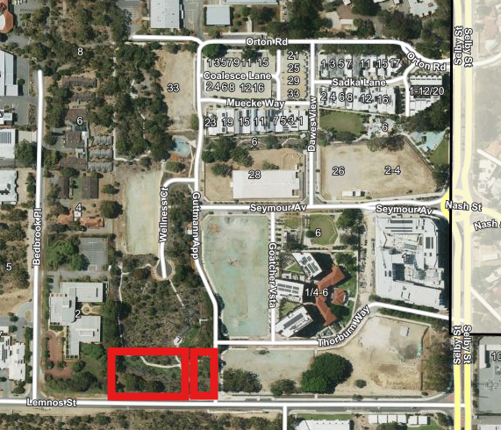
Map: Location of dog exercise area
These two spaces have been further designed to accommodate different types of dogs depending on their activity level and how they want to interact with other dogs. One of the parks is smaller, with a size of approximately 440 square metres, that includes a surrounding chain mesh fencing, double gate system to allow dogs and people to enter safely, natural shade from the remnant mature bushland trees, dog bag stations, a recycling and waste receptacle, a park bench, drinking fountain with dog bowl, and interaction zones around trees. This smaller park is designed for passive and smaller dogs, lacking the large space enabling dogs to gather momentum, making it an ideal environment for gentle play and socialisation among these types of dogs.

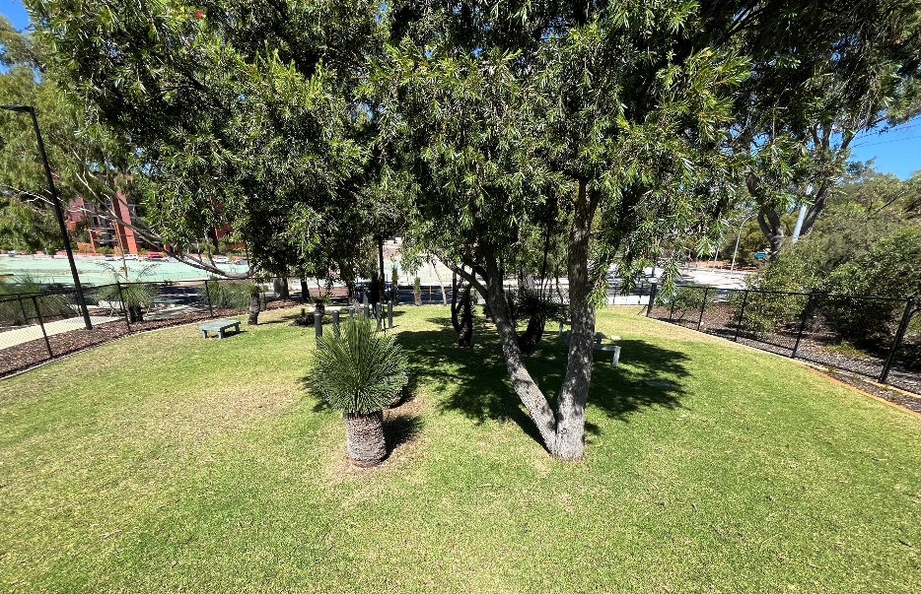
Picture: Passive dog park (looking East)
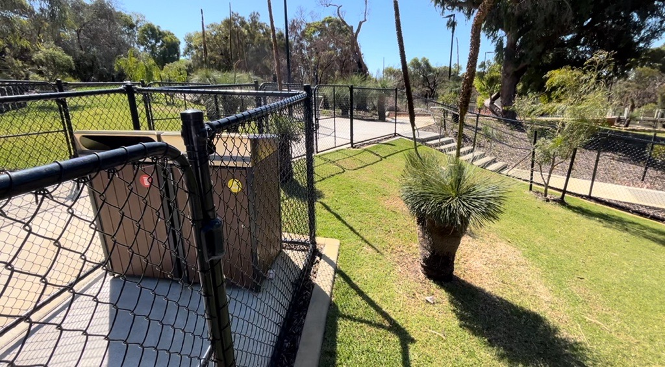
Picture: Facilities in the Passive dog park (looking North)

The second fenced exercise area has been designed to accommodate larger and more active dogs. It is approximately 1140 square metres park that includes a surrounding chain mesh fencing, double gate system on the western and eastern end of the park to allow dogs and people to enter safely, natural shade from the remnant mature bushland trees, dog bag stations, a recycling and waste receptacle at each entry point, several park benches, drinking fountains with dog bowls, agility equipment, and sensory areas.

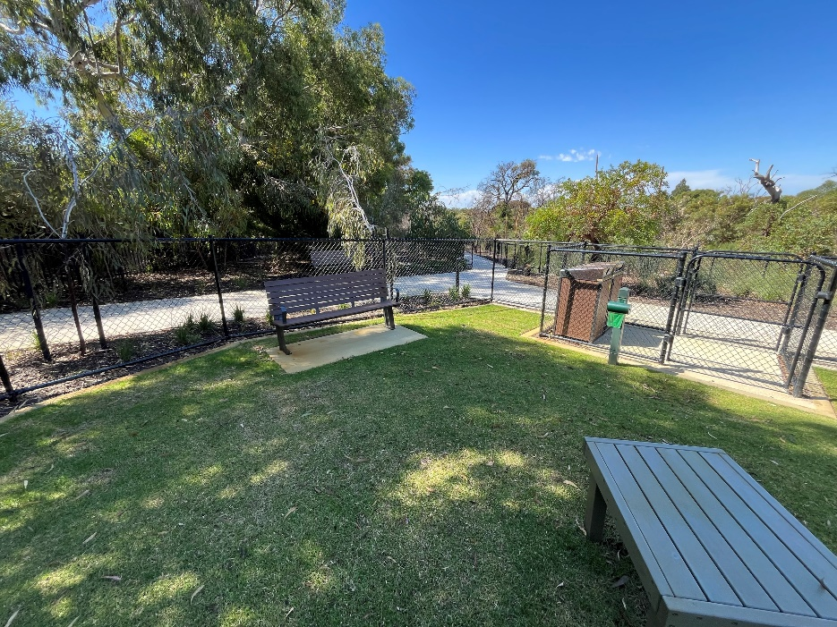
Picture: Facilities in the Active dog park (looking North)
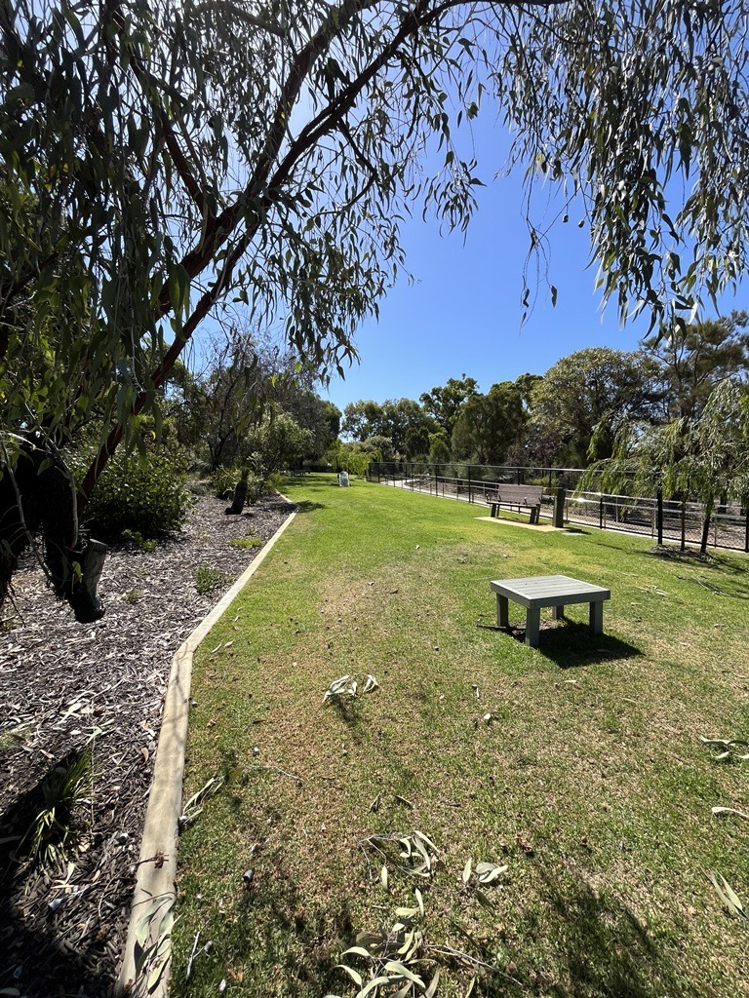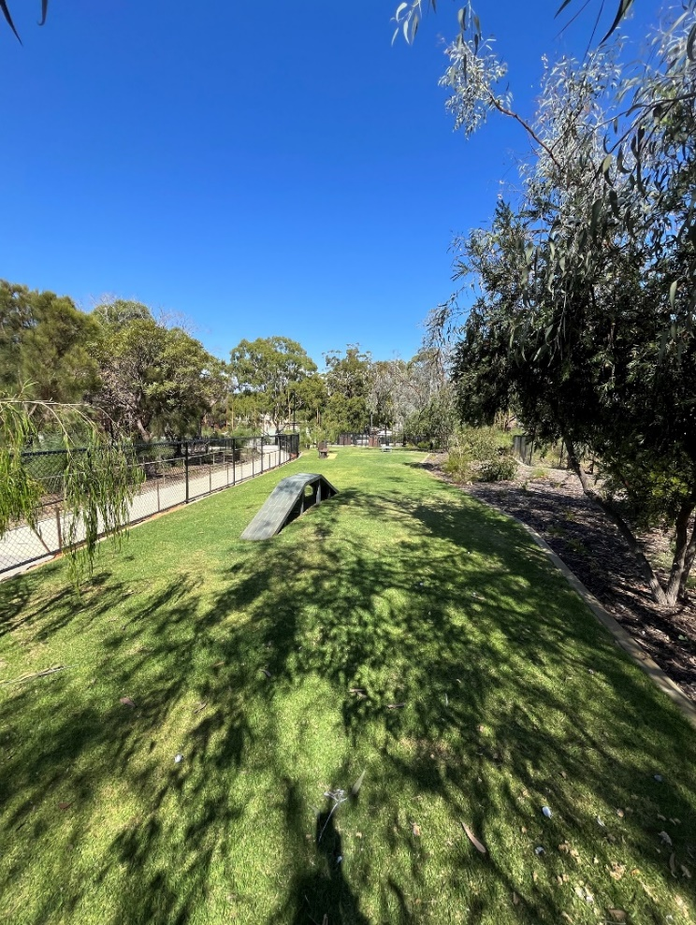
Picture: Active dog park (looking West) Picture: Active dog park (looking East)

The Dog Act 1976 Section 31 allows public places under the care, control, and management of the local government, to be designated as dog exercise areas or dog prohibited areas subject to a Council Resolution by Absolute Majority. Having a designated list of dog exercise areas and prohibited areas removes the legislative burden of having to update a local law if there is a requirement to add or remove dog parks.
Discussion

The Dogs in Public Places Council Policy (Policy) was formally presented to Council in the meeting held 28 March 2023 Item 19.2 CEO04.03.23 Proposed Dogs Local Law alongside the proposed Dogs Local Law 2023. Council resolved to give public notice as per the requirements of the Local Government Act 1995 and Dog Act 1976, provide the results of the public consultation to Council for consideration, and the ‘Places where dog are Prohibited Absolutely’ to be modified to include “a theatre, picture gardens, playground or public toilet area”.

Public Notice was given and consultation on the Policy was open from the 28 April 2023 and closed on 30 June 2023.

The results of the consultation and adoption of the Dog Local Law 2023 were presented in the Ordinary Council Meeting held on 12 December 2023 Ordinary Item 19.4 CEO39.12.23 Adoption of City of Nedlands Local Law 2023. This report only included a list of ‘Dog Exercise Areas’ and ‘Places where dogs are Prohibited Absolutely’ not the entire Policy. Only the list was adopted by Council.

Consultation

Nil. The purpose of this report is to seek Council’s approval to consult on the intention to specify these dog parks as dog exercise areas.

Strategic Implications

This item is strategically aligned to the City of Nedlands Council Plan 2022-33 vision and desired outcomes as follows:

Vision | Sustainable and responsible for a bright future

Pillar | People
Outcome | 2. A healthy, active and safe community.

Pillar | Place
Outcome | 7. Attractive and welcoming places.

Pillar | Performance
Outcome | 11. Effective leadership and governance.

Budget/Financial Implications

There are no financial implications associated with the adoption of the Dogs in Public Places Council Policy. Update to an exercise area dog map can be accommodated within the 2024/25 Financial Year operational budget.

Legislative and Policy Implications

Dog Act 1976 – Section 31
Places where dogs are prohibited absolutely and places which are dog exercise areas under S31(3a) of the Dog Act 1976.

Decision Implications

If Council do not approve for the City to give 28 days notice to specific these two sections of Montario Quarter as a dog exercise area, the decision of Council made on 12 December 2023 item 19.4 to approve the list of places Where Dogs are Prohibited Absolutely, and Places Which are Dog Exercise Areas, under section 31(3a) of the Dog Act 1976 will remain in effect.

The two dog parks at Montario Quarter will not be designated as off lead dog exercise areas. Users of this park will be required to have their dogs on lead which will conflict with the purpose of the specifically designed off lead parks as intended by Development WA.

Conclusion

The two Montario Quarter fenced dog parks should be placed out for public notice for at least 28 days as defined by the Local Government Act 1995 Section 1.7 of its intention to specify it as a dog exercise area under Section 31(3A) of the Dog Act 1976. These ensures the correct process for specifying a dog exercise area. A report to Council will be presented in September 2024 de-identifying the submissions lodged for the local public notice.

Further Information

Nil.

PD51.07.24 Public Health Plan

Meeting & Date | Council Meeting – 23 July 2024
Applicant | City of Nedlands
Employee Disclosure under section 5.70 Local Government Act 1995 | Employee disclosure required where there is an interest in any matter of which the employee is providing advice or a report.
Report Author | Andrew Melville – Manager Health and Compliance
Director | Tony Free – Director Planning and Development
Attachments | - City of Nedlands Public Health Plan

Purpose

The purpose of this report is for Council to consider adopting the City of Nedlands Public Health Plan 2024-28 as required by the Public Health Act 2016 and in accordance with the City’s Council Plan 2023-33.
Recommendation

That Council adopts the City of Nedlands Public Health Plan 2024-28 as required by the Public Health Act 2016 and in accordance with City’s Council Plan 2023-33.

Voting Requirement

Simple Majority.

Background

In 2016, the Public Health Act 2016 (Act) was introduced to replace the Health Act 1911. It is currently in a transition phase. There are two aspects of the new Act which are currently pertinent and opportunistic for the City. Firstly, the Act is outcome based, which allows more flexibility for the City in achieving effective public health outcomes.

The second aspect is that the public health duties undertaken by a local government can be varied based on the unique needs of that local government area. Public health planning provides the City with a significant opportunity to tailor its services directly to the areas identified of most need.

Part 5 of the Act will require the preparation of two types of public health plans:

- A state public health plan prepared by the state’s Chief Health Officer, and
- A local public health plan prepared by each local government district.

The Chief Health Officer published the StatePublic Health Plan for Western Australia Objectives and Priorities for 2019-2024 in 2019, to support local governments and ensure consistency with the objectives and policy priorities of the state.

A local public health plan must be consistent with the state public health plan whilst responding to local public health risks. It must;
- identify the public health needs of the local government district,
- include an examination of data relating to health status and health determinants in the local government district,
- establish objectives and policy priorities for the promotion and protection of public health in the local government district, and
- describe the development and delivery of public health services in the local government district.

The local government must also report on the performance of its functions under the Act to WA Department of Health annually.

The requirement for each local government to have a public health plan is in Part 5 of the Act which recently commenced on 4 June 2024. Local governments are required to finalise their public health plans by no later than 4 June 2026.

Discussion

The City’s draft public health plan had been developed and was presented at the Council Meeting on 26 March 2024, where it was resolved that the draft Plan be released for the purposes of public consultation for a period of six weeks on Your Voice Nedlands platform and at the City’s administration building.

A total of 13 submissions were received via Your Voice Nedlands and email during the six-week consultation period. The submissions received, were made by local residents, rate payers, visitors, volunteers, people who use services or work within the City’s district, and a state government agency.

The table below shows feedback the submissions provided about the draft plan.

 | Feedback received | City of Nedlands response
 | I'd like to provide feedback from a community perspective. | Refer to Item 3.
 | Good to know that there is ongoing oversight of important facets of community health and wellbeing. There is a big impact at local level as to all aspects of health and wellness - the environment we live in, the air we breathe, the food we eat, health aspects. | Positive commentary feedback noted.
 | Feedback from a Community perspective. Relative to the Draft Public Health Plan specific, Figure 4 notes GOLD plan and CCTV which are not relevant to the City of Nedlands specific.  The Community Health and wellbeing profile from the Department of Health 2021 displays data that 1 in 4 get less than 150minutes of physical activity a week, this is a staggering statistic and I am wondering what we can do as a City to promote physical activity (walking) within our community. Perhaps we could leverage the Whadjuk Trail in some way? | Noted. Figure 4 aims to provide information to the public about the relationship between the social determinants of health and the work of typical local governments. Figure description amended for better clarification.  The City promotes a healthy and active lifestyle, as part of Action 1.1.1, to benefit from the facilities situated throughout the city. These include the City’s natural areas and managed parklands, footpath networks, the Whadjuk Trail Network, Swanbourne Beach and the Nedlands Foreshore.
 | The first and best thing the Council can do for Public Health is to return its Red Bin collection to a WEEKLY collection instead of fortnightly. Retaining red bins for two weeks means they will be inevitably overfilled, stink, and attract and retain rodents. We are fast becoming the filthy stinking suburb, receiving less service for higher rates. | The WA State Government has set a target to divert 65 percent of waste materials from landfill by 2025. To address this, the City introduced the FOGO bin service, a standardised waste service recommended by the State Government which has resulted in the changed bin collection regime.  The City offers an expanded service at an additional cost, that residents can request, where a larger bin is provided and collected fortnightly.
 | Injury Matters would like to congratulate the City of Nedlands on your Draft Public Health Plan 2024-2028.  The following recommendations have been provided based on our expertise.  1. Suggest including injury as an outcome within pillar one.  Inspiring, empowering and enabling healthy living.  This pillar focuses on the significant opportunities to improve the health and wellbeing of our community by improving the surrounding environment to create vibrant, liveable neighbourhoods that offer a sense of belonging, culture and spirit, and by facilitating behaviour change to support people to lead healthier lifestyles and reduce injury.  2. Outcome 1 – Improved health and wellbeing of our community  Injury Matters would suggest the addition of an activity here similar to that within 1.2.1, 1.3.2 & 6.1.2.  Promote local, state, and federal campaigns to increase awareness among community members to lead active lifestyles and reduce injury.  3. Outcome 1 – Improved health and wellbeing of our community  Given falls are the leading cause of injury hospitalisation and fatalities in the City of Nedlands, Injury Matters recommends that the actions take this into consideration when provisioning health and wellbeing programs. 1323 falls hospitalisations between 2017-2021 with > 71% being in people aged 65+. This should be considered within activities 1.1.2 and the grant opportunities that are provided to supporting clubs to engage older people and support falls prevention and health ageing as part of the City’s Positive Ageing Plan.  4. Outcome 1 - Improved health and wellbeing of our community  Given the City of Nedlands health profile has identified that ¼ residents drink alcohol at harmful levels, Injury Matters suggest there is opportunity for further action within objective 1.3. Injury Matters suggests the addition of an action focused on alcohol. There are a variety of actions that Local government can take in this area including:  Reducing the availability of alcohol in The City of Nedlands. This could be achieved through:  • Develop or amend existing local government schemes and policies to limit the number and location and opening hours of liquor outlets in your community.  • Ensure safe consumption limits are enforced at licensed venues using a Liquor Accord or other agreement between your local Council, licensed premises and the police.  • Lead by example by adopting an alcohol-free policy for local government staff and elected members to prevent alcohol from being served at Council events and on Council property  5. Injury Matters is pleased to see the injury included in the explanatory blurb for pillar two. Given the way in which these objectives and activities are written, Injury Matters is unable to provide much feedback; however, assume that the actions taken in this area will encompass injury.  6. Injury Matters is pleased to see the inclusion of objectives and actions addressing the built environment and pillar addressing climate change within the plan as these are both cross cutting risk factors for injury in the community. Injury Matters suggest that within 6.1.5 and or 6.1.6 the City could consider the potential inclusion of the trial of innovative road surfaces, building materials and external finishes to support sustainability and reduce urban heat.  At Injury Matters, we work with people and organisations across WA to innovate and deliver injury prevention and recovery solutions. Solutions that keep people safer and healthier at home, at work and on the go. Solutions that save lives and make our community stronger.  Our approach is as expansive and inclusive as our remit, which spans everything from road safety to trauma recovery and falls to substance-related harm.  As a not-for-profit organisation, we work with local communities, industry, government and our health, emergency, and social services partners, drawing on the latest research, evidence and lived experience here in WA to:  - Raise awareness of injury risks, consequences, and solutions.  Prevent injuries through a range of education and support programs.  - Support the recovery of people, families and communities impacted by injury and trauma.  Advise and enable local and national agencies and policymakers to make smarter, safer, more informed policy decisions to support the needs of the community we work alongside.  Together, we find and share injury prevention, recovery and policy solutions that keep everyone safer and healthier – solutions that reduce the far-reaching physical, emotional, and financial impact caused by injuries and trauma.  Injury Matters would be pleased to support the City of Nedlands to deliver on the actions outlined within the Public Health Plan (through our existing funding) to support outcomes related to improving the health and wellbeing of residents. If you have any questions in relation to this submission please do not hesitate to contact our team on info@knowinjury.org.au.  Injurymatters.org.au  https://www.injurymatters.org.au/wp-content/uploads/2021/05/InjuryMatters-LocalGovernmentDL.pdf | Positive feedback noted.  Agreed. The wording “... and reduce injury.” added to the pillar commentary for ‘Inspiring empowering and enabling healthy living’ on page 19.  Many specific activities related to community health and wellbeing, including injury prevention, fall outside the role and capacity of local government. The City does, however, ensure that when delivering services and projects to the community, injury prevention considerations are included. To reinforce this, the pillar commentary for ‘Inspiring empowering and enabling healthy living’ on page 19 has been amended to include ‘… and reduce injury’.  The City is currently reviewing its Positive Ageing Program with the aim to develop a new Seniors Program (55+). This review seeks to analyse current resources and gaps, to develop a future proof suite of activities and supporting services inclusive of seniors’ needs and circumstances.  Liquor consumption and control of premises licenced for alcohol are regulated and overseen by the Department of Local Government, Sport and Cultural Industries (DLGSC). The City works with the DLGSC to ensure that the consumption and service of alcohol is consumed in accordance with the legislated requirements.  The City works with WA Police and DLGSC to manage compliance related behaviours at licensed premises. The suggested approach may be considered if this service delivery model were to change.  The City has existing alcohol policies that affect both City employees and the hiring and use of Council managed facilities.  Commentary noted.  This will be considered as part of the implementation of Action 5.1.1 of the City of Nedlands Council Plan 2023-33 requires the City to “Prepare a Sustainabiltiy Strategy to guide the City’s adoption of sustainable practices, improve community awareness and adoption of sustainable practices, and report on progress against key performance indicators via a Sustainability Dashboard Report”. The strategy is scheduled for development the 2024-25 and 2025-26 financial years.  Commentary noted.
 | Photo on page 9 shows (a) dog not on lead (b) Ranger in contact with dog without PPE (gloves) (c) standing water on paving, indicative of poor drainage and potential health issues. | This photo is considered appropriate for inclusion in the plan.
 | I would like to see fair and equitable distribution of service delivery across the LGA area included in this plan. In accordance with the LGA1995 requirement. Specific examples include pedestrian corridors and park maintenance levels of service.  There is also no metric or goal around management of noise, antisocial behaviour, contamination, asbestos and other carcinogenic dusts, heavy metals, pfas and related forever chemicals, odour, feral animals. | Existing services provided by the City are in accordance with legislative requirements, and scope of the City’s service plans and capital works program. Any changes to service delivery would need to be considered by Council.  There is existing legislation that regulates noise, antisocial behaviour, contamination, asbestos and other carcinogenic dusts, heavy metals, per- and polyfluoroalkyl substances and related forever chemicals, odour and feral animals. The City and other enforcement agencies undertake investigative and compliance activities where appropriate to address concerns with these matters.
 | I think Council is spreading itself far too thinly in trying to address all the issues in the Plan. Traditional areas such as infant and child health and support for seniors in the community as well as support for the City’s recreational facilities should be prioritised rather than trying to address a wide range of buzzwords such as sustainability and indigenous issues. Council has limited funds and these should be directed at areas which impact on local residents. | Although it is a legislative requirement to have the plan, many specific activities related to public health, fall outside the role and capacity of local government. However, actions within the plan integrate public health considerations either directly or indirectly as part of business-as-usual services such as through the Positive Ageing Program for seniors.
 | Section 3.1.  Would be good to see the inclusion of a solid plan to manage the environmental nuisance caused by the odour coming from the waste water treatment Center. It is sometimes difficult to aerate the home due to limitations caused by the odour which engulfs the air for extended periods of time. | The Wastewater Treatment Facility is not operated by the City. The City however, is in contact with, and aware that the facility is currently experiencing odour issues resulting from necessary works being undertaken by the Water Corporation. These works are expected to be completed in July 2024. The City understands that the Water Corporation are liaising with the community with regards to this odour issue.
 | Couldn’t see this detail in there but...although Tresillian and Library are there, compared to Kuringai Council NSW and other places lot more can be done!  More detail for online classes exercises like other Councils in WA would be great.  Bulk billing GP in Dalkeith and Mobile dental services would be great for aged living at home.  Better security CCTV around parks and Dalkeith, lot of areas not well lit.  Primary care centres out of Waratah Centre staffed by paramedic or nurse - in person or phone triage would be good.  Online transport bookings would be helpful for transport and other services.  Monash Uni has Telehealth programme, may be worth screening. | The City is currently reviewing its Positive Ageing Program with the aim to develop a new Seniors Program (55+). This new program will encompass services provided at Tresillian Arts Centre and the libraries and seek to increase these in-line with the needs to the community.  There is no planning approval required for a mobile dentist or doctor to operate within the local area. The City does not directly provide these services but would support their operation withing the local area.  This will be considered as part of the implementation of Action 2.5.3 of the City of Nedlands Council Plan 2023-33 requires the City to “Audit City-owned lights along the foreshore and in parks, sports facilities and other public places to determine how to deliver safer and more sustainable lighting and incorporate recommendations into the Capital Works Program”. This audit is scheduled to take place in the 2025-26 financial year.  These activities fall outside the scope of the existing services provided by the City. However, the City will remain engaged with WA local governments and the community through the Council Plan process to further understand the service needs of the local community.
 | 'Yes.  3.1 Manage environmental hazards to protect community health.  3.1.1 Investigate a range of environmental parameters that manage risk to the public including animals, noise, pest control, air quality, litter/dumping and environmental nuisance.  I would like to see more emphasis placed on air quality and propose solutions such as sealing laneways.  1. Seal laneways  Road dust may be associated with health implications (literature review attached) including deficits in neurobehavioural and cognitive development in childhood, increased cardiovascular related hospital admissions, low birth weight, asthma and cancer risk.  Our children's backyard backs on to our unsealed laneway which has a high traffic load as well as a lot of dust due to some of our neighbours using leaf blowers in the laneway. Fiona Argyle mentioned that Hollywood Private Hospital is the city's biggest rate payer and largest private hospital in Australia, yet there are unsealed lanes less than a block away from the hospital's entrance.  I have also attached a summary below of points from literature review on Road dust and its effect on human health. The Mount Alexander Council in Victoria, also discusses options of what can be done for road dust, and states that "sealing of unsealed roads provides the best solution to dust issues."  2.2 Provide and facilitate events, workshops and programs that bring community together.  2.2.2 Support the health and wellbeing of families and children.  I would like to see more sustainable children's playground equipment and more shade offered in playgrounds such as Leura Street park.  1.1.1 Provide and maintain environments and opportunities to enable the community to lead active lifestyles.  2. Sustainable use of playground equipment  With the proposed upgrade of the playground at Swanbourne beach we would like to see the council implement sustainable practices and consider recycling this equipment to other smaller parks around Nedlands Council, such as the Leura Street playground and to offer more trees to these parks surrounding the play equipment.  Summary of points from literature review on Road dust and its effect on human health  - Potgieter-Vermaak et al. found that lead and chromium compounds in road dust were present in human body fluids, indicating that exposure to road dust carries certain risks. Lead is known to be responsible for deficits in neurobehavioral and cognitive development in childhood. Reports have also found lead exposure to result in dysfunction of the reproductive system, as well as microcytic anemia resulting in conditions such as hypertension and chronic renal failure  - Kioumourt-zoglou et al. found an association between increased cardiovascular-related hospital admissions and PM2.5 in road dust. Mar et al. found a strong association between respiratory symptoms in children and PM2.5. Pun et al. determined that PM10 from vehicle emissions, nitrate-rich soils, and sea salt was associated with higher rates of hospitalization due to ischemic heart disease in Hong Kong.  - Bell et al. found that elements of PM2.5 road dust particles such as aluminum and silicon were associated with low birth weight (LBW).  - Li et al. measured the health risks of road dust and found that a higher risk was associated with the presence of lead, chromium, and copper in children living near industrial areas. They also found ingestion to be the main route of road dust exposure in humans. Liu et al. found that non-carcinogenic health risks were associated with the presence of higher concentration of barium, lead, and copper in road dust in high-traffic areas. Chromium is known to be carcinogenic. In human subjects, chromium has been found to cause allergic reactions and respiratory distress after short-term exposure. Long-term exposure to chromium has been proven to be associated with lung cancer.  - Xu et al. found arsenic to have a higher concentration than other components in road dust near an industrial area, as well as in commercial areas. Additionally, the risk of cancer associated with arsenic exposure via road dust was high in the children.  - Jiang et al. found higher levels of polycyclic aromatic hydrocarbons (PAHs) than of other compounds in road dust. Their estimated cancer risk of PAH in road dust was higher through the dermal and ingestion routes than through inhalation. They found that children were more susceptible to the hazard than adults due to their greater engagement in hand-to-mouth activities outdoors and lower body weight. Yu et al. found that PAH-contaminated road dust in urban areas was associated with an elevated risk of cancer. Soltani et al. reported high PAH concentrations in road dust near high-traffic roads. They concluded that both adults and children are vulnerable to the potential carcinogenic risk of road dust. In a meta-analysis, evidence was found of an association between PAHs and lung cancer. Ramesh et al. found PAHs to be related to colon cancer and breast cancer in humans, and to show high mutagenicity in laboratory animals.  - 17 studies, including review articles, that reported that exposure to road dust had adverse health effects on the respiratory system. These effects included asthma, as well as forms of respiratory carcinoma such as mesothelioma. Four articles specifically mentioned mesothelioma as one of the effects of road dust on the respiratory system | There is existing legislation that regulates these matters and the City undertakes compliance activities where it has the authority. The City and other enforcement agencies undertake investigative and compliance activities where appropriate, to address concerns related to these matters. Existing services provided by the City are in accordance with legislative requirements, and scope of the City’s service plans and capital works program. Any changes to service delivery would need to be considered by Council.  The City is currently reviewing the sealing of laneways and the broad suite of options available. This includes a review of the policy, service levels and the financial implications related to this activity. Current service levels as approved by Council is that: “Council will maintain laneways to a minimum standard to provide a safe environment for pedestrians, a trafficable surface for motorists and will be drained to contain a 1 in 5 year storm event.”  The City is currently investigating the shade needs of the City’s playgrounds. Playground equipment when replaced is generally not suitable for reuse as it is at the end of its useful life.  The Swanbourne Beach playground equipment has been assessed and determined to be at the end of its lifespan and is not appropriate for reuse.  The City has a program of tree planting and continually seeks to find a balance between tree shade and the risk to equipment.  Commentary noted. The City recognises that there are a number of factors impacting human health within the metropolitan area. The City’s activities and upgrades undertaken as required and as budgetary priorities permit. Existing services provided by the City are in accordance with legislative requirements, and scope of the City’s service plans and capital works program. Any changes to service delivery would need to be considered by Council.
 | ADDITIONAL FUNDING TO COMPLETE THE ALL ABILITIES PLAY SPACE. | The Jo Wheatley All Abilities Play Space has been completed and is now in the maintenance and renewal phase.
 | - SUGGESTION Images - add a description of where and what is in the image o e.g. Bin image on page 25 – describe the strategy depicted in the image to clarify why a bin is the focus point. | Agreed. Contextual commentary added to all key images throughout the plan.
 | - SUGGESTION Links - it may be helpful in the live document to have links to the documents that are mentioned within the PHP to allow readers to follow and gain a deeper understanding if they wish to do so. | The City’s strategic document templates do not currently include this option however, the City can consider this for future updates. All documents referred to in the plan will be listed within the location on the website.
 | - SUGGESTION Executive Message (Page 4) - replace the word ‘abuse’ with ‘misuse’ (this is important for destigmatising substance misuse rather than the punitive language of substance abuse). See relevant article, Words Matter - Terms to Use and Avoid When Talking About Addiction | National Institute on Drug Abuse (NIDA) (nih.gov) and Mindframe_AOD_Guidelines.pdf (imgix.net). | Agreed, wording amended to replace ‘abuse’ with ‘misuse’.
 | - SUGGESTION Page 4 - an acknowledgement of lived and living experience is also recommended, particularly when the plan speaks to alcohol and other drugs and Mental Health issues. | This is currently not a practice of the City but the City can note for consideration for in future strategic document templates.
 | - SUGGESTION Page 7- this image appears a little confusing and quite busy, many community members may struggle to understand this image’s meaning. | The City is limited with this infographic as it shows the existing State Government legislative framework. Some additional text has been added to the commentary on page 7 to assist with contextualising the infographic.
 | - GENERAL Pages 8 and 9 - again great background and integration information for the reader. | Positive commentary noted.
 | - GENERAL Page 11 - great visual tool for the reader to understand the determinants of health. | Positive commentary noted.
 | - GENERAL Page 13 - Publicly highlighting existing work acknowledges the great work the local government is doing which can increases job satisfaction for staff. Additionally, this also shows the community what great work is happening too, as they may not be aware. | Positive commentary noted.
 | - GENERAL Page 15 - this diagram of the process that was undertaken is also very important as it provides transparency and builds trust within the community for the work the local government is doing. | Positive commentary noted.
- , | - SUGGESTION Page 17 - Round the percentages to whole numbers. | Agreed, percentage figures on page 17 rounded to whole numbers.
 | - SUGGESTION Page 17 - community health and wellbeing profile: o There is some context missing (eg. injury). Is this lifetime/annual, is it permanent/temporary? | Agreed, additional commentary added to injury statistic “In the last 12 months requiring treatment from a health professional.” on page 17.
 | - SUGGESTION Page 19 - the Key may need further clarity, there is a little bit of ‘government speak’ in there and the average reader ay not understanding the meaning of some of the items, e.g. OP – Operating Project. | Agreed. The commentary prior to the Key on page 18 has been amended to provide clarity on the meaning of “Operation Project”.
 | - SUGGESTION Page 20 - Objective 1.2 Replace “....community to incorporate healthy food and drink options into their diet” with “....community to consume a healthy diet consistent with national guidelines”. | Agreed. Objective 1.2 amened to: “Support opportunities available for the community to consume a healthy diet consistent with national guidelines”.
 | - SUGGESTION Page 20 - Objective 1.2.3 Replace “....guidance on healthy food and drink options into event funding guidelines” with “....guidance to encourage healthy eating at activities delivered, funded [and/or supported] by the City”. | Noted however the City is satisfied that Action 1.2.3. “Provide guidance on healthy food and drink options into event funding guidelines.” as currently worded is satisfactory.
 | - SUGGESTION Include one or more case studies e.g. Act Belong Commit; Walking program. | This is currently a practice but the City can note this for consideration for in future strategic templates.
 | REQUEST Include an acknowledgement of NMHS contribution to the public health planning process, for example, “We would like to acknowledge North Metropolitan Health Service for your contributions on the Public Health Plan Working Group.” | Agreed. Acknowledgement included on page 5 of the plan.

Consultation

The draft Plan was advised for public consultation for six weeks between 15 April 2024 and 24 May 2024 on Your Voice Nedlands and at the City’s administration building.

Strategic Implications

This item is strategically aligned to the City of Nedlands Council Plan 2023-33 Vision and Outcomes as follows:

Vision | Sustainable and responsible for a bright future

Pillar | People
Outcomes | 2. A healthy, active and safe community.  3. A caring and supportive community for all ages and abilities.

Budget/Financial Implications

A budget allocation was allocated across the 2022-23 and 2023-24 financial years for the development of the Plan.

Actions identified in the Plan are funded or planned in alignment with the City’s Council Plan 2023-33. Expenditure associated with the Plan has been planned for and will be subject to further consideration by Council during annual budget processes for the life of the plan.

Legislative and Policy Implications

Section 45, Part 5 of the Public Health Act 2016. Each local government is required to have a public health plan finalised by no later than 4 June 2026.

Decision Implications

If Council resolves to approve the recommendation, the Public Health Plan will form an issue-specific plan to accompany the Council Plan. It will be made publicly available on the City’s website. The City will provide an annual report to Council and WA Chief Health Officer, demonstrating the extent to which the City has successfully implemented the Public Health Plan in accordance with requirements under the Public Health Act 2016.

Should the recommendation not be adopted, the City will be required to have a Council approved Public Health Plan by no later than 4 June 2026 as required by the Public Health Act 2016.

Conclusion

Each Western Australian local government is required to have a public health plan and have its plan finalised and in place by 4 June 2026 as per the Public Health Act 2016.

The City’s draft public health plan was presented at the Council Meeting held on 26 March 2024 where it was resolved to advertise the draft plan for six weeks on Your Voice Nedlands Platform and at the City’s administration building.

It is recommended that the draft Plan be adopted as required by the Public Health Act 2016 and an issue-specific plan of City’s Council Plan 2023-33.

Further Information

Question from Councillor Smyth

Now that we are 2 years ahead of time, do we have the budget to implement what the policy is leading to?

Officer response:

The actions identified in the Plan are funded or planned in alignment with the City’s Council Plan 2023-33. Any actions that are not part of the business of usual activities of the City will be undertaken by City staff as time and staffing resources permit. All expenditure associated with the Plan actions, has been planned for, and would be subject to further consideration by Council during annual budget processes for the life of the plan.

Divisional Reports - Technical Services

TS22.07.24 Removal of Hazardous Tree – 88 Victoria Avenue, Dalkeith

Meeting & Date | Council Meeting – 23rd July 2024
Applicant | City of Nedlands
Employee Disclosure under section 5.70 Local Government Act 1995 | Nil.
Report Author | Jac Scott, Manager Urban Landscape and Conservation
Director | Matthew MacPherson, Director Technical Services
Attachments | Nil

Purpose

A verge tree at 88 Victoria Avenue, Dalkeith recently dropped a significant branch on or around 29th May 2024. The tree is proposed for removal due to presenting a hazard because of the significant impact of the branch drop on the main leader, reducing the cross section by approximately 50%.

Approval of a tree of this size for removal is no longer an administrative decision following a Notice of Motion passed at the Ordinary Council Meeting held on 28th November 2023, and further confirmed in the Street Trees Council Policy update approved at the Ordinary Council Meeting on 23rd April 2024.

Recommendation

That Council:

- approves the removal of a Jacaranda mimisifolia (Jacaranda) from the verge of 88 Victoria due to it presenting a hazard following storm damage, and programs the planting of a suitable replacement tree in forthcoming planting season.

Voting Requirement

Simple Majority.

Background

The current Street Tree policy, approved at the April 2024 Council Meeting, requires:
“Any verge tree above 5 metres in height which is not dead, diseased or dying must be presented to Council for decision.”

Discussion

The Jacaranda mimisifolia, Asset ID 568, located on the verge of 88 Victoria Ave dropped a large limb on or around 29th May 2024. This has impacted on the structural integrity of the tree such that it now presents a hazard. At this point the tree is not dead or dying.

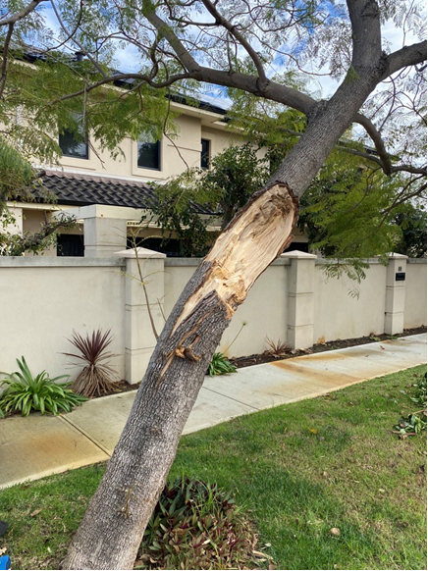
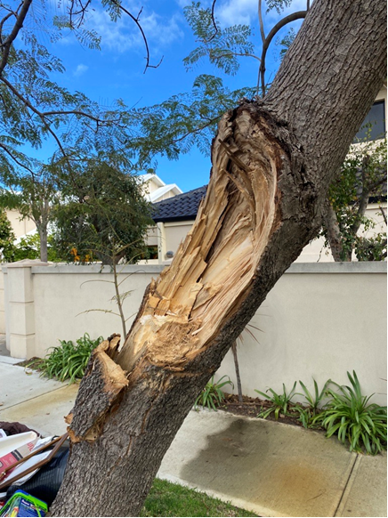
Figure1: Damage to leader is evident Figure 2: Damage point demonstrating loss of
cross section and resultant structural integrity

The main leader (trunk) at the point of damage has been significantly damaged (Figure 1).
As a result of the significant loss of cross section, and the damage to the main leader (Figure 2), the prognosis for the tree is poor in the mid to long term. The tree now presents a hazard and increased risk of failure at the point of damage.

The Council Street Trees Policy does not allow officers to approve tree removals in these circumstances, as the tree is not dead or in decline.

Consultation

Nil

Strategic Implications

This item is strategically aligned to the City of Nedlands Council Plan 2023-33 vision and desired outcomes as follows:

Vision | Sustainable and responsible for a bright future

Pillar | Planet
Outcome | 4. Healthy and sustainable ecosystems.

Pillar | Performance
Outcome | 11. Effective leadership and governance.

Budget/Financial Implications

This tree is of a suitable size to be removed by the internal arboriculture team. Stump grinding would be in the region of $500.

Legislative and Policy Implications

The Council Street Trees Policy requires Council authorisation for removal.

Decision Implications

Should Council not endorse the removal the City will retain liability.

Conclusion

That Council should support the removal of one Jacaranda mimisifolia due to it presenting an unacceptable hazard.

Further Information

Question from Councillor Bennett

Could the recommendation include a new tree to be planted in place of the removed tree?

Officer Response

Yes. Given there is ever limited locations for planting opportunities in a build out locality, City officers add sites which were subject to tree removal directly onto future planting location lists as a matter of process. While this may not always occur in the same calendar year/ planting season depending on the date of the removal, they are prioritised for planting as soon as possible with a suitable new species in accordance with the latest policy.

The Officers have chosen to amend their original recommendation to remove any doubt, by adding the words “…and programs the planting of a suitable replacement tree in forthcoming planting season.”

TS23.06.2024 Removal of Hazardous Tree – 2A Tyrell Street, Nedlands

Meeting & Date | Council Meeting – 23rd July 2024
Applicant | City of Nedlands
Employee Disclosure under section 5.70 Local Government Act 1995 | Nil.
Report Author | Jac Scott, Manager Urban Landscape and Conservation
Director | Matthew MacPherson, Director Technical Services
Attachments | Nil

Purpose

A verge tree at 2A Tyrell Street, Nedlands dropped a significant branch on or around 5th June 2024 and has since been confirmed to be breaching statutory clearances. The tree is proposed for removal due to presenting a hazard to large vehicles and subsequent potential for ongoing branch drop following physical damage.

Approval of a tree of this size for removal is no longer an administrative decision following a Notice of Motion passed at the Ordinary Council Meeting held on 28th November 2023, further confirmed in the Street Trees Council Policy update approved at the Ordinary Council Meeting on 23rd April 2024.

Recommendation

That Council approves the removal and subsequent stump grinding of a Eucalyptus nicholii (Narrow-Leaved Black Peppermint) from the verge of 2A Tyrell Street due to it presenting a hazard and breaching statutory clearance zones.

Voting Requirement

Simple Majority.

Background

The current Street Tree policy, approved at the April 2024 Council Meeting, requires:
“Any verge tree above 5 metres in height which is not dead, diseased or dying must be presented to Council for decision.”

Discussion

The Eucalyptus nicolii, Asset ID 9715, located on the verge of 2A Tyrell Street dropped a large limb on or around 5th June 2024. The tree impinges on the statutory clearance zones and has evidently been struck multiple times by vehicles. The branch failure point on this occasion was too high to have been likely to be as a direct result of these impacts, though may have been a result of related deleterious impacts. Despite having been struck several times, and the loss of the significant branch, the tree appears to remain in good health.
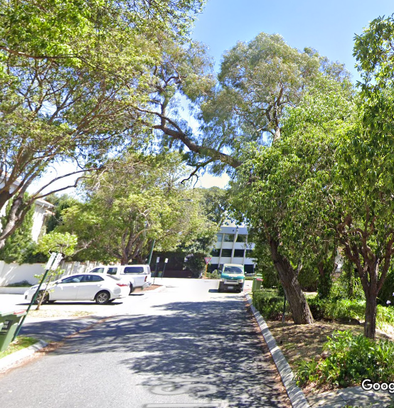  Figure 3: Historic view of the roadway (Google Street View) with the lean, and resultant impingement of statutory clearance zones, evident. | 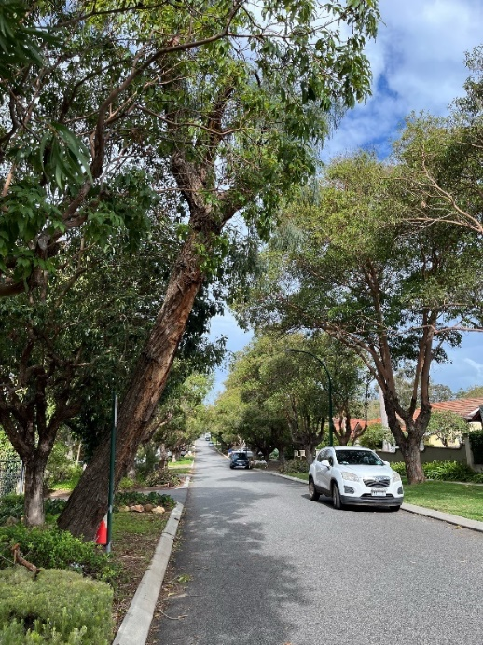  Figure 4: Tree following branch loss, showing the continued impingement of the roadway | 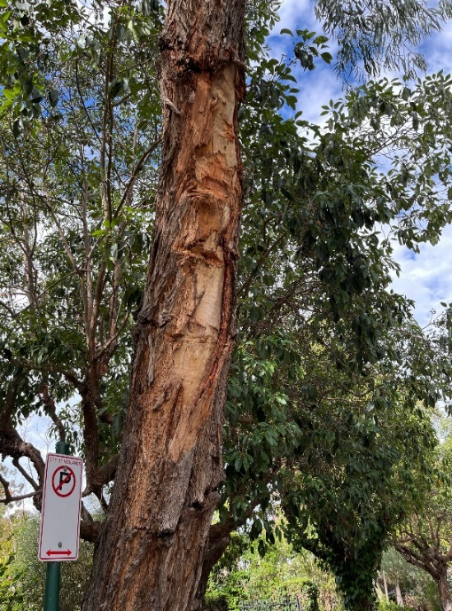  Figure 5: Evidence of ongoing damage to the leader resulting from multiple vehicular impacts

The main leader (trunk), as well as the first order branch that subsequently fell, exhibit(ed) a pronounced “lean” into and over the roadway (Figure 1) that impinged on the statutory clearance zone. This requires a vertical clearance of 4.5m over carriageways used by cars and trucks and 2.4m over footpaths used by cyclists and pedestrians. This lean appears to be photo-tropic in nature, as the tree seeks light away from the adjacent tree canopy. The tree is not planted on the planting line, hence being limited in clear growing space, and is potentially privately planted or self-sown.

This main leader continues to contravene the required clearance of 4m above the roadway by approximately 2m at the kerbline, with impingement of statutory clearance areas reducing as the tree continues into the roadway (Figure 2).

It is expected that the tree will continue to receive vehicular damage (Figure 3). Given the continuing impingement on statutory clearances, it is incumbent on the City to remove the tree. Given the limited space on the verge to appropriately accommodate a replacement it is not recommended to plant a replacement, give the likelihood of continuing phototropic growth of any replacement tree into the statutory clearance zone.

The Council Street Trees Policy does not allow officers to approve tree removals in these circumstances, as the tree is not dead or in decline.

Consultation

Nil

Strategic Implications

This item is strategically aligned to the City of Nedlands Council Plan 2023-33 vision and desired outcomes as follows:

Vision | Sustainable and responsible for a bright future

Pillar | Planet
Outcome | 4. Healthy and sustainable ecosystems.

Pillar | Performance
Outcome | 11. Effective leadership and governance.

Budget/Financial Implications

Tree Removal costs are generally in the region of $2000-$4000.

Legislative and Policy Implications

The Council Street Trees Policy requires Council authorisation for removal. The tree is impinging into statutory clearance zones that are required to be kept clear of vegetation.

Decision Implications

Should Council not endorse the removal the tree will remain and continue to impinge on statutory clearance requirements. The City will retain liability.

Conclusion

That Council should support the removal of one Eucalyptus nicholii due to it presenting a hazard and breaching statutory clearance zones.

Further Information

Question from Councillor Bennett

Requested further potential options to retain the tree.

Officer Response

The tree, whilst still alive has been compromised by the damage to date, although still remains in good health.

Although the damage has seemingly occurred over the last few years, data extracted from information on the City’s system shows the last formal tree asset inspection was dated 17/05/2012 (photo below),
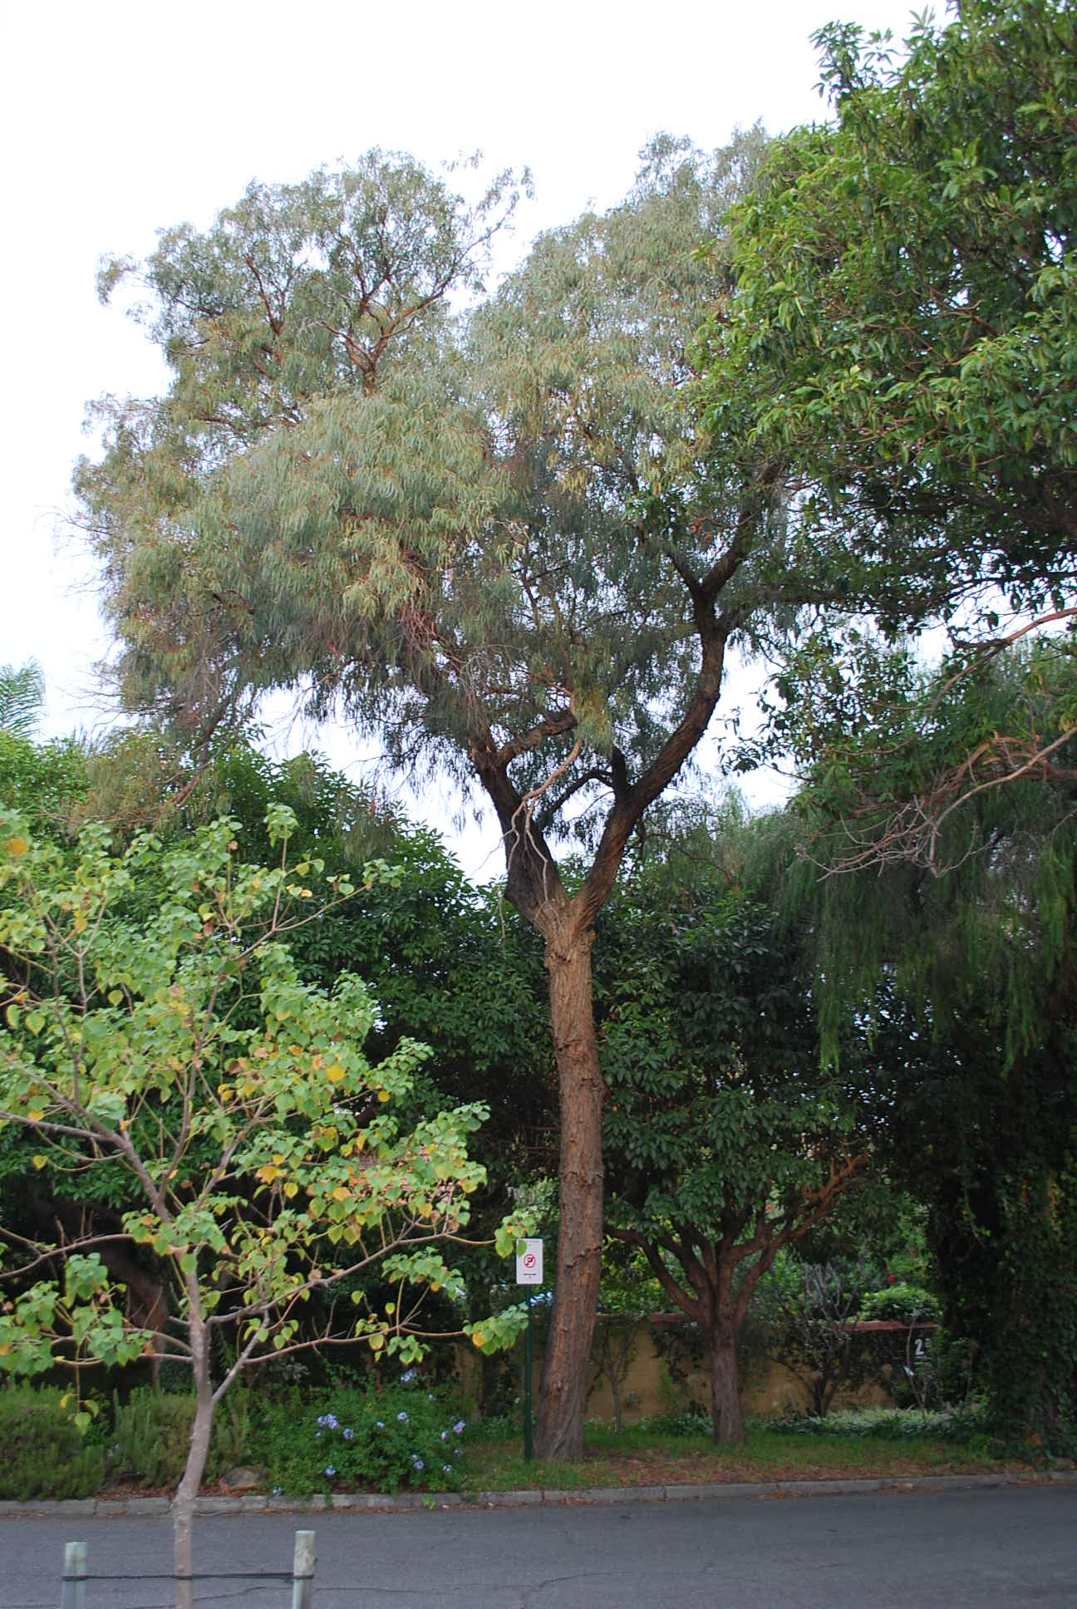
Around the same time, it was identified as a high-risk tree, even before damage due to the proximity to the road carriageway, and it has been fortunate that damage had not occurred previously. Whilst its condition at the time was deemed ‘excellent’ its growth was then identified as average, and has not looked to significantly increase over the past twenty years and from pictures looks to have had the canopy coverage decline.

To retain the tree, increased separation between the tree and vehicles is required. Given the tree location is fixed – the roadway would need to be re-configured to laterally shift the vehicles, either by narrowing the carriage way, installing a chicane, or installation of some other form of physical deflection may be required.

It is unlikely that line marking will be an acceptable option to minimise the risk of conflict, nor unlikely to be approved by Main Roads Western Australia as the statutory body. Other minimalistic treatments such as informal delineation may expose the city from a liability perspective in future by not acting sufficiently to deal with the known risk.

To aid the Council in their decision, a high-level opinion of probable costs is presented below to install a ‘squeeze point’ consisting of an elongated kerb protrusion / knib in that proximity to narrow the road to the bare minimum width. Due to the approach and departure, a transition will be required along the roadway.

This has not been designed or scoped and may vary – requiring further investigation to be confident.

The City would compare the price to retain this tree given its risk against the value of planting new trees in the vicinity which may achieve an overall net increase in canopy where it is needed elsewhere in the City, where risk to the public can be minimised.

In terms of equivalent value of new trees, the estimated direct cost of works would afford the planting and standard maintenance of approximately 15 large trees.

Council may wish to consider:
- to retain the tree, accepting the risk.
- Remove the tree as per the officer recommendation.
- A request to the CEO to investigate and scope a potential capital project to make modifications to the kerb line in an effort to retain the tree for Council consideration.

Divisional Reports – Community Services & Development

CSD04.07.24 Acquisition of Tim Macfarlane Reid Sculpture

Meeting & Date | Council Meeting – 23 July 2024
Applicant | City of Nedlands
Employee Disclosure under section 5.70 Local Government Act 1995 | Employee disclosure required where there is an interest in any matter of which the employee is providing advice or a report.
Report Author | Amanda Cronin – Coordinator Community Development
Director/CEO | Keri Shannon – Chief Executive Officer
Attachments | Attach only documents that have been referred to in the report.  - Image Sheet  - Location options

Purpose

For Council to consider the lease or purchase of the Tim Macfarlane Reid Sculpture, ‘Mantle’, for the Norn Bidi trail.

Recommendation

That Council:
- approves an amount of $65,700 for consideration in the 2024/2025 draft budget process to facilitate the purchase of ‘Mantle’ by Tim Macfarlane Reid; and
- approves installation of ‘Mantle’ at Swanbourne Beach Reserve pending budget allocation.

Voting Requirement

Simple Majority.

Background

Following a notice of motion from Mayor Fiona Argyle, Council resolved at its Ordinary Meeting on 27 February 2024 as follows:
“That Council requested the Acting CEO to investigate the lease, and purchase of the Tim Macfarlane Reid Sculpture for the Norn Bidi trail and report back to Council”.

This report has been prepared in response to the notice of motion.
Discussion

“Mantle” is an artwork by West Australian artist Tim Macfarlane Reid who works from his art practice in Fremantle. He has been a full time sculptor for the past 17 years, with five solo exhibitions and numerous group exhibitions. The artwork is an exploration of unforeseen forces beneath the earths surface. Slowly undulating physical forces move and shift, impacting the landscape we experience. See image at Attachment 1.

The artwork is available for purchase for $65,700 (ex GST) including interstate freight, local delivery and installation, footings and signage costs. Alternatively, the artwork is available on a 3-year lease for $46,824 (ex GST) including interstate freight, local delivery and installation, /deinstallation, footings and signage costs. The purchase option represents better value for money. As the artowork is aliminium, it is completely suitable for outdoor display and there is no upkeep other than to keep it clean, as with any outdoor sculpture.

The Sculptures by the Sea team have suggested Swanbourne Beach Reserve as a possible location for installing the artwork, rather than the Norn Bidi trail. A location at Swanbourne Beach Reserve would compliment the artwork and achieve more visibility. An overview of site options can be seen at Attachment 2.

Consultation

No consultation has taken place. This has not been considered by the City’s Arts committee.

Strategic Implications

This item is strategically aligned to the City of Nedlands Council Plan 2023-33 vision and desired outcomes as follows:

Vision | Sustainable and responsible for a bright future

Pillar | People
Outcome | 1. Art, culture and heritage are valued and celebrated.

Pillar | Place
Outcome | 7. Attractive and welcoming places.

Budget/Financial Implications

Table 1: Lease – v – Purchase Cost Comparison

 | 3 year Lease  (ex GST) | Purchase  (ex GST)
Sale Price | - | $58,500
Annual Artist Lease Fee | $15,000 | N/A
Annual Artist Agent Fee | $9,000 | N/A
Annual Marketing and Management Fee | $9,000 | N/A
Shipping (NSW – WA) | $5,400 | $5,400
Local delivery & installation | $3,312 | Inc sale price
Footings/Engineering | $1,000 | $1,000
Signage | $800 | $800
Deinstallation & return local delivery | $3,312 | N/A
Return freight | N/A | N/A
 | $46,824 | $65,700

A cost comparison is available at Table 1, which details the total estimated costs around the acquisition of ‘Mantle’. The City’s public art reserve currently has a balance of $45,461 available for expenditure. This leaves a shortfall in funding which is detailed in Table 2. Further funding would need to be considered as part of the 2024/2025 budget deliberations for either option.

Table 2: Budget Information

 | Lease | Purchase
Available funds | $45,461 | $45,461
Less proposed expenditure | $46,824 | $65,700
Funding shortfall | ($1,363) | ($20,239)

Legislative and Policy Implications

Public Art Policy

Decision Implications

If Council endorses the recommendation, Council can consider budget allocation for the acquisition of ‘Mantle’ through the 2024/2025 draft budget process.

If Council doesn’t endorse the recommendation or pursues an alternative option, the City may miss out on the acquisition of ‘Mantle’.

Conclusion

It is recommended Council consider purchasing ‘Mantle’ and allocating funding through the 2024/2025 draft budget process. The sculpture represents good value for money being unsold following the 2023 Sculptures by the Sea exhibition. Further artworks will become available following the 2024 Sculptures by the Sea exhibition. However, acquisition of these, is less likely to achieve such value for money.

Further Information

Question from Councillor Smyth
Can there be an explanation of the $5,400 for shipping (NSW-WA) was this is the original cost scope?

Officer Response

Yes, this was the original as the artwork is currently in New South Wales.

Question from Councillor Smyth

Has Mayor Argyle the mover of the original NoM been made aware of the proposed change of location from Central Allen Park (Norn Bidi) to Beach front BBQ park?

Officer Response

Mayor Argyle hasn’t been contacted specifically; however all information has been included in the report to agenda forum and the agenda for the upcoming council meeting.

Divisional Reports - Corporate Services

CPS32.07.24 LGIS Annual Insurance Renewal 2024-25

Meeting & Date | Council Meeting – 23 July 2024
Applicant | City of Nedlands
Employee Disclosure under section 5.70 Local Government Act 1995 | Employee disclosure required where there is an interest in any matter of which the employee is providing advice or a report.
Report Author | Michael Cole Director Corporate Services
CEO | Keri Shannon
Attachments | - Confidential Attachment - LGISWA Scheme Membership Renewals 2024-25

Purpose

The purpose of this report is for Council to note the renewal of insurances through LGISWA for the 2024/25 financial year.

Recommendation

That Council notes the renewal of insurances as per the attachment - LGISWA Scheme Renewals 2024/25.

Voting Requirement

Simple Majority.

Background

The City has sought renewal of insurance cover for the 2024-25 financial year through LGISWA. Insurance cover limits any financial loss due to loss or damage to property and other assets. Cover is provided for public liability, professional indemnity and workers' compensation.

Discussion
In the attached summary, the total cost of renewal of insurance for the City is $669,794.40. This is an overall decrease of $13,632.71 on the total cost of insurance premiums for 2023/24.
While there has been a significant increase (6%) in LGIS Liability and (10%) in LGIS Management Liability, this increase cost has been offset by an overall reduction in LGIS Property cover. LGIS Property cover increased by 2.5% but there has been a reduction due to an overall decrease in the insured value of assets.

LGIS have provided the following comments in relation to LGIS Liability, LGIS Property and LGIS Management Liability.

“LGIS Liability
Capacity has come under pressure with several reinsurance partners looking to reduce their exposures. LGIS’ long-term and strong relationships across the market have allowed us to negotiate positive terms and find new partners for the Liability portfolio.”

“LGIS Property
Despite moving through a relatively positive bushfire and cyclone season, claims costs were still up on average due to ongoing inflationary pressure and supply chain bottlenecks.”

“LGIS Management Liability
It’s taken a few years, but we are now seeing the impact of work, health and safety (WHS) legislative changes. Notifications to WorkSafe WA have increased and the corresponding potential for investigation. There are several significant matters that will fall within the new legislation and will develop in the years ahead, as investigations conclude and decisions to prosecute are made.”

A summary comparing from 2023/24 to 2024/25 is as follows:

Scheme Fund | 2023/24 (Inc GST) | 2024/25 (Inc GST) | Comments
LGIS Liability | $235,821.17 | $249,970.60 | 6% increase applied across the sector
LGIS Commercial Crime and Cyber Liability * increased to $2m | $22,957.78 | $26,328 | Rollover rate negotiated.
LGIS Management Liability | $35,798.55 | $39,592.30 | 10% increase
LGIS Property | $152,637.60 | $120,106.80 | Minor rate increase of 2.5%. Overall reduction due to decrease in assets
LGIS M/V Fleet | $52,554.70 | $53,289.50 | Rollover rate
LGIS Workcare | $181,209.60 | $181,209.60 | Rollover rate
LGIS Corporate Travel | $939.51 | $1,024.10 | Minor increase
LGIS Volunteer Workers | $1,508.20 | $1,643.40 | Minor Increase
Total | $683,427.11 | $673,164.30
Consultation

Nil.

Strategic Implications

This item is strategically aligned to the City of Nedlands Council Plan 2023-33 vision and desired outcomes as follows:

Vision | Sustainable and responsible for a bright future
Pillar | Performance
Outcome | ​​11. Effective leadership and governance.​

Budget/Financial Implications

The overall cost to renew insurance cover for 2024/25 financial year will be included in the draft 2024/25 Annual Budget.

By way of comparison, the total premiums for 2024/25 are $669,794.40 (Inc GST) whereas the total premiums for 2023/24 were $683,427.11 (Inc GST).

Further Information

Question from Councillor Smyth
“Cover is also required for public liability, professional indemnity and workers' compensation.”

Can the wording be corrected to confirm that the items are covered in the renewal?

CPS33.07.24 Monthly Financial Report – June 2024

Meeting & Date | Council Meeting – 23 July 2024
Applicant | City of Nedlands
Employee Disclosure under section 5.70 Local Government Act 1995 | Nil.
Report Author | Bonnie Durham – Acting Manager Financial Services
Director | Lauren Fitzgerald – Acting Director Corporate Services
Attachments | - Statement of Financial Activity – 30 June 2024  - Statement of Net Current Assets – 30 June 2024  - Statement of Comprehensive Income – 30 June 2024  - Statement of Financial Position – 30 June 2024  - Reserve Movements – 30 June 2024  - Borrowings – 30 June 2024  - Capital Works Program – 30 June 2024

Purpose

Administration is required to provide Council with a monthly financial report in accordance with regulation 34(1) of the Local Government (Financial Management) Regulations 1996. The monthly financial variance from the budget of each business unit is reviewed with the respective manager and the Executive to identify the need for any remedial action. Material variances are highlighted to Council in the attached Monthly Financial Report.

Recommendation

That Council receive the Monthly Financial Report for 30 June 2024.

Voting Requirement

Simple Majority.

Background

Nil.

Discussion

The monthly financial management report meets the requirements of regulation 34(1), 34(3), and 34(5) of the Local Government (Financial Management) Regulations 1996.
The attached report shows the month end position as at the end of June 2024. Please note that the closing position is a preliminary result for the year ended 30 June 2024 as the Financial Statements for 2023-24 are still being finalised and as a result will be subject to change and that due to the Disclaimer of Opinion issued for the 2022-23 Annual Financial Statements, the opening position is subject to change as restatements of the prior financial year are completed. The municipal closing surplus as of 30 June 2024 is $3,255,263 which is a $3,255,263 favourable variance, compared to a budgeted surplus for the same period of $0.

The operating revenue at the end of June 2024 was $11,492,540 which represents a $487,415 favourable variance compared to the year-to-date budget of $11,005,125 primarily in Operating Grants which is offset by Other Revenue.

The operating expense at the end of June 2024 was $41,215,264 which represents a ($949,422) unfavourable variance compared to the year-to-date budget of $40,265,842 primarily in Depreciation.

As depreciation is a non-cash item, it is then removed from the surplus calculation, which results in a favourable variance of $1,360,474 for total operating activities.

The attached Statement of Financial Activity compares Actuals with Amended Budget by Nature or Type as per regulation 34 (3) of the Local Government Financial Management Regulations 1996. Material variances, as defined by a previous decision of Council, from the budget of revenue and expenditure are detailed below.

Operating Activities

Operating grants, subsidies, and contributions
Favourable variance of $856,233 primary due to advanced payment of 2024-25 Financial Assistance Grant.

Fees and charges
No variance analysis required as variance to budget is less than 10%.

Service charges
No variance analysis required as variance to budget is less than $20,000.

Interest earnings
No variance analysis required as variance to budget is less than 10%.

Other revenue
Unfavourable variance of $322,156 primarily due to lower than budget other sundry revenue received across the organisation.

Profit on disposal of assets
Unfavourable variance of $73,761 due to pending disposal of assets to be processed in the asset accounting book. To be completed as part of year end processing, once asset balances are restated for the 2022-23 financial year.

Employee costs
No variance analysis required as variance to budget is less than 10%.

Materials and contracts
No variance analysis required as variance to budget is less than 10%.

Utility charges
Unfavourable variance of $126,321 due to increased electricity costs.

Depreciation and amortisation
Unfavourable variance of $1,3,45,450 due to budget being based on asset values prior to the 2022-23 infrastructure asset revaluation being finalised.

Insurance expenses
Favourable variance of $79,620 due to budget being based on an estimate prior to the insurance premiums being confirmed.

Interest expenses
Favourable variance of $24,077 due to year end interest expenses for leases yet to be processed. To be completed once liability balances are restated for the 2022-23 financial year.

Other expenditure
Unfavourable variance of $272,604 due to allocation of contributions and subsidies.

Loss on disposal of assets
No variance analysis required as variance to budget is less than $20,000 and 10%.

Investing Activities

Non-operating grants, subsidies, and contributions
Unfavourable variance of $445,904 primarily due to funding for the Vincent Street Safety Upgrades being returned.

Proceeds from disposal of assets
Unfavourable variance of $184,487 due to plant and fleet items not being sold prior to 30 June as anticipated.

Purchase of property, plant, and equipment
Favourable variance of $1,140,700 overhead allocations yet to be applied being finalisation of accrued expenditure, and delay in plant and fleet item replacements.

Purchase and construction of infrastructure
Favourable variance of $2,596,856 primarily due to overhead allocations yet to be applied being finalisation of accrued expenditure, withdrawal of the Vincent Street Safety Upgrades project, and saving in the Lemnos Street Road Renewal project.

Purchase of right of use assets
Favourable variance of $500,061 due to recognition of new right of use assets being delayed until the completion of the asset balances for the 2022-23 financial year.

Payments for intangible assets
Favourable variance of $1,002,849 due to the different accounting treatment in the actuals to budgeted, following audit decision for the 2022-23 financial year.

Financing Activities

Repayment of borrowings
No variance analysis required as variance to budget is less than $20,000 and 10%.

Recoup from self-supporting loans
No variance analysis required as variance to budget is less than $20,000 and 10%.

Payment for principal portion of lease liability
Favourable variance of $216,912 due to new right of use assets being delayed until the completion of the asset balances for the 2022-23 financial year

Transfer to reserves
Favourable variance of $1,563,044 due to timing of transfers being processed. To be done once all accrued revenue and expenditure is recognised.

Transfer from reserves
Unfavourable variance of $3,170,658 due to timing of transfers being processed. To be done once all accrued revenue and expenditure is recognised.

Rates
No variance analysis required as variance to budget is less than 10%.

Outstanding rates debtors are $463,662 as of 30 June 2024 compared to $595,144 as of 30 June 2023. Breakdown as follows:

Receivable | 30 June 2024 ($) | 30 June 2023 ($) | Variance ($)
Rates & UGP | $309,617 | $493,382 | ($183,795)
Rubbish & Pool | $74,585 | $38,554 | $36,031
Pensioner Rebates | $19,266 | $31,027 | ($11,761)
ESL | $60,194 | $32,180 | $28,014
Total | $463,662 | $595,144 | ($131,481)

Employee Data

Description | Number
Budgeted FTE (1July 2023) | 165
Budgeted FTE (30 June 2024) | 162
Headcount (Active Employees including FT, PT, & Casual) | 162
Occupied FTE (FT & PT) | 141
Occupied FTE (Casual) | 3
No. of contract employees (Temporary/Agency) | 7

The figures reported are as at the end of the calendar month of June 2024.

Consultation

N/A

Strategic Implications

This item relates to the following elements from the City’s Council Plan.

Vision Sustainable and responsible for a bright future

Pillar Performance
Outcome 11. Effective leadership and governance

Budget/Financial Implications

At the Special Council Meeting on 11 August 2022, item CPS36.08.22, Council adopted the following thresholds for the reporting of material financial variances in the monthly statement of financial activity reports:

a. Operating items – Greater than 10% and a value greater than $20,000
b. Capital items – Greater than 10% and a value greater than $50,000

pursuant to regulation 34(5) of the Local Government (Financial Management) Regulations 1996, and Australian Accountings Standard AASB 1031 Materiality.

Legislative and Policy Implications

Local Government Act 1995, Local Government (Financial Management) Regulations 1996, and Australian Accounting Standards.

Decision Implications

Nil.

Conclusion

The municipal surplus as of 30 June 2024 is $3,255,263 which is favourable, compared to a budgeted surplus for the same period of $0.

The operating revenue at the end of June 2024 was $11,492,540 which represents a $487,415 or 4.43% favourable variance compared to the year-to-date budget of $11,005,125 primarily in Operating Grants offset by Other Revenue.

The operating expense at the end of June 2024 was $41,215,264, which represents a ($949,422) or -2.36% unfavourable variance compared to the year-to-date budget of $40,265,842, primarily in Depreciation.

Further Information

Nil.

CPS34.07.24 - Monthly Investment Report - June 2024

Meeting & Date | Council Meeting – 23 July 2024
Applicant | City of Nedlands
Employee Disclosure under section 5.70 Local Government Act 1995 | Nil.
Report Author | Bonnie Durham – Acting Manager Financial Services
Director | Lauren Fitzgerald – Acting Director Corporate Services
Attachments | - Investment Report for the period ended 30 June 2024

Purpose

In accordance with the Council’s Investment Policy, Administration is required to present a summary of investments to Council monthly.

Recommendation

That Council receive the Investment Report for the period ended 30 June 2024.

Voting Requirement

Simple Majority.

Background

Nil.

Discussion

Council’s Investment of Funds report meets the requirements of Section 6.14 of the Local Government Act 1995.

The Investment Policy is structured to minimise any risks associated with the City’s cash investments. The officers adhere to this Policy, and continuously monitor market conditions to ensure that the City obtains attractive and optimum yields without compromising on risk management.

The Investment Summary shows that as of 30 June 2023 and 30 June 2024 the City held the following funds in investments:

Funds | 30 June 24 ($) | 30 June 23 ($)
Municipal | 3,167,808 | 909,548
Reserve | 7,959,558 | 5,096,418
Total Investments | 11,127,396 | 14,186,966

The total interest earned from investments as of 30 June 2024 was $500,333, comprising of $436,135 received at maturity and $64,198 accrued.

The Investment Portfolio comprises holdings in the following institutions:

Financial Institution | Funds Invested | Proportion of Portfolio
NAB | $3,753,648 | 34%
WBC | $4,319,151 | 38%
ANZ | $1,181,352 | 11%
CBA | $1,873,244 | 17%
Total | $11,127,396 | 100.00%

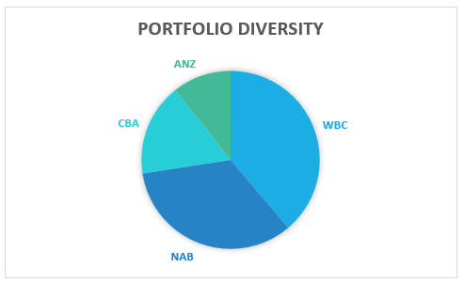

Consultation

N/A

Strategic Implications

This item relates to the following elements from the City’s Council Plan 2023 -33.

Vision | Sustainable and responsible for a bright future

Pillar | Performance
Outcome | 11. Effective leadership and governance.

Budget/Financial Implications

The June 2024 YTD Actual interest income from investments is $500,333 compared to the June 2023 YTD Budget of $472,050.

Legislative and Policy Implications

City of Nedlands - Investment of Operating Cash Policy

Decision Implications

N/A

Conclusion

The Investment Report is presented to Council.

Further Information

N/A

CPS35.07.24 - List of Accounts Paid - June 2024

Meeting & Date | Council Meeting – 23 July 2024
Applicant | City of Nedlands
Employee Disclosure under section 5.70 Local Government Act 1995 | Nil.
Report Author | Bonnie Durham – Acting Manager Financial Services
Director | Lauren Fitzgerald – Acting Director Corporate Services
Attachments | - Creditor Payment Listing – June 2024  - Credit Card and Purchasing Card Payments – June 2024  - Fuel Card Payments – June 2024

Purpose

The purpose of this report is to present list of accounts paid for the month of June 2024.

Recommendation

That Council receives the List of Accounts Paid for the month of June 2024.

Voting Requirement

Simple Majority.

Background

Regulation 13 of the Local Government (Financial Management) Regulations 1996 requires a list of accounts paid to be prepared each month, showing each account paid since the last list was prepared. This list is to include the following information:

- the payee’s name;
- the amount of the payment:
- the date of the payment; and
- sufficient information to identify the transaction.

Discussion

The accounts payable procedures ensure that risk is managed, and no fraudulent payments are made by the city, and these procedures are strictly adhered to by the officers. These include the final vetting of approved invoices by the Coordinator Revenue and the Manager Financial Services (or designated alternative officers).

Consultation

Nil.

Strategic Implications

This item relates to the following elements from the City’s Council Plan 2023-33.

Vision | Sustainable and responsible for a bright future

Pillar | Performance
Outcome | 11. Effective leadership and governance.

Budget/Financial Implications

The payments are made in accordance with the approved budget.

Legislative and Policy Implications

In accordance with regulation 13 of the Local Government (Financial Management) Regulations 1996 administration is required to present the List of Accounts Paid for the month of June 2023 to Council.

Decision Implications

Nil.

Conclusion

The List of Accounts Paid for the months of June 2024 complies with the relevant legislation and can be received by Council (see attachments).

Further Information

Nil.

Reports by the Chief Executive Officer

CEO22.07.24 Proposed Establishment of Policy and Legislation Committee
Meeting & Date | Council Meeting – 23 July 2024
Applicant | City of Nedlands
Employee Disclosure under section 5.70 Local Government Act 1995 | Nil.
Report Author | Keri Shannon – Chief Executive Officer
CEO | Keri Shannon – Chief Executive Officer
Attachments | - Terms of Reference Policy and Legislation Committee

Purpose

It is recommended that the City establish a Policy, Delegation and Legislation Committee to deal with the formulation of policy, delegations and legislation.

Recommendation

That Council approves by an absolute majority -

1. Pursuant to section 5.8 and 5.9(2)(b) of the Local Government Act 1995 to
ESTABLISH a ‘City of Nedlands Policy and Legislation Committee’ to support Council in fulfilling its responsibility under section 2.7(2)(b) of the Local Government Act 1995, and to assist the Council in considering the Register of Delegations and in carrying out its legislative functions to manage local laws.
2. To ADOPT the Terms of Reference for the Policy and Legislation Committee as contained in Attachment 1.
3. Appoints the Mayor and four (4) Councillors (insert names) (one Councillor from each ward) to the City of Nedlands Policy and Legislation Committee for the period ending immediately prior to the next Local Government elections in 2025.
4. Appoints the Deputy Mayor and four (4) Councillors (insert names) (one Councillor from each ward) as Deputy Members of the Committee

Voting Requirement

Absolute Majority.

Background

Under s. 2.7 of the Local Government Act 1995 the Role of Council is defined as:

2.7 (1) The council:
- governs the local government’s affairs; and
- is responsible for the performance of the local government’s functions.

(2) without limiting subsection (1), the council is to –
(a) oversee the allocation of the local government’s finances and resources; and
(b) determine the local government’s policies.

A Policy and Legislation Committee will deal with the formulation of policy, review delegations and subsidiary legislation.

Discussion

The establishment of the Committee is consistent with the City’s focus on its strategic governance role. A Policy and Legislative Committee will provide valuable support and assistance to the Council in fulfilling its responsibility under section 2.7(2)(b) under the Local Government Act 1995.

In order to accommodate the proposed Committee, it is suggested the Agenda Briefing Forums be moved to the third Monday of the month commencing at 6:00pm and the Audit and Risk Committee be moved to the third Tuesday of the month. The Governance Framework will need to be amended to reflect these changes and should Council establish the Committee and agree to the proposed changes to the meeting cycle, the Framework will be brought to the August Ordinary Council Meeting for adoption.

Consultation

Not applicable.

Strategic Implications

This item is strategically aligned to the City of Nedlands Council Plan 2023-33 vision and desired outcomes as follows:

Vision Sustainable and responsible for a bright future

Pillar Performance
Outcome 11. Effective leadership and governance

Budget/Financial Implications

There are no budget or financial implications in this report.

Legislative and Policy Implications

Local Government Act 1995.
City of Nedlands Governance Framework.

Decision Implications

The establishment of the proposed Committee will provide a forum for Council to deal with the formulation of policy and the review of statutory delegations and subsidiary legislation in an efficient manner. Should Council not adopt the Committee, the current system of tabling new or significantly amended policies to a Concept Forum will continue. It is noted that the Concept Forum is not the most effective forum to deal with policies and legislation as it does not allow for in-depth consideration and discussion by Council and may lead to delay in policy progression.

Conclusion

It is recommended that Council establish the Committee.

Further Information

Question from Councillor Hodsdon

Could the committee include all councillors instead of 4 councillors as we do in the Audit Committee so that everybody’s contribution is heard?

Officer Response

The primary purpose of a committee is to provide more detailed consideration and insight to the formulation of the policy and legislation, in order to ensure the council make the most well-informed decisions. A committee of 4 councillors will be more agile and more able to undertake detailed consideration and development of policy and legislation.

Questions from Councillor Smyth

Could consideration be given to this option please?
Tuesday Week 1 – Concept Forum / briefings/ workshops 6pm
Tuesday Week 2 – Agenda Forum 7pm
Monday Week 3 – Audit Committee 6pm
Tuesday Week 3 – Policy Committee 6pm
Tuesday Week 4 – OCM & (Wed week 4 for re-convenement after 11pm adjournment) 7pm

Officer Response

There would be insufficient time to get the Policy and Legislation committee reports to the OCM Agenda. The administration suggest swapping the Agenda Forum to Tuesday Week 3 with the Policy and Legislation Committee on Tuesday Week 2.

20.2 CEO23.07.24 Workforce Agreements
Meeting & Date | Council Meeting – 23 July 2024
Applicant | City of Nedlands
Employee Disclosure under section 5.70 Local Government Act 1995 | No officer involved in the preparation of this report has a declarable interest.
Report Author | Keri Shannon – Chief Executive Officer
Director/CEO | Keri Shannon – Chief Executive Officer
Attachments | - City of Nedlands Outside Workforce Agreement 2023 dated 14 February 2024;  - City of Nedlands Inside Workers Industrial Agreement 2023 dated 8 March 2024.

Purpose

To advise the Council regarding the registration of Enterprise Bargaining Agreements (EBAs) for the City of Nedlands Outside Workforce Agreement 2023 and City of Nedlands Inside Workers Industrial Agreement 2023.

Recommendation

That Council receives the City of Nedlands Outside Workforce Agreement 2023 dated 14 February 2024 and City of Nedlands Inside Workers Industrial Agreement 2023 dated 8 March 2024.

Voting Requirement

Simple Majority.

Background

The City initially commenced EBA discussions in 2022 however the WA state government decided as of 1 January 2023 all WA local governments were to be covered by the state industrial relations system. Local government employers previously operating under the national Fair Work Act 2009 transferred to the state system on this date.

Discussion

The negotiation meetings for both the inside and outside workforce agreements took place between June 2023 and 20 October 2023. The proposed agreements were not brought before the council for approval despite the financial impact of the agreements.

The final agreements were agreed and signed on 21 December 2023 by the Director of Corporate Services. The Director of Corporate Services had a delegation up to a threshold of $100,000. The CEO had a delegation up to a threshold of $249,999. The City’s Approvals: Internal staffing matters provided that EBA sign off should be approved by the CEO. The Acting CEO on 21 December 2023 did not sign the agreements.

Under the City’s Procurement of Goods and Services Policy all requests for tender RFT and contracts over $250,000 must be brought to Council for approval. It is submitted that in accordance with these governance protocols the Workforce Agreements should have been brought to Council for endorsement.

The agreements were lodged with the Commission for approval. The agreements were not registered with the WA Industrial Relations Commission until 14 February 2024 and 8 March 2024 which means the financial impact was not budgeted in the 2023/24 budget.

The agreements provided for pay increases as follows:

 | 2023/24 | 2024/25 | 2025/26
Pay increase | 5% | 3.5% or CPI, whichever is higher | 3.5% or CPI, whichever is higher
Total Cash Salary increase | $621,795 | $457,019 | $473,015
Total Salary (incl super) increase | $752,372 | $574,865 | $597,351

The total salary impact of the salary pay increases are shown in the table above.

In 2022/23 the superannuation guarantee (SG) contribution was 10.5%. On 1 July 2024 the superannuation guarantee contribution increased from 11% to 11.5%. The superannuation guarantee rate is legislated to rise incrementally each year until it reaches 12% on 1 July 2025.

The total financial impact of the two workforce agreements was $1,551,831. The total financial impact of the workforce agreements plus the increases in superannuation guarantee from 11% to 12% will be $1,924,590 based on the current workforce over three (3) years.

Relevant legislation

Section 2.5 of the Local Government Act provides that the local government is a body corporate with perpetual succession and a common seal, and has the legal capacity of a natural person. Under section 2.6 of the Local Government Act each local government is to have an elected council as its governing body.

A decision of a council does not have effect unless it has been made by a simple majority. Decisions approving unbudgeted expenditure must be passed by an absolute majority. Section 5.43(ha) states that a local government cannot delegate to a CEO the power under section 9.49A(4) to authorise a person to sign documents on behalf of the local government.

The execution of the Workforce Agreements required a council resolution authorising the CEO and Mayor to sign the documents on behalf of the local government.

In order to ensure the proper governance policy is followed it is recommended:

- Preparation of Governance Statement

In order to ensure proper governance at the City and to protect the integrity of public funds the City administers, it is recommended that all organisations the City deals with on significant matters should be provided with a governance statement which outlines how the organisation is structured and how decisions will be made.
Governing documents outlining the rules and how the governing body will be operated and an extract of the legislation which sets out the manner in which the entity can enter into contracts and makes decisions should be provided to any entity undertaking dealings with the City. The statement should also require that the person signing the contract must have proven that it has the authority to do so.

- Training

Training on the use of the approval grid be provided to senior employees and executive regarding the requirement to ensure that documents are duly executed by the City.

- Advise WA Industrial Relation Commission

To ensure the legality of agreement lodged with the Commission it is advised that the CEO be requested to advice the WAIRC of the invalid authorisation of the Director who signed the agreements so that the Commission can provide advice regarding appropriate remediation actions.

Consultation

Nil.

Strategic Implications

This item is strategically aligned to the City of Nedlands Council Plan 2023-33 vision and desired outcomes as follows:

Vision | Sustainable and responsible for a bright future

Pillar | Performance
Outcome | ​​11. Effective leadership and governance.​

Budget/Financial Implications

The total financial impact of the two workforce agreements over the term of 3 years is $1,551,831. The total financial impact of the EBAs plus the increases in superannuation guarantee to 12% will be $1,924,590 based on the current workforce.

Legislative and Policy Implications

Local Government Act 1995.

Decision Implications

Nil

Conclusion

That the Council receives City of Nedlands Inside Workers Industrial Agreement 2023 and City of Nedlands Outside Workforce Agreement 2023 for noting.

Further Information

Questions from Councillor Smyth

Question 1

What are the options open to Council given the late receipt of this advice?
Can Council make recompense for the budget impact through any late adjustments to the forthcoming budget?

Question 2

Depending on the answer to Q1.
Can a Clause 2 be drafted that instructs the CEO to take measures (for example reserves for superannuation increases)? Or to test the validity of the WFA governance?

Officer Response
Before Relevant Legislation add the following :

Other agreed amendments to the terms and conditions of the Outside Workforce agreement included:

Clause 8 – Employment Categories
Incorporates entitlement to casual conversion where Employee in the previous 12 months has worked a pattern of hours.

Clause 11 – Redundancy
For Employees prior to registration of this Agreement, no change to previous provisions
For Employees engaged after registration of this Agreement, 52 weeks’ cap on redundancy pay

Clause 15 – Public Holidays
Easter Sunday is to be observed as a Public Holiday

Clause 23 – Superannuation
Whereas Employees had to contribute 5.0% under previous Agreement to receive additional 2.0% Employer contribution, this Agreement:
- Employees may contribute 1.0% to receive an additional 1.0% Employer contribution
- Employees may contribute 2.0% to receive an additional 2.0% Employer contribution
- Employees may contribute more than 2.0% to receive an additional 2.0% Employer contribution

Clause 25 - Christmas Leave
Employees not working between Christmas and New Year during shutdown, previously had to use leave (such as annual leave or leave without pay if insufficient leave accrued).

Employees on this Agreement will be credited with three (3) days paid Christmas Leave (pro-rata for part time employees) between Christmas and New Year.

If Employees work between Christmas and New Year, they may use the credited leave in the next 12 months.

Clause 26 – Personal Leave
Personal Leave (cumulative) equates to 10 days paid personal leave (pro rata) per annum.

Whereas Employees under the previous Agreement had to provide evidence of illness where 2 or more successive days of personal leave were taken or three non-consecutive days of personal leave, the following changes have been made:

- Employees on this Agreement to provide reasonable evidence of illness where three days as a block are taken for reason of personal leave, within a 12-month period, 5 single days within a 12-month without a medical certificate and 3 days as a block without a medical certificate in a 12-month period.
Clause 27 - Paid Family and Domestic Violence Leave
Whereas in the previous Agreement, Employees were entitled to use Personal Leave when experiencing family violence or needing to provide support to immediate family who was experiencing family violence, the clause in this Agreement provides 10 days per annum (non-cumulative) Paid Family and Domestic Violence Leave, as a separate provision.

Clause 31 – Parental Leave
Parental Leave reflects the provisions of the Minimum Conditions of Employment Act 1993 and the Fair Work Act 2009.

31.8 Paid Parental Leave
Eligible Employees will be paid City-funded 12 weeks paid parental leave (or 24 weeks’ half pay) – pro rata for part time staff.
*The previous Agreement provided City-funded 6 weeks paid parental leave (or 12 weeks at half pay) – pro rata for part time staff.

31.9 Paid Partner Leave
The City will pay 2 weeks paid leave to Employees who are non-primary carer partners (or 4 weeks half pay) to be taken within 12 months after the birth or adoption of a child – pro rata for part time staff.

Clause 32 – Joint Consultative Committee
A Joint Consultative Committee (JCC) between Management and Employees will be created with the purpose of Employee-Management communication and collaboration.

Clause 33 – Trade Union Training Leave
Two (2) Employees may apply to attend Trade Union Training for 5 days per financial year, such time to be paid for by the City.

Other agreed amendments to the terms and conditions of the Inside Workforce agreement included:

Clause 5 – Employment Categories
• Retains 25% casual loading on top of hourly rate for casual employees
• Incorporates entitlement to casual conversion where Employee in the previous 12 months has worked a pattern of hours.

Clause 11 – Redundancy
• Redundancy pay has been increased from the provision in the previous agreement where a maximum of 17 weeks’ pay where more than 10 years’ employee service - to 18 weeks’ pay plus 2 weeks’ pay for each year in excess of 10 years’ service, up to a maximum of 52 weeks’ pay.

Clause 12 – Public Holidays
• Easter Sunday is to be observed as a Public Holiday

Clause 13 – Salary
• Year 1: Effective first pay period after 1 July 2023, Employees will be paid a 5.0% increase to existing 2022/2023 salaries;
• Year 2: Effective first pay period after 1 July 2024, Employees will be paid a 3.5% increase, or Perth CPI end March quarter 2024, whichever is greater;
• Year 3: Effective first pay period after 1 July 2025. Employees will be paid a 3.5% salary increase, or, Perth CPI end March quarter 2025, whichever is greater.

Clause 14 – Review of Remuneration and Classification System
• The Employer has committed to reviewing the remuneration and classification system during the life of this Agreement.

Clause 16 – Superannuation
Whereas Employees had to contribute 5.0% under the previous Agreement to receive an additional 2.0% Employer contribution, in this Agreement:
• Employees may contribute 1.0% to receive an additional 1.0% Employer contribution;
• Employees may contribute 2.0% to receive an additional 2.0% Employer contribution; or
• Employees may contribute more than 2.0% to receive an additional 2.0% Employer contribution.

Clause 18 – Annual Leave
• Annual Leave remains unchanged at 5 weeks’ leave per annum, cumulative.

Clause 19 – Personal Leave
• Personal Leave (cumulative) equates to 10 days’ paid personal leave (pro rata) per annum.
• Whereas Employees under the previous Agreement had to provide evidence of illness where two (2) or more successive days of personal leave were taken or more than four (4) non - consecutive days of personal leave in a calendar year, the following changes have been made:
• Employees on this Agreement to provide reasonable evidence of illness where four (4) or more days as a block are taken for reason of personal leave, within a 12-month period, or five (5) single days within a 12-month period without a medical certificate

Clause 20 - Paid Family and Domestic Violence Leave
• This Agreement provides 10 days per annum (non-cumulative) Paid Family and Domestic Violence Leave.

Clause 24 – Trade Union Training Leave
• Two Union delegates shall be allowed paid for up to 5 days’ per financial year to attend trade union training courses provided notice given and fits with staffing arrangements.

Clause 25 – Parental Leave
• Employer Paid Parental Leave: increase from 6 weeks’ Employer paid parental leave, or 12 weeks’ half pay (as in previous Agreement) - to Employer paid 12 weeks’ paid parental leave, or 24 weeks’ half-pay (pro rata for part time employees).

• Paid Partner Leave: new provision for non-primary carer partner to be paid 2 weeks’ paid leave or 4 weeks’ half pay within 12 months after the birth or adoption of a child (pro rata for part time employees).

Clause 28 – Resolution of Disputes
• Incorporates referral to the WAIRC where necessary.

Clause 29 – Joint Consultative Committee
• A Joint Consultative Committee (JCC) between Management and Employees will be created with the purpose of Employee-Management communication and collaboration.

CEO24.07.24 Elected Members Information Bulletin

Meeting & Date | Council Meeting – 23 July 2024
Applicant | City of Nedlands
Employee Disclosure under section 5.70 Local Government Act 1995 | Nil.
Report Author | Keri Shannon – Chief Executive Officer
CEO | Keri Shannon – Chief Executive Officer
Attachments | - Elected Members Information Bulletin July 2024

Purpose

An Elected Member Information Bulletin has been introduced to replace the weekly CEO Updates provided in order to ensure an efficient and effective means of communication of Information between the City’s Administration and Elected Members.

Recommendation

That Council RECEIVES the Information Bulletin dated 25 June 2024.

Voting Requirement

Simple Majority.

Background

For a number of years, the CEO has circulated a weekly CEO Update which contained a substantial amount of information collated across a number of service departments.

The CEO has suggested that in order to increase efficiency and effectiveness of staff time tree updates will be provided on a fortnightly basis and CIBNs will be provided as required, to elected members on the Councillor Portal by Friday 4pm with an elected member information bulletin included in the council agenda each month.

Consultation

Not applicable.
Strategic Implications

This item is strategically aligned to the City of Nedlands Council Plan 2023-33 vision and desired outcomes as follows:

Vision Sustainable and responsible for a bright future

Pillar Performance
Outcome 11. Effective leadership and governance

Budget/Financial Implications

There are no budget or financial implications in this report.

Legislative and Policy Implications

Not applicable.

Decision Implications

N/A

Conclusion

The discussion points will be noted.

Further Information

Nil.

CEO25.07.24 Outstanding Council Resolutions

Meeting & Date | Council Meeting – 23 July 2024
Applicant | City of Nedlands
Employee Disclosure under section 5.70 Local Government Act 1995 | No officer involved in the preparation of this report has a declarable interest.
Report Author | Libby Kania – Coordinator Governance and Risk
Director/CEO | Keri Shannon – Chief Executive Officer
Attachments | - Register of Outstanding Council Resolutions (to be distributed before the council meeting)

Purpose

For Council to consider the Register of Outstanding Council Resolutions (OCR) and the actions taken by Administration in progressing these items.

Recommendation

That Council receives the Register of Outstanding Council Resolutions dated July 2024.

Voting Requirement

Simple Majority.

Background

Council has requested that all Outstanding Council Resolutions be tabled on a monthly basis at the OCM.

Discussion

Attached to the Council report is the register of OCRs for Council’s noting and consideration.

The report has been updated by officers when required.

Information will be periodically provided to Councillors on previous resolutions of Council that:

- have been completed since the last update and
- have not yet been fully implemented. Reasons for any delays or unforeseen challenges are included.

Councillors are able to seek an update on any particular project or resolution outside of the reporting period, by contacting the CEO directly for information or by referring to the information on the Councillor portal.

Consultation

Nil.

Strategic Implications

This item is strategically aligned to the City of Nedlands Council Plan 2023-33 vision and desired outcomes as follows:

Vision | Sustainable and responsible for a bright future

Pillar | Performance
Outcome | 11. Effective leadership and governance.

Budget/Financial Implications

Nil.

Legislative and Policy Implications

Local Government Act 1995.

Decision Implications

Councillors have oversight of the implementation of previous Council decisions, through access to the Register and the Councillor portal. Information on decisions may be provided through the CEO Weekly update, and direct request to the CEO. The City may include the register on the website to provide transparency to the community, although the community is able to access the document through the Council agenda.

Conclusion

That the Council receives the Register of Outstanding Council Resolutions for noting.

Further Information

Nil.

CEO 26.07.24 Integrated Transport Strategy Committee Membership

Meeting & Date | Council Meeting – 23 July 2024
Applicant | City of Nedlands
Employee Disclosure under section 5.70 Local Government Act 1995 | No officer involved in the preparation of this report has a declarable interest.
Report Author | Libby Kania – Coordinator Governance and Risk
Director/CEO | Keri Shannon – Chief Executive Officer
Attachments | 1. Terms of Reference

Purpose

The purpose of this report is for Council to consider disbanding the Integrated Transport Strategy (ITS) Steering Committee in accordance with the Local Government Act 1995.

Recommendation

That Council approves by absolute majority, to disband the Integrated Transport Strategy (ITS) Steering Committee.

Voting Requirement

Absolute Majority.

Background

On 28 November 2023, Council resolved the membership of the Committee.

The Committee’s project has now been completed and the Integrated Transport Strategy was adopted by Council at the Ordinary Council Meeting of 23rd April 2024.

Discussion

Committee and discontinuance

The project has reached completion with the adoption by Council of the Integrated Transport Strategy at the Ordinary Council Meeting of 23rd April 2024.

The scope of the ITS Steering Committee was the following:

- Provide guidance to the Consultant on the Community Consultation Plan and process;

- Approve the Community Consultation Plan;

- Provide guidance to the Consultant on the Community Consultation results;.

- Provide guidance and input to each iteration of the draft Integrated Transport Strategy; and

- Consider the draft Integrated Transport Strategy and make a recommendation to Council on the adoption of the Integrated Transport Strategy.

It is therefore open to Council to disband the Committee if they choose by an absolute majority resolution. City officers recommend the Steering Committee be disbanded.

Consultation

Nil.

Strategic Implications

This item is strategically aligned to the City of Nedlands Council Plan 2023-33 vision and desired outcomes as follows:

Vision | Sustainable and responsible for a bright future

Pillar | Performance
Outcome | 11. Effective leadership and governance.

Budget/Financial Implications

Nil.

Legislative and Policy Implications

Section 5.8 of the Local Government Act 1995 allows Council to establish Committees to assist the Council to exercise the power and discharge the duties of the Local Government.

Decision Implications

Council may consider disbanding the Committee in accordance with the Act. If it chooses to continue with the Committee, Council will need to consider the appointment of Cr Pollard as the Deputy Member Hollywood Ward in accordance with the Committee’s Terms of Reference. The appointment of a Deputy Member would ensure that all wards are represented equally at Committee meetings in the event of a member being absent.

Conclusion

It is recommended that Council disband the Committee now that it has completed the task it was established to perform.

Further Information

Nil.

CEO27.07.24 Foreshore Management Steering Committee Membership - Hollywood Ward

Meeting & Date | Council Meeting – 23 July 2024
Applicant | City of Nedlands
Employee Disclosure under section 5.70 Local Government Act 1995 | No officer involved in the preparation of this report has a declarable interest.
Report Author | Libby Kania – Coordinator Governance and Risk
Director/CEO | Keri Shannon – Chief Executive Officer
Attachments | 1. Terms of Reference

Purpose

The purpose of this report is for Council to appoint the member and deputy member to the Foreshore Management Steering Committee in accordance with the Committee’s Terms of Reference.

Recommendation

That Council

- appoints Councillor ______________________ as the Committee Member for the Hollywood Ward to the Foreshore Management Steering Committee; and

- appoints Councillor _______________________ as the Deputy Member for the Hollywood Ward to the Foreshore Management Steering Committee.

Voting Requirement

Absolute Majority.

Background

With the resignation of Councillor McManus from Council effective 1 June 2024, the position of Member of the Committee was left vacant. Cr McManus had been appointed as the Hollywood Ward Committee Member at the Special Council Meeting held in October 2023. Cr Hodsdon was appointed the Deputy Member to the Committee.

Discussion

Under the Committee’s Terms of Reference, the membership of the committee shall comprise the Mayor and one Councillor from each ward with the Councillors being determined by nomination and if necessary, a ballot conducted at a Council Meeting and up to one non-Councillor Member, being a representative from the Department of Biodiversity, Conservation and Attractions (DBCA) as voting members.

Council will also appoint one Councillor from each ward as deputy members of the committee. If a vacancy on the committee occurs for whatever reason, then Council shall appoint a replacement in accordance with the same arrangements as for the original appointment. Deputy members are only required to attend and vote if the primary member is absent, an apology or on leave or has resigned.

To ensure that the Committee is properly constituted, Council is required to appoint a member and a deputy member to the Foreshore Management Steering Committee in accordance with the Committee’s Terms of Reference.

Consultation

Nil.

Strategic Implications

This item is strategically aligned to the City of Nedlands Council Plan 2022-23 vision and desired outcomes as follows:

Vision | Sustainable and responsible for a bright future

Pillar | Performance
Outcome | 11. Effective leadership and governance.

Budget/Financial Implications

Not applicable.

Legislative and Policy Implications

Section 5.8 of the Local Government Act 1995 allows Council to establish Committees to assist the Council to exercise the power and discharge the duties of the Local Government.

Section 5.10 of the Local Government Act 1995 allows for the appointment of committee members.

Section 5.11A of the Local Government Act 1995 allows for the appointment of a deputy of a member of a committee.

Decision Implications

Council is required to appoint the members to the Committee in accordance with the Terms of Reference. The appointment of a Member and Deputy Member ensures that all wards are represented equally at Committee meetings even when a member is absent.

Conclusion

The Foreshore Management Plan project is a unique opportunity for the City of Nedlands to undertake community consultation to inform the City on how residents want to use the Foreshore over the coming decades, and to develop a long-term strategic plan to manage and improve the Foreshore.

The Foreshore Management Steering Committee will ensure Council has the opportunity to provide strategic guidance to the project and is involved in the development process. Appointment of a Hollywood Ward Member and deputy member will ensure all wards are equally represented on the Committee.

Further Information

Nil.

CEO 28.07.24 Public Art Committee Membership - Hollywood Ward

Meeting & Date | Council Meeting – 23 July 2024
Applicant | City of Nedlands
Employee Disclosure under section 5.70 Local Government Act 1995 | No officer involved in the preparation of this report has a declarable interest.
Report Author | Libby Kania – Coordinator Governance and Risk
Director/CEO | Keri Shannon – Chief Executive Officer
Attachments | 1. Terms of Reference

Purpose

The purpose of this report is for Council to appoint the deputy member to the Public Art Committee in accordance with the Committee’s Terms of Reference.

Recommendation

That Council appoints Councillor Pollard as the Hollywood Ward Deputy Member to the Public Art Committee for the period ending immediately prior to the next Local Government elections in 2025.

Voting Requirement

Absolute Majority.

Background

On 12 December 2023, Council resolved the membership of the Committee. Cr Hodsdon was appointed as the Hollywood Ward member in accordance with the Terms of Reference. Cr McManus was appointed as the Deputy Member.

CEO40.12.23 – Establishment & Appointment of Members – Public Art Committee

That Council:

1. appoints the Mayor and Councillors Hodsdon, Brackenridge, Smyth and Youngman (four - one from each Ward) to the Public Art Committee for the period ending immediately prior to the next Local Government elections in 2025;

2. appoints the Deputy Mayor and Councillors McManus, Coghlan, Amiry and Bennett (four - one from each Ward) as Deputy Members to the Public Art Committee for the period ending immediately prior to the next Local Government elections in 2025.
With the resignation of Councillor McManus from Council on 29 May 2024 (effective 1 June 2024), the position of Deputy Member of the Committee was left vacant.

Discussion

The Public Arts Committee was established in 2014 with the aim of the Committee being to ensure that the City of Nedlands includes artworks of a high standard in the public domain. The scope of the Committee is outlined within the attached Terms of Reference.

With the resignation of Cr McManus as the Deputy Member, the position is vacant and it is open for Council to appoint Cr Pollard as the Hollywood Ward Deputy Member to the Committee in accordance with the terms of reference.

The Terms of Reference state –

- The membership of the committee shall comprise the Mayor and one Councillor from each ward with the Councillors being determined by nomination and if necessary, a ballot conducted at a Council Meeting.
- The membership of the Committee shall comprise of one Councillor from each ward as deputy members with voting rights with the Councillors being determined by nomination and if necessary, a ballot conducted at a Council Meeting.
- Deputy members are only required to attend and vote if the primary member is absent, an apology or on leave or has resigned.
- If a vacancy on the committee occurs for whatever reason, then Council shall appoint a replacement in accordance with the same arrangements as for the original appointment.

It is therefore open to Council to appoint Cr Pollard to the position of Deputy Member on the Committee.

Consultation

Nil.

Strategic Implications

This item is strategically aligned to the City of Nedlands Council Plan 2023-33 vision and desired outcomes as follows:

Vision | Sustainable and responsible for a bright future

Pillar | Performance
Outcome | 11. Effective leadership and governance.
Budget/Financial Implications

Nil.

Legislative and Policy Implications

Section 5.8 of the Local Government Act 1995 allows Council to establish Committees to assist the Council to exercise the power and discharge the duties of the Local Government.

Section 5.11A of the Local Government Act 1995 allows for the appointment of a deputy of a member of a committee.

Decision Implications

Council is required to appoint the members to the Public Arts Committee in accordance with the Terms of Reference. The appointment of a Deputy Member ensures that all wards are represented equally at Committee meetings in the event of a member being absent.

Conclusion

It is recommended that Council appoints Cr Pollard as the Deputy Member.

Further Information

Nil.

CEO 29.07.24 Adoption of Council Member Request and Provision of Information Policy
Meeting & Date | Council Meeting – 23 July 2024
Applicant | City of Nedlands
Employee Disclosure under section 5.70 Local Government Act 1995 | No officer involved in the preparation of this report has a declarable interest.
Report Author | Keri Shannon – Chief Executive Officer
Director/CEO | Keri Shannon – Chief Executive Officer
Attachments | - Draft Council Member Request and Provision of Information Policy

Purpose

For Council to consider and adopt the draft Council Member Request and Provision of Information Policy.

Recommendation

That Council adopts the Council Member Request and Provision of Information Policy as contained in Attachment 1.

Voting Requirement

Simple Majority.

Background

The draft Council Member Request and Provision of Information Policy has been developed and presented to Council to establish an agreed procedure for Council members to submit their requests or enquiries to the City’s Administration. The outlined procedure determines a central point for tracking, monitoring and responding to such requests, and provides a coordinated and efficient approach to their management. It is considered best practice for a local government to have a documented process to deal with Council Member requests. This ensures that requests are actioned appropriately and in a timely manner.

Discussion

The proposed Policy determines that the Chief Executive Officer is the pivotal point for Council Member Requests. Council Members can contact the City’s Administration via an established Outlook Mailbox, from which the request will be received, acknowledged and registered. The Council Member Requests Register will then provide for the management and coordination of such requests.

Council Members should note that under the Local Government Amendment Act 2023, a local government is to establish a communications agreement between the Council and the CEO to regulate access to information held by the local government under s. 5.92 of the Act and other requests for information, including the steps that a council member who wants to request information must take and the steps the CEO must take if the a council member requests information. It must also include the way in which dealings may be had and communications may be made between a council member and an employee. It is intended that the draft policy form the initial basis for this agreement which will be built upon when regulations come into effect, and/or the default communications agreement commences.

Consultation

The draft policy has been provided to Council in the Agenda for their consideration prior to the July Council meeting.

Strategic Implications

This item is strategically aligned to the City of Nedlands Council Plan 2023-33 vision and desired outcomes as follows:

Vision | Sustainable and responsible for a bright future

Pillar | Performance
Outcome | 11. Effective leadership and governance.

Budget/Financial Implications

There are no budgetary costs associated with the proposed policy.
Legislative and Policy Implications

Local Government Act 1995.
City of Nedlands Code of Conduct for Council Members, Committee Members and Candidates.

Decision Implications

The draft policy codifies the Administrative practise that has commenced at the City. Failure to adopt the draft policy or a similar policy will impact the administrative efficiency of dealing with Council Member requests. The draft policy also provides for the effective capture of records and workflow of Council Member requests.

Conclusion

The policy codifies the accepted administrative communication channels between Council and the Administration.

Further Information

Questions from Councillor Smyth

Attachment 1 – Ratepayer Requests
It is not possible for EMs to determine whether a requests is from a ratepayer or a resident or an elector, or some other stakeholder.
Could a broader terminology be used for this category? Maybe change to stakeholder?

Officer Response

The term resident was chosen as it describes the predominant user group. The term stakeholder can be added by amendment.

Questions from Councillor Hodsdon

Please can the wording of 13.12 be re worded

CEO30.07.24 Audit Committee Membership
Meeting & Date | Council Meeting – 23 July 2024
Applicant | City of Nedlands
Employee Disclosure under section 5.70 Local Government Act 1995 | Nil.
Report Author | Libby Kania – Coordinator Governance and Risk
CEO | Keri Shannon - Chief Executive Officer
Attachments | Nil

Purpose

The purpose of this report is to provide the opportunity to Cr Pollard to be a member of
the Audit Committee.
Recommendation

Council appoints Councillor Melanie Pollard Hollywood Ward to the Audit
Committee.
Voting Requirement

Absolute Majority.

Background

At the Ordinary Meeting of Council on 23 April 2024, Council resolved to appoint all Elected Members of the City of Nedlands to a whole of Council Audit Committee, subject to any Elected Member indicating they do not wish to be appointed to the Audit Committee. At the Ordinary Council Meeting held on 28 May 2024, Council subsequently confirmed the appointment of eight of the then nine Council members to the Audit Committee. Cr L McManus confirmed that he did not wish to be a member of the Audit Committee.

Discussion

To assist with Governance arrangements such as agenda preparation, minutes and establishing a quorum, it is necessary to clarify membership of the Audit Committee by resolution of Council.

With the resignation of Cr McManus from Council effective 1 June 2024 and the election of Cr Pollard, it is necessary to affirm the Councillor’s membership of the Audit Committee.

Consultation

Nil.

Strategic Implications

This item is strategically aligned to the City of Nedlands Council Plan 2023-33 vision and desired outcomes as follows:

Vision Sustainable and responsible for a bright future

Pillar Performance
Outcome 11. Effective leadership and governance.

Budget/Financial Implications

There are no budget or financial implications in the report.

Legislative and Policy Implications

Local Government Act 1995

Decision Implications

Confirmation of membership of the Audit Committee is required for governance purposes. This will assist with agenda and minute preparation and determination of a quorum for meetings. Under the adopted terms of reference a quorum will be 50% of the offices of the Audit Committee as per Section 5.19 of the Local Government Act 1995.

Conclusion

It is recommended that Council endorse this recommendation.

Further Information

Nil.

20.10 CEO20.06.24 Establishment & Appointment of Members – CEO Performance Review Committee
Meeting & Date | Council Meeting – 23 July 2024
Applicant | City of Nedlands
Employee Disclosure under section 5.70 Local Government Act 1995 | Nil.
Report Author | Libby Kania – Coordinator Governance and Risk
CEO | Keri Shannon - Chief Executive Officer
Attachments | - Proposed CEO Performance Review Committee Terms of Reference.  - Chief Executive Officer Performance Review Policy

Recommendation

That Council:

1. appoints the Mayor and all Councillors to the CEO Performance Review Committee for the period ending immediately prior to the next Local Government Ordinary elections in 2025;

- requests the CEO to call for expressions of interest for an independent Consultant;

- requests the CEO to call for expressions of interest and appoints an independent community member in accordance with Local Government (Administration) Regulations 1996 and the Local Government (Administration) Amendment) Regulations 2021. The independent community member is to have voting rights on the Committee;

- adopts the Terms of Reference of the CEO Performance Review Committee as
contained in Attachment 1; and

- amends the Chief Executive Officer Performance Review Policy as contained in
Attachment 2.

Purpose

The purpose of this report is to appoint members of the Chief Executive Officer’s Performance Review Committee and adopt the terms of reference.

Voting Requirement

Absolute Majority.

Background

Following the October 2023 Ordinary Local Government Elections, the CEO Performance Committee was not established. A CEO Recruitment committee was established to recruit and appoint a new CEO for the City.

With the commencement of the new CEO in May 2024, it is now required that the Council reconstitute the CEO Performance Review Committee in accordance with the Local Government Act 1995, policy and guidelines.

The item was considered by Council at the Ordinary Council Meeting held on 25 June 2024. At that meeting Council resolved to defer the item to the July Ordinary Council Meeting. The item is therefore being brought back to Council for consideration in accordance with the resolution.

Discussion

5.38. Annual review of employees’ performance
  - A local government must review the performance of the CEO if the CEO is employed for a term of more than 1 year.

  - The CEO must ensure that the performance of each other employee who is employed for more than 1 year is reviewed.

  - A review under subsection (1) or (2) must be conducted at least once in relation to each year of the person’s employment.

The Chief Executive Officer’s Performance Review Committee meets from time to time on an as required basis.

Council needs to be aware that the Local Government Amendment Act 2023 will see the deletion of s. 5.38 above and the following included –

5.38. Annual review of CEO’s performance

(1) A local government must review the performance of the CEO if the CEO is employed for a term of more than 1 year.

(2) A review under subsection (1) must be conducted at least once in relation to each year of the CEO’s employment.

(3) If a local government reviews the performance of the CEO under subsection (1), the local government must —

(a) prepare a report of the review; and
(b) provide a copy of the report to the CEO; and
(c) give the CEO a reasonable opportunity to respond to the report.

(4) The report under subsection (3)(a) must include, for publication under section 5.39AA(1)(b), a statement that —

(a) sets out each performance criterion against which the CEO’s performance was reviewed; and
(b) for each performance criterion, summarises the outcome of the review; and
(c) includes any prescribed information.

(5) The CEO’s response under subsection (3)(c) may include, for publication under section 5.39AA(1)(c), a statement responding to the statement under subsection (4).

(6) A report or response under subsection (3)(a) or (c), including any statement under subsection (4) or (5), must comply with any prescribed requirements relating to its form or content.

As a consequence, it is deemed prudent to update the Terms of Reference to ensure alignment with the new provisions. The proposed Terms of Reference have been amended to provide greater clarity around the process. Council may make any amendment to the Terms of Reference and policy if it requires, but should do so in consultation and agreement with the CEO.

The Chief Executive Officer Performance Review Policy has also been updated to take into account the City’s Council Plan 2023 – 2033 (Attachment 2). Minor amendments have been made to the Policy to align it with the new Plan.

Consultation

N/A.

Strategic Implications

This item is strategically aligned to the City of Nedlands Council Plan 2023-33 vision and desired outcomes as follows:

Vision | Sustainable and responsible for a bright future

Pillar | Performance
Outcome | 11. Effective leadership and governance.
Budget/Financial Implications

Nil.

Legislative and Policy Implications

Local Government Act 1995

Decision Implications

If the Council establishes this Committee and endorses the Terms of Reference, then Council will be able to fulfil its responsibilities and review the performance of the CEO annually.

If Council does not establish this Committee, it will be unable to review the performance of the CEO annually and will be in breach of the Local Government Act 1995.

Conclusion

It is recommended that Council establish the CEO Performance Review Committee, appoint members and deputy members and adopt the Terms of Reference to enable to review of the CEO’s performance and ensure compliance with the Local Government Act 1995.

Further Information

Nil.

20.11 CEO31.07.24 Exercise of Delegation
Meeting & Date | Council Meeting – 23 July 2024
Applicant | City of Nedlands
Employee Disclosure under section 5.70 Local Government Act 1995 | No officer involved in the preparation of this report has a declarable interest.
Report Author | Keri Shannon – Chief Executive Officer
Director/CEO | Keri Shannon – Chief Executive Officer
Attachments | 1. Table of delegations (to be distributed before the council meeting)

Purpose

To provide Council with details of the delegations exercised for the period 1 April to 30 June 2024.

Recommendation

That Council receives the record of delegations exercised for the period 1 April to 30 June 2024 as contained in the report.

Voting Requirement

Simple Majority.

Background

In accordance with the City’s obligations under Regulation 19 of the Local Government (Administration) Regulations 1996 which requires the person to whom the power or duty has been delegated to keep a written record of :
- how the person exercised the power or discharged the duty;
- when the person exercised the power or discharged the duty; and
- the person or classes of person directly affected by the exercise of the power or the discharge of the duty.

Consistent with the City’s values and in order to ensure transparency and accountability the CEO will report the exercise of these delegations every 3 months.

Discussion

This report provides Council with a record of the exercise of delegations by the CEO and City officers for the period 1 April to 30 June 2024.

Consultation

Nil.

Strategic Implications

This item is strategically aligned to the City of Nedlands Council Plan 2023-33 vision and desired outcomes as follows:

Vision | Sustainable and responsible for a bright future

Pillar | Performance
Outcome | 11. Effective leadership and governance.

Budget/Financial Implications

Nil.

Legislative and Policy Implications

Local Government Act 1995 s. 5..

Decision Implications

To ensure transparency, accountabiltiy and inform the Council as to the exercise of the power delegated by Council to officers.

Conclusion

That Council receives the exercise of delegation from1 April – 30 June 2024 for noting.

Further Information

Nil.

21 Council Members Notice of Motions of Which Previous Notice Has Been Given

21.1 NOM32.07.24 – Councillor Hodsdon - Council Meetings to Adjourn at 11.00pm
Date of submission | 3 July 2024
Meeting date | 23 July 2024
Item title | Council Meetings to Adjourn at 11.00pm
Name of elected member | Cr. Hodsdon

Notice of motion
That Council Meetings must be adjourned via a vote at 11.00pm.

Reason / Justification
1. Completely unfair on staff and councillors
2. Councillors who work for a living will have capacity impeded via unreasonable hours.
3. Bad decisions are more likely when we are tired. It is like being drunk at the wheel.
Administration Comment
The City has an obligation to provide a healthy work environment and persons conducting a business or undertaking (PCBUs) are responsible for using a risk management approach to manage fatigue as outlined in the Work Health and Safety Act 2020. Staff at the council meeting have worked a full day before attendance. The extended work hours caused by attendance at a late council meeting can affect the amount of time available for adequate sleep opportunity. The administration is broadly supportive of an 11pm adjournment of the meeting with the balance of agenda items to be decided at a reconvened meeting.
Officers Recommendation
It is recommended that the motion be amended to suggest the meeting is adjourned to the following evening.

21.2 NOM33.07.24 – Councillor Youngman - Positive Aging & Affinity Club
Date of submission | 11 July 2024
Meeting date | 23 July 2024
Item title | Engagement Survey
Name of elected member | Cr. Youngman

Notice of motion
Directs the CEO to include in the 2024/2025 Budget and beyond funding to keep a minimum 2 FTE to run the Positive Aging, Affinity Club activities and the Shopping Bus.

Reason / Justification
- It is too easy for the elderly to stop being a part of our community. This only fills up nursing homes when with some extra support many are able to stay in their own homes.
- Having one phone number to call and one office to visit is extremely important for many of our elderly residents who are not computer literate.
- Since the demise of the NCC the Positive Aging and Affinity Club have become the de facto community link in the City of Nedlands for our older residents and ratepayers.
- The NCC, Positive Aging and Affinity Club staff had been holding our elderly community together with their incredible professionalism and empathy.
- Positive Aging and the Affinity Club are well used.
- Many of the participants have been very long term ratepayers in the CoN.
- Most, if not all, of the services provided by Positive Aging and the Affinity Club require a fee to be paid.
- There is currently only one staff member looking after this complex yet vital service when there were three staff members as recently as late last year when I was visiting some of the groups.
- The Shopping Bus is a service where volunteers take residents shopping, generally to Floreat Forum where there is good bus access, a safe drop off and pick up area, safe floor space for elderly people and a broad selection of shops available.
- The bus service had stopped running back in February 2024.
- The bus is still available and volunteers are still willing to drive the bus.
- In February 2023 negotiations with the former CEO guaranteed the continuation of the Shopping Bus, a service the private providers that took over the NCC role would not undertake.
- Older residents need a simpler single stop method of being able to communicate with the City of Nedlands to book into activities and social communication that these bring.
- The community believe that the CoN is out to stop the services of Positive Aging and the Affinity Club. We need to provide the certainty that they are not the forgotten people in our City.

Administration Comment

The Positive Ageing program was recently under review as there were a number of concerns identified:
- Lower than budgeted revenue
- Low engagement in several paid instructor led activities
- Underutilisation of existing staff
- Concerns raised by existing user groups

The City delivered a community consultation survey from March – June 2024. Surveys were distributed via Your Voice, email and paper distribution. 108 completed surveys were received, with feedback on both Positive Ageing and the Affinity Club. Feedback from the community identified:

- The need for a lower cost and/or free services in Nedlands, similar to neighbouring councils.
- More services required at different locations within the City, ie Mt Claremont
- The need for the Shopping bus to be re-instated.
In response to community feedback, a number of initiatives are being launched:

- A New Look Affinity Club, where members no longer pay an annual fee for membership.
  - Volunteer delivered activities delivered free to attendees.
  - Professional instructor delivered activities delivered at capped cost of $10 per session. These fees are paid directly to the instructor.
  - The above model is similar to neighboring councils, where activities are free or low cost and no annual fee for the privilege to attend.
- More activities being delivered by volunteers to expand the free options, and more activities at different locations, including Mt Claremont.
- A comprehensive calendar that includes
  - City Sporting and Community Groups with activities and events suitable for 55+
  - Neighboring council seniors' activities to complement the City’s Affinity Club calendar.
- The re-launch of the shopping bus service, to be operated 2 days a week.

Administration believes that the above services will meet current demand of residents. There is no reduction in activities, all current paid instructors have agreed to continue their services under the new program, and work is underway to engage more volunteers to deliver more free options. To communicate what is on offer, an expanded monthly calendar will be provided to the community, displayed in a variety of locations and formats to ensure cross promotion. This includes noticeboards at Administration, Dalkeith Hall, Nedlands and Mt Claremont libraries, email, City website, social media platforms and a mail out when the new service is launched.

The new look Affinity club calendar of events will be available at the end of July.

The shopping bus service is being prepared for the end of July, pending scheduling of available volunteers.

Administration believe that FTE allocation of the above duties will be met with 0.6FTE.

For Budget implications, see the following Service Plan models, including:
- The current service plan with 3.4 FTE;
- The potential service plan responding to the NOM with 2.2FTE
- The proposed service plan, with recommended 0.6FTE

Current Service Planning with *3.4FTE:

* Includes 3FTE for Positive aging, plus 0.4FTE Manager allocation.

Resources: | Budget | Budget | Projections
Resources: | 2022/23 | 2023/24 | 2024/25 | 2025/26 | 2026/27 | 2027/28
Revenue | $72,996 | $87,000 | $89,175 | $91,404 | $93,689 | $96,032
Expenditure | ($250,411) | ($405,654) | ($415,795) | ($426,190) | ($436,845) | ($447,766)
Operating Projects | $0 | $0 | ($10,000) | ($10,000) | $0 | $0
Corporate Overhead | ($49,999) | ($65,961) | ($67,610) | ($69,300) | ($71,033) | ($72,809)
Net Cost of Service | ($227,414) | ($384,615) | ($404,230) | ($414,086) | ($414,188) | ($424,543)
FTE (WFP Assumptions) | 2.10 | 3.40 | 3.40 | 3.40 | 3.40 | 3.40

Potential Service Planning with *2.2FTE:

* Includes 2FTE for Positive Ageing, plus 0.2FTE Manager allocation.

Resources: | Budget | Actuals | Projections
Resources: | 2022/23 | 2023/24 | 2024/25 | 2025/26 | 2026/27 | 2027/28
Revenue | $72,996 | $44,206 | $55,000 | $56,925 | $58,917 | $60,979
Expenditure | ($250,411) | ($261,837) | ($284,613) | ($294,574) | ($304,885) | ($315,555)
Operating Projects | $0 | $0 | $0 | $0 | $0 | $0
Corporate Overhead | ($49,999) | ($65,961) | ($67,610) | ($69,300) | ($71,033) | ($72,809)
Net Cost of Service | ($227,414) | ($283,322) | ($297,214) | ($306,949) | ($317,001) | ($327,385)
FTE (WFP Assumptions) | 2.10 | 2.10 | 2.20 | 2.20 | 2.20 | 2.20

Proposed Service Planning w *0.8FTE:

* Includes 0.6 FTE for Positive Ageing, plus 0.2FTE Manager allocation.
**Revenue estimate from bus service booking fee only

Resources: | Budget | Actuals | Projections
Resources: | 2022/23 | 2023/24 | 2024/25 | 2025/26 | 2026/27 | 2027/28
Revenue | $72,996 | $44,206 | **$12,000 | **$12,420 | **$12,855 | **$13,305
Expenditure | ($250,411) | ($261,837) | ($103,939) | ($107,576) | ($111,342) | ($115,239)
Operating Projects | $0 | $0 | $0 | $0 | $0 | $0
Corporate Overhead | ($49,999) | ($65,961) | ($67,610) | ($69,300) | ($71,033) | ($72,809)
Net Cost of Service | ($227,414) | ($283,322) | ($159,549) | ($164,456) | ($169,520) | ($174,743)
FTE (WFP Assumptions) | 2.10 | 2.10 | 0.8 | 0.8 | 0.8 | 0.8

Officers Recommendation

We recommend the service delivery of the Positive Ageing program with the allocation of 0.8FTE. This will include 0.6 FTE from Community Development, and 0.2FTE of the standard Manager allocation to each service delivery area.

The new model for delivering lower cost activities to residents of Nedlands ensures the continued delivery of existing activities, some new activities with new volunteer recruitment, and the information for residents to find other opportunities in neighbouring councils.

The re-launch of the shopping bus will meet the needs of elderly residents who are in real need of support from the City to stay in their homes.

The above service delivery requires a low FTE allocation to ensure reduced costs for supporting elderly residents while also providing staff support for the ongoing personal contact and service delivery for residents.

22 Urgent Business Approved By the Presiding Member or By Decision

22.1PD52.07.24 Consideration of Responsible Authority Report for 27 Multiple Dwellings at 1A (Lot 2) Thomas Street, Nedlands

Meeting & Date | Council Meeting – 23 July 2024
Applicant | RAD Architecture
Employee Disclosure under section 5.70 Local Government Act 1995 | The author, reviewers and authoriser of this report declare they have no financial or impartiality interest with this matter. There is no financial or personal relationship between City staff involved in the preparation of this report and the proponents or their consultants.
Report Author | Nathan Blumenthal – A/Manager Urban Planning
Director | Tony Free – Director Planning and Development
Attachments | - Responsible Authority Report and Attachments

Purpose

The purpose of this report is for Council to consider the Development Assessment Panel (DAP) application for the development of 27 multiple dwellings at 1A Thomas Street, Nedlands.

This application was first considered by the Development Assessment Panel on 9 May 2024, at which it was resolved to defer the application for up to 120 days to allow for a number of matters to be addressed. The application in a modified form is now tabled for further consideration.

Council is requested to make its recommendation to the Metro Inner Development Assessment Panel as the Responsible Authority. Council’s recommendation will be incorporated into the Responsible Authority Report and lodged with the DAP Secretariat on 23 August 2024.

It is recommended that Council adopt the Officer Recommendation for approval.

Recommendation

Adopts as the Responsible Authority the Officer Recommendation contained in the Responsible Authority Report for the development of 27 multiple dwellings at 1A (Lot 2) Thomas Street, Nedlands as follows:

It is recommended that the Metro Inner DAP resolves to:

- Approve DAP Application reference DAP/24/02627 and accompanying plans (attachment 2) in accordance with Clause 68 of Schedule 2 (Deemed Provisions) of the Planning and Development (Local Planning Schemes) Regulations 2015, and the provisions of City of Nedlands Local planning scheme No. 3, subject to the following conditions:

Conditions

- Pursuant to clause 26 of the Metropolitan Region Scheme, this approval is deemed to be an approval under clause 24(1) of the Metropolitan Region Scheme.

- This decision constitutes planning approval only and is valid for a period of 4 years from the date of approval. If the subject development is not substantially commenced within the specified period, the approval shall lapse and be of no further effect.

- All works indicated on the approved plans shall be wholly located within the lot boundaries of the subject site.

- Prior to the issue of a building permit, a Construction Management Plan shall be submitted and approved to the satisfaction of the City. The approved Construction Management Plan shall be observed at all times throughout the construction process to the satisfaction of the City.

Design

- Prior to occupation, the finish of the parapet walls is to be finished in accordance with the approved plans and are to be thereafter maintained to the satisfaction of the City of Nedlands.

- Prior to occupation, all screening as shown on the approved plans shall be installed and screened in accordance with the Residential Design Codes by either:

- fixed and obscured glass to a height of 1.6 metres above finished floor level;
- fixed screening devices to a height of 1.6 meters above finished floor level that are at least 75% obscure and made of a durable material;
- a minimum sill height of 1.6 metres above the finished floor level; or
- an alternative method of screening approved by the City of Nedlands.

The required screening shall be thereafter maintained to the satisfaction of the City of Nedlands

- A minimum of 20% multiple dwellings is to be designed at building permit stage to the Silver Level requirements as defined in the Liveable Housing Design Guidelines (Liveable Housing Australia) and implemented prior to occupation to the satisfaction of the City of Nedlands.

- Prior to occupation, all air-conditioning plant, satellite dishes, antennae and any other plant and equipment to the roof of the building shall be located or screened to the satisfaction of the City of Nedlands.

Engineering

- All stormwater discharge from the development shall be contained and disposed of on-site unless otherwise approved by the City of Nedlands. Prior to the issue of a building permit, detailed stormwater calculations and design are to be submitted to the satisfaction of the City.

- Prior to issue of a building permit, a Dilapidation Report shall be submitted to the City of Nedlands and the owners of the adjoining properties listed below detailing the current condition and status of all buildings (both internal and external together with surrounding paved areas and rights of ways), including ancillary structures located upon these properties:

Lots 59 and 60 (No. 1B) Thomas Street, Nedlands
Lot 50 (No. 60) Stirling Highway, Nedlands

In the event that access for undertaking the dilapidation survey is denied by an adjoining owner, the applicant must demonstrate in writing to the satisfaction of the City of Nedlands that all reasonable steps have been taken to obtain access and advise the affected property owner of the reason for the survey and that these steps have failed.

- Prior to issue of a building permit, a Geotechnical Report covering the development area is to be prepared by a suitably qualified practitioner at the applicant’s cost, to the satisfaction of the City of Nedlands. The report will give due consideration to any potential impacts on neighbouring properties including but not limited to: ground water management, excavation or modifications to existing ground levels; vibration or consolidation of material throughout the construction phase of the project. The Geotechnical Report will identify any remedial treatments required to mitigate any adverse impacts and will be lodged with the building permit application, together with certification that the design is suitable for the site conditions as outlined in the Geotechnical Report.

- All car parking dimensions (including associated wheel stops and headroom clearance), manoeuvring areas, ramps, crossovers and driveways shall comply with Australian Standard 2890.1-2004 - Off-street car parking and Australian Standard 2890.6:2009 - Off-street parking for people with disabilities (where applicable) to the satisfaction of the City of Nedlands.

- Prior to occupation of the development, all car parking bays are to be clearly line marked, drained and with visitor parking clearly marked or signage provided, and maintained thereafter by the landowner to the satisfaction of the City of Nedlands.

- Prior to occupation, all bicycle racks shall be provided and installed to the satisfaction of the City of Nedlands and maintained for the lifetime of the development.

Environmental Health

- External lighting shall comply with the requirements of Australian Standard 4282 – Control of Obtrusive Effects of Outdoor Lighting.

- Prior to occupation, the recommendations contained within the Stantec Acoustic Report dated received 21 December 2023, or any approved modifications, are to be carried out and maintained for the lifetime of the development to the satisfaction of the City of Nedlands.

- Prior to the issue of a building permit for the development, details are to be included on the building permit demonstrating to the satisfaction of the City of Nedlands that the development incorporates the noise mitigation ‘Quiet House Requirements’ Category C of Table 3 of the State Planning Policy 5.4 ‘Road and Rail Noise Guidelines’, or designs and implements an approved Noise Management Plan by a qualified acoustic practitioner. All requirements are to be implemented prior to occupation and maintained for the life of the development to the satisfaction of the City.

- Prior to occupation, a Noise Management Plan is to be submitted and approved by the City of Nedlands detailing measures that will be undertaken to ensure noise levels during operation of the development are kept within levels prescribed in the Environmental Protection (Noise) Regulations 1997 to the specifications and satisfaction of the City of Nedlands. The Noise Management Plan shall be adhered to at all times for the life of the development.

- Prior to occupation of the development, a notification pursuant to Section 70A of the Transfer of Land Act 1893 shall be prepared at the expense of the owner and registered against the Certificate of Title to the land the subject of the proposed development advising the owners and subsequent owners of the land of the following matter(s):

“This lot is situated in the vicinity of a transport corridor and is currently affected or may in the future be affected by transport noise. Additional planning and building requirements may apply to development on this land to achieve an acceptable level of noise reduction.”

Waste

- The development shall comply with the approved Waste Management Plan prepared by Talis dated received 25 March 2024 to the satisfaction of the City of Nedlands. Any modification to the approved Waste Management Plan will require further approval by the City.

Landscaping

- Prior to issue of a building permit, an amended Landscaping Plan must be prepared and approved by the City. Prior to occupation, landscaping shall be completed in accordance with the approved plan and all landscaped areas are to be maintained on an ongoing basis for the life of the development on the site to the satisfaction of the City of Nedlands.

- Prior to commencement of excavation works, the owner shall take reasonable endeavours to obtain agreement from the property owners at 60 Stirling Highway, Nedlands to undertake an Arborist Report investigating opportunities to minimise adverse health effects to the trees retained within the property boundaries of 60 Stirling Highway, Nedlands. If agreement is achieved with the owner(s) of the above addresses, a copy of the Arborist Report shall be provided to the City of Nedlands prior to construction commencement and be included in the appointed contractor’s Construction Management Plan.

- Prior to occupation, the applicant is to plant one tree, with a minimum size of 35L, located on the Thomas Street verge, at the expense of the applicant and to the specification of the City of Nedlands.

- Prior to occupation, all communal and private open space areas with landscaping shall include a tap connected to an adequate water supply for the purpose of irrigation.

- The street tree(s) within the verge are to be protected and maintained through the duration of the demolition and construction processes to the satisfaction of the City of Nedlands. Should the tree(s) die or be damaged, they are to be replaced with a specified species at the owner’s expense and to the satisfaction of the City of Nedlands.

Sustainability

- Prior to occupation, the recommendations contained within the Emergen Sustainability Report dated received 21 December 2023, or any approved modifications, are to be carried out and maintained for the lifetime of the development to the satisfaction of the City of Nedlands.

- Prior to issue of a building permit, specifications shall be provided demonstrating that the roof colour and material has a maximum solar absorptance rating of 0.4 for metal flat roofs not visible from the street or adjacent properties, 0.5 for all other metal roofs, and 0.58 for roof tiles. The specified roof colour is to be installed to the satisfaction of the City.

Voting Requirement

Simple Majority.

Background

Land Details
Metropolitan Region Scheme Zone | Urban
Local Planning Scheme Zone | Mixed Use
R-Code | R-AC1
Land area | 1,014m2
Land Use | Residential
Use Class | ‘P’ – Permitted Use

The application is for 27 multiple dwellings at 1A Thomas Street, Nedlands.
This application was first considered by the Development Assessment Panel on 9 May 2024, where the Metro Inner DAP resolved to:

Defer DAP Application reference DAP/24/02627 and accompanying plans (attachment 2) for 120 days in accordance with Clause 68 of Schedule 2 (Deemed Provisions) of the Planning and Development (Local Planning Schemes) Regulations 2015, and the provisions of City of Nedlands Local Planning Scheme No. 3, to address the following matters:
- Reduce the building height and plot ratio to make the scale of development more consistent with the desired future scale of the area.
- Amend the vehicle access ramps to meet AS/NZS 2890.1, thereby reducing vehicle conflicts with cyclists and pedestrians.

On 27 June 2024 a final set of amended plans were submitted for further consideration. These plans differ from the plans previously considered by DAP in the following keys ways:
- Reduction in height of one storey, from 11 to 10 storeys.
- Reduction of two apartments, from 29 to 27 apartments.
- Relocation of communal open space from rooftop to Level 4.
- Amendments to ramps and basement levels to comply with Australian Standard AS2890.1.
- Additional screening included to Level 3 podium balconies and Level 4 communal terrace.

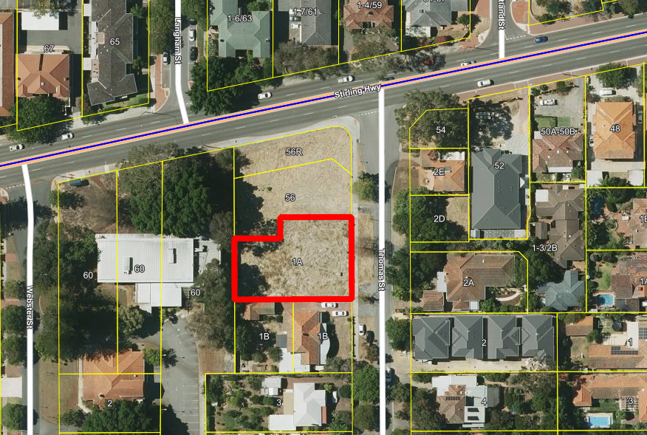
Figure 1: Aerial image
Discussion

Assessment of Statutory Provisions

The proposal has been assessed against all relevant legislative requirements of LPS 3, and State and Local Planning Policies as outlined above. In considering the reasons for deferral, the matters below have been identified as considerations for the determination of this application.

- Building Height.
- Plot Ratio.
- Vehicle Access.

These matters have been addressed in detail within the Responsible Authority Report (RAR). The amended development is consistent with the relevant planning framework and the likely future context of development within the area as envisaged in the NSHAC Strategy.

Design Review Panel

The original development application was reviewed by the City’s Design Review Panel (DRP) on two occasions. The modified proposal was reviewed by the Acting DRP Chair on two occasions. A summary of the Panel’s evaluation of the proposal at each stage of the review process is provided below.

DRP Design Quality Evaluation
 | Supported
 | Further Information / Condition Required
 | Not supported
SPP 7.0 Principles | 22 January 2024 (Panel review) | 8 April 2024 (Panel review) | 13 June 2024 (A/Chair review) | 1 July 2024 (A/Chair review)
- Context and Character
- Landscape Quality
- Built Form and Scale
- Functionality and Built Quality
- Sustainability
- Amenity
- Legibility
- Safety
- Community
- Aesthetics

The final comments from the A/DRP Chair were as follows:

- Overall good design which sits comfortably within the site.
- Bulk and scale has been reduced significantly. The reduction of one floor is significant and supported.
- The arrangement of built form has minimised the visual perception of building bulk.
- Further justification and diagrams are appreciated.
- All previous amenity issues have been resolved.
- Typical signifiers of overdevelopment (lack of natural sun, ventilation, reliance of screening for privacy) are not present and thereby the proposed plot ratio is not considered to indicate overdevelopment.

Consultation

Public Consultation

In accordance with the City’s Local Planning Policy 7.3 Consultation of Planning Proposals (LPP 7.3), the original plans received 21 December 2023 were advertised for a period of 28 days, from 19 January 2024 to 16 February 2024. At the close of the advertising period, the City received 20 submissions, 11 in support and nine objecting to the proposal. Key concerns raised in objections relate to:

- Height.
- Plot Ratio.
- Traffic.
- Visual privacy.
- Overshadowing.
- Lack of landscaping.
- Construction Management.
- Sustainability.

These matters have been addressed within the RAR.

Amended plans received 31 May 2024 were advertised for a period of 14 days, from 11 June 2024 to 25 June 2024. At the close of the advertising period, the City received no submissions.

Final amended plans were submitted to the City on 27 June 2024 that differ from the advertised plans in the following key ways:

- Amendments to the basement ramps to meet Australian Standard AS/NZS2890.1. This resulted in increasing the height of the overall development by 0.6m, whilst also improving amenity of the ground floor apartment by making it sit higher than street level to create a sense of privacy while maintaining street surveillance.
- Modifications to the penthouse level to bring in the roofline above to further reduce the perceived bulk and scale when viewing the building
- Modification to design of community facilities.

The amendments did not trigger the need for formal re-advertising of the proposal. All submissions on this proposal have been given due regard in this assessment in accordance with Clause 67(y) of the Planning and Development (Local Planning Schemes Regulations) 2015.

It is acknowledged that the City of Nedlands owns in freehold an adjoining site. Separate to the planning assessment, from a landowners perspective its considered that the proposed development at 1A Thomas Street will have minimal impact on the City’s buildings behind it for the following reasons:

- The building is located centrally to the site and the rear setbacks exceed the acceptable outcomes.
- There is a 6m rear setback to the podium level, which is devoted primarily to deep soil areas and with medium sized trees proposed near the rear boundary.
- Floors above the podium level are set back 9m from the rear boundary.
- Rear setbacks meet or exceed Acceptable Outcomes for visual privacy to the rear in the event future residential development is proposed.

Strategic Implications

This item is strategically aligned to the City of Nedlands Council Plan 2023-33 vision and desired outcomes as follows:

Vision | Sustainable and responsible for a bright future

Pillar | Place
Outcome | 6. Sustainable population growth with responsible urban planning.
Budget/Financial Implications

Nil

Legislative and Policy Implications

Council is requested to make a recommendation to the DAP in accordance with Regulation 12 of the Planning and Development (Development Assessment Panels) Regulations 2011. Council may recommend to approve, refuse or defer the application.

Decision Implications

Council’s recommendation will be incorporated into the Responsible Authority Report (RAR) and lodged with the DAP Secretariat on or before the 23 August 2024. The recommendation noted above is the officer recommendation that is also included in the RAR. In the event that Council does not adopt the officer recommendation, Council’s recommendation will be located at the front of the RAR as the Responsible Authority Recommendation and the officer recommendation will be contained in the rear of the report. In the event that Council does not make a recommendation, the RAR will be forwarded to DAP on 23 August 2024 with the Officer Recommendation only.

Conclusion

Council is requested to consider the proposed development as the Responsible Authority. It is requested that Council makes a recommendation to the DAP to either approve, refuse or defer the application.

The application for a 10 storey development is considered consistent with the City’s current planning framework and meets all Element Objectives of the R-Codes. The development is well designed and is within the expected future scale of development within the area given the transition to Mixed Use R-AC1 and the location within the NSHAC Strategy. The proposal has been amended to respond to the recommendations of the City’s DRP and the City.

For the above reasons, it is recommended Council adopt the Officer Recommendation contained in the RAR for approval subject to conditions.

Further Information

Nil

Confidential Items

23.1 CONFIDENTIAL CSD05.07.24 Point Resolution Childcare Centre (PRCC)

A CONFIDENTIAL report has been circulated to Council Members separately.

24 Declaration of Closure

There being no further business, the Presiding Member will declare the meeting closed.

