Corporate & Strategy Reports

Committee Consideration – 9 March 2021
Council Resolution – 23 March 2021

Table of Contents

Item No. Page No.

CPS05.21 List of Accounts Paid – January 2021 2
CPS06.21 Future of Nedlands Child Health Clinic – 152 Melvista Avenue, Nedlands 4
CPS07.21 Swanbourne Nedlands Surf Life Saving Club – Variation to Lease at 282 Marine Parade, Swanbourne 14
CPS08.21 Mid-Year Budget Review – 2020/21 25

CPS05.21 List of Accounts Paid – January 2021

Committee | 9 March 2021
Council | 23 March 2021
Applicant | City of Nedlands
Employee Disclosure under section 5.70 Local Government Act 1995 | Nil.
Director | Ed Herne – Director Corporate & Strategy
Attachments | - Creditor Payment Listing – January 2021; and  - Credit Card and Purchasing Card Payments – January 2021 (29 December 2020 – 27 January 2021).
Confidential Attachments | Nil.

Executive Summary

In accordance with Regulation 13 of the Local Government (Financial Management) Regulations 1996 Administration is required to present the List of Accounts Paid for the month to Council.

Recommendation to Committee

Council receives the List of Accounts Paid for the months of January 2021 as per attachments.

Discussion/Overview

Background

Regulation 13 of the Local Government (Financial Management) Regulations 1996 requires a list of accounts paid to be prepared each month, showing each account paid since the last list was prepared. This list is to include the following information:

- the payee’s name;
- the amount of the payment;
- the date of the payment; and
- sufficient information to identify the transaction.

It is normal practice for the monthly payment list to be a month in arrears to allow for the production of Council reports, the timetable is such that Council reports are being finalised for the following months’ round of meetings before the completion of the current month.

Risk Management

The accounts payable procedures ensure that no fraudulent payments are made by the City, and these procedures are strictly adhered to by the officers. These include the final vetting of approved invoices by the Manager Finance and the Director Corporate and Strategy (or designated alternative officers).

Conclusion

The List of Accounts Paid for the months of January 2021 complies with the relevant legislation and can be received by Council (see attachments).

Consultation

Required by legislation: Yes No
Required by City of Nedlands policy: Yes No

Strategic Implications

The 2020/21 approved budget is in line with the City’s strategic direction. Payments are made to meet the City’s spend on operations and capital expenses undertaken in accordance with the approved budget.

The 2020/21 approved budget ensured that there is an equitable distribution of benefits in the community

The 2020/21 budget was prepared in line with the City’s level of tolerance of risk and it is managed through budgetary review and control.

Budget/Financial Implications

The payments are made in accordance with the approved budget and achieves a surplus cashflow balance.

CPS06.21 Future of Nedlands Child Health Clinic – 152 Melvista Avenue, Nedlands

Committee | 9 March 2021
Council | 23 March 2021
Applicant | City of Nedlands
Employee Disclosure under section 5.70 Local Government Act 1995 | Nil.
Director | Ed Herne – Director Corporate & Strategy
Attachments | - Building Maintenance Inspection – May 2020; and  - Asset Management Inspection – May 2020.
Confidential Attachments | Nil.

Executive Summary

This item is presented to Council to consider the future of the facility at 152 Melvista Avenue, Nedlands – better known as the ‘Nedlands Child Health Clinic’.

In October 2015, Council agreed to enter into a Lease Arrangement with the Department of Health on the basis that the Lessee be responsible for all running costs (including utilities, cleaning and consumables) and routine maintenance and the City be responsible for capital works onsite. Rental was to be charged at a rate sufficient to cover costs of capital works and ongoing maintenance.

At the time, Council also agreed to consider the budget necessary to undertake works at the facility to restore the building to an acceptable condition and to allocate funds in its ongoing annual budget to provide for necessary capital works onsite.

This has resulted in the City investing a total of $36,817 towards renovations to restore the building to an acceptable condition with a further $61,500 investment required as soon as possible for repairs to the roof and gutters. The City has also spent an average of $8,199 per year on other ongoing maintenance requirements during that time.

Since the resolution in 2015, the City and Department Health have been unable to agree on terms for a formal agreement of tenure and this report outlines the options available to Council in order to move forward.

Recommendation to Committee

Council:

- Accepts the variances to the Management Licence requested by the Department of Health, with the exclusion of the request to reduce the Licence Fee to $5,000 per annum; and

- Instructs the CEO to advise the Department of Health that the City’s final offer for a Licence Fee will remain at $10,000 per annum.

- Should the Department of Health accept the City’s terms, and subject to the Minister for Lands Consent, approves the Mayor and CEO to execute the agreement and apply the City’s common seal.

- Should the Department of Health decline to accept the City’s terms, instruct the CEO to request the Department vacate the premises, giving 3 months’ notice and request Administration investigate possible cost-neutral or revenue generating options for the facility, including detail and cost implications surrounding demolition of the facility and provide a further report to Council.

Discussion/Overview

Background

The Nedlands Child Health Clinic (‘Clinic’) is a purpose-built clinic constructed in 1951. The Clinic is located on Crown Reserve 21657 with purpose “Child Health Centre”. A Management Order for this reserve vests the City of Nedlands with the care control and management over the reserve.

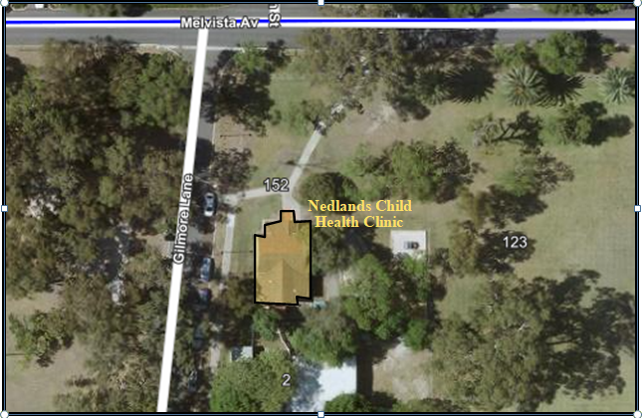

The Child and Adolescent Health Service (‘CAHS’) is a branch of the Department of Health (‘Department’). According to its website, CAHS provide a comprehensive service supporting the health, wellbeing, and development of young Western Australians. They aim to ensure that children and young people get the best start in life through health promotion; early identification and intervention; and patient-centred, family-focused care.

In particular, the Department has utilised the Clinic for its ‘Community Health’ services which are a range of community-based early identification and intervention services for children, young people and families. They include child health assessments (also known as Purple Book appointments), screenings, immunisations, school health and other general support and advice.

In August 2020, Administration requested a formal Data Release Request from the Department to ascertain current numbers of current health clients (babies) that the Clinic services. That data is listed below:

- Current clients: 706
- Current clients who reside with the City boundaries*: 489
- Clients serviced over the last 3-years (July 2017-June 2020): 1640
- Clients serviced over the last 3-years who reside with the City boundaries: 1042
- Over the last 3-years, the clinic has also provided 153 group sessions to its clients.

Note: *City of Nedlands suburbs included Dalkeith, Floreat, Mount Claremont, Nedlands, Shenton Park, Swanbourne and Karrakatta

Council are advised that child health checks are not compulsory, and some clients choose to see their GP instead. Given current client numbers in ratio to clients serviced over the past 3-years, it is estimated that 71% of City of Nedlands residents who are listed as a client, utilise the service.
The Department also noted as part of the data release that clients who do choose to utilise the service have a ‘universal schedule’ of 5x appointments in the babies first 2-years of life.

As noted in the Council Report of October 2015, there has never been a formal agreement of tenure outlining the terms of use of the Clinic by the Department. It is understood that these services have in many local governments been delivered through a partnership between Local Government Authorities and the Department of Health with Local Government providing the facility from which the Department provided the service.

The City’s Administration has previously attempted to negotiate a lease agreement for the building. In 2010, following a request to the Minister for Lands, the City received in-principle consent to lease this reserve to the Department of Health. This request was made in preparation for negotiations at the time and this in-principle consent was valid for a period of 6 months from issue and that the City would need to make a further request when new terms have been negotiated. At the time WALGA was involved in leading negotiations with the Department of Health to seek some form of agreement, however this was subsequently abandoned, now that the City has re-joined WALGA an opportunity may present itself to reinstate these negotiations.

In September 2014, Administration briefed Councillors on the matter noting the absence of any lease arrangements between the City and Department and advising that the City would be liaising with the Department with view to requiring a lease be in place by the end of the financial year (2014/15). Terms of this lease were to reflect the City’s standard leasing practices for a community purpose – that is the Department responsible for operating and maintenances costs.

Further to this briefing session the City wrote a letter to the Department with request for lease negotiations to commence and outlined the requirement for terms to be based on the City’s standard terms. The correspondence provided a copy of the City’s standard Deed of Lease and also noted the example of the arrangement to the south of the Clinic, at 150 Melvista Avenue, where the Department of Education leases the Nedlands Park Early Learning Centre premises.

Following no response from the Department, the City further contacted the Department requesting response. In March 2015, the Department responded with an annotated copy of the City’s standard Deed of Lease with annotation essentially noting that the Department was unable to assume responsibility for items of capital maintenance as it was contrary to Department policy.

In October 2015, Council agreed to enter into a Lease Arrangement with the Department on the basis that the Lessee be responsible for all running costs (including utilities, cleaning and consumables) and routine maintenance and the City be responsible for capital works onsite. Rental was to be charged at a rate sufficient to cover costs of capital works and ongoing maintenance.

At time, Council also agreed to consider the budget necessary to undertake works at the facility to restore the building to an acceptable condition and to allocate funds in its ongoing annual budget to provide for necessary capital works onsite.

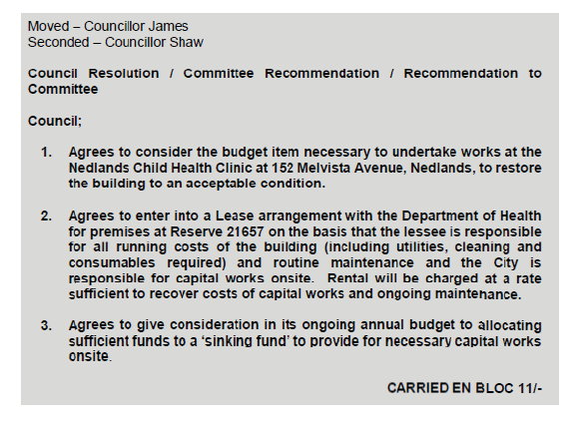

In November 2016, the City’s Executive reviewed the progress with the Clinic’s upgrades and tenancy and decided Technical Services would create schedule of works for the Clinic from which negotiations on tenancy agreement could be based.
While the model for the City’s asset management for tenanted buildings was developed, progress on formalising the tenancy was slow. It was also decided at this time that a Management Licence would better suit the model for this tenant. McLeods produced a draft licence agreement which was provided in to CAHS in May 2019 for review. The essential terms of the agreement were:
- The City would maintain and insure the building
- CAHS as licensee would pay an annual licence fee of $10,000 (as per Management Licence Framework presented at a Council briefing in 2018).
- CAHS would pay all outgoings
- CAHS would have exclusive use of the premises during the term
- The term of the licence was 10 years

On 27 November 2019, CAHS requested the City reconsider the Management Licence with noted variances to the essential terms as listed above:
- CAHS as licensee requested an annual licence fee of $5,000 which would be consistent with most other child health facilities that are accommodated within Local Government Authorities.
- CAHS as licensee requested the term of the licence is 10 years be split into a five (5) year initial term + an option to renew for five (5) years. This was to align with CAHS Strategic Service Planning and associated Facility Planning.
- CAHS as licensee agreed to pay all outgoings. However, the State Solicitors Office included some draft clauses within the agreement which in short ensure complete transparency with any on-costed amount. It was recommended that sub-meters be installed for both Water and Electricity at the site. Currently, there is no Water Sub-Meter.

Administration advises that there is no risk to the City associated with the variance to the term and recommends that the installation of a Water Sub-Meter be a responsibility of the Licensee. The only real consideration is the Licence Fee.

The Clinic

At the time of writing this report, the City’s Building Maintenance Team have advised the last inspection report was undertaken in May 2020 (see attachment 1) and that ‘The inside of the building was refurbished two years ago and is still in good condition throughout. Security was also upgraded to be added to the City’s access control system. The City has begun taking over routine maintenance obligations. Externally the roof, gutters and downpipes need immediate work due to rusting and sagging. The City has received quotes to ascertain an idea of the cost of this work – those estimates equate to approximately $61,500. Building Maintenance recommend this work be undertaken as soon as possible.

The City’s Asset Management Team have advised the last inspection report was undertaken in May 2020 (see attachment 2) and that ‘When aligned in to the four categories Structure, Fit out, Mechanical and Roof, the building as a whole is rated structurally in good condition.’

Since the resolution of Council in October 2015, the City has invested $36,817 towards renovations to restore the building to an acceptable condition and has spent an average of $8,199 per year on other ongoing maintenance requirements during that time. There is also an estimated cost of $61,500 to refurbish the roof, gutters, and downpipes – works which will need to be undertaken as soon as possible

Discussion

It is unquestionable that the service provided from the Nedlands Child Health Clinic by the Department of Health’s CAHS branch is a valuable and worthwhile service to the community. However, the City has competing requirements in its ‘Use of Council Facilities for Community Purposes’ policy which requires that a tenancy on an exclusive use basis be in the form of a lease or management licence agreement is based on no cost to Council.

There are many examples of this around the City with community and sporting groups as well as two premises leased to the state government. This is particularly relevant in that the Department of Education leases 2 premises – one in Nedlands; and one in Dalkeith, on the basis of a peppercorn rental with all maintenance undertaken by the Department. Therefore, it seems unfounded to say that state government departments do not assume responsibility for items of capital maintenance at lease premises.

The City acknowledges that historical practice involved a partnership between local government and state government in the provision of health clinics throughout the community where a local government would provide the building from which the Department of Health would provide the service. Over time this arrangement has shifted somewhat with cost pressures and resource rationalisation. It was evident in 2015 that the model at Nedlands Child Health Clinic needed review and formalisation and that has not changed.

Options

Given the City and Department are still yet to agree to terms of tenure, Council are now asked to consider their options to move forward. The options available are shown below

- Agree to the variances proposed by CAHS, with the exception of the $5,000 Licence Fee.

This would mean the City’s Administration would advise CAHS that all other terms are agreed to, but the minimal acceptable Licence Fee would be $10,000.

Should CAHS agree, this Council Report will provide endorsement for the agreement to be formally executed.

Should CAHS disagree, the City will instruct CAHS to vacate the premises on 3-months’ notice and will commence investigations into alternate uses for the site.

- Agree to the variances proposed by CAHS, including the $5,000 Licence Fee.

This would mean the City’s Administration would advise CAHS that all other terms are agreed to and this Council Report will provide endorsement for the agreement to be formally executed.

- Disagree to the variances proposed by CAHS and cease negotiations.

The City’s Administration will then instruct CAHS to vacate the premises on 3-months’ notice and will commence investigations into alternate uses for the site.

- Disagree to the variances proposed by CAHS and cease negotiations.

The City’s Administration will then instruct CAHS to vacate the premises on 3-months’ notice and can choose to demolish the asset.

Note: As the facility is located on land not owned by the City (vested land), the land and/or facility cannot be sold.

Alternate Uses

Any alternative options to dispose of the building on a cost-neutral basis would need to be consistent with both Section 3.58 of the Local Government Act 1995 and the current purpose of the Reserve Management Order which is ‘Child Health Centre’.

To entertain a disposal of any other purpose (than Child Health) there would be a requirement to amend the Management Order. This involves a process with Department of Planning, Lands and Heritage whereby any application from the City for consideration would require a proposed alternate use, demonstrated public consultation and an endorsement of Council.

Conclusion

Given the circumstances as detailed above:

- The difficulties faced with negotiating an agreement which satisfies both the City’s requirement for agreements of exclusive tenure to be cost-neutral whilst also allowing the Department to maintain a valuable service for the community; and
- The significant investment over the last 5-years the City has committed towards renovations to restore the building to an acceptable condition ($36,817) and the significant investment required to repair the roof and gutters as soon as possible ($61,500); and
- The significant investment and resource requirements to investigate alternate use of the facility, which may not in the end be approved.

Administration recommend Option 1 be approved by Council

Key Relevant Previous Council Decisions:

PD43.15 – On 27 October 2015, Council agreed to enter into a Lease Arrangement with the Department of Health on the basis that the Lessee be responsible for all running costs (including utilities, cleaning and consumables) and routine maintenance and the City be responsible for capital works onsite. Rental was to be charged at a rate sufficient to cover costs of capital works and ongoing maintenance.

CPS07.15 - On 24 March 2015, Council resolved to adopt the City’s reviewed policy entitled “Use of Council Facilities for Community Purposes”. The policy guides the leasing of City premises for community purposes and specifically includes lessees such as government departments.

Consultation

The City has remained in constant communication with the Child and Adolescent Community Health branch of the Department of Health on future terms of its tenancy at the Nedlands Child Health Clinic. CAHS have conveyed they remain committed to moving towards a formal agreement of tenure as the site is a well-established, free service to the Nedlands community. They have noted that the data as provided in August 2020 show that as part of a broader Child Health Service, a service in or nearby to the current location is preferable. The closest service to the Clinic is ‘The Grove Child Health Clinic’ (Peppermint Grove), some 6kms away.

In consultation with internal departments, the following comments from the City’s Community Development Team were noted:

‘Community Child Health Services provided by the State Government are valuable and necessary services provided to our local community. These services support parents of young children at a critical time of their lives and of the development of those children. These services assist with assessing developmental milestones, supporting parents in their roles as caregivers and in providing health information and support. These services are valuable and highly valued by community members

It has been traditional over many decades for local governments and the state government to ensure that such services are available to the community, by sharing some of the costs. While the state government provides the actual service run from the facility, in many instances the relevant local government provides the building from which the service is run.
Community Development is of the view that the City should provide that building to the state government on the same basis that buildings are provided to sporting clubs that require exclusive use of a building – that is, that the building should be made available at no cost to Council.’

Strategic Implications

How well does it fit with our strategic direction?

KFA: Community Development - an agreement of tenure for the premises with the Department of Health will ensure the much-valued child health service continue in the community.

KFA: Governance and Civic Leadership – an agreement of tenure for the premises with the Department of Health on the City’s standard terms will ensure consistency with the City’s ‘Use of Council Facilities for Community Purposes’ policy. Formalising an agreement of tenure over the building on either basis as discussed above will ensure the City’s asset is properly maintained on a cost-neutral basis.

Who benefits?

The City of Nedlands community benefit from having the critical service available

The City’s ratepayers benefit from the sound and sustainable financial decision making.

Does it involve a tolerable risk?

An agreement of tenure reduces any risk to the City by having clear and concise terms from which the asset can be managed.

Do we have the information we need?

All required information has been provided to Council.

Budget/Financial Implications

Can we afford it?

Given the average ‘ongoing maintenance costs’ over the last 5-years equates to $8,199 per annum, the proposed Management Licence Fee of $10,000 per annum ensures the arrangement would ensure no-cost to the City.

However, the estimated cost to repair the roof, gutters and downpipes totaling $61,500 is currently unbudgeted and is likely to be considered for budget inclusion within the next financial year.

How does the option impact upon rates?

Given the average ‘ongoing maintenance costs’ over the last 5-years equates to $8,199 per annum, the proposed Management Licence Fee of $10,000 per annum ensures the arrangement would not have a negative impact on rates.

An inclusion of $61,500 in a future budget would equate to a 0.26% impact on rates

CPS07.21 Swanbourne Nedlands Surf Life Saving Club – Variation to Lease at 282 Marine Parade, Swanbourne

Committee | 9 February 2021
Council | 23 February 2021
Applicant | City of Nedlands
Employee Disclosure under section 5.70 Local Government Act 1995 | Nil.
Director | Ed Herne – Director Corporate & Strategy
Attachments | Nil.
Confidential Attachments | Nil.

Executive Summary

This item is presented to Council to consider the proposed Deed of Variation relating to the Lease of the facility at 282 Marine Parade, Swanbourne – better known as the ‘Swanbourne Nedlands Surf Life Saving Club’ (‘Club’).

In June 2013, Council resolved to enter into a Lease and Sublease arrangement with the Club (PD27.13). Since the execution of the Lease document in 2014, it has been noted by both parties that an error was made within the Lease which was not consistent with Council’s resolution and a Deed of Variation is required to correct the error.

The error itself refers to the Annual Grant provision (‘Grant’) within the Lease which was included at the time of execution to compensate the Club for a loss of income relating to a kiosk which was formally on the lease premises and operated by the Club. Council’s resolution was for the Grant to be ‘reviewed’ on 1 March 2021 and the Lease states the Grant was to ‘expire’ on 1 March 2021.

Along with the required Deed of Variation, this report also provides Council with the opportunity to review the Annual Grant lease provision.

Recommendation to Committee

Council:

- a) instructs the CEO to arrange a Deed of Variation to the Lease with Swanbourne Nedlands Surf Life Saving Club with the agreement to be prepared at the City’s cost. and;

b) subject to the Minister for Lands Consent, authorises the CEO and Mayor to execute the Deed of Variation agreement and apply the City’s Common Seal.
Discussion/Overview

Background

Swanbourne Nedlands Surf Life Saving Club Inc. (‘Club’) operates out of a purpose-built clubhouse and boat shed facility at the northern end of the Swanbourne Beach precinct. The Club’s premises are for the most part located within Reserve 7804 for which the City is the management body pursuant to a Management Order. Under the Order the City has the power to lease the land for any term not exceeding 21 years. A small portion of the premises is located within Lot 404 on Deposited Plan 36773 which is land which the City leases from the State of Western Australia for a period of 21 years with an option to extend the initial term for a further 10 years. A depiction of the Lease premises is shown below.

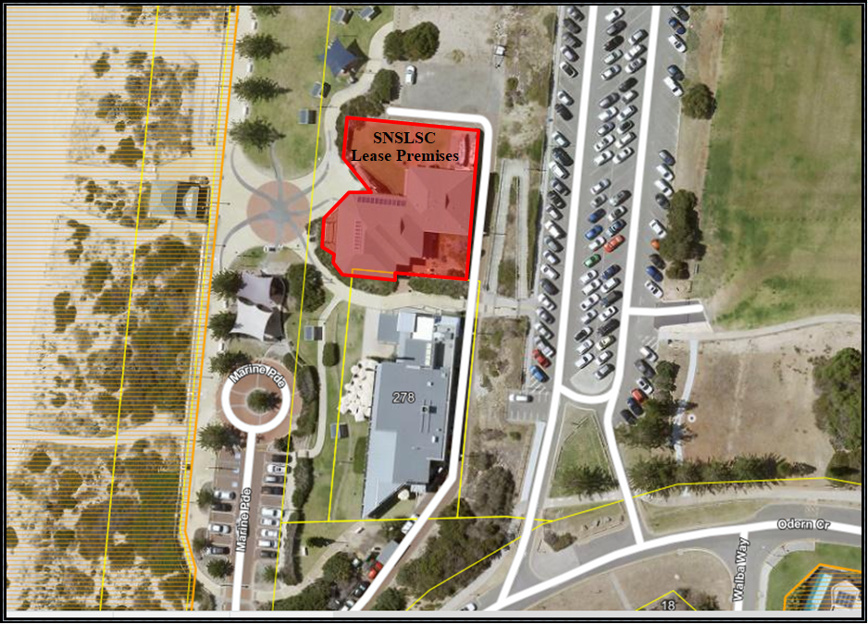

The Club’s relationship with the site dates to 1932 when the Club was formed, and the City gave permission for the Club to use a shed located on site. Since then, there has been further development with the lookout tower built on the beach side of the club rooms in 1995 along with the refurbishment of the change room facilities and upgrade to the gym. The City has contributed financially to the previous capital works.

A Lease agreement with commencement 24 November 1983 between the City and Club was for a term of 21 years, expiring on 24 November 2004. As per the holding over clause of that lease, the Club remained as a week-to-week tenant subject to the same covenants and conditions detailed within that lease. Negotiations for a new lease were stalled until plans for the Swanbourne Beach Redevelopment were determined, including the Naked Fig Cafe development (now the Shorehouse) and the associated financial impact on the Club.
In 1999, the City provided a grant of $21,000 to the Club as part of the CSRFF process towards Stage 1 of the club’s redevelopment of their clubrooms.

In April 2001, the City provided a grant of $19,250 to the club towards Stage 2 of their club redevelopment.

On 23 October 2001, Item C95.01, Council approved a $100,000 grant to the club to enable the completion of additional building renovations at that time. One of the conditions attached to the grant was that the club agree to enter into negotiations towards a new lease.

On 13 December 2005, Item CM23.05, Council approved a ten-year lease with the option of a further five-year term between the City and the Club whereby the Club as tenant were responsible for all maintenance, cleaning, utility fees and insurance for all of the buildings contained within their leased area. This Council resolution also stated:

“that an annual grant of $34,000 (indexed to the ‘all groups CPI’ for Perth as calculated by the Australian Bureau of Statistics and adjusted annually and effective at the end of the September quarter commencing 2006/07) is paid by the City (the City) to the Swanbourne Nedlands Surf Life Saving Club (the Club), from the time that the Club ceases to receive income from the kiosk and to be calculated on a pro-rata basis in the first year”.

The kiosk which previously formed part of the Club’s premises for which they received revenue from was disestablished and later demolished upon the establishment of the Swanbourne Beach Cafe - The Naked Fig Café (now the Shorehouse).

The Deed of Lease was signed by the City and Club and had a commencement date of 2 March 2006. However, in 2009, when the Club wished to apply for a liquor licence, it was noted that this Lease had not been endorsed by the Minister for Lands as required under Section 18 of the Land Administration Act 1997 and therefore the Deed was essentially null and void.

In 2010, the City instructed McLeod’s to prepare a new ten (10) year deed of lease with the option of an additional five (5) year term based on the terms contained within the void 2006 lease. The City and Club then continued to negotiate the terms of the lease agreement over the next 3-years which included correspondence from the Premier himself, various meetings, and workshops. In the end both parties reached a mutual consensus to the majority of terms for lease and sublease of the Club’s premises and on 25 June 2013, Item PD27.13, Council resolved the following:
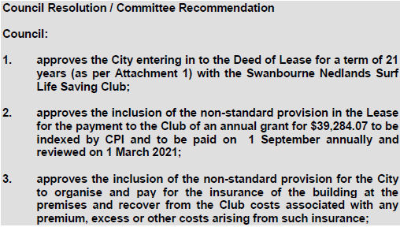

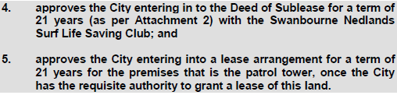

The Deeds of Lease and Sublease were subsequently signed by the City and the Club on 20 March 2014.

Annual Grant Review

Clause 43 of the Lease agreement executed in 2014 describes the Annual Grant provision which includes reference to the Grant being made based on lost revenue from a kiosk being removed from the lease premises.

A recent review also shows that Clause 43.3 does not reflect the recommendations adopted by the Council at the Council Meeting on 25 June 2013, specifically that the Annual Grant is to be ‘reviewed’ on 1 March 2021 as opposed to ‘expire’ on 1 March 2021 – see excerpt below.

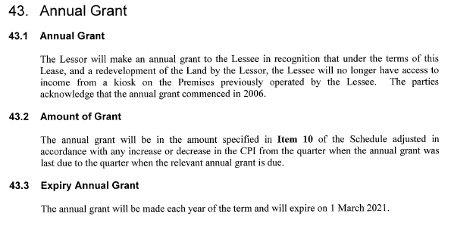

Review of Loss of Kiosk Revenue

As noted in the background above, there is significant history which needs to be considered by Council when deciding whether to continue or cease the Annual Grant payment.

As noted in the June 2013 Report to Council, the Annual Grant Clause was included to preserve the Club’s position as intended by both parties upon the signing of the Lease in 2006. The 2006 Lease encapsulated Council’s resolution of 13 December 2005 - to make an annual grant for $34,000 indexed to CPI, and payable upon cessation of Club receiving income from the kiosk (which was later demolished upon the establishment of the Naked Fig Cafe). The resolution further provided for the Grant to be recorded in the Deed of Lease with an initial term of 10 years plus an option to renew for a further 5 years. That Lease agreement contained a commencement date of 2 March 2006 and final expiration of 1 March 2021.

Within June 2013 Report to Council, it was also stated that:

- during the period until March 2021, ‘the Club would have adequate opportunity to find an alternate means of income’.
- that ‘any term for the Grant beyond 1 March 2021 is considered far beyond the standard for financial provision to sporting or community groups in the City’.
- that ‘any subsequent application made by the Club to the City for financial assistance / grant funding will be assessed on its merits’.
- and that the Club objected to the expiration of the Annual Grant on 1 March 2021 on the basis that the ‘Grant was intended to compensate the Club for loss of earnings upon the closure of the kiosk’. The Club requested ‘that the Grant should survive the full term of the Lease (ie. until its expiration in 2034) and then be renegotiated thereafter.’

For reference, the Annual Grant itself is a non-standard provision and does not comply with the City’s Use of Council Facilities for Community Purposes’ policy which is used to arrange the tenure of a large majority of the City’s Community Groups and Sporting Clubs. Administration can confirm that no other Community Group or Sporting Club who operates under leasehold is granted any annual financial payments or subsidies.
The below table illustrates the total cost to the ratepayer for provision of the Annual Grant since 2009, and also estimates the annual cost for the remainder of the Lease Term and is based on a CPI increase of 1.8% per annum for future payments*.

*CPI forecast data sourced from Government of WA Financial Projection Statement December 2020

Year | Payment/Estimated Payment
2009/10 | $21,600.25*  *Pro-rata annual payment from December 2009
2010/11 | $37,029.00
2011/12 | $38,139.87
2012/13 | $39,284.07
2013/14 | $40,064.53
2014/15 | $42,118.77
2015/16 | $42,591.57
2016/17 | $42,788.57
2017/18 | $43,143.17
2018/19 | $43,655.38
2019/20 | $44,364.58
2020/21 | $44,955.58
SUB TOTAL | $479,735.53
2021/22 | $45,764.78
2022/23 | $46,588.55
2023/24 | $47,427.14
2024/25 | $48,280.83
2025/26 | $49,149.88
2026/27 | $50,034.58
2027/28 | $51,852.04
2028/29 | $52,785,37
2029/30 | $53,735.51
2030/31 | $54,702.75
2031/32 | $55,687.40
2032/33 | $56,689.77
2033/34 | $57,710.19
2034/35 | $58,748.97
TOTAL | $1,304,784.08

At the end of this financial year, the City would have paid a total of $479,735.53 in Annual Grants under the Lease, whilst the Club would have had a 15-year opportunity to source an alternate means of income since the loss of the kiosk.

Should Council choose to continue the Annual Grant payment, it is estimated there will be an additional cost of $825,048.55 to rate-payers over the next 14-years and in total would mean an estimated cost of $1,304,784.08 would reflect the loss of the kiosk.

Lifesaving Service

When discussing this report with Swanbourne Nedlands Life Saving Club, the club were very clear that the continuance of the financial support from the City was absolutely necessary in order for the Club to be able to continue to provide a beach patrol lifesaving service to the City of Nedlands community.

Swanbourne Nedlands Surf Life Saving Club currently patrol 2.3km of beach area on a voluntary basis for an average of 4000 hours per year. This year, the Club are on track to complete more than 4500 volunteered patrol hours. In 2019 alone, the Club performed 609 preventative rescue actions.

In addition, the lifesaving service provided by the Club extends to ancillary activities such as:

- annually training more than 65+ community members as lifesavers.
- undertaking annual ‘skills maintenance’ for all currently qualified volunteer lifesavers which enables them to continue to perform duties with the most recent medical advice and guidance.
- other educational activities such as ‘Nipper’ and ‘Cadet’ programs, Bronze Medallion Courses, Surf Rescue Certificates and numerous other higher education and training.
- providing abridged or full lifesaving education courses to other organisations such as Scotch College, UWA, Leading Youth Forward.
- facilitating the meeting and connection of older surf lifesaving members (over 55s) as part of the ‘Swanny Vets’.
- sending volunteer surf lifesavers to other high-risk ocean locations such as various abalone patrols when required
- provides water safety volunteers to community events such as Rottnest Channel Swim, Busselton Jetty Swim and Rottnest Swim Run
- manages one of the best attended ocean swims, the ‘Swanny Ocean Classic’ for more than 1000 local community members.
- participates in other environmental initiatives that range from recycling to rubbish collection days in the Swanbourne area.

As most surf clubs in WA offer an invaluable lifesaving service to the community which is considered above and beyond what other sporting clubs and community groups offer, Officers investigated how other Local Government Authorities support their surf lifesaving clubs. After communicating with the 8x other metropolitan LGAs who have a surf club within their municipality, it was evident each Local Government supported their surf club in some capacity to ensure that the valuable lifesaving service was able to be continued by the respective clubs.

In every instance, to ensure the continuance of the lifesaving service, each LGA either supported their surf club financially or where appropriate, provided the club with a viable means to generate revenue commercially.

As Swanbourne Nedlands Surf Life Saving Club do not have the means to generate significant commercial revenue, the support that the City of Nedlands offers to its surf club can be directly compared to 6x other metropolitan based LGAs. Of the 10x clubs within those 6x LGAs, the financial assistance per annum ranged from $6,000 to $63,000 with an average of $33,850. Of those clubs located in the western suburbs, the average equates to $46,500 per year.

Conclusion

- In reference to the review of the Annual Grant as noted in Council’s Resolution of June 2013, it is recommended that Council do not agree to continue to make the annual payment for income lost as a result of the kiosk no longer being operated by the Club. The cessation of the payment would be consistent with the City’s Use of Council Facilities for Community Purposes’ policy and would also be consistent with the December 2005 resolution which approved an annual grant to be paid for the entirety of a 15-year lease term, expiring in March 2021.

- However, it is also evident that Swanbourne-Nedlands Surf Life Saving Club provide a service to the City of Nedlands community which is invaluable. It is recommended that the City continue to assist the Club to be able to continue to provide the lifesaving service by providing an annual financial grant.

It is recommended that Council do not continue to pay an Annual Grant based on the loss of income from a kiosk which was removed from the lease premises in 2009 as the Club has had ample opportunity to source alternate means of income but instead continue to assist the Club financially in order for the club to continue the invaluable lifesaving services to the community.

Under the current lease arrangement, it is estimated the 2021/22 financial assistance will be approximately $45,764.78. With the western suburbs average support being almost the same amount, it is recommended no change be made to the annual grant amount.

To enable the above recommendation to be resolved and in accordance with Clause 30 within the lease agreement, a Deed of Variation is required to accurately reflect Council’s decisions on this matter.

The proposed Deed of Variation will reflect Council’s decision to no longer ay the Annual Grant in lieu of the lost kiosk revenue, but more accurately for the invaluable service the Club provides. The Deed will continue with the same financial assistance as what has currently been provided to the Club but will clearly state that the support shall continue until the expiration of the current agreement.

As the City’s Officers were responsible for the preparation of the Lease in 2013 and subsequent error, it is recommended by Administration that the City absorb the costs for the Deed of Variation preparation. It is estimated by McLeod’s that the cost for such works would be approximately $270 (inclusive of GST).

Key Relevant Previous Council Decisions:

Item PD27.13, 25 June 2013, Council resolved to enter into a lease for a term of 21 years with the Club, including the non-standard provision in the Lease for the payment to the Club of an annual grant for $39,284.07 to be indexed by CPI and to be paid on 1 September annually and reviewed on 1 March 2021.

Item D97.10, 14 December 2010 – Council resolved that the lease lay on the table and that the CEO arranges a workshop with Council lawyers, City officers and representatives from the Swanbourne Nedlands Surf Life Saving Club.

Item 13.1, 30 June 2009 - Council resolved to object to the proposed hours applied for by the club in regards a Club licence application made to the Department of Racing, Gaming and Liquor.

Item CM23.05, 13 December 2005 – Council resolved to approve the payment of an annual grant of $34,000.00 (indexed to CPI and adjusted annually and effective at the end of the September quarter commencing 2006/07 by the City to the Club from the time that the Club ceased to receive income from the kiosk and to be calculated on a pro-rata basis in the first year). Council also approved a ten (10) year lease with the option of a further five (5) year term between the City and Club. The Lease included provision for the annual grant.

Item C95.01, 23 October 2001 – Council approved $100,000 to the club to enable the completion of additional building renovations at that time. One of the conditions attached to the grant was that the club agree to enter into lease negotiations.

Item C33.01, 10 April 2001 – Council resolved to approve $19,250.00 be allocated in 2001/02 budget to contribute towards the Club’s clubroom building project.

Consultation

To discuss this matter, the Club by formal letter received by Administration on 12 December 2020 requested a meeting. That meeting was attended by Officers and Club representatives on 18 December 2020.

It is also worth noting that since the 2013 resolution of Council, the Club and City have a significantly improved relationship. From an administrative perspective, the Lease provisions are being adhered to by the Club and the Club has built a strong reputation within the community which is evident by its formidable community support for upgraded changeroom and toilet facilities.

Strategic Implications

How well does it fit with our strategic direction?

One of the ‘Priorities’ within Nedlands 2028 Strategic Community Plan, under ‘Provide for Sport and Recreation’ mentions that an annual operational grant to Swanbourne Nedlands Surf Life Saving Club be provided. The endorsement of the recommendation would fit within that strategic direction.

Additionally;
KFA: Community Development – an accurate agreement of tenure with the Swanbourne Nedlands Surf Life Saving Club reflects stronger relationships for the City with its Sporting Clubs and Community Groups.

.. and;
KFA: Governance and Civic Leadership – an agreement of tenure which reflects the City’s standard terms will reflect good governance and will ensure consistency with the City’s ‘Use of Council Facilities for Community Purposes’ policy.

Who benefits?

The Swanbourne Nedlands Surf Life Saving Club’s members and the greater beach going community benefit from the service that the Club provides.

Does it involve a tolerable risk?

An accurate agreement of tenure reduces any risk to the City by having clear and concise terms from which the agreement can be managed.

Do we have the information we need?

All required information has been provided to Council.

Budget/Financial Implications

Can we afford it?

Should Council agree to absorb the costs of the Deed of Variation Preparation as per Administrations recommendation, the one off cost will be $270 (inclusive of GST).

Should Council agree to continue the payment of the Annual Grant, it is estimated by the end of the Lease Term (31 December 2034), the additional cost to Council will be approximately $825,048.55. This information is based on a CPI increase of 1.8% per annum.

How does the option impact upon rates?

The cost to absorb the Deed of Variation preparation is negligible.

Should Council agree to continue the payment of the Annual Grant, it is estimated the additional cost to Council annually would equate to approximately 0.2% impact on rates each year.

CPS08.21 Mid-Year Budget Review – 2020/21

Committee | 9 February 2021
Council | 23 February 2021
Applicant | City of Nedlands
Employee Disclosure under section 5.70 Local Government Act 1995 | Nil.
Director | Ed Herne – Director Corporate & Strategy
Attachments | - Revised Rate Setting Statement for the year ending 30 June 2021;  - List of Changes Required to the Revised Operating Budget 2020/21; and  - List of Changes Required to the Revised Capital Works & Acquisition Program Budget 2020/21.
Confidential Attachments | Nil.

Executive Summary

The Local Government Act 1995 and its regulations require a local government to review its annual budget between 1 January and 31 March each year. The recommendation for changes to the current Budget are submitted for consideration and adoption by Council.

Recommendation to Committee

Council:

- receives and adopts, in accordance with Regulation 33A of the Local Government (Financial Management) Regulations 1996, the mid-year budget review and the revised Rate Setting Statement for the year ending 30 June 2021;

- notes the requested changes to the current 2020/21 Annual Budget listed in Attachments 2 and 3, and summarised in this report;

- approves the net decrease in transfers from reserves of $460,828; and

- approves the Draft Budget incorporating all the changes listed in Attachments 1, 2 and 3 of this report, providing an estimated net surplus of $620,742 (Attachment 1).

ABSOLUTE MAJORITY REQUIRED

Discussion/Overview

Background

Regulation 33A of the Local Government (Financial Management) Regulations 1996 requires as follows:
  - Between 1 January and 31 March in each year a local government is to carry out a review of its annual budget for that year.

  - Within 30 days after a review of the annual budget of a local government is carried out it is to be submitted to the council.

  - A council is to consider a review submitted to it and is to determine* whether or not to adopt the review, any parts of the review or any recommendations made in the review.

  - Within 30 days after a council has made a determination, a copy of the review and determination is to be provided to the Department.

*Absolute majority required.

Discussion

In accordance with legislation, the City has undertaken a review of its annual budget and now recommends that review for adoption. The review proposes amendments to the budget which can be summarised as follows:

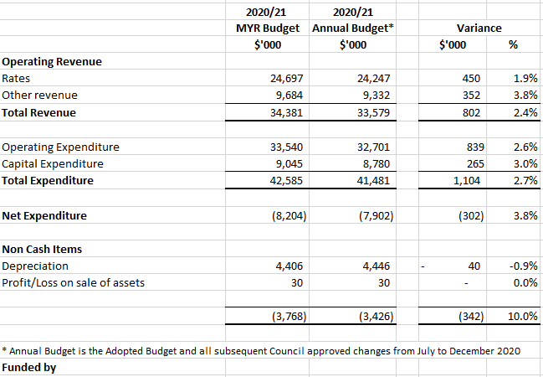

A snapshot of the approved changes in Operating and Capital Budget following Budget Adoption and the net impact on Surplus/deficit is shown below:

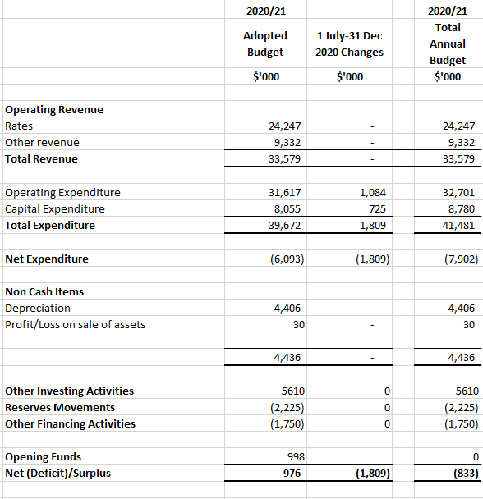

Commentary of major changes to the budget

Operating Revenue

The increase in operating revenue is mainly relating to:
- higher interim rates expected ($450k) as a result of increased building and subdivision activity
- higher revenue from building permit applications ($70k)
- higher revenue from Development applications ($175k)
- additional parking fines revenue ($60k)
- increased Grant revenue for NCC ($36k)
- increased artwork sales ($20k)

The adjusted revenue also takes into account:
- reduction in interest income ($145k) as a result of general decline in interest rates
- reduced food fines due to reduced compliance activity because of Covid-19 ($10k)
- reduction in Operating Grants for Volunteer Services due to service being discontinued ($16k)

Operating Expenditure

The increase in operating expenditure is mainly relating to:
- Increased consultancy and professional fees for corporate strategic planning across Corporate Services ($94k) and Planning and Development ($290k);
- Increased salaries and wages for Town Planning based on year to date spend ($216k)
- Increased material for Urban Projects ($145k)
- Increased legal fees in Governance ($70k);
- Additional ICT expenditure ($56k)
- Staff overtime for Council and other Committee meetings ($40k)
- Increased recruitment and advertising costs ($20K)
- Increased internal audit fees ($25k)
- Increased Footpath and Parks maintenance (70k) and Building Repairs and Maintenance ($14k)
- Additional advertising for strategic projects and complex Development Applications ($21k)

The adjusted expenditure also takes into account:
- Reduction in Special Projects Professional Fees as a result of the WESROC officer position no longer held at the City ($249k)

Net Capital Expenditure

The net increase in Capital Expenditure was due to:
- a number of projects approved by Council to be brought forward from future years. These were approved at various Council meetings to December 2020 and total $725k
- a new Tressilian Kiln for essential pottery classes ($19k)
- additional expenditure required for the IP Phone Collaboration System ($40k)
- additional expenditure for the Website Review ($25k)
- upgrade to the AssetFinda application ($15k)
- Additional Administration Comms Rack Clean Up and Replacing SSD expenditure ($35k)

Reserves Movement

The City’s Reserves have been adjusted to reflect the movement in transfers relating to an increase in transfers to the City Development Reserve ($40k) and a decrease in transfer to the Finance System Reserve ($500k) as explained below.

Transfer to Reserves

There is an increase of $39,172 in the transfer to reserves relating to an increase in the Whitfield Street Footpath project.

Transfer from Reserves

There is an overall decrease of $500,000 transferred from reserves due to the Finance System project expected to occur in the next financial year.

Conclusion

The outcome of the budget review shows an estimated end of year surplus of $620,742 compared with the surplus of $976,898 in the Annual Budget adopted in June 2020.

The Draft Budget for 2020/21 is recommended for adoption and for the above adjustments to be approved.

Consultation

Required by legislation: Yes No
Required by City of Nedlands policy: Yes No

Strategic Implications

The 2020/21 Budget Review is a tool to assess and guide the City’s strategic direction.

The 2020/21 Budget Review ensures that there is an equitable distribution of benefits in the community.

The 2020/21 Budget Review was prepared in line with the City’s level of tolerance of risk.

Budget/Financial Implications

As outlined in this report.

