Planning and Development Reports

Committee Consideration – 10 November 2020

Council Resolution – 24 November 2020

Table of Contents

Item No. Page No.

PD53.20 No. 3 Village Mews, Floreat – Residential – Ground Floor Alterations and Upper Floor Addition to Single House 2
PD54.20 Local Planning Scheme 3 – Draft Interim Local Planning Policy - Hollywood West Transition Zone 13

PD53.20 | No. 3 Village Mews, Floreat – Residential – Ground Floor Alterations and Upper Floor Addition to Single House
Committee | 10 November 2020
Council | 24 November 2020
Applicant | Ben Hohnen
Landowner | Helen Kornweibel
Director | Peter Mickleson – Director Planning & Development
Employee Disclosure under section 5.70 Local Government Act 1995 | Nil
Report Type  Quasi-Judicial | When Council determines an application/matter that directly affects a person’s right and interests. The judicial character arises from the obligation to abide by the principles of natural justice. Examples of Quasi-Judicial authority include town planning applications and other decisions that may be appealable to the State Administrative Tribunal.
Reference | DA20/51253
Previous Item | Nil
Delegation | In accordance with the City’s Instrument of Delegation, Council is required to determine the application due to an objection being received.
Attachments | - Applicant’s Justification Report
Confidential Attachments | - Plans  - Submission  - Assessment

- Executive Summary

The purpose of this report is for Council to determine a Development Application received by the City of Nedlands on 20 July 2020, for alterations and an upper floor addition at No. 3 Village Mews, Floreat (the subject site).

The application was advertised to adjoining landowners and occupiers in accordance with the City of Nedlands Local Planning Policy (LPP) – Consultation of Planning Proposals. During the consultation period, one objection was received. As an objection has been received, this application is presented to Council for determination.

It is recommended that the application be approved by Council as it is considered to satisfy the design principles of the Residential Design Codes (R-Codes) Volume 1 and is unlikely to have a significant adverse impact on the local amenity and character.

- Recommendation to Committee

Council approves the development application received on 20 July 2020 with plans date stamped 5 August 2020 for alterations and an upper floor addition to a Residential (Single House) at Lot 69 (No. 3) Village Mews, Floreat, subject to the following conditions and advice notes:

- The development shall at all times comply with the application and the approved plans, subject to any modifications required as a consequence of any condition(s) of this approval.

- This development approval only pertains to a Residential – alterations and upper floor addition to a Single house as indicated on the determination plans.

- All footings and structures to retaining walls, fences and parapet walls, shall be constructed wholly inside the site boundaries of the property’s Certificate of Title.

- Prior to occupation of the development, the western elevation of the balcony on the upper floor facing west is to be screened in accordance with C1.2 of Clause 5.4.1 of the Residential Design Codes (Vol 1). The screening device is to be at least 1.6m in height above the finished floor level of the balcony, at least 75% obscure, permanently fixed and made of a durable material to restrict view in the direction of overlooking to the western adjoining property. The required screening shall be thereafter maintained to the satisfaction of the City of Nedlands.

- All stormwater from the development, which includes permeable and non-permeable areas shall be contained onsite.

- Prior to occupation of the development, all external fixtures including, but not limited to TV and radio antennae, satellite dishes, plumbing vents and pipes, solar panels, air conditioners and hot water systems shall be integrated into the design of the building and not be visible from the primary street, secondary street to the satisfaction of the City of Nedlands.

- Prior to occupation of the development, all air-conditioning plant, satellite dishes, antennae and any other plant and equipment to the roof of the building shall be located or screened so as not to be highly visible from beyond the boundaries of the development site to the satisfaction of the City of Nedlands.

- This approval does not relate to any site works, decking or retaining walls 500mm or greater above the approved ground levels.

Advice Notes specific to this proposal:

- All street tree assets in the nature-strip (verge) shall not be removed. Any approved street tree removals shall be undertaken by the City of Nedlands and paid for by the owner of the property where the development is proposed, unless otherwise approved under the Nature Strip Development approval.

- An exterior fixture associated with any air-conditioning unit or hot water system is considered an appropriate location where it is positioned:
  - outside of balcony/verandah areas (if applicable) and below the height of a standard dividing fence within a side or rear setback area; or within a screened rooftop plant area or nook.

- All downpipes from guttering shall be connected so as to discharge into drains, which shall empty into a soak-well; and each soak-well shall be located at least 1.8m from any building, and at least 1.8m from the boundary of the block. Soak-wells of adequate capacity to contain runoff from a 20-year recurrent storm event. Soak-wells shall be a minimum capacity of 1.0m³ for every 80m² of calculated surface area of the development.

- All internal water closets and ensuites without fixed or permanent window access to outside air or which open onto a hall, passage, hobby or staircase, shall be serviced by a mechanical ventilation exhaust system which is ducted to outside air, with a minimum rate of air change equal to or greater than 25 litres / second.

- Where the existing structures are to be demolished, a demolition permit is required to be obtained for the proposed demolition work. The demolition permit must be issued prior to the removal of any structures on site All works are required to comply with relevant statutory provisions.

- Prior to the commencement of any demolition works, any Asbestos Containing Material (ACM) in the structure to be demolished, shall be identified, safely removed and conveyed to an appropriate landfill which accepts ACM. Removal and disposal of ACM shall be in accordance with Health (Asbestos) Regulations 1992, Regulations 5.43 - 5.53 of the Occupational Safety and Health Regulations 1996, Code of Practice for the Safe Removal of Asbestos 2nd Edition, Code of Practice for the Management and Control of Asbestos in a Workplace, and any Department of Commerce Worksafe requirements. Where there is over 10m² of ACM or any amount of friable ACM to be removed, it shall be removed by a Worksafe licensed and trained individual or business.

- Where building works are proposed to the building, a building permit shall be applied for prior to works commencing.

- The landowner is advised that all mechanical equipment (e.g. air-conditioner, swimming pool or spa) is required to comply with the Environmental Protection (Noise) Regulations 1997, in relation to noise.

- The applicant is advised to consult the City’s Acoustic Advisory Information in relation to locating any mechanical equipment (e.g. air-conditioner, swimming pool or spa) such that noise, vibration impacts on neighbours are mitigated. The City does not recommend installing any equipment near a property boundary where it is likely that noise will intrude upon neighbours. Prior to selecting a location for an air-conditioner, the applicant the applicant is advised to consult the online fairair noise calculator at www.fairair.com.au and use this as a guide to prevent noise affecting neighbouring properties.

- This decision constitutes planning approval only and is valid for a period of four years from the date of approval. If the subject development is not substantially commenced within the four-year period, the approval shall lapse and be of no further effect.

- The applicant is advised that all development must comply with this planning approval and approved plans at all times. Any development, whether it be a structure or building, that is not in accordance with the planning approval, including any condition of approval, may be subject to further planning approval by the City.

- The applicant is advised that variations to the hereby approved development including variations to wall dimensions, setbacks, height, window dimensions and location, floor levels, floor area and alfresco area, may delay the granting of a Building Permit. Applicants are therefore encouraged to ensure that the Building Permit application is in compliance with this planning approval, including all conditions and approved plans. Where Building Permit applications are not in accordance with the planning approval, a schedule of changes is to be submitted and early liaison with the City’s Planning Department is encouraged prior to lodgement.

- This planning decision is confined to the authority of the Planning and Development Act 2005, the City of Nedlands’ Local Planning Scheme No. 3 and all subsidiary legislation. This decision does not remove the obligation of the applicant and/or property owner to ensure that all other required local government approvals are first obtained, all other applicable state and federal legislation is complied with, and any restrictions, easements, or encumbrances are adhered to.

- Background

3.1 Land Details

Metropolitan Region Scheme Zone | Urban
Local Planning Scheme Zone | Residential
R-Code | R20
Land area | 486m²
Additional Use | No
Special Use | No
Local Development Plan | No
Structure Plan | No
Land Use | Existing – Residential use for a Single House  Proposed – Residential use for a Single House
Use Class | Permitted (P)

3.2 Locality Plan

The subject property is located in Floreat, within the City of Nedlands. As shown in the map below, the subject property is coded R20 and borders properties coded R12.5 to the north.

The property gains access from a driveway off Village Mews which joins to Birkdale Street to the east.

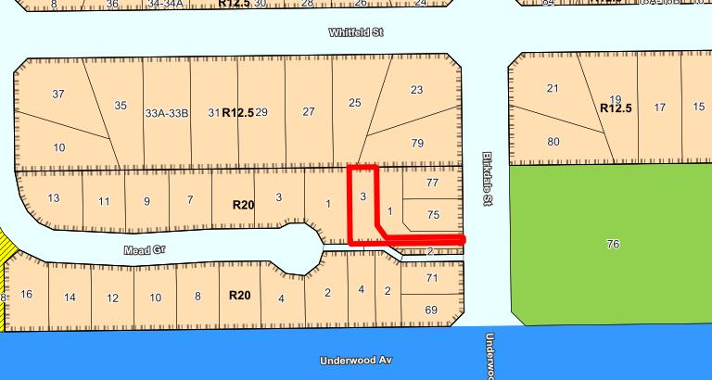

The subject property is relatively flat and consists of a single storey dwelling, with a garage in the south western corner of the lot.

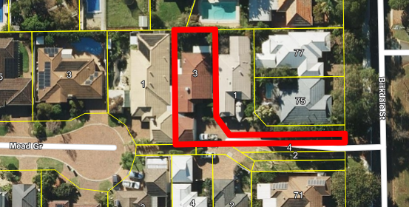
- Application Details

The applicant seeks development approval for alterations to the existing dwelling, including the addition of an upper floor.

The ground floor alterations include:
- Removal of internal doors and walls
- Conversion of an existing bedroom into a rumpus room
- Conversion of an existing bedroom into a study room
- Installation of stairs

The upper floor addition includes:
- Master Bedroom, with Ensuite and walk in robe
- Bathroom
- Two bedrooms
- Sitting room
- Balcony

By way of justification in support of the development application the applicant has
provided a Justification Report, which is provided as Attachment 1 to this report.

- Consultation

The development meets all relevant deemed-to-comply provisions of the Residential Design Codes (R-Codes) with the exception of clause 5.4.1 Visual Privacy. This element has been assessed against the design principles for visual privacy.

Due to the need to assess visual privacy against the design principles, the application was advertised in accordance with the City’s Local Planning Policy - Consultation of Planning Proposals to three surrounding owners and occupiers. During the advertising period, one objection was received for the proposal.

The following table is a summary of the concerns/comments raised and the City’s response and action taken in relation to each issue:

Submission | Officer Response | Action Taken
Objection to the visual privacy setback proposed to the western lot boundary which does not comply with the deemed to comply 7.5m visual privacy setback prescribed in the R-Codes. | The western portion of the balcony facing west is provided with 1.6m high screening. The screening is in accordance with Clause 5.4.1 (C1.2) to prevent direct overlooking from the western portion of the balcony. Condition 4 of this recommendation also reinforces this screening requirement and the required screening shall be thereafter maintained to the satisfaction of the City of Nedlands.  A detailed Design Principle assessment is provided under Section 6.3.1 of this Council Report for the overlooking from the southern elevation of the balcony facing west | Condition 4 is recommended in the Determination and a Design Principle assessment provided under Section 6.3.1 of the report for Visual Privacy.
Proposed development may impact on the future development potential of the neighbouring property. | The R-Codes are intended to ensure external impacts of a development are minimised. Compliance with the design principles will ensure the future development potential of neighbouring properties is not affected. | No further action required.  Design principle assessment provided under Section 6.3.1 of the report for Visual Privacy.

Note: A full copy of all relevant consultation feedback received by the City has been given to the Councillors prior to the Council meeting.

- Assessment of Statutory Provisions

6.1 Planning and Development (Local Planning Schemes) Regulations 2015 (Deemed Provisions)

Clause 67 of the Deemed Provisions stipulates those matters that are required to be given due regard to the extent relevant to the application. Where relevant, these matters are discussed in the following sections.

In accordance with provisions (m) and (n) of the Regulations clause 67, due regard is to be given to the likely effect of the proposed development’s height, scale, bulk and appearance, and the potential impact it will have on the amenity of the locality.

6.2 Local Planning Scheme No. 3

6.2.1 – Clause 9: Aims of the Scheme

Requirement | Proposal | Satisfies
- Protect and enhance local character and amenity | The surrounding area is characterised by Single Houses within the vicinity of Floreat.  The residential dwellings are characterised by two storey, contemporary dwellings, with a mix of pitched and concealed roof forms.  Administration considers that the proposed ground floor alterations and upper floor addition is consistent with the local character and amenity of this particular locality. | Yes
- Respect the community vision for the development of the district; | The development is not considered to adversely affect the community vision for the development of the district in that it is consistent with the endorsed Local Planning Strategy. | Yes
- Achieve quality residential built form outcomes for the growing population; | The built form of the development has been assessed and is considered to achieve the relevant design principles of the R-Codes Vol. 1 and is consistent with the expectations of the Residential R20 density coding. | Yes
- To develop and support a hierarchy of activity centres; | The proposed development is consistent with the intent of the R20 density code. | Yes
- To integrate land use and transport systems; | The subject site is not located within a high frequency public transport route.  The vehicle access for the site will be obtained from Village Mews, which is a minor road of Birkdale Street. | Yes
- Facilitate improved multi-modal access into and around the district; | The subject site is located in close proximity to walking and cycle networks. | Yes
- Maintain and enhance the network of open space | The proposed development does not impact the City’s network of open space. | Yes
- Facilitate good public health outcomes; | The development is not considered to adversely affect the desired public health outcomes. | Yes
- Facilitate a high-quality provision of community services and facilities; | The development is not considered to adversely affect the community services or facilities and will contribute to ensuring their viability. | Yes
- Encourage local economic development and employment opportunities; | The development is considered to positively contribute to economic development and employment opportunities created for builders and tradespersons. | Yes
- To maintain and enhance natural resources; | The development does not propose the removal of trees on the site, which is considered a positive outcome for this type of application. | Yes
- Respond to the physical and climatic conditions; | The development maintains solar access to adjoining properties by having appropriate setbacks.  The dwelling design encompasses cross ventilation and adequate ceilings to allow for effective air circulation. | Yes
- Facilitate efficient supply and use of essential infrastructure; | The development does not negatively impact this objective. | Yes

6.2.2 – Clause 16: Residential Zone Objectives

Requirement | Proposal | Satisfies
- To provide for a range of housing and a choice of residential densities to meet the needs of the community; | The proposal is considered to positively contribute to the City’s housing diversity. | Yes
- To facilitate and encourage high quality design, built form and streetscapes throughout residential areas; | The development has achieved an acceptable design, with an appropriate built form and streetscape presentation. The proposed built form is suitable for the R20 density code. | Yes
- To provide for a range of non-residential uses, which are compatible with and complementary to residential development; | This objective is not applicable to the subject application as this application only proposes the use of the land for Residential purposes. | N/A
- To ensure development maintains compatibility with the desired streetscape in terms of bulk, scale, height, street alignment and setbacks; | The development is considered to achieve a balance between the existing streetscape character and the future character of this area.  The City considers that the proposal complements the local character and amenity of the site, with the two storey height provision which is consistent with the surrounding area.  Where discretion is sought for visual privacy setbacks, the proposal is considered to satisfy the Design Principles for clause 5.4.1 – Visual Privacy. | Yes

6.3 Policy/Local Development Plan Consideration

6.3.1 Residential Design Codes – Volume 1 (State Planning Policy 7.3)

Volume 1 of the R-Codes apply to single and grouped dwellings. The document provides a comprehensive basis for control of residential development.

When assessing applications for development the City must have regard to the following policy objectives:

- to provide residential development of an appropriate design for the intended residential purpose, density, context of place and scheme objectives;
- to encourage design consideration of the social, environmental and economic opportunities possible from new housing, and an appropriate response to local amenity and place;
- to encourage design that considers and respects heritage and local culture; and
- to facilitate residential development that offers future residents the opportunities for better living choices and affordability.

The applicant is seeking assessment under the Design Principles of the R-Codes for Clause 5.4.1 – Visual Privacy as addressed in the below table:

Design Principles
The application seeks assessment under the design principles which are as follows:

“P1.1 Minimal direct overlooking of active habitable spaces and outdoor living areas of adjacent dwellings achieved through:
- building layout and location;
- design of major openings;
- landscape screening of outdoor active habitable spaces; and/or
- location of screening devices.

P1.2 Maximum visual privacy to side and rear boundaries through measures such as:
- offsetting the location of ground and first floor windows so that viewing is oblique rather than direct;
- building to the boundary where appropriate;
- setting back the first floor from the side boundary;
- providing higher or opaque and fixed windows; and/or
- screen devices (including landscaping, fencing, obscure glazing, timber screens, external blinds, window hoods and shutters).”
Deemed-to-Comply Requirement
The deemed to comply setback for the Balcony on the eastern elevation of the upper floor facing east is 7.5m to the eastern lot boundary.

The deemed to comply setback for the Balcony on the southern elevation of the upper floor facing west is 7.5m to the western lot boundary.
Proposed
The Balcony on the eastern elevation of the upper floor facing east proposes a 6.3m setback to the eastern lot boundary.

The Balcony on the southern elevation of the upper floor facing west proposes a 2.5m setback to the western lot boundary.
Administration Assessment
The application meets the Design Principles for the reasons outlined below.

The application proposes minimal direct overlooking of active habitable spaces and outdoor living areas of the adjacent western and eastern properties.

The overlooking from the southern elevation of the balcony, facing west falls over the roof of the garage on the western property (1 Mead Grove, Floreat) as shown in the plans. A garage is not a major opening, active habitable space or outdoor living area. Furthermore, a garage is considered to be a space which is not commonly occupied or frequented for extended periods of time. As such, the overlooking over the garage is not considered to negatively impact the amenity of the western property.

The overlooking from the eastern elevation of the balcony facing east also falls over the setback areas of the eastern property (1 Village Mews, Floreat). The cone of vision of overlooking does not fall over an active habitable spaces or an outdoor living area as shown in the plans. Where the cone of vision for overlooking falls, there is a garage on the property and a bedroom. As mentioned above, a garage is not a habitable space. In relation to the bedroom, there is an existing 1.8m high brick rendered wall between the subject property and the eastern property (1 Village Mews, Floreat) which will prevent overlooking. The overlooking itself from the Balcony does not fall over the bedroom. The cone of vision of the overlooking (7.5m setback) falls over the side setback area of 1 Village Mews, Floreat and over the brick wall.

As such, it is considered that there is minimal overlooking of major openings, active habitable spaces and outdoor living areas of adjacent dwellings achieved through dwelling design, design of major openings and the location of the screening device on the eastern property.

Furthermore, the design of the development of the upper floor addition has been setback from the side lot boundaries with compliant lot boundary setbacks. As such, it is considered that the proposed development does not negatively impact upon future development potential of adjoining properties.

All other major openings along the eastern and western elevations are provided with highlight windows so as to limit overlooking to the eastern and western adjoining properties.

While there is a 1.7m setback from the western portion of the balcony to the western lot boundary, this portion of the balcony is screened in accordance with the deemed to comply provisions of Clause 5.4.1 (C1.2). Condition 4 of this recommendation also reinforces this screening requirement and the screening shall be thereafter maintained to the satisfaction of the City of Nedlands.

Bedroom 2 and 3 on the northern elevation of the upper floor provide compliant setbacks of at least 4.5m, in direct line of sight within the cone of vision which is in compliance with Clause 5.4.1 (C1.1) of the R-Codes.

In light of the above, the application is considered to successfully meet the Design Principles for Clause 5.4.1 – Visual Privacy as it proposes minimal direct overlooking of active habitable spaces and outdoor living areas of the adjacent western and eastern properties.

- Conclusion

The application for additions to the existing single house at 3 Village Mews, Floreat has been submitted for Council consideration as an objection has been received. The objection raises concerns with visual privacy. The proposal is fully compliant with the deemed-to-comply provisions of the R-Codes with the exception of the visual privacy setbacks to the proposed upper storey balcony. These variations have been assessed against the design principles for visual privacy. The western elevation will be provided with screening in accordance with the R-Codes and is considered to be deemed-to-comply. The proposed 6.3m setback to the eastern boundary meets the design principles for visual privacy.

Accordingly, it is recommended that the application be approved by Council, subject to Conditions and Advice Notes.

PD54.20 | Local Planning Scheme 3 – Draft Interim Local Planning Policy - Hollywood West Transition Zone
Committee | 10 November 2020
Council | 24 November 2020
Director | Peter Mickleson – Director Planning & Development
Employee Disclosure under section 5.70 Local Government Act 1995 | Nil
Reference | Nil
Previous Item | Nil
Attachments | - Draft LPP - Hollywood West Transition Zone

- Executive Summary

The purpose of this report is for Council to prepare (adopt for advertising) the Hollywood West Transition Zone Local Planning Policy.

This policy seeks to establish the local planning framework for the Hollywood West Transition Zone. To do this the City is required to establish what the future desired context and character is for these areas and to provide design guidance and certainty for decision makers, the community, and developers in this area. In establishing the desired future character of the precinct, the policy will provide design guidance and built form requirements for development within the Transition Zones. These built form guidelines will balance the preservation of valued elements of built form character with the requirements of the existing local planning framework and associated zoning. These policies will provide a planning instrument to facilitate best practice design in delivering housing diversity in the context of areas which have been significantly up coded in density.

This policy is being presented to Council for consent to advertise to the community in draft format. Further built form modelling is required to be undertaken to test the existing planning framework as well as test the draft policy provisions being presented. This will be undertaken prior to finalising the policy and will be brought back to Council with the associated testing and modelling in its final version for adoption. The built form modelling will provide the necessary information to ascertain the most effective built form controls for this area. However, Administration also wishes to seek feedback on this draft concept from Council and the City’s residents which may involve several rounds of consultation.

- Recommendation to Committee

Council prepares, and advertises for a period of 21 days, in accordance with the Planning and Development (Local Planning Schemes) Regulations 2015 Schedule 2, Part 2, Clause 4, Draft Local Planning Policy Transition Zones (Hollywood West), as per Attachment 1.

- Background

With the gazettal of the Scheme in April 2019, density code increases were implemented across sections of the City of Nedlands. The density increases are concentrated around the areas of the City now known as Precincts, being Town Centre, Stirling Highway East and West, Broadway, Hampden Road and Waratah Avenue.

The City’s Local Planning Strategy identifies the areas directly adjacent to these Precincts as Transition Zones, and states the intention of them as:

“Transition Zones will exist immediately adjacent to Urban Growth Areas for the purposes of creating a buffer between high intensity and low intensity development. This buffer will visually smooth the differences in built form (e.g., height, bulk etc.) and help mitigate any conflict between non-compatible land uses. It is expected the Transition Zones will contain mostly residential developments of multiple dwellings (apartments) and grouped dwellings (townhouses and similar). Some small-scale non-residential uses may still be appropriate.”

Administration have identified several locations bordering the Precincts that have medium to high density coding that function as Transition Zones for low density areas. A suite of Local Planning Policies is being prepared to provide guidance on the preferred built form for these Zones. This will ensure that the desired character of these areas is identified and considered by future development.

Transition Zones Local Planning Policy Preparation Process

To ascertain the existing character of the area, Administration conducted built form character surveys in the Transition Zones. City staff and volunteers from the Urban Planning and Architecture departments at Curtin University and the University of Western Australia undertook the survey. Each street within the Transition Zones was walked, with each dwelling photographed and its features documented.

The data from this survey was collated into spreadsheets, and now offers meaningful information regarding the existing built form of the various Transition Zones. This data provides insight into the aspects of the street that contribute to its character. Key elements that the Policies should seek to retain were identified, such as significant front and rear setbacks, mature vegetation and discreet car parking structures. The Policies have been developed by utilising the information produced from this data.

The Transition Zones Policies will capture the following Transition Zones:

- Hollywood Central;
- Hollywood West;
- Melvista East;
- Melvista West; and
- Hollywood East – it is noted that this will be included in the Hampden Road Activity Centre, due to their proximity and shared unique architectural form.

The draft Local Planning Policies for Hollywood Central, Melvista East and Melvista West have previously been presented to Council for their consent to advertise.

During discussion around these policies between Administration and the Department of Planning, Lands and Heritage (DPLH), Administration has been advised that these policies will be required to be supported by rigorous built form modelling to support the proposed requirements. Built form modelling will provide a sound strategic planning framework to support the policy and provide it with statutory weight, which is vital in the event that the policy is tested in a legislative environment such as the State Administrative Tribunal. Further advice has been provided to the effect that built form controls, once developed, should be incorporated into the Scheme. The appropriate time to undertake scheme amendments will be once built form modelling and consultation have been finalised. Once provisions via scheme amendment have then been adopted and gazetted, those provisions can be removed from the local planning policies.

Community Engagement

A key element in formulating the Transition Zone Policies will be feedback received from the Nedlands community. The initial step in the community engagement program for these Policies has been the Transition Zones – Planning for the Future Your Voice page going live. This page includes a survey that community members can complete to share their thoughts on what they believe the valued elements of their local area are. This page also contains information on what Transition Zones and Precincts are, statements about the character of the Transition Zones, and FAQ’s in relation to the local and state planning framework.

The feedback collected from this survey will be considered in conjunction with the feedback received during the draft Policy’s advertising period. Once built form modelling and peer reviews have been completed, a community engagement program will be created by Administration. This program will bring the community feedback, along with the built form modelling results, together to be presented to Council and the community in an interactive format. The end result of the community engagement program will be that the Policy has been through several rounds of engagement with both the Council and the community, maximising the transparency of the process.

- Detail

This policy applies to all residential developments within the Hollywood West Transition Zone. The Hollywood West Transition Zone Area is located in the Hollywood Ward within the City of Nedlands Local Planning Scheme Area. The Transition Zone area abuts the western LGA boundary, where Nedlands meets the Town of Claremont, stretching west between Loch Street and Martin Avenue, and from Bedford Street in the North to Stirling Highway in the South. Hollywood West has a relatively flat topography, with greater undulation towards Stirling Highway.

A map of Hollywood West is shown in Figure 1.

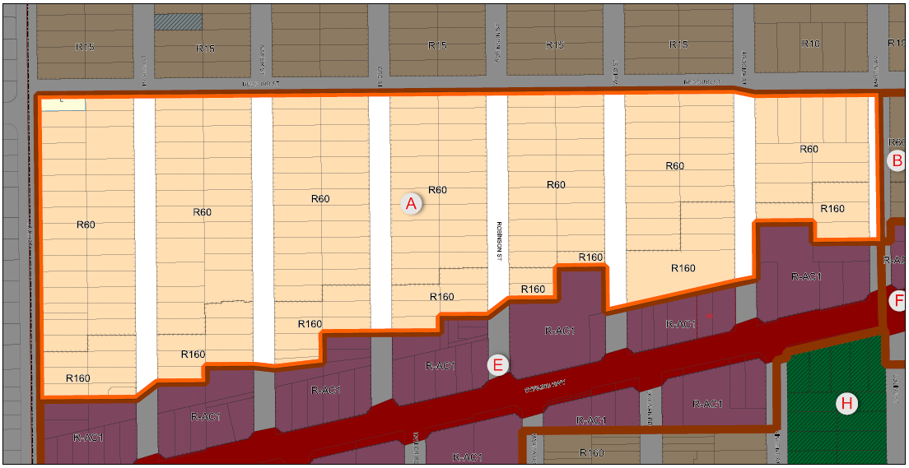
Figure 1 – Hollywood West Transition Zone

The purpose of the Transition Zone Policies is to provide design guidance and built form provisions for residential developments within the Transition Zone. These built form requirements will aid in the preservation of valued elements of built form character within the Transition Zones. The policy is also intended to provide guidance to assist officers in assessing applications for residential developments within Hollywood West.

The City has engaged consultant Hames Sharley to present the Policies in a professional typeset format, including mapping of the precinct areas. This mapping includes representations of the potential pattern of development within the Transition Zone in accordance with the built form provisions proposed. Presenting the Policy and mapping in this manner is intended to provide Council and the community with a tangible representation of the proposed built form controls and how they will translate into real world development outcomes. These provisions will be supported by the built form modelling that will form the testing part of the process of creating these Policies.

- Consultation

If Council resolves to prepare the draft Hollywood West Transition Zone Policies, they will be advertised for 21 days in accordance with Schedule 2, Part 2, Division 2, Clause 4 of the Regulations, and the City’s Local Planning Policy – Consultation of Planning Proposals. This will include a notice being published in the newspaper and details being included on the City’s website (Your Voice engagement portal), a letter posted to all residents and property owners in the Policy area and a social media post.

Following the advertising period, the policy will be presented back to Council for it to consider any submissions received and to:

- Proceed with the policy without modification;
- Proceed with the policy with modification; or
- Not to proceed with the policy.

- Strategic Implications

How well does it fit with our strategic direction?
The City’s Local Planning Strategy identifies urban growth areas and transition zones within the City, which have been reflected in rezoning and up-coding through the Scheme. This Policy provides design guidance for the transition zones, and facilitates urban growth identified in the Strategy in a manner that will impose minimal negative impacts on surrounding residential properties.

Who benefits?
The City and its residents will benefit from this Local Planning Policy. The Policy is intended to reduce the impact of grouped and multiple dwellings developments on single residential dwellings and will establish the position of desired future character for the area in the context of its transitioning nature from low density to more intense infill.

Does it involve a tolerable risk?
The Transition Zones Policies are considered to decrease the risks to the City and its residents that are associated with infill development.

Do we have the information we need?
Further information is required and can be obtained through built form modelling of the proposed provisions for the Transition Zones.

- Budget/Financial Implications

Can we afford it?
The costs associated with this Local Planning Policy are in relation to advertising and built form modelling, both of which are included in the current year budget.

How does the option impact upon rates?
Nil.

- Statutory Provisions

Planning and Development (Local Planning Schemes) Regulations 2015
Under Schedule 2, Part 2, Clause 3(1) of the Regulations the City may prepare a local planning policy in respect to any matter related to the planning and development of the Scheme area.

Once Council resolves to prepare a policy it must publish a notice of the proposed policy in a newspaper circulating the area for a period not less than 21 days.

- Conclusion

The Hollywood West Transition Zones Policy provides design guidance and built form provisions to assist in retaining the valued character elements of the area.

In accordance with advice received from the WAPC, built form modelling is required to provide a sound strategic planning framework to support the policy and provide it with statutory weight, prior to final endorsement.

With the inclusion of thorough built form modelling and community consultation, the Policy will provide a robust strategic and statutory planning framework to guide development within the Transition Zone.

As such, it is recommended that Council endorses administration’s recommendation to prepare (consent to advertise) the Draft Local Planning Policy Transition Zones (Hollywood West).

