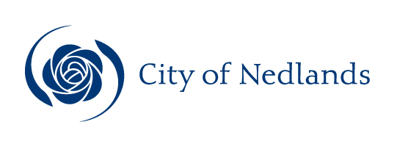

Technical Services Reports

Committee Consideration – 10 November 2020

Council Resolution – 24 November 2020

Table of Contents

Item No. Page No.

TS18.20 Acceptance of Management Orders for New Public Open Space at Montario Quarter, Shenton Park 2
TS19.20 City of Nedlands Waste Plan 6

TS18.20 Acceptance of Management Orders for New Public Open Space at Montario Quarter, Shenton Park

Committee | 10 November 2020
Council | 24 November 2020
Applicant | City of Nedlands
Employee Disclosure under section 5.70 Local Government Act 1995 | Nil
Director | Jim Duff – Director Technical Services
Attachments | - Plan of lots 8001-8004, Deposited Plan 415258  - Photos of lots 8001, 8002 & 8004, Deposited Plan 415258
Confidential Attachments | Nil.

Executive Summary

This report is presented to Council to seek acceptance for Management Orders being issued to the City of Nedlands for lots 8001-8004 on Deposited Plan 415258, Shenton Park. These lots denote the four (4) newly created public reserves associated with Stage 1 of the Montario Quarter development.

Recommendation to Committee

Council:

1. accepts issuing of Management Orders to the City of Nedlands for the four (4) newly created reserves associated with Stage 1 of the Montario Quarter development, Shenton Park known as Dawes Park, Guttmann Park, Orton Park and Seymour Park comprising lots 8001-8004 on Deposited Plan 415258;

2. acknowledges that accepting care, control and management of the four (4) reserves will require an operational budget for maintenance and agrees to allocate funding in the 2021-22 financial year when the City assumes responsibility for maintaining the reserves in September 2021; and

3. acknowledges that final costs for maintaining the four (4) reserves will be presented for consideration during the 2021-22 budget process following competitive procurement of contract maintenance services.

Discussion/Overview

Background

Subdivision of the former Shenton Park Hospital Rehabilitation Hospital site was conditionally approved by the Western Australian Planning Commission (WAPC) on 25 May 2017. As part of the process of approving the new Montario Quarter subdivision development four (4) parcels of land were ceded to the Crown for the purposes of Public Open Space.

The reserves individually known as Dawes Park, Guttmann Park, Orton Park and Seymour Park comprise lots 8001-8004 on Deposited Plan 415258, Shenton Park (Reserves). Development of the Reserves has been completed by DevelopmentWA (DWA) in consultation with the City. The City issued DWA practical completion for development of the Reserves on 23 September 2019.

DWA is responsible for the maintenance of the Reserves for an agreed period of two (2) years following practical completion. Maintenance of the Reserves is currently being undertaken by contractors appointed by DWA. In accordance with Condition 11 of WAPC subdivision planning approval, the City will be responsible for maintaining the Reserves after DWA’s statutory maintenance responsibility ceases.

The Department of Planning, Lands and Heritage is seeking to issue management orders vesting the care, control and management for each of the Reserves to the City in accordance with established practice. Assuming management of public recreation reserves and improving and maintaining these on behalf, and for the benefit, of the community is a core function of local government.

Key Relevant Previous Council Decisions:

Council meeting 22 March 2016 – item 13.4: Shenton Park Rehabilitation Hospital Draft Improvement Scheme – Lot 3240 (No. 6) Selby Street, Shenton Park – Request for Comment.

Consultation

The approved Shenton Park Rehabilitation Hospital Improvement Scheme was subject to extensive community consultation, inclusive of provision and planning of the public open space.

Strategic Implications

How well does it fit with our strategic direction?

Accepting issuing of Management Orders for the Reserves supports the strategic priorities listed below contained in the Strategic Community Plan 2018-28:

- Renewal of Community Infrastructure (roads, footpaths, community and sports facilities)

  - Invest in parks infrastructure in accordance with enviro-scape master plans

- Providing for sport and recreation

  - Increase the level of service for parks, ovals and associated equipment
  - Formulate master plans for strategic recreation areas

Who benefits?

The primary beneficiaries will be property owners and residents residing in, and proximate to, the Montario Quarter development. The level of infrastructure and layout within the Reserves is likely to provide a broader community benefit as they will provide new opportunities to accommodate City and community run events.

Does it involve a tolerable risk?

The City has a Ground Water License (GWL) issued by the Department of Water and Environmental Regulation (DWER). The City’s GWL provides an allocation of 709,300 kilolitres of groundwater abstraction annually for use as irrigation for public open space. DWER have informed industry that GWL allocations will be reduced. The DWER sub district of Nedlands is fully allocated which results in no dispensation to increase the City’s current GWL allocation. The City has consulted with DWER and commenced the process to assign the existing GWL and allocation over the site, currently issued to DWA, across to the City.

Condition 11 of the WAPC approval stipulates DWA’s maintenance responsibility for the Reserves statutorily ceases once the reserves have been developed and maintained for “two summers”. As this condition is open to interpretation, the City has written agreement from DWA that this is interpreted to be 24 months from practical completion being issued by the City, which occurred in September 2019. As security against the eventuation of an alternate interpretation, DWA agreed to provide the City an appropriate guarantee determined on the total contract amount for development of the Reserves secured against the agreed interpretation.

Do we have the information we need?

No further information is required.

Budget/Financial Implications

Development of the Reserves was undertaken by DWA following extensive consultation with the City. Design of the Reserves, along with the selected materials and infrastructure, represents an appreciably higher level of service than parks of a similar hierarchical standing within the City. This was an intended design outcome in response to the higher density associated with the development comprising a mix of small lots and larger unit developments with reduced access to private open space. A consequence of this will be a higher cost in maintaining the Reserves per unit of measure across the various infrastructure. The only comparable facility in the City with a similar level of infrastructure is the Jo Wheatley All Abilities Place Space (JWAAPS). The projected costs for maintaining facilities at the JWAAPS, which have proven relatively accurate, is in the order of 100% above that of other City parks per unit of area.

Can we afford it?

The cost of developing the Reserves was conveyed to DWA as the developer. Maintenance costs over the lifecycle of the Reserves and assets will be inherently compensated by the increase in rates generated by the development.

How does the option impact upon rates?

The Shenton Park Rehabilitation Hospital site was non rateable property prior to its approved subdivision. Stage 1 of the Montario Quarter development comprises 48 lots of mixed zoning with 44 of these being rateable freehold lots. The subdivision development has potential to create up to 1,600 new dwellings which would represent an approximate increase in rateable properties of 17% on current numbers within the City. Application of the minimum rateable amount for 2020/21 to the fully developed subdivision would generate an approximate 10% increase in rates revenue. In this basic scenario, the estimated whole of life cost to maintain the reserves equates to an overall impact of less than 1% impact of overall annual rateable revenue balanced against a conservatively estimated 10% increase.

TS19.20 City of Nedlands Waste Plan

Committee | 10 November 2020
Council | 24 November 2020
Applicant | City of Nedlands
Employee Disclosure under section 5.70 Local Government Act 1995 | Nil
Director | Jim Duff – Director Technical Services
Attachments | - Letter from Department of Water and Environmental Regulation dated 7 November 2019  - Letter to Department of Water and Environmental Regulation dated 4 December 2019  - City of Nedlands Waste Plan  - City of Nedlands Waste Minimisation Strategy and Action Plan 2017-2020

Executive Summary

The City is required to prepare a Waste Plan under Section 40(4) of the Waste Avoidance and Resource Recovery Act 2007. The City of Nedlands Waste Plan has been prepared for endorsement by Council prior to submission to the Department of Water and Environmental Regulation.

The City of Nedlands Waste Plan aligns with the City’s Waste Minimisation Strategy and Action Plan 2017–2020 and the Western Australian Waste Avoidance, Resource Recovery Strategy 2030.

The Waste Plan includes the implementation of Waste to Energy processing from 2022 and Food Organics / Green Organics by 2025. Waste to Energy will provide a cost saving of approximately $28,000 per annum. The implementation of FOGO will result in an increased cost per dwelling of $2.42 plus CPI commencing in year 2.

Recommendation to Committee

Council approve the City of Nedlands Waste Plan for submission to the Department of Water and Environmental Regulation.

Discussion/Overview

The CEO received a letter on 7 November 2019 from the Department of Water and Environmental Regulation requesting the preparation of a Waste Plan under Section 40(4) of the Waste Avoidance and Resource Recovery Act 2007. The Department of Water and Environmental Regulation letter is provided in Attachment 1. The City responded to the letter on 4 December 2019 advising that the City would prepare a Waste Plan as requested. The response letter is provided in Attachment 2.
Waste Avoidance and Resource Recovery Strategy 2030

Historically, Western Australia has generated the highest volume of waste per capita in the nation and has had among the lowest rates of waste recovery. The Waste Avoidance and Resource Recovery Strategy (WARRS) 2030 will guide the State in becoming a sustainable, low-waste circular economy. Figure 1 shows the overall objectives and targets.

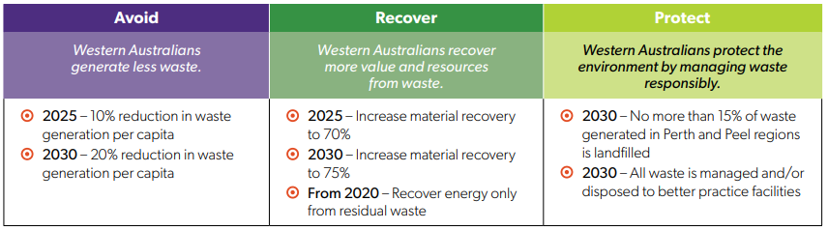 Figure 1 - State Government objectives and targets

City of Nedlands Waste Plan

The City of Nedlands Waste Plan aligns with the City’s Waste Minimisation Strategy and Action Plan 2017–2020 and the targets set out in the Western Australian Waste Avoidance, Resource Recovery Strategy 2030. The City of Nedlands Waste Plan is provided in Attachment 3 and the City of Nedlands Waste Minimisation Strategy and Action Plan 2017–2020 in Attachment 4.

The City has liaised with the Department of Water and Environmental Regulation in preparing the Waste Plan and has incorporated comments and advice provided.

The purpose of the Waste Plan is to:

- Align the City’s waste management activities with WARRS.
- Analyse current performance and establish a benchmark to achieve Waste Strategy targets.
- Monitor progress on local government achievement of Waste Strategy targets.
- Design programs and activities which will support the implementation of waste plans.

The Waste Plan comprises the following sections:

- Part 1 – Services and Performance
- Part 2 – Implementation Plan

Part 1 – Services and Performance establishes the City’s waste profile and baseline information in relation to the objectives and targets set out in the Waste Avoidance and Resource Recovery Strategy 2030.

Part 2 – Implementation Plan is structured around the following sections:

- Waste Services;
- Policies and Procurement;
- Behavior Change Programs and Initiatives; and
- Data.

Waste to Energy

The City of Nedlands Waste Plan is a strategic plan which includes the implementation of Waste to Energy (WTE) processing from 2022. The process is essentially the combustion of waste to produce superheated steam which is sent to a steam turbine to generate electricity for sale on the commercial market.

In accordance with the Waste Avoidance and Resource Recovery Strategy 2030, only the residual waste after recycling and reprocessing should be sent to energy recovery. The City will continue to operate the 3-bin recycling service and only the residual putrescible waste will be sent to Waste to Energy. The implementation of Waste to Energy from 2022 will be the subject of a separate Council report and approval.

Waste to Energy will provide a cost saving of approximately $28,000 per annum based on the current bin stock and new waste contract rates commencing December 2020. This cost saving equates to a cost per dwelling of $3.37.

Food Organics / Green Organics - FOGO
The City of Nedlands Waste Plan also includes the implementation of Food Organics / Green Organics (FOGO) collection and processing by 2025. FOGO will require residents to dispose of kitchen organics into the existing green bin. The green bin collection will change from fortnightly to weekly and the waste bin collection will change from weekly to fortnightly. The green bin contents will be processed into compost to be sold on the commercial market.
In accordance with the Waste Avoidance and Resource Recovery Strategy 2030, the implementation of FOGO needs to occur by 2025. The implementation of FOGO will be the subject of a separate Council report and approval which will include community engagement.
The cost to implement the FOGO service is shown on Table 1. The costs are determined from the current bin stock and new waste contract rates commencing December 2020.

Cost Description | Year 1 | Year 2 | Year 3 | Year 4 | Year 5
Opex
FOGO Collection & Processing | 195,728 | 201,600 | 207,648 | 213,878 | 220,294
Kitchen Caddy Bin Liners |  | 51,294 | 52,833 | 54,418 | 56,050
Kitchen Organics Landfill Diversion (1,603 tonne) | 226,059 | 232,841 | 239,826 | 247,021 | 254,431
Opex Delta | 30,331 | 20,054 | 20,655 | 21,275 | 21,913

Cost Description | Year 1 | Year 2 | Year 3 | Year 4 | Year 5
Capex
Kitchen Caddy’s | 58,100
Community Education | 50,000
Kitchen Caddy Bin Liners | 49,800
Contingency | 10,000
Capex Delta | 167,900
Total FOGO Service delta | 137,569 | 20,054 | 20,655 | 21,275 | 21,913
Total cost per dwelling | N/A | 2.42 | 2.49 | 2.56 | 2.64
Table 1 – FOGO Service Costs

The additional cost will be approximately $138,000 in year 1 reducing to $20,054 per annum plus CPI thereafter. The initial capital expenditure of $137,569 in year 1 is expected to be covered by a Better Bins Grant from the Waste Authority of Western Australia. Therefore, the increased cost per dwelling is $2.42 plus CPI commencing in year 2. The increased cost per dwelling is essentially attributable to the ongoing cost to supply kitchen caddy bin liners.

The FOGO collection and processing cost is attributable to processing the combined greenwaste and kitchen organics into compost. Organic material undergoes a 12-week composting process using the MAF (Mobile Aerated Floor) composting system. The stockpile of raw organic green waste material is spread over a series of perforated pipes into windrows. An electrically powered fan box pumps air through these perforated pipes, allowing oxygen levels to be controlled every minute of the day.

The pre-sort plant includes:

- Infeed Hopper - fed by front end loader
- Drum Feeder - to regulate flow of material to be processed
- Incline conveyor - to transfer material to sorting platform
- Sorting Platform - enclosed sorting platform to remove contamination from processed FOGO
- Overbelt magnet - to recover any residual ferrous material

The plant will require five full time employees to undertake the decontamination of the FOGO delivered. This would include one front end loader operator and four sorters on the picking line.

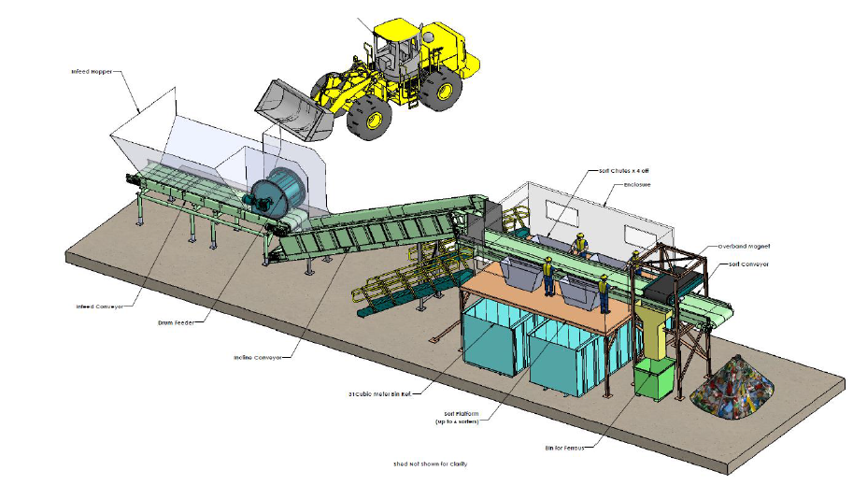
Figure 2 – FOGO Pre-Sort Plant

Stockpiles are watered and conditioned to achieve a 60% moisture content and then a thick 300mm layer of coarse composted mulch is placed over this stockpile. The microbe-rich composted mulch kick-starts the composting process and helps maintain moisture and heat in the stockpile.

All composting operations are conducted on an impermeable asphalt hardstand to prevent any leachate entering the environment. Stormwater and leachate runoff is collected in a leachate collection pond and is reused on the compost stockpiles to achieve and maintain moisture levels.

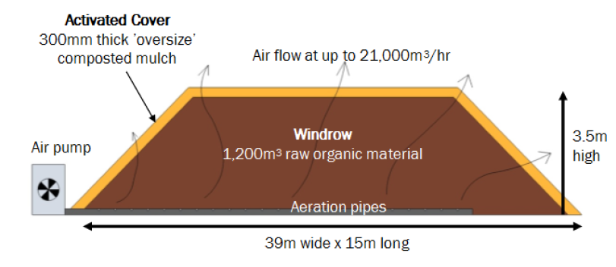Figure 3 – FOGO Processing

The City completed the waste services tender process in August 2020 and is therefore confident that the FOGO implementation costs provided are competitive market costs, at this time.

The new waste services contract commences in December 2020 and is for a five-year term with an option to extend for a further two years. The cost of FOGO may reduce over the next five years as the technology is enhanced in Western Australia and the commercial market for the compost product increases. The option is available for Council to delay the implementation of FOGO until 2025 to test the market again and potentially receive reduced tender rates for the implementation of FOGO.

Technical Services anticipates that the State Government imposed Waste Levy will continue to increase as an economic instrument to reduce waste to landfill and to generate funds for waste and environmental purposes. An increasing landfill levy will result in the cost of FOGO reducing in future years.

Key Relevant Previous Council Decisions:

Nil

Consultation

Not Applicable.

Strategic Implications

How well does it fit with our strategic direction?

The City of Nedlands Waste Plan aligns with the targets and action plan detailed in the Waste Minimisation Strategy 2017–2020 in relation to increasing resource recovery and reducing waste to landfill.

Who benefits?

The entire community benefits from improved environmental outcomes achieved through improving resource recovery and reducing waste to landfill.

Does it involve a tolerable risk?

Risks have been identified and documented in the Implementation Plan and mitigated to an acceptable level.

Do we have the information we need?

The City has quality resource recovery data collected since 2014 to allow for informed decision making on future waste strategies.

Budget/Financial Implications

Can we afford it?

The additional cost will be approximately $138,000 in year 1 reducing to $20,054 per annum plus CPI thereafter. The initial capital expenditure of $137,569 in year 1 is expected to be covered by a Better Bins Grant from the Waste Authority of Western Australia. Therefore, the increased operating cost is $20,054 plus CPI commencing in year 2. This cost is not currently included in the Long-Term Financial Plan.

How does the option impact upon rates?

The introduction of FOGO will result in an increase to the standard waste rate in years 1 to 5, as outlined in the section above.
Conclusion

The City of Nedlands Waste Plan aligns with the City’s Waste Minimisation Strategy and Action Plan 2017–2020 and the Western Australian Waste Avoidance, Resource Recovery Strategy 2030.

The Waste Plan includes the implementation of Waste to Energy processing from 2022 and Food Organics / Green Organics by 2025. Waste to Energy will provide a cost saving of approximately $28,000 per annum. The implementation of FOGO will result in an increased cost per dwelling of $2.42 plus CPI commencing in year 2.

The implementation of Waste to Energy and FOGO will be the subject of a separate Council reports and approval. The implementation of FOGO will include City wide community engagement.

