

Planning and Development Reports

Committee Consideration – 10 September 2019

Council Resolution – 24 September 2019

Table of Contents

Item No. Page No.

PD34.19 No. 20 Nardina Crescent, Dalkeith – Additions to Single House 2
PD35.19 No. 52 Stirling Highway, Nedlands – Single Dwelling 12
PD36.19 No. 100 Stirling Highway, Nedlands – Roof Sign (Retrospective) 19
PD37.19 Scheme Amendment No. 2 – Lot 325-329 Bedford Street, Nedlands 25
PD38.19 Local Planning Scheme 3 – Local Planning Policy Waste Management and Guidelines 35
PD39.19 Local Planning Scheme 3 – Local Planning Policy Parking 38
PD40.19 Local Planning Scheme 3 – Local Planning Policy - Residential Development: Single and Grouped Dwellings 44

Council: 24 September 2019

PD34.19 | No. 20 Nardina Crescent, Dalkeith – Additions to Single House
Committee | 10 September 2019
Council | 24 September 2019
Applicant | Snell Building Services
Landowner | J Liu & Z Gu
Director | Peter Mickleson – Director Planning & Development
Employee Disclosure under section 5.70 Local Government Act 1995 | Nil.
Report Type  Quasi-Judicial | When Council determines an application/matter that directly affects a person’s right and interests. The judicial character arises from the obligation to abide by the principles of natural justice. Examples of Quasi-Judicial authority include town planning applications and other decisions that may be appealable to the State Administrative Tribunal.
Reference | DA19/35759
Previous Item | Nil.
Delegation | In accordance with Clause 6.7.1a) of the City’s Instrument of Delegation, Council is required to determine the application due to objections being received
Attachments | - Applicant’s Justification  - Site Photographs

- Executive Summary

The purpose of this report is for Council to consider a development application received from the applicant on 7 May 2019 for additions to a two-storey single house at No. 20 Nardina Crescent, Dalkeith.

A design principle assessment was carried out in relation to the lot boundary setbacks and building height. It is recommended that the application be approved by Council, subject to conditions because the proposed development meets the relevant design principles for lot boundary setbacks and building height.

The application was advertised to adjoining neighbours in accordance with the City’s Local Planning Policy – Consultation of Planning Proposals. One objection was received during the advertising period. The same objector submitted a second submission after the advertising period had completed.

It is considered that the proposed development satisfies the design principles of the R-Codes and is unlikely to have a significant adverse impact on the local amenity of the area and therefore should be approved by Council.

- Recommendation to Committee

Council approves the development application dated 7 May 2019, with amended plans received on 9 August 2019 for additions to a single house at No. 20 Nardina Crescent, Dalkeith, subject to the following conditions and advice:

- The development shall at all times comply with the application and the approved plans, subject to any modifications required as a consequence of any condition(s) of this approval;

- This development approval only pertains to additions to the single house and associated site works;

- All footings and structures to retaining walls, fences and parapet walls, shall be constructed wholly inside the site boundaries of the property’s Certificate of Title; and

- All stormwater from the development, which includes permeable and non-permeable areas shall be contained onsite.

Advice Notes specific to this proposal:

- A separate development application is required to be submitted to and approved by the City prior to erecting any fencing within the street setback area(s) which is not compliant with the deemed-to-comply provisions of the Residential Design Codes, and/or erecting any fencing behind the primary street setback area which is more than 1.8m in height above natural ground level;

- All street tree assets in the nature-strip (verge) shall not be removed. Any approved street tree removals shall be undertaken by the City of Nedlands and paid for by the owner of the property where the development is proposed, unless otherwise approved under the Nature Strip Improvement approval;

- All swimming pool wastewater shall be disposed of into an adequately sized, dedicated soak-well located on the same lot. Soak-wells shall not be situated closer than 1.8m to any boundary of a lot, building, septic tank or other soak-well;

- All swimming pools, whether retained, partially constructed or finished, shall be kept dry during the construction period. Alternatively, the water shall be maintained to a quality which prevents mosquitoes from breeding;

- All downpipes from guttering shall be connected so as to discharge into drains, which shall empty into a soak-well; and each soak-well shall be located at least 1.8m from any building, and at least 1.8m from the boundary of the block. Soak-wells of adequate capacity to contain runoff from a 20-year recurrent storm event. Soak-wells shall be a minimum capacity of 1.0m3 for every 80m2 of calculated surface area of the development;

- All internal water closets and ensuites without fixed or permanent window access to outside air or which open onto a hall, passage, hobby or staircase, shall be serviced by a mechanical ventilation exhaust system which is ducted to outside air, with a minimum rate of air change equal to or greater than 25 litres / second;

- The applicant is advised to consult the City’s Visual and Acoustic Privacy Advisory Information in relation to locating any mechanical equipment (e.g. air-conditioner, swimming pool or spa) such that noise, vibration and visual impacts on neighbours are mitigated. The City does not recommend installing any equipment near a property boundary where it is likely that noise will intrude upon neighbours;

Prior to selecting a location for an air-conditioner, the applicant is advised to consult the online fairair noise calculator at www.fairair.com.au and use this as a guide to prevent noise affecting neighbouring properties;

Prior to installing mechanical equipment, the applicant is advised to consult neighbours, and if necessary, take measures to suppress noise; and

- This decision constitutes planning approval only and is valid for a period of two years from the date of approval. If the subject development is not substantially commenced within the two-year period, the approval shall lapse and be of no further effect.

- Background

3.1 Land Details

Metropolitan Region Scheme Zone | Urban
Local Planning Scheme Zone | Residential
R-Code | R10
Land area | 1171.1m²
Additional Use | No
Special Use | No
Local Development Plan | No
Structure Plan | No
Land Use | Residential
Use Class | P

3.2 Locality Plan

The subject property is relatively flat and accommodates an existing two-storey single house and associated dividing fencing. The subject property is surrounded by residential dwellings and in a locality that displays primarily residential characteristics.

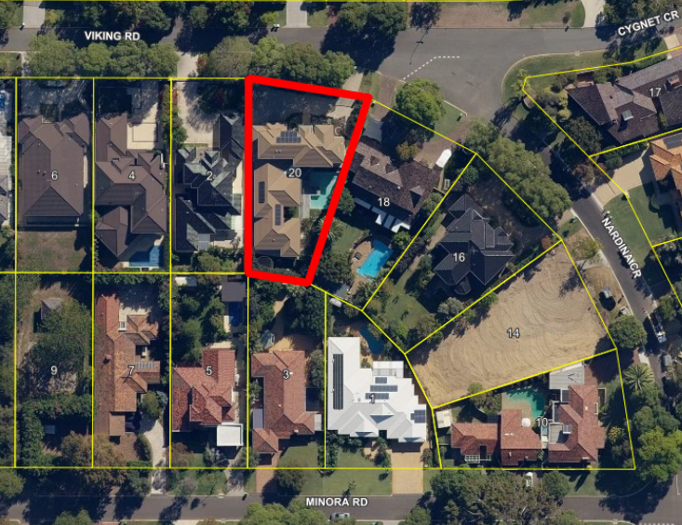
- Application Details

The applicant seeks development approval for additions to a two-storey single house at No. 20 Nardina Crescent, Dalkeith, details of which include the following:

- Three bedrooms to the upper floor,
- Four bathrooms to the upper floor,
- Games room to the upper floor,
- Additional ground floor stair well leading to the upper floor extension.

By way of justification in support of the development application, the applicant has submitted a design principles assessment provided as an attachment to this report (attachment 1).

- Consultation

The applicant is seeking assessment under the Design Principles of the R-Codes for the following:

- Lot boundary setbacks
- Building Height

The development application was therefore advertised in accordance with Council’s Neighbour Consultation Policy to two residents and landowners. One objection was received during the advertising period. The same objector submitted a second submission after the advertising period had completed, in conjunction to the first submission. As such, there was one submission with an objection and there was one non-submitter from neighbour consultation carried out.

The following table is a summary of the concerns/comments raised and the City’s response and action taken in relation to each issue:

Submission | Officer Response | Action Taken
The addition will impact upon the privacy of the objector’s property due to 7 windows which face into the backyard, pool and alfresco of the property.  The application does not meet the Design Principle for Clause 5.1.3 of the R-Codes due to overlooking. It has been requested that screening measures be put in place to address our concerns. | The application is compliant with Clause 5.1.4- Visual Privacy of the R-Codes. The upper floor additions are setback at a sufficient distance to prevent any overlooking issues to the eastern property. The upper floor additions along the western elevation are all minor openings because the windows are highlight windows.  It should be noted that all openings of bedroom additions of the upper floor along the eastern elevation are located in excess of 9m from the eastern lot boundary. The games room is setback 4.746m from the eastern lot boundary. The applicant provided amended plans on 9 August 2019 making the games room opening along the upper floor eastern elevation a minor opening.  The visual privacy component of the development is assessed against Clause 5.1.4- Visual Privacy of the R-Codes. Since the application is entirely compliant with the requirements of visual privacy, an assessment against the design principles of other clauses of the R-Codes such as Clause 5.1.3 as stated in the objection is not required to assess the visual privacy.  The R-Codes require permanent screening when major openings are not setback according to the deemed-to-comply setback requirements for Clause 5.1.4-Visual Privacy. The application is compliant with the deemed-to-comply setback requirements and as such, no screening is required to restrict views within the cone of vision from any major openings.  However, to address the objection received, the applicants submitted amended plans to make the games room window a minor opening. This is because the games room is located in the closest proximity to the eastern lot boundary whereas the rest of the habitable rooms on the upper floor of the eastern elevation are setback considerably from the lot boundary. | All the windows of the upper floor additions facing east are compliant with the requirements of visual privacy and no screening measures are required- no action is required.
The proposed eastern side setback of 4.746m in lieu of the required 6.6m will present excessive building bulk when viewed from the property and is unnecessary given the scale of the already dominant two storey dwelling on site.  The application does not meet the Design Principle for reducing building bulk on adjoining properties, resulting in an impact on the amenity of the property. | The impacts of building bulk upon the eastern lot boundary are considered to be minor. The additions to the dwelling and elevations which feature multiple major openings and setbacks allow the perception of building bulk to be broken up. Additionally, the varying setbacks and the design of the dwelling will help to add visual depth to the dwelling.  There is some vegetation located along the lot boundary to the east on the neighbour’s property. This vegetation will act as additional screening for the proposed additions. This vegetative screening is considered to reduce the impact of the building bulk on the property to the east. | The setback is considered to comply with the design principles of the R Codes and therefore- no action is required.
The building height of 6.3m in lieu of 6m will result in excessive building bulk when viewed from the eastern property. | The elevation of the dwelling which has a building height of 6.3m is setback at a minimum distance of 12.69m from the eastern lot boundary. The maximum setback provided from the eastern elevation is 16m. It is considered that the additional 0.3m in building height over a minimum setback of 12.69m is unlikely to present any building bulk issues to the eastern property. | The building height is considered to comply with the design principles- no action required.

Note: A full copy of all relevant consultation feedback received by the City has been given to the Councillors prior to the Council meeting.

- Assessment of Statutory Provisions

6.1 Planning and Development (Local Planning Schemes) Regulations 2015

Schedule 2, Part 9, clause 67 (Matters to be considered by local government) stipulates those matters that are required to be given due regard to the extent relevant to the application. Where relevant, these matters are discussed in the following sections.

In accordance with provisions (m) and (n) of the Regulations clause 67, due regard is to be given to the likely effect of the proposed development’s height, scale, bulk and appearance, and the potential impact it will have on the local amenity.

6.2 Policy/Local Development Plan Consideration

6.2.1 Residential Design Codes – Volume 1 (State Planning Policy 7.3)

The applicant is seeking assessment under the Design Principles of lot boundary setbacks and building height of the R-Codes as addressed in the below tables:

Clause 5.1.3 Lot Boundary Setbacks

Design Principles
The application seeks assessment under the design principles which are as follows:

P3.1 Buildings set back from lot boundaries or adjacent buildings on the same lot so as to:
- reduce impacts of building bulk on adjoining properties;
- provide adequate direct sun and ventilation to the building and open spaces on the site and adjoining properties; and
- minimise the extent of overlooking and resultant loss of privacy on adjoining properties.
Deemed-to-Comply Requirement
The required upper floor setback is 6.6m from the eastern lot boundary.

The required upper floor setback is 3.3m from the western lot boundary.
Proposed
The minimum upper floor setback proposed to the eastern lot boundary is 4.746m

The minimum upper floor setback proposed to the western lot boundary is 1.8m
Administration Assessment
The minimum setback provided to the east is 4.746m from the upper floor addition of the Games Room and Bathroom 8 which has a total wall length of 8.79m with a non-major opening. As there are varying setbacks along the eastern elevation, if this wall was assessed independently with a length of 8.79m and a height of 6.3m with a non-major opening, a setback of 1.2m would be required. The provided setback of 4.476m is much greater than the required 1.2m from an individual setback assessment.

Considering this individual setback, the upper floor elevation of the games room which is closest to the eastern lot boundary poses minimal building bulk to the adjoining eastern property. The remainder of the upper floor additions which consist of bedrooms and bathrooms are setback at a minimum distance of 12.69m from the eastern lot boundary. With the provision of a 12.69m setback to the east, the proposed upper floor additions are unlikely to result in any building bulk to the east.

There is some vegetation located along the lot boundary to the east and south. This vegetation will act as additional screening for the proposed additions. This vegetative screening is considered to reduce the impact of the building bulk of the proposed development.

The upper floor additions are setback 1.8m from the western lot boundary in lieu of the deemed to comply requirement of 3.3m. It is considered that an encroachment of 1.5m to the western lot boundary acceptable given that the property to the west is also a two-storey house. The property to the west at No. 2 Viking Road, Dalkeith is also setback approximately 1.5m to the subject property at No. 20 Nardina Crescent, Dalkeith. It is considered that the upper floor additions will not unduly result in building bulk issues upon the western property.

The development proposes various habitable rooms facing north on the upper and ground floors. This allows for the effective passive solar design given the large major openings facing north in conjunction with uncovered usable open space. Additionally, the proposed development is fully compliant with the provisions of Clause 5.4.2 – Solar Access for Adjoining Sites. As such, no adjoining site will be denied any measurable and adequate access to direct sun.

In the context of ventilation, the proposed development is complaint with Clause 5.1.4 – Open Space, features no boundary walls, and an alfresco open on three sides. This permits adequate airflow around the dwelling and also on neighbouring properties.

Additionally, all other openings have been adequately setback from their respective boundaries as to avoid overlooking to the southern, eastern and western lots. The proposed development is compliant with Clause 5.1.4- Visual Privacy. As such, the proposed development respects the visual privacy of the adjoining sites with large setbacks provided to the eastern lot boundary and southern lot boundary and minor openings through highlight windows which face west.

Clause 5.1.6 Building Height

Design Principles
The application seeks assessment under the design principles which are as follows:

P6 Building height that creates no adverse impact on the amenity of adjoining properties or the streetscape, including road reserves and public open space reserves; and where appropriate maintains:
- adequate access to direct sun into buildings and appurtenant open spaces;
- adequate daylight to major openings into habitable rooms; and
- access to views of significance.
Deemed-to-Comply Requirement
For pitched roof designs, the maximum wall height is 6m as measured from natural ground level directly beneath the wall.
Proposed
The wall height to the eastern elevation is 6.3m.

The wall height to the western elevation is 6.9m.
Administration Assessment
Town Planning Scheme No. 2 was repealed on the 16th April 2019 with the gazettal of Local Planning Scheme No. 3 which does not contain building height provisions for single and grouped dwelling developments, hence the City is required to use the Residential Design Codes for assessing residential building height.

Until such time as a local planning policy is adopted which modifies the building height requirements, the City is required to use the R-Codes provisions. On the Special Council Meeting of 2 May 2019, the Council adopted a Local Planning Policy for Residential Development which includes that building height be assessed in accordance with Category B of the R Codes, with height measured in accordance with Figure series 7 and Table 3 which specifies a wall height of 6m and roof height of 9m for pitched roof designs as measured above natural ground level directly below the wall and roof pitch.

At the Ordinary Council Meeting of 25 June 2019, the Council:

- resolves that, notwithstanding the removal of building height provisions from transitioning from Town Planning Scheme 2 to Local Planning Scheme 3, the height limits in Clause 2 below are to be taken as default policy provision for residential developments up to and including single and grouped dwellings; and
- determines that the Residential Development Local Planning Policy should specify height limits for single and grouped dwellings in the residential zone as follows:
- Maximum Building Heights:
  - Top of external wall (roof above) 8.5m
  - Top of external wall (concealed roof) 8.5m

The intention of this resolution is to ensure the height limits for residences that have been in place since 1985 continue unchanged, notwithstanding any new flexibility and/or constraints arising from adoption of the new Local Planning Scheme 3 by the City of Nedlands.

Since 1985, Town Planning Scheme No. 2 has allowed an 8.5m wall and 10m building height for all development which were established prior to the R-Codes. Under the new Local Planning Scheme 3, maximum height limits for residential development default to those specified in the R-Codes, resulting in lower maximum heights of 6m and 9m respectively. This change will create anomalies in the streetscape with differing two-story building heights as well as an increased number of referrals of development applications to Council for determination.

The reduction in residential building heights in an area where larger than average homes have been the norm will create in effect two classes of residence thereby on average
reducing the values of new affected properties. Reduced height may also result in lower internal ceiling heights (more boxy rooms) with less efficient ventilation and sense of space.

There is now discretion for decision makers to vary the maximum heights specified in the R-Codes under LPS 3, unlike the situation under TPS 2.

The elevation of the dwelling which has a building height of 6.3m is setback at a minimum distance of 12.69m from the eastern lot boundary. The maximum setback provided from the eastern elevation is 16m. It is considered that the additional 0.3m in building height over a minimum setback of 12.69m is unlikely to result in any negative impact upon the access to direct sun into buildings and open spaces to the property to the east.

A 6.9m building height is proposed to the west. However, there are varying building heights along this elevation, with the maximum height being 6.9m. The remainder of the building heights vary from 5.96m and 6.3m. The varying building heights respond to the natural contour of the land and allow for some depth to the building façade from the west.

The proposed upper floor additions are located primarily towards the middle and rear of the existing single house. The dwelling itself to the Eastern property is located towards the front (north of the property). It is considered that the additional building height of 0.3m is unlikely to negatively adequate daylight to major openings into habitable rooms for the eastern property at No. 18 Nardina Crescent, Dalkeith.

As shown in the locality plan of this report, the subject lot is bounded by residential land uses and there are no particular views of significance. As such, the proposed additions to the single house are not considered to unduly impact on any access to views of significance for the adjoining properties.

The lot boundary setbacks to the northern, southern and rear lot boundaries and the open space provided for the lot also meets the deemed to comply requirements. The building height is therefore considered to within the context of the locality and addresses the contours of the land.

The wall heights proposed are assessed as being within the context of the locality. The building height provision of 8.5m for a pitched roof is prevalent within the locality of Dalkeith which was previously applicable Town Planning Scheme No. 2. This had been in place prior to the R-Codes coming into effect and therefore the 8.5m wall height and 10m roof height are well established throughout the locality. It is considered that the proposed development meets the design principle and is appropriate to the local context of the site.

- Conclusion

The proposed development is considered to satisfy the design principles of the R-Codes for the lot boundary setbacks and building height as presented in section 6.2.1 of this report. Considering the nature and the scale of the development, the site layout and the local development context, the development will conform to the anticipated development context and is unlikely to have a detrimental impact on the local amenity.

In light of the above, it is recommended that Council approves the application subject to conditions.

PD35.19 | No. 52 Stirling Highway, Nedlands – Single House
Committee | 10 September 2019
Council | 24 September 2019
Applicant | SSB Pty Ltd t/a Content Living the Home Builder
Landowner | Stirling High Pty Ltd
Director | Peter Mickleson – Director Planning & Development
Employee Disclosure under section 5.70 Local Government Act 1995 | Nil.
Report Type  Quasi-Judicial | When Council determines an application/matter that directly affects a person’s right and interests. The judicial character arises from the obligation to abide by the principles of natural justice. Examples of Quasi-Judicial authority include town planning applications and other decisions that may be appealable to the State Administrative Tribunal.
Reference | DA19/34537
Previous Item | Nil.
Delegation | In accordance with the City’s Instrument of Delegation, Council is required to determine the application when discretion exists to approve the application and the officer recommendation is for refusal.
Attachments | - Site Photographs  - Main Roads Comment

- Executive Summary

The purpose of this report is for Council to determine a development application received from the applicant on the 15 February 2019, for a proposed single house at No. 52 Stirling Highway, Nedlands.

The single house is proposed on property which is zoned Mixed Use and is subject to the provisions of the City’s Local Planning Scheme No. 3. These provisions, clause 32.4 (2) and (3) specify that within the Mixed-Use zone, residential uses are not permitted on the ground floor facing the primary street and buildings are to have an active frontage to the primary street. Therefore, the single house does not comply with the provisions of the Scheme.

The application was advertised to adjoining neighbours within 100m of the subject property in accordance with the City’s Local Planning Policy – Consultation of Planning Proposals. Two submissions of no objection were received during the consultation period.

This is a very important application (a possible “test case”) in that it is the first time Council have been asked to determine an application that is in conflict with its adopted Local Planning Strategy. How Council determines this application is likely to impact on subsequent applications of a similar nature and set the scene for how Administration deals with applications that it has delegated authority to determine.

Although, in this case, the development complies with the provisions of the R-Codes, it does not comply with the City’s Local Planning Strategy which identifies Stirling Highway has a ‘Targeted Infill Urban Growth Area’. The proposed “under-development” of this site with a single house instead of more dense development anticipated in the Local Planning Strategy poses the question that if more single houses are approved in this zone will the density the City is required to accommodate be pushed further into the suburbs away from Stirling Highway?

After very careful consideration it is recommended that the application be refused as the development does not comply with the scheme provisions nor the objectives of the Mixed-Use zone. The objectives of the Mixed-Use zone require active frontages at street level, a mixture of land uses and a scale of new development sympathetic to the desired character of the area. The development of a single house will reduce the City’s ability to meet density targets and create an undesirable residential amenity for the property when neighbouring properties are developed in the future at a much higher density. (i.e. a 4-story wall on all boundaries as of right)

- Recommendation to Committee

Council refuses the development application dated 15 February 2019 at Lot 14, No. 52 Stirling Highway, Nedlands, for the following reasons:

- The development is inconsistent with the City’s Local Planning Strategy which outlines Stirling Highway as being an Urban Growth Corridor to facilitate the majority of in-fill housing for the municipality;

- As per clause 32.4 (2), residential uses are not permitted on the ground floor facing the primary street;

- As per clause 32.4 (3), the development does not have an active frontage facing Stirling Highway;

- The development does not meet the objectives of the zone as follows:

  - To facilitate development of an appropriate scale which is sympathetic to the desired character of the area;

  - To provide a variety of active uses on street level which are compatible with residential and other non-active uses on upper levels; and

  - To allow for the development of a mix of varied but compatible land uses.

- Background

3.1 Land Details

Metropolitan Region Scheme Zone | Urban
Metropolitan Region Scheme Reserve | Primary Regional Road
Local Planning Scheme Zone | Mixed Use
R-Code | R-AC1
Land area | 1044m²
Additional Use | No
Special Use | No
Local Development Plan | No
Structure Plan | No
Land Use | Existing – Vacant  Proposed – Residential
Use Class | Proposed – P

3.2 Locality Plan

The subject site is zoned Mixed Use with a density code of R-AC1 under Local Planning Scheme No. 3 (LPS 3). The site is located on the southern side of Stirling Highway, within the street block bounded by Thomas Street and Tyrell Street. The lot has a total area of 1044m² with approximately 221.8m² of land reserved for Primary Regional Roads under the Metropolitan Region Scheme (MRS). The site is positioned within the street block and has a single primary street frontage and vehicle access to Stirling Highway. The lot is currently vacant and has a slight slope down away from Stirling Highway to the rear of the lot.

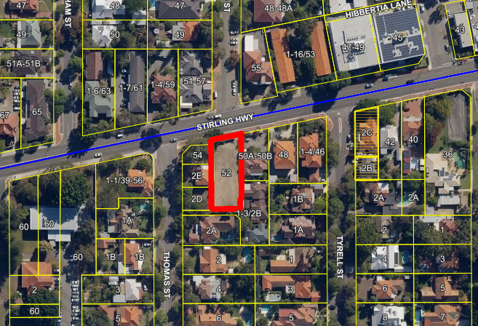

The development application was lodged when Town Planning Scheme No. 2 was still in force. The City referred the application to Main Roads (MRWA) for comment for the required 30 days and also assessed the application against TPS 2 and the Residential Design Codes. The initial proposal was more likened to two grouped dwellings with two kitchens and two laundries in separate parts of the house only connected by a doorway. This could not comply with the planning legislation nor building legislation and therefore amended plans were requested.

Amended plans which clearly demonstrated only one house were not received until April 2019 and therefore the development could no longer be considered under TPS 2 and hence required assessment under the new Local Planning Scheme No. 3 (LPS 3) which was gazetted on 16 April 2019.

- Application Details

The applicant seeks development approval for a single storey single house with:

- 5 bedrooms and bathrooms;
- One laundry;
- Painting room and adjacent cleaning room;
- Study, music room and formal sitting;
- Sitting and kitchen in open plan area;
- Entertaining space;
- Double garage; and
- Two entry points

The applicant has not provided a justification against the scheme provisions for the development.

- Consultation

The development is seeking discretion against scheme provisions clause 32.4 (2) and 32.4 (3) for the following:

- Lot boundary setbacks
- Visual Privacy

The development application was therefore advertised in accordance with City’s Local Planning Policy – Consultation of Planning Proposals to all residents, business owners and landowners within 100m of the subject property. No objections and two non-objections were received. The content of the non-objections is namely in favour of the development of the lot and preference for single storey development generally in the area.

Note: A full copy of all relevant consultation feedback received by the City has been given to the Councillors prior to the Council meeting.

- Assessment of Statutory Provisions

6.1 Planning and Development (Local Planning Schemes) Regulations 2015

Schedule 2, Part 9, clause 67 (Matters to be considered by local government) stipulates those matters that are required to be given due regard to the extent relevant to the application. Where relevant, these matters are discussed in the following sections.

In accordance with provisions (m) and (n) of the Regulations clause 67, due regard is to be given to the likely effect of the proposed development’s height, scale, bulk and appearance, and the potential impact it will have on the local amenity.

6.2 Local Planning Strategy – 2017

Although the development complies with the provisions of the R-Codes, it does not comply with the City’s Local Planning Strategy which identifies Stirling Highway has a ‘Targeted Infill Urban Growth Area’. The strategy envisages that Urban Growth Areas will contain the most intense development in the City of Nedlands.

Under part 5.1 Population and Housing, the strategy aims to facilitate potential realisation of the specified housing targets and to pursue diverse high intensity development within Urban Growth Areas (particularly Stirling Highway). The strategy cites that the Local Government is to develop controls to ensure key sites are not underdeveloped, thus ensuring existing residential character is protected long term and development is focused in a few specified locations.

Part 5.9.10 of the strategy sets out includes planning the highway as a high intensity, predominantly medium rise Urban Growth Area within the City of Nedlands.

The subject site is assigned a density code of R-AC1, the highest density code provided for by the Residential Design Codes. The site is in a key strategic location to deliver significant residential redevelopment to meet the needs of the City’s growing population and contribute to the City’s dwelling targets assigned by Perth and Peel @ 3.5million. With a plot ratio of 3.0 assigned to the R-AC1 density, there is potential for the site to accommodate up to approximately 35 new dwellings. It is also noted the site is within a 400m walkable catchment of the ‘Nedlands Town Centre’, being located approximately 290m away.

The scale of development anticipated by the State Planning Framework, Local Planning Strategy and Local Planning Scheme for the Stirling Highway corridor is one that is much higher and more intense than the current suburban context and promotes higher density apartment-style housing in more intensive multi-level forms. If Stirling Highway were to develop with single storey or even only a two-storey format it would be an under-realisation of the strategic expectations of this targeted infill urban growth area. As such, the proposal represents a significant under-development of the site and does not achieve a level of development appropriate for the growth corridor.

6.3 Local Planning Scheme No. 3

Part 3 clause 16 – Table 2 – Zone objectives

The objectives of the Mixed-Use zone are as follows:

- “To provide for a significant residential component as part of any new development.
- To facilitate well designed development of an appropriate scale which is sympathetic to the desired character of the area.
- To provide for a variety of active uses on street level which are compatible with residential and other non-active uses on upper levels.
- To allow for the development of a mic of varied but compatible land uses such as housing, offices, showrooms, amusement centres and eating establishments which do not generate nuisances detrimental to the amenity of the district or to the health and safety of its residents.”

Part 4 clause 32 – Table 6 - Additional site and development requirements

Clause 32.4 sub clause 2 and 3 are relevant to this application and are listed as follows:

“(2) Residential uses are not permitted on the ground floor facing the primary or secondary streets, except where the use faces a right-of-way or laneway in the Mixed-Use zone, or where identified in an approved local planning policy.
(3) Buildings are to have active frontages to the primary and/or secondary street, except where a use faces a right-of-way or laneway.”

Approval of the application would create a significant undesirable precedent in the consideration of similar proposals on all other sites directly adjacent to Stirling Highway. As a result, there would be significant risk to the City in achieving the dwelling targets set out by the wider Regional Planning Framework.

It is noted that although LPS 3 provides for discretion in considering variations to Clause 32 requirements, there is currently no guidance provided in the planning framework about how to apply discretion in relation to these specific requirements. A decision to vary these Scheme requirements from the outset of the Scheme’s gazettal without further planning guidance will likely create an undesirable development precedent.

Further to this, when considering the objectives of the Mixed-Use zone, there may be opportunities to deliver developments in select locations of only residential land use but the form of this type of development is required to have appropriate density to ensure the residential amenity of development on the highway is consistent and of an appropriate scale to mitigate the impacts of noise and other environmental factors from being within close proximity of the highway. Further to this, the locations where this may be appropriate have not yet been determined as the City is currently undertaking work in this area which may result in Precinct Plans being created for sections of the highway.

6.4 Policy/Local Development Plan Consideration

6.4.1 Residential Design Codes – Volume 1 (State Planning Policy 7.3)

As the development is a single house within the R-AC1 density code, the development complies with the deemed to comply criteria which would usually be applicable for a much smaller lot.

6.4.2 Rail and Road Transport Noise – State Planning Policy 5.4

A noise-sensitive development is defined within the policy as any proposed development for a noise-sensitive land use that would normally require planning approval by a local government authority or the WAPC. The Policy states that discretion may be exercised by a local government authority to apply this policy in the case of an application for a building permit for a single house that would not ordinarily require planning approval but would be subject to critical levels of noise given its location adjacent to a major transport corridor.

For residential buildings, acceptable indoor noise levels are LAeq(Day) of 40dB(A) in living and work areas and LAeq(Night) of 35dB(A) in bedrooms.

The following table outlines the acceptable noise criteria.

Time of day | Noise Target | Noise Limit
Day (6 am–10 pm) | LAeq(Day) = 55dB(A) | LAeq(Day) = 60dB(A)
Night (10 pm–6 am) | LAeq(Night) = 50dB(A) | LAeq(Night) = 55dB(A)

The applicant has not provided any details as to how compliance will be achieved with this policy and therefore should this development proceed, a noise assessment is required to be submitted demonstrating either acceptable noise levels are achievable inside and outside the development or the noise can be managed through other methods as specified within the implementation guidelines.

- Conclusion

The development does not comply with the development provisions nor the mixed-use zone objectives of Local Planning Scheme No. 3. The applicant has not submitted justification to support what can be considered a significant under-development of the property. The non-objections received were due to the neighbouring landowners wanting to keep the area as a low-density area which is contrary to the Local Planning Strategy adopted by Council and the WAPC and the associated zoning and scheme provisions applicable in Local Planning Scheme No. 3.

A decision to approve this development which varies numerous Scheme requirements and objectives of the Mixed-use zone from the outset of the Scheme’s gazettal without further planning guidance will likely create an undesirable development precedent and reduce the City’s ability to meet density targets within the urban growth corridor, placing further pressure on areas which are less suitable for increased density to be rezoned in the future.

PD36.19 | No. 100 Stirling Highway, Nedlands – Roof Sign (Retrospective)
Committee | 10 September 2019
Council | 24 September 2019
Applicant | Element
Landowner | Independent Cinemas Pty Ltd
Director | Peter Mickleson – Director Planning & Development
Employee Disclosure under section 5.70 Local Government Act 1995 | Nil.
Report Type  Quasi-Judicial | When Council determines an application/matter that directly affects a person’s right and interests. The judicial character arises from the obligation to abide by the principles of natural justice. Examples of Quasi-Judicial authority include town planning applications and other decisions that may be appealable to the State Administrative Tribunal.
Reference | DA19/36628
Previous Item | PD23.18 Municipal Inventory– May 2018  PD06.19 Request to remove deed – February 2019
Delegation | Refusal of applications where discretion exists for Council to approval the variations under the City’s Local Planning Scheme No. 3 or policies.
Attachments | - Site Photograph – January 2019  - Listing on Municipal Inventory  - Applicant’s report  - Main Roads comment

- Executive Summary

The purpose of this report is for Council to determine a retrospective development application received from the applicant on the 12 June 2019, for an existing roof sign to the ‘Windsor Cinema’ at No. 100 Stirling Highway, Nedlands.

The application was advertised to adjoining neighbours in accordance with clause 5.3 of the City’s Local Planning Policy – Consultation of Planning Proposals. No submissions were received during the consultation period. The application was also referred to Main Roads for comment with submission of no comment/objection received.

It is recommended that the application be refused by Council as the development does not comply with the provisions of the City’s Signs Local Planning Policy, namely the size of the signage and also the signage being for third party advertising and not in relation to the business on site. The City has no ability to take into consideration the success or failure of a business based on the source of income from unauthorised development nor the ability to consider the land use as a ‘community benefit’.

- Recommendation to Committee

Council refuses the retrospective development application dated 12 June 2019 for a Roof Sign at No. 100 (Lot 123) Stirling Highway, Nedlands, for the following reason:

- The roof sign does not comply with the City’s Local Planning Policy – Signs objective “to avoid the proliferation of signs or signage which are not relevant to the business”, as the signage relates to third party advertising.

- Background

3.1 Land Details

Metropolitan Region Scheme Zone | Urban
Metropolitan Region Scheme Reserve | Primary Regional Road
Local Planning Scheme Zone | Mixed Use
Land area | 2532m2
Additional Use | No
Special Use | No
Local Development Plan | No
Structure Plan | No
Land Use | Cinema/theatre
Use Class | X – non-conforming use rights exist as a result of LPS 3 gazettal in April 2019

3.2 Locality Plan

The subject property is located on Stirling Highway within close proximity of the Dalkeith Road intersection.

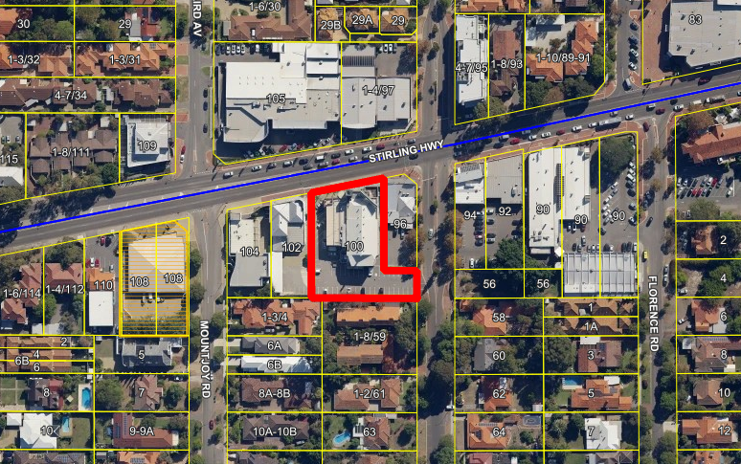

Council approved a 9m x 1.8m roof sign at the Windsor Cinema in 1986. It was subsequently brought to the City’s attention that a 12m x 3m unauthorised roof sign existed at the property. The Minister instructed for the sign to be removed following an appeal by the landowner.

The roof sign concerned was allowed by the City to remain subject to a legal agreement (deed) being prepared between the City and the landowner. The deed was drafted by the City’s solicitors in 1996 and signed by both the City and Independent Cinemas Pty Ltd – the current owners of the site.

The deed details conditions such as the Windsor Theatres listing on the Municipal Inventory as well as restrictions around the appearance of the sign and the location of the advertisement on the sign. The deed stipulates that the deed will be abolished if the roof sign is removed. The sign remains in place and an image of the sign at present can be seen in Attachment 1.

At the Council Meeting on the 22 May 2018 Council resolved to allow properties where an owner objects to the listing on the Municipal Inventory to have their address removed from the list. A listing on the Municipal Inventory does not prohibit, restrict, or otherwise alter the development potential of the place.

The applicant wishes to remove their property at 100 Stirling Highway Nedlands (the Windsor Cinema) from the Municipal Inventory and subsequently remove the deed. Removal of the Windsor Cinema from the Municipal Inventory will require removal of the deed.

In order to remove the deed from the certificate of title, the sign must be removed or obtain development approval. If this application is approved, the City can agree to the removal of the deed from the certificate of title. If the application is refused, the City may issue directions to remove the sign or continue to have the deed over the property.

- Application Details

The applicant seeks retrospective development approval for a roof sign, details of which are as follows:

- 43.69m² area;
- 15.26m in height above natural ground level
- 4.6m above the building directly below the sign; and
- Displays third party advertising not relevant to the operations of the approved cinema land use.

By way of justification in support of the retrospective development application the applicant has provided justification which is provided as an attachment to this report (Attachment no. 3).

- Consultation

The applicant is seeking assessment under the Objectives of the City’s Local Planning Policy – Signs for the following:

- Area of the signage;
- Height of the roof sign above the building;
- Display of third-party advertising.

The development application was therefore advertised in accordance with the City’s Local Planning Policy - Consultation of Planning Proposals to residents/landowner and businesses within 100m of the subject property. No submissions were received during the consultation period.

The application was also referred to Main Roads for comment as the subject property is partially reserved for Regional Roads under the Metropolitan Region Scheme. Main Roads have advised they have no objection to the development (See Attachment 4).

- Assessment of Statutory Provisions

6.1 Planning and Development (Local Planning Schemes) Regulations 2015

Schedule 2, Part 9, clause 67 (Matters to be considered by local government) stipulates those matters that are required to be given due regard to the extent relevant to the application. Where relevant, these matters are discussed in the following sections.

In accordance with provisions (m) and (n) of the Regulations clause 67, due regard is to be given to the likely effect of the proposed development’s height, scale, bulk and appearance, and the potential impact it will have on the local amenity.

Perceived community benefit

Further to this, clause 67 (v) states that the City may take into consideration “the potential loss of any community service or benefit resulting from the development other than potential loss that may result from economic competition between new and existing businesses”. The applicant has advised that the signage creates an additional income stream for the landowner which assists the landowner in operating the business. However the sign displays material which is not in relation to the approved cinema land use and hence the sign cannot be considered to benefit the cinema land use but rather the owner – who may or may not elect to have profits from the signage flow into the cinema revenue. Therefore, it cannot be claimed that the signage has a community benefit to allow the cinema to continue operating as the signage only benefits the landowner.

Length of time signage on site

The length of time that the signage has been on site without a development approval is not able to be taken into consideration when determining this application. The signage is currently unauthorised, and no action has been taken to rectify this solely based on the deed over the property. If there was no deed, compliance action likely would have been undertaken to ensure compliance with the relevant planning legislation.
6.2 Policy/Local Development Plan Consideration

6.2.3 Local Planning Policy – Signs

Policy Objective
Variations to the deemed-to-comply requirements can be considered subject to satisfying the following objectives:

- To ensure that signs do not adversely impact on the amenity of the surrounding area.
- To avoid the proliferation of signs nor signage which are not relevant to the business.
- To ensure that commercial signs are generally located in non-residential areas.
- To ensure that signs do not detract from the level of safety for drivers, cyclists and pedestrians.
- To ensure that signage directs pedestrian and vehicular traffic appropriately and is proportionate to the scale of the building.
Policy Requirement
Clause 4.2 states:
All signs:

- Shall be in keeping with the scale and form of the building;
- Shall not be in any position where it obstructs the site lines of vehicles and/or pedestrians; and
- Shall not contain any discriminatory or offensive material;
- Shall be displayed at the site to which it relates with the exception of Sponsorship Signage (cl. 4.8.)

Note: a sponsorship sign is defined as a sign which is for a financial or other benefit to a sporting or community club but is not directly related to the functions or activities of the club. As the business is not a sporting or community club, the business is not eligible for the sign to be considered sponsorship signage.

Clause 4.4.6 is relevant for roof signs and states:

- Shall have regard to the amenity of any nearby residential zoned properties;
- Shall comply with the building heights which are applicable for the property; and
- Roof signs should not exceed a maximum area of 5m2 and a maximum height of 2m above the roof level.
Proposed
The sign is proposed to be 43.69m² area in lieu of 5m² in area.

The sign is proposed to be 4.6m above the building directly below the sign in lieu of 2m.
The height of the signage is 15.26m in height above natural ground level. The height complies with the building height permitted along Stirling Highway as clause 26 (3) of Local Planning Scheme No. 3 specifies there is currently no building height restriction.

The signage displays material which is not in relation to the cinema (i.e. third-party advertising).
Administration Assessment
The height of the signage coupled with the area of the signage is substantially more than what the policy permits and hence the sign can be considered to have greater proportions than the scale and size of the building.

The displays third party advertising not relevant to the operations of the approved cinema land use does not comply with the objective of the policy. The success or failure of a business should rely on the functions of the business only and any other approved use on site – not through means of unauthorised development and uses on site.

At the state administrative tribunal, the use of policy in decision making is only given weight to the review if the policy is consistently applied. If Council elects to approve this application, the policy will not have as much weight as decisions from its inception would have been made contrary to the objectives and provisions. Therefore, if Council elects to approve this application, to ensure that the policy continues to have weight and reflects decision making from Council, administration would recommend amendment to the policy in the future to allow third party advertising and permit larger areas and heights for roof signs. This may result in a proliferation of third-party advertising along the highway.

- Conclusion

The roof sign does not meet the provisions of the City’s Local Planning Policy – Signs in relation to area, height above the building and display of third-party material. When considering ‘variations’ to the provisions of this policy, the application is required to be assessed under the objectives of the Policy. The sign also does not comply with the objectives of the policy. A review of other relevant planning legislation has outlined there is no valid planning reason for the sign to be approved. Based on this, the sign is recommended for refusal.

If the application is refused, the applicant is in a fortunate position compared to others due to the existing deed agreement allowing the retention of the signage without development approval. If the landowner wishes to have the deed removed without a development approval, the sign must be removed.

If Council elects to approve the sign, conditions of development approval can be provided upon request.

PD37.19 | Scheme Amendment No. 2 – Lot 325-329 Bedford Street, Nedlands
Committee | 10 September 2019
Council | 24 September 2019
Applicant | Hex Design & Planning
Landowner | Various
Director | Peter Mickleson – Director Planning & Development
Employee Disclosure under section 5.70 Local Government Act 1995 | Nil.
Reference | Nil.
Previous Item | Nil.
Attachments | - Scheme Amendment No. 2 Applicants Report

- Executive Summary

The purpose of this report is for Council to provide consent to advertise (initiate) the proposed Scheme Amendment No. 2 to Local Planning Scheme 3 (LPS 3).

The amendment has been prepared by Hex Design and Planning on behalf of the five landowners that reside at No 1, 3, 5, 7 & 9 (Lots 325-329) Bedford Street, Nedlands. The amendment proposes to rezone the subject land, from 'Residential R10' to the 'Residential R60'.

The amendment is considered a standard scheme amendment as it is an amendment that is consistent with the City’s Local Planning Strategy that has been endorsed by the Western Australian Planning Commission (WAPC) and is an amendment that does not result in any significant environmental, social, economic or governance impacts on land in the scheme area.. As per the Planning and Development (Local Planning Schemes) Regulations 2015 (Regulations) Part 5, Division 3, Section 47 a standard amendment requires advertising to the public.

- Recommendation to Committee

Council:

- Initiates Scheme Amendment 2 to Local Planning Scheme No. 3 Pursuant to Section 75 of the Planning and Development Act 2005, and by:

- Amending the Scheme Map by rezoning Lots 325-329 Bedford Street, Nedlands, from 'Residential R10' to 'Residential R60';

- Considers that the amendment is a Standard Amendment in accordance with Planning and Development (Local Planning Schemes) Regulations 2015 regulation 35 (2), for the following reasons:

- The proposed amendment is consistent with the Council’s Local Planning Strategy which has been endorsed by the Commission; and
- The proposed amendment does not result in any significant environmental, social, economic or governance impacts on land in the scheme area;

- Forward Local Planning Scheme Amendment 2 – Bedford Street to the Environmental Protection Authority pursuant to Section 81 of the Planning and Development Act 2005; and

- Advertise Local Planning Scheme Amendment 2 for a period of 42 days in accordance with Regulation 47 of the Planning and Development (Local Planning Schemes) Regulations 2015 and the City of Nedlands Local Planning Policy, Consultation of Planning Proposals Subject to Section 84 of the Planning and Development Act 2005.

- Background

3.1 Land Details

Land Area | 5063m²
Metropolitan Region Scheme Zone | Urban
Local Planning Scheme No. 3 Zone and Density Code | Residential R10
Proposed Local Planning Scheme No. 3 Zone and Density Code | Residential R60

3.2 Locality Plan

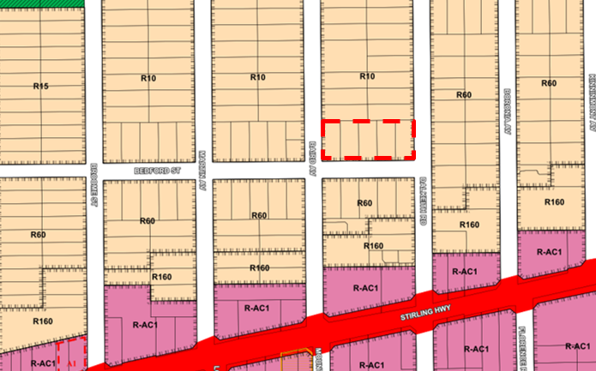
Figure 1: Locality Plan

The subject land is 5,063m² in area and is located on Bedford Street, Nedlands, running the entire length of the northern side of the road reserve between Baird Avenue and Dalkeith Road. As shown in Figure 1.

It is surrounded by predominantly a mix of medium and low density residential development. This can be seen in Figure 2 showcasing the medium density built form existing on the southern side of Bedford Street at R60 and the eastern side of Dalkeith Road at R60. The lower density to the northern boundary of the subject site currently has a density code of R10 under LPS 3.

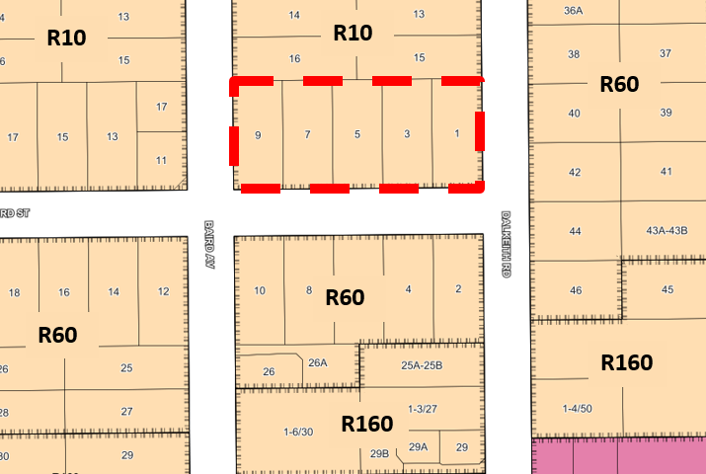
Figure 2: Subject site and surrounding density codes

- Amendment Details

The applicant is requesting a scheme amendment for the purposes of upcoding Lots 325-329 Bedford Street, Nedlands from R10 to R60. This will allow for more dwellings to be developed on the sites. The difference between the R10 and R60 density can be seen in the below table.

R-Code Development Guidelines | R10 | R60
Building Height | 2 Storeys | 2 storeys for Grouped dwellings  3 storeys for Apartments (both discretionary)
Average Lot Size (Single and Grouped) | 1000m² | 150m²  (5% variation can apply with WAPC Approval) Corner lots can apply for minimum lot size DC2.2, with WAPC approval.
Minimum Lot Size (Single and Grouped) | 875m² | 120m²  (5% variation can apply with WAPC Approval)
Plot Ratio (Apartments) | N/A | 0.8  (discretionary)
Rear Setback | 6m (discretionary) | As per wall length and wall height for Grouped dwellings  3m for Apartments (both discretionary)
Primary Street Setback | 9m (discretionary) | 2m (discretionary)

An R60 density code allows for the development of single houses, grouped dwellings and multiple dwellings (apartments). As the lots are approximately 1000m² in size in accordance with the R60 density code redevelopment potential of approximately 6 grouped dwellings or 8 apartments on each lot is possible.

Under the current R10 code only a single house could be developed on each lot. As per the Residential Design Codes Volume 1 aged dependant persons dwellings can be developed on a lot of any density and the site area required within Table 1 can be reduced by up to one third. This would mean for an R10 lot of 1000m² two aged dependant persons dwellings could be developed. Ancillary dwellings up to 70m² can also be developed in conjunction with a single house where the lot is over 450m². Both aged dependant persons dwellings and ancillary dwellings would be assessed in accordance with the provisions of the R10 density code in relation to bulk, height and setbacks.

- Assessment against Planning Framework

5.1 Metropolitan Region Scheme

The subject site is zoned ‘Urban’ under the Metropolitan Region Scheme (MRS). The proposal is an urban use and is therefore consistent with the zoning classification under the MRS.

5.2 Perth and Peel @ 3.5 Million (2018)

Perth and Peel @ 3.5 Million is a strategic planning document which aims to ensure that there will be suitable land identified for future housing and employment to accommodate a population of 3.5 million in the Perth and Peel area by 2050.

The City of Nedlands is prescribed a density target of an extra 4,400 dwellings by the year 2050, which is expected to be met by the density which was provided through the recently gazetted LPS 3. The proposed amendment would seek to contribute up to an approximate of additional 30-40 dwellings which will contribute towards reaching this dwelling target.

5.3 City of Nedlands Local Planning Strategy (2017)

The subject land is located with the ‘Nedlands North’ area as identified in the City of Nedlands Local Planning Strategy, which seeks to provide targeted infill along the growth corridor of Stirling Highway. The Local Planning Strategy illustrates a second density transition zone which could extend to these lots, this is shown in Figure 3 below. The objective of the transition zone is to act as a buffer between the urban growth areas of intense redevelopment along and near Stirling Highway and the low density suburban residential areas. It is expected that the transition zones will contain a mixture of dwelling types. The subject amendment seeks to create a consistent streetscape for this section of Bedford Street, rather than one side of the street being low density R 10 and the alternate side of the street containing medium density with greater building height and lesser street setback.

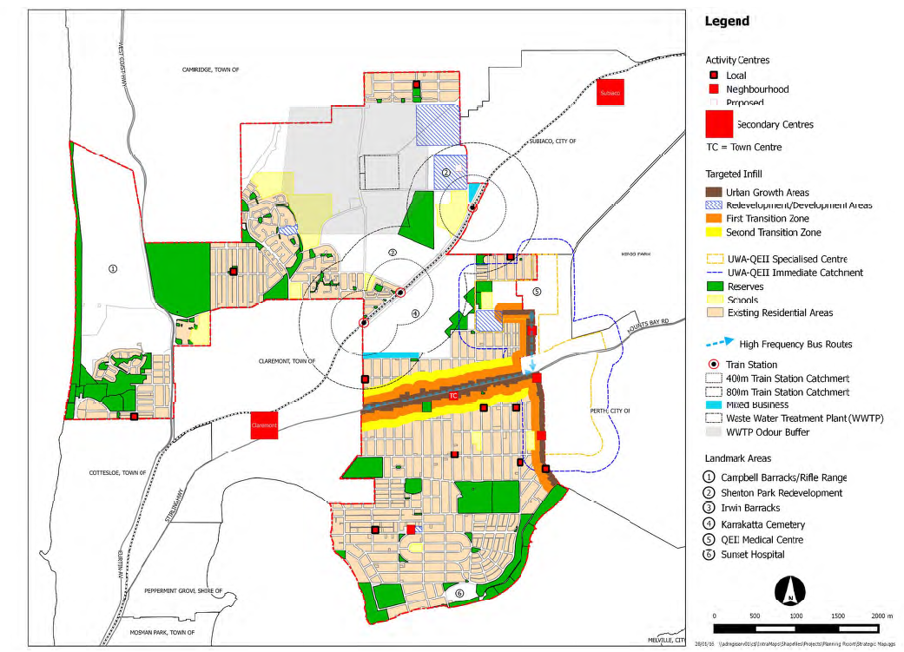
Figure 3: Local Planning Strategy Map

5.4 City of Nedlands Local Planning Scheme No. 3

December 2016: Council Originally adopted LPS 3

The originally adopted version of LPS 3 shows that the subject sites were listed in a Special Control Area (SCA) which allowed the properties to develop to R50 if they developed prior to subdividing. This version of the scheme was not supported by the Commission and did not progress.

December 2017: Advertised LPS 3

The advertised draft LPS 3 proposed that the subject sites be coded R60 along with all other properties within that street block, as shown in Figure 4 below.

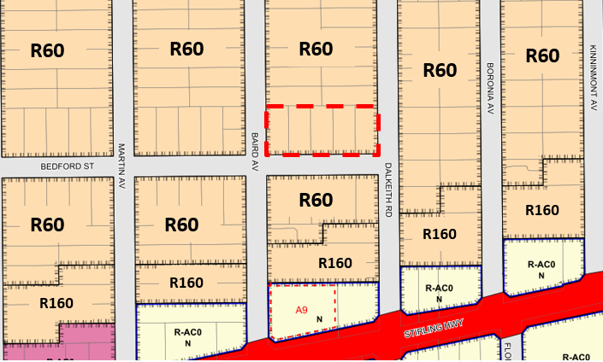
Figure 4: Advertised LPS 3

July 2018: Administration Modifications for Council

Whilst the modifications proposed by Administration were not supported by Council, it is worth including in this report as it offers an alternative that may be worth exploring through this scheme amendment process. The modifications proposed by Administration for the Special Council Meeting in July 2018 showed that the subject sites were applied with a dual density code of R10/R40. This would have meant that all development would comply with the lower density code (R10), unless the lot had a minimum area of 1800m² and the development had a maximum of one consolidated vehicular access point for each street frontage of the lot.

This would have meant that the subject properties could only develop to the R40 density if amalgamation occurred as all subject lots are 1010m² – 1020m². The R40 coding is also a lower density than proposed by the applicant having a two-storey height limit similar to that of the existing R10 to the north. The dual density can be seen in Figure 5 below. It is worth noting that dual or split density coding is no longer supported by the WAPC or the Minister for Planning and therefore this provision never progressed.

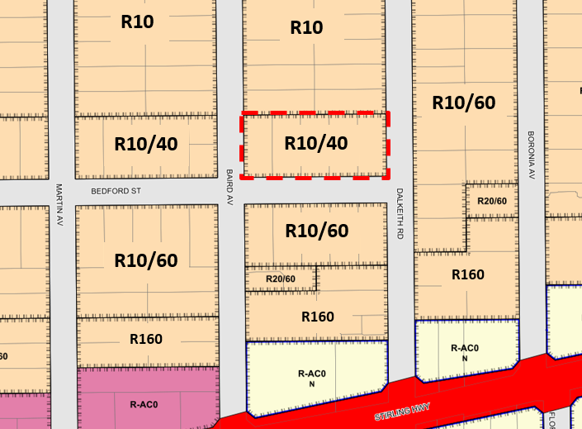
Figure 5: Modifications made by Administration

April 2019: Gazetted LPS 3

LPS 3 was gazetted on 16 April 2019 and is in effect. Under LPS 3 the subject sites are zoned R10. As shown in Figure 6 the density has been pulled back and the roads used as boarders to form a clear delineation between densities.

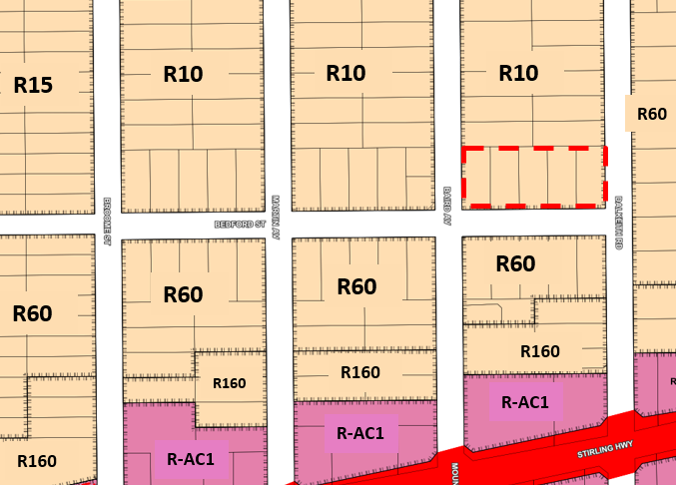
Figure 6: Subject site as per gazetted LPS 3
- Consultation

If the Scheme Amendment is granted consent to advertise the City will refer the application to the Environmental Protection Authority (EPA) who can advise of any environmental conflicts.

The application is required to be advertised in accordance with the Planning and Development (Local Planning Schemes) Regulations 2015 (the Regulations). The consultation of this Scheme Amendment will also be conducted in accordance with the City’s Consultation of Planning Proposals Local Planning Policy. Advertisement of a standard scheme amendment under the Regulations is as follows:

- The City must prepare a notice in a form approved by the West Australian Planning Commission (WAPC) giving details of; the purpose, where the amendment may be inspected and to whom and during what period submissions can be made.
- The City must then advertise the amendment by publishing the notice in the newspaper, display the notice in the Administration building, provide a copy to all public authorities which are likely to be affected and publish a copy on the City’s website.
- The advertising period can be no less than 42 days commencing on the day that the notice is published in a newspaper circulating in the scheme area.

The City’s Consultation of Planning Proposals Policy also requires letters to owners and occupiers within a 100m radius, a sign on site and social media advertising.

Once submissions are received the City must acknowledge in writing the receipt of each submission.

The consideration period for a standard scheme amendment is 60 days, after the end of the submission period, the City must consider all submissions and Council must pass a resolution to support, support with modifications or not support the proposed amendment.

Once Council has made a decision regarding initiation of the scheme amendment, all documents will be referred to the WAPC and they will deliver a recommendation to the Minister for Planning and Transport. The Minister will then make the final decision on the proposed scheme amendment.

- Budget / Financial Implications

Application fees are paid by the applicant to initiate and to commence a scheme amendment, therefore only administration resource allocation as an associated expense is required.

- Risk Management

Nil.

- Regulatory Process

Once the Scheme Amendment is granted consent to advertise the City will refer the application to the EPA who can advise of any environmental conflicts.

Once the City has received approval to proceed from the EPA, the City will then undertake advertising, in accordance with the Planning and Development (Local Planning Schemes) Regulations 2015 (the Regulations). The City will then consider all submissions received and propose changes if necessary.

The amendment will then be put to Council where they can:
- Support; or
- Support with modifications; or
- Not support the amendment.

Modifications to the proposed scheme amendment can only be made by Council in its deliberations following submissions, and if significant modifications are proposed, re-advertising can be undertaken.

If Council support the amendment it is then referred onto the WAPC who will make a recommendation to the Minister. The Minister then will support, support with modifications or not support the amendment.

- Administration Comment

Administration considers the proposed Scheme Amendment is in line with the higher order State planning strategies and policies and the City’s Local Planning Strategy. It is recognised that this location is at the very edge of the transition area from higher density codes to the lower density suburban areas.

All previous draft versions of LPS 3 had identified the subject properties as being proposed to be up coded in some manner and part of a final density transition zone.

The biggest difference occurs between the advertised draft LPS 3 and the proposed scheme amendment, which is that the advertised draft LPS 3 applied R60 to the whole street block (north to Carrington Street and east to Broome Street). This would therefore have eliminated any potential conflict between the subject sites and the adjoining properties to the north and would have maintained a consistent streetscape on both sides of Bedford Street.

The subject properties however were ultimately not up coded and have remained at the R10 density code under the gazetted LPS 3.

The proposed scheme amendment seeks to up code only those five properties fronting Bedford Street between Dalkeith Rd and Baird Ave whilst the remaining properties along Bedford Street and the adjoining properties to the north remain coded R10.

Up coding the properties to R60 would harmonise the streetscape along Bedford Street as the properties on the southern side are coded R60, thus a better interface between the properties on the southern side would be created. Although, if a consistent streetscape along Bedford Street is desired, the City should investigate extending the R60 density to all lots on the northern side of Bedford Street from Broome Street to Dalkeith Road.

An issue identified by upcoding the subject lots to R60 would be the volume of dwellings and building bulk on the site would be significantly different from the adjoining northern properties. Specifically, there would not be a 6m rear setback to the properties to the north and there is the potential for three-storey multiple dwellings under the R60 code. This interface between the proposed R60 and existing R10 densities would need to be further managed through the planning framework and Administration would suggest a Local Development Plan may be the most appropriate mechanism by which to specify building controls. This issue can be resolved as part of the scheme amendment process and does not preclude the proposal from proceeding.

Considering the above, Administration believes that there are planning merits for the proposal that warrant it being advertised to the community, to seek their feedback on the proposed upcoding. Therefore, it is recommended that Council adopt to initiate the proposed scheme amendment for advertising and referral to the EPA.

PD38.19 | Local Planning Scheme 3 – Local Planning Policy Waste Management and Guidelines
Committee | 10 September 2019
Council | 24 September 2019
Director | Peter Mickleson – Director Planning & Development
Employee Disclosure under section 5.70 Local Government Act 1995 | Nil.
Reference | Nil
Previous Item | Nil
Attachments | - Draft Waste Management LPP  - Draft Waste Management Guidelines

- Executive Summary

The purpose of this report is for Council to prepare (adopt for advertising) the Waste Management and Guidelines Local Planning Policy required under Local Planning Scheme 3 (LPS 3).

This policy details the requirements relating to waste management and minimisation which is to be considered in the design, construction and management of any proposed development within the City of Nedlands.

- Recommendation to Committee

Council prepares, and advertises for a period of 21 days, in accordance with the Planning and Development (Local Planning Schemes) Regulations 2015 Schedule 2, Part 2, Clause 4, the Waste Management and Guidelines Local Planning Policy.

- Background

Waste Management Plans have been required by the City on an ad hoc basis for development applications which the City believes will generate surplus waste above the normal household. Prior to Local Planning Scheme No.3 (LPS 3) there weren’t many opportunities to develop grouped or multiple dwellings, therefore the waste management of these developments were dealt with on a case by case basis.

Previously the City has had issues with a surplus of bins being placed onto the verge and blocking areas used by both cars and pedestrians. Previously there has not been a set guideline for people and business to adhere to.

The proposed policy guidelines will aid in waste management being undertaken at a high standard for the community and will also be beneficial for developers as it will clearly set out what is expected by the City as a minimum standard.

With LPS 3 this has introduced more opportunities for the development of grouped and multiple dwellings as well as large-scale mixed-use developments. This has necessitated the need for a Local Planning Policy and subsequent Guidelines to set out the procedure and requirements for waste management plans, when they must be prepared and what specifications are expected by the City.
- Detail

The policy details the requirements for waste management and minimisation which are to be considered in the design, construction and management of any proposed development in accordance with the City’s Waste Minimisation Strategy 2017-2020.

All aspects of waste management should be considered in the initial design stage of a development, including but not limited to waste generation, recycling, storage, truck accessibility and collection options.

Early consideration of waste management requirements will ensure effective integration of facilities into the design, that visual amenity, convenience, efficiency and health and safety is maintained at a high standard for the development.

The policy details when a waste management plan is required and the overall objectives of waste management within the City, whereas the guidelines component (Appendix One) provide the technical information in relation to the City’s specifications for waste management and what must be included in the waste management plan.

- Consultation

If Council resolves to prepare the draft LPP, it will be advertised for 21 days in accordance with Schedule 2, Part 2, Division 2, Clause 4 of the Planning and Development (Local Planning Scheme) Regulations 2015. This will include a notice being published in the newspaper and details being included on the City’s website and the Your Voice engagement portal.

Following the advertising period, the policy will be presented back to Council for it to consider any submissions received and to:

- Proceed with the policy without modification;
- Proceed with the policy with modification; or
- Not to proceed with the policy.

- Statutory Provisions

Planning and Development (Local Planning Schemes) Regulations 2015

Under Schedule 2, Part 2, Clause 3(1) of the Planning Regulations the City may prepare a local planning policy in respect to any matter related to the planning and development of the Scheme area.

Once Council resolves to prepare a local planning policy is must publish a notice of the proposed policy in a newspaper circulating in the area for a period not less than 21 days.

- Conclusion

The Waste Management LPP and guidelines are the best mechanism to guide decision making and advise the community of the Council’s position in relation to waste management within the City and what the waste management plans must cover. In order to properly manage an increased number of applications for medium and higher density, the City is required to manage waste using current best practice, this policy and associated guidelines provide the necessary framework to manage appropriate information and advice regarding waste.

As such, it is recommended that Council endorses administration’s recommendation to prepare (adopt to advertise) the Waste Management LPP and Guidelines.

PD39.19 | Local Planning Scheme 3 – Local Planning Policy Parking
Committee | 10 September 2019
Council | 24 September 2019
Director | Peter Mickleson – Director Planning & Development
Employee Disclosure under section 5.70 Local Government Act 1995 | Nil.
Reference | Nil
Previous Item | Item 6 – 2 May 2019 - Special Council Meeting  PD25.19 – 23 July 2019 – Ordinary Council Meeting
Attachments | - Draft Parking Local Planning Policy (TPS 2 parking ratios with no other standards)  - Draft Parking Local Planning Policy (TPS 2 parking ratios and other standards)

- Executive Summary

The purpose of this report is for Council to adopt the Parking Local Planning Policy (LPP). The purpose of the Parking LPP is to define the appropriate number of car parking bays for the land uses contained within the City’s Local Planning Scheme No. 3 (LPS 3).

The Parking LPP has been modified following Council resolution from 23 July 2019, to reflect the parking requirements from Town Planning Scheme No. 2 (TPS 2).

Council is being presented with two versions of the Parking LPP, included as Attachment 1 and Attachment 2. Both versions reflect the parking ratios of TPS 2, however Attachment 2 also includes standards beyond just car parking. The recommendation is that Council adopts the version which only contains the car parking ratios from TPS 2 with no additional standards, as set out in Attachment 1.

Once adopted, the Parking LPP will need to be referred to the West Australian Planning Commission (WAPC) for approval. This is because the LPP seeks to amend Part 3.9 of State Planning Policy 7.3 Residential Design Codes Volume 2 – Apartments (R-Codes Vol.2) with non-residential parking standards.

- Recommendation to Council

Council

- Proceeds to adopt the Parking Local Planning Policy, with modifications set out in Attachment 1, in accordance with the Planning and Development (Local Planning Schemes) Regulations 2015 Schedule 2, Part 2, Clause 4(3)(b)(ii); and

- Refers the Parking Local Planning Policy to the Western Australian Planning Commission for final approval in accordance with State Planning Policy SPP7.3, Residential Design Codes Volume 2 – Apartments 2019 Clause 1.2.3 and the City’s Local Planning Scheme No 3 Clause 32.4(5).

Alternate Recommendation

Council

- Proceeds to adopt the Parking Local Planning Policy, with modifications set out in Attachment 2, in accordance with the Planning and Development (Local Planning Schemes) Regulations 2015 Schedule 2, Part 2, Clause 4(3)(b)(ii); and

- Refers the Parking Local Planning Policy to the Western Australian Planning Commission for final approval in accordance with State Planning Policy SPP7.3, Residential Design Codes Volume 2 – Apartments 2019 Clause 1.2.3 and the City’s Local Planning Scheme No 3 Clause 32.4(5).

- Background

2 May 2019 – Special Council Meeting

Council resolved to prepare and advertise a series of policies, including the Parking LPP, in accordance with the Planning and Development (Local Planning Schemes) Regulations 2015 Schedule 2, Part 2, Clause 4.

The LPP was modified via Council’s Resolution so that the parking standards for the Office and Shop land uses reflected the Town Planning Scheme 2 (TPS 2) prior to advertising for community consultation.

Following advertising, submissions were made on the LPP stating that the parking requirements were too onerous. As such, Administration recommended modifications, specifically the parking ratios for the Office and Shop land uses were proposed to be modified to align with the original ratios presented at the 2 May 2019 meeting.

23 July 2019 – Ordinary meeting of Council

The modified LPP was presented to Council for adoption at its 23 July 2019 meeting, where it was resolved that:

“Council Resolution

Council approves the parking requirements as stated in Town Planning Scheme 2 as the Parking Policy, pending finalisation of a revised policy.”

6 August 2019 - Council Briefing

Administration sought further clarification in order to resolve how Council envisioned the finalisation of a revised policy.
It was pointed out that the land uses have changed between TPS 2 and LPS 3, and as such it was suggested that the Parking LPP should apply the TPS 2 parking standards as closely as possible to the new LPS 3 land uses.

- Discussion

Based on Council’s 23 July 2019 resolution, and the 6 August 2019 Council Briefing session, Administration has modified the Parking LPP so that it is reflective of the parking standards set out in TPS 2, Schedule 3.

The TPS 2 parking standards have been applied to the LPS 3 land uses as closely as possible within the modified Parking LPP, as outlined in the table below.

TPS 2 Land Use | Comparable LPS 3 Land Use/s | TPS 2 Parking requirement to be applied in Parking LPP
Religious purposes | Civic use  Community purpose  Funeral parlour  Place of worship  Reception centre | 1 bay per 4 persons.
Educational establishment | Educational establishment
Primary | Primary | 1.2 bays per staff member.
Secondary | Secondary | 2 bays per staff member PLUS 1 per rostered canteen worker PLUS 2 for each 10 provided (or part thereof).
Licenced premises | Small bar  Tavern | 1 bay per bedroom PLUS 1 per each 1.3m² of bar and public areas PLUS and 1 per each employee on duty.
Restaurant | Lunch bar  Restaurant/café  Fast food outlet | 1 bay per 2.6m² of restaurant seating area OR 1 per 2 persons (whichever is greater).
Light industry | Industry - light | 2.2 bays per each 100m² of gross leasable floor area OR 1 per employee (whichever is greater).
Hospital | Consulting rooms  Hospital  Veterinary centre  Medical centre | 12 bays OR 1 bay per every 4 beds (whichever is greater).
Motor repair station | Motor vehicle repair  Motor vehicle wash  Service station | 5 bays per each working bay PLUS 1 bay per employee.
Office/ professional office | Office | 4.75 bays per every 100m² of gross leasable floor area.
Public amusement | Amusement parlour  Art gallery  Betting agency  Cinema/theatre  Club premises  Exhibition centre  Recreation – private | 1 bay per 2 persons.
Shop | Convenience store  Liquor store – small  Market  Shop | 8.3 bays per every 100m² of leasable floor area.
Showroom/ warehouse | Bulky goods showroom  Garden centre  Motor vehicle, boat or caravan sales  Trade display  Trade supplies  Warehouse/storage | 2.2 bays per every 100m² gross leasable floor area OR 1 per employee (whichever is greater).

It is noted that the following LPS 3 land uses have no comparable land uses within TPS 2:

- Animal establishment;
- Bed and breakfast;
- Child care premises;
- Family day care;
- Holiday accommodation;
- Holiday house;
- Home business;
- Hotel;
- Motel;
- Residential aged care facility; and
- Serviced apartment.

For these land uses, the parking standards are proposed to remain unchanged from the LPP which was considered by Council at its 23 July 2019 meeting.

The parking requirements set out in TPS 2 also included guidance on how floor areas should be measured for certain land uses (such as gross leasable floor area). The parking requirements contained within the LPP have been updated to reflect the new terminologies for floor areas under LPS 3.

Council is being presented with two versions of the Parking LPP, included as Attachment 1 and Attachment 2. Both versions reflect the parking ratios of TPS 2, however Attachment 1 only contains the car parking ratios from TPS 2 with no additional standards. Attachment 2 also includes standards beyond just car parking which could be considered to represent better “planning practice” based on current thinking.

If Council is of the view to adopt the additional provisions contained within Attachment 2, an alternate recommendation has been included to this effect. These additional provisions relate to maximum number of car bays, parking reductions, bicycle, motorcycle and special purpose parking, end of trip facilities, cash-in-lieu, shared car parking, parking layout and design and parking and transport assessments. The inclusion of these additional provisions would provide Council with guidance to facilitate and promote alternative modes of transport and provide guidance for reducing the impact of parking facilities and access ways on the character and amenity of an area.

WAPC Approval

When Council adopts this LPP, regardless of which version, all provisions can be applied immediately to land zoned Private Community Purposes and Service Commercial under LPS 3.

However, the parking standards will not be enforceable within the Neighbourhood Centre, Local Centre and zones until such time as the WAPC approves the LPP. This is due to Clause 32.4(5) of LPS 3 which states that, where standards are not contained within a Structure Plan, Activity Centre Plan or Local Development Plan, all non-residential developments within Mixed Use, Neighbourhood Centre and Local Centre zones are subject to the standards of the R-Codes.

The Parking LPP seeks to amend Part 3.9 – Car and bicycle parking of the R-Codes Vol. 2 with non-residential parking ratios, which, under Part 1.2.3 of the R-Codes Vol. 2 requires WAPC approval.

Accordingly, once adopted by Council, the LPP will be referred to the WAPC in order to seek their approval for provisions related to parking standards within the Mixed Use, Local Centre and Neighbourhood Centre zones. This report, together with Council’s resolution on the report, will also be referred to the WAPC.

- Consultation

The Parking LPP was advertised in accordance with the Planning and Development (Local Planning Schemes) Regulations 2015 Schedule 2, Part 2, Clause 4 from the 18 May 2019 until the 8 June 2019.

One submission was received in relation to the Parking LPP during the advertising period. This submission, which raised concern with some of the proposed parking standards, was considered in the previous report presented to Council on 23 July 2019. Following Council’s resolution at this meeting, the LPP was further modified to reflect the TPS 2 parking requirements, which is now being presented back to Council for final adoption.

- Budget/Financial Implications

Nil.

- Statutory Provisions

Planning and Development (Local Planning Schemes) Regulations 2015

Schedule 2, Part 2, Clause 4(3) of the Planning and Development (Local Planning Schemes) Regulations 2015, sets out that after the expiry of the 21-day advertising period, the local government must review the proposed policy in light of any submissions made and resolve to:

- Proceed with the policy without modification;
- Proceed with the policy with modification; or
- Not to proceed with the policy.

- Conclusion

The Parking LPP is an integral policy under LPS 3 as it provides standards for non-residential car parking within the City of Nedlands. The modifications made to the LPP are reflective of Council’s 23 July 2019 resolution to have the LPP reflect the parking standards of TPS 2.

Two versions of the LPP are being presented to Council. Attachment 1 includes only the TPS 2 parking ratios, with no additional standards. Attachment 2 includes the TPS 2 parking ratios as well as additional provisions relating to maximum number of car bays, parking reductions, bicycle, motorcycle and special purpose parking, end of trip facilities, cash-in-lieu, shared car parking, parking layout and design and parking and transport assessments.

Once adopted, the LPP will be referred to the WAPC for approval in accordance with Part 1.2.3 of the R-Codes Vol. 2, given that it seeks to amend Part 3.9 of R-codes Vol. 2 with non-residential parking standards.

PD40.19 | Local Planning Scheme 3 – Local Planning Policy - Residential Development: Single and Grouped Dwellings
Committee | 10 September 2019
Council | 24 September 2019
Director | Peter Mickleson – Director Planning & Development
Employee Disclosure under section 5.70 Local Government Act 1995 | Nil.
Reference | Nil
Previous Item | Item 6 – 2 May 2019 - Special Council Meeting  PD27.19 – 23 July 2019 – Ordinary Council Meeting
Attachments | - Draft Residential Single and Grouped Dwelling Development Local Planning Policy  - Draft Residential Single and Grouped Dwelling Development Local Planning Policy with tracked changes  - Administration responses to the Mayor’s suggested Local Planning Policy modifications

- Executive Summary

The purpose of this report is for Council to adopt the Residential Single and Grouped Dwelling Development Local Planning Policy (Residential Development LPP), as contained in Attachment 1, for the purpose of readvertising.

The Residential Development LPP provides guidance and supplementary requirements to Local Planning Scheme 3 (LPS 3) and State Planning Policy 7.3 Residential Design Codes Volume 1 (R-Codes Vol.1) in relation to single and grouped dwelling developments in all densities. The policy does not apply to multiple dwellings or mixed-use developments which are captured by Volume 2 of the R-Codes.

The policy was adopted for consent to advertise to the community at the Special Council Meeting held on 2 May 2019. The policy was advertised for a period of 21 days with 14 submissions being received.

The Residential Development LPP has been modified several times since being advertised for public comment. Attachment 2 contains a tracked change version of the Residential Development LPP which incorporates all changes supported by Administration. The proposed modifications are considered to be substantial in nature and therefore warrant advertising the Residential Development LPP again for public comment. Accordingly, it is recommended that Council adopts the draft Residential Development LPP, as contained in Attachment 1, for the purpose of readvertising.

- Recommendation to Council

Council proceeds with the draft Residential Single and Grouped Dwelling Development Local Planning Policy, with modifications as set out in Attachment 1, and re-advertises for a period of 21 days, in accordance with the Planning and Development (Local Planning Schemes) Regulations 2015 Schedule 2, Part 2, Clause 4(2).

- Background

The Residential Development LPP has been modified several times since being presented to the Special Council Meeting 2 May 2019. A summary of these modifications is provided below.

2 May 2019 – Special Council Meeting

Council resolved to prepare and advertise a series of policies, including the Residential Development LPP, in accordance with the Planning and Development (Local Planning Schemes) Regulations 2015 Schedule 2, Part 2, Clause 4. In relation to the Residential Development LPP, Council resolved to adopt the draft Residential Development LPP with the following amendments.

Issue | Presented to Council | Amendment by Council
Carport setback from primary street | 2.5m. | 3.5m.
Building Height | 8.5m wall height & 10m to roof pitch (deemed to comply heights as were applicable in TPS 2). | 6m wall height & 9m to roof pitch (as per R-Codes Vol. 1).
Further guidance required for variations to 9m front setback clauses in LPS3. | Local Housing Objectives included as cl. 4.1.1 of the policy to provide further guidance for the assessment of development applications proposing less than 9m front setback. | cl. 4.1.1 deleted.  Proposed reductions to 9m front setback to be assessed against only the Design Principles of R-Codes.
St. Johns Wood & Hollywood | Location specific clauses have precedent. | None, as this clause was already provided in the Residential Development LPP.
Landscaping | No provisions proposed.  Officers did not consider landscaping requirements were required for single dwellings. Existing landscaping provisions for grouped dwellings are contained in the R-Codes. | Provision inserted to require 20% minimum for all single house and grouped dwelling proposals.

25 June 2019 – Council Meeting

At the Council meeting on 25 June 2019 the following resolution was adopted:

“Council:

- resolves that, notwithstanding the removal of building height provisions from transitioning from Town Planning Scheme 2 to Local Planning Scheme 3, the height limits in Clause 2 below are to be taken as default policy provision for residential developments up to and including single and grouped dwellings; and

- determines that the Residential Development Local Planning Policy should specify height limits for single and grouped dwellings in the residential zone as follows:

- Maximum Building Heights

  - Top of external wall (roof above) 8.5m
  - Top of external wall (concealed roof) 8.5m

- Top of pitched roof 10.0m
Gable walls above eaves height:

Less than 9m long: exempted
Greater than 9m long: add one third of the height of the gable, between the eaves and the apex of the gable wall, to the eaves height.

- Applies to ridges greater than 6m long. Short ridges: add 0.5m height for each 2m reduction in length.”

In response to this resolution of Council, the Building Height provisions have been amended to include the above.

23 July 2019 – Council Meeting

Following review of the submissions and further investigation of the policy provisions, the Residential Development LPP was further proposed to be modified by Administration as follows:

- Added guidance for assessing applications which seek a reduction to the 9m front setback requirement;
- Added guidance for assessment of buildings within the 6m rear setback area for low density areas; and
- Inserting building heights to reflect those previously applied under Town Planning Scheme No. 2 (TPS 2) alongside other modifications.

This modified version of the Residential Development LPP was presented to Council for adoption to readvertise at its 23 July 2019 meeting, where Council resolved as follows:

“That Council proceed to the next item of business.”

6 August 2019 – Council Briefing

Just prior to the 23 July 2019 Council meeting, the Mayor provided Administration with several suggested amendments to the Residential Development LPP. These suggested amendments, together with Administration’s responses are contained within Attachment 3. A number of these suggestions Administration can agree to and they have been incorporated into the draft Policy in Attachment 1.

The Residential Development LPP was presented to a Council Briefing session on 6 August 2019 for further discussion. This discussion focussed on the following components of the Residential Development LPP:

- Development within the front setback area;
- Carports within the front setback area;
- Building heights (acknowledging previous resolution on this matter); and
- Buildings within the rear setback areas.

These matters are discussed below.

- Discussion

Development within the front setback area

Under Clause 26 of LPS 3 the front setback requirement under the R-Codes for R10, R12.5 and R15 densities has been modified (from an average 7.5m setback) to be a minimum of 9m.

As the 9m front setback is a discretionary requirement (rather than a non-discretionary requirement as previously under TPS 2), there is already the ability for landowners to seek approval for a reduced setback through an assessment under the Design Principles of the R-Codes.

Under the Design Principles, there are considerations for when a reduced front setback is acceptable, however, Administration recommends further guidance (control) is provided in the Residential Development LPP to qualify how a ‘prevailing development context and streetscape’ is interpreted for the purpose of this assessment. This will ensure that the assessment of an established streetscape is consistent.

Under TPS 2 and the previous TPS 2 front setback policy, a reduced front setback was only permitted where more than half the lots on the same side of the street block had a setback of less than 9m. Notably, TPS 2 and the policy did not specify how much the front setback could be reduced in these instances. The draft Residential Development LPP sets out that an established streetscape of less than 9m is described as occurring when more than 50% of the dwellings on one side of the street are forward of the 9m setback line, which is consistent with TPS 2 and the previous TPS 2 front setback policy.

The draft Residential Development LPP differs from TPS 2 and the previous TPS 2 front setback policy as it does now specify how much the front setback can be reduced when 50% of the dwellings are forward of the 9m setback line. When this occurs, the setback of the proposed dwelling is considered to be appropriate if it accords with the average setback distance of the dwellings on that side of the street. By considering the existing setbacks of dwellings on the street, this provision allows for an equitable assessment of a proposal for a reduced setback.

This provision exists in the Residential Development LPP as policy measure 4.1.1 (a). In the absence of this provision, the assessment of a reduced setback is dependent on the Design Principles of the R-Codes which do not define what constitutes a prevailing streetscape.

Carports within the front setback area

The 9m front setback requirement also applies to garages and carports, so should an application for a reduced front setback be received for a garage or carport that is not Deemed to Comply it would have to be assessed as a reduced setback and an assessment under the Design Principles of the R-Codes applied.

The draft Residential Development LPP seeks to replicate the old policy by allowing an additional Deemed to Comply pathway for carports to be permitted, as of right, within the front setback area. This provision does not apply to garages, which will still have the 9m front setback applied. This means that if a carport satisfies the requirements of this provision, then the carport is Deemed to Comply, and development approval would not be required.

One of the requirements is that if there is space for a carport behind the 9m setback line, then it is preferred that the carport be located in that area, that is, behind the 9m front setback line. Any proposal for a carport within the front setback area would not be Deemed to Comply and require a development application and assessment against the corresponding Design Principles of the R-Codes.

This provision exists as policy measure 4.2.1 in the Residential Development LPP. It is noted that this proposed Deemed to Comply pathway is for carports only. Garages within the front setback area would still require a development application and assessment against the corresponding Design Principles of the R-Codes.

Building Heights

The advertised policy requires R-Code Vol. 1 wall and building heights of:
- 6m to top of walls; and
- 9m to the top of the roof.

Following advertising, fourteen submissions were received seeking the wall and building height measurements applicable under TPS 2 to be reinstated under LPS 3.

Since 1985, TPS 2 permitted an 8.5m wall and 10m building height for all buildings within the City. These TPS 2 heights were established prior to the R-Codes and were non-discretionary.

Under LPS 3, there are no residential heights specified in the Scheme and as a result, wall and building heights for residential development default to those specified in the R-Codes, resulting in lower Deemed to Comply heights of 6m and 9m respectively.

It is considered appropriate, given the Nedlands context of large, architecturally designed homes, for it to be permitted to build to a greater building height than that specified by the R-Codes.

The application of building heights as per the R-Codes (i.e. 6m and 9m) would result in advertising of applications that would previously have been Deemed to Comply and may result in an increase in the number of referrals of development applications to Council for determination.

In order to allow the 8.5m and 10m wall and building height provisions to have effect, these height limits need to be specified in the policy. Accordingly, the policy is recommended to permit 8.5m wall heights and 10m top of roof heights. These provisions exist as policy measure 4.5.1.

This matter has now been addressed through Council’s resolution of 25 June 2019 which re-instates the height limits that applied under TPS2.

Buildings within the rear setback areas

As the 6m rear setback requirement is a discretionary requirement under the R-Codes, there is already the ability for landowners to seek approval for a reduced setback through an assessment under the Design Principles of the R-Codes.

Council has recently received several applications for buildings within the rear 6m setback area on low density lots and has been to the State Administrative Tribunal (SAT) over these matters.

The R-Codes provide some guidance to consider a reduced setback, however, specific guidance would assist staff and Council in making consistent decisions in the future.

There are no automatic allowances being introduced through the policy. Any application for a building/structure within the rear 6m setback area will still require a development application (except outbuildings which have their own separate requirements). The R-Codes Vol. 1 Design Principles will still apply to provide guidance for assessment and the same advertising procedures will apply.

In considering an application for a building in the rear 6m setback area, some structures may be appropriate and could be approved whilst others are not and should be refused.

The types of structures which may be considered appropriate are patios, ‘pool houses’, ancillary accommodation (granny flats) and the like, as these are common within the City of Nedlands context and many approvals have been granted for such applications.

However, these are not proposed to be permitted ‘as of right’, and an application still needs to demonstrate the proposal meets the objectives of the Residential Development LPP, which includes:
- the presence of buildings on adjacent neighbouring properties;
- that the building contributes to a more effective use of space on the lot; and
- the cumulative bulk and distribution of all buildings on site warrant consideration of a reduction to the 6m rear setback.

It is in those circumstances an approval could be granted. The converse is also true, in that, should an application fail to demonstrate the above, it could be refused. Administration is of the opinion that the local housing objectives will assist staff and Council in determining what can and cannot be approved in the rear 6m setback areas.

These provisions exist as a Local Housing Objectives under policy measure 4.4.2 (a).

- Consultation

The amendments resolved by Council on the 2 May 2019 were made to the Residential Development LPP and the policy was then advertised for a period of 21 days, during which 14 submissions were received.

All 14 submissions requested that Council reinstate the Administration proposed policy building heights for single and grouped dwellings being 8.5m to wall height and 10m to roof pitch. One submission raised two additional points which were in relation to landscaping and sight line requirements.

The following is a summary of the issues raised:

- Strongly object to the R-Codes building heights being applied to the City of Nedlands. Previous TPS 2 heights of 8.5m for walls and 10m for buildings should be maintained;
- Strongly support the proposed vehicle sightlines changes; and
- Strongly support the proposed landscaping provisions.

These submissions were considered in the previous report presented to Council on 23 July 2019.

- Budget/Financial Implications

Nil.

- Statutory Provisions

Planning and Development (Local Planning Schemes) Regulations 2015

Planning and Development (Local Planning Schemes) Regulations 2015 (the Regulations) Schedule 2, Part 2, Clause 4(3), sets out that after the expiry of the 21-day advertising period, the local government must review the proposed policy in light of any submissions made and resolve to:

a) Proceed with the policy without modification; or
b) Proceed with the policy with modification; or
c) Not to proceed with the policy.

Administration recommends that Council resolves to proceed with the Residential Development LPP with modifications.

There are modifications being proposed to the Residential Development LPP that respond to submissions, but there is also new content being introduced which the public have not had the opportunity to comment on and is not considered minor.

Despite it not being set out in the Regulations, due to the number and extent of the changes being recommended to the policy, particularly the insertion of new content and provisions, the Council could resolve, and it is recommended by Administration, that the policy be readvertised for a period of 21 days, in the same format as previously advertised. However, this a decision for Council and it could adopt the policy without further advertising.

Elements requiring WAPC approval

The draft Residential Development LPP contains provisions that are not provisions that a local government can introduce without the approval of the WAPC.

As per R-Codes part 7.3.1 (a), provisions relating to Landscaping are not listed as an element that a Local Government can amend.

Accordingly, WAPC approval is required prior to these provisions taking effect. Once the policy is adopted by Council, it will be forwarded to the WAPC for approval of those provisions. All other parts of the policy will be able to operate as intended upon Council adoption.

- Conclusion

The Residential Development LPP provides guidance and supplementary requirements to LPS 3 and R-Codes Vol.1 in relation to single and grouped dwelling development.

The proposed modifications include guidance for assessing applications which seek a reduction to the 9m front setback requirement, assessment of buildings within the 6m rear setback area for low density areas and inserting building heights to reflect those previously applied under TPS 2 alongside other modifications.

Following advertising fourteen submissions were received, all seeking the 8.5m and 10m wall and building heights be reinstated.

It is recommended that Council follows the Administration recommendation and that the policy be readvertised, with modifications, for a further 21 days. Council does have the option not to re-advertise if it considers the amendments to the policy to be minor.

