Planning and Development Reports

Committee Consideration – 11 May 2021

Council Resolution – 25 May 2021

Table of Contents

Item No. Page No.

PD16.21 Consideration of Retrospective Sea Containers and Proposed Façade Treatments at No. 52 Jutland Parade, Dalkeith 2
PD17.21 Consideration of a Residential – Single House at No. 79 Rosedale Street, Floreat 9
PD18.21 Consideration of Development Application for additions to a two-storey single house (including rooftop-terrace) at 18 Walba Way, Swanbourne (DA20/54704) 16
PD19.21 Local Planning Policy – Community Engagement on Planning Proposals 24
PD20.21 Scheme Amendment No 7 – South Broadway Final Adoption 32
PD21.21 Consideration of Development Application for 5 Single Houses at No. 22 Vincent Street, Nedlands 38

PD16.21 | Consideration of Retrospective Sea Containers and Proposed Façade Treatments at No. 52 Jutland Parade, Dalkeith
Committee | 11 May 2021
Council | 25 May 2021
Applicant | Nathan Stride
Landowner | Jeffery John Leach
Director | Tony Free – Director Planning & Development
Employee Disclosure under section 5.70 Local Government Act 1995 | The author, reviewers and authoriser of this report declare they have no financial or impartiality interest with this matter.  There is no financial or personal relationship between City staff and the proponents or their consultants.  Whilst parties may be known to each other professionally, this relationship is consistent with the limitations placed on such relationships by the Codes of Conduct of the City and the Planning Institute of Australia.
Report Type  Quasi-Judicial | When Council determines an application/matter that directly affects a person’s right and interests. The judicial character arises from the obligation to abide by the principles of natural justice. Examples of Quasi-Judicial authority include town planning applications and other decisions that may be appealable to the State Administrative Tribunal.
Reference | DA20/56128
Previous Item | Nil
Delegation | In accordance with the City’s Instrument of Delegation, Council is required to determine the application due to objections being received.
Attachments | - Planning and Development (Local Planning Schemes) Regulations 2015 Assessment  - Aims of the Scheme Assessment  - Residential Zone Objectives Assessment
Confidential Attachments | - Plans  - Submissions  - Site photos

- Executive Summary

The purpose of this report is for Council to determine a Development Application received on 3 November 2020, for retrospective sea containers and a proposed façade treatment on the sea containers at No. 52 Jutland Parade, Dalkeith (the subject site).

The application was advertised to adjoining landowners and occupiers in accordance with the City of Nedlands Local Planning Policy (LPP) – Consultation of Planning Proposals with three objections received. As objections have been received, this application is presented to Council for determination.

It is recommended that the application be refused by Council as the sea containers are considered to have a significant adverse impact on the local amenity and streetscape character.

Recommendation to Committee

- In accordance with Clause 68 (2)(c) of the Planning and Development (Local Planning Scheme) Regulations 2015 Council resolves to refuse the development application dated 3 November 2021 for Retrospective Sea Containers and Proposed Façade Treatments at Lot 80 (No. 52) Jutland Parade, Dalkeith for the following reasons:

  - The proposed development does not comply with Clause 67(2)(m) of Schedule 2 of the Planning and Development (Local Planning Schemes) Regulations 2015 as the development is not considered to be compatible with its setting, desired future character of its setting and the relationship of the development to development on adjoining land being the likely effect of the appearance of the development.

  - The proposed development does not comply with Clause 67(2)(n) of Schedule 2 of the Planning and Development (Local Planning Schemes) Regulations 2015 as the development is not in keeping with the character of the locality.

  - The proposed development does not comply with Clause 9 (a) of the City of Nedlands Local Planning Scheme No. 3 as the development is not considered to protect and enhance the local character and amenity.

  - The proposed development does not comply with the Residential Zone Objectives of the City of Nedlands Local Planning Scheme No. 3 as the development –

    - Does not facilitate high quality design, built form and streetscapes;
    - is a non-residential land use which is not complementary to the existing residential development in the locality; and
    - Does not maintain compatibility with the desired streetscape in terms of bulk and height.

- In accordance with Section 214(3) of the Planning and Development Act 2005, Council directs the applicant to remove the sea containers from No. 52 Jutland Parade, Dalkeith within 60 days of the date of this direction. The site is to be restored as nearly as practicable to its condition immediately before the sea containers were placed on site, to the satisfaction of the City of Nedlands.

Voting Requirement

Simple Majority.

- Background

2.1 Land Details

Metropolitan Region Scheme Zone | Urban and Parks and Recreation
Local Planning Scheme Zone | Residential and Parks and Recreation (MRS)
R-Code | R12.5
Land area | 1959m²
Additional Use | No
Special Use | No
Local Development Plan | No
Structure Plan | No
Land Use | Existing – Vacant  Proposed – the use of ‘sea container’ is not listed in the City of Nedlands LPS 3 Zoning Table
Use Class | n/a

2.2 Locality Plan

The subject property is located in Dalkeith, within the City of Nedlands. As shown in the map below, the subject property has a density code of R12.5.

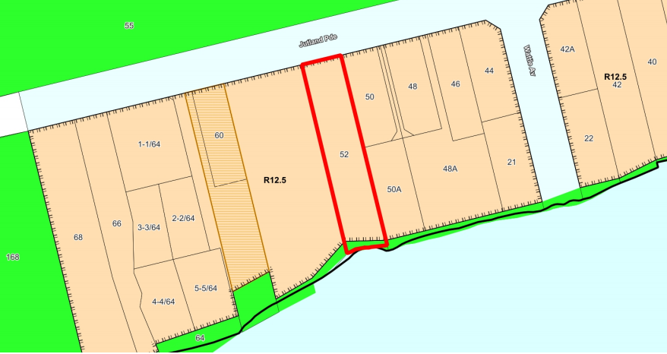

To the north of the property is the primary street – Jutland Parade. To the south of the property is the foreshore reserve for the Swan River. The property is bound by residential properties to the eastern and western boundaries.

The subject site slopes down approximately 18 metres from the north of the site to the south of the site. The site is currently vacant.

- Application Details

The application has resulted from a compliance enquiry received in relation to the sea containers. The applicant was provided with the opportunity to remove the sea containers or apply for a retrospective application to legalise the development.

The applicant consequently lodged a retrospective development application, seeking approval for two sea containers, which are stacked.

The subject site has Development Approval for a two-storey Single House, granted in 2019. However, no Building Permit has been lodged for construction of the dwelling.

To assist with the appearance of the sea containers from the street, the applicant has proposed façade treatments. The proposed façade treatments will be a mural of the approved dwelling and will face Jutland Parade.

3.1 Direction under the Planning and Development Act 2005 for illegal development

Section 214 of the Planning and Development Act 2005 outlines the authority’s powers in relation to illegal development where:

- a development is undertaken in contravention of a planning scheme or an interim development order if the development —

- is required to comply with the planning scheme or interim development order; and
- is commenced, continued or carried out otherwise than in accordance with the planning scheme or interim development order or otherwise than in accordance with any condition imposed with respect to that development by the responsible authority pursuant to its powers under that planning scheme or interim development order.

Under Section 214(3), the Act allows the responsible authority (the local government) to give a written direction to the owner or any other person who undertook the development –

- to remove, pull down, take up, or alter the development; and
- to restore the land as nearly as practicable to its condition immediately before the development started, to the satisfaction of the responsible authority.

Accordingly, it is recommended that Council directs the applicant to remove the sea containers from the subject site within 60 days of the date of the direction. The site is to be restored as nearly as practicable to its condition immediately before the sea containers were placed on site, to the satisfaction of the City of Nedlands.
Where the applicant is aggrieved by the decision, the applicant may apply for a review to the State Administrative Tribunal (SAT), in accordance with Part 14 of the Planning and Development Act 2005.

- Consultation

The application was advertised in accordance with the City’s Local Planning Policy - Consultation of Planning Proposals to 16 adjoining owners and occupiers to seek comments on the proposal.

Three objections were received from adjoining properties. The following table is a summary of the concerns/comments raised and the City’s response and action taken in relation to each issue:

Submission | Officer Response | Action Taken
The sea containers have a negative visual impact on the amenity from the adjoining properties. | The City’s Administration agrees, the sea containers have a negative impact on the visual amenity of adjoining properties. | Application is recommended for refusal.
The sea containers are possibly being used as an office/workplace on the vacant block and the property is being used as a storage facility for the construction materials and parking of vehicles. | The City’s Administration have not received any evidence of the sea containers being used as an office/workplace. In any case, Administration is not supportive of the use of the sea containers for an office or the use of the site for storing materials and parking vehicles. | Application is recommended for refusal.
The sea containers are not in keeping with the peaceful and residential street of Jutland Parade. | The City’s Administration agrees, the sea containers are considered to be incompatible with their setting, including the relationship of the development to development on adjoining land and land in the locality. | Application is recommended for refusal.
The façade treatments proposed will not assist in improving the impact of the sea containers on the locality. | The façade treatment is considered by Administration as inconsistent with the character of the locality. Murals of this type are normally seen in non-residential settings, associated with public spaces. | Application is recommended for refusal.
The sea containers are not temporary and have been on site for over 3 years which is not ‘temporary.’ | The sea containers do not meet the City’s Exempt Development Local Planning Policy which permit sea containers to be on site for a maximum of 14 days from being placed on site | It is recommended that Council instruct the applicant to remove the sea containers and to restore the site to its original condition.
Sea containers could be considered where there is a building under construction which is not the case at the subject property | Administration agrees. The subject site currently does not have any development under construction to warrant the need for the sea containers on site | Application is recommended for refusal.

Note: A full copy of all relevant consultation feedback received by the City has been given to the Councillors prior to the Council meeting.

- Assessment of Statutory Provisions

5.1 Planning and Development (Local Planning Schemes) Regulations 2015

Schedule 2, Part 9, clause 67 (Consideration of application by local government) stipulates those matters that are required to be given due regard to the extent relevant to the application. Refer to Attachment 1 for the full assessment against the relevant provisions.

5.2 City of Nedlands Local Planning Scheme No. 3

5.2.1 – Clause 9: Aims of the Scheme

The City considers that the development does not meet Aims of the Scheme, as identified in Attachment 2.

5.2.2 – Clause 16: Residential Zone Objectives

The City considers that the development does not meet the ‘Residential’ zone objectives, as identified in Attachment 3.

5.3 Policy/Local Development Plan Consideration

5.3.1 City of Nedlands Exempt Development Local Planning Policy

This policy outlines types of development exempt from requiring development approval in the City of Nedlands.

The application does not meet Policy Measure 4.1.7(d) as the sea containers have been placed on the lot for more than 14 days.

The sea containers are not classified as being temporary and are therefore not exempt under the Policy.

- Conclusion

Council is requested to make a decision in accordance with clause 68(2) of the Deemed Provisions. Council may determine to approve the development without conditions (cl.68(2)(a)), approve with development with conditions (cl.68(2)(b)), or refuse the development (cl.68(2)(c)).

The application for the retrospective sea containers and proposed façade treatments at No. 52 Jutland Parade, Dalkeith have been submitted for Council consideration as objections have been received. The objections raise concerns with the visual impact of the sea containers on the amenity of the locality, the bulk and scale and the presence of the sea containers on site for an extended period of time than typically permitted.

The proposal does not meet the aims of the City of Nedlands Local Planning Scheme No. 3 and the residential zone objectives of the Scheme. The development is not considered to be compatible with its setting, including the desired future character of its setting and the relationship development to development on adjoining land and land in the locality.

Accordingly, it is recommended that-

      - Council refuses the application and
      - Council directs the applicant to remove the sea containers from No. 52 Jutland Parade, Dalkeith within 60 days of the date of the direction. The site is to be restored as nearly as practicable to its condition immediately before the sea containers were placed on site, to the satisfaction of the City of Nedlands.

PD17.21 | Consideration of a Residential – Single House at No. 79 Rosedale Street, Floreat
Committee | 11 May 2021
Council | 25 May 2021
Applicant | Rubix Homes
Landowner | A Scanlan and K Scanlan
Director | Tony Free –Director Planning & Development
Employee Disclosure under section 5.70 Local Government Act 1995 | The author, reviewers and authoriser of this report declare they have no financial or impartiality interest with this matter.  There is no financial or personal relationship between City staff and the proponents or their consultants.  Whilst parties may be known to each other professionally, this relationship is consistent with the limitations placed on such relationships by the Codes of Conduct of the City and the Planning Institute of Australia.
Report Type  Quasi-Judicial | When Council determines an application/matter that directly affects a person’s right and interests. The judicial character arises from the obligation to abide by the principles of natural justice. Examples of Quasi-Judicial authority include town planning applications and other decisions that may be appealable to the State Administrative Tribunal.
Reference | DA21/59826
Previous Item | Nil
Delegation | In accordance with the City’s Instrument of Delegation, Council is required to determine the application due to an objection being received.
Attachments | - Applicant’s Cover Letter
Confidential Attachments | - Plans  - Submission  - Assessment

- Executive Summary

The purpose of this report is for Council to determine a Development Application received on 21 January 2021, for a Single House at No. 79 Rosedale Street, Floreat (the subject site).

The application was advertised to adjoining landowners and occupiers in accordance with the City of Nedlands Local Planning Policy (LPP) – Consultation of Planning Proposals and one objection was received from an adjoining property. As an objection has been received, this application is presented to Council for determination.

It is recommended that the application be approved by Council as it is considered to satisfy the design principles of the Residential Design Codes (R-Codes) Volume 1 and is unlikely to have a significant adverse impact on the local amenity and character.

Recommendation to Committee

In accordance with Clause 68(2)(a) of the Deemed Provisions of the Planning and Development (Local Planning Schemes) Regulations 2015, Council approves the development application received on 21 January 2021 in accordance with plans date stamped 18 March 2021 for a Single House at Lot 17 (No. 79) Rosedale Street, Floreat, subject to the following conditions:

- The development shall at all times comply with the application and the approved plans, subject to any modifications required as a consequence of any condition(s) of this approval.

- This development approval only pertains to a Residential – Single House as indicated on the determination plans.

- All footings and structures to retaining walls, fences and parapet walls, shall be constructed wholly inside the site boundaries of the property’s Certificate of Title.

- Prior to occupation of the development, all major openings and unenclosed outdoor active habitable spaces, which have a floor level of more than 0.5m above natural ground level and overlook any part of any other residential property behind its street setback line shall be setback, in direct line of sight within the cone of vision from the lot boundary, a minimum distance as prescribed in C1.1 of Clause 5.4.1 – Visual Privacy of the Residential Design Codes. Alternatively, the major openings and unenclosed outdoor active habitable spaces are screened in accordance with the Residential Design Codes by either;

- fixed obscured glazing or translucent glass to a height of 1.60 metres above finished floor level, or
- Timber screens, external blinds, window hoods and shutters to a height of 1.6m above finished floor level that are at least 75% obscure.
- a minimum sill height of 1.60 metres as determined from the internal floor level, or
- an alternative method of screening approved by the City of Nedlands.

The required screening shall be thereafter maintained to the satisfaction of the City of Nedlands.

- Prior to occupation of the development the finish of the parapet wall is to be finished externally to the same standard as the rest of the development in:

- Face brick,
- Painted render,
- Painted brickwork; or
- Other clean material as specified on the approved plans and maintained thereafter to the satisfaction of the City of Nedlands.

- All stormwater from the development, which includes permeable and non-permeable areas shall be contained onsite.

- Prior to occupation of the development, all external fixtures including, but not limited to TV and radio antennae, satellite dishes, plumbing vents and pipes, solar panels, air conditioners and hot water systems shall be integrated into the design of the building and not be visible from the primary street, secondary street to the satisfaction of the City of Nedlands.

- Prior to occupation of the development, all air-conditioning plant, satellite dishes, antennae and any other plant and equipment to the roof of the building shall be located or screened so as not to be highly visible from beyond the boundaries of the development site to the satisfaction of the City of Nedlands.

- Retaining walls, fences or other structures are to be truncated or reduced to no higher than 0.75m within 1.5m of where the wall, fences, other structures adjoining vehicle access points where a driveway meets a public street to the satisfaction of the City of Nedlands.

Voting Requirement

Simple Majority

- Background

2.1 Land Details

Metropolitan Region Scheme Zone | Urban
Local Planning Scheme Zone | Residential
R-Code | R12.5
Land area | 827m²
Additional Use | No
Special Use | No
Local Development Plan | No
Structure Plan | No
Land Use | Residential – Single House
Use Class | Permitted (P)

2.2 Locality Plan

The subject property is located in Floreat, within the City of Nedlands. The site is currently developed with a single storey Single House. As shown in the map below, the subject property has a density code of R12.5. All surrounding properties are also coded R12.5.

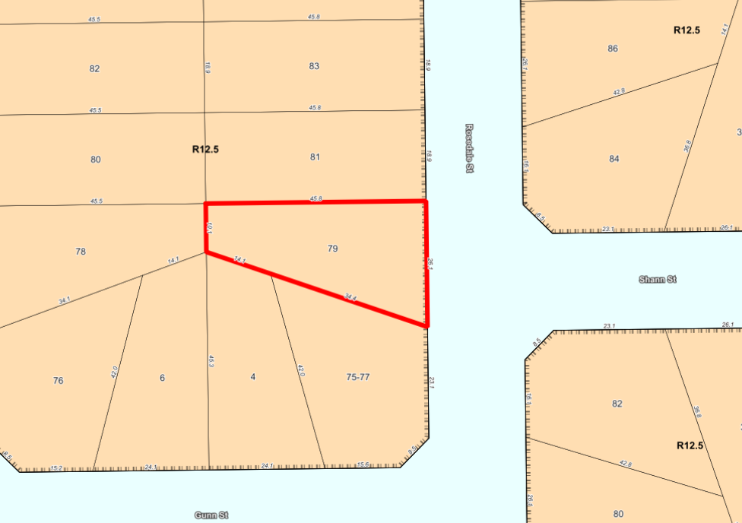

The property has an irregular lot shape, with an angled lot boundary to the south. The rear lot boundary to the west has a total length of 10m. The property is bounded by residential properties to the north, west and south. To the east is the primary street – Rosedale Street.

The subject site is relatively flat and slopes down approximately 1 metre from south east to the north west.

- Application Details

The applicant seeks development approval for a Single House, details of which are as follows:

Ground Floor:
- Double garage, Kitchen, Living, Dining, Scullery, Alfresco, Laundry, Bathrooms, Music Room, Master Bedroom and Lounge

Upper Floor:
- Bedroom 2, Bedroom 3, Bedroom 4, Bathrooms, Study, Retreat

In support of the development application the applicant has provided a Justification Report, which is provided as Attachment 1.

- Consultation

The application was advertised in accordance with the City’s Local Planning Policy - Consultation of Planning Proposals to the adjoining owners to the north to seek comments on the aspects of the development where the applicant is seeking discretion to be applied under the Design Principles of the R-Codes for the following clauses:

- Clause 5.1.3 – Lot Boundary Setbacks

The application was advertised via informal advertising. The landowner of the subject property presented the plans to the northern landowners for their comments.

The following table is a summary of the concerns/comments raised and the City’s response and action taken in relation to each issue:

Submission | Officer Response | Action Taken
The garage wall on the boundary with no setback will present significant building bulk in close proximity to the residence, resulting in a negative impact on amenity. | A detailed Design Principle assessment for Clause 5.1.3 – Lot Boundary Setbacks is provided at Section 5.2.1 of this Council Report. | Design Principle assessment provided under Section 5.2.1.
The plan is not in keeping with the Floreat Precinct Local Planning Strategy | The City does not have a Local Planning Strategy for Floreat. However, the proposed residential use is consistent with the City’s endorsed Local Planning Strategy, which identifies the locality as ‘existing residential’. | No action required.  The application is assessed against the relevant Planning framework

Note: A full copy of all relevant consultation feedback received by the City has been given to the Councillors prior to the Council meeting.

- Assessment of Statutory Provisions

5.1 Planning and Development (Local Planning Schemes) Regulations 2015

Clause 67(2) of the Deemed Provisions stipulates those matters that are required to be given due regard to the extent relevant to the application. Where relevant, these matters are discussed in the report.

In accordance with provisions (m) and (n) of the Regulations clause 67(2), due regard is to be given to the likely effect of the proposed development’s height, scale, bulk and appearance, and the potential impact it will have on the amenity of the locality.

5.2 Policy/Local Development Plan Consideration

5.2.1 Residential Design Codes – Volume 1 (State Planning Policy 7.3)

State Planning Policy 7.3 (Volume 1) of the Residential Design Codes (R-Codes) apply to single and grouped dwellings. The application is seeking an assessment under the Design Principles for the R-Codes for lot boundary setbacks as addressed in the below tables.

Clause 5.1.3 – Lot Boundary Setbacks

Design Principles
The application seeks assessment under the design principles which are as follows:

“P3.1 Buildings set back from lot boundaries or adjacent buildings on the same lot so as to:
- reduce impacts of building bulk on adjoining properties;
- provide adequate direct sun and ventilation to the building and open spaces on the site and adjoining properties; and
- minimise the extent of overlooking and resultant loss of privacy on adjoining properties.

P3.2 Buildings built up to boundaries (other than the street boundary) where this:
- makes more effective use of space for enhanced privacy for the occupant/s or outdoor living areas;
- does not compromise the design principle contained in clause 5.1.3 P3.1;
- does not have any adverse impact on the amenity of the adjoining property;
- ensures direct sun to major openings to habitable rooms and outdoor living areas for adjoining properties is not restricted; and
- positively contributes to the prevailing or future development context and streetscape as outlined in the local planning framework.”
Deemed-to-Comply Requirement
Building on boundary is only deemed to comply where it abuts an existing building on boundary of a similar or greater dimension.
Proposed
The building on boundary does not abut an existing building on boundary of a similar or greater dimension.
Administration Assessment
The application meets the Design Principles for the reasons outlined below.

- The City notes that on the western side of Rosedale Street (where the subject property is located), there is a precedence of boundary walls. The properties at 75, 77, 85, 87 and 89 Rosedale Street all have boundary walls. These boundary walls consist of a mix of carports, garages and dwellings.

- The design of the parapet wall for the garage ensures that there is effective use of space to maximise north-facing outdoor living areas and private recreation in the backyard.

- The boundary wall is not considered to adversely impact on the amenity of the adjoining northern property. The boundary wall has a height of 2.8m from the NGL at the boundary. In the R12.5 density code, there are no prescriptions for the height of a boundary wall. In comparison to an R20 density code, a 3.5m wall height from natural ground level is deemed to comply. The height proposed in this application for the boundary wall is less than the deemed to comply height of 3.5m for a boundary wall in a density code of R20 or greater.
- Due to the orientation of the lot, the development does not result in overshadowing of adjoining properties as the overshadowing from the development will fall wholly within the lot. There is direct sun and ventilation to the building itself and the open space areas.

- The open space proposed is compliant, with a north facing outdoor living area and living spaces. There are a number of openings which provide ventilation to the building and the compliant setbacks proposed to all other lot boundaries on the ground and upper floors ensure there is sufficient ventilation to the adjoining building and open space to the adjoining site.

- The development does not result in any overlooking impacts and resultant loss of privacy on the adjoining properties behind the front setback area. All the prescribed visual privacy setback provisions for a site coded R12.5 have been achieved.

- The development uses a variety of contemporary materials and textures include a sand finish render, feature timber cladding and an appealing streetscape façade which is considered to positively contribute to the prevailing development context and streetscape of Floreat.

- In light of the above, the application is considered to successfully meet the Design Principles for Clause 5.1.3 – Lot Boundary Setbacks.

- Conclusion

Council is requested to make a decision in accordance with clause 68(2) of the Deemed Provisions. Council may determine to approve the development without conditions (cl.68(2)(a)), approve with development with conditions (cl.68(2)(b)), or refuse the development (cl.68(2)(c)).

The application for the Single House at No. 79 Rosedale Street, Floreat has been submitted for Council consideration as an objection has been received. The objection raises concerns with the impact of the boundary wall on the amenity of the adjoining property. The proposal meets the key amenity related elements of R-Codes Volume 1 and as such is unlikely to have a significant adverse impact on the local amenity of the area. The Single House is considered to be consistent with the Residential R12.5 density code and has been designed to complement the existing streetscape. The proposal has been assessed and satisfies the design principles of the Residential Design Codes.

Accordingly, it is recommended that the application be approved by Council, subject to Conditions.

PD18.21 | Consideration of Development Application for additions to a two-storey single house (including rooftop-terrace) at 18 Walba Way, Swanbourne (DA20/54704)
Committee | 11 May 2021
Council | 25 May 2021
Applicant | James Billington
Landowner | Gemma Banfield
Director | Tony Free - Director Planning & Development
Employee Disclosure under section 5.70 Local Government Act 1995 | The author, reviewers and authoriser of this report declare they have no financial or impartiality interest with this matter.  There is no financial or personal relationship between City staff and the proponents or their consultants.  Whilst parties may be known to each other professionally, this relationship is consistent with the limitations placed on such relationships by the Codes of Conduct of the City and the Planning Institute of Australia.
Report Type  Quasi-Judicial | When Council determines an application/matter that directly affects a person’s right and interests. The judicial character arises from the obligation to abide by the principles of natural justice. Examples of Quasi-Judicial authority include town planning applications and other decisions that may be appealable to the State Administrative Tribunal.
Reference | DA20/54704
Previous Item | Nil
Delegation | In accordance with the City’s Instrument of Delegation, Council is required to determine the application due to objections being received.
Attachments | - Applicant Justification Letter
Confidential Attachments | - Plans  - Submissions

- Executive Summary

The purpose of this report is for Council to determine a Development Application received from the applicant on 24 September 2020, for proposed additions to a single house at No. 18 Walba Way, Swanbourne.

The application was advertised to adjoining neighbours in accordance with the City’s Local Planning Policy - Consultation of Planning Proposals. At the close of advertising period two (2) submissions objecting to the development proposal were received.

Due to objections being received, this application is presented to Council for determination.

It is recommended that the application be approved by Council as it is considered to satisfy the Design Principles of the Residential Design Codes (R-Codes), appropriately respond to the site constraints of the lot and is unlikely to have an adverse impact on the local amenity and character of the locality.

Recommendation to Committee

In accordance with Clause 68(2)(a) of the Deemed Provisions of the Planning and Development (Local Planning Schemes) Regulations 2015, Council approves the development application received on 24 September 2021 (DA20/54704), with amended plans received on 15 March 2021, for ground floor and first floor additions to a single house at Lot 13 (No. 18) Walba Way, Swanbourne, subject to the following conditions:

- This approval is for a ‘Residential’ land use as defined under the City of Nedlands Local Planning Scheme No.3 and the subject land may not be used for any other use without prior approval of the City.

- The development shall at all times comply with the application and the approved plans, subject to any modifications required as a consequence of any condition(s) of this approval.

- All footings and structures shall be constructed wholly inside the site boundaries of the property’s Certificate of Title.

- Prior to occupation of the development the finish of the parapet walls is to be finished externally to the same standard as the rest of the development in:

- Face brick;
- Painted render;
- Painted brickwork; or
- Other clean material as specified on the approved plans; and maintained thereafter to the satisfaction of the City.

- Prior to occupation of the development, the screening as shown on the approved shall be installed in accordance with the Residential Design Codes by either:

- Fixed obscured or translucent glass to a height of 1.60 metres above finished floor level; or
- Timber screens, external blinds, window hoods and shutters to a height of 1.6m above finished floor level that are at least 75% obscure;
- A minimum sill height of 1.60 metres as determined from the internal floor level; or
- An alternative method of screening approved by the City.

The required screening shall be thereafter maintained to the satisfaction of the City.

- Prior to occupation of the development, all external fixtures including, but not limited to TV and radio antennae, satellite dishes, plumbing vents and pipes, solar panels, air conditioners and hot water systems shall be integrated into the design of the building and not be visible from the primary street to the satisfaction of the City.

- Prior to occupation of the development, all air-conditioning plant, satellite dishes, antennae and any other plant and equipment to the roof of the building shall be located or screened so as not to be highly visible from beyond the boundaries of the development site to the satisfaction of the City.

- All stormwater from the development, which includes permeable and non-permeable areas shall be contained onsite.

Voting Requirement

Simple Majority.

- Background

2.1 Land Details

Metropolitan Region Scheme Zone | Urban
Local Planning Scheme Zone | Residential
R-Code | R12.5
Land area | 842.3m²
Additional Use | No
Special Use | No
Local Development Plan | No
Structure Plan | No
Land Use | Residential Single House
Use Class | ‘P’ Permitted

2.2 Locality Plan

The subject site is located at No.18 Walba Way, Swanbourne and Coded R12.5 by the City of Nedlands Local Planning Scheme No. 3. The lot has an area of 842m² and a 28.2m wide primary street frontage. The lot is orientated east-west. There is approximately a 1.2m fall towards the eastern boundary.

The subject site is currently occupied with a two-storey single house.

The locality of the subject site is characterised by large, two storey single houses with an average lot area of approximately 850m². To the north of the subject site is the WA Bridge Club and the Swanbourne Nedlands Surf Life Saving Club. To the west of the subject site lies Swanbourne Beach. To the south of the subject site is the Town of Cottesloe.

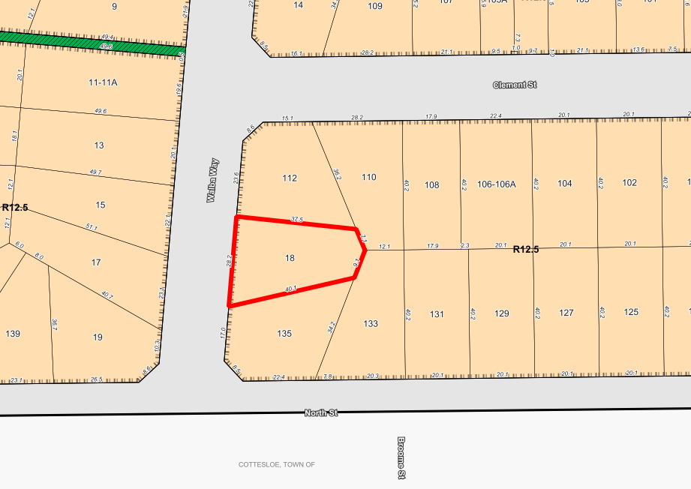
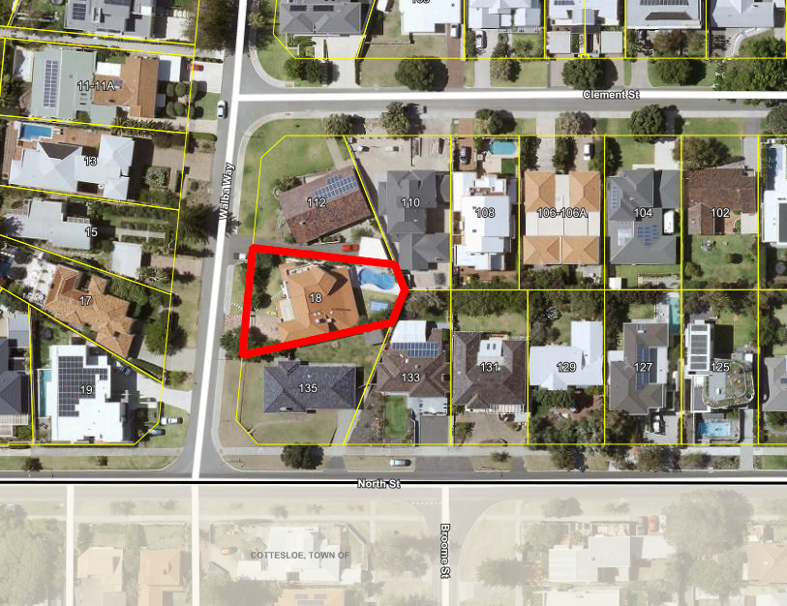

- Application Details

The applicant seeks development approval for additions to a single house, details of which are as follows:

- Ground floor construction of a ‘games room’ ensuite and sauna addressing the eastern and southern lot boundaries.
- Internal layout changes to the first floor.
- Addition of a rooftop-terrace.

By way of justification in support of the development proposal the applicant has provided a Design Principles assessment and response to submissions. This has been provided as an attachment to this report (Attachment 2).

- Consultation

The applicant is seeking assessment under the Design Principles of the R-Codes for the following:

- Lot boundary setbacks

The development application was advertised in accordance with the City’s Local Planning Policy - Consultation of Planning Proposals for a period of 14 days to 4 adjoining landowners/occupiers. At the close of advertising period, two (2) submissions objecting to the development proposal were received.

The City has provided a separate schedule of submissions as an attachment to this report (Attachment 3). A full copy of all consultation feedback received by the City has been given to the Councillors prior to the Council meeting as a Confidential Attachment.

The following table is a summary of the concerns/comments raised and the City’s response and action taken in relation to each issue:

Submission | Officer Response | Action Taken
The setback requirements should be made to comply with the requirements of the R-Codes. | There is no requirement for an application to meet the ‘deemed to comply’ development requirements of the R-Codes (State Planning Policy 7.3 Residential Design Codes). Where an application does not satisfy the ‘deemed to comply’ development requirements an assessment is required to be undertaken against the ‘design principles’. The development proposal is considered to meet the design principles. (see Administration assessment below (Clause 5.2) | Application considered to meet the Design Principles. Approval recommended.
Visual privacy should be made to comply with the requirements of the R-Codes | The development proposal seeks to amend previously approved major openings only. Visual privacy intrusions have been previously approved as part of the original build. It is not considered appropriate to retroactively apply current visual privacy requirements to a previously approved dwelling. | Visual privacy intrusions previously approved. No action required.
Access to natural light will be affected by the proposed additions. | The development is considered to satisfy the ‘deemed to comply’ requirements of Clause 5.4.2 Solar Access for Adjoining Sites. | Application satisfies the ‘deemed to comply’ development requirements for solar access. Approval recommended.
The development is too large for the lot and more open space should be provided. | The development is considered to satisfy the ‘deemed to comply’ requirements of Clause 5.1.4 Open Space. | Application satisfies the ‘deemed to comply’ development requirements for open space. Approval recommended.

Note: A full copy of all relevant consultation feedback received by the City has been given to the Councillors prior to the Council meeting.

- Assessment of Statutory Provisions

5.1 Planning and Development (Local Planning Schemes) Regulations 2015

Clause 67(2) of the Deemed Provisions stipulates those matters that are required to be given due regard to the extent relevant to the application. Where relevant, these matters are discussed in the report.

In accordance with provisions (m) and (n) of the Regulations clause 67(2), due regard is to be given to the likely effect of the proposed development’s height, scale, bulk and appearance, and the potential impact it will have on the amenity of the locality.

5.2 Residential Design Codes – Volume 1 (State Planning Policy 7.3)

State Planning Policy 7.3 (Volume 1) of the Residential Design Codes (R-Codes) apply to single and grouped dwellings. The application is seeking an assessment under the Design Principles of the R-Codes for lot boundary setbacks and visual privacy setbacks as addressed in the tables below:

South-East (Rear)

- Ground Floor (entire length) setback at 1.5m in lieu of 6m

Building on Boundary

- Verandah to Games (south) – 9.48m long x 2.87m tall boundary wall proposed addressing the southern lot boundary. No boundary walls are permitted as-of-right under a R12.5 residential density code.
Design Principles
P3.1 Buildings set back from lot boundaries or adjacent buildings on the same lot so as to:
- reduce impacts of building bulk on adjoining properties;
- provide adequate direct sun and ventilation to the building and open spaces on the site and adjoining properties; and
- minimise the extent of overlooking and resultant loss of privacy on adjoining properties.
P3.2 Buildings built up to boundaries (other than the street boundary) where this:
- makes more effective use of space for enhanced privacy for the occupant/s or outdoor living areas;
- does not compromise the design principle contained in clause 5.1.3 P3.1;
- does not have any adverse impact on the amenity of the adjoining property;
- ensures direct sun to major openings to habitable rooms and outdoor living areas for adjoining properties is not restricted; and
- positively contributes to the prevailing or future development context and streetscape as outlined in the local planning framework.
Administration Assessment
Having regard to the Design Principles of State Planning Policy 7.3, Residential Design Codes Volume 1, the proposed development is considered to appropriately respond to the development site and associated site constraints.

Rear Lot Boundary Setback:
A property coded R12.5 is required to provide a minimum 6.0m rear lot boundary setback to maintain an open character. However, the City can consider the surrounding area to determine whether the deemed to comply provision should be upheld.

An overview of the surrounding properties reveals an established precedent of development within the 6.0m rear setback area. Intrusions into the rear setback area has been shown graphically on the image below. Properties containing a red dot contain structures within the rear setback area.
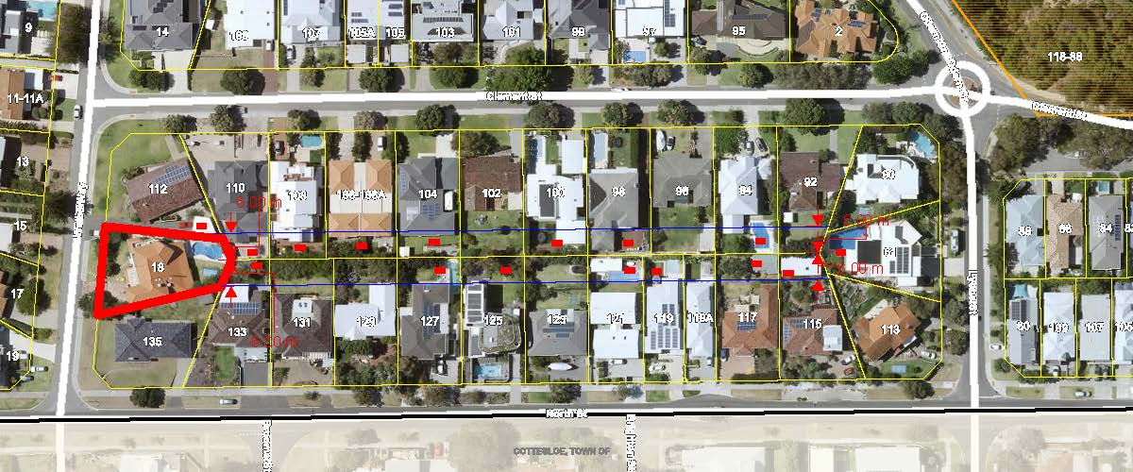

- From the above assessment of the immediate surrounding development context, it is demonstrated that the locality is characterised by rear lot boundary setback intrusions. The development proposal is considered to respond to the prevailing development context and provide a suitable rear lot boundary setback.

Assessment of C3.1

- The applicant has proposed a minimum 1.5m rear lot boundary setback for the proposed ground floor additions, achieving an average rear setback of 6.0m. The articulated wall is setback far enough from the rear lot to provide satisfactory areas of open space and landscaping which help to reduce the overall impact of building bulk.
- The rear elevation casts shadow onto the adjoining southern property. However, overall, it complies with element 5.4.2 – Solar access to adjoining properties.
- The rear elevation contains no major openings and the deemed to comply requirements for element 5.4.1 – Visual privacy; thereby maintaining privacy to the rear lot.

Boundary Wall:
- A R12.5 density code provides as deemed-to-comply a minimum 1.0m lot boundary setback to all side lot boundaries, with no right to a boundary wall, unless abutting an existing boundary wall of equal or greater length on a neighbouring lot.
- The development proposes a 9.5m long boundary wall, with a maximum height of 2.9m addressing the southern lot boundary.
- Considering the lot restrictions consisting of an existing pool and single house, the proposed boundary wall is considered to make more effective use of space for the site, having no negative visual privacy implications addressing the southern lot.
- The boundary wall is proposed to address the southern lot boundary and is restricted in height to a maximum of 2.9m.
- The proposed boundary wall addresses the southern lot boundary and is unlikely to detrimentally affect the southern landowner’s access to natural light and ventilation, considering its low height.
- It is noted that no objection was received from the southern adjoining landowner in relation to the development proposal.

In light of the above, the application is considered to successfully meet the Design Principles for Clause 5.1.3 – Lot Boundary Setbacks.
- Conclusion

Council is requested to make a decision in accordance with clause 68(2) of the Deemed Provisions. Council may determine to approve the development without conditions (cl.68(2)(a)), approve with development with conditions (cl.68(2)(b)), or refuse the development (cl.68(2)(c)).

The application for additions to a single house at No. 18 Walba Way, Swanbourne has been submitted for Council consideration as an objection has been received. The objection raises concerns with regards to lot boundary setbacks, building bulk and visual privacy. The proposal is considered to meet the key amenity related elements of R-Codes Volume 1 and as such is unlikely to have a significant adverse impact on the local amenity of the area or neighbouring landowners. The development proposal is consistent with the Residential R12.5 density code and has been designed to complement the existing streetscape. The proposal has been assessed and satisfies the design principles of the Residential Design Codes.

Accordingly, it is recommended that the application be approved by Council, subject to Conditions.

PD19.21 | Local Planning Policy – Community Engagement on Planning Proposals
Committee | 11 May 2021
Council | 25 May 2021
Applicant | City of Nedlands
Director | Tony Free – Director Planning & Development
Employee Disclosure under section 5.70 Local Government Act 1995 | Nil  “The author, reviewers and authoriser of this report declare they have no financial or impartiality interest with this matter.  There is no financial or personal relationship between City staff and the proponents or their consultants.  Whilst parties may be known to each other professionally, this relationship is consistent with the limitations placed on such relationships by the Codes of Conduct of the City and the Planning Institute of Australia”.
Previous Item | PD51.20 of 27 October 2020 Ordinary Council Meeting
Attachments | - Draft Local Planning Policy – Community Engagement on Planning Proposals  - Planning Regulations Amendment Regulations 2020 – New Consultation Requirements  - Summary of proposed amendments to the Local Planning Policy – Consultation of Planning Proposals

- Executive Summary

Administration is proposing to amend the adopted Local Planning Policy – Consultation of Planning Proposals (Consultation LPP). The main purpose of the amendment is to introduce engagement provisions for strategic planning proposals.

The opportunity has been taken to also revise some of the existing policy provisions to improve delivery, as well as to ensure consistency with consultation changes introduced in February 2021 through the Planning Regulations Amendment Regulations 2020. Reflective of the proposed provisions, the title of the policy is proposed to be amended to Local Planning Policy – Community Engagement on Planning Proposals (Community Engagement LPP).

The purpose of this report is for Council to adopt the draft Community Engagement LPP (Attachment 1) for the purpose of advertising.

Recommendation to Committee

Council proceeds with the draft modified Local Planning Policy – Community Engagement on Planning Proposals, Attachment 1, and advertises for a period of 21 days, in accordance with the Planning and Development (Local Planning Schemes) Regulations 2015 Schedule 2, Part 2, Clause 4(2).

Voting Requirement:

Simple Majority.

- Background

The City’s Local Planning Scheme No. 3 (LPS 3) was gazetted in April 2019, resulting in an increased body of strategic planning work to create a local planning framework for areas which have been rezoned and up coded. Administration has sought to involve the community early in the process of developing this local planning framework. However, the Consultation LPP currently provides no guidance on how this type of non-statutory pre-engagement should be undertaken. As such, the main purpose of reviewing the Consultation LPP is to introduce engagement provisions for strategic planning proposals.

The Consultation LPP was adopted by Council on 2nd May 2019 and was subsequently amended by a Notice of Motion at the 24th of September 2019 Council Meeting (24 September 2019 Notice of Motion). The 24th of September 2019 Notice of Motion only related to the required advertising extent for a front setback variation under the Residential Design Codes Volume 1 (R-Codes Volume 1). However, the justification provided highlighted some other potential amendments to the Consultation LPP. These are discussed in further detail in the Discussion section below.

At the 28th of April 2020 Council Meeting, a Notice of Motion was carried to instruct the CEO to prepare a Terms of Reference for a Community Working Group (CWG) consisting of 12 community members and chaired by a Councillor. The Terms of Reference was subsequently prepared and endorsed by Council at its 26th May 2020 Meeting. The CWG is intended to act as a conduit between the Council and the community, helping to inform and identify local community priorities in the review and formulation of local planning policies and other strategic planning instruments. Part of Council’s 26th May 2020 Resolution was to instruct the CEO to undertake a review of the Consultation LPP to include referral of material to the CWG as part of the consultation process. The review of the Consultation LPP in line with this resolution is discussed in further detail in the Discussion section below.

This item was previously presented to Council at the 27 October 2020 Ordinary Council. Since being presented to Council on 27 October 2020, the following update has been made to the draft Community Engagement LPP:

- Incorporation of changes to consultation introduced through the Planning Regulations Amendment Regulations 2020, which became operational on 15 February 2021.

- Discussion

Introduce engagement provisions for strategic planning proposals

The International Association for Public Participation (IAP2) sets out five levels of engagement, at increasing levels of community involvement in decision-making:

- Inform
- Consult
- Involve
- Collaborate
- Empower

Levels 1 and 2 generally relate to statutory advertising requirements under the Planning and Development (Local Planning Scheme) Regulations 2015 (2015 Regulations). They are generally appropriate for planning proposals such as development applications, where the goal is to obtain feedback on specific proposals which have already been substantially progressed.

Levels 3 to 5 generally relate to engagement methods which are not statutory requirements under the 2015 Regulations. These methods are more appropriate for strategic planning proposals, such as local planning policies, where the goal is to obtain community input throughout the entire policy-development process to ensure that community concerns and aspirations are directly reflected in the alternatives developed.

In its current form, the Consultation LPP primarily deals with engagement at levels 1 and 2. Noting the City’s increasing body of strategic planning work which has come out of the gazettal of LPS 3, Administration is proposing to amend the Consultation LPP to also include engagement methods at the higher levels of the IAP2 spectrum, as outlined below.

Methods of engagement at Level 3 ‘Involve’ and Level 4 ‘Collaborate’

Noting that each strategic planning proposal is unique in its complexity and extent, it is inappropriate to dictate exactly which engagement measures should be used in each case. Therefore, this section provides a range of possible engagement methods, such as online surveys, one-on-one meetings, workshops, and community working/reference groups. This section also requires the preparation of a Community Engagement Plan, which is to outline the purpose of the engagement and the specific engagement methods proposed.

This section also clarifies that the City may engage external consultants to facilitate engagement activities. This approach has been used previously for the preparation of precinct-based local planning policies and has been considered highly valuable in bringing independent expertise into the engagement process.

Extent of engagement at Level 3 ‘Involve’ and Level 4 ‘Collaborate’

For strategic planning proposals which relate to a defined geographical area, such as a precinct-based local planning policy, the Community Engagement LPP proposes that higher-level engagement methods be targeted at the community within the area, and within a specified catchment around the area. This approach ensures that those people most affected by the proposal are given a voice early in the process. Broader engagement with the wider community could then take place after the proposal is in draft form (such as through the mandatory 21-day minimum consultation period for draft local planning policies).

For strategic planning proposals which do not relate to a defined geographical area, such as a public open space strategy, the Community Engagement LPP proposes that higher-level engagement methods be open to all members of the community. A representative sample of the community may also be used to focus engagement activities.

The extent of higher-level engagement would also need to be addressed in the Community Engagement Plan, and justification for the chosen approach would need to be provided.

Pre-lodgement engagement for scheme amendments and complex development applications

From time to time, applicants for scheme amendments and complex development applications have conducted their own engagement with the community prior to lodging an application with the City. This is not a statutory requirement, or pre-requisite. This process allows applicants to gauge community desires and concerns in the early stages of developing their proposal.

This new section of the Community Engagement LPP encourages applicants to conduct this form of pre-engagement with the community and sets requirements for the applicant to keep the City informed of the process and outcomes of the pre-engagement activities.

24 September 2019 Notice of Motion

The 24^{th of} September 2019 Notice of Motion modified the advertising extent for front setback variations under the R-Codes Volume 1, from properties within 100m of the subject site on the same street, to five properties either side of the subject site. This was considered a minor amendment and was therefore not advertised.

The justification provided for the 24 September 2019 Notice of Motion, together with the comment provided by Administration, foreshadowed several other future amendments for consideration:

- Incorporating engagement guidelines from the Department of Planning, Lands and Heritage (DPLH) Action Plan for Planning Reform;
- Consultation involving adjoining local authorities;
- Sign on site requirements; and
- Level of discretion Administration has in choosing the appropriate method of consultation.

DPLH released its Action Plan for Planning Reform in August 2019. One of the actions identified in this plan was the development of a toolkit of consistent guidelines on consultation and engagement on planning proposals. The first stage of resultant changes were made through the Planning Regulations Amendment Regulations 2020, which became operational on 15 February 2021. These Regulations include new provisions to improve consultation practices and make them consistent across local governments. Such provisions include (but are not limited to):

- Specific advertising requirements, including a 28-day advertising period, for complex development applications;
- Increased focus on online and digital engagement, rather than traditional methods such as newspaper advertisements;
- Consistent advertising exclusion periods for Christmas/New Year and Easter holidays; and
- Longer consultation periods for structure plans.

A full summary of these changes is provided in Attachment 2, and explanation for how they have been incorporated into the Community Engagement LPP is provided in Attachment 3.

Consultation involving adjoining local authorities, sign on site requirements and the level of discretion Administration has in choosing the appropriate method of consultation has been addressed by proposed amendments to the Consultation LPP, as outlined in the Other Amendments section below.

Community Working Group

In accordance with Council’s 28th April and 26th May 2020 Resolutions relating to the CWG, the Consultation LPP has been amended as follows:

- Table 2 – Methods of Engagement at Level 1 ‘Inform’ and Level 2 ‘Consult’ has been amended to include optional referral to the CWG for the following planning proposals:

  - Structure plans;
  - Standard and complex scheme amendments;
  - Local planning policies
  - Local development plan; and
  - Other strategic proposals.

- Engagement with the CWG has been added as an option for engagement at Level 3 ‘Involve’ and Level 4 ‘Collaborate’.

A minor modification has been made to the CWG Terms of Reference since its adoption on 26 May 2020, for the purpose of clarifying the media protocol.

Community Information Sessions

The 28^{th of} April 2020 Notice of Motion discussed earlier in this report called for CWGs to replace Community Information Sessions (Information Sessions).

The intent of Information Sessions is for the community and Councillors to ask specific questions about a planning proposal, and for answers to be provided by Administration and the applicant of the proposal. As they are currently run, Information Sessions are open to any member of the community who would like to receive further information about a proposal. This further information can then be used to inform community members’ submissions on the proposal. The establishment of a select group of community members, such as a community working group, would not replace this important function of Information Sessions.

Administration acknowledges several previous issues with recent CIS for complex development applications, including:

- Confusion as to what the community expects from these sessions (i.e., formal presentation vs. question and answer structure);
- Unclear expectations of the role of Councillors at these sessions;
- Community members significantly overwhelming the resources provided by Administration; and
- Perception that the City is presenting an application to the community in conjunction with the applicant (and that the City is therefore supportive of the application).

In response to these identified issues, Administration has prepared a Community Information Session (CIS) Procedure.

The CIS Procedure sets out the following:

- Clarification on the purpose of the sessions;
- Requirements to RSVP to sessions to ensure an appropriate ratio of Administration to community members to ensure everyone is attended to;
- Clarification on the roles and expected behaviours of each party to ensure respectful and meaningful interactions during these sessions.

It is noted that the CIS Procedure is currently being used by Administration and is successfully addressing the abovementioned issues.

If Council resolve to adopt the Community Engagement LPP, and associated CIS Procedure, following advertising then Administration could review the implementation effectiveness after a set period of time (i.e., six months). If this review finds that further improvements could be made, Administration could either review the CIS Procedure accordingly, or seek alternative methods for consulting on development applications (such as one-on-one appointments with Administration).

Administration recommends that Council supports this abovementioned approach, rather than removing the option of CIS all together at this juncture.

Other Amendments

In addition to the amendments and additions described above, there are also several amendments proposed to the existing provisions within the Consultation LPP. A summary of these other amendments, together with the justification for each amendment, is included as Attachment 4.

- Consultation

The draft modified Local Planning Policy – Community Engagement on Planning Proposals was presented to the City’s Community Working Group (CWG) on 14 October 2020 for consideration and no feedback was provided. If Council resolve to adopt the draft modified Local Planning Policy – Community Engagement on Planning Proposals for advertising, the CWG will be consulted for further comment.

If Council resolves to prepare the local planning policy, it will be advertised for 21 days in accordance with Schedule 2, Part 2, Division 2, Clause 4 of the Planning and Development (Local Planning Scheme) Regulations 2015. This will include details being included on the City’s website and the Your Voice engagement portal.

Following the advertising period, the policy will be presented back to Council for it to consider any submissions received and to:

- Proceed with the policy without modification;
- Proceed with the policy with modification; or
- Not to proceed with the policy.

- Strategic Implications

How well does it fit with our strategic direction?
The City’s Local Planning Strategy establishes urban growth areas and transition areas within the City, which have been reflected in rezoning and up-coding through LPS 3. This has resulted in the need for local planning controls in areas affected by LPS 3, and the Community Engagement LPP is intended to create a framework for community involvement in developing this framework.

Who benefits?
The Community Engagement LPP has been amended to introduce better guidance on engagement methods at the higher levels of the IAP2 engagement spectrum. These engagement methods will allow the City to obtain community input throughout the entire process of developing a strategic planning proposal, to ensure that community concerns and aspirations are directly reflected in the alternatives developed. Therefore, the City benefits from developing strategic planning proposals which better reflect the community, and the community benefits from being able to have such involvement in the process.

Does it involve a tolerable risk?
When a strategic planning proposal is developed without input from the community it will be affecting, there is always a risk that the policy will not be adopted or will not achieve appropriate outcomes for the community. Therefore, the proposed early involvement of the community in the development of strategic planning proposals is considered to reduce such risks.

Do we have the information we need?
Yes.

- Budget/Financial Implications

Can we afford it?
The Community Engagement LPP provides guidance on engagement methods at the higher levels of the IAP2 engagement spectrum. These methods generally have a cost associated with them (i.e., consultant to facilitate engagement activities), which will be accounted for in the budget of each project.

How does the option impact upon rates?
As above.

- Statutory Provisions

Planning and Development (Local Planning Schemes) Regulations 2015

Under Schedule 2, Part 2, Clause 3(1) of the Planning and Development (Local Planning Scheme) Regulations 2015, the City may prepare a local planning policy in respect to any matter related to the planning and development of the Scheme area.

Once Council resolves to prepare a local planning policy it must publish a notice of the proposed policy in a newspaper circulating in the area for a period not less than 21 days.

- Conclusion

It is proposed to amend the adopted Local Planning Policy – Consultation of Planning Proposals (Consultation LPP). The main purpose of the amendment is to introduce engagement provisions for strategic planning proposals. The opportunity is also being taken to revise some of the existing provisions. Reflective of the proposed provisions, the title of the policy is proposed to be amended to Local Planning Policy – Community Engagement on Planning Proposals (Community Engagement LPP).

The purpose of this report is for Council to adopt the Community Engagement LPP (Attachment 1) for the purpose of advertising.

PD20.21 Scheme Amendment No 7 – South Broadway Final Adoption

Committee | 11 May 2021
Council | 25 May 2021
Applicant | City of Nedlands
Director | Tony Free – Director Planning & Development
Employee Disclosure under section 5.70 of the Local Government Act 1995 | Nil.  “the author, reviewers and authoriser of this report declare they have no financial or impartiality interest with this matter. There is no financial or personal relationship between City staff and the proponents or their consultants. Whilst parties may be known to each other professionally, this relationship is consistent with the limitations placed on such relationships by the Codes of Conduct of the City and the Planning Institute of Australia”.
Previous Item | OCM 28 April 2020 - PD15.20  SCM 3 September 2020 – Item 9
Attachments | - Justification Report – Scheme Amendment No 7  - Summary of Submissions – Scheme Amendment No 7
Confidential Attachments | - Full Submissions – Scheme Amendment No 7

- Executive Summary

The purpose of this report is to provide Council with an overview of the submissions received during the advertising period for the proposed Scheme Amendment No 7 (SA7) to Local Planning Scheme No 3 (LPS3).

Recommendation to Committee

Council:

- Pursuant to section 75 of the Planning and Development Act 2005 and in accordance with section 41(3) of the Planning and Development (Local Planning Schemes) Regulations 2015, does NOT support the amendment to Local Planning Scheme No. 3 for the following reasons:

- Scheme Amendment No 7 is not supported by evidence based built form modelling that indicate the proposed amendments would comply with the density targets as set out in Perth and Peel @ 3.5 million; and

- The City and DPLH are working in partnership on a GAPs analysis of the City’s strategic planning framework. Scheme Amendment No 7 does not propose work that is identified as a priority by the GAPs analysis, and is therefore considered to be reactive, premature, and not part of an agreed program of works.

- In accordance with Regulation 44 of the Planning and Development (Local Planning Schemes) Regulations 2015, submit the required information for the proposed Scheme Amendment No 7 to the West Australian Planning Commission.

- Discussion/Overview

SA7 proposes changes to the residential density coding along Broadway, Hillway, Kingsway, Edward Street and Elizabeth Street.

SA7 proposes the following changes to the residential density coding of subject properties as follows:

- Numbers 2 to 36 Kingsway and 42 to 96 Kingsway, Nedlands from R60 to R40;
- Numbers 7 to 23 Hillway, Nedlands from R60 to R40 (northwest side of street);
- Numbers 1 to 4 Hillway, Nedlands from R-AC3 to R-AC4 (northwest side of street);
- Number 5 Hillway, Nedlands from R-AC3 to R40
- Numbers 69 to 139 Broadway, Nedlands from R-AC3 to R-AC4;
- Number 2 Edward Street from R-AC3 to R-AC4; an
- Numbers 1, 1A and 1B Elizabeth Street from R-AC3 to RAC4.

Scheme Amendment No 7 has now completed advertising as a complex amendment and is presented to Council for their final recommendation. Under Regulation 41(3) Council must now choose one of the following options:

- support the amendment to the local planning scheme without modification;

- support the amendment to the local planning scheme with proposed modifications to address issues raised in the submissions; or

- not to support the amendment to the local planning scheme.

- Key Relevant Previous Council Decisions:

At the April 2020 Ordinary Council Meeting (OCM), Council was advised by Administration that proposed Scheme Amendment No 7 is ‘complex’ in nature. In accordance with the Planning and Development (Local Planning Schemes) Regulations 2015 (the Regulations), approval from the Western Australia Planning Commission (WAPC) is required prior to advertising the Policy. However, Council adopted the amendment as a ‘standard’ amendment, and it was advertised by Administration as a standard scheme amendment for a period of 42 days as per Section 47 of the Regulations. When presented to Council at the 3 September Special Council Meeting (SCM) post advertising, Administration recommended that Council resolve not to support the amendment as it was not based on sound town planning principles and was premature.

Council instead resolved to support the scheme amendment. The scheme amendment was subsequently submitted to the WAPC as a standard amendment for its assessment.

On the 23 September 2020, the WAPC wrote to the City, advising that it considered the scheme amendment to be a ‘complex’ amendment for the following reasons:

a. It is not consistent with a local planning strategy for the scheme that has been endorsed by the WAPC;
b. It is not addressed by any local planning strategy; and
c. It relates to development of a scale or will have an impact that is significant relative to development in the locality.

The WAPC directed the City to treat the amendment as a complex amendment in accordance with Regulation 54. In addition to this, the WAPC has directed the City to readvertise the amendment as complex and progress the amendment accordingly thereafter. Administration advised Council their only option under the Regulations was to advertise the scheme amendment as complex, and so the scheme amendment was advertised for a period of 60 days as per the requirements of the Regulations for a complex amendment.

- Strategic Documents

Built Form Modelling / Distinctiveness Character Study

The City engaged consultants at Hassell to complete a local distinctiveness study, context analysis and built form modelling to inform built form controls for the Broadway Precinct. The intent of the distinctiveness study is to review the characteristics of the existing built form that inform the character of the area. The focus has been to uncover elements that make a positive contribution to local distinctiveness and the opportunities for enhancement. The local distinctiveness study and context analysis will be used to inform built form modelling, which will test different development scenarios for the precinct. Once these development scenarios are reviewed and explored through community engagement, a local precinct-based planning policy will be drafted for the precinct, which will define appropriate built form controls that are likely to form an amendment to the Scheme.

It is expected that the built form controls will assist in ameliorating the impacts of harsh transitions in density coding, such as the sites codes RAC3 abutting those coded R60, which provides for a default interface of 6 storey down to 3 storeys. The local planning policy that will be an output of the local distinctiveness study and built form modelling is expected to be presented to Council in mid-2021.

Specialised Activity Centre Plan

Land within the Crawley-Nedlands neighbourhood, which includes the University of Western Australia (UWA) and associated colleges, Broadway, Queen Elizabeth II Medical Centre (QEIIMC) and Hollywood Hospital is identified as a Specialised Activity Centre under the State Government’s Central Sub-Regional Planning Framework. In consultation with the City of Nedlands, the City of Perth and Department of Planning, Lands and Heritage have been working to prepare a Specialised Activity Centre Plan (SACP). The SACP aims at supporting the centre through the development of complementary activities that support the primary function of health, education, and research in addition to balancing future growth, built form outcomes and transport. Once prepared, the future SACP will affect the future planning and development of the locality which will be further guided by State Planning Policy 4.2 Activity Centres for Perth and Peel or equivalent replaced State Planning Framework and 7.2 Precinct Design. There is currently no set timeframe for the completion of the SACP as it is at a preliminary stage. Any changes to density along Broadway should be made collaboratively with the City of Perth and the Department so that they are in line with this plan.

UWA has made a submission to Scheme Amendment No. 7 stating that they do not support the amendment and that amendments should not jeopardise the future intent of this centre to become a globally competitive centre for health, medical, education, research, and innovation.

Local Planning Strategy

The City’s Local Planning Strategy (the Strategy) endorsed in 2017 suggested that the Hampden/Broadway Precinct should have medium intensity and be a low to medium rise urban growth area within the City. Without built form modelling, it is unclear how the density proposed in Scheme Amendment No. 7 responds to the objectives of the Strategy.

Residential Design Codes Volume 2

The Residential Design Codes confirms that the R-AC3 code is intended for mid-rise urban centres. In the Local Planning Strategy, Broadway is described as an ‘urban growth area’ and ‘low to medium rise’ which correlates with the mid-rise urban centre typology prescribed in the Residential Design Codes Volume 2 Appendix 2. The built form context of a mid-rise urban centre includes a building height of up to 6 storeys. Buildings have a direct street frontage and may be built to the boundary. These centres are usually highly walkable with proximity to high frequency transit services, public open space and commercial and/or retail uses. Broadway fits within these parameters, and as such, the existing R-AC3 is appropriate. The scheme amendment proposed Broadway be down coded to R-AC4. The R-AC4 code is better suited to smaller neighbourhood centres. It would be inappropriate to apply the R-AC4 code to Broadway in light of its classification in the Local Planning Strategy, and the area’s inclusion in the QEII/UWA SACP.

Perth and Peel @ 3.5 Million

Perth and Peel at 3.5 Million provides the City of Nedlands with a density target of 4320 additional dwellings by 2050. Local Planning Scheme No. 3 was described by the Minister as meeting the density targets prescribed to the City. Any reductions in density would necessitate the provision of adjusted yield calculations to demonstrate that the minimum density targets prescribed can be achieved. It is unclear as to how the proposed density under the scheme amendment relates to the current density target. Built form assumptions, determined through built form modelling, are required to inform calculations on how the scheme amendment will contribute to dwelling yield targets. Without detailed justification that confirm an amendment will not prejudice these targets, an amendment may not be supported by the Commission and the Minister.

- Consultation

Scheme Amendment No 7 was advertised in accordance with Regulation 54(a) for a period of 60 days from the 31 October 2020 to the 31 January 2021. The advertising period was extended to accommodate the City’s advertising blackout period over the New Year period, as required by the City’s Local Planning Policy – Consultation of Planning Proposals.

During the consultation period the City received 109 submissions, of which 13 were objections, 95 were in support and 1 was commenting. A summary of submissions is provided in Attachment 2 of this report.

- Strategic Implications

How well does it fit with our strategic direction?
The scheme amendment was required to be re-advertised as directed by the WAPC in accordance with the Regulations. However, now that advertising has closed, it is recommended that Council defer any decision seeking density code changes until built form modelling has been completed and thoroughly tested built form response can be supported based on sound town planning principles.

Who benefits?
The proposed scheme amendment seeks to benefit some members of the community who wish to seek lower density within an area which has recently been up coded as part of LPS3. Those who do not benefit are landowners who have bought properties intending to develop at the current applicable density codes.

Does it involve a tolerable risk?
The risk involved is that the WAPC will refuse the scheme amendment after being advertised for a second time as a complex amendment.

Do we have the information we need?
Scheme Amendment No 7 is not informed by built form modelling or research. It also does not form part of a program for strategic planning for the City, which has been agreed to under the Gaps Analysis. This scheme amendment is therefore considered to be premature, and without the information required to be supported.

- Budget/Financial Implications

Can we afford it?
Costs involved are those associated with administrative work.

How does the option impact upon rates?
There is no current impact upon rates. A reduced density coding will result in a decrease in the potential dwelling yield compared to redevelopment at current density coding.

- Conclusion

Scheme Amendment No 7 is considered premature, as it does not form part of the City’s strategic planning program, which is currently being worked on between the City and DPLH. The City is also yet to conclude their built form modelling work, which will ultimately result in built form controls upon which the City can base further strategic documents.

Scheme Amendment No 7 is not considered to propose the optimal orderly and proper planning outcome for the City, and it is recommended that Council resolve not to support the proposed amendment to LPS3.

8.1 Alternate Resolution

If Council choose to continue with the amendment without modifications, the following Resolution is recommended.

Council:

      - Pursuant to section 75 of the Planning and Development Act 2005 and in accordance with section 41(3) of the Planning and Development (Local Planning Schemes) Regulations 2015, supports Scheme Amendment No.7 to amend Local Planning Scheme No. 3 as detailed in Attachment 1 – Scheme Amendment No. 7 without modification.

      - In accordance with Regulation 44 of the Planning and Development (Local Planning Schemes) Regulations 2015, submit the required information for the proposed Scheme Amendment No 7 to the West Australian Planning Commission.

PD21.21 | Consideration of Development Application for 5 Single Houses at No. 22 Vincent Street, Nedlands
Committee | 11 May 2021
Council | 25 May 2021
Applicant | Coastview Australia Pty Ltd
Landowner | Lenmal Pty Ltd
Director | Tony Free – Director Planning & Development
Employee Disclosure under section 5.70 Local Government Act 1995 | The author, reviewers and authoriser of this report declare they have no financial or impartiality interest with this matter.  There is no financial or personal relationship between City staff and the proponents or their consultants.  Whilst parties may be known to each other professionally, this relationship is consistent with the limitations placed on such relationships by the Codes of Conduct of the City and the Planning Institute of Australia.
Report Type  Quasi-Judicial | When Council determines an application/matter that directly affects a person’s right and interests. The judicial character arises from the obligation to abide by the principles of natural justice. Examples of Quasi-Judicial authority include town planning applications and other decisions that may be appealable to the State Administrative Tribunal.
Reference | DA20-55087
Previous Item | Nil
Delegation | In accordance with the City’s Instrument of Delegation, Council is required to determine the application due to objections being received.
Attachments | - Applicant Justification
Confidential Attachments | - Development Plans  - Submissions  - Site Photos

- Executive Summary

The purpose of this report is for Council to determine a Development Application received from the applicant on the 5 October 2020, for the proposed five (5) single houses located at Lot 90 (No. 22) Vincent Street, Nedlands.

The land was approved for a five lot, freehold subdivision by the Western Australian Planning Commission (WAPC) on 16 July 2020. Although titles have not yet been issued, the City has assessed the application as five single houses as opposed to grouped dwellings given the future tenure of the land.

A demolition permit was issued on 16 December 2020 by the City of Nedlands (the City). A site inspection to the site on 23 March 2021 established that the site has been cleared and the existing single house and vegetation removed.

The application was advertised to adjoining neighbours in accordance with the City’s Local Planning Policy - Consultation of Planning Proposals. Six (6) objections were received during the advertising period.

This application is presented to Council for determination in accordance City’s Instrument of Delegation, due to the application proposing five (5) single houses. It is recommended that the application be approved by Council as it is considered to satisfy the design principles of the Residential Design Codes (R-Codes) Volume 1 and is unlikely to have a significant adverse impact on the local amenity and character.

Recommendation to Committee

In accordance with Clause 68(2)(b) of the Deemed Provisions of the Planning and Development (Local Planning Schemes) Regulations 2015, Council approves the development application received on 5 October 2020 in accordance with plans date stamped 3 March 2021 and 20 April 2021 (DA20-44087) for five (5) Single Houses at Lot 90 (No. 22) Vincent Street, Nedlands, subject to the following conditions:

- The development shall at all times comply with the application and the approved plans, subject to any modifications required as a consequence of any condition(s) of this approval.

- This approval is for a ‘Residential- Single House’ land use as defined under the City of Nedlands Local Planning Scheme No.3 and the subject land may not be used for any other use without prior approval of the City.

- Prior to the issue of a Building Permit, a Construction Management Plan shall be submitted to the satisfaction of the City. The approved construction shall be observed at all times throughout the construction process to the satisfaction of the City.

- All landscaping shall be installed and maintained in accordance with the approved landscaping plan dated 20 April 2021, or any modifications approved thereto, for the lifetime of the development thereafter, to the satisfaction of the City.

- Prior to occupation of the development all fencing/visual privacy screens and obscure glass panels to major openings and unenclosed active habitable areas as annotated on the development plans dated 3 March 2021 and 20 April 2021, shall be screened in accordance with the Residential Design Codes. Screening referred to in c1.1(ii) of the Residential Design Codes Volume 1 is to be in the form of;

- Fixed obscured or translucent glass to a height of 1.60 metres above finished floor level, or
- Timber screens, external blinds, window hoods and shutters to a height of 1.6m above finished floor level that are at least 75% obscure.
- A minimum sill height of 1.60 metres as determined from the internal floor level; or
- An alternative method of screening approved by the City of Nedlands.

The required setbacks and/or screening shall be thereafter maintained to the satisfaction of the City.

- Prior to occupation of the development the finish of the parapet walls is to be finished externally to the same standard as the rest of the development in:

- Face brick;
- Painted render;
- Painted brickwork; or
- Other clean material as specified on the approved plans.

And maintained thereafter to the satisfaction of the City.

- In accordance with the Australian Standard AS2890.1 (as amended), all car parking and vehicle manoeuvring areas are to maintain adequate circulation space, free of intrusions such as doors and storage areas which do not compromise the minimum parking dimensions required under AS2890.1.

- The parking bays and vehicle access areas shall be drained, paved, and constructed in accordance with the approved plans and are to comply with the requirements of AS/NZS 2890.1:2004 prior to the occupation or use of the development.

- All footings and structures shall be constructed wholly inside the site boundaries of the property’s Certificate of Title.

- All stormwater from the development, which includes permeable and impermeable areas shall be contained onsite.

- Prior to occupation of the development, all external fixtures including, but not limited to, TV and radio antennae, satellite dishes, plumbing vents and pipes, solar panels, air conditioners, hot water systems and utilities shall be integrated into the design of the building and not be visible from the primary street to the satisfaction of the City.

Voting Requirement

Simple Majority

- Background

2.1 Land Details

Metropolitan Region Scheme Zone | Urban
Local Planning Scheme Zone | Residential
R-Code | R60
Land area | 1014m²
Additional Use | No
Special Use | No
Local Development Plan | No
Structure Plan | No
Land Use | Residential (Single House)
Use Class | P – Permitted

2.2 Locality Plan

The subject site currently comprises one lot at No. 22 Vincent Street, Nedlands (the subject site) which is currently vacant. The site previously contained a Single House and vegetation which have recently been removed.

On 16 July 2021, the Western Australian Planning Commission (WAPC) approved a freehold subdivision for five (5) single lots on the subject site.

The subject site is located within the street block bounded by Stirling Highway and the Memorial Rose Garden to the north, Louise Street to the east, Jenkins Avenue to the south, and Vincent Street to the west. The subject site has primary frontage to Jenkins Avenue and secondary frontage to Vincent Street.

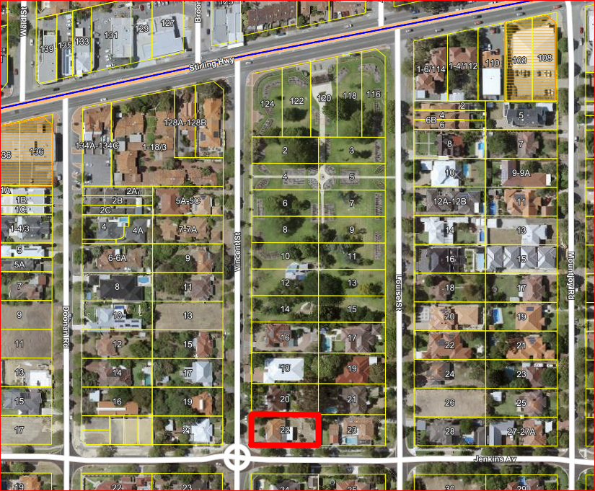
Figure 1 – Aerial Map

Within the street block, the land abutting the highway is zoned public open space with the remaining land in the street block forming a transitionary growth and built form area. The subject site is coded Residential R60, which is a medium density coding that contemplates low to mid-rise apartments and grouped dwellings.

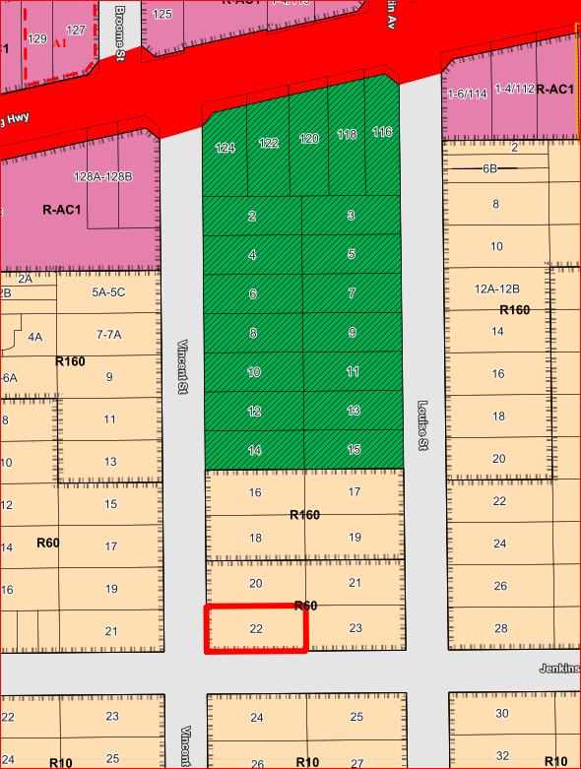
Figure 2 – Zoning Map

Although the surrounding area is predominated by single houses, it is not an intact streetscape. There are a number of redeveloped homes and recently subdivided lots in close proximity to the site as follows:
- On 26 November 2020, the Metro Inner-North Joint Development Assessment Panel (DAP) approved seven (7) grouped dwellings and six (6) multiple dwellings on 21 and 23 Louise Street, Nedlands. This development is located abutting the eastern lot boundary of the subject site.
- On 9 July 2020, the DAP approved 37 multiple dwellings on 17-19 Louise Street, Nedlands. This development is located adjacent to the north of 21-23 Louise Street and within 25m radius of the subject site.
- On 11 May 2020, DAP approved 15 multiple dwellings on 13 Vincent Street, Nedlands. This development is located to the north of the subject site.
- Demolition permit applications have been received by the City for 20 and 21 Vincent Street, Nedlands which are abutting the northern and western lot boundaries of the subject site.

The area is considered to be undergoing change given the recent development approvals. The predominant housing stock within the locality is a mix of grouped dwellings close to Stirling Highway and the Memorial Rose Garden, single houses and approved multiple dwellings.

The predominant landscape character of this locality is vegetated front and rear gardens and mature canopy trees within the verge area.

The site is located in the Melvista West Transition Zone. In September 2020 Council adopted for advertising a draft Local Planning Policy which seeks to define the desired future character and calibrate appropriate design and built form settings with respect of this area.

- Application Details

The applicant seeks development approval, for the construction of five (5) single houses, details of which are as follows:

- Each single house will have a double garage, living, dining areas, three (3) bedrooms, two bathrooms and storerooms.
- Lot 1 is a two (2) storey single house and Lots 2-5 single houses are designed to have two (2) storeys above an undercroft basement garage and storeroom.
- Lot 1 garage access from Vincent Street and Lots 2-5 garage access is from Jenkins Avenue.
- A total of seven (7) x medium sized (200L) Chinese tallow trees and two (2) x small (100L) snow pear trees are to be planted.

By way of justification in support of the development application the applicant has provided an assessment of the proposal in accordance with the planning framework, contained in Attachment 1.

- Consultation

The applicant is seeking assessment under the Design Principles of the R-Codes for the following:

- Lot boundary setbacks;
- Open space;
- Site works;
- Retaining walls; and
- Visual Privacy.

The development application was advertised in accordance with the City’s Local Planning Policy - Consultation of Planning Proposals to nine (9) residents and landowners. Six (6) objections were received.

The following table is a summary of the concerns/comments raised and the City’s response and action taken in relation to each issue:

Submission | No. of times issue raised | Officer Response | Action Taken
Concerns regarding the number of multiple crossovers proposed along Jenkin Avenue which is a safe active street. | 5 | Objection noted.  On 16 July 2021, the Western Australian Planning Commission (WAPC) approved a green title subdivision for five (5) single lots. The number of crossovers is consistent with the number of single houses proposed for the subject site with one (1) being located on Vincent Street and four (4) on Jenkins Avenue. It is noted that the provision of 5 separate crossovers was considered appropriate by the WAPC when it granted subdivision approval, notwithstanding the City’s concerns.  Administration has reviewed vehicle access to and from the subject site and has determined that safety can still be maintained from Jenkins Avenue which is a safe active street. | No further action
Loss of one (1) mature street tree and no replacement. | 5 | Objection noted.  The revised site and landscape plan in Attachment 2, show that the existing street tree (Queensland Brush Box) is proposed to be removed and will be replaced with a new tree in the location between Lot 3 and 4 crossovers. In the event if Council approves the proposal, an advice note is recommended to ensure that the street tree removal and replacement for one (1) new street tree costs is funded by the applicant.  It should be noted that the applicant is supportive of additional street trees to be planted within the verge, if the City decides to plant more trees along Jenkins Avenue and Vincent Street which will further contribute towards a ‘leafy green’ streetscape which Nedlands is known for. | Advice Note
Visual Privacy  - Concerns over visual privacy to properties along Jenkins Avenue.  - Concerns over visual privacy from balconies to the northern lot boundary.  - Concerns over visual privacy from the raised outdoor living areas above 0.5m from the Natural Ground Level (NGL). | 4 | Objection noted.  - Visual privacy is compliant along the southern elevation of all 5 single houses as all balconies will face and overlook into Jenkins Avenue.  - There are no balconies proposed along the northern elevation of the proposed development.  - The visual privacy variation identified for Lots 2-5 raised outdoor living areas is further discussed in the Planning Assessment section in the report. | No further action
Concerns that the outdoor living areas for each lot does not comply. | 3 | Objection noted.  The subject site requires a minimum of 16m² of outdoor living areas (OLA) for a R60 zoned site.  The OLA is compliant with the requirements of element 5.3.1 – Outdoor Living Areas of the R-Codes. | Nil
Concerns that the proposal is a three (3) level home.  The building height will compromise the amenity of the street. | 2 | Objection noted.  The proposal does not exceed 8.5m high measured from the NGL for concealed roof developments.  The proposed building height is in accordance with the City’s Local Planning Policy – Residential Development: Single and Grouped Dwellings (Residential Development Policy) and element 5.1.6 – Building height of the R-Codes. | No further action
No visitor parking bay provided. | 1 | Objection noted.  Visitor car parking is not required by the R-Codes for dwellings that do not share a common driveway. | Nil
Concerns over waste collection along Jenkins Avenue as a safe active street. | 1 | Objection noted.  The City has reviewed the proposal and waste collection from Jenkins Avenue can be gathered safely from Jenkins Avenue. | No further action

- Assessment of Statutory Provisions

5.1 Planning and Development (Local Planning Schemes) Regulations 2015

Clause 67(2) of the Deemed Provisions (Consideration of application by local government) stipulates those matters that are required to be given due regard to the extent relevant to the application. Where relevant, these matters are discussed in the following sections.

In accordance with sub-clauses (m) and (n) of the Regulations clause 67(2), due regard is to be given to the likely effect of the proposed development’s height, scale, bulk and appearance, and the potential impact it will have on the local amenity.

5.2 Local Planning Scheme No. 3

An assessment of the Scheme as they relate to this application is provided below.

Item | Requirement | Proposal | Satisfies
9 – Aims of Scheme | - Protect and enhance local character and amenity | The surrounding area is varied in terms of built form but predominated by single dwellings with several examples of grouped and multiple dwellings closer to Stirling Highway. The area’s housing stock is similarly varied in terms of roof forms, height, and setbacks. The City acknowledges that over time, the existing built form character within the locality will change and a new built form will emerge.  As viewed from surrounding streets, the development is considered to have architectural merit which uses design references such as concealed roofs, rendered walls, light colour scheme and inclusion of windows and balconies overlooking the street which will transition well with the approved seven (7) grouped dwellings approved on 21 and 23 Louise Street abutting the subject site on the eastern lot boundary. | Yes
 | - Respect the community vision for the development of the district; | The development is not considered to adversely affect the community vision for the development of the district in that it reflects the endorsed Local Planning Strategy.  The Draft Local Planning Policy – Melvista West Transition Zone seeks to establish a localised planning response for the Melvista West Transition Zone. The subject site is located within this precinct. A discussion of the policy is provided later in the report. | Yes
 | - Achieve quality residential built form outcomes for the growing population; | The built form of the development has been assessed and is considered to achieve or can be made to achieve all relevant design principles of the R-Codes Vol. 1 and is consistent with the expectations of the Residential R60 density coding. | Yes
 | - To develop and support a hierarchy of activity centres; | The medium-rise development is consistent with the intent of the R60 density code identified by Local Planning Scheme No. 3. The development will contribute to the dwelling target set out in the Local Planning Strategy for this transition zone. | Yes
 | - To integrate land use and transport systems; | The development is located approximately 250m from Stirling Highway which is serviced by a number of buses including Bus 102, 103, 107 and high frequency Bus 999. | Yes
 | - Facilitate improved multi-modal access into and around the district; | The site is located on the Safe Active Streets Network – a pedestrian and cycle friendly boulevard. | Yes
 | - Maintain and enhance the network of open space; | The development does not impact the City’s network of open space. | Yes
 | - Facilitate good public health outcomes; | The development is not considered to adversely affect the desired public health outcomes. | Yes
 | - Facilitate a high-quality provision of community services and facilities; | The development is not considered to adversely affect the community services or facilities and will contribute to ensuring their viability. | Yes
 | - Encourage local economic development and employment opportunities; | The development is considered to positively contribute to the support of local businesses, during and post-construction. | Yes
 | - To maintain and enhance natural resources; | The proponent will plant a total of seven (7) x medium sized (200L) Chinese tallow trees and two (2) x small (100L) snow pear trees on the subject site. | Yes
 | - Respond to the physical and climatic conditions; | The development maintains solar access to adjoining properties by having appropriate setbacks. The dwelling design encompasses cross ventilation and adequate ceilings to allow for effective air circulation. | Yes
 | - Facilitate efficient supply and use of essential infrastructure; | The development does not negatively impact this objective. | Yes
16.2 - Residential Zone Objectives | To provide for a range of housing and a choice of residential densities to meet the needs of the community; | The proposal is considered to provide a type of housing that will contribute to the City’s housing diversity. | Yes
 | To facilitate and encourage high quality design, built form and streetscapes throughout residential areas; | The development has achieved a quality design, with an appropriate built form and streetscape presentation. It is noted that a multiple dwelling outcome may have achieved a smaller footprint and allowed a greater proportion of landscaping. | Yes
 | To provide for a range of non-residential uses, which are compatible with and complementary to residential development; | This objective is not applicable to the subject application. | N/A
 | To ensure development maintains compatibility with the desired streetscape in terms of bulk, scale, height, street alignment and setbacks; | The development includes a under croft basement and two storeys above it in height and setback sufficiently between 3-4m to provide some landscaped front area for the narrow lots around 9.0m wide (particularly for Lots 2-5). This has been undertaken to ensure the building sits well within the streetscape, which is characterised by front setbacks varying between 3-6m.  The development is now considered to strike a balance between achieving the built form expectations of the R60 density code and responding appropriately to the local context.  Furthermore, the City considers that the proposal, subject to compliance with conditions will complement the local character and amenity of the site, with the proposed height provision being consistent with the surrounding area. | Partially

5.3 Design of the Built Environment (State Planning Policy 7.0)

Design Principle | Officer Comment
- Context and Character  Good design responds to and enhances the distinctive characteristics of a local area, contributing to a sense of place. | In accordance with the City’s Local Planning Strategy the proposal will provide built form transition from the high-density mixed-use development that is anticipated on Stirling Highway to the low-density residential area to the south. Given that there are no acceptable outcome height limits on Stirling Highway, and a default height of five (5) storeys within the R160 zone to the north, the proposal will provide built form transition between those areas of medium density development and the lower density area to the south.  The development proposes five (5) single houses that all address the street, have individual driveways and entries and is setback greater than the minimum 2.0m required for a R60 site by 3-4m. This is consistent along Jenkins Avenue which has a street setback that varies between approximately 3-6m.  The development is a contemporary build, reinforcing its unique distinctiveness and responding sympathetically to local building forms and patterns such as the use of concealed roofs, rendered walls, stone feature walls, light colour scheme and inclusion of windows and balconies overlooking the street which will transition well with the approved seven (7) grouped dwellings approved on 21 and 23 Louise Street abutting the subject site on the eastern lot boundary.  The provision of a variety of landscaping vegetation and addition of seven (7) x medium sized (200L) Chinese tallow trees and two (2) x small (100L) snow pear trees on the subject site along primary and secondary street setback areas will help contribute to the existing leafy-green streetscape of Vincent Street and Jenkins Avenue.  This principle is considered to have been met as the design positively contributes to the identity of an area including adjacent sites, streetscapes and the surrounding neighbourhood.
- Landscape Quality  Good design recognises that together landscape and buildings operate as an integrated and sustainable system, within a broader ecological context. | Whilst there are no ecosystems or environmental features that are specific to this site, the proposed vegetation within the development includes:  - Seven (7) x medium sized Sepium Sebiferum trees (Chinese tallow tree);  - Two (2) x small Pyrusnivalls trees (snow pear tree); and  - A variety of vegetation such as kangaroo paw bushes, grevillea plants throughout the development for each lot.  The proposal of a variety of native vegetation is considered to provide a positive outcome for the benefit of the environment, the climate, the future residents of the single houses and the amenity of the City of Nedlands. The proposed trees when planted will ensure the development better integrates with the surrounding environment, which is considered to be ‘leafy green’, as the proposed trees will have a canopy diameter at maturity of a minimum 6.0m for a medium Chinese tallow tree and a minimum of 4.0m for a small snow pear tree.  It is noted that all existing vegetation on the site has been removed to accommodate this development and one (1) street tree (Queensland Brush Box) is proposed to be removed. In the event that Council approves the proposal, an advice note will be placed to inform the applicant that the street tree removal and replacement will be funded by the applicant.  It should be noted that the applicant is supportive of additional street trees to be planted within the verge if the City’s Park Services Unit decides to plant more trees along Jenkins Avenue and Vincent Street. This will further contribute towards a ‘leafy green’ streetscape for which Nedlands is known for.  This principle is considered to have been met.
- Built form and scale  Good design ensures that the massing and height of development is appropriate to its setting and successfully negotiates between existing built form and the intended future character of the local area. | The single houses are considered sympathetic and characteristic of the existing and emerging dwellings within the locality. The development is not considered to negatively impact the surrounding properties by way of building height, setbacks or overshadowing.  This principle is considered to have been met as the new development positively responds to the built form and topography of the surrounding buildings. The orientation and articulation of the built form delivers an outcome which is suited to the character of the adjacent streetscape and positively contributes to the amenity of the future development, the adjoining sites and the locality.
- Functionality and build quality  Good design meets the needs of users efficiently and effectively, balancing functional requirements to perform well and deliver optimum benefit over the full life cycle. | The proposal includes sizable bedrooms and open plan living areas making the dwellings functional and accessible for all demographics.  The site is accommodated with building utilities and services in an integrated manner so as not to negatively impact the amenity of the site.  All rooms are of an appropriate size and the layout is straight-forward so as to provide functional environments and spaces that are suited to their intended purpose and arranged to facilitate ease of use.  This principle is considered to have been met as the design provides functionality and build quality without detriment to the appearance, functionality and serviceability of the dwellings.
- Sustainability  Good design optimises the sustainability of the built environment, delivering positive environmental, social and economic outcomes. | Predominately north facing outdoor living areas are provided for the proposed dwellings. The design is supported as it maximises the northern aspect of the site.  This principle is considered to have been met as the design responds to site conditions by providing appropriate orientation and natural ventilation.
- Amenity  Good design provides successful places that offer a variety of uses and activities while optimising internal and external amenity for occupants, visitors and neighbours, providing environments that are comfortable, productive and healthy. | The proposed design provides an appropriate amount of indoor and outdoor activity space, with reasonably sized bedrooms, living spaces and an outdoor living area which is orientated north. The site planning considers the impact of overshadowing and bulk by limiting boundary walls to the north.  This principle is considered to have been met as the design delivers internal amenity with rooms and spaces that are adequately sized, comfortable, and easy to use, with good levels of daylight, natural ventilation, and outlook. This principle is considered to have been met as the site is afforded with good external amenities within close proximity.
- Legibility  Good design results in buildings and places that are legible, with clear connections and easily identifiable elements to help people find their way around. | The design provides for clear and definable pedestrian and vehicle entrances which provides for a clear delineation of spaces from the public and private realm.  This principle is considered to have been met as the design makes the site easy to navigate, with recognisable entry and exit points and being well-connected to existing movement network to Vincent Street and Jenkins Avenue. The sight lines are well-considered and the movement through the development is logical and intuitive.
- Safety  Good design optimises safety and security, minimising the risk of personal harm and supporting safe behaviour and use. | Each dwelling has at least one major opening facing the street, providing adequate passive surveillance. Furthermore, there are no areas capable of being used for concealment.  The City would prefer the number of crossovers to be consolidated. It is noted that the site does not have access to a laneway and there is a current green title WAPC approval for five (5) single lots on the subject site. The number of crossovers is consistent with the number of single houses proposed for the subject site with one (1) being located off from Vincent Street and four (4) being located off from Jenkins Avenue.  The City has reviewed vehicle access to and from the subject site and have determined that safety can be maintained from Jenkins Avenue, which is a safe active street.  This principle is considered to have been met as safety and security is promoted by maximising opportunities for passive surveillance of public pedestrian paths and minimising areas of concealment. The design provides a positive, clearly defined relationship between public and private spaces and addresses the need to provide optimal safety and security both within a development and to the adjacent public realm.
- Community  Good design responds to local community needs as well as the wider social context, providing environments that support a diverse range of people and facilitate social interaction. | The development provides a degree of medium density dwelling diversity within the City by improving the range of housing availability in the area and accommodating for a wider range of demographics.  This principle is considered to have been met as the new development has the capacity to adapt to changing demographics, an ageing population where applicable, new uses, and people with disability. The design provides a housing choice for different demographics and accommodating all ages and abilities wishing to downsize.
- Aesthetics  Good design is the product of a skilled, judicious design process that results in attractive and inviting buildings and places that engage the senses. | The proposed materials are considered high-quality, and the development is consistent with the contemporary homes and buildings within the surrounding area.  The design incorporates a mixture of materials and colours including contrasting textured stone, wood, light coloured metallic framing elements and glass.  This principle is considered to have been met as the design delivers outcomes that are logical and guided by a consideration of the experiential qualities that it will provide. The proposal is a well-conceived design which addresses scale, the articulation of building form with detailing of materials and building elements which enables an integrated response to the character of the locality.

5.4 Precinct Design Assessment (State Planning Policy 7.2)

State Planning Policy 7.2 (SPP 7.2) and its associated guidelines have been recently introduced by the State Government. Whilst the Policy relates primarily to the creation of precinct plans, it does require subdivision and development to apply the Policy and Guidelines where a precinct plan is not in place, in particular to areas which are within a precinct boundary.

The City’s comments on the extent the development addresses the design elements is outlined below.

Design Element 1: Urban Ecology

O1.1 To protect, enhance and respond to the ecological systems of the precinct. | The site has recently been demolished and is currently vacant. The development is proposing landscaped areas and a total of nine (9) trees to be planted on the subject site, which will be beneficial to precinct ecology.
O1.2 To enhance sense of place by recognising and response to Aboriginal, cultural and built heritage. | There is no known Aboriginal heritage on or near the site in accordance with the City’s Municipal Heritage Inventory 2012.
O1.3 To reduce the environmental and climate change impacts of the precinct development. | The development outdoor living areas are orientated to benefit from the northern exposure of the site.

Design Element 2: Urban Structure

O2.1 To ensure the pattern of blocks, streets, buildings and open space responds and contributes to distinct, legible precinct character. | The development fronts onto the existing street layout.
O2.2 To promote an urban structure that supports accessibility and connectivity within and outside the precinct. | The development is designed to be accessible.
O2.3 To ensure the urban structure supports the built form, public realm and activity intended for the precinct. | No precinct plan has been developed at this time.
O2.4 To ensure an adaptable urban structure that can respond to and facilitate change within a precinct. | The development is unlikely to be adaptable in terms of the residential land use.

Design Element 3: Public Realm

O3.1 To ensure the public realm is designed to promote community health and wellbeing. | Not applicable
O3.2 To enable local character and identity to be expressed in public realm to enhance a sense of place. | Not applicable
O3.3 To ensure than key environmental attributes are protected and enhanced within the public realm. | Not applicable
O3.4 To ensure the public realm is designed to be inclusive, safe and accessible for different users and people of all ages and abilities. | Not applicable
O3.5 To ensure public realm design is integrated with the built form, movement network and landscape of the precinct. | Not applicable

Design Element 4: Movement

O4.1 To ensure the movement network supports the function and ongoing development of the precinct. | The development utilises the existing movement network.
O4.2 To ensure a resilient movement network that prioritises affordable, efficient, sustainable and healthy modes of transport. | The development is located approximately 250m from Stirling Highway, which is serviced by several buses including Bus 102, 103, 107 and high frequency Bus 999.
O4.3 To enable a range of transport choices that meet the needs of residents, workers and visitors. | The site is in an area that provides transport choice from walking, cycling and public transport.
O4.4 To ensure the quantity, location, management and design of parking supports the vision of the precinct. | There is currently no precinct vision. Overall, the proposed parking provision is appropriate to support the development.

Design Element 5: Land Use

O5.1 To ensure current and planned land uses respond to the needs and expectations of the community. | The proposed residential land use in the development is permissible by the Scheme. This objective would be more appropriate when considering land uses over an entire precinct rather than a single site.
O5.2 To ensure the planned land use types contribute positively to the precinct character and amenity. | The precinct character and level of amenity has not been determined. However, the proposal is generally consistent with the development expectations attributable to the R60 higher density code.
O5.3 To achieve a mix of land uses and activity that supports the precinct vision. | Not applicable

Design Element 6: Built Form

O6.1 To ensure that the built form is responsive to the purpose, context and intended character of the precinct. | The bulk and scale of the development is considered to be consistent with the intent of an R60 coded lot.
O6.2 To ensure building placement, scale and massing is appropriate for the intended precinct and streetscape character. | The scale of the development is considered to be appropriate as a transition from lots coded R160 to the north and lots coded R10 to the south.  The development features single houses that are oriented to Jenkins Avenue which will positively contributes to the existing streetscape along Jenkins Avenue.
O6.3 To ensure that built form design reduces energy demand across the precinct by facilitating climate-responsive design. | The development seeks to maximise the northern aspect of the site. The design responds to site conditions by providing appropriate orientation and natural ventilation.
O6.4 To ensure that built form design is responsive to the streetscape and contributes to a safe and comfortable public realm. | The proposal is seen to provide an appropriate built form design for an R60 density which will contribute to a safe and comfortable public realm.  The development proposes a mix of materials and textures such as white render, light window frames, stone and wood elements and a modern contemporary design to create an aesthetic streetscape appeal.  The orientation and articulation of the built form delivers an outcome which is suited to the character of the adjacent streetscape and positively contributes to the amenity site.
6.0 Policy/Local Development Plan Consideration

  - Residential Design Codes – Volume 1 (State Planning Policy 7.3)

The applicant is seeking assessment under the Design Principles of the R-Codes for lot boundary setbacks, open space, site works, retaining walls and visual privacy as addressed in the following tables:

Element 5.1.3 – Lot boundary setback
Design Principles
P3.1 Buildings set back from lot boundaries or adjacent buildings on the same lot so as to:
- reduce impacts of building bulk on adjoining properties;
- provide adequate direct sun and ventilation to the building and open spaces on the site and adjoining properties; and
- minimise the extent of overlooking and resultant loss of privacy on adjoining properties.

P 3.2 Buildings built up to boundaries (other than the street boundary) where this:
- makes more effective use of space for enhanced privacy for the occupant/s or outdoor living areas;
- does not compromise the design principle contained in clause 5.1.3 P3.1;
- does not have any adverse impact on the amenity of the adjoining property; ensures direct sun to major openings to habitable rooms and outdoor living areas for adjoining properties is not restricted; and
- positively contributes to the prevailing or future development context and streetscape as outlined in the local planning framework.
Deemed-to-Comply Requirement
C3.1 Buildings which are set back in accordance with the following provisions, subject to any additional measures in other elements of the R-Codes:
- buildings set back from lot boundaries in accordance with Table 1, Tables 2a and 2b (refer to Figure Series 3 and 4);

Walls may be built up to a lot boundary behind the street setback (specified in Table 1 and in accordance with clauses 5.1.2, 5.2.1 and 5.2.2), within the following limits and subject to the overshadowing provisions of clause 5.4.2 and Figure Series 11:
- where the wall abuts an existing or simultaneously constructed wall of similar or greater dimension;
- in areas coded R20 and R25, walls not higher than 3.5m with an average of 3m or less, up to a maximum length of the greater of 9m or one-third the length of the balance of the lot boundary behind the front setback, to one side boundary only;
- in areas coded R30 and higher, walls not higher than 3.5m with an average of 3m or less, for two-thirds the length of the balance of the lot boundary behind the front setback, to one side boundary only; or
- where both the subject site and the affected adjoining site are created in a plan of subdivision submitted concurrently with the development application.
Proposed
Side and rear setbacks variations
- Lot 2- Ground floor western setback is proposed to be 1.0m in lieu of 1.5m (impact to Lot 1 only).
- Lot 2 - Upper floor western setback is proposed to be 1.0m in lieu of 2.0m (impact to Lot 1 only).
- Lot 3 - Ground floor eastern setback is proposed to be 1.0m in lieu of 1.5m (impact to Lot 4 only).
- Lot 3 - Upper floor eastern setback is proposed to be 1.0m in lieu of 2.0m (impact to Lot 4 only).
- Lot 4 - Ground floor eastern setback is proposed to be 1.0m in lieu of 1.5m (impact to Lot 3 only).
- Lot 4 - Upper floor eastern setback is proposed to be 1.0m in lieu of 2.0m (impact to Lot 3 only).
- Lot 5 - Upper floor eastern setback is proposed to be 1.5m in lieu of 1.9m (impact to 23 Louise Street)

Building on boundary variations
- Lot 1 - Boundary walls proposed on the northern and eastern lot boundaries in lieu of one side only (impact to 20 Vincent Street and Lot 2)
- Lot 1 - Garage boundary wall is proposed to be 80% in lieu of 66.66% of the northern lot boundary.
- Lot 1 - Eastern boundary wall is proposed to be 73% in lieu of 66.66% of the eastern lot boundary (abutting to Lot 2).
Administration Assessment
C3.1 - Side and rear setbacks
The side setback variations proposed in Points 1-7, is considered to meet the Design Principle P3.1 for the following reasons:

In regard to the variations outlined in Points 1-6:
- The proposed side setback variations are between each lot internally. The proposed internal side setback variations do not impact upon building bulk to adjoining properties to the north (20 Vincent Street) or east (23 Louise Street).
- The proposed variations still allow direct sun and ventilation to Lots 2, 3, 4 and 5 as the development outdoor living areas and living/dining areas take advantage of the northern aspect of the subject site.
- The proposed side setback variations do not result in overlooking or a loss of privacy between each lot.

In regard to the variation outlined in Point 7:
- The proposed side setback variation of 0.4m is noted for the upper floor side setback for Lot 5 to the eastern lot boundary. This is not considered to have a building impact to the adjoining eastern property given that the variation is considered to be consistent with the side setbacks of the recent DAP approval for seven (7) grouped dwellings and six (6) multiple dwellings on 21 and 23 Louise Street, Nedlands.
- The proposed variations allow direct sun and ventilation to the eastern property as the development does not overshadow any outdoor living area of the adjoining property (overshadowing falls towards Jenkins Avenue).
- The proposed side setback variation does not result in overlooking or a loss of privacy to the eastern property.

C3.2 - Building on boundary
The building on boundary variations proposed in Points 8-10, is considered to meet the Design Principle P3.2 for the following reasons:
- The development could have utilised the deemed to comply length and height permitted under Residential R60 which would have had a much greater impact on the adjoining properties. Instead, the proposed boundary walls do not exceed the 3.5m height and 3.0m average height requirements of the R20 density. Therefore, the proposal’s impact on the amenity is considered lower than what is capable under the deemed to comply.
- In R60, building on boundary is permitted for two-thirds (66%) of the length of the balance of the lot boundary behind the front setback. The boundary walls along the northern (abutting 20 Vincent Street) and eastern (internal) boundaries makes effective use of space given the narrow size of Lot 1 (11m wide). This will assist in privacy for the occupants as there are no openings along the boundary walls.
- The boundary walls do not exacerbate the overshadowing as per element 5.4.2 of the R-Codes Vol. 1 to the adjoining lots, with overshadowing falling towards Jenkins Avenue. As such, the proposed development does not unduly compromise the direct sun and ventilation to the building and open spaces upon the adjoining properties.
- The proposed boundary walls do not contain any major openings on the walls and as such, the boundary walls ensure there is minimal overlooking and resultant loss of privacy on adjoining properties.
- It is considered that the proposal of the single house contributes to the future development context and streetscape of the locality, representing an appropriate development for the R60 density code.

Element 5.1.4 – Open Space
Design Principles
P4 Development incorporates suitable open space for its context to:

- reflect the existing and/or desired streetscape character or as outlined under the local planning framework;
- provide access to natural sunlight for the dwelling;
- reduce building bulk on the site, consistent with the expectations of the applicable density code and/or as outlined in the local planning framework;
- provide an attractive setting for the buildings, landscape, vegetation and streetscape;
- provide opportunities for residents to use space external to the dwelling for outdoor pursuits and access within/around the site; and
- provide space for external fixtures and essential facilities.
Deemed-to-Comply Requirement
The deemed to comply open space for each lot is 40%.
Proposed
Lots 2, 3 and 4- Open space is proposed to be 38.5% in lieu of 40% deemed-to-comply.
Administration Assessment
The open space provision for Units 2-4 is considered to meet the Design Principles for the following reasons:

- The development as a whole is consistent with the existing and emerging streetscape character. It is noted that the 1.5% variation of open space to Lots 2, 3 and 4 does not negatively impact upon the streetscape character of Jenkins Avenue. Units 1 and 5, proposes a total of 42% open space which exceeds the deemed to comply requirement of 40% per lot.
- A variety vegetation such as Chinese tallow trees, snow pear trees, kangaroo paw bushes and Grevillea plants are proposed in the open spaces of the site will reflect and enhance the streetscape character of Jenkins Avenue as a ‘leafy green’ locality.
- Despite the minor variation to open space, the design of the development carefully considers the importance of the northern aspect of the site. All outdoor living areas and principal living spaces are orientated to take advantage of the northern aspect of the site which will improve the living amenity of the future residents.
- The design of the development utilises multiple articulations at ground and upper floor so as to reduce the building bulk of the site onto adjoining properties where possible. With a compliant primary street setback proposed along the southern lot boundary, the City does not consider that the open space shortfall is as a result of overdevelopment of the site and this proposal is consistent with the expectations of the R60 density code.
- As shown in the Site Plan and Landscaping Plan, the development provides an attractive setting for the buildings, nestled amongst a variety of trees, shrubs and vegetation which will improve the amenity of the future residents of the single houses.
- The outdoor living areas which face north will provide opportunities for the residents to use these spaces for private recreation and outdoor pursuits. It is also noted that the site is within close proximity of the Peace Memorial Rose Gardens, where future residents will have access to open space for outdoor pursuits.

Element 5.3.5 – Vehicle Access
Design Principles
P5.1 Vehicular access provided for each development site to provide:

- vehicle access safety;
- reduced impact of access points on the streetscape;
- legible access;
- pedestrian safety;
- minimal crossovers; and
- high quality landscaping features.
Deemed-to-Comply Requirement
C5.3 Driveways shall be:

- located so as to avoid street trees, or, where this is unavoidable, the street trees replaced at the applicant’s expense or replanting arrangement to be approved by the decision-marker.
Proposed
Lot 4- Proposed location of the driveway and crossover results in the removal of one (1) x Street Tree on Jenkins Avenue.
Administration Assessment
The street tree removal is considered to meet the Design Principles for the following reasons:

- The proposed driveway and crossover results in the removal of one (1) street tree (Queensland Brush Box) along Jenkins Avenue. The removal of the street tree will provide legible and safe vehicle access to and from Lot 4 for residents.
- Whilst the City would prefer the number of crossovers to be consolidated, it is noted that the site does not have access to a laneway and there is a current freehold WAPC approval for five (5) single lots on the subject site.
- The City has reviewed vehicle access to and from the subject site and have determined that vehicle and pedestrian safety can be maintained from Jenkins Avenue which is a safe active street.
- The proposed street tree removal was supported by Administration, subject to the street tree being replaced at the applicant’s expense. In the event that Council approves the proposal, an advice note will be placed advising the applicant that removal and replacement of the street tree will be at their cost.
- It should be noted that the applicant is supportive of additional street trees to be planted within the verge, if the City decides to plant more trees along Jenkins Avenue and Vincent Street which will further contribute towards a ‘leafy green’ streetscape.

Element 5.3.7 – Site works
Design Principles
P7.1 Development that considers and responds to the natural features of the site and requires minimal excavation/fill.

P7.2 Where excavation/fill is necessary, all finished levels respecting the natural ground level at the lot boundary of the site and as viewed from the street.
Deemed-to-Comply Requirement
The Deemed to comply requirements allow filling behind a street setback line and within 1.0m of a lot boundary, not more than 0.5m above the natural ground level (NGL) at the lot boundary.
Proposed
Lot 4- Proposed filling 0.52m high in lieu of 0.5m on the northern lot boundary from the NGL.
Administration Assessment
The site works is considered to meet the Design Principles for the following reasons:

- Due to the sloping nature of the site which changes significantly from the north to the south (Jenkins Avenue) by 0.5m and from the east to the west by 2.5m. The proposed fill of a maximum 0.52m is necessary to respond to the natural topography of the site.
- The fill along the northern lot boundary for Lot 4 and does not result in any undue amenity impacts to the existing streetscape along Jenkins Avenue.
It should be noted that no submissions were received objecting to this variation when it was advertised in accordance with the City’s Consultation Policy.

Element 5.3.8 – Retaining walls
Design Principles
P8 Retaining walls that result in land which can be effectively used for the benefit of residents and do not detrimentally affect adjoining properties and are designed, engineered and landscaped having due regard to clauses 5.3.7 and 5.4.1.
Deemed-to-Comply Requirement
The Deemed to comply requirements allow retaining walls set back from lot boundaries in accordance with the setback provisions of Table 1.
Proposed
Lot 4- The northern retaining wall greater than 0.5m high is located on the lot boundary in lieu of being setback 1.0m.
Administration Assessment
The retaining wall is considered to meet the Design Principles for the following reasons:

- Due to the sloping nature of the site which changes significantly from the north to the south (Jenkins Avenue) by 0.5m and from the east to the west by 2.5m. The proposed retaining wall of 0.52m high located along the northern lot boundary is necessary to respond to the natural topography of the site.
- The proposed retaining wall is designed well to respond to the changing NGLs of the site and is not considered to detrimentally affect the adjoining property at 20 Vincent.
It should be noted that no submissions were received objecting to this variation when it was advertised in accordance with the City’s Consultation Policy.

Element 5.4.1 – Visual privacy
Design Principles
P1.1 Minimal direct overlooking of active habitable spaces and outdoor living areas of adjacent dwellings achieved through:

- building layout and location;
- design of major openings;
- landscape screening of outdoor active habitable spaces; and/or
- location of screening devices.

P1.2 Maximum visual privacy to side and rear boundaries through measures such as:
- offsetting the location of ground and first floor windows so that viewing is oblique rather than direct;
- building to the boundary where appropriate;
- setting back the first floor from the side boundary;
- providing higher or opaque and fixed windows; and/or
- screen devices (including landscaping, fencing, obscure glazing, timber screens, external blinds, window hoods and shutters).
Deemed-to-Comply Requirement
The Deemed to comply requirements for unenclosed outdoor active habitable spaces is 6.0m setback for areas coded higher than R50.

Proposed
- Lots 2, 3 and 4 proposed outdoor living area (Finished Floor Level is greater than 0.5m from Natural Ground Level) is proposed to be setback 4.9m in lieu of 6.0m from northern lot boundary.
- Lot 5 proposed outdoor living area (Finished Floor Level is greater than 0.5m from Natural Ground Level) is proposed to be setback 4.9m in lieu of 6.0m from northern lot boundary and 3.1m in lieu of 6.0m from northern lot boundary
Administration Assessment
The visual privacy is considered to meet the Design Principles for the following reasons:

- Due to the sloping nature of the site which changes significantly from the north to the south (Jenkins Avenue) by 0.5m and from the east to the west by 2.5m. There is a section adjacent to the dining area which is a landing area for residents to step out and then proceed to step down to the main alfresco area.
- The proposed landing area adjacent to the dining room forms part of the OLA is only 1.2m in width x 3.8m in length which the occupants are unlikely use as their main OLA.
- The proposal has attempted to minimise overlooking as much as possible by locating the main alfresco area lower than the dining room to reduce impacts to the northern property.
- It should be noted that 20 Vincent Street, Nedlands has a demolition permit application with the City and a new development maybe approved on the site.
- Rear setbacks of the proposed development from the northern lot boundary meet the deemed to comply as per element 5.1.3 of the R-Codes Vol. 1 to the adjoining lot.
It should be noted that no submissions were received from adjoining properties to the northern and eastern lots directly impacted by the visual privacy variation advertised.

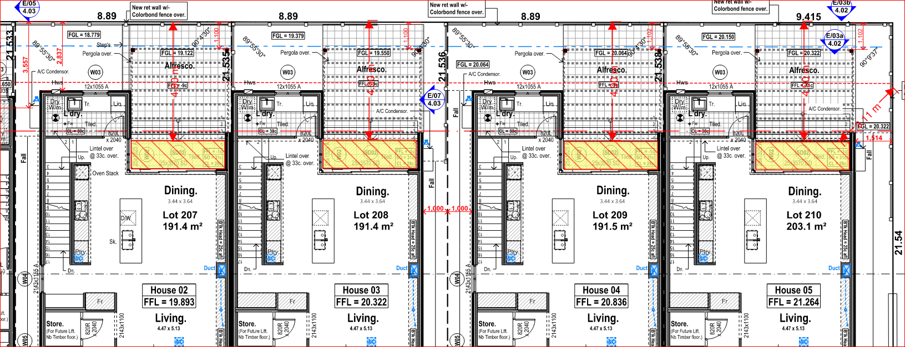

6.2 City of Nedlands Peace Memorial Rose Garden Precinct Local Planning Policy

The Local Planning Policy – Peace Memorial Rose Garden Precinct (PMRG Policy, was prepared by residents, and submitted to Council to adopt for advertising. It was submitted with the stated purpose to “ensure that the character of the well-established precinct is sustained and evolved as new development occurs”. The subject site is within this precinct. The precinct boundary is illustrated below in the map below:

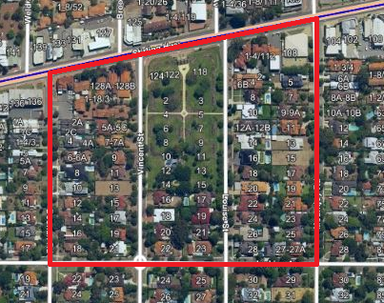
Subject site

The development of the PMRG Policy does not validly form part of the City’s current planning framework, given that the policy was prepared by landowners, rather than by the City, which is not supported by the Planning and Development Act. For this reason, the assessment of the amended plans does not include reference to this policy.

6.3 Melvista West Transition Zone Draft Local Planning Policy

The Draft Local Planning Policy – Melvista West Transition Zone (draft Melvista West Policy) seeks to establish a localised planning response for the Melvista West Transition Zone. The subject site is within this precinct.

Image: The precinct boundary of the Melvista West Transition Zone
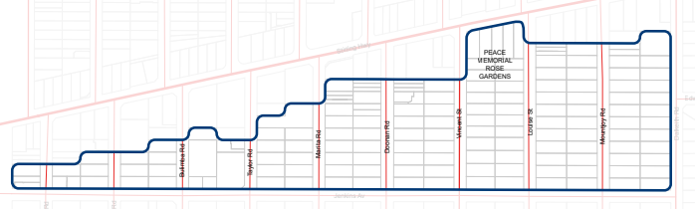
Subject site

The draft Melvista West Policy was adopted for advertising by Council at its 3rd September 2020 Special Council Meeting. Advertising of this policy has now closed. In its report for this item, Administration noted that the draft policy will form a “starting point” for development guidance in the precinct and will be subject to further revisions through built form modelling, legal and architectural review, external referrals, horticultural and heritage advice, as well as community engagement.

The draft Melvista West Policy seeks to augment provisions of both R-Codes Vol. 1 and Vol. 2, as outlined below.

R-Codes Vol. 1 – proposed changes to deemed-to-comply provisions for:
- Street setback
- Lot boundary setback
- Building height
- Setback of garages and carports
- Landscaping
- Design of car parking spaces
- Vehicle access

Pursuant to clause 67(2)(b) of the deemed provisions, in considering an application for development approval, due regard is to be given by the decision-maker to the requirements of any planning instrument that the local government is seriously considering adopting or approving.

‘Due regard’ requires the decision maker to give proper, genuine, and realistic consideration to the draft policy. However, the weight which is given to that consideration is a matter for the decision-maker.

The legal principles that are applied when assessing the weight afforded to a draft instrument, such as a local planning policy, are explained in the SAT’s decision in Nicholls and Western Australian Planning Commission [2005] WASAT 40. Those principles require four factors to be given consideration to, which are:

- the degree to which the draft assesses the specific application;
- the degree to which the draft is based on sound town planning principles;
- the degree to which the ultimate approval of the draft could be regarded as ‘certain’; and
- the degree to which the ultimate approval of the draft could be regarded as ‘imminent’.

With respect to the above factors, Administration will only comment on the third and fourth matters. As noted above, the provisions of the draft Melvista West Policy are still subject to change because of rigorous testing, peer review and community engagement. Given that this policy is a “starting point” for development guidance in the precinct, the City’s position is that the weight given to the draft Melvista West Policy should not prevail over the weight afforded to the relevant Deemed-to-Comply provisions of the R-Codes (Vol 1) in determining whether the application has met the element objective(s) as the draft policy is neither certain in its final form nor is it imminent in terms of adoption. For this reason, the proposal has not been assessed against the draft Melvista West Draft Policy.

Setting aside the specific development criteria, the draft Melvista West Policy contains a desired future character statement, specifically in respect to the additional consideration of the desired future character of an area. The City has considered the draft statement is tabled below:

Desired Future Character Element | Officer Response
Built form will respond to the streetscape and changes in development density within an appropriate building envelope, using innovative design treatments and providing appropriate massing | The built form is considered to be sympathetic to its surrounding development and is developing to the higher density coding potential.  Being proximate to the edge of the transitional area, the proposal is consistent with the intention of the R60 area and for five (5) x two storey with undercroft garage single houses be located on this site. It successfully negotiates the need for infill and to transition the built form down from the intended heights on Stirling Highway to the lower density area south of Jenkins Avenue which is zoned R10.  The development is a contemporary build, reinforcing its unique distinctiveness and responding sympathetically to local building forms and patterns as viewed from surrounding streets. The development is considered to have architectural merit which uses design references such as concealed roofs, rendered walls, light colour scheme and inclusion of windows and balconies overlooking the street which will transition well with the approved seven (7) grouped dwellings approved on 21 and 23 Louise Street abutting the subject site on the eastern lot boundary.  The City acknowledges that the proposed built form, which responds to the Residential R60 code, is in keeping with the existing built form in that it is proposing single houses.
Appropriately dimensioned setbacks will support the retention and consolidation of canopy trees and vegetation. | The site has been cleared and no trees are retained on-site. The landscape plan proposes the following vegetation on the subject site:  - Seven (7) x medium sized Sepium Sebiferum trees (Chinese tallow tree);  - Two (2) x small Pyrusnivalls trees (snow pear tree); and  - A variety of vegetation such as kangaroo paw bushes, grevillea plants throughout the development for each lot.  The proposed trees and native vegetation planted will ensure the development better integrates with the surrounding environment, which is considered to be ‘leafy green’.  It is noted that one (1) street tree (Queensland Brush Box) is proposed to be removed. In the event that Council approves the proposal, an advice note will be placed advising the applicant that removal and replacement of the street tree will be at their cost.  It should be noted that the applicant is supportive of additional street trees to be planted within the verge if the City decides to plant more trees along Jenkins Avenue and Vincent Street which will further contribute towards the existing streetscape.
Development will reference the traditional built form character of the area through the integration of design elements and a high-quality palette of materials and finishes. | The proposed development includes concealed roofs, render, light colour scheme and a modern contemporary design, which are considered sympathetic and characteristic of the existing and new dwellings within the locality.
Open, legible and attractive streetscapes. | The design provides for a clear and definable pedestrian and vehicle entrances which provides for a clear delineation of spaces from the public and private realm.  The design makes the site easy to navigate, with recognisable entry and exit points for all lots and being well-connected to existing movement network to Vincent Street and Jenkins Avenue.
Vegetated interface to the lot boundary and street. | The proposal incorporates new vegetation within the proposed development such as:  - Seven (7) x medium sized Sepium Sebiferum trees (Chinese tallow tree);  - Two (2) x small Pyrusnivalls trees (snow pear tree); and  - A variety of vegetation such as kangaroo paw bushes, grevillea plants throughout the development for each lot.  The proposed trees are located within the primary street setbacks for all lots facing Jenkins Avenue and the secondary street setback area of Lot 1 facing Vincent Street. The inclusion of additional trees in the street setback area will provide a softer interface between the street and the development, consistent with the character of the area.
Aesthetic of the current architectural style and form being reinterpreted in a contemporary manner. | The development is broadly consistent with this desired element.

- Conclusion

Council is requested to make a decision in accordance with clause 68(2) of the Deemed Provisions. Council may determine to approve the development without conditions (cl.68(2)(a)), approve with development with conditions (cl.68(2)(b)), or refuse the development (cl.68(2)(c)).

Whilst the proposal is a more intense form of development than what currently exists, it is compatible with the built form and scale of the redeveloped homes that is along Vincent Street and Jenkins Avenue and is consistent with the emerging streetscape character. The proposal is seen to be an appropriate type of development in a transitional zone between high density on Stirling Highway and lower density in south of Jenkins Avenue.

The proposal meets the key amenity related elements of R-Codes Volume 1 and as such is unlikely to have a significant adverse impact on the local amenity of the area. The five (5) x single houses proposed at the subject site are considered to be consistent with the Residential R60 density code and has been designed to complement the existing streetscape. The proposal has been assessed and satisfies the design principles of the Residential Design Codes and does not prejudice the intent of the zone or objectives of the Scheme.

Accordingly, it is recommended that the application be approved by Council.

