AGENDA

Council Meeting

25 October 2022

Notice of Meeting

To Mayor & Councillors

A Council Meeting of the City of Nedlands is to be held on Tuesday 25 October 2022 in the Council chambers at 71 Stirling Highway Nedlands commencing at 6pm.

Bill Parker
Chief Executive Officer
20 October 2022
Information

Council Meetings are run in accordance with the City of Nedlands Standing Orders Local Law. If you have any questions in relation to items on the agenda, procedural matters, public question time, addressing Council or attending meetings please contact the Executive Officer on 9273 3500 or council@nedlands.wa.gov.au

Public Question Time

Public question time at a Council Meeting is available for members of the public to ask a question about items on the agenda. Questions asked by members of the public are not to be accompanied by any statement reflecting adversely upon any Council Member or Employee.

Questions should be submitted as early as possible via the online form available on the City’s website: Public question time | City of Nedlands

Questions may be taken on notice to allow adequate time to prepare a response and all answers will be published in the minutes of the meeting.

Addresses by Members of the Public

Members of the public wishing to address Council in relation to an item on the agenda must complete the online registration form available on the City’s website: Public Address Registration Form | City of Nedlands

The Presiding Member will determine the order of speakers to address the Council and the number of speakers is to be limited to 2 in support and 2 against any particular item on a Special Council Meeting Agenda. The Public address session will be restricted to 15 minutes unless the Council, by resolution decides otherwise.

Disclaimer

Members of the public who attend Council meetings should not act immediately on anything they hear at the meetings, without first seeking clarification of Council’s position. For example, by reference to the confirmed Minutes of Council meeting. Members of the public are also advised to wait for written advice from the Council prior to taking action on any matter that they may have before Council.

Any plans or documents in agendas and minutes may be subject to copyright. The express permission of the copyright owner must be obtained before copying any copyright material.
Table of Contents

1. Declaration of Opening 4
2. Present and Apologies and Leave of Absence (Previously Approved) 4
3. Public Question Time 4
4. Addresses by Members of the Public 4
5. Requests for Leave of Absence 4
6. Petitions 4
7. Disclosures of Financial Interest 4
8. Disclosures of Interests Affecting Impartiality 5
9. Declarations by Members That They Have Not Given Due Consideration to Papers 5
10. Confirmation of Minutes 5
11. Announcements of the Presiding Member without discussion. 5
12. Members Announcements without discussion. 6
13. Matters for Which the Meeting May Be Closed 6
14. En Bloc Items 6
15. Minutes of Council Committees and Administrative Liaison Working Groups 6
15.1 Minutes of the following Committee Meetings (in date order) are to be received: 6
16. Divisional Reports - Planning & Development Report No’s PD66.10.22 to PD71.10.22 7
16.1 PD66.10.22 Consideration of Development Application – Signage at 47 Aberdare Road, Nedlands 7
16.2 PD67.10.22 Consideration of Development Application –Single House at 24 Rockton Road, Nedlands 12
16.3 PD68.10.22 Amendments to Local Planning Policy – Residential Development 23
16.4 PD69.10.22 Statutory Planning Controls for the Conservation of Heritage and Character 32
16.5 PD70.10.22 Adoption for Advertising of Local Planning Policy – Signage and Advertisements 38
16.6 PD71.10.22 Adoption of the Election Signs Council Policy 43
17. Divisional Reports - Technical Services Report No’s TS21.10.22 49
17.1 TS21.10.22 Repurposing of Former Tennis Courts at David Cruickshank Reserve, Dalkeith 49
18. Divisional Reports - Corporate & Strategy Report No’s CPS46.10.22 to CPS49.10.22 55
18.1 CPS46.10.22 New Lease to Dalkeith Nedlands Bowling Club 55
18.2 CPS47.10.22 Monthly Financial Report – September 2022 63
18.3 CPS48.10.22 Monthly Investment Report – September 2022 69
18.4 CPS49.10.22 List of Accounts Paid – September 2022 72
19. Council Members Notice of Motions of Which Previous Notice Has Been Given 74
19.1 Councillor Smyth – Allen Park Master Plan and the Whadjuk (Norn Bidi) Trail 74
19.2 Councillor Smyth – New Public Road – Mt Claremont Depot Access Driveway – Reserve 45632 – Progress Actions 82
20. Urgent Business Approved By the Presiding Member or By Decision
20.1 PD72.10.22 Consideration of response to State Development Assessment Unit Referral for Extension of Time of Approval for Residential Aged Care Facility at 16-18 Betty Street and 73-75 Doonan Road, Nedlands
20.2 TS22.10.22 Drainage Construction Upgrade Works – RFT 2022-23.020
20.3 CEO13.10.22 Review of Wards and Representation
21. Confidential Items
22. Declaration of Closure

Declaration of Opening

The Presiding Member will declare the meeting open at 6.00 pm and will draw attention to the disclaimer on page 2.

Present and Apologies and Leave of Absence (Previously Approved)

Leave of Absence Councillor N R Youngman Dalkeith Ward
(Previously Approved)

Apologies None as at distribution of this agenda.

Public Question Time

Questions received from members of the public will be read at this point.

The order in which the CEO receives questions shall determine the order of questions unless the Mayor determines otherwise. Questions must relate to a matter affecting the City of Nedlands.

Addresses by Members of the Public

Addresses by members of the public who have completed Public Address Registration Forms to be made at this point.

Requests for Leave of Absence

Any requests from Council Members for leave of absence will be dealt with at this point.

Petitions

Petitions to be tabled at this point.

Disclosures of Financial Interest

The Presiding Member to remind Council Members and Staff of the requirements of Section 5.65 of the Local Government Act to disclose any interest during the meeting when the matter is discussed.

A declaration under this section requires that the nature of the interest must be disclosed. Consequently, a member who has made a declaration must not preside, participate in, or be present during any discussion or decision-making procedure relating to the matter the subject of the declaration.
However, other members may allow participation of the declarant if the member further discloses the extent of the interest. Any such declarant who wishes to participate in the meeting on the matter, shall leave the meeting, after making their declaration and request to participate, while other members consider and decide upon whether the interest is trivial or insignificant or is common to a significant number of electors or ratepayers.

Disclosures of Interests Affecting Impartiality

The Presiding Member to remind Council Members and Staff of the requirements of Council’s Code of Conduct in accordance with Section 5.103 of the Local Government Act.

Council Members and staff are required, in addition to declaring any financial interests to declare any interest that may affect their impartiality in considering a matter. This declaration does not restrict any right to participate in or be present during the decision-making procedure.

The following pro forma declaration is provided to assist in making the disclosure.

"With regard to the matter in item x ….. I disclose that I have an association with the applicant (or person seeking a decision). This association is ….. (nature of the interest).

As a consequence, there may be a perception that my impartiality on the matter may be affected. I declare that I will consider this matter on its merits and vote accordingly."

The member or employee is encouraged to disclose the nature of the association.

Declarations by Members That They Have Not Given Due Consideration to Papers

Members who have not read the business papers to make declarations at this point.

Confirmation of Minutes

10.1 Ordinary Council Meeting Minutes – 27 September 2022

The minutes of the Ordinary Council Meeting held 27 September 2022 are to be confirmed.

Announcements of the Presiding Member without discussion.

This item will be dealt with at the Ordinary Council Meeting. Any written or verbal announcements by the Presiding Member to be tabled at this point.

Members Announcements without discussion.

Written announcements by Council Members to be tabled at this point. Council Members may wish to make verbal announcements at their discretion.

Matters for Which the Meeting May Be Closed

For the convenience of the public, the following Confidential items are identified to be discussed behind closed doors, as the last items of business at this meeting.

Nil.

En Bloc Items

That the officer recommendations for Items 15.1, 16.1, 16.2, 16.3, 16.4, 16.5, 16.6, 17.1, 18.1, 18.2, 18.3 and 18.4 be adopted en bloc and the remaining items 19.1, 19.2, 20.1, 20.2 and 20.3 will be dealt with separately.

Minutes of Council Committees and Administrative Liaison Working Groups

Minutes of the following Committee Meetings (in date order) are to be received:

This is an information item only to receive the minutes of the various meetings held by the Council appointed Committees (N.B. This should not be confused with Council resolving to accept the recommendations of a particular Committee. Committee recommendations that require Council’s approval should be presented to Council for resolution via the relevant departmental reports).

CEO Recruitment & Selection Committee Meeting 29 August 2022
Unconfirmed, circulated to Councillors on 5 September 2022

CEO Performance Review Committee Meeting 20 September 2022
Unconfirmed, circulated to Councillors on 21 September 2022

Divisional Reports - Planning & Development Report No’s PD66.10.22 to PD71.10.22

PD66.10.22 Consideration of Development Application – Signage at 47 Aberdare Road, Nedlands

Meeting & Date | Council Meeting - 25 October 2022
Applicant | RJ.S & CY Pty Ltd
Employee Disclosure under section 5.70 Local Government Act 1995 | The author, reviewers and authoriser of this report declare they have no financial or impartiality interest with this matter.  There is no financial or personal relationship between City staff involved in the preparation of this report and the proponents or their consultants.
Report Author | Roy Winslow – Manager Urban Planning
Director | Tony Free – Director Planning and Development
Attachments | - Aerial Image and Zoning Map  - Development Plans

Purpose

The purpose of this report is for Council to consider a retrospective development application for a temporary hoarding sign at 47 Aberdare Road, Nedlands.

Recommendation

That Council in accordance with Clause 68(2)(c) of the Deemed Provisions of the Planning and Development (Local Planning Schemes) Regulations 2015, Council refuses the development application in accordance with the plans date stamped 11 August 2022 for Signage at 47 Aberdare Road, Nedlands, for the following reasons:

- The sign is inconsistent with the objectives of the City’s Local Planning Policy – Signs as it is excessive in size and will have an adverse impact on the amenity and character of the residential neighbourhood, and;

- The sign is inconsistent with the aims of the City’s Local Planning Scheme No. 3 as it does not enhance or protect the local character and amenity.

Voting Requirement

Simple Majority.

This report is of a quasi-judicial nature as it is a matter that directly affects a person’s rights and interests. The judicial character arises from the obligation to abide by the principles of natural justice. Examples of Quasi-Judicial authority include town planning applications and other decisions that may be appealable to the State Administrative Tribunal.
The decision must be made in a manner that is impartial, free from bias, and in accordance with the principles of natural justice. The decision must be made in having regard to the facts of the matter under consideration, and in accordance with the relevant laws and policies as they apply to that matter.

Discretionary considerations and judgments in the decision must be confined to those permitted to be considered under the laws and polices applicable to the matter and given such weight in making the decision as the relevant laws and polices permit them to be given.

Background

Land Details

Metropolitan Region Scheme Zone | Urban / Other Regional Road
Local Planning Scheme Zone | Residential / Other Regional Road
R-Code | R60
Land area | 1045m²
Land Use | Residential – Multiple Dwellings
Use Class | ‘P’ – Permitted Use

The site is located at 47 Aberdare Road, Nedlands. The lot is 1,045m² in area and is relatively flat, with a fall in ground level of approximately 0.5m from north to south. The site is burdened by a Metropolitan Region Scheme (MRS) Other Regional Road (ORR) reserve on its northern boundary, which is 4m in width and encompasses 92m² of land.

The site, excluding the MRS reserve, is zoned Residential by LPS3 with a residential density coding of R60 and has its sole street frontage to Aberdare Road. Directly abutting the site to the south are residential lots coded R10, across Aberdare Road the lots are coded R20. The site is currently vacant with the exception of the unapproved signage for which retrospective development approval is being sought.

Background

On 10 May 2022, the Metro Inner-North Joint Development Assessment Panel approved a development application (DAP/22/02160) at 47 Aberdare Road for a three storey building comprising 12 multiple dwellings.

The City became aware that a sign advertising the approved development had been erected on site without development approval. On 12 July 2022, in accordance with s. 214(3) of the Planning and Development Act 2005, the City issued a direction to either remove the hoarding sign within 60 days or lodge an application for retrospective development approval within 30 days.

30 days after the direction was issued, a development application was subsequently lodged.

Application Details

The application seeks development approval for a hoarding sign at 47 Aberdare Road, Nedlands. The sign is 7m in width and 2.6m in height including the support posts. The sign displays promotional material relating to the approved development application. The application is retrospective as the sign has already been erected on site.

Discussion

Assessment of Statutory Provisions
The proposal has been assessed in accordance with the Scheme, the City’s Signs Local Planning Policy (Signs LPP), and the matters to be considered of clause 67(2) of the Planning and Development (Local Planning Schemes) Regulations 2015 (the Regulations). Because the sign is located entirely within the Other Regional Road reservation, the City’s regulatory framework does not hold much authority but has nonetheless been used as a guide.

Local Planning Scheme No. 3

The sign is located wholly within the Road Reserve and is not zoned by the Scheme. In the absence of any zone objective, the proposal has been assessed against the aims of LPS3. The proposal is inconsistent with the following aim of LPS3:

- Protect and enhance local character and amenity

In relation to local character and amenity, the sign is located in a predominantly residential area. Large advertising signage is not typical or expected residential development and is not compatible with the desired streetscape. The visual impact of the sign may present as a nuisance to surrounding residential development. In this regard the proposal is not considered to protect nor enhance local amenity.

Signs Local Planning Policy (Signs LPP)

The proposal is defined as a ‘hoarding sign’ as per the City’s Signs LPP. The Signs LPP states that hoarding signs are permitted, subject to development provisions, on all zoned land except the Residential zone. The proposed sign is located on land which is not zoned by the Scheme.

In the absence of development controls for hoarding signs on reserved land, the development is to be assessed against the objectives of the Signs LPP. The sign does not meet the following objective of the policy:

3.1 To ensure that signs do not adversely impact on the amenity of the surrounding area.

In relation to 3.1, the sign is considered to adversely impact the amenity of the surrounding residential area due to its size. The sign is 7m in width and obscures 30% of the lot frontage. At 2.6m, the sign’s height is considered excessive.

Consultation

The development application was not advertised to the community. Comment was not sought from adjoining owners and occupiers as the development is not considered appropriate for the locality and should be removed.

Strategic Implications

This item relates to the following elements from the City’s Strategic Community Plan.

Vision Our city will be an environmentally-sensitive, beautiful and inclusive place.

Values Great Natural and Built Environment
We protect our enhanced, engaging community spaces, heritage, the natural environment and our biodiversity through well-planned and managed development.

Priority Area Urban form - protecting our quality living environment

Budget/Financial Implications

N/A

Legislative and Policy Implications

Because the development is located entirely within an Other Regional Road reservation and on land that is not zoned by LPS3, Council is requested to make a decision in accordance with MRS delegation DEL2022/03 (Delegation).

If Council wishes to approve the development, the proposal will first have to be referred to the Department of Planning, Lands and Heritage (DPLH) for transport planning related comments in accordance with section B of the Delegation. For this reason, Council may resolve to defer the application to allow for referral of the development application or refuse the development.

Decision Implications

If Council resolves to refuse the proposal, the applicant will be directed to remove the development and restore the land as nearly as practicable to its condition immediately before the development started. As a direction to remove the development has already been issued, the applicant will have 30 days to remove the sign. The applicant will have a right of review to the State Administrative Tribunal (SAT).

If Council wishes to approve the development, the application will have to be deferred to seek DPLH referral comments. Subject to the referral comments, the development application can be approved by Council at the next available Council Meeting in accordance with the Council Resolution made on 27 July 2021 which requires hoarding signs 5m² or greater be presented to Council for determination. When approval is granted, the development can proceed after receiving a Building Permit and necessary clearances. Should an applicant be aggrieved by one or more conditions of approval, this can be reviewed by the SAT.

Conclusion

The application for temporary signage has been presented for Council consideration as the sign exceeds 5m². The proposal is inconsistent with the aims of LPS3 and the Signs LPP. It is recommended that Council refuse the application.

Further Information

Further to the information provided within the Legislative and Policy Implications section of the report, the following is also provided to Council.

In accordance with WAPC Instrument of Delegation DEL2022/03, the City has delegation to determine applications within Other Regional Road Reserves, on the provision that the application is referred to the Department of Planning Lands and Heritage (DPLH) for comment.

Referral to the DPLH is not required where the Local Government first decides to refuse the application.

Should Council be of mind to approve the signage application, the application should be deferred to allow for referral to the DPLH in accordance with DEL2022/03.

PD67.10.22 Consideration of Development Application –Single House at 24 Rockton Road, Nedlands

Meeting & Date | Council Meeting – 25 October 2022
Applicant | Black Pearl Homes
Employee Disclosure under section 5.70 Local Government Act 1995 | The author, reviewers and authoriser of this report declare they have no financial or impartiality interest with this matter.  There is no financial or personal relationship between City staff involved in the preparation of this report and the proponents or their consultants.
Report Author | Roy Winslow – Manager Urban Planning
Director | Tony Free – Director Planning and Development
Attachments | - Aerial Image and Zoning Map  - Development Plans  - Architectural Perspective  - Revised Development Plans  - CONFIDENTIAL ATTACHMENT – Submissions

Purpose

The purpose of this report is for Council to consider a development application for a single house at 24 Rockton Road, Nedlands.

Recommendation

That Council in accordance with Clause 68(2)(b) of the Deemed Provisions of the Planning and Development (Local Planning Schemes) Regulations 2015, approves the development application in accordance with the plans date stamped 30 September 2022 for a Single House at 24 Rockton Road, subject to the following conditions:

- This approval relates only to the development as indicated on the approved plans dated 30 September 2022. It does not relate to any other development on this lot and must substantially commence within 2 years from the date of the decision letter.

- All works indicated on the approved plans shall be wholly located within the lot boundaries of the subject site.

- Prior to occupation, walls on or adjacent to lot boundaries are to be finished externally to the same standard as the rest of the development in:

- Face brick;
- Painted render;
- Painted brickwork; or
- Other clean finish as specified on the approved plans.

And are to be thereafter maintained to the satisfaction of the City of Nedlands.

- Prior to occupation, the privacy screens to the Kitchen, Master Bedroom, Bed 2 and Bed 3 as annotated in red on the approved plans shall be screened in accordance with the Residential Design Codes by either;

- fixed and obscured glass to a height of 1.6 metres above finished floor level; or
- fixed screening devices to a height of 1.6 meters above finished floor level that are at least 75% obscure and made of a durable material; or
- a minimum sill height of 1.6 metres above the finished floor level; or
- an alternative method of screening approved by the City of Nedlands.

The required screening shall be thereafter maintained to the satisfaction of the City of Nedlands.

- Prior to the issue of a demolition permit and a building permit, a Demolition or Construction Management Plan (as appropriate) shall be submitted and approved to the satisfaction of the City. The approved Demolition and Construction Management Plans shall be observed at all times throughout the construction and demolition processes to the satisfaction of the City.

- All stormwater discharge from the development shall be contained and disposed of on-site unless otherwise approved by the City of Nedlands.

Voting Requirement

Simple Majority.
This report is of a quasi-judicial nature as it is a matter that directly affects a person’s rights and interests. The judicial character arises from the obligation to abide by the principles of natural justice. Examples of Quasi-Judicial authority include town planning applications and other decisions that may be appealable to the State Administrative Tribunal.

The decision must be made in a manner that is impartial, free from bias, and in accordance with the principles of natural justice. The decision must be made in having regard to the facts of the matter under consideration, and in accordance with the relevant laws and policies as they apply to that matter.

Discretionary considerations and judgments in the decision must be confined to those permitted to be considered under the laws and polices applicable to the matter and given such weight in making the decision as the relevant laws and polices permit them to be given.

Background

Land Details
Metropolitan Region Scheme Zone | Urban
Local Planning Scheme Zone | Residential
R-Code | R12.5
Land area | 461m²
Land Use | Residential – Single House
Use Class | ‘P’ – Permitted Use

The site is located at 24 Rockton Road, Nedlands. The site is on the eastern side of Rockton Road opposite the Western Power Nedlands Substation. The lot is rectangular with a 10m frontage and an area of 461m2. The land is sloping, with a 2m fall from west to east. The lot is currently vacant.

The lot has density coding of R12.5. The site originally featured 2 grouped dwellings in a ‘built strata’ scheme configuration. The grouped dwellings were demolished in approximately July 2021 and the site was converted to a survey strata scheme, resulting in two lots (24 and 26 Rockton Road) with a density coding of R12.5. In accordance with State Planning Policy 7.3: Residential Design Codes (R-Codes), the minimum size for an R12.5 lot is 700m2. The lot is undersized for the R12.5 code, being 461m2. This size lot is more typical of the R20 code.

Application Details
The application seeks development approval for the construction of a two storey single house at 24 Rockton Road, Nedlands. During the community consultation period, a set of preliminary development plans for a two storey single house on the southern adjoining lot at 26 Rockton Road were provided by the neighbouring landowner. The assessment has considered these preliminary plans where appropriate.

Discussion

Assessment of Statutory Provisions
If a proposal does not satisfy the deemed to-comply provisions of the R-Codes, Council is required to exercise a judgement of merit to determine the proposal against the design principles of the R-Codes. It is recommended that the application be approved by Council as it is considered to satisfy the design principles of the R-Codes. Further, it is considered unlikely that the development will have a significant adverse impact on the local amenity and character of the locality.

Local Planning Scheme No. 3
Schedule 2, Clause 67(2) (Consideration of application by Local Government) – identifies those matters that are required to be given due regard to the extent relevant to the application. Where relevant, these matters are discussed in the following sections. Overall, the development is considered to meet these objectives, particularly in regard to height, scale, bulk and appearance, and the potential impact it will have on the local amenity.

State Planning Policy 7.3 - Residential Design Codes – Volume 1
The R-Codes apply to all single and grouped dwelling developments. An approval under the R-Codes can be obtained in one of two ways. This is by either meeting the deemed-to-comply provisions or via a design principle assessment pathway.

Given the lot size is less than what is provided for R12.5 in the R-Codes, a number of design principle assessment are required. The proposed development is seeking a design principle assessment pathway for street setback, lot boundary setback, landscaping, site works, visual privacy and solar access. As required by the R-Codes, Council, in assessing the proposal against the design principles, should not apply the corresponding deemed-to-comply provisions.

Clause 5.1.2 – Street setback
The dwelling proposes a minimum primary street setback of 7m. The design principles require the development to be consistent with and contribute to the established streetscape and not be visually imposing from the street. The application meets the design principles as:

- The proposal satisfies policy measures 4.1.1 of the Residential Development Local Planning Policy as 54% of the houses on the eastern side of Rockton Road have a setback of less than 9m with an average of 7.5m. The proposed setback of 7.0m on the ground floor and 7.6m on the upper floor is largely consistent with the established streetscape.
- As per policy measure 4.1.2 of the Residential Development LPP, a reduced street setback can be considered if the lot is considerably undersized for its density coding. If the density coding of the lot were commensurate with its size, the proposed street setback would be deemed-to-comply.
- The building uses design features that minimise its impact on the street. The street façade includes an entry archway on the ground floor and articulation on the upper floor to create visual interest.
- The proposal maintains deemed-to-comply outdoor living areas and open space.

Clause 5.1.3 – Lot boundary setbacks
The following lot boundary setbacks seek a design principle assessment:

- The northern wall on the ground floor proposes a minimum 1.0m setback
- The northern wall on the upper floor proposes a minimum 1.8m setback
- A boundary wall is proposed to the southern lot boundary.

The design principles for lot boundary setbacks consider the impact of building bulk on adjoining properties, providing adequate sun and ventilation, minimising overlooking and allowing effective use of space for privacy and outdoor living areas.

North

The northern setbacks achieve the design principles as:

- The ground floor elevation is articulated with setbacks from 1.0m to 4.0m. The taller portions of the wall are broken up with varying materials, such as cement render and metal cladding. Any bulk from the upper floor wall is unlikely to be perceived by the adjoining property as there is only one major opening on the ground floor and the proposed wall is further setback where it is adjacent to the neighbouring balcony (see Figure 1 below).

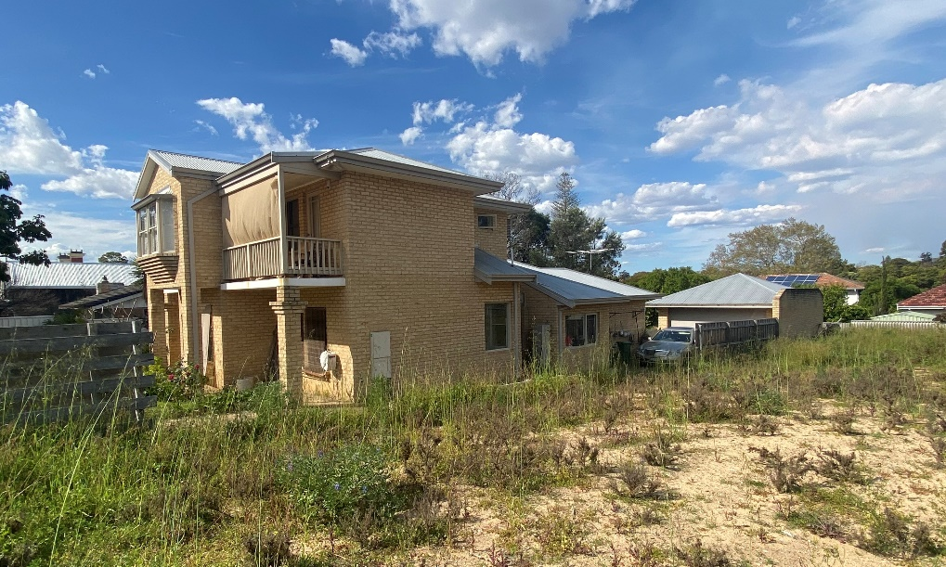
Figure 1: the house on the adjoining northern lot at 22 Rockton Road.

- Ventilation is maintained by the varied setbacks on the ground floor and the 1.8m setback on the upper floor.
- The wall is to the northern boundary so does not result in overshadowing.
- Overlooking is minimised as the major openings on the ground floor will be screened by a dividing fence or the existing garage wall towards the rear of the lot on the adjoining site. There are no major openings on the upper floor.

South (boundary wall)

The application proposes a garage built up to the southern boundary. The development achieves the design principles as:

- The location of the boundary wall to the south improves solar access to the northern portion of the house.
- The boundary wall allows for the provision of a double car garage and an adequately sized study room.
- Boundary walls are a feature of the established streetscape. Several lots on Rockton Road have boundary walls visible from the street, including 18, 16 and 12 Rockton Road.
- The boundary wall is a typical size for a garage, being 7.2m in length and 3.2m in height. If the residential density coding of the lot were commensurate with its size, this aspect of the proposal would be deemed-to-comply.

Clause 5.2.1 – Setback of garages
The garage is setback 7.7m from Rockton Road. The garage satisfies the design principles as the setback does not interfere with sight lines along the street and footpath. The proposal achieves the deemed-to-comply vehicular sightlines. The garage will not be the dominant visual feature from the street as the garage is setback 0.7m behind the study window on the ground floor. The upper floor features architectural projections forward of the garage door to create visual interest.

Clause 5.3.2 - Landscaping
The application proposes 37% landscaping within the front setback area.

The design principles provide for retention or planting of vegetation and a positive contribution to the streetscape. The proposed landscaping meets the design principles as:

- The front setback area features an entry path of mulch and vegetation separated by steppingstones. This entry path has been discounted from landscaped area but will practically contribute to the sense of greenery and permeability in the front setback area.
- The site includes 30m2 of landscaped area behind the street setback area along the side and at the rear of the house. This provides residents with landscape features that offset the hardscaped surface within the front setback area.
- The design proposes a tree within the front setback area which further contributes to a sense of greenery and creates visual interest when viewed from the street. The proposal also includes two new trees within the site: one to be planted in a small courtyard along the southern boundary and one to be planted in the landscaping at the rear.

Clause 5.3.7 – Site Works
The development proposes retaining walls to a maximum height of 0.6m along the northern and southern lot boundaries. The site slopes 2m from the west to the east. The proposal responds to this slope as the house features three different finished floor levels that step down with the natural slope of the land. The retaining meets the design principles as it responds to the natural slope of the site, only exceeds a height of 0.5m for short lengths and does not create undue building bulk or over-height walls.

Clause 5.4.1 – Visual privacy
The following major openings on the ground floor are seeking a design principle assessment:

- Kitchen window overlooking the southern lot.
- Master Bedroom window overlooking the northern lot.
- Living Room window overlooking the northern lot.

The design principles for visual privacy consider the minimal overlooking of active habitable spaces and outdoor living areas of adjacent dwellings and maximum visual privacy to side and rear boundaries. The application meets the design principles as:

- All relevant openings are on the ground floor and a standard height dividing fence will partially or entirely obscure views and ensure privacy for adjoining landowners.
- The cone of vision from the Kitchen window is reduced by a fixed privacy screen. Further, the preliminary plan provided by the landowner of 26 Rockton Road shows that any overlooking from the Kitchen will only impact a wall without major openings.
- The cone of vision from the Master Bedroom window does not impact outdoor living areas or major openings as it falls almost entirely over the existing boundary wall on the adjacent northern lot.
- The view from the Living Room window will be obscured by proposed landscaping. Any overlooking will be further minimised as the window is perpendicular to the lot boundary, so overlooking is oblique rather than direct.

Clause 5.4.2 – Solar access for adjoining sites
The development proposes 37% shadow over the lot at 26 Rockton Road to the south.
The design principles for solar access consider effective solar access for the development and the impact of solar access for neighbouring properties by considering existing outdoor living areas, major openings to habitable rooms and solar collectors on adjoining sites.

Consideration must be given to the lot constraints. The relatively small lot size, lot width and east-west orientation makes it difficult for a two-storey house to achieve deemed-to-comply solar access without compromising liability and amenity for residents. The application meets the design principles as:

- Based on the preliminary plan provided by 26 Rockton Road, the shadow from the proposal will fall over 16% of the uncovered portion of the outdoor living area, leaving approximately 80m2 of the uncovered outdoor living unaffected by overshadowing. The shadow will fall over less than half of the alfresco area and will not affect any north facing major openings.
- Due to the two storey height, the shadow from the proposal will not affect any future roof mounted solar collectors.
- The shadow that falls over the adjoining outdoor living area is minimised as it is cast by a single storey wall.
- It is acknowledged that a single storey house would result in less shadow to the south. However, altering the design to a single storey house in an attempt to meet the deemed-to-comply provision for overshadowing would likely result in a building that occupies a substantial portion of the site with less corresponding open space and landscaping potential. Whilst a two-storey dwelling creates greater overshadowing, it provides a better overall level of amenity for residents.

Consultation

The development application was advertised in accordance with the City’s Local Planning Policy - Consultation of Planning Proposals to 29 adjoining owners and occupiers. The application was advertised for a period of 14 days, from 20 July 2022 to 2 August 2022. At the close of the advertising period, three objections were received.
The following is a summary of the concerns/comments raised and the response and action taken in relation to each issue:

- The street setback should be 9.0m.
The proposed setback is supported as the development proposal is consistent with the immediate development context and is unlikely to negatively impact the amenity of adjoining landowners or the streetscape. See Clause 5.1.2 assessment above.

- Stormwater and pool water should be contained on site and drained properly.
A condition of development approval is recommended that requires all stormwater be contained on site. The pool will have to comply with applicable Building and Environmental Health regulations.

- Windows and outdoor areas on the ground and upper floors will overlook adjoining properties.
All windows from the upper floor satisfy the deemed-to-comply provisions in relation to visual privacy. The proposed overlooking is supported from ground floor openings as they achieve the design principles of clause 5.4.1 Visual privacy as per the assessment above.

- Lot boundary setbacks proposed to the southern boundary will adversely impact the amenity of adjoining occupants.
All lot boundary setbacks to the southern lot satisfy the deemed-to-comply provisions, except for the boundary wall. The proposed boundary wall is considered to achieve the design principles. See Clause 5.1.3 assessment above.

- Overshadowing should achieve the deemed-to-comply provisions.
The development proposal is seeking a design principle assessment for the solar access to the adjoining southern site. The overshadowing is supported as the shadow reasonably avoids the indicative outdoor living area and major openings of the adjoining lot. See Clause 5.4.2 assessment above.

- Dividing fencing should be full height along the entire length of the northern lot boundary.
As indicated on the amended plans, a dividing fence along the northern boundary will be erected subject to discussion with the neighbouring landowner. Dividing fencing is a civil matter between two landowners and is governed by the Dividing Fences Act 1961.

Strategic Implications

This item relates to the following elements from the City’s Strategic Community Plan.

Vision Our city will be an environmentally-sensitive, beautiful and inclusive place.

Values Great Natural and Built Environment
We protect our enhanced, engaging community spaces, heritage, the natural environment and our biodiversity through well-planned and managed development.

Priority Area Urban form - protecting our quality living environment

Budget/Financial Implications

Nil.

Legislative and Policy Implications

Council is requested to make a decision in accordance with clause 68(2) of the Deemed Provisions. Council may determine to approve the development without conditions (cl.68(2)(a)), approve with development with conditions (cl.68(2)(b)), or refuse the development (cl.68(2)(c)).

Decision Implications

If Council resolves to approve the proposal, development can proceed after receiving a Building Permit and necessary clearances.

In the event of a refusal, the applicant will have a right of review to the State Administrative Tribunal. The Tribunal will have regard to the R-Codes as a State Planning Policy. Similarly, should an applicant be aggrieved by one or more conditions of approval, this can be reviewed by the Tribunal.

Conclusion

The application for a single house has been presented for Council consideration due to objections being received. The proposal meets the design principles of the R-Codes and as such will not have an adverse impact on the amenity of adjoining lots. The proposal is considered consistent with the immediate locality and established streetscape character.

Accordingly, it is recommended that the application be approved by Council, subject to conditions contained in the recommendation.

Further Information

Question
Councillor Mangano – what is the maximum wall height on this application?

Officer Response
The maximum wall height on the plans included in the agenda is 7.4 metres.

Question
Councillor Youngman – are the plans viewed by Miss Crawford different from the submitted plans for the Development Application? Can the updated plans be provided to Miss Crawford?

Officer Response
The plans have been modified following advertising. The applicant and the neighbour have discussed the revised plans with City officers.

The following issues were raised by the neighbour and have been addressed as follows:

- The dividing fence should be free standing between the boundary wall and 26 Rockton Road.

A condition of approval is recommended which requires the wall of the garage be setback from the boundary by 100mm to allow for a free standing dividing fence.

- The western window from the ground floor ensuite bathroom may permit overlooking.

The top of the window will be below 1.8m. The dividing fence will restrict any view from this window into the adjoining southern lot.

- The finished floor level of the eastern portion of the ground floor master bedroom should not be raised more than 0.5m above natural ground level.

Agreement as been reached that the finished floor level of the master bedroom will be reduced to a maximum of 0.5m above natural ground level.

- The eastern facing window from the kitchen on the ground floor may permit overlooking.

The screening in front of the window has been extended. The cone of vision from the window will meet the deemed-to-comply provisions of Clause 5.4.1 Visual Privacy of the R-Codes Vol. 1.

Officers expect to receive the modified plans reflecting these changes after the agenda is published. A revised officer recommnedation will be circulated to Elected Members with the updated plans prior to the Council meeting.

Additional Information

As mentioned in the additional information within the Council agenda, revised plans as a result of negotiations have been received and a revised officer recommendation is now provided. The revised plans reflect the four elements which have been discussed with the neighbour and referred to in the Additional Information included in the agenda.

Revised Officer Recommendation

That Council:

In accordance with Clause 68(2)(b) of the Deemed Provisions of the Planning and Development (Local Planning Schemes) Regulations 2015, approves the development application in accordance with the plans date stamped 21 October 2022 for a Single House at 24 Rockton Road, Nedlands subject to the following conditions:
- This approval relates only to the development as indicated on the approved plans dated 21 October 2022. It does not relate to any other development on this lot and must substantially commence within 2 years from the date of the decision letter.

- All works indicated on the approved plans shall be wholly located within the lot boundaries of the subject site.

- Prior to occupation, walls on or adjacent to lot boundaries are to be finished externally to the same standard as the rest of the development in:

- Face brick;
- Painted render;
- Painted brickwork; or
- Other clean finish as specified on the approved plans.

And are to be thereafter maintained to the satisfaction of the City of Nedlands.

- Prior to the issue of a building permit, the plans shall be amended to depict the southern wall of the garage setback a minimum of 100mm from the southern lot boundary.

- Prior to occupation, the windows to the Kitchen, Master Bedroom, Bed 2 and Bed 3 as annotated in red on the approved plans shall be screened in accordance with the Residential Design Codes by either;

- fixed and obscured glass to a height of 1.6 metres above finished floor level; or
- fixed screening devices to a height of 1.6 meters above finished floor level that are at least 75% obscure and made of a durable material; or
- a minimum sill height of 1.6 metres above the finished floor level; or
- an alternative method of screening approved by the City of Nedlands.

The required screening shall be thereafter maintained to the satisfaction of the City of Nedlands.

- Prior to the issue of a demolition permit and a building permit, a Demolition or Construction Management Plan (as appropriate) shall be submitted and approved to the satisfaction of the City. The approved Demolition and Construction Management Plans shall be observed at all times throughout the construction and demolition processes to the satisfaction of the City.

- All stormwater discharge from the development shall be contained and disposed of on-site unless otherwise approved by the City of Nedlands.

PD68.10.22 Amendments to Local Planning Policy – Residential Development

Meeting & Date | Council Meeting - 25 October 2022
Applicant | City of Nedlands
Employee Disclosure under section 5.70 Local Government Act 1995 | The author, reviewers and authoriser of this report declare they have no financial or impartiality interest with this matter.  There is no financial or personal relationship between City staff involved in the preparation of this report and the proponents or their consultants.
Report Author | Roy Winslow, Manager Urban Planning
Director | Tony Free, Director Planning and Development
Attachments | - Draft LPP – Residential Development

Purpose

Amendments to the Local Planning Policy – Residential Development (the Policy) are being presented to Council for adoption for the purpose of community consultation. The proposed changes simplify and rationalise the criteria and provide updates to improve planning outcomes.

Recommendation

That Council:

- adopts the draft amendments to the Local Planning Policy – Residential Development for advertising in accordance with Clause 4 of the Deemed Provisions of Schedule 2 of the Planning and Development (Local Planning Schemes) Regulations 2015; and

- notes that the advertising period will be for a minimum of 28 days.

Voting Requirement

Simple Majority

Background

The current City of Nedlands Residential Development Policy was adopted on 17 December 2019. The Policy applies to all development assessed under Volume 1 of the Residential Design Codes (R-Codes). Some of the Policy provisions supersede the R-Codes, while other provisions provide guidance for assessment. Where a proposal does not meet the deemed-to-comply criteria within the policy, it is assessed against any design guidance in the Policy and the design principles of the R-Codes.

The Policy has been operative for about three years and is in need of a general review and update. Council also passed a resolution regarding additional solar access protections and building height that are addressed below. In updating the policy, the format has been amended to reflect the format of the draft precinct policies for Hollywood-Hampden, Waratah and Broadway. Provisions have also been re-ordered to match the order that they appear in the R-Codes.

The proposed Residential Development Policy will initially apply to all single houses and grouped dwellings throughout the City. However, any specific local planning policy will supersede the draft Policy. The City is currently advertising specific local precinct planning policies for Waratah, Hollywood-Hampden, and Broadway precincts, and is in the process of preparing a local planning policy for residential areas north and south of Stirling Highway. Once these policies are adopted, the draft Residential Development Policy would then only impact properties outside of these areas.

The Policy may have to be reviewed once the WA R-Codes Medium Density Policy comes into effect (expected in 2023) to ensure consistency for single houses and grouped dwellings on lots coded R30 and above that fall outside the precinct areas.

Discussion

Amendments to the Policy have been made in order to improve planning outcomes and fix issues that have been identified in the nearly three years since the Policy was first adopted. The changes are identified below.

Major amendments

- Height

Council resolved to eliminate the existing height controls within the current Policy and revert to the default Table B controls of the R-Codes. A comparison between the existing height settings of the Policy and the R-Codes are shown in the below table:

Element | Existing Policy Height | R-Codes Volume 1 Height
Wall height (roof above) | 8.5m | 7m
Wall height (gable, skillion and concealed roof) | 8.5m | 8m
Roof height | 10m | 10m
Table 1: Policy versus R-Codes heights

Should Council adopt the height settings of the R-Codes, it would reduce the deemed-to-comply wall heights across the City. It is recommended that the height settings remain as they are in the Policy, with the inclusion of additional design guidance provided for the assessment of building height that exceeds the Policy criteria. This is recommended for the following reasons:

- The City of Nedlands height controls were originally enshrined in Council’s former Town Planning Scheme No. 2. Dwellings have been developed to this greater deemed-to-comply allowance for several decades, with the design response well enshrined throughout the City.
- The areas of Swanbourne, Dalkeith and the dunes areas around Mt Claremont, among other places, tend to have larger houses owing to the steep slope of the natural ground level of the sites (particularly near the river and the ocean) and the general expectations of residents. Reducing the current deemed-to-comply heights to meet the R-Codes would disadvantage newer houses and additions to existing houses compared to any immediate neighbours. The deemed-to-comply height reduction would also impact any house on a lot with steeply sloping ground level, particularly those near the Swan River and the ocean. Any reduction in the current heights is likely to result in more houses seeking a design principles assessment.
- The City of Nedlands traditionally has higher quality development with better amenity than the R-Codes allows. A key measure of indoor liveability is floor to ceiling heights. Larger floor to ceiling heights make house interiors seem more spacious, and allow for better sunlight access and ventilation through the use of larger windows. Retaining the increased wall heights will continue to encourage high quality housing.

Given the longstanding nature of the height controls in place in Nedlands, their general acceptance by the community, and the improved internal amenity outcomes, removal of the local planning policy height provisions is not recommended.

However, it is recommended that further controls be provided to ensure greater protection for solar access to adjoining properties.

- Solar access

An additional deemed-to-comply requirement and associated design guidance is proposed to protect existing solar collectors on adjoining lots. The deemed-to-comply provision is adopted from the draft Medium Density Codes and provides for a minimum four hours of sunlight to reach existing solar panels on adjoining lots during midwinter. This additional provision applies regardless of whether the new house achieves the deemed-to-comply threshold for overshadowing of adjoining lots.

Additional guidance has been adopted from the State of Victoria Planning Practice Note 88 to help consider whether solar panel location is reasonable and appropriate for purposes of a design principles assessment. For instance, consideration can be given to whether the panels are located high on the roof, whether the adjoining building is set back appropriately, etc.

Protection of solar panels is an important change to the way applications are assessed under the current R-Codes. Currently, if a development achieves the deemed-to-comply for overshadowing, there is no discretion to consider where the shadow falls or what it impacts.

Officers also considered provisions for the protection of future solar panels and major openings to living areas on adjoining southern lots. However, such provisions were considered too complex to be effective and would hamper good outcomes for the following reasons:
- Providing for future solar panels on adjoining southern lots would have the effect of preventing overshadowing to any roof, as solar panels could potentially be placed anywhere on the roof. This would burden any proposals for two storey development that abut single storey development and potentially lead to poorer quality outcomes. Further, there is no guarantee that an existing property would add solar panels in the future. This is especially true as the single storey houses likely to be affected are predominantly older housing stock with a higher probability of being redeveloped in the short to mid-term, which would render any roof consideration moot.

- Some existing major openings may be located too close to boundaries to avoid any degree of overshadowing. This would require substantial setbacks, particularly for upper floors, and may again lead to poorer quality outcomes through the provision of larger unusable space given over to side setbacks.

Protecting sunlight to major openings and future solar panels as deemed-to-comply criteria would add a degree of complexity to an assessment that the Western Australian Planning Commission (WAPC) would be unlikely to support. It would be difficult to determine what an “acceptable” overshadowing would be, and even more complex to manage and assess both for Officers and applicants.

Protecting existing solar panels is a much more feasible control and is important to safeguard existing development. The draft provisions are also consistent with the draft Medium Density policy proposed by WAPC. However, this provision of the policy will require approval from the WAPC before it can be adopted by Council.

- Landscaping

The R-Codes have a deemed-to-comply provision stating that the primary street setback is to consist of at least 50% impervious surfaces. The R-Codes also include swimming pools, barbecue areas and playgrounds in the definition of landscaping. This lends confusion as to what type of “landscaping” is acceptable. The draft Policy defines “impervious surfaces” as:

“Generally vegetated areas not occupied by water impermeable roofed structures except roof eaves, and includes but is not limited to garden beds, ground covers, shrubs and trees, lawn, rockeries and ornamental ponds; but excludes: swimming pools, artificial turf, turf-cell, pavement, gravelled or pebble areas or the like.”

This change is recommended to ensure that proposed landscaping meets the generally expected definition of landscaping, meaning vegetation or similar “natural areas” rather than hardscape such as pools, etc. As per the Deemed provisions, this change to the landscaping provisions of the R-Codes will require approval from the WAPC.

Criteria for landscaping in the rear cannot be imposed through a policy because, unlike landscaping within the street setback, there is no existing R-Codes criteria for local government to modify that pertains to rear landscaping. The R-Codes states that if a single house meets all the deemed-to-comply criteria it does not require development approval unless otherwise required by the scheme. Therefore, any criteria within a policy that requires landscaping in the rear would sit outside the R-Codes and would be unable to be enforced.

- Garage width

Garage width allowances have been increased for narrow lots (less than 10m frontage). The changes would allow these lots to have a garage and supporting structures that are 6m wide as viewed from the street (compared to the existing 60% frontage). This would be permitted where an upper floor or balcony extends over more than half the width of the garage, and the garage is set back 1m behind the main wall of the house. This change would apply where there is no available laneway. A 6m wide garage is the minimum width to achieve the Australian Standards for internal car bays.

- Undersized lots

Provisions are recommended to modify deemed-to-comply criteria for lots that are undersized relative to their density code. A few blocks within Swanbourne contain numerous lots that are undersized (refer Figure 1 below).

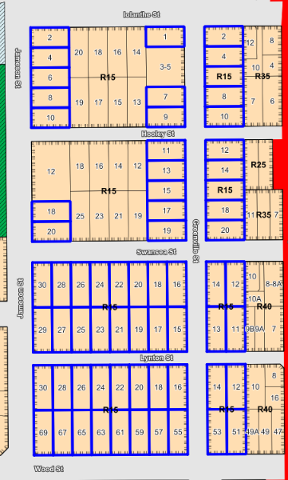
Figure 1: Lots in blue are Swanbourne lots undersized for their density code.
The draft amendments would allow these lots (and any other undersized lots throughout the City) to meet the deemed-to-comply criteria associated with the density code that relates to their actual lot size for open space and lot boundary setbacks. In effect, this would allow the R15 lots in Figure 1 above to achieve R20 deemed-to-comply criteria for some items. Importantly, the lot boundary setback modification would only apply where the adjoining impacted lot was similarly undersized or of a higher code, otherwise the setbacks would revert to those associated with the R15 coding.

For example, take the lot on the corner of Jameson Street and Iolanthe Street in Figure 1 above. This lot and the adjoining southern lot both have a site area of approximately 473 square metres, which is commensurate with a lot coded R20. The lot to the east has a site area of approximately 591 square metres, which is consistent with its assigned density code of R15.

Under the proposed Policy, the corner lot would be allowed to meet the deemed-to-comply criteria for open space and southern lot boundary setbacks commensurate with a R20 density. Rear setbacks against the lower coded R15 lot would still need to meet the deemed-to-comply provisions for rear setbacks on a R15 coded lot (Notwithstanding that a development could seek a design principles assessment).

These undersized lots predominantly have existing houses that already achieve these outcomes. The draft Policy will allow consistent assessment methodology for new single houses or additions on these lots with the intent that they will have comparable outcomes to the existing houses along the street.

- Minor amendments

A number of minor amendments are proposed including:

- Front fencing requirements have been modified and simplified as follows:

  - There is currently a requirement that pillars be separated by 1.5 metres. This doesn’t take into account pedestrian gates and, in any event, is unnecessary as the remaining criteria provide for visual permeability. This pier separation requirement is recommended to be deleted.
  - Meter boxes are recommended to be allowed to have a width of 1.2m in lieu of the current 1m when perpendicular to the street. This is based on officer experience and will allow these minor works (which have minimal impact on the street) to be exempt from requiring approval.

  - Vehicular access requirements have been modified to clarify that where a house has a common property driveway, the house is to use that driveway rather than apply for an additional driveway and crossover.
  - Carport criteria in areas coded R15 and lower have been clarified as design guidance rather than deemed-to-comply criteria. This is because the primary street setbacks for carports in areas coded R15 and lower are set out in the City’s scheme, and policies cannot alter a scheme.
  - Screening that is detached from but adjacent to a dividing fence is now considered as if it were a wall for setback purposes. Currently, it is unclear whether these freestanding structures require planning approval at all.
  - Additional design guidance to assist in a design principles assessment has been provided for building height, vehicular access, and solar access.

WAPC Approval

The R-Codes sets out which items the local government may not change without approval from the WAPC. The draft amendments seek to change the following items that will require WAPC approval:

- Landscaping
- Vehicular access; and
- Solar access.

After adoption by Council, the Policy will be forwarded to the WAPC for approval of the above three sections. Under the Deemed provisions, the WAPC must approve the above amendments before they can go into effect.

Consultation

In drafting the Policy, the following questions were raised by Elected Members at the Concept Forum of 15 September 2022:

- How can a 10m high wall work within the overshadowing requirements of the R Codes?

No matter the wall height, development will still have to achieve either the deemed-to-comply criteria or the design principles of the R-Codes. This may mean that higher walls would have to be set back further from boundaries, not be as long, etc.

- Can areas of Camelia Avenue Mt Claremont that appear to have incorrect zoning also be included in the undersize lot area?

The criteria for undersized lots will be available for all undersized lots throughout the City, not just the lots identified in Figure 1 above.

- Can the policy place restrictions on rear crossovers that access reserves?

Reserves are generally controlled by the City, with any access requiring permission, usually in the form of a crossover permit. Crossovers are controlled by the City’s Technical Services department and do not form part of this Policy.

- Can the policy consider hard landscaping restrictions in rear setbacks also?

The proposed changes to modify landscaping build on the existing R-Codes criteria for landscaping within the front setback. There is no mechanism for controlling hardstand in backyards for single houses or grouped dwellings beyond the general requirement that all stormwater is to be maintained onsite.

- Can a figure (meters) be added to the (percentage) of garage frontage?

The draft Policy has now been amended to stipulate that lots with small (less than 10m) frontage will be permitted to have a 6m wide (previously 75% frontage) garage as viewed from the street, subject to meeting specific criteria. This is the minimum width to allow two internal car bays to meet Australian Standards.

If Council endorses the recommendation, the draft Policy will be advertised for community comment for a period of not less than 28 days.

Once advertising has closed, submissions will be reviewed and possible modifications made. Council may then adopt the Policy and refer required sections to the WAPC for approval. Those sections will not take effect unless and until the WAPC approves them. If the WAPC approves the sections, they can automatically be incorporated into the Policy.

Strategic Implications

This item relates to the following elements from the City’s Strategic Community Plan.

Vision Our city will be an environmentally-sensitive, beautiful and inclusive place.

Values Great Natural and Built Environment
We protect our enhanced, engaging community spaces, heritage, the natural environment and our biodiversity through well-planned and managed development.

Reflects Identities
We value our precinct character and charm. Our neighbourhoods are family-friendly with a strong sense of place.

Priority Area Urban form - protecting our quality living environment

Budget/Financial Implications

Nil.

Legislative and Policy Implications

Clause 5 of the Deemed provisions within the Planning and Development (Local Planning Schemes) Regulations 2015 provides requirements and processes for amending a local planning policy. The Deemed provisions requires that, where parts of a proposed policy require WAPC approval, those parts will not become operable until approval has been granted by the WAPC. Once adopted by the WAPC and Council, the entire Policy will apply to any development to which the R-Codes Volume 1 applies.

Decision Implications

If Council endorses the recommendation, the draft Policy will be advertised for community comment for a period of not less than 28 days.

If Council does not endorse the recommendation to advertise, the amendments will not be progressed, and the current policy will remain as is.

Conclusion

It is recommended that Council adopts the draft Policy for community consultation.

Further Information

Nil.

PD69.10.22 Statutory Planning Controls for the Conservation of Heritage and Character

Meeting & Date | Council Meeting – 25 October 2022
Applicant | City of Nedlands
Employee Disclosure under section 5.70 Local Government Act 1995 | The author, reviewers and authoriser of this report declare they have no financial or impartiality interest with this matter.
Report Author | Roy Winslow, Manager Urban Planning
Director | Tony Free, Director Planning and Development
Attachments | - Schedule of Submissions

Purpose

The purpose of this report is to:

- Address the 26 April 2022 Council resolution relating to heritage protection to Allen Park, Dalkeith/Nedlands Foreshore, Nedlands Baths and the Tawarri Reception Centre;
- Outline the Statutory Planning framework for heritage protection; and
- Outline the potential for planning controls to conserve heritage and character.

Recommendation

That Council acknowledges:

- its statutory requirements under the Heritage Act 2018 and the Planning and Development (Local Planning Schemes) Regulations 2015;

- that a further Discussion paper will be presented at a Concept Forum regarding the potential protection of the Nedlands character via Character Areas;

- that community engagement is an integral part of heritage protection;

- that a Discussion paper will be presented at a concept the City’s Local Heritage Survey will need to be updated in the future; and

- submissions received following consultation on the Dalkeith/Nedlands Foreshore, Nedlands Baths and Tawarri Reception Centre and thanks those submitters for their comments.

Voting Requirement

Simple Majority.
Background

Heritage Classification in Western Australia

Heritage listings within Western Australia broadly fall into three categories.

The first is the Local Heritage Survey (previously the Municipal Heritage Inventory). This is a starting resource for local heritage planning and itself has no statutory role. The Local Heritage Survey assists local governments in making decisions reflecting local heritage values and supports the creation of a heritage list or heritage areas.

The second is the Heritage List, which is a list of places compiled under a local governments Local Planning Scheme. These places are given certain protection under the Scheme such as the requirement for development approval for most works as well as demolition. The Heritage List is derived from those places within the Local Heritage Survey with the highest levels of heritage significance.

The third is the State Register of Heritage Places, which is a statutory list of places that generally is the best representation of the story of Western Australia’s history and development. State heritage listing, like the local Heritage List, is afforded a higher level of protection by the Heritage Act 2018.

Local Heritage Survey (LHS)

It is a statutory requirement for all Local Governments to establish and maintain a LHS in accordance with the Heritage Act 2018.

The City’s first MHI contained 144 places and was first adopted by Council in 1999. In 2018, the MHI was reviewed and endorsed by Council after consultation with affected landowners and included a total of 112 places. The Department of Planning, Lands and Heritage recommends that Local Governments review their LHS every 5-8 years.

Heritage List

The City’s Heritage List identifies places which are of cultural heritage significance and worthy of conservation and heritage protection. It is a statutory requirement for all Local Governments to establish and maintain a Heritage List in accordance with the Planning and Development (Local Planning Schemes) Regulations 2015 (Deemed Provisions).

The City maintains a Heritage List in accordance with the Deemed Provisions. The Heritage List was last reviewed in 2017 and contains 21 places.

26 April 2022 Council Resolution

At the 26 April 2022 Ordinary Council Meeting Council resolved:

Council:

- requests that the CEO advertises seeking early public comment submissions from the Nedlands community proposing establishment of concept Heritage precincts to protect areas consisting of concentrated heritage and character sites of significance to the Nedlands community in the following areas;

  - Nedlands Foreshore and surrounds
  - Allen Park and surrounds

- requests that the CEO advertises seeking early public comment submissions from the Nedlands community proposing stronger Heritage protections for the following locations;

  - the Nedlands Baths, more recently known as JoJo's Cafe and Aqua Viva Reception Venue
  - the Tawarri Reception Centre
  - any other Nedlands foreshore sites or surrounds of heritage significance to the Nedlands community

- requests that the CEO brings a report of these early public submissions to the Council by the July 2022 Ordinary Council Meeting.

A response to each part of the resolution is discussed further in this report, including the findings of consultation.

Discussion

Heritage within the Nedlands Context

The gazettal of the City’s Local Planning Scheme No. 3 in 2019 saw an increase in density throughout many areas which were identified for character protection within the 2014 review of the Municipal Heritage Inventory. Currently there are no statutory heritage protections for streetscapes or character areas within the City. As a result of the zoning and density changes, the City could lose many character areas and heritage properties which are not currently protected from redevelopment and intensification. There are two pathways that could be used to protect these streetscapes: Heritage Area designation, or Character Area designation.

Heritage Area

A Heritage Area is a collection of houses which has been assessed as having cultural heritage significance and, in the opinion of Council, requires special planning controls to conserve and enhance the cultural heritage significance of the area.

Heritage Areas would not prohibit development but would aim to ensure new development is designed to be respectful and sympathetic to the existing heritage values of the area. However, a Heritage Area is afforded additional legislative power such as requiring development approval on sites where they may already meet the deemed to comply criteria of the R-Codes as well as requiring landowners to submit for the approval to demolish their property. A Heritage Area would focus more on the significance of the street rather than the individually heritage listed properties. This generally means that, when considering a development application, the primary concern would relate to items that could potentially impact the streetscape appearance. This may include things like the location of a second floor so it doesn’t overwhelm the house, or controls on extensions forward of the dwelling such as porches and carports.

Character Area

A Character Area is a lower level of protection and would operate by providing design guidelines for development, through a local planning policy. However, it would not have the legislative power to stop the demolition of buildings nor would it require development approval if a development meets specific deemed to comply provisions. A Character Area would instead focus on the redevelopment of properties within a precinct.

A Character Area would likely provide additional development requirements for street-fronting design elements such as street and lot boundary setbacks, building heights, front fencing, street surveillance and carport and garage location. A Character Area would make new development more sensitively designed to the character of its street, but would not be as far reaching as a Heritage Area designation.

Heritage Value and condition for Allen Park, Swanbourne

Allen Park is a 13.6ha reserve which contains a mixture of sports grounds and bush with Melon Hill as the prominent natural landmark. Four buildings, ‘Tom Collins House’, ‘Mattie Furphy House’, ‘Tom Fricker House’ and the ‘Friends of Allen Park Cottage’ are located on the reserve and identified within the City’s LHS. A fifth building, ‘Mayo House’ no longer exists as it was destroyed by fire in 2007. ‘Tom Collins House’ and ‘Mattie Furphy House’ have individual listings on the heritage list and state heritage register.
In 2020, the City undertook building condition inspections of ‘Tom Collins House’ and ‘Mattie Furphy House’, which concluded that they were in either in good or fair to good condition. ‘Mattie Furphy House’ was in better condition of the two, requiring only monitoring of external concrete slabs for uneven surfaces. ‘Tom Collins House’ inspection identified external painting as an item which would need to be addressed due to some areas of cracking and swelling. In February 2022, the City undertook building condition inspections of ‘Tom Fricker House’ and concluded that apart from minor maintenance issues, the building noted as showing signs of aging but is in a neat and tidy condition overall.

Owing to the heritage significance of ‘Tom Collins House’, ‘Mattie Furphy House’ and ‘Tom Fricker House’ the continual maintenance and review of these structures and allocation of funding determined by the condition of each building, is recommended.

Dalkeith/Nedlands Foreshore, Nedlands Baths and Tawarri Reception Centre
The Dalkeith/Nedlands foreshore, Tawarri Reception Centre and Nedlands Baths were all listed on the municipal inventory in the initial review of the inventory in 1999. As such, they were recognised as having a considerable level of heritage significance. However, these properties were not included in the 2018 adoption of the municipal inventory (now known as the Local Heritage Survey).

As the City’s Local Heritage Survey is reaching five years since review and noting absences from the Survey such as the Nedlands Baths and Foreshore area, it is proposed that a discussion paper be presented at a concept forum for the potential of updating the Local Heritage Survey.
Consultation as part of the Council resolution

The City undertook public consultation following the 26 April 2022 Council resolution, seeking the community’s views and comments on providing stronger heritage protection to the following sites:

- Dalkeith/Nedlands Foreshore and surrounds;
- Allen Park and surrounds;
- Nedlands Baths (including JoJo’s Café and Aqua Viva Reception Centre); and
- Tawarri Reception Centre

A total of 12 submissions were received, with six supporting and six objecting further heritage protection measures on site. A summary of these submissions is included in Attachment 1.

Consultation

Should Council wish to introduce statutory development provisions for the retention of cultural heritage significance and character, this can be achieved through the introduction of Heritage or Character Areas. Either a Heritage Area or Character Area would require significant consultation with the community and would include community forums whereby affected landowners would be able to speak directly with an officer of the City, posts to social media, door knocking and letter drops to take landowners and occupiers on the journey of separate heritage or character protection.

Strategic Implications

This item relates to the following elements from the City’s Strategic Community Plan.

Vision Our City will be an environmentally-sensitive, beautiful and inclusive place.

Values Great Natural and Built Environment
We protect our enhanced, engaging community spaces, heritage, the natural environment and our biodiversity through well-planned and managed development.

Priority Area Urban form - protecting our quality living environment
Budget/Financial Implications

There is no allocation of funds for Heritage projects within the 2022/23 budget.

Legislative and Policy Implications

Under Schedule 2, Part 2, Clause 3(1) of the Planning and Development (Local Planning Schemes) Regulations 2015, the City may prepare a local planning policy in respect to any matter related to the planning and development of the Scheme area.

Under Schedule 2, Part 3, Clause 9 of the Planning and Development (Local Planning Schemes) Regulations 2015, the City may designate an area as a Heritage Area subject to consultation with affected landowners.

Decision Implications

Nil.

Conclusion

Built heritage and character are key to the City’s identity and should be preserved, whether the City approaches this through heritage area protection or as character areas, both of which would require the development of separate local planning policies.

Owing to the current age of the endorsed Local Heritage Survey, a report will be presented to council in 2023 ensuring all properties worthy of recognition are listed.

Further Information

Nil.

PD70.10.22 Adoption for Advertising of Local Planning Policy – Signage and Advertisements

Meeting & Date | Council Meeting – 25 October 2022
Applicant | City of Nedlands
Employee Disclosure under section 5.70 Local Government Act 1995 | The author, reviewers and authoriser of this report declare they have no financial or impartiality interest with this matter.  There is no financial or personal relationship between City staff involved in the preparation of this report and the proponents or their consultants.
Report Author | Roy Winslow – Manager Urban Planning
Director | Tony Free – Director Planning & Development
Attachments | - Local Planning Policy – Signage and Advertisements

Purpose

The purpose of this report is for Council to adopt for advertising the draft Local Planning Policy – Signage and Advertisements (the Policy), included as Attachment 1.

Recommendation

That Council:

- adopts the draft Local Planning Policy – Signage and Advertisements for the purpose of advertising in accordance with Clause 4 of the Deemed Provisions of Schedule 2 of the Planning and Development (Local Planning Schemes) Regulations 2015; and

- notes that the advertising period for the draft Local Planning Policy – Signage and Advertisements will be for a minimum of 21 days.

Voting Requirement

Simple Majority

Background

The current Signs Local Planning Policy (the Policy) was adopted at the Ordinary Council Meeting held on 23 July 2019. A review of the Policy has been undertaken in the context of the Council resolution dated 27 July 2021, which reflects the development pressure Nedlands is currently facing, with attention to construction signs and property transaction signs. The review also includes amending the Register of Delegation in relation to construction site, property transaction and hoarding signs 5 square metres or larger. The Policy has been updated in line with the resolution as discussed below.
Discussion

The content of the Policy has been reviewed in the context of the legislative planning requirements and practical application of the existing provisions.

The updated Policy seeks to provide a more contemporary and concise set of provisions to assist the City in the assessment of signage proposals.

The key elements of the Policy include:

  - Policy Title

The policy title has been revised from “Signs Local Planning Policy” to “Signage and Advertisements Local Planning Policy” to align with the statutory terminology used by the Planning and Development (Local Planning Schemes) Regulations 2015 relating to Advertisements.

The Regulations also contain a definition of “heritage-protected place”, and this new terminology is proposed to be included in the Policy.

  - Objectives

The objectives of the Policy are worded to highlight the importance of minimising the adverse impacts of signage and advertisements on the amenity of residential areas and heritage-protected places.

The objectives seek to limit commercial signage to areas zoned for non-residential uses and reduce the proliferation and cumulative impact of signage across the City.

  - Exemptions/Non-Exemptions

Temporary advertisements and election advertisements are exempt under the Regulations and the Policy updated to reflect this.

  - Where approval is required

All signs on “heritage protected places” require development approval, as do signs which emit light (refer to section 4.1 (i) and (vii)).

Appendix A provides a list of the different signs, including a definition and an image of an example of that form of signage.

If the sign meets the requirements listed under “Development Provisions for Exemption” then approval is not required.

The following key Provisions are highlighted:

- Construction Site and Development Signs

For a Construction site and Development Sign, if the sign is:
- More than 5 square metres in area or
- More than 2 metres above the natural ground level

then development approval will be required, or if more than one sign per street frontage is requested.

- Digital Signs

All digital signs will require a development application to be lodged, with the exception of window signs less than 5 square metres in area located in the window of an approved or exempt business.

Property Transaction Signs

The definition of a property transaction sign is to be updated to include the words ‘coming soon’ and the sign is to be removed within 14 days of settlement or leasing of the property.

Development approval is required if the proposed property transaction sign has an area of more than 3 square metres.

- Roof Sign

Development approval is required if:

- the total height of the building and the sign (combined) exceed the building height for the applicable property
- the sign exceeds 5 square metres in area.

Deemed to Comply or Acceptable Outcomes Criteria

Deemed to comply or acceptable outcomes criteria are not considered appropriate in respect to a signage policy, as “exempt” provisions (effectively deemed to comply / acceptable outcomes) already exist in the Regulations and draft policy. It is important to provide consistency, certainty, and clarity in the application of such a policy.

However, previous legal advice received by the city confirms that a local planning policy cannot fetter discretionary consideration. In other words, a planning policy cannot be used to ban advertisements over a certain size, for example. Application for signage and advertisements that exceed the exemption criteria are assessed against the objectives of the policy (Clause 3) as well as the general requirements for all signage and advertisements (Clause 4).

Consultation

If Council resolve to adopt the Policy for advertising it will be advertised in accordance with the City’s Local Planning Policy – Consultation of Planning Proposals, which involves the following methods of consultation:

- Minimum 21-day advertising period
- Notice in the local newspaper
- Notice on the City’s Notice board
- Notice on the City’s Your Voice engagement portal
- Notice on the City’s social media channels

Strategic Implications

This item relates to the following elements from the City’s Strategic Community Plan.

Vision Our city will be an environmentally-sensitive, beautiful and inclusive place.

Values Great Natural and Built Environment
We protect our enhanced, engaging community spaces, heritage, the natural environment and our biodiversity through well-planned and managed development.

Reflects Identities
We value our precinct character and charm. Our neighbourhoods are family-friendly with a strong sense of place.

Priority Area Urban form - protecting our quality living environment

Budget/Financial Implications

If Council proceeds with the Policy, there will be no immediate cost to the City other than those associated with advertising.

Legislative and Policy Implications

Clause 3(1) of the Deemed Provisions of Schedule 2 of the Regulations allows the City to prepare an LPP in respect to any matter related to the planning and development of the Scheme area. The review and amendments made to the existing Signs Local Planning Policy are significant and as such require the Policy to be advertised. Once Council resolves to prepare an LPP, in accordance with Clause 4 of the Deemed Provisions it must publish a notice of the proposed policy in a newspaper circulating the area for a period of not less than 21 days and seek submissions. Further detail on the advertising of the Policy is provided in the Community Consultation section above.

Following the advertising period, the Policy will be presented back to Council to consider any submissions received and to:

- Proceed with the policy without modification;
- Proceed with the policy with modification; or
- Not proceed with the policy.

Decision Implications

If Council resolves to prepare the Policy, it will be advertised in accordance with the process outlined above.

If Council resolves not to endorse the recommendation, the Policy will not be advertised or progressed. Doing so will mean the existing Policy will remain in use by the City when assessing Development Applications for signage and advertisements.

Conclusion

The Policy has been reviewed and updated to provide applicants with clear and concise provisions to support applicants in determining their approval obligations for proposed signage and advertisements. It also guides the assessment of development applications for proposed signage and advertisements by officers. It is recommended that Council adopts the Recommendation and formally advertises the Policy.

Further Information

Nil.

PD71.10.22 Adoption of the Election Signs Council Policy

Meeting & Date | Council Meeting – 25 October 2022
Applicant | City of Nedlands
Employee Disclosure under section 5.70 Local Government Act 1995 | The author, reviewers and authoriser of this report declare they have no financial or impartiality interest with this matter.
Report Author | Jessica Bruce – Acting Manager Health and Compliance
Director | Tony Free – Director Planning and Development
Attachments | - Draft Election Signs Council Policy

Purpose

The purpose of this report is for Council to adopt the Draft Election Signs Council Policy included in Attachment 1.

Recommendation

That Council adopts the Draft Election Signs Council Policy as per attachment 1.

Voting Requirement

Simple Majority.

Background

At its meeting of 24 May 2022 Council resolved:

That the City of Nedlands Signs Local Planning Policy Section 4.3.2(b) be amended as follows:

- Election advertising signs not to obstruct public thoroughfares.
- Signs need to be placed on either private property or on front boundary of property and a maximum of 1 sign per frontage; and
- No signs to be placed on City of owned or controlled land.

During the past Federal, State and Local Government elections, free-standing election signs were erected in road reserves. The purpose of this Policy is for Council to formalise the practice of the placement of election signs for Federal, State, Local Government elections, and Referendums in road reserves. It is considered appropriate that Council should allow election signs within road reserves as it is in line with the implied freedom of political communication contained within the Australian Constitution.

The Policy establishes a clear framework regulating how, where and for what period of time election signs may be displayed whereby safety and public health are prioritised.

Discussion

The proposed draft Policy proposes the following regime:

  - Election signs will be allowed in thoroughfares controlled by the City provided they meet the criteria in the Policy. Signs that do not meet the criteria in the Policy can be removed and impounded.

  - Whereby election signs have been placed on the thoroughfare or on City buildings/land which demonstrates a flagrant breach of the conditions outlined in this Policy, the City may either immediately remove and impound the sign or issue an infringement notice for failure to obtain a permit in accordance with the relevant local law.

  - Election signs must not be placed where it will obstruct driver’s vision or pose a risk to road users, including cyclists and pedestrians. The City prioritises safety and public health.

The requirements of the Policy are that signs must be:

  - At least 1.5 metres from the edge of the carriageway and 0.5 metres from the footpath;

  - Erected at least 10 metres from any intersection of thoroughfares;

  - Not closer than 50 metres to a signalised intersection or before any speed indicator sign;

  - Not placed on a median strip, roundabout or other traffic control device;

  - Not placed within an intersection;

  - Not placed within 50m of a pedestrian crossing;

  - Not located in, or within 50 metres of, a 40kph school zone;

  - Election signs are not permitted to be placed on or within any City parks and/or reserves to ensure the safe use;

  - Election signs on City facilities or City land are interpreted as having the endorsement of the City. Election signs are not permitted on or adjacent to municipal buildings and leased facilities, including but not limited to Nedlands Library, Mt Claremont Library, Nedlands Community Care, Tresillian, Point Resolution Child Care, Depot, and the Administration Building;

  - The above point does not apply to any City Land or facility that is used as a polling place on an election day where election signs may be displayed;

  - The following process will apply to the removal and impounding of signs:

    - the candidate will be notified that the sign has been removed and impounded and will be held by the City for 48 hours during which time it will be available for collection; and

    - if the sign is not collected within the 48 hours, the sign may be destroyed by the City.

Consultation

The draft Election Signs Council Policy was emailed to political parties on 24 August 2022 that have run in Curtin or Nedlands electorates recently and parties represented in the Legislative Council. The Administration has received several acknowledgements of receiving the email and a forward of the draft Policy to Mr Shane Love MLA as Shadow Minister for Local Government. No further feedback on the Policy has been received by the City.

At the Concept Forum of 20 September the following matters were raised;

- Signs being 3 metres from the carriage – the proposed policy has been modified to make this 1.5m.

- Main Roads have a catch all provision associated with safety – under the Enforcement section of the Policy it notes “Where a sign breaches this Policy, the Local Law or any other relevant law, or poses a health or safety hazard, the City will exercise its powers to ensure compliance and/or remove any health and safety hazard as appropriate”.

Strategic Implications

This item relates to the following elements from the City’s Strategic Community Plan.

Vision Our city will be an environmentally-sensitive, beautiful and inclusive place.

Values Great Governance and Civic Leadership
We value our Council’s quality decision-making, effective and innovative leadership, transparency, accountability, equity, integrity and wise stewardship of the community’s assets and resources. We have an involved community and collaborate with others, valuing respectful debate and deliberation.

Priority Area

- Urban form - protecting our quality living environment

Budget/Financial Implications

No financial implications have been identified associated with the recommendations. Activities relating to compliance and enforcement of the Policy will align with the existing operational budget and resource allocation.

Legislative and Policy Implications

Subject to the terms of this Policy, a permit for election signs to be displayed on City land will not be required under the City’s Local Law relating to Thoroughfares. Activities and signage that do not meet the provisions within the policy will be subject to the City’s ordinary approval procedures in accordance with the relevant City local law.

- Commonwealth Electoral Act 1918
- Electoral Act 1907
- Local Government Act 1995
- Local Law Relating to Throughfares 2000
- ReferendumsAct1983

At the Concept Forum of 20 September additional background information was sought in relation to the court cases which have informed the Policy. With respect to this matter previous Supreme Court and High Court decisions have clarified the extent of the local government’s powers to control election signs in light of the implied right to freedom of political communication. In particular, laws attempting to control or limit elections signs may not be enforceable unless they are to protect health and safety.

The High Court in the case of Australian Capital Television Pty Ltd v Commonwealth of Australia (1992) deemed there is an implied freedom of political communication (‘the implied freedom’) within the Australian Constitution. In this case, the majority of the High Court reasoned that representative democracy is constitutionally entrenched and there is therefore implied in the Constitution a guarantee of freedom of communication on all political matters.

The position in Western Australia was the subject of a decision by the Supreme Court in Liberal Party of Australia (WA Division) Inc v City of Armadale (2013). The City of Armadale’s Local Planning Policy prohibited electoral signage in the locality of Armadale, even on privately owned land. At the hearing the City sought a compromise, as opposed to a complete ban, limiting:

- the number of electoral signs to one sign per street frontage of every lot;
- the area of the sign would not exceed 1 square metre in area; and
- the period during which the signs were erected to no more than 60 days prior to the election date.

The Court considered that the above regulatory controls were still a significant fetter against political communications in the lead up to the State election in circumstances where the only justification was the preservation of local amenity. The Court concluded that the democratic process outweighed any concerns about amenity, at least for the duration of the looming election campaign.
The City must ensure that the policy does not conflict with the provisions of the Electoral Act 1907 or the Referendums Act 1983 including any applicable subsidiary legislation. Any policy development on election signs will need to align with the Supreme Court and High Court decisions which clarify the extent of the local governments powers to control election signs in light of the implied right to freedom of political communication. In particular, rules attempting to control or limit elections signs where the only justification is preservation of local amenity may not be enforceable unless they are to protect health and safety.

Decision Implications

If adopted by Council the Policy will become an official Council Policy and will prescribe the way in which the City responds to election activities and signage. Activities and signage that do not meet the provisions within the policy will be subject to enforcement provisions under the Policy. This Policy will guide engagement with electoral candidates as it relates to political communication signage and provide them with direction to ensure compliance and the health and safety of the community.

If this Policy is refused, the placement and enforcement of election signage along with the directions given to candidates will lack solid policy foundation whereby safety and public health may be compromised.

Conclusion

The proposed Election Signs Council Policy outlines how election signs may be displayed within the boundaries of the City of Nedlands during Federal, State, Local elections, and Referendums. The Policy establishes a clear framework regulating how, where and for what period of time election signs may be displayed. The Administration has developed the Policy for the adoption by Council.

Further Information

Question
Councillor Mangano – has the City obtained legal advice?

Officer Response
The City has sought legal advice in respect of whether it is possible to prohibit election signage from the City’s thoroughfares altogether, having regard to the implied constitutional right of freedom of political communication which has been recognised in several decided court cases. The advice notes:

“The Policy encourages the City to adopt a practice whereby it will not require that a permit be obtained for the display of election signs provided certain criteria are met. The Policy is consistent with both the Thoroughfares Local Law and the proposed Public Places Local Law, and thereby valid, because it simply guides the exercise of the City’s prosecutorial discretion not to enforce the offence provisions contained in the local laws on certain conditions.

A provision imposing a blanket prohibition on the display of election signage on thoroughfares contained within the Policy would be invalid on that basis that it would contravene the implied constitutional right of freedom of political communication.

The Policy, by allowing the display of election signage without a permit on satisfaction of certain criteria, would not breach the constitutional right of freedom of political communication. This is supported by several cases dealing with the issue.”

Question
Councillor Smyth – if someone removes a sign from their verge can they be fined?

Officer Response
Officers understand that a person removing an election sign without lawful authority is not specifically mentioned as an offence under the Electoral Act 1907 or the Commonwealth Electoral Act 1918. However, this act may lead to further investigations by the Australian Electoral Commission and Western Australian Police.

Question
Councillor Hodsdon – can we include in the policy a provision for the property owner to be able to provide consent for signs on their verge?

Officer Response
The Policy has been updated to include the provision suggested, with Section 4 – Enforcement of the Election Signs Policy has been updated to include:

(b) Placement of election signs on a verge is permitted with the consent of adjacent he landowner or occupier. The City will intervene if the sign is placed without the consent and/or the sign poses an immediate health or safety hazard.

An updated Policy is shown in Attachment 1

Divisional Reports - Technical Services Report No’s TS21.10.22

TS21.10.22 Repurposing of Former Tennis Courts at David Cruickshank Reserve, Dalkeith

Meeting & Date | Council Meeting – 25 October 2022
Applicant | City of Nedlands
Employee Disclosure under section 5.70 Local Government Act 1995 | Nil.
Report Author | Andrew Dickson – Project Manager (Parks Services)
Director | Daniel Kennedy-Stiff – Acting Director Technical Services
Attachments | - Image of tennis court area on 5 March 2017  - Image of tennis court area on 24 March 2022  - Overview of proposed works

Purpose

The purpose of this report is to seek Council’s endorsement for a proposed least cost solution for improving the upkeep and presentation of the former tennis courts at David Cruickshank Reserve, whilst preserving the opportunity to undertake a more comprehensive project at a later date to repurpose the area for the long term.

Recommendation

Council:

- endorses the proposal for a least cost solution for improvements to enhance the upkeep and presentation of the former tennis courts at David Cruickshank reserve in the short term;

- requests a capital budget item is prepared to be included in the 2022/23 midyear budget review for Council’s consideration, which if approved, will provide for the proposed works to be delivered in the fourth quarter of the 2022/23 financial year; and

- requests that a capital budget item is prepared for the 2023/24 annual budget for Council’s consideration to provide for a more comprehensive design and delivery project to deliver a permanent repurposing of the former tennis courts at David Cruickshank Reserve.

Voting Requirement

Simple Majority.

Background

The David Cruickshank Reserve Enviro-scape Master Plan (EMP) concept was endorsed by Council at its meeting on 27 June 2017. When the EMP was endorsed, the Dalkeith Tennis Club (Club) lease included six (6) tennis courts at David Cruickshank Reserve (DCR) directly south of the Point Resolution Child Care building. These courts were maintained by the Club in accordance with their terms of lease with the City. On 31 October 2017, the Club formally notified the City of its intention to surrender this portion of their lease.

The City formally took back responsibility for the former lease area on 2 January 2018. As a consequence of these events, future use of the former leased tennis court area was not considered during the EMP consultation process. Other than the removal of the fencing surrounding the courts, the area has remained largely unchanged since the City assumed responsibility for its maintenance.

Previous Council resolution

Ordinary Council meeting 23 August 2022 – item 21.3 accepted

- Council Resolution

That the CEO provides a report to Council by the October 2022 OCM to provide a least cost solution to repurpose the former tennis courts in front of PRCC which were not included in the David Cruickshank Reserve Enviro Masterplan.

Discussion

DCR is classified as a ‘District Park’ in accordance with the City’s adopted Parks and Reserves Function and Hierarchy Classifications. Repurposing of the former tennis courts needs to consider what recreational activities are already catered for at DCR and within its catchment.

A District Park typically has a catchment area of between two (2) and five (5) kilometres or a five (5) to ten (10) minute drive. District Parks will attract visitors from nearby districts and should broadly cater for surrounding communities. Parks and public open space that are within the DCR catchment area include:

- Sunset Hospital Precinct
- Point Resolution Reserve
- Bishop Road Reserve
- Sunset Foreshore
- Beaton Park (Jo Wheatley All Abilities Play Space)
- Charles Court Reserve
- Melvista Park
- College Park
- Masons Gardens
- Peace Memorial Rose Garden
- Eleven (11) ‘Local and Neighbourhood Parks’
- Ten (10) foreshore reserves

Least cost solution

The proposed concept of a least cost solution for repurposing the former tennis courts may not provide for the best long term solution and may limit future opportunities for the area.

In considering the least cost requirements of Council’s resolution, the Administration proposes limited intervention to enhance the upkeep and presentation of the area in the short term, maintaining the area as reticulated passive turf over the summer period. This will involve mowing once every 3-4 weeks, and watering approximately once per week. Watering need will be based on the climactic conditions being experienced at that time.

This will involve leaving the area largely unchanged, as an open grassed area for passive recreation use. The recently landscaped eco-zone surrounding the area is establishing and maturing. Additional native trees and shrubs can be extended marginally into the grassed area to lessen the geometric interface between the former courts and the new landscaping.

Any identified hazards in the area would be remediated and made safe (e.g., sudden level changes). It is proposed that reticulation in the area is renewed to deliver better presented turf through summer, and the bollards are extended to infill the current gap along the car park to prevent vehicle access. No other infrastructure need be incorporated within the area at this time. To further reduce costs, it is proposed to use City resources and equipment wherever possible to deliver works and to limit the use of contractors.

This proposal is intended to improve the safety, appearance and presentation of the area in the short term at minimal cost. The proposed works would not be considered a long term solution. The intent is to improve the upkeep and appearance of the area whilst preserving the opportunity to explore more extensive options for repurposing the area at a later date.

Consultation

If the recommendation is adopted, the proposed least cost solution would involve community consultation based around informing the community of the purpose for the restricted works and the longer term plans for the area.

Feedback associated with recent projects at David Cruickshank Reserve has provided some ideas for the repurposing of the former tennis courts. Concepts put forward by the community following endorsement of the EMP have been generally aspirational and could not be considered to fall within the scope of a least cost solution as resolved by Council. The feedback has been useful in that it has provided a sense of community expectation for the area in the longer term.

Strategic Implications

This item relates to the following elements from the City’s Strategic Community Plan.

Vision Our city will be an environmentally-sensitive, beautiful and inclusive place.

Values Great Natural and Built Environment
We protect our enhanced, engaging community spaces, heritage, the natural environment and our biodiversity through well-planned and managed development.

Great Communities
We enjoy places, events and facilities that bring people together. We are inclusive and connected, caring and support volunteers. We are strong for culture, arts, sport and recreation. We have protected amenity, respect our history and have strong community leadership.

Priority Areas Renewal of community infrastructure such as roads, footpaths, community and sports facilities.

Providing for sport and recreation

Budget/Financial Implications

Subject to Council endorsing the proposed actions within this report, the Administration proposes to submit a capital budget item to the 2022/23 midyear budget review to improve upkeep and presentation of the area as outlined. Without the benefit of current quotes, the capital budget estimate to deliver the scope of works proposed would be in the order of $15,000 (inclusive of project management costs) +/- 30%.

It is not anticipated that the proposed improvements to the area will incur substantial additional operational costs to the City. There will be a reallocation in resources from other areas to cover the extra time required to maintain the area to a higher level of presentation, noting any impacts on other locations will be minor and likely less than $5,000 per annum.

The officer recommendation does not propose any additional works other than the ground levelling, bollard installation and reticulation. Any works in addition to these will need to be considered and consulted on as part of a new project initiative, within the context of the Long Term Financial Plan, should Council wish to look at providing new services in this area.

Legislative and Policy Implications

- Disability Discrimination Act 1992 (Federal) – the City is obligated to observe the accessibility design standards for public use areas legislated under the Act.

- Community Engagement Council Policy – the City is required to consult with stakeholders on all proposals and new initiatives in accordance with Council’s policy.
Decision Implications

Endorsement of the recommendation will allow the City to progress a course of action to improve the upkeep and presentation of the former tennis court area as a short term solution at the least cost. It will also preserve the opportunity to deliver a more considered repurposing of the area for the long term.

If Council do not consider this proposal adequate and desire a more comprehensive repurposing of the area, either now or in the future, this will need more comprehensive consideration of available resources. To deliver a suitable long-term solution will require appropriate project planning, concept development, community consultation and adequate budget allocation to allow for project delivery.

Conclusion

The City has proposed a least cost solution for improving the appearance and upkeep of the former tennis court area at DCR. This proposal is intended to provide short term improvements to the area without comprising the future options for a more significant project to comprehensively repurpose the space if this was the long term expectation of Council and the community.

Further Information

Question
Councillor Bennett – Can trees be planted instead of bollards and would this be most cost effective?

Officer Response
Yes. The City has previously planted Tuart trees which are establishing along the western boundary of the former tennis court area and the car park. These trees have been planted at appropriate intervals/spacings for the species to ensure their long term health and viability. Bollards can be incorporated in between the existing trees on the same alignment to provide a hybrid barrier of trees and bollards. Additional trees can be planted at appropriate intervals to further reduce bollard numbers.

There will be a minimal cost difference if additional trees are planted.

Question
Councillor Mangano – how much cut and fill is being done?

Officer Response
It is proposed that the abrupt/vertical level changes created by the slab retaining be primarily remediated using excess fill stored at the City’s John XXIII depot. The City proposes to remove the existing slab retaining, backfill the change in levels with soil and batter the fill to provide a safe transition that will eventually be covered by grass. Cut operations would be minimal and only be required to smooth out levels.

Question
Councillor Bennett – Can the City work with local friends’ groups and school for weed management instead of spraying constantly?

Officer Response
The City will consult with existing volunteer groups and local schools on their capability and capacity to assist the City with weed control in the established eco-zones at David Cruickshank Reserve.

Divisional Reports - Corporate & Strategy Report No’s CPS46.10.22 to CPS49.10.22

CPS46.10.22 New Lease to Dalkeith Nedlands Bowling Club

Meeting & Date | Council Meeting – 25 October 2022
Applicant | Dalkeith Nedlands Bowling Club (inc)
Employee Disclosure under section 5.70 Local Government Act 1995 | Nil.
Report Author | Peter Scasserra – Coordinator Land and Property
Director | Michael Cole – Director Corporate Services
Attachments | Nil

Purpose

The purpose of this report is for Council to consider a new lease for the Dalkeith Nedlands Bowling Club Inc. for portion of Reserve 1668, 55 Jutland Parade Dalkeith.

Recommendation

That Council:

- approves the disposal of a 13,860 m² (approx.) portion of Reserve 1668 (Part Lot 14867 on Deposited Plan 35721) by way of lease to the Dalkeith Nedlands Bowling Club Inc. consistent with the key terms noted within this report;

- approves an exemption to section 3.58 of the Local Government Act 1995 pursuant to Regulation 30 of the Local Government (Functions and General) Regulations 1996 for the disposal of a 13,860 m² (approx.) portion of Reserve 1668 (Part Lot 14867 on Deposited Plan 35721) by way of lease; and

- subject to the Minister for Lands’ Consent, authorises the Chief Executive Officer and Mayor to execute all documents necessary to give effect to a lease and apply the City’s Common Seal.

Voting Requirement

Simple Majority

Background

Reserve 1668 (Reserve) comprises Lot 14867 on Deposited Plan 35721 and is land owned by the State of Western Australia that has been vested to the City of Nedlands (City) by way of a Management Order.

The Management Order for the Reserve provides the City with a statutory right to manage and control the Crown land for the purpose of Recreation with power to lease for any term not exceeding 21 years, subject to consent of the Minister for Lands.

Reserve 1668 currently consists of land utilised by several Sporting Clubs a Day Care Centre and Pre-School. The Sporting Clubs and Pre-School occupy their respective facilities pursuant to either a lease or management licence whilst the Day Care Centre is operated by the City of Nedlands. The management licence agreements provide a source of revenue for the City.

The proposal seeks approval from the City to lease a 13,860 m² (approx.) portion of Reserve 1668 for the purpose of lawn bowls and clubrooms to the existing Dalkeith Nedlands Bowling Club.

Considering Reserve 1668 is land classified within the Metropolitan Region Scheme (MRS) area for parks and recreation purposes, a use that is within the definition of “parks and recreation” can be considered.

The Dalkeith Nedlands Bowling Club (Club) was established in 1948, with planting of the first two greens on the then Point Resolution Reserve in September that year. Following the establishment of the adjacent Tennis Club in 1938, the subject land began to establish itself as a Community Recreation Reserve.

The Club’s official opening occurred in November 1950. By the end of the year the Club had affiliated with the Western Australian Bowling Association and was entering teams regularly in pennant competition. A third green with electric lighting was eventually added to the facility to allow for night games.

The clubhouse building was officially opened in 1955 and remained unchanged until 1958 when the architects W.G. Bennet and Associates designed changes to facilitate required upgrades and extensions.

Presently, the facility has five greens in regular use as well as the existing clubhouse that is being occupied by the Club pursuant to a lease with the City. Considering the lease expires on 24 September 2022 with no option for a further term, the Club is seeking Council approval for a new lease to secure tenure and ensure their current operations can continue for a term of 10 years with a further term of 5 years.

Discussion

Reserve 1668 is located within the locality of Dalkeith and is situated on the corner of Jutland Parade and Victoria Avenue, opposite Point Resolution Reserve. Development within and surrounding the Reserve comprises Adam Armstrong Pavilion, Point Resolution Child Care Centre, Dalkeith Tennis Club, Dalkeith Pre-School and established single residential dwellings.

The Reserve is Crown land vested to the City by way of a Management Order. A Management Order provides a nominated management body with a statutory right to care, control and manage Crown land in accordance with any conditions on the use and development of the reserve and may grant the management body certain powers to deal with the land, such as power to lease.

The Management Order for Reserve 1668 permits the land to be used for the purpose of ‘Recreation’ and requires the City to seek the consent of the Minister for Lands prior to formalising any agreement for lease over the Reserve. The Club’s proposal does not change the existing land use which is consistent with the MRS reservation and with the Management Order.

Reserve 1668 is also an MRS Reserve classified for parks and recreation purposes. Noting the current use of the site by other recreational and sporting bodies that provide services of benefit to the community, it is considered that a use that is within the definition of “parks and recreation” can continue to operate on the site. The MRS defines “parks and recreation” as “Land of regional significance for ecological, recreation or landscape purposes”.

The Dalkeith Nedlands Bowling Club currently has 241 active members (excluding casual bowlers at functions), of which approximately one third are City of Nedlands residents. In addition to delivering sport and recreation for a wide range of community uses, their operations also provide various social and community benefits, particularly for seniors.

The recommendation proposes Council consider approving a lease for the Dalkeith Nedlands Bowling Club for a 13,860 (approx.) portion of Reserve 1668 for the purpose of lawn bowls and clubrooms and uses reasonably ancillary thereto subject to reviewing and being satisfied with the key terms and the inclusion of a redevelopment clause.

Key Terms and Special Conditions

The Key Terms have been negotiated in accordance with the City’s ‘Use of Council Facilities for Community Purposes Policy’.

On 18 August 2022, the Dalkeith Nedlands Bowling Club’s agreed to all the key terms noted within the report below to facilitate a lease.

Proposed Lease – Dalkeith Nedlands Bowling Club (Inc)
Key Terms
Lease Term | Details
Land | Part of Reserve 1668
Lease Area | As per Sketch (TBC)
Landlord | City of Nedlands
Tenant | Dalkeith-Nedlands Bowling Club (Inc)
Commencement Date | Upon execution by both parties
Term of Lease | 10 years with an additional 5 year option
Permitted Purpose | Lawn Bowls and Clubrooms and uses reasonably ancillary thereto.
Lease Fee | Peppercorn
Rent Reviews | N/A
Outgoings | All outgoings payable by Lessee
Insurance | Building Insurance - The City will insure its interest in the building and will on-charge a pro-rata premium to the Lessee.  Public Liability - The Lessee is responsible for Public Liability, however, the City will continue to hold its policy.
Maintenance | All maintenance obligations to be undertaken by the Lessee, including structural maintenance.
Works and Fit Out | N/A
Signage | With prior written consent from the Lessor and subject to the Lessors conditions.
Special Conditions | 1. Subject to City of Nedlands Council approval. 2. Subject to Minister for Lands consent.

Lease Area Sketch
The current lease area sketch is displayed below.

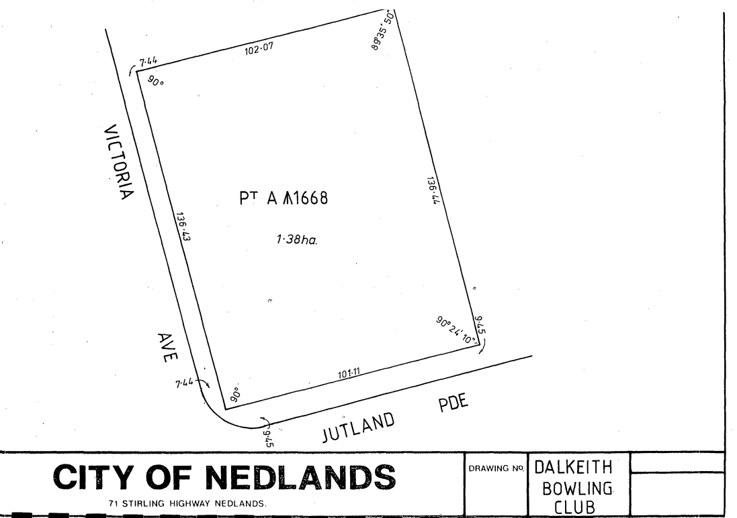

To identify the lease area more clearly, the following lease area sketch is proposed as an annexure to the lease should Council resolve to approve a new agreement.

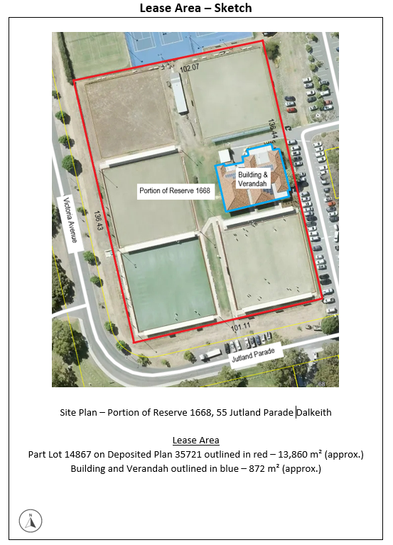

Consultation

Upon receiving the request from the Dalkeith Nedlands Bowling Club for a new lease for portion of Reserve 1668, 55 Jutland Parade Dalkeith, the City carried out the following internal engagement.

Planning Services
The City’s Planning Services Team advised they have no objections to land tenure arrangement, but suggested clauses be included within the agreement to ensure the Applicant understands no alterations or additions are to made without statutory approvals being obtained.

Community Development
The City’s Community Development Team advised they support Dalkeith Nedlands Bowling Club’s request for a new lease. The request is consistent with Council’s strategic priority of providing for sport and recreation.

Land & Property
The City’s Land & Property Team advised they have no objections to the land tenure arrangement. The proposed lease is consistent with the terms of the current arrangement and the inclusion of the updated survey sketch is of benefit to the City. The Key Terms as proposed within this report mitigate all risk to Council and do not have any cost implications either.

Strategic Implications

This item relates to the following elements from the City’s Strategic Community Plan.

Values Great Governance and Civic Leadership
We value our Council’s quality decision-making, effective and innovative leadership, transparency, accountability, equity, integrity and wise stewardship of the community’s assets and resources. We have an involved community and collaborate with others, valuing respectful debate and deliberation.

Budget/Financial Implications

The lease as proposed would be at no cost to Council.

Should elected members agree to the recommendation as proposed, the new lease would be prepared by a solicitor and full costs would be on-charged to the proponent.

Legislative and Policy Implications

The City is bound by specific conditions under the Local Government Act 1995 with regard to the disposal of property. Section 3.58 of the Act enables a local government to dispose of a property to the highest bidder at a public auction, by way of a public tender process or by giving local public notice of the proposed disposition and following the public consultation process as prescribed by sub-section section 3.58 (3) of the Act. In this context, disposing of a property means to ‘sell, lease or otherwise dispose of, whether absolutely or not’.

Considering the Dalkeith Nedlands Bowling Club are an incorporated recreational sporting body, they are eligible for an exemption to section 3.58 of the Local Government Act 1995 pursuant to Regulation 30 of the Local Government (Functions and General) Regulations 1996, therefore the proposed disposal of land is not required to be advertised.

Proposals to lease or licence land for a community/recreational purpose will be subject to the terms of the City’s ‘Use of Council Facilities for Community Purposes Policy’.

Crown land reserves vested to the City by way of a Management Order are generally subject to conditions. Consent is required from the Minister for Lands prior to formalising any lease agreement for Reserve 1668.

Decision Implications

Should Council resolve to approve the disposal of a 13,860 m² (approx.) portion of Reserve 1668 to the Dalkeith Nedlands Bowling Club by way of lease, Officers will instruct the City’s solicitor to prepare a lease in accordance with the key terms contained within this report at the full cost of the Lessee.

If Council do not resolve to approve the disposal of a 13,860 m² (approx.) portion of Reserve 1668 to the Dalkeith Nedlands Bowling Club by way of a lease, the proponent will not be able to secure tenure and will have to consider their future within the City. The lease expiry date is 27 September 2022.

Conclusion

The Dalkeith Nedlands Bowling Club have occupied the facility on portion of Reserve 1668 from circa 1950. Their lease will expire on 27 September 2022 and does not provide an option for a further term. To allow their operations to continue, the Dalkeith Nedlands Bowling Club are seeking Council approval to continue using a 13,860 m² (approx.) portion of Reserve 1668, 55 Jutland Parade Dalkeith in accordance with a lease for the purpose of lawn bowls and clubrooms and uses reasonably ancillary thereto.

Officers believe this request can be accommodated without significant changes to the current arrangement. Additionally, the proposal presents an opportunity for social engagement contributing to the health and well-being of the community.

Further Information

Question
Councillor Youngman – Can the bowling club be asked to monitor their water usage as part of the lease agreement?

Officer Response
The Dalkeith Nedlands Bowling Club have confirmed they would be pleased to be involved in a water monitoring program similar in nature to the program that the City is proposing to undertake for College Park.

Question
Councillor Mangano – Can signs be included in lease which firmly identifies how many signs and what types of signs can be displayed?
Officer Response
The lease can restrict signage by way of a general provision that prohibits the installation of signs, score-boards, notices and advertisements (promotional or sponsorship) on the Premises without prior written consent from the Lessor. Lessor consent may be reasonably withheld or subject to conditions if required.

The draft leasing policy (currently subject to further review and Council consideration) captures signage as a standard tenure condition that effectively becomes a non-negotiable lease provision. The condition states “Signage is prohibited without prior written consent from the City which may be withheld or subject to conditions”.

CPS47.10.22 Monthly Financial Report – September 2022

Meeting & Date | Council Meeting – 25 October 2022
Applicant | City of Nedlands
Employee Disclosure under section 5.70 Local Government Act 1995 | Nil.
Report Author | Lauren Fitzgerald – Senior Project Accountant
Director/CEO | Michael Cole – Director Corporate Services
Attachments | 1. Statement of Financial Activity – 30 September 2022  2. Statement of Net Current Assets – 30 September 2022  3. Statement of Comprehensive Income – 30 September 2022  4. Statement of Financial Position – 30 September 2022  5. Reserve Movements – 30 September 2022  6. Borrowings – 30 September 2022  7. Capital Works Program – 30 September 2022

Purpose

Administration is required to provide Council with a monthly financial report in accordance with regulation 34(1) of the Local Government (Financial Management) Regulations 1996. The monthly financial variance from the budget of each business unit is reviewed with the respective manager and the Executive to identify the need for any remedial action. Material variances are highlighted to Council in the attached Monthly Financial Report.

Recommendation

That Council receive the Monthly Financial Report for 30 September 2022.

Voting Requirement

Simple Majority.

Background

Nil.

Discussion

The monthly financial management report meets the requirements of regulation 34(1), 34(3), and 34(5) of the Local Government (Financial Management) Regulations 1996.
The attached report shows the month end position as at the end of September 2022. Please note that the opening position is a preliminary result for the year ended 30 June 2022 as the Financial Statements for 2021/22 are still being finalised and as a result will be subject to change. The municipal closing surplus as at 30 September 2022 is $24,275,789 which is a $403,045 unfavourable variance, compared to a budgeted surplus for the same period of $24,678,834.

The operating revenue at the end of September 2022 was $30,525,709 which represents a $704,937 unfavourable variance compared to the year-to-date budget, primarily in operating grants, subsidies, and contributions.

The operating expense at the end of September 2022 was $8,501,200, which represents a $1,371,811 favourable variance compared to the year-to-date budget, primarily in materials and contracts.

The attached Statement of Financial Activity compares Actuals with Amended Budget by Nature or Type as per regulation 34 (3) of the Local Government Financial Management Regulations 1996. Material variances, as defined by a previous decision of Council, from the budget of revenue and expenditure are detailed below.

Operating Activities

Operating grants, subsidies, and contributions
Unfavourable variance of $657,638 primary due to timing of revenue recognition of FOGO grant of $174,300, and Nedlands Community Care grants of $386,354.

Fees and charges
No variance analysis required as variance to budget is less than 10%.

Service Charges
No variance analysis required as variance to budget is less than 10%.

Interest earnings
No variance analysis required as variance to budget is less than $20,000 and 10%.

Other revenue
Favourable variance of $74,181 primarily due to design work fee for Aldi Nedlands site of $37,497.

Employee costs
No variance analysis required as variance to budget is less than 10%.

Materials and contracts
Favourable variance of $1,020,99, primary due to contract services for waste of $625,654, buildings maintenance of $132,232, parks maintenance of $126,200, and civil maintenance of $106,679.

Utility charges
No variance analysis required as variance to budget is less than $20,000 and 10%.

Depreciation and amortisation
Favourable variance of $43,380, due to year-to-date depreciation based on June 2022 value until finalisation of 2021/22 Financial Statements.

Insurance expenses
Favourable variance of $62,219 due to timing of instalment payments to LGIS.
Interest expenses
No variance analysis required as variance to budget is less than $20,000 and 10%.

Other expenditure
Favourable variance of $47,670 primary due to timing of sundry purchasing in the Information Technology business unit.

Loss on disposal of assets
No variance analysis required as variance to budget is less than $20,000 and 10%.

Investing Activities

Non-operating grants, subsidies, and contributions
No variance analysis required as variance to budget is less than $50,000 and 10%.

Proceeds from disposal of assets
No variance analysis required as variance to budget is less than $50,000.

Purchase of property, plant, and equipment
Unfavourable variance of $233,091 primary due to budget phasing of capital projects. To be adjusted at mid-year review.

Purchase and construction of infrastructure
Unfavourable variance of $1,619,740 primary due to budget phasing of capital projects. To be adjusted at mid-year review.

Payments for intangible assets
Favourable variance of $106,646 primarily due to timing of consultant payments for OneCouncil project. Project is in the planning stages of phase two, with consultant time scheduled from late September.

Financing Activities

Repayment of borrowings
No variance analysis required as variance to budget is less than $20,000 and 10%.

Recoup from self-supporting loans
No variance analysis required as variance to budget is less than $20,000 and 10%.

Payment for principal portion of lease liability
No variance analysis required as variance to budget is less than $20,000.
Transfer to reserves
Unfavourable variance of $38,784 primary due to timing of maturity dates of reserve investments, delaying interest being transferred to reserve.

Transfer from reserves
No variance analysis required as variance to budget is less than $20,000 and 10%.

Rates
Unfavourable variance of $98,751 primary due to timing of interim rates being raised.

Outstanding rates debtors are $13,787,860 as at 30 September 2022 compared to $11,448,000 as at 30 September 2021. Breakdown as follows:

Receivable | 30-Sep-22 ($) | 30-Sep-21 ($) | Variance ($)
Rates | 11,889,613 | 9,256,000 | 2,633,613
Rubbish & Pool | 580,785 | 508,000 | 72,785
Pensioner Rebates | -7,724 | 950,000 | -957,724
ESL | 1,325,186 | 734,000 | 591,186
Total | 13,787,860 | 11,448,000 | 2,339,860

Employee Data
Description | Number
Full time / Part time / Casual Head - Total Headcount | 185.00
Establishment (Budgeted FTE) | 169.04
Occupied positions (FTE) | 151.29
Casual positions (FTE) | 9.07
Contract employees - temporary/agency (FTE) | 3.00
Resignations (employee number) | 4.00

The figures reported are as at the end of the calendar month of September.

Consultation

N/A

Strategic Implications

This item relates to the following elements from the City’s Strategic Community Plan.

Vision Our city will be an environmentally-sensitive, beautiful and inclusive place.

Values Great Governance and Civic Leadership
We value our Council’s quality decision-making, effective and innovative leadership, transparency, accountability, equity, integrity and wise stewardship of the community’s assets and resources. We have an involved community and collaborate with others, valuing respectful debate and deliberation.
The 2022/23 approved budget is in line with the City’s strategic direction. Our operations and capital spend, and income is undertaken in line with and measured against the budget.

The 2022/23 approved budget ensures that there is an equitable distribution of benefits in the community.

The 2022/23 budget was prepared in line with the City’s level of tolerance of risk and it is managed through budgetary review and control.

The approved budget was based on zero based budgeting concept which requires all income and expenses to be thoroughly reviewed against data and information available to perform the City’s services at a sustainable level.

Budget/Financial Implications

At the Special Council Meeting on 11 August 2022, item CPS36.08.22, Council adopted the following thresholds for the reporting of material financial variances in the monthly statement of financial activity reports:

a. Operating items – Greater than 10% and a value greater than $20,000
b. Capital items – Greater than 10% and a value greater than $50,000

pursuant to regulation 34(5) of the Local Government (Financial Management) Regulations 1996, and Australian Accountings Standard AASB 1031 Materiality.

Legislative and Policy Implications

Local Government Act 1995, Local Government (Financial Management) Regulations 1996, and Australian Accounting Standards.

Decision Implications

Nil.

Conclusion

The municipal surplus as at 30 September 2022 is $24,275,789 which is unfavourable, compared to a budgeted surplus for the same period of $24,678,833 being a -1.63% variance.

The operating revenue at the end of September 2022 was $30,525,709 which represents a $704,937 or 2.26% unfavourable variance compared to the year-to-date budget of 31,230,646, primarily in operating grants, subsidies, and contributions.

The operating expense at the end of September 2022 was $8,504,200, which represents a $1,371,811 or 13.89% favourable variance compared to the year-to-date budget of $9,873,011, primarily in materials and contracts.

Further Information

Nil.

CPS48.10.22 Monthly Investment Report – September 2022

Meeting & Date | Council Meeting – 25 October 2022
Applicant | City of Nedlands
Employee Disclosure under section 5.70 Local Government Act 1995 | NIL.
Report Author | Lauren Fitzgerald – Senior Project Accountant
Director | Michael Cole – Director Corporate Services
Attachments | 1. Investment Report for the period ended 30 September 2022

Purpose

In accordance with the Council’s Investment Policy, Administration is required to present a summary of investments to Council on a monthly basis.

Recommendation

That Council receive the Investment Report for the period ended 30 September 2022.

Voting Requirement

Simple Majority.

Background

Nil.

Discussion

Council’s Investment of Funds report meets the requirements of Section 6.14 of the Local Government Act 1995.

The Investment Policy is structured to minimise any risks associated with the City’s cash investments. The officers adhere to this Policy, and continuously monitor market conditions to ensure that the City obtains attractive and optimum yields without compromising on risk management.

The Investment Summary shows that as at 30 September 2022 and 30 September 2021 the City held the following funds in investments:

Funds | 30-Sep-22 ($) | 30-Sep-21 ($)
Municipal | 2,066,151 | 5,321,913
Reserve | 8,263,144 | 3,576,530
Total Investments | 10,329,295 | 8,898,444
The total interest earned from investments as at 30 September 2022 was $47,701, comprising of $9,669 received at maturity and $38,032 accrued.

The Investment Portfolio comprises holdings in the following institutions:

Financial Institution | Funds Invested | Proportion of Portfolio
NAB | $ 3,463,667 | 33.53%
WBC | $ 4,007,213 | 38.79%
ANZ | $ 1,118,406 | 10.83%
CBA | $ 1,740,009 | 16.85%
Total | $ 10,329,295 | 100.00%

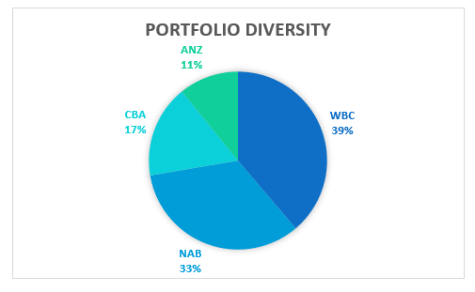

Consultation

N/A.

Strategic Implications

This item relates to the following elements from the City’s Strategic Community Plan.

Vision Our city will be an environmentally-sensitive, beautiful and inclusive place.

Values Great Governance and Civic Leadership
We value our Council’s quality decision-making, effective and innovative leadership, transparency, accountability, equity, integrity and wise stewardship of the community’s assets and resources. We have an involved community and collaborate with others, valuing respectful debate and deliberation.

Budget/Financial Implications

The September 2022 YTD Actual interest income from investments is $47,701 compared to the September 2022 YTD Budget of $54,292.

Legislative and Policy Implications

Investment of Council Funds Council Policy

Decision Implications

N/A.

Conclusion

The Investment Report is presented to Council.

Further Information

N/A

CPS49.10.22 List of Accounts Paid – September 2022

Meeting & Date | Council Meeting – 25 October 2022
Applicant | City of Nedlands
Employee Disclosure under section 5.70 Local Government Act 1995 | Nil.
Report Author | Lauren Fitzgerald – Senior Project Accountant
Director | Michael Cole - Director Corporate Services
Attachments | - Creditor Payment Listing – September 2022; and  - Credit Card and Purchasing Card Payments - September 2022

Purpose

The purpose of this report is to present list of accounts paid for the month of September 2022.

Recommendation

Council receives the List of Accounts Paid for the month of September 2022.

Voting Requirement

Simple Majority.

Background

Regulation 13 of the Local Government (Financial Management) Regulations 1996 requires a list of accounts paid to be prepared each month, showing each account paid since the last list was prepared. This list is to include the following information:

- the payee’s name;
- the amount of the payment:
- the date of the payment; and
- sufficient information to identify the transaction.

Discussion

The accounts payable procedures ensure that risk is managed, and no fraudulent payments are made by the city, and these procedures are strictly adhered to by the officers. These include the final vetting of approved invoices by the Coordinator Revenue and the Manager Financial Services (or designated alternative officers).

Consultation

Nil.

Strategic Implications

This item relates to the following elements from the City’s Strategic Community Plan.

Vision Our city will be an environmentally-sensitive, beautiful and inclusive place.

Values Great Governance and Civic Leadership
We value our Council’s quality decision-making, effective and innovative leadership, transparency, accountability, equity, integrity and wise stewardship of the community’s assets and resources. We have an involved community and collaborate with others, valuing respectful debate and deliberation.

Priority Area

Nil.

Budget/Financial Implications

The payments are made in accordance with the approved budget.

Legislative and Policy Implications

In accordance with regulation 13 of the Local Government (Financial Management) Regulations 1996 administration is required to present the List of Accounts Paid for the month of September 2022 to Council.

Decision Implications

Nil.

Conclusion

The List of Accounts Paid for the months of September 2022 complies with the relevant legislation and can be received by Council (see attachments).

Further Information

Nil.

Council Members Notice of Motions of Which Previous Notice Has Been Given

Councillor Smyth – Allen Park Master Plan and the Whadjuk (Norn Bidi) Trail

On the 20 September 2022, Councillor Smyth gave notice of her intention to move the following motion.

With respect to the Allen Park Master Plan and the Whadjuk (Norn Bidi) Trail precedence, Council requests the CEO, during Q3/Q4 2022, to:

- Promote and preserve the connectivity and delineation of the bush to beach path network in Allen Park by:

- Construct (i) a wheelchair accessible path between the central car park (off Odern Crescent) and the existing formed pathway to the west; and (ii) the well-used 60m track on the east side of the swale adjacent to Swanbourne Reserve, as marked on Map 1a;

- delineating with ground markings such as paint or raised pavement, a pedestrian route through the central car park, to highlight the convergence of the various trails, as marked on Map 1b;

- collaborating with WESROC to re-instate suitable signage at the confluence points in the car park vicinity.

- Review the bushcare management priority framework in the track vicinity, so that Melon Hill Bushland Group volunteers in conjunction with the City of Nedlands can plan, plant and establish tree canopy and understory vegetation to shade the pathway.

- Action this matter promptly so that priority is given to public access and safety ahead of any proposed construction works.

- Amend the 2022/23 budget to allocate $140,000 for the proposed works.

Map 1a – As referenced in the Motion
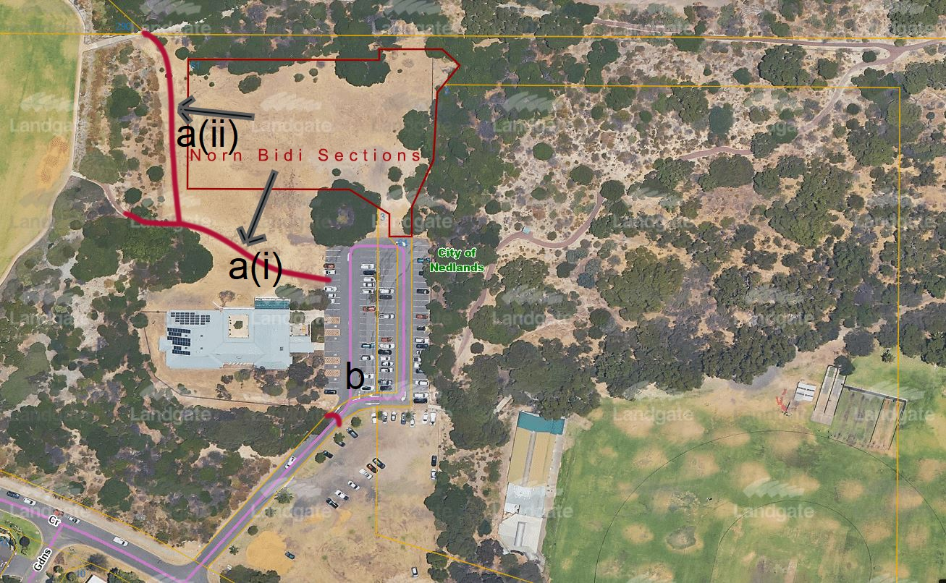

Map 1b – As referenced in the Motion
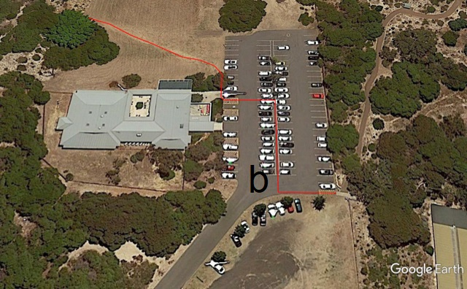

Reasons

Currently the trail descends from Melon Hill and ends at the mosaic limestone entry point. Walkers have no waypoint to direct them to the existing path fringing the north-western edge of the bridge club. They are obliged to navigate their way across the car park to join the existing path on to the beach oval and continuing on towards Swanbourne Beach.

This motion seeks to:

- Enhance the Norn Bidi section of the Whadjuk trail, being the only public throughfare through Allen Park from bush to beach which is on level ground.

- Implement the recommendations of the Allen Park Master Plan 2017 regarding the construction of formal pathways in this area.

- Preserve and encourage public access and use of all land within Allen Park by visually ensuring the public is not discouraged to access those areas, particularly the existing path network.

- Prevent encroachment by Class C reserve titleholders (whether primary or leasehold on existing Class A reserve.

- Create opportunities for the establishment of further tree canopy and understory plantings in the area.

Justification

Scope
Relates to recreational pathways known as Whadjuk (Norn Bidi) Trail and does not include the Commuter Cycle Network.

- Whadjuk (Norn Bidi) Trail
The Whadjuk Trails Network traverses through Allen Park, and one of the trails meets the paths that converge in the Heritage Precinct, at the gateway to Melon Hill; the large dune with magnificent 360° views to Rottnest Island and Perth’s skyline. As the hill is predominantly tuart woodland, its vegetation is typically coastal, with sedges and shrubland on its flanks. The log-and-chain path mounting the eastern slope is of particular interest to those on fitness training circuits.

This point of convergence is also where an information shelter is positioned. The noticeboard provides information relevant to community and bushcare activities in the area. There is a smaller noticeboard positioned outside Mattie Furphy’s House to promote upcoming writers’ events.

To the west, the trail descends from Melon Hill and ends at the mosaic limestone entry point. Walkers have no waypoint to direct them to the existing path fringing the north-western edge of the bridge club. They are obliged to navigate their way across the car park to join the existing path on to the beach oval and continuing on towards Swanbourne Beach.

- Allen Park Master Plan
Excerpt from the APPMP Plan Report – Final
(page 21) Paths and Trails, restore Whadjuk Trail.
(page 23) 10.3 The Whadjuk Trail (Bush to Beach Trail) runs through the precinct. The trail was initiated in 2002 to link the remnant bushlands in Perth’s western suburbs. The vision was to encourage community use and appreciate the local bushland areas. The trail is now 16.3km long and has a defined route linking bushland and other heritage trails from Kings Park through the Grant Marine Park in Cottesloe.

(page 42) Realignment of Whadjuk Trail.
The Whadjuk Trail is an important trail network however in some sections of the precinct, there is not clear delineation of the trail.
The trail is clearly signed until it stops and is ‘cut off’ at the bridge club car park. The path picks up again at the western edge of the Swanbourne Reserve
As the path is effectively not delineated from the car park edge, persons using the trail have no choice but to cross a car park (at times very busy) with no safety measures in place if they wish to access the trail of the beach area.

- Bushcare Management and Planning
APPMP page 50. Revegetated bushland. The inclusion of additional bush planting in and around the facilities suggested for this area of the precinct will enhance the existing ‘green’ feel of the location.

- Allen Park Management Plan 2013-2018
Page 34 (see appendix)
Work done so far and intent to mesh in with Odern Crescent section.

- Council & Committee References
There are many instances in recent Council Resolutions refer to the Path Network and give guidance to its importance in the overall strategy for the recreational priority.
Site Assessment Working Group Meeting Minutes 30 May 2022
(Link to recommendation)

Council Meeting Minutes 28 June 2022 - Item 16.2 PD36.06.22 Comment on State Development Assessment Unit Application for Children’s Hospice Development at 61 (Lot 503) Clement Street, Swanbourne
https://www.nedlands.wa.gov.au/council-meetings/ordinary-council-meeting/ordinary-council-meeting-28-june-2022/471/documents/2022-council-meeting-minutes-28-june.pdf

Council Meeting Minutes 14 December 2021 - Item TS14.21 Perth Children’s Hospital Foundation Proposal to Fund Development of a Community Park
https://www.nedlands.wa.gov.au/council-meetings/ordinary-council-meeting/ordinary-council-meeting-14-december-2021/27/documents/2021-council-meeting-minutes-14-december.pdf

Images of Whadjuk (Norn Bidi) Trail
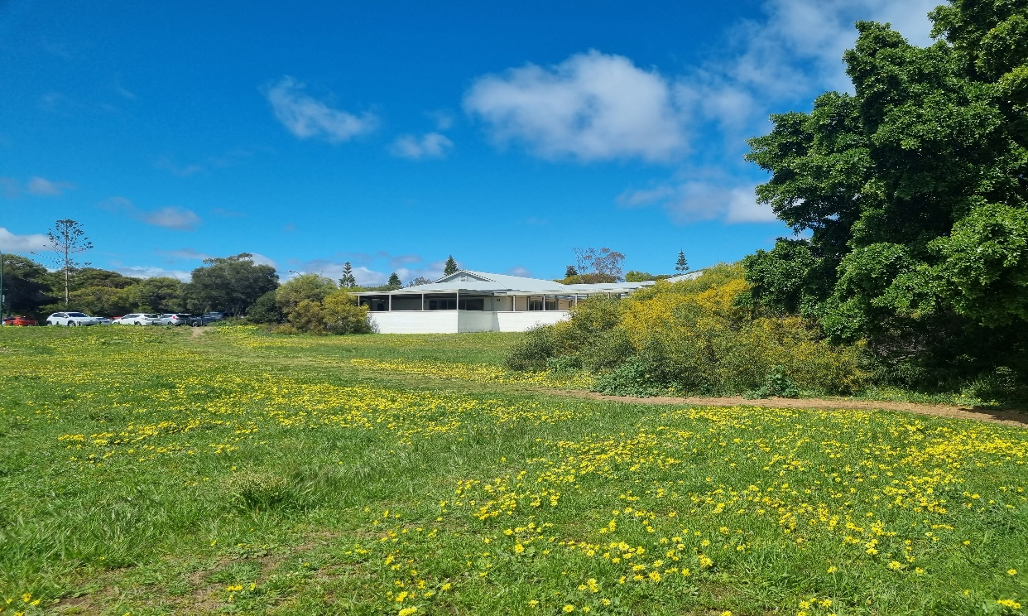

Way Finding Map on Sayer Street
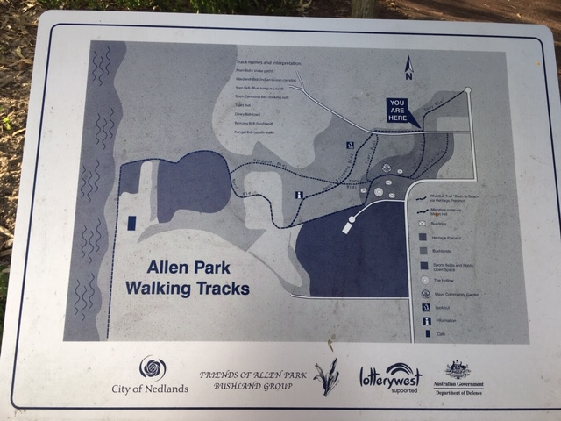
Trail Map available online
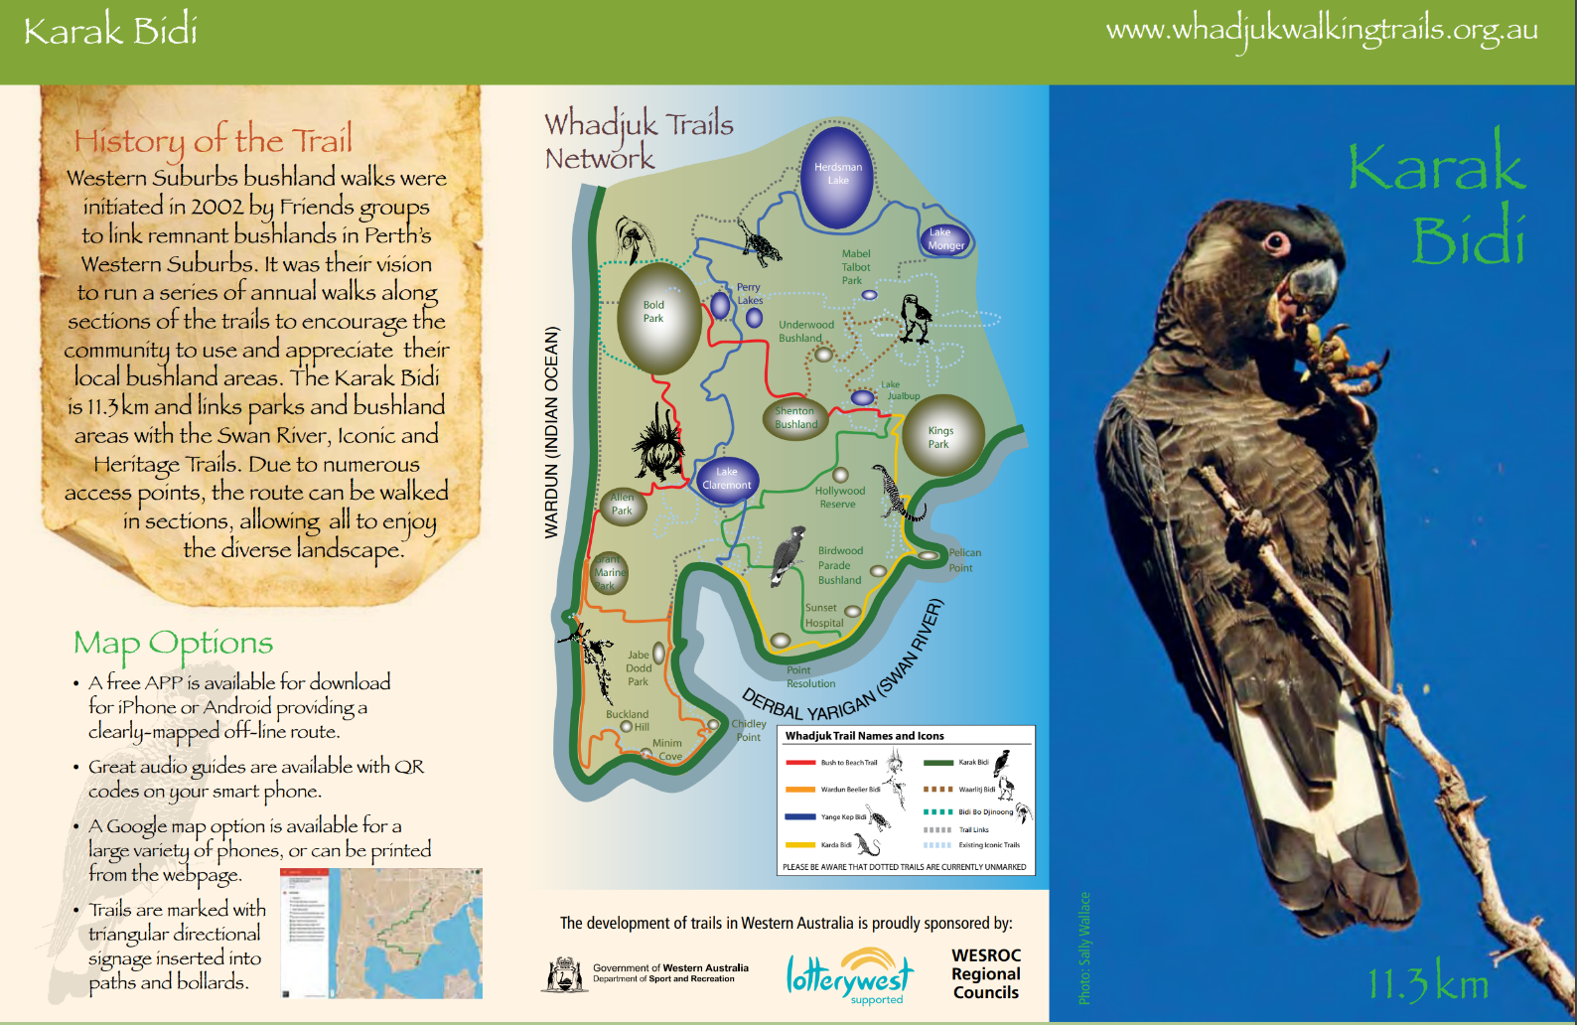
Allen Park Management Plan 2013-2018

https://www.nedlands.wa.gov.au/documents/479/allen-park-management-plan

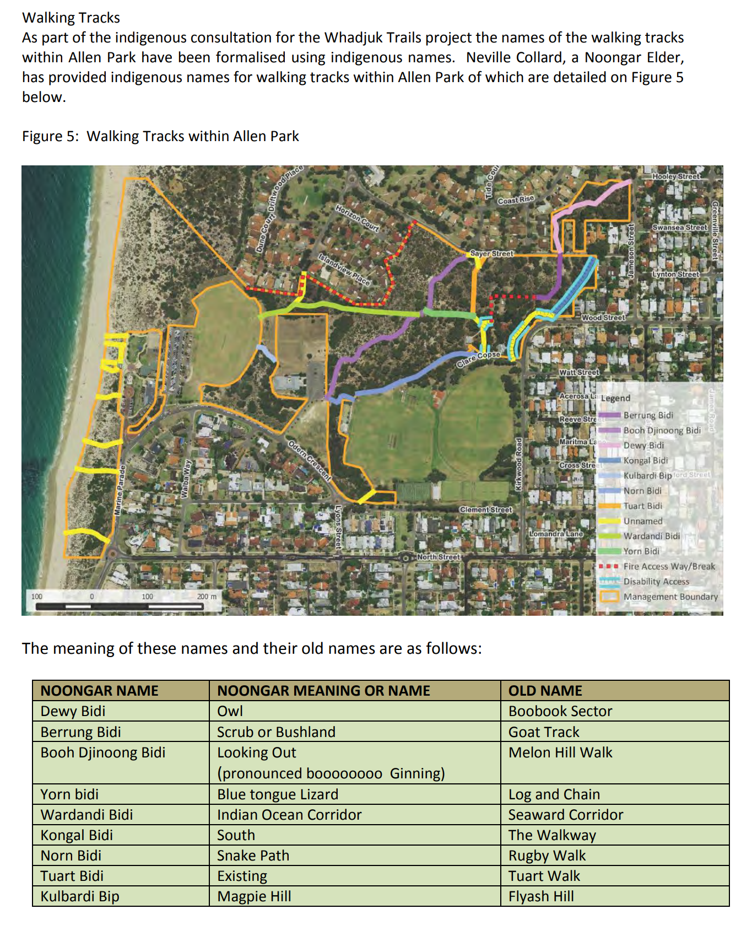

Allen Park Master Plan 2017

https://www.nedlands.wa.gov.au/council-meetings/ordinary-council-meeting/ordinary-council-meeting-19-december-2017/198/documents/20171219-council-meeting-agenda-19-december_0.pdf

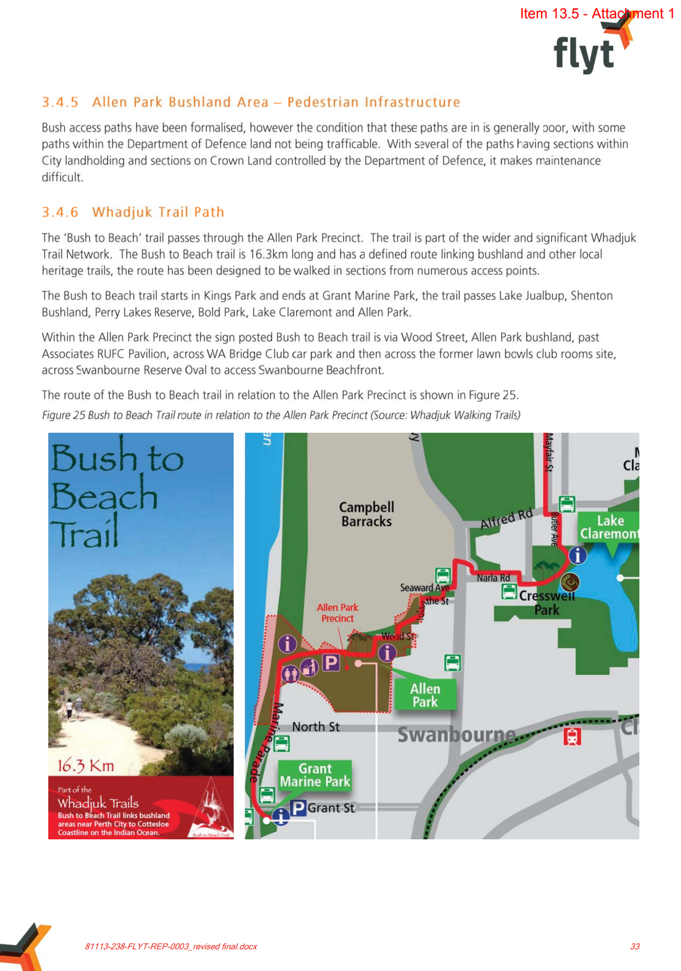
Administration Comment.

Officers support the improvement of the Whadjuk Trail Bush to Beach Trail to specifically connect trails emerging from the Melon Hill bushland to the path network around Swanbourne Reserve. This improvement aligns with the recommendation listed as part of the Allen Park Precinct Master Plan whereby the opportunity to improve linages through the Whadjuk Trails network should be established. Improving these linkages will further enhance the precinct amenity and support future use as a walkable precinct.

The cost estimate of the paths is estimated to be a minimum of $140,000 for a wheelchair accessible concrete (2m wide) footpath between the central car park to the existing footpath at Swanbourne Reserve and the path on the east side of the swale adjacent to Swanbourne Reserve. This is an early estimate without the benefit of a site survey, nor a conceptual design having been undertaken/prepared. The final cost may well be higher. There is no budget allocation for this project in the 2022/23 budget. If Council wished to pursue this project, consideration should be given to the inclusion of the project funds in the 2023/24 budget.

An alternative approach would be that subject to the Hospice development approval, the City engage with the Hospice for the paths referred to in part 1a of the Notice of Motion to be provided as part of the works associated with the Hospice. This has the potential for the paths to be provided without cost to the City. It is the City’s expectation to continue discussions regarding the specific landscape design, delineation, plant selection aligning with the Allen Park Plant Communities Species List.

Recommended Alternative Wording

That Council:

- requests that the Chief Executive Officer work with the proponents of the Western Australian Children’s Hospice for the developer to design and construct accessible paths to connect the trails emerging from the Melon Hill bushland to the path network around Swanbourne Reserve. These paths should align with Whadjuk Trail and the proposed location referenced in the Notice of Motion with consideration for wheelchair accessibility.

- acknowledges modifications of the Allen Park Bushland management boundary to incorporate the remaining areas outside the Children’s Hospice development site into Allen Park Bushland to be managed in accordance with the City’s Natural Areas Management Policy and the Allen Park Bushland Management Plan.

- requests that the City collaborate with WESROC to review and re-instate signage along the Whadjuk Trails within Nedlands.

Councillor Smyth – New Public Road – Mt Claremont Depot Access Driveway – Reserve 45632 – Progress Actions

On the 14 October 2022, Councillor Smyth gave notice of her intention to move the following motion.

That Council instructs the CEO to:

- progress the investigation for the creation of a Public Road connecting John 23rd Ave with Brockway Road, via the City’s depot holdings, taking into account previous Council resolutions relating to:

- the Local Planning Strategy (LPS) and the Local Structure Plan (LSP) work for the Mt Claremont North-East precinct;
- the leases and land use management at the City of Nedlands Depot (John 23rd Avenue);
- the Christ Church Grammar School playing fields acquisition and development (including City’s participation);
- the Depot Service Road northern extension to connect with Brockway Road, as marked in yellow on Map 1; and

- provide a provisional project outline that includes:

- scope options, timelines and budget;
- a risk assessment that considers:

- school and sports precinct access and egress requirements,
- impact on any local structure plans and zoning within the LPS3,
- local traffic modelling.

Map 1 – As referenced in the Motion
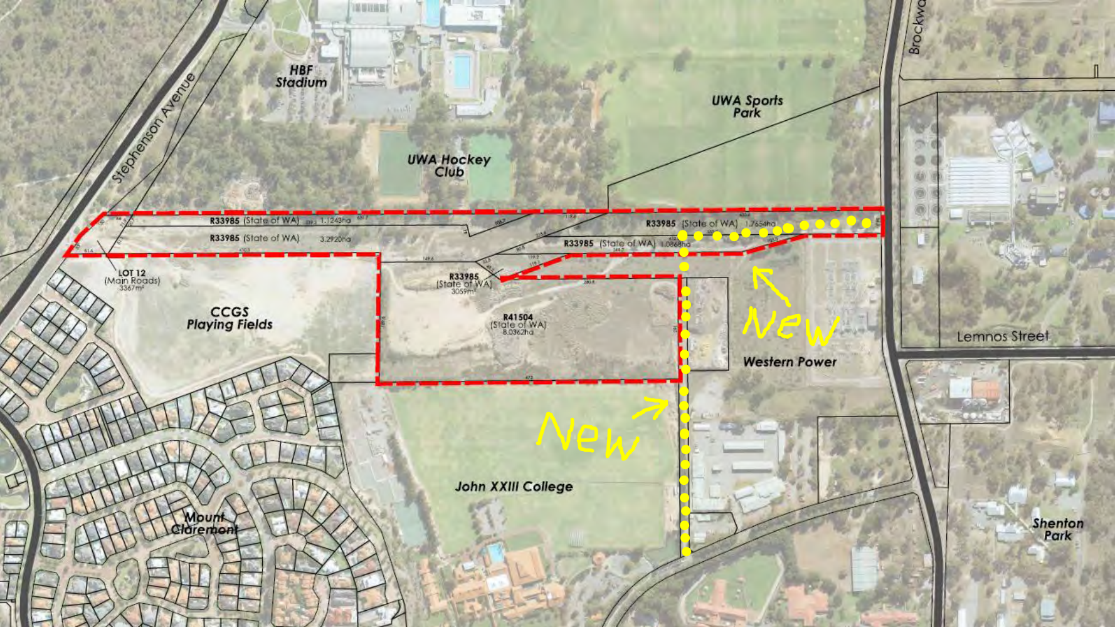
Reasons

- Provides a much-needed public thoroughfare that will relieve traffic congestion by providing an alternate northern access route to the schools and sports precinct.
- Provides public road access to the otherwise landlocked City depot and land leased to Cambridge and Subiaco.
- In the case of emergency evacuation and disaster management provides better road penetration of the area for emergency vehicle access.
- Projects the City as the responsible authority for decisions about the local road network before it is taken out of our hands by adjacent landholders creating private roads.
- Addresses the issue of JTC using this existing “non-road” as a slipway into their newly constructed car park and bus precinct.
- Addresses the issue of JTC connection to its newly acquired property and workshops precinct on the eastern corner at Lot 12241.
- Provides the opportunity for the City to develop an enhanced parkway verge for the City’s tree planting quota program. It could be similar in character to Montgomery Ave and Brockway Road.
- Facilitates forward planning and future budget allocations.
- Provides direction for collaboration with JTC and CCGS regarding joint landscape projects along the boundary interface.

Justification
1.0 Background – Decommissioned Landfill Site
The City’s depot in Mt Claremont is accessed by a Driveway on Lot 503, a long thin parcel of land that is classified as C class reserve R45632. The land is not currently a dedicated public road. The road network in this area has been static for the last 30 years since the closing of the Brockway Landfill Site, and its subsequent repurposing.
Redevelopment of this area into a schools and sports precinct, alongside more than one thousand new dwellings presents the urgent need for a re-think of the road and pathway networks. The area has been in a holding pattern for more than 30 years, the time has come to plan and act.

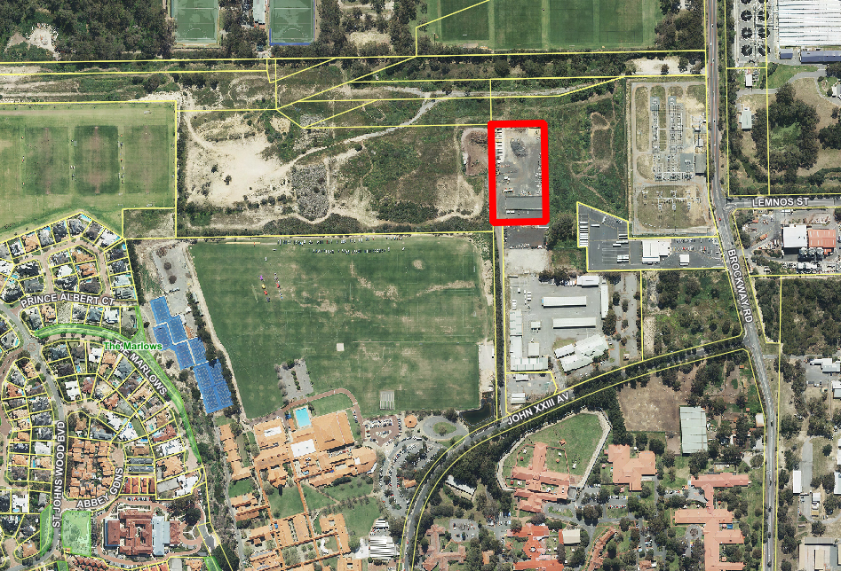
MAP 2: The Depot Driveway R45632 is 4,111m² of (C class reserve)
2.0 Planning for Future Land Uses
The Mt Claremont N-E Precinct was the site of the Brockway Landfill facility that closed over 30 years ago. It includes other public utility land holdings and is within the area of the wastewater odour buffer. There are a range environmental contamination issues in the area that require across government remedial coordination and local motivation.

Although partly re-habilitated the area remains isolated and an urban waste land. It is a scar on the landscape of the western suburbs and out of step with the vision for the City of Nedlands. The creation of a Local Structure Plan would provide the planning direction and civic leadership to mastermind the recovery of this valuable heartland.

Despite the development restrictions and planning ambiguities, there is growing pressure to permit land-uses that provide less than optimum advantage to the surrounding residential community. This is in direct contrast to the Local Planning Strategy outline below.

3.0 Local Planning Strategy Context
City of Nedlands Local Planning Strategy endorsed by the Western Australian Planning Commission 26 September 2017 provides the following direction.

5.9.3 Mt Claremont East Precinct Strategies:
- Retain and enhance the character and streetscape of the existing residential areas
- Comprehensively plan for the remaining non-residential areas.
  - Land uses and development within this area shall not conflict with the urban character being predominantly of sporting, research and educational facilities.
- Prevent the encroachment of sensitive land uses and residential development within the Subiaco WWTP odour buffer area.
- Consider opportunities to consolidate and improve access throughout the precinct.

4.0 Related Council Resolutions
Since the 2017 adoption and endorsement of the Local Planning Strategy there have been a number of Council Resolutions that have either supported or ignored the LPS intent.

4.1 Structure Plan Items
26 June 2018
Item 14.4 – Local Structure Plan for Mt Claremont North-East
Instructing CEO to investigate the creation of Local Structure Plan for Mt Claremont North-East; report received October 2018.

23 October 2018
Item PD53.18 - Mt Claremont North-East Structure Plan Investigation
Council approves preparation of a Project Plan and Community Engagement Strategy.
Report received December 2019.

17 December 2019
Item PD55.19 - Mt Claremont North-East Structure Plan Investigation
Council instructs the CEO to cease current work on the Mt Claremont Structure Plan Investigation and commence work on a Master Plan for the area as per the WAPC advice.
No report received to date.

https://www.nedlands.wa.gov.au/council-meetings/ordinary-council-meeting/ordinary-council-meeting-17-december-2019/120/documents/20191217-pd-reports-pd4819-pd5619-17-december.pdf

4.2 City of Nedlands Depot (John XXIII Avenue) Items
26 June 2018
Item TS12.18 - John XXIII Depot Upgrade
Council endorses business case to upgrade and lease portion of depot to City of Subiaco and Town of Claremont.
Update on venture received from Director Corporate Services 21/9/2022.

23 July 2019
Item 13.7 - City of Subiaco – Lease Portion of Reserve 45054 – City Depot at John XXIII Avenue, Mt Claremont
Council endorses lease to City of Subiaco, including landscape plan.
No satisfactory landscaping has been undertaken.

23 September 2022
Item 19.1 - CPS39.09.22 - Lease to Leo Heaney Pty Ltd – Portion of Reserve 45054 John XXIII Depot in Mt Claremont
Item 19.2 - CPS40.09.22 - Lease to WMRC – City of Nedlands John XXIII Depot in Mt Claremont, Portion of Reserve 45054, Lot 502 on Deposited Plan 73830, Mt Claremont.
Both items deferred until Council is provided with an adequate risk assessment of this service road usage.

4.3 Christ Church Grammar School Playing Fields Items
23 April 2019
Item PD13.19 - Christ Church Grammar School – Request for Endorsement of Possible Acquisition of Landfill Site
Council instructs letter of support with conditions regarding public access and future use.

28 July 2020
Item 13.4 – Deed of Easement and Deed of Agreement former Brockway Landfill Site
Council approves signing access agreement with Christ Church Grammar School.

4.4 Depot Service Road Items
23 February 2021
Item 14.5 – Public Road Connecting John 23rd Ave with Brockway Road
Instructing CEO to investigate the creation of this public road; no report received to date.

23 September 2022
Item 19.1 - CPS39.09.22 - Lease to Leo Heaney Pty Ltd – Portion of Reserve 45054
John XXIII Depot in Mt Claremont
Item 19.2 - CPS40.09.22 - Lease to WMRC – City of Nedlands John XXIII Depot in Mt Claremont, Portion of Reserve 45054, Lot 502 on Deposited Plan 73830, Mt Claremont.
Both items deferred until Council is provided with an adequate risk assessment of this service road usage.

Further Information
Administration had been requested to provide further information regarding what work had occurred in actioning the council resolution to making the road a dedicated road and having a northern access point. (Ref: Agenda September 2022).

Officer Response - The City has investigated the land tenure for the surrounding land including Lot 1500 on DP419082 being land immediately adjacent to the City’s Mount Claremont Depot site to determine whether a northern access point can be achieved.
Subject to consent from Christ Church Grammar School and the Minister for Lands an arrangement granting access rights over Lot 1500 may be achieved through one of three legal mechanisms, these include: Licence, Easement, Lease.

Conclusion
The City needs to:
- Progress the investigation for the creation of a Public Road connecting John 23rd Ave with Brockway Road, via the City’s depot holdings, taking into account previous Council resolutions.
- Provide a provisional project outline that includes scope options, timelines, budget and a risk assessment.

Attachments
Excerpts from Council Minutes – Council Resolutions
- 26 June 2018 - Item 14.4 – Local Structure Plan for Mt Claremont North-East.
- 23 April 2019 - Item PD13.19 - Christ Church Grammar School – Request for Endorsement of Possible Acquisition of Landfill Site
- 28 July 2020 - Item 13.4 – Deed of Easement and Deed of Agreement former Brockway Landfill Site
- 23 February 2021 - Item 14.5 – Public Road Connecting John 23rd Ave with Brockway Road
- 23 September 2022 - Item 19.1 - CPS39.09.22 - Lease to Leo Heaney Pty Ltd – Portion of Reserve 45054 John XXIII Depot in Mt Claremont
- 23 September 2022 - Item 19.2 - CPS40.09.22 - Lease to WMRC – City of Nedlands John XXIII Depot in Mt Claremont, Portion of Reserve 45054, Lot 502 on Deposited Plan 73830, Mt Claremont.
A1 - Council Minutes 23 April 2019
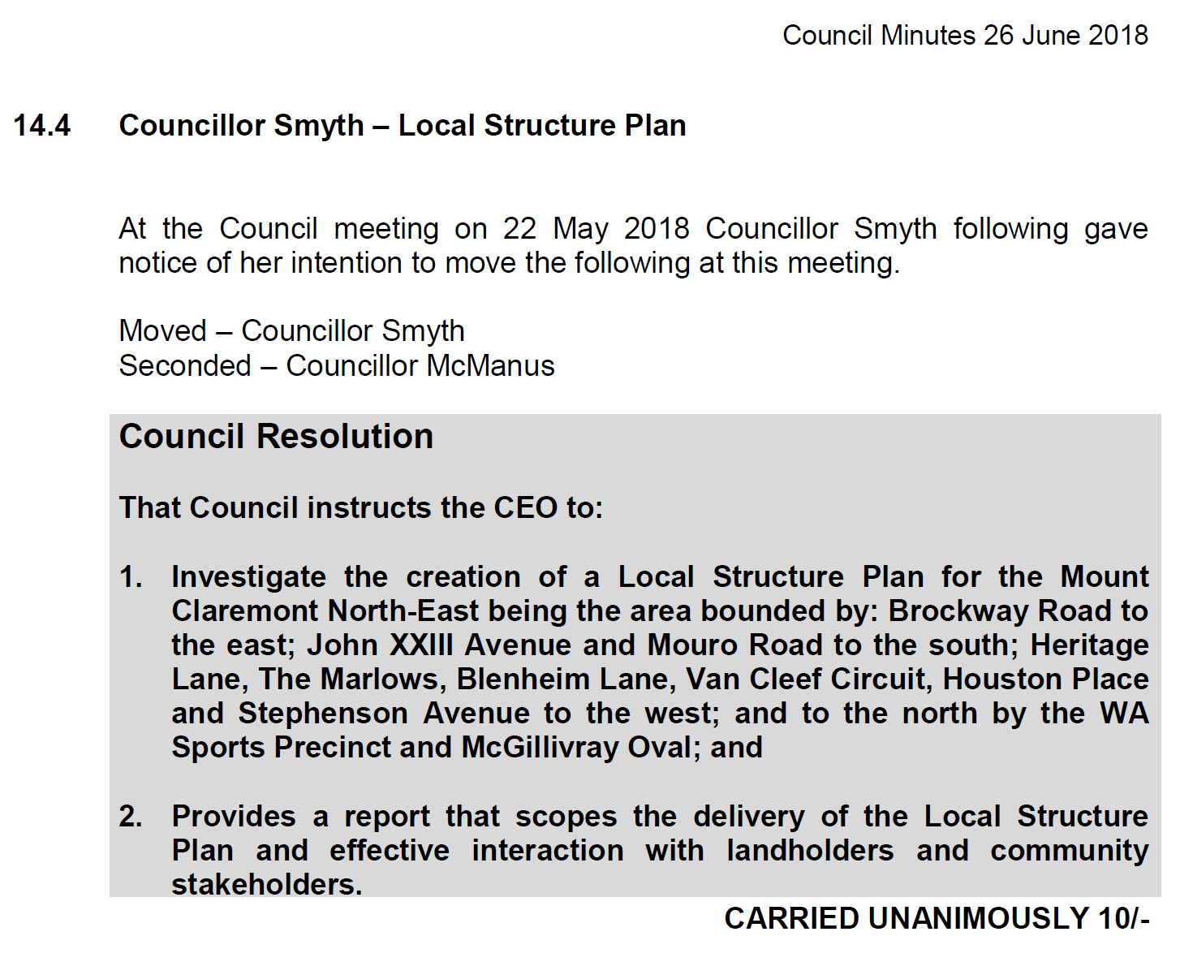
A2 - Council Minutes 23 April 2019
Item PD13.19 - Christ Church Grammar School – Request for Endorsement of Possible Acquisition of Landfill Site
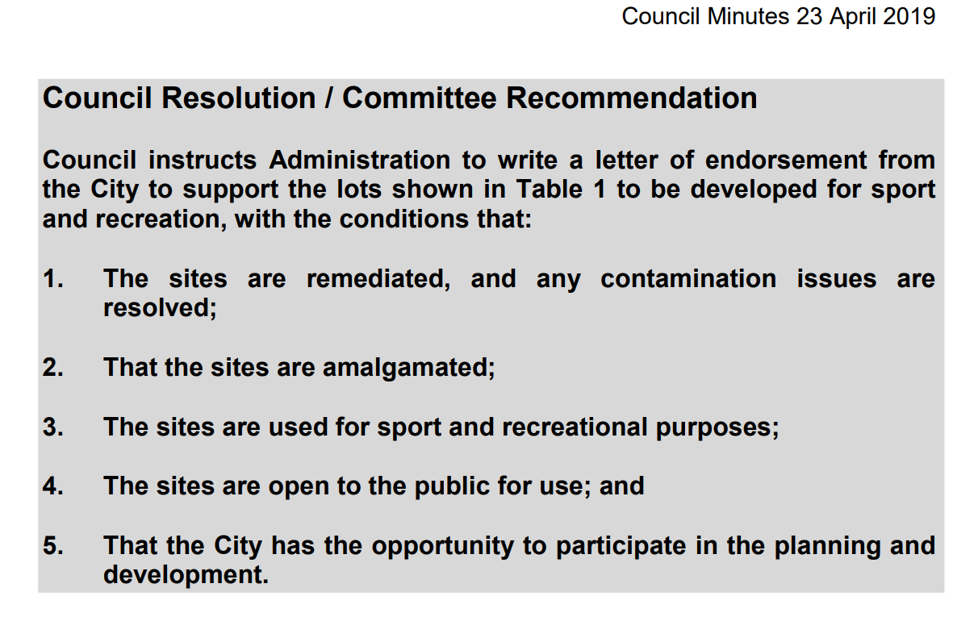

A3 - Council Minutes 28 July 2020
Item 13.4 – Deed of Easement and Deed of Agreement former Brockway Landfill Site
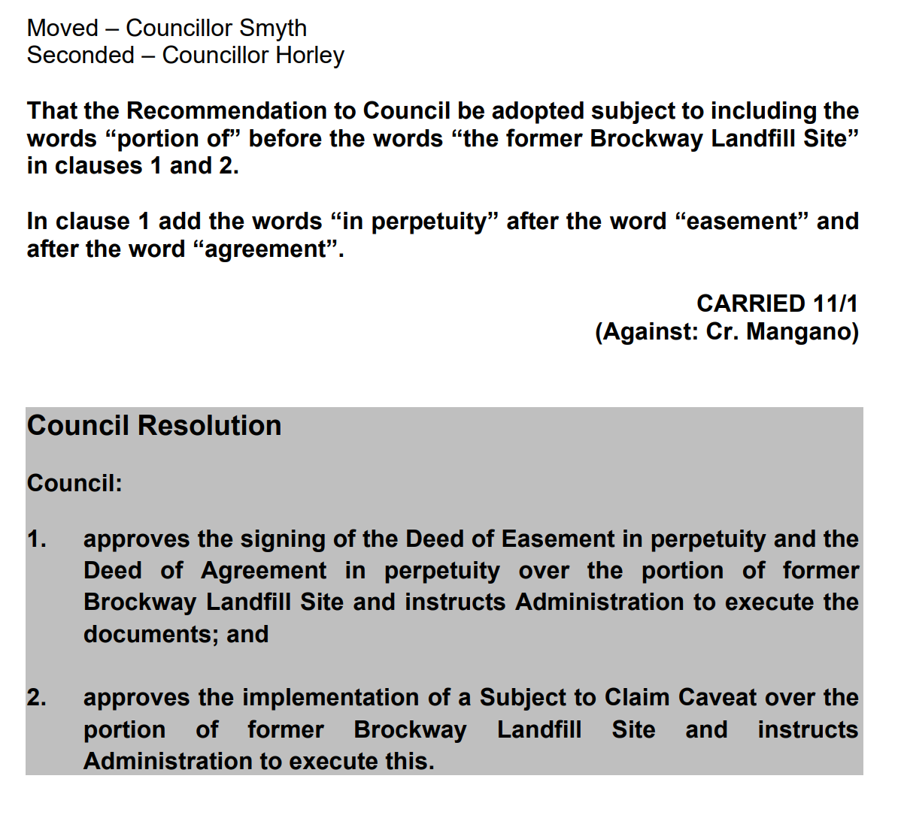
A4 - Council Minutes 23 April 2019
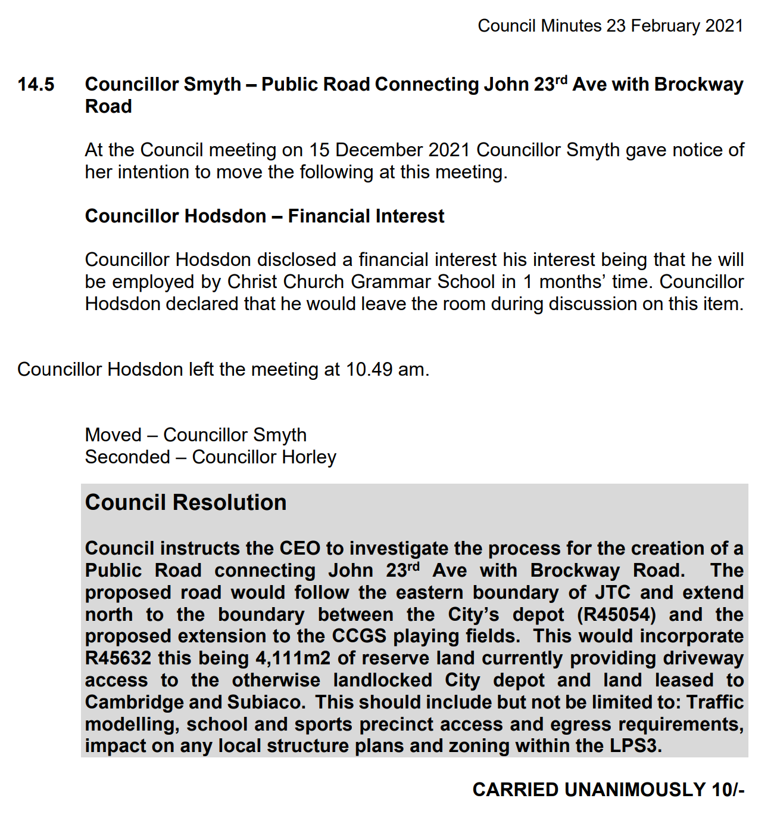
A5 - Council Minutes 23 September 2022
Item 19.1 - CPS39.09.22 - Lease to Leo Heaney Pty Ltd – Portion of Reserve 45054 John XXIII Depot in Mt Claremont

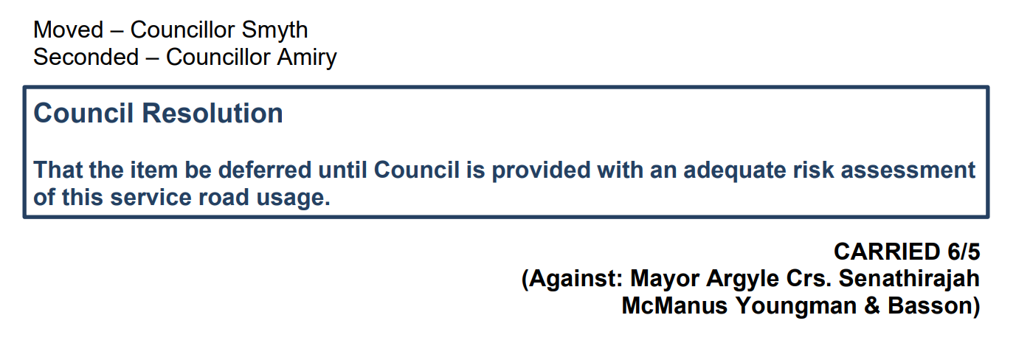

A6 - Council Minutes 23 September 2022
Item 19.2 - CPS40.09.22 - Lease to WMRC – City of Nedlands John XXIII Depot in Mt Claremont, Portion of Reserve 45054, Lot 502 on Deposited Plan 73830, Mt Claremont.

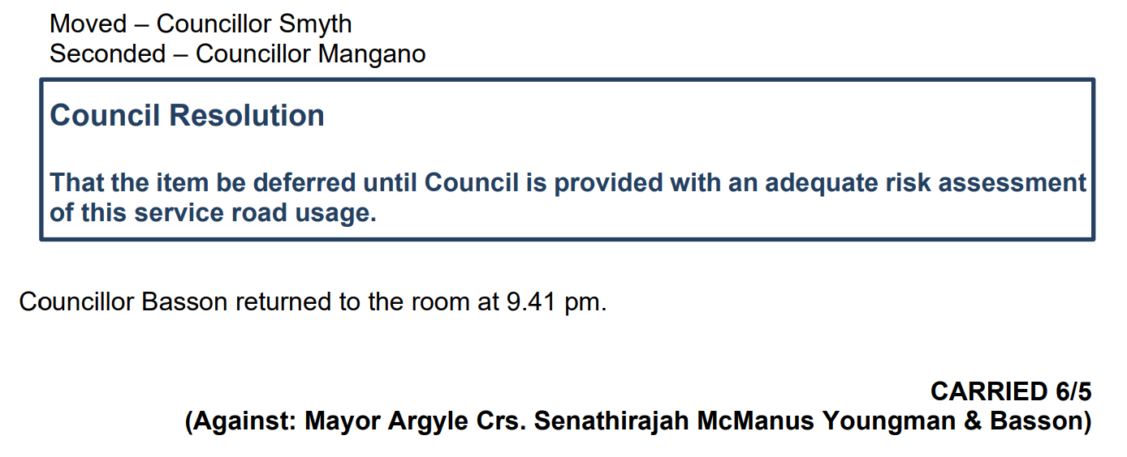

Administration Comment

There are significant land tenure issues with the suggested public road link, noting the part of the land in question is controlled by various parties including:

- CCGSPF Pty Ltd
- Department of Local Government, Sport and Cultural Industries; and the
- Electricity Network Corporation

The creation of a public road will require negotiations with these parties, with no certainty as to the likely success of the outcome.

Such a process will require a clear and justifiable rationale as to why such a link would be required and ultimately how the link would be funded would also need to be considered.
Reaching agreement with the relevant parties on the desirability of creating such a link is likely to take a considerable number of years. If agreement is reached, then the road reserve would need to be legally established prior to the actual construction of the road, which would be subject to funding. In short, the establishment of this link is not a short-term project.

Council has previously requested at a Local Structure Plan be prepared over this wider area. Rather than a structure plan, a non-statutory master plan, which established the Council’s vision for the linkages over the land, subject to the Wastewater Treatment Plant might be the most appropriate first step for Council to undertake. It’s not envisaged that such a master plan would address issues of land use. Officers understand that work is being considered by the State Government on how best to deal with the Wastewater Treatment Plant and the land uses within the existing buffer area. Again, this work is not going to progress (in terms of works on the ground) in the short term.

Officers consider an alternative approach as follows;

That the Chief Executive Officer be requested to:

- To present at a Concept Forum a Discussion Paper on the potential formation of a non-statutory Master Plan for the Mt Claremont location centred around Brockway Road.

- A report be presented to Council following the Concept Forum for the Master Plan to be formally considered.

- Give consideration to the inclusion in the 2023/24 Council budget for funds to prepare the Master Plan documentation.

Urgent Business Approved By the Presiding Member or By Decision

The following items have been approved by the Presiding Member.

PD72.10.22 Consideration of response to State Development Assessment Unit Referral for Extension of Time of Approval for Residential Aged Care Facility at 16-18 Betty Street and 73-75 Doonan Road, Nedlands

Meeting & Date | Council Meeting – 25 October 2022
Applicant | State Development Assessment Unit
Employee Disclosure under section 5.70 Local Government Act 1995 | Employee disclosure required where there is an interest in any matter of which the employee is providing advice or a report.
Report Author | Roy Winslow, Manager Urban Planning
Director | Tony Free
Attachments | - Applicant’s letter and approved plans

Purpose

The purpose of this report is to allow Council to provide a formal response to the State Development Assessment Unit (SDAU) referral concerning extending the approval timeframe by 24 months for the proposed residential aged care facility at 16-18 Betty Street and 73-75 Doonan Road, Nedlands.

Recommendation

That Council advises the State Development Assessment Unit that it does not support an extension of time being granted for the development of a residential aged care facility at 16-18 Betty Street and 73-75 Doonan Road, Nedlands on the following grounds:

- There has been a significant change to the planning framework that affects the ability for the development to be approved as follows:

  - The introduction of the R80 primary controls to the development by City of Nedlands Local Planning Scheme No.3 has identified an inability for plot ratio to meet Element Objective 2.5.1 of the Residential Design Codes Volume 2; and
  - City of Nedlands Local Planning Scheme requires a local development plan to prepared. The development as proposed does not meet the requirements of clause 56(2) of the Deemed Provisions to allow waiving of this requirement.

- The proponent has not demonstrated a justification for a 24 month extension of time, with this considered excessive by the City given the objective of the Part 17 development approval process to facilitate ‘shovel ready’ projects; and

- The proponent has not actively and relatively conscientiously pursued the approval.

Voting Requirement

Simple Majority.

It is noted that Council is not the decision-maker for this proposal. Council is invited to provide formal comments for consideration by the Western Australian Planning Commission (WAPC) when it determines the application.

Background

Initial approval

A development approval for the construction of a four-storey residential aged care facility at 16-18 Betty Street and 73-75 Doonan Road, Nedlands was granted by the WAPC on 11 March 2021. This approval was granted under Part 17 of the Planning and Development Act 2005 (as amended) for a period of 18 months (ending 11 September 2022).

Current status

The proponent has advised the SDAU that they have to date:

- Engaged a number of consultants to progress detailed design;
- Engaged with SDAU with respect to minor adjustments to the approved development;
- Sought tenders for building works and engaged a builder to undertake the “stage 1” works (which relate primarily to earthworks other forward works);
- Obtained a demolition permit and engaged a contractor;
- Undertaken most of the dilapidation reports for surrounding properties; and
- Progressed with clearance of conditions of approval relating to construction, traffic, waste and stormwater management plans, forward works plan, arborists report and geotechnical report.

At the time of writing this report, demolition has not taken place.

Change in legislation

At the time of the original approval, the Part 17 process did not allow for extensions of time. This reflected the original intention of Part 17 to generate economic activity during the Covid-19 pandemic by providing an expeditious approvals process for ‘shovel ready’ projects.

The State Government has recently amended the Part 17 legislation to allow for previous-approved developments to have the approval period extended. The current proposal is now subject to an application under the amended Part 17 process.

Considerations for granting an extension of time

The Planning and Development Act 2005 does not specify the matters relevant to an application to extend approval period. However, the following have been considered by decision-makers, such as SAT on similar applications:

- Has the planning framework changed substantially since the development approval was granted?
- Would the development likely receive approval now?
- Has the proponent actively and relatively conscientiously pursued implementation?
- Was the initial period for approval provided reasonable and adequate?

This report will focus on examination of each of these questions. However, the two that appear to have the most relevance (and weight) in this situation are whether the framework has changed and how much effort the proponent has put in to acting on the development approval.

Discussion

Has the planning framework changed?

Since approval of the development in March 2021, the planning framework has changed. Amendment 10 to the City of Nedlands Local Planning Scheme No.3 (LPS3) has been gazetted. This amendment modified the conditions relating to Additional Use Area 9 (A9), which applies to the development site and adjoining land to the south. Relevant to the proposal, the A9 conditions now include that:

- a residential aged care facility is a ‘P’ (permitted) use;
- a local development plan is to be prepared; and
- development on the subject land is to be in accordance with the R80 density code and associated primary controls contained in Part 2 of the Residential Design Codes Volume 2.

Amendment 10 is a significant change to the planning framework, given that it now imposes development standards on the subject site that were largely absent previously. Notwithstanding there has been significant change, the WAPC as the decision-maker is not bound by the planning framework where an application is made under Part 17. However, it must have due regard to the purpose and intent of LPS3, the need to ensure orderly and proper planning and the preservation of amenity.

It is noted that a local development plan is now required by LPS3 for the A9 additional use area. This plan has not been prepared to date.

A local development plan is to be given due regard as a ‘matter to be considered’ under clause 67(2) of the Deemed Provisions. As a due regard document, a local development plan is not binding on a decision-maker. Provision is made in the Deemed Provisions to allow for development to be approved without a local development plan in some circumstances. Clause 56(2) of the Deemed Provisions allows for development to be approved in the absence of a local development plan where:

- the proposed development does not conflict with the principles of orderly and proper planning; and
- the proposed development would not prejudice the overall development potential of the area.

The matter of whether the current application meets the threshold for approval without a local development plan is discussed below.

Would the development likely receive approval now?

Notwithstanding there has been significant change to the planning framework, it is now necessary to consider whether the development would likely receive approval under the new arrangements.

LPS 3 now provides for residential aged care to be a ‘P’ (permitted) use on the site. As a ‘P’ use, the purpose of residential aged care is permitted on the site if it complies with any relevant development standards and requirements of the Scheme. Where a use is permitted, there is generally no discretion to not allow it where all relevant standards and requirements have been adequately addressed.

The Scheme now applies the R80 density code to the subject site for the purposes of establishing the ‘primary controls’ for development. Primary controls are identified by the Residential Design Codes Volume 2 as building height, setbacks, plot ratio, building depth and building separation. The R-Codes provide a series of element objectives with acceptable outcomes that act as default provisions to assist in satisfying the objectives. A review of the approved plans against the primary controls of the R-Codes Volume 2 has identified that the plot ratio of the development does not meet Element Objective 2.5.1.

The objective requires the overall bulk and scale of the development to be appropriate for the existing or planned character of the area. The plot ratio as calculated by the SDAU for the original assessment is 2.1, based upon the definition of ‘plot ratio’ contained in LPS3 rather than the definition contained in the R-Codes Volume 2. The LPS3 definition does not exclude common areas and services to the same extent as the R-Codes variation. This then creates a higher plot ratio number when compared to an R-Codes assessment. The acceptable outcome plot ratio for R80 is 1.0. Given the nature of the building, some allowance for a plot ratio increase is warranted. However, a more than doubling of plot ratio is not considered consistent with the Element Objective.

The need to consider plot ratio is a significant change that may affect the ability for the development to be approved under the new planning framework.

As outlined above, a local development plan is required by the Scheme for the additional use A9 area. However, the deemed provisions provide the ability to approve development notwithstanding a local development scheme has not been approved. Given that there is no local development plan, it is necessary to consider whether the development meets the requirements of clause 56(2) of the Deemed Provisions for approval without the plan.

The ‘test’ to be used relates to whether approval would be consistent with the orderly and proper planning of the locality. The second limb of the test is to ascertain if the development would prejudice the development potential of the locality.

In relation to orderly and proper planning, consideration of whether the development could be approved under the current planning framework is useful. As outlined above, the main development framework now in place is the R80 primary controls discussed above. With the exception of plot ratio, the development is considered to meet the element objectives of Part 2 of the R-Codes for the R80 density. The development is not considered to meet the element objective for plot ratio. Therefore, an argument can be made that the bulk and scale of the development as proposed would be inconsistent with the orderly and proper planning of the locality.

The bulk and scale of the development will impact upon the development of the adjoining site to the south, which is also included in the A9 area and subject to the same controls. Notwithstanding the development was approved with the plot ratio and other settings that are currently proposed, the imposition of the R80 density and need for a local development plan should be considered afresh. The main benefit of a local development plan would be to ensure that the remainder of the A9 area can be developed in an ‘orderly and proper manner’. Ensuring a local development plan is in place now would allow for the plot ratio as proposed to be mitigated appropriately so that future development potential of surrounding properties is not affected.

Approval of the extension of time in the absence of a local development plan would not meet the requirements of clause 56(2) of the Deemed Provisions as the development has failed to meet all element objectives of the primary controls of the R-Codes Volume 2. A local development plan would allow for consideration of the impacts of the development as proposed on the development potential of surrounding areas and ensure proper and orderly planning.

In conclusion, there are some doubts over whether the application would be approved today in the form it is currently presented.

Has the proponent actively and relatively conscientiously pursued implementation?

The actions undertaken to date by the proponent were outlined earlier in this report. The amount of work undertaken in the last 18 months needs to be considered in the light of the Part 17 intent that developments are ‘shovel ready’. It is noted that the original application sought a 24-month approval, which was recommended by the SDAU to be reduced to 12 months to reflect the intent of Part 17. The WAPC subsequently provided an 18-month approval to reflect the then-situation that there was no ability to extend the approval period.

The steps taken by the proponent to progress the approval are considered modest. The City is aware that working drawings have recently been finalised. However, no building permit for the building has been submitted at this stage. Whilst a demolition permit has been granted, no demolition has taken place. It is understood that the proponent did not wish for the site to remain vacant for a protracted period of time and wishes to demolish closer to the construction start date. Whilst this is considered prudent from an amenity perspective, it indicates that the development is not yet near implementation.

It is noted that the information provided does not provide a detailed rationale for the proposed 24-month extension of time. Given that an initial 18-month period was provided, it is unclear why a further 24 months is required given the proponent maintains they are moving forward as quickly as possible.

Based on the information provided, it cannot be established that implementation has been actively and conscientiously pursued in a manner consistent with the intent of the Part 17 process to approve ‘shovel ready’ developments.

Was the initial approval period sufficient?

Ordinarily, a period of 18 months for the substantial commencement of a major development may be considered inadequate. It is noted that had the application been considered by the Joint Development Assessment Panel rather than via the Part 17 process, an effective 4 year period would be provided. However, the 18-month approval period must be viewed in the context of Part 17, in which pre-qualification requires the development to be ‘shovel ready’ and the statutory purpose of which is to facilitate development in response to the economic effects of the COVID-19 pandemic.

The proponent requested an initial 24 month approval period and likely made the decision to submit to the Part 17 process on the understanding that the development could be delivered in this timeframe. Given this, the 18-month period granted could be considered to be slightly inadequate. Having established this, this inadequacy does not necessarily justify the current request for a 24-month extension.

Consultation

Public consultation was undertaken by the State Development Assessment Unit. Consideration of submissions received will by undertaken by the WAPC as part of its deliberations.

Strategic Implications

This item relates to the following elements from the City’s Strategic Community Plan.

Vision Our city will be an environmentally-sensitive, beautiful and inclusive place.

Values Great Natural and Built Environment
We protect our enhanced, engaging community spaces, heritage, the natural environment and our biodiversity through well-planned and managed development.

Priority Area Urban form - protecting our quality living environment

Budget/Financial Implications

Nil.

Legislative and Policy Implications

As discussed earlier in this report, the requested extension of time is being made under Part 17 of the Planning and Development Act 2005.

Decision Implications

Council is requested to make comment to the State Development Assessment Unit on the proposed extension of time. As the WAPC is the decision-maker for this application, there are no statutory implications in Council making a submission to either support or not support the application.

Conclusion

The application to extend the approval period for the residential aged care facility at 16-18 Betty Street and 73-75 Doonan Road, Nedlands is not supported by City officers. The planning framework surrounding the subject site has substantially changed, affecting the likelihood that the development would be approved today. The key concern with approval is the advent of the R80 primary control settings. An assessment of the approved development in the light of the R80 density primary controls indicates the element objective for plot ratio is not achieved. A secondary concern is the lack of a local development plan, as now required by LPS3. Whilst there is an ability not to require the plan, the development does not on balance meet the tests contained in clause 56(2) of the Deemed Provisions.

Given the ‘shovel ready’ nature of the Part 17 approvals process, the actions taken to date to implement the approval are considered modest. There is also insufficient rationale provided in support of a 24-month approval extension.

Further Information

Nil.

TS22.10.22 Drainage Construction Upgrade Works – RFT 2022-23.020

Meeting & Date | Council Meeting – 25 October
Applicant | City of Nedlands
Employee Disclosure under section 5.70 Local Government Act 1995 | Nil.
Report Author | Dooshan Goburdhun – Project Engineer
Director | Daniel Kennedy-Stiff – Acting Director of Technical Services
Attachments | - CONFIDENTIAL - RFT 2022-23.02 - Evaluation and Recommendation Report  - CONFIDENTIAL - RFT 2022-23.02 – Evaluation and Recommendation Report – Appendix C

Purpose

The Purpose of this report is to seek Council approval to enter into a contract with Drainflow Pty Ltd for the Request for Tender -“Drainage Construction Upgrade Works”.

In accordance with Council’s amended purchasing policy, Council approval is required where the minimum number of quotes was not received during the procurement process. A Request for Tender (RFT) for the ‘Drainage Construction Upgrade Works’ received two submissions from an open tender Procurement process.

Recommendation

That Council accepts the request for tender received from Drainflow Services Pty Ltd for ‘Drainage Construction Upgrade Works’ for $147,200.00 (excl GST).

That Council:

- approves the award of the contract for Drainage Construction Upgrade Works in accordance with the City’s Request for Tender number RFT 2022-23.02 and comprising of that request, the City’s Conditions of Contract and the Drainflow Services Pty Ltd submission;

- instructs the CEO to arrange for a Letter of Acceptance and a Contract document be sent to Drainflow Services Pty Ltd for execution; and

- instructs the CEO to arrange for all other tender respondents to be advised of the outcome.

Voting Requirement

Simple Majority
Background

The City of Nedlands Procurement of Goods and Services Policy was amended by Council at the Ordinary Council Meeting on 24 May 2022. This amendment requires procurement items to be brought to Council where the minimum number of responses has not been received prior to the issue the award.
The Administration undertook an open tender process for the supply of design and construction services for RFT - Drainage Construction Upgrade Works. The procurement band ($50,001 to $250,000) requires that a minimum of 3 responses be obtained however at the close of the RFT advertisement period, two responses were submitted for consideration.

The City of Nedlands engaged an external firm to undertake a Stormwater Infrastructure Upgrade study for the Nedlands Local Government Area in response to the flooding events on the 9th July 2021. The City’s stormwater system uses a combination of pits, pipes, and road reserves to collect and convey stormwater to basins, the Swan River, and other receiving systems. In some areas the stormwater system does not currently meet performance standards and requires upgrade and renewal.

This study investigated the cause of historical flooding events, and in particular the 9th July 2021 storm. During this storm, many residents reported various degrees of flooding, with the more complex or uncertain locations included in scope for investigation. Based on the causes identified by the external firm, the study recommended new and upgraded drainage infrastructure be installed at various locations throughout the City to improve the capacity of the City’s stormwater infrastructure.

RFT 2022-23.02 will allow for the design and construction of upgraded stormwater infrastructure at the flowing locations:

- 66, 70 & 72 Archdeacon St, Nedlands
- 1 Birdwood Parade, Dalkeith
- 28 Watkins Road, Dalkeith
- 29, 31 &33 Beatrice Road, Dalkeith
- 65 Hobbs Ave, Dalkeith
- 80 & 82 Monash Road, Nedlands
- 71 & 75 Philip Road, Dalkeith

This request was publicly advertised on the West Australian newspaper and Tenderlink. At the close of the RFT period, only two tenderers have submitted a price for this procurement.

The Chief Executive Officer has endorsed the evaluation report and this matter is now brought to Council to consider approving the use of this supplier for the Design and Construction Services for the Drainage Construction Upgrade Works.

Discussion

After the closure of the tender period, the evaluation panel completed the analysis and evaluation of the two (2) submissions. At the conclusion of the process, Drainflow Services Pty Ltd was nominated as the preferred Contractor for this package of works. The submissions were rated against the following criteria:

- Relevant Experience (30%),
- Key personnel skills and experience (20%),
- Tenderers Resources (25%), and
- Demonstrated Understanding (25%)

Drainflow Services Pty Ltd provided information on similar works that they have recently undertaken, demonstrating an ability to complete the requirements of this request.

Key personnel listed were experienced, suitably skilled and have experience delivering similar works.

The Tenderer’s resources were basic and limited information on contingency planning to see works delivered.

Drainflow Services Pty Ltd provided an acceptable understanding of the City’s requirements.
The referees provided for Drainflow Services Pty Ltd, supported the recommendation for Drainflow Services Pty Ltd as the preferred supplier. Additionally, their offer represents good value for money to the City within the market.

Consultation

N/A

Strategic Implications

This item relates to the following elements from the City’s Strategic Community Plan.

Vision Our city will be an environmentally-sensitive, beautiful and inclusive place.

Values High standard of services
We have local services delivered to a high standard that take the needs of our diverse community into account.

Great Governance and Civic Leadership
We value our Council’s quality decision-making, effective and innovative leadership, transparency, accountability, equity, integrity and wise stewardship of the community’s assets and resources. We have an involved community and collaborate with others, valuing respectful debate and deliberation.

Priority Area

- Renewal of community infrastructure such as roads, footpaths, community and sports facilities
Budget/Financial Implications

A budget of $202,800 was approved as part of the 2022/23 Annual Budget for this project.

Legislative and Policy Implications

City of Nedlands Procurement of Goods and Services Policy
Local Government (Functions & General) Regulation 1996

Decision Implications

If Council endorses the recommendation, City staff can progress the procurement to carry out the required design and construction works for the Drainage Construction Upgrade Works project for the 2022/23 financial year.

If Council doesn’t endorse the recommendation, then the planned works for the Drainage Construction Upgrade Works project will be postponed and result in delays in the delivery of required works program for 2022/23.

Conclusion

Drainflow Services Pty Ltd have completed similar projects for other metropolitan local governments, have the required skills and experience necessary to complete the works. It is for these reasons that they are the recommended organisation for this contract of works.

Drainflow Services Pty Ltd total weighted score is the highest. The price schedule provided by Drainflow Services Pty Ltd was the lowest of the assessed submissions. Their submission demonstrated adequate organisational capabilities, good quality outcomes from similar work backed up by references and a basic understanding of the requirements of the contract. Assessment officers were in agreement that Drainflow Services Pty Ltd offered the best overall value for money.

It is recommended that Council accepts the tender for the Drainage Construction Upgrade Works from Drainflow Services Pty Ltd.

CEO13.10.22 Review of Wards and Representation

Council | Council Meeting – 25 October 2022
Applicant | City of Nedlands
Employee Disclosure under section 5.70 Local Government Act 1995 and City of Nedlands Code of Conduct for Employees | Nil.
CEO | Bill Parker
Attachments | - Draft Review of Wards and Representation discussion paper

Purpose

The purpose of this report is for Council to consider initiating a ward and representation review.

Recommendation to Council

That Council:

- advises the Department of Local Government, Sport and Cultural Industries of its intension to pursue the Voluntary Pathway for the review of wards and representation;

- initiates a review of the City of Nedlands wards and representation system in accordance with clause 6 of Schedule 2.2 of the Local Government Act 1995;

- resolves to give local public notice of the wards and representation review in accordance with 7(1) Schedule 2.2 of the Local Government Act 1995; and

- endorses the Review of Wards and Representation Discussion Paper detailed in Attachment 1 for the purposes of community consultation.

Voting Requirement

Simple Majority.

Background

On 20th September 2022, Hon John Carey MLA, Minister for Housing, Lands, Homelessness and Local Government sent a memorandum to all local government Chief Executive Officers regarding a proposed series of reforms aimed at strengthening local democracy and increasing community engagement.
In this correspondence, the Minister stated that the proposed reforms may require some local governments to:

- Reduce the number of elected members on Council in accordance with population thresholds.
- Change from a Council elected Mayor or President to a directly elected Mayor or President (this reform affects only band 1 and 2 local governments).
- Abolish wards (for band 3 and 4 local governments with wards).
- Implement more than one of the above.

The Department of Local Government, Sport and Cultural Industries (DLGSC) has completed an initial review and identified that the City of Nedlands may need to reduce the number of elected members under the proposed reforms.

In response, the City has been asked to consider two options to achieve the reforms:

- Voluntary Pathway
- Reform Election Pathway

Under the Voluntary Pathway, the City can decide to implement these changes on a voluntary basis. If Council wishes to undertake this process, it should, by 28 October 2022:

- Advise the Department of Local Government, Sport and Cultural Industries (DLGSC) of its intention to undertake a voluntary process. This advice should include a high-level plan outlining the potential changes to be implemented for the ordinary elections to be held in 2023 (and in 2025, if applicable); and
- Initiate a ward and representation review to determine the specific changes to the structure of the Council for the 2023 and 2025 ordinary elections, to be completed by 14 February 2023.

Under the Reform Election Pathway, amendments to the Local Government Act 1995 are expected to be introduced into Parliament in early 2023. This Amendment Act will provide for all of the proposed changes to be implemented through the 2023 election process.

This pathway would provide that all of the Council’s offices can be declared vacant, all wards can be abolished (if applicable) and the number of Council offices would be set based on the reform proposals. For local governments in band 1 or 2 (this includes the City of Nedlands), the newly elected Council would then be able to consider whether to establish new wards through a future ward and representation review.

Given the uncertainty of the Reform Election Pathway, it is recommended that Council selects the Voluntary Pathway and initiates a ward and representation review.

Discussion

The State Government is proposing to amend the Local Government Act 1995 to reduce the number of elected members in accordance with population thresholds. Under the proposal, local governments with populations between 5,000 and 75,000 would have between 5 and 9 Councillors (including the Mayor).

In order to comply with the proposed amendments, the City has been invited to initiate a ward and representation review. Schedule 2.2 of the Local Government Act 1995 provides that a local government of a district that is divided into wards is to carry out reviews of:

(a) its ward boundaries; and
(b) the number of offices of councillor for each ward, from time to time so that not more than 8 years elapse between successive reviews.

The Act further provides that when undertaking a review of wards and representation, any of the following may be considered:

- Creating new wards in a district already divided into wards;
- Changing the boundaries of a ward;
- Abolishing any or all of the wards into which a district is divided;
- Changing the name of a district or a ward;
- Changing the number of offices of councillor on a council; and
- Specifying or changing the number of offices of councillor for a ward.

Clause 8 of Schedule 2.2 requires a council to assess options against the following factors:

- Community of interest;
- Physical and topographical features;
- Demographic trends;
- Economic factors; and
- The ratio of councillors to electors in the various wards.

Reviews by local governments are assessed by the Local Government Advisory Board (LGAB), which in turn makes recommendations to the Minister for Local Government as to whether or not local governments have taken these factors into account. These factors can be interpreted as:

Community of Interest | Physical and Topographic Features | Demographic Trends | Economic Factors | Ratio of Councillors to Electors
The term community of interest has a number of elements. These include a sense of community identity and belonging, similarities in the characteristics of the residents of a community and similarities in the economic activities.  It can also include dependence on the shared facilities in an area as reflected in catchment areas of local schools and sporting teams, or the circulation areas of local newspapers.  Neighborhoods, suburbs and towns are important units in the physical, historical and social infrastructure and often generate a feeling of community and belonging. | These may be natural or man-made features that will vary from area to area. Water features such as rivers and catchment boundaries may be relevant considerations.  Coastal plain and foothills regions, parks and reserves may be relevant as may other man-made features such as railway lines and freeways. | Several measurements of the characteristics of human populations, such as population size, and its distribution by age, sex, occupation and location provide important demographic information. Current and projected population characteristics will be relevant as well as similarities and differences between areas within the local government. | Economic factors can be broadly interpreted to include any factor that reflects the character of economic activities and resources in the area.  This may include the industries that occur in a local government area (or the release of land for these) and the distribution of community assets and infrastructure such as road networks. | The Board considers that the ratio of Councillors to electors is particularly significant - it is expected that each local government will have similar ratios of electors to Councillors across its wards.  The Board will not support deviations of more than plus or minus 10% of the average ratio of electors to Councillors between wards.

The LGAB places particular emphasis on an even ratio of electors per Councillor where a local government is divided into wards but considers a deviation of plus or minus 10% between wards to be reasonable.

If satisfied that a review has properly taken these factors into consideration, the Board then makes a recommendation to the Minister for Local Government as to whether or not the proposal should be approved. The Minister may accept or reject the Board’s recommendation.

Any changes will come into effect at the next local government elections scheduled for October 2023.

While the City last undertook a ward and representation review in 2020, using elector numbers from March 2022 (the most recent Federal election) there is an imbalance between the ratio of electors per Councillor for the Coastal ward that is outside the average maximum of plus or minus 10% that the Board considers acceptable:
Ward | No of Electors | No of Councillors | Ratio of Councillors per Elector | % Ratio Deviation
Hollywood | 4,018 | 3 | 1,339 | -2.93%
Dalkeith | 3,572 | 3 | 1,191 | 8.50%
Melvista | 3,535 | 3 | 1,178 | 9.45%
Coastal | 4,490 | 3 | 1,497 | -15.02%
Totals/ average | 15,615 | 12 | 1,301
Table 1: Current ward structure highlighting the representation imbalance.

In order to achieve the requested reduction in the number of Councillors and balance the representation to acceptable thresholds, various options are available. Some of the options are outlined below:

Option 1 – no wards
Under this option, all wards are abolished resulting in 8 Councillors representing the City of Nedlands. There are approximately 85 local governments in Western Australia that have no wards.

Option 2 – Move electors between existing wards to correct imbalance
Under this option, four wards are retained as close as possible to their current configurations, with a reduced number of two Councillors in each ward.

Option 3 – Two wards of four councillors each
Under this option the existing Coastal/ Hollywood and Dalkeith/ Melvista wards are merged, resulting in two wards of four councillors each.

For the purposes of public consultation, a discussion paper has been prepared that explains the options presented above and outlines the advantages and disadvantages of each option.

Consultation
Clause 7 of Schedule 2.2 of the Local Government Act 1995 stipulates that a local government is to give local public notice that a review is to be carried out and that the notice must also advise that submissions may be made to the local government by a date at least 6 weeks from the date of the first notice.

Step or Item | Meeting date or deadline
Council resolution to begin public consultation | 25 October 2022
Start public consultation period (minimum 6 weeks) | 29 October 2022
Public consultation period closes | 12 December 2022
Possible Concept Forum with Elected Members to provide results of community consultation and consider way forward | 7 February 2023
Council meeting to decide outcome and make submission to LGAB | 13 February 2023
Deadline for submission to LGAB | 14 February 2023
Table 2: Indicative timeframes for City of Nedlands actions.
Strategic Implications

This item relates to the following elements from the City’s Strategic Community Plan.

Values Great Governance and Civic Leadership
We value our Council’s quality decision-making, effective and innovative leadership, transparency, accountability, equity, integrity and wise stewardship of the community’s assets and resources. We have an involved community and collaborate with others, valuing respectful debate and deliberation.

Reflects Identities
We value our precinct character and charm. Our neighbourhoods are family-friendly with a strong sense of place.

Budget/Financial Implications

The proposed reforms may result in a reduction in costs. Based on the 2022/23 Councillor fees and allowances, a reduction in Councillor numbers from 12 to 8 would save the City of Nedlands approx. $110,000 per annum.

Legislative and Policy Implications

Schedule 2.2 of the Local Government Act 1995 - Provisions about names, wards and
Representation applies to this item.

Conclusion

Given the uncertainty of the Reform Election Pathway, it is recommended that Council selects the Voluntary Pathway and initiates a ward and representation review.

Further Information

Nil.

Confidential Items

Confidential items to be discussed at this point.

Declaration of Closure

There being no further business, the Presiding Member will declare the meeting closed.

