

Planning and Development Reports

Committee Consideration – 11 September 2018

Council Resolution – 25 September 2018

Table of Contents

Item No. Page No.

PD43.18 (Lot 388) No. 103 Hardy Road, Nedlands – Short Term Accommodation 2
PD44.18 (Lot 49) No. 115 Victoria Avenue, Dalkeith – Two-Storey Single House with Roof Terrace and Under-croft Basement 9
PD45.18 (Lot 88) No. 4 Colin Street, Dalkeith – Two-Storey Single House 18
PD46.18 (Lot 3) No.117 North Street, Swanbourne- Screen Fence (Retrospective) 27
PD47.18 Scheme Amendment No. 208 – Bedbrook Place, Shenton Park 32

Council: 25 September 2018

PD43.18 | (Lot 388) No. 103 Hardy Road, Nedlands – Short Term Accommodation
Committee | 11 September 2018
Council | 25 September 2018
Applicant | S de Tissera
Landowner | S de Tissera
Director | Peter Mickleson – Director Planning & Development
Reference | DA18/29354
Previous Item | Item PD51.17 – November 2017
Delegation | In accordance with Clause 6.7.1a) of the City’s Instrument of Delegation, Council is required to determine the application due to objections being received.
Attachments | - Photographs of the building being used as short-term accommodation  - Proposed Management Plan from the Applicant

- Executive Summary

In November 2017, Council resolved to retrospectively approve an application for a building at the rear of the property to be used as short-term accommodation. It is a condition, amongst others, that this approval is for 12 months from the decision being made after which time a separate approval must be obtained for the use to continue beyond this period.

An application has been received for the rear building to continue to be used as short-term accommodation beyond November 2018.

During the advertising period 3 objections and 3 non-objections were received. In addition, 3 letters of support were received prior to the advertising period commencing.

It is recommended that the application be approved by Council as it is considered that the use of the rear building as short-term accommodation is not currently having any greater impact on the local amenity as compared to permanent residential accommodation.

The existing management plan is not proposed to be changed. This formed part of the November 2017 approval, and according to the City’s records the owner has not breached any of the conditions to date.

- Recommendation to Committee

Council approves the development application for the existing two-storey building at the rear of (Lot 388) No. 103 Hardy Road, Nedlands, to continue to be used as short-term accommodation, received on 5 June 2018, subject to the following conditions and advice:

1. The development shall at all times comply with the application and the approved plans, subject to any modifications required as a consequence of any condition(s) of this approval.

2. There shall be one vehicle permitted only to be parked on the property for those occupants and visitors associated with the short-term accommodation, and this vehicle shall be parked wholly on the site at all times when the short-term accommodation occupants are at the site.

3. The approved Management Plan being complied with at all times to the City’s satisfaction, and shall include a requirement for the landowner to notify all occupants of the short-term accommodation that:

- They are only permitted to bring one vehicle to the property;

- They are required to park their vehicle wholly on site at all times when they are at the site; and

- No vehicles shall be parked at any time in the rear laneway.

Advice Notes specific to this approval:

- Noise levels are to comply with the Environmental Protection (Noise) Regulations 1997.

- Site Details

Parent lot area | 490m²
Metropolitan Region Scheme Zoning | Urban
Town Planning Scheme No. 2 Zoning | Residential R25
Detailed Area Plan | No
Controlled Development Area | No
State Heritage Listed | No
Listed in Municipal Heritage Inventory | No

The subject property and those surrounding contain single dwellings.

At the rear of the subject property is a two-storey building which is currently being used as short-term accommodation. An aerial image showing the location of this building is on the following page.
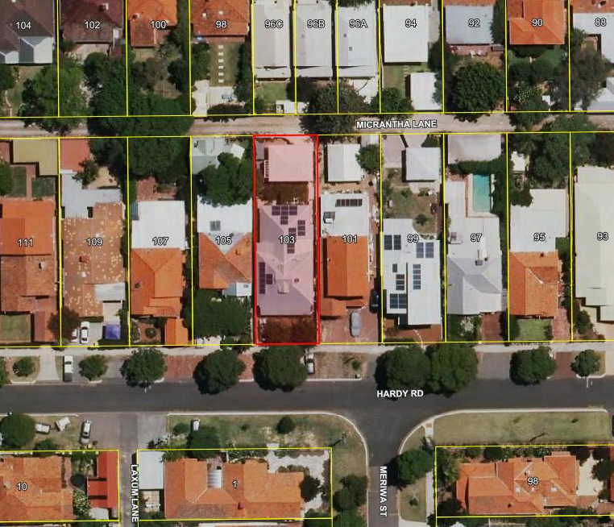
Building being used as short-term accommodation

- Background

In September 2016, a building permit was granted for a two-storey building at the rear of the property which is detached from the existing single dwelling. According to the approved plans the building was proposed to be used as an extension to the existing dwelling for the purposes of accommodating children.

In accordance with the Planning and Development (Local Planning Schemes) Regulations 2015 (Regulations), as the development complied with Town Planning Scheme No. 2 (TPS 2) and the deemed-to-comply provisions of the Residential Design Codes (R-Codes) it did not require development approval.

The construction of the development was completed by April 2017.

In June 2017, the City received a written compliant concerning the property and that the building was being used as short term accommodation due to being advertised on the AirBnB website.

A retrospective development application was subsequently received for the building to continue to be used for such purposes. This was approved by Council in November 2017 for a 12 month period.

- Specific Application Details

The applicant seeks approval for the existing rear building to continue to be used as short stay accommodation beyond November 2018 on a permanent basis.

Up to 3 adults and 1 child, or 2 adults and 2 children are proposed to be accommodated.

A Management Plan has been prepared by the applicant (refer to Attachment 2) which outlines the conditions which those residing at the property will be required to comply with if the application is approved by Council.

By way of justification in support of the proposal, the applicant has provided the following justification:

“The short-stay accommodation has been operating successfully since approval was sought. There have been no complaints made to the owner, the City of Nedlands planners & rangers or to the police regarding the operation of the short stay accommodation.

In addition to the required documents 2 references from past occupants and an article about Airbnb from the Australian Business Review 18th April 2018 have been provided.”

Note: A full copy of the reference and the article received by the City has been given to the Councillors prior to the Council meeting.

- Consultation

Three objections and 3 non-objections were received during the advertising period. The following is a summary of the concerns received:

- Nearby fencing potentially being damaged by vehicles entering the garage via the rear laneway.
- A car being parked in the rear laneway outside of the residence.
- The use potentially resulting in car parking issues in the local area.
- People staying at the property smoking in the rear laneway.
- How increased levels of refuse will be managed.
- Light spill from the subject property encroaching onto nearby properties.

In addition to this, 3 letters of support were received prior to the advertising period commencing.

Note: A full copy of all relevant consultation feedback, the letters of support, and the responses from the applicant to the concerns raised, received by the City have been given to the Councillors prior to the Council meeting.

- Assessment of Statutory Provisions

7.1 Planning and Development (Local Planning Schemes) Regulations 2015

Schedule 2, Part 9, clause 67 (Matters to be considered by local government) of the Regulations stipulates those matters that are required to be given due regard to the extent relevant to the application. Where relevant, these matters are discussed in the following sections.

7.2 Town Planning Scheme No. 2

7.2.1 Amenity

Under clause 5.5.1 of TPS 2 Council may refuse to approve any development if:

“in its opinion the development would adversely affect the amenity of the surrounding area having regard to the likely effect on the locality in terms of the external appearance of the development, traffic congestion and hazard, noise or any other factor inconsistent with the use for which the lot is zoned.”

In accordance with provisions (n), (s), (t) and (u) of the Planning and Development (Local Planning Schemes) Regulations 2015 clause 67, due regard is to be given to the likely effect of the proposal on the local amenity, the proposed means of access, and potential traffic impacts.

In response to the concerns the following is advised:

- As mentioned under section 5.0 of this report, a Management Plan has been prepared by the applicant which outlines the conditions which those visiting and residing at the property will be required to comply with if the application is approved by Council. There is no evidence to date that the management plan which formed part of the application previously approved by Council has been breached.

- The building contains one bedroom and the ability to also contain a sofa bed. Based on this it is likely that those residing in the building will be related to each other and therefore only need to bring one car to the property. A single car garage is available for them at the rear of the property.

- It is noted that there is a limited amount of street car parking spaces in the local area due to parking restrictions and the number of vehicles being parked by those visiting Hollywood Private Hospital nearby. The availability of a single car garage at the rear of the property for guests means that there will unlikely be an increase in demand for street parking nearby.

- Monash Avenue is a bus route therefore there is the possibility that guests at the short-term accommodation will use public transport to and from the property instead of their private car.

- If noise complaints are received by the City they will be investigated, and enforcement action taken, if necessary, in accordance with the Environmental Protection (Noise) Regulations 1997 as with any residential noise complaint. There is no record of any noise complaints being received by the City associated with the building being used as short-term accommodation since its temporary approval was granted by Council.

- The design and location of the garage and the driveway is consistent with the approvals granted, which satisfy the requirements in terms of vehicle access and sight lines.

Considering the above, the use of the rear building as short-term accommodation is not considered to have a greater impact on the local amenity compared with if the dwelling was occupied on a permanent basis.

It is also worth noting that any impacts caused as a result of the detached building being used as short-term accommodation will likely be minimal as any impacts will also affect the owner of the property.

- Other Matters of Concern

During the advertising period concerns were also received regarding the following:

- A car being parked in the rear laneway outside of the residence.
- People staying at the property smoking in the rear laneway.

8.1 A Car Parking in the Rear Laneway

Despite being requested no evidence has been provided to date which shows any vehicle associated with the short-term accommodation being parked in the rear laneway.

If the application is approved by Council, it is recommended that the management plan be amended to include a requirement for the landowner to notify all occupants of the short-term accommodation that they are required to park their vehicle(s) wholly on site at all times when they are at the site.

The applicant has advised that they will install a small no parking sign on the wall on their property to try and prevent it from possibly occurring in future.

8.2 People Smoking in the Rear Laneway

The potential impact people smoking may have on neighbouring properties is not a matter due regard is to be given to when determining the application under the Regulations.

- Conclusion

No complaints have been received to date regarding the building being used as short-term accommodation, and there is no evidence the management plan is not being adhered to by those staying there.

If approved by Council on a permanent basis the short-term accommodation use is unlikely to have a significant adverse impact on the local amenity due to its residential nature and scale.

It is also worth noting that the applicant will continue to be residing on the same property where the short-term accommodation is located. It is expected that the impacts will be minimal as any impacts will also affect the owner of the property.

For these reasons it is considered that the use of the detached building as short-term accommodation is unlikely to have a greater impact on the local amenity in terms of noise, car parking or traffic generation, compared with if it was resided in on a more permanent basis by this number of people.

It is therefore recommended that the application be approved by Council on a permanent basis.

PD44.18 | (Lot 49) No. 115 Victoria Avenue, Dalkeith – Two-Storey Single House with Roof Terrace and Under-croft Basement
Committee | 11 September 2018
Council | 25 September 2018
Applicant | Abel Ling Architect
Landowner | F Wijaya & J Ng
Director | Peter Mickleson – Director Planning & Development
Reference | DA18/29311
Previous Item | N/A
Delegation | In accordance with Clause 6.7.1a) of the City’s Instrument of Delegation, Council is required to determine the application due to objections being received.
Attachments | - Applicant Justification  - Site Photographs

- Executive Summary

A development application has been received for a two-storey single house with under-croft basement and roof terrace at the subject property. The development proposes variations to the deemed to comply provisions of the Residential Design Codes (R-Codes) for the secondary street setback and vehicle access.

Neighbouring landowners and residents were invited to comment with one objection and one comment being received during the consultation period regarding the proposed variations.

The secondary street setback is proposed to be a minimum of at 2m in lieu of 3m, however the majority of the dwelling is setback over 3m to the secondary street.

Vehicle access from Victoria Avenue is proposed including a reduced width crossover. It has been determined by the City that this will not pose a threat to safe access and provides for vehicular access to exit in forward gear.

The development is considered to comply with the relevant design principles of the R-Codes and is recommended for approval subject to conditions.

- Recommendation to Committee

Council approves the development application dated 31 May 2018 with amended plans dated 03 August 2018 to construct a two-storey single house with roof terrace and under-croft basement at (Lot 49) No. 115 Victoria Avenue, Dalkeith, subject to the following conditions and advice:

- The development shall at all times comply with the application and the approved plans, subject to any modifications required as a consequence of any condition(s) of this approval.

- This development approval only pertains to the proposed single dwelling, under-croft basement, roof terrace, associated site works and fencing.

- The roof terraces shall remain uncovered from water impermeable cover at all times.

- The use of the basement and rooms on the roof terrace level shall be restricted to the uses of plant and equipment, storage, toilets and/or the parking of wheeled vehicles. Prior to occupation of the dwelling, the owner shall execute and provide to the City a notification pursuant to s. 70A of the Transfer of Land Act 1893 to be registered on the title to the land as notification to prospective purchasers that the use of the basement and upper levels are subject to the restriction set-out above.

- All footings and structures to retaining walls, fences and parapet walls, shall be constructed wholly inside the subject site lot boundaries as specified on the property’s Certificate of Title.

- All visual privacy screens and obscure glass panels to Major Openings and Unenclosed Active Habitable Spaces as shown on the approved plans, shall prevent overlooking in accordance with the visual privacy requirements of the Residential Design Codes 2018. The visual privacy screens and obscure glass panels shall be installed prior to the development’s practicable completion and remain in place permanently, unless otherwise approved by the City.

- All stormwater from the development, which includes permeable and non-permeable areas shall be contained onsite.

- The dwelling shall not be used as a display home without further approval from the City being obtained.

Advice Notes specific to this proposal:

- The proposed dwelling shall not be used as ancillary accommodation or short-term accommodation.

- All crossovers to the street(s) shall be constructed to the Council’s Crossover Specifications and the applicant / landowner to obtain levels for crossovers from the City’s Infrastructure Services under supervision onsite, prior to commencement of works.

- The redundant crossover(s) shall be removed and the nature-strip (verge) reinstated to the City’s satisfaction.

- Any development in the nature-strip (verge), including footpaths, will require a Nature-Strip Development Application (NSDA) to be lodged with, and approved by, the City’s Technical Services department, prior to construction commencing.

- All street tree assets in the nature-strip (verge) not approved for removal shall be retained and protected during the construction period. Any approved street tree removals shall be undertaken by the City of Nedlands and paid for by the owner of the property where the development is proposed, unless otherwise approved under the Nature Strip Development approval.

- All swimming pool waste water shall be disposed of into an adequately sized, dedicated soak-well located on the same lot. Soak-wells shall not be situated closer than 1.8m to any boundary of a lot, building, septic tank or other soak-well.

- All swimming pools, whether retained, partially constructed or finished, shall be kept dry during the construction period. Alternatively, the water shall be maintained to a quality which prevents mosquitoes from breeding.

- All downpipes from guttering shall be connected to discharge into drains, which shall empty into a soak-well; and each soak-well shall be located at least 1.8m from any building, and at least 1.8m from the boundary of the block. Soak-wells of adequate capacity to contain runoff from a 20-year recurrent storm event. Soak-wells shall be a minimum capacity of 1.0m³ for every 80m² of calculated surface area of the development.

- All internal water closets and ensuites without fixed or permanent window access to outside air or which open onto a hall, passage, hobby or staircase, shall be serviced by a mechanical ventilation exhaust system which is ducted to outside air, with a minimum rate of air change equal to or greater than 25 litres / second.

- Prior to the commencement of any demolition works, any Asbestos Containing Material (ACM) in the structure to be demolished, shall be identified, safely removed and conveyed to an appropriate landfill which accepts ACM.

Removal and disposal of ACM shall be in accordance with Health (Asbestos) Regulations 1992, Regulations 5.43 - 5.53 of the Occupational Safety and Health Regulations 1996, Code of Practice for the Safe Removal of Asbestos 2nd Edition, Code of Practice for the Management and Control of Asbestos in a Workplace, and any Department of Commerce Worksafe requirements.

Where there is over 10m² of ACM or any amount of friable ACM to be removed, it shall be removed by a Worksafe licensed and trained individual or business.

- The applicant is advised to consult the City’s Visual and Acoustic Privacy Advisory Information in relation to locating any mechanical equipment (e.g. air-conditioner, swimming pool or spa) such that noise, vibration and visual impacts on neighbours are mitigated. The City does not recommend installing any equipment near a property boundary where it is likely that noise will intrude upon neighbours.

Prior to selecting a location for an air-conditioner, the applicant is advised to consult the online fairair noise calculator at www.fairair.com.au and use this as a guide to prevent noise affecting neighbouring properties.

Prior to installing mechanical equipment, the applicant is advised to consult neighbours, and if necessary, take measures to suppress noise. Further information can be obtained from the City’s Environmental Health department.

- This decision constitutes planning approval only and is valid for a period of two years from the date of approval. If the subject development is not substantially commenced within the two-year period, the approval shall lapse and be of no further effect.

- Site Details

Lot area | 1011.7m²
Metropolitan Region Scheme Zoning | Urban
Town Planning Scheme No. 2 Zoning | Residential – R10
Detailed Area Plan/Outline Development Plan | No
Controlled Development Area | No
State Heritage Listed | No
Listed in Municipal Heritage Inventory | No

The subject property is a corner lot and is relatively flat, accommodating an existing single storey dwelling which is proposed to be demolished for the proposed development.

An aerial image showing the location of the property follows.

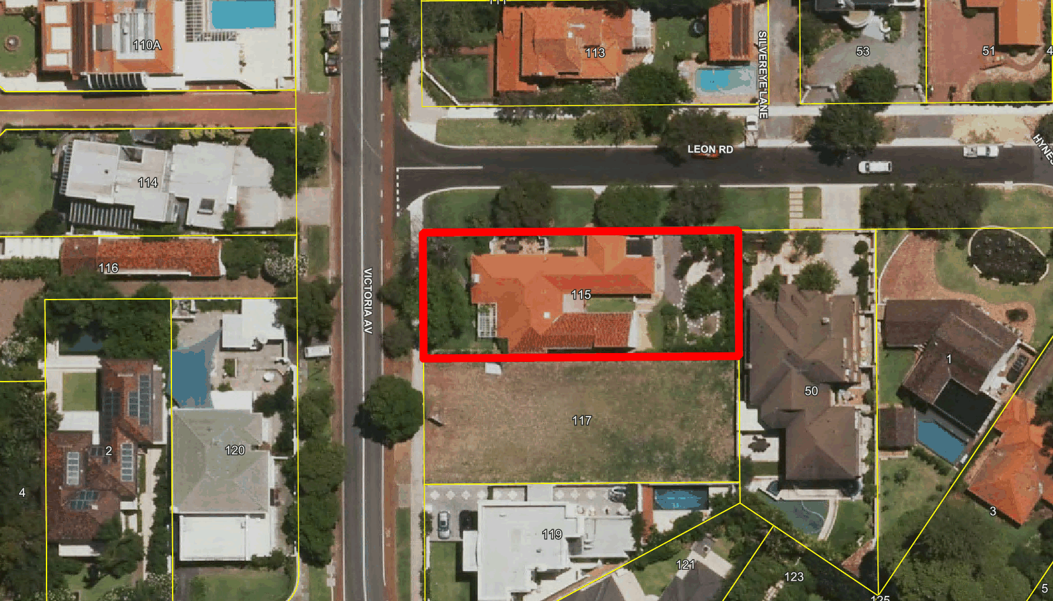

- Specific Application Details

The applicant seeks development approval to construct a single dwelling, details of which are as follows:

- An under-croft basement garage and storage area;
- Two storeys of habitable space;
- Roof terraces;
- A below ground swimming pool; and
- Fencing to the secondary and primary street boundaries.

The development proposes variation to the secondary street setback being 2m in lieu of 3m and the vehicle access being from the primary street (Victoria Avenue) in lieu of the Secondary Street (Leon Road).

The applicant has provided justification in support of these variations, provided as an attachment to this report (Attachment 1).

- Consultation

The development application was initially advertised to affected landowners for comment due to variations. The variations include lot boundary setbacks to the southern side lot boundary and overshadowing variations to the southern neighbouring property. The lot boundary setback and overshadowing variations have since been removed from the proposal with revised plans received by the City on the 3 August 2018 and objection to these variations rescinded by the impacted neighbouring landowner.

The following is a summary of the concerns raised in relation to the street setback and vehicle access variations:

- “To reduce the likelihood of vehicle conflicts, vehicle accesses should be located on the road with the least amount of traffic, which in this case is Leon Road which is a local road compared to Victoria Avenue which is classified as a local distributor.”
- “This requirement is particularly important due to the existing safety issues associated with the location of the proposed vehicle access. This section of Victoria Avenue is already unsafe due to the sharp turn it features south of the property which restricts sight lines, and consequently makes accessing properties in this location dangerous. Adding another crossover to Victoria Avenue will further exacerbate this problem.”
- “Similarly, the vehicle access should be located on Leon Road is to increase the safety of cyclists and pedestrians. Victoria Avenue features both a cycle lane and a footpath and consequently the risk of vehicle conflict with cyclists and pedestrians is greater than if the vehicle access was located on Leon Road, where there is no dedicated cycling or pedestrian infrastructure. The safety of cyclists in this area is already compromised due to the cycling lane abruptly stopping at the intersection with Bishop Road.”
- “Where possible, vehicle access should be located on a secondary street to reduce the proliferation of vehicle accesses on the primary street, which the adjoining vacant lot will also contribute to once developed. The removal of a street tree to make way for a vehicle access should also not be considered, especially when it is not absolutely necessary.”
- “The reduced setbacks will negatively impact on the streetscape as they contribute to the visual setting of a building, which in turn contributes to the attractiveness and character of the locality.”

Note: A full copy of all relevant consultation feedback received by the City has been given to the Councillors prior to the Council meeting.

- Assessment of Statutory Provisions

6.1 Planning and Development (Local Planning Schemes) Regulations 2015

Schedule 2, Part 9, clause 67 (Matters to be considered by local government) stipulates those matters that are required to be given due regard to the extent relevant to the application. Where relevant, these matters are discussed in the following sections.

6.2 Town Planning Scheme No. 2

6.2.1 Amenity

Under clause 5.5.1 Council may refuse to approve any development if:

“in its opinion the development would adversely affect the amenity of the surrounding area having regard to the likely effect on the locality in terms of the external appearance of the development, traffic congestion and hazard, noise or any other factor inconsistent with the use for which the lot is zoned.”

The lot boundary setbacks, open space, visual privacy and overshadowing proposed are compliant with the deemed-to-comply provisions of the R-Codes. Although the development is significant, it is not out of context with the locality.

The proposed setback of 2m is the minimum setback from the street, with the majority of the development setback over 3m from the secondary street which when an average is applied, would result in a setback of 3m or more. Both the existing dwelling on the subject property and the property on the opposite side of Leon Road (no. 113 Victoria Avenue) have a minimum secondary street setback of less than 3m provided to Leon Road. This would therefore ensure that the variation is not out of context with the locality and existing established streetscape.

The vehicle access being proposed from Victoria Avenue allows for safer vehicle access including the ability to exit the site in forward gear when leaving the property rather than reversing into the street. No. 116 and 120 Victoria Avenue have vehicle access from Victoria Avenue in lieu of Bishop Road. It is noted that there are several other examples within the immediate streetscape locality where vehicle access is obtained from Victoria Avenue where alternate secondary street or laneway access is available. The vehicle access being in forward gear reduces potential for conflict with pedestrians and cyclists and is therefore supported

The City has approved a Nature Strip Development Application for a new vehicle access to Victoria Avenue and the removal of a small street tree to facilitate this which in turn facilitates the retention of three more mature trees along Leon Road.

The vehicle access being proposed from the primary street allows the rear yard area to be used as outdoor living area rather than a vehicle access location.

6.3 Residential Design Codes (State Planning Policy 3.1)

6.3.1 Street setbacks

Deemed-to-Comply  Requirement | Proposed | Complies?
Buildings setback 3m to the secondary street boundary. | 2m setback in lieu of 3m | No
Design Principles

Variations to the deemed-to-comply requirements can be considered subject to satisfying the following Design Principle provisions:

“P2.1 Buildings set back from street boundaries an appropriate distance to ensure they:
- contribute to, and are consistent with, an established streetscape;
- provide adequate privacy and open space for dwellings;
- accommodate site planning requirements such as parking, landscape and utilities; and
- allow safety clearances for easements for essential service corridors.

P2.2 Buildings mass and form that:
- uses design features to affect the size and scale of the building;
- uses appropriate minor projections that do not detract from the character of the streetscape;
- minimises the proportion of the façade at ground level taken up by building services, vehicle entries and parking supply, blank walls, servicing infrastructure access and meters and the like; and
- positively contributes to the prevailing or future development context and streetscape as outlined in the local planning framework.”

Administration Comments

The reduction in the secondary street setback allows for a larger setback to be provided to the southern side lot boundary. This will result in a plan that complies with the lot boundary setbacks, visual privacy and overshadowing requirements of the R-Codes. The proposed 2m setback provided is the minimum street setback, with the majority of the building setback 3m or more from the street and the street setback averaging 3m which mitigates the impact of building bulk.

The reduced setback is consistent with the existing Leon Road streetscape including the existing dwelling on the subject property and no. 113 Victoria Avenue having reduced setbacks to the Leon Road street boundary. The applied averaging street setback of 3m in lieu of providing a minimum 3m supports this. The secondary street elevation as proposed includes appropriate articulation and windows to break up the building bulk and creates an activated streetscape along Leon Road with complaint rear and primary street setback areas free of minor structures (such as carports, outbuilding and gatehouses).

6.3.2 Vehicle access

Deemed-to-Comply  Requirement | Proposed | Complies?
Access to on-site car parking spaces to be provided from a secondary street where no right-of-way exists; or from the primary street frontage where no secondary street or right-of-way exists. | Access is proposed from the primary street (Victoria Avenue) where access can be obtained from the secondary street (Leon Road). | No.
Design Principles

Variations to the deemed-to-comply requirements can be considered subject to satisfying the following Design Principle provisions:

“P5.1 Vehicular access provided for each development site to provide:
- vehicle access safety;
- reduced impact of access points on the streetscape;
- legible access;
- pedestrian safety;
- minimal crossovers; and
- high quality landscaping features.

Administration Comments

The difference in road hierarchy between Victoria Avenue and Leon Road is 2,000 vehicle movements per day. The location of the vehicle access on Victoria Avenue is not of great consequence in terms of mitigating additional traffic movements – with location on Victoria Avenue likely to remove additional traffic movements from Leon Road.

The vehicle access being proposed from Victoria Avenue allows access and egress in forward gear with turn around area provided within the basement area. Additionally, the width of the crossover is reduced to be slightly wider than single width, rather than a double width crossover to Leon Road for above ground car parking which would have greater impact on the streetscape. This in turn reduces potential conflict with cyclists and pedestrians on Victoria Avenue due to the increased visibility afforded by forward gear access.

The vehicle access location allows retention of three mature street trees along Leon Road and greater passive solar orientation through location of additional major openings to the northern elevation of the proposed dwelling.

- Other Issues Raised

During the advertising period, an objection was raised in relation to the proposed roof terraces and overlooking created from these terraces to neighbouring properties. Further to this, a comment was received in relation to the impact of the vehicle access location on the design of the southern neighbour’s proposed front fence with request made to increase the driveway setback to 1.5m.

With regards to the roof terraces proposed, the terraces are proposed to be screened on the southern side to prevent any overlooking to residential properties in accordance with the visual privacy requirements of the R-Codes. All other sides of the roof terraces are proposed to be unscreened as overlooking will be to street setback areas (not used as outdoor living area), road reserve or wholly contained within the subject property. All other residential properties are over 10m from the unscreened sections of the roof terraces which is more than the required 7.5m setback required under the R-Codes.

In relation to the proposed vehicle access location and the southern neighbour’s proposed front fence, it should be noted that neither a development application nor building permit has been received for a front fence at the southern neighbour’s property and the proposed sightlines and front fence proposed for the subject property are compliant with the City’s Fill and Fencing Local Planning Policy.

Further to this, there is a power dome on the southern neighbour’s property adjacent to the proposed vehicle access point on the subject property which is likely to prevent any additional front fencing being within the sightline of the driveway at the subject property.

- Budget / Financial Implications

N/A

- Risk management

N/A

- Conclusion

The proposed street setback and vehicle access variations will not have an adverse impact on the streetscape and immediate amenity of the locality given that there are examples of the similar variations present at neighbouring/nearby properties whereby amenity of the locality and neighbouring properties is not detrimentally impacted.

The proposed street setback complies as does the vehicle access proposed.

The development is therefore considered to be compliant with the design principles of the R-Codes and therefore recommended for approval, subject to conditions.

PD45.18 | (Lot 88) No. 4 Colin Street, Dalkeith – Two-Storey Single House
Committee | 11 September 2018
Council | 25 September 2018
Applicant | Oswald Homes
Landowner | K M & M A Branchi
Director | Peter Mickleson – Director Planning & Development
Reference | DA18/28919
Previous Item | Nil.
Delegation | In accordance with Clause 6.7.1a) of the City’s Instrument of Delegation, Council is required to determine the application due to an objection being received.
Attachments | - Applicant’s justification  - Site Photographs

- Executive Summary

A development application has been received for a two-storey single house at the subject property.

The development proposes variations to the deemed-to-comply provisions of the Residential Design Codes 2018 (R-Codes) for:

- A front verandah is proposed to have an area of 31.97m² in lieu of 6m² and have a height of 4.5m above natural ground level in lieu of 3.5m;
- A garage is proposed to have a nil setback in lieu 1.1m to the southern side lot boundary;
- The ground floor of the house is proposed to have a minimum 3.4m setback in lieu of 4m to the northern side lot boundary;
- The ground floor of the house is proposed to have a minimum 1m setback in lieu of 6m to the rear lot boundary; and
- The upper floor of the house is proposed to have a minimum 3.65m setback in lieu of 6m to the rear lot boundary.
- The front verandah is proposed to have a 4m visual privacy setback in lieu of 7.5m to the northern side lot boundary.

Neighbouring landowners and residents were invited to comment with one objection being received during the consultation period due to the proposed boundary wall for the garage and the front verandah’s elevation and size.

The lot is an irregular size being wider and not as deep as other lots within the locality of the same size and coding. The setback variations proposed are as a result of this irregular lot shape.

Boundary wall development is prevalent in the immediate streetscape, ensuring that the prevalent streetscape amenity will not be negatively impacted as a result of the proposed boundary wall to the southern side lot boundary.

A large portion of the front verandah is not proposed to be covered by a roof, however is proposed to be raised a maximum of 0.75m above the natural ground level. The appearance of this verandah will add bulk within the 9m front setback area and reduce the streetscape amenity of the locality as a result. The City recommends that the proposed verandah is made to be compliant by reducing the finished floor level by 250mm so that it is no more than 0.5m above natural ground level at any given point. This in turn will also remove the visual privacy variation proposed.

With the recommended reduction to the finished floor level of the uncovered section of the front verandah, the development is considered to comply with the relevant design principles of the R-Codes and is recommended for approval subject to conditions.

- Recommendation to Committee

Council approves the development application dated 15 May 2018 with amended plans received 09 August 2018 to construct a two-storey single house at (Lot 88) No. 4 Colin Street, Dalkeith subject to the following conditions and advice:

- The development shall always comply with the application and the approved plans, subject to any modifications required as a consequence of any condition(s) of this approval.

- This development approval only pertains to the proposed single dwelling.

- Amended plans are to be submitted as part of the building permit application showing either the removal of the front verandah or the finished floor level of the front verandah being reduced to no more than 0.5m above natural ground level at any given point.

- All footings and structures to retaining walls and fences shall be constructed wholly inside the site boundaries of the property’s Certificate of Title.

- All stormwater from the development, which includes permeable and non-permeable areas shall be contained onsite.

- The parapet wall being finished to a professional standard within 14 days of the proposed development’s practicable completion and be maintained thereafter by the landowner to the City’s satisfaction.

- The pool pump area not being roofed with water impermeable material.

Advice Notes specific to this proposal:

- A separate development application is required to be submitted to and approved by the City prior to erecting any fencing within the street setback area(s) which is not compliant with the deemed-to-comply provisions of the Residential Design Codes, and/or erecting any fencing behind the primary street setback area which is more than 1.8m in height above natural ground level.

- All crossovers to the street(s) shall be constructed to the Council’s Crossover Specifications and the applicant / landowner to obtain levels for crossovers from the Council’s Infrastructure Services under supervision onsite, prior to commencement of works.

- Any development in the nature-strip (verge), including footpaths, will require a Nature-Strip Development Application (NSDA) to be lodged with, and approved by, the City’s Technical Services department, prior to construction commencing.

- All downpipes from guttering shall be connected so as to discharge into drains, which shall empty into a soak-well; and each soak-well shall be located at least 1.8m from any building, and at least 1.8m from the boundary of the block. Soak-wells of adequate capacity to contain runoff from a 20-year recurrent storm event. Soak-wells shall be a minimum capacity of 1.0m³ for every 80m² of calculated surface area of the development.

- All internal water closets and ensuites without fixed or permanent window access to outside air or which open onto a hall, passage, hobby or staircase, shall be serviced by a mechanical ventilation exhaust system which is ducted to outside air, with a minimum rate of air change equal to or greater than 25 litres / second.

- The applicant is advised to consult the City’s Visual and Acoustic Privacy Advisory Information in relation to locating any mechanical equipment (e.g. air-conditioner, swimming pool or spa) such that noise, vibration and visual impacts on neighbours are mitigated. The City does not recommend installing any equipment near a property boundary where it is likely that noise will intrude upon neighbours.

Prior to selecting a location for an air-conditioner, the applicant is advised to consult the online fairair noise calculator at www.fairair.com.au and use this as a guide to prevent noise affecting neighbouring properties.

Prior to installing mechanical equipment, the applicant is advised to consult neighbours, and if necessary, take measures to suppress noise.

- This decision constitutes planning approval only and is valid for a period of two years from the date of approval. If the subject development is not substantially commenced within the two-year period, the approval shall lapse and be of no further effect.

- Site Details

Lot area | 826m²
Metropolitan Region Scheme Zoning | Urban
Town Planning Scheme No. 2 Zoning | Residential – R12.5
Detailed Area Plan/Outline Development Plan | No
Controlled Development Area | No
State Heritage Listed | No
Listed in Municipal Heritage Inventory | No

The subject property is vacant and slopes upwards approx. 1.5m from the street to the rear of the property. An aerial image showing the location of the property is on the following page.

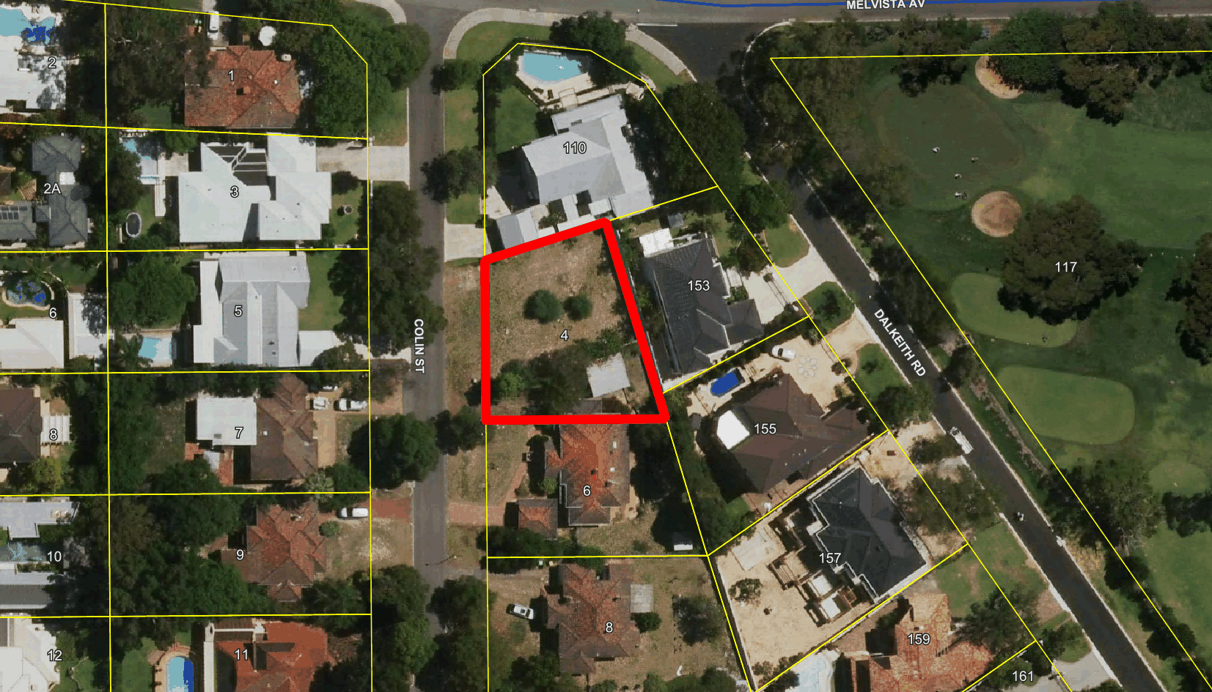

- Background

The subject property has recently been subdivided with the parent lot originally being No. 6 Colin Street. The development application is for a single house on the northern new lot which is No. 4 Colin Street. The house which existed on 6 Colin Street has recently been demolished and the site is therefore now vacant.

- Specific Application Details

The applicant seeks approval to construct a two-storey single house. The development proposes variations to the deemed to comply provisions of the Residential Design Codes as follows:

- The front verandah is proposed to have an area of 31.97m² in lieu of 6m² or less and have a height of 4.5m above natural ground level in lieu of 3.5m;
- The garage is proposed to have a nil setback in lieu 1.1m to the southern side lot boundary;
- The ground floor is proposed to have a minimum 3.4m setback in lieu of 4m to the northern side lot boundary;
- The ground floor is proposed to have a minimum 1m setback in lieu of 6m to the rear lot boundary; and
- The upper floor is proposed to have a minimum 3.65m setback in lieu of 6m to the rear lot boundary.
- The front verandah is proposed to have a 4m visual privacy setback in lieu of 7.5m to the northern side lot boundary.

The applicant has provided justification in support of the proposed boundary wall which is included as an attachment to this report (Attachment 1).

- Consultation

The development application was advertised to affected landowners for comment on the proposed variations. One (1) objection was received during the consultation period. The following is a summary of the concerns raised:

- “Object to raising the height of patio 0.5m above natural ground level – no. 4 is on the high side of the street. The proposed dwelling will ‘tower’ over the lower side of the street and the single level existing dwellings.
- Objection to the setback – nil setbacks are not in keeping with the existing dwellings on Colin Street.”

Note: A full copy of all relevant consultation feedback received by the City has been given to the Councillors prior to the Council meeting.

- Assessment of Statutory Provisions

7.1 Planning and Development (Local Planning Schemes) Regulations 2015

Schedule 2, Part 9, clause 67 (Matters to be considered by local government) stipulates those matters that are required to be given due regard to the extent relevant to the application. Where relevant, these matters are discussed in the following sections.

7.2 Town Planning Scheme No. 2

7.2.1 Amenity

Under clause 5.5.1 Council may refuse to approve any development if:

“in its opinion the development would adversely affect the amenity of the surrounding area having regard to the likely effect on the locality in terms of the external appearance of the development, traffic congestion and hazard, noise or any other factor inconsistent with the use for which the lot is zoned.”

Proposed Verandah

The design includes a significant verandah within the front setback area which is proposed to be raised more than 0.5m above the natural ground level and will be covered by a pergola and solid roof. The section of the front porch which is covered is for the front entry.

This section is functional and consistent with other developments within the streetscape, with the variation to the height as a result of the gable end feature and the finished floor level being raised in the front part of the lot due to the slope of the ground. This portion of the porch/verandah is considered to not compromise the streetscape amenity and desired streetscape character.

The section of the front verandah which is of concern is the section which is covered by a pergola and not in front of the entry to the dwelling. This section does not comply with the City’s Carports and Other Minor Structures within the Front Setback Area Policy with additional building area in the 9m front setback.

The 9m front setback requirement creates front setback areas with minimal buildings within the front setback area to contribute to the open feeling of the suburb and allow for additional landscaping opportunities. Additional building in this area will reduce opportunities for landscaping and contribute to bulk within the front setback area which is inconsistent with the prevailing streetscape context.

The City allows 6m² for an entry porch only and with over 31.97m² area, the variation cannot be considered minor and the applicant has not demonstrated a precedence of this type of development within the locality.

The City therefore recommends that the pergola and additional front verandah be removed from the plans or alternatively, the finished floor level of the additional verandah area be lowered by 250mm to be no more than 0.5m above natural ground level

The lowering of the finished floor level will make this structure consistent with the definition of a pergola only which is exempt from requiring development approval under the Deemed Provisions of the Planning and Development (Local Planning Schemes) Regulations 2015.

Proposed Garage

The applicant has provided a couple of examples within proximity of the subject property which have boundary wall development for garages – two of which are within immediate proximity of the subject property at no. 3 Colin Street and No. 110 Melvista Avenue.

As there is a precedence of this type of development within the locality, and the southern vacant lot to the south is likely to also propose a boundary wall adjacent (due to the sewer line adjacent to their southern side lot boundary), the development is consistent with the prevailing development context and streetscape amenity.

7.3 Residential Design Codes (State Planning Policy 3.1)

7.3.1 Lot boundary setbacks

Deemed-to-Comply  Requirement | Proposed | Complies?
Boundary walls within R12.5 permitted where adjacent to existing or proposed boundary wall of similar dimension. | The garage is proposed to have a nil setback in lieu 1.1m to the southern side lot boundary and is not proposed to be adjacent to a proposed boundary wall of similar dimension. | No
Side setbacks – as per Table 2A and 2B | The ground floor is proposed to have a minimum 3.4m setback in lieu of 4m to the northern side lot boundary. | No
Rear setback required – 6m | The ground floor is proposed to have a minimum 1m setback in lieu of 6m to the rear lot boundary. | No
Rear setback required – 6m | The upper floor is proposed to have a minimum 3.65m setback in lieu of 6m to the rear lot boundary. | No

Design Principles

Variations to the deemed-to-comply requirements can be considered subject to satisfying the following Design Principle provisions:

“P3.1 Buildings set back from lot boundaries or adjacent buildings on the same lot so as to:
- reduce impacts of building bulk on adjoining properties;
- provide adequate direct sun and ventilation to the building and open spaces on the site and adjoining properties; and
- minimise the extent of overlooking and resultant loss of privacy on adjoining properties.

P3.2 Buildings built up to boundaries (other than the street boundary) where this:
- makes more effective use of space for enhanced privacy for the occupant/s or outdoor living areas;
- does not compromise the design principle contained in clause 5.1.3 P3.1;
- does not have any adverse impact on the amenity of the adjoining property;
- ensures direct sun to major openings to habitable rooms and outdoor living areas for adjoining properties is not restricted; and
- positively contributes to the prevailing or future development context and streetscape as outlined in the local planning framework.”

Administration Comments

Boundary wall to southern side lot boundary
The boundary wall to the southern side lot boundary is not permitted as of right within the R12.5 density code unless adjacent to an existing or simultaneously proposed boundary wall of similar dimensions.

The lot has recently been subdivided with the southern neighbouring lot currently vacant.

There are two examples of boundary wall developments within the immediate vicinity of the subject property and a couple more further along Colin Street for garages and carports. The presence of existing boundary walls will ensure that the development is not out of context within the locality, consistent with the development context and will not have adverse impact on the streetscape amenity.

Northern side lot boundary setback
The presence of major openings and fireplace/chimney wall height increases the required setback to the northern side lot boundary. The existing boundary wall development on the northern neighbouring property ensures that the development will not be visible from outdoor living areas and major openings of the northern neighbouring property.

Rear lot boundary setbacks
The irregular lot shape and 9m front setback requirement requires that the 6m rear setback is varied. Other lots of similar configuration (i.e. to the rear of the subject property) within the locality also have lesser setbacks to the rear lot boundary, ensuring that the variations are not out of context for the locality. The major openings on the ground floor are screened by the dividing fence and the upper floor has minor openings only (over 1.6m above finished floor level) to ensure no loss in privacy. The lot configuration also ensures that no additional overshadowing will occur to the rear neighbouring properties nor the southern neighbouring property as a result of the rear setback variation.

7.3.2 Visual privacy

Deemed-to-Comply  Requirement | Proposed | Complies?
Raised outdoor living areas are setback 7.5m from lot boundaries behind the front setback area. | The front verandah has a visual privacy setback of 4m to the area behind the front setback | No
Design Principles

Variations to the deemed-to-comply requirements can be considered subject to satisfying the following Design Principle provisions:

“P1.1 Minimal direct overlooking of active habitable spaces and outdoor living areas of adjacent dwellings achieved through:
- building layout and location;
- design of major openings;
- landscape screening of outdoor active habitable spaces; and/or
- location of screening devices.

P1.2 Maximum visual privacy to side and rear boundaries through measures such as:
- offsetting the location of ground and first floor windows so that viewing is oblique rather than direct;
- building to the boundary where appropriate;
- setting back the first floor from the side boundary;
- providing higher or opaque and fixed windows; and/or
- screen devices (including landscaping, fencing, obscure glazing, timber screens, external blinds, window hoods and shutters).”

Administration Comments

If the application is approved by Council, it is recommended that a condition be included which requires the height of the front verandah to be reduced to change the structure to a pergola only which will be exempt from requiring development approval. This will also remove the visual privacy variation. However, if Council elects not to include this condition, the overlooking is only to a boundary wall to the northern neighbouring property ensuring privacy is maintained between the properties.

7.4 Local Planning Policy 6.23 – Carports and Minor Structures Forward of the Primary Street Setback

Policy Requirement | Proposed | Complies?
Verandahs not permitted forward of the primary street setback line.  Porticos or similar structures not exceeding 6m²  No structure to exceed 3.5m height  Structures do not detract from the visual amenity of the streetscape. | The development includes a porch roofed structure and a raised verandah with pergola above.  The total area is 31.97m².  The maximum height of the porch is proposed to be 4.5m.  The verandah structure proposed may detract from the open visual amenity of the streetscape. | No

Policy Objectives

The following objective is stipulated under the Policy:

“To ensure that the present open character and street amenity of the City of Nedlands is not compromised by the construction of carports and other small structures within the primary street setback area.”
Administration Comments

As advised under section 7.2.1.1 of this report, the variation cannot be considered minor and the applicant has not demonstrated a precedence of this type of development within the locality.

The City therefore recommends that the uncovered portion of the front verandah be removed from the plans or alternatively, the finished floor level of the additional verandah area be lowered by 250mm to be no more than 0.5m above natural ground level

The lowering of the finished floor level will make this structure consistent with the definition of a pergola only which is exempt from requiring development approval.

- Budget / Financial Implications

N/A

- Risk management

N/A

- Conclusion

The lot is an irregular shape with the lot being wider and not as deep as other lots within the locality of the same size and coding. This contributes to the requirement for a rear setback variation and the need for a boundary wall to the southern side lot boundary which seeks to maximise space for a rear outdoor living area. Both variations are prevalent within the locality and therefore are unlikely to cause a significant impact on the amenity of the streetscape or neighbouring properties.

With the proposed modification to the portion of the front verandah which is not permanently covered, the structure can be made compliant with the deemed-to-comply provisions of the R-Codes and comply with the City’s Local Planning Policy and TPS2 provisions. This will ensure that the streetscape remains open in nature and consistent with the development context of the locality.

With the modification to the front verandah, the development is considered to comply with the relevant design principles of the R-Codes and is recommended for approval subject to conditions.

PD46.18 | (Lot 3) No.117 North Street, Swanbourne- Screen Fence (Retrospective)
Committee | 11 September 2018
Council | 25 September 2018
Applicant | P. J. Rutledge and C. C. Codner
Landowner | P. J. Rutledge and C. C. Codner
Director | Peter Mickleson – Director Planning & Development
Reference | DA18-29706
Previous Item | Nil.
Delegation | In accordance with Clause 6.7.1a) of the City’s Instrument of Delegation, Council is required to determine the application due to objections being received.
Attachments | - Site Photographs

- Executive Summary

Retrospective development approval is being sought for an existing screen fence (the screen) to remain adjacent to the subject property’s western (side) lot boundary.

The screen is 2.9m in height in lieu of 1.8m above natural ground level, is 8m in length and is setback 0.1m from the lot boundary.

The screen has been erected by the applicants to encourage a rose bush to climb vertically to mitigate glare of the roof on the adjoining house at 119A North Street.

The screen is not deemed to have a significant impact on the neighbours’ visual amenity due to their property being lower and the existence of solid dividing fencing along a retaining wall between 117 and 119A North Street. However, the vegetation on the screen will likely further reduce the amount of natural light able to enter a kitchen and dining room area in future on the neighbour’s property which is already restricted due to their lower ground level, the solid dividing fencing and the building’s setback distance from the boundary.

It is therefore recommended that the application be approved subject to the screen being setback at least 1m from the lot boundary.

- Recommendation to Committee

Council approves the development application dated 28 June 2018 for a screen fence at (Lot 3) No.117 North Street, Swanbourne, subject to the following conditions and advice notes:

- The development shall always comply with the application and the approved plans, subject to any modifications required as a consequence of any condition(s) of this approval.

- This development approval only pertains to the screen fence.

- Amended plans to be provided as part of the building certificate application which demonstrate that the screen is being setback at least 1m from the western lot boundary.

- The screen being moved at least 1m from the western lot boundary within 28 days of the building certificate being issued to the City’s satisfaction.

Advice Notes specific to this proposal:

- This decision constitutes planning approval only and is valid for a period of two years from the date of approval. If the subject development is not substantially commenced within the two-year period, the approval shall lapse and be of no further effect.

- A separate development application is required to be submitted to and approved by the City prior to erecting any further fencing behind the primary street setback area which is more than 1.8m in height above natural ground level.

- Site Details

Lot area | 809.4m²
Metropolitan Region Scheme Zoning | Urban
Town Planning Scheme No. 2 Zoning | Residential (R12.5)
Land Use Permissibility | N/A
Detailed Area Plan/Outline Development Plan | No
Controlled Development Area | No
State Heritage Listed | No
Listed in Municipal Heritage Inventory | No

The subject property and those surrounding contain single dwellings and associated outbuildings. The topography of the land falls from north to south. An aerial image showing the location of the property follows.

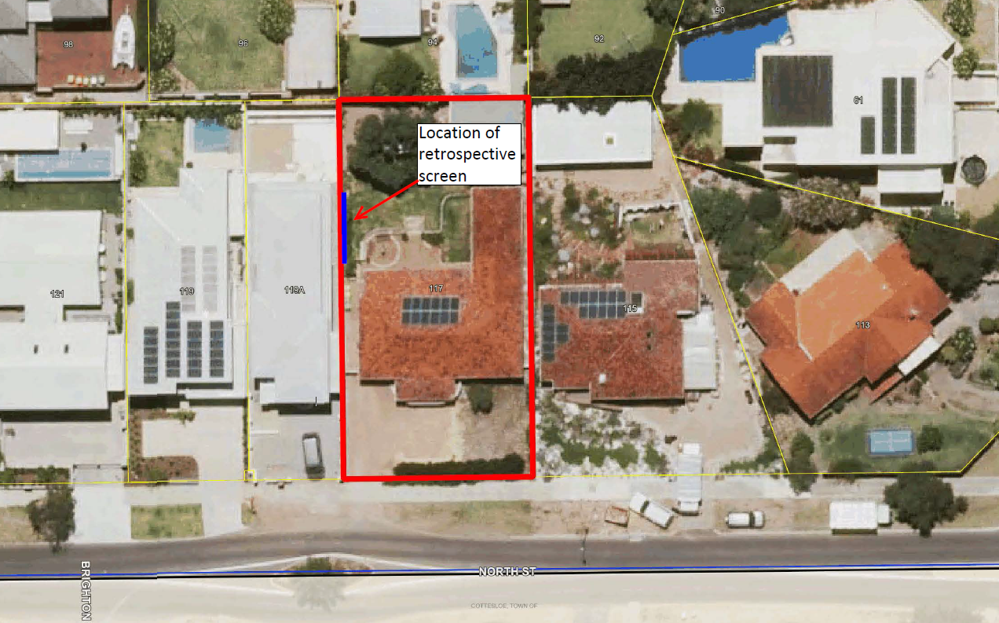

- Background

In May 2018 the City received concerns regarding the erection of a screen on the subject property. Following an inspection of the property by the City a retrospective development application was requested and was subsequently received for the screen to remain.

- Specific Application Details

The applicant seeks retrospective development approval for a screen to remain, details of which are as follows:

- The screen is 2.9m high in lieu of 1.8m above natural ground level.
- The screen is setback 0.1m from the western lot boundary. The screen is 8m in length.

By way of justification in support of the retrospective development application the applicant has advised the following:

“The structure has been erected to a height of 2.9m to encourage the rose to grow vertically and we have been training new growth laterally across the width of the structure. Our aim is for the vegetation to mitigate the glare from the eastern wall and lower-level skillion roof of the newly constructed house at 119A North Street. The effect of the stark white surfaces are degrading the amenity of our back garden and impacting the view from our bedroom window.”

- Consultation

The development application was advertised to affected landowners for comment. The following is a summary of the concerns raised:

- Does not comply with the current planning scheme.
- The height of the screen reducing the amount of light entering the submitter’s property.
- Impacted enjoyment of the residence and increased utility costs

Note: A full copy of all relevant consultation feedback received by the City and photographs taken on the submitter’s property of the screen have been given to the Councillors prior to the Council meeting.

- Assessment of Statutory Provisions

7.1 Planning and Development (Local Planning Schemes) Regulations 2015

Schedule 2, Part 9, clause 67 (Matters to be considered by local government) stipulates those matters that are required to be given due regard to the extent relevant to the application. Where relevant, these matters are discussed in the following sections.

7.2 Town Planning Scheme No. 2

7.2.1 Amenity

Under clause 5.5.1 Council may refuse to approve any development if:

“in its opinion the development would adversely affect the amenity of the surrounding area having regard to the likely effect on the locality in terms of the external appearance of the development, traffic congestion and hazard, noise or any other factor inconsistent with the use for which the lot is zoned.”

Clause 5.6.4 of the Scheme stipulates that a screen fence is not able to be more than 1.8m in height above natural ground level and less than 0.9m from a lot boundary. unless development approval is obtained, and it does not adversely affect the amenity of the occupants of the adjoining lot.

The screen has been erected by the applicants to encourage a rose bush to climb vertically to mitigate glare of the roof of the adjoining house at 119A North Street.

The finished ground level of the neighbouring property is approximately 0.4m to 0.8m lower than the finished ground level on 117 North Street, and solid fencing of up to 1.8m in height has been erected along the retaining wall which exists on the lot boundary between the properties.

On 119A North Street windows for a kitchen and a dining room directly face the portion of the lot boundary where the screen exists, which are setback between 1m and 1.5m from the boundary according to the City’s records.

The area on the neighbouring property directly adjacent to where the screen exists is used for side access to the rear of the property.

Taking this into consideration, the screen is deemed to not be having a significant impact on the neighbours’ visual amenity, particularly when viewed from inside their house, due to their property being lower and the existence of solid dividing fencing. However, the vegetation on the screen may further reduce the amount of natural light able to enter the kitchen and dining room areas in future which is already restricted due to their lower ground level, the solid fencing and the building’s setback distance from the boundary.

The layout and the size of the applicant’s property means that ample space is available for the screen to be setback at least 1m from the lot boundary or use alternative methods to reduce any glare being experienced, such as trees or tall growing shrubs.

- Budget / Financial Implications

N/A

- Risk management

N/A

- Conclusion

The screen structure is not deemed have any significant visual impact on the neighbouring property due to its location, however the vegetation growing upwards on it may further reduce the amount of natural light able to enter major openings on 119A North Street in future which is already limited.

It is therefore recommended that the application be approved by Council subject to the screen being setback at least 1m from the lot boundary.

PD47.18 | Scheme Amendment No. 208 – Bedbrook Place, Shenton Park
Committee | 11 September 2018
Council | 25 September 2018
Applicant | Element Advisory
Landowner | Various
Director | Peter Mickleson – Director Planning & Development
Previous Item | PD24.16 – May 2016  PD49.16 – October 2016  PD42.17 – September 2017
Attachments | - Schedule of Submissions  - Schedule V Map and Text with recommended modifications  - Schedule of Modifications

- Executive Summary

The purpose of this report is to enable Council to consider submissions received during the advertising period on Scheme Amendment No. 208 – Bedbrook Place, Shenton Park and determine if the amendment should be supported with or without modifications, or not be supported.

A summary of submissions received during the advertising period, and Administration’s response to these submissions is provided as part of this report, which ultimately forms the basis for the recommendation that follows to support the Scheme Amendment with modifications.

- Recommendation to Committee

Council resolves:

- Pursuant to Regulation 41(3) of the Planning and Development (Local Planning Schemes) Regulations 2015 to support Amendment No. 208 to Town Planning Scheme No 2 with modifications to address issues raised in the submissions as referred to in Attachment 3 – Schedule of Modifications.

- Pursuant to Regulation 44(1) of the Planning and Development (Local Planning Schemes) Regulations 2015, requests the Chief Executive Officer forward to the Western Australian Planning Commission a copy of the schedule of submissions, and any other such information required by the Regulations.

- Chief Executive Officer to ensure that all submitters are advised in writing of Council’s resolution.

- Background

Until recently, the subject lots were reserved ‘Public Purpose’ under the Metropolitan Region Scheme (MRS), which was not reflective of the current or proposed future intended uses.

In June 2015, a request to amend the MRS by transferring the subject lots from the Public Purpose reserve to the ‘Urban’ zone was initiated by the applicant.

In May 2017, the MRS amendment was approved by the Western Australian Planning Commission (WAPC) and took effect. The WAPC did not support a request made by the City to concurrently rezone the subject lots ‘Development’ under TPS2. As a result, the subject lots are now zoned Urban under the MRS but have no zone that applies in TPS2. As a result, the provisions of TPS2 are unable to be implemented, and thus there is a lack of certainty as to how the land may be developed.

- Amendment Details

Amendment No. 208 to TPS2 proposes to:

- Zone Lots 12830, 12829, 11329, 10024 and 9722 Bedbrook Place, and Lot 11605 Lemnos Street, Shenton Park, Special Use; and
- Amend Schedule V – Special Use zone to include various permitted uses and provisions that would apply to the subject lots.

The provisions proposed under Schedule V would allow for:

- The requirement for a Local Development Plan (LDP) to be prepared and approved to facilitate the orderly planning of each of the sites identified in the Special Use zone schedule prior to the consideration of development applications.
- Buildings up to 18 metres in height, which equates to 4 to 5 storeys (commercial) or 5 to 6 storeys (non-commercial).
- Other development standards in accordance with the ‘Office/Showroom’ zone.
- The uses Boarding House, Educational Establishment, Hostel and Caretaker’s Dwelling being able to be considered on the lots along the eastern side of Bedbrook Place, as they fall outside of the Subiaco Wastewater Treatment Plant odour buffer.

The proposed text also includes direct reference to the wastewater treatment plant odour buffer and incompatible (sensitive) land uses (refer Attachment 2).

- Key Relevant Previous Council Decision

Council Resolution Meeting Minutes 26 September 2017

“Council Resolution / Committee Recommendation / Recommendation to Committee:

- Pursuant to section 75 of the Planning and Development Act 2005 adopts Scheme Amendment No. 208 to amend Town Planning Scheme No. 2 as detailed in Attachment 1 – Proposed Schedule V and in accordance with section 37(1) proceed to advertise with the following modifications:

  - Modify clause i) for Lots 12830, 12829, 11329, 10024 and 9722 Bedbrook Place and Lot 11605 Lemnos Street, to the following:

“i) All development standards, with the exception of Clause 5.11 (Maximum Building Height), shall be in accordance with the requirements of the ‘Office/Showroom’ zone.”

  - Modify clause ii) for Lots 12830, 12829 and 11329 Bedbrook Place and Lot 11605 Lemnos Street, to the following:

“ii) Uses applicable to the Special Use zone shall be in accordance with Table I – Use Class Table, Column 4, with the exception of a Caretakers Dwelling which is ‘X’.”

  - Delete clause iii) for Lots 10024 and 9722 Bedbrook Place.

- In accordance with Planning and Development (Local Planning Schemes) Regulations 2015 section 35(2) is of the opinion that the amendment is a Complex Amendment for the following reason:

- The amendment is not consistent with a local planning strategy for the scheme that has been endorsed by the Commission.”

- Legislation / Policy

- Planning and Development Act 2005 (P&D Act)
- Planning and Development (Local Planning Schemes) Regulations 2015
- Metropolitan Region Scheme
- City of Nedlands Town Planning Scheme No. 2 (TPS2)

- Consultation

Required by legislation: Yes No
Required by City of Nedlands policy: Yes No

Following Council resolution at the meeting of 26 September 2017, consultation was undertaken for a period of 60 days concluding on Friday 29 June 2018 in accordance with r.38 of the Planning and Development (Local Planning Schemes) Regulations 2015. The Regulations require the following steps to be undertaken as part of the consultation process:

- Advertising in local newspapers (Post and Western Suburbs Weekly);
- Notices displayed in libraries and Administration building;
- Letters to government organisations and agencies considered affected; and
- Information and copies available for download on the website.

A total of 16 submissions were received. A summary schedule of submissions is provided in Attachment 1. The following overview of the submissions is provided as follows.

Government Agency Submissions

- 10 of the 16 submissions were from government agencies.
- No objections were raised by any of the government agencies.
- 5 of the 10 government agency submissions provided advice and suggested either modifications to the amendment, or further information.

Non-Government Agency Submissions

- 6 of the 16 submissions were from individual persons or corporate entities.
- 4 of the 6 submissions above were either from or made on behalf of landowners within or adjacent to the amendment area.
- 2 of the 6 submissions above partially objected to or expressed concerns with the amendment.
- 3 of the 6 submissions above suggested either modifications to the amendment, or further information.

Key Issues Raised in Submissions

The key issues raised in the submissions are noted as follows.

- Bushfire management
- Traffic and car parking
- Retention of vegetation
- Preparation and approval of a Local Development Plan (LDP)

Administration Comment

Bushfire Management

The amendment area is situated within a designated bushfire prone area. Whilst the amendment does not propose any new development, based on the submission received from the Department of Fire and Emergency Services (DFES), it is considered appropriate to modify the amendment provisions to mandate the requirement for a bushfire management plan (BMP) to be prepared and approved at the next stage of the planning process (LDP).

The requirement to prepare a BMP is normally triggered at the time that a subdivision and/or development application is considered in accordance with State Planning Policy 3.7 – Planning in Bushfire Prone Areas.

Under SPP3.7, a scheme amendment is considered a ‘strategic planning proposal’, and the applicant has complied this element of SPP3.7 by preparing a Bushfire Hazard Level assessment as part of the scheme amendment process.

However, given the potential for vulnerable or high-risk land uses to be considered as part of the permissible range of land uses in the amendment provisions, it is considered appropriate to mandate the requirement for a BMP to be prepared as part of a future LDP in the next stage of the planning process, to ensure that appropriate bushfire management measures are considered and approved prior to the submission of a subdivision and/or development application.

Traffic and Car Parking

Concerns regarding traffic and car parking were raised in one of the submissions. Whilst the width of Bedbrook Place is considered adequate for the purposes of accommodating current and future traffic flows, the road essentially leads to a ‘dead end’ with no through access to the north beyond No. 13 Bedbrook Place. Accordingly, it is considered appropriate to modify the amendment provisions to mandate the requirement for an LDP to be prepared and approved and the next stage of the planning process, which will provide the opportunity for traffic issues to be considered in more detail prior to the submission of a subdivision and/or development application.

In terms of car parking, all developments are required to comply with the TPS2 for the provision of on-site parking.

Retention of Vegetation

Several of the submissions, including advice received from the Environmental Protection Agency (EPA) expressed concerns regarding the conservation and protection of vegetation. Accordingly, it is considered appropriate to modify the amendment provisions to mandate the requirement for an LDP to be prepared and approved and the next stage of the planning process, which will provide the opportunity for vegetation retention to be considered in more detail prior to the submission of a subdivision and/or development application.

Preparation and approval of a Local Development Plan (LDP)

Several of the submissions raised the suggestion that the next stage of the planning process should provide for the consideration and approval of an LDP prior to the consideration of future subdivision and development applications. An LDP provides an appropriate mechanism to consider bushfire, traffic and vegetation retention issues to ensure the orderly future planning of within the amendment area.

- Risk management

Section 87 of the Planning and Development Act 2005 provides that an amendment to a local planning scheme requires the approval of the Minister for Planning. The Minister has the following powers under the P&D Act:

- Approve the amendment;
- Require the City to modify the amendment to be resubmitted for the Minister’s approval; or
- Refuse to approve the amendment.

If Council resolves not to support the proposed amendment, the Minister for Planning may approve the scheme amendment or instruct the City to modify the amendment for the Minister’s approval.

- Conclusion

Scheme Amendment No. 208 to TPS2 proposes to zone properties in the vicinity of Bedbrook Place, Shenton Park to ‘Special Use’ to rectify the anomaly of land which currently has no zone applying to it as a result of MRS Amendment 1311/57.

The introduction of the Special Use zone is imperative to provide certainty for the community with respect to the planning framework that applies to the subject lots, and to coordinate the orderly and proper planning of the area.

Having regard to the submissions received during the community consultation period, it is recommended that Council supports the scheme amendment with modifications as referred to in Attachment 3.

