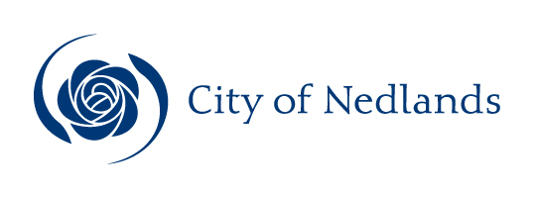

Technical Services Reports

Committee Consideration – 12 March 2019

Council Resolution – 26 March 2019

Table of Contents

Item No. Page No.

TS03.19 City of Nedlands 2019 Annual Waste Report 2
TS04.19 RFT 2018-19.08 Provision and Maintenance of Bus Shelters in Return for Advertising Rights 8

TS03.19 City of Nedlands 2019 Annual Waste Report

Committee | 12 March 2019
Council | 26 March 2019
Applicant | City of Nedlands
Officer | Chaminda Mendis – Waste Minimisation Coordinator
Director | James Cresswell – Acting Director Technical Services
Attachments | Nil.

Executive Summary

The City of Nedlands’ Waste Minimisation Strategy 2017-2020 (WMS) includes the following recommendation:

“The Administration prepare an annual report to Council on the progress of the Waste Minimisation Strategy (WMS) 2017-2020 with the report included in the March Agenda”.

During the 2017-2018 financial year the City diverted 53 percent of all waste collected comprising general waste, recyclable waste, green waste, bulk waste (verge collection), e-waste, mattresses and Household Hazardous Waste from landfill.

The Waste Avoidance and Resource Recovery Strategy 2030 (WARRS) was adopted in February 2019 and has established an action plan to manage or dispose waste to better practice facilities.

“A consistent three bin kerbside collection system, which includes separation of food organic and garden organics from waste categories, to be provided by all local governments in the Perth and Peel region by 2025 and supported by State Government through the application of financial mechanisms and increase material recovery to 75 percent by 2030”

The City’s WMS also outlines action plans for the City to achieve 65 percent waste diversion from landfill target by 2020.

The City’s feasibility study and waste audits confirmed that food waste is a large component of household waste which ends up in landfill. The introduction of a weekly Food Organic Garden Organic (FOGO) bin service will increase the overall waste diversion to over 66 percent.

Recommendation to Committee

Council:

- Notes the City of Nedlands 2019 Annual Waste Report; and

- Notes that the City will commence the community consultation for the introduction of a FOGO service in mid-2019.

Discussion/Overview

Waste Collection Services

Residential waste and recycling collection services are provided to all households. The commercial and business precincts are accommodated by kerbside waste and recycling collections on request. The City provides two bulk verge collection services per year to residents.

The Waste Management Services coordinated the following collection and diversion services during 2017-2018 financial year.

Collection | Services (No.) | Collected (t) | Diverted | Percentage
General | 9,134 | 5,321 | No | 47%
Recycling | 10,428 | 2,085 | Yes
Green | 8,171 | 2,648 | Yes
Bulk* | 2 | 1,622 | Yes | 93%
Total | 27,735 | 11,676 | Yes | 53%

Bulk* includes hard waste and green waste collected from the verge, e-waste, mattresses and Household Hazardous Waste (HHW).

From 1 July 2017 to 30 June 2018 the City collected 11,676 tonnes of waste and 6,241 tonnes of the waste, excluding contamination, was directed to recovery providing a 53 percent overall diversion rate from landfill. See figure 1 below.

Figure 1 - Overall waste diversion of all waste for 2017/18

Following the introduction of the three-bin system in 2006, there was approximately 20 percent increase in the proportion of the City’s waste being diverted from landfill. However, since 2008 there has only been a gradual improvement in the diversion rate.

In the 2017-2018 financial year, 53 percent of combined waste was diverted from landfill to be recovered, reused or recycled. This was a slight drop in performance in comparison to last year’s diversion of 54 percent, however this was predominantly due to lack of certainty in the recycling sector with overseas markets restricting the imports of recyclables. The City’s kerbside collection contractor SUEZ, have advised that only two percent of recyclables collected from the City of Nedlands were affected, the main contributor to the minor reduction. Figure 2 shows waste diversion since the introduction of the three-bin system in 2006.

Figure 2 - Diversion of all waste since introduction of the three-bin system in 2006

Waste Minimisation

The City’s WMS 2020 provides a series of recommendations aimed at reducing waste and increasing recycling and recovery of waste throughout the City, to ultimately achieve the State Government’s 2030 target of all waste being diverted from landfill.

The recommendations and brief update for each are as follows:

Recommendation | Brief Update
- Review the current recycling services and cost structures. | Included in the 2017-18 budget.
- Develop information sheets and education materials which encourage residents to place all recyclables in the recycle bin. | Completed.
- Provide details on the performance of the new bulk waste collection service. | The City completed the second full year of the new bulk collection contract on Friday 7 December 2018.  The collection was completed in a four-week period with 802 tonnes of hard waste and 820 tonnes of green waste collected from the City’s verges. 1622 tonnes (93%) was recovered from landfill. This is a significant improvement in comparison to the last bulk collection contract where the collection took eight weeks with a recovery rate of 51%.
- Review the waste page on the City’s website to improve the information available to the Community with respect to reduce, reuse and recycle. | Completed.
- Develop and continually update education materials regarding waste performance for students (primary, secondary and tertiary). | Completed.
- Investigate methods to ascertain the actual level of C&D waste recycling within the City. | No progress to date.
- Explore options to accommodate food waste into the green waste stream. | - The city is monitoring the FOGO bin implementation at the City of Melville.  - A feasibility study to review the disposal of food waste into the existing kerbside green waste bin was completed.
- Research options for the potential reuse of residual waste materials. | - The City is monitoring the progress of the Kwinana Waste to Energy facility contract agreements with other Local Government Authorities.

Feasibility Study of Food Organics and Garden Organics Bin (FOGO) Report

A feasibility study report has been completed by MRA Consulting Group. The report findings are critically reviewing the introduction of a FOGO service for the City’s residents including how to integrate a FOGO service using the current infrastructure.

The introduction of a FOGO bin system has the potential to achieve the City’s diversion target of 65 percent.

The City’s waste audits confirm that food waste is a large component of household waste which ends up in landfill. The 2014 and 2017 waste audits revealed that 56 percent and 54 percent respectively, of all waste in the putrescible waste bins is organics (approximately 13 percent overall). Therefore, the introduction of a weekly FOGO bin service could increase the overall waste diversion to over 66 percent.

A focus on organics diversion is becoming increasingly common as organic waste is relatively inexpensive to divert per tonne of waste diverted. Recovery of food waste via a FOGO collection and processing service represents an opportunity to:

- Reduce the amount of waste currently being disposed of to landfill;
- Recover more resources and return them to the economy;
- Reduce potential methane emissions from landfill and return carbon and nutrients to the soil;
- Improve the service currently being offered to the community;
- Demonstrate leadership in waste and resource management; and
- Foster long term behavior change.

Waste Avoidance and Resource Recovery Strategy 2030 (WARRS)

The WARRS will guide the State in becoming a sustainable, low-waste circular economy. Historically, Western Australia has generated the highest volume of waste per capita in the nation and has had among the lowest rates of waste recovery. The 2030 action plan will ensure all households have a three bin kerbside collection system, which includes separation of FOGO by 2025. Implementing this system will ensure to meet the targets set out in the WARRS; towards minimising waste, maximising recycling and reducing the amount of waste going to landfill wherever possible. See overall objectives and State target table below.

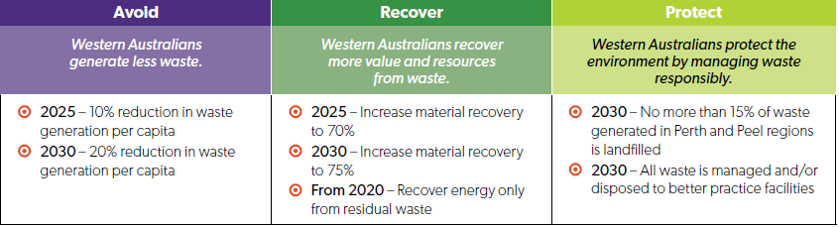

Conclusion

The City’s waste service continues to operate on a cost recovery basis.

The implementation of the green waste bin in 2006 increased overall waste diversion from 29 to 47 percent and savings on overall disposal cost. The implementation of hard waste recovery from the bulk waste collection further increased the recovery from 47 to 53 percent. Although there may still be minor improvements in diversion through existing services it is not anticipated that they will achieve the 65% target without consideration of inclusion of food waste into the existing residential kerbside greenwaste bin, otherwise known as a FOGO service.

Consultation

The City will commence community consultation on the proposed FOGO service in mid-2019.

Budget/Financial Implications

In 2017-18 the City adopted a budget of $ 3,027,753 for the provision of waste services. The details of the budget performance are as follows:

- Budget Expenditure $ 3,027,753
- Actual Expenditure $ 2,785,570 (92%)
- Budget Income $ 3,317,800
- Actual Income $ 3,316,952 (99.9%)

The waste service cost saving of $289,199 allowed for waste rates to not increase in the 2018-2019 budget.

TS04.19 RFT 2018-19.08 Provision and Maintenance of Bus Shelters in Return for Advertising Rights

Committee | 12 March 2019
Council | 26 March 2019
Applicant | City of Nedlands
Officer | Nathan Brewer – Purchasing and Tenders Coordinator
Director | Martyn Glover – Director Technical Services
Attachments | - Final Evaluation Scoresheet (Confidential)  - Bus Shelter Design Options

Executive Summary

To award the tender for the Provision and Maintenance of Bus Shelters in Return for Advertising Rights.

Recommendation to Committee

Council

- Agrees to award tender no. RFT 2018-19.08 to oOh!media Street Furniture Pty Ltd for the Provision and Maintenance of Bus Shelters in Return for Advertising Rights excluding alcoholic drink products;

- Authorises the Chief Executive Officer to sign an acceptance of offer for this tender; and

- Approves the installation of the Liberty Shelter to all sites including two new bus shelters at Brookdale Street, Floreat after Alderbury Street and Aberdare Road, Karakatta after Hopetoun Terrace.

Discussion/Overview

Background

There is a total of 83 bus stops with shelters within the City Area and 14 of these shelters are currently owned by the current contractor. This agreement concludes on 17 March 2019 where ownership of the bus shelters will transfer to the City.

The City now wishes to make a new 10-year agreement with the option of one further five-year extension with a suitable organisation to:

- replace the Existing Advertising Bus Shelters;
- clean, repair and maintain all shelters;
- arrange advertising on the shelters which provides an income to the City; and
- identify locations for the installation of additional shelters where appropriate.

Similar to the previous agreement, the successful Respondent will have the exclusive right to advertise on Contractor Street Furniture at bus stops within the City.

Tender Information

The consideration under the contract is expected to exceed $150,000. Therefore, to comply with legislative requirements outlined in the Local Government Act 1995 and ensure the best value for money for the City, this contract must be tendered.

Tender RFT 2018-19.08 was advertised on 6th November 2018 in the West Australian Newspaper and on www.tenderlink.com/nedlands. The tender period ended on 29th November 2018 and submitted tenders were opened by officers of the City at 14:30. Three (3) compliant submissions were received by the City. Compliant tenders were received from the following companies:

- oOh!media Street Furniture Pty Ltd.
- Global Smart Cities Pty Ltd ta yStop.
- Claude Outdoor Pty Ltd.

Evaluation

The tender was independently evaluated by three (3) City officers in accordance with the qualitative criteria specified in the tender documentation, qualitative criteria was afforded a total of 100% of the total score. While revenue to the City was an influencing factor, the provision of other benefits, such as the design, supply and installation of the shelters and the maintenance program were also important factors. A section named ‘Considerations to the City’ was afforded 50% of the total score for the evaluation panel to consider the total benefit to the City. The estimated revenue from each submission can be found in the confidential attachment RFT 2018-19.08 Final Evaluation Scoresheet.

A confidential evaluation and recommendation report was completed and approved by the evaluation panel, Manager Engineering Services and Director Technical Services. References were sought from appropriate sources for quality assurance purposes which backed up the findings of the evaluation panel.

The final evaluation, including pricing and scoring, can be viewed in the confidential attachment – RFT 2018-19.08 Final Evaluation Scoresheet.

Conclusion

oOh!media Street Furniture Pty Ltd scored highest in the evaluation process. oOh!media, recently acquired Adshel Pty Ltd, who have held the current contract for bus shelter supply and maintenance in return for advertising rights for the past 18 years. In that period, they have provided a reliable service to the City, maintaining bus shelters and providing revenue to the City from advertising content.

In their submission to RFT 2018-19.08 they demonstrated possessing a well-qualified team with worldwide and national experience but also a strong local presence. Resources available and nominated for this contract were sufficient along with plans for equipment upgrade and replacement. oOh!media, in conjunction with their demonstrated experience with the City, currently hold similar contracts with numerous local government organisations in WA and nationally. Positive references were obtained which backed up the findings of the evaluation panel.

The City is the first local government to stipulate that the advertising of alcohol products in excess of 0.5 percent alcohol is not permissible under this contract. While in the short term this will result in marginally lower revenues (approximately $3,000 per annum), once ten metropolitan local governments with advertising shelters adopt a similar provision in their contract, revenues will increase by this margin.

The origin of the proposal was through the Public Health Advocacy Institute of WA (PHAIWA), an independent public health voice based within Curtin University with a purpose to discourage alcohol consumption by persons under the age of 18. The PHAIWA website includes the following statement:

‘In September 2018, St John Ambulance advised that the number of ambulances called out to help “blind-drunk” children in WA had risen by 24 percent over 2 years. That is an average call out to 9 children a week.’

Council has not made any decision on support for alcohol advertising to date consequently an alternative recommendation has been provided should Council wish to retain this form of advertising.

As part of their submission, oOh!media Street Furniture Pty Ltd have identified 2 locations for the installation of new advertising bus shelters. One on Brookdale Street, Floreat after Alderbury Street (see below photo and map).

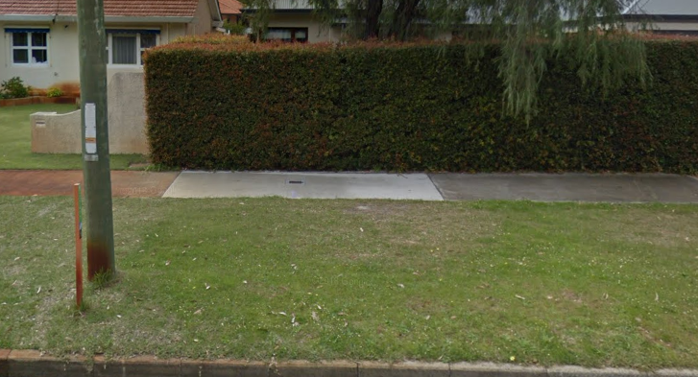
Photo: Potential Location for Installation of new bus shelter – Brookdale Street, Floreat

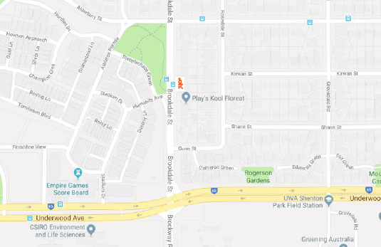
Map: Potential Location for Installation of new bus shelter – Brookdale Street, Floreat

The other on Aberdare Road, Karakatta after Hopetoun Terrace replacing an existing City owned shelter which shall be refurbished and relocated as appropriate (see below photo and map):

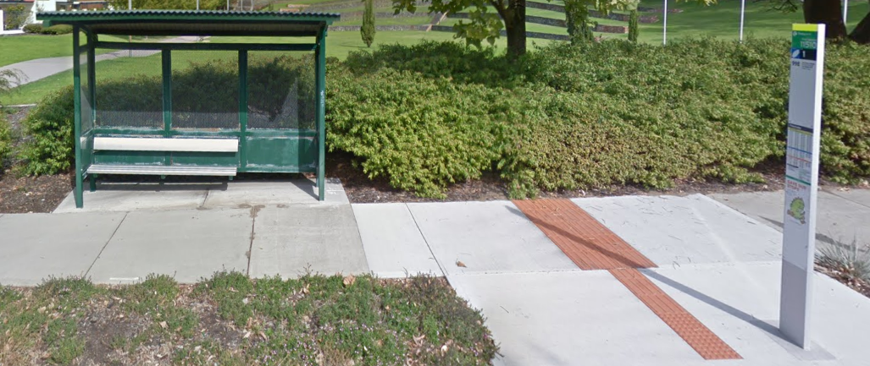
Photo: Potential Location for Installation of new bus shelter – Aberdare Road, Karrakatta

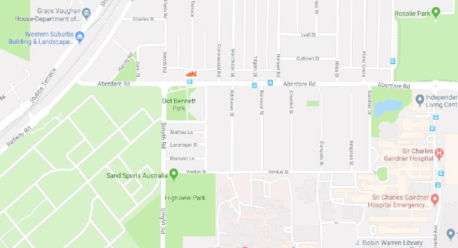
Map: Potential Location for Installation of new bus shelter – Aberdare Road, Karrakatta

A detailed methodology encompassing each stage of the bus shelter replacement program was provided, fully compliant with the request documentation. The proposed fortnightly maintenance program and reactive repair plans will ensure that the bus shelters retain an as new appearance as far as possible. oOh!’s proposal includes 3 different bus shelter designs with the option of integrating various technological options including Wi-Fi, solar powered lighting and portable device charging.

The Administration reduced the design options to two (see Attachment 2) and sought comment from the Councillors on the preferred design noting that the Contractors will only install one design option. The Councillors indicated their preference for the Liberty shelter which will be provided in City of Nedlands livery.

The offer allows the City to retain comparable levels of revenue income to other offers without significant expansion of advertising furniture.

It is recommended that oOh!media Street Furniture Pty Ltd is awarded the tender, the preferred shelter is the Liberty and alcohol product advertising is not supported.

Key Relevant Previous Council Decisions:

None.

Consultation

The City will consult with residents in Brookdale Street, Floreat adjacent to the proposed site without an existing shelter.

Budget/Financial Implications

The contract will provide an income of approximately $0.5 million over the term of the contract as well as reduced costs to the City for bus shelter maintenance.

Alternative Recommendation

- Agrees to award tender no. RFT 2018-19.08 to oOh!media Street Furniture Pty Ltd for the Provision and Maintenance of Bus Shelters in Return for Advertising Rights;

- Authorises the Chief Executive Officer to sign an acceptance of offer for this tender; and

- Approves the installation of the Liberty Shelter to all sites including two new bus shelters at Brookdale Street, Floreat after Alderbury Street and Aberdare Road, Karakatta after Hopetoun Terrace.

