Corporate & Strategy Reports

Committee Consideration – 13 April 2021
Council Resolution – 27 April 2021

Table of Contents

Item No. Page No.

CPS09.21 List of Accounts Paid – February 2021 2
CPS10.21 New Lease to Fellowship of Australian Writers (WA) –
Tom Collins House 4

CPS09.21 List of Accounts Paid – February 2021

Committee | 13 April 2021
Council | 27 April 2021
Applicant | City of Nedlands
Employee Disclosure under section 5.70 Local Government Act 1995 | Nil.
Director | Ed Herne – Director Corporate & Strategy
Attachments | - Creditor Payment Listing – February 2021; and  - Credit Card and Purchasing Card Payments – February 2021 (28 January – ## February 2021).
Confidential Attachments | Nil.

Executive Summary

In accordance with Regulation 13 of the Local Government (Financial Management) Regulations 1996 Administration is required to present the List of Accounts Paid for the month to Council.

Recommendation to Committee

Council receives the List of Accounts Paid for the months of February 2021 as per attachments.

Discussion/Overview

Background

Regulation 13 of the Local Government (Financial Management) Regulations 1996 requires a list of accounts paid to be prepared each month, showing each account paid since the last list was prepared. This list is to include the following information:

- the payee’s name;
- the amount of the payment;
- the date of the payment; and
- sufficient information to identify the transaction.

It is normal practice for the monthly payment list to be a month in arrears to allow for the production of Council reports, the timetable is such that Council reports are being finalised for the following months’ round of meetings before the completion of the current month.

Risk Management

The accounts payable procedures ensure that no fraudulent payments are made by the City, and these procedures are strictly adhered to by the officers. These include the final vetting of approved invoices by the Manager Finance and the Director Corporate and Strategy (or designated alternative officers).

Conclusion

The List of Accounts Paid for the months of February 2021 complies with the relevant legislation and can be received by Council (see attachments).

Consultation

Required by legislation: Yes No
Required by City of Nedlands policy: Yes No

Strategic Implications

The 2020/21 approved budget is in line with the City’s strategic direction. Payments are made to meet the City’s spend on operations and capital expenses undertaken in accordance with the approved budget.

The 2020/21 approved budget ensured that there is an equitable distribution of benefits in the community

The 2020/21 budget was prepared in line with the City’s level of tolerance of risk and it is managed through budgetary review and control.

Budget/Financial Implications

The payments are made in accordance with the approved budget and achieves a surplus cashflow balance.

CPS10.21 New Lease to Fellowship of Australian Writers (WA) – Tom Collins House

Committee | 13 April 2021
Council | 27 April 2021
Applicant | City of Nedlands
Employee Disclosure under section 5.70 Local Government Act 1995 | Nil.
Director | Ed Herne – Director Corporate & Strategy
Attachments | Nil.
Confidential Attachments | Nil.

Executive Summary

The Fellowship of Australian Writers, Western Australia Inc. (‘FAWWA’) are a non-profit organisation dedicated to providing advocacy, training, support and friendship to Western Australia’s writing community. The organisation conducts workshops and master-classes in prose, poetry, scriptwriting, memoir, food writing and music writing.

Tom Collins House is located with the Allen Park Heritage Precinct, Swanbourne and is occupied by FAWWA.

FAWWA have been operating from both Tom Collins House and Mattie Furphy House since the buildings were relocated to the Allen Part Heritage Precinct in 2005. Whilst there is a lease agreement in place for the Mattie Furphy House, there is no agreement in place between the City and FAWWA for the Tom Collins House

Administration have been working with FAWWA and the Department for Planning, Lands and Hertiage on various issues including land tenure and insurance obligations in order to finalise an agreement of tenure.

This item is now presented to Council for consideration of that agreement.

Recommendation to Committee

Council:

- approves an exclusive use lease between the City of Nedlands and The Fellowship of Australian Writers Western Australia Inc. for the Tom Collins House site consistent with the key terms as noted within this report. and;

- subject to the Minister for Lands Consent, authorises the CEO and Mayor to execute the agreement and apply the City’s Common Seal.

Discussion/Overview

Background

The Fellowship of Australian Writers Western Australia Inc is a non-profit organisation dedicated to providing advocacy, training, support and friendship to Western Australia’s writing community. The organisation conducts workshops and master-classes in prose, poetry, scriptwriting, memoir, food writing and music writing.

Founded in 1938, FAWWA is a state-wide membership organisation which welcomes emerging, developing and established writers across all genres along with individuals interested in the cultural heritage of WA.

FAWWA have been operating from both Tom Collins House and Mattie Furphy House since the buildings were relocated to the Allen Part Heritage Precinct in the early 2000’s. Whilst there is a lease agreement in place for the Mattie Furphy House, there is no agreement in place between the City and FAWWA for the Tom Collins House. Both parties agree that a lease is required to define and clarify both the City’s and organisations responsibilities in regards the future management of Tom Collins House.

Tom Collins house was originally built in Swanbourne and was located at house number 9 Servetus Street. The building is a single-storey iron and timber framed 'workers' cottage' with a corrugated galvanized roof that was constructed in 1907 by Joseph Furphy and Godfrey Reinfelds (Carpenter).

The land on which the building currently resides is legally described as Lot 500 on Plan 73170 Marine Parade, Swanbourne being part Crown Reserve 7804.

Lot 500 is a Category “A” Crown Reserve (Reserve 7804) and has been vested to the City since 25 September 1936 for the purpose of Park and Recreation by way of Management Order. This grants the City the power to lease Reserve 7804 for any term not exceeding 21 years, subject to the consent of the Minister for Lands.

Discussion

The City has been in discussions with FAWWA about a lease arrangement since the early 2000’s. There were various issues which required management in order to finalise an agreeable position for both parties. Those issues, which have always been dealt with by both parties in a positive way, are detailed below

- FAWWA insisted that the City would not assume ownership of the dwelling.

Although the City recognise FAWWA’s ownership of the building, as the dwelling is located on land vested to the City, conditions needed to be included within the proposed new lease to ensure that the building is appropriately maintained from a liability and amenity perspective. It would seem reasonable that FAWWA, in exchange for a token peppercorn rental, have an obligation to keep the building in good repair. This position is consistent with the conditions contained within the Mattie Furphy House Lease.

- When Tom Collins House was first moved onsite, it was incorrectly located across two lots meaning the City did not have the power to lease.
Unfortunately, during the relocation phase, the building was placed over two lots, with one of those lots being a road reserve. In 2018, the City’s Administration finalised a lengthy project with the Department for Planning, Lands and Heritage to have the reserve boundaries realigned to allow for the portion of the road reserve to be included within Reserve 7804.

- A dead tree was hanging over Tom Collins House, creating insurance problems for FAWWA.

More recently, a dead tree which was hanging over the roof line of Tom Collins House has created some unease for FAWWA. In order for the insurance obligations within the proposed new lease to be acceptable, FAWWA have worked with the City’s Parks and Environmental Teams to have the risks associated with the tree mitigated. In October 2020, for safety reasons, the tree was removed by the City.

On 26 February 2021, FAWWA advised in writing they were in agreeance with terms as described within the draft lease agreement.

Proposed New Lease

Consistent with the City’s ‘Use of Council Facilities for Community Purposes’ Policy, McLeod’s Barristers and Solicitors have prepared a draft lease and shown below are the agreed key terms:

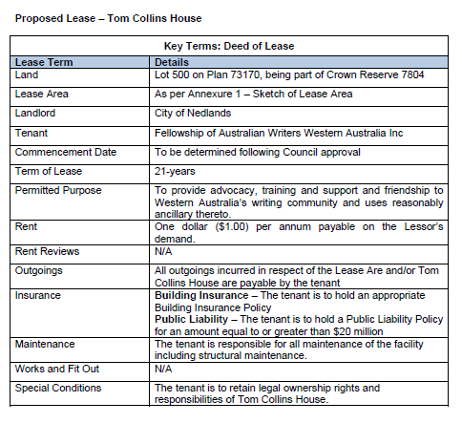
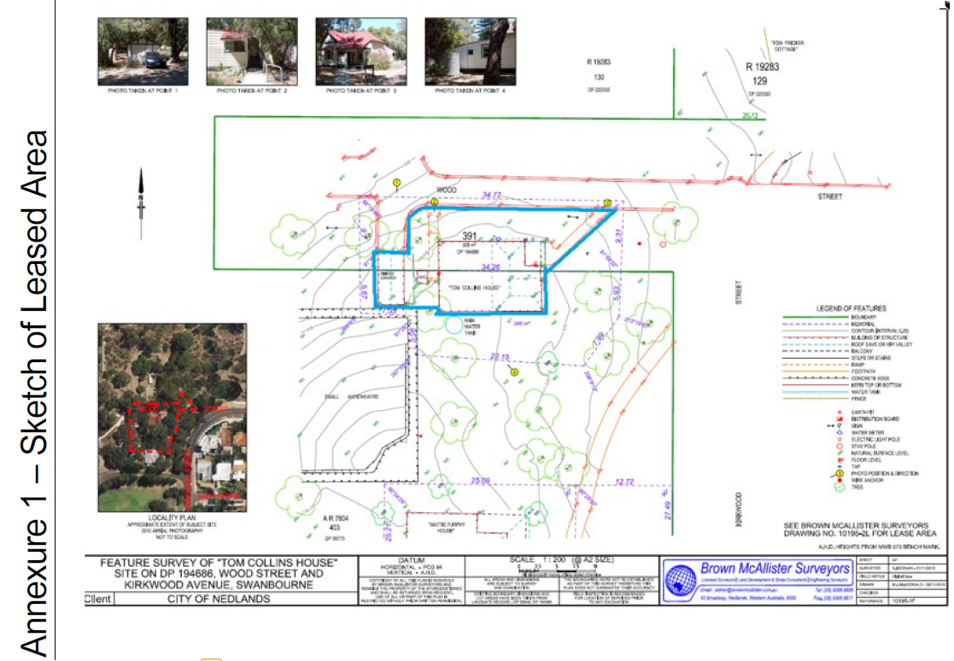

Conclusion

As there is no current legal agreement in place between the City and FAWWA, a lease will clarify the organisations and City’s responsibilities for the future management of Tom Collins House. This will provide FAWWA with security of tenure and protect the City from expending monies on maintain a facility that it does not own.

As per s3.58 of the Local Government Act 1995, Council approval is required to enter into any Lease Agreement, and when considering the above information, it is recommended that a new lease be approved by Council.

Key Relevant Previous Council Decisions:

Nil

Consultation

Administration have been in constant communication with various FAWWA representatives over the years. This included the reignition of negotiations as committee members and City staff have changed. The relationship has always been positive.

The City’s Community Development Team have also been consulted and have provided the following comments.

‘The Fellowship of Australian Writers WA is a not-for profit volunteer run organisation that supports existing and emerging writers in Western Australia. FAWWA provides writing workshops, author talks, poetry readings and book launches. FAAWA has used Tom Collins House for many years, during which they have been responsible long-standing tenants, providing valuable services to the community. The services they provide are unique in the City of Nedlands and the western suburbs’.

Strategic Implications

How well does it fit with our strategic direction?

Support of this request contributes towards the ‘Community Development’ key focus area of the City’s Strategic Community Plan by building community partnerships and strengthening the community’s capacity to meet its own needs.

Who benefits?

FAWWA, its local members and the local community benefit from the support of this request. The support will help enable a long term, and secure future for the organisation.

Does it involve a tolerable risk?

There is minimal risk associated with support of this request. FAWWA have a strong volunteer base and a new lease would have clauses within to protect the City’s interest in the land.

Do we have the information we need?

All required information has been provided to Council.

Budget/Financial Implications

Can we afford it?

Support of the recommendation and a new lease agreement would have no financial implications on the City as any legal costs associated with the arrangement of agreement will be borne by FAWWA. This is an agreed position by both parties and is consistent with the City’s ‘Use of Council Facilities for Community Purposes’ Policy which states peppercorn agreements should only be arranged at no cost to council.

How does the option impact upon rates?

Approval of the recommendation would have no impact on rates.

