Planning and Development Reports

Committee Consideration – 13 August 2019

Council Resolution – 27 August 2019

Table of Contents

Item No. Page No.

PD29.19 No 2. Bellevue Avenue, Dalkeith - Front Fence 2
PD30.19 No. 47 Alderbury St, Floreat – Additions to Single Dwelling (Retrospective) 9
PD31.19 Local Planning Scheme 3 – Local Planning Policy Short- Term Accommodation 19
PD32.19 Petition 8a Alexander Road, Dalkeith – Height Variation 22
PD33.19 Scheme Amendment No. 1 – Amendment to Clause 32.4(5) 26

Council: 27 August 2019

PD29.19 | No 2. Bellevue Avenue, Dalkeith - Front Fence
Committee | 13 August 2019
Council | 27 August 2019
Applicant | MNB Residential
Landowner | B D Kumar & V K Govindappa
Director | Peter Mickleson – Director Planning & Development
Employee Disclosure under section 5.70 Local Government Act 1995 | Nil.
Report Type  Quasi-Judicial | When Council determines an application/matter that directly affects a person’s right and interests. The judicial character arises from the obligation to abide by the principles of natural justice. Examples of Quasi-Judicial authority include town planning applications and other decisions that may be appealable to the State Administrative Tribunal.
Reference | DA19/35612
Previous Item | Nil.
Delegation | In accordance with the City’s Instrument of Delegation, Council is required to determine the application due to objections being received.
Attachments | - Site Photographs provided by Applicant  - Applicants Justification

- Executive Summary

The purpose of this report is for Council to determine a development application received from the applicant on 24 April 2019, for a portion of front fencing along Bellevue and Brockman Avenue which is proposed to be solid and 1.8m in height.

The front fence at 2 Bellevue Avenue has previously been approved receiving both planning approval and building approval with a more visually permeable configuration. Since approval, the landowners have decided to install a swimming pool at the corner street setback area of Bellevue and Brockman Avenue which requires a different type of fencing than previously approved to comply with the pool fencing regulations. An application has been received to assess the solid portion of the wall which also seeks to provide for privacy and screening to the swimming pool.

The application was advertised to adjoining neighbours in accordance with the City’s Local Planning Policy – Consultation of Planning Proposals as the development requires assessment under the Design Principles of the Residential Design Codes for street walls and fences. One objection was received for the proposed solid fencing. The objection relates to the implications of the solid fencing on the safety of vehicles and cyclists, the development not adhering to the Residential Design Codes requirements and the implications of solid walls on the future context of the neighbourhood.

It is recommended that the application be approved by Council as it is considered to satisfy the design principles of the Residential Design Codes (R-Codes) and is unlikely to have a significant adverse impact on the local amenity and is consistent with the local character of the locality.
- Recommendation to Committee

Council approves the development application dated 24 April 2019 to construct a portion of solid fencing at Lot 251, No. 2 Bellevue Avenue, Dalkeith, subject to the following conditions and advice

- The development shall at all times comply with the application and the approved plans, subject to any modifications required as a consequence of any condition(s) of this approval;

- This development approval only pertains to a solid portion of the wall to be constructed to a height of 1.8m above the level in the verge adjacent along Bellevue Avenue and Brockman Avenue;

- All structures associated with retaining walls and fences, shall be constructed wholly inside the site boundaries of the property’s Certificate of Title; and

- All stormwater from the development, which includes permeable and non-permeable areas shall be contained onsite.

Advice Notes specific to this proposal:

- The applicant is advised that a separate development application is required to be submitted to and approved by the City prior to erecting any fencing within the street setback area(s) which is not compliant with the deemed-to-comply provisions of the Residential Design Codes, and/or erecting any fencing behind the primary street setback area which is more than 1.8m in height above natural ground level;

- The applicant is advised that any development in the nature-strip (verge), including footpaths, will require a Nature-Strip Works Application (NSWA) to be lodged with, and approved by, the City’s Technical Services department, prior to construction commencing;

- The applicant is advised that no street tree assets in the nature-strip (verge) shall not be removed. Any approved street tree removals shall be undertaken by the City of Nedlands and paid for by the owner of the property where the development is proposed, unless otherwise approved under the Nature Strip Works approval; and

- This decision constitutes planning approval only and is valid for a period of two years from the date of approval. If the subject development is not substantially commenced within the two-year period, the approval shall lapse and be of no further effect.

- Background

3.1 Land Details

Metropolitan Region Scheme Zone | Urban
Local Planning Scheme Zone | Residential
R-Code | R10
Land area | 918.1m²
Additional Use | No
Special Use | No
Local Development Plan | No
Structure Plan | No
Land Use | Residential (Single Dwelling)
Use Class | P- Permitted

3.2 Locality Plan

The subject lot is a corner property and accommodates a two-storey single house which is currently under construction. The property is located with Bellevue Avenue to the north, Brockman Avenue to the east and Ringneck Lane to the south. The subject property is surrounded by residential dwellings and a locality that displays residential characteristics.
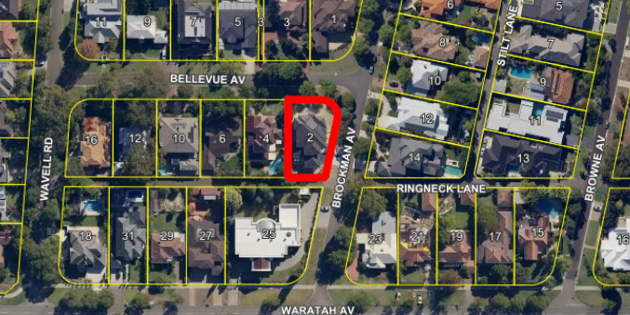

- Application Details

The applicant seeks development approval to construct a solid portion of front fencing, with a portion of the fencing along the corner elevation of Bellevue and Brockman Avenue to be visually impermeable (solid) at a height of 1.8m above natural ground level. The only portion of the fence which will be solid is the section immediately adjacent to a future swimming pool as shown in the site photos provided by the applicant (Attachment No. 1).

By way of justification in support of the development application the applicant has provided a design principle assessment provided as an attachment to this report (Attachment No. 2).

- Consultation

The applicant is seeking assessment under the Design Principles of the R-Codes for the following:

- Street Walls and Fences

The development application was advertised in accordance with Council’s Local Planning Policy - Consultation of Planning Proposals to 9 residents and landowners. 1 objection was received and there were 8 non-submitters as illustrated on the pie graph below.

The following table is a summary of the concerns/comments raised and the City’s response and action taken in relation to each issue:

Submission | Officer Response | Action Taken
The solid wall on a corner property will block the views of traffic passing down the streets, causing danger for vehicles or cyclists | Only a portion of the wall along the corner elevation of Bellevue and Brockman Avenue is solid. The remainder of the fencing along the street frontages is compliant with the requirements of the R-Codes for Street Walls and Fences.  This solid section is set well away from the vehicular and pedestrian access points of the house and therefore will have no impact on any of these important access points in terms of safety or surveillance.  In terms of passing traffic, the street verge along the solid portion of the fencing is setback over 6m from the street. The solid portion of the wall is setback 10.5m at the apex of the corner intersection of Bellevue and Brockman Avenue. The property also has a curved truncation to ensure sightlines at the intersection of Bellevue and Brockman Avenue are safe for vehicles and pedestrians. Therefore, even with the increased height being proposed this will have negligible impact to passing vehicles in terms of visual safety. | The sightlines at the intersection and at vehicle access points comply with the deemed to comply criteria – no action required.
The owners of the new house under construction had the opportunity to build the swimming pool to the rear of the property where it would have appropriate screening. Proposing a swimming pool in the front setback area is not allowed under the codes. | The R-Codes do not precent or discourage construction of a swimming pool within the front setback area. The pool has been designed to be located within this area in order to take best advantage of the northern aspect of the lot which will allow the pool to be used for a longer period of the year as it will be exposed to full sunlight. It is considered that this fencing is necessary for privacy and screening of the outdoor recreation for the subject property.  In order to ensure privacy for the occupants of the home, the portion of the wall directly adjacent to the pool is proposed to be solid. The applicant has ensured that the fencing is only solid where necessary and the remainder of the fencing is to remain with the infill panels to maintain a high level of surveillance from the dwelling to the street and vice versa. | The swimming pool location complies with the deemed to comply criteria of the R-Codes – no action required.
The guidelines prevent solid fences on the front boundary, so walls do not predominate the streets. The solid wall will set a precedence in the street | The R-Codes prescribe a maximum solid wall height of 1.2m above natural ground level, measured from the primary street. However, the R-Codes also allow for discretion by determining whether the proposal meets the Design Principles for street walls and fences. The application is considered to be compliant with the Design Principles of the R-Codes, which will be explained in further detail in Section 6 below.  There is an existing precedence of solid walls in the street. 25 Waratah Avenue to the south, 23 Waratah Avenue to the south east, 3 Bellevue Avenue to the north east and 1 Brockman Avenue to the north all have solid fences. | The height of the fencing is considered to comply with design principles – no action required.

Note: A full copy of all relevant consultation feedback received by the City has been given to the Councillors prior to the Council meeting.

- Assessment of Statutory Provisions

6.1 Planning and Development (Local Planning Schemes) Regulations 2015

Schedule 2, Part 9, clause 67 (Matters to be considered by local government) stipulates those matters that are required to be given due regard to the extent relevant to the application. Where relevant, these matters are discussed in the following sections.

In accordance with provisions (m) and (n) of the Regulations clause 67, due regard is to be given to the likely effect of the proposed development’s height, scale, bulk and appearance, and the potential impact it will have on the local amenity.

6.4 Policy/Local Development Plan Consideration

6.4.1 Residential Design Codes – Volume 1 (State Planning Policy 7.3)

The applicant is seeking assessment under the Design Principles of the R-Codes for street walls and fences as addressed in the below table:

Clause 5.2.4 Street Walls and Fences

Proposed
A portion of the fencing along the corner elevation of Bellevue Avenue and Brockman Avenue is proposed to be visually impermeable (solid) at a height of 1.8m above natural ground level. The only portion of the fence which will be solid is the section immediately adjacent to a future swimming pool.
Design Principles
The application seeks assessment under the design principles which are as follows:

“P4- Front fences are low or restricted in height to permit surveillance (as per Clause 5.2.3) and enhance streetscape (as per clause 5.1.2), with appropriate consideration to the need:
- for attenuation of traffic impacts where the street is designated as a primary or district;
- distributor or integrator arterial; and
- for necessary privacy or noise screening for outdoor living areas where the street is designated as a primary or district distributor or integrator arterial.”
Deemed-to-Comply Requirement
Front fences within the primary street setback area that are visually permeable above 1.2m of natural ground level, measured from the primary street sides of the fence.
Administration Assessment
The main reasons for the solid fencing, deemed to comply requirement for front fencing to be a maximum of 1.2m in height is to allow passive surveillance of the street from the dwelling, while also maintaining an open streetscape. The application proposes only a portion of the fencing along the corner elevation of Bellevue Avenue and Brockman Avenue to be solid where it is immediately adjacent to the proposed swimming pool. The remainder of the fencing will be visually permeable to ensure there is street surveillance from the main dwelling to the street and vice versa.

The single house on the lot under construction at the site is two-storey. The upper floors along the elevations of Bellevue and Brockman Avenue both consist of major openings which overlook onto the street to permit surveillance. It is considered that even with the portion of the wall being solid to a height of 1.8m, there will still be passive surveillance to the street from the major openings of the upper floor and major openings of the ground floor to Brockman Ave where not adjacent to the swimming pool.

Only a portion of the wall along the corner elevation of Bellevue and Brockman Avenue is solid. The remainder of the fencing along the street frontage is compliant with the requirements of the R-Codes for Street Walls and Fences.

This solid section is set well away from the vehicular and pedestrian access points of the house and therefore will have no impact on any of these important access points in terms of safety or surveillance.

There is a variety of trees located on the verge adjacent to the subject property which will act as a visual screen to the proposed portion of solid wall and the trees will visually provide for break up the solid portion of the wall.

As described by the applicant, the location of the swimming pool has been chosen to maximise the northern aspect of the lot which will allow the pool to be used more efficiently through the year with improved sunlight exposure. The applicant has addressed the need for necessary privacy and screening of outdoor living areas for a street through the proposal of this application.

In light of the above, the application is considered to satisfy the design principles for street walls and fences of the R-Codes. The proposed fencing does not restrict the opportunities for passive surveillance from the dwelling to Bellevue and Brockman Avenue. The proposed development does not negatively impact on the streetscape due to the presence of a wide verge which will allow the solid wall to be setback from the street and the presence of trees which will act as a buffer and provide screening of the solid portion of the wall.

- Conclusion

The proposed development is considered to satisfy the design principles of the R-Codes for street walls and fences. Considering the nature and the scale of the development, the dwelling orientation on the lot and the existing streetscape, the development will conform with the local development context and is unlikely to have a detrimental impact on the amenity of the local neighbourhood.

Considering the above, it is recommended that Council approves the application subject to conditions.

PD30.19 | No. 47 Alderbury St, Floreat – Additions to Single Dwelling (Retrospective)
Committee | 13 August 2019
Council | 27 August 2019
Applicant | Greg Cowie Homes
Landowner | Deborah Fraser
Director | Peter Mickleson – Director Planning & Development
Employee Disclosure under section 5.70 Local Government Act 1995 | Nil.
Report Type | When Council determines an application/matter that directly affects a person’s right and interests. The judicial character arises from the obligation to abide by the principles of natural justice. Examples of Quasi-Judicial authority include town planning applications and other decisions that may be appealable to the State Administrative Tribunal.
Reference | DA19/35178
Previous Item | Nil
Delegation | In accordance with Clause 6.7.1a) of the City’s Instrument of Delegation, Council is required to determine the application due to objections being received
Attachments | - Site Photographs  - Applicant Design Principle Justification and Response to Objectors

- Executive Summary

The purpose of this report is for Council to determine a retrospective development application for additions to the existing single dwelling at no. 47 Alderbury Street, Floreat.

This retrospective development application seeks approval for fill and retaining within the street setback area, primary and secondary street boundary fencing and over-height dividing fencing to the eastern lot boundary. The development application results from the construction being inconsistent with an existing planning approval issued in 2017 for the dwelling and street boundary fencing which did not include any fill and retaining within the street setback area and the swimming pool being in a different location.

The fill and retaining has been installed up to both the primary and secondary street boundaries to a height of 0.65m above natural ground level with solid boundary fencing installed above this retaining, addressing both the primary and secondary street to a height of 2.45m above the street side of the fencing (height is inclusive of fill and retaining). The original planning approval indicated primary street fencing to be solid to a height of 1.2m, with visually permeable infill panels above to a height of 1.8m and secondary street fencing to a solid height of 1.8m as measured from natural ground level from the street side of the fencing which complied with the deemed to comply provisions of the R-Codes and the City’s Fill and Fencing Local Planning Policy.

The application was advertised to adjoining neighbours in accordance with the City’s
Local Planning Policy – Consultation of Planning Proposals as the development
requires assessment under various Design Principles of the R-Codes and the over-height dividing fencing requires assessment under the objectives of the City’s Fill and Fencing Local Planning Policy. One objection has been received relating to the height and lack of visual permeability of the primary and secondary street fencing.

It is recommended that the application be approved by Council, subject to a condition being applied seeking to modify the fencing to reduce the impact of the fencing on the established streetscape and to ensure that the streetscape amenity of the locality is maintained.

- Recommendation to Committee

Council retrospectively approves the development application dated 27 March 2019 for Additions to Single Dwelling including dividing fencing, primary street fencing, secondary street fencing, fill and retaining at No. 47 Alderbury Street, Floreat, subject to the following conditions and advice:

- The development shall at all times comply with the application and the approved plans, subject to any modifications required as a consequence of any condition(s) of this approval;

- This development approval only pertains to the street boundary fencing, eastern side boundary fencing and site works and retaining walls within the street setback areas as shown on the approved plans;

- Revised drawings shall be submitted with the Building Approval Certificate application, to the satisfaction of the City, demonstrating the following:

  - The fencing within the primary street setback area being visually permeable 1.2m above natural ground level, measured from the primary street side of the front fence; and

  - The secondary street fencing outside of the pool area being reduced to a maximum height of 2.1m above the Alderbury street side of the fencing.

- Remedial works required to bring all unauthorised works into conformity with this planning approval, shall be completed within 30 days from the date of this approval;

- All footings and structures to retaining walls and fences shall be constructed wholly inside the site boundaries of the property’s Certificate of Title; and

- All stormwater from the development, which includes permeable and non-permeable areas shall be contained onsite.

Advice Notes specific to this proposal:

- The applicant shall make application to the City’s Building Services for a Building Approval Certificate, to acknowledge the unauthorised works;

- All street tree assets in the nature-strip (verge) shall not be removed. Any approved street tree removals shall be undertaken by the City of Nedlands and paid for by the owner of the property where the development is proposed, unless otherwise approved under the Nature Strip Works approval;

- This development approval does not remove any other legal obligations under the Dividing Fencing Act 1961; and

- This decision constitutes planning approval only and is valid for a period of two years from the date of approval. If the subject development is not substantially commenced within the two-year period, the approval shall lapse and be of no further effect.

- Background

A development application was received on 3 March 2017, for a two-story single dwelling at 47 Alderbury Street Floreat. Lissadell Street was designated as the primary street for this property, with Alderbury Street being the designated secondary street. The original plans indicated (by means of text) that boundary fencing, addressing Alderbury Street would be solid to 1.8m in height above the level at the street boundary, and fencing addressing Lissadell Street (and the truncation) would be solid to a height of 1.2m in height , with visually permeable infill panels above to a height of 1.8m above the level at the street boundary. The application was approved under delegation.

A building Permit was lodged with the City on 24 December 2017. The building permit included revised plans for front boundary fencing addressing Alderbury and Lissadell Street indicating the boundary fencing addressing both Lissadell and Alderbury Street to have a total height of 2.45m due to the introduction of retaining within the street setback area. Fencing addressing Lissadell Street was indicated to be visually permeable above 1.85m. The building permit was approved and issued on 10 January 2018.

On 27 March 2019, the City received a retrospective development application for over-height dividing fencing, between 45 and 47 Alderbury Street (the eastern lot boundary of the subject property). The plans submitted as part of the development application indicated that the street fencing did not match the development approval and therefore the applicants were given option to remove the unauthorised development and comply with the original approval or include the fencing and retaining in this retrospective development application.

A building permit does not overrule a planning approval, instead there is a requirement that Building Permits must reflect any previous development approvals associated with the development proposal. Under section 20 of the Building Act 2011 and regulation 18 of the Building Regulations 2012, it is a requirement that building works comply with “other written laws”, this includes any planning approvals issued in accordance with the Planning and Development Act 2005.

The original planning approval does not indicate any fill within the front setback area. The retrospective development application indicates retaining walls to a height of 0.65m have been constructed. The deemed to comply maximum height of fill is 0.5m, any fill exceeding this requires a development application, planning approval and an associated building permit prior to their construction.

The applicants advised that due to the location of the pool being moved closer to Lissadell Street, the finished ground level was increased in this location and the requirement for 1.8m high fencing from the inside of the pool area to the lot boundary increased the required fencing height from the levels approved in the development application. For this reason, the applicants have elected to include all the unauthorised development in this retrospective development application as the current design complies with pool fencing regulations.

Further to the above, a site visit noted that the ‘visually permeable infill panels’ installed are not compliant as the gaps provided do not meet the definition of visually permeable within the Residential Design Codes.

Please see Attachment 1 for the site inspection images.

3.1 Land Details

Metropolitan Region Scheme Zone | Urban
Local Planning Scheme Zone | Residential
R-Code | R12.5
Land area | 943m²
Additional Use | No
Special Use | No
Local Development Plan | No
Structure Plan | No
Land Use | Residential (Single Dwelling)
Use Class | P – Permitted

3.2 Locality Plan

The subject property is a corner lot addressing both Alderbury and Lissadell Street. Lissadell Street has been designated the primary street frontage for the property, with Alderbury Street as the secondary street. Alderbury Street represents the border between the City of Nedlands and the Town of Cambridge. Properties to the north of Alderbury Street are under the jurisdiction of the Town of Cambridge and properties to the south of Alderbury Street are located within the City of Nedlands.

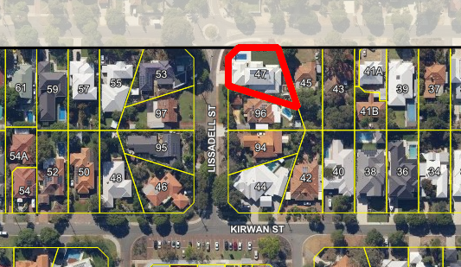

- Application Details

The applicant seeks retrospective development approval for over-height dividing fencing, street boundary fencing and site works and retaining walls within the front setback area, details of which are as follows:

- Retaining and fill has been constructed up to the northern and western street boundaries to a height of 0.65m above natural ground level;
- Solid fencing addressing the primary street, Lissadell Street, has been installed to a height of 2.45m above natural ground level as measured from the street side of the street boundary;
- Solid fencing addressing the secondary street, Alderbury Street, has been installed to a height of 2.45m above natural ground level as measured from the street side of the street boundary; and
- Dividing fencing has been installed along the eastern side lot boundary to a height of 2.35m above natural ground level.

By way of justification in support of the retrospective development application the applicant has provided a design principle assessment and addressed the submissions received during community consultation as an attachment to this report (See attachment 2).

- Consultation

The applicant is seeking assessment under the Design Principles of the R-Codes for the following:

- Street walls and Fencing;
- Site works;
- Setback of Retaining Walls; and
- Dividing Fencing Height.

The development application was advertised in accordance with the City’s Local Planning Policy – Consultation of Planning Proposals to 34 residents and landowners. One (1) written objection relating to the solid nature of the boundary fencing and its height was received and two (2) non-objections were received. Please see the below pie graph for the outcome of the community consultation:

The following table is a summary of the concerns/comments raised and the City’s response and action taken in relation to each issue:

Submission | Officer Response | Action Taken
The over-height solid fencing goes against the general openness of the neighbourhood. | The R-Codes and the City’s Fill and Fencing Local Planning Policy are in place to preserve and protect the established streetscape character and openness of street frontages within the City of Nedlands. The requirement for visually permeable primary street fencing seeks to promote passive surveillance of the streetscape and reduce the presence of bulk addressing the street, producing an open and friendly community aesthetic.  Fencing addressing the secondary street is permitted to be solid to a height of 1.8m to allow for screening and privacy of outdoor living areas and habitable spaces from the street. The restrictions of boundary wall heights and the requirement for visual permeability are in place to maintain a unique and open streetscape character within the Nedlands region. | The officer recommendation is to increase the amount of visually permeable fencing to the primary street to better comply with the City’s Fill and Fencing Local Planning Policy.
The solid fencing is disruptive to the established Nedlands streetscape character | The R-Codes and the City’s Fill and Fencing Policy are in place to preserve and protect the established streetscape character and openness of street frontages within the Nedlands region. The requirement for visually permeable primary street fencing seeks to promote passive surveillance of the streetscape and reduce the presence of bulk addressing the street, producing an open and friendly community aesthetic. The City’s officers believe that a great proportion of visually permeable fencing will reduce the bulk and scale as viewed from the street.  The restrictions of boundary wall heights and the requirement for visual permeability are in place to maintain a unique and open streetscape character within the Nedlands region. | The officer recommendation is to decrease the height of the secondary street fencing and increase the amount of visually permeable in-fill to the primary street setback area fencing to reduce bulk and scale and improve passive surveillance from the dwelling.

Note: A full copy of all relevant consultation feedback received by the City has been given to the Councillors prior to the Council meeting.

- Assessment of Statutory Provisions

6.1 Planning and Development (Local Planning Schemes) Regulations 2015

Schedule 2, Part 9, clause 67 (Matters to be considered by local government) stipulates those matters that are required to be given due regard to the extent relevant to the application. Where relevant, these matters are discussed in the following sections.

In accordance with provisions (m) and (n) of the Regulations clause 67, due regard is to be given to the likely effect of the proposed development’s height, scale, bulk and appearance, and the potential impact it will have on the local amenity.

6.2 Policy/Local Development Plan Consideration

6.2.1 Residential Design Codes – Volume 1 (State Planning Policy 7.3)

The applicant is seeking assessment under the Design Principles of the R-Codes for [over-height boundary fencing, non-visually permeable primary street fencing, over-height fill and over-height retaining] as addressed in the below table/s:

Clause 5.2.4 – Street walls and fences

Proposed
The fencing addressing the primary street (Lissadell Street) has been installed to a solid height of 2.45m from natural ground level as measured from the street side of the lot boundary.
Design Principles
The application seeks assessment under the design principles which are as follows:

“P4 – Front fences are low or restricted in height to permit surveillance (as per Clause 5.2.3) and enhance streetscape (as per clause 5.1.2), with appropriate consideration to the need:
- for attenuation of traffic impacts where the street is designated as a primary or district distributor or integrator arterial; and
- for necessary privacy or noise screening for outdoor living areas where the street is designated as a primary or district distributor or integrator arterial.”
Deemed-to-Comply Requirement
C4 – Front fences within the primary street setback area that are visually permeable above 1.2m of natural ground level, measured from the primary street side of the front fence.

Administration Assessment
The front fence lacks visual permeability as viewed from the primary street and has an imposing presence on the streetscape given the surrounding streetscape is open in nature with permeable fencing or no fencing provided. Therefore, a condition of development approval is recommended to modify the fence to have a greater proportion of visually permeable in-fill.

It is recommended that the solid portion is reduced with visually permeable in-fill provided 1.2m above natural ground level as measured from the primary street side of the front fence. The location of the permeable in-fill can be placed in a way so as to ensure that the fencing will still comply with the pool fencing regulations.

Clause 5.3.7 – Site works & Clause 5.3.8 – Retaining walls

Proposed
Fill and retaining is proposed to be 0.65m above natural ground level within the street setback areas.
Design Principles
The application seeks assessment under the design principles which are as follows:

“P7.1 – Development that considers and responds to the natural features of the site and requires minimal excavation/fill.

P7.2 – Where excavation/fill is necessary, all finished levels respecting the natural ground level at the lot boundary of the site and as viewed from the street”

“P8 – Retaining walls that result in land which can be effectively used for the benefit of residents and do not detrimentally affect adjoining properties and are designed, engineered and landscaped having due regard to clauses 5.3.7 and 5.4.1.”
Deemed-to-Comply Requirement
C7.1 – Excavation or filling within 3m of the street alignment shall not exceed 0.5m, except where necessary to provide for pedestrian or vehicle access, drainage works or natural light for a dwelling.

C8 – Retaining walls greater than 0.5m in height set back from lot boundaries in accordance with the setback provisions of Table 1. Retaining walls 0.5m or less in height may be located up to the lot boundary.
Administration Assessment
The requirements for the setback of retaining walls are in place to promote responsive design outcomes to work with the existing topography rather than make extensive modification to the existing landscape and topography present across a lot. The setback of both fill and retaining seeks to minimise the impact of site works on the streetscape.

The additional height of the retaining above the deemed to comply level on its own is not significant and facilitates a level and usable space in conjunction with the dwelling However, the presence of this over-height fill and retaining has created the need for increased street boundary fencing height, in order to comply with the Australian Standard for pool fencing.

It is recommended that the fill and retaining are approved in their current location and at their current levels as the impact of this fill and retaining can be minimised through modification to the installed boundary fencing heights and permeability.

6.2.3 Local Planning Policy – Fill and Fencing Policy

Policy Purpose
To outline the City’s requirements with regard to fill and the minimum standard of fencing
to ensure that the amenity of neighbouring properties and the streetscape is maintained.
Policy Statement
The City values the protection of the quality of the streetscape and the amenity of owners and occupants by minimising the visual impact of fill and/or fencing whilst allowing for adequate surveillance of public places.
Policy Requirement
4.0 Fencing Height Requirements

4.1 Dividing fences shall have a maximum height of 1.8m above any approved or deemed-to-comply fill or retaining under the R-Codes.

4.2 Brick piers to a maximum height of 2.1 metres from natural ground level for fencing in primary and secondary street setback area(s).

4.3 In primary street setback areas, solid fencing to a maximum height of 1.2 metres above natural ground level, and visually permeable fencing to a maximum height of 1.8m above natural ground level.
Proposed
- Primary street fencing is proposed to be solid to a height of 2.45m from natural ground level, when viewed from the street.
- Secondary street fencing is proposed to be solid to a height of 2.45m from natural ground level, when viewed to from the street.
- Dividing fencing to the eastern lot boundary is proposed to be solid to a height of 2.35m.
Administration Assessment
Please see above comment in relation to the fencing within the primary street setback area.

The secondary street fencing is 1.8m above the fill and retaining. This fencing provides compliance with pool fencing regulations and also provides privacy to the pool area and backyard area. The fencing to Alderbury Street which is outside of the pool area can be reduced slightly to reduce the bulk and scale of the fencing as viewed from the street whilst still providing privacy for the outdoor area of the dwelling. Accordingly, a condition is recommended to this effect.

It should be noted that the street is lower than the subject property due to the slope of the land and therefore there is built in privacy for the outdoor area with any additional privacy able to be obtained more appropriately through landscaping rather than fencing.

The dividing fencing to the eastern side lot boundary is mainly an issue between the two landowners (no. 45 and no. 47 Alderbury Street) which is to be negotiated under the requirements of the Dividing Fencing Act 1961. The City advertised the additional height and did not receive an objection to the dividing fencing which is currently installed at 2.35m. As the additional height is localised to the two properties and there is no immediate impact on the streetscape or amenity of the locality, the City recommends approval for this aspect of the development without modification being required.

- Conclusion

The height and lack of visual permeability of the fencing to the street is considered to have a negative impact on the streetscape and therefore, the officer recommendation is to increase the permeability of the front fencing and decrease the height of the secondary street fencing outside of the pool area. This will ensure compliance with the pool fencing regulations, improves passive surveillance of the street and reduction of bulk and scale as viewed from the street. The additional dividing fencing height to the eastern side lot boundary is considered to be acceptable and is recommended for approval without further modification.

Considering the above, it is recommended that Council approves the application subject to the recommended conditions.

PD31.19 | Local Planning Scheme 3 – Local Planning Policy Short-Term Accommodation
Committee | 13 August 2019
Council | 27 August 2019
Director | Peter Mickleson – Director Planning & Development
Reference | Nil
Previous Item | PD21.18 – Draft Short-Term Accommodation Local Planning Policy
Attachments | - Draft Short-Term Accommodation LPP

- Executive Summary

The purpose of this report is for Council to prepare (adopt for advertising) the Short-Term Accommodation Local Planning Policy required under Local Planning Scheme 3 (LPS 3).

The purpose of this policy is to provide guidance and development provisions for operators seeking to establish short-term accommodation land uses within the City of Nedlands.

- Recommendation to Committee

Council prepares and advertises the Short-Term Accommodation Local Planning Policy for a period of 21 days, in accordance with the Planning and Development (Local Planning Schemes) Regulations 2015 Schedule 2, Part 2, Clause 4.

- Background

Following consideration of a number of development applications for short-term accommodation, Council, in May 2018, resolved for administration to prepare report addressing short-term accommodation land uses. The resolution is as follows:

“Council Resolution

Council requests the CEO to prepare a draft report relating to “short term accommodation” (STA) in single residential zonings including duplexes that reflects the main residential precincts across the City of Nedlands. The outcomes from this report will form the basis of a policy for inclusion in the draft LPS3 when it is available for public consultation.

The response from Administration should:

- Include a working definition of STA.

- Include a procedure for Community Consultation from well-informed electors for support or non-support of STA within precincts.

- Include relationship between short term accommodation (no services provided other than accommodation - with proprietor present and proprietor absent) and the currently approved “bed and breakfast” style of short-term accommodation in residential precinct (proprietor present).

- Suggest rules pertaining to any approved short-term accommodation including a management plan and conditions under which an STA approval may be terminated and how compliance will be achieved.

- Include whether the WA Government has any plans to regulate STA within the metropolitan area within the coming year or as part of the recently announced review of the Local Government Act 1995; and

- Investigate current advertisements for short-stay accommodation in the City of Nedlands and report on their status of approval.”

The policy was prepared and presented to Council at the May 2018 Ordinary Council meeting for approval to advertise. The policy was prepared in response to Councils motion, the increasing number of short-term accommodation development applications received by the City, and the absence of any specific policy requirements. At the time there were no short-term accommodation land use definitions under Town Planning Scheme 2 (TPS 2) and the policy sought to clarify the land uses and apply standardised provisions. Council resolved it no longer wished to adopt a short-term accommodation local planning policy under TPS 2.

With the gazettal of LPS 3 short-term accommodation land uses are now defined and are capable of approval within the Residential, Mixed use and Local Centre zones. It is anticipated that the City will receive applications for short-term accommodation land uses and it would be prudent to guide decision making and advise the community of Councils position on these uses.

- Detail

This policy applies to all short-term accommodation proposals, within all zones, captured by the following land use categories as defined in LPS 3:

- Bed and breakfast;
- Holiday house;
- Holiday accommodation; and
- Serviced Apartments.

The purpose of this policy is to provide guidance and development provisions for operators seeking to establish short-term accommodation uses within the City of Nedlands and to help officers assess short term accommodation development applications in line with Councils position.

The policy clearly states location criteria for all short-term accommodation uses as well as design criteria for serviced apartments. The policy also sets out car parking, signage and consultation requirements for short-term accommodation uses.

Short-term accommodation uses will be initially approved for a 12-month period. Following this initial 12-month period, a subsequent development approval will be required to be submitted for the renewal of the approval for the short-term accommodation which may then be on a permanent basis. As part of assessing whether permanent approval should be granted, Council can take into account any substantiated complaints received during the initial 12-months.

The policy requires the submission of a management plan which shall set out contact details of the property manager and basic administration of the premises. This is considered particularly important when the land owner does not reside on-site.

The policy also provides a template for a management plan to show applicants what information is expected to be provided in the management plan which will accompany an application for short-term accommodation.

- Consultation

If Council resolves to prepare the draft LPP, it will be advertised for 21 days in accordance with Schedule 2, Part 2, Division 2, Clause 4 of the Regulations. This will include a notice being published in the newspaper and details being included on the City’s website & the Your Voice engagement portal.

Following the advertising period, the policy will be presented back to Council for it to consider any submissions received and to:

- Proceed with the policy without modification;
- Proceed with the policy with modification; or
- Not to proceed with the policy.

- Statutory Provisions

Planning and Development (Local Planning Schemes) Regulations 2015

Under Schedule 2, Part 2, Clause 3(1) of the Planning Regulations the City may prepare a local planning policy in respect to any matter related to the planning and development of the Scheme area.

Once Council resolves to prepare a LPP is must publish a notice of the proposed policy in a newspaper circulating the area for a period not less than 21 days.

- Conclusion

The Short-term Accommodation LPP is the best mechanism to guide decision making and advise the community of the Council position in relation to development applications for short-term accommodation throughout the City.

As such, it is recommended that Council endorses Administration’s recommendation to provide (consent to advertise) the Short-term Accommodation LPP.

PD32.19 | Petition 8a Alexander Road, Dalkeith – Height Variation
Committee | 13 August 2019
Council | 27 August 2019
Director | Peter Mickleson – Director Planning & Development
Reference | Nil
Previous Item | OCM 25 June 2019
Attachments | - Petition – Alexander Road Dalkeith – Height Variation

- Executive Summary

At the Council meeting held 25 June 2019, the Chief Executive Officer tabled a petition on behalf of Ms. Maria De Carmen Tutor of 8a Alexander Road, Dalkeith with 11 signatures. The petition content is requesting a height variation to dwellings on Alexander Road, Dalkeith between Phillip Road and Waratah Avenue (house numbers 1-10). The restriction sought is to introduce a to a two-storey height limit to restrict development so that the front street elevation is in sync with the existing low-density streetscape.

Council resolved to refer the petition to Administration for comment.

Administration recommends that Council acknowledges this requests but in response take no action in relation to the request put forward in the petition given that a two-storey height limit in an R80 and R60 zoned streetscape is not deemed to be consistent with the objectives of that R Coding and that should the petitioner seek to pursue the matter, they engage a planning consultant to formulate local planning controls for the site (and surrounds).

Administration also wish to advise that they will soon be progressing a Draft Precinct Plan and associated community consultation for the Waratah Village Precinct, and such issues will be encapsulated in that process and will be discussed and debated further.

- Recommendation to Committee

    - Council resolves to take no action with regard to the petitioner for Alexander Road height reduction at present.

    - Council instructs the Chief Executive Officer to prepare a Precinct Plan for the Waratah Village Precinct, including the residential frame rezoning area with consideration being given to building heights within the precinct.

- Discussion/Overview

The City received a petition in May 2019 from a resident at 8A Alexander Road, Dalkeith seeking that Council act to reduce the permissible height of future development on Alexander Road, Dalkeith between Philip Road and Waratah Avenue to a 2 storey height limit so that the height is in line with the current streetscape.

The properties which would be affected by the petitions proposed height reduction are shown in figure 1 below.

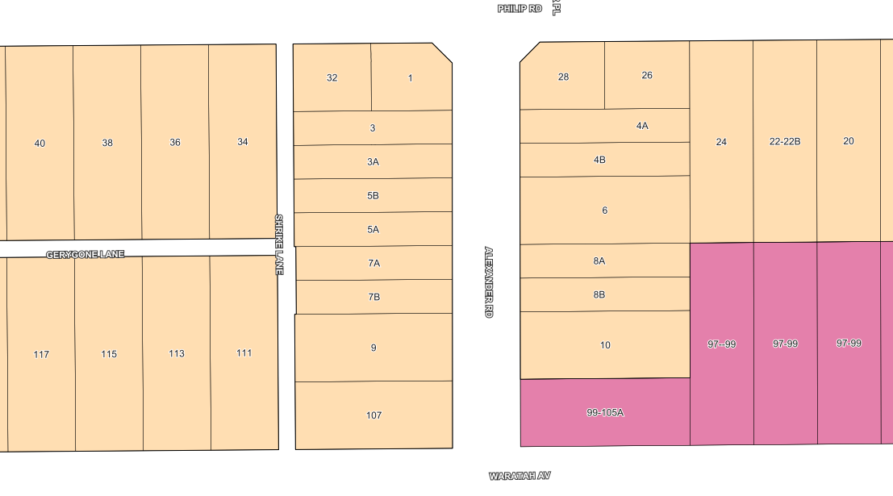
Properties within area indicated by petition for building height reduction
Figure 1 – Properties identified in the petition for reduced building height

The properties indicated in Figure 1 were zoned Residential R20 (eastern side of Alexander Rd) and R25 (western side of Alexander Rd) under Town Planning Scheme No. 2 (TPS 2) in 2005. Those properties are now zoned Residential R80 (eastern side of Alexander Rd) and Residential R60 (western side of Alexander Rd) under Local Planning Scheme 3 (LPS 3).

The properties on the eastern side, zoned Residential R80, abut the Waratah Ave commercial strip which is zoned Mixed Use R-AC3 and Residential R80 lots along Philip Rd. The properties on the western side, zoned R60, abut a laneway which then adjoins Residential R40 and Residential R10 properties along Philip Rd and Waratah Ave. See figure 2 below for R-Code map.

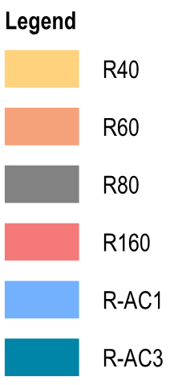
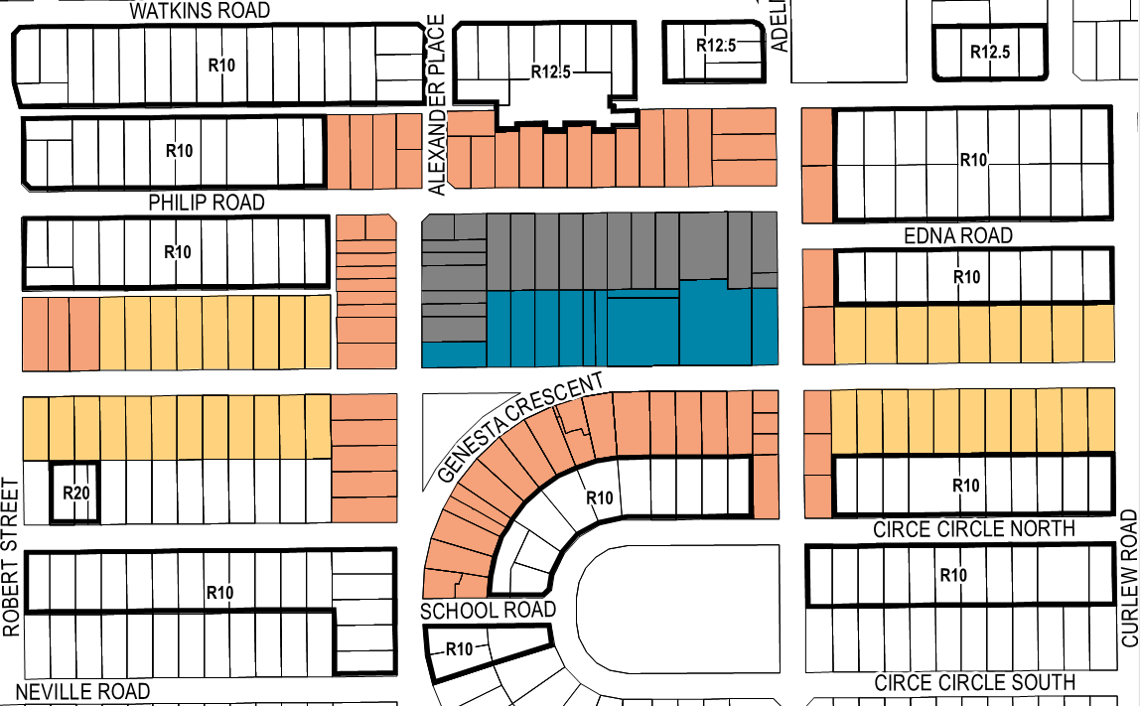
The Waratah Avenue Activity Centre, being zoned Mixed Use R-AC3, can currently seek to develop to 6-storeys as prescribed in State Planning Policy 7.3 Residential Design Codes Volume 2 Apartments (R-Codes Vol.2).

The properties on the eastern side of Alexander Road, being zoned Residential R80, can seek to develop Multiple Dwellings (Apartments) subject to the element objectives of Part 2.2 Building Height with acceptable outcomes of A2.2.1 provisions 4-storeys as per R-Codes Vol.2 or can develop Grouped or Single Dwellings to 2-storeys as per State Planning Policy 7.3 Residential Design Codes Volume 1 (R-Codes Vol.1).

The properties to the western side of Alexander Road, being zoned Residential R60, can develop Multiple Dwellings (Apartments) subject to the element objectives of Part 2.2 Building Height with acceptable outcomes of A2.2.1 provisions 3-storeys as per the R-Codes Vol.2 or can develop Grouped or Single Dwellings to 2-storeys as per R-Codes Vol.1. (Please note that height is performance based in R Codes V2 and not prescriptive as it was in TPS2)

R-Code permitted building heights
Location | Philip Rd - west | Waratah Ave - west | Alexander Rd - west | Alexander Rd – east  Philip Rd – east | Waratah Ave Commercial strip
R-Code | R10 | R40 | R60 | R80 | R-AC3
Permitted Building Height for Multiple dwellings (apartments) | 2 storeys | 2 storeys | 3 storeys (discretionary) | 4 storeys  (discretionary) | 6 storeys  (discretionary)
Permitted Building Height for Grouped & Single dwellings (townhouse units) | 2 storeys | 2 storeys | 2 storeys | 2 storeys | 2 storeys

The zones and R-Codes assigned under LPS 3 create a transition in height from the Waratah Avenue Activity Centre to the low-density suburban areas that surround, in a logical and stepped manner, precisely as intended by the City’s Local Planning Strategy. This holds true for the development of multiple dwellings (apartments), should grouped or single dwellings be proposed, a 2 storey height limit applies.

Limiting building height to a maximum height of 2-storeys for multiple dwelling development in the R80 and R60 codes would limit the development potential of the affected properties and is not consistent with the density which has been provided under LPS 3. A height restriction of 2-storeys is also inconsistent with the R-Codes Vol.2 element objectives for building height which refers to the desired future scale of an area. The existing height provisions permitted by the assigned R-Codes also allow for the appropriate and adequate transition of building height from the Waratah Avenue Mixed Use area to the surrounding low-density suburban areas.

Further to this, any development for multiple dwellings must meet all the element objectives of the R-Codes Vol.2 which provides for consideration of a development and its possible impact on the adjoining properties, particularly in relation to overshadowing, overlooking, setbacks and building bulk.

In relation to the petitioner’s discussion regarding development being in sync with the existing streetscape, the properties in question were part of an up coding in 2005 under TPS 2 with the houses on the East of Alexander Rd being coded R20 and those to the West of Alexander Rd being coded R25. These properties were subject to a 6m front setback as per Appendix V of TPS 2. Under LPS 3, the R80 density to the East would require a 2m primary street setback for Multiple Dwellings (Apartments) and 1m primary street setback for Grouped and Single Dwellings. The R60 density to the West would require a 2m front setback for both Multiple (Apartments), Grouped and Single Dwellings. It is anticipated that the streetscape setback of dwellings in this location will change over time as redevelopment occurs and that a reduction in the building height would not have a significant impact streetscape if the front setback still being reduced incrementally.

For these reasons, it is not considered appropriate to reduce building height in these locations and the City should not attempt to amend the Scheme in an attempt to do so. The City recognises that further work is required and at this point in time a Precinct Plan which will seek to establish both a localised strategic and statutory planning framework and controls for this area following a greater level of analysis and community feedback.

- Key Relevant Previous Council Decisions:

The petition was presented to Council at the Council Meeting on 25 June 2019. Council resolved:

“That Council receive the petition and refer to administration.”

- Consultation

Nil.

- Budget/Financial Implications

Nil.

PD33.19 | Scheme Amendment No. 1 – Amendment to Clause 32.4(5)
Committee | 13 August 2019
Council | 27 August 2019
Director | Peter Mickleson – Director Planning & Development
Reference | Nil
Previous Item | Nil
Attachments | - Scheme Amendment No. 1 Report

- Executive Summary

The purpose of this report is for Council to provide consent to prepare (adopt) the proposed Scheme Amendment No. 1 to Local Planning Scheme 3 (LPS 3).

The amendment proposes a minor textual change to Clause 32.4(5) which refers non-residential developments to the requirements of the R-codes in the absence of an approved structure plan, local development plan or activity centre plan within Mixed Use, Neighbourhood Centre and Local Centre zones.

The amendment proposes to include Local Planning Policies as an instrument to contain non-residential development standards for the above zones to replace application of the R-Codes.

The amendment is considered as a basic scheme amendment as it is to correct an administrative error; make the scheme consistent with the model provisions and deemed provisions; and creates consistency with a state planning policy. As per the Planning and Development (Local Planning Schemes) Regulations 2015 (Regulations) a basic amendment does not require advertising.

- Recommendation to Committee

Council:

- Pursuant to Section 75 of the Planning and Development Act 2005, adopt an Amendment to Local Planning Scheme 3 by:

  - Inserting the words ‘local planning policy’ into clause 32.4(5) to state “in relation to developments that are not subject to the R-Codes, where development standards are not specified in an approved structure plan, local development plan, local planning policy and/or activity centre plan, the development standards are subject to the applicable R-Code;”

- In accordance with Planning and Development (Local Planning Schemes) Regulations 2015 section 35(2), the City believes that the amendment is a Basic Amendment for the following reasons:

- An amendment to correct an administrative error;

- An amendment to the scheme so that it is consistent with the model provisions in schedule 1 or with another provision of the local planning scheme; and
- An amendment to the scheme so that it is consistent with a State planning policy.

- Pursuant to Section 81 of the Planning and Development Act 2005, refers Scheme Amendment 1 to the Environmental Protection Authority.

- Amendment Details

Clause 32.4(5) of LPS 3 applies the requirements of the R-Codes to non-residential developments in Mixed Use, Local Centre and Neighbourhood Centre zones in the absence of an approved structure plan, local development plan, or activity centre plan. The clause does not include ‘an approved Local Planning Policy’ as an instrument to replace the application of the R-Codes in the above zones. There are many issues associated with this which are discussed within the scheme amendment report.

The main issues are summarised as follows:
- The R-Codes alone are inadequate to address all planning and design considerations for non-residential developments;
- The Mixed-Use zones within the City do not meet the criteria of the Regulations for a structure plan or activity centre plan to be prepared. A local development plan should only be applied to individual sites or localised area. A local planning policy is therefore currently the only planning instrument suitable to contain non-residential development standards in these areas;
- The only process to create a policy with non-residential standards through the clause is to amend the R-Codes as provided through Part 1.2.1 and 1.2.2;
- The R-Codes do not allow amendment to the Element Objectives and only allow amendment or replacement of the Acceptable Outcomes for each section. In many instances, the element objectives do not provide the content necessary for assessment of non-residential development.
- A policy cannot amend the R-codes to include provisions for non-residential development which are not provided for (in an existing section) in the R-Codes;
- Obtaining WAPC approval for all policies which propose non-residential development standards (which amend section contained within 1.2.2) affecting mixed use, neighbourhood centre and local centre zones within the City (which constitutes a significant proportion of all non-residential land within the City) will result in delays in establishing the local planning framework.
- There is tension between clause 32.4(5) and the deemed provisions and other scheme clauses in the ability for the City to prepare local planning policies affecting the mentioned zones.

The process in creating local planning policy through the clause is convoluted and confusing and is not how the planning framework is intended to operate. The minor textual change proposed will correct these issues.

- Consultation

Under the Regulations the process for basic scheme amendments does not include consultation. The amendment is very minor and does not have implications for landowners or specific properties.

- Budget / Financial Implications

Nil.

- Risk Management

Nil.

