

Technical Services Reports

Committee Consideration – 13 August 2019

Council Resolution – 27 August 2019

Table of Contents

Item No. Page No.

TS16.19 Jones Park Enviro-scape Master Plan – Bushland Conservation Fencing Petition 2
TS17.19 Adoption of the Asset Management Strategy 2019 – 2029 10
TS18.19 Execution of Grant of Easement to the City of Nedlands 13

TS16.19 Jones Park Enviro-scape Master Plan – Bushland Conservation Fencing Petition

Committee | 13 August 2019
Council | 27 August 2019
Applicant | City of Nedlands
Employee Disclosure under section 5.70 Local Government Act 1995 | Nil.
Director | James Duff – Director Technical Services
Attachments | - Jones Park Enviro-scape Master Plan (as endorsed).  - Petition: Ms Barbara Leonard, 13 Hooley Street, Swanbourne – Bushland adjacent to Jones Park

Executive Summary

The Council received a petition at its meeting on 28 May 2019 from residents in areas surrounding Jones Park, Swanbourne. The petitioners requested that the Council do not allow the proposed construction of bushland conservation fencing within Jones Park. The bushland conservation fencing is included within the approved works program for the endorsed Jones Park Enviro-scape Master Plan (Jones Park MP).

The petition contained 88 signatories, with 72 of these residing in the City of Nedlands and representing 58 properties. Council resolved to receive the petition. Having considered the petition, the Administration is reporting to Council recommending how to proceed.

Recommendation to Committee

Council

- approves the installation of bushland conservation fencing at Jones Park in accordance with the endorsed Jones Park Enviro-scape Master Plan subject to:

  - the Administration consulting with local residents to obtain consensus on the style of fencing to be installed;

  - amending the alignment of the fencing in the concept to allow children to access the western garden area and investigating how this area may be enhanced to provide for unstructured nature-based play opportunities; and

- requests Administration advise the lead petitioner of Council’s decision.

Discussion/Overview

Background:

Following community consultation, Council endorsed the Jones Park MP at its meeting on 28 August 2018. Contained within the Jones Park MP and associated concept drawing is a provision for installation of bushland conservation fencing to a portion of the reserve adjacent to Jameson Street. The purpose for inclusion of the fencing is to provide appropriate management controls for the remnant bushland within the reserve in accordance with the City’s environmental conservation management principles.

The Jones Park MP was developed and endorsed following completion of the Allen Park Precinct Master Plan project (Allen Park PMP) in 2017. Jones Park was encompassed within the Allen Park PMP project area. The Allen Park PMP project involved extensive community consultation and a key outcome from this was that the protection and management of existing areas of valuable biodiversity was a community and Council priority. The Jones Park MP was developed to a significant degree to reflect the outcomes of the Allen Park PMP.

Jones Park Bushland:

The remnant bushland component of Jones Park (Reserve 47257) is approximately 0.79 hectares in area which comprises approximately 59% of the total area of the reserve. The bushland has been identified as being in good condition and having high conservation value as remnant woodland with mature Tuart Trees. Figures 1 to 3 (below and overleaf) illustrate the remnant nature of the bushland and the resident vegetation.
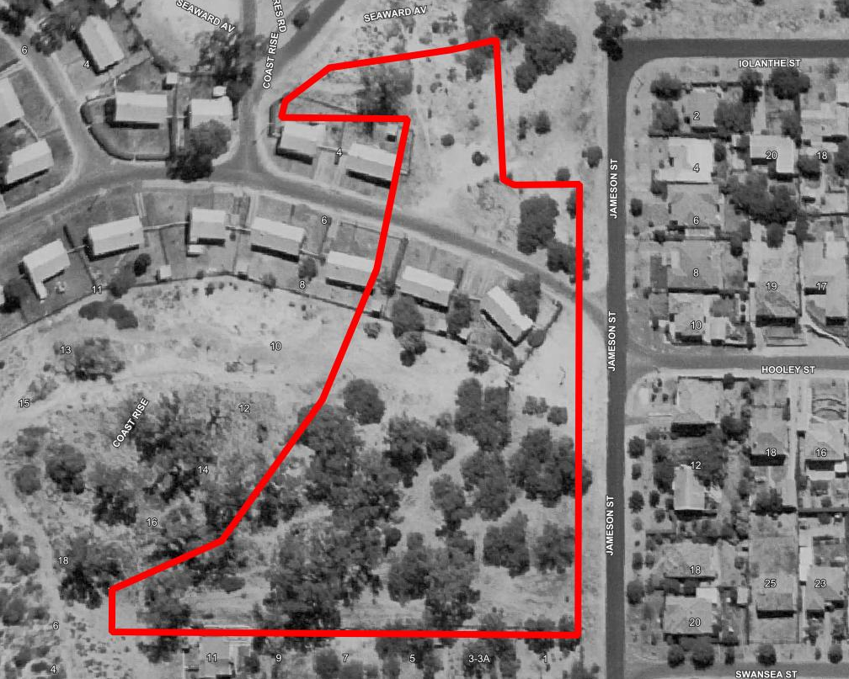
Figure 1: Aerial image taken in 1965, boundary of Jones Park is indicated in red
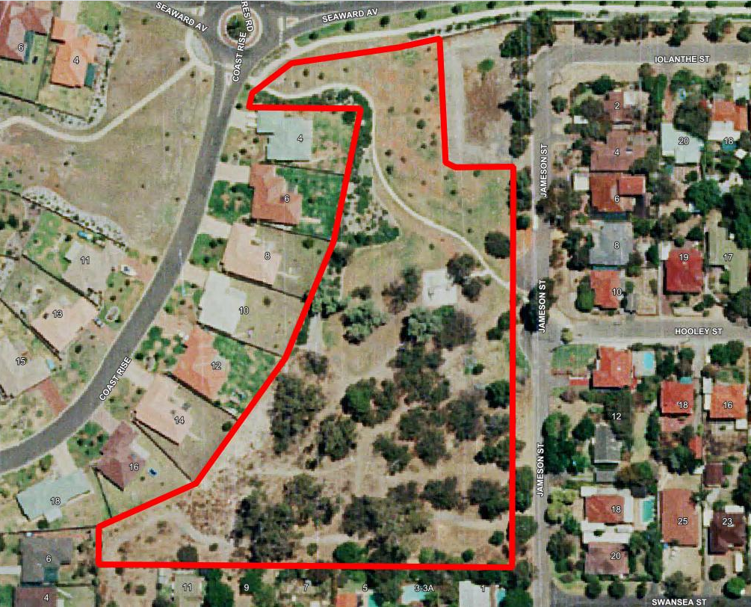
Figure 2: Aerial image taken in 1995, following development of ‘Seaward Village’

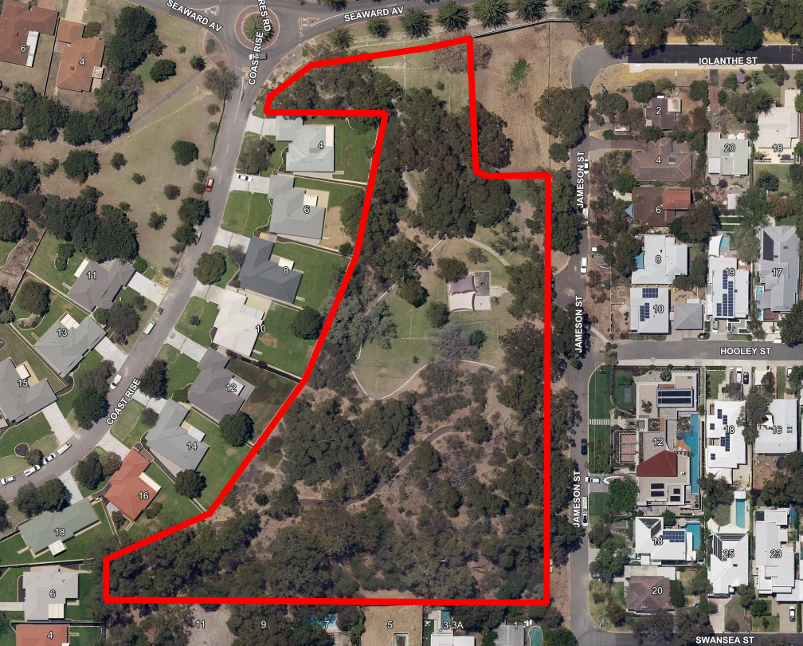
Figure 3: Aerial image taken in 2019, following commencement of Master Plan works
Jones Park bushland is connected to the Allen Park bushland and is proposed to be incorporated within the management boundary of the forthcoming Allen Park Bushland Management Plan 2019-2024. The bushland is managed and maintained by the City with the assistance of ‘Friends Group’ volunteers. Mapping and monitoring of the condition of the bushland is ongoing. The most recent condition rating of the bushland, completed in 2018, has indicated a slight decline in condition between the period 2012 and 2018 as illustrated in Figures 4 and 5 following.

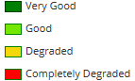
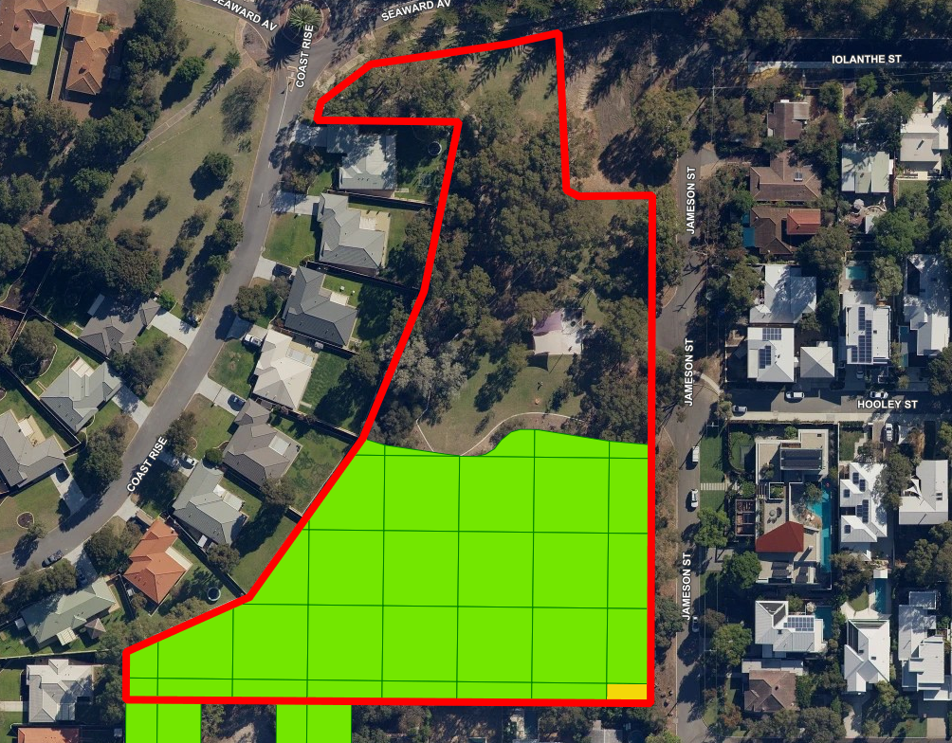
Figure 4: Jones Park - Bushland condition 2012

The bushland at Jones Park is not fenced to manage access at present. There are old pine post style bollards along Jameson Street which do not inhibit access. Areas of marginal degradation adjacent to the boundary of the bushland, abutting Jameson Street and the grassed parkland, correlates with where the highest level of unmanaged pedestrian access is likely to be occurring. The other area of degradation along the southern boundary of the bushland is where a firebreak is maintained, which is a statutory requirement.

Petition:

The primary reasons given in the petition for requesting the bushland conservation fencing around the bushland area at Jones Park not be constructed include:

- That the bushland area be kept natural and undeveloped.
- Residents were not clearly informed of the proposed fencing.
- The proposed fencing was not made clear on the plan made available as part of the community engagement period from 1 June 2018 to 2 July 2018.
- A fence would need frequent repair and, being a barrier, will be distorted or cut by people meeting the obstruction.
- Ball games are often played on the grass and retrieving lost balls would become a problem and potentially a hazard.
- It is thought a fence will not prevent dogs and children from accessing the bush areas.
- The area of bushland bounded by Jameson and Sayer Streets is too small and narrow to be self-sustaining and therefore needs to be treated differently than larger areas of bush.
- The City is wanting to enclose existing bush and nature with cement and fences and keep our kids out of the area.
- Children continue to use the bush and surrounding area without any further deterioration to the bush area.
- Bushland conservation fencing is not aesthetically pleasing to look at and will devalue properties in the area.

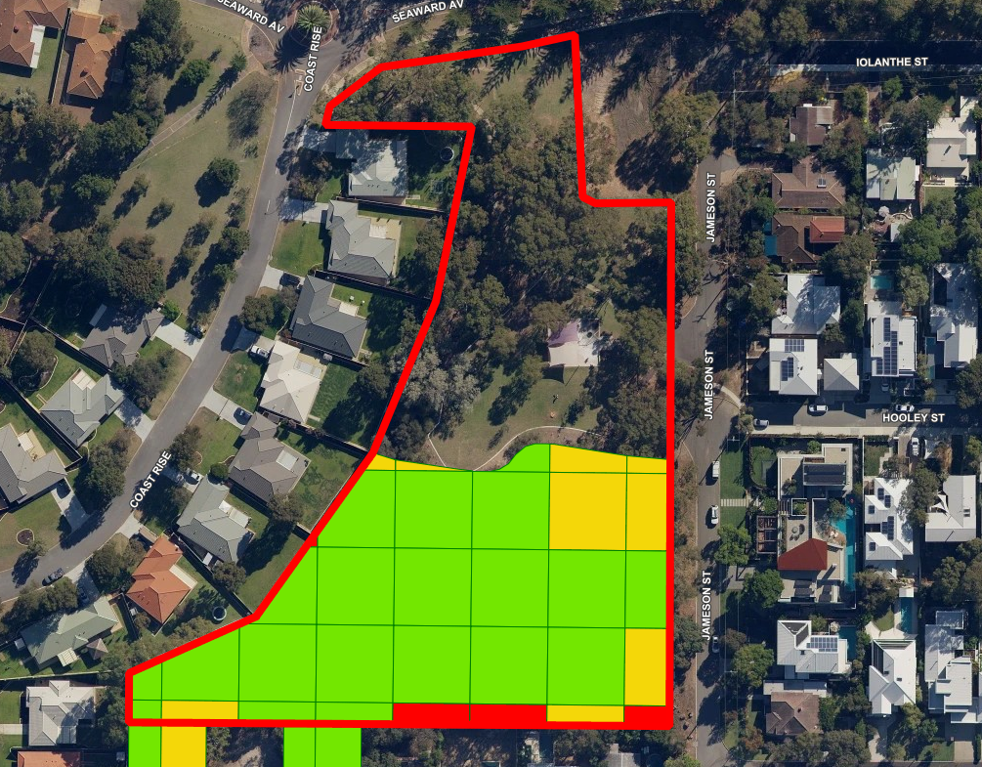
Figure 5: Jones Park - Bushland condition 2018

Having carefully considered the above reasons for not wanting the fence constructed, the Administration believes there is no evidence to support many of the claims.

Fencing Proposal:

The bushland conservation fencing proposed to be installed is the standard treated pine post and chain-wire fencing the City uses at bushland conservation sites (refer Figure 6). The intent of the proposed bushland conservation fencing is to deter direct access to the bushland from the road and parkland. The endorsed plan does not propose to enclose the bushland with fencing to prevent access entirely. The plan proposes to place fencing only along the boundary of the bushland that abuts Jameson Street and the grass where pedestrian traffic is highest.

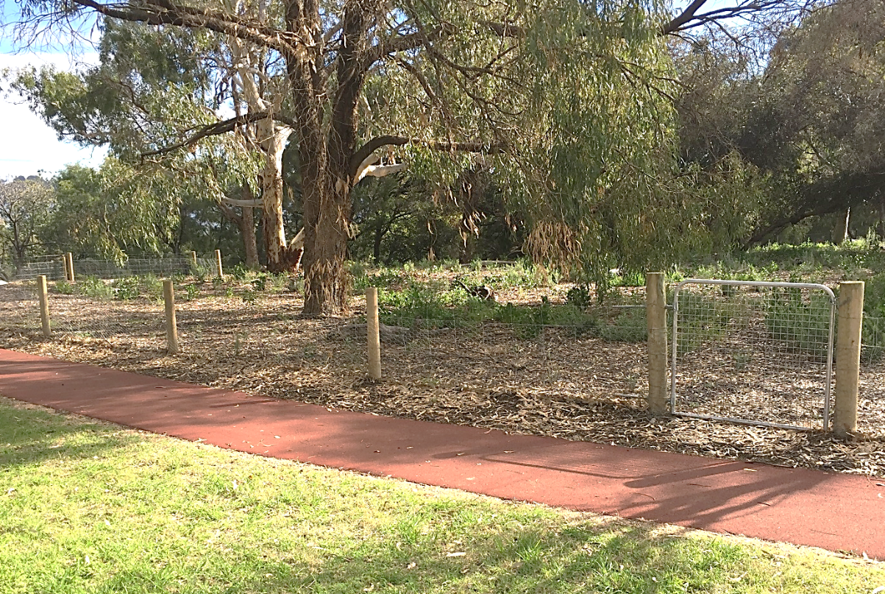
Figure 6: The City’s standard bushland conservation fencing (Point Resolution Reserve)

The City has advised that if the aesthetics of the fence is an issue, there are other options that can explored that will provide improved amenity. An example of this can be seen in Figure 7 below. One of the primary issues raised is that children will not be able to access the bushland for nature play based activities. The City has advised that the area of western garden bed could be removed from the proposed fenced area and planned as a nature play opportunity. A slight amendment to the alignment of the fence would provide this opportunity (refer to Figure 8 overleaf).

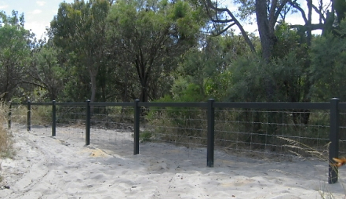
Figure 7: Potential alternative bushland fencing option, recycled plastic bollards with top rail

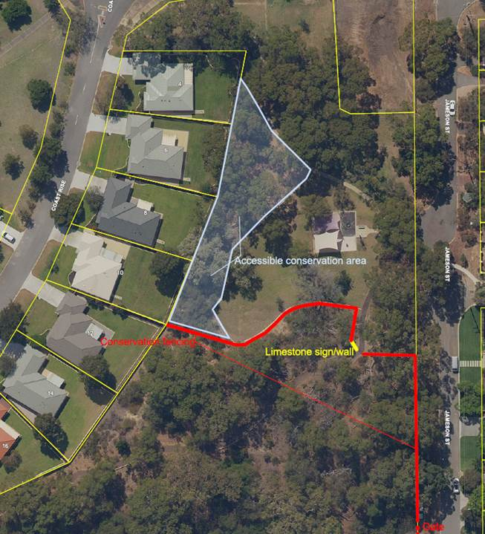
Figure 8: Potential Realignment of proposed fence providing natural play opportunities

Key Relevant Previous Council Decisions:

Ordinary Meeting of Council 28 August 2018, Item 12.3, Report TS19.18 – Jones Park Enviro-scape Master Plan

Council Resolution:

“Council endorses the Jones Park Enviro-scape Master Plan concept.”

Ordinary Meeting of Council 28 May 2019, Item 4.1, Petitions – Ms Barbara Leonard, 13 Hooley Street, Swanbourne – Bushland adjacent to Jones Park

Council Resolution:

“That Council receive the petition.”

Consultation

Extensive community consultation was undertaken in respect to both the Jones Park MP project and the Allen Park PMP project, in which Jones Park was included. The results of the community consultation for both projects were contained in the reports to Council seeking endorsement for both master plans.

Budget/Financial Implications

The works associated with the endorsed Jones Park MP have been included in the five (5) year capital work program and approved by Council to date through the budget process. The table below indicates the works that have been completed and the proposed works in future years. The bushland conservation fencing has Council approved funding for the current financial year.

Financial  Year | Project Description | Cost  (inc. on-costs) | Grant | Municipal | Status
2018/19 | Upgrade irrigation system and include hydro-zoning | $19,558 | $0 | $19,558 | Complete
2018/19 | Install 165 m of garden kerbing | $16,639 | $0 | $16,639 | Complete
2018/19 | Complete missing link in asphalt path | $21,405 | $0 | $21,405 | Complete
2018/19 | Install drinking fountain | $8,204 | $0 | $8,204 | In progress
2019/20 | Replace wooden bollards with recycled plastic bollards and install bushland fencing | $43,736 | $0 | $43,736 | Subject to this  report
2019/20 | Install junior basketball half court | $31,240 | $0 | $31,240 | In design
2020/21 | Upgrade stormwater sump | $98,000 | $0 | $98,000 | -
2022/23 | Replace bike racks (2) | $5,060 | $0 | $5,060 | -
 | TOTALS | $243,842 | $0 | $$243,842

TS17.19 Adoption of the Asset Management Strategy 2019 – 2029

Committee | 13 August 2019
Council | 27 August 2019
Applicant | City of Nedlands
Employee Disclosure under section 5.70 Local Government Act 1995 | Nil.
Director | Jim Duff – Director Technical Services
Attachments | - Draft Asset Management Strategy 2019-2029

Executive Summary

The purpose of this report is for Council to adopt the Asset Management Strategy 2019-2029 (AMS).

Recommendation to Committee

Council adopt the Asset Management Strategy 2019-2029 (AMS).

Discussion/Overview

Background

All local governments are currently required to produce a plan for the future under S5.56 (1) of the Local Government Act 1995. Regulations have been made under S5.56(2) of the Act to briefly outline the minimum requirements to achieve this.

Section 19DA(3)(c) of the Local Government (Administration) Regulations 1996 states that a Local Government must develop and integrate matters relating to resources, including asset management, workforce planning and long-term financial planning.

With regards to asset management, the Department of Local Government, Sport and Cultural Industries (DLGSCI) has developed guidelines to follow. The guidelines state the following:

“Asset management is critical to meeting local government strategic goals within an Integrated Planning and Reporting approach. Asset Management Policies, Asset Management Strategies and Asset Management Plans are informed by, and in turn inform, the community aspirations and service requirements in the Strategic Community Plan.”

History

On the 22 June 2010, Council adopted Built Facility Asset Management Policy, Asset Management Strategy and associated Asset Management Plans primarily for its building assets.

Council approved its current Asset Management Policy on the 27 November 2012 and was last reviewed on the 28 July 2015.

On the 6 March 2014, the Executive Management Team (EMT) approved a Strategic Asset Management Plan as a guiding document as to how administration would fulfill its legislative obligations in developing the City's asset management system. Its objectives were as follows:

- Set up single, live, operational asset register and asses data confidence;
- To obtain the value and condition data of all infrastructure asset classes;
- Develop the ability for predictive modelling on asset replacement/renewal for
incorporation into long term financial planning;
- Start developing individual asset management plans;
- To analyse data and report on assets in accordance with Australians Fair
Accounting Practice; and
- Review the document for adoption by Council when objectives have been met.

Conclusion

Administration has reviewed the outcomes of the original document and has developed the draft AMS for adoption by Council.

Key Relevant Previous Council Decisions:

Ordinary Council meeting 22 June 2010, item D34.10

“Council adopts the Built Facility Asset Management Policy, Asset Management Strategy and associated Asset Management Plans.”

Ordinary Council meeting 27 November 2012, item CPS48.12

“Council approves the following policies:

- Payments to Employees in Addition to Contract and Award;
- Responsibility for Matters Associated with the Administrative Structure of Council;
- Occupational Health and Safety;
- Asset Management;
- Rights of Way – Maintenance and Construction; and
- Nature Strip Development.

Ordinary Council Meeting 28 July 2015, item CPS18.15

“Approves the following reviewed policies:

- Trading in Public Places;
- Social Media;
- Development of Policies and Administrative Protocols;
- Asset Management; and
- Occupational Safety and Health.

Consultation

Administration used the Strategic Community Plan Nedlands 2028 for the basis of the public consultation needed as it is the master strategy that has had community input in its creation.

The Asset Management Coordinator has sought feedback and input from the Infrastructure Managers in developing this AMS.

Budget/Financial Implications

The development of this AMS was developed within the current Technical Services operational budget. Any further budget requirement that may arise with the adoption of this AMS would need to be addressed as part of the long-term financial planning and Council budgeting process.

TS18.19 Execution of Grant of Easement to the City of Nedlands

Committee | 13 August 2019
Council | 27 August 2019
Applicant | City of Nedlands
Employee Disclosure under section 5.70 Local Government Act 1995 | Nil.
Director | Jim Duff – Director Technical Services
Attachments | - Copy of letter from Kott Gunning Lawyers.  - Copy of Easement in Gross Documents.  - Map of lot 182 on Deposited Plan 21826, Montgomery Avenue, Mt Claremont.

Executive Summary

The purpose of this report is to approve the application of the Common Seal on a Grant of Easement for Lot 182 on Deposited Plan 21826, Montgomery Avenue Mt Claremont (Lot 182).

The Grant of Easement is to the City of Nedlands by the Water Corporation for the purposes of access to Daran Park (Reserve 45730), Mt Claremont.

Recommendation to Committee

Council

- approves the application of the Council Common Seal (seal) by the CEO on the Grant of Easement documentation for Lot 182 in triplicate; and

- directs the Mayor and Chief Executive Officer (CEO) to execute the Grant of Easement documentation in triplicate by way of signing.

Discussion/Overview

Background

Lot 182 is the subject of a transfer of land transaction (the transaction) between Landcorp and the Water Corporation, both State owned corporations.

The lot is currently held in freehold by Landcorp but has significant Water Corporation sewerage infrastructure within it. Lot 182 also has the access driveways in to Daran Park and the drainage sump, both City of Nedlands (the City) assets.

During the transaction negotiation between Landcorp and Water Corporation it was noted that whilst the City had access driveways in Lot 182, there was no formal agreement guaranteeing the City access rights. It was therefore agreed that as part of the transaction, formal access rights to the City, by way of a Grant of Easement to the City was required.

Action

Kott Gunning Lawyers (Kott Gunning), acting on behalf of Water Corporation, delivered the easement documents to the City by priority post on the 4 July 2019.

Once approved by Council, the seal will be applied to the easement documents in triplicate in presence of the Mayor and CEO, who are then required to sign the easement documents in triplicate. At this point the documentation is said to be executed by the City.

Once executed, the easement documents will then be hand delivered by an Administration officer to the offices of Kott Gunning. On receipt, Kott Gunning will arrange for the Water Corporation to execute their portion of the easement documents. Kott Gunning with then will undertake the lodging of the easement documents at Landgate.

Legislation

The Local Government Act 1995 states:

9.49A. Execution of documents

(1) A document is duly executed by a local government if —
(a) the common seal of the local government is affixed to it in accordance with subsections (2) and (3); or
(b) it is signed on behalf of the local government by a person or persons authorised under subsection (4) to do so.

(2) The common seal of a local government is not to be affixed to any document except as authorised by the local government.

(3) The common seal of the local government is to be affixed to a document in the presence of —

- the mayor or president; and

(b) the chief executive officer or a senior employee authorised by the chief executive officer, each of whom is to sign the document to attest that the common seal was so affixed.

(4) A local government may, by resolution, authorise the chief executive officer, another employee or an agent of the local government to sign documents on behalf of the local government, either generally or subject to conditions or restrictions specified in the authorisation.

Key Relevant Previous Council Decisions:

Ordinary Council meeting 23 April 2019

“Council:

1. approves the application of the Council Common Seal (seal) by the CEO on the Grant of Easement documentation in triplicate for Lot 416 (No. 1) Heritage Lane Mt Claremont; and

2. directs the Mayor and Chief Executive Officer (CEO) to execute the Grant of Easement documentation in triplicate by way of signing.”

Consultation

Negotiations were undertaken between Landcorp and the Water Corporation. Further negotiations were then undertaken between the Water Corporation and Administration, with the CEO approving the wording to the easement documents.

Budget/Financial Implications

Nil.

