Corporate & Strategy Reports

Committee Consideration – 13 July 2021
Council Resolution – 27 July 2021

Table of Contents

Item No. Page No.

CPS14.21 Lease to Floreat Community Pre-Kindy Inc. 2
CPS15.21 Procurement of Goods and Services Council Policy Review 13

CPS14.21 Lease to Floreat Community Pre-Kindy Inc.

Committee | 13 July 2021
Council | 27 July 2021
Applicant | City of Nedlands
Employee Disclosure under section 5.70 Local Government Act 1995 | Nil.
Director | Andrew Melville – Acting Director Corporate & Strategy
Attachments | - Floreat Community Pre-Kindy Inc. – Proposal and Business Plan; and  - Letter of Support – Floreat Toy Library
Confidential Attachments | Nil.

Executive Summary

The Business Owner of Annie’s Playschool (‘Annie’s’) who currently lease the Strickland Street Infant Health Clinic, located on Strickland Street, Mount Claremont has advised the City that she intends to terminate her lease which expired on 30 June 2021.

In order for the valued service which is currently being offered to the community to continue, in May 2021, the three-teachers (the ‘Applicants’) currently employed at Annie’s formed the Floreat Community Pre-Kindy Inc. (‘FCPK’) as a not-for-profit incorporated association.

Due to the ongoing constraints at the 25 Strickland Street site and regulations imposed on Annie’s by the Education and Care Regulatory Unity (‘ECRU’), the FCPK committee have submitted a formal proposal to the City requesting to undertake a lease at the recently vacated Hackett Play Centre site which is located on Draper Street in Floreat.

Council is now asked to consider a new lease being awarded to FCPK for the exclusive use of the Hackett Play Centre consistent with the key terms as noted within this report.

Recommendation to Committee

Council:

- approves an exclusive use lease for the Hackett Play Centre site between the City of Nedlands and Floreat Community Pre-Kindy Inc. consistent with the key terms as noted within this report;

- subject to the Minister for Lands Consent, authorises the CEO and Mayor to execute the lease agreement and apply the City’s Common Seal; and

- requests the CEO to provide a further report detailing options for the future use of the Strickland Street Infant Health Centre.

Voting Requirement

Simple Majority

Discussion/Overview

Background

Cherie Lewis, (‘Business Owner’) of Annie’s Playschool (‘Annie’s’) entered into a lease agreement with the City for exclusive use of the Strickland Street Infant Health Clinic located on Strickland Street in Mount Claremont on 1 July 2014. The lease agreement expired on 30 June 2021 and the City has now invoked the ‘holding over’ provision within the lease agreement.

At the Ordinary Council Meeting of September 2020 (Item 16.1), Council endorsed an 18-month extension of the lease to the Business Owner. However, when working through the finer details of that decision, in April 2021, the three teachers employed by Annie’s (the ‘Applicants’) advised City officers that discussions had taken place over the past few months between the Business Owner and the Applicants about the Business Owner’s intent to cease her involvement with the business.

On 14 April 2021, officers had verbal confirmation of the above discussions with the Business Owner as the leaseholder, and this was later confirmed in writing on 3 May 2021. In this correspondence, the Business Owner advised that her heart was ‘bursting to know that the playschool service may continue’ and that she was willing to continue the lease on a ‘holding over’ provision until a transition takes place.

In the time since, the Applicants have investigated numerous options available to ensure the service remains available to the local community.

The Service

The service currently being offered to the community by Annie’s is much valued. The service provides the community with education and care which assists young children with their transition into a formal school curriculum.

The demands of the modern school curriculum mean that parents are frequently looking for an early education service which is a beneficial alternative to long form day-care.

The learning programs offered are led by qualified and experienced primary and early learning teachers and are guided by the National Quality Framework which provides a national approach to regulation, assessment and quality improvement for early childhood education and care across Australia.

The activities offered are based upon a ‘learning through play’ philosophy which focuses on each child’s learning journey through real life experiences in nature and social interaction in a relaxed and intimate setting. The service is also unique in that it offers flexibility of days and hours.

Strickland Street Infant Health Clinic

The Strickland Street Infant Health Clinic is currently leased to provide the playschool service. The facility is not purpose built and is considered an ageing asset. The facility is located within a parcel of land owned in freehold by the City which also includes a public playground. Although this playground is not part of the current lease area and is strictly not for ‘exclusive use’ by the tenant, it is acknowledged that the playground is used most days by the members of the playschool and the greater community.

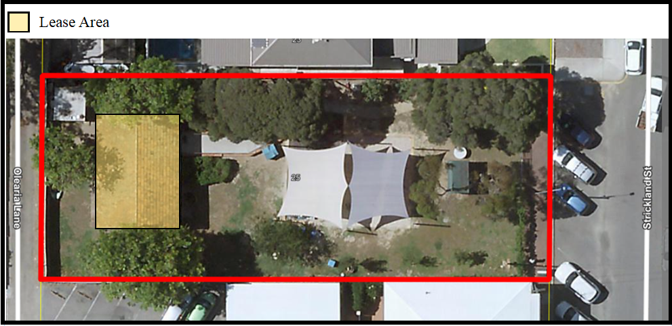

The Department of Communities’ Education and Care Regulatory Unity (‘ECRU’) are the regulatory body for all education and care services under the State of WA’s Education and Care Services National Law (WA) Act 2012 and the Education and Care Services National Regulations 2012. Throughout the current lease term, the tenant has battled with ECRU about the site’s suitability given the non-exclusive nature of the playground area and lack of fencing which could provide exclusive use. Each year, the tenant is having to apply for exemptions, and this has proved more and more difficult each year.

The Business Owner has on numerous occasions over the years approached officers about the possibility of exclusive use of the playground in order to satisfy ECRU requirements. This has been declined each time on the basis that the playground and park area be available to the public.

Without significant modifications to the lease arrangement (being fencing or exclusive use of the playground area), ECRU have advised the Applicants in writing on 10 March 2021 that similar exemptions as in the past would not be supported, ultimately deeming the Strickland Street site no longer suitable for playschool purposes if a transfer of business was to take place.

Hackett Play Centre

Following discussions with City officers in April, and in conjunction with advice from ECRU, the Applicants began investigating alternate sites from which the service could continue to operate. The Hackett Play Centre in nearby Floreat was identified as potential site given its purpose-built nature with its former use being a community pre-school. Critically, this facility has a fenced playground area which could be used exclusively by any prospective tenant.

The Hackett Play Centre is one of three City-owned occupiable assets on what is known as Lawler Park. The land itself is vested to the City for care and control via Management Order for the purposes of ‘Kindergarten, Infant Health Clinic, Children’s Playground and Park’.

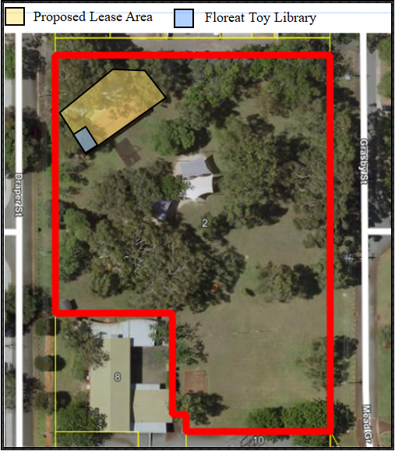

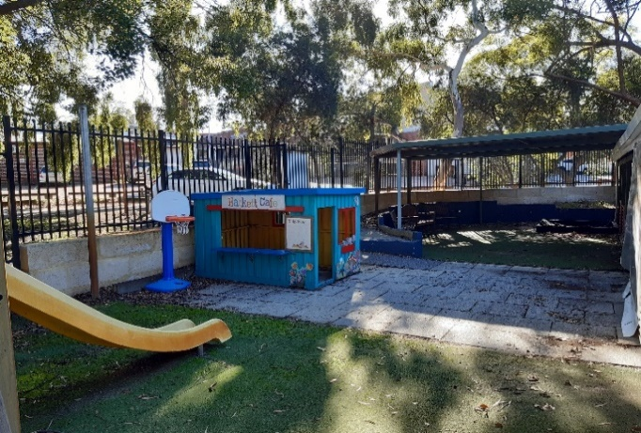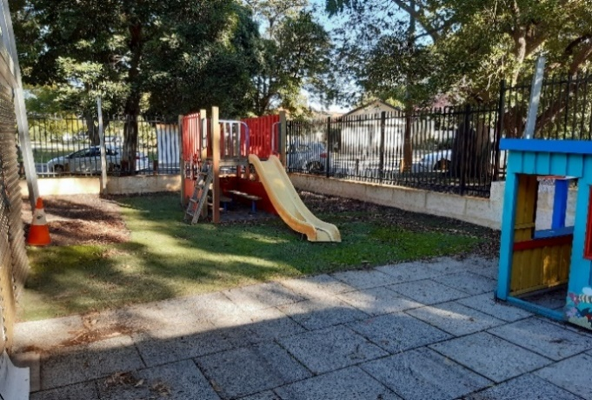

Hackett Play Centre has most recently been used by both the Hackett Playgroup and Floreat Toy Library. However, following the recent sewerage issue at the facility which rendered the building closed from July 2020 to March 2021, the Hackett Playgroup has since amalgamated with another playgroup outside the City of Nedlands, and no longer operates from the facility. The Floreat Toy Library have recently recommenced operations from one room of the facility, for 2-hours per week on a Saturday morning, one weeknight per month for committee meetings, and 2-days per year for stock-take purposes. At present, the facility remains vacant at all other times.

Floreat Community Pre-Kindy Proposal

On 13 May 2021, the Applicants advised that they had officially formed an incorporated association under the Associations Incorporations Act 2015 and were intending to seek Council’s approval to operate from the Hackett Play Centre site as a not-for-profit entity offering the same playschool service as was previously offered at Strickland Street. The title of the incorporated association is Floreat Community Pre-Kindy Inc. (‘FCPK’)

On 4 June 2021, the above advice was followed by a formal proposal from FCPK to the City and included a detailed business plan (the ‘Proposal’). The Proposal (Attachment 1) includes details of the FCPK structure, their aim for providing a valuable service to the community, their background, details about the service to be offered (including statutory obligations), projected profit and loss statements and overall, their commitment to the City and greater community should their proposal be acceptable.

Due Diligence

The advantages and disadvantages associated with the proposal are described in the table below.

Advantages | Disadvantages
The playschool service being currently offered by Annie’s would continue to be offered to the community (via FCPK) | Nil
Hackett Play Centre is purpose built and would be utilised at a greater capacity | Strickland Street Infant Health Clinic would become vacant
ECRU would be supportive of the change in site and exemptions to operate would not be necessary | Nil
Floreat Toy Library are excited at the opportunity to collaborate with FCPK and may benefit from increased numbers | Nil
Nil | The City would lose rental revenue from the Strickland Street Infant Health Clinic site which has been estimated at $11,750* for 2021/22.  *Note, this revenue would not be realised if the Business Owner chose to terminate the lease anyway
The City would no longer be liable for maintenance or cleaning costs at Hackett Play Centre (estimated savings of $13,700pa) | Pending Council’s decision on future use, the City may be liable for maintenance and cleaning costs at Strickland Street Infant Health Clinic (estimated costs $10,000-$15,000pa)
FCPK are a known entity. Although they are a new incorporation, their history with the City is lengthy and their understanding of the City’s expectations of its tenants is strong. | Nil

Should Councillors choose to support the recommendation, the actions and details below are proposed to mitigate any disadvantage that has been identified.

- It is noted the Strickland Street Infant Health Clinic would become vacant. However, as part of the recommendation, Administration would be instructed to provide a further report to Council outlining future options for this site.
- It is noted that the City would lose approximately $11,750 in rental revenue for the 2021/22 financial year. However, Councillors are advised that should the Business Owner choose to terminate the lease (as is her intention), this revenue would not be realised anyway.
- It is noted that the Strickland Street Infant Health Clinic, pending future use, may require maintenance and cleaning (at an estimated cost of $10,000-$15,000pa). Councillors are advised this cost would be offset by the savings the City would realise by not having to maintain the Hackett Play Centre estimated at $13,700pa).
- In addition, generally, when Council’s choose to enter into a new lease agreement with not-for-profit groups, they want to ensure the asset will be maintained. Although FCPK are a new incorporation, they are a known quantity to the City and they have a sound understanding of the City’s expectations. Within their Proposal, FCPK have clearly identified the requirements to adequately budget for building maintenance and other costs associated with undertaking a lease from the City of Nedlands.

Consultation

Once Hackett Play Centre was identified by FCPK as the site they wished to utilise in order to operate the service to the community, it was necessary that current occupants, Floreat Toy Library would need to be consulted. On 14 May 2021, officers arranged a meeting between Floreat Toy Library, FCPK and City representatives to discuss the opportunity. The meeting was positive and both parties were enthusiastic to create a new collaborative relationship. City officers advised that any agreement of tenure between FCPK and the City would need to acknowledge the current use of the site by Floreat Toy Library in and for safety of the children, any usage of the building by either group would need to be strictly exclusive (i.e. both groups would not be permitted to operate from the building at the same time).

Floreat Toy Library were welcoming of the opportunity and have provided documented support to both the City and FCPK of this arrangement. A copy of this can be viewed in Attachment 2.

In addition, FCPK have communicated the possible change to their current members, and City officers have been advised this information has been received with unanimous support. FCPK have also advised that ‘parents are excited’. Without this support, the move would not be viable.

Key Terms

Consistent with the City’s ‘Use of Council Facilities for Community Purposes’ Policy, should Council choose to support the recommendation, McLeod’s Barristers and Solicitors can be asked to prepare a draft lease agreement based on the Key Terms following:

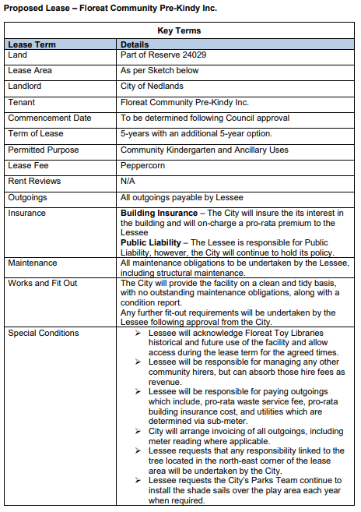
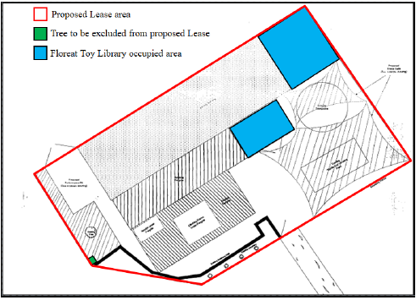

As noted in the Special Conditions, the only variation to Council’s policy is the exclusion of the tree located on the western boundary of the lease premises and the continuation of shade sail erection each summer. Whilst the maintenance of this tree and the shade sails would normally be included as a tenant responsibility as it is within the lease area, FCPK have specifically asked for this tree to be removed from the proposed lease. The rationale for the request is due to the safety concern the tree presents when considering its proximity to the asset and the playground where children will frequent. FPCK have advised they would be comfortable in proceeding with a lease, should the City bear responsibility of this tree. The City’s Parks service has advised they support the requests, as the City maintains the tree and shade sails as existing City assets.

Key Relevant Previous Council Decisions

Item 16.1, 22 September 2020 – Council approved an 18-month extension on the Lease to Cherie Lewis. This extension was never executed due to a change of circumstances.

Consultation

Upon receiving the Proposal from FCPK, consultation was completed with the City’s internal teams to identify any risks and confirm that there are no concerns with the Proposal.

Planning Services

The City’s Planning Service has advised that based on the merits on what has been proposed, planning approval will not be required and there are no objections.

This is on the basis of:
- The Management Order for Reserve 24029, issued on 22 September 2014, has provided conditions. Those conditions relate to the site being used for ‘Kindergarten, Infant Health Clinic, Children’s Playground and Park’. The use proposed is consistent with the Management Order conditions and consistent with the zone objectives for the site.
- There is an existing building with parking, where there has historically been used for ‘Kindergarten, Infant Health Clinic, Children’s Playground and Park’ purposes. The use is a continuation of that and is consistent.
- Based on the number of staff and parking to the north, the parking available will be able to accommodate the children, staff, parents during drop off and pickup times.

Community Development

Community Development support of the proposal to enter into a lease with the Floreat Community Pre-Kindy at the Hackett Play Centre. It is acknowledged that the change will have an impact on the Floreat Toy Library who currently use the building.

To ensure the impact is minimal, the following conditions will be included in the Floreat Community Pre-Kindy’s lease:

- The Floreat Toy Library’s hours of use will be stated in the lease.
- The Floreat Toy Library will have access to the entire building for their hours of use.
- The Floreat Toy Library’s fee will be set in Council’s fees and charges.

The Floreat Toy Library have been consulted and are in support of the proposal.

Land and Property

The City’s Coordinator Land and Property has confirmed that there is no objection to the Proposal. With the exception of the minor variation surrounding one tree on the western boundary of the proposed lease area, the Key Terms as noted within this report are consistent with the City’s ‘Use of Council Facilities for Community Purposes’ Policy.

Most importantly, the agreement will protect the City’s interest in the facility whilst acknowledging and protecting the interests of the current occupant, Floreat Toy Library.

Strategic Implications

Councils support of this recommendation will ensure a community organisation operating within the district can strengthen its capacity to meet both its own, and the community’s needs.

This aligns with the Great Governance and Civic Leadership Value within the City’s Strategic Community Plan which values quality decision making by Council and involving the community in decision making.

Who benefits?
The members of FCPK will benefit from this initiative. The approved change will also assist FCPK in engaging new members and increasing the services offered to the community. This will also assist the current occupants, Floreat Toy Library, to collaborate with another community group and widen their reach within the community.

Does it involve a tolerable risk?
There is minimal risk associated with support of this recommendation. The Proposal is compliant with all planning regulations and is consistent with historical uses of the facility and the City’s Use of Council Facilities for Community Purposes’ Policy.

The cost of maintaining the Hackett Play Centre facility, estimated at $13,700pa, which is currently being met by the City will be passed on to the tenant, however any savings will be offset by the City having to absorb the costs of maintaining the Strickland Street Infant Health Clinic which is estimated to cost between $10,000 & $15,000pa.

By supporting this recommendation, Council will also recognise a loss of rental income in 2021/22 of approximately $11,750. It is important to note that this rental income is unlikely to have been realised, given the Business Owner’s intent to terminate the lease.

The risk of losing the service to the community will be mitigated by supporting this recommendation.

Do we have the information we need?
Yes. All relevant information has been presented to Councillors.

Budget/Financial Implications

Support of this recommendation will result in a loss of $11,750 rental income. However, this rent is unlikely to have been realised regardless, given the Business Owners intent to terminate the lease.

Can we afford it?
The loss of rental income is considered minimal and is not something Council can control.

How does the option impact upon rates?
The impact on rates would be negligible.

Conclusion

The recommendation presented to Councillors supports the continuance of an important community service that the City is at risk of losing in the very near future (due to the Business Owner advising her intent to close the business) Essentially, the service is simply being shifted from one asset to another.

The Applicant in their Proposal has demonstrated that the ability to relocate the playschool service will have various advantages for the service itself and the greater community.

This recommendation will render a facility with long term occupation as vacant. It is important to note that Council has had a number of discussions previously on appropriate uses for this site, and this provides an opportunity for Council to investigate all options for the future use of this facility, and the site generally.

CPS15.21 Procurement of Goods and Services Council Policy Review

Committee | 13 July 2021
Council | 27 July 2021
Applicant | City of Nedlands
Employee Disclosure under section 5.70 Local Government Act 1995 | Nil.
Director | Andrew Melville – Acting Director Corporate & Strategy
Attachments | - Procurement of Goods and Service Council Policy
Confidential Attachments | Nil.

Executive Summary

The Procurement of Goods & Services Council Policy has been reviewed and suggested updates included to the content as part of an annual review process. The current Policy was prepared and endorsed by Council in April 2020. That revised Policy was prepared with very short notice to reflect an emergency amendment to Local Government (Functions & General) Regulations published at that time.

Due to the short time available for the April 2020 review, the Policy was further reviewed after a twelve-month period to assess its efficacy over the preceding 12 months. A number of amendments were made, and a tracked copy of the Policy is attached identifying these for the Committee’s consideration.

The report is presented to inform the Council of these amendments and enable Council to review and approve the updated policy.

Recommendation to Committee

Council adopts the updated Procurement of Goods and Services Policy, as per attachment 1.

Voting Requirement

Simple Majority.

Discussion/Overview

Due to the haste in which the revised Policy was produced in April 2020, it was considered prudent to revise it again after a 12 months period in use to address any areas in which it was found to be lacking in content or in detail.

The review addresses all areas of the policy document, and the following amendments are recommended:

- Statement
The original policy Statement was inadequate, and it has been expanded to better capture the principles and purposes the City wants from its procurement activities.

- Thresholds
The thresholds retain the same monetary values but the procedures within the spending limits have been altered to align with what is both current practice and expected efficiencies.

- Form of Quotation
The changes made reflect improvements made to the process for obtaining quotations from suppliers.

- Panels of Pre-Qualified Suppliers
Wording has been modified to reflect organisational expectations and provide improved alignment with the Regulations.

- Quotation Exemptions
The quotation exemption of WALGA Preferred Suppliers was excluded from the original Policy. This is due to the City not being a WALGA member at the time that the original Policy was written.

- Variations
The processing of Variations on contracts was unclear and was causing operational problems. The changes reflect a need to provide better definition and improved clarity on what is reasonable to approve and at what level it can be authorised.

Contract variations are generally not large value transactions. The operational need to streamline these processes should align with the level of risk exposure to the City, ensuring contracts are managed effectively. Higher level transactions are captured with existing organisational procedures. In construction contracts there are often contractual obligations which require essential variations to be processed within “reasonable” timeframes so as not to incur additional costs or delays in contract delivery.

The amendments made allows for the majority of variations to be processed quickly and with appropriate oversight.

- Value for Money
As this is the overarching principle for all public sector spending, extra definition has been provided.

Key Relevant Previous Council Decisions:

Special Council Meeting,14 April 2020

“Council Resolution

In response to the Coronavirus Disease 2019 (COVID 19), Council:

14. approves an amendment to the City of Nedlands Purchasing of Goods and Services Policy as per Attachment 2, on the condition that the Local Government (Functions and General) Regulations 1996 are amended to a $250,000 tender limit;”

Audit & Risk Committee Meeting, 31 May 2021.

“Committee Recommendation / Recommendation to Committee

The Audit and Risk Committee recommends that Council adopts the updated Procurement of Goods and Services Policy, as attached to this report.”

Consultation

Consultation not required.

Strategic Implications

The revised Policy will contribute towards the delivery of good governance.

Improved operational efficiency and value for money outcomes will benefit all residents.

The revised Policy will contribute to a significant reduction in procurement associated risks.

City officers are satisfied that they have identified relevant issues and the revised Policy will deliver a benefit to the City.

Budget/Financial Implications

The revised Policy will address the principles of best practice procurement and the delivery of value for money to the City and by extension deliver benefits to the community.

Conclusion

The Procurement of Goods & Services Council Policy has been reviewed by the City’s administration and a number of amendments are proposed. These are put to the Audit and Risk Committee for consideration.

