

Planning and Development Reports

Committee Consideration – 13 July 2021

Council Resolution – 27 July 2021

Table of Contents

Item No. Page No.

PD23.21 Consideration of Development Application – Carport Addition & Driveway at 10 Cygnet Crescent, Dalkeith…………2

PD24.21 Consideration of Development Application for a Change

of Use from ‘Animal Establishment’ to ‘Industry-Light’ at

29 Carrington Street, Nedlands……..……………………………9

PD25.21 Consideration of Development Application - 6 Aged and Dependent Persons’ Dwellings at Lot 100 Montgomery

Avenue, Mt Claremont…………...…………………………….…18

PD26.21 Consideration of Street Tree Removal at 22 Pine Tree

Lane, Mt Claremont……………..………………………….….….26

|  |  |
| --- | --- |
| **PD23.21** | **Consideration of Development Application – Carport Addition & Driveway at 10 Cygnet Crescent, Dalkeith** |
|  | |
| **Committee** | 13 July 2021 |
| **Council** | 27 July 2021 |
| **Applicant** | S and D O’Keeffe |
| **Landowner** | S and D O’Keeffe |
| **Director** | Tony Free – Director Planning & Development |
| **Employee Disclosure under section 5.70 Local Government Act 1995 and section 10 of the City of Nedlands Code of Conduct for Impartiality.** | The author, reviewers and authoriser of this report declare they have no financial or impartiality interest with this matter.  There is no financial or personal relationship between City staff and the proponents or their consultants.  Whilst parties may be known to each other professionally, this relationship is consistent with the limitations placed on such relationships by the Codes of Conduct of the City and the Planning Institute of Australia. |
| **Report Type**  Quasi-Judicial | When Council determines an application/matter that directly affects a person’s right and interests. The judicial character arises from the obligation to abide by the principles of natural justice. Examples of Quasi-Judicial authority include town planning applications and other decisions that may be appealable to the State Administrative Tribunal. |
| **Reference** | DA21/63007 |
| **Previous Item** | Nil |
| **Delegation** | In accordance with the City’s Instrument of Delegation, Council is required to determine the application due to an objection being received. |
| **Confidential Attachments** | 1. Plans 2. Submission 3. Assessment |

1. **Executive Summary**

The purpose of this report is for Council to determine a Development Application received on 13 April 2021, for a Carport at No.10 Cygnet Crescent, Dalkeith.

The application was advertised to adjoining landowners and occupiers in accordance with the City of Nedlands Local Planning Policy (LPP) – Consultation of Planning Proposals due to street setbacks, lot boundary setbacks and the location of the driveway. At the close of the advertising period, one objection was received.

As an objection has been received, this application is presented to Council for determination.

It is recommended that the application be approved by Council as it is considered to satisfy the design principles of the Residential Design Codes (R-Codes) Volume 1 and is unlikely to have a significant adverse impact on the local amenity.

**Recommendation to Committee**

**In accordance with Clause 68(2)(a) of the Deemed Provisions of the *Planning and Development (Local Planning Schemes) Regulations 2015,* Council approves the development application received on 13 April 2021 in accordance with plans date stamped 30 June 2021 for a Carport and Driveway at Lot 819 (No. 10) Cygnet Crescent, Dalkeith subject to the following conditions:**

1. **This development approval only pertains to the addition of a Carport and Driveway as indicated on the determination plans.**
2. **All sides of the carport shall remain open and shall not accommodate a door.**
3. **All building works to be carried out under this development approval are required to be contained within the boundaries of the subject lot.**
4. **All stormwater from the development, which includes permeable and non-permeable areas shall be contained onsite; and**
5. **The development shall at all times comply with the application and the approved plans, subject to any modifications required as a consequence of any condition(s) of this approval.**

**Voting Requirement**

Simple Majority

1. **Background**

**2.1 Land Details**

|  |  |
| --- | --- |
| **Metropolitan Region Scheme Zone** | Urban |
| **Local Planning Scheme Zone** | Residential |
| **R-Code** | R10 |
| **Land area** | 1,237m2 |
| **Land Use** | Residential – Single House |
| **Use Class** | ‘P’ - Permitted |

**2.2 Locality Plan**

The subject lot is located at No.10 Cygnet Crescent, Dalkeith and is zoned ‘Residential’ with a density coding of R10. The area is surrounded by existing two-storey houses, some of which include carports and garages in the front setback area.

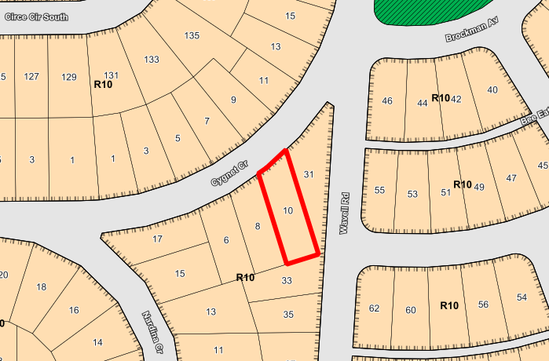

The subject lot has an existing two storey single house and a dual semi-circle driveway which connects from the west and east of the site. Access to the property is via Cygnet Crescent. The site is relatively flat and slopes down approximately 1.5 metres from east to west.

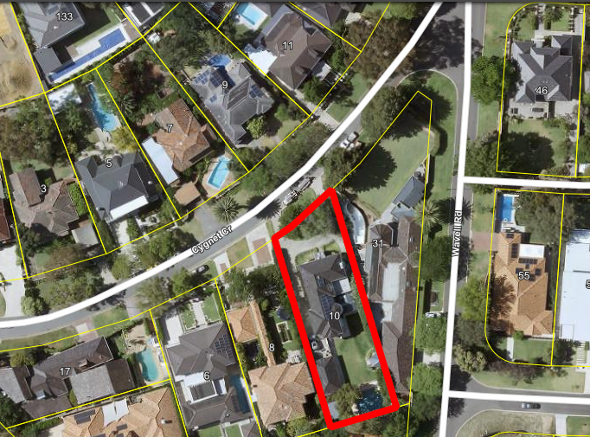

1. **Application Details**

The application seeks development approval for a double carport situated in the front setback area and associated extension to the driveway. The carport is proposed to be located in the north-east of the site, with a minimum setback of 1.7m from Cygnet Crescent.

1. **Consultation**

The application is seeking assessment under the Design Principles of the R-Codes for the following:

* Setbacks of Garages and Carports
* Vehicle Access

The application was advertised in accordance with the City’s Local Planning Policy - Consultation of Planning Proposals to the owners and occupiers of five adjoining properties. The advertising period was for 14 days from 17 May 2021 to 31 May 2021. At the close of the advertising period, one objection was received. The main concerns raised are:

* The removal of the existing letter box and retaining wall, which adjoin an existing dividing wall, may have implications for the structural integrity of the wall;
* The proximity of the carport to the lot boundary, design of the carport, impacts of building bulk and overshadowing; and
* Impact of carport on streetscape and character of surrounding area.

*Note: A full copy of all relevant consultation feedback received by the City has been given to the Councillors prior to the Council meeting and contained in Confidential Attachment 2.*

**4.1 Amended Plans**

Following the advertising of the application and receipt of the objection, the applicant sent amended plans to the City on 30 June 2021. The amended plans provide an increased setback to the eastern lot boundary. The carport now proposes a 1.0m setback to the eastern lot boundary. Originally, the carport proposed a 0.6m setback to the eastern lot boundary. With the amended plans, the carport now achieves the deemed to comply requirements under the Residential Design Codes (R-Codes) for lot boundary setbacks.

**4.2 Summary of Consultation**

The following is a summary of the concerns/comments raised from the neighbour consultation and the City’s response and action taken in relation to each issue:

1. Concerns relating to the modifications to the existing retaining, letterbox and garden beds to allow for the proposal which form part of the existing dividing wall between 31 Wavell Road and 10 Cygnet Crescent.

* To allow for the development of the carport, the garden beds and letterbox will need to be removed. The structural integrity and engineering for the changes to the retaining and dividing fence will be assessed during the Building Permit stage where there is a ‘Notifiable Event’ through the BA20a Form.

1. Proximity of carport to lot boundary and resultant impacts of building bulk, overshadowing, vehicle noise and negative amenity to the adjoining property’s outdoor living area and swimming pool.

* Following the advertising period, the City has received amended plans for the carport proposal which now provides a 1.0m setback to the eastern lot boundary. The application is now fully deemed to comply with the R-Codes for the required setback to the eastern lot boundary.
* No further action is required.

1. Development negatively impacts the streetscape and is out of character of the surrounding area.

* A detailed Design Principles assessment for Clause 5.2.1 – Setbacks of Garages and Carports is provided at Section 5.2.1 of this Report.

1. The submitters note the carport proposal could be supported with design changes such as reducing the size of the double carport into a single carport, repositioning the carport to retain the garden beds and letterbox, situate carport to other side of semi-circular driveway, reduction in height of the pitch to the maximum boundary wall height.

* The applicants provided amended plans for the carport proposal which now provides a 1.0m setback to the eastern lot boundary in lieu of 0.6m as originally proposed by the development.
* The location of the carport abuts an existing boundary wall which has a total height of 3.6m from the ground level at the subject property. The carport has a total height of 4.0m at the northern elevation. The portion of the carport pitch that will be visible from the adjoining lot above the boundary wall is 0.4m. As shown in image below in blue, the total area of the carport that will be visible above the dividing boundary wall is 0.1m2 from the northern elevation.

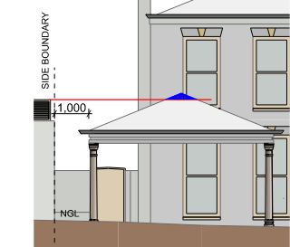

1. **Assessment of Statutory Provisions**

**5.1 Planning and Development (Local Planning Schemes) Regulations 2015**

Clause 67(2) of the Deemed Provisions stipulates those matters that are required to be given due regard to the extent relevant to the application. Where relevant, these matters are discussed in the report. In accordance with provisions (m) and (n) of the Regulations clause 67(2), due regard is to be given to the likely effect of the proposed development’s height, scale, bulk and appearance, and the potential impact it will have on the amenity of the locality.

**5.2 State Planning Policy**

**5.2.1 State Planning Policy 7.3 – Residential Design Codes (R-Codes) – Vol 1**

State Planning Policy 7.3 Residential Design Codes Volume 1 (R-Codes) apply to all single and grouped dwelling developments. An assessment under the R-Codes can be undertaken in one of two ways. This is by either meeting the deemed-to-comply provisions or via a Design Principle assessment pathway. The applicants are seeking a Design Principle assessment pathway for this proposal. An assessment is sought under the Design Principles for the R-Codes for Setbacks of Garages and Carports and Vehicular Access. All other areas are fully compliant with the deemed-to-comply provisions.

**Clause 5.2.1 – Setbacks of Garages and Carports**

The carport proposes a minimum setback of 1.7m to the primary street in lieu of 3.5m. The development is considered to meet the Design Principles as –

* The carport is considered to contribute to an established streetscape which displays a variety of intrusions into the front setback area, including carports at No. 3 and No. 7 Cygnet Crescent, Dalkeith;
* Due to the angle of the lot boundary addressing the street, the minimum carport setback is 1.7m however the eastern carport post is setback 4.5m from the primary street. As an average setback, the carport proposes a 3.1m setback to the primary street in lieu of 3.5m. With an average setback consideration, the carport is considered to be setback from the street boundary at an appropriate distance;
* The carport incorporates design features such as a pitched roof so as to complement the existing two storey residence with a pitched roof design. The pitched roof will contribute to the character of the development of the subject lot from the streetscape;
* The carport location allows for the maintenance of clear sight lines across the street; and
* Due to the curvature of Cygnet Crescent, the eastern lot boundary of the subject site is approximately 8m longer than the western lot boundary. The carport location along the eastern lot boundary abutting the existing 3.6m high boundary wall is considered to be an appropriate location so as not to detract from the streetscape or appearance of the dwellings. The carport does not obstruct views from the dwelling to the street and vice versa.

**Clause 5.3.5 – Vehicle Access**

The driveway proposes a nil setback to the eastern lot boundary in lieu of 0.5m deemed-to-comply. The development is considered to meet the Design Principles as–

* The siting of the development still permits legible access and pedestrian safety;
* The proposed development does not introduce any additional crossovers to the site and the use of the carport will be facilitated by the existing semi-circular driveway; and
* The vehicular access for the carport is proposed along the north eastern corner of the site so as to ensure the mature tree in the front setback area does not require removal to accommodate for the siting of the carport.

**5.3 Local Planning Policy**

**City of Nedlands Residential Development Local Planning Policy (LPP)**

The LPP modified provisions of the City of Nedlands Local Planning Scheme No. 3 and the R-Codes in relation to the setback of garages and carports. These provisions of the LPP relating to the setback of the carport have been addressed under the SPP 7.3 – R-Codes assessment above.

1. **Conclusion**

Council is requested to make a decision in accordance with clause 68(2) of the Deemed Provisions. Council may determine to approve the development without conditions (cl.68(2)(a)), approve with development with conditions (cl.68(2)(b)), or refuse the development (cl.68(2)(c)).

The application for the Carport at No. 10 Cygnet Crescent, Dalkeith has been submitted for Council consideration as an objection has been received. The objection raises concerns with the impact of the carport on the amenity of the adjoining property. The City received amended plans following the advertising of the application. The carport now provides a compliant side setback to the eastern lot boundary, therefore addressing the deemed to comply requirements for lot boundary setbacks.

The proposal meets the key amenity related elements of R-Codes Volume 1 and as such is unlikely to have a significant adverse impact on the local amenity of the area. The proposal has been assessed and satisfies the design principles of the Residential Design Codes.

Accordingly, it is recommended that the application be approved by Council, subject to Conditions.

|  |  |
| --- | --- |
| **PD24.21** | **Consideration of Development Application for a Change of Use from ‘Animal Establishment’ to ‘Industry-Light’ at 29 Carrington Street, Nedlands** |
|  | |
| **Committee** | 13 July 2021 |
| **Council** | 27 July 2021 |
| **Applicant** | Hatch Roberts Day |
| **Landowner** | Hamlet Properties Pty Ltd |
| **Director** | Tony Free – Director Planning & Development |
| **Employee Disclosure under section 5.70 Local Government Act 1995** | The author, reviewers and authoriser of this report declare they have no financial or impartiality interest with this matter.  There is no financial or personal relationship between City staff and the proponents or their consultants.  Whilst parties may be known to each other professionally, this relationship is consistent with the limitations placed on such relationships by the Codes of Conduct of the City and  the Planning Institute of Australia. |
| **Report Type**  Quasi-Judicial | When Council determines an application/matter that directly affects a person’s right and interests. The judicial character arises from the obligation to abide by the principles of natural justice. Examples of Quasi-Judicial authority include town planning applications and other decisions that may be appealable to the State Administrative Tribunal. |
| **Reference** | DA21-62959 |
| **Previous Item** | Nil |
| **Delegation** | In accordance with the City’s Instrument of Delegation, Council is required to determine the application due to objections being received. |
| **Attachments** | 1. Summary of Submissions |
| **Confidential Attachments** | 1. Development Plans 2. Business Management Plan 3. Submissions |

1. **Executive Summary**

The purpose of this report is for Council to determine a Development Application received on 13 April 2021 for a change of use from an ‘Animal Establishment’ to ‘Industry-Light’ at No. 29 Carrington Street, Nedlands.

The overall intent of the application is to utilise the premises for additional space to support the existing operations of ‘Bread in Common Bakery’ (Common Bakery) for the manufacturing and distribution of bread and pastries directly to restaurants.

The proposed ‘Industry-Light’ use is classified as an ‘A’ use by the City of Nedlands Local Planning Scheme No.3 and was advertised to the owners and occupants of premises within a 100m radius of the site in accordance with the City’s Local Planning Policy – Consultation of Planning Proposals. A total of six (6) submissions were received with four (4) of these being objections, one (1) support with modifications and one support. Consequently, the application has been referred to Council for determination.

It is recommended that the application be approved by Council as it is considered to satisfy the Scheme and Zone Objectives. The proposal is considered unlikely to have a significant adverse impact on the local amenity, being consistent with the intent and character of the locality.

**Recommendation to Committee**

**In accordance with clause 68(2)(b) of the Deemed Provisions of the *Planning and Development (Local Planning Schemes) Regulations 2015*, Council approves the development application received on 13 April 2021 in accordance with the plans date stamped 23 April 2021 (DA21-62959) for the Change of Use from ‘Animal Establishment’ to ‘Industry-Light’ at Lot 387 (No. 29) Carrington Street, Nedlands, subject to the following conditions:**

1. **This approval is for a ‘Industry-Light’ land use as defined under the City’s Local Planning Scheme No.3 and the subject land may not be used for any other use without prior approval of the City of Nedlands.**
2. **A maximum of 10 staff (inclusive) shall be permitted on the premises at any one time.**
3. **Prior to the issue of a Building Permit, the Waste Management Plan dated 28 June 2021, is to be updated in accordance with the City of Nedlands Waste Management Local Planning Policy and Guidelines to include:**
4. **Detailing of waste generation for the bakery premises; and**
5. **Inclusion of the SUEZ agreement and waste truck specifications.**

**The updated Waste Management Plan is to be implemented prior to occupation and maintained at all times, to the satisfaction of the City of Nedlands.**

1. **The bin enclosure location and construction is to comply with the City’s Health Local Laws 2017 and maintained at all times, to the satisfaction of the City of Nedlands.**
2. **The premises is required to comply with the requirements of the Environmental Protection (Noise) Regulations 1997 at all times, to the satisfaction of the City of Nedlands.**
3. **All car parking dimensions, manoeuvring areas, crossovers and driveways shall comply with Australian Standard AS2890.1 to the satisfaction of the City of Nedlands.**
4. **Service and/or delivery vehicles must not service the premises before 7.00am or after 7.00 pm Monday to Saturday, and/or before 9.00 am or after 7.00 pm on Sundays and Public Holidays unless prior approval from the City of Nedlands is granted.**
5. **All staff parking bays and deliveries (drop off and pick up) will be serviced from the rear of the site from Government Road at all times, to the satisfaction of the City of Nedlands; and**
6. **The development shall at all times comply with the application and the approved plans, subject to any modifications required as a consequence of any conditions of this approval.**

**Voting Requirement**

Simple Majority

1. **Background**

**2.1 Land Details**

|  |  |
| --- | --- |
| **Metropolitan Region Scheme Zone** | Urban |
| **Local Planning Scheme Zone** | Service Commercial |
| **R-Code** | N/A |
| **Land area** | 696m2 |
| **Land Use** | Existing – Animal Establishment  Proposed – Industry Light |
| **Use Class** | Proposed – ‘A’ use |

**2.2 Locality Plan**

The subject site is located at No. 29 Carrington Street, Nedlands (the site). The site has primary frontage to Carrington Street and secondary frontage to Government Road.

The site is currently used as a “doggy day care” facility called the Canine Lounge. The site was approved as an ‘Animal Establishment’ by Council at the 6 September 2018 Council Meeting.

Currently Common Bakery operates at No. 27 Carrington Street, Nedlands as a Bakery with an incidental shop tenancy. The bakery includes the manufacturing and distribution of bread and pastries to a range of cafés and restaurants. The bakery has been in operation since 2016 since its approval by the City on 27 July 2016.

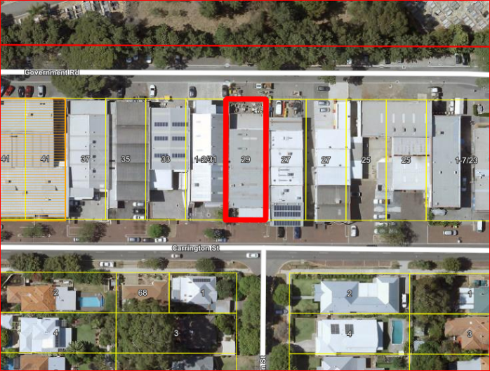

Within the street block there is a number of business ranging from Lunch Bars (Ginos Orange Lunch Bar) to commercial business, the land to the north is Karrakatta Cemetery and within 100m to the east is the City’s Depot facility.

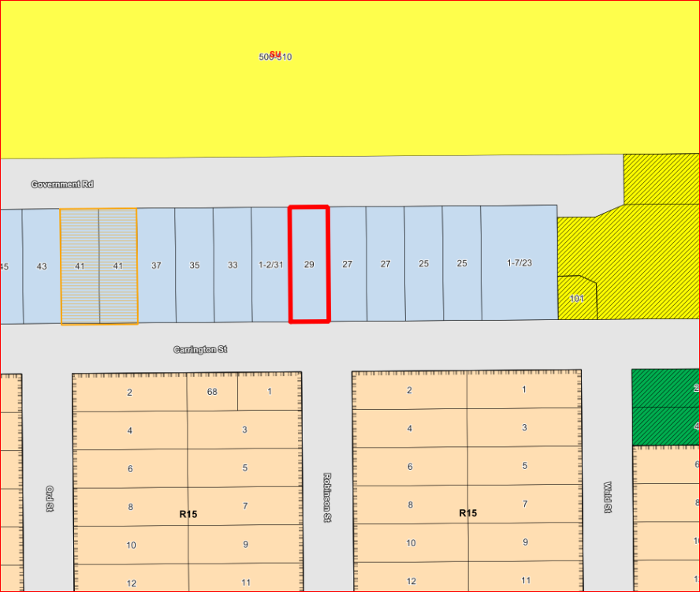

1. **Application Details**

Details of the proposal is as follows:

* The site will be used to predominately for mixing dough, bread storage and pastry moulding.
* A portion of the site will be used for food production which includes the preparation of pickles and preserves.
* No wood fire ovens or baking ovens are proposed at the site and will remain in the existing Common Bakery site at 27 Carrington Street.
* Internal modifications to the existing building includes a new Universal Access Toilet, staff change rooms, breakout area and an internal door will be created between 27 and 29 Carrington Street for staff to move back and forth between both sites.
* The existing roller door located at the front elevation of the site will be removed and replaced by a new window and a new ramp located to the rear of the building will be installed.
* No customers will be serviced from the site.
* All deliveries (drop off and pick up) and waste collection will be serviced from the rear of the site from Government Road.
* A total of ten (10) car bays is provided on site. Four (4) existing car bays located at the front of the building will remain and the rear car parking area will be reconfigured to have six (6) car bays.
* Approximately 7 staff members will be working at Common Bakery on both sites at one time as they move back and forth for the business operations depending on demand.
* The hours of operation of the site will match the current bakery operations at 27 Carrington Street as follows:

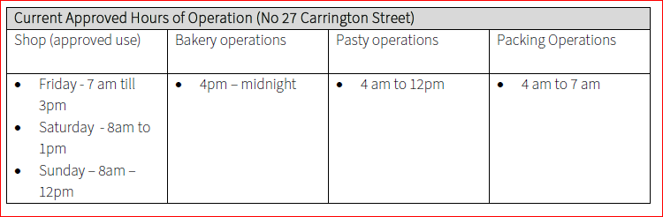

1. **Consultation**

The proposal is an ‘A’ use under the City’s Local Planning Scheme No. 3 (LPS 3). An ‘A’ use requires consultation in accordance with Clause 64 of the Deemed Provisions and the City’s Local Planning Policy – Consultation of Planning Proposals (Consultation Policy).

The development application was advertised in accordance with the Consultation Policy by way of letter for 14 days within a 100m radius of the subject site. The application was advertised to 61 landowners and occupiers, commencing on 6 May 2021 and concluding on 20 May 2021.

At the close of the advertising period, a total of six (6) submissions were received (1 in support, 1 support subject to modifications and 4 objections). The main issues raised in the submissions relate to:

* Car parking/Traffic;
* Vehicles Reversing;
* Car parking reconfiguration;
* Common Bakery takeaway coffee
* Noise;
* Air quality; and
* Operation hours.

Refer to **Attachment 1** for the submission table which outlines the comments received and Administration’s and the applicant’s response to each submission.

*Note: A full copy of all relevant consultation feedback received by the City has been given to the Councillors prior to the Council meeting.*

1. **Assessment of Statutory Provisions**

**5.1 Planning and Development (Local Planning Schemes) Regulations 2015**

Clause 67(2) of the Deemed Provisions (Consideration of application by local government) stipulates those matters that are required to be given due regard to the extent relevant to the application. Where relevant, these matters are discussed in the following sections.

**5.2 Local Planning Scheme No. 3**

**5.2.1 Land Use Permissibility**

The proposed land use of the Common Bakery use on the site is classified as ‘Industry-Light’ under LPS3.

Industry-Light is defined as:

“means premises used for an industry where impacts on the amenity of the area in which the premises is located can be mitigated, avoided or managed”

Industry is defined as:

“means premises used for the manufacture, dismantling, processing, assembly, treating, testing, servicing, maintenance or repairing of goods, products, articles, materials or substances and includes facilities on the premises for any of the following purposes –

(a) the storage of goods;

(b) the work of administration or accounting;

(c) the selling of goods by wholesale or retail;

(d) the provision of amenities for employees;

(e) incidental purposes.”

‘Industry-Light’ has an ‘A’ use permissibility within the ‘Service Commercial’ zone. An ‘A’ use is not permitted unless the local government has exercised its discretion by granting development approval after giving notice in accordance with clause 64 of the deemed provisions*.* The proposal has been advertised in accordance with the City’s Consultation Policy.

Considering the proposed land use, the objectives of the Service Commercial zone and the use class permissibility of the proposed land use on the site, the proposed change of use is considered to be appropriate for the site’s context and in accordance with the objectives and intent of the Scheme.

**5.2.2 Objective of Zone**

The subject site is zoned ‘Service Commercial’ by LPS3. A Service Commercial zone has the following objectives under the Scheme:

* To accommodate commercial activities which, because of the nature of the business, require good vehicular access and/or large sites.
* To provide for a range of uses which, by reason of their scale, character, operational or land requirements, are not generally appropriate in, or cannot conveniently or economically be accommodated in centre, commercial or industrial zones.
* To ensure land use is compatible with any adjacent commercial, mixed-use or residential areas and would not have a detrimental effect on the amenity of the locality.
* To maintain compatibility with the general streetscape, for all new buildings in terms of scale, height, style, materials, street alignment and design of facades.

The proposed land use of a ‘Industry-Light’ is considered to meet the objectives of the Service Commercial zone for the following reasons:

* The site will accommodate the expansion of a bakery production business (Common Bakery) that currently exists within the Service Commercial zone.
* The proposal does not result changes to the bulk and scale to the existing building. Some minor cosmetic upgrades to the front facade and a new ramp are proposed at the rear of the building.
* The proposed land use promotes a local business within the area and is considered to be compatible with the existing mix of businesses along Carrington Street.

Considering the above, the proposed land use is deemed to satisfy the objectives of the Service Commercial zone.

**5.3 Local Planning Strategy**

The City’s Local Planning Strategy was endorsed by the Western Australian Planning Commission in 2017. The Strategy identifies the Carrington Street semi-industrial area as a future Precinct within the City. The Strategy seeks to facilitate Carrington Street commercial strip as a mixed business area.

This precinct is the only “industrial” area within the City of Nedlands and in more recent times has undergone a minor transition from a service industrial area to a more commercially-orientated precinct characterised by office development at the corner of Carrington and Loch Streets.

The proposed change of use application is consistent with the overall strategic intent of the precinct as the use is characterised as ‘Light industry’ and this precinct is the only ‘industrial’ area within the City’s jurisdiction.

**5.4 Local Planning Policies**

**5.4.1 Local Planning Policy – Parking**

The proposal complies with the car parking requirement for an Industry-Light use for the site as follows:

* Car parking requirement: 9 car bays.
* Proposed car parking on site: 10 car bays.

**5.4.2 Traffic Management**

The proposal will not service customers from 29 Carrington Street and all staff parking will be accommodated within the site. All deliveries will be collected and delivered from the rear of the site from Government Road as well as waste collection.

However, some submissions raised concern in regard to the car parking arrangement located outside both 27 and 29 Carrington Street, Nedlands within the verge area owned by the City.

Parking and traffic along Carrington Street should be holistically considered by the Council, as much of the parking sits on Council owned land. In the long term, consideration should be given to a strategic review of the parking and traffic of the Service Commercial area along Carrington Street. The current proposal at No. 29 Carrington Street will assist the overall operation of the Bakery by the provision of additional parking. The proposal will not add to traffic along Carrington Street.

**5.4.3 Local Planning Policy – Waste Management**

The application was assessed against the Waste Management Local Planning Policy. The Waste Management Plan has been reviewed and is supported. A condition of the determination of the application requires the development to comply with the approved Waste Management Plan in perpetuity.

1. **Conclusion**

Council is requested to make a decision in accordance with clause 68(2) of the Deemed Provisions. Council may determine to approve the development without conditions (cl.68(2)(a)), approve with development with conditions (cl.68(2)(b)), or refuse the development (cl.68(2)(c)).

Considering the proposed land use, the property’s zoning and the proposed use of the site, it is unlikely that the bakery manufacturing will have a negative impact of the amenity of the immediate locality.

Based on the car parking assessment provided as part of the development application, the proposal will reduce the number of visitors to the site as the site will not service any customers and the car parking meets the City’s Parking Policy.

Considering the above, the proposal is unlikely to have a detrimental impact on the local amenity. Therefore, it is recommended that Council approves the application subject to the conditions identified above.

|  |  |
| --- | --- |
| **PD25.21** | **Consideration of Development Application - 6 Aged and Dependent Persons’ Dwellings at Lot 100 Montgomery Avenue, Mt Claremont** |
|  | |
| **Committee** | 13 July 2021 |
| **Council** | 27 July 2021 |
| **Applicant** | Apex Planning |
| **Landowner** | Western Power |
| **Director** | Tony Free – Director Planning & Development |
| **Employee Disclosure under section 5.70 Local Government Act 1995** | The author, reviewers and authoriser of this report declare they have no financial or impartiality interest with this matter.  There is no financial or personal relationship between City staff and the proponents or their consultants.  Whilst parties may be known to each other professionally, this relationship is consistent with the limitations placed on such relationships by the Codes of Conduct of the City and the Planning Institute of Australia. |
| **Report Type**  Quasi-Judicial | When Council determines an application/matter that directly affects a person’s right and interests. The judicial character arises from the obligation to abide by the principles of natural justice. Examples of Quasi-Judicial authority include town planning applications and other decisions that may be appealable to the State Administrative Tribunal. |
| **Reference** | DA21-63578 |
| **Previous Item** | Nil |
| **Delegation** | In accordance with the City’s Instrument of Delegation, Council is required to determine the application as more than 4 dwellings are proposed |
| **Attachments** | 1. Location Plan & Zoning Plan |
| **Confidential Attachments** | 1. Plans 2. Submissions |

1. **Executive Summary**

The purpose of this report is for Council to determine a Development Application received on 27 April 2021, for six (6) Aged or Dependant Persons’ Dwellings at Lot 100 Montgomery Avenue, Mt Claremont.

The application was advertised to adjoining neighbours in accordance with the City of Nedlands Local Planning Policy (LPP) – Consultation of Planning Proposals due to site works, retaining, plot ratio area and open space. At the close of the advertising period two (2) submissions neither supporting nor objecting to the development proposal were received.

As the application proposes more than 4 dwellings, this application is presented to Council for determination.

It is recommended that the application be approved by Council as it is considered to satisfy the design principles of the Residential Design Codes (R-Codes) and is unlikely to have a significant adverse impact on the local amenity.

**Recommendation to Committee**

**In accordance with Clause 68(2)(a) of the Deemed Provisions of the *Planning and Development (Local Planning Schemes) Regulations 2015,* Council approves the development application received on 27 April 2021 in accordance with amended plans date stamped 10 June 2021 for six (6) Aged and Dependent Persons’ Dwellings at Lot 100 Montgomery Avenue, Mt Claremont subject to the following conditions:**

1. **This approval is for a ‘Residential – Aged and Dependent Persons Dwelling’ land use as defined under the City’s Local Planning Scheme No.3 and the subject land may not be used for any other use without prior approval of the City.**
2. **Prior to the issue of a Building Permit, the owner must execute and provide to the City a notification pursuant to Section 70A of the *Transfer of Land Act 1893* (as amended) to be registered on the Certificate of Title advising prospective purchasers that the use of the land is subject to the Aged and Dependent Persons’ restriction. The notification required by shall read as follows:**

**“This property is approved for use as an Aged or Dependent Persons’ Dwelling. The dwelling restricted to be occupied by a person who:**

* 1. **Is aged 55 years or more; or**
  2. **Has a recognised form of disability requiring special or supported accommodation; and**
  3. **May also accommodate the spouse or carer of that person and in any case no more than one other person.”**

1. **The Aged and Dependent Persons’ dwelling internal design, external paths and car parking areas shall be constructed in accordance with Clause 5.5.2 of the Residential Design Codes and AS4299/1995 – Adaptable Housing.**
2. **Prior to occupation of the development the finish of the parapet walls is to be finished externally to the same standard as the rest of the development or in:**
3. **Face brick;**
4. **Painted render;**
5. **Painted brickwork; or**
6. **Other clean material as specified on the approved plans and maintained thereafter to the satisfaction of the City.**
7. **Prior to occupation of the development, all major openings and unenclosed outdoor active habitable spaces, which have a floor level of more than 0.5m above natural ground level and overlook any part of any other residential property behind its street setback line shall be setback, in direct line of sight within the cone of vision from the lot boundary, a minimum distance as prescribed in C1.1 of Clause 5.4.1 – Visual Privacy of the Residential Design Codes. Alternatively, the major openings are screened in accordance with the Residential Design Codes by either;**
8. **fixed obscured glazing or translucent glass to a height of 1.60 metres above finished floor level; or**
9. **Timber screens, external blinds, window hoods and shutters to a height of 1.6m above finished floor level that are at least 75% obscure;**
10. **a minimum sill height of 1.60 metres as determined from the internal floor level; or**
11. **an alternative method of screening approved by the City.**

**The required screening shall be thereafter maintained to the satisfaction of the City.**

1. **Prior to commencement of development, a detailed landscaping plan shall be submitted to and approved by the City of Nedlands and is to be installed and maintained in accordance with that plan, or any modifications approved thereto, for the lifetime of the development thereafter, to the satisfaction of the City.**
2. **Prior to the occupation of the development, all structures within 1.5m visual truncation areas abutting vehicle access points shall be truncated or reduced to 0.75m height to the satisfaction of the City.**
3. **Prior to occupation, each dwelling is to have an adequate area set aside for clothes drying screened so as to not be highly visible from any adjacent public place in accordance with the requirements of the Residential Design Codes to the satisfaction of the City.**
4. **Prior to the occupation of the development, the car parking designated for visitors shall be clearly marked or signage provided to the specification and maintained thereafter by the landowner to the satisfaction of the City.**
5. **Prior to occupation of the development, all air-conditioning plant, satellite dishes, antennae and any other plant and equipment to the roof of the building shall be located or screened so as not to be highly visible from beyond the boundaries of the development site to the satisfaction of the City.**
6. **All stormwater from the development, which includes permeable and non-permeable areas shall be contained onsite.**
7. **The location of any bin stores shall be behind the street alignment so as not to be visible from a street or public place and constructed in accordance with the City’s Health Local Law 1997.**
8. **All building works to be carried out under this development approval are required to be contained within the boundaries of the subject lot; and**
9. **The development shall at all times comply with the application and the approved plans, subject to any modifications required as a consequence of any condition(s) of this approval.**

**Voting Requirement**

Simple Majority

1. **Background**

**2.1 Land Details**

|  |  |
| --- | --- |
| **Metropolitan Region Scheme Zone** | Urban |
| **Local Planning Scheme Zone** | Residential |
| **R-Code** | R30 |
| **Land Use** | Current – Vacant  Proposed - Aged or Dependant Persons’ Dwellings |
| **Use Class** | ‘P’ Permitted Use |

**2.2 Locality Plan**

The subject site is located at Lot 100 Montgomery Avenue, Mt Claremont and is zoned ‘Urban’ by the Metropolitan Region Scheme and ‘Residential’ by the City of Nedlands Local Planning Scheme No.3 (the Scheme). The site has a residential density code of R30.

There are five two-storey houses which directly abut the site to the north and north-west and are also zoned ‘Residential’ R30. To the west is Biara Gardens, a managed reserve located within the Town of Cambridge. To the south is vacant land zoned ‘Residential’. Refer to Attachment 1 – Aerial & Zoning Plan.

**Background**

The site was previously owned by Western Power and has recently been sold. A subdivision application has been lodged with the Western Australian Planning Commission for two free-hold lots in a side-by-side configuration.

The owners intend to the develop the site in a staged approach. The Aged or Dependent Persons dwellings are considered to be part of Stage 1. Stage 2 is proposed to be a Child Care Centre, located further south (annotated on the plans as ‘future development’).

An application for pre-lodgement Design Review has been lodged with the City for the Child Care Centre. Once lodged, Stage 2 will be determined by the Metro Inner North Joint Development Assessment Panel.

1. **Application Details**

The application seeks development approval for six (6) single storey Aged or Dependent Persons’ Dwellings. Each dwelling proposes three bedrooms and two bathrooms across a single floor level. The proposed dwellings are serviced by a common property driveway, located at the centre of the development proposal and includes two visitor bays.

1. **Consultation**

The applicant is seeking assessment under the Design Principles of the R-Codes for the following:

* Open Space
* Site Works and Retaining
* Plot Ratio Area

The Development application was advertised in accordance with the City’s Local Planning Policy - Consultation of Planning Proposals to 5 adjoining landowners and occupiers. The application was advertised for a period of 14 days from 4 June 2021 to 18 June 2021. At the close of the advertising period two (2) submissions were received. The main concerns raised within the submissions were:

* Request that the western dividing fence be constructed of 1.8m rendered brick lieu of colourbond fencing.
* The development site is bushfire prone and inadequate separation distance is provided from the adjoining reserve.
* Request for a dilapidation report be prepared for all properties located to the north of the subject site.

Note: A full copy of all relevant consultation feedback received by the City has been given to the Councillors prior to the Council meeting and can be found in Confidential Attachment 2.

The following is a summary of the concerns/comments raised and the City’s response and action taken in relation to each issue:

1. Request for brick dividing fence.

The applicant has been advised of the request and is encouraged to discuss the request with the neighbour. Neither the Residential Design Codes nor the City’s Local Planning Policies require that the boundary fence be constructed of brick, thus it is not a condition of Administration’s recommendation.

1. The development site is bushfire prone.

The subject site was previously identified as ‘bushfire prone’ under *State Planning Policy 3.7: Planning in Bushfire Prone Areas* prior to 2019. The 2019 review of the bushfire prone area mapping completed by the Department of Fire and Emergency Services reclassified the subject site as ‘not-bushfire prone’. As a result, the subject site is not currently classified as bushfire prone.

1. Request for a dilapidation report to be prepared.

In the event of substantial excavations works being proposed it is appropriate to require that a dilapidation report be undertaken. In the case of the proposed development, no significant excavation is proposed. The applicant has been advised of the request for a dilapidation report.

1. **Assessment of Statutory Provisions**

**5.1 Planning and Development (Local Planning Schemes) Regulations 2015**

Schedule 2, Clause 67(2) (Consideration of application by Local Government) – identifies those matters that are required to be given due regard to the extent relevant to the application.  Where relevant, these matters are discussed in the following sections. Overall, the development is considered to meet these objectives, particularly in regard to height, scale, bulk and appearance, and the potential impact it will have on the local amenity.

**5.2 State Planning Policy**

**5.2.1** **State Planning Policy 7.3 - Residential Design Codes – Volume 1**

State Planning Policy 7.3 Residential Design Codes Volume 1 (R-Codes) apply to all single and grouped dwelling developments. An assessment under the R-Codes can be undertaken in one of two ways. This is by either meeting the deemed-to-comply provisions or via a Design Principle assessment pathway. The applicants are seeking a Design Principle assessment pathway for a part of this proposal. An assessment is sought under the Design Principles for the R-Codes for Open Space, Site Works & Retaining and Plot Ratio. All other areas are fully compliant with the deemed-to-comply provisions.

**Clause 5.1.4 Open Space**

The development proposes the following open space percentages in lieu of 45% under the deemed-to-comply provisions.

* Unit 1 – 41% (4% shortfall 10.7m2)
* Unit 2 & 3 – 42% (3% shortfall 8.2m2)
* Unit 5 – 40% (5% shortfall 13.35m2)
* Unit 6 – 44% (1% shortfall 2.83m2)

It is noted Unit 4 achieves 45% open space.

Open Space is considered to meet the Design Principles as:

* The proposed dwellings are considered to maximise access to natural light through the northern aspect of the site through windows and openings to habitable rooms and outdoor living areas.
* All dwellings meet the deemed-to-comply lot boundary setback and building height. The scale of the development proposal is consistent with the existing established streetscape character of Mt Claremont.
* The primary street frontage is appropriately landscaped with 2 medium trees and various ground covered foliage. The proposal includes 8 medium sized trees and landscaping within the communal areas.
* The proposed outdoor living areas provides opportunities for residents to use external space for outdoor pursuits, including a covered entertaining area.
* The open space shortfall is limited to between 1-4 percent of each individual lot’s area, with the parent lot proposing 43% site cover, producing an overall 3% open space shortfall.

**Clause 5.3.7 & Clause 5.3.8 – Site Works & Retaining Wall**

The development proposes the following cut, fill and retaining that is above and/or below the 0.5m deemed-to-comply.

* Unit 3 – 0.6m retaining/fill on the western lot boundary
* Unit 4 – 0.7m retaining/cut on the southern lot boundary.
* Unit 5 – 0.9m retaining/cut on the southern lot boundary.
* Unit 6 – 0.9m retaining/cut on the western lot boundary & 1m retaining/cut proposed on the southern lot boundary.

The development is considered to meet the Design Principles as:

* Other than Unit 3, all retaining is because of ‘cutting into’ the site in order to respond to the natural contours of the site and provide for a ‘level’ finish floor level. Where cutting is proposed it means that it is below natural ground level, not visible to neighbours and does not result in any overlooking of neighbouring properties.
* Unit 3 proposes fill and retaining up to 0.6m. This is in order to provide for a level outdoor living area, without steps under AS4299. Due to the location of the fill and retaining, it does result in any direct overlooking under the deemed-to-comply provisions.
* Overall, the design has considered and responded to the natural contours of the site. The excavation and fill is necessary to address AS4299.

**Clause 5.5.2 – Aged or Dependant Person’s Dwellings**

The development proposes the following plot ratio areas per unit in lieu of a maximum 100m2 under the deemed-to-comply:

* Unit 1 – 121m2
* Unit 2 – 120m2
* Unit 3 – 123m2
* Unit 4 – 119m2
* Unit 5 – 125m2
* Unit 6 – 118m2

The development is considered to meet the Design Principles as:

* The low scale of the development and interface with adjoining residential properties to the north of the site does not impact on the adjoining neighbour’s amenity, as noted through the submissions.
* The development is considered to appropriately interface with the streetscape.
* The development area is responding to the demand for larger Aged Persons’ dwellings to be provided within the community.
* The development meets the deemed to comply provisions relating to height, setbacks, visual privacy and parking.
* The development appropriately responds to the site’s context and topography.

**5.3 Local Planning Policies**

**5.3.1 City of Nedlands Residential Development Local Planning Policy**

The LPP modified provisions of the City of Nedlands Local Planning Scheme No. 3 and the R-Codes in relation to street setbacks, lot boundary setbacks, street walls and fences and building height. Where relevant, these matters have been considered in Administration’s assessment.

**5.3.2 - City of Nedlands Waste Management Local Planning Policy**

Clause 3.1.5 of the Waste Management Guidelines recommends a maximum of 4 x 240L waste bins and 4 x 240L recycling bins to be placed on the verge for kerbside collection, in which more than 8 bins would require internal service arrangements. The intent of this provision is to preserve the amenity of the streetscape and avoid a proliferation of bins on collection day. The development proposes a maximum of 12 bins to be placed on the verge for collection. The bin area (as shown on the proposed site plan) successfully demonstrates that the bins can be accommodated on the verge for safe collection without negatively impacting the areas amenity.

1. **Conclusion**

Council is requested to make a decision in accordance with clause 68(2) of the Deemed Provisions. Council may determine to approve the development without conditions (cl.68(2)(a)), approve with development with conditions (cl.68(2)(b)), or refuse the development (cl.68(2)(c)).

The application for 6 Aged or Dependant Persons’ Dwellings has been presented for Council consideration due to Council’s Instrument of Delegation, requiring all grouped dwelling proposals with 5 or more dwellings to be determined by Council. The proposal is considered to meet the key amenity related elements of R-Codes Volume 1 and as such is unlikely to have a significant adverse impact on the local amenity of the area. The proposal has been assessed and satisfies the design principles of the Residential Design Codes.

Accordingly, it is recommended that the application be approved by Council, subject to conditions of Administration’s recommendation (Above).

|  |  |
| --- | --- |
| **PD26.21** | **Consideration of Street Tree Removal at 22 Pine Tree Lane,** **Mt Claremont** |
|  | |
| **Committee** | 13 July 2021 |
| **Council** | 27 July 2021 |
| **Applicant** | Bellagio Homes Pty Ltd |
| **Landowner** | B.D. Slater |
| **Director** | Tony Free – Director Planning & Development |
| **Employee Disclosure under section 5.70 Local Government Act 1995** | The author, reviewers and authoriser of this report declare they have no financial or impartiality interest with this matter.    There is no financial or personal relationship between City staff and the proponents or their consultants. |
| **Report Type**  Quasi-Judicial | When Council determines an application/matter that directly affects a person’s right and interests. The judicial character arises from the obligation to abide by the principles of natural justice. Examples of Quasi-Judicial authority include town planning applications and other decisions that may be appealable to the State Administrative Tribunal. |
| **Reference** | DA21-59818 |
| **Previous Item** | Nil |
| **Delegation** | The application may require a recommendation for refusal where discretion exists for Council to approve the variations under the City’s Local Planning Scheme No. 3, policies and/or the Residential Design Codes. |
| **Confidential Attachments** | 1. Plans |

1. **Executive Summary**

The purpose of this report is for Council to consider the removal of a 7m jacaranda street tree at 22 Pine Tree Lane, Mt Claremont.

A development application submitted to the City proposes a new single house on the site. Council is not required to consider the approval of the single house itself, which can be approved under delegated authority. The application includes a garage and crossover to Camelia Avenue which requires the removal of a 7m jacaranda street tree.

The applicant provided a Traffic Statement in support of the proposal to the remove the 7m jacaranda street tree. The Traffic Statement maintains that although there are alternative locations for the crossover, the safest and most practical location is in front of the 7m jacaranda street tree.

Council is requested to consider three options: the relocation of the street tree at the applicant’s expense, the removal and replacement of the street tree at the applicant’s expense or resolving to not support the removal of the street tree. If the street tree’s removal is not supported, it will result in the refusal of the development application.

It is recommended that the street tree be relocated further west along Camelia Avenue at the applicant’s expense as it will preserve the character of the locality while facilitating a safe and practical design for the proposed single house.

**Recommendation to Committee**

**Council grants approval to relocate the 7m Jacaranda street tree (ID #11720) located abutting the Camelia Avenue frontage of 22 Pine Tree Lane, Mt Claremont to a location further west on Camelia Avenue at the applicant’s expense and to the satisfaction of the City of Nedlands.**

**Voting Requirement**

Simple Majority

1. **Background**

**2.1 Land Details**

|  |  |
| --- | --- |
| **Metropolitan Region Scheme Zone** | Urban |
| **Local Planning Scheme Zone** | Residential |
| **R-Code** | R20 |
| **Land area** | 665sqm |
| **Land Use** | Residential |
| **Use Class** | ‘P’ - Permitted |

**2.2 Locality Plan**

The subject property is located at 22 Pine Tree Lane in Mt Claremont and is currently vacant. It is a corner lot with frontage to Pine Tree Lane and Camelia Avenue. There are no existing vehicle crossovers on site. The property has an irregular shape with an east – west orientation. The lot is bound by residential properties with single houses to the north and east. Across Pine Tree Lane to the west is Pine Tree Park. Camelia Avenue features jacaranda street trees along its northern verge for 250m.

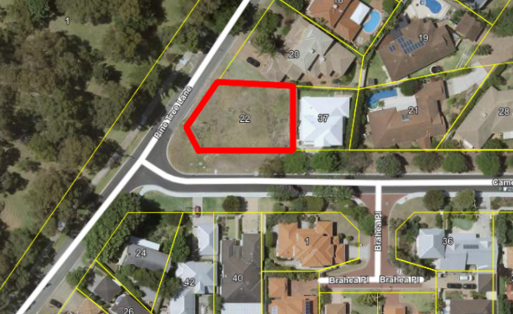

The lot has a density coding of R20. Surrounding properties are coded R20 north of Camelia Avenue and coded R25 south of Camelia Avenue.

**2.3 History**

The current lot at 22 Pine Tree Lane is the result of a two-lot subdivision approved in 2014. Prior to the subdivision, the site was a single lot with a single house. Vehicle access for the single house was facilitated by a crossover from Camelia Avenue, encircled in red on the image below.

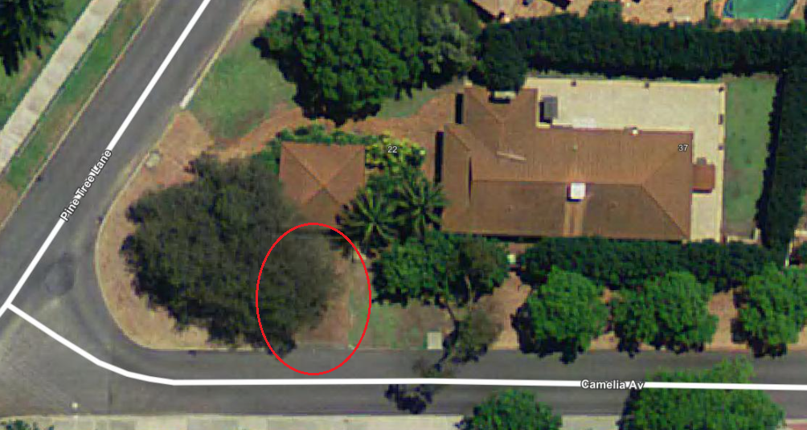

1. **Application Details**

**3.1 Proposal**

The applicant seeks development approval for a new two storey single house. The proposal includes a garage and crossover to Camelia Avenue. The proposed location of the garage requires the removal of a 7m jacaranda street tree (ID #11720). The image below depicts the intended location of the garage and street tree to be removed. A full set of development plans can be viewed as confidential Attachment 1.

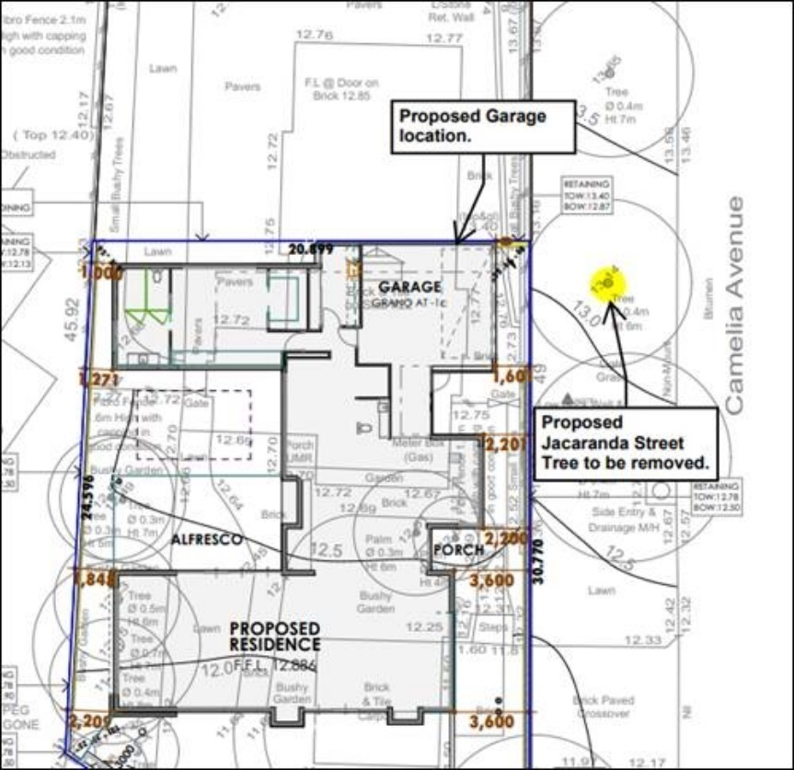

Development approval for the single house itself can be determined under delegated authority and does not require Council consideration at this time. The purpose of this report is solely for Council to consider the proposed removal of the street tree as it relates to the development.

**3.2 Street Tree**

The subject street tree is a jacaranda tree 7m in height. The City’s asset database lists the tree’s condition as ‘good.’ The tree is pictured below.

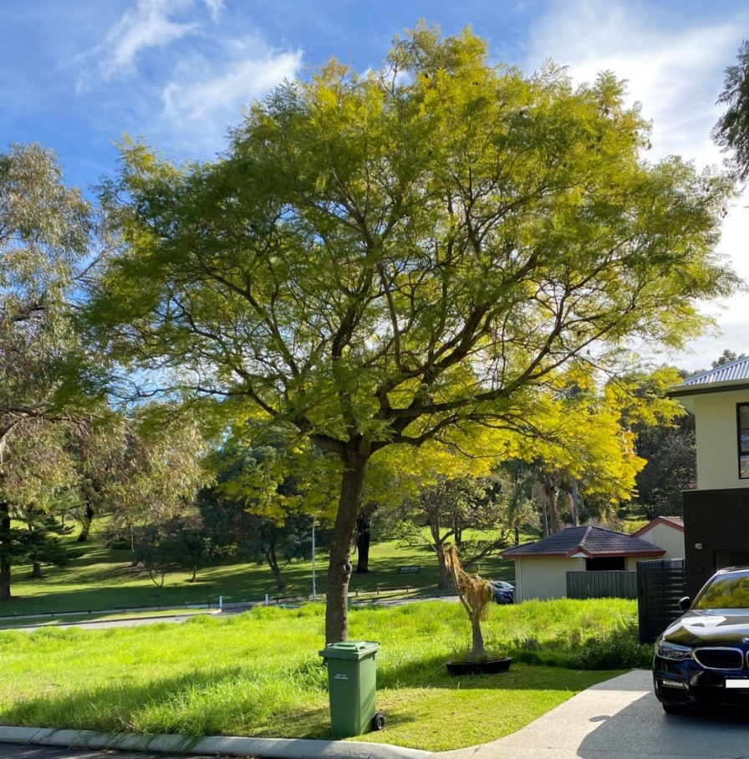

**3.3 Traffic Statement**

By way of justification in support of the tree’s removal the applicants have provided a Traffic Statement. The Traffic Statement outlines the available locations for a crossover along each street frontage, depicted below:

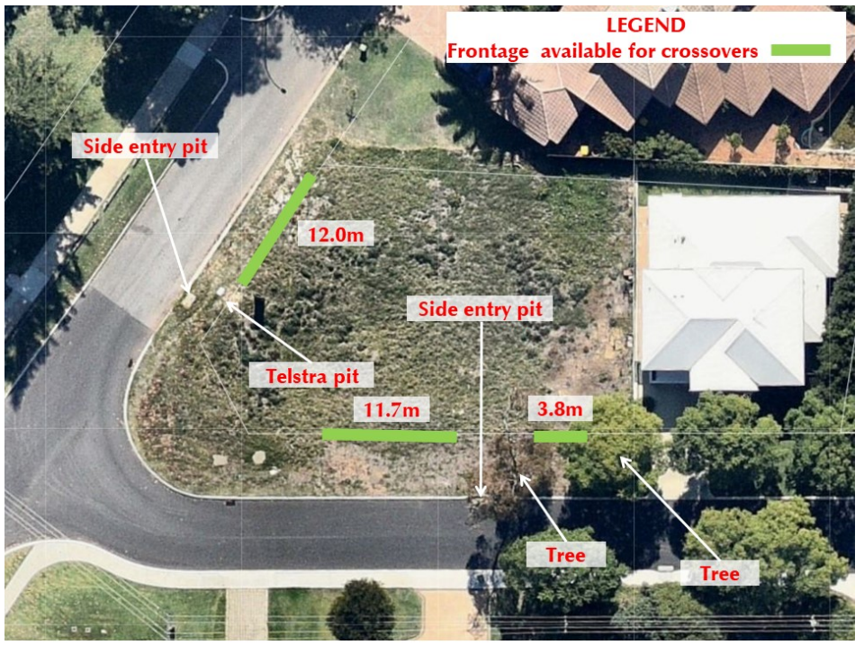

Despite other available locations, the Traffic Statement maintains that the removal of the street tree is acceptable and preferable for the reasons summarised below:

* The intended garage placement facilitates access from the secondary street as recommended by the Residential Design Codes Volume 1 (R-Codes).
* The best place for the crossover and garage is in front of the jacaranda street tree on Camelia Avenue due to the amount of traffic on Pine Tree Lane, the location of drainage pits and infrastructure and the requirement for safe distance from an intersection.
* The City’s Street Tree policy allows for the removal of street trees where it is unreasonable to redesign the development proposal to enable tree retention.

1. **Assessment of Council Policy Provisions**

**4.1 State Planning Policy 7.3 Residential Design Codes – Volume 1**

State Planning Policy 7.3 R-Codes applies to all single and grouped dwelling developments. An assessment against the R-Codes can be undertaken in one of two ways. This is by either meeting the deemed-to-comply provisions or via a Design Principle assessment pathway. The applicants seek a Design Principle assessment for the provision that relates to street tree removal.

Clause 5.3.5 Vehicle access of the R-Codes Volume 1 includes the following deemed to-comply provision:

* C5.3 – Driveways shall be located so as to avoid street trees, or, where this is unavoidable, the street trees replaced at the applicant’s expense or re-planting arrangements to be approved by the decision maker.

Clause 5.3.5 Vehicle access of the R-Codes Volume 1 includes the following Design Principle:

* P5.1 Vehicular access provided for each development site to provide: vehicle access safety; reduced impact of access points on the streetscape; legible access; pedestrian safety; minimal crossovers; and high quality landscaping features.

The proposal, which involves either relocating or removing and replacing the jacaranda street tree, is considered to meet the design principle as:

* The crossover is proposed to be located as far east along Camelia Avenue as possible. This location was selected to achieve the maximum distance between the crossover and the intersection of Camelia Avenue and Pine Tree Lane. Distance from the intersection will reduce the conflict between exiting vehicles from 22 Pine Tree Lane and vehicles turning onto Camelia Avenue.
* The number of crossovers proposed on site is one. This is the minimum amount required and, accordingly, will have minimal impact on the streetscape.
* The pedestrian footpath is located on the south side of Camelia Avenue. The crossover proposed will not interact with this footpath and helps ensure pedestrian safety.
* The applicants are willing to relocate or replace the subject jacaranda street tree to retain Camelia Avenue’s ‘leafy green’ character and appeal.

**4.2 Street Trees Council Policy**

The City’s Street Tree policy allows for tree removal in the following circumstances:

* The tree poses a hazard whether to persons or property and pruning or other techniques cannot effectively remedy that hazard; and
* To facilitate private development where, following consultation between the City and the developer, it is not considered reasonable to redesign or amend the development proposal to enable retention of the street tree.

Administration considers it unreasonable to redesign the single house for the following reasons:

* It would be impractical to locate the garage in the middle of the house.
* Due to the irregular shape of the lot, it would be impractical to shift a portion of the bottom floor west to move the garage further west along Camelia Avenue. This design may also result in ‘wasted space’ along the eastern boundary.
* Vehicle safety may be reduced as the crossover would be closer to the road intersection.

The policy also considers how a tree will be replaced if it is removed with the following provisions:

* Where a development is approved that necessitates the removal of a street tree the developer shall replace the tree and bear 100% of the cost for the City to remove the tree and plant two suitable replacement trees from the preferred species list.
* Removal and replacement of street trees upon request, if approved, is conditional to the property owner agreeing to accept all associated costs for tree removal and establishment of a replacement tree or trees, as is the case, in the City’s standard planting size

1. **Options**

In considering the above information, there are three options that can be pursued.

These options are as follows:

1. Recommended (Relocation of tree)

The 7m jacaranda street tree (ID# 11720) can be relocated further west along Camelia Avenue at the applicant’s expense. This will result in delegated authority approval of the single house as currently proposed, subject to conditions. The cost of tree relocation is approximately $15,000 - $20,000. This is the recommended option.

1. Alternate Recommendation (Refusal of removal)

Council:

1. Refuses the application to remove the jacaranda mimosifolia street tree located at No. 22 (Lot 302) Pine Tree Lane, Mt Claremont (ID #11720).
2. In accordance with clause 68(2)(c) of the Deemed Provisions, Council refuses to grant development approval for a single house at No. 22 (Lot 302) Pine Tree Lane, Mt Claremont, for the following reason:
   1. Non-compliance with the Design Principles of R-Codes Vol. 1 in relation to 5.3.5 P5.1 vehicular access (i.e., access requires removal of a street tree).
3. Alternate Recommendation (Approval of removal)

Council grants approval for the removal of the 7m high jacaranda mimosifolia street tree (ID #11720) located abutting the Camelia Avenue frontage of 22 Pine Tree Lane, Mt Claremont and requires the planting of two suitable replacement trees from the preferred species list at the applicant’s expense and to the satisfaction of the City of Nedlands.

1. **Conclusion**

There are several things to consider regarding the retention of the street tree at 22 Pine Tree Lane, Mt Claremont. These matters include the location of the previous crossover on the site pre-subdivision, the availability of other crossover locations, the maximisation of safety by locating the crossover as far east along Camelia Avenue as possible and the value of the tree to the locality.

There are three options for Council consideration. Relocating the street tree further west along Camelia Avenue at the applicant’s expense or supporting the removal and replacement of the street at the applicant’s expense will result in the delegated authority approval of the single house, subject to conditions. Resolving not to support the removal of the street tree will result in the refusal of the development application for the single house as currently proposed.

In order to retain the jacaranda street tree while ensuring safety and well-designed development, it is recommended that the jacaranda street tree be relocated further west along Camelia Avenue at the applicant’s expense.