Technical Services Reports

Committee Consideration – 13 October 2020

Council Resolution – 27 October 2020

Table of Contents

Item No. Page No.

TS16.20 Quintilian Road Traffic Calming, Parking and Shared Path 2
TS17.20 Hampden Road Project – Budget Variation 8

TS16.20 Quintilian Road Traffic Calming, Parking and Shared Path

Committee | 13 October 2020
Council | 27 October 2020
Applicant | City of Nedlands
Employee Disclosure under section 5.70 Local Government Act 1995 | Nil.
Director | Jim Duff – Director Technical Services
Attachments | - Concept Design - Option 1  - Concept Design - Option 2  - Concept Design - Option 3
Confidential Attachments | Nil.

Executive Summary

At the Ordinary Meeting of Council on 23 July 2019, Council requested that Administration investigate the development of a shared path along the northern verge of Quintilian Road incorporating parallel parking bays and a reduced road width.

Administration has developed several options to meet this request and these options were presented to interested parties at a site meeting on 9 September 2020. The meeting involved Jim Duff, Director of Technical Services, Councillor Wetherall and several local residents.

During the meeting, Option 1 was selected as the preferred design and approval is now sought from Council to commence community consultation.

Recommendation to Committee

Council:

- approves to undertake community consultation on Option 1;

- approves, following a successful outcome of the public consultation process, to implement interim traffic calming measures on Quintilian Road in line with the available 2020/21 budget;

- approves to include the outstanding work from Option 1 in the Five-Year Capital Works Program prioritisation review in February 2021; and

- approves, following the Five-Year Capital Works Program prioritisation review in February 2021, to seek WA Bicycle Network grant approval from the Department of Transport.
Discussion/Overview

Quintilian Road is a local access road, approximately 490m in length and is one of four roads within the City of Nedlands that connects Brockway Road to Stubbs Terrace in Mt Claremont. There is a mix of on-street parking, 90° parking and angled parking bays that cater for residents, Quintilian School, Irwin Barracks and commuters.

Concept designs have been prepared for a shared path along the northern verge incorporating parallel parking bays and an adjustment to the carriageway width. The designs comprise additional traffic calming features such as traffic lane narrowing and/or rubber or asphalt speed cushions.

Three concept design options are presented for Council to select a preferred option to proceed to community consultation. Drawings are provided in Attachments 1 to 3 and cost estimates are provided in Table 1. The cost estimates are based on two dimensional designs and are plus or minus 30% estimate accuracy. Survey and detailed three-dimensional design are required to further refine the cost estimates to plus or minus 10%. However, designs are sufficiently detailed to allow for community consultation to be undertaken.

Option | Cost Estimate
1 | $565,000
2 | $570,000
3 | $414,000
Table 1: Cost Estimates

Administration recommends Option 1 as it provides the greatest parking capacity and was the clear preference at a site meeting on 9 September attended by Quintilian Avenue residents and a Ward Councilor.

Option 1 comprises the following:

- Parallel parking both sides of the road adjacent Quintilian School
- 6m traffic lane width adjacent Quintilian School
- Installation of rubber or asphalt speed cushions at the east end of Quintilian School and mid-block between Tuart Entrance and Stubbs Terrace
- Installation of a traffic island at the east end of Quintilian School to enable traffic lane lateral shift
- Widening of the existing raised plateau adjacent Brockway Road intersection to enable the required road widening
- Parallel parking both sides of the road at the residential, eastern end of Quintilian Road.
- 5.5m traffic lane width at the residential, eastern end of Quintilian Road.
- Drainage pit relocations

Option 2 comprises the following:

- Parallel parking both sides of the road adjacent Quintilian School.
- 6m traffic lane width adjacent Quintilian School.
- Installation of rubber or asphalt speed cushions at the east end of Quintilian School and mid-block between Tuart Entrance and Stubbs Terrace
- Installation of a traffic island at the east end of Quintilian School to enable traffic lane lateral shift.
- Widening of the existing raised plateau adjacent Brockway Road intersection to enable the required road widening.
- Parallel parking both sides of the road at the residential, eastern end of Quintilian Road.
- 6m traffic lane width at the residential, eastern end of Quintilian Road.
- Drainage pit relocations.
- Removal of street tree asset numbers 21273 and 21274 which are considered to be significant trees.

Option 3 comprises the following:

- Parallel parking both sides of the road adjacent Quintilian School.
- 6m traffic lane width adjacent Quintilian School.
- Installation of rubber or asphalt speed cushions at the east end of Quintilian School and mid-block between Tuart Entrance and Stubbs Terrace
- Installation of a traffic island at the east end of Quintilian School to enable traffic lane lateral shift.
- Widening of the existing raised plateau adjacent Brockway Road intersection to enable the required road widening.
- Parallel parking north side of the road at the residential, eastern end of Quintilian Road.
- 6m traffic lane width at the residential, eastern end of Quintilian Road.
- Drainage pit relocations.

Key Relevant Previous Council Decisions:

Ordinary Meeting of Council 23 July 2019, Item TS15.19

“That Council investigates the development of a shared path on the northern verge of Quintilian Road incorporating parallel parking bays along the northern verge and narrowing of the existing roadway to 6 metres”

Consultation

Because the design potentially impacts on the residents within the St Peters Square development, it is proposed to write to all residents and landowners within the area bound by Brockway Road, Alfred Road, Stubbs Terrace and Quintilian Road (refer overleaf) seeking their feedback on the proposal.

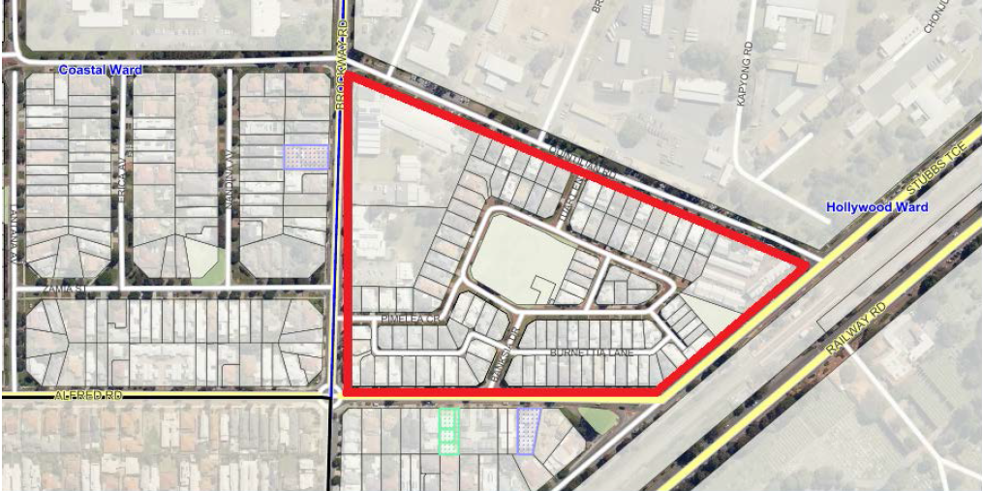

Feedback received from previous consultations can provide an indication on community priorities. Two separate consultations have been completed in the last two years in relation to:

- Proposed traffic calming installation; and
- Proposed partial road closure.

Concerns raised by the community are summarised below:

- Quintilian Road is an important link to the City and the railway station.
- Perceived speeding issue exists from residents of Quintilian Road and Quintilian School.
- Lack of support for speed plateaus stem from concerns around noise and discomfort for cyclists.
- Congestion near the school.
- Commuter parking at the east end of Quintilian Road creating visibility issues.
- Requests to provide safe cyclist access from Camelia Avenue to Quintilian Road.
- Any proposed closures would only serve to redirect existing traffic issues.

Strategic Implications

How well does it fit with our strategic direction?

The Strategic Community Plan 2018-2028 includes the following priorities:

- Maintain investment in roads, footpaths, cycle ways and drainage
- Improve connectivity for pedestrians on all paths and on roads.

The proposed Quintilian Road traffic calming, embayed parking and shared path may be considered by Council to fit with our vision and strategic priorities.
Who benefits?

All users of Quintilian Road will benefit from improved road safety and parking amenity, and commuter and recreational cyclists will benefit from new cycle infrastructure.

Similar traffic calming, embayed parking, and cycle infrastructure projects are in construction in other parts of the City.

Does it involve a tolerable risk?

The risk of project cost increase can be mitigated through thorough detailed design and project management processes. The risk fits within our risk tolerance level accepted on similar road improvement projects.

Do we have the information we need?

We have sufficient information to identify community concerns and to inform concept designs and order of magnitude cost estimates. A detailed multi-criteria prioritisation was carried out prior to undertaking the concept design work to eliminate lower ranked solutions.

Budget/Financial Implications

Can we afford it?

Additional traffic calming is included as a project in the 2020/21 capital budget. The allocated project budget is $71,500. Additional funding is required to make up the shortfall and could be identified in the Five-Year Capital Works Program prioritisation review in February 2021. Following this review the City will seek a 50% funding contribution from DOT through the Bicycle Network grant application process.

The Quintilian Road shared path necessitates narrowing of traffic lanes and construction of embayed parking to provide sufficient verge space. The Brockway and Quintilian Road shared path project is supported in principle by DOT with current funding commitments as follows:

- Stage 1 – Brockway Road (Underwood Avenue to Lemnos Street) – Construction - $140,000

- Stage 2 – Brockway Road (Lemnos Street to Quintilian Road) – Construction - $150,000

- Stage 3 – Quintilian Road – Design only - $20,000

Following a successful outcome of the public consultation process interim traffic calming measures can be implemented on Quintilian Road in line with the available 2020/21 budget. The interim traffic calming measures will comprise the installation of rubber speed cushions at the east end of Quintilian School and mid-block between Tuart Entrance and Stubbs Terrace. Some rework of the speed cushions will be required when the remaining works are undertaken as there will be a shift in traffic lane position.

How does the option impact upon rates?

Rate increases are not necessary to fund the project provided the project is planned and prioritised in the Five-Year Capital Works Program in February 2021.

TS17.20 Hampden Road Project – Budget Variation

Committee | 13 October 2020
Council | 27 October 2020
Applicant | City of Nedlands
Employee Disclosure under section 5.70 Local Government Act 1995 | Nil.
Director | Jim Duff – Director Technical Services
Attachments | Nil.

Executive Summary

The Alfred Road (Narla Road to West Coast Highway) project was completed in 2019/20 and an administrative error resulted in the budget being carried over to 2020/21. The final cost of the Hampden Road rehabilitation project has exceeded available budget and additional funding is required. Council’s approval is requested to reallocate $114,377 of the $145,726 budget for the Alfred Road (Narla Road to West Coast Highway) project, to the Hampden Road project, and the surplus to general revenue.

Recommendation to Committee

Council approves the reallocation of $114,377 of the $145,726 budget for the Alfred Road (Narla to West Coast Highway) project to the Hampden Road project and directs the surplus to general revenue.

Discussion/Overview

The Hampden Road rehabilitation budget comprised $253,400 from the City of Nedlands and $199,000 from the City of Perth (CoP). As part of the 2019/20 mid-year review process the City’s budget was reduced from $253,400 to $235,700 in line with the contractor’s original estimate and in anticipation of the works being completed in the 2019/20 financial year. The City’s budget comprised $105,233 municipal and $130,467 MRRG funds.

The project commenced on 15 June 2020 with a completion timeframe of approximately four weeks. During the early phase of the project the City was asked to modify the agreed work methodology to address concerns raised by CoP, PTA and local business owners regarding the potential impact on their business. To minimise any adverse impacts the City reprogrammed the works to introduce nightworks and weekend works. The modification to the construction methodology had an impact on the construction schedule resulting in it extending over the 2019/20 and 2020/21 financial year and increased the overall project cost. The final cost of the project is $563,029 comprising the contractor cost of $556,136 and the MRWA signs and lines charge of $6,897.

In recognition that many of the changes were requested by the City of Perth they have agreed to increase their overall project contribution from $199,000 to $277,615. The City is responsible for the remaining cost of $285,414 which is to be funded by a combination of MRRG funds ($130,467) and municipal funds ($154,947). The remaining municipal cost increases from $154,947 to $220,024 after 42% on cost is applied. The contractor’s first progress payment of $105,647 was made in 2019/20. Additional municipal funding of $114,377 ($220,024 minus $105,647) is required to meet the shortfall.

The Alfred Road (Narla Road to West Coast Highway) road rehabilitation project was completed and all invoices paid in 2019/20. Due to an administrative error $145,726 was carried over to the 2020/21 budget. It is proposed that the Hampden Road funding shortfall of $114,377 be met from the Alfred Road (Narla Road to West Coast Highway) budget.

Key Relevant Previous Council Decisions:

Nil.

Consultation

A community engagement plan was completed in September 2019, with the construction delivery program, traffic management plan, noise management plan, and resident notification letters sent to the occupants and property owners of Hampden Road and one street back, on 20 May 2020 advising of the project start date of 15 June 2020.

Two Variable Message Board trailers were erected on Hampden Road near the intersections of Park Avenue and Karella Avenue on 29 May 2020, informing the public of the upcoming works. Throughout early June 2020, the City liaised with the CoP approvals unit, PTA and local Business Owners to resolve issues relating to potential noise regulations, public transport servicing and business impacts with the final approvals being issued on the 10 June 2020. The City of Perth subsequently issued updated notification letter to its residents and business owners on 10 June 2020.

Throughout this period the Your Voice website was regularly updated.

Strategic Implications

How well does it fit with our strategic direction?

The Strategic Community Plan includes maintain investment in roads, footpaths, cycle ways and drainage as a priority.

Who benefits?

All users of Hampden Road will benefit from improved road safety and pedestrian amenity.

Does it involve a tolerable risk?

The project risk was managed through detailed collaboration with the CoP and relevant agencies. The construction works were managed in accordance with all relevant regulatory standards and the risk fits within the City’s risk tolerance accepted on similar road improvement projects.

Do we have the information we need?

The City has collaborated with CoP and relevant agencies to identify any community concerns and endeavored to proactively address issues in advance of them becoming a risk to the project delivery. The information required to plan and implement a project of this nature is similar to other road improvement projects.

Budget/Financial Implications

The Hampden Road rehabilitation budget comprised $253,400 from the City of Nedlands and $199,000 from the City of Perth (CoP). As part of the 2019/20 mid-year review process the City’s budget was reduced from $253,400 to $235,700. The City’s budget comprised $105,233 municipal and $130,467 MRRG funds.

The final project cost of $563,029 exceeded the available budget and additional municipal funding of $114,377 is required to meet the shortfall.

The Alfred Road (Narla Road to West Coast Highway) road rehabilitation project was completed and all invoices paid in 2019/20. Due to an administrative error $145,726 was carried over to the 2020/21 budget. It is proposed that the Hampden Road funding shortfall of $114,377 be met from the Alfred Road (Narla Road to West Coast Highway) budget.

