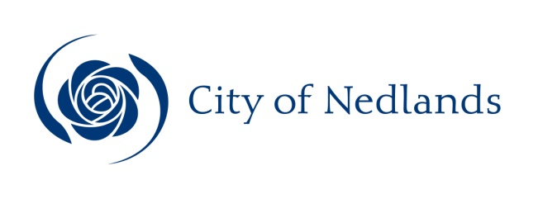

Community Development Report

Committee Consideration – 14 April 2020
Council Resolution – 28 April 2020

Table of Contents

Item No. Page No.
CM03.20 Proposed Changes to Arts Committee’s Terms of Reference 2

CM03.20 Proposed Changes to Arts Committee’s Terms of Reference

Committee | 14 April 2020
Council | 28 April 2020
Applicant | City of Nedlands
Employee Disclosure under section 5.70 Local Government Act 1995 | Nil.
Director | Lorraine Driscoll – Director Corporate and Strategy
Attachments | Attachment 1 – Proposed Amended Terms of Reference for Public Art Committee

Executive Summary

On 18 November 2019 the Arts Committee recommended that its Terms of Reference should be amended to:

- change the name of the Committee and
- specify the process for appointing its chairperson.

These changes are now being presented to Council for consideration.

Recommendation to Committee

That Council amends the Arts Committee Terms of Reference to:

- change its name to the Public Art Committee and;

- specify the process for appointing the Committee’s chairperson.

Discussion/Overview

Proposed Change of Committee’s Name

The Committee recommended changing its name from the Arts Committee to the Public Art Committee to more accurately reflect its role and purpose.

Public art can be defined as artwork that is:

- located in a public place;
- is highly visible and available to the public; and
- has a strong impact on the surrounding physical and cultural landscape.
Public art may be differentiated from other forms of art that impact at an individual, small group or community level. For example, many of the activities held at Tresillian, such as art classes and art exhibitions - while very important - are not generally regarded as public art. However, the collection of major, large-scale artworks owned by Council and permanently installed in highly visible public places throughout the City are generally regarded as public artworks, because of their public locations, prominence, intended permanence, strong presence and high level of impact on the public domain. The Committee’s role to date has been to focus on adding to and maintaining Council’s impressive public art collection. This focus is on public art is expressed throughout the Committee’s Terms of Reference, except in the Committee’s name.

The Arts Committee’s current Terms of Reference state that the Committee’s aim is “To ensure that the City of Nedlands includes artworks of a high standard in the public domain”. The Committee’s scope is to “Initiate, consider and decide on proposals for public artworks and to:

- Oversee the implementation of public artworks.
- Consider external proposals for public artworks to be donated to the City of Nedlands.
- Promote awareness of the City’s existing public artworks.
- Review the City’s art collection and make recommendations to Council on its conservation.
- Review Council’s Public Art Policy as required and make recommendations to Council on any proposed changes.
- Develop a draft Percent for Art Policy and make recommendations to Council on its adoption.”

Public art generally involves significant expenditure and has a strong presence and long-term impact on the public domain. Therefore, it is appropriate that the Committee’s focus is on public art, rather than other types of art practice that are not primarily aimed at impacting the public domain.

In keeping with the Committee’s already-established focus on public art and strategic direction, it is recommended that Council approves the Committee’s recommendation to change its name from the Arts Committee to the Public Art Committee, as reflected in Attachment 1 – Proposed Amended Terms of Reference for Public Art Committee.

Appointing Committee Chairperson

Currently the Committee’s Terms of Reference do not specify how its chairperson is to be appointed. Therefore, the Committee has recommended amending its Terms of Reference to make this process explicit. On this basis, it is recommended that a new section is added to the Terms of Reference to clarify this process. The recommended addition can be seen at Attachment 1 – Proposed Amended Terms of Reference for Public Art Committee.

Key Relevant Previous Council Decisions:

10 December 2013 – CM11.13 Arts Committee and Terms of Reference
27 October 2015 – 14.6 Arts Committee and Terms of Reference
23 February 2016 – CM01.16 Appointment Community Members Arts Committee
24 October 2017– Arts Committee Terms of Reference
23 April 2019 – 14.1 Notice of Motion - Arts Committee Terms of Reference
5 November 2019 – Item 5.3 Special Council Meeting

Consultation

Arts Committee Meeting 18 November 2019

Budget/Financial Implications

Nil.

Conclusion

It is recommended that Council approves the recommendation made by what is currently the Arts Committee, by amending its Terms of Reference in the following ways:

- firstly, changing its name to the Public Art Committee, to more accurately reflect its public and strategic focus; and
- secondly, by specifying the process for the Committee’s appointment of its chairperson.

These are positive changes recommended by the Committee and will contribute to greater clarity of purpose and process.

