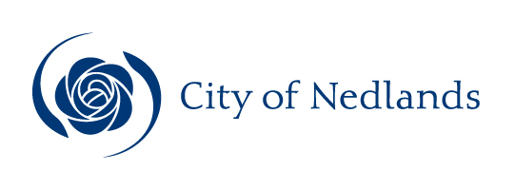

Technical Services Reports

Committee Consideration – 14 April 2020

Council Resolution – 28 April 2020

Table of Contents

Item No. Page No.

TS06.20 Boundary Roads Agreement – City of Subiaco 2
TS07.20 Hollywood Hospital Bus Service Improvement 5
TS08.20 City of Nedlands 2020 Annual Waste Report 9

TS06.20 Boundary Roads Agreement – City of Subiaco

Committee | 14 April 2020
Council | 28 April 2020
Applicant | City of Nedlands
Employee Disclosure under section 5.70 Local Government Act 1995 | Nil.
Director | Jim Duff – Director Technical Services
Attachments | - Draft Boundary Roads Agreement – City of Nedlands and City of Subiaco

Executive Summary

In August 2017, the City held a series of meetings with the City of Subiaco staff to agree the process that guides how joint projects are planned, implemented funded by both Local Governments.

The Memorandum of Understanding for Boundary Road Agreement document (refer Attachment 1) has been presented to the City of Subiaco at the Ordinary Council Meeting of 17 March 2020 and was approved. The document is being presented to the City of Nedlands at its Ordinary Council Meeting of 28 April 2020 with recommendation to approve.

Recommendation to Committee

That Council authorises the Mayor and Chief Executive Officer to sign the Memorandum of Understanding for the Boundary Road Agreement between the City of Nedlands and the City of Subiaco as detailed in Attachment 1 of this report.

Discussion/Overview

Background

In late 2016 the Administration recognized that there were issues with the boundary roads with respect to funding and service levels. This situation is causing problems for the City and the ratepayers who resided on these roads. The solution was to develop agreements with the neighbouring Local Governments, Town of Cottesloe, Town of Claremont, Town of Cambridge, City of Perth and City of Subiaco.

Following a discussion at the WESTECH meeting in August 2017, the City of Nedlands presented the City of Subiaco with a draft “Boundary Roads Agreement” document as a Memorandum of Understanding (MOU). The MOU details the roads shared with the City of Subiaco and the proposed arrangements applicable to these roads. There are two roads in the City of Nedlands that come under the effect of this agreement (refer to Appendix 1 in Attachment 1).

The MOU provides an ideal opportunity to provide consistency, and to open channels of communication between the LGA’s to allow for improved forward planning of maintenance and capital works projects.

History shows that past works conducted on these boundary roads were sometimes completed in isolation with each Council having their own set of service levels, forward works programming, style guides, tree selection, verge treatments etcetera.

Key Relevant Previous Council Decisions:

Nil.

Consultation

The City of Nedlands Staff
The City of Subiaco Staff

Strategic Implications

How well does it fit with our strategic direction?

Section 05 of the Strategic Community Plan “Our Priorities indicates working with neighbouring Councils to achieve the best outcomes for the western suburbs.

Who benefits?

The Community of both LGA’s

Does it involve a tolerable risk?

It is proposed that by working with our neighbouring Councils that risks can be identified and managed in a proactive way. Early communication and forward planning enable consistency in the delivery of infrastructure across boundaries and provides for more accurate and timely budget decisions linked to forward works programs.

Having a boundary road agreement in place will assist the City to manage risks associated with shared works.

Do we have the information we need?

By continuing to work in partnership with other local Councils creates better opportunities to attract project funding as well as standardize service levels and deliver potential cost saving through the economies of scale.

Budget/Financial Implications

The City of Nedlands has one project scheduled over the next five years that will affect this agreement (see Table 1 below):

Road | Project | Year | Funded by | Proposed Budget
Aberdare Road / Railway Road | Intersection Upgrade | 2021/2022 | Black Spot  $1,000,000  City of Nedlands  $250,000  City of Subiaco  $250,000 | $1,500,000
Table 1: Scheduled Projects

Any future changes to intersections on boundary roads, either civil or traffic light sequencing, must be able to meet the warrants set by Main Roads WA. Should changes be approved, then grant funding will be available to assist with these costs.

Can we afford it?

Decisions are based on sound asset management principles and promote a “whole of life” approach to the management of assets across the City.

How does the option impact upon rates?

The development of boundary road agreements will improve cost sharing arrangements between neighbouring local governments, while benefiting from the economies of scale for our rate payers.

TS07.20 Hollywood Hospital Bus Service Improvement

Committee | 14 April 2020
Council | 28 April 2020
Applicant | City of Nedlands
Employee Disclosure under section 5.70 Local Government Act 1995 | Nil.
Director | Jim Duff – Director Technical Services
Attachments | - Drawings – Monash Avenue Proposed Bus Embayment’s  - Supporting Letter from Hollywood Hospital

Executive Summary

The City has received a request from the Public Transport Authority (PTA) to increase bus services on Monash Avenue, as part of the QEII Bus Service Improvement Proposal. The PTA have identified Hollywood Private Hospital as an area where bus patronage numbers are low, and PTA is seeking to address this through provision of a new bus service operating directly between Perth CBD and Hollywood Private Hospital. PTA are also seeking funding to create bus interchange facilities at Shenton Park Station, if this submission is successful, then services are planned to be extended from Shenton Park Station to Hollywood Private Hospital.

Administration has worked collaboratively with PTA to identify two suitable locations on Monash Avenue for the proposed new bus stops. The bus service is planned to operate every 10-20 minutes during peak periods and 15-30 minutes during off peak periods with the bus stops being located close to the Hollywood Private Hospital Main Entrance.

The addition of two new stops on Monash Avenue will require the removal of three (3) on street parking embayment’s located to the west of Williams Road. These embayment’s are currently zoned as 2P (2 Hour Parking) 8am – 6pm, Monday – Saturday.

Recommendation to Committee

Council:

- Supports the provision of increased bus services as proposed in this report to service Monash Avenue, Nedlands; and

- approves the proposed bus stops as per Attachment 1 including changes to signage and line marking.

Discussion/Overview

Background

Currently Hollywood Private Hospital is served by Route 25, which operates every 20 minutes during peak periods and every 60 minutes during off-peak Monday to Saturday. This route primarily provides a community service function, taking an indirect route between key destinations so that it can serve local residents who are unable to walk to the high frequency route locations. The nearest bus stops to Hollywood Private Hospital are located on Williams Road and Monash Avenue (100 metres and 200 metres respectively from the main entrance) the current patronage numbers are reported by PTA as being around 100 passengers per week. By way of comparison, the stops near Perth Children’s Hospital and QEII services approximately 20,000 passengers per week.

The nearest stop to Hollywood Private Hospital, served by high frequency route, is located approximately 550 metres from the Hospital entrance on Hampden Road. Numerous studies demonstrate that passengers are willing to walk 400-500 metres to access bus routes, however, if the walk is longer or unpleasant, then usage significantly decreases, and the bus service ceases to be viable. This is particularly relevant for hospital staff, who work 24/7 and have staggered start/finish times, often required to travel during the hours of darkness. It is worth noting that the 550 metres walking distance does not consider the distance from the point of origin within the Hospital grounds.

The combination of existing parking demand around Hollywood Private Hospital, and the future construction of additional high-density residential units at the western end of Monash Avenue, creates an opportunity to encourage further public transport usage for trips to and from the Perth CBD to Hollywood Private Hospital. Recent construction of the roundabout at the intersection of Smyth Road and Monash Avenue allows buses to be turned around easily without having to operate out of service busses within local adjacent streets.

The PTA, in partnership with the City of Nedlands, have developed a design for the new bus stops. The initial proposal indicated that a total of two (2) bus stops were required to service the new bus route along Monash Avenue. It is proposed to use the existing area of road currently zoned as a “No Stopping”. This was considered a better option to avoid the loss of a further six (6) on street parking bays.

The removal of three (3) on street parking bays on the northern side of Monash Avenue will be offset by the expansion of the internal parking facilities within the future Hollywood Private Hospital development. Furthermore, the improvement to the Public Transport options will help mitigate the overall parking demand and congestion currently experienced within Monash Avenue. PTA have predicted if 10% of people currently using parking bays use the bus, it would have the potential to free up 200 parking bays around the precinct, along with potentially reducing at least 400 vehicle movements from the surrounding road network.

Proposal

PTA have sought the City support to implement two new bus stops on Monash Avenue, west of Williams Road (see Attachment 1). The recommended proposal will:

- Provide a high frequency bus service between Hollywood Private Hospital and Perth CBD;
- Provide a direct and easily accessible bus service close to the Hollywood Private Hospital Entrance; and
- Encourage patrons of the Hollywood Private Hospital to utilise public transport.

Key Relevant Previous Council Decisions:

Ordinary Meeting of Council 17 December 2019, Item 13.8 (Extract)

“That Council notes:

2. Its concerns that the effects on the cumulative impacts of development on traffic volumes may impact the area negatively, that public transport needs to be addressed, the UWA QEII Activity Centre Plan needs to be fast tracked and requests the CEO to convey this message to the State Government and to all lower and upper house Parliamentarians for this area.”

Consultation

As part of this report administration is seeking Council approval to commence consultation with all affected stakeholders.

Strategic Implications

How well does it fit with our strategic direction?

Section 02 of the Strategic Community Plan identifies the “Public Transport Plan for Perth 2031. Collaboration between the PTA and the City will result in improvements to frequency of services, upgrade bus stops and improve overall accessibility to cater for people with disabilities.

Who benefits?

The proposal will benefit both the City of Nedlands community and the wider community outside the City to gain improved access to the medical precinct.

Does it involve a tolerable risk?

By continuing to work in partnership with the PTA, this allows the City to plan for improvements in public transport network along with reducing parking and traffic congestion in the local area.

Do we have the information we need?

PTA have provided the necessary detail on current and future service plans. Subject to Council’s decision and the outcomes of the public consultation process, PTA will be advised to progress their concept plan to the next stage of design and provide this information to the City for our review and final approval.

Budget/Financial Implications

The cost for implementing the parking signs is summarised in Table 2.

Item | Cost per Item | Number of Items | Total
Replace sign only | $ 30.00 | 2 | $ 60.00
Remove sign only | $ 30.00 | 1 | $ 30.00
Install new sign pole | $ 130.00 | 2 | $ 260.00
Remove redundant line marking | $ 6.00LM | 42m | $ 252.00
Install new line marking | $3.16LM | 70m | $ 221.20
Total Cost |  |  | $823.00
Table 2. Cost estimate of proposed signage

The works in Table 2 will be funded from the City’s operations budget. All other works will be funded by the PTA.

Can we afford it?

Decisions are based on sound asset management principles and seek to promote a “whole of life” approach to the management of assets across the City. As this is a partnership, there is a shared cost arrangement with PTA, with the City’s costs estimated to be $823.00.

How does the option impact upon rates?

By continuing to form and work in partnership with State Government agencies such as PTA, it will result in improved services to our community and reduce the financial impact on the City of Nedlands.

TS08.20 City of Nedlands 2020 Annual Waste Report

Committee | 14 April 2020
Council | 28 April 2020
Applicant | City of Nedlands
Employee Disclosure under section 5.70 Local Government Act 1995 | Nil
Director | Jim Duff – Director Technical Services
Attachments | Nil.

Executive Summary

The City of Nedlands’ Waste Minimisation Strategy 2017-2020 (WMS) includes the following recommendation:

“The Administration prepare an annual report to Council on the progress of the Waste Minimisation Strategy (WMS) 2017-2020 with the report included in the March Agenda”.

During the 2018/19 financial year, the City diverted 53 percent of all waste collected comprising of general waste, recyclable waste, green waste, bulk waste (verge collection), e-waste, mattresses and household hazardous waste from landfill.

The West Australian Waste Avoidance and Resource Recovery Strategy 2030 (WARRS) has established an action plan which aims to guide the state in its transition towards a low waste circular economy. The City’s Waste Minimisation Strategy (WMS) aligns with the objectives and targets of the WARRS.

Recommendation to Committee

Council notes the City of Nedlands 2020 Annual Waste Report.

Discussion/Overview

Residential waste and recycling collection services are provided to all households within the City of Nedlands. The commercial and business precincts are serviced by kerbside waste and recycling collections on request. The City provides two bulk verge collection services per year to residents.

Table 1 shows collection and diversion rates for the 2018/19 financial year.

Collection | Services (No.) | Collected (tonnes) | Diverted | Diversion Rate
General | 9,165 | 5,060 | Nil | 49%
Recycling | 10,575 | 2,520 | Yes
Green | 8,284 | 2,743 | Yes
*Bulk | 2 | 1,351 | Yes | 87%
Total | 28,026 | 11,241 | Yes | 53%
Table 1: Waste Services Statistics

*Bulk includes hard waste and green waste collected from the verge, e-waste, mattresses and Household Hazardous Waste (HHW).

Figure 1 shows the City collected 11,241 tonnes of waste and 6,007 tonnes of recyclables (excluding contamination) from 1 July 2018 to 30 June 2019. This corresponds to an overall diversion rate from landfill of 53 percent.

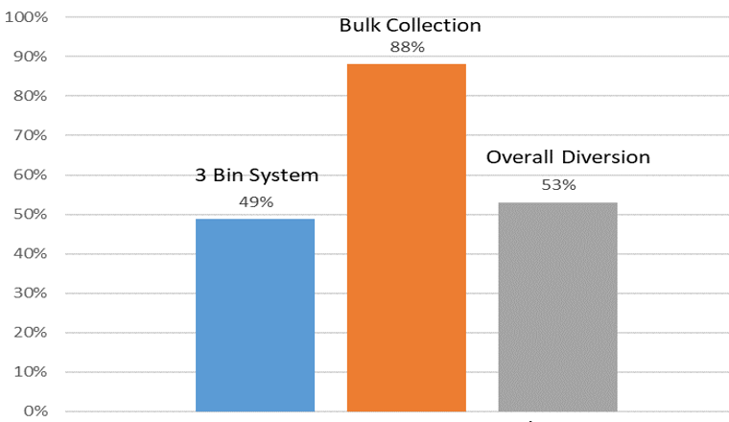
Figure 1: Waste Diversion 2018/19

Figure 2 shows waste diversion rates since 2006. The introduction of the three-bin system in 2006 resulted in an increase in waste diversion from landfill of approximately 20 percent. However, since 2008 there has been a gradual improvement in the diversion rate.

In the 2018/19 financial year, 53 percent of combined waste was diverted from landfill which was either recovered, reused or recycled. In comparison to 2017/18, the overall diversion rate for 2018/19 remains unchanged.

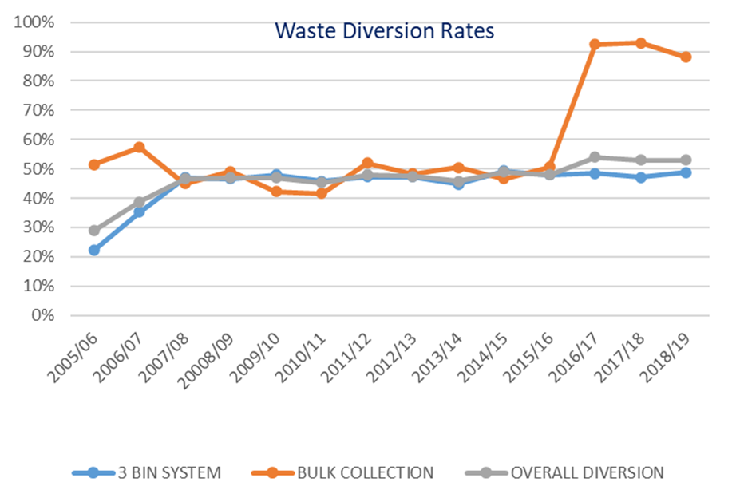
Figure 2: Waste Diversion Rate

Waste Minimisation Strategy

The City’s Waste Minimisation Strategy (WMS) 2017-2020 provides a series of recommendations aimed at reducing waste and increasing recycling and recovery of waste throughout the City, to ultimately achieve the State Government’s 2030 target and objectives.

The recommendations and brief update for each are as follows:

Recommendation | Brief Update
- Review the current recycling services and cost structures. | Included in the 2018-19 budget.
- Develop information sheets and education materials which encourage residents to place all recyclables in the recycle bin. | Annual waste brochure distributed to all residents with their rates each year.
- Provide details on the performance of the new bulk waste collection service. | The City completed the second full year of the new bulk collection contract on 29 November 2019. Recovery from landfill was 1,177 tonnes or 87%.
- Review the waste page on the City’s website to improve the information available to the Community with respect to reduce, reuse and recycle. | Completed in June 2019.
- Develop and continually update education materials regarding waste performance for students (primary, secondary and tertiary). | Completed in February 2019, however this is ongoing.
- Investigate methods to ascertain the actual level of C&D waste recycling within the City. | Due to current resource constraints no progress to date.
- Explore options to accommodate food waste into the green waste stream. | City of Nedlands Waste Survey report has been submitted.
- Research options for the potential reuse of residual waste materials. | The City is monitoring the progress of the Kwinana Waste to Energy facility and contract agreements with other Local Government Authorities.

Waste Avoidance and Resource Recovery Strategy 2030 (WARRS)

The WARRS will guide the state in becoming a sustainable, low-waste circular economy. Historically, Western Australia has generated the highest volume of waste per capita in the nation and has had among the lowest rates of waste recovery. The 2030 action plan is devised to meet the targets set out in the WARRS towards minimising waste, maximising recycling and reducing the amount of waste going to landfill wherever possible. See overall objectives and state targets in Figure 3.

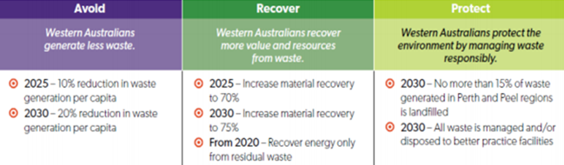
Figure 3: State Government Objectives and Targets

Consultation

The City will commence community consultation on the draft WMS 2020-2025 in Mid-2021.

Strategic Implications

The City’s WMS and action plan 2017-2020 supports the City’s Strategic Community Plan in the following area.

- Key focus area – Roles and Services / Education

The key objective is to ensure that the community expectations and concerns has been addressed and delivers the industry’s best practice of waste management and recycling services to the community.

Budget/Financial Implications

In 2018/19 the City adopted a budget of $2,954,537 for the provision of waste services.

Administration has worked closely with the City’s Waste Management Contractors to deliver a highly efficient and cost-effective waste service to our residents while avoiding waste service change increases.

2018/19 budget performance is as follows:

- Budget Expenditure $2,954,537
- Actual Expenditure $2,901,744 (98%)
- Projected Budget Income $3,305,600
- Actual Income $3,314,831 (101%)

Residents’ annual waste charge has now remained unchanged since 2013.

