

***Agenda***

***Council Meeting***

***28 August 2018***

Dear Council member

The next Ordinary Meeting of the City of Nedlands will be held on Tuesday 24 April 2018in the Council Chambers at 71 Stirling Highway Nedlands commencing at 7 pm.



Greg Trevaskis

Chief Executive Officer

21 August 2018

**Table of Contents**

Declaration of Opening 4

Present and Apologies and Leave Of Absence (Previously Approved) 4

1. Public Question Time 5

2. Addresses by Members of the Public 5

3. Requests for Leave of Absence 5

4. Petitions 5

5. Disclosures of Financial Interest 5

6. Disclosures of Interests Affecting Impartiality 6

7. Declarations by Members That They Have Not Given Due Consideration to Papers 6

8. Confirmation of Minutes 6

8.1 Ordinary Council Meeting 24 July 2018 6

8.2 Special Council Meeting 31 July 2018 6

9. Announcements of the Presiding Member without discussion 6

10. Members announcements without discussion 7

11. Matters for Which the Meeting May Be Closed 7

12. Divisional reports and minutes of Council committees and administrative liaison working groups 7

12.1 Minutes of Council Committees 7

12.2 Planning & Development Report No’s PD36.18 to PD42.18 (copy attached) 8

PD36.18 (Lot 601) No. 2A Korel Gardens, Swanbourne – Two Storey Single House 8

PD37.18 (Lot 54) No. 14 Odern Crescent, Swanbourne – Amendment to DA18/28369 (Two Storey Single House with Under-croft) 11

PD38.18 (Lot 329) No. 9 Bedford Street, Nedlands – Additions (Patio and Carport) to Single House 12

PD39.18 (Lot 396) No. 64 Florence Road, Nedlands – Two Storey Single House 14

PD40.18 (Lot 211) No. 11 Lupin Hill Grove, Nedlands – Home Business (Eye Lash Extensions) 17

PD41.18 Cottesloe Golf Club – Proposed Works for Reserve 9299 19

PD42.18 Review of Western Central Local Emergency Management Arrangements 20

12.3 Technical Services Report No’s TS19.18 to TS20.18 (copy attached) 21

TS19.18 Jones Park Enviro-Scape Master Plan 21

TS20.18 Proposed Reserve Names for the Shenton Park Rehabilitation Hospital Redevelopment 22

12.4 Community & Organisational Development Report No’s CM02.18 (copy attached) 23

CM02.18 Community Sport and Recreation Facilities Fund Application – Nedlands Tennis Club 23

12.5 Corporate & Strategy Report No’s CPS17.18 (copy attached) 24

CPS17.18 List of Accounts Paid – June 2018 24

13. Reports by the Chief Executive Officer 25

13.1 List of Delegated Authorities – July 2018 25

13.2 Monthly Financial Report – July 2018 29

13.3 Monthly Investment Report – July 2018 32

13.4 Professional Development Approved by the Chief Executive Officer 34

13.5 Lot (388) - 95A Waratah Avenue – Request for temporary access 35

13.6 Provision of Community Services from Zamia Room at Mt Claremont Community Centre 40

14. Elected Members Notices of Motions of Which Previous Notice Has Been Given 42

14.1 Councillor Mangano – Birdwood Parade Paths Clean Up & Repairs 42

15. Elected members notices of motion given at the meeting for consideration at the following ordinary meeting on 25 September 2018 47

16. Urgent Business Approved By the Presiding Member or By Decision 48

17. Confidential Items 48

Declaration of Closure 48

**City of Nedlands**

**Notice of an Ordinary Meeting of Council to be held in the Council Chambers, Nedlands on Tuesday 28 August 2018 at 7 pm.**

###### Council Agenda

# Declaration of Opening

The Presiding Member will declare the meeting open at 7 pm and will draw attention to the disclaimer below.

(NOTE: Council at its meeting on 24 August 2004 resolved that should the meeting time reach 11.00 p.m. the meeting is to consider an adjournment motion to reconvene the next day).

# Present and Apologies and Leave Of Absence (Previously Approved)

**Leave of Absence** Councillor L J McManus Coastal Districts Ward

**(Previously Approved)**

**Apologies** Councillor N W Shaw Melvista Ward

**Disclaimer**

Members of the public who attend Council meetings should not act immediately on anything they hear at the meetings, without first seeking clarification of Council’s position. For example by reference to the confirmed Minutes of Council meeting. Members of the public are also advised to wait for written advice from the Council prior to taking action on any matter that they may have before Council.

Any plans or documents in agendas and minutes may be subject to copyright. The express permission of the copyright owner must be obtained before copying any copyright material.

# Public Question Time

A member of the public wishing to ask a question should register that interest by notification in writing to the CEO in advance, setting out the text or substance of the question.

The order in which the CEO receives registrations of interest shall determine the order of questions unless the Mayor determines otherwise. Questions must relate to a matter affecting the City of Nedlands.

# Addresses by Members of the Public

Addresses by members of the public who have completed Public Address Session Forms to be made at this point.

# Requests for Leave of Absence

Any requests from Councillors for leave of absence to be made at this point.

# Petitions

Petitions to be tabled at this point.

# Disclosures of Financial Interest

The Presiding Member to remind Councillors and Staff of the requirements of Section 5.65 of the *Local Government Act* to disclose any interest during the meeting when the matter is discussed.

A declaration under this section requires that the nature of the interest must be disclosed. Consequently a member who has made a declaration must not preside, participate in, or be present during any discussion or decision making procedure relating to the matter the subject of the declaration.

However, other members may allow participation of the declarant if the member further discloses the extent of the interest. Any such declarant who wishes to participate in the meeting on the matter, shall leave the meeting, after making their declaration and request to participate, while other members consider and decide upon whether the interest is trivial or insignificant or is common to a significant number of electors or ratepayers.

# Disclosures of Interests Affecting Impartiality

The Presiding Member to remind Councillors and Staff of the requirements of Council’s Code of Conduct in accordance with Section 5.103 of the *Local Government Act*.

Councillors and staff are required, in addition to declaring any financial interests to declare any interest that may affect their impartiality in considering a matter. This declaration does not restrict any right to participate in or be present during the decision-making procedure.

The following pro forma declaration is provided to assist in making the disclosure.

“With regard to …… the matter in item x….. I disclose that I have an association with the applicant (or person seeking a decision). As a consequence, there may be a perception that my impartiality on the matter may be affected. I declare that I will consider this matter on its merits and vote accordingly.”

The member or employee is encouraged to disclose the nature of the association.

# Declarations by Members That They Have Not Given Due Consideration to Papers

Members who have not read the business papers to make declarations at this point.

# Confirmation of Minutes

## Ordinary Council Meeting 24 July 2018

The Minutes of the Ordinary Council Meeting held 24 July 2018 are to be confirmed.

## Special Council Meeting 31 July 2018

The Minutes of the Special Council Meeting held 31 July 2018 are to be confirmed.

# Announcements of the Presiding Member without discussion

Any written or verbal announcements by the Presiding Member to be tabled at this point.

# Members announcements without discussion

Written announcements by Councillors to be tabled at this point.

Councillors may wish to make verbal announcements at their discretion.

# Matters for Which the Meeting May Be Closed

Council, in accordance with Standing Orders and for the convenience of the public, is to identify any matter which is to be discussed behind closed doors at this meeting, and that matter is to be deferred for consideration as the last item of this meeting.

# Divisional reports and minutes of Council committees and administrative liaison working groups

## Minutes of Council Committees

This is an information item only to receive the minutes of the various meetings held by the Council appointed Committees (N.B. This should not be confused with Council resolving to accept the recommendations of a particular Committee. Committee recommendations that require Council’s approval should be presented to Council for resolution via the relevant departmental reports).

**The Minutes of the following Committee Meetings (in date order) are to be received:**

**Council Committee 14 August 2018**

Circulated to Councillors on 17 August 2018

**Note: As far as possible all the following reports under items 12.2, 12.3, 12.4 and 12.5 will be moved en-bloc and only the exceptions (items which Councillors wish to amend) will be discussed.**

## Planning & Development Report No’s PD36.18 to PD42.18 (copy attached)

Note: Regulation 11(da) of the *Local Government (Administration) Regulations 1996* requires written reasons for each decision made at the meeting that is significantly different from the relevant written recommendation of a committee or an employee as defined in section 5.70, but not a decision to only note the matter or to return the recommendation for further consideration.

|  |  |
| --- | --- |
| **PD36.18** | **(Lot 601) No. 2A Korel Gardens, Swanbourne – Two Storey Single House** |
|  | |
| **Committee** | 14 August 2018 |
| **Council** | 28 August 2018 |
| **Applicant** | Westlake Corp Pty Ltd (Trendsetter Homes) |
| **Landowner** | Mr A R & Ms K F Johnson |
| **Director** | Peter Mickleson – Director Planning & Development |
| **Reference** | DA18/28993 |
| **Previous Item** | Nil. |
| **Delegation** | In accordance with Clause 6.7.1a) of the City’s Instrument of Delegation, Council is required to determine the application due to objections being received. |
| **Attachments** | 1. Site Photographs 2. Applicant Justification |

**Committee Recommendation**

**That Council refuses the development application.**

Recommendation to Committee

Council approves the development application received 18 May 2018 with amended plans dated 5 July 2018 to construct a Two Storey Single House at (Lot 601) No. 2A Korel Gardens, Swanbourne, subject to the following conditions and advice:

1. The development shall at all times comply with the application and the approved plans, subject to any modifications required as a consequence of any condition(s) of this approval.
2. This development approval only pertains to the proposed dwelling, associated site works, fencing and swimming pool.
3. The parapet wall being finished to a professional standard within 14 days of the proposed development’s practicable completion and be maintained thereafter by the landowner to the City’s satisfaction.
4. All footings and structures to retaining walls, fences and parapet walls, shall be constructed wholly inside the site boundaries of the property’s Certificate of Title.
5. The bed 4 north facing awning window shall be obscured and restricted to an opening of less than 0.3m.
6. All fencing, visual privacy screens and obscure glass panels to Major Openings and Unenclosed Active Habitable Spaces as shown on the approved plans, shall prevent overlooking in accordance with the visual privacy requirements of the *Residential Design Codes 2018*. The fencing, visual privacy screens and obscure glass panels shall be installed prior to the development’s practicable completion and remain in place permanently, unless otherwise approved by the City.
7. All stormwater from the development, which includes permeable and non-permeable areas shall be contained onsite.

Advice Notes specific to this proposal:

1. Any development in the nature-strip (verge), including footpaths, will require a Nature-Strip Development Application (NSDA) to be lodged with, and approved by, the City’s Technical Services department, prior to construction commencing.
2. The crossover to the street shall be constructed to the Council’s Crossover Specifications and the applicant / landowner to obtain levels for the crossover from the Council’s Infrastructure Services under supervision onsite, prior to commencement of works.
3. All swimming pool waste water shall be disposed of into an adequately sized, dedicated soak-well located on the same lot. Soak-wells shall not be situated closer than 1.8m to any boundary of a lot, building, septic tank or other soak-well.
4. All swimming pools, whether retained, partially constructed or finished, shall be kept dry during the construction period. Alternatively, the water shall be maintained to a quality which prevents mosquitoes from breeding.
5. All downpipes from guttering shall be connected so as to discharge into drains, which shall empty into a soak-well; and each soak-well shall be located at least 1.8m from any building, and at least 1.8m from the boundary of the block. Soak-wells of adequate capacity to contain runoff from a 20 year recurrent storm event. Soak-wells shall be a minimum capacity of 1.0mP3P for every 80mP2P of calculated surface area of the development.
6. All internal water closets and ensuites without fixed or permanent window access to outside air or which open onto a hall, passage, hobby or staircase, shall be serviced by a mechanical ventilation exhaust system which is ducted to outside air, with a minimum rate of air change equal to or greater than 25 litres / second.
7. Prior to the commencement of any demolition works, any Asbestos Containing Material (ACM) in the structure to be demolished, shall be identified, safely removed and conveyed to an appropriate landfill which accepts ACM.

Removal and disposal of ACM shall be in accordance with *Health (Asbestos) Regulations 1992*, Regulations 5.43 - 5.53 of the *Occupational Safety and Health Regulations 1996*, *Code of Practice for the Safe Removal of Asbestos 2*P*nd*P *Edition*, *Code of Practice for the Management and Control of Asbestos in a Workplace*, and any Department of Commerce Worksafe requirements.

Where there is over 10mP2P of ACM or any amount of friable ACM to be removed, it shall be removed by a Worksafe licensed and trained individual or business.

1. The applicant is advised to consult the City’s Visual and Acoustic Privacy Advisory Information in relation to locating any mechanical equipment (e.g. air-conditioner, swimming pool or spa) such that noise, vibration and visual impacts on neighbours are mitigated. The City does not recommend installing any equipment near a property boundary where it is likely that noise will intrude upon neighbours.

Prior to selecting a location for an air-conditioner, the applicant is advised to consult the online fairair noise calculator at www.fairair.com.au and use this as a guide to prevent noise affecting neighbouring properties.

Prior to installing mechanical equipment, the applicant is advised to consult neighbours, and if necessary, take measures to suppress noise.

1. This decision constitutes planning approval only and is valid for a period of two years from the date of approval. If the subject development is not substantially commenced within the two year period, the approval shall lapse and be of no further effect.

|  |  |
| --- | --- |
| **PD37.18** | **(Lot 54) No. 14 Odern Crescent, Swanbourne – Amendment to DA18/28369 (Two Storey Single House with Under-croft)** |
|  | |
| **Committee** | 14 August 2018 |
| **Council** | 28 August 2018 |
| **Applicant** | Element Advisory Pty Ltd |
| **Landowner** | A M Cullen & M E Hands |
| **Director** | Peter Mickleson – Director Planning & Development |
| **Reference** | DA18/29077 |
| **Previous Item** | PD07.18 – 27 March 2018 |
| **Delegation** | In accordance with Clause 6.7.1a) of the City’s Instrument of Delegation, Council is required to determine the application due to objections being received. |
| **Attachments** | 1. Site Photographs |

**Committee Recommendation / Recommendation to Committee**

**Council approves the development application dated 23 May 2018 for Amendments to DA18/28369 (Two Storey Single House) at (Lot No. 54) No. 14 Odern Crescent, Swanbourne, subject to the following conditions and advice:**

1. **The development shall at all times comply with the application and the approved plans, subject to any modifications required as a consequence of any condition(s) of this approval.**
2. **The previous development approval (DA18/28369, dated 18 April 2018) and conditions there-in, remain in effect. This excludes the plans approved as part of the previous development application.**

**Advice Notes specific to this proposal:**

1. **This decision constitutes planning approval only and is valid for a period of two years from the date of the original approval (18 December 2017). If the subject development is not substantially commenced within the two-year period, the approval shall lapse and be of no further effect.**

|  |  |
| --- | --- |
| **PD38.18** | **(Lot 329) No. 9 Bedford Street, Nedlands – Additions (Patio and Carport) to Single House** |
|  | |
| **Committee** | 14 August 2018 |
| **Council** | 28 August 2018 |
| **Applicant** | Great Aussie Patios |
| **Landowner** | A W & D L White |
| **Director** | Peter Mickleson – Director Planning & Development |
| **Reference** | DA18/29007 |
| **Previous Item** | Nil. |
| **Delegation** | Administration has elected not to exercise delegation under clause 6.7.1 due to the nature of the variations proposed and conditions of approval requiring alteration to the development. |
| **Attachments** | 1. Site photographs. |

**Committee Recommendation / Recommendation to Committee**

**Council approves the development application received 21 May 2018 with amended plans received 26 June 2018 for additions (carport and patio) to the existing single house at (Lot 329) No. 9 Bedford Street, Nedlands, subject to the following conditions and advice:**

1. **The development shall at all times comply with the application and the approved plans, subject to any modifications required as a consequence of any condition(s) of this approval.**
2. **This development approval only pertains to the proposed patio and carport.**
3. **Revised drawings shall be submitted with the Building Permit application, to the satisfaction of the City, showing modifications to the carport and driveway as follows:** 
   1. **The eastern side lot boundary setback for the carport is increased to 0.9m (as measured to the post and eave);**
   2. **The carport colours and materials of construction to compliment or match the existing dwelling; and**
   3. **The eastern side lot boundary setback to the driveway is increased to 1m.**
4. **The existing garage spaces are to be retained as covered car parking spaces.**
5. **All sides of the carport shall remain open and shall not accommodate a door.**
6. **All footings and structures to retaining walls, fences and parapet walls, shall be constructed wholly inside the site boundaries of the property’s Certificate of Title.**
7. **All stormwater from the development, which includes permeable and non-permeable areas shall be contained onsite.**

**Advice Notes specific to this proposal:**

1. **A separate development application is required to be submitted to and approved by the City prior to erecting any fencing within the street setback area(s) which is not compliant with the deemed-to-comply provisions of the Residential Design Codes, and/or erecting any fencing behind the primary street setback area which is more than 1.8m in height above natural ground level.**
2. **All crossovers to the street(s) shall be constructed to the Council’s Crossover Specifications and the applicant / landowner to obtain levels for crossovers from the Council’s Infrastructure Services under supervision onsite, prior to commencement of works.**
3. **Any development in the nature-strip (verge), including footpaths, will require a Nature-Strip Development Application (NSDA) to be lodged with, and approved by, the City’s Technical Services department, prior to construction commencing.**
4. **Any approved street tree removals shall be undertaken by the City of Nedlands and paid for by the owner of the property where the development is proposed, unless otherwise approved under the Nature Strip Development approval.**
5. **All downpipes from guttering shall be connected so as to discharge into drains, which shall empty into a soak-well; and each soak-well shall be located at least 1.8m from any building, and at least 1.8m from the boundary of the block. Soak-wells of adequate capacity to contain runoff from a 20-year recurrent storm event. Soak-wells shall be a minimum capacity of 1.0m**P**3**P **for every 80m**P**2**P **of calculated surface area of the development.**
6. **This decision constitutes planning approval only and is valid for a period of two years from the date of approval. If the subject development is not substantially commenced within the two-year period, the approval shall lapse and be of no further effect.**

|  |  |
| --- | --- |
| **PD39.18** | **(Lot 396) No. 64 Florence Road, Nedlands – Two Storey Single House** |
|  | |
| **Committee** | 14 August 2018 |
| **Council** | 28 August 2018 |
| **Applicant** | Atrium Homes |
| **Landowner** | Mr W Pangestu |
| **Director** | Peter Mickleson – Director Planning & Development |
| **Reference** | DA18/28642 |
| **Previous Item** | Nil. |
| **Delegation** | In accordance with Clause 6.7.1a) of the City’s Instrument of Delegation, Council is required to determine the application due to objections being received. |
| **Attachments** | 1. Site Photographs 2. Applicant Justification |

***Please note:***No recommendation was made at the Committee Meeting. Council may wish to refuse the application to provide direction to staff and the applicant.

Recommendation to Committee

Council approves the development application dated 01 May 2018 to construct a two-storey single house at (Lot 396) No. 64 Florence Road, Nedlands, subject to the following conditions and advice:

1. The development shall at all times comply with the application and the approved plans, subject to any modifications required as a consequence of any condition(s) of this approval.
2. This development approval only pertains to the proposed single house, front fence and associated site works.
3. All footings and structures to retaining walls, fences and parapet walls, shall be constructed wholly inside the site boundaries of the property’s Certificate of Title.
4. All fencing, visual privacy screens and obscure glass panels to Major Openings and Unenclosed Active Habitable Spaces as shown on the approved plans, shall prevent overlooking in accordance with the visual privacy requirements of the *Residential Design Codes 2018*. The fencing, visual privacy screens and obscure glass panels shall be installed prior to the development’s practicable completion and remain in place permanently, unless otherwise approved by the City.
5. All stormwater from the development, which includes permeable and non-permeable areas shall be contained onsite.

Advice notes:

1. The dwelling shall not be used as a display home without further approval from the City being obtained.
2. All crossovers to the street(s) shall be constructed to the Council’s Crossover Specifications and the applicant / landowner to obtain levels for crossovers from the Council’s Infrastructure Services under supervision onsite, prior to commencement of works.
3. The redundant crossover(s) shall be removed and the nature-strip (verge) reinstated to the City’s satisfaction.
4. Any development in the nature-strip (verge), including footpaths, will require a Nature-Strip Development Application (NSDA) to be lodged with, and approved by, the City’s Technical Services department, prior to construction commencing.
5. All street tree assets in the nature-strip (verge) shall not be removed. Any approved street tree removals shall be undertaken by the City of Nedlands and paid for by the owner of the property where the development is proposed, unless otherwise approved under the Nature Strip Development approval.
6. All downpipes from guttering shall be connected so as to discharge into drains, which shall empty into a soak-well; and each soak-well shall be located at least 1.8m from any building, and at least 1.8m from the boundary of the block. Soak-wells of adequate capacity to contain runoff from a 20-year recurrent storm event. Soak-wells shall be a minimum capacity of 1.0mP3P for every 80mP2P of calculated surface area of the development.
7. All internal water closets and ensuites without fixed or permanent window access to outside air or which open onto a hall, passage, hobby or staircase, shall be serviced by a mechanical ventilation exhaust system which is ducted to outside air, with a minimum rate of air change equal to or greater than 25 litres / second.
8. The applicant is advised to consult the City’s Visual and Acoustic Privacy Advisory Information in relation to locating any mechanical equipment (e.g. air-conditioner, swimming pool or spa) such that noise, vibration and visual impacts on neighbours are mitigated. The City does not recommend installing any equipment near a property boundary where it is likely that noise will intrude upon neighbours.

Prior to selecting a location for an air-conditioner, the applicant is advised to consult the online fairair noise calculator at www.fairair.com.au and use this as a guide to prevent noise affecting neighbouring properties.

Prior to installing mechanical equipment, the applicant is advised to consult neighbours, and if necessary, take measures to suppress noise.

1. This decision constitutes planning approval only and is valid for a period of two years from the date of approval. If the subject development is not substantially commenced within the two-year period, the approval shall lapse and be of no further effect.

|  |  |
| --- | --- |
| **PD40.18** | **(Lot 211) No. 11 Lupin Hill Grove, Nedlands – Home Business (Eye Lash Extensions)** |
|  | |
| **Committee** | 14 August 2018 |
| **Council** | 28 August 2018 |
| **Applicant** | E and Y Kurniawan |
| **Landowner** | E and Y Kurniawan |
| **Director** | Peter Mickleson – Director Planning & Development |
| **Reference** | DA18/29084 |
| **Previous Item** | Nil. |
| **Delegation** | In accordance with Clause 6.7.1a) of the City’s Instrument of Delegation, Council is required to determine the application due to an objection being received. |
| **Attachments** | 1. Photograph of subject property |

**Committee Recommendation / Recommendation to Committee**

**Council approves the development application for a home business (eye lash extensions) to operate at (Lot 211) No.11 Lupin Hill Grove, Nedlands, received on 17 May 2018, subject to the following conditions and advice:**

1. **The development shall at all times comply with the application and the approved plans, subject to any modifications required as a consequence of any condition(s) of this approval.**
2. **The home business approval being valid for a period of 12 months from the date of Council’s decision in accordance with Council’s Home Business Policy, after which time it is not permitted to continue operating unless a separate planning application has been approved.**
3. **The proposed use complying with the home business definition stipulated under the City’s Town Planning Scheme No. 2 (refer to advice note 1).**
4. **Customers visiting the property by prior appointment only.**
5. **Customer vehicles being parked on site only.**
6. **The home business only being permitted to operate between the following times:**

**Monday to Friday - 8.30am and 7.00pm.**

**Saturday and Sunday - 8.30am and 5.00pm.**

**Advice Notes specific to this approval:**

1. **With regard to Condition 2, The applicant is advised that the use ‘Home Business’ is defined as being the following under the City’s Town Planning Scheme No. 2:**

***“Home Business - means a business, service or profession carried out in a dwelling or on land around a dwelling by an occupier of the dwelling which:***

***i) does not employ more than 2 people not members of the occupier's household;***

***ii) will not cause injury to or adversely affect the amenity of the neighbourhood;***

***iii) does not occupy an area greater than 50 square metres;***

***iv) does not involve the retail sale, display or hire of goods of any nature;***

***v) in relation to vehicles and parking, does not result in traffic difficulties as a result of the inadequacy of parking or an increase in traffic volumes in the neighbourhood, and does not involve the presence, use or calling of a vehicle more than 3.5 tonnes tare weight; and***

***vi) does not involve the use of an essential service of greater capacity than normally required in the zone.”***

**2. Noise levels are to comply with the *Environmental Protection (Noise) Regulations* *1997*.**

**3. This decision constitutes planning approval only and is valid for a period of two years from the date of approval. If the subject development is not substantially commenced within the two-year period, the approval shall lapse and be of no further effect.**

|  |  |
| --- | --- |
| **PD41.18** | **Cottesloe Golf Club – Proposed Works for Reserve 9299** |
|  | |
| **Committee** | 14 August 2018 |
| **Council** | 28 August 2018 |
| **Applicant** | Cottesloe Golf Club Inc. |
| **Landowner** | City of Nedlands |
| **Director** | Peter Mickleson – Director Planning & Development |
| **Previous Item** | PD33.13 on 20 August 2013 |
| **Attachments** | 1. Proposed Works and Form 1 Application for Development Approval including Management Plan for Remnant Bushland |

**Committee Recommendation / Recommendation to Committee**

**Council:**

1. **As landlord of Reserve 9299, being the Cottesloe Golf Course, endorses the proposed works by Cottesloe Golf Club Inc. as outlined in Attachment 1; and**
2. **Instructs the Chief Executive Officer to sign the Form 1 Application for Development Approval, as representative of the landlord.**

|  |  |
| --- | --- |
| **PD42.18** | **Review of Western Central Local Emergency Management Arrangements** |
|  | |
| **Committee** | 14 August 2018 |
| **Council** | 28 August 2018 |
| **Director** | Peter Mickleson – Director Planning & Development |
| **Attachments** | 1. Copy of the Western Central Local Emergency Management Arrangements dated June 2018 (Appendix Six and Seven excluded as some contact details are private contact numbers that only Hazard Management Agency need to access). |

**Committee Recommendation**

**That Council:**

1. **in accordance with Part 3, Division 2 of the *Emergency Management Act 2005*, adopt the Western Central Local Emergency Management Arrangements dated June 2018.**
2. **brings to the attention of the Western Central Local Emergency Management Committee that the template for Local Emergency Recovery Plan include provision for the Local Emergency Co-ordinator to notify the President/Mayor of the relevant Shire, Town or City that an emergency event has occurred in the said Shire, Town or City.**

Recommendation to Committee

That Council in accordance with Part 3, Division 2 of the *Emergency Management Act 2005*, adopt the Western Central Local Emergency Management Arrangements dated June 2018.

## Technical Services Report No’s TS19.18 to TS20.18 (copy attached)

Note: Regulation 11(da) of the *Local Government (Administration) Regulations 1996* requires written reasons for each decision made at the meeting that is significantly different from the relevant written recommendation of a committee or an employee as defined in section 5.70, but not a decision to only note the matter or to return the recommendation for further consideration.

|  |
| --- |
| **TS19.18 Jones Park Enviro-Scape Master Plan** |

|  |  |
| --- | --- |
| **Committee** | 14 August 2018 |
| **Council** | 28 August 2018 |
| **Applicant** | City of Nedlands |
| **Officer** | Andrew Dickson – Manager Parks Services |
| **Director** | Martyn Glover – Director Technical Services |
| **Attachments** | 1. Jones Park Enviro-Scape Master Plan 2. Community Engagement Results |

**Committee Recommendation / Recommendation to Committee**

**Council endorses the Jones Park Enviro-scape Master Plan concept.**

|  |
| --- |
| **TS20.18 Proposed Reserve Names for the Shenton Park Rehabilitation Hospital Redevelopment** |

|  |  |
| --- | --- |
| **Committee** | 14 August 2018 |
| **Council** | 28 August 2018 |
| **Applicant** | Landcorp |
| **Officer** | Steve Crossman – Asset Management Coordinator |
| **Director** | Martyn Glover – Director Technical Services |
| **Attachments** | 1. Application from Landcorp 2. Location Plan 3. Extract of Policies and Standards for Geographical Naming in Western Australia. |

**Committee Recommendation / Recommendation to Committee**

**Council:**

1. **endorses the following proposed road names for use by Landcorp for the Shenton Park Hospital redevelopment:**

* **Orton Road;**
* **Salk Road; or**
* **Sabin Road.**

1. **Supports the use of the name Orton Road for the re-naming of Ellis Griffiths Drive.**

## Community & Organisational Development Report No’s CM02.18 (copy attached)

Note: Regulation 11(da) of the *Local Government (Administration) Regulations 1996* requires written reasons for each decision made at the meeting that is significantly different from the relevant written recommendation of a committee or an employee as defined in section 5.70, but not a decision to only note the matter or to return the recommendation for further consideration.

|  |
| --- |
| **CM02.18 Community Sport and Recreation Facilities Fund Application – Nedlands Tennis Club** |

|  |  |
| --- | --- |
| **Committee** | 17 August 2018 |
| **Council** | 28 August 2018 |
| **Applicant** | Nedlands Tennis Club |
| **Officer** | Amanda Cronin – Coordinator Community Development  Marion Granich – Manager Community Development |
| **Director** | Lorraine Driscoll – Director Corporate and Strategy |
| **Attachments** | 1. Site Plan 2. Lighting Plan |

**Committee Recommendation / Recommendation to Committee**

**Council:**

1. **Advises Department of Local Government, Sport and Cultural Industries (DLGSCI) that it has ranked and rated the application to the Community Sport and Recreation Facilities Fund Annual Grant round as follows:**
2. **Nedlands Tennis Club – Floodlight and Court upgrade: Well planned and needed by the municipality (A Rating);**
3. **Endorses the application to DLGSCI on the condition that all necessary statutory approvals are obtained by the applicant.**
4. **Approves an amount of $65,603 for the Nedlands Tennis Club conditional on the project receiving DLGSCI funding.**

## Corporate & Strategy Report No’s CPS17.18 (copy attached)

Note: Regulation 11(da) of the *Local Government (Administration) Regulations 1996* requires written reasons for each decision made at the meeting that is significantly different from the relevant written recommendation of a committee or an employee as defined in section 5.70, but not a decision to only note the matter or to return the recommendation for further consideration.

|  |
| --- |
| **CPS17.18 List of Accounts Paid – June 2018** |

|  |  |
| --- | --- |
| **Committee** | 14 August 2018 |
| **Council** | 28 August 2018 |
| **Applicant** | City of Nedlands |
| **Officer** | Vanaja Jayaraman – Manager Finance |
| **Director** | Lorraine Driscoll – Director Corporate & Strategy |
| **Attachments** | 1. Creditor Payment Listing June 2018 2. Purchasing Card Payments June 2018 (2pth May – 28th June) |

**Committee Recommendation / Recommendation to Committee**

**Council receives the List of Accounts Paid for the month of June 2018** **(refer to attachments).**

# Reports by the Chief Executive Officer

## List of Delegated Authorities – July 2018

The attached List of Delegated Authorities for the month of July 2018 is to be received.

|  |  |  |  |  |  |
| --- | --- | --- | --- | --- | --- |
| **Date of use of delegation of authority** | **Title** | **Position exercising delegated authority** | **Act** | **Section of Act** | **Applicant / CoN / Property Owner / Other** |
| 05/07/2018 | 3031754 – Parking Infringement Withdrawal – other compassionate grounds | Manager Health & Compliance – Andrew Melville | Local Government Act 1995 | Section 9.20/6.12(1) | Liz Jaeschke-Angi |
| 09/07/2018 | 3030165 – Parking Infringement Withdrawal – other compassionate grounds | Manager Health & Compliance – Andrew Melville | Local Government Act 1995 | Section 9.20/6.12(1) | Sarah Joubert |
| 10/07/2018 | 3030202 – Parking Infringement Withdrawal – other compassionate grounds | Manager Health & Compliance – Andrew Melville | Local Government Act 1995 | Section 9.20/6.12(1) | Corey Stott |
| 10/07/2018 | 3030110 – Parking Infringement Withdrawal – other compassionate grounds | Manager Health & Compliance – Andrew Melville | Local Government Act 1995 | Section 9.20/6.12(1) | Eloise Skoss |
| 12/07/2018 | 3015923 – Parking Infringement Withdrawal – other compassionate grounds | Manager Health & Compliance – Andrew Melville | Local Government Act 1995 | Section 9.20/6.12(1) | Deborah Tatam |
| 13/07/2018 | 3031755 – Parking Infringement Withdrawal – other compassionate grounds | Manager Health & Compliance – Andrew Melville | Local Government Act 1995 | Section 9.20/6.12(1) | Wei Zhang |
| 17/07/2018 | (APP) – DA18/28824 – 64 Kingsway – Two Storey Single House | A/Manager Planning – Aron Holbrook | City of Nedlands TPS2 | Section 6.7.1 | Averna Pty Ltd |
| 18/07/2018 | (APP) – DA18/29132 – 45 Taylor Rd, Nedlands – Additions (Patio) to Single House | A/Coordinator Statutory Planning - Kate Bainbridge | City of Nedlands TPS2 | Section 6.7.1 | Patiolife |
| 19/07/2018 | (APP) – DA17/336 – 35 Alexander Rd, Dalkeith – Retrospective Two Storey Single House Front Fencing | A/Manager Planning – Aron Holbrook | City of Nedlands TPS2 | Section 6.7.1 | Urbanista Town Planning |
| 19/07/2018 | (APP) – DA18/28884 – 13 James Rd, Swanbourne – Addition (Patio) to Single House | A/Manager Planning – Aron Holbrook | City of Nedlands TPS2 | Section 6.7.1 | City Limits Landscapes |
| 20/07/2018 | (APP) – DA18/29305 – 11 Cygnet Cr, Dalkeith – Additions (Patio, Alfresco and Swimming Pool) to Single House | A/Coordinator Statutory Planning – Kate Bainbridge | City of Nedlands TPS2 | Section 6.7.1 | CF Town Planning and Development |
| 20/07/2018 | (APP) – DA18/29641 – 45 Clifton St, Nedlands – Renovation and Extension to Dwelling | A/Coordinator Statutory Planning – Kate Bainbridge | City of Nedlands TPS2 | Section 6.7.1 | Mrs K & Mr D Yeates |
| 23/07/2018 | (APP) – DA18/29482 – 99 North St, Swanbourne – Enclosing Balcony and Re-roof to Courtyard | A/Coordinator Statutory Planning – Kate Bainbridge | City of Nedlands TPS2 | Section 6.7.1 | Nash & Ghersinich Architects |
| 23/07/2018 | (APP) – DA18/29586 – 2 Bellevue Ave, Dalkeith – Street Boundary Fencing | A/Coordinator Statutory Planning – Kate Bainbridge | City of Nedlands TPS2 | Section 6.7.1 | 383 Design Homes & Additions P/L |
| 23/07/20l18 | 3032058 – Parking Infringement Withdrawal – other compassionate grounds | Manager Health & Compliance – Andrew Melville | Local Government Act 1995 | Section 9.20/6.12(1) | Kerry Wagland |
| 24/07/2018 | 3016197 – Parking Infringement Withdrawal – other compassionate grounds | Manager Health & Compliance – Andrew Melville | Local Government Act 1995 | Section 9.20/6.12(1) | Maria Roldan |
| 24/07/2018 | 3031799 – Parking Infringement Withdrawal – other compassionate grounds | Manager Health & Compliance – Andrew Melville | Local Government Act 1995 | Section 9.20/6.12(1) | Tracey Ambler |
| 24/07/2018 | 3031785 – Parking Infringement Withdrawal – other compassionate grounds | Manager Health & Compliance – Andrew Melville | Local Government Act 1995 | Section 9.20/6.12(1) | Allan Stewart |
| 25/07/2018 | 3015977 – Parking Infringement Withdrawal – other compassionate grounds | Manager Health & Compliance – Andrew Melville | Local Government Act 1995 | Section 9.20/6.12(1) | Frank Ma |
| 25/07/2018 | 3018032 & 3018032 – Parking Infringement Withdrawal – other compassionate grounds | Manager Health & Compliance – Andrew Melville | Local Government Act 1995 | Section 9.20/6.12(1) | Lisette Carey |
| 26/07/2018 | (APP) – DA18/29718 – 18 Clifton St, Nedlands – Alterations and Additions to Dwelling | A/Coordinator Statutory Planning – Kate Bainbridge | City of Nedlands TPS2 | Section 6.7.1 | Infinite Developments Pty Ltd |
| 27/07/2018 | (APP) – DA18/29558 – 86 Florence Rd, Nedlands – Home Business (Medical) | A/Coordinator Statutory Planning – Kate Bainbridge | City of Nedlands TPS2 | Section 6.7.1 | C S White |
| 30/07/2018 | (APP) – DA18/29303 – 42 Birrigon loop, Swanbourne – Two Storey House with Swimming Pool | Manager Planning – Ross Jutras-Minett | City of Nedlands TPS2 | Section 6.7.1 | Lime Street Projects |

## Monthly Financial Report – July 2018

|  |  |
| --- | --- |
| **Council** | 28 August 2018 |
| **Applicant** | City of Nedlands |
| **Officer** | Vanaja Jayaraman – Manager Financial Services |
| **Director** | Lorraine Driscoll – Director Corporate & Strategy |
| **Attachments** | 1. Financial Summary (Operating) by Business Units – 31 July 2018 2. Capital Works & Acquisitions – 31 July 2018 3. Net Current Assets – 31 July 2018 4. Statement of Activity – 31 July 2018 |

**Executive Summary**

Administration is required to provide Council with a monthly financial report in accordance with *Regulation 34(1) of the Local Government (Financial Management) Regulations 1996.* The monthly financial variance from the budget of each business unit is reviewed with the respective manager and the Executive to identify the need for any remedial action. Significant variances are highlighted to Council in the attached Monthly Financial Report.

**Recommendation to Council**

**Council receives the Monthly Financial Report for 31 July 2018.**

**Discussion/Overview**

The monthly financial management report meets the requirements of *Regulation 34(1) and 34(5)* of the *Local Government (Financial Management) Regulations 1996.*

The monthly financial variance from the budget of each business unit is reviewed with the respective Manager and the Executive to identify the need for any remedial action. Significant variances are highlighted to Council in the Monthly Financial Report.

This report gives an overview of the revenue and expenses of the City for the month of July 2018 together with a Net Assets Statement as at 31 July 2018.

The operating revenue at the end of July 2018 was $30.02 M which represents a $5.02 M favourable variance compared to the year-to-date budget.

The operating expense at the end of July 2018 was $3.18M, which represents a $1.82 M favourable variance compared to the year-to-date budget.

The attached Operating Statement compares “Actual” with “Budget” by Business Units. Variations from the budget of revenue and expenses by Directorates are highlighted in the following paragraphs.

**Governance**

Expenditure: Favourable variance of $ 201,656

Revenue: Unfavourable variance of $ 15,845

The favourable expenditure variance is mainly due to special projects, professional fees, ICT expenses and training expenses of $151k not incurred yet. Salaries and other employee expenses are lower by $35k due to timing differences and will even out during the year.

The unfavourable revenue variance is due to less revenue from Hollywood private hospital parking and WESROC.

**Corporate and Strategy**

Expenditure: Favourable variance of $ 239,577

Revenue: Favourable variance of $ 27,292

The favourable expenditure variance is mainly due to timing differences in the commencement of special projects and the use of professional services, ICT expenses and loan interest payments of $187k. Salaries expenses are lower by $35k due to timing differences and will even out during the year.

Favourable revenue variance is due to slightly higher rates revenue.

**Community Development**

Expenditure: Favourable variance of $171,319

Revenue: Favourable variance of $125,609

The favourable expenditure variance is mainly due to expenses not expended yet for community donations of $40k and NCC of $24k, and Tresillian tutor fees of $21k. Salaries and relief staff expenses is lower by $54k mainly due to positions not filled yet, and timing differences.

The Favourable revenue variance is due to HACC grants of $156k received earlier than budgeted and a compensating lower fees and charges received for PRCC and Tresillian.

**Planning and Development**

Expenditure: Favourable variance of $ 287,498

Revenue: Favourable variance of $ 182,232

The favourable expenditure variance is mainly due to expenses not expended yet for operational activities of $205k. Salaries and relief staff expenses is lower by $66k mainly due to positions not filled yet, and timing differences.

Favourable revenue variance is mainly due to higher income on Planning fees of $33K, and swimming pool inspection fee for the year of $154k arising from timing issue.

**Technical Services**

Expenditure: Favourable variance of $ 920,970

Revenue: Favourable variance of $ 4,703,004

The favourable expenditure variance is mainly due to expenses not expended yet for underground power project of $655k and park services of $348k.

The favourable revenue variance is due to timing of recognition of revenue on waste services of $3m and higher revenue from upfront payment of underground power service charge of $1.7 M. The underground power revenue budget will be updated at budget review, when all the affected owners confirm whether they elect upfront payment or instalment payments.

**Net Current Assets Statement**

At 31 July 2018, net current assets were $32.3 M compared to $3.6 M as at 30 June 2018. This is mainly due to rates notices amounting to $23.1 M has been issued during the month for the financial year 2018/19.

**Capital Works Programme**

At the end of July, the expenditure on capital works were $263k with further commitments of $1.97 M which is 16.1% of a total budget of $13.88 M.

**Conclusion**

The statement of financial activity for the period ended 31 July 2018 indicates that operating expenses are under the year-to-date budget by 36.4% or $1.8 M, while revenue is above the Budget by 20.1% or $5.02 M.

**Key Relevant Previous Council Decisions:**

Nil.

**Consultation**

N/A

**Budget/Financial Implications**

As outlined in the Monthly Financial Report.

## Monthly Investment Report – July 2018

|  |  |
| --- | --- |
| **Council** | 28 August 2018 |
| **Applicant** | City of Nedlands |
| **Officer** | Vanaja Jayaraman – Manager Financial Services |
| **Director** | Lorraine Driscoll – Director Corporate & Strategy |
| **Attachments** | * + - 1. Investment Report for the period ended 31 July 2018 |

**Executive Summary**

In accordance with the Council’s Investment Policy, Administration is required to present a summary of investments to Council on a monthly basis.

**Recommendation to Council**

**Council receives the Investment Report for the period ended 31 July 2018.**

**Discussion/Overview**

Council’s Investment of Funds report meets the requirements of Section 6.14 of the Local Government Act 1995.

The Investment Policy of the City, which is reviewed each year by the Audit and Risk Committee of Council, is structured so as to minimise any risks associated with the City’s cash investments. The officers adhere to this Policy, and continuously monitor market conditions to ensure that the City obtains attractive and optimum yields without compromising on risk management.

The Investment Policy of the City, which is reviewed each year by the Audit and Risk Committee of Council, is structured so as to minimise any risks associated with the City’s cash investments. The officers adhere to this Policy, and continuously monitor market conditions to ensure that the City obtains attractive and optimum yields without compromising on risk management.

The Investment Summary shows that as at 31 July 2018 the City held the following funds in investments:

Municipal Funds $ 2,013,141.59

Reserve Funds $ 6,051,137.61

Total $ 8,064,279.20

The total interest earned from investments as at 31 July 2018 was $16,582.84.

The Investment Portfolio comprises holdings in the following institutions:

|  |  |  |  |
| --- | --- | --- | --- |
| **Financial Institution** | **Funds Invested** | **Interest Rate** | **Proportion of Portfolio** |
| NAB | $2,777,665.31 | 2.46% - 2.74% | 34.44% |
| Westpac | $2,616,819.18 | 2.81% | 32.45% |
| ANZ | $175,826.15 | 2.50% | 2.18% |
| CBA | $2,493,968.56 | 1.30% - 2.47% | 30.93% |
| **Total** | **$8,064,279.20** |  | **100.00%** |

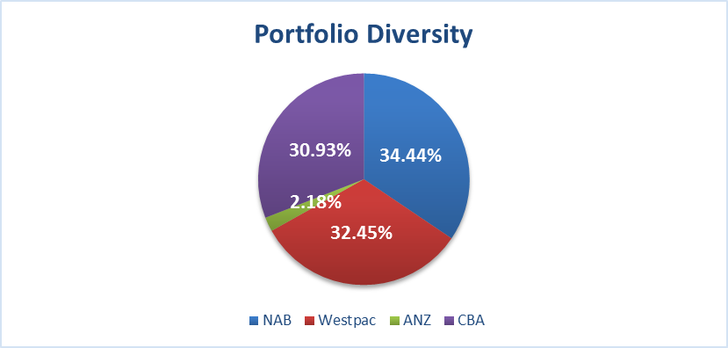

**Conclusion**

The Investment Report is presented to Council.

**Key Relevant Previous Council Decisions:**

Nil.

**Consultation**

Required by legislation: Yes  No

Required by City of Redlands policy: Yes  No

**Budget/Financial Implications**

Investment income is steady as per budget.

## Professional Development Approved by the Chief Executive Officer

The attached Professional Development Approved by the Chief Executive Officer for the month of January 2018 is to be received.

|  |  |  |
| --- | --- | --- |
| **Name** | **Conference Details** | **Reason** |
| Chaminda Mendis, Waste Minimisation Coordinator | Waste Conference  3-4 October 2018  Melbourne Convention & Exhibition Centre | Attending this conference, will benefit the City in gaining a significant knowledge in alternative disposal systems and new innovations particular in Alternative Waste Technology (AWT) and Food Organic bin service model (FOGO) that are currently in operation.  Furthermore, this opportunity will assist the City to develop the scope of works required for next Waste Management Service contract. |

## Lot (388) - 95A Waratah Avenue – Request for temporary access

|  |  |
| --- | --- |
| **Council** | 28 August 2018 |
| **Applicant** | Village Cinemas Dalkeith Pty Ltd |
| **Landowner** | Village Cinemas Dalkeith Pty Ltd |
| **Director** | Peter Mickleson – Director Planning & Development |
| **Attachments** | 1. Letter with request for agreement to temporary access easement dated 25 June 2018 |

1. **Executive Summary**

The property at 95A Waratah Avenue was sold in 2017 and the new owners intend to redevelop the site following the expiry of the current lease at the end of 2019.

The site is located in Precinct 3 of the Dalkeith Redevelopment Area and as such is subject to special requirements under Town Planning Scheme No.2 (TPS2) which include providing a laneway along the western and northern boundaries of the site facilitating the intended laneway linking Adelma Road through to Waratah Avenue.

Given the large amount of space these laneways would take up in terms of redevelopment potential for the site, the owners wish to construct the northern laneway but not the western laneway. The provisions of the scheme allow for the western (north/south) laneway to be varied.

The draft LPS3 presented to Council on 31 July 2018 recommended the removal of the laneway entirely from the western boundary of 95A Waratah Avenue. That version of draft LPS3 removes all reference to laneways in this shopping precinct from within the Scheme itself and it is expected that the laneway linkage from Adelma Road to Waratah Avenue will be dealt with in a Local Development Plan.

However, it is expected that the north/south laneway will be located somewhere on the Council owned Dalkeith Hall site located immediately adjoining the subject site to the west.

Until a decision is made on where the north/south laneway is to be located, the applicant has requested a temporary access easement or similar over the Council owned Dalkeith Hall property to gain access to the rear of their site.

1. **Recommendation to Committee**

**Council:**

1. **Gives in principle support to granting a temporary easement over 97-99 Waratah Avenue, Dalkeith in favour of 95A Waratah Avenue, Dalkeith subject to:**
2. **the owner of 95A Waratah Avenue, Dalkeith in agreement with the Chief Executive Officer, specifying the proposed location and dimensions of the easement, together with any proposed consideration to be paid to the City for the easement;**
3. **compliance with the requirements of section 3.58 of the Local Government Act 1995; and**
4. **the owner of 95A Waratah Avenue, Dalkeith being responsible for all costs associated with the processing, preparation and registration of any easement, including costs of compliance with the requirements of the Local Government Act 1995.**
5. **Instructs the Chief Executive Officer to give local public notice of the proposed easement and to obtain the market valuation required for that purpose.**
6. **Site Details**

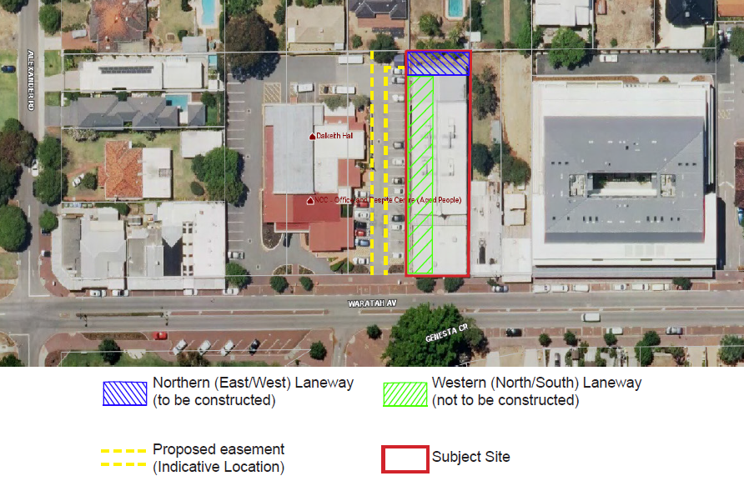

Figure 1 – Aerial view of access.

1. **Discussion**

UBackground

The Waratah Avenue Shopping Centre is identified within Precincts 1-3 of the Dalkeith Redevelopment Area Guidelines under TPS2 and as such require laneway access across the rear and western boundaries of the commercial properties linking Adelma Road through to Waratah Avenue.

The City of Nedlands owns 3 lots of land located directly adjacent to land within Precinct 3. Lot 385, 386 and 387 on Deposited Plan 3395 comprise a total area of 3,406mP2P and are held by the City in freehold. The lots are addressed as 97-99 Waratah Avenue, Dalkeith. The land is zoned for municipal purposes and is the location of the Dalkeith Hall and Nedlands Community Centre.

Originally the north/south part of the laneway in Precinct 3 was proposed on the Dalkeith Hall site, however, when the Dalkeith Hall site was excluded from the Guideline Area, the laneway was moved to the western boundary of 95A Waratah Avenue.

Through the process of responding to submissions on draft LPS3, the draft LPS3 presented to Council on 31 July 2018 recommended the removal of the laneway entirely from the western boundary of 95A Waratah Avenue. That version of draft LPS3 removes all reference to laneways in this shopping precinct from within the Scheme itself and it is expected that the laneway linkage from Adelma Road to Waratah Avenue will be dealt with in a Local Development Plan.

However, both laneway requirements remain on the site under TPS2. A redevelopment of 95A Waratah Avenue under the current scheme would result in a loss of 45% of the site to provide both laneways.

In recognition of the likelihood that this part of the laneway will not be required on this site under LPS3 or subsidiary planning mechanisms and to ensure access is available to the rear laneway which will be constructed and ceded to the Council as part of the redevelopment of the site, the applicants request a temporary access easement to plan for the redevelopment.

Redevelopment of the property would potentially provide benefit to the community through additional residential and commercial offerings in the Waratah Avenue precinct. This same logic could potentially be applied to any redevelopment of neighboring 93 and 93A Waratah Avenue.

The City as a landowner of 97-99 Waratah Ave is now presented with an opportunity to become an active participant in realising its vision for the laneway linkage in this area. By agreeing the mechanism of temporary access to 95A Waratah via the City’s land this could potentially provide an opportunity for property owners of 93 and 93A Waratah Avenue to also redevelop providing access at the northern boundary of their lots, further enabling linkage of laneway between Adelma Rd and Waratah Ave.

The easement requested is considered temporary until Council settles on the format for the final leg to the Adelma Road – Waratah Avenue linkage – specifically, where will the north/south link be located.

The easement as shown in figure 1 above would have relatively little impost in the current site layout of 97-99 Waratah Avenue as the site of Dalkeith Hall and Nedlands Community Centre is a building in the center of the three freehold lots surrounded by car parking and through road, enabling thoroughfare of vehicles to and from a redeveloped 95A Waratah Avenue.

It is noted that the easement would limit options for redevelopment. It is therefore proposed that the landowner of 95A Waratah Avenue compensate the City for its benefit through the easement over City of Nedlands freehold land. This would be determined by an independent valuation. This compensation would offset the City’s loss of development potential and impost of private use of Local Government land. If Council in future considers the solution to the north / south leg of the laneway to be across City land at 97-99 Waratah Avenue, then the City can move to cede that land for road reserve and remove the easement.

It is also noted that in future once the linkage from Waratah Avenue to Adelma Road is in place the land at 97-99 Waratah Avenue may also benefit through additional access options.

ULocal Government Act 1995

The City can only dispose of property in accordance with the provisions of the *Local Government Act 1995*. This is whether the disposition is absolute or not. An easement is a recognised form of property right.

If Council wishes to provide an easement to 95A Waratah Avenue for access to the rear of the site, the City will be required to comply with the requirements of section 3.58(3) and (4) of the *Local Government Act 1995*.

These provisions require the Council, before agreeing to dispose of the property to give public notice for 2 weeks. As part of this notice a market valuation of the disposition is required. It is expected the valuation would consider the effect which the grant of an easement would have on the value of the City’s property.

In addition, the location and dimensions of the easement would need to be agreed upon. Consideration would need to be given to issues such as increased traffic and the effect on the circulation of traffic including taking into account the needs of the aged clients bus drop off point. There is also a storage shed located in top northeastern corner of the site which would need to be relocated.

Council would be required to consider any submissions and give reasons for its decision which are required to be recorded at a Council meeting.

1. **Budget/Financial Implications**

All costs of processing, preparation and registration of the easement would be covered by the owners. The effect on the valuation of the property can be considered after a valuation is obtained and before the final decision on the proposal.

1. **Consultation**

Administration have met on several occasions and liaised via telephone and email with representatives of the owner of 95A Waratah Avenue regarding their request for temporary access.

Administration have consulted McLeods Barristers & Solicitors to learn the necessary process for an agreement to temporary access in the form of an easement over City land at 97-99 Waratah Avenue Dalkeith. McLeods advice is considered in drafting this report.

1. **Conclusion**

It is expected the location of the north/south leg of the laneway to provide access to the rear laneway of the redevelopment area will be amended via Local Planning Scheme No.3 (LPS3) and subsidiary planning mechanisms attaching to it. In the meantime, the owner of the property would like to plan for redevelopment; have certainty of access; and certainty of the area of the property that can be developed.

Redevelopment of the property would provide potential gains for the community in terms of residential and commercial offerings in the Waratah Avenue precinct.

If Council chooses not to agree to the temporary access and without a solution to the north/south leg of the laneway in Precinct 3 then development of neighbouring properties could potentially be stalled until certainty is provided in the Town Planning Scheme and its requirements for this precinct.

## Provision of Community Services from Zamia Room at Mt Claremont Community Centre

|  |  |
| --- | --- |
| **Council** | 28 August 2018 |
| **Applicant** | City of Nedlands |
| **Officer** | Patricia Panayotou – Manager Community Service Centres |
| **Director** | Lorraine Driscoll – Director Corporate & Strategy |
| **Attachments** | Nil. |

**Executive Summary**

Approval requested for the reallocation of $23,000 from the Capital Works budget for Point Resolution Child Care, to be used to upgrade the Zamia Room at Mt Claremont Community Centre for the delivery of Community Services and activities by the City.

**Recommendation to Committee**

**Council approves the requested reallocation of $23,000 of Council funding to upgrade the Zamia Room at Mt Claremont Community Centre.**

**Discussion/Overview**

The Zamia Room is in the Mt Claremont Community Centre and has been leased at various times by businesses to provide a café. The café premises has been officially vacant since 28 September 2016. In October 2016, a public expression of interest (EOI) process was conducted by the City and no submissions were received.

In July this year, the City’s Community Service Centre teams identified that the Zamia Room, which now has no counters or display cabinets installed, would be an ideal location to hold various activities and services. This would include activities, currently provided at Nedlands Community Care, Dalkeith Hall and Nedlands Library and some activities tailored for the community.

Programs and activities have been planned which are designed to engage each demographic of Mt Claremont and the surrounding community, including inter-generational activities and engaging with local schools and seniors.

Most of these activities and programs will be run on a regular basis and some will be designed for school holiday events.

The Zamia Room provides an excellent location for promoting and providing the planned activities and services, with high exposure to community members coming to the community centre to use the Mt Claremont library, or participate in activities in one of the rooms inside the centre.

As the Zamia Room has been vacant for so long, it requires some minor repairs and upgrade and the purchase of some minor equipment and resources to enable the provision of the services and activities.

**Key Relevant Previous Council Decisions:**

N/A

**Consultation**

N/A

**Budget/Financial Implications**

There are no funds allocated for this project in the 2018/19 budget, as this opportunity was realized after the budget was adopted. There are funds allocated in the budget for works at Point Resolution Child Care (PRCC), to provide an upgrade to the shed area, however due to changing priorities this is likely to happen next financial year, resulting in funds available to reallocate.

It is requested that $23,000 from the capital budget for PRCC works be approved for the upgrade to the Zamia Room at Mt Claremont and the budget be adjusted accordingly in the mid-year budget review.

# Elected Members Notices of Motions of Which Previous Notice Has Been Given

Disclaimer: Where administration has provided any assistance with the framing and/or wording of any motion/amendment to a Councillor who has advised their intention to move it, the assistance has been provided on an impartial basis. The principle and intention expressed in any motion/amendment is solely that of the intended mover and not that of the officer/officers providing the assistance. Under no circumstances is it to be expressed to any party that administration or any Council officer holds a view on this motion other than that expressed in an official written or verbal report by Administration to the Council meeting considering the motion.

## Councillor Mangano – Birdwood Parade Paths Clean Up & Repairs

On 14 August 2018 Councillor Mangano gave notice of his intention to move the following at this meeting.

**Council directs the CEO to clean up and repair all 3 paths and provide mitigation to prevent sand or limestone washouts onto these paths, to be completed by end of September 2018.**

Justification

There are 3 bitumen pathways through the bushland between Birdwood Parade and The Esplanade in Dalkeith.

All 3 were laid around 30 years ago and are in a poor condition and need to sand, leaves or limestone washouts attended to.

With the opening of the AAPS there is increased usage of these paths and there could be a member of the public hurt slipping on these pathways which may result in liability to the City due to lack of maintenance.

Administration Comment

An upgrade of the Birdwood Parade pathways by September is a lengthy process and not one that is practically achievable within this timeframe. The paths require:

* Design plans to be prepared.
* Plans to be approved by the Department of Biodiversity Conservation and Attractions (DBCA) as the pathways lie within the Swan River Development Control Area.
* Any requested changes by DCBA are then made to the design.
* Quotations are then sought where a Tender report is likely to have to be prepared for Council consideration.
* Once a company has been appointed they need to prepare and submit a Construction Management Plan for the approval of the Department of Biodiversity Conservation and Attractions.

Completion of these steps could take 3 to 5 months depending how many changes are requested from the Department of Biodiversity Conservation and Attractions and the need for a tender submission to be approved by Council.

The paths at Birdwood Parade are proposed to be scheduled for upgrade in the 2019/20 capital works program which will be subject to Council approval through the annual budget process.

In the Administration’s view, the paths subject to this Notice of Motion at Birdwood Parade are in better condition compared to pathways at Hollywood Reserve (pictured) which has a budget allocation for works this financial year. The Birdwood Parade paths have had significant maintenance work undertaken on them within the last five or so years which followed a large storm around 2013.

The maintenance work included:

* Asphalt overlay, and curbing installed along the pathway opposite Nedlands Yacht Club.
* Asphalt repairs and limestone retaining and spill ways on the pathway opposite the Flying Squadron Yacht Club.
* Asphalt repairs and curbing installed along the pathway opposite Tawarri Reception and Function Centre.

Currently there is some sand wash that occurs in a few known areas of the paths following rain events. This is expected at this time of year and is demonstrated in the photos below. There is also some minor leaf litter on the Tawarri pathways which is common in all of the City’s bushland areas. Areas that are subject sand wash are cleaned up where they are identified by staff and present a clear hazard to path users. The path network is not regularly swept as part of an operational program and this aligns with service levels of footpath networks across the City.

The City has not received any complaints from members of the community regarding the condition or safety of these paths. Cr. Mangano has raised the condition of these paths a number of times with the City.

There is $142,800 allocated to the Hollywood Reserve paths in the 2018/19 budget. To date this money has not been spent on the upgrade of those paths and is scheduled for our work program in February to April 2019.

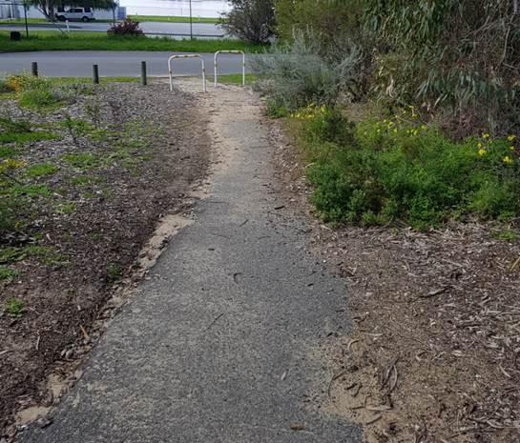

Birdwood Parade Reserve: Sand wash on lower pathway opposite Nedlands Yacht Club

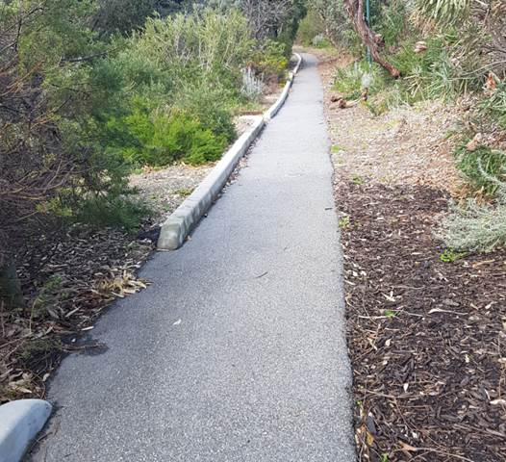

Birdwood Parade Reserve:Upper pathway Opposite Nedlands Yacht Club

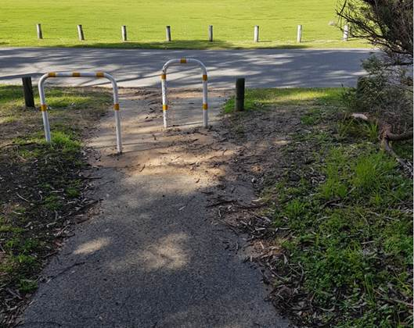

Birdwood Parade Reserve: Minor sand wash on lower pathway opposite Flying Squadron Yacht Club

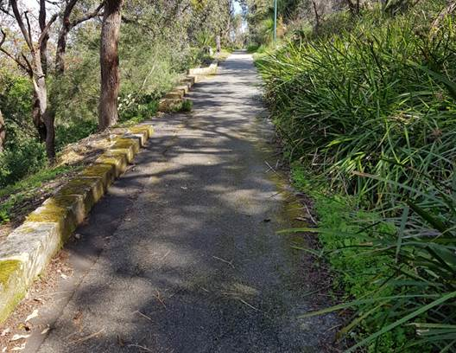

Birdwood Parade Reserve: Upper pathway opposite Flying Squadron Yacht Club

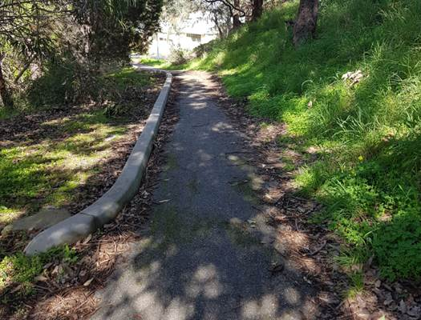

Birdwood Parade Reserve: Upper pathway opposite Tawarri

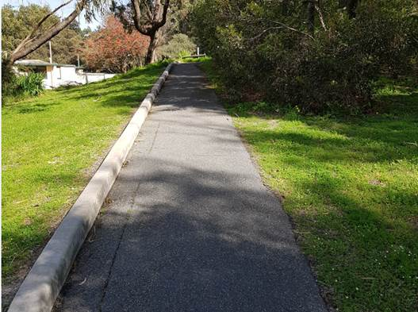

Birdwood Parade Reserve: Lower pathway opposite Tawarri

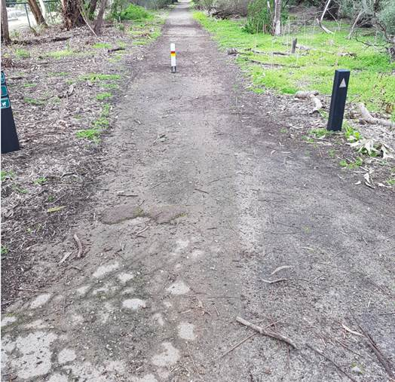

Hollywood Reserve pathway due for upgrade in 2018/19.

# Elected members notices of motion given at the meeting for consideration at the following ordinary meeting on 25 September 2018

Disclaimer: Where administration has provided any assistance with the framing and/or wording of any motion/amendment to a Councillor who has advised their intention to move it, the assistance has been provided on an impartial basis. The principle and intention expressed in any motion/amendment is solely that of the intended mover and not that of the officer/officers providing the assistance. Under no circumstances is it to be expressed to any party that administration or any Council officer holds a view on this motion other than that expressed in an official written or verbal report by Administration to the Council meeting considering the motion.

Notices of motion for consideration at the Council Meeting to be held on 25 September 2018 to be tabled at this point in accordance with Clause 3.9(2) of Council’s Local Law Relating to Standing Orders.

# Urgent Business Approved By the Presiding Member or By Decision

Any urgent business to be considered at this point.

# Confidential Items

Any confidential items to be considered at this point.

# Declaration of Closure

There being no further business, the Presiding Member will declare the meeting closed.