Agenda

Sustainable Nedlands Committee Meeting

20 June 2011

ATTENTION

This Agenda has yet to be dealt with by the Committee.

The Administration Recommendations, shown at the beginning of each item, have yet to be considered by the Committee and are not to be interpreted as being the position of either the Committee or Council.

The Minutes of the meeting held to discuss this Agenda should be read to ascertain the decision of the Committee.

Before acting on any recommendation of the Committee a check must also be made in the Ordinary Council Minutes following the Committee Meeting to ensure that Council did not make a decision at variance to the Committee Recommendation.

Table of Contents

Declaration of Opening 3
Present and Apologies and Leave of Absence (Previously Approved) 3
1. Public Question Time 4
2. Public Address Session (only for items listed on the agenda) 4
3. Disclosures of Financial Interest 4
4. Disclosures of Interests Affecting Impartiality 5
5. Declarations by Members that they have not given due
consideration to papers 5
6. Confirmation of Minutes 6
6.1 Sustainable Nedlands Committee Meeting – 6 December 2010 6
7. Items for Discussion 6
7.1 Urban Development Presentation 6
7.2 Sustainable Development Conference 2011 6
7.3 Water Corporation Greywater Reuse Hardstand Proposal 6
7.4 Sustainable Nedlands Recycling Tour 7
7.5 Meeting Frequency 7
7.6 Key Policy Objectives 8
8. Date of Next Meeting 9
Declaration of Closure 9

City of Nedlands

Notice of a meeting of the Sustainable Nedlands Committee to be held in the Council Chambers, 71 Stirling Highway, Nedlands on Monday, 20 June 2011 at 7.00 pm.

Dear Committee Member

The next meeting of the Sustainable Nedlands Committee will be held on Monday, 20 June 2011 in the Council Chambers at 71 Stirling Highway, Nedlands at 7.00 pm.

Andrew Melville
Manager Sustainable Nedlands
14 June 2011

Sustainable Nedlands Committee Agenda

Declaration of Opening

The Presiding Member will declare the meeting open at 7.00 pm and will draw attention to the disclaimer below.

Present and Apologies and Leave of Absence (Previously Approved)

Leave of Absence None
(Previously Approved)

Apologies None as at distribution of this agenda.

Disclaimer

                - No responsibility whatsoever is implied or accepted by the City of Nedlands for any act, omission or statement or intimation occurring during Council or Committee meetings. City of Nedlands disclaims any liability for any loss whatsoever and howsoever caused arising out of reliance by any person or legal entity on any such act, omission or statement or intimation occurring during Council or Committee meetings. Any person or legal entity who acts or fails to act in reliance upon any statement, act or omission made in a Council or Committee meeting does so at that person’s or legal entity’s own risk.

In particular and without derogating in any way from the broad disclaimer above, in any discussion regarding any planning application or application for a licence, any statement or intimation of approval made by a member or officer of the City of Nedlands during the course of any meeting is not intended to be and is not to be taken as notice of approval from the City of Nedlands. The City of Nedlands warns that anyone who has any application lodged with the City of Nedlands must obtain and should only rely on WRITTEN CONFIRMATION of the outcome of the application, and any conditions attaching to the decision made by the City of Nedlands in respect of the application.

The City of Nedlands wishes to advise that any plans or documents contained within this agenda may be subject to copyright law provisions (Copyright Act 1968, as amended) and that the express permission of the copyright owner(s) should be sought prior to their reproduction.

It should be noted that Copyright owners are entitled to take legal action against any persons who infringe their copyright. A reproduction of material that is protected by copyright may represent a copyright infringement.

Public Question Time

A member of the public wishing to ask a question should register that interest by notification in writing to the CEO in advance, setting out the text or substance of the question. Questions tabled at the meeting may be unable to be answered due to the requirement for technical research and will therefore be answered direct afterwards.

Questions must relate to a matter contained within the agenda of this meeting.

Public Address Session (only for items listed on the agenda)

Addresses by members of the public who have completed Public Address Session Forms will be invited to be made at this point.

Disclosures of Financial Interest

                - The Presiding Member to remind Councillors and Staff of the requirements of Section 5.65 of the Local Government Act to disclose any interest during the meeting when the matter is discussed.

                - A declaration under this section requires that the nature of the interest must be disclosed. Consequently a member who has made a declaration must not preside, participate in, or be present during any discussion or decision making procedure relating to the matter the subject of the declaration.

                - However, other members may allow participation of the declarant if the member further discloses the extent of the interest. Any such declarant who wishes to participate in the meeting on the matter, shall leave the meeting, after making their declaration and request to participate, while other members consider and decide upon whether the interest is trivial or insignificant or is common to a significant number of electors or ratepayers.

Disclosures of Interests Affecting Impartiality

                - The Presiding Member to remind Councillors/Staff of the requirements of Council’s Code of Conduct in accordance with Section 5.103 of the Local Government Act.

                - Committee members and staff are required, in addition to declaring any financial interests to declare any interest that may affect their impartiality in considering a matter. This declaration does not restrict any right to participate in or be present during the decision-making procedure.

                - The following pro forma declaration is provided to assist in making the disclosure.

                - “With regard to …… the matter in item x….. I disclose that I have an association with the applicant (or person seeking a decision). As a consequence, there may be a perception that my impartiality on the matter may be affected. I declare that I will consider this matter on its merits and vote accordingly.”

                - The member or employee is encouraged to disclose the nature of the association.

Declarations by Members That They Have Not Given Due Consideration to Papers

Members who have not read the business papers to make declarations at this point.

Confirmation of Minutes

Sustainable Nedlands Committee Meeting – 6 December 2010

The Minutes of the Sustainable Nedlands Committee held on 6 December 2010 are to be confirmed.

Items for Discussion

NOTE: Regulation 11(da) of the Local Government (Administration) Regulations 1996 requires written reasons for each decision made at the meeting that is significantly different from the relevant written recommendation of a committee or an employee as defined in section 5.70 (but not a decision to only note the matter or to return the recommendation for further consideration).

Urban Development Presentation

Dr George Crisp a local GP and State Representative of the Doctors for the Environment will discuss urban development, the loss of green space and vegetation, and the environmental health impact on the community.

Sustainable Development Conference 2011

Councillor Bronwen Tyson will discuss the recent NSW Sustainable Development Conference 2011.

Water Corporation Greywater Reuse Hardstand Proposal

Attached is the email that Manager Sustainable Nedlands sent to the Committee on the 22 December 2010 following the 6 December 2010 meeting referred to in the Committee’s recommendation which stated that:

Moved – John McBain
Seconded – Kay Whyte

Committee Recommendation

The Committee is interested in receiving the results of Thursdays
meeting and further supports the reuse of the water source at the
City of Nedlands.

CARRIED UNANIMOUSLY 7/-

Further to this email, please find attached an information update email received on 24 February 2011 from the Water Corporation regarding this project. The Water Corporation seeks advice regarding the City’s ongoing support for this project.

Manager Sustainable Nedlands will provide an additional update on this project.

Sustainable Nedlands Recycling Tour

Manager Sustainable Nedlands has negotiated with the City’s kerbside waste and recycling contractor, a tour for Councillors and Committee members of the Perthwaste Material Recovery Facility (MRF).

The date proposed for the information tour is Wednesday 10 August 2011.

Meeting Frequency

Further to the Committee’s request at the previous meeting, Councillor Tyson will discuss the frequency of meetings of the Sustainable Nedlands Committee. Please find the Sustainable Nedlands Committee Terms of Reference attached.

Key Policy Objectives

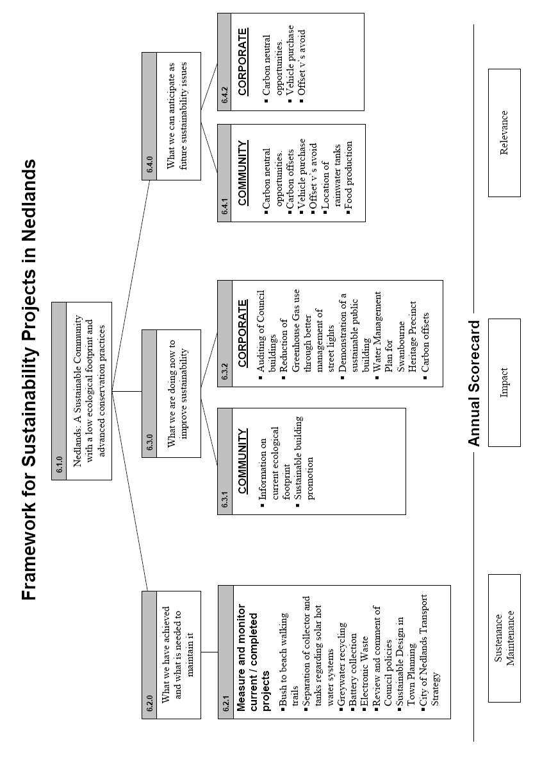

Date of Next Meeting

The next meeting of this Committee is scheduled for Monday, 5 September 2011 commencing at 7.00 pm.

Declaration of Closure

There being no further business, the Presiding Member will declare the meeting closed.

Andrew Melville
Manager Sustainable Nedlands

