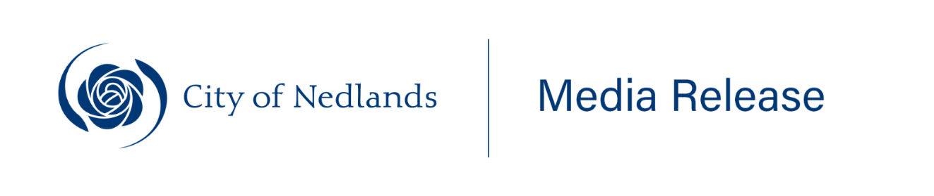
________________________________________________________
29 July 2025
Special Council Meeting to be held under new Commissioners
A Special Council Meeting of the City of Nedlands will be held on Wednesday, 30 July 2025, marking the first official Council meeting held under the newly-appointed Commissioners.
Commissioner Chair David Caddy, Commissioner Deputy Chair Bianca Sandri and Commissioner Cath Hart gave notice to the City for the Special Council Meeting last Friday.
“This Special Council Meeting will address a number of matters including establishing the Audit and Risk Committee, various statutory appointments, and progressing the 2025/26 Budget,” Commissioner Caddy said.
The three Commissioners formally assumed responsibility for the Council on Friday, 25 July 2025, when they were sworn in.
Commissioner Caddy said the first meeting marked a fresh chapter for the City of Nedlands.
“This Special Council Meeting is the first meeting of the Council under the Commissioners and signals a return to stability and good governance,” Commissioner Caddy said.
“Our focus is to prioritise and progress outstanding Council business, reconstitute essential committees, and provide strong oversight of the City’s finances through the budget process.
“We are committed to ensuring continuity of service delivery for the Nedlands community and to maintaining high standards of accountability and integrity.
“We encourage residents to stay informed, attend meetings, and participate in a respectful and constructive way.”
The Special Council Meeting will commence at 5:00 PM at the City of Nedlands Council Chambers.
Members of the public can attend the meeting or follow proceedings via the City’s website.
Meeting Details:
What: Special Council Meeting
When: Wednesday, 30 July 2025, 5:00 PM
Where: City of Nedlands Council Chambers, 71 Stirling Highway, Nedlands

ENDS
_________________________________________________________________________________
For further information please contact the City of Nedlands Communications and Engagement Team at communications@nedlands.wa.gov.au

