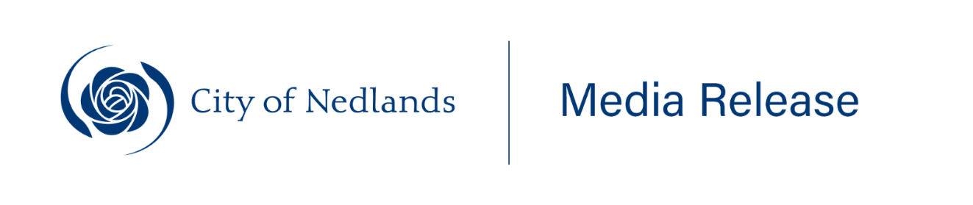
_____________________________________________
14 August 2025
Human/Nature art exhibition at Tresillian Arts Centre
Exhibition overview:
Human/Nature brings together three Perth artists—Jamie Russell, Melissa De Winter, and Nellie Pease—in a thoughtful exploration of the fragile and layered relationship between people and the natural world.
At a time when nature feels increasingly distant, the exhibition invites reflection on how we live within, impact, and care for the ecosystems we share. Despite their varied styles and techniques, the artists are united by their use of traditional media, found and reclaimed materials, and a shared focus on connection and the human-nature interface.
About the artists:
Nellie Pease
A scientist and artist, Pease sees both disciplines as driven by curiosity and a desire to understand our place in the world. Her work invites viewers to pause and celebrate the overlooked—finding beauty in discarded objects and hidden details, and reflecting on our connection to the natural world.
Jamie Russell
Russell’s expressive oil paintings draw on Expressionism, Cubism, and Art Deco, using bold colour, exaggerated perspective, and surreal interiors. His works explore themes of containment and observation—worlds within worlds, looking in or out.
Melissa De Winter
Working in encaustic, De Winter embeds sketches and found materials in molten beeswax, blending structure with spontaneity. Her practice is grounded in sustainability and shaped by themes of resilience and interconnectedness, encouraging viewers to slow down and look closer.
Opening night: Thursday 29 August, 6pm
Exhibition dates: 29 August – 19 September
Venue: Tresillian Arts Centre, 21 Tyrell Street, Nedlands
Gallery Hours: Monday to Friday: 9am – 4pm // Sundays: 1pm – 4pm.
ENDS
_________________________________________________________________________________
For further information please contact the City of Nedlands Communications and Engagement Team at communications@nedlands.wa.gov.au

