Information Statement
  - 2026-2027

Contents
1 Introduction 5
1.1 Background 6
2 Legislation Administered 7
2.1 Local Laws of the City of Nedlands 9
2.2 Standards & Codes of Practice Affecting the City of Nedlands 10
3 Structure and Functions 11
3.1 Council 11
3.1.1 Role of Council 11
3.1.2 Role of the Mayor is as follows: 11
3.1.3 Role of Deputy Mayor 11
3.1.4 Role of Councillors 11
3.2 City of Nedlands Administration 12
3.2.1 Office of the CEO 13
3.2.2 City Performance and Community Development 13
3.2.3 City Development and Regulatory Services Directorate 14
3.2.4 City Infrastructure and Environment Directorate 14
3.3 Delegated Authority 15
4 Decision Making Functions 16
4.1 Council 16
4.2 Council Committees 16
4.3 The Committees are responsible for making recommendations to Council, as documented in the committee meeting minutes. Chief Executive Officer (CEO) 16
5 Public Participation 17
5.1 Written Requests 17
5.2 Public Address at Council Meetings 17
5.3 Public Question Time 17
5.4 Petitions 18
5.5 Electors’ Meetings 18
5.5.1 Annual Meeting of Electors 18
5.5.2 Annual Meeting of Electors 18
5.6 Elected Members 18
5.7 Community Engagement 18
5.8 Council Committees 18
6 Documents held by the City 20
6.1 Council and Committee Agendas and Minutes 20
6.2 Public Registers 20
6.3 Local Laws 20
6.4 Policies and Register of Delegated Authority 21
6.5 Council Plan 21
6.6 Community Directory 21
6.7 Disability Access and Inclusion Plan 21
6.8 Electoral Rolls and Street Directories 21
6.9 Schedule of Fees and Charges 21
6.10 Annual Budget 21
6.11 Annual Report 22
6.12 Tender Register 22
6.13 Contracts Register 22
6.14 Freedom of Information (FOI) Statement (This document) 22
6.15 Local Government Retention and Disposal Schedule 22
6.16 Records Management Manual 22
6.17 Record Keeping Plan 22
6.18 Building/Development Applications 22
6.19 Municipal Heritage Inventory 23
6.20 Local Studies Collection (Nedlands Library) 23
6.21 Correspondence files 24
6.22 Current files 24
6.23 Archived files 24
7 Access to Documents - Outside of FOI 25
7.1 Documents Published (some available for inspection) 25
7.2 Paid Services 26
7.3 CCTV Footage 26
8 Freedom of Information 27
8.1 Lodging a Freedom of Information Application 27
8.2 Freedom of Information Charges 27
8.3 Deposit 28
8.4 Access Arrangements 28
8.5 Notice of Decision 28
8.6 Refusal of Access 28
8.7 Amendment of Personal Information 29
8.8 Privacy Rights and Legislation 29
8.9 Freedom of Information Legislation 30

Disclaimer

The information contained within this publication is considered correct at the time of publication. The information has been compiled with care, but no warranty, expressed or implied, is given to the accuracy, correctness, or completeness of the information, or for any advice given, or omissions.

Introduction
The most important feature of local government is that it is ‘local’. Established under the Local Government Act of Western Australia its primary concern is providing services in the local area for its local people.

The Freedom of Information Act 1992 (the Act) creates a general right of access to State and local government documents. The objects and intent of the Act are to:
- Enable the public to participate more effectively in governing the State; and
- Make the persons and bodies that are responsible for State and local government more accountable to the public.

Part 5 (Division 94) of the Act also requires that government agencies (State and Local) prepare and publish an Information Statement annually. This Information Statement must:
- State the structure and functions of the City;
- Describe the ways in which the functions of the City affect members of the public;
- Describe any arrangements that exist to enable members of the public to participate in the formulation of the City’s policy and performance of the City’s functions;
- Describe the types of documents that are usually held by the City which may be viewed, purchased, or obtained free of charge;
- Describe the City’s procedures for giving members of the public access to documents; and
- Describe the City’s procedures for amending personal information in the documents held by the City.

This Information Statement is published by the City of Nedlands in accordance with the requirements of the Act as outlined above. Copies of this document can be obtained by accessing the City’s website ( www.nedlands.wa.gov.au ) or by visiting the City’s Administration Building (71 Stirling Hwy, Nedlands, 6009).

Enquiries about this document can be made by submitting an enquiry online via:
- Create Customer Request; or
- www.nedlands.wa.gov.au

Alternatively, by contacting the City’s Information Management Team on (08) 9273 3500 Monday to Friday 8.30am – 5.00pm.

1.1 Background
The City of Nedlands had its’ origins in the Claremont Road Board. This was due primarily to the fact that the Nedlands’ district fell within the former Claremont jurisdiction. The Claremont Road Board came about because of the population growth in Claremont prior to the turn of the 20th Century.

This allowed the residents in the area to petition the government, and they received their own Road Board by 1893. Seven men were nominated to the new Board, which became the first local government authority for the Nedlands area.

In 1932, the Nedlands Road Board was formed. On 1 July 1959, the City of Nedlands became a City. The City was made up of four wards – Melvista, Hollywood, Dalkeith and Coastal. These wards continue to the present day.

In all, the City encompasses some 20.6km². Within this area, the Council is responsible of maintaining a network of 320 roads, equating to 180 kilometres of road surface, and more than 320Ha of parks and gardens. 22,132 residents live in the City of Nedlands (2021 census).

Legislation Administered
The City of Nedlands was established under, and operates in accordance with, the Local Government Act 1995 (the Act). Section 3.1 (2) of the Act 1995 requires that the scope of the general function of local government is to be constructed in the context of other functions and constraints imposed by it and any other Act.

General – section 3.1
The general function of a local government under s. 3.1 of the Act is to provide for the good government of persons in its district. The general function of a local government under the Act includes legislative and executive responsibilities.

Legislative – section 3.5
Using its legislative powers under s. 3.5 of the Act, a local government may make local laws prescribing all matters that are required or permitted to be prescribed by a local law or are necessary or convenient to be so prescribed for it to perform any of its functions under the Act.

Executive – section 3.18
The local government's executive powers under s. 3.18 of the Act, involves administering its local laws and doing other things that are necessary or convenient to be done for, or in connection with, performing its functions under the Act including the provision of services and facilities.

There are over 300 statutes that local governments are wholly and partially responsible for administering in Western Australia. Some of the main ones that the City of Nedlands administers include:

- Local Government Act 1995
  - Local Government (Administration) Regulations 1996
  - Local Government (Audit) Regulations 1996
  - Local Government (Constitution) Regulations 1998
  - Local Government (Elections) Regulations 1997
  - Local Government (Employee Superannuation) Regulations 2016
  - Local Government (Financial Management) Regulations 1996
  - Local Government (Functions and General) Regulations 1996
  - Local Government (Long Service Leave) Regulations 2024
  - Local Government (Parking for People with Disabilities) Regulations 2014
  - Local Government (Regional Subsidiaries) Regulations 2017
  - Local Government (Model Code of Conduct) Regulations 2021
  - Local Government (Uniform Local Provisions) Regulations 1996

- Local Government (Miscellaneous Provisions) Act 1960
- Public Health Act 2016
- Health (Miscellaneous Provisions) Act 2005
- Bush Fires Act 1954
  - Bush Fire Regulations 2012
- Planning and Development Act 2005
- Dog Act 1976
  - Dog Regulations 2013
- Food Act 2008
- Disability Services Act 1993
  - Disability Services Regulations 2004
- Animal Welfare Act 2002
- Building Act 2011
  - Building Regulations 2012
- Cat Act 2011
  - Cat Regulations 2012
- Dividing Fences Act 1961
  - Dividing Fences Regulations 1971
- Emergency Management Act 2005
  - Emergency Management Regulations 2006
- Environmental Protection Act 1986
  - Environmental Protection Regulations 1987
  - Environmental Protection (Noise) Regulations 1997
- Equal Opportunity Act 1984
  - Equal Opportunity Regulations 1986
- Fire and Emergency Services Act 1998
  - Fire and Emergency Services Regulations 1998
- Freedom of Information Act 1992
  - Freedom of Information Regulations 1993
- Privacy and Responsible Information Sharing Act 2024
- Health Act 1911
- Local Government Grants Act 1978
- Planning and Development Act 2005
  - Planning and Development Regulations 2009
  - Planning and Development (Local Planning Schemes) Regulations 2015
  - Planning and Development (Development Assessment Panels) Regulations 2011
- Public Interest Disclosure Act 2003
  - Public Interest Disclosure Regulations 2003
- Public Works Act 1902
- Rates and Charges (Rebates and Deferments) Act 1992
  - Rates and Charges (Rebates and Deferments) Regulations 1992
- Salaries and Allowances Act 1975
  - Salaries and Allowances Regulations 1975

- State Records Act 2000
  - State Records Principles and Standards 2016
- Workers Compensation and Injury Management Act 1981
  - Workers Compensation and Injury Management Regulations 1982
- City of Nedlands Local Planning Scheme No. 3
- City of Nedlands Local Planning Strategy 2017

Copies of Acts and Regulations are available from: -

WA Legislation - 4/109 St Georges Terrace Perth
Ph. 9215 7333 website Publications Online Store: Home Page (timg.com).
Or, electronically at WA Legislation WALW - Home (legislation.wa.gov.au).

2.1 Local Laws of the City of Nedlands

Local Laws are enforceable rules made by local governments to apply within their district. They help to establish and maintain the quality of life in line with the expectations of the local community and provide a standard under which businesses, residents and ratepayers must conduct their activities.

Local Laws support higher legislation (Acts of Parliament) to control and manage the more basic matters that affect the community. They can be helpful in the resolution of disputes, as well as achieving effective government.

- Local Laws – Standing Orders
- Local Laws – Health
- Local Laws – Dogs
- Local Laws – Council Halls
- Local Laws – Reserves, Foreshores and Beaches
- Local Laws – Thoroughfares
- Local Laws – Parking and Parking Facilities
- Local Laws – Site Erosion and Sand Drift
- Local Laws – Trading in Public Places
- City of Nedlands Repeals Local Law 2016
- The City of Nedlands Waste Local Laws 2016

All of the above Local Laws are available to view on the City’s website (Local Laws).

2.2 Standards & Codes of Practice Affecting the City of Nedlands

The following government and industry standards and codes of practice have been imposed upon or adopted by the City of Nedlands:
- Australian Accounting Standards
- Australian Records Management Standard AS/ISO 15489-2002 Parts 1 & 2
- General Retention and Disposal Authority for Local Government Records GRDA2023-005
- Freedom of Information 1992
- Freedom of Information Regulations 1993
- Cyber Security Act 2024
- Privacy & Responsible Information Sharing Act 2024
- Privacy Act 1988
- Cyber Security ISO 270001
- Quality Management ISO 9000/2000
- National Competition Policy
- Risk Management AS/NZS ISO 31000:2018
- Environmental Management ISO14001-2004
- DLFSC Integrated Planning and Reporting Framework and Guidelines

Structure and Functions

3.1 Council

The City of Nedlands is governed by nine (9) Elected Members (Council), with two representatives in each ward, along with an independently elected Mayor. The Deputy Mayor is chosen by the Councillors. Council act in a voluntary capacity and are provided with an allowance only. At each election, any vacant Council positions may be filled for four-year terms. Elections are held every two years to appoint members to seats where the term is ending. Council has implemented a Code of Conduct to support effective decision-making.

Link to Current Mayor & Councillors

Role of Council

The Council -
- Governs the local government’s affairs;
- Is responsible for the performance of the local government’s functions;
- Oversee the allocation of the local government’s finances and resources; and
- Determine the local government’s policies.

Role of the Mayor is as follows:

The role of the Mayor is to:
- Provides leadership and guidance to the council and council members, including guidance as to the roles of the council and council members; and
- Acts as the principal spokesperson for the local government, and carries out civic and ceremonial duties on behalf of the local government, at all times acting consistently with council decisions; and
- Presides at meetings of the council, ensuring that meetings are orderly and held in accordance with this Act; and
- Promotes, facilitates and supports positive and constructive working relationships among council members; and
- Liaises with the CEO on the local government’s affairs and the performance of its functions.

Role of Deputy Mayor
The Deputy Mayor performs the functions of the Mayor when the Mayor is unavailable to perform the functions of the Mayor.

Role of Councillors

A Councillor –
- Represents the interests of the electors, ratepayers and residents of the district and takes account of the interests of other persons who work in, or visit, the district;
- Participates in the deliberation and decision-making of the local government at council and committee meetings; and
- Facilitates communication with the community about council decisions; and
- Facilitates and maintains good working relationships with other councillors, the mayor or president and the CEO; and
- Acts consistently with section 2.7(3) to (5); and
- Maintains and develops the requisite skills to effectively perform their role.

Decisions of Council are made at Council Meetings. Ordinary Meetings are usually held on the fourth Wednesday of each month excluding December and January where the arrangements made may be different.

These meetings are held in the Council Chamber at 71 Stirling Highway, Nedlands and are also livestreamed. Council Agendas and Minutes are published and are available on the City’s website for public viewing at www.nedlands.wa.gov.au.

A review of the ward system is required by law every eight years with the City’s last ward review done in 2023.
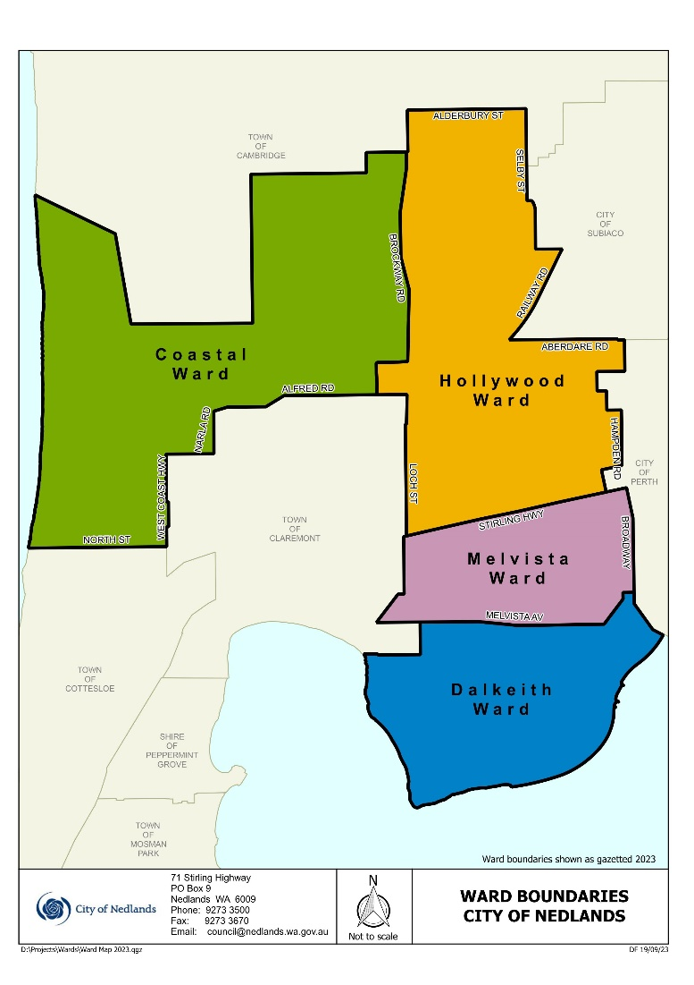

3.2 City of Nedlands Administration
Each local government appoints a Chief Executive Officer (CEO) to manage staff, provide advice to the Council, and oversee the organisation’s daily operations. The CEO acts as the link between Elected Members and the City’s employees, The CEO is responsible for directing all staff, who report directly to them.

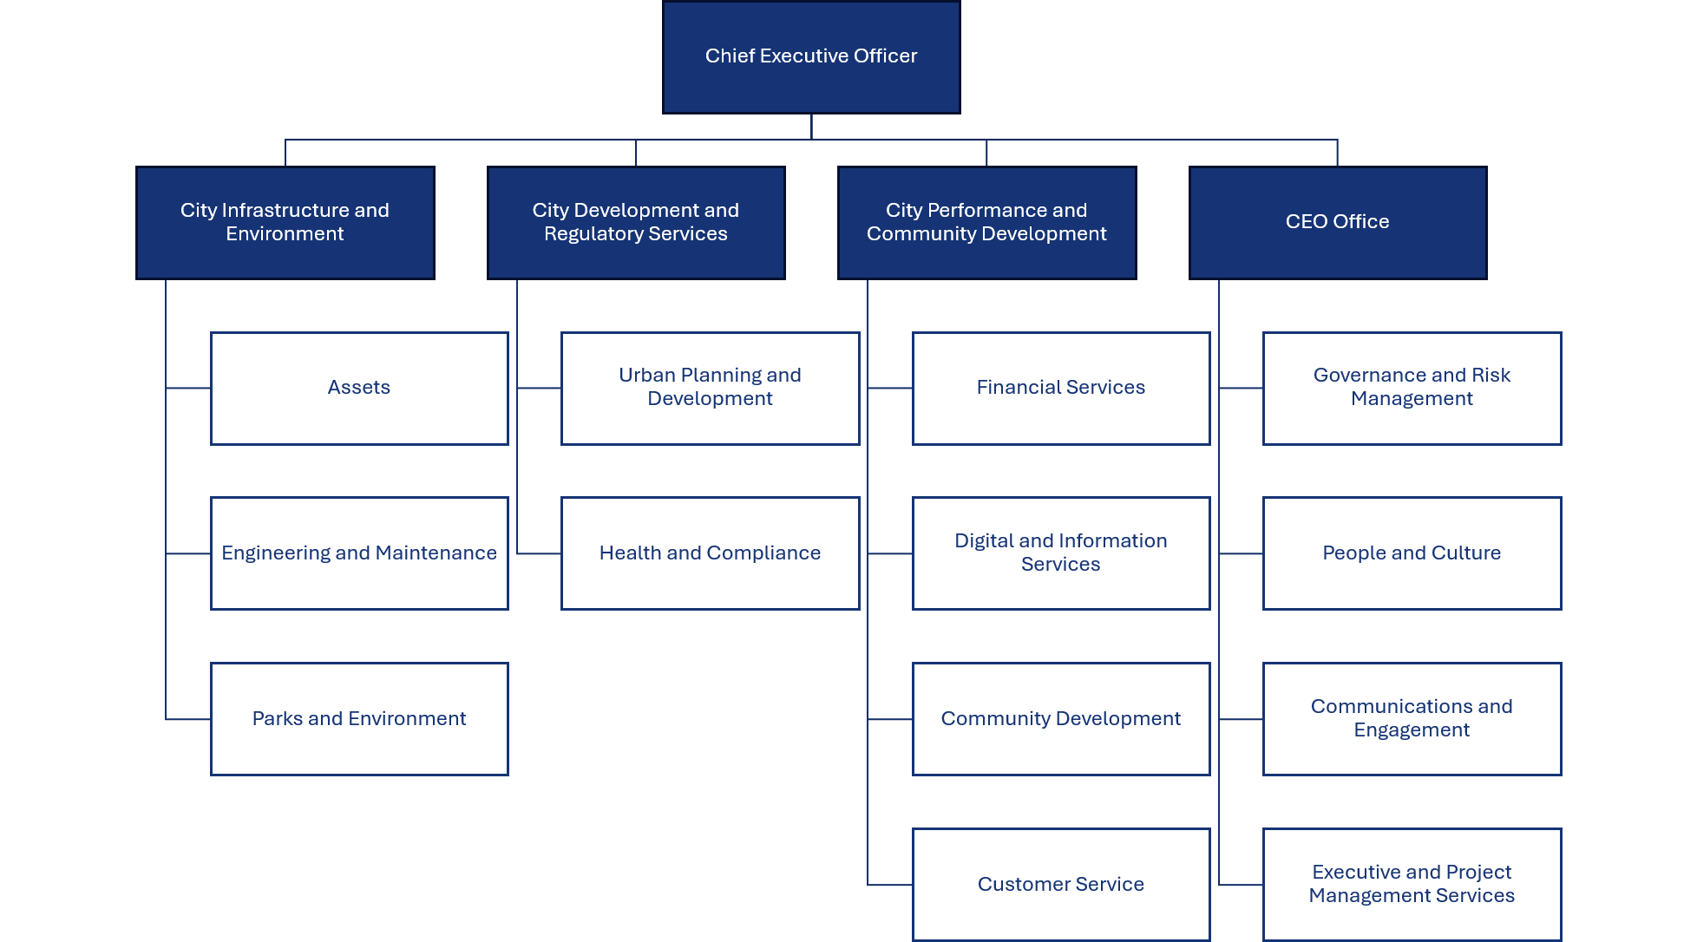

The City of Nedlands Administration consist of the following Directorates by Business Units and Services Areas:

Office of the CEO
The Office of the Chief Executive Officer provides strategic leadership and organisational oversight to support the effective governance and operation of the City. The Office works closely with Elected Members, the Executive Leadership Team and the community to deliver the City's strategic priorities, ensure accountable decision-making and promote the efficient delivery of services for the benefit of the community. It is responsible for the following Business Units and Service Areas:

Business Units | Service Areas
CEO Office | CEO Office
Governance and Risk Management Office | Governance, Risk Management and Legal
Communications and Engagement | Communications and Engagement
Executive and Project Management Services | Executive and Project Management Services
People and Culture | People and Culture
People and Culture | Work, Health and Safety

City Performance and Community Development
The Corporate Services, City Performance and Community Development Directorate provides a range of services that support both the community and the effective operation of the City. The Directorate is responsible for managing the City's finances, information, technology systems and customer services, while also delivering programs and initiatives that enhance community wellbeing and connection.

The Directorate works to ensure that the City's resources, systems and information are managed effectively so that services can be delivered efficiently and to the expected standards of the community. It is responsible for the following Business Units and Service Areas:
Business Units | Service Areas
City Performance and Community Development | City Performance and Community Development Administration
Financial Services | Revenue and Rates  Procurement and Contracts  Accounting Services  Payroll
Digital and Information Services
Community Development | Community Partnerships  Library Services  Tresillian Arts Centre
Customer Service | Customer Service

City Development and Regulatory Services Directorate
The City Development and Regulatory Services Directorate supports the sustainable growth, safety and wellbeing of the community through long-term planning, regulatory services and informed decision-making. The Directorate works to protect the City's character, manage development and deliver efficient, transparent and customer-focused services that contribute to a liveable, prosperous and sustainable City.
It is responsible for the following Business Units and Service Areas:
Business Units | Service Areas
City Development and Regulatory Services | City Development and Regulatory Services Administration
Urban Planning and Development | Planning Approvals  Building Approvals  Strategic Planning
Health & Compliance | Environmental Health  Development Compliance  Rangers Services  Swimming Pools

City Infrastructure and Environment Directorate
The City Infrastructure and Environment Directorate delivers and maintains the infrastructure, assets and public spaces that support the community. The Directorate is responsible for strategic infrastructure planning, capital works delivery, asset management and the maintenance of roads, drainage, parks and public spaces. It works to provide safe, sustainable and well-maintained facilities and services that meet the needs of current and future generations.
It is responsible for the following Business Units and Service Areas:
Business Units | Service Areas
City Infrastructure and Environment | City Infrastructure and Environment Administration
Engineering and Maintenance | City Projects  Civil Maintenance  Facilities Management
Assets | Asset Management  Fleet  Waste  Transport & Development
Parks and Environment | Parks Services  Arboriculture  Environmental Conservation  Parks Strategy and Programs

Delegated Authority
In addition to the legislated functions of the CEO and to ensure the efficient management of Council activities, authority has been delegated to the CEO and other officers to make decisions of an operational nature according to Council policies and specific matters by resolution of Council.

Delegated Authorities are listed in the Delegated Authority Register and are reviewed at least annually by Council.

Decision Making Functions

Council
Meetings of Council are held to make all decisions concerning the municipal district, other than those delegated, as authorised by the Local Government Act 1995 and other legislation as appropriate. Decisions are generally made after considering recommendations from committees unless a Special Meeting of Council has been called to consider a specific issue.

Council Committees
Committees meet to consider issues which are under their area of control as identified in their Terms of Reference. These Committees may comprise of Elected Members, and community representatives. Committees are constituted by Council and have special responsibilities depending on their function.

The City’s Administration provides reports and advice to the various Committees in the agenda for each meeting and recommends an appropriate course of action. The Committee may then either endorse the officer recommendation or recommend an alternative course of action.

The Committees are responsible for making recommendations to Council, as documented in the committee meeting minutes. Chief Executive Officer (CEO)
The CEO’s role is to advise Council on the City of Nedlands’ responsibilities under the Local Government Act 1995 and other relevant legislation, and to ensure that Council has the information needed to make informed decisions. The CEO is also responsible for all staff matters. In addition, the CEO liaises with the Mayor on local government affairs and the City’s performance and ensures that records and documents are properly maintained.

Public Participation

Members of the public have several opportunities to participate in developing the City’s strategies, policies, and plans. They can also provide feedback on the performance of the City’s services and functions.

Written Requests
The public can write to the Council on any policy, activity, function, service of the Council via:
- Written correspondence addressed to:
Chief Executive Officer
City of Nedlands
PO Box 9
Nedlands WA 6909

Public Address at Council Meetings
The City of Nedlands Standing Orders Local Law 2016, Clause 3.4, allows members of the public to address Council Meetings or Committee meetings.
In order to make an address, members of the public are asked to complete an Online Public Address Registration Form linked on the City’s website and submit their address by 12 noon the day prior to the commencement of the meeting.

Public Question Time
The Local Government Act 1995, Local Government (Administration) Regulations 1996 and the City of Nedlands Standing Orders Local Law 2016, allows members of the public to ask questions in regard to any issue relating to the City. A minimum of 15 minutes will be allowed for public question time.

To ask a question, members of the public are required to complete an online public question time submission form available on the City’s website. Up to two (2) written questions shall be submitted by no later than 12 noon the day prior to the commencement of the meeting.

If the City is unable to answer your question at the meeting, your question will be taken on notice and will be answered in writing at a later stage. All questions, together with the answers, will be included in the minutes of the meeting at which your questions were asked.

Questions tabled at Committee meetings should relate and be relevant to the work of that particular Committee. Questions tabled at Council meetings can relate to any matter within Council’s jurisdiction.

Opening statements made before questions are not precluded but should be as brief as the question to which it relates. If a question posed by the same individual is repetitive in nature, the Presiding Member may refer to an answer given to a question on a previous occasion.

Members of the public are discouraged from asking questions which contain defamatory remarks, offensive language or questioning the competency of staff or Council members. Members of the public are encouraged to direct their question to an issue rather than individuals.

Petitions
Written petitions can be presented to the Council on any issue within the Council's jurisdiction.

Electors’ Meetings
Electors have an opportunity to give their opinions on any issue at either the Annual Meeting of Electors or Special Meetings of Electors.

5.5.1 Annual Meeting of Electors
An Annual Meeting (AGM) of Electors is held at least once in each financial year, at a time appointed by Council for the following purposes:
- Receiving the Annual Report,
- Special Business of which notice has been given, and
- General Business.

5.5.2 Annual Meeting of Electors
Electors may initiate a Special Meeting of Electors under procedures prescribed in the Local Government Act 1995.

Special meetings are called to consider special business which is notified when calling the meeting.

No business shall be transacted at a special meeting other than that for which the special meeting was called.

Elected Members
Members of the public can contact the City’s Elected Members to discuss any issue relevant to the Council.

Electors can vote every second year for Councillors in their Ward to represent them in the decision-making functions of Council.

Community Engagement
Council may consult residents on any issue that is currently under consideration.
Other than direct consultation, or via its website, Council may notify residents of issues by advertising in local papers, calling public meetings, or surveys.

Under each of these methods electors, ratepayers and residents can provide input and lodge objections and are provided with guidelines for doing so.

Council Committees
Prior to the appointment of Commissioners, the following council committees were established pursuant to the Local Government Act 1995 to provide assistance to the Council on specific matters of interest affecting the local government. Some, but not all of the committees, have community representatives sitting as members, and those that have a delegated authority are open to members of the public for example.

- Audit Risk and Improvement Committee
- Chief Executive Officer’s Performance Review Committee
- Chief Executive Officer's Recruitment & Selection Committee

Council also appoints Elected Member delegates on the following external committees:
- WALGA Central Metropolitan Zone
- Development Assessment Panel
- Lake Claremont Advisory Committee
- Metropolitan Regional Road Group – Western Suburbs Group

Delegates to these committees represent the City of Nedlands. Minutes of these meetings are presented to Council, as are specific matters that require Council consideration.

Documents held by the City

Council maintains records regarding its operational activities according to legislative requirements. Many of these documents are available for public inspection free of charge.
Public inspection may take place at:
- City of Nedlands Administration Building - 71 Stirling Highway, Nedlands, 6009;
- Nedlands Library - 60 Stirling Highway, Nedlands, 6009;
- Mt. Claremont Branch Library – 19 Haldane Street, Mt Claremont, 6010; or
- City website (www.nedlands.wa.gov.au).

The types of documents available are explained below.

Council and Committee Agendas and Minutes
Reports listed for discussion at Council and Committee Meetings and the resultant minutes of those meetings are available for viewing as soon as they are produced, no later than 14 days after Council Meetings or 7 days after Committee Meetings.

Public Registers
In accordance with the Local Government Act 1995, the following registers are available for inspection at Council:
- Delegations of Authority,
- Gift Register,
- Electoral Gift Register,
- Annual and Primary Financial Returns of Elected Members and staff granted delegated authority,
- Disclosure of Financial Interests Register,
- Register of Owners and Occupiers,
- Rates Record,
- Tenders Register,
- Complaints Register (Rules of Conduct Regulations), and Code of Conduct.

Local Laws
The laws that Council makes to enable it to fulfil its functions. Copies of the City’s local laws are available electronically from the City’s website, or in hard copy from the City’s administration centre.

Policies and Register of Delegated Authority

All current Council Policies are available on the City website and may be accessed using the link.

Note: Some policies and registers may require updates and are under review to ensure they remain current and effective.

The City has adopted a Register of Delegated Authority, which is reviewed annually. A copy of the Register is available on the City’s website.

Council Plan
A local government’s ‘plan for the future’, required in terms of the Local Government Act 1995, section 5.56., comprising a Strategic Community Plan (SCP) and a Corporate Business Plan (CBP), and setting out the long-term vision, aspirations and objectives of the community and a local government’s priorities, programs, plans and resources to address these across four years. The Council Plan is reviewed annually.

Community Directory
Western Suburbs Alliance (WSA), a joint initiative of seven western suburbs local governments to identify and develop shared regional services, advocacy and potential joint initiatives. This includes environmental matters such as animal control, walking trail network, sustainability, sporting bodies and activities within the City of Nedlands and wider Western Suburbs area. Only available electronically through the City’s website, www.nedlands.wa.gov.au.

Disability Access and Inclusion Plan
A plan developed by the City, where available as required by the Disability Services Act 1993, to ensure that people with disabilities have access to the City’s functions, facilities, and services.

Electoral Rolls and Street Directories
The Council is required to keep a continuing electoral roll of the district, consisting of a Residents roll and an Owners and Occupiers roll (sections 4.40 and 4.41 of the Local Government Act 1995). The Electoral roll is available to view at the City’s Administration Centre upon request.

Schedule of Fees and Charges
A schedule of fees and charges, where available, for services and facilities provided by the City and approved by Council annually.

Annual Budget
Gives details of the budget approved by Council within a financial year. Available from the City’s website, www.nedlands.wa.gov.au.

Annual Report
Produced by the City of Nedlands, detailing the Council activities for the year. Available from the City’s website, www.nedlands.wa.gov.au.

Tender Register
Gives details and results of tenders, where available, called for works and services.

Contracts Register
Gives details of contracts awarded for all non-tender items (consultancies etc.), where available. Access is provided, where available, only if it is demonstrated to be in the public interest and there is no conflict with commercial confidentiality.

Freedom of Information (FOI) Statement (This document)
A document required under the Freedom of Information Act 1992 which provides detailed information on the City of Nedlands. The Statement is designed as a guide for the community on the structure and nature of the Council.

Local Government Retention and Disposal Schedule
A manual, where available, released by the State Records Office to ensure conformity and safekeeping of records within local government.

Records Management Manual
A manual, where available, written to enable staff within the Council to abide by the procedures and policies decided by Council to ensure the safekeeping of records within its care. The manual incorporates the FOI Procedure to ensure the correct application of the Freedom of Information Act 1992.

Record Keeping Plan
The State Records Act 2000 governs the creation and management of Government and State records, including local government records. This Act requires the development and implementation of a Record Keeping Plan based on the management of records addressing six fundamental Principles:
- Proper and Adequate Records,
- Policies and Procedures,
- Language Control,
- Preservation,
- Retention and Disposal, and
- Compliance
The plan, where available, provides an accurate reflection of the record keeping program within the organisation.

The current Record Keeping Plan was approved by the State Records Commission on 07 September 2023. The plan will be reviewed within 5 years of the approval date.

Building/Development Applications
As the authority responsible for granting planning approval for development and issuing building licences for land zoned under the City Planning Scheme, the City of Nedlands has a vast record of drawings and plans of buildings within the City area. The drawings and plans can include site plans, floor plans, elevations and in some cases perspective drawings.
Access to this information is available subject to the consent of the current owner of the property. Information about the year of construction, builder details and cost of construction can also be obtained. Charges apply for obtaining this information and the availability of plans in all instances cannot be assured. Contact Planning and Development Services for more information.

Municipal Heritage Inventory
Under the Heritage of Western Australia Act 1990 the City of Nedlands is required to prepare a Municipal Heritage Inventory. This is an inventory of all buildings within the boundary of the City of Nedlands that are or may become of cultural heritage significance to the community. Details in the inventory include, property address, ownership, description, historical information, architectural information, bibliography, listing status, and an electronic image of each building.

Contact Planning and Development Services for more information.

Local Studies Collection (Nedlands Library)
The Local Studies Collection is in the Nedlands Library at 60 Stirling Highway, Nedlands. Access to the Local Studies Collection is free of charge.

The Local Studies Collection contains materials which relate to the history and development of the Nedlands area (including Claremont) and the City of Nedlands. It consists of:
  - Books,
  - Reports,
  - Pamphlets,
  - maps & posters,
  - local newspapers – copies are held in the Local Studies Collection, with complete sets of back copies located at the J.S. Battye Library of Western Australia (Alexander Library Building),
  - videos,
  - minute books,
  - subject files of articles from newspapers & periodicals,
  - photographs,
  - genealogy tools including CD-ROMS and online databases,
  - Oral History interviews,
  - Microfiche, and
  - CD-ROMs.

Some materials may be restricted for conservation/preservation or privacy reasons. For further information, the library can be reached via:

- Online: Make a Library enquiry;
- Phone: (08) 9273 3644; or
- Written Correspondence addressed to:
The Local Studies Librarian
Nedlands Library Services
60 Stirling Highway
NEDLANDS WA 6009

Correspondence files
The City of Nedlands manages several files relating to various functions of the City. All files are subject to disposal in accordance with the current General Retention Disposal Authority for local government records (GRDA2023-005)

Current files
These files are located at the council’s administration centre and in the City’s offsite facility, with an electronic file and correspondence register available. Majority of the files relate to specific property/street addresses, roads, and reserves/parks, with several subject files relating to organisations, events, services provided, special projects and general administrative issues also forming part of the current filing system.

Archived files
These files are located at the City’s offsite facility.

Please note considerable research maybe required to locate some information, and the search may result in a considerable number of files being retrieved.

FOI Applications to view these files will be considered on a case-by-case basis and information may be released in an edited form. Charges may apply to accessing these records as specified in the Freedom of Information Act (Regulations) 1993 and listed in Regulation 5, Section 16(1) of this document.

Access to Documents - Outside of FOI

Members of the public have access to various forms of council information (hardcopy or digital) outside of the FOI process. This information is made available through a range of mediums including:
- Public Statements
- News Releases
- The City’s Internet Website
- Advertisements placed in local and state-wide newspapers
- Public Notice Boards
- Library Services
- Information Sheets and other publications
- Individual Correspondence
- Public and Statutory Documents
- Reports

Documents Published (some available for inspection)
The City’s website (www.nedlands.wa.gov.au) is updated on a regular basis and may contain information not listed at time of preparation of this document.

Note: Some published documents may require updates and are under review to ensure they remain current and effective.

- Agendas, Minutes, Reports (Council / Committee) (2011 to current)
- Annual Budget
- Annual Report (Under Review)
- Asset Management Strategy
- Council Plan – Strategic Community Plan / Corporate Business Plan (Under Review)
- Council Policies - (Under Review)
- Customer Service Charter
- City Planning Schemes (Under Review)
- Code of Conduct – Council Members, Committee Members & Candidates (Under Review)
- Community Citizen of the Year Awards
- Declarations and Registers of Interest (Under Review)
- Disability Access & Inclusion Plan
- District Map with Ward Boundaries
- General Meeting of Electors
- Governance Framework Policy (Under Review)
- Gifts Register – Staff
- Gifts Register – Elected Members
- Gift Register – Electoral
- Employee Code of Conduct (Under Review)
- Freedom of Information
- Foreshore Management Plan
- Information Statement (this document)
- Local Government Act 1995
- Local Government Directory
- Local Government Retention and Disposal Authority
- Local Laws (Under Review)
- Local Planning Strategy (Under Review)
- Long Term Financial Plan (Under Review)
- Minor Breaches Register (Under Review)
- Public Notices
- Public Art Strategy
- Public Interest Disclosure Information (Under Review)
- Rates, Fees and Charges
- Sports and Recreation
- Tender Register (Under Review)
- Urban Forest Strategy
- Workforce Plan (Under Review)
- Waste Plan

Paid Services
- Retrieval of House Plans/Property Files

CCTV Footage
City utilises CCTV surveillance system to keep City buildings and assets safe and minimise crime and damage. The City’s CCTV practice allows for footage to be released to:
- Only to WA Police (for investigation and/or prosecution);

Freedom of Information

It is the aim of the City to make information available promptly and at the lowest reasonable cost. Whenever possible, documents will be provided outside of the FOI process.

The Freedom of Information Act 1992 (the Act) provides a general right of access to documents held by the City, subject to limitations. It also enables the public to ensure that personal information help by the City is accurate, complete, and up to date.

The documents accessible under the FOI Act include paper records, plans and drawings, photographs, tape recordings, films, videotapes, or information stored in a computerised form.

Lodging a Freedom of Information Application
A valid Freedom of Information application must:
- Be in writing;
- Give enough information so that the documents requested can be identified;
- Give an Australian address to which notices can be sent; and
- Be lodged at the City with the application fee payable.
Applications and enquiries can be made via:
- Freedom of Information Request; or
- Written correspondence addressed to:
Information Management Officer
City of Nedlands
PO BOX 9
NEDLANDS WA 6909

The FOI application form is available here.
Applications will be acknowledged in writing, and you will be notified of the decision within 45 calendar days.

Freedom of Information Charges
A scale of fees and charges are set out in the FOI Regulations 1993. Apart from the application fee for non-personal information (information that is not personal information about the applicant), all charges are discretionary. The fees and charges are as follows:

Type of FOI request | Charge Applicable
Personal Information about the Applicant | No Fee
Amending personal information | No Fee
Application fee (non-personal information) | $30
Access time supervised by staff (per hour or pro rata) | $30
Dealing with applications (per hour or pro rata) | $30
Photocopying (per copy) | 20c
Transcribing from tape, film, or computer (per hour or pro rata) | $30
Duplicating a tape, film, or computer information | Actual Cost
Delivery, packaging, and postage | Actual Cost
Advanced deposit may be required of the estimated charges | 25%
Further advanced deposit may be required to meet the charges for dealing with the application | 75%

An estimate of charges will be provided if the cost is expected to exceed $25.00. For impecunious applicants or those issued with prescribed pensioner concession cards, any charges payable are reduced by 25%.

If an estimate of charges in submitted to the applicant, processing of the FOI application will not proceed until written consent of the estimate has been received and the required deposit is paid. If the applicant is not satisfied with the estimate, the applicant can work with the City to discuss how the scope can be revised to reduce the estimate.

Deposit
A deposit of 25% of the estimated charge may be requested. A further advance deposit of up to 75% of the fee may be required should it be considered necessary to meet the charges for dealing with the application. The imposition of this charge is entirely at the discretion of the City of Nedlands.

Access Arrangements
Access to documents can be granted by way of inspection; a copy of a document; a copy of an audio or video tape; a computer disk; or a transcript of a recorded, shorthand or encoded document from which words can be reproduced.

Notice of Decision
As soon as possible but in any case, within 45 days, applicants are provided with a Notice of Decision which will include the following details:
- the date the decision was made;
- the name and the designation of the officer who made the decision;
- If access is refused, the reason for claiming the document is exempt; and
- Information on the right to review and the procedures to be followed to exercise those rights.

Refusal of Access
Applicants who are dissatisfied with a decision of the City are entitled to ask for an internal review by the City. The internal review application should be made in writing within 30 days of receiving the notice of decision.

Applicants will be notified of the outcome of the review within 15 days.

If applicants disagree with the result of the internal review, they can then apply to the Information Commissioner (details are located below) for an external review. The external review application should be made within 60 calendar days after being given the City’s written notice of the internal review decision. (Note: if you are requesting external review as a third party or following an application for amendment of personal information, you must lodge your external review application within 30 calendar days after being given written notice of the internal review decision.
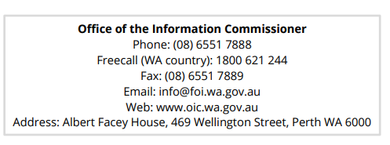

Amendment of Personal Information
The Act gives a person the right to apply for amendment of personal information, which is inaccurate, incomplete, and out of date or misleading. The agency may make the amendment by altering, striking out, inserting information or inserting a note in relation to the information.

Applications to amend personal information must be in writing to:
- Freedom of Information Request; or
- Written correspondence addressed to:
Information Management Officer
City of Nedlands
PO BOX 9
NEDLANDS WA 6909

There are no fees or charges associated with an application for the amendment of personal information under the FOI Act.

Note: The FOI Act does not allow the City to obliterate or remove information or destroy a document without written certification from the Information Commissioner.

Privacy Rights and Legislation
The City of Nedlands views privacy compliance as an integral part of its commitment to accountability and integrity in all its activities and programs. The City is committed to compliance with the laws that deal with personal and health information about individuals that is stored or received by it. Consequently, we will:
- Only use personal information provided by an individual for the purposes for which it was collected and for any other authorised use;
- Only disclose personal information to any third party (including other authorities) where authorised or as required/allowed under the Australian Privacy Principals and Privacy Act 1988, Privacy and Responsible Information Sharing Act 2024; and
- Take all necessary measures to prevent unauthorised access or disclosure. ensure personal information is collected, accessed, used, stored and disposed of in accordance with the Privacy Act 1988, Privacy Amendment Act 2004 and Privacy and Responsible Information Sharing Act 2024 and to provide guidelines for the City when dealing with information.

Freedom of Information Legislation
Should you wish to obtain a copy of the Freedom of Information Act 1992 or associated regulations, please visit the WA Legislation Website at WALW - Home WALW - Home (legislation.wa.gov.au) where a full copy of all State Legislation is available.

Further information about Freedom of Information (FOI) can also be found on the Office of the Information Commissioner (Freedom of Information for Western Australia) website at www.oic.wa.gov.au.

Paul Martin
CHIEF EXECUTIVE OFFICER

