Greenways Policy

Status Council

Responsible
Division Planning & Development

Objectives a) To designate greenways around the City.
b) To outline how greenways will be developed and/or enhanced.
- To protect, retain and promote flora and fauna along local and regional greenways within the City.

- Context

Definition

Greenways - (Also referred to as Greenway Corridors)

Networks of land containing linear elements that are planned, designed and managed for multiple use including ecological, recreational, cultural aesthetic, or other purposes compatible with the concept of sustainable land use. Primarily greenways act as networking links to better enable travel by wildlife using greenways as connecting corridors between natural areas, encouraged through the specific planting of types of native flora. These act as areas to connect wildlife populations that would otherwise be separated by human activities or structures (such as roads and development).

A greenway does not have to be any specific width or size, only a narrow area of land can be effective as a greenway. Land identified as being part of the greenway network within the City is planted with specific types of native flora to encourage and support wildlife utilising the greenway corridor for habitat and movement.

The City’s greenways form a part of the Perth Metropolitan regional greenway network. This policy identifies the local and regional greenways that are located within the City’s area of management and control.

  - Background

The City of Nedlands is well regarded as a tree-lined leafy municipality. This was acknowledged as part of the community led Our Vision 2030 process which as part of its natural environment vision declared:

“We will live sustainably within a thriving natural environment. Our gardens, streets and parks will be leafy and green despite water restrictions. Our bushland, river and beaches will be healthy ecosystems supporting local wildlife and enjoyed by people. We will be recognised as a global benchmark for sustainable living because of our innovative use of water, energy and other resources.”

The City of Nedlands Greenways Policy evolved following the development of “A Strategic Plan for Perth’s Greenways 1998” by Tingay and Associates. This report was commissioned by the Ministry for Planning in association with the Commonwealth Department of Transport and Regional Development. Contained within this report were recommendations for local governments to identify potential and existing green corridors in their structure plans and Town Planning Scheme (if possible) along with the development of a Local Planning Policy to deal with the planning and implementation of local greenways.

The Greenways Corridors Policy was approved in 2001. Prior to its approval public consultation was undertaken with residents requested to provide comment on the policy.

Developing and enhancing Greenways through revegetation programs on public land provides the opportunity for achieving this vision. In doing so Greenways can become a crucial feature of the urban fabric as they link the natural and built environments of the City’s neighbourhoods and provide for biodiversity and achieve sustainability.
This is a Council policy for public land to guide its activities to:

- retain and enhance existing greenways; and
- create new greenways around the City.

This policy encourages greater biodiversity and enhanced amenity around the City’s neighbourhoods.

1.2 Designated greenways (map attached)

Regional and local greenways have been designated along transport routes where they connect to parkland, remnant bushland and government lands. The connecting parkland, remnant bushland and government lands also form part of the green corridor.

Regional greenways provide linkages between regionally significant remnant bushland areas, coastal habitats, riverine habitats and wetlands as well as parklands. Local greenways provide linkages between locally significant remnant bushland, open space, parks and recreational areas along with extending regionally significant bushland.

- The following routes have been designated Greenways due to their ability to:

- Provide linkages from the coast to the river
- Provide linkages along foreshore areas
- Provide linkages between wetlands
- Provide linkages between large bushland areas and small fragmented bushlands
- Represent areas to develop or secure linkages

- Coastal Regional Greenway
Marine Parade Swanbourne

- Railway Regional Greenway
Railway Road (north of Loch Street)
Stubbs Terrace (north of Brockway Road)

- Foreshore Regional Greenway
Along Swan River Foreshore

- Coast and Allen Park to Bold Park via Campbell Barracks and Cottesloe Golf Course Regional Greenway
Through Seaward Village
West Coast Highway

- Bold Park to Kings Park Regional Greenway
Rochdale Road
Stephenson Avenue
Underwood Avenue
Selby Street
Bedbrook Place
Little Gibraltar Road
Aberdare Road (between Railway Road and Smyth Road)
Smyth Road (between Aberdare Road and Monash Avenue)
Monash Avenue

- Coast and Bold Park to Lake Claremont Regional Greenway
Marine Terrace
Allen Park
Narla Road (northern half of north/south section)
Lake Claremont
Alfred Road
Montgomery Avenue
Bold Park

- Local Greenways
Aberdare Road (from Smyth Road to Thomas Street)
Alexander Place
Alexander Road
Allen Park
Bay Road (from Princess Road to Melvista Avenue)
Biara Gardens
Birdwood Parade (between Wavell Road and Throssell Street)
Birdwood Parade Bushland
Bostock Road
Brockway Road
Bromilow Green (along Lesley Graham Reserve)
Brookdale Street
Broome Street (north of Carrington Street)
Carrington Street (between Broome Street and Dalkeith Road)
Cottesloe Golf Course
Dalkeith Road (from Melvista to Gallop Road)
Gallop Road
Godetia Gardens
Government Road
Hackett Road (between Kathryn Crescent and Melvista Avenue)
Heritage Lane green space
Hollywood Reserve
Jutland Parade (between Wattle Avenue and bowling club)
Karella Street (between Dalkeith Road and Smyth Road)
Kathryn Crescent (between Garland Road and Hackett Road)
Lantana Avenue (north of Zamia Street)
Lemnos Street (between Brockway Road and Shenton College)
Loch Street (between Government Road and Railway Road)
Loftus Street
McKenna Glen
Melvista Avenue
Montgomery Avenue (between Stephenson Avenue and Lobelia Street)
Mooro Drive green space
Mt Claremont Community Centre green space
Mt Claremont Oval Reserve
Mt Claremont Oval Bushland Reserve
Mt Claremont Reserve (between Montgomery Drive and Whitney Crescent)
Nedlands Golf Course
Pine Tree Lane green space
Primula Place
Point Resolution Reserve
Princess Road (between Bulimba to Bay Road)
Shenton Bushland
Sunset Hospital
Vix Street
Waroonga Road
Watkins Road (between Alexander Place and Garland Road)
Wattle Avenue (between Jutland Parade and Beatrice Road)
Wavell Road
Zamia Street

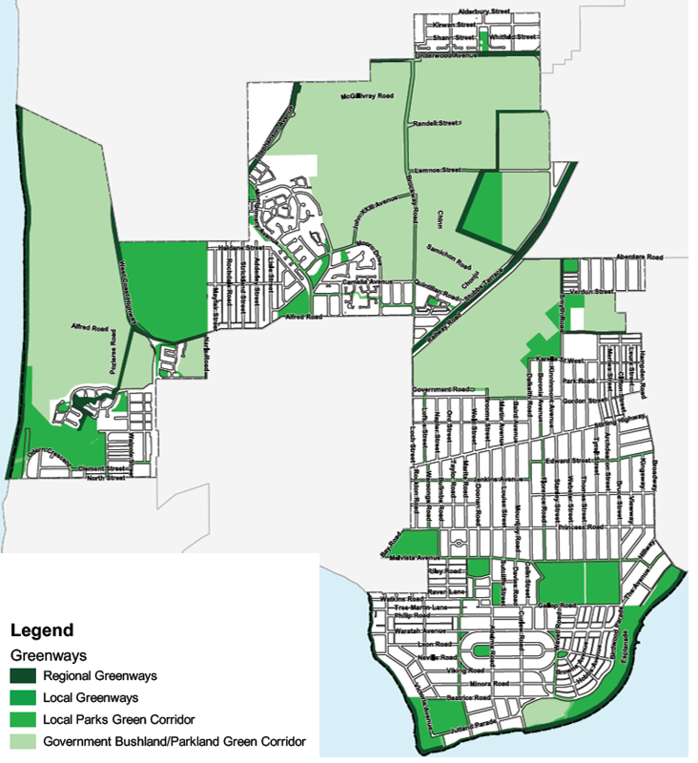
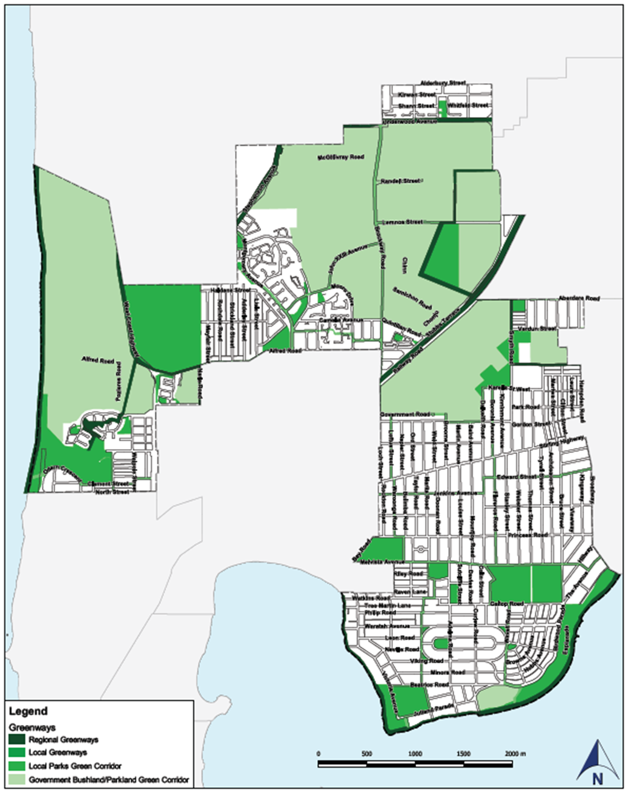
Map 1: Greenways Concept Map
Statement

2.1 Objectives

The objectives of this policy are:

- To designate greenways around the City.
- To outline how greenways will be developed and/or enhanced.
- To protect, retain and promote flora and fauna along local and regional greenways within the City.

  - Outcomes

The outcomes of this policy are that:

- Biodiversity within the City is maintained and protected.
- The habitat and food sources for fauna (especially threatened or endangered species) is retained, protected and enhanced.
- The movement of fauna (particularly avifuana) between areas of remnant bushland is facilitated.
- Greenways physically link natural areas and parklands.
- Landscaping amenity along greenways, built environments and local reserves are improved.
- Genetic diversity and biodiversity of flora will be maintained.

  - Guiding principles

The following guiding principles will assist in achieving the above outcomes:

- Existing healthy trees will not be removed when developing and/or enhancing greenways.
- Local indigenous species are preferred when planting or seeding greenways.
- Where possible, local seed stock will be used to maintain genetic diversity and biodiversity.
- Consultation with adjoining residents and landowners will be undertaken prior to greenways being developed.
- Adjoining residents and landowners will be encouraged to plant complementary species of native flora where their boundaries adjoin a greenway.

Special measures will be taken to retain trees within greenways that are used as a source of food and for roosting by endangered Carnaby’s Black-Cockatoo.

Related documentation

WESROC Greening Plan
A Strategic Plan for Perth’s Greenways, Tingay and Associates 1995
Regional Framework for Local Biodiversity Conservation Priorities for Perth and Peel, Perth Biodiversity Project
City of Nedlands Greenways Procedure
City of Nedlands Street Trees Policy
City of Nedlands Landscaping Plans Local Planning Policy
City of Nedlands Nature Strip Policy

Related Local Law/legislation

Environmental Protection Act 1986
Environmental Protection (Clearing of Native Vegetation) Regulations 2004
Environmental Protection and Biodiversity Conservation Act 1999

Related delegation

Nil

Review History

17 December 2019 (Item 13.7)
26 April 2017 (Report CPS13.17)
24 July 2012 (Report CP31.12)
14 August 2001 (Report T34.01)

