

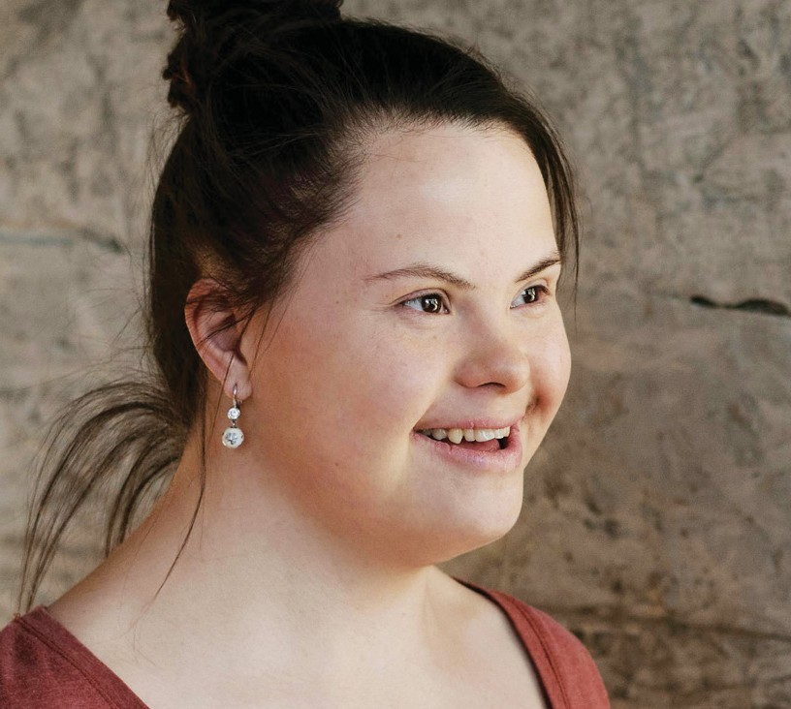

**Disability Access and Inclusion Plan**

2023 – 2028



**Contents**

Accessible Information

3

Introduction

4

Legislation and Strategic Influences

5

What is a disability?

6

Information about the City of Nedlands

7

Facilities and services provided by the City of Nedlands

8

Preparing, monitoring, and reporting on the DAIP

9

DAIP Outcome Areas

10

Achievements during the 2018-19 – 2022-23 DAIP

11

2

City of Nedlands | **Disability Access and Inclusion Plan 2023 - 2028**



**Accessible Information**

This document provides details about how the City of Nedlands will improve access to its facilities and inclusion to its services for people with disability in accordance with the outcome areas in the Western Australian Disability Services Act 1993 (amended 2004).

The City of Nedlands can provide this document in an alternative format on request.

For an alternative format of the document please contact the City of Nedlands on:

**Acknowledgements**

City of Nedlands | **Disability Access and Inclusion Plan 2023 - 2028**

3

**Acknowledgement of consultation contribution**

The City of Nedlands acknowledges the valuable input from its community members and staff. Their feedback and advice have been critical to developing the Disability Access and Inclusion Plan.

**Acknowledgement of Country**

The City of Nedlands acknowledges the traditional custodians of this land, the Whadjuk people of the Noongar Nation, and pays respect to the Elders both past and present.

**In person:** 71 Stirling Highway, Nedlands

[**Website:** nedlands.wa.gov.au](http://nedlands.wa.gov.au/)

**Email:** [commdev@nedlands.wa.gov.au](mailto:commdev@nedlands.wa.gov.au)

**Phone:** 08 9273 3500



**Introduction**

Local governments have unique knowledge of and close connections with their communities. Interaction between ratepayers and council staff occur at many levels and in a variety of ways and settings, which enable the actions of local governments to be closely guided by their communities.

This is important as the actions of local governments have a direct impact on those who live within their boundaries.

The 2023-24 – 2028-29 City of Nedlands Disability Access and Inclusion Plan (DAIP or the Plan) has been created

as a result of engagement with real people who are at risk of exclusion in community life. A series of conversations with City of Nedlands staff, contractors,

disability service providers, community organisations, people with disability and their families have been essential in the development of this DAIP. This DAIP follows on from the City of Nedlands 2018-19 – 2022-23 plan by incorporating lessons learnt and identifying recurring themes raised by the community to make the Plan relevant, useful and achievable.

The DAIP aims to improve access for all. This includes not just people with a permanent disability, but also parents with young children and prams, the elderly and people from cultural and linguistically diverse backgrounds as well as those community members who have a temporary impairment.

4

City of Nedlands | **Disability Access and Inclusion Plan 2023 - 2028**



**T“his DAIP follows on from the City of Nedlands**

**2018-19 – 2022-23 plan**

**by incorporating lessons learnt and identifying**

**recurring themes raised by the community to**

**make the Plan relevant, useful and achievable.**

**Legislation and Strategic Influences**

*The Disability Services Act 1993 (WA)* and its 2004 amendments, require that all State and local government authorities implement a DAIP. The purpose is for the relevant authority to ensure that people with disability have equal access to its facilities and services.

Other legislation relevant to access and inclusion includes:

* *Equal Opportunity Act 1984 (WA).*
* *Commonwealth Disability Discrimination Act – Access to Premises/Buildings 2011 (DDA).*
* *United Nations Convention on the Rights of People with Disabilities (UNCRPD)*.

*The National Disability Insurance Scheme (NDIS)* aims to support a better life for Australians with a significant and permanent disability, their families and carers. This scheme is currently being implemented across Australia and will assist people with disability.

**“The National Disability Insurance Scheme (NDIS) aims to support a better life for Australians with a significant and permanent disability, their families and carers.**

City of Nedlands | **Disability Access and Inclusion Plan 2023 - 2028**

5



**What is a disability?**

A disability is any continuing condition that restricts everyday activities.

*The Disability Services Act 1993 (WA)* defines disability as something which:

•

Is attributable to an intellectual, psychiatric, cognitive, neurological, sensory or physical impairment or a combination of those impairments.

Is permanent or likely to be permanent.

May or may not be of a chronic or episodic nature.

Results in substantially reduced capacity of the person for communication,

social interaction, learning or mobility and a need for continuing support services.

•

•

•

**Hidden versus visible disability**

A disability and the impact of it cannot always be easily identified.

An individual in a wheelchair trying to navigate an uneven footpath is different to a person with a cognitive impairment due to dementia who may be unable to communicate all their needs. Awareness and education

are vital to prevent ignorance of the range of disabilities.

**A“wareness and**

**education are vital to**

**prevent ignorance of the range of disabilities.**



**Information about the City of Nedlands**

The City of Nedlands has a population of more than 21,000 people and comprises the suburbs of Nedlands, Dalkeith, Mt Claremont, Swanbourne and parts of Floreat and Shenton Park.

The City of Nedland’s community, built environment and natural landscape

all influence inclusion. While the City is a modern local government area, it also has a number of older heritage- listed buildings. The City has a mix of

commercial, educational and residential land uses, as well as a significant number of disability service providers, particularly in the suburb of Shenton Park.

The Indian Ocean at Swanbourne, as well as the Swan River foreshore in Nedlands and Dalkeith, require unique accessibility considerations. In regard to mobility corridors, the City is well- serviced with significant road and public transport, both bus and train.

Consideration needs to be given to all these factors, and their potential as barriers, when aiming to increase inclusion through the DAIP.

**“**

**The City of Nedland’s community, built**

**environment and**

**natural landscape all influence inclusion.**

City of Nedlands | **Disability Access and Inclusion Plan 2023 - 2028**

7

**Facilities and services provided by the City of Nedlands**

The City of Nedlands provides the standard functions of a local government including:

Asset management. E.g. footpaths, roads, buildings, playgrounds, reserves and other open space

Ranger services

Parking Sustainability

Events

Community Development Waste

Environmental Health

Building and planning approvals

•

•

•

•

•

•

•

•

•

ALDERBURY ST

TOWN OF CAMBRIDGE

CITY OF SUBIACO

ABERDARE RD

**Coastal Ward**

ALFRED RD

**Hollywood Ward**

CITY OF PERTH

TOWN OF CLAREMONT

NORTH ST

**Melvista Ward**

MELVISTA AVE

TOWN OF

COTTESLOE

**Dalkeith Ward**

SHIRE OF PEPPERMINT GROVE

TOWN OF MOSMAN PARK

8

City of Nedlands | **Disability Access and Inclusion Plan 2023 - 2028**

WEST COAST HWY

NARLA RD

BROCKWAY RD

LOCH ST

SELBY ST

HAMPDEN RD



**Preparing, monitoring and reporting on the DAIP**

The Community Development department is responsible for co- ordinating the development, monitoring and reporting of the City’s DAIP to the Department of Communities, Disability Services.

Each business unit within the City creates its own specific DAIP actions and reports against them annually with DAIP actions being

assigned to a responsible officer. Whole-of-organisation collaboration is encouraged to ensure the co-ordinated delivery of City services.

*The Disability Services Act 1993 (WA)* requires the City of Nedlands to report on the implementation of its DAIP in its annual reporting.

City of Nedlands | **Disability Access and Inclusion Plan 2023 - 2028**

9



**DAIP Outcome Areas**

10

City of Nedlands | **Disability Access and Inclusion Plan 2023 - 2028**

**Outcome 7 – Employment**

People with disability have the same opportunities as other people to obtain and maintain employment with the City of Nedlands.

**Outcome 6 – Public Consultation**

People with disability have the same opportunities as other people to participate in any public consultation by the City of Nedlands.

**Outcome 5 – Feedback and Complaints**

People with disability have the same opportunities as other people to make complaints to the City of Nedlands.

**Outcome 4 – Service from Employees**

People with disability receive the same level and quality of service from the staff of the City of Nedlands as other people receive from the staff of the City of Nedlands.

**Outcome 3 – Information**

People with disability receive information form the City of Nedlands in a format that will enable them to access the information,

as readily as other people are able to access it.

**Outcome 2 - Building & Facilities**

People with disability have the same opportunities as other people to access the buildings and other facilities of the City of Nedlands.

**Outcome 1 – Services and Events**

People with disability have the same opportunities as other people to access the services of and any events organised by the City of Nedlands.





**Achievements during the 2018 – 2023 DAIP**

City of Nedlands | **Disability Access and Inclusion Plan 2023 - 2028**

11

Completion of the Jo Wheatley All Abilities Play Space at Beaton Park, including a changing places facility.

Provided disability training for Point Resolution Child Care staff.

Implemented a hearing augmentation device into the Mount Claremont Community Centre.

Provided online, downloadable eAudiobook, eBook and eMagazine collections through the Library Service.

Provided a large screen television for easier viewing for vision impaired clients at Nedlands Community Care.

Provided PDF and Word versions of Council agendas, minutes and Council reports on City’s website. (Note: may exclude some Council report attachments)



**The process:**

**Development of the 2023-24 – 2028-29 DAIP**

The City of Nedlands commenced the review of the DAIP in 2023. The process included recommendations provided by the Department of Communities, Disability Services to assist local governments to develop a DAIP.

Development of a communication and consultation plan identifying key stakeholders and the best methods to communicate and engage with them including:

* Word of mouth
* Advertising on Council website
* Advertising in local newspapers
* Face-to-face, phone and electronic conversations
* Survey via the City of Nedlands ‘Your Voice’ engagement portal as well as hard copy and large print distributed to key locations within the City
* Two drop-in sessions for community members at public libraries

12

City of Nedlands | **Disability Access and Inclusion Plan 2023 - 2028**



**Outcome 1 – Service and Events**

City of Nedlands | **Disability Access and Inclusion Plan 2023 - 2028**

13

**Objectives**

**Actions**

**Supporting Plans**

**Lead**

**23/24**

**24/25**

**25/26**

**26/27**

**27/28**

1.1. People with disability have the same opportunities

as other people to access the services of, and any events organised by, the City of Nedlands

1.1.1

Provide and promote library activities and services aimed at inclusion and preventing social isolation.

DAIP 2023

- 2028

Manager Community Development

1.1.2

Provide a large print and talking book collection at Nedlands and Mt Claremont libraries.

1.1.3

Provide online, downloadable Audiobook, eBook and Magazine collections through the Library Service.

1.1.4

Develop a book collection at Nedlands and Mt Claremont libraries for children that explain autism and other disabilities.

1.1.5

Promote and provide a positive ageing program to the seniors within the Nedlands community.

1.1.6

Provide technology classes and/or workshops for seniors within the Nedlands community.

1.1.7

Provide activities for children which encourage cultural and social inclusion.

1.1.8

Provide Community Grants program for Disability related projects.

Manager Community Development

1.1.9

Develop the capacity and capability of staff and community to support and deliver accessible and inclusive events and programs within the City of Nedlands.

1.1.10

Include a question on accessibility in user satisfaction survey of events run by Community Development.

1.1.11

Develop an Access Advisory Group as per Council Resolution from 25 May, 2021.



**Outcome 2 – Buildings and Facilities**

**Outcome 3 – Information**

14

City of Nedlands | **Disability Access and Inclusion Plan 2023 - 2028**

**Objectives**

**Actions**

**Supporting Plans**

**Lead**

**23/24**

**24/25**

**25/26**

**26/27**

**27/28**

3.1. People with disability receive information

from the City of Nedlands in a format that will enable them

to access the information, as readily as other people are able to access it.

3.1.1

Review and update the corporate Style Guide and other relevant policies and procedures to include

best practice in accessible communications.

DAIP 2023

- 2028

Coordinator Communications and Engagement

3.1.2

Review the City's website information on existing bushland trails that are suitable for disability access.

Manager Health and Compliance

3.1.3

Undertake a review of the City's website regarding ACROD parking within the City of Nedlands.

3.1.4

Include accessibility in the usability assessment when procuring new software, hardware, or systems for the City of Nedlands.

Manager ICT

**Objectives**

**Actions**

**Supporting Plans**

**Lead**

**23/24**

**24/25**

**25/26**

**26/27**

**27/28**

2.1. People with disability have the same opportunities

as other people to access the buildings and other facilities of the City of Nedlands.

2.1.1

Ensure new buildings and facilities, including

significant upgrades, exceed minimum disability access requirements where possible.

DAIP 2023

- 2028

Manager City Projects and Programs

2.1.2

Identify opportunities to improve universal access to Council facilities and reserves (i.e. self-opening doors, ramps, sealing footpaths and accessways, parking, beach and river access etc.)

2.1.3

All projects are designed and constructed in compliance with Australian Standards

for equal access and safety where possible and practical.

2.1.4

Budget for an audit of 5 City buildings to identify disability access issues and improvements required.

Manager Assets

2.1.5

Re-establish the sensory garden at the Jo Wheatley All Abilities Play Space.

Manager Urban Landscapes and Conservation

2.1.6

As Parks furniture is replaced, look at accessible furniture for replacement where practical.



**Outcome 4 – Service from Employees**

**Outcome 5 – Feedback and Complaints**

**Outcome 6 – Public Consultation**

**Outcome 7 – Employment**

City of Nedlands | **Disability Access and Inclusion Plan 2023 - 2028**

15

**Objectives**

**Actions**

**Supporting Plans**

**Lead**

**23/24**

**24/25**

**25/26**

**26/27**

**27/28**

7.1. People with disability have the same opportunities as other people to obtain and maintain employment with the City of Nedlands.

7.1.1

Continue to comply with legislative requirements for disability employment.

DAIP 2023

- 2028

Manager Human Resources

**Objectives**

**Actions**

**Supporting Plans**

**Lead**

**23/24**

**24/25**

**25/26**

**26/27**

**27/28**

6.1. People with disability have the same opportunities as other people to participate in any public consultation by the City of Nedlands.

6.1.1

When planning engagement activities in facilities, ensure accessibility is addressed.

DAIP 2023

- 2028

Coordinator Communications and Engagement

**Objectives**

**Actions**

**Supporting Plans**

**Lead**

**23/24**

**24/25**

**25/26**

**26/27**

**27/28**

5.1. People with disability have the same opportunities as other people to make complaints to the City of Nedlands.

5.1.1

Review City's complaints process and ensure it is accessible to people with disability.

DAIP 2023

- 2028

Manager ICT

**Objectives**

**Actions**

**Supporting Plans**

**Lead**

**23/24**

**24/25**

**25/26**

**26/27**

**27/28**

4.1. People with disability receive the same level and quality of service from the staff of the City of Nedlands as other people receive from the staff of the City of Nedlands.

4.1.1

Human Resources staff and other relevant staff to

participate in discrimination awareness training.

DAIP 2023

- 2028

Manager Human Resources

4.1.2

Current staff to complete refresher EEO and diversity training.

4.1.3

New staff to complete EEO and diversity training as

part of onboarding induction process.





71 Stirling Hwy Nedlands WA 6009

PO Box 9 Nedlands WA 6909

P: 9273 3500

**nedlands.wa.gov.au**