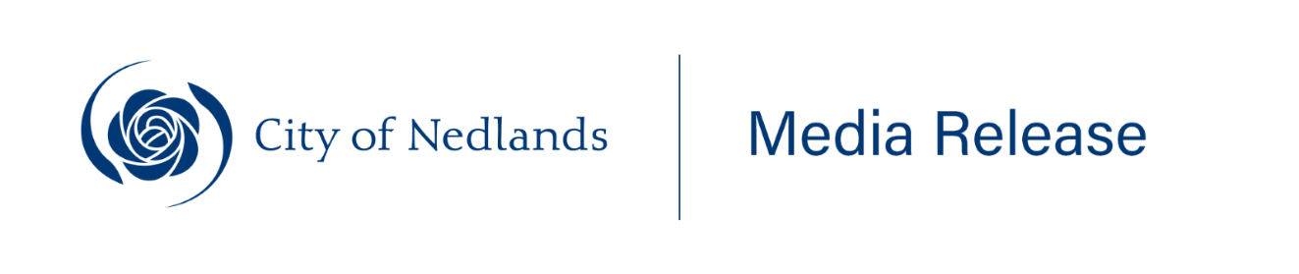
______________________________________________________
28 March 2025
MEDIA RELEASE
Emerge Youth Art Awards 2025: Celebrating young talent in Western Australia
The City of Nedlands is proud to announce the return of the prestigious Emerge Youth Art Awards for its 13th year. This annual event is a cornerstone of the City's youth program, providing a platform for young artists aged 12-25 from across Western Australia to showcase their creativity and compete for a generous prize pool of $2,250.
Key dates:
- Entries open: Friday, 28 March 2025
- Entries close: Monday, 14 July 2025
- Exhibition opening and Awards night: Saturday, 26 July 2025, 4:00pm-6:00pm
- Exhibition dates: 26 July - 22 August 2025
The exhibition will be held at the beloved Tresillian Arts Centre, where the community can view the artworks for free and vote for their favourite piece in the People's Choice Award. This year's categories include the Open Award, Resident’s Award, People’s Choice Award, and Under 18 Award, with cash prizes awarded to the winners.
Mayor Fiona Argyle expressed her enthusiasm for the event, stating, "Emerge is an incredible opportunity for young artists to showcase their talent at our iconic Tresillian Arts Centre. We’re calling on all passionate, up-and-coming artists in the City of Nedlands and beyond to submit their work."
The Emerge Youth Art Awards highlights the artistic talents of young individuals and fosters a sense of community and support for early-career artists. The City of Nedlands invites everyone to join in celebrating the creativity and innovation of young people in the local community and across the state.
For more information and to enter the awards: nedlands.wa.gov.au/emerge.
Contact: Tessa Dorotich, Community Development Officer, Arts & Culture.
Ph: 08 9273 3500 Email: tdorotich@nedlands.wa.gov.au

ENDS
_________________________________________________________________________________
For further information, please contact the Communications & Engagement Team via communications@nedlands.wa.gov.au

